Name of Journal: World Journal of Clinical Cases
Manuscript NO: 79716
Manuscript Type: CASE REPORT

Amiodarone-induced muscle tremor in an elderly patient: A case report

Zhu XY et al. Adverse reactions caused by amiodarone

Xiao-Yong Zhu, Xin-Hu Tang, Hua Yu

Xiao-Yong Zhu, Xin-Hu Tang, Hua Yu, Department of Cardiology, Jiujiang University Affiliated Hospital, Jiujiang 332000, Jiangxi Province, China

Author contributions: Zhu XY reviewed the literature and contributed to manuscript drafting and revising; Zhu XY was the patient’s doctor and contributed to collecting the patient’s medical data and making a revision to the manuscript; Tang XH and Yu H were responsible for the revision of the manuscript for important intellectual content; all authors issued final approval for the version to be submitted.

Corresponding author: Xin-Hu Tang, PhD, Professor, Department of Cardiology, Jiujiang University Affiliated Hospital, No. 57 Road, Xunyang District, Jiujiang 332000, Jiangxi Province, China. 18879292198@163.com

Received: September 3, 2022
Revised: October 9, 2022
Accepted: November 4, 2022
Published online: December 6, 2022

Abstract
BACKGROUND
Amiodarone is a Class III antiarrhythmic drug, which has been adopted for the treatment of atrial fibrillation and ventricular arrhythmia. However, the use of amiodarone can cause lower limb muscle tremors, which is recognized as a rare side effect of this medication.

CASE SUMMARY
An 84-year-old female was administrated with amiodarone for paroxysmal supraventricular tachycardia and frequent ventricular tachycardia. The patient developed a bilateral gastrocnemius tremor in the course of medication, and the strength of the patient’s bilateral knee flexor and extensor reached 4/5 and 3/5, respectively. After the use of amiodarone was stopped, and the patient was given a small dose of levetiracetam, the lower limb tremor symptoms were significantly mitigated, along with activity and function.

CONCLUSION
Attention should be paid to the significance of the side effects of drugs in the elderly, which may be atypical in the elderly. The relevant side effects of drugs may not be as rare as reported due to individual differences and different pharmacokinetics. If the side effects are generated, the medication should be adjusted in time, and the progress of the side effects should be intervened.

Key Words: Adverse reaction; Arrhythmia; Muscle disease; Amiodarone; Levetiracetam; Case report

©The Author(s) 2022. Published by Baishideng Publishing Group Inc. All rights reserved.

Citation: Zhu XY, Tang XH, Yu H. Amiodarone-induced muscle tremor in an elderly patient: A case report. World J Clin Cases 2022; 10(34):12726-12733
URL: https://www.wjgnet.com/2307-8960/full/v10/i34/12726.htm
DOI: https://dx.doi.org/10.12998/wjcc.v10.i34.12726

Core Tip: A patient who developed lower limb muscle tremors after the use of amiodarone was administrated with supraventricular tachycardia and frequent ventricular tachycardia. The symptoms was mitigated continuously. After the use of amiodarone was stopped, and the patient was given levetiracetam, the symptoms were gradually mitigated. This type of adverse reaction to amiodarone has been rare. The adverse reaction caused by amiodarone should be considered when similar symptoms occur during diagnosis and treatment.

INTRODUCTION
Conventional doses of drugs may be accompanied by adverse reactions during the treatment of diseases, many of which can affect the neuromuscular system^{[1]}. Amiodarone is an antiarrhythmic drug with numerous relevant side effects. Muscle tremors, which are characterized by marked weakness at the proximal and distal ends, loss of distal sensation, and weakening of muscle stretch reflex, with the lower limbs being more susceptible than the upper^{[1]}. It is a rare side effect of this drug. Amiodarone is considered to interact with lipid membranes to produce complexes that resist lysosomal digestion^{[2]}.
This study reports an 84-year-old woman who developed bilateral lower limb muscle pain and tremor, a rare adverse reaction, under amiodarone treatment. We wish to emphasize the significance of drug side effects, which can be typical or atypical, in the elderly. Due to the changes in pharmacodynamics and pharmacokinetics of an aging body, rare adverse reactions may occur more frequently in this group of people. Therefore, in the elderly, the advantages and disadvantages of certain medications must be carefully evaluated before use.

CASE PRESENTATION
Chief complaints
An 84-year-old female suffering from repeated palpitations for three days and aggravated for 5 h went to the Jiujiang University Affiliated Hospital on August 9, 2022.

History of present illness
Three days ago, the patient complained that there was no obvious inducement for repeated palpitation attacks, and each attack was mitigated for one hour. The attacks were characterized by sudden arrest, and no active diagnosis and treatment were made. The patient complained that there was no obvious cause for the re-occurrence of palpitations 5 h ago. The symptoms persisted and were not mitigated. Admission electrocardiogram (ECG): Paroxysmal supraventricular tachycardia with frequent ventricular premature beats. The patient was administrated with 150 mg amiodarone intravenously. It was observed that the patient’s heart rhythm did not revert to sinus rhythm, and frequent ventricular premature beats were observed. Subsequently, the patient was given amiodarone 1 mg/min for continuous pumping.
At 8:20 on August 10, 2022, the patient started to have lower extremity gastrocnemius tremor, accompanied by pain (muscle fiber necrosis) at a frequency of about 6 Hz. The patient was given an intravenous injection of calcium gluconate 1 mg, the symptoms were not mitigated significantly, the tremor symptoms persisted, and the tremor occurred after lower extremity activity It was aggravated and mitigated slightly after rest, but the tremor still persisted. It was considered to be drug-induced tremor. The patient only added drugs such as amiodarone. It was considered to be lower extremity muscle tremor caused by amiodarone. The tachycardia and frequent premature ventricular tachycardia persisted, combined with burst ventricular tachycardia, such that amiodarone was continued to be used, whereas the dose of amiodarone was adjusted from 1 mg/min to 0.5 mg/min. After 3 h, the patient complained. The pain and tremor of the lower extremities persisted and became unbearable, such that amiodarone was discontinued, and the patient was administrated with propafenone 70 mg intravenously, and sinus rhythm was well restored. However, the patient's lower extremity muscle tremors remained.

History of past illness
The patient had a history of hypertension for 20 years. She took amlodipine besylate 5 mg qd regularly to control the patient’s blood pressure, noting that the blood pressure level was controlled well. She did not take any other medications. The patient denied history of coronary heart disease, cerebral infarction, diabetes, rheumatism, and immune system. She also denied history of trauma.

Personal and family history
The patient denied smoking, drinking history, and family disease history.

Physical examination
Body temperature, 36.5 ℃; breathing, 20 breaths/min; blood pressure, 94/56 mmHg; heart rate, 170 beats/min. The gastrocnemius pain of lower limbs was accompanied by muscle tremors; the strength of bilateral knee flexors and extensors reached 4/5 and 3/5, respectively.

Laboratory examinations
Creatine kinase (CK) was 4504 µ/L after the onset of the disease. It evolved dynamically with the course of the disease (Figure 1). Blood routine, liver function, renal function, electrolyte, blood sugar, C-reactive protein, immune function, anti-nuclear antibody, anti-neutrophil cytoplasmic antibodies, and tumor indexes were not abnormal.

Imaging examinations
ECG: Paroxysmal supraventricular tachycardia and frequent ventricular premature beats (Figure 2). No significant abnormality was reported in lumbar magnetic resonance. The measurement result of nerve conduction velocity indicated that discharge was found in the bilateral tibial nerves after the F wave. The electromyography diagram indicated that the bundle fibrillation potential was seen when some muscles were relaxed (Figure 3). Lower limb muscle tremor image (Video 1). Disease development timeline (Figure 4).

FINAL DIAGNOSIS
Lower limb muscle tremors induced by amiodarone injection.

TREATMENT
The department of neurology was invited for consultation. At that time, the possibility of amiodarone was great since the cause of muscle tremor was to be investigated. The patient was given levetiracetam 250 mg twice a day to improve the symptoms of lower limb muscle tremors; the CK level of the patient was dynamically monitored. Active rehabilitation treatment included strength training, balance exercise, as well as targeted physical therapy.

OUTCOME AND FOLLOW-UP
The patient slowly began to recover the function of lower limbs, was able to walk independently, and was discharged home with the same activity ability before admission.

DISCUSSION
Amiodarone is a Class III antiarrhythmic drug that is adopted for the treatment of atrial fibrillation and ventricular arrhythmia. Neuromyopathy has been confirmed as a rare complication of amiodarone, with an incidence of 3%–30% (e.g., tremors, ataxia, peripheral neuropathy, gait disorder, and myopathy^{[3-5]}). Amiodarone-induced muscle tremors are rare in comparison with other drugs causing neuromyopathy (e.g., statins^{[6]}). Patients with neuromyopathy exhibit clinical features of proximal and distal muscle tremor, ataxia, and polymyotic spasms, with electromyography showing low-amplitude, fast-twitch motor potentials in proximal muscles^{[7]}. Although the mechanism of amiodarone-induced neurotoxicity remains unclear, amiodarone and its active metabolite desethylamiodarone are detectable in the central nervous system, thus suggesting that the drug is capable of crossing the blood-brain barrier^{[8]}. The pathogenesis may be similar to that of chloroquines since amiodarone and desethylamiodarone contain separate hydrophilic and hydrophobic structures^{[9]}, are capable of interacting with anionic groups of membrane phospholipids, neutralizing the charge of phosphate groups and displacing calcium ions^{[10]}. The above changes may result in necrosis of muscle fibers and muscle tremors in patients. In addition, amphiphilic drugs penetrate into lysosomes. Once in acidic lysosomes, amphiphilic molecules (e.g., amiodarone and desethylamiodarone) are capable of facilitating aggregation of Schwann cells, fibroblasts, and perineural cells to form lysosomal phospholipid complexes, thus resulting in increased pH inside lysosomes and inhibition of lysosomal enzymes, which interfere with lysosomal protein degradation^{[10-12]}. Autophagic vacuoles were formed, and muscle biopsy showed the features of necrotizing myopathy and vacuolar myopathy, with disorganized muscle fibers, and the patient showed peripheral neurological symptoms (e.g., muscle twitching and muscle weakness)^{[13]}. The dose of amiodarone-induced muscle tremor remains unclear. Amiodarone-induced hypothyroidism, renal insufficiency, concomitant use of statins, and age all significantly increase the incidence of toxic neuromyopathy^{[7,14]}.
There are five reports related to amiodarone induced muscle tremor on pumbed, one of which reported two cases of amiodarone induced muscle tremor, for a total of six patients, and we summarize their data in Table 1, from which we can find that the median age of these patients at the onset of muscle tremor was 63.5 years (range 41-87), the median dose of amiodarone was 400 mg/d (range 200-600), the median duration of taking amiodarone at the onset of symptoms was 2 mo (range 2-10), the patients were instructed to discontinue amiodarone, two of them were given levetiracetam and the other four simply discontinued amiodarone, and the patients were closely observed for changes in their condition, and the final result was that the muscle tremor symptoms were effectively relieved in all six patients.
After admission, the patient improved the lumbar magnetic resonance, and no significant spinal stenosis was identified. We did not consider the correlation of nerve compression. The patient had never taken statins, and muscle injury caused by statins was not considered. The patient also had no history of diabetes; blood glucose and glycosylated hemoglobin were normal after admission, and diabetes neuropathy was not considered. After the onset of the disease, the rheumatic-immune-related disease was improved, and no abnormality was identified. Rheumatic disease was excluded. Blood calcium level was normal after admission and after onset; muscle tremors caused by hypocalcemia was not considered. Furthermore, electromyography examination was also performed, the result of which suggests that bundle fibrillation potential can be seen when some muscles are relaxed. If further diagnosis is required needed, muscle biopsy will be required.
However, after the patient’s family was informed about the purpose and risk of this examination, the family members strongly refused the examination. In accordance with the patient’s symptoms and onset characteristics, it is more consistent with lower limb tremors induced by amiodarone. In general, this symptom occurs 12 d to 12 mo after the initiation of amiodarone treatment^{[8]}. Curiously, the patient of this study developed sustained tremors of the lower limb muscles after intravenous injection of amiodarone for one day. The pathophysiology of this phenomenon remains unclear. In most cases, the above symptoms are mitigated after the discontinuation of amiodarone or gradual reduction of amiodarone^{[15]}. Muscle tremor is a movement disorder characterized by involuntary, rapid and sudden muscle movement, which is likely to be cortical, subcortical, spinal cord, or peripheral. The treatment varies with the classification. In the patient of this study, a muscle tremor was primarily concentrated in the gastrocnemius of the lower limb and presents continuous tremors, consistent with the classification of cortical myoclonus. The muscle spasm caused by drugs is usually cortical^{[16]}.
Lastly, after the patient was given levetiracetam, tremors in the patient’s lower limb muscles subsided. Levetiracetam is a broad-spectrum antiepileptic drug binding to synaptic vesicle protein SV2A and regulating synaptic transmission by changing vesicle fusion. Levetiracetam has been confirmed as one of the first-line treatments for reflex cortical myoclonus, with the main aim of enhancing the inhibitory process in the sensorimotor cortex^{[17]}. Levetiracetam is conducive to shortening the duration of amiodarone-induced muscle tremors, whereas it can cause changes in behavior and personality (e.g., psychosis, irritability, hypertension, weakness, and lethargy). Accordingly, the patient was given a small dose of levetiracetam to reduce the adverse effects of the drug.

CONCLUSION
A case of lower limb muscle tremors caused by amiodarone was introduced, which was improved after treatment. When elderly patients are administrated with amiodarone, cardiologists and pharmacists should carefully evaluate the long-term and short-term side effects, as well as whether combined use with other drugs will increase the adverse reactions of amiodarone. Changes in the patient's condition should be closely observed, and if there are signs of adverse reactions, immediate intervention (e.g., changing the drug or reducing the dose of the drug) should be performed to reduce the adverse reactions of amiodarone.

REFERENCES
1 Colunga Biancatelli RM, Congedo V, Calvosa L, Ciacciarelli M, Polidoro A, Iuliano L. Adverse reactions of Amiodarone. J Geriatr Cardiol 2019; 16: 552-566 [PMID: 31447894 DOI: 10.11909/j.issn.1671-5411.2019.07.004]
2 Mammen AL. Toxic myopathies. Continuum (Minneap Minn) 2013; 19: 1634-1649 [PMID: 24305451 DOI: 10.1212/01.CON.0000440663.26427.f4]
3 Mäntyjärvi M, Tuppurainen K, Ikäheimo K. Ocular side effects of amiodarone. Surv Ophthalmol 1998; 42: 360-366 [PMID: 9493278 DOI: 10.1016/s0039-6257(97)00118-5]
4 Mansour AM, Puklin JE, O'Grady R. Optic nerve ultrastructure following amiodarone therapy. J Clin Neuroophthalmol 1988; 8: 231-237 [PMID: 2977138]
5 Vorperian VR, Havighurst TC, Miller S, January CT. Adverse effects of low dose amiodarone: a meta-analysis. J Am Coll Cardiol 1997; 30: 791-798 [PMID: 9283542 DOI: 10.1016/s0735-1097(97)00220-9]
6 Pasnoor M, Barohn RJ, Dimachkie MM. Toxic myopathies. Curr Opin Neurol 2018; 31: 575-582 [PMID: 30080718 DOI: 10.1097/WCO.0000000000000606]
7 Flanagan EP, Harper CM, St Louis EK, Silber MH, Josephs KA. Amiodarone-associated neuromyopathy: a report of four cases. Eur J Neurol 2012; 19: e50-e51 [PMID: 22507462 DOI: 10.1111/j.1468-1331.2012.03678.x]
8 Willis MS, Lugo AM. Amiodarone-induced neurotoxicity. Am J Health Syst Pharm 2009; 66: 567-569 [PMID: 19265185 DOI: 10.2146/ajhp080196]
9 Pasnoor M, Barohn RJ, Dimachkie MM. Toxic myopathies. Neurol Clin 2014; 32: 647-670, viii [PMID: 25037083 DOI: 10.1016/j.ncl.2014.04.009]
10 Kuncl RW, Wiggins WW. Toxic myopathies. Neurol Clin 1988; 6: 593-619 [PMID: 3065603]
11 Borden MB, Parke AL. Antimalarial drugs in systemic lupus erythematosus: use in pregnancy. Drug Saf 2001; 24: 1055-1063 [PMID: 11735661 DOI: 10.2165/00002018-200124140-00004]
12 Sundelin SP, Terman A. Different effects of chloroquine and hydroxychloroquine on lysosomal function in cultured retinal pigment epithelial cells. APMIS 2002; 110: 481-489 [PMID: 12193209 DOI: 10.1034/j.1600-0463.2002.100606.x]
13 Palakurthy PR, Iyer V, Meckler RJ. Unusual neurotoxicity associated with amiodarone therapy. Arch Intern Med 1987; 147: 881-884 [PMID: 3034178]
14 Alsheikh-Ali AA, Karas RH. Adverse events with concomitant amiodarone and statin therapy. Prev Cardiol 2005; 8: 95-97 [PMID: 15860984 DOI: 10.1111/j.1520-037x.2005.4060.x]
15 Deik AF, Shanker VL. A case of amiodarone-associated myoclonus responsive to levetiracetam. Can J Neurol Sci 2012; 39: 680-681 [PMID: 23066555 DOI: 10.1017/s0317167100018229]
16 Kojovic M, Cordivari C, Bhatia K. Myoclonic disorders: a practical approach for diagnosis and treatment. Ther Adv Neurol Disord 2011; 4: 47-62 [PMID: 21339907 DOI: 10.1177/1756285610395653]
17 Levy A, Chen R. Myoclonus: Pathophysiology and Treatment Options. Curr Treat Options Neurol 2016; 18: 21 [PMID: 27039330 DOI: 10.1007/s11940-016-0404-7]
18 Stanton MM, Samii L, Leung G, Pearce P. Amiodarone-induced neuromyopathy in a geriatric patient. BMJ Case Rep 2020; 13 [PMID: 33148598 DOI: 10.1136/bcr-2020-236620]
19 Celli D, Marquez A, Byer M, Colombo R. Levetiracetam for the treatment of myoclonic neurotoxicity induced by amiodarone. HeartRhythm Case Rep 2020; 6: 488-490 [PMID: 32817824 DOI: 10.1016/j.hrcr.2020.04.010]
20 Itoh K, Kato R, Hotta N. A case report of myolysis during high-dose amiodarone therapy for uncontrolled ventricular tachycardia. Jpn Circ J 1998; 62: 305-308 [PMID: 9583467 DOI: 10.1253/jcj.62.305]
21 Arnaud A, Neau JP, Rivasseau-Jonveaux T, Marechaud R, Gil R. [Neurological toxicity of amiodarone. 5 case reports]. Rev Med Interne 1992; 13: 419-422 [PMID: 1344923]

Footnotes
Informed consent statement: Informed written consent was obtained from the patient for publication of this report and any accompanying images.

Conflict-of-interest statement: All the authors report no relevant conflicts of interest for this article.

CARE Checklist (2016) statement: The authors have read the CARE Checklist (2016), and the manuscript was prepared and revised according to the CARE Checklist (2016).

Open-Access: This article is an open-access article that was selected by an in-house editor and fully peer-reviewed by external reviewers. It is distributed in accordance with the Creative Commons Attribution NonCommercial (CC BY-NC 4.0) license, which permits others to distribute, remix, adapt, build upon this work non-commercially, and license their derivative works on different terms, provided the original work is properly cited and the use is non-commercial. See: https://creativecommons.org/Licenses/by-nc/4.0/

Provenance and peer review: Unsolicited article; Externally peer reviewed.

Peer-review model: Single blind

Peer-review started: September 3, 2022
First decision: September 27, 2022
Article in press: November 4, 2022

Specialty type: Medicine, research and experimental
Country/Territory of origin: China
Peer-review report’s scientific quality classification
Grade A (Excellent): 0
Grade B (Very good): B
Grade C (Good): C
Grade D (Fair): D
Grade E (Poor): 0

P-Reviewer: Sun P, China; Watanabe T, Japan S-Editor: Wei ZH L-Editor: A P-Editor: Wei ZH

Figure Legends
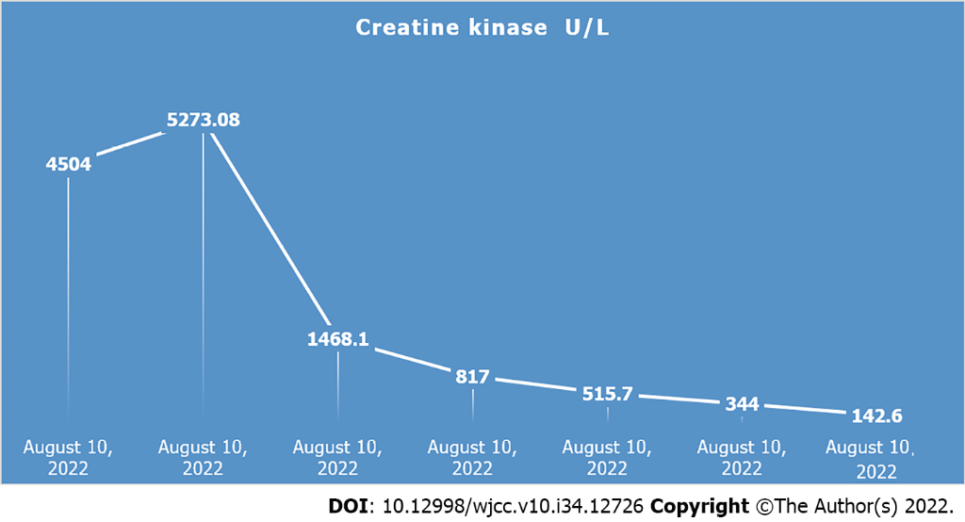
Figure 1 Dynamic evolution of creatine kinase level with the course of disease.
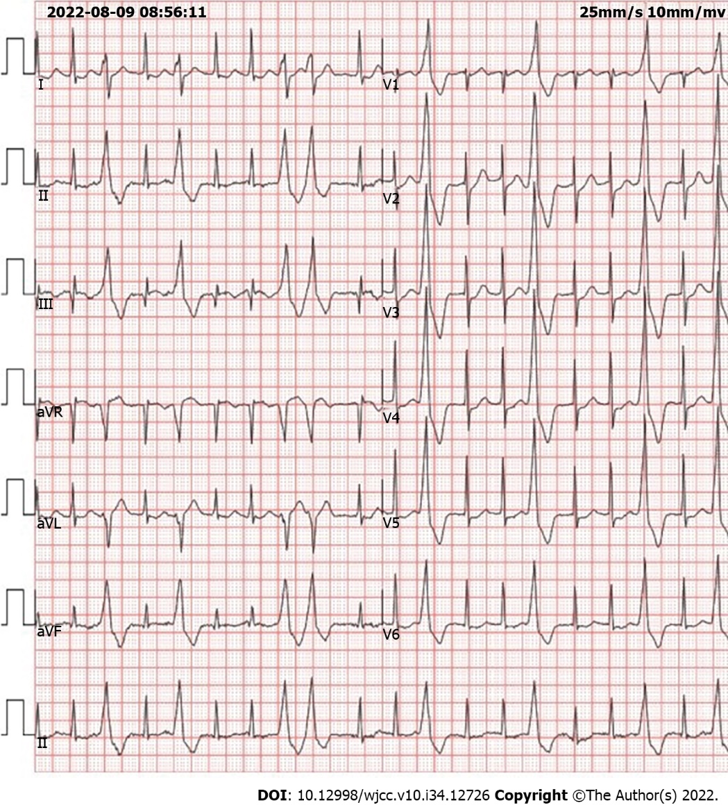
Figure 2 Electrocardiogram, paroxysmal supraventricular tachycardia with frequent ventricular premature beats.
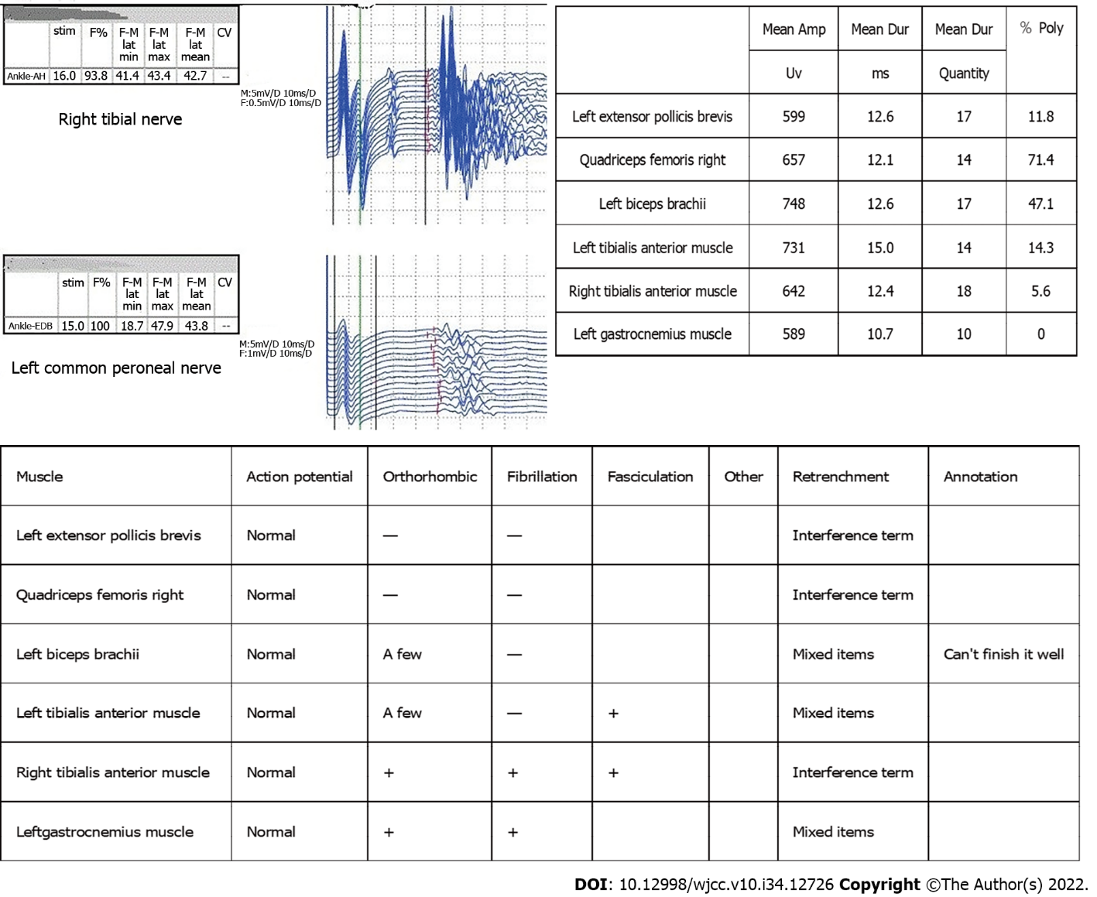
Figure 3 Bilateral tibial nerves show discharge after the F wave; bundle fibrillation potential can be seen.
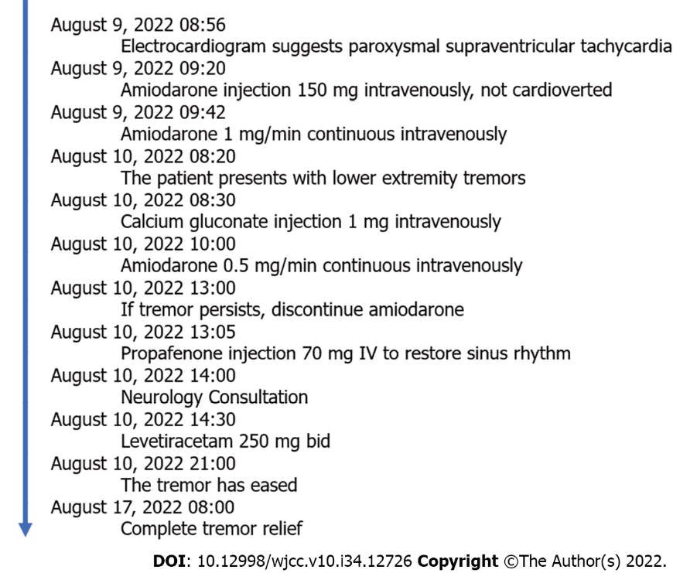
Figure 4 Disease development timeline.

Table 1 Summary of case data on amiodarone induced muscle tremor
Ref. | Name of journal | Age and gender | Primary disease | Amiodarone administration method | Dosage timing of appearance of side effects | Course of treatment for primary diseas | Timing of appearance of side effects | Outcome
Stanton et al^{[18]}, 2020 | BMJ Case Rep | 87- female | Atrial fibrillation | Oral administration | 600 mg/d | 3 mo | 2 mo | Tremor improved
Celli et al^{[19]}, 2020 | HeartRhythm Case Rep | 60- male | Ventricular tachycardia | Oral administration | 200 mg/d | 3 yr | 4 mo | Tremor improved
Itoh et al^{[20]}, 1998 | JAPANESE CIRCULATION JOURNAL | 41- male | Ventricular tachycardia | Oral administration | 400 mg/d | 6 yr | 10 mo | Symptoms completely relieved
Flanagan et al^{[7]}, 2012 | Eur J Neurol | 67- male | Atrial tachycardia | Oral administration | 400 mg/d | Unknown | 2 mo | Symptoms completely relieved
Flanagan et al^{[7]}, 2012 | Eur J Neurol | 76- male | Atrial fibrillation | Oral administration | 200 mg/d | Unknown | 2 mo | Symptoms completely relieved
Arnaud et al^{[21]}, 1992 | La Revue de Médecine Interne | 45- male | Ventricular tachycardia | Oral administration | 400 mg/d | Unknown | 2 mo | Symptoms completely relieved

Published by Baishideng Publishing Group Inc
7041 Koll Center Parkway, Suite 160, Pleasanton, CA 94566, USA
Telephone: +1-925-3991568
E-mail: bpgoffice@wjgnet.com
Help Desk: https://www.f6publishing.com/helpdesk
https://www.wjgnet.com

© 2022 Baishideng Publishing Group Inc. All rights reserved.

