Name of Journal: World Journal of Clinical Cases
Manuscript NO: 86462
Manuscript Type: CASE REPORT

Left hepatic artery pseudoaneurysm complicating endoscopic retrograde cholangiopancreatography: A case report

Li M et al. Left hepatic artery pseudoaneurysm complicating ERCP

Qiao-Mei Li, Bin Ye, Shang-Wen Yang, Huan Zhao

Qiao-Mei Li, Bin Ye, Shang-Wen Yang, Department of Gastroenterology, Lishui Central Hospital, The Fifth Affiliated Hospital of Wenzhou Medical University, Lishui 323000, Zhejiang Province, China

Huan Zhao, Department of Pathology, Lishui Central Hospital, The Fifth Affiliated Hospital of Wenzhou Medical University, Lishui 323000, Zhejiang Province, China

Author contributions: Li QM reviewed the literature and contributed to manuscript drafting; Zhao H performed the contributed to data collection; Yang SW and Ye B were responsible for the revision of the manuscript for important intellectual content; All authors issued final approval for the version to be submitted.

Supported by the Medical Health Science and Technology Project of Zhejiang Provincial Health Commission, No. 2020KY1082; and No. 2021KY1238.

Corresponding author: Wen Shang, MPhil, Doctor, Department of Gastroenterology, Lishui Central Hospital, The Fifth Affiliated Hospital of Wenzhou Medical University, No. 289 Kuocang Road, Liandu District, Lishui 323000, Zhejiang Province, China. strawberry198709@163.com

Received: June 26, 2023
Revised: July 22, 2023
Accepted: August 1, 2023
Published online:

Abstract
BACKGROUND
Pseudoaneurysms of the hepatic artery or its branches have been reported following abdominal trauma, iatrogenic injury at the time of many operations such as percutaneous transhepatic biliary drainage and cholecystectomy. Hepatic artery pseudoaneurysms after endoscopic retrograde cholangiopancreatography (ERCP) are uncommon and potentially life threatening and should be identified and treated rapidly.

CASE SUMMARY
We report a case of intra-abdominal hemorrhage secondary to a left hepatic artery pseudoaneurysm resulting from guide wire injury at ERCP. The patient primary diagnosis was acute biliary pancreatitis with cholangitis, he underwent ERCP on the third day of admission. During ERCP, the left intrahepatic bile duct was cannulated three times. Over the sixth day, Contrast enhanced computed tomography scan demonstrated left hepatic lobe contusion and a pseudoaneurysm formation. The patient was successfully treated with the embolization of a small branch of left hepatic artery angiographically.

CONCLUSION
The common complications of ERCP are pancreatitis, bleeding and perforation. False aneurysms occur as a result of damage to the wall of an artery. As far as we know, it is rare complication has been reported following ERCP. We advise urgent referral for angiographic embolization in this situation to avoid aneurysm rupture.

Key Words: Endoscopic retrograde cholangiopancreatography; ERCP complication; Pseudoaneurysm; Angioembolization; Case report

QM Li, Ye B, Yang SW, Zhao H. Left hepatic artery pseudoaneurysm complicating endoscopic retrograde cholangiopancreatography: A case report. World J Clin Cases 2023; In press

Core Tip: Hepatic artery pseudoaneurysms after endoscopic retrograde cholangiopancreatography are uncommon and potentially life threatening and should be identified and treated rapidly. Angiographic embolization is the preferred choice for the treatment of pseudoaneurysms, because transarterial angigraphy can find the precise site of vascular injury, and give a treatment at the same time.

INTRODUCTION
Endoscopic retrograde cholangiopancreatography (ERCP) has been widely practiced for the diagnosis and treatment of biliary-pancreatic diseases. Bleeding as a result of endoscopic sphincterotomy has been reported in 1% to 10% of the patients. Rarely^{[1]}, significant bleeding may occur secondary to the injury to the branches of the gastroduodenal artery. Although secondary hemorrhage from pseudoaneurysms developed in the branches of the gastroduodenal artery or pancreatoduodenal artery have been reported^{[2-4]}, Pseudoaneurysms developing from the branches of hepatic artery following ERCP are rarely reported^{[3-5]}, and most pseudoaneurysms are suspected associated with stent insertion or endoscopic sphincterotomy or inflammatory etiologies such as pancreatitis. We report one case of a 73-year-old man who underwent ERCP for relieving cholangitis and stone removal, and subsequently developed intra-abdominal hemorrhage secondary to a left hepatic artery pseudoaneurysm, which was managed successfully with embolization.

CASE PRESENTATION
Chief complaints
A 73-year-old Chinese man presented with abdominal pain for 2 d.

History of present illness
He had acute cholangitis with fever, upper abdominal pain, vomiting and jaundice. The pain was constant, localized to upper abdomen.

History of past illness
The patient was previously healthy. The patient had no history of abdominal surgery, toxicity, or radiation exposure.

Personal and family history
The patient denied any family history of biliary tract and pancreatic diseases.

Physical examination
Temperature was 99.4℉, pulse was 96 beats/min, respiration was 18 times/min and blood pressure was 127/80 mmHg, O2 saturation 96% on room air. The skin sclera yellow dyed, the abdomen was soft, had no distension, had tenderness in the upper abdomen but no rebound tenderness. The Murphy’s sign was positive.

Laboratory examinations
Laboratory data were the following: White blood cell count, 12.0 × 10⁹/L [normal (4-10) × 10⁹/L]; neutrophils, 96.9% (40%-75%); hemoglobin, 132 g/dL (94-122 g/L); serum C-reactive protein, 200 mg/L (0-8 mg/L); procalcitonin, 60 ng/mL (0-0.05 ng/mL); aspartate aminotransferase, 31 U/L (15-40 U/L); alanine aminotransferase, 63 U/L (9-50 U/L); alkaline phosphatase, 177 U/L (40-150 U/L); total bilirubin, 92.6 μmol/L (3-22 μmol/L); amylase, 100 U/L (30-110 U/L).

Imaging examinations
Computed tomography (CT) and magnetic resonance cholangiopancreatography (MRCP) were performed, and demonstrated severe dilated common bile duct of 2.5 cm, many common bile duct stones, gallstone and cholecystitis (Figure 1A). A primary diagnosis was acute biliary pancreatitis with cholangitis. Initially, patient was managed conservatively with antibiotic of Cefperazone-Sulbactam and ornidazole, on the third day of admission, he underwent ERCP.

During and after ERCP
During ERCP, the duodenoscope was passed easily into the duodenum. A hookworm and a large diverticulum were seen in the descending part of the duodenum. Sphincterotomy was performed in the usual manner and resulted in a gush of bile from the papilla. The left intrahepatic bile duct was cannulated three times (Figure 1B). A 8.5 Fr pigtail type plastic biliary plastic stent and a COOK straight nose bile duct were inserted at the end of the procedure (Figure 1C).In the next few days, the patient had no complain and was scheduled to undergo a cholecystectomy, Over the sixth day, patient had progressively worsening abdominal pain and abdominal distention, the hematocrit and hemoglobin declined from 132 g/L to 51 g/L, respectively. Abdominal puncture draw out blood.

FINAL DIAGNOSIS
Contrast enhanced computed tomography scan on arterial phase demonstrated left hepatic lobe contusion with hemoperitoneum and a pseudoaneurysm formation (Figure 2A).

TREATMENT
The patient underwent blood transfusion and albumin, then had stable vital signs. Transarterial angiography revealed a pseudoaneurysm in the distal left hepatic artery (Figure 2B). Transcatheter embolization of hepatic artery was performed using Ivalon particles and 2-3 mm diameter platinum coil spring, postembolization angiogram revealed no contrast filling of the aneurysm (Figure 2C).

OUTCOME AND FOLLOW-UP
The bleeding stopped, we did not perform abdominal paracentesis drainage for hemoperitoneum. Although the patient had left lobe contusion, there was no any evidence of bile leak. The patient had pleural effusion, which was caused by hypoproteinemia, then he underwent pleural puncture and drainage and made full recovery, the patient was discharged home after a few weeks. According to the guidelines, cholecystectomy was recommended, but he refused, he decided to recover for some time before coming back for surgery. During follow-up, the patient developed choledocholithiasis, biliary tract infection and cholecystitis again, he underwent laparoscopic cholecystectomy, choledocholithotomy with choledochoscope and t duct drainage. After that surgery, he did not develop abdominal pain, obstructive jaundice or pancreatitis, he had completely recovered.

DISCUSSION
Complications of ERCP are divided into those related to sedation, endoscopy, cannulation and contrast medium injection and therapeutic procedures^{[6]}. Pseudoaneurysms developing from the branches of hepatic artery following ERCP are rarely reported^{[3-5]}, in those cases, one patient had a history of plastic stent implantation, the author consider hepatic pseudoaneurysm might have formed as a result of traumatic stimulation related to the stent placement, because it had been placed improperly and its tip located at the site of the aneurysm^{[4]}. Another patient had cholangitis and underwent a open cholecystectomy, which might be implicated in the information of the false aneurysm^{[7]}. In our patient, despite the patient had cholangitis and biliary pancreatitis, which has been reported the cause of the pseudoaneurysm^{[7]}, the pseudoaneurysm is believed to be procedure-related, because CT and MRCP did not disclose any hematoma or pseudoaneurysm before ERCP. Although our patient placed a biliary stent during ERCP, which may have resulted in the formation of a pseudoaneurysm, the pseudoaneurysm was located on the left hepatic artery deep within the left lobe of the liver, far from the stent. In addition, the endoscopist review and angiography showed guide wire entered the left intrahepatic bile duct several times during ERCP. We believe that these findings support our hypothesis that the guide wire penetrated through the biliary tree and traumatized the artery during the ERCP. Hepatic artery pseudoaneurysm as a complication of guide wire associated injury during ERCP is more common than we believe^{[8,9]}. Although over the last decade, more attention had been paid to guide wire related complications, and the use of less traumatic guide wires has likely reduced the frequency of iatrogenic hemobilia^{[10]}. We want to suggest again that endoscopists ensure the ‘soft’ of the guide wire is inserted and should avoid the guide wire going too far into the biliary tree. Therapeutic angiographic embolization is the preferred choice for the treatment of pseudoaneurysms, because transarterial angigraphy can find the precise site of vascular injury, and give a treatment at the same time^{[11]}.

CONCLUSION
False aneurysms is rare complication has been reported following ERCP. We advise urgent referral for angiographic embolization in this situation to avoid aneurysm rupture. Although surgical intervention is another option, surgery is reserved after failure of selective embolization. In the present case, selective embolization of hepatic artery branch has been proven safe and effective.

REFERENCES
1 So YH, Choi YH, Chung JW, Jae HJ, Song SY, Park JH. Selective embolization for post-endoscopic sphincterotomy bleeding: technical aspects and clinical efficacy. Korean J Radiol 2012; 13: 73-81 [PMID: 22247639 DOI: 10.3348/kjr.2012.13.1.73]
2 Priya P, Bhattacharyya A, Mohammed S, Gulati S, Ghatak S. Angiographic management of pseudoaneurysms of gastroduodenal artery following endoscopic sphincterotomy. Indian J Gastroenterol 2016; 35: 242-244 [PMID: 27225797 DOI: 10.1007/s12664-016-0663-y]
3 Gottschalk U, Meyer DR, Steinberg J. [Pseudoaneurysm of the left hepatic artery as a complication of ERCP with sphincterotomy]. Z Gastroenterol 2006; 44: 329-332 [PMID: 16625462 DOI: 10.1055/s-2006-926588]
4 Yasuda M, Sato H, Koyama Y, Sakakida T, Kawakami T, Nishimura T, Fujii H, Nakatsugawa Y, Yamada S, Tomatsuri N, Okuyama Y, Kimura H, Ito T, Morishita H, Yoshida N. Late-onset severe biliary bleeding after endoscopic pigtail plastic stent insertion. World J Gastroenterol 2017; 23: 735-739 [PMID: 28216982 DOI: 10.3748/wjg.v23.i4.735]
5 Austin AS, Lobo DN, Hinwood D, Iftikhar SY, Norton B. Intra-hepatic false aneurysm: a rare complication of ERCP. Eur J Gastroenterol Hepatol 1999; 11: 1171-1173 [PMID: 10524649]
6 Loperfido S, Angelini G, Benedetti G, Chilovi F, Costan F, De Berardinis F, De Bernardin M, Ederle A, Fina P, Fratton A. Major early complications from diagnostic and therapeutic ERCP: a prospective multicenter study. Gastrointest Endosc 1998; 48: 1-10 [PMID: 9684657 DOI: 10.1016/s0016-5107(98)70121-x]
7 Gaduputi V, Tariq H, Dev A. Visceral arterial aneurysms complicating endoscopic retrograde cholangiopancreatography. Case Rep Gastrointest Med 2013; 2013: 515201 [PMID: 24187633 DOI: 10.1155/2013/515201]
8 Horn TL, Peña LR. Subcapsular hepatic hematoma after ERCP: case report and review. Gastrointest Endosc 2004; 59: 594-596 [PMID: 15044910 DOI: 10.1016/s0016-5107(04)00013-6]
9 Ortega Deballon P, Fernández Lobato R, García Septiem J, Nieves Vázquez MA, Martínez Santos C, Moreno Azcoita M. Liver hematoma following endoscopic retrograde cholangiopancreatography (ERCP). Surg Endosc 2000; 14: 767 [PMID: 11287996 DOI: 10.1007/s004640040001]
10 Baillie J. Hemobilia. Gastroenterol Hepatol (N Y) 2012; 8: 270-272 [PMID: 22723760]
11 Hong Duc P, Xuan Dung P, Quang Huy H. Post-Blunt Traumatic Hemobilia From Pseudoaneurysm Successfully Treated With Embolization. Cureus 2020; 12: e7961 [PMID: 32382469 DOI: 10.7759/cureus.7961]

Footnotes
Informed consent statement: Informed written consent was obtained from the patient for publication of this report.

Conflict-of-interest statement: All the authors report no relevant conflicts of interest for this article.

CARE Checklist (2016) statement: The authors have read CARE Checklist (2016), and the manuscript was prepared and revised according to CARE Checklist (2016).

Open-Access: This article is an open-access article that was selected by an in-house editor and fully peer-reviewed by external reviewers. It is distributed in accordance with the Creative Commons Attribution NonCommercial (CC BY-NC 4.0) license, which permits others to distribute, remix, adapt, build upon this work non-commercially, and license their derivative works on different terms, provided the original work is properly cited and the use is non-commercial. See: https://creativecommons.org/Licenses/by-nc/4.0/

Provenance and peer review: Unsolicited article; Externally peer reviewed.
Peer-review model: Single blind

Peer-review started: June 26, 2023
First decision: July 7, 2023
Article in press:

Specialty type: Medicine, general and internal
Country/Territory of origin: China
Peer-review report’s scientific quality classification
Grade A (Excellent): 0
Grade B (Very good): B
Grade C (Good): C
Grade D (Fair): 0
Grade E (Poor): 0

P-Reviewer: Ghannam WM, Egypt; Varma V, India S-Editor: Liu JH L-Editor: A P-Editor:
Figure Legends
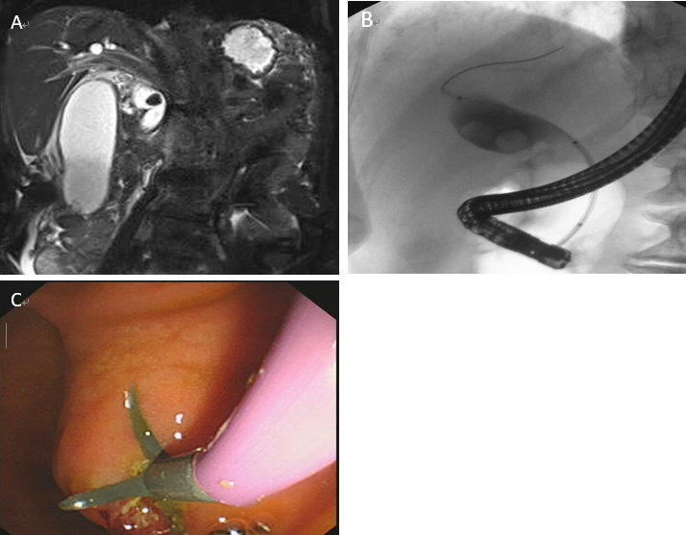
Figure 1 Magnetic resonance cholangiopancreatography and Endoscopic retrograde cholangiopancreatography. A: Magnetic resonance cholangiopancreatography demonstrating severe dilated common bile duct, common bile duct stones, gallstone; B: Endoscopic retrograde cholangiopancreatography (ERCP) demonstrating the guide wire reached the left hepatic bile duct; C: ERCP demonstrating a plastic stent was inserted at the end of the procedure.

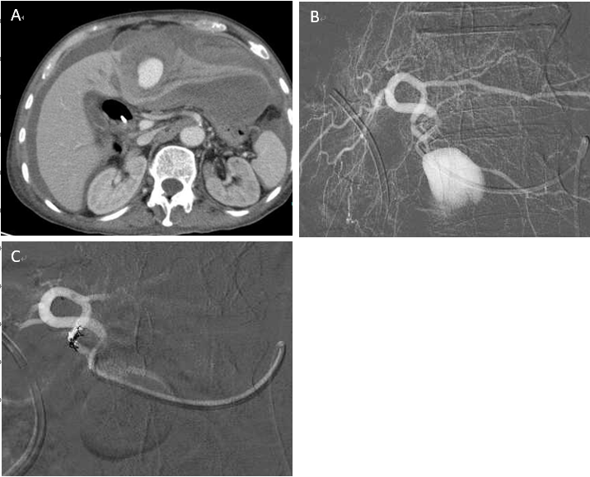
Figure 2 Pseudoaneurysm formation and Treatment. A: Computed tomography scan on arterial phase demonstrating left hepatic lobe contusion and a pseudoaneurysm formation; B: Transarterial angiography demonstrating a pseudoaneurysm in the distal left hepatic artery; C: Postembolization angiogram demonstrating no contrast filling of the aneurysm, the bleeding stopped.

