Name of Journal: World Journal of Clinical Cases
Manuscript NO: 77436
Manuscript Type: CASE REPORT

Submucosal esophageal abscess evolving into intramural submucosal dissection: A case report

Jiao Y et al. Submucosal esophageal abscess and IED

Yang Jiao, Yin-He Sikong, Ai-Jun Zhang, Xiu-Li Zuo, Pu-Yue Gao, Qing-Guo Ren, Ru-Yuan Li

Yang Jiao, Department of General Surgery, Shandong University of Qilu Hospital (Qingdao), Qingdao 266000, Shandong Province, China

Yin-He Sikong, Ai-Jun Zhang, Pu-Yue Gao, Ru-Yuan Li, Department of Gastroenterology, Shandong University of Qilu Hospital (Qingdao), Qingdao 266000, Shandong Province, China

Xiu-Li Zuo, Department of Gastroenterology, Qilu Hospital of Shandong University, Jinan 250000, Shandong Province, China

Qing-Guo Ren, Department of Radiology, Shandong University of Qilu Hospital, Shandong University, Qingdao 266000, Shandong Province, China

Author contributions: Jiao Y wrote this article; Sikong YH and Gao PY managed this patient’s hospitalization; Ren QG was in charge of the imaging diagnosis; Zuo XL and Zhang AJ made the diagnosis and treatment plan; Li RY performed the operation of this patient.

Corresponding author: Ru-Yuan Li, MM, Attending Doctor, Department of Gastroenterology, Shandong University of Qilu Hospital (Qingdao), No. 758 Hefei Road, Shibei District, Qingdao 266000, Shandong Province, China. liruyuan163@163.com

Received: May 6, 2022
Revised: June 28, 2022
Accepted: September 1, 2022
Published online: October 16, 2022

Abstract
BACKGROUND
Here we report a rare case of submucosal esophageal abscess evolving into intramural submucosal dissection.

CASE SUMMARY
An 80-year-old woman was admitted to our emergency department with a chief complaint of dysphagia and fever. Laboratory tests showed mild leukocytosis and elevated C-reactive protein level. Computed tomography showed thickening of the esophageal wall. Upper endoscopy showed a laceration of the esophageal mucosa and a submucosal mass. Spontaneous drainage occurred, and we could see purulent exudate from the crevasse. We closed the laceration with endoscopic clips. The patient did not remember swallowing a foreign body; however, she ate crabs before the symptoms occurred. We prescribed the patient with antibiotic, and the symptoms were gradually relieved. Two months later, upper endoscopy showed that the laceration was healed, and the submucosal abscess disappeared. However, intramural esophageal dissection was formed. We performed endoscopic incision of the septum using dual-knife effectively.

CONCLUSION
In conclusion, we are the first to report the case of esophageal submucosal abscess evolving into intramural esophageal dissection. The significance of this case lies in clear presentation of the evolution process between two disorders. In addition, we recommend that endoscopic incision be considered as one of the routine therapeutic modalities of intramural esophageal dissection.

Key Words: Submucosal esophageal abscess; Intramural esophageal dissection; Endoscopic incision; Case report

©The Author(s) 2022. Published by Baishideng Publishing Group Inc. All rights reserved.

Citation: Jiao Y, Sikong YH, Zhang AJ, Zuo XL, Gao PY, Ren QG, Li RY. Submucosal esophageal abscess evolving into intramural submucosal dissection: A case report. World J Clin Cases 2022; 10(29): 10695-10700
URL: https://www.wjgnet.com/2307-8960/full/v10/i29/10695.htm
DOI: https://dx.doi.org/10.12998/wjcc.v10.i29.10695

Core Tip: We are the first to report the case of esophageal submucosal abscess developing into intramural dissection. The significance of this case lies in clear presentation of the evolution process between two disorders, and we demonstrated that esophageal submucosal abscess is one of the etiologies of intramural esophageal dissection, which is a rare entity.

INTRODUCTION
Esophageal submucosal abscess is an extremely rare disease caused by mucosal injury to the esophagus but without transmural perforation. It has been rarely reported^{[1-5]}. Intramural esophageal dissection (IED) is also a rare disorder characterized by extensive laceration between the mucosal and submucosal layers of the esophageal wall. Herein, we report a rare case of submucosal esophageal abscess evolving into intramural submucosal dissection.

CASE PRESENTATION
Chief complaints
An 80-year-old woman was admitted to our emergency department with a chief complaint of dysphagia and fever for 14 d.

History of present illness
She also had a sore throat.

History of past illness
She had hypertension and type 2 diabetes.

Personal and family history
No special notes.

Physical examination
On examination, the patient was febrile and tachycardiac.

Laboratory examinations
Laboratory tests showed mild leukocytosis and an elevated C-reactive protein level.

Imaging examinations
Chest computed tomography showed eccentric thickening of the esophageal wall.

FINAL DIAGNOSIS
Esophageal carcinoma was our first consideration. To confirm this diagnosis, we performed upper endoscopy, which showed a laceration of the esophageal mucosa 30 cm distal to the incisors and a submucosal mass right above the esophagogastric junction. Spontaneous drainage of the submucosal mass occurred, and we could see purulent exudate from the crevasse. Therefore, the diagnosis of esophageal submucosal abscess was made.

TREATMENT
We closed the laceration above the mass with metal endoscopic clips (Figure 1). The patient did not remember swallowing any foreign bodies, but she had eaten crabs before the symptoms occurred. Therefore, we presumed that she might have unintentionally swallowed some crab shell, which caused the laceration of the esophagus. We performed contrast-enhanced chest computed tomography after the endoscopy and found that the thickening of the esophageal wall was worse than before. We prescribed the patient a broad-spectrum antibiotic (sulperazone), and the dysphagia and fever were gradually relieved.

OUTCOME AND FOLLOW-UP
Two months later, we performed chest computed tomography and upper endoscopy again. Computed tomography showed a double-barreled esophagus without thickening of the esophageal wall (Figure 2). Upper endoscopy showed that the laceration had healed, and the submucosal abscess had disappeared. However, an IED formed. Endoscopic incision of the septum between two lumens was performed using a dual-knife process (Olympus, Tokyo, KD650L) with diathermy (Figure 3). An esophagogram taken 3 d after endoscopic incision showed that the barium could pass smoothly through the esophagus, and the dissection had disappeared (Figure 4).

DISCUSSION
Esophageal submucosal abscess is an extremely rare disease caused by mucosal injury to the esophagus but without transmural perforation, which has been reported in very few cases^{[1-5]}. They are often caused by tuberculosis, fish bones, piriform sinus fistulae, and peritonsillar abscesses. In our case, the patient had unintentionally swallowed a foreign body that injured the esophageal mucosa and caused subsequent submucosal abscess.
In the present patient, the diagnoses of esophageal submucosal abscess and IED were both made by endoscopy and computed tomography. This case is quite unique in that spontaneous rupture of the abscess occurred, which allowed sufficient drainage. Although the submucosal abscess was cured with broad-spectrum antibiotics, an intramural dissection formed after 2 mo. This case is the first to allow any research team to witness the entire development of the condition as it transitioned from esophageal submucosal abscess to IED. This rare type of IED was confirmed to be the result of a submucosal abscess, establishing that esophageal submucosal abscess is one of the etiologies of IED.
IED is a rare disorder characterized by extensive laceration between the mucosal and submucosal layers of the esophageal wall. It was first reported by Marks and Keet in 1968^{[6]}. The pathogenesis of IED remains unclear, however two theories have been proposed. The first theory postulates that intramural dissection from submucosal bleeding secondarily tears the mucosa, decompressing the hematoma into the esophageal lumen^{[7]}. The second presumes that the mucosa tears first, with secondary dissection of the submucosa^{[8]}. In rare cases^{[9]}, IED is considered to be the result of an intramural abscess caused by a foreign body, as in our patient.
Most teams choose to treat IED with conservative management because of its good prognosis. It is recommended that the patient’s regimen should include parenteral nutrition and fasting^{[10]}, and reports state that symptoms usually resolve after several days. Surgical treatment is rarely necessary^{[9]}. In our case, the patient was senile and had diabetes mellitus, which rendered her susceptible to various infections. Thus, to avoid food retention and secondary infection, we performed endoscopic incision of the septum with a needle-knife. This endoscopic procedure has been proven to be simple and effective in several cases^{[11-13]}. In rare cases, IED has been treated with self-expandable metal stents and endoscopic dilation^{[14,15]}. Given its safety and effectiveness, we highly recommend endoscopic incision as a routine therapeutic modality for IED.

CONCLUSION
In conclusion, we are the first to report a case of esophageal submucosal abscess developing into intramural dissection. The significance of this case lies in clear presentation of the evolutionary transition between two disorders. We found endoscopic incision of the septum to be a viable therapeutic option for IED.

REFERENCES
1 Inoue M, Okamoto K, Nagao H, Toyoda K. A Case of Esophageal Submucosal Abscess Originating from a Peritonsillar Abscess. Nihon Jibiinkoka Gakkai Kaiho 2016; 119: 962-966 [PMID: 30051978]
2 Eroğlu A, Kürkçüoğlu C, Karaoğlanoğlu N, Yilmaz O, Gürsan N. Esophageal tuberculosis abscess: an unusual cause of dysphagia. Dis Esophagus 2002; 15: 93-95 [PMID: 12060051 DOI: 10.1046/j.1442-2050.2002.00235.x]
3 Lee KH, Kim HJ, Kim KH, Kim HG. Esophageal tuberculosis manifesting as submucosal abscess. AJR Am J Roentgenol 2003; 180: 1482-1483 [PMID: 12704077 DOI: 10.2214/ajr.180.5.1801482]
4 Takeno S, Moroga T, Ono K, Kawahara K, Hirano T, Moriyama M, Suzuki M, Maki K, Yamana I, Hashimoto T, Shibata R, Naito M, Shiwaku H, Sasaki T, Yoshida Y, Yamashita Y. Endoscopic mucosal incision for successful treatment of submucosal abscess extending the full length of the esophagus due to fish bone: report of a case. Esophagus 2015; 12: 199–202 [DOI: 10.1007/s10388-014-0413-0]
5 Koyama S, Fujiwara K, Morisaki T, Fukuhara T, Kawamoto K, Kitano H, Takeuchi H. Submucosal Abscess of the Esophagus Caused by Piriform Sinus Fistula Treated with Transoral Video Laryngoscopic Surgery. ORL J Otorhinolaryngol Relat Spec 2016; 78: 252-258 [PMID: 27560953 DOI: 10.1159/000448589]
6 Marks IN, Keet AD. Intramural rupture of the oesophagus. Br Med J 1968; 3: 536-537 [PMID: 5676956 DOI: 10.1136/bmj.3.5617.536]
7 Shay SS, Berendson RA, Johnson LF. Esophageal hematoma. Four new cases, a review, and proposed etiology. Dig Dis Sci 1981; 26: 1019-1024 [PMID: 7028429 DOI: 10.1007/BF01314765]
8 Phan GQ, Heitmiller RF. Intramural esophageal dissection. Ann Thorac Surg 1997; 63: 1785-1786 [PMID: 9205192 DOI: 10.1016/s0003-4975(97)83865-9]
9 Hanson JM, Neilson D, Pettit SH. Intramural oesophageal dissection. Thorax 1991; 46: 524-527 [PMID: 1877040 DOI: 10.1136/thx.46.7.524]
10 Barone JE, Robilotti JG, Comer JV. Conservative treatment of spontaneous intramural perforation (or intramural hematoma) of the esophagus. Am J Gastroenterol 1980; 74: 165-167 [PMID: 6778204]
11 Ooi M, Norton I. Spontaneous intramural esophageal dissection successfully treated by endoscopic needle-knife incision. Gastrointest Endosc 2016; 84: 195-196 [PMID: 26708922 DOI: 10.1016/j.gie.2015.12.004]
12 Cho CM, Ha SS, Tak WY, Kweon YO, Kim SK, Choi YH, Chung JM. Endoscopic incision of a septum in a case of spontaneous intramural dissection of the esophagus. J Clin Gastroenterol 2002; 35: 387-390 [PMID: 12394226 DOI: 10.1097/00004836-200211000-00006]
13 Murata N, Kuroda T, Fujino S, Murata M, Takagi S, Seki M. Submucosal dissection of the esophagus: a case report. Endoscopy 1991; 23: 95-97 [PMID: 2050017 DOI: 10.1055/s-2007-1010623]
14 Fischer A, Höppner J, Richter-Schrag HJ. First successful treatment of a circumferential intramural esophageal dissection with perforation in a patient with eosinophilic esophagitis using a partially covered self-expandable metal stent. J Laparoendosc Adv Surg Tech A 2015; 25: 147-150 [PMID: 25683073 DOI: 10.1089/lap.2014.0594]
15 Gluck M, Jiranek GC, Low DE, Kozarek RA. Spontaneous intramural rupture of the esophagus: clinical presentation and endoscopic findings. Gastrointest Endosc 2002; 56: 134-136 [PMID: 12085053 DOI: 10.1067/mge.2002.125360]

Footnotes
Informed consent statement: Informed written consent was obtained from the patient for publication of this report and any accompanying images.

Conflict-of-interest statement: All authors declare that they have no conflict of interest to disclose.

CARE Checklist (2016) statement: The authors have read the CARE Checklist (2016), and the manuscript was prepared and revised according to the CARE Checklist (2016).

Open-Access: This article is an open-access article that was selected by an in-house editor and fully peer-reviewed by external reviewers. It is distributed in accordance with the Creative Commons Attribution NonCommercial (CC BY-NC 4.0) license, which permits others to distribute, remix, adapt, build upon this work non-commercially, and license their derivative works on different terms, provided the original work is properly cited and the use is non-commercial. See: https://creativecommons.org/Licenses/by-nc/4.0/

Provenance and peer review: Unsolicited article; Externally peer reviewed.
Peer-review model: Single blind

Peer-review started: May 6, 2022
First decision: June 8, 2022
Article in press: September 1, 2022

Specialty type: Gastroenterology and hepatology
Country/Territory of origin: China
Peer-review report’s scientific quality classification
Grade A (Excellent): 0
Grade B (Very good): B
Grade C (Good): C, C
Grade D (Fair): D
Grade E (Poor): 0

P-Reviewer: Kohno S, Japan; Zhang X, United States S-Editor: Liu JH L-Editor: Filipodia P-Editor: Liu JH

Figure Legends
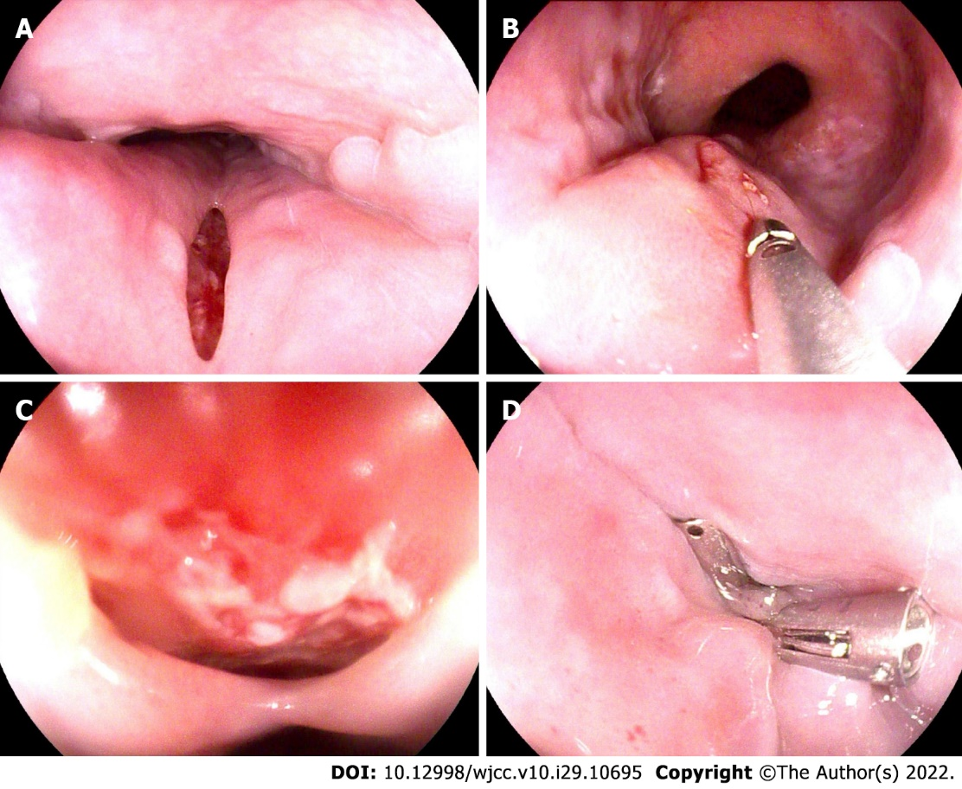
Figure 1 Resolution of the laceration above the mass with metal endoscopic clips. A: 2 cm laceration of the esophagus (30 cm distal to the incisors); B: Submucosal mass was beneath the laceration, with spontaneous rupture; C: Detailed view of the crevasse showing granulated tissues and purulent exudate; D: Laceration was completely closed with metal endoscopic clips.

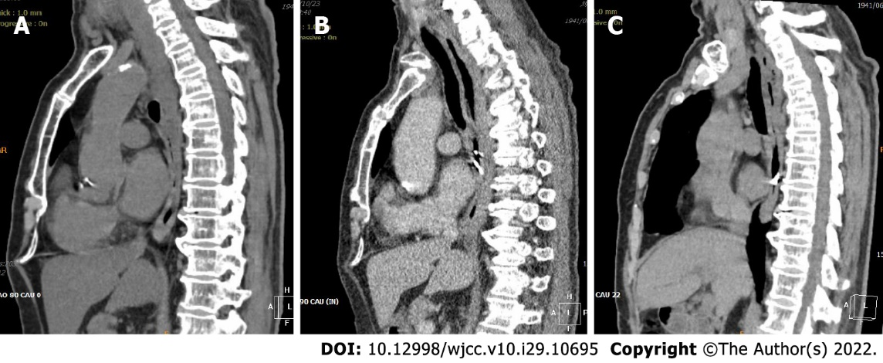Figure 2 Computed tomography showed a double-barreled esophagus without thickening of the esophageal wall. A: Chest computed tomography scan showed eccentric thickening of the esophageal wall; B: Chest computed tomography scan taken immediately after endoscopy showed worsened diffuse thickening of the esophageal wall; C: Chest computed tomography scan taken 2 mo after endoscopy showed that the thickening of the esophageal wall was alleviated with a double-barreled esophagus visible.

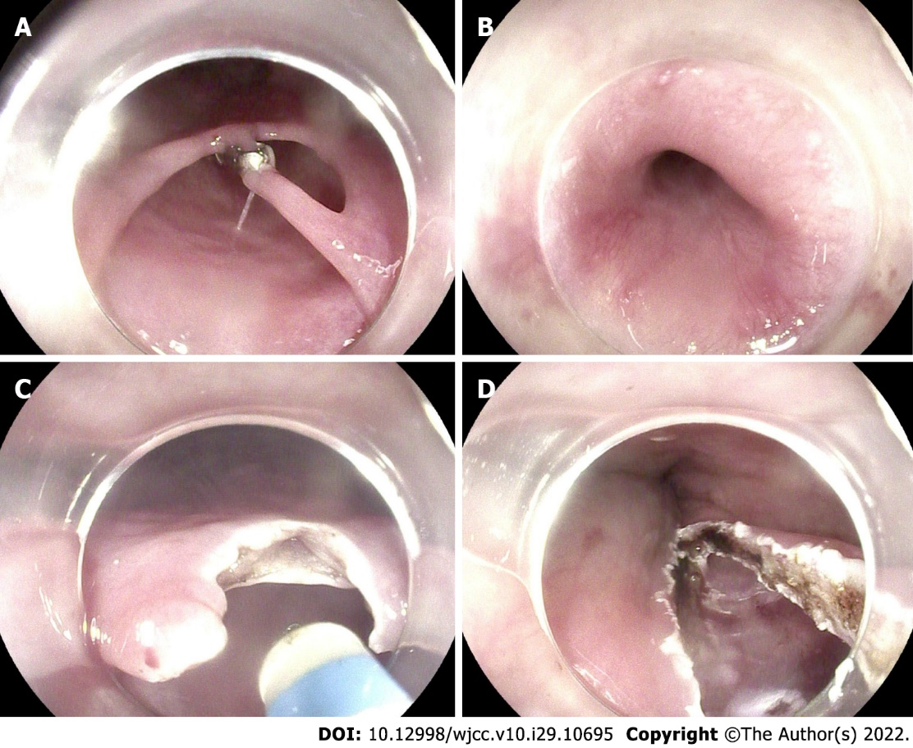
Figure 3 Endoscopic incision of the septum between two lumens was performed using a dual-knife process with diathermy. A: Intramural submucosal dissection, with one endoscopic clip remaining; B: Internal space of the dissection; C: Endoscopic incision of the septum between two lumens; D: Completely cut septum.

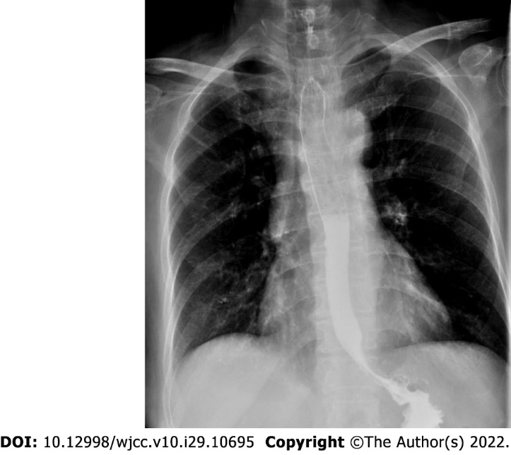
Figure 4 Esophagogram taken 3 d after endoscopic incision showed the dissection had disappeared, and the barium passed smoothly through the esophagus.

Published by Baishideng Publishing Group Inc
7041 Koll Center Parkway, Suite 160, Pleasanton, CA 94566, USA
Telephone: +1-925-3991568
E-mail: bpgoffice@wjgnet.com
Help Desk: https://www.f6publishing.com/helpdesk
https://www.wjgnet.com

© 2022 Baishideng Publishing Group Inc. All rights reserved.

