Name of journal: World Journal of Gastroenterology
ESPS Manuscript NO: 15760
Columns: CASE REPORT

Endoscopic mucosal resection of duodenal bulb adenocarcinoma with neuroendocrine features: An extremely rare case report

Wen MY et al. Endoscopic treatment of duodenal bulb with NEF

Ming-Yao Wen, Yu Wang, Xiao-Yan Meng, Hua-Ping Xie

Ming-Yao Wen, Department of Otolaryngology-Head and Neck Surgery, Tongji Hospital, Tongji Medical College, Huazhong University of Science and Technology, Wuhan 430030, Hubei Province, China

Yu Wang, Department of Pathology, Tongji Hospital, Tongji Medical College, Huazhong University of Science and Technology, Wuhan 430030, Hubei Province, China

Xiao-Yan Meng, Department of Radiology, Tongji Hospital, Tongji Medical College, Huazhong University of Science and Technology, Wuhan 430030, Hubei Province, China

Hua-Ping Xie, Department of Gastroenterology, Tongji Hospital, Tongji Medical College, Huazhong University of Science and Technology, Wuhan 430030, Hubei Province, China

Author contributions: Wen MY and Xie HP designed the study; Xie HP performed the EMR; Wang Y confirmed the pathology; Meng XY analyzed the CT imagines; Wen MY and Xie HP wrote the manuscript.

Ethics approval: The study was reviewed and approved by the Tongji Hospital, Tongji Medical College, Huazhong University of Science and Technology Institutional Review Board.

Informed consent: All study participants, or their legal guardian, provided informed written consent prior to study enrollment.

Conflict-of-interest: The authors have declared no competing interests exist.

Open-Access: This article is an open-access article which was selected by an in-house editor and fully peer-reviewed by external reviewers. It is distributed in accordance with the Creative Commons Attribution Non Commercial (CC BY-NC 4.0) license, which permits others to distribute, remix, adapt, build upon this work non-commercially, and license their derivative works on different terms, provided the original work is properly cited and the use is non-commercial. See: http://creativecommons.org/licenses/by-nc/4.0/

Correspondence to: Dr. Hua-Ping Xie, Department of Gastroenterology, Tongji Hospital, Tongji Medical College, Huazhong University of Science and Technology, No. 1095 Jiefangdadao, Wuhan 430030, Hubei Province, China. hpxie@tjh.tjmu.edu.cn
Telephone: +86-27-83663333
Fax: +86-27-83662891
Received: December 7, 2014
Peer-review started: December 8, 2014
First decision: January 8, 2015
Revised: February 13, 2015
Accepted: March 18, 2015
Article in press:
Published online:

Abstract
Duodenal adenocarcinoma, especially duodenal bulb with neuroendocrine features (NEF), is extremely rare. Here we report one such case of duodenal bulb adenocarcinoma with neuroendocrine features. A 63-year-old Han Chinese woman was admitted to our department with the diagnosis of duodenal bulb polyp and has undergone endoscopic mucosal resection. The pathological findings confirmed it as duodenal bulb adenocarcinoma with NEF. The patient remains curative after one and half a year follow-up. Duodenal adenocarcinoma with NEF might be a low malignant neuroendocrine tumor rather than a conventional adenocarcinoma. Endoscopic treatment, including endoscopic mucosal resection might be an ideal option for the adenocarcinomas with NEF.

Key words: Duodenal adenocarcinoma; Neuroendocrine features; Endoscopic mucosal resection; Duodenal bulb; Rarity

© The Author(s) 2015. Published by Baishideng Publishing Group Inc. All rights reserved.

Core tip: We report one such extremely rare case of duodenal bulb adenocarcinoma with neuroendocrine features (NEF). Duodenal adenocarcinoma with NEF might be a low malignant neuroendocrine tumor rather than a conventional adenocarcinoma. Endoscopic treatment, including endoscopic mucosal resection is plausibly an ideal option for the adenocarcinomas with NEF.

Wen MY, Wang Y, Meng XY, Xie HP. Endoscopic mucosal resection of duodenal bulb adenocarcinoma with neuroendocrine features: An extremely rare case report. World J Gastroenterol 2015; In press

INTRODUCTION
Primary malignant tumors of the duodenum represent 0.3% of all gastro-intestinal tract tumors.
Duodenal adenocarcinoma accounts for half of all small bowel adenocarcinomas^{[1-3]}. Histologically, 40% of small bowel cancer belongs to adenocarcinoma with another 40% belonging to neuroendocrine tumors. Recently a rare case of duodenal adenocarcinoma with neuroendocrine features (NEF) was reported that was neither a conventional neuroendocrine tumor nor a typical duodenal adenocarcinoma^{[4]}. It remains unclear whether the duodenal adenocarcinoma with NEF should be treated as adenocarcinoma or neuroendocrine tumors or both. Here we report one extremely rare case of duodenal bulb adenocarcinoma with NEF which has been successfully removed by endoscopic mucosal resection (EMR) and enjoys a good survival without recurrence or metastasis during one and half a year follow up.

CASE REPORT
A 63-year-old Han Chinese woman was admitted to our department with anorexia and epigastric fullness for more than two years. She complained of aggravation after eating and remission after belching. The medical history has no other significant prior diseases. Esophagogastroduodenoscopy from the local hospital revealed a protrusion in the duodenum with the size of 0.6 cm × 0.6 cm, which was admitted with an intention of ‘polypectomy’. There were no remarkable findings from physician examinations. Biochemical examinations were all in normal range, except that the serum chromogranin (CgA) level was 151 ng/mL (reference: 27-94 ng/mL). The multi-row computed tomography (CT) of small intestine detected a protrusion of duodenum without lymph node invovlement. The protrusion was removed by EMR (endoscopic mucosal resection) successfully (Figure 1). The pathological report revealed a diagnosis of highly differentiated adenocarcinoma with a clean margin, but the immunohistochemical staining for synaptophysin (Syn), CgA and CD56 was positive (Figure 2). The patient’s tumor has fulfilled the diagnostic criteria neither for neuroendocrine tumors nor for carcinoids. Thus, we diagnosed duodenal adenocarcinoma with NEF. The patient refused further surgical treatment, and was followed up without any further treatment. At the 2nd and 18th month after EMR, there were no signs of recurrence or metastasis by checking with the esophagogastroduodenoscopy and color Doppler ultrasound of epigastrium.

DISCUSSION
Previously, Kato et al^{[4]} reported one case of duodenal adenocarcinoma with NEF at the descending part in a 67-year-old woman. However, it was accompanied with acromegaly and other types of tumors, namely GH-producing pituitary adenoma and thyroid papillary adenocarcinoma with familial clustering. As per the published literature, our report is a second instance of duodenal adenocarcinoma with NEF, especially without any concomitant endocrine diseases or other tumors. Moreover, it located at the duodenal bulb, which is supposed to be physiologically, immunologically, or otherwise uniquely privileged to virtually escape oncogenic transformation based on the extreme rarity of duodenal bulb adenocarcinoma^{[3]}. Only five cases of adenocarcinoma were clearly defined arising from the mucosa of the duodenal bulb at a diligent review of 724 reported cases in the published literature^{[3]}.
Generally, the prognosis of duodenal adenocarcinoma is poor; lymph node metastasis is the only independent predictor of decreased survival. Early surgery is required, although risk of surgical complications and death due to operations are not ruled out^{[5-8]}. Surgical resection can be variable and depends mainly on the location of the tumor. Tumors arising in the first, second or third portion of the duodenum typically require pancreaticoduodenectomy, whereas tumors occurring in the fourth portion may be more amenable to segmental duodenal resection^{[8]}. However, neuroendocrine component may have a considerable impact on duodenal adenocarcinoma^{[9]}. One case of duodenal adenocarcinoma with NEF combined with liver metastasis survived for more than 24 mo without progression of the primary and metastatic lesions. It is plausible that the duodenal adenocarcinoma with NEF is predominantly a neuroendocrine tumor of low malignancy potential, rather than a common adenocarcinoma^{[4]}. Malignant NET, such as type 3 gastric NETs, which are considered to be aggressive and often with metastasis, can also be treated successfully by endoscopic treatment, including EMR^{[10]}. Endoscopic resection appears to be a safe and effective treatment for duodenal carcinoid tumors measuring ≤ 10 mm in diameter and confined to the submucosal layer^{[11]} .Here we removed the tumor with the lift and cut EMR method,, in compliance with neuroendocrine tumors. This might be an optimal method for the treatment of duodenal adenocarcinomas with neuroendocrine differentiation (NED). The curative therapy in our caseindicates that the treatment for NEF component in duodenal adenocarcinoma is adequate.
Incidentally, the presence of NED remains a poor prognostic factor in other adenocarcinomas. In gastric adenocarcinomas, even a minor proportion of 10% of NED is associated with significantly poorer survival^{[12]}. In a meta analysis including 1587 cases of colorectal adenocarcinoma; patients with NED has a poor 5-year survival rate that those without NED^{[13]}. In prostate cancer, NED is also a poorer prognostic factor. The levels of serum CgA are increased in patients with prostate cancer compared with benign conditions. The early detection of high serum levels of CgA could be an indicator for a change to a more aggressive therapy^{[14]}. Although the exact function of NEF component is still unknown, it is evident that NEF component in duodenal and other adenocarcinomas have apparently different functions.
Here we present a rare case of duodenal bulb adenocarcinoma with NED, which was successfully removed by EMR and remains curative during the follow-up time. Duodenal adenocarcinoma with NEF might be treated as a neuroendocrine tumor and the role of NED in duodenal adenocarcinoma still need further study.

ACKNOWLEGDEMENTS
We would like to give our thanks to Dr. P Sivaramakrishna Rachakongda from the Division of Molecular Genetic Epidemiology at German Cancer Research Center for the revision of manuscript.

COMMENTS
Case characteristics
A 63-year-old Han Chinese woman complained of anorexia and epigastric fullness for more than two years.

Clinical diagnosis
One lesion of duodenal bulb was detected by Endoscopy.

Differential diagnosis
The lesion of duodenal bulb should be differentially diagnosed with polyp and other benign diseases.

Laboratory diagnosis
Biochemical examinations were all in normal range, except that the serum chromogranin (CgA) level was 151 ng/mL (reference: 27-94 ng/mL).

Imaging diagnosis
Esophagogastroduodenoscopy from the local hospital revealed a protrusion in the duodenum with the size of 0.6 cm × 0.6 cm, which was also detected by the multi-row computed tomography of small intestine, without lymph node invovlement.

Pathological diagnosis
The pathological report revealed a diagnosis of highly differentiated adenocarcinoma with the immunohistochemical staining for synaptophysin (Syn), CgA and CD56 positive ,which has fulfilled the diagnostic criteria neither for neuroendocrine tumors nor for carcinoids and diagnosed duodenal adenocarcinoma with neuroendocrine features (NEF).

Treatment
The duodenal protrusion was removed by endoscopic mucosal resection (EMR) successfully

Related reports
One case of duodenal adenocarcinoma with NEF with liver metastasis reported in a 67-year-old woman was accompanied with acromegaly and other types of tumors, namely GH-producing pituitary adenoma and thyroid papillary adenocarcinoma with familial clustering.

Term explanation
EMR is an endoscopic technique used to remove cancerous or other abnormal lesions found in the gastrointestinal tract.

Experiences and lessons
Lesions at the duodenal bulb should not be underestimated duo to the risk of malignant diseases.

Peer-review
Duodenal adenocarcinoma with NEF might be a low malignant neuroendocrine tumor rather than a conventional adenocarcinoma. Endoscopic treatment, including EMR might be an ideal option for the adenocarcinomas with NEF. However, only one case cannot give a strong support for the idea.

REFERENCES
1 Aparicio T, Zaanan A, Svrcek M, Laurent-Puig P, Carrere N, Manfredi S, Locher C, Afchain P. Small bowel adenocarcinoma: epidemiology, risk factors, diagnosis and treatment. Dig Liver Dis 2014; 46: 97-104 [PMID: 23796552 DOI: S1590-8658(13)00184-9]
2 Neugut AI, Jacobson JS, Suh S, Mukherjee R, Arber N. The epidemiology of cancer of the small bowel. Cancer Epidemiol Biomarkers Prev 1998; 7: 243-251 [PMID: 9521441]
3 Goldner B, Stabile BE. Duodenal adenocarcinoma: why the extreme rarity of duodenal bulb primary tumors? Am Surg 2014; 80: 956-959 [PMID: 25264638]
4 Kato K, Takeshita Y, Misu H, Ishikura K, Kakinoki K, Sawada-Kitamura S, Kaneko S, Takamura T. Duodenal adenocarcinoma with neuroendocrine features in a patient with acromegaly and thyroid papillary adenocarcinoma: a unique combination of endocrine neoplasia. Endocr J 2012; 59: 791-796 [PMID: 22673565 DOI: DN/JST.JSTAGE/endocrj/EJ11-0324]
5 Rose DM, Hochwald SN, Klimstra DS, Brennan MF. Primary duodenal adenocarcinoma: a ten-year experience with 79 patients. J Am Coll Surg 1996; 183: 89-96 [PMID: 8696551]
6 Scott-Coombes DM, Williamson RC. Surgical treatment of primary duodenal carcinoma: a personal series. Br J Surg 1994; 81: 1472-1474 [PMID: 7820475]
7 Sohn TA, Lillemoe KD, Cameron JL, Pitt HA, Kaufman HS, Hruban RH, Yeo CJ. Adenocarcinoma of the duodenum: factors influencing long-term survival. J Gastrointest Surg 1998; 2: 79-87 [PMID: 9841972 DOI: S1091-255X(98)80107-8]
8 Poultsides GA, Huang LC, Cameron JL, Tuli R, Lan L, Hruban RH, Pawlik TM, Herman JM, Edil BH, Ahuja N, Choti MA, Wolfgang CL, Schulick RD. Duodenal adenocarcinoma: clinicopathologic analysis and implications for treatment. Ann Surg Oncol 2012; 19: 1928-1935 [PMID: 22167476 DOI: 10.1245/s10434-011-2168-3]
9 Elias D, Cavalcanti de Albuquerque A, Eggenspieler P, Plaud B, Ducreux M, Spielmann M, Theodore C, Bonvalot S, Lasser P. Resection of liver metastases from a noncolorectal primary: indications and results based on 147 monocentric patients. J Am Coll Surg 1998; 187: 487-493 [PMID: 9809564 DOI: S1072-7515(98)00225-7]
10 Kwon YH, Jeon SW, Kim GH, Kim JI, Chung IK, Jee SR, Kim HU, Seo GS, Baik GH, Choi KD, Moon JS. Long-term follow up of endoscopic resection for type 3 gastric NET. World J Gastroenterol 2013; 19: 8703-8708 [PMID: 24379589 DOI: 10.3748/wjg.v19.i46.8703]
11 Kim GH, Kim JI, Jeon SW, Moon JS, Chung IK, Jee SR, Kim HU, Seo GS, Baik GH, Lee YC. Endoscopic resection for duodenal carcinoid tumors: a multicenter, retrospective study. J Gastroenterol Hepatol 2014; 29: 318-324 [PMID: 24117946 DOI: 10.1111/jgh.12390]
12 Park JY, Ryu MH, Park YS, Park HJ, Ryoo BY, Kim MG, Yook JH, Kim BS, Kang YK. Prognostic significance of neuroendocrine components in gastric carcinomas. Eur J Cancer 2014; 50: 2802-2809 [PMID: 25201164 DOI: S0959-8049(14)00883-1]
13 Zeng YJ, Lai W, Liu L, Wu H, Luo XX, Wang J, Chu ZH. Prognostic significance of neuroendocrine differentiation in colorectal adenocarcinoma after radical operation: a meta-analysis. J Gastrointest Surg 2014; 18: 968-976 [PMID: 24549474 DOI: 10.1007/s11605-014-2480-x]
14 Sagnak L, Topaloglu H, Ozok U, Ersoy H. Prognostic significance of neuroendocrine differentiation in prostate adenocarcinoma. Clin Genitourin Cancer 2011; 9: 73-80 [PMID: 22035833 DOI: S1558-7673(11)00047-4]
P-Reviewer: Arbizu EA, Ahmad J, Stift A
S-Editor: Yu J L-Editor: E-Editor:

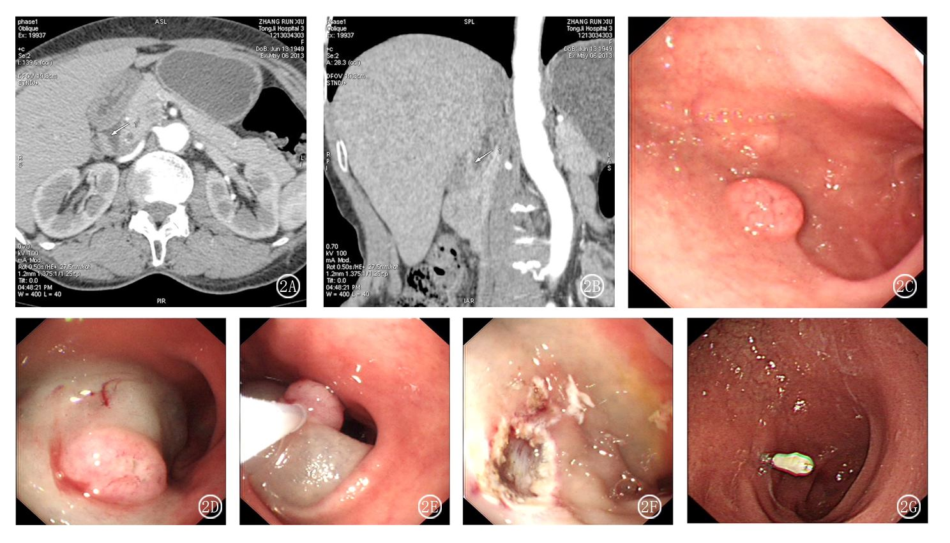
Figure 1 Computered tomography, endoscopic imagine and endocopic mucosal resection of duodenal tumor with neuroendocrine features. A: Computered tomography (CT) imagine of a duodenal tumor (arrow); B: Three-dimensional CT imagine reonstruction of the duodenal tumor (arrow); C: Endoscopic imagine of the duodenal tumor; D: Positive lifting sign after injection of physiological saline with 1:10000 norepinephrine; E: Endoscopic mucosal resection after snare; F: Clean border of the wound after endocopic mucosal resection (EMR); G: Scar formation on EMR position at gastroscopic review after two months.

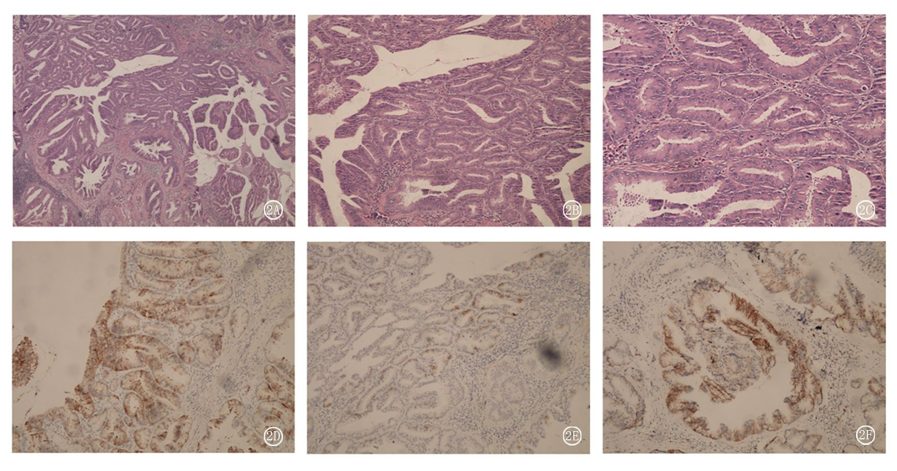
Figure 2 Histopathology of duodenal adenocarcinoma with neuroendocrine features. A: Hematoxylin and eosin (HE) staining (original magnification × 40); B: HE staining (original magnification × 100); C: HE staining (original magnification × 200); D: Immunohistochemical staining for synaptophysin (original magnification × 100); E: Immunohistochemical staining for chromogranin (original magnification × 100); F: Immunohistochemical staining for CD56 (original magnification × 100).

