Name of journal: World Journal of Gastroenterology
ESPS Manuscript NO: 16030
Columns: ORIGINAL ARTICLE

Basic Study
TLR4–HMGB1-, MyD88- and TRIF-dependent signaling in mouse intestinal ischemia/reperfusion injury

Wang J et al. Signalling in ischemia/reperfusion injury

Jie Wang, Gui-Zhen He, Yu-Kang Wang, Qian-Kun Zhu, Wei Chen, Tai Guo

Jie Wang, Gui-Zhen He, Yu-Kang Wang, Qian-Kun Zhu, Wei Chen, Department of Parenteral and Enteral Nutrition, Peking Union Medical College Hospital, Centre for Translational Medicine, Chinese Academy of Medical Sciences and Peking Union Medical College, Beijing 100730, China

Tai Guo, National Institutes for Food and Drug Control, Beijing 100050, China

Author contribution: Wang J performed the animal experiment and research, analyzed the data and wrote the paper; He GZ designed the research and was also involved in editing the manuscript; Wang YK performed the animal experiment; Zhu QK performed the animal experiment and data collection; Chen W performed the animal experiment and research; Guo Tai performed the animal experiment.

Supported by National Natural Science Foundation of China, No. 30940069; and the Natural Sciences Foundation of Beijing, No.7102127.

Ethics approval: The study was reviewed and approved by the Academic Committee of Chinese Academy of Medical Sciences and Peking Union Medical College Hospital Institutional Review Board.

Institutional animal care and use committee: All procedures involving animals were reviewed and approved by the Institutional Animal Care and Use Committee of the Academic Committee of Chinese Academy of Medical Sciences and Peking Union Medical College Hospital (IACUC protocol number:XHDW-2013-008).

Conflict-of-interest: The authors declare no conflict of interest.

Data sharing: No additional data are available.

Open-Access: This article is an open-access article which was selected by an in-house editor and fully peer-reviewed by external reviewers. It is distributed in accordance with the Creative Commons Attribution Non Commercial (CC BY-NC 4.0) license, which permits others to distribute, remix, adapt, build upon this work non-commercially, and license their derivative works on different terms, provided the original work is properly cited and the use is non-commercial. See: http://creativecommons.org/licenses/by-nc/4.0/

Correspondence to: Gui-Zhen He, Professor, Department of Parenteral and Enteral Nutrition, Peking Union Medical College Hospital, Chinese Academy of Medical Sciences and Peking Union Medical College, No.1 Shuaifuyuan Wangfujing, Dongcheng District, Beijing 100730, China. hgzpumc@163.com
Telephone: +86-10-69154096
Fax: +86-10-69154096

Received: December 22, 2014
Peer-review started: December 23, 2014
First decision: February 10, 2015
Revised: April 1, 2015
Accepted: May 20, 2015

Article in press:
Published online:

Abstract
AIM: To characterize high mobility group protein 1-toll-like receptor 4 ((HMGB1-TLR4) and downstream signalling pathways in intestinal ischemia/reperfusion (I/R) injury.

METHODS: 40 Specific-Pathogen-Free male C57BL/6 mice were randomly divided into five groups (n = 8 per group): sham, control, anti-HMGB1, anti-myeloid differentiation gene 88 (MyD88), and anti-translocating-chain-associating membrane protein (TRIF) antibody groups. Vehicle with the control IgG antibody, or anti-HMGB1, or anti-MyD88, or anti-TRIF antibodies (all, 1 mg/kg, 0.025%) were injected via the caudal vein 30 min prior to ischemia. After anesthetization, the abdominal wall was opened and the superior mesenteric artery was exposed, followed by 60 min mesenteric ischemia and then 60 min reperfusion. For the sham group, the abdominal wall was opened for 120 min without I/R. We measured levels of serum nuclear factor (NF)-κB p65, interleukin (IL)-6, and tumor necrosis factor (TNF)-α, and MPO activity in the lung and liver, as well as, morphological changes that occurred in the lung and intestinal tissues. Levels of mRNA transcripts encoding HMGB1 and NF-κB were measured by real-time quantitative PCR, and levels of HMGB1 and NF-κB protein were measured by western blot. Results were analysed using one-way analysis of variance.

RESULTS: Blocking HMGB1, MyD88, and TRIF expression by injecting anti-HMGB1, anti-MyD88, or anti-TRIF antibodies prior to ischemia can significantly reduce the levels of inflammatory cytokines in serum, including TNF-α, IL-6, and NF-κB (the sham group vs the control group vs the anti-HMGB1 group vs the anti-MyD88 group vs the anti-TRIF group, NF-KB p65, 104.64 ± 11.89 vs 228.53 ± 24.85 vs 145.00 ± 33.63 vs 191.12 ± 13.22 vs 183.73 ± 10.81, P < 0.05; IL-6,50.02 ± 6.33 vs 104.91 ± 31.18 vs 62.28 ± 6.73 vs 85.90 ± 17.37 vs 78.14 ± 7.38, P < 0.05; TNF-α, 43.79 ± 4.18 vs 70.81 ± 6.97 vs 52.76 ± 5.71 vs 63.19 ± 5.47 vs 59.70 ± 4.63, P < 0.05), and can also alleviate tissue injury in the lung and small intestine compared with the control group in the mouse intestinal I/R model. The administration of anti-HMGB1, anti-MyD88, and anti-TRIF antibodies can significantly reduce damage caused by I/R, which might have therapeutic implications and the role of anti-HMGB1 antibody was the most obvious.

CONCLUSION: HMGB1 and its downstream signalling pathways play important roles in the mouse intestinal I/R injury and the effect of the TRIF-dependent pathway are slightly larger.

Key words: C57BL/6 mouse; Intestinal ischemia-reperfusion injury; High mobility group protein 1; Myeloid differentiation gene 88; Translocating-chain-associating membrane protein; Nuclear factor-κB

© The Author(s) 2015. Published by Baishideng Publishing Group Inc. All rights reserved.

Core tip: Intestinal mucosal barrier injury induced by intestinal ischemia/reperfusion (I/R) can often be the basis for a bad prognosis in many diseases. Although extensive investigative efforts have focused on it, the underlying mechanism remains the subject of debate and there are no effective methods for its prevention and control yet available. Our findings suggest that the high mobility group protein 1–toll-like receptor 4 axis and the two downstream signalling pathways all play important roles in I/R injury and show the potential therapeutic value of blocking these pathways. This study has an important clinical significance which could improve the survival rate and reduce complications in critically ill patients.

Wang J, He GZ, Wang YK, Zhu QK, Chen W, Guo T. TLR4–HMGB1-, MyD88- and TRIF-dependent signaling in mouse intestinal ischemia/reperfusion injury. World J Gastroenterol 2015; In press

INTRODUCTION
Ischemia/reperfusion (I/R) injury is a syndrome in which serious cellular structural damage and functional metabolic disorders occur and organ function is further aggravated when blood flow that was halted curing ischemia is restored after a period of time^{[1-4]}.The gut is an important functional organ for the immune and endocrine systems, and it also serves as a protective barrier. Intestinal I/R injury is one of the main triggers that can lead to a systemic inflammatory response syndrome (SIRS), acute lung injury (ALI), acute respiratory distress syndrome (ARDS), and multiple organ dysfunction syndrome (MODS)^{[5-8]}. Although extensive investigative efforts have focused on characterizing the pathogenesis of distant organ injury induced by intestinal I/R, the underlying mechanism remains the subject of debate and there are no effective methods for its prevention and control yet available.
Recently, many studies have suggested that I/R injury could be caused by interactions between Toll-like receptor 4 (TLR4) and high mobility group protein 1 (HMGB1), an endogenous TLR4 ligand. HMGB1 can activate TLR4, which can subsequently trigger downstream signal transduction pathways^{[9]}. The downstream signal transduction pathways initiated by TLR4 and HMGB1 are thought to include myeloid differentiation gene 88/TIR domain-containing adaptor protein (MyD88/TIRAP)- and TIR domain-containing adaptor inducing IFN-β/translocating-chain-associating membrane protein (TRIF/TRAM)-dependent pathways^{[10]}. In the process whereby TLR4 stimulates the release of inflammatory cytokines induced by endotoxin, MyD88- and TRIF-dependent pathways both play critical roles^{[11]}. However, only a few studies have examined these pathways in aseptic/non-infectious I/R injury. Furthermore, whether intestinal I/R induces local and distant organ injury via these pathways has been poorly characterized. This study aimed to determine whether administering HMGB1 antibody could reduce tissue damage induced by intestinal I/R and to characterize the role of the HMGB1–TLR4 axis in I/R injury by administrating anti-HMGB1 antibody to block the binding of HMGB1 and TLR4 using a mouse intestinal I/R model. Additionally, to further investigate the MyD88/TIRAP or TRIF/TRAM pathways, we went on to characterize whether one pathway serves a dominant function in inducing a systemic inflammatory response and distant organ injury following intestinal I/R (figure 1). This study has an important clinical significance that will inform efforts to identify an effective targeted therapy, which could improve the survival rate and reduce complications in critically ill patients.

MATERIALS AND METHODS
Animals
Forty male C57BL/6 mice that were specific pathogen free grade and weighed 24-26 g were purchased from Beijing Vital River Laboratory Animal Technology Co. Ltd (scxk 2007-0001). The mice were housed under barrier-sustained conditions at a temperature of 25 °C and 50% humidity with 12 h light/dark cycles, and had free access to water and food for two weeks prior to the operation. The mice were randomly divided into five groups: sham, control (injected vehicle with the control IgG antibody), anti-HMGB1 (injected anti-HMGB1 antibody), anti-MyD88 (injected anti-MyD88 antibody) and anti-TRIF (injected anti-TRIF antibody, n = 8 for each group). All mice were maintained in accordance with the recommendations of the Guide for the Care and Use of Laboratory Animals. The research protocols were approved by the Academic Committee of Chinese Academy of Medical Sciences and Peking Union Medical College.

Intestinal I/R
Prior to the operation, all mice were fasted overnight, but were allowed access to water ad libitum. Vehicle with the control IgG antibody (abcam, Cambridge, United Kingdom), or anti-HMGB1(abcam,Cambridge,UK),or anti-MyD88 (abcam, Cambridge, United Kingdom), or anti-TRIF (Biolegend, San Diego, United States) antibodies (all, 1 mg/kg, 0.025%) were injected respectively via the caudal vein 30 min prior to ischemia^{[12,13]} (The selection of dose was based on references and the results of preliminary experiment). The mice were anesthetized with an intraperitoneal injection of 1% sodium pentobarbital (50 mg/kg). A midline incision was performed to bluntly separate the superior mesenteric artery (SMA). In addition to the sham group, the SMA was occluded for 60 min with an noninvasive artery clamp, followed by reperfusion for 60 min (According to the results of preliminary experiment). In the sham group, the abdominal cavity was only opened for 120 min without I/R. All animals were euthanized by barbiturate overdose (intraperitoneal injection, 150 mg/kg pentobarbital sodium) for tissue collection.

Specimen collection
Blood: After the operation, blood was collected from the eye socket veinand centrifuged at 3000 rpm for 15 min at 4°C. Next, serum was separated and stored at −80 °C for further analysis.
Tissue: After mice were sacrificed, the left lower lobe of lung, a 3 cm proximal section of the jejunum and a 3 cm distal section of the ileum were excised, rinsed in ice-cold normal saline, and dried on filter paper for histologic examination. The right liver, the left upper lobe and right lung, the 6 cm proximal section of the jejunum, and the 6 cm distal section of the ileum were stored at −80 °C after being quickly immersed in liquid nitrogen for all other measurements.

Sample analysis
Hematoxylin and eosin staining of mice tissue slices: Samples of the intestine and lung were fixed in 10% formalin solution and sectioned (4mm) after dehydration, cleaning, and paraffin embedding. The sections were flattened, mounted, and heated on blank glass slides. Histological evaluations were performed by hematoxylin and eosin staining and pathological examination.
Lung histological scoring system was applied as described^{[14]}. Lung injury was scored in each sample according to the following four items: alveolar congestion, hemorrhage, infiltration or aggregation of neutrophils in the airspace or vessel wall, and thickness of the alveolar wall. A score of 0 represented normal findings and scores of 1, 2, 3 and4 represented mild (< 25%), moderate (25%-50%), severe (50-75%) and very sever (> 75%) lung involvement, respectively. The overall score was based on the sum of all scores.
To evaluate the degree of intestinal injury according to the scoring system developed by Anthony Stallion et al^{[15]} (Table 1). The scale ranges from 0 to 4. No injury is scored as 0, with grade 4 depicting transmural necrosis of the intestine. The important components of injury include loss of villus height, infiltration of lymphocytes, and degree of necrosis.

Measurement of tissue MPO activity: Tissue MPO activity was determined in the lung and liver. The left upper lobe of lung and liver were harvested, rinsed, blotted dry, and frozen at −80 ℃. The samples were measured using an MPO detection assay according to the supplier’s specifications (Jiancheng Bio, Nanjing, China). Tissue MPO activity was expressed as activity units per gram of protein.

Cytokines assay: The serum concentrations of interleukin (IL)-6 ,tumor necrosis factor-α (TNF-α) and NF-κBp65 were determined using enzyme-linked immunosorbent assay kits (eBioscience;ME044,ME055,ME053) according to the kit protocols.

Quantitative real-time reverse transcriptase-polymerase chain reaction of HMGB1and NF-κB mRNA levels in terminal ileum and lung: Total RNA was extracted respectively from terminal ileum and lung tissue specimens using E.Z.N.A.® Total RNA KitⅡ(OMEGA). The purity of RNA extract was tested by spectrophotometry analysis of optical density (OD, OD260/OD280 = 1.95-2.0). Reverse transcription polymerase chain reaction (RT-PCR) amplification were conducted with MyCycler PCR (Bio-Rad Laboratories), in accordance with the illustrations of the GoScriptTM Reverse Transcription System (Promega, A5000). Utilizing 2 µL of reverse transcriptase products, real-time quantitative PCR was performed in a final volume of 20 µl using the gene-specific primers. The following primers designed with Primer Express Software were used: 5'-TTAGTCCCAGCGAAGGCTAT-3’ (forward) and 5'- CAAGTTTCCTGAGCAATCCA-3’ (reverse) for mouse HMGB1; 5'-GCTACACAGAGGCCATTGAA-3’ (forward) and 5'-GTGGAGGAAGACGAGAGAGG-3’ (reverse) for mouse NF-κB; 5'- GGCATTTCACTGCTTGATGT-3’ (forward) and 5'- TGACATTCCCATGAAACCTC-3’ (reverse) for mouse MyD88; 5'- TCAGAGAGTCCATCATT CGG-3' (forward) and 5'-TACACGCCCACTCTTCTGAG-3' (reverse) for mouse TRIF; 5'- GCAAGTTCAACGGCACAG-3'(forward) and 5'- CGCCAGT AGACTCCACGAC-3' (reverse) for mouse GAPDH. Amplification was processed on Roche LightCycler® 480 as follows: 10 min at 95 ℃, followed by 40 cycles of 15 s at 95 ℃, 60 s at 60 ℃, and then the melting curve was determined. Gene transcripts were quantified with SYBR green PCR master mix (ABI). Data were calculated by the 2^{−ΔΔCT} method and presented as fold change of transcripts for the HMGB1 and NF-κB gene in the ileum and lung tissue of other groups compared with sham-operated mice (defined as1.0-fold). Mouse GAPDH was used as an internal control. The relative expression of the target gene was normalized to the level of GAPDH in the same cDNA.

Western blots for detecting the expression of HMGB1 and NF-κB protein in jejunum, ileum and lung: Total protein extract was prepared, and samples were separated using 10%sodium dodecyl sulfate polyacrylamide gels (SDS-PAGE). Proteins were then transferred to nitrocellulose membranes, which were then blocked for 2 h in 5% nonfat dry milk. The membranes were then incubated overnight in anti-HMGB1 primary antibody(abcam,Cambridge,UK,1:1000), NF-κB primary antibody(CST,Danvers,USA,1:1000) and β-actin primary antibody (santa cruz, California, United States, 1:1000) respectively. Membranes were washed in PBST and incubated in horseradish-peroxidase-conjugated mouse secondary antibody in 5% nonfat milk(santa cruz,california,USA,1:10000) for 1 h at room temperature. Protein bands were visualized by chemiluminescence.

Statistical analysis
Quantitative data were presented as mean ± SD. Statistical software SPSS l9.0 (IBM Corp., Armonk, NY) was used to test the homogeneity of variance. Multiple comparisons were performed with one-way analysis of variance followed by a least-significant difference test. Statistical significance was determined by analyzing the data with the nonparametric Kruskal–Wallis test, followed by the Mann–Whitney test for the histological score. Statistical significance was set at P < 0.05.
The statistical methods of this study were reviewed by Li Hai-long from Department of Health Statistics of Peking Union Medical College.

RESULTS
Serum levels of inflammatory factors
Serum levels of IL-6, TNF-α and NF-κBp65 in the control, anti-HMGB1, anti-MyD88, and anti-TRIF groups were significantly higher than in the sham group (P < 0.05).However, the increased levels of inflammatory cytokines in the anti-HMGB1, anti-MyD88, and anti-TRIF groups were significantly lower than in the control group (P < 0.05). Furthermore, the amounts of reduction in the anti-MyD88 and anti-TRIF groups were lower than in the anti-HMGB1 group (P < 0.05). There was a slight but non-significant increase in the anti-MyD88 group compared with the anti-TRIF group (P > 0.05; Table 2).

Levels of MPO activity in the liver and lung
The levels of MPO activity (an enzyme marker for activated neutrophils) in the liver and lung in the four groups (C, H, M, T) were significantly higher than those in the sham group (P < 0.05). The increases in MPO levels in three groups (H, M, T) were lower than that in the control group (P < 0.05). The anti-HMGB1 group, which showed the largest reduction among the three experimental groups, showed a significant difference compared with the anti-MyD88 and anti-TRIF groups. However, there was no significant change between the anti-MyD88 and anti-TRIF groups (P > 0.05; Figure 2; Table 3).

Histopathologic evaluation
Pathological changes of lung: To observe pathological changes in the lung tissues, we used haematoxylin and eosin (HE) staining. As shown in Figure 3A, mice in the sham group had normal lung tissue with a complete and clear alveolar structure; neither oedema nor alveolar haemorrhage was observed in these lungs. Lung tissue from the control group showed features of significant lung injury, including alveolar epithelial damage, fracture and fusion, alveolar septal thickening, interstitial and intra-alveolar oedema with patchy haemorrhage, vascular congestion and some collapsed alveoli, as well as notable inflammatory cell infiltration (Figure 3B). Compared with the control group, tissue injury was markedly attenuated by HMGB1 antibody administration. Alveoli were well aerated and a mild neutrophil infiltration in the interstitium could be observed (Figure 3C). The degree of tissue injury in the anti-MyD88 and anti-TRIF treated groups was significantly lower than in the control group, but was markedly more serious than in the anti-HMGB1 group. There was a trend towards a reduction in lung injury in the anti-TRIF group compared with the anti-MyD88 group, but this difference was not statistically significant (Figure 3D and 3E) (Table 4).

Pathological changes of the jejunum and ileum: By light microscopy, small intestine specimens of the sham group showed unchanged morphological structures with an integrated mucosal epithelial, clear tissue layers, no congestion, and inflammatory cell infiltration. Compared with the sham group, the control group showed obvious tissue injury based on mucosal necrosis, erosion, oedema, and hyperaemia, as well as the reduction of intestinal villi height and mucosal thickness, regional bleeding in the mucosa and lamina propria, and a large amount of inflammatory cell infiltration. However, the anti-HMGB1 group showed slight damage in the villus apex and less inflammatory cell infiltration in the mucosa. The anti-HMGB1 group showed obvious attenuation of small intestinal injury compared with the control group. Our findings for intestinal injury in the anti-MyD88 and anti-TRIF groups were in accordance with these findings in lung (Figure 4; Table 5).

The mRA expression of HMGB1, NF-κB, MyD88 and TRIF in ileum and the mRNA expression of HMGB1 and NF-κB in lung
The mRNA expression of HMGB1 and NF-κB in the lung and the ileum in the other four groups were all significantly higher than the sham group (P < 0.05). And the increase in the control group was most obvious with significantly higher than the anti-HMGB1 group. The increment in the anti-MyD88 group and anti-TRIF group was significantly lower than in the control group, but was markedly more serious than in the anti-HMGB1 group. There was a slight increase in the anti-MyD88 group compared with the anti-TRIF group, but no significant difference (P > 0.05; Tables 6 and 7). The mRNA expression of MyD88 in ileum in the anti-HMGB1 group and the anti-MyD88 group were all significantly lower than in the control group and the anti-TRIF group (P < 0.05); The mRNA expression of TRIF in ileum in the anti-HMGB1 group and the anti-TRIF group were all significantly lower than in the control group and the anti-MyD88 group (P < 0.05; Table 7).

Protein expression levels of HMGB1 and NF-κB in lung, jejunum, and ileum
After intestinal I/R injury, protein expression levels of HMGB1 and NF-κB in the lung, jejunum, and ileum in four groups were significantly increased compared with the sham group (P < 0.05), but the protein expression level was significantly lower in the anti-HMGB1, anti-MyD88, and anti-TRIF groups compared with the control group (P < 0.05). The reduced injury in the anti-MyD88 and anti-TRIF groups were lower than that in the anti-HMGB1 group (P < 0.05), and there was no significant difference in the reduction in protein expression between the anti-MyD88 and anti-TRIF groups (P > 0.05), although there was a slight trend towards attenuation in the anti-TRIF group compared with the anti-MyD88 group (Figure 5).

DISCUSSION
Surgery, trauma, shock, transplantation, and many other diseases often induce tissue I/R. I/R results in the recruitment and activation of a number of downstream adaptor proteins and signaling kinases^{[16]}. Previous studies have shown that high levels of molecular oxygen and overproduction of toxic oxygen radicals are play a critical role in the pathological process of I/R injury^{[17]}. Wu et al^{[18]} summarize that during renal I/R injury, ROS can not only directly inhibit the reperfusion of renal tissue; but more importantly, they can induce and amplify inflammatory responses via oxidative stress, thereby increasing renal injury and apoptosis. In additional, the study of Quesnelle et al^{[19]} shows that hepatic I/R injury involves numerous pathophysiological processes, for example, during I/R injury, ROS(Reactive Oxygen Species) are generated in excess which leads to oxidative stress and results in cell injury and death. Furthermore, ROS, along with oxidative stress, is an essential mediator in the release of HMGB1. As the gut is a sensitive organ to ischemia, intestinal mucosal barrier injury induced by intestinal I/R can often be the basis for a bad prognosis in many diseases, but its specific mechanism remains unclear. Recently, studies have found that the expression of HMGB1 and TLR4 in heart, brain, liver, and kidney are increased during I/R and the HMGB1–TLR4 axis might be the most important trigger of the inflammatory response to I/R injury in many organs^{[20-23]}.
Toll-like receptors (TLRs), which can recognize molecules such as danger-associated molecular patterns (DAMPs), are a family of transmembrane proteins that can bind to a range of microbial products and also can recognize endogenous ligands to mediate the secretion of cytokines and the generation of natural immune responses^{[24-26]}. High mobility group (HMG) protein was originally identified as a type of highly conserved DNA binding protein and is widely expressed in mammals. Within the nucleus, HMGs participate in the construction and stability of nucleosomes and also regulate gene transcription; outside the nucleus, HMGs mediate inflammatory reactions, and promote cell differentiation and tumour growth^{[27,28]}. Among HMGs, HMGB1 has the closest association with I/R injury. HMGB1 can be released by monocytes/macrophages, and has been shown to bind to TLR4 after I/R^{[29,30]}. Our experimental results showed that the protein and mRNA expression levels of HMGB1 in the small intestine and lung and levels of serum inflammatory cytokines, including TNF-α and IL-6, in mice subjected to intestinal I/R were increased significantly compared with sham-operated mice. Administering HMGB1 antibody prior to ischemia, resulted in the marked attenuation of the protein and mRNA expression levels of HMGB1 and inflammatory factors contrasted with the control group. Our findings confirmed that the HMGB1–TLR4 axis plays an important role in local and distant organ damage induced by I/R. The HMGB1–TLR4-mediated signalling mainly activates NF-κB, which plays a critical role in the release of inflammatory factors through two downstream pathways, including MyD88- and TRIF-dependent pathways^{[31-32]}. The MyD88/TIRAP pathway causes the release of various inflammatory factors, such as IL-1, IL-6, IL-8, IL-10, IL-12, IL-18, and TNF-α, mainly through the activation of NF-κB^{[32]}. The TRIF/TRAM pathway mainly depends on the activation of IFN regulatory factor 3 (IRF-3), followed by the expression of IFN-β and IFN-induced genes (such as IP-10) and the activation of transcription factors (NF-κB) that induce the synthesis and release of inflammatory factors^{[32]}. In our present study, we observed that the mRNA expression levels of MyD88 and TRIF in ileum in mice subjected to I/R were obviously increased, and the MyD88/TIRAP and TRIF/TRAM pathways could be blocked effectively by injecting anti-MyD88 or anti-TRIF antibody, respectively. Previous studies reported that the contribution of these two downstream pathways is not equivalent in organ I/R injury. For example, the MyD88-dependent pathway was confirmed to play a key role in kidney I/R injury by comparing renal tubular epithelial cells between MyD88-deficient and wild-type animals^{[33]}. Furthermore, the MyD88-dependent pathway might play a more important role in aseptic inflammatory reactions, such as rheumatoid arthritis. However, the TRIF-dependent pathway might play a dominant role in the process of nerve cell degeneration induced by brain I/R^{[34-35]}. However, in intestinal I/R injury, whether there is a dominant pathway activated by TLR4 that drives pathology has not been reported. Our results demonstrate that the levels of inflammatory cytokines in serum containing IL-6, TNF-α, and NF-κBp65 in anti-HMGB1, anti-MyD88, and anti-TRIF groups were significantly lower than in the control group. Additionally, the degree of reduction in the anti-HMGB1 group was the most obvious (perhaps because HMGB1 has essential role, and downstream molecules MyD88 and TRIF might have partial redundancy). However, there was a slight increase in the anti-MyD88 group compared with the anti-TRIF group, but this difference was not significant. We observed consistent changes in lung and small intestinal morphology and levels of MPO activity in the liver and lung. We can make some preliminary conclusions: first, HMGB1–TLR4 plays an important function in intestinal I/R injury in mice by triggering MyD88- and TRIF-dependent downstream signalling pathways; second, these two downstream signalling pathways both play important roles, but the effect of the TRIF-dependent pathway might be slightly greater; and finally, the tissue damage caused by I/R was obviously alleviated by antibody administration.
The NF-κB family contains important transcription factors that play critical roles in regulating the expression of groups of genes involved in immune and inflammatory responses^{[36]}. MyD88- and TRIF-dependent pathways can both activate NF-κB to induce the release of inflammatory cytokines. Our study showed that the mRNA expression levels of NF-κB in the lung and ileum in the anti-HMGB1, anti-MyD88, and anti-TRIF groups were significantly lower than those in the control group. The degrees of reduction in the anti-MyD88 and anti-TRIF groups were lower than that in the anti-HMGB1 group. Our measurements of the protein expression levels of NF-κB were in accordance with those of the levels of mRNA expression. These findings further suggest that HMGB1–TLR4 is key in local and distant tissue injury induced by intestinal I/R, and that the two downstream pathways both take affects levels of protein and mRNA expression.
The protein and mRNA expression levels of HMGB1 in lung and small intestine were markedly attenuated by administration of anti-HMGB1, anti-MyD88, or anti-TRIF antibody. There are several possible reasons for this finding: HMGB1 can stimulate the secretion of inflammatory factors, such as TNF-α, IL-6, IL-1β, and IL-8; or inflammatory factors secreted after HMGB1 stimulation could promote monocyte/macrophage secretion of HMGB1. Therefore, HMGB1 could form a positive feedback loop to cause inflammatory signal cascade amplification^{[33]}. Blocking the MyD88/TIRAP and TRIF/TRAM pathways by injecting anti-MyD88 and anti-TRIF antibodies, respectively, can partially inhibit the expression of inflammatory factors (e.g., NF-κB, IL-6, and TNF-α), and the reduction of levels of inflammatory factors can in some contexts attenuate levels of HMGB1 expression .
Blocking HMGB1, MyD88 and TRIF expression by injecting anti-HMGB1, anti-MyD88, or anti-TRIF antibodies prior to ischemia can significantly reduce the levels of inflammatory cytokines in serum, including TNF-α, IL-6 and NF-κB, and can also alleviate tissue injury in the lung and small intestine compared with the control group in the mouse intestinal I/R model. Our findings also suggest that the HMGB1–TLR4 axis and the two downstream signalling pathways all play important roles in I/R injury and shows the potential therapeutic value of blocking these pathways. Interventions to prevent the release of HMGB1 and to block the two downstream signalling pathways could become a new clinical therapeutic method to reduce intestinal I/R injury in the future.
In conclusions, HMGB1 and its downstream signalling pathways play important roles in the mouse intestinal I/R injury and the effect of the TRIF-dependent pathway are slightly larger, although there is no significant difference between the importance of these two downstream pathways in this model. The administration of anti-HMGB1, anti-MyD88, and anti-TRIF antibody could each significantly reduce the damage caused by I/R, and the role of anti-HMGB1 antibody is the most obvious.

ACKNOWLEDGMENTS
We sincerely thank our technician Mr. Wang De-Tian for help with pathology and Mrs. Dou Ya-Ling for help with PCR. We also express our thanks to Zhang Rui, Yang Jiong-Xian and Li Zi-Jian.

COMMENTS
Background
Intestine is an important organ on immune, endocrine and barrier function. The intestinal ischemia reperfusion (I/R) injury, is believed to lead to ALI, SIRS, even MODS, but the specific mechanism remains in controversial. The traditional theory of bacterial translocation which is being questioned cannot explain a lot of questions. The interaction of Toll like receptor 4 (TLR4) and high mobility group protein1 (HMGB1) and its two downstream signalling pathways get more and more attention in organ injury induced by I/R.

Research frontiers
Recently, studies have found that the expression of HMGB1 and TLR4 in heart, brain, liver, and kidney are increased during I/R and the HMGB1–TLR4 axis might be the most important trigger of the inflammatory response to I/R injury in many organs.

Innovations and breakthroughs
Only a few studies have examined TLR4-HMGB1 axis and its downstream signalling pathway in aseptic/non-infectious I/R injury. Furthermore, whether intestinal I/R induces local and distant organ injury via these pathways has been poorly characterized. This study aimed to determine whether administering HMGB1 antibody could reduce tissue damage induced by intestinal I/R and to characterize the role of the HMGB1–TLR4 axis in I/R injury by administrating anti-HMGB1 antibody to block the binding of HMGB1 and TLR4 using a mouse intestinal I/R model. Additionally, to further investigate the MyD88/TIRAP or TRIF/TRAM pathways, the authors went on to characterize whether one pathway serves a dominant function in inducing a systemic inflammatory response and distant organ injury following intestinal I/R.

Applications
The study results suggest that interventions to prevent the release of HMGB1 and to block the two downstream signalling pathways could become a new clinical therapeutic method to reduce intestinal I/R injury in the future. Furthermore, it has an important clinical significance that could improve the survival rate and reduce complications in critically ill patients.

Terminology
Intestinal I/R injury: Intestinal I/R injury is the “motor” of SIRS, ARDS and MODS, and can be associated with severe trauma, acute necrotizing pancreatitis, major surgery, extensive burns, and other stresses; HMGB1: HMGB1 is one of the endogenous ligands which can be recognized by and combine with TLR4, and is also the key factor of inflammation of aseptic injury. MyD88-dependent pathway: MyD88-dependent pathway is the downstream signalling pathway of TLR4-HMGB1 axis in I/R injury and causes the release of various inflammatory factors, such as IL-1, IL-6, IL-8, IL-10, IL-12, IL-18, and TNF-α, mainly through the activation of NF-κB; TRIF-dependent pathway: TRIF-dependent pathway is the other downstream signalling pathway of TLR4-HMGB1 axis in I/R injury and mainly depends on the activation of IFN regulatory factor 3 (IRF-3), followed by the expression of IFN-β and IFN-induced genes (such as IP-10) and the activation of transcription factors (NF-κB).

Peer-review
This is a good descriptive study in which authors analyze the HMGB1 and its downstream signalling pathways play important roles in the mouse intestinal I/R injury. The results are interesting and suggest that interventions to prevent the release of HMGB1 and to block the two downstream signalling pathways could become a new clinical therapeutic method to reduce intestinal I/R injury in the future.

REFERENCES
1 Elias-Miró M, Jiménez-Castro MB, Rodés J, Peralta C. Current knowledge on oxidative stress in hepatic ischemia/reperfusion. Free Radic Res 2013; 47: 555-568 [PMID: 23738581 DOI: 10.3109/10715762.2013.811721]
2 Liao YF, Zhu W, Li DP, Zhu X. Heme oxygenase-1 and gut ischemia/reperfusion injury: A short review. World J Gastroenterol 2013; 19: 3555-3561 [PMID: 23801856 DOI: 10.3748/wjg.v19.i23.3555]
3 Kougias P, Lau D, El Sayed HF, Zhou W, Huynh TT, Lin PH. Determinants of mortality and treatment outcome following surgical interventions for acute mesenteric ischemia. J Vasc Surg 2007; 46: 467-474 [PMID: 17681712 DOI: 10.1016/j.jvs2007.04.045]
4 Slone EA, Fleming SD. Membrane lipid interactions in intestinal ischemia/reperfusion-induced Injury. Clin Immunol 2014; 153: 228-240 [PMID: 24814240 DOI: 10.1016/j.clim.2014.04.018]
5 Ding HS, Yang J, Chen P, Yang J, Bo SQ, Ding JW, Yu QQ. The HMGB1-TLR4 axis contributes to myocardial ischemia/reperfusion injury via regulation of cardiomyocyte apoptosis. Gene 2013; 527: 389-393 [PMID: 23727604 DOI: 10.1016/j.gene.2013.05.041]
6 Yang Z, Deng Y, Su D, Tian J, Gao Y, He Z, Wang X. TLR4 as receptor for HMGB1-mediated acute lung injury after liver ischemia/reperfusion injury. Lab Invest 2013; 93: 792-800 [PMID: 23628899 DOI: 10.1038/labinvest.2013.66]
7 Sánchez-Miralles A, Castellanos G, Badenes R, Conejero R. [Abdominal compartment syndrome and acute intestinal distress syndrome]. Med Intensiva 2013; 37: 99-109 [PMID: 22244213 DOI: 10.1016/j.medin.2011.11.019]
8 Guzel A, Kanter M, Guzel A, Yucel AF, Erboga M. Protective effect of curcumin on acute lung injury induced by intestinal ischaemia/reperfusion. Toxicol Ind Health 2013; 29: 633-642 [PMID: 22252860 DOI: 10.1177/0748233711430984]
9 Reino DC, Pisarenko V, Palange D, Doucet D, Bonitz RP, Lu Q, Colorado I, Sheth SU, Chandler B, Kannan KB, Ramanathan M, Xu da Z, Deitch EA, Feinman R. Trauma hemorrhagic shock-induced lung injury involves a gut-lymph-induced TLR4 pathway in mice. PLoS One 2011; 6: e14829 [PMID: 21829592 DOI: 10.1371/journal.pone.0014829]
10 Moresco EM, LaVine D, Beutler B. Toll-like receptors. Curr Biol 2011; 21: R488-R493 [PMID: 21741580 DOI: 10.1016/j.cub.2011.05.039]
11 O'Neill LA, Bowie AG. The family of five: TIR-domain-containing adaptors in Toll-like receptor signalling. Nat Rev Immunol 2007; 7: 353-364 [PMID: 17457343 DOI: 10.1038/nri2079]
12 Kojima M, Tanabe M, Shinoda M, Yamada S, Miyasho T, Suda K, Hibi T, Obara H, Itano O, Kawachi S, Kitajima M, Maruyama I, Kitagawa Y. Role of high mobility group box chromosomal protein 1 in ischemia-reperfusion injury in the rat small intestine. J Surg Res 2012; 178: 466-471 [PMID: 22494911 DOI: 10.1016/j.jss.2012.01.044]
13 Sawa H, Ueda T, Takeyama Y, Yasuda T, Shinzeki M, Nakajima T, Kuroda Y. Blockade of high mobility group box-1 protein attenuates experimental severe acute pancreatitis. World J Gastroenterol 2006; 12: 7666-7670 [PMID: 17171797 DOI: 10.3748/wjg.v12.i47.7666]
14 Kim DH, Chung JH, Son BS, Kim YJ, Lee SG. Effect of a neutrophil elastase inhibitor on ventilator-induced lung injury in rats. J Thorac Dis 2014; 6: 1681-1689 [PMID: 25589960 DOI: 10.3978/j.issn.2072-1439.2014.11.10]
15 Stallion A, Kou TD, Latifi SQ, Miller KA, Dahms BB, Dudgeon DL, Levine AD. Ischemia/reperfusion: a clinically relevant model of intestinal injury yielding systemic inflammation. J Pediatr Surg 2005; 40: 470-477 [PMID: 15793720 DOI: 10.1016/j.jpedsurg.2004.11.045]
16 Merry HE, Phelan P, Doak MR, Zhao M, Hwang B, Mulligan MS. Role of toll-like receptor-4 in lung ischemia-reperfusion injury. Ann Thorac Surg 2015; 99: 1193-1199 [PMID: 25747278 DOI: 10.1016/j.athoracsur.2014.12.062]
17 Yapca OE, Borekci B, Turan MI, Gulapoglu M. The effect of agomelatine on oxidative stress induced with ischemia/reperfusion in rat ovaries. Adv Clin Exp Med 2014; 23: 715-721 [PMID: 25491684]
18 Wu K, Li H, Tian J, Lei W. Protective effect of baicalein on renal ischemia/reperfusion injury in the rat. Ren Fail 2015; 37: 285-291 [PMID: 25519209 DOI: 10.3109/0886022X.2014.991999]
19 Quesnelle KM, Bystrom PV, Toledo-Pereyra LH. Molecular responses to ischemia and reperfusion in the liver. Arch Toxicol 2015; 89: 651-657 [PMID: 25566829]
20 He GZ, Zhou KG, Zhang R, Wang YK, Chen XF. Impact of intestinal ischemia/reperfusion and lymph drainage on distant organs in rats. World J Gastroenterol 2012; 18: 7271-7278 [PMID: 23326132 DOI: 10.3748/wjg.v18.i48.7271]
21 Zhang YX, Zhang JR, Wang ZG. Mycophenolate mofetil affects monocyte Toll-like receptor 4 signaling during mouse renal ischemia/reperfusion injury. Chin Med J (Engl) 2013; 126: 1224-1229 [PMID: 23557548 DOI: 10.3760/cma.j.issn.0366-6999.20121542]
22 Zhang J, Wu Y, Weng Z, Zhou T, Feng T, Lin Y. Glycyrrhizin protects brain against ischemia-reperfusion injury in mice through HMGB1-TLR4-IL-17A signaling pathway. Brain Res 2014; 1582: 176-186 [PMID: 25111887 DOI: 10.1016/j.brainres.2014.07.002]
23 Hu X, Zhang K, Xu C, Chen Z, Jiang H. Anti-inflammatory effect of sodium butyrate preconditioning during myocardial ischemia/reperfusion. Exp Ther Med 2014; 8: 229-232 [PMID: 24944626 DOI: 10.3892/etm.2014.1726]
24 Li XQ, Lv HW, Tan WF, Fang B, Wang H, Ma H. Role of the TLR4 pathway in blood-spinal cord barrier dysfunction during the bimodal stage after ischemia/reperfusion injury in rats. J Neuroinflammation 2014; 11: 62 [PMID: 24678770 DOI: 10.1186/1742-2094-11-62]
25 Cotroneo TM, Nemzek-Hamlin JA, Bayliss J, Su GL. Lipopolysaccharide binding protein inhibitory peptide alters hepatic inflammatory response post-hemorrhagic shock. Innate Immun 2012; 18: 866-875 [PMID: 22535680 DOI: 10.1177/1753425912444641]
26 Szatmary Z. Molecular biology of toll-like receptors. Gen Physiol Biophys 2012; 31: 357-366 [PMID: 23255661 DOI: 10.4149/gpb_2012_048]
27 Fan J, Li Y, Levy RM, Fan JJ, Hackam DJ, Vodovotz Y, Yang H, Tracey KJ, Billiar TR, Wilson MA. Hemorrhagic shock induces NAD(P)H oxidase activation in neutrophils: role of HMGB1-TLR4 signaling. J Immunol 2007; 178: 6573-6580 [PMID: 17475888 DOI: 10.4049/jimmunol.178.10.6573]
28 Tsung A, Tohme S, Billiar TR. High-mobility group box-1 in sterile inflammation. J Intern Med 2014; 276: 425-443 [PMID: 24935761 DOI: 10.1111/joim.12276]
29 Levy RM, Mollen KP, Prince JM, Kaczorowski DJ, Vallabhaneni R, Liu S, Tracey KJ, Lotze MT, Hackam DJ, Fink MP, Vodovotz Y, Billiar TR. Systemic inflammation and remote organ injury following trauma require HMGB1. Am J Physiol Regul Integr Comp Physiol 2007; 293: R1538-R1544 [PMID: 17652366 DOI: 10.1152/ajpregu.00272.2007]
30 Doi K, Ishizu T, Tsukamoto-Sumida M, Hiruma T, Yamashita T, Ogasawara E, Hamasaki Y, Yahagi N, Nangaku M, Noiri E. The high-mobility group protein B1-Toll-like receptor 4 pathway contributes to the acute lung injury induced by bilateral nephrectomy. Kidney Int 2014; 86: 316-326 [PMID: 24646859 DOI: 10.1038/ki.2014.62]
31 Ding HS, Yang J, Gong FL, Yang J, Ding JW, Li S, Jiang YR. High mobility group [corrected] box 1 mediates neutrophil recruitment in myocardial ischemia-reperfusion injury through toll like receptor 4-related pathway. Gene 2012; 509: 149-153 [PMID: 22890140 DOI: 10.1016/j.gene.2012.07.072]
32 Zhao H, Perez JS, Lu K, George AJ, Ma D. Role of Toll-like receptor-4 in renal graft ischemia-reperfusion injury. Am J Physiol Renal Physiol 2014; 306: F801-F811 [PMID: 24523386 DOI: 10.1152/ajprenal.00469.2013]
33 Lu YC, Yeh WC, Ohashi PS. LPS/TLR4 signal transduction pathway. Cytokine 2008; 42: 145-151 [PMID: 18304834 DOI: 10.1016/j.cyto.2008.01.006]
34 Hosmane S, Tegenge MA, Rajbhandari L, Uapinyoying P, Kumar NG, Thakor N, Venkatesan A. Toll/interleukin-1 receptor domain-containing adapter inducing interferon-β mediates microglial phagocytosis of degenerating axons. J Neurosci 2012; 32: 7745-7757 [PMID: 22649252 DOI: 10.1523/JNEUROSCI.0203-12.2012]
35 Kawamoto T, Ii M, Kitazaki T, Iizawa Y, Kimura H. TAK-242 selectively suppresses Toll-like receptor 4-signaling mediated by the intracellular domain. Eur J Pharmacol 2008; 584: 40-48 [PMID: 18299127 DOI: 10.1016/j.ejphar.2008.01.026]
36 Shi Z, Lian A, Zhang F. Nuclear factor-κB activation inhibitor attenuates ischemia reperfusion injury and inhibits Hmgb1 expression. Inflamm Res 2014; 63: 919-925 [PMID: 25209109 DOI: 10.1007/s00011-014-0765-x]
P-Reviewer: Hei ZQ, Liu QL, Senturk GE, Yu LCH S-Editor: Yu J
L-Editor: E-Editor:

TLR4+HMGB1
HMGB1 antibody

TRIF antibody
MyD88 antibody

MyD88 dependent
TRIF dependent

NF-κB
NF-κB

IFNs , ILs
TNF, ILs

Figure 1 High mobility group protein 1-toll-like receptor 4 and downstream signalling pathways. HMGBI: High mobility group protein 1; TLR4: Toll-like receptor 4; TRIF: Translocating-chain-associating membrane protein; MyD88: Myeloid differentiation gene 88.

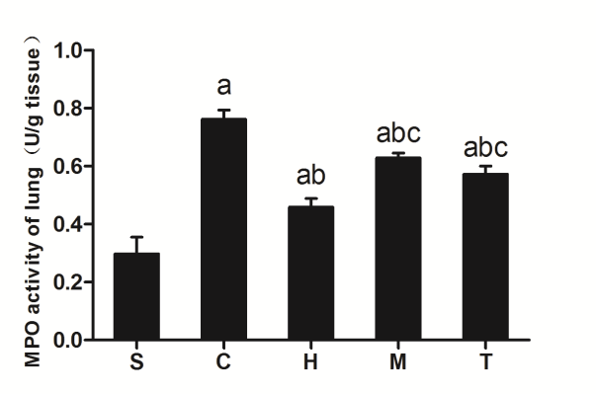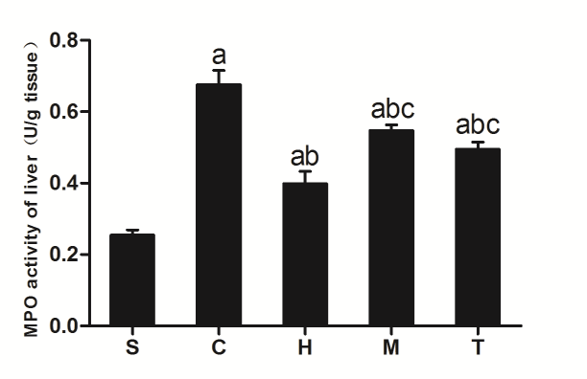
Figure 2 Levels of MPO activity in the lung and liver. S: sham group; C: control group; H: anti-HMGB1 group; M: anti-MyD88 group; T: anti-TRIF group; n = 4; ªP < 0.05 vs sham group; ^{b}P < 0.05 vs control group; ^{c}P < 0.05 vs anti-HMGB1 group. HMGBI: High mobility group protein 1; TRIF: Translocating-chain-associating membrane protein; MyD88: Myeloid differentiation gene 88.

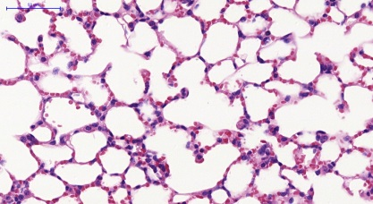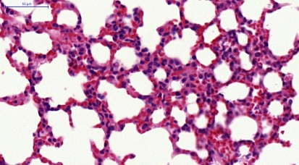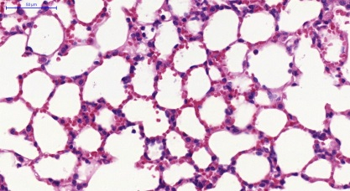
C
B
A
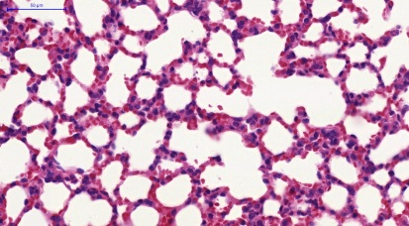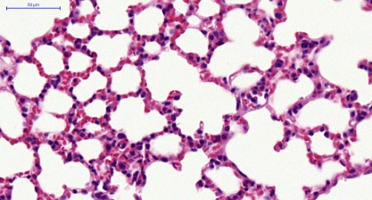
E
D
Figure 3 Hematoxylin and eosin staining of lungs in all groups (magnification × 400). A: Sham group; B: Control group; C: Anti-HMGB1group; D: Anti-MyD88 group; E: Anti-TRIF group. Scale bars = 50 µm.

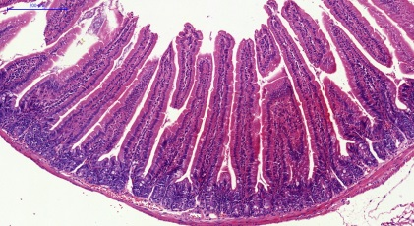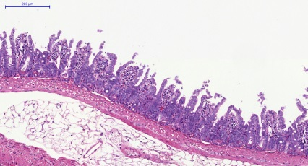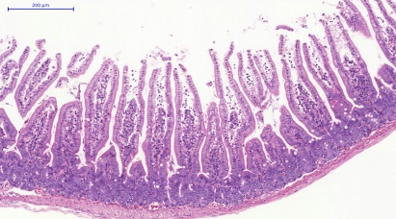
C1
B1
A1
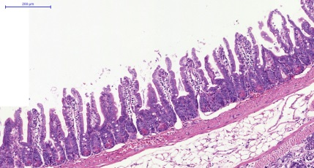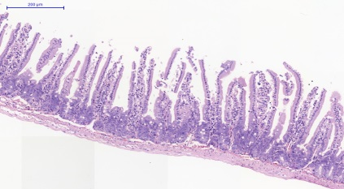
E1
D1

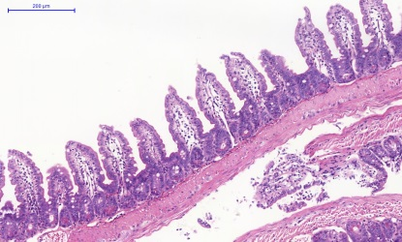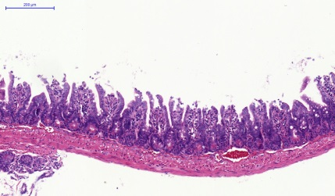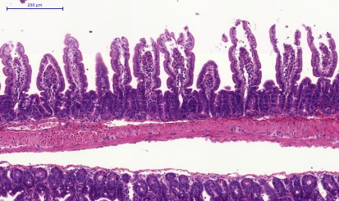
C2
B2
A2
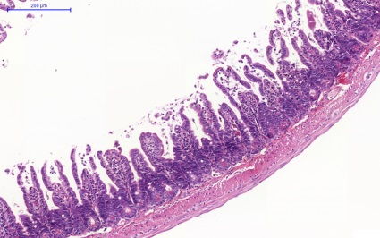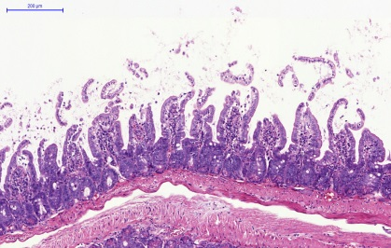
E2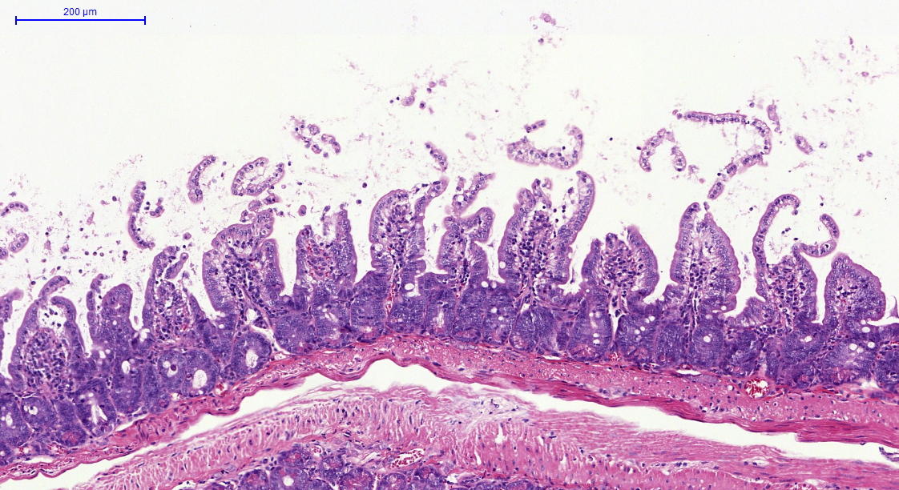
D2
Figure 4 Hematoxylin and eosin staining of the jejunum and ileum in all groups (magnification × 100). A1、B1、C1、D1 and E1 were jejunum tissue, A2、B2、C2、D2 and E2 were ileum tissue; A1, A2: sham group; B1, B2: control group; C1, C2: anti-HMGB1group; D1, D2: anti-MyD88 group; E1, E2: anti-TRIF group; Scale bars = 200 µm.

S C H M T Mr
S C H M T Mr
65 000
29 000
HMGB1
NF-κB
42 000
β-actin

β-actin

42 000
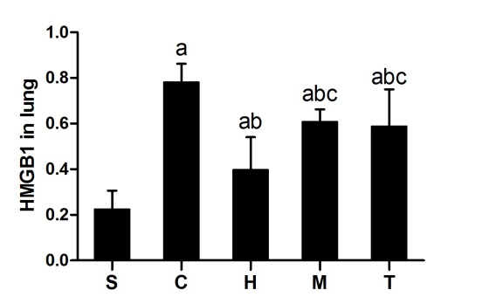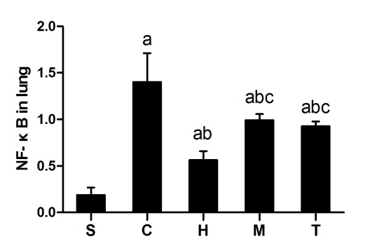
A1
B1

S C H M T Mr

S C H M T Mr

65 000

29 000
HMGB1

NF-κB

42 000

β-actin

β-actin
42 000

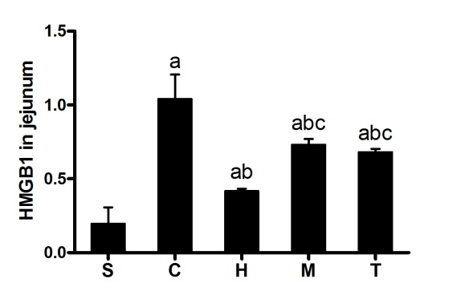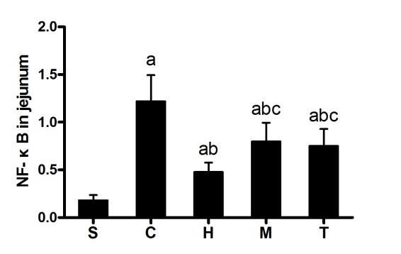
B2
A2
S C H M T Mr
S C H M T Mr
65 000

NF-κB

29 000

HMGB1

42 000

β-actin

42 000

β-actin

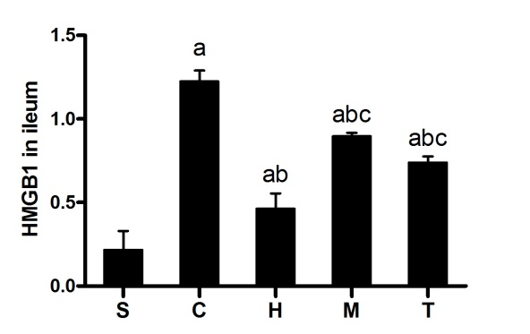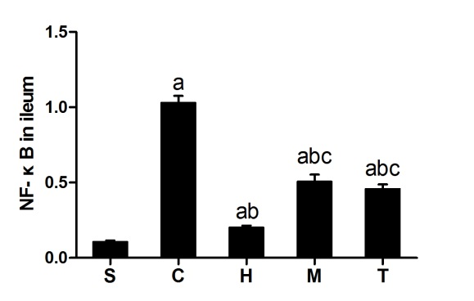
B3
A3

Figure 5 Expression of HMGB1 and NF-κB in lung, jejunum, and ileum in all groups. A1, A2 and A3 represent the expression of HMGB1 in lung, jejunum and ileum, respectively, in all groups; B1, B2 and B3 represent the expression of NF-κB in lung, jejunum and ileum, respectively, in all groups. S: sham group; C: control group; H: anti-HMGB1 group; M: anti-MyD88 group; T: anti-TRIF group. n = 4, ªP < 0.05 vs sham group; ^{b}P < 0.05 vs control group; ^{c}P < 0.05 vs anti-HMGB1 group.

Table 1 Histologic grading of intestinal ischemia-reperfusion injury
Grade | Features
0 | Normal; Villus to crypt ratio 5 or 6:1;Minimal number of lymphocytes and plasma cells; Tall columnar surface epithelial cells
1 | Epithelial cell degenerative changes (cuboidal, vacuolated) but intact; Mild increase of lymphocytes and plasma cells in lamina propria
2 | Decreased villus height, yielding villus to crypt ratio = 1 or less; Epithelial cell necrosis, erosions; More chronic inflammation in lamina propria ± neutrophils; Glandular dilatation
3 | Villi effaced (flat surface); Epithelial cell necrosis, erosions; May be pseudomembrane on surface; Glandular destruction, inflammation extending deep to muscle layer
4 | Transmural changes (all of above plus change in muscle layer)

Table 2 Concentrations of inflammatory factors in serum (mean ± SD)
Groups (n = 8) | p65 (pg/mL) | IL-6 (pg/mL) | TNF-α (pg/mL)
sham | 104.64 ± 11.89 | 50.02 ± 6.33 | 43.79 ± 4.18
control | 228.53 ± 24.85ª | 104.91 ± 31.18ª | 70.81 ± 6.97ª
anti-HMGB1 | 145.00 ± 33.63^{a,b} | 62.28 ± 6.73^{a,b} | 52.76 ± 5.71^{a,b}
anti-MyD88 | 191.12 ± 13.22^{a,b,c} | 85.90 ± 17.37^{a,b,c} | 63.19 ± 5.47^{a,b,c}
anti-TRIF | 183.73 ± 10.81^{a,b,c} | 78.14 ± 7.38^{a,b,c} | 59.70 ± 4.63^{a,b,c}
ªP < 0.05 vs sham group; ^{b}P < 0.05 vs control group; ^{c}P < 0.05 vs anti-HMGB1 group. HMGBI: High mobility group protein 1; TRIF: Translocating-chain-associating membrane protein; MyD88: Myeloid differentiation gene 88.

Table 3 Levels of MPO activity in the lung and liver (mean ± SD)
Groups (n = 4) | Levels of MPO activity
 | Lung | Liver
sham | 0.30± 0.12 | 0.25 ± 0.03
control | 0.76 ± 0.06ª | 0.68± 0.08ª
anti-HMGB1 | 0.46± 0.06^{ab} | 0.40± 0.07^{ab}
anti-MyD88 | 0.63± 0.03^{abc} | 0.55± 0.03^{abc}
anti-TRIF | 0.57 ± 0.06^{abc} | 0.50± 0.04^{abc}
ªP < 0.05 vs sham group; ^{b}P < 0.05 vs control group; ^{c}P < 0.05 vs anti-HMGB1 group. HMGBI: High mobility group protein 1; TRIF: Translocating-chain-associating membrane protein; MyD88: Myeloid differentiation gene 88.

Table 4 Lung injury score in all groups (mean ± SD)
Groups(n = 6) | Alveolar congestion | Hemorrhage | Neutrophil infiltration | Alveolarwall thickness |  |  | Total score
Sham | 1.18 ± 0.21 | 0.63 ± 0.27 | 0.23 ± 0.08 |  | 0.17 ± 0.08 | 2.22 ± 0.64
Control | 3.82 ± 0.18 | 2.72 ± 0.18 | 1.85 ± 0.15 |  | 2.37 ± 0.23 | 10.75 ± 0.73ª
Anti-HMGB1 | 2.05 ± 0.12 | 1.02 ± 0.26 | 0.47 ± 0.10 |  | 0.55 ± 0.14 | 4.08 ± 0.60^{a,b}
Anti-MyD88 | 3.07 ± 0.16 | 2.13 ± 0.26 | 0.87 ± 0.18 |  | 1.08 ± 0.23 | 7.15 ± 0.77^{a,b,c}
Anti-TRIF | 2.93 ± 0.16 | 1.92 ± 0.18 | 0.77 ± 0.14 |  | 1.02 ± 0.16 | 6.63 ± 0.62^{a,b,c}
ªP < 0.05 vs sham group; ^{b}P < 0.05 vs control group; ^{c}P < 0.05 vs anti-HMGB1 group. HMGBI: High mobility group protein 1; TRIF: Translocating-chain-associating membrane protein; MyD88: Myeloid differentiation gene 88.

Table 5 Intestine injury score in all groups (mean ± SD)
Groups (n = 6) | Jejunum | Ileum
Sham | 0.17 ± 0.08 | 0.22 ± 0.12
Control | 2.97 ± 0.16ª | 3.15 ± 0.32ª
Anti-HMGB1 | 1.23 ± 0.23^{a,b} | 1.32 ± 0.27^{a,b}
Anti-MyD88 | 2.17 ± 0.22^{a,b,c} | 2.18 ± 0.29^{a,b,c}
Anti-TRIF | 2.08 ± 0.17^{a,b,c} | 2.05 ± 0.27^{a,b,c}
ªP < 0.05 vs sham group; ^{b}P < 0.05 vs control group; ^{c}P < 0.05 vs anti-HMGB1 group. HMGBI: High mobility group protein 1; TRIF: Translocating-chain-associating membrane protein; MyD88: Myeloid differentiation gene 88.

Table 6 Levels of HMGB1 and NF-κB mRNA expression in lungs from all groups (mean ± SD)
Groups(n = 6) | HMGB1 mRNA | NF-κB mRNA
Sham | 1.04 ± 0.19 | 1.03 ± 0.21
Control | 2.67 ± 0.30ª | 2.04 ± 0.29ª
Anti-HMGB1 | 1.89 ± 0.18^{a,b} | 1.42 ± 0.23^{a,b}
Anti-MyD88 | 2.35 ± 0.31^{a,b,c} | 1.77 ± 0.18^{a,b,c}
Anti-TRIF | 2.29 ± 0.28^{a,b,c} | 1.70 ± 0.13^{a,b,c}

ªP < 0.05 vs sham group; ^{b}P < 0.05 vs control group; ^{c}P < 0.05 vs anti-HMGB1 group. HMGBI: High mobility group protein 1; TRIF: Translocating-chain-associating membrane protein; MyD88: Myeloid differentiation gene 88.

Table 7 Levels of HMGB1, NF-κB, MyD88, and TRIF mRNA expression in ileum from all groups (mean ± SD)
Groups (n = 6) |  | HMGB1 mRNA | NF-κB mRNA | MyD88 mRNA | TRIF mRNA
 | Sham | 1.04 ± 0.19 | 1.03 ± 0.21 | 1.01 ± 0.10 | 1.01 ± 0.11
 | Control | 2.67 ± 0.30ª | 2.04 ± 0.29ª | 2.55 ± 0.16ª | 3.05 ± 0.10ª
 | Anti-HMGB1 | 1.89 ± 0.18^{a,b} | 1.42 ± 0.23^{a,b} | 2.37 ± 0.08^{a,b} | 2.90 ± 0.13^{ab}
 | Anti-MyD88 | 2.35 ± 0.31^{a,b,c} | 1.77 ± 0.18^{a,b,c} | 2.30 ± 0.16^{a,b} | 3.04 ± 0.13^{a,c}
 | Anti-TRIF | 2.29 ± 0.28^{a,b,c} | 1.70 ± 0.13^{a,b,c} | 2.53 ± 0.07^{a,c,d} | 2.85 ± 0.12^{a,b,d}

ªP < 0.05 vs sham group; ^{b}P < 0.05 vs control group; ^{c}P < 0.05 vs anti-HMGB1 group; ^{d}P < 0.05 vs anti-MyD88 group. HMGBI: High mobility group protein 1; TRIF: Translocating-chain-associating membrane protein; MyD88: Myeloid differentiation gene 88.

