Name of Journal: World Journal of Radiology
Manuscript NO: 39530
Manuscript Type: Case Report

Obesity and pericallosal lipoma in X-linked emery-dreifuss muscular dystrophy: A case report - Does Emerin play a role in adipocyte differentiation?

Spanu F et al. Pericallosal lipoma in X-linked emery-dreifuss muscular dystrophy

Fabio Spanu, Luca Saba

Fabio Spanu, Luca Saba, Department of Radiology, Azienda Ospedaliero Universitaria, Cagliari 09045, Italy

ORCID number: Fabio Spanu (0000-0003-3765-3905); Luca Saba (0000-0003-2870-3771).

Author contributions: Spanu F designed and wrote the report and collected the patient’s clinical data; Saba L provided the radiologic data, checked the case and reviewed the paper.

Conflict-of-interest statement: All authors have no conflicts of interest to report.

CARE Checklist (2013) statement: Guidelines of the CARE Checklist (2013) have been adopted while writing this manuscript.

Open-Access: This article is an open-access article which was selected by an in-house editor and fully peer-reviewed by external reviewers. It is distributed in accordance with the Creative Commons Attribution Non Commercial (CC BY-NC 4.0) license, which permits others to distribute, remix, adapt, build upon this work non-commercially, and license their derivative works on different terms, provided the original work is properly cited and the use is non-commercial. See: http://creativecommons.org/licenses/by-nc/4.0/

Manuscript source: Unsolicited manuscript

Correspondence to: Fabio Spanu, MD, Surgeon, Department of Radiology, Azienda Ospedaliero Universitaria, Polo di Monserrato s.s. 554 Monserrato, Cagliari 09045, Italy. docfabio.spanu@gmail.com

Telephone: +39-705-1096242
Fax: +39-705-6092299

Received: April 25, 2018
Peer-review started: April 25, 2018
First decision: June 6, 2018
Revised: June 11, 2018
Accepted: June 27, 2018
Article in press:
Published online:

Abstract
Emery dreifuss muscular dystrophy (EDMD) is a rare genetic syndrome consisting of tendon retractions, progressive muscle atrophy and cardiac involvement. We report a case of an obese patient affected by the familiar X-linked form in which a pericallosal lipoma was found during investigation for a suspected acute vasculopathy. To date, EDMD has never been associated to cerebral lipomas and the X-linked form was never considered involved in lipodystrophic syndromes or non-muscular conditions. Our case confirms the variable expressivity of the disease and suggests a possible role of Emerin in the intranuclear regulation of signals for adipocytes cells differentiation.

Key words: Emery-dreifuss-distrophy; Pericallosal lipoma; Emerin; Familiar EDMD; Adipocytes differentiation

© The Author(s) 2018. Published by Baishideng Publishing Group Inc. All rights reserved.

Core tip: To date emery dreifuss muscular dystrophy has never been associated to cerebral lipomas and the X-linked form was never considered involved in extra-muscular syndromes. We presented a case of a patient affected by the X-linked form with a particular adipose tissue distribution, a cerebral and spinal lipoma, so suggesting a possible role of Emerin in the intranuclear regulation of signals for cell differentiation or in lipidic intracellular dysmetabolism when absent.

Spanu F, Saba L. Obesity and pericallosal lipoma in X-linked emery-dreifuss muscular dystrophy: A case report - Does Emerin play a role in adipocyte differentiation? World J Radiol 2018; In press

INTRODUCTION
Emery dreifuss muscular dystrophy (EDMD) is a rare genetic syndrome described for the first time in 1966 after studying families with slowly progressive muscular dystrophy compared to the Duchenne-type^{[1]}. It belongs to the group of nuclear envelopathies, defects of proteins making up the nuclear envelope, and even if included among the subgroup of laminopathies, not all the pathogenic variants show defects in Lamins. Specifically, in the X-linked EDMD variant, the protein Emerin, normally ubiquitously expressed on the nuclear membrane, is absent in 95% of individuals^{[2]}. This form has a similar clinical picture compared to the autosomal dominant variant (involving Lamin A/C)^{[3]}, although not exactly the same, and is characterized by joint contractures, usually the first sign, slowly and progressive muscle weakness, appearing firstly in AD variants, and cardiac involvement with arrhythmias and dilated cardiomyopathy^{[4]}. Most of emerinopathies are null variants, but the phenotype may show intra-familiar variability. Nevertheless, differently from mutations in the Lamin A/C gene, XL-EDMDs are not associated with Dunnigan-type familiar partial lipodystrophy nor with cerebral involvement, including the occurrence of intracranial lipomas^{[5]}.

CASE REPORT
A 27-year-old man with Emery-Dreifuss muscular dystrophy presented at E.D. three hours after the onset of objective vertigo followed by painful left arm weakness. He was from a family with 4 brothers affected by the X-linked form of the disease, due to the 130 C>T (Q44X) non-sense mutation in the exon 2 of the EMD gene. He was obese, with a particular accumulation of facial and neck adipose tissue, and pharmacologically treated with ramipril, bisoprolol and apixaban for cardiac rhythm disorders, monitored with a loop recorder reveal. His medical history revealed several episodes of aberrant intraventricular conduction followed by SVPT, isolated episodes of bradycardia and atrial ectopic beats. Echocardiograms had shown bi-atrial and LV enlargement. Muscular involvement was moderate with deterioration of medial head of gastrocnemius, semimembranosus and, although mildly, lateral head of gastrocnemius, vasti, adductor magnus and long head of biceps femoris. No clear deformities or contractures were evident, differently from two younger brothers and a first-grade cousin affected.
The clinical exam at the E.D. showed a left arm downward drift associated with local joint pain. The patient was alert, oriented and cooperative while the thoracic and abdominal clinical evaluation showed normal findings. Suspecting an acute vasculopathy, he underwent an urgent head NCCT that revealed the presence of a left sided hypodense peri-callosal curvilinear lesion (Figure 1). No clear cerebral ischemic signs were observed, and a further CT Angiography showed the perilesional course of pericallosal arteries, below the rostrum and the genu of the corpus callosum where both were pushed on the right side of the lesion and upward, resulting above the lesion in correspondence of the body and splenium of corpus callosum (Figure 2). Left artery narrowed progressively compared to the contralateral. Furthermore, the exam ruled out vascular obstructions. The scan at thoracic level revealed a lesion with similar density and characteristics at T1-T2 level posteriorly to the cord and occupying the extradural space (Figure 3) with apparent dural impression. Then, the patient was admitted at the ward and, the next day, was submitted to an MRI which didn’t show diffusivity alterations, so definitely excluding areas of ischemia. Along the pericallosal region from rostrum to splenium, the lesion described in CT appeared hyperintense at T1-W and long TR sequences, hypointense at fat suppression sequences, without contrast enhancement and with clearly defined limits (Figure 4). These finding confirmed the initial hypothesis of a complete curvilinear pericallosal lipoma, left sided. Callosal aplasia wasn’t observed. The day after, the pain was subsiding with painkillers while the weakened arm was completely recovered so that he could be discharged at home.

DISCUSSION
EDMD is a rare genetic disease with an estimated prevalence of 0.13:100000-0.2:100000 overall^{[6]}, and of 1:100000 inhabitants for the XL-EDMD variant^{[7]}. We reported a case of XL-EDMD in a family of 5 members affected and a sister carrier of the same mutation c.130 C<T (pQ44X), in exon 2 of EMD or STA gene. This mutation inserts a stop at codon 44 causing an early termination of translation of Emerin, with consequent C-terminal truncation and in vivo destabilization with complete loss^{[8]}.
Emerin is a type 2 integral membrane protein of 29-kDa, resident of inner nuclear membrane (INM) in which it is closely linked to Lamin proteins, components of the nuclear lamina. It has been observed that in cells lacking a functional A-type lamin gene, as it is observed in AD-EDMD, Emerin is largely dislocated to the peripheral endoplasmic reticule (ER). It has been postulated that the nuclear lamina plays a crucial role in limiting the segregation of INM proteins to the outer nuclear membrane and peripheral ER^{[9]}. The tissues specificity associated with laminopathies may be explained with a dysfunction in specific processes which take place in the ER, like cholesterol and fatty acid synthesis, due to the accumulation of proteins no more contained within the nuclear envelope. This would result in an aberrant adipocyte development and lipodystrophic diseases as it could be observed in Dunnigan-type familial partial lipodystrophy associated to mutations in the lamin A/C gene and characterized by selective loss of subcutaneous fat from the limbs and trunk and its accumulation in the face and neck^{[10]}. Similarly, muscles and myocardium may suffer from an impaired Ca²⁺ release in the sarcoplasmic reticulum during contraction.
An alternative hypothesis suggests that the accumulation of nuclear envelope proteins in the ER could promote alterations in intracellular signaling pathways with effects on gene expression and cell survival^{[11]}. Differently from laminopathies, in XL-EDMD, Emerin is truncated at C-terminal and not detectable in the nuclear membrane, so even if it is supposed to result in a more soluble form in vitro^{[12]}, the pathogenetic theory of accumulation results less consistent.
Our patient showed a particular obese habitus with accumulation of adipose tissue in the neck and face districts with disproportionally leaner limbs. Evaluating the clinical course and the exams performed, the pericallosal (PL) and the spinal lipoma may be considered incidental findings whereas the symptoms complained could be related to an initial painful contracture, that in facts subsided after painkillers.
PL are rare, fat containing lesions, generally asymptomatic and accounting approximately for 0.1%-0.5% of all intracranial lesions^{[13]}. Curvilinear and tubulonodular types have been described. Tubulonodular lipomas are considered more frequently associated to corpus callosum malformations^{[14]}, even if the series of Yilmaz et al^{[15]} showed a stronger association with curvilinear lipomas. Our case is aligned with the classical association, not showing clear morphological alterations in corpus callosum. This may be important, since lipomas are considered congenital malformations and, for that, more often occur with cortical and callosal dysplasias and vascular malformations^{[16]}. Nevertheless, Zettner and Netsky pointed out that callosal dysgenesis are not the cause of lipomas, believing rather that the two conditions derive from two distinct pathological processes, namely a meningeal mal-differentiation for lipomas and dysraphism for callosal abnormalities^{[17,18]}.
Finally, it is nowadays clear that LEM domain proteins such as LAP2B and Emerin interact with transcriptional regulators playing a further role in gene regulation, other than structural. In vitro models speculate that Emerin binds A and B-type lamins as well as RB, that regulates the entry into S-phase and terminal differentiation and at least four transcriptional factors, including germ-cell-less (GCL), BCL2-associated transcription factor (BTF) and barrier-to-autointegration factor (BAF)^{[19]}. After binding Emerin, GCL acts on DP3-E2F repressing its dependent gene expression, while BTF acts as a cell-death-promoting transcription repressor after binding a DNA-specific partner. BAF can bind directly to both lamin A and Emerin blocking GCL binding to Emerin, or directly represses CRX dependent genes in vivo after binding to dsDNA. In muscle cells Emerin binds several actin-binding proteins including a nuclear isoform of Spectrin, reinforcing the lamina network through a further link between actin and protein 4.1 that is implied in reconstruction of nuclei after mitosis^{[19]}.
To date EDMD has never been associated to cerebral lipomas and the X-linked form was never considered involved in lipodystrophic syndromes or non-muscular conditions.
Our case confirms the variable expressivity of the disease, adding the suggestion of a possible role of Emerin in the intranuclear regulation of signals for adipocytes cell differentiation or lipidic intracellular metabolism in particular cell groups subject to specific and variable stimuli during lifetime.

ARTICLE HIGHLIGHTS
Case characteristics
Spontaneous left arm weakness, objective vertigo, obesity.

Clinical diagnosis
Left arm downward drift associated with local joint pain.

Differential diagnosis
Acute vasculopathy; neuropathies; joint affections.

Laboratory diagnosis
Unremarkable laboratory examination.

Imaging diagnosis
A head NCCT revealed the presence of a left sided hypodense peri-callosal curvilinear lesion; a CT Angiography ruled out vascular obstructions while the thoracic scan showed two posterior extradural hypodense lesions at T1-T2. The MRI didn’t show diffusivity alterations: the curvilinear peri-callosal lesion appeared hyperintense in T1-W and hypointense at fat suppression sequences, without contrast enhancement, so confirming the lipoma.

Treatment
Rest and painkillers.

Term explanation
Envelopathies: defects of proteins making up the nuclear envelope.

Experiences and lessons
A particular obesity pattern associated with cerebral-spinal lipomas may be related to the same gene defect in patients affected by Emery-Dreifuss muscular dystrophy X-linked variant. In our case, lipomas may be considered incidental findings whereas the symptoms complained could be related to an initial painful contracture, as a typical hallmark of the disease.

REFERENCES
1 Emery AE, Dreifuss FE. Unusual type of benign x-linked muscular dystrophy. J Neurol Neurosurg Psychiatry 1966; 29: 338-342 [PMID: 5969090 DOI: 10.1136/jnnp.29.4.338]
2 Yates JR, Wehnert M. The Emery-Dreifuss Muscular Dystrophy Mutation Database. Neuromuscul Disord 1999; 9: 199 [PMID: 10382916]
3 Vytopil M, Benedetti S, Ricci E, Galluzzi G, Dello Russo A, Merlini L, Boriani G, Gallina M, Morandi L, Politano L, Moggio M, Chiveri L, Hausmanova-Petrusewicz I, Ricotti R, Vohanka S, Toman J, Toniolo D. Mutation analysis of the lamin A/C gene (LMNA) among patients with different cardiomuscular phenotypes. J Med Genet 2003; 40: e132 [PMID: 14684700 DOI: 10.1136/jmg.40.12.e132]
4 Pasotti M, Klersy C, Pilotto A, Marziliano N, Rapezzi C, Serio A, Mannarino S, Gambarin F, Favalli V, Grasso M, Agozzino M, Campana C, Gavazzi A, Febo O, Marini M, Landolina M, Mortara A, Piccolo G, Viganò M, Tavazzi L, Arbustini E. Long-term outcome and risk stratification in dilated cardiolaminopathies. J Am Coll Cardiol 2008; 52: 1250-1260 [PMID: 18926329 DOI: 10.1016/j.jacc.2008.06.044]
5 Shackleton S, Lloyd DJ, Jackson SN, Evans R, Niermeijer MF, Singh BM, Schmidt H, Brabant G, Kumar S, Durrington PN, Gregory S, O'Rahilly S, Trembath RC. LMNA, encoding lamin A/C, is mutated in partial lipodystrophy. Nat Genet 2000; 24: 153-156 [PMID: 10655060 DOI: 10.1038/72807]
6 Norwood FL, Harling C, Chinnery PF, Eagle M, Bushby K, Straub V. Prevalence of genetic muscle disease in Northern England: in-depth analysis of a muscle clinic population. Brain 2009; 132: 3175-3186 [PMID: 19767415 DOI: 10.1093/brain/awp236]
7 Bonne G, Leturcq F, Ben Yaou R. Emery-Dreifuss Muscular Dystrophy. In: Adam MP, Ardinger HH, Pagon RA, Wallace SE, Bean LJH, Stephens K, Amemiya A, editors. SourceGeneReviews® [Internet]. Seattle (WA): University of Washington, Seattle; 1993-2018. 2004 Sep 29 [updated 2015 Nov 25]. [PMID: 20301609]
8 Sullivan T, Escalante-Alcalde D, Bhatt H, Anver M, Bhat N, Nagashima K, Stewart CL, Burke B. Loss of A-type lamin expression compromises nuclear envelope integrity leading to muscular dystrophy. J Cell Biol 1999; 147: 913-920 [PMID: 10579712 DOI: 10.1083/jcb.147.5.913]
9 Burke B, Mounkes LC, Stewart CL. The nuclear envelope in muscular dystrophy and cardiovascular diseases. Traffic 2001; 2: 675-683 [PMID: 11576443 DOI: 10.1034/j.1600-0854.2001.21001.x]
10 Garg A, Peshock RM, Fleckenstein JL. Adipose tissue distribution pattern in patients with familial partial lipodystrophy (Dunnigan variety). J Clin Endocrinol Metab 1999; 84: 170-174 [PMID: 9920078 DOI: 10.1210/jcem.84.1.5383]
11 Manilal S, Recan D, Sewry CA, Hoeltzenbein M, Llense S, Leturcq F, Deburgrave N, Barbot J, Man N, Muntoni F, Wehnert M, Kaplan J, Morris GE. Mutations in Emery-Dreifuss muscular dystrophy and their effects on emerin protein expression. Hum Mol Genet 1998; 7: 855-864 [PMID: 9536090 DOI: 10.1093/hmg/7.5.855]
12 Pahl HL, Baeuerle PA. The ER-overload response: activation of NF-kappa B. Trends Biochem Sci 1997; 22: 63-67 [PMID: 9048485 DOI: 10.1016/S0968-0004(96)10073-6]
13 Seidl Z, Vaneckova M, Vitak T. Intracranial lipomas: a retrospective study. Neuroradiol J 2007; 20: 30-36 [PMID: 24299585 DOI: 10.1177/197140090702000104]
14 Yildiz H, Hakyemez B, Koroglu M, Yesildag A, Baykal B. Intracranial lipomas: importance of localization. Neuroradiology 2006; 48: 1-7 [PMID: 16237548 DOI: 10.1007/s00234-005-0001-z]
15 Yilmaz MB, Genc A, Egemen E, Yilmaz S, Tekiner A. Pericallosal Lipomas: A Series of 10 Cases with Clinical and Radiological Features. Turk Neurosurg 2016; 26: 364-368 [PMID: 27161462 DOI: 10.5137/1019-5149.JTN.13008-14.0]
16 Jiménez Caballero PE. Interhemispheric lipoma associated with agenesis of the corpus callosum. Neurologia 2012; 27: 515-517 [PMID: 21890243 DOI: 10.1016/j.nrl.2011.07.008]
17 Zettner A, Netsky MG. Lipoma of the corpus callosum. J Neuropathol Exp Neurol 1960; 19: 305-319 [PMID: 13847327 DOI: 10.1097/00005072-196004000-00010]
18 Wallace D. Lipoma of the corpus callosum. J Neurol Neurosurg Psychiatry 1976; 39: 1179-1185 [PMID: 1011028 DOI: 10.1136/jnnp.39.12.1179]
19 Cohen M, Lee KK, Wilson KL, Gruenbaum Y. Transcriptional repression, apoptosis, human disease and the functional evolution of the nuclear lamina. Trends Biochem Sci 2001; 26: 41-47 [PMID: 11165516 DOI: 10.1016/S0968-0004(00)01727-8]
P-Reviewer: Bazeed mf, De Cecco cn, Mahajan a, Ulaşoğlu c S-Editor: Ma YJ L-Editor: E-Editor:

Specialty type: Radiology, nuclear medicine and medical imaging
Country of origin: Italy
Peer-review report classification
Grade A (Excellent): 0
Grade B (Very good): B, B
Grade C (Good): C, c
Grade D (Fair): 0
Grade E (Poor): 0
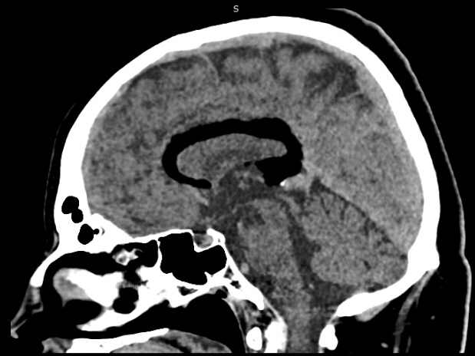

Figure 1 a paramedian left non-contrast computer tomography scan showing a curvilinear fat density lesion above corpus callosum.

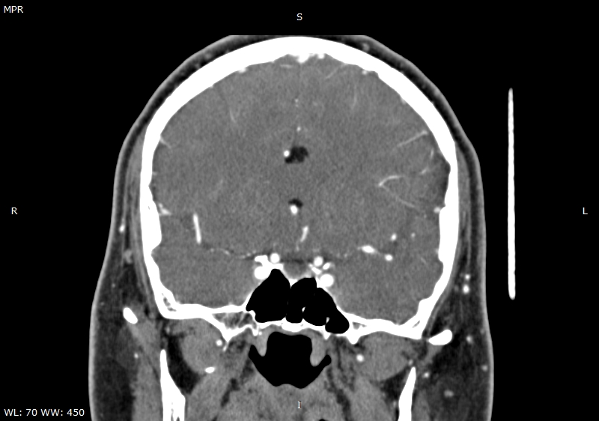

Figure 2 A coronal DSA showing the lipoma (white arrows), the right rostral A2 (blue arrowhead), the right pericallosal artery (black arrowhead), left rostral A2 (blue arrow) and left pericallosal artery (black arrow).

Figure 3 A sagittal CT Angiography showing two hypodense images compatible with lipomas within the extradural compartment, dorsally to the cord at T1-T2 level (blue arrowheads).

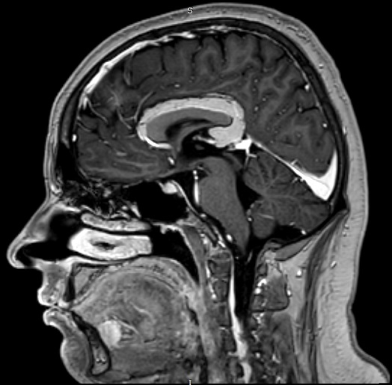

A b
Figure 4 A T1-W 3D TFE+MDC magnetic resonance imaging. A: showing the relationships between vasculature, corpus callosum, lipoma and adjacent brain tissues; B: showing the pericallosal lesion, compatible with a complete curvilinear lipoma without callosal aplasia.

