Name of journal: World Journal of Clinical Oncology
ESPS Manuscript NO: 16074
Columns: CASE REPORT

Sentinel lymph node mapping of a breast cancer of the vulva: Case report and literature review

Cripe J et al. Breast cancer of the vulva

James Cripe, Ramez Eskander, Krishnansu Tewari

James Cripe, Ramez Eskander, Krishnansu Tewari, Division of Gynecologic Oncology, Department of Obstetrics and Gynecology, The University of California, Irvine Medical Center, Orange, CA 92701, United States

Author contributions: Cripe J, Eskander R and Tewari K all contributed equally to this work; Cripe J drafted the manuscript; Eskander R made significant edits of intellectual content; Tewari K approved the overall works.

Ethics approval: The case report was approved by the University of California – Irvine.

Informed consent: The patient provided informed written consent prior to case review.

Conflict-of-interest: The authors have no financial or non-financial disclosures to make.

Open-Access: This article is an open-access article which was selected by an in-house editor and fully peer-reviewed by external reviewers. It is distributed in accordance with the Creative Commons Attribution Non Commercial (CC BY-NC 4.0) license, which permits others to distribute, remix, adapt, build upon this work non-commercially, and license their derivative works on different terms, provided the original work is properly cited and the use is non-commercial. See: http://creativecommons.org/licenses/by-nc/4.0/

Correspondence to: James Cripe, MD, Division of Gynecologic Oncology, Department of Obstetrics and Gynecology, The University of California, Irvine Medical Center, 101 the City Drive, Orange, CA 92701, United States. jccripe@gmail.com

Telephone: +1-714-4566707

Received: December 24, 2014
Peer-review started: December 26, 2014
First decision: January 8, 2015
Revised: January 29, 2015
Accepted: February 10, 2015
Article in press:
Published online:

Abstract
Ectopic breast tissue is rare and typically presents as an axillary mass. Previous reports have identified ectopic breast tissue in the vulva, but malignancy is exceedingly uncommon. We present a 62 years old with locally advanced breast carcinoma arising in the vulva demonstrates the utilization of sentinel lymph node mapping to identify metastatic lymph nodes previously unable to be identified via traditional surgical exploration. Our case supports the principles of adjuvant therapy for breast cancer to be applied to ectopic breast cancer arising in the vulva. A literature review highlights common key points in similar cases to guide management.

Key words: Vulvar cancer; Breast cancer; Sentinel lymph node; Ectopic breast; Vulvar breast cancer

© The Author(s) 2015. Published by Baishideng Publishing Group Inc. All rights reserved.

Core tip: Our findings describe the presentation of ectopic breast cancer in the vulva. We demonstrate use of sentinel lymph node technology with identification of the sentinel node, only possible after the use of this technology. We conclude with a review of the literature outlining treatment of this enigmatic disease.

Cripe J, Eskander R, Tewari K. Sentinel lymph node mapping of a breast cancer of the vulva: Case report and literature review. World J Clin Oncol 2015; In press

INTRODUCTION
Ectopic breast tissue has been previously reported in various locations along the primitive milk line, from the axilla to the vulva (Figure 1). Axillary ectopic breast tissue is the most frequent location and the vulva being the least common site^{[1]}. Malignant ectopic breast tissue is rare, typically presenting as an axillary mass, with vulvar breast malignancy being exceedingly rare^{[1]}. In 1935, Green et al^{[2]} published the first case report of adenocarcinoma arising from breast tissue in the vulva. Although 22 cases of malignant vulvar breast tissue have been reported since then, there are no clear guidelines regarding surgical or adjuvant treatment. We present a case that outlines the diagnosis and management of primary breast cancer of the vulva, highlighting diagnostic dilemmas, the utility of sentinel node mapping and reinforcing the importance of a multidisciplinary approach in the management of this rare clinical entity.

CASE REPORT
A 62 years old Hispanic multiparous women noted a new 1.3 cm left labial mass for approximately 1 year and presented to her primary gynecologist for evaluation. She underwent a wide local excision that was noteworthy for an invasive ductal carcinoma arising in ectopic breast tissue. Final pathology was confirmed by independent review at two separate institutions. Immunohistochemical staining showed the lesion to be 95% Estrogen receptor (ER) positive, 10% Progesterone receptor (PR) positive, and Human epidermal growth factor 2 (HER2) negative (Figure 2).
The patient underwent an MRI of the breast that was negative for a breast primary malignancy. Approximately one month after initial presentation in September of 2012, the patient was referred to gynecologic oncology and underwent a partial radical vulvectomy at the prior vulvar scar site. Final pathology was negative for residual disease and the patient, given absence of metastatic disease declined adjuvant therapy. The patient initiated close surveillance and had a Fluoro-deoxyglucose (FDG) Positron emission tomography (PET) scan in January 2013 with findings of suspicious left inguinal-femoral lymphadenopathy, with standard uptake value (SUV) of 8.1.
The patient was counseled to undergo left inguinal-femoral lymphadenectomy (LND). The dissection was completed superficial to the cribiform fascia and final pathology identified 14 lymph nodes ranging from 1.2-2.5 cm that were all negative for tumor. On follow up examination in April 2013, the patient was found to have a 1-2 mm firm, non-tender nodule under her healing scar. In office biopsy confirmed recurrent invasive ductal carcinoma, with identical histology to the previous primary lesion. A repeat wide local excision was performed in June 2013. Pathology from that surgical resection was negative for tumor.
A PET-CT in August 2013 was repeated and was significant for suspicious left inguinal lymph node measuring 1.1 cm × 1.6 cm with SUV of 8.2 (Figure 3). The patient returned to the operating room with preoperative technetium 99 lymphoscintography and lymphazurin blue (injected into the previous left surgical site) lymph node localization (Figure 4). An inguinal incision was created and the Geiger counter was used to identify “hot” areas. Dissection continued until area of maximum radioactivity was encountered. A hot, blue, slightly firm, 1.2 cm left sentinel was identified superficial to the cribiform fascia and excised. Intraoperative frozen section was positive for metastasis and comprehensive LND was performed. Two additional left sentinels (both hot and blue) were positive for ductal carcinoma. A right-sided sentinel node was not identified, but given contralateral positive nodes a comprehensive right LND was performed. Final pathology (Figure 2) confirmed three positive sentinels and 14 negative left and right inguinofemoral nodes.
Metastatic workup was negative and the patient underwent intensity modulated radiation therapy (4500 cGy) with 5900 cGy boosts to the left groin. Chemotherapy included weekly taxol followed by adriamycin and cyclophosphamide. Following adjuvant therapy she started maintenance therapy with an aromatase inhibitor.
She is currently without evidence of disease recurrence 13 months after sentinel lymph node detection.

DISCUSSION
Ectopic breast tissue is rare and accounts for 0.2%-0.6% of all breast cancers. Only 4% of these ectopic breast cancers are located in the vulva, making vulvar breast cancer exceedingly rare^{[3]}. Ectopic breast tissue originates in the fetus at the ectodermal mammary streak extending from the axilla to the groin as demonstrated in Figure 1. Most of this structure disappears with small portions persisting in the thorax. This primordial ectoderm penetrates the underlying mesenchyme and gives rise to small solid out buddings that canalize and form the lactiferous ducts and alveoli of the mammary gland^{[4,5]}.
There have been 22 reported cases since Greene’s index case report in 1935. The majority of these patients presented with an innocuous solitary lesion of the vulva (Table 1); upon surgical excision, adenocarcinoma or ductal carcinoma arising in normal appearing breast tissue was identified. Extensive preoperative imaging is traditionally used to exclude metastasis of a primary breast malignancy. Two of these reported cases were indeed metastatic from a primary breast lesion^{[6,7]}. Adjuvant chemotherapy and radiation treatment protocols are heterogeneous (Table 2) given the rare frequency of these lesions, and absence of standardized treatment paradigms. Anti-hormonal therapy has been used in 14 (13 Tamoxifen and 1 Aromatase) patients with ER/PR positive specimens with various outcomes. The use of trastuzumab in HER2 positive cases has not been previously reported.
The presence of metastatic tumor in regional lymph nodes remains the most significant prognostic factor for several malignancies, including breast cancer. Sixteen patients underwent inguinal LND with all 16 patients having lymph node involvement. Survival and adjuvant therapy data are outlined in Table 2. Sentinel lymph node mapping is a technique that minimizes morbidity while maintaining diagnostic accuracy by isolating the first or “sentinel” node to drain the affected area burdened with tumor. This is traditionally performed with injection of the tumor with isosulfan blue and a radiolabeled colloid, most often technetium 99. This technique was pioneered by Morton in the treatment of melanoma in the early 1990’s^{[8]}. The assessment of regional lymph nodes in breast cancer paralleled the work in melanoma, in an effort to limit the morbidity of axillary lymph node dissection^{[9]}. Numerous clinical trials have detailed the effectiveness and reduced morbidity associated with sentinel lymph node dissection in breast cancer patients in both the primary surgical setting and following neoadjuvant therapy. Current American Society of Clinical Oncology (ASCO) guidelines recommends sentinel lymph node mapping as standard of care in breast cancer^{[10]}.
Sentinel node mapping in vulvar cancer is a more contemporary topic with evolving literature, and has paralleled some advances in penile carcinoma lymphatic mapping. GROINS-V, an observational study, followed 403 patients with primary vulvar tumors less than 4 cm treated with sentinel node mapping. 8 patients had groin recurrence with a false negative rate of 5.9% and a false negative predictive value of 2.9%^{[11]}. Similar results were replicated in GOG protocol 173^{[12]}, a phase 3 multi-institutional study of intraoperative lymphatic mapping in patients with invasive squamous cell carcinoma of the vulva. Inclusion criteria included depth of invasion > 1 mm and primary tumor size 2-6 cm. 452 patients underwent sentinel node mapping with 418 patients having a sentinel node identified. 11 (8.3%) patients with negative sentinel lymph nodes had groin recurrence. The false negative rate in primary lesions < 4 cm was 2%, but with lesions > 4 cm the false negative rate was 4%^{[11]}. It is important to note that all patients in GOG protocol 173 underwent comprehensive LND after sentinel LND regardless of its status. GROINS-V also identified a statistically significant decrease in wound breakdown, cellulitis, and lymphedema in patients undergoing sentinel lymph node mapping. Both studies provide evidence to support the incorporation of sentinel LND in the management of vulvar malignancies.
Our case utilized sentinel lymph node mapping at time of recurrence and precisely aided in the identification of the metastatic lymph nodes. This technology was not utilized in the primary surgical management due to uncertainties on how it would perform when the primary lesion was comprised of ectopic breast tissue. However, after failing to identify the PET positive nodes with standard LND, SLD was employed to identify and excise the lymph nodes.
Primary breast cancer originating in the vulva is rare and management strategies stem from individual case reports or case series. Current literature supports the use of sentinel lymph node mapping in vulvar cancer and we anticipate that future cases will utilize this practice. Bogani et al^{[13]} as well as our case have been the only published literature to utilize sentinel lymph node mapping after a previous LND. Both cases identified positive sentinel lymph nodes that were previously unable to have been resected. These findings may support the up-front use of sentinel lymph node localization.
From our review of the literature there are several key concepts in managing this rare malignancy. First, exclusion of a primary breast malignancy needs to be confirmed by pretreatment imaging and physical examination. Next, occurrence of positive nodes is high and can be difficult to locate; primary surgical excision (radical vulvectomy) with sentinel lymph node dissection to help identify the sentinel lymph node should be considered.
Systemic chemotherapy based on adjuvant therapy platforms for breast cancer with docetaxel or paclitaxel, plus doxorubicin, and cyclophosphamide should be considered. Given the biologic parallels between primary breast and vulvar breast cancer, treatment paradigms mimicking primary breast cancer are a rational approach and are advisable. This is supported by the median survival of patients treated with adjuvant therapy for breast cancer had a mean survival of 30 mo in comparison to 12 mo for those receiving a vulvar treatment (surgery followed by radiation). Finally, patients with estrogen and progestin receptor positive specimens may be maintained on tamoxifen or aromatase inhibitors.

COMMENT
Case characteristics
A 62 years old Hispanic women presented with a 1.3 cm left labial mass.

Clinical diagnosis
Suspected neoplasm originating from the left labia.

Differential diagnosis
Gartners duct cyst, labial myoma, vulvar squamous cell carcinoma, and vulvar melanoma.

Pathological diagnosis
Histologic examination identified the ectopic breast tissue and carcinoma present in excised specimen.

Treatment
Excisional procedure.

Related reports
Previous reports of vulvar breast cancer present similarly with an isolated labial mass, treated with surgical excision, however many do not receive chemotherapy that parallels breast cancer treatments

Experiences and lessons
When vulvar breast cancer is encountered, the physician should exclude a primary breast malignancy, perform an excision procedure, and utilize sentinel lymph node mapping as recommended in breast cancer.

Peer-review
Well written case report.

REFERENCES
1 Nihon-Yanagi Y, Ueda T, Kameda N, Okazumi S. A case of ectopic breast cancer with a literature review. Surg Oncol 2011; 20: 35-42 [PMID: 19853438 DOI: 10.1016/j.suronc.2009.09.005]
2 Greene HJ. Adenocarcinoma of supernumerary breasts of the labia majora in a case of epidermoid carcinoma of the vulva. Am J Obstet Gynecol 1936; 31: 660–663 Available from: URL: http: //www.ajog.org/article/S0002-9378(36)90467-2/abstract
3 Visconti G, Eltahir Y, Van Ginkel RJ, Bart J, Werker PM. Approach and management of primary ectopic breast carcinoma in the axilla: where are we? A comprehensive historical literature review. J Plast Reconstr Aesthet Surg 2011; 64: e1-11 [PMID: 20934398 DOI: 10.1016/j.bjps.2010.08.015]
4 Irvin WP, Cathro HP, Grosh WW, Rice LW, Andersen WA. Primary breast carcinoma of the vulva: a case report and literature review. Gynecol Oncol 1999; 73: 155-159 [PMID: 10094898 DOI: 10.1006/gyno.1998.5269]
5 Marshall MB, Moynihan JJ, Frost A, Evans SR. Ectopic breast cancer: case report and literature review. Surg Oncol 1994; 3: 295-304 [PMID: 7889223 DOI: 10.1016/0960-7404(94)90032-9]
6 Guerry RL, Pratt-Thomas HR. Carcinoma of supernumerary breast of vulva with bilateral mammary cancer. Cancer 1976; 38: 2570-2574 [PMID: 187318 DOI: 10.1002/1097-0142(197612)]
7 Kennedy DA, Hermina MS, Xanos ET, Schink JC, Hafez GR. Infiltrating ductal carcinoma of the vulva. Pathol Res Pract 1997; 193: 723-726 [PMID: 9505265 DOI: 10.1016/S0344-0338(97)80033-7]
8 Giuliano AE, Kirgan DM, Guenther JM, Morton DL. Lymphatic mapping and sentinel lymphadenectomy for breast cancer. Ann Surg 1994; 220: 391-398; discussion 391-398 [PMID: 8092905 DOI: 10.1097/00000658-199409000-00015]
9 Edge SB, Niland JC, Bookman MA, Theriault RL, Ottesen R, Lepisto E, Weeks JC. Emergence of sentinel node biopsy in breast cancer as standard-of-care in academic comprehensive cancer centers. J Natl Cancer Inst 2003; 95: 1514-1521 [PMID: 14559873 DOI: 10.1093/jnci/djg076]
10 Lyman GH, Temin S, Edge SB, Newman LA, Turner RR, Weaver DL, Benson AB, Bosserman LD, Burstein HJ, Cody H, Hayman J, Perkins CL, Podoloff DA, Giuliano AE. Sentinel lymph node biopsy for patients with early-stage breast cancer: American Society of Clinical Oncology clinical practice guideline update. J Clin Oncol 2014; 32: 1365-1383 [PMID: 24663048 DOI: 10.1200/JCO.2005.08.001]
11 Van der Zee AG, Oonk MH, De Hullu JA, Ansink AC, Vergote I, Verheijen RH, Maggioni A, Gaarenstroom KN, Baldwin PJ, Van Dorst EB, Van der Velden J, Hermans RH, van der Putten H, Drouin P, Schneider A, Sluiter WJ. Sentinel node dissection is safe in the treatment of early-stage vulvar cancer. J Clin Oncol 2008; 26: 884-889 [PMID: 18281661 DOI: 10.1200/JCO.2007.14.0566]
12 Levenback C, Coleman RL, Burke TW, Bodurka-Bevers D, Wolf JK, Gershenson DM. Intraoperative lymphatic mapping and sentinel node identification with blue dye in patients with vulvar cancer. Gynecol Oncol 2001; 83: 276-281 [PMID: 11606084 DOI: 10.1006/gyno.2001.6374]
13 Bogani G, Uccella S, Cromi A, Casarin J, Donadello N, Ghezzi F. Primary mammary-like ductal carcinoma of the vulva: a case report and analysis of the literature. Am J Dermatopathol 2013; 35: 685-687 [PMID: 23518640 DOI: 10.1097/DAD.0b013e31828484c0]
14 Hendrix RC, Behrman SJ. Adenocarcinoma arising in a supernumerary mammary gland in the vulva. Obstet Gynecol 1956; 8: 238-241 [PMID: 13349053]
15 Guercio E, Cesone P, Saracino A, Gatti M, Arisio R, Oberto F. [Adenocarcinoma occurring in an aberrant mammary gland located in the vulva]. Minerva Ginecol 1984; 36: 315-319 [PMID: 6472725]
16 Cho D, Buscema J, Rosenshein NB, Woodruff JD. Primary breast cancer of the vulva. Obstet Gynecol 1985; 66: 79S-81S [PMID: 4022521]
17 Simon KE, Dutcher JP, Runowicz CD, Wiernik PH. Adenocarcinoma arising in vulvar breast tissue. Cancer 1988; 62: 2234-2238 [PMID: 3052783 DOI: 10.1002/1097-0142(19881115)62: 10<2234: : AID-CNCR2820621027>3.0.CO; 2-F]
18 Rose PG, Roman LD, Reale FR, Tak WK, Hunter RE. Primary adenocarcinoma of the breast arising in the vulva. Obstet Gynecol 1990; 76: 537-539 [PMID: 2199874]
19 Di Bonito L, Patriarca S, Falconieri G. Aggressive "breast-like" adenocarcinoma of vulva. Pathol Res Pract 1992; 188: 211-24; discussion 211-24; [PMID: 1594493 DOI: 10.1016/S0344-0338(11)81181-7]
20 Bailey CL, Sankey HZ, Donovan JT, Beith KA, Otis CN, Powell JL. Primary breast cancer of the vulva. Gynecol Oncol 1993; 50: 379-383 [PMID: 8406206 DOI: 10.1006/gyno.1993.1230]
21 Levin M, Pakarakas RM, Chang HA, Maiman M, Goldberg SL. Primary breast carcinoma of the vulva: a case report and review of the literature. Gynecol Oncol 1995; 56: 448-451 [PMID: 7705684 DOI: 10.1006/gyno.1995.1080]
22 Gorisek B, Zegura B, Kavalar R, But I, Krajnc I. Primary breast cancer of the vulva: a case report and review of the literature. Wien Klin Wochenschr 2000; 112: 855-858 [PMID: 11098538]
23 Piura B, Gemer O, Rabinovich A, Yanai-Inbar I. Primary breast carcinoma of the vulva: case report and review of literature. Eur J Gynaecol Oncol 2002; 23: 21-24 [PMID: 11876386]
24 Chung-Park M, Zheng Liu C, Giampoli EJ, Emery JD, Shalodi A. Mucinous adenocarcinoma of ectopic breast tissue of the vulva. Arch Pathol Lab Med 2002; 126: 1216-1218 [PMID: 12296762 DOI: 10.1043/00039985(2002)126<1216: MAOEBT>2.0.CO; 2]
25 Yin C, Chapman J, Tawfik O. Invasive mucinous (colloid) adenocarcinoma of ectopic breast tissue in the vulva: a case report. Breast J 2003; 9: 113-115 [PMID: 12603384 DOI: 10.1046/j.1524-4741.2003.09213.x]
26 Lopes G, DeCesare T, Ghurani G, Vincek V, Jorda M, Glück S, Silva O. Primary ectopic breast cancer presenting as a vulvar mass. Clin Breast Cancer 2006; 7: 278-279 [PMID: 16942646 DOI: 10.3816/CBC.2006.n.041]
27 Fracchioli S, Puopolo M, De La Longrais IA, Scozzafava M, Bogliatto F, Arisio R, Micheletti L, Katsaros D. Primary "breast-like" cancer of the vulva: a case report and critical review of the literature. Int J Gynecol Cancer 2006; 16 Suppl 1: 423-428 [PMID: 16515638 DOI: 10.1111/j.1525-1438.2006.00364.x]
28 North J, Perez D, Fentiman G, Sykes P, Dempster A, Pearse M. Primary breast cancer of the vulva: case report and literature review. Aust N Z J Obstet Gynaecol 2007; 47: 77-79 [PMID: 17261107 DOI: 10.1111/j.1479-828X.2006.00685.x]
29 Naseer MA, Mohammed SS, George SM, Das Majumdar SK. Primary ectopic breast cancer mimicking as vulval malignancy. J Obstet Gynaecol 2011; 31: 553-554 [PMID: 21823871 DOI: 10.3109/01443615.2011.587054]

30 McMaster J, Dua A, Dowdy SC. Primary breast adenocarcinoma in ectopic breast tissue in the vulva. Case Rep Obstet Gynecol 2013; 2013: 721696 [PMID: 24066246 DOI: 10.1155/2013/721696]

P-Reviewer: AliRA, Park Y, Peng Y S-Editor: Ji FF L-Editor: E-Editor:

Table 1 Clinical presentations of vulvar-breast cancer
Ref. | Year | Age (yr) | Location | Size (cm) | Symptoms and duration | Duration (mo)
Green^{[2]} | 1935 | 59 | Right labia majora | 20 × 15 | Mass | 12
Hendri et al^{[14]} | 1956 | 58 | Right Labia minora | 3 | Ulcerated mass | 84
Guerry et al^{[6]} | 1976 | 62 | Right labia minora | 1.5 | Mass | 4
Guercio et al^{[15]} | 1984 | 49 | Left labia majora | 2 | Mass | Unk
Cho et al^{[16]} | 1985 | 70 | Right labia majora | 3 × 4 | Mass | 30
Simon et al^{[17]} | 1988 | 60 | Right labia majora | 2 × 2 | Ulcerated mass | 36
Rose et al^{[18]} | 1990 | 68 | Right labia majora | 3.5 × 3.5 | Mass | 36
Di Bonito et al^{[19]} | 1992 | 46 | Right labia majora | 1.5 | Ulcerated mass | 24
Bailey et al^{[20]} | 1993 | 65 | Right labia majora | 3 × 2 | Ulcerated mass | 36
Levin et al^{[21]} | 1994 | 62 | Left clitorus | 2.5 | Mass | Unk
Kennedy et al^{[7]} | 1997 | 71 | Left labia majora | 5 | Ulceration and dysuria | 1
Irvin et al^{[4]} | 1998 | 64 | Left lateral mons | 3 | Indurated mass | 48
Gorisek et al^{[22]} | 2000 | 81 | Left labia majora | 2 × 3 | Ulcerated mass | Unk
Piura et al^{[23]} | 2002 | 69 | Left labia majora | 3 | Ulcerated mas | Unk
Chung-park et al^{[24]} | 2002 | 47 | Right labia minora | 2 | Ulcerated mass | 12
Yin et al^{[25]} | 2003 | 84 | Mons | 5 | Swelling | 24
Lopes et al^{[26]} | 2006 | 44 | Left vulva | 2 | Mass | 48
Fracchioli et al^{[27]} | 2006 | 57 | Left vulva | 1 | Mass | Unk
North et al^{[28]} | 2006 | 49 | Right labia minora and clitoris  Left groin | 1.5  2 | Pain and pressure | Unk
Naseer et al^{[29]} | 2011 | 57 | Right labia majora | 1.5 | Non painful lesion | Unk
McMaster³⁰ | 2013 | 60 | Left labia majora | 3 | Pedunculated ulcerated mass | 6
Bogani et al^{[13]} | 2013 | 71 | Left labia Majora  Left groin | 4  3 | Painful ulcerated mass | Unk

Unk: Unkown.
Table 2 Previously published reports
Ref. | Treatment | Histology | ER | PR | Her2-neu | LN | Status | Follow up (mo)
Green^{[2]} | None | AC + S | NA | NA | NA | NA | DOD | 1
Hendrix et al^{[14]} | Surgery | AC | NA | NA | NA | NA | DOD | 4
Guerry et al^{[6]} | Surgery | DC | NA | NA | NA | NA | DOD | 24
Guercio et al^{[15]} | Surgery + RT | LO | NA | NA | NA | 11/24 | NED | 36
Cho et al^{[16]} | Surgery + Tamoxifen | AC | + | + | NA | 2/9 | NED | 24
Simon et al^{[17]} | Surgery + Tamoxifen +cyclophosphamide, Adriamycin, 5FU  Recurrence cisplatin/etoposide then carboplatin/etoposide | AC | + | + | NA | 3/11 | DOD | 27
Rose et al^{[18]} | Surgery + RT + Tamoxifen | DC | + | - | NA | 1/15 | Unk | Unk
Di Bonito et al^{[19]} | Surgery | Unk |  |  | NA | 11/13 | NED | 4
Bailey et al^{[20]} | Surgery + Tamoxifen | DC | + | + | NA | 2/20 | NED | 12
Levin et al^{[21]} | Surgery + Tamoxifen  Recurrence restarted Tamoxifen/RT | AC | + | - | + | 4/11 | NED  NED | 24  12
Kennedy et al^{[7]} | Surgery + adriamycin/cyclophosphamide | Unk | - | - | NA | 9/9 | NED | 15
Irvin et al^{[4]} | Surgery + Cytoxan/Mtx/5FU + RT + Tamoxifen | AC | + | + | NA | 1/14 | NED | 4
Gorisek et al^{[22]} | Surgery + Tamoxifen | AC | + | + | NA | NA | NED | 19
Piura et al^{[23]} | Surgery + adriamycin/cyclophosphamide/paclitaxel + RT + Tamoxifen | AC | + | + | NA | 7/15 | NED | 14
Chung-park et al^{[24]} | Surgery | MU | + | + | - | NA | NED | 36
Yin et al^{[25]} | Surgery | MU | + | + | - | 1/11 | NED | 9
Lopes et al^{[26]} | Surgery + docetaxol/doxorubicin/cyclophosphamide + Tamoxifen | MU | + | NA | - | 2/13 | Unk | Unk
Fracchioli et al^{[27]} | Surgery + 5FU/adriamycin/cyclophosphamide + Tamoxifen  Recurrence -paclitaxel | AC | - | NA | NA | 7/7 | Rec  Unk | 36  Unk
North et al^{[28]} | Surgery + cyclophosphamide/epirubicin/5FU + weekly docetaxel + Tamoxifen | DC | + | + | - | 5/7 | Unk | Unk
Naseer et al^{[29]} | Surgery + 5FU/epirubicin/cyclophosphamide + weekly docetaxel + RT + Aromatase | DC | + | + | - | 3/13 | Unk | Unk
McMaster et al^{[30]} | Surgery + RT | DC | + | NA | NA | NA | Unk | Unk
Bogani et al^{[13]} | Surgery + epirubicin/cyclophosphamide + Tamoxifen | DC | + | + | NA | 1/8 | NED | 24

AC: Adenocarcinoma; DC: Ductal carcinoma; DOD: Dead of disease; LO: Lobular; MU: Mucinous; Mtx: Methotrexate; NA: Not applicable; NED: No evidence of disease; Rec: Recurrence; RT: Radiation therapy; S: Squamous; Unk: Unknown; 5FU: 5-fluoruouracil.

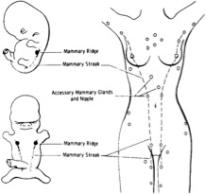
Figure 1 Ectopic breast tissue has been previously reported in various locations along the primitive milk line, from the axilla to the vulva.

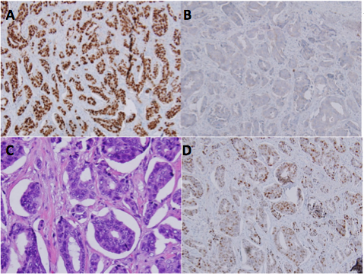
Figure 2 Estrogen receptor staining of primary tumor (A), Her2neu staining of primary tumor (B), metastasis to the lymph node (C), progesterone receptor staining of primary tumor (D).

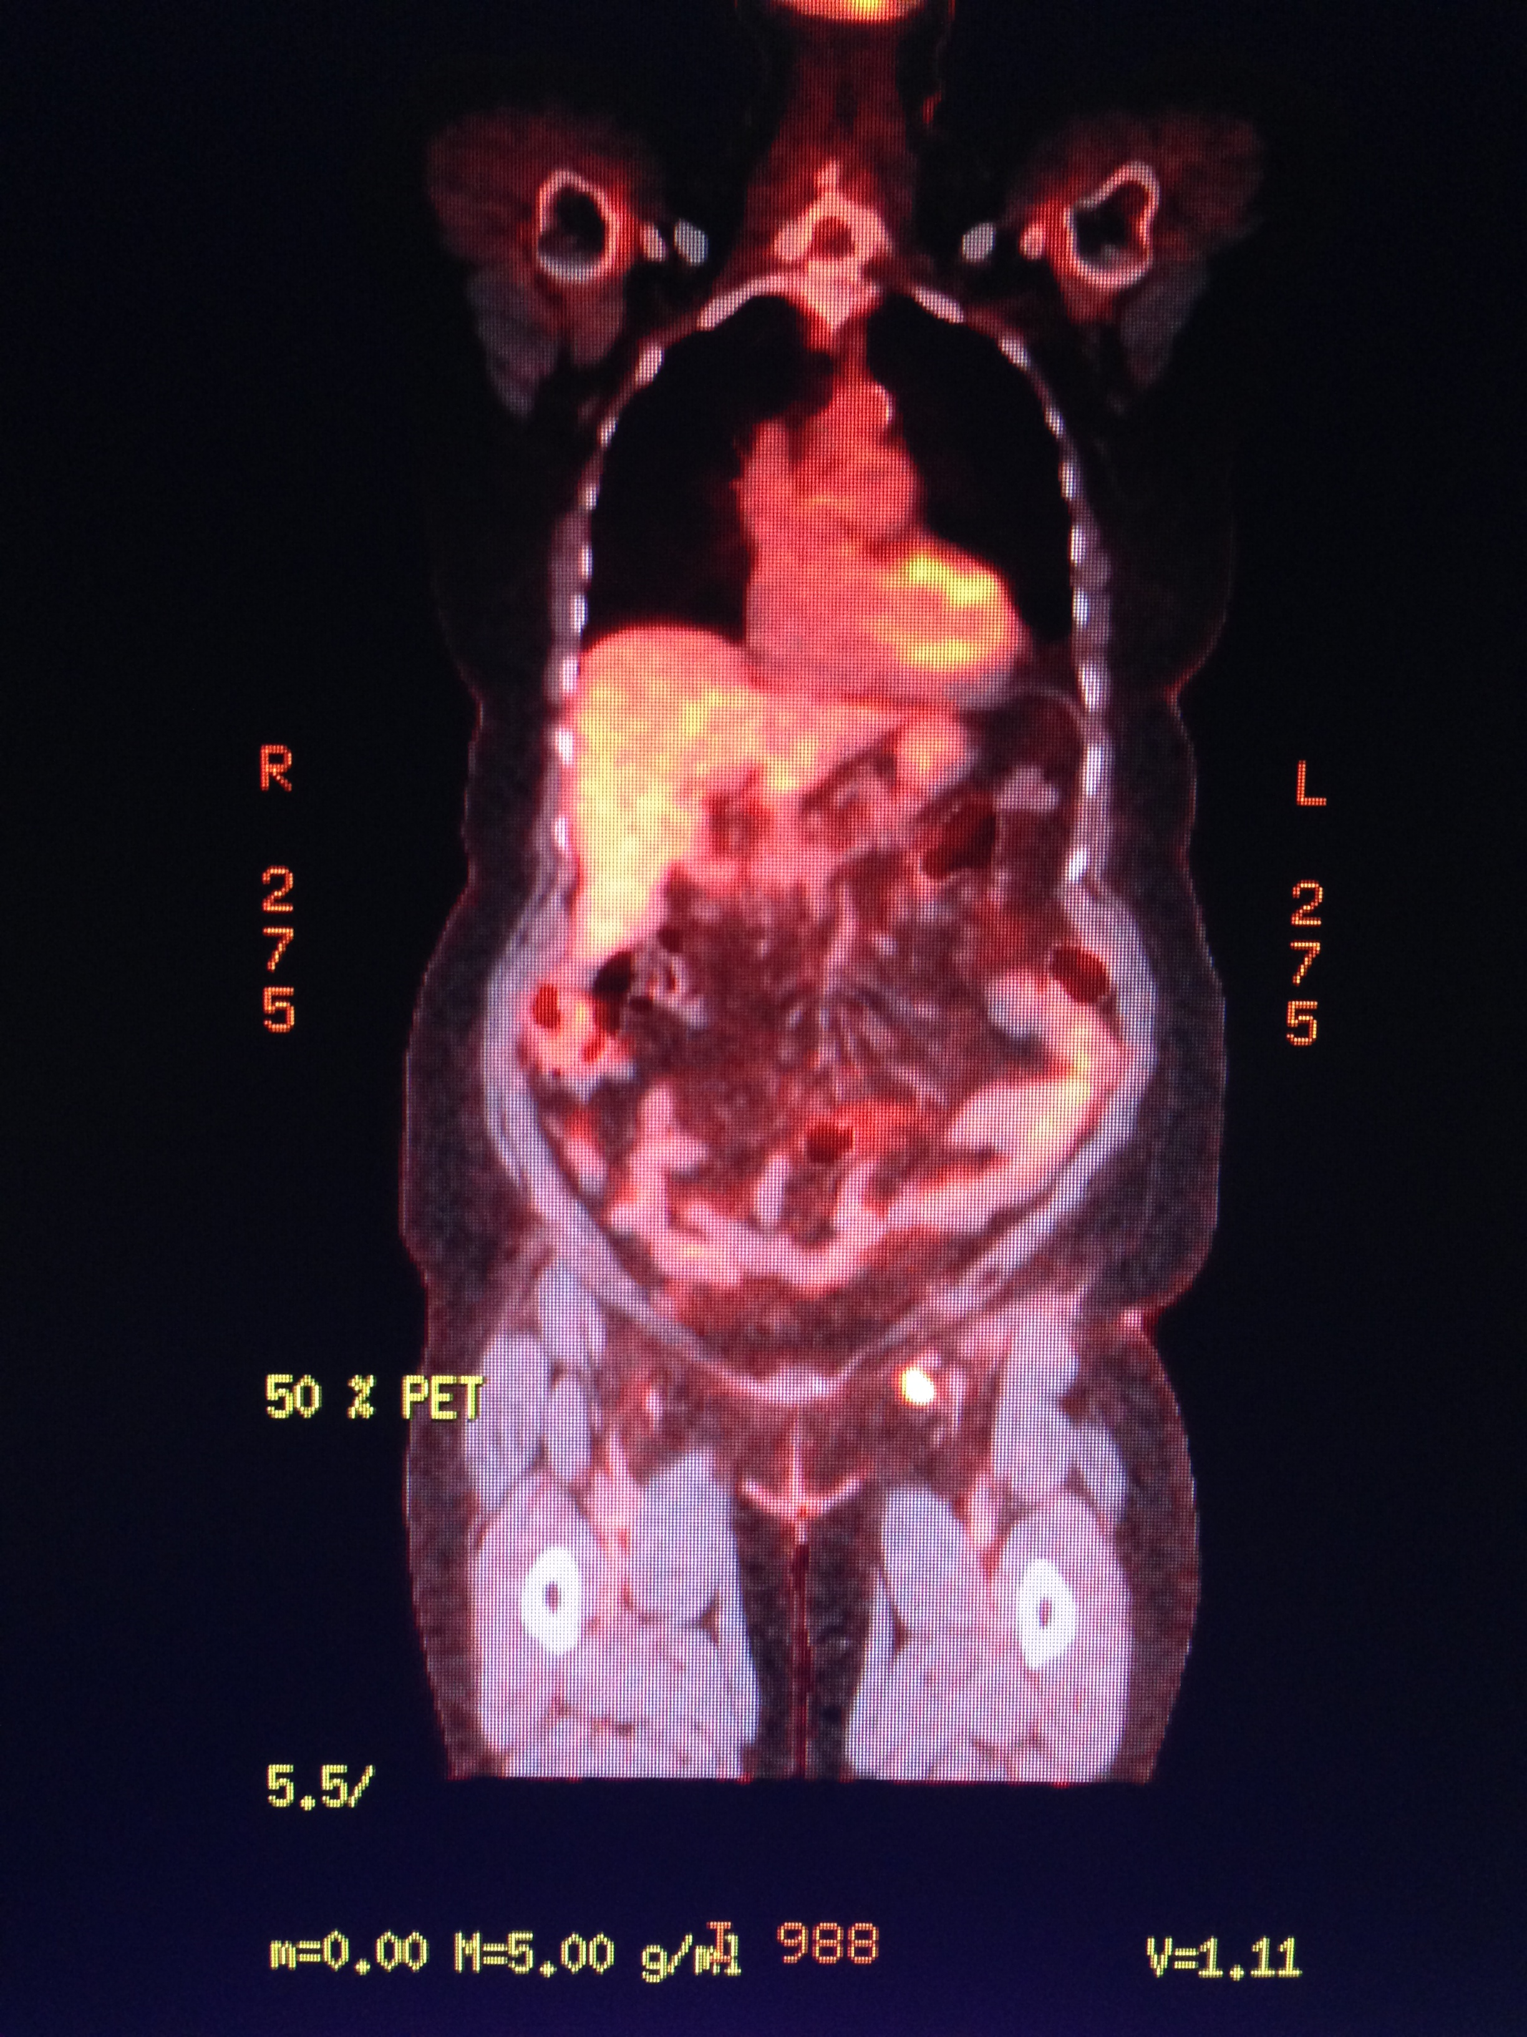

Figure 3 The patient returned to the operating room with preoperative technetium 99 lymphoscintography and lymphazurin blue (injected into the previous left surgical site) lymph node localization.

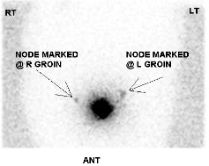
Figure 4 Ectopic breast tissue originates in the fetus at the ectodermal mammary streak extending from the axilla to the groin.

