Name of Journal: World Journal of Clinical Cases
Manuscript NO: 62207
Manuscript Type: ORIGINAL ARTICLE

Retrospective Study
Macular ganglion cell complex injury in different stages of anterior ischemic optic neuropathy

Zhang W et al. mGCC injury in AION

Wei Zhang, Xin-Quan Sun, Xiao-Yan Peng

Wei Zhang, Xiao-Yan Peng, Beijing Tongren Eye Hospital, Capital Medical University, Beijing 100730, China

Wei Zhang, Beijing Aier Intech Eye Hospital, Beijing 100021, China

Xin-Quan Sun, China-Japanese Friendship Hospital, Beijing 100029, China

Author contributions: Sun XQ contributed to the conception of the study; Peng XY designed the work; Zhang W contributed to the acquisition of the data; all authors contributed to the analysis and interpretation of data; Zhang W drafted the initial manuscript; Sun XQ and Peng XY revised the manuscript critically for important intellectual content; All authors have read the manuscript and gave their final approval of the version to be published.

Corresponding author: Xiao-Yan Peng, PhD, Doctor, Professor, Beijing Tongren Eye Hospital, Capital Medical University, No. 1 Dongjiao Min Xiang, Dongcheng District, Beijing 100730, China. drzhangwei2014@163.com

Received: January 1, 2021
Revised: March 4, 2021
Accepted: June 17, 2021
Published online:

Abstract
BACKGROUND
Anterior ischemic optic neuropathy (AION) is a group of ophthalmic diseases in which the optic nerve is injured causing blindness. However, the pathogenesis, clinical manifestations, and clinical treatments of AION are yet elusive. Only a few related experimental or clinical reports are available on the disease. In this study, spectral domain optical coherence tomography (SD-OCT) was used to examine the morphology of thickness swelling and atrophic changes of macular ganglion cell complex (mGCC) in the different stages of AION that were then compared with the visual fields. Thus, the clinical value of mGCC examination was alleged to be similar to that of the visual field.

AIM
To explore the mGCC injury at different stages in AION and the clinical significance.

METHODS
Cases with AION were analyzed in a retrospective study. SD-OCT was used to analyze the correlation between mGCC and peripapillary retinal nerve fiber layer thicknesses at different stages of AION and the changes in the corresponding stages of visual fields.

RESULTS
A total of 21 cases (28 eyes) presented AION. The onset time of AION was defined as early stage (within 3 wk of onset), middle stage (from 3 wk to 2 mo), and late stage (disease span > 2 mo). In the early stage, the mGCC thickness of SD-OCT was within the normal high limit, and the perioptic nerve fibers thickness was more than the normal. The changes in the visual field in early stage were not consistent with the swelling changes in mGCC and peri-disc nerve fibers. In addition, atrophy and thinning appeared in mGCC, and the perioptic nerve fibers were swollen. However, the thickness was lower in the middle period than that in the early stage. The change in visual field was consistent with that of mGCC in this period. In the late stage, mGCC shrank and thinned, and the thickness of the nerve fibers around the optic disc in the corresponding region shrank and thinned.

CONCLUSION
The changes in mGCC thickness in patients with AION showed early, middle, and late stages of development by SD-OCT. Although the early stage visual field changes of AION were not consistent with the swelling changes of mGCC, the horizontal delimitation or annular atrophy of mGCC was consistent with that in the middle and late stage of the disease. The atrophy of peripheral nerve fibers was later than that of the mGCC atrophy.

Key Words: Anterior ischemic optic neuropathy; Macular ganglion cell complex; Visual field; Spectral domain optical coherence tomography; Eyes

Zhang W, Sun XQ, Peng XY. Macular ganglion cell complex injury in different stages of anterior ischemic optic neuropathy. World J Clin Cases 2021; In press

Core Tip: This study to explore the macular ganglion cell complex (mGCC) injury at different stages in anterior ischemic optic neuropathy and the clinical significance. The onset time of anterior ischemic optic neuropathy was defined as early stage, middle stage, and late stage. The early stage visual field changes of anterior ischemic optic neuropathy were not consistent with the swelling changes of mGCC. The horizontal delimitation or annular atrophy of mGCC was consistent with that in the middle and late stage of the disease. The atrophy of peripheral nerve fibers was later than that of the mGCC atrophy.
INTRODUCTION
Anterior ischemic optic neuropathy (AION) is a group of ophthalmic diseases in which the optic nerve is injured causing blindness. Clinical practice is not uncommon. AION can be divided into inflammatory and non-inflammatory diseases according to the causes. However, the pathogenesis, clinical manifestations, and clinical treatments of AION are yet elusive^{[1,2]}. Based on the previous clinical cases, the present study aimed to analyze the changes in ganglion cells, perioptic nerve fibers, and the visual fields in different stages of AION in order to further understand the clinical pathogenesis and pathogenesis of AION. Presently, only a few related experimental or clinical reports are available on the disease^{[3-5]}, which indicates the changes in macular ganglion cell complex (mGCC) thickness as assessed by neuro-ophthalmology and mGCC atrophic injury caused by chiasma opticum, visual radiation, and visual cortical diseases^{[6-9]}. In this study, spectral domain optical coherence tomography (SD-OCT) was used to examine the morphology of thickness swelling and atrophic changes of mGCC in the different stages of AION that were then compared with the visual fields^{[10]}. Thus, the clinical value of mGCC examination was alleged to be similar to that of the visual field.

MATERIALS AND METHODS
Clinical data
A total of 21 cases (28 eyes) of AION including 13 males and 8 females undergoing ambulatory treatment in our hospital from 2012 to 2015 were analyzed in this retrospective study. The age of the patients was 29-69 (average: 50) years. The cohort comprised of 7 binoculus cases and 14 monocular cases (right eye of 14 cases and left eye of 14 cases). Also, 7 bilateral cases of optic nerve atrophy, which occurred months or years ago, were identified at the time of treatment. Almost all cases had different degrees of optic papillary edema. Fundus fluorescein angiography (FFA) results showed that the optic disc had different degrees of fluorescein leakage and optic disc staining in the late stage. In addition to optic disc staining, no abnormalities were detected in the retinal fluorescence angiography. Except for a few cases with severe optic disc edema, staining of the serous retinal detachment was observed in the macular area. Moreover, none of the patients showed optic nerve injury caused by glaucoma, intracranial disease, trauma, heredity, and toxic damage. Also, the patients with AION in this study were not accompanied by inflammatory or non-inflammatory disease. The patients were tested for erythrocyte sedimentation rate, anti-O, G protein reaction, anti-cardiolipin antibody, chest fluoroscopy or radiography, and liver and kidney functions. A majority of the patients presented non-arteritic AION (NAION). However, whether AION has inflammatory or non-inflammatory differentiation was investigated to understand the etiology of the disease and the treatment and prognostic significance. Because the present case had damaged ganglion cells, it was not elucidated clearly. This research was conducted with Beijing Aier Intech Eye Hospital Infirmary Institutional Review Board approval and adhered to the tenets of the Declaration of Helsinki.

Visual field and SD-OCT examination
In this study, 2005 or 2010 Carl Zeiss Meditec visual field analyzer was used for detecting the AION cases. A few cases were treated with OCTOPUS visual field analyzer, and all underwent a 30° central visual field examination. Topcon frequency domain OCT-1000 MARK II was used to analyze the retinal thickness of the macular area, mGCC thickness, and perioptic nerve fiber thickness topographic map (peripapillary retinal nerve fiber layer, pRNFL) on the topographic maps and the probability analysis of the clinically significant lesion, respectively, was conducted. Among them, the mGCC thickness topographic map and the probability analysis of the clinically significant lesion were dominant, followed by the coordinated analysis of macular retinal thickness and pRNFL with the clinically significant lesion probability analysis. The examination time was at the beginning of onset, within 3 wk of onset, from 3 wk to 2 mo after onset, and after 2 mo of onset.

Introduction of typical cases
Case 1: A 58-year-old male patient, due to “binocular vision decline, right eye for 1 wk, and left eye for > 1 year,” visited the hospital. The patient had a history of hypertension, and oral drug was used to regulate the blood pressure. More than a year ago, he had left eye disease and was administered oral hormone, vitamins, and injected nerve growth factor after the treatment of stable visual acuity after discharge. The outpatient ophthalmological examination revealed that the best corrected visual acuity was 0.1 in the right eye and 0.5 in the left eye. Fundus: the right optic disc edema with hemorrhage of the optic disc, macular central light reflex disappeared; the left optic disc was light, the retinal artery was thin, and macular central light reflex disappeared. FFA: right optic disc edema and leakage and double late stage optic disc staining. Visual field and SD-OCT examination is described in Figures 1-3.

Case 2: A 58-year-old female patient visited the hospital because of the requirement of fundus examination. She had a history of Sjögren’s syndrome and was orally administered hormones and immunosuppressive agents for a prolonged period and occasionally hydroxychloroquine. Ophthalmological examination: best corrected visual acuity: binocular 1.0, normal binocular vision field; SD-OCT examination: bilateral mGCC and peripheral optic disc nerve fiber thickness slightly increased. After 8 mo, the patient revisited the hospital because of “left eye sudden inferior visual field occlusion for 2 mo.” After the onset of the disease, the patient did not show any significant improvement in the symptoms after treatment for 2 mo. Best corrected visual acuity: right eye 1.0, left eye 0.2. Medical records and color fundus images obtained from the outside hospital showed edema of the optic disc of the left eye with a small amount of bleeding. The diagnosis of AION by FFA late optic disc leakage staining was conclusive. The SD-OCT examination is described in Figure 4.

RESULTS
Examination results of visual field and SD-OCT in patients with AION at different stages
The onset time of AION was defined as early stage (within 3 wk of onset), middle stage (course of disease of 3 wk to 2 mo), and late stage (course of disease > 2 mo). The visual field of 28 eyes from 21 patients with AION showed the level or quadrant defect associated with the optic disc, and SD-OCT showed different changes at various time points. The examination results of the visual field and SD-OCT in 28 eyes of 21 patients with AION were summarized as follows:
Early stage: the visual acuity of the affected eyes decreased markedly, the visual field disappeared sharply, and the FFA late optic disc was stained. The mGCC thickness of SD-OCT was within the normal high limit. The perioptic nerve fiber thickness exceeded the normal thickness. The early visual field changes were not consistent with the mGCC and swelling changes in the peridisc nerve fibers.
Medium stage: visual acuity and visual field improved slightly. mGCC showed partial atrophy and thinning (exhibiting horizontal suture or a ring). Although the nerve fibers surrounding the optic disc were swollen, the thickness was lower than that in the early stage. The change in the visual field was consistent with the altered mGCC.
Late stage: the visual acuity and visual field changes were stable. mGCC shrank and thinned, and the thickness of the nerve fibers around the optic disc shrank in the corresponding area. The visual field changes were consistent with that of mGCC.

Examination results of SD-OCT in contralateral normal eyes of AION
The contralateral non-diseased eye visual field was normal in 19/21 cases with AION in this study. However, SD-OCT revealed that the mGCC and pRNFL thicknesses were in the high or partially high limit of the normal range, and the FFA late optic disc was stained. Therefore, we proposed the concept of “subnormal eyes.” It is characterized by bilateral mGCC swelling (in normal high limit range or beyond high limit thickness) and pRNFL swelling (referring to high or beyond high thickness in normal range). Also, the visual acuity and visual field were found to be normal or stable [thickness of ganglion cell layer (GCL) + inner plexus layer (IPL) and RNFL at different stages, Table 1 and Figure 5].

DISCUSSION
Concept of “subnormal eye” in the SD-OCT examination of mGCC
A total of 50% of the retinal ganglion cells (RGC) were concentrated in the macular area, especially in the annular area around the central fovea of the macula. The thickness of mGCC demonstrated that the thickness in the annular area was almost evenly distributed, showing a yellowish ring. However, the temporal thickness of the ring was slightly thicker than that of the nasal side. The ring appearing intensely red from reddish-pink-crimson indicated that the mGCC thickness was gradually increasing. The “subnormal eye” was a clinical phenomenon often observed by the authors during mGCC examination based on the four main features: bilateral mGCC swelling thickening or normal high limit range; bilateral optic disc nerve fiber swelling thickening or normal high limit range; bilateral FFA late optic disc staining; and visual field was normal or stable (clinical disease cured eyes). The subnormal eyes may represent the preclinical latent state of mGCC swelling-related ophthalmopathy (such as fundus disease, optic nerve disease, and glaucoma)^{[11-18]}.

Requirements and precautions for mGCC examination by SD-OCT
The SD-OCT examination of patients with AION includes three parts of thickness images: macular retinal thickness map; mGCC layer thickness map (mGCC); and pRNFL image. AION are diseases of ganglion cell axons, and axon injury is the primary lesion. The swelling of the neuronal bodies is secondary to axonal lesions. In the case of severe axon injury, the axoplasmic flow is blocked. Over a period, the ganglion cell bodies degenerate leading to apoptosis, followed by atrophy and thinning, and finally the corresponding non-functional swelling axons shrink and thin consecutively. The three images are obtained simultaneously, and then the sequence of these causality injuries is analyzed and matched. In addition, high quality and high definition are required to reduce the error caused by the image.
The probabilistic analysis of the clinical significance of mGCC figure: RNFL (retinal nerve fiber thickness in macular area), GCL + (representing the thickness of the GCL and the IPL, GCL + IPL), GCL++ (representing the thickness of GCL and RNFL added together, which is the thickness of the three layers of the entire ganglion cell). Strikingly, GCL++ constitutes the addition of the three layers in an algebraic sum. Nonetheless, if GCL+ is slightly damaged (probability chart shows yellow as dominant) and RNFL shows swelling and thickening, then GCL++ is normal as swelling thickening and slight shrinking thinning counteract each other. Kupersmith et al^{[8]} also reported RGC layer thinning within 1 mo of NAION. Acute optic nerve injury, such as NAION, where swelling obscures early demonstration of RNFL thinning, the GCL and the inner plexiform layer are severely unaffected, providing a reliable measure of retinal neuronal structure with three-dimensional segmentation. Thinning within 1 mo to 2 mo of onset is before the RNFL swelling subsides. Before 1 mo of NAION, the RGC body was lost and atrophy or the dendritic arborizations was reduced. After 1 mo, RNFL thickness measurements partially reflected the loss and thinning of affected axons. By 3 mo, most eyes showed thinning of RNFL, while the thinning of GCL + IPL essentially ceased. These data suggest that RNFL subclinical edema or swelling lasts for at least 3 mo. This suggests that GCL + IPL measurement is superior to RNFL thickness as a biomarker for early structural loss of NAION^{[8]}.
Scanning laser polarimetry (SLP) is based on the delay of irradiation of polarized light by intracellular organelles in parallel tissues in the axons of RGCs and has been used for RNFL measurements in other different optic neuropathy. The comparison of OCT and SLP suggests that the diagnostic validity of SLP may be superior to OCT in terms of RNFL measurement. SD-OCT and SLP with high sensitivity and specificity for RNFL retinal imaging may be an additional tool for the diagnosis optic neuropathy^{[19]}.

Correlation between mGCC and visual field examination
The SD-OCT examination is objective and non-injurious and can be widely used in the clinical examination. Also, it is more reliable than the visual field, which is also indispensable^{[20,21]}. Because the change in the visual field occurs before the mGCC shrinks (Figure 1), both should be confirmed for accuracy and reliability. Figure 1 shows that in the early stage of the onset of the disease, mGCC was at the stage of swelling thickening or normal thickness high limit stage (before atrophy), and the visual field was changed. Thus, the visual field examination of this stage was critical and indispensable. However, during the middle and late stages of the disease, both visual field and mGCC were abnormal (mGCC appeared horizontal or circular, ring-shaped, or vertical line demarcation atrophy) with location-based diagnostic value. When mGCC showed bilateral atrophy of the midvertical line, it could objectively locate the lesion of optic chiasma. Interestingly, when mGCC displayed the atrophy of the midperpendicular line, the lesion could be located in the relevant area of the posterior optic pathway (optic bundle, visual radiation, and visual cortex).Furthermore, when the horizontal suture or similar circle occurred in mGCC, the atrophy of the annular central area indicated the location of the lesion in the anterior optic nerve segment of the optic disc-optic chiasma. The mGCC examination is a valuable method for clinical diagnosis and differential diagnosis of diseases, especially for patients who could not complete the visual field examination. The case in Figure 1 also showed that some of the ganglion cells in the swelling stage of mGCC have some functions, while some had no function, even if the vision and visual field were abnormal. Thus, if the cause of the disease was removed immediately, at least partial visual acuity and visual field might be restored.

Clinical differential diagnosis
The mGCC of AION showed horizontal atrophy. In addition, the visual field showed vascular and nerve tract defects or horizontal defect, which was associated with glaucoma with similarities in the changes in the visual field of the late normal intraocular pressure glaucoma and the patients with retinal artery occlusion at convalescent stage. Furthermore, the intraocular pressure level and intraocular pressure fluctuation necessitate further exploration to repeatedly measure the intraocular pressure curve for 24 h. In the recovery stage of retinal artery occlusion, atrophy of retinal inner layer must exist, that is, atrophy of retinal bipolar cell layer and GCL at the same time, while atrophy of GCL only exists in AION.

CONCLUSION
The altered mGCC thickness in patients with AION was examined by SD-OCT. It reflected the early mGCC swelling in the cases with AION (subnormal eye stage in the early stage of clinical onset), horizontal boundary atrophy thinning in the middle stage mGCC (metaphase segregation), and peripheral optic nerve fibers atrophied with the corresponding mGCC in the late stage (late clinical stable atrophy stage). The clinical three stages, except the early stage, coincided with the change in the visual field. Furthermore, visual field and mGCC examination exhibit specific and indispensable functions.

ARTICLE HIGHLIGHTS
Research background
Presently the changes of macular ganglion cell complex (mGCC) thickness were assessed for neuro-ophthalmology and mGCC atrophic injury caused by chiasma opticum, visual radiation, and visual cortical diseases. This study aimed to explore the mGCC injury at different stages in anterior ischemic optic neuropathy (AION) and the clinical significance.

Research motivation
The pathogenesis, clinical manifestations, and clinical treatments of AION are yet elusive. The spectral domain optical coherence tomography examination is objective and non-injurious and can be widely used in the clinical examination of the AION.

Research objectives
Through study, the mGCC injury was different at the stages in AION. The most severe ganglion cell layer + inner plexus layer thinning occurred early when potential neuroprotective or protective therapy must be provided before 3 wk to reduce retinal ganglion cells loss.

Research methods
Ganglion cell layer plus inner plexiform layer is acutely unaffected in the early inflammatory edema stage of the AION and provides a reliable method to measure the structure of retinal neurons using optical coherence tomography 3D segmentation.

Research results
The “subnormal eye” was put forward as a clinical phenomenon often observed by the authors during mGCC examination. The onset time of AION was defined as early stage (within 3 wk of onset), middle stage (course of disease of 3 wk to 2 mo), and late stage (course of disease > 2 mo).

Research conclusions
The ganglion cell layer + inner plexus layer segmentation measurement of the spectral domain optical coherence tomography was superior to RNFL thickness as a biomarker for early structural loss in nerve ophthalmology.

Research perspectives
The mGCC analysis can be widely used in the study of nerve ophthalmology.

ACKNOWLEDGEMENTS
Thank you to our scientific research team, Professor Gu W, Professor Liang J, Doctor An N, Doctor Zhang X, my family, Ms. Bi DG and my lovely daughter Anne.

REFERENCES
1 Syc SB, Saidha S, Newsome SD, Ratchford JN, Levy M, Ford E, Crainiceanu CM, Durbin MK, Oakley JD, Meyer SA, Frohman EM, Calabresi PA. Optical coherence tomography segmentation reveals ganglion cell layer pathology after optic neuritis. Brain 2012; 135: 521-533 [PMID: 22006982 DOI: 10.1093/brain/awr264]
2 Ho JK, Stanford MP, Shariati MA, Dalal R, Liao YJ. Optical coherence tomography study of experimental anterior ischemic optic neuropathy and histologic confirmation. Invest Ophthalmol Vis Sci 2013; 54: 5981-5988 [PMID: 23887804 DOI: 10.1167/iovs.13-12419]
3 Cho JW, Sung KR, Lee S, Yun SC, Kang SY, Choi J, Na JH, Lee Y, Kook MS. Relationship between visual field sensitivity and macular ganglion cell complex thickness as measured by spectral-domain optical coherence tomography. Invest Ophthalmol Vis Sci 2010; 51: 6401-6407 [PMID: 20631238 DOI: 10.1167/iovs.09-5035]
4 Kardon RH. Role of the macular optical coherence tomography scan in neuro-ophthalmology. J Neuroophthalmol 2011; 31: 353-361 [PMID: 22089499 DOI: 10.1097/WNO.0b013e318238b9cb]
5 Shon K, Sung KR. Assessment of macular ganglion cell loss patterns in neurologic lesions that mimic glaucoma. Korean J Ophthalmol 2014; 28: 314-322 [PMID: 25120340 DOI: 10.3341/kjo.2014.28.4.314]
6 Kupersmith MJ, Garvin MK, Wang JK, Durbin M, Kardon R. Retinal ganglion cell layer thinning within one month of presentation for optic neuritis. Mult Scler 2016; 22: 641-648 [PMID: 26362894 DOI: 10.1177/1352458515598020]
7 Gonul S, Koktekir BE, Bakbak B, Gedik S. Comparison of the ganglion cell complex and retinal nerve fibre layer measurements using Fourier domain optical coherence tomography to detect ganglion cell loss in non-arteritic anterior ischaemic optic neuropathy. Br J Ophthalmol 2013; 97: 1045-1050 [PMID: 23759443 DOI: 10.1136/bjophthalmol-2013-303438]
8 Kupersmith MJ, Garvin MK, Wang JK, Durbin M, Kardon R. Retinal Ganglion Cell Layer Thinning Within One Month of Presentation for Non-Arteritic Anterior Ischemic Optic Neuropathy. Invest Ophthalmol Vis Sci 2016; 57: 3588-3593 [PMID: 27388052 DOI: 10.1167/iovs.15-18736]
9 Koh VT, Tham YC, Cheung CY, Wong WL, Baskaran M, Saw SM, Wong TY, Aung T. Determinants of ganglion cell-inner plexiform layer thickness measured by high-definition optical coherence tomography. Invest Ophthalmol Vis Sci 2012; 53: 5853-5859 [PMID: 22836772 DOI: 10.1167/iovs.12-10414]
10 Fisher JB, Jacobs DA, Markowitz CE, Galetta SL, Volpe NJ, Nano-Schiavi ML, Baier ML, Frohman EM, Winslow H, Frohman TC, Calabresi PA, Maguire MG, Cutter GR, Balcer LJ. Relation of visual function to retinal nerve fiber layer thickness in multiple sclerosis. Ophthalmology 2006; 113: 324-332 [PMID: 16406539 DOI: 10.1016/j.ophtha.2005.10.040]
11 Na JH, Kook MS, Lee Y, Baek S. Structure-function relationship of the macular visual field sensitivity and the ganglion cell complex thickness in glaucoma. Invest Ophthalmol Vis Sci 2012; 53: 5044-5051 [PMID: 22700706 DOI: 10.1167/iovs.11-9401]
12 Walter SD, Ishikawa H, Galetta KM, Sakai RE, Feller DJ, Henderson SB, Wilson JA, Maguire MG, Galetta SL, Frohman E, Calabresi PA, Schuman JS, Balcer LJ. Ganglion cell loss in relation to visual disability in multiple sclerosis. Ophthalmology 2012; 119: 1250-1257 [PMID: 22365058 DOI: 10.1016/j.ophtha.2011.11.032]
13 Aggarwal D, Tan O, Huang D, Sadun AA. Patterns of ganglion cell complex and nerve fiber layer loss in nonarteritic ischemic optic neuropathy by Fourier-domain optical coherence tomography. Invest Ophthalmol Vis Sci 2012; 53: 4539-4545 [PMID: 22678499 DOI: 10.1167/iovs.11-9300]
14 Hood DC, Raza AS, de Moraes CG, Liebmann JM, Ritch R. Glaucomatous damage of the macula. Prog Retin Eye Res 2013; 32: 1-21 [PMID: 22995953 DOI: 10.1016/j.preteyeres.2012.08.003]
15 Raza AS, Cho J, de Moraes CG, Wang M, Zhang X, Kardon RH, Liebmann JM, Ritch R, Hood DC. Retinal ganglion cell layer thickness and local visual field sensitivity in glaucoma. Arch Ophthalmol 2011; 129: 1529-1536 [PMID: 22159673 DOI: 10.1001/archophthalmol.2011.352]
16 Takagi ST, Kita Y, Yagi F, Tomita G. Macular retinal ganglion cell complex damage in the apparently normal visual field of glaucomatous eyes with hemifield defects. J Glaucoma 2012; 21: 318-325 [PMID: 21423034 DOI: 10.1097/IJG.0b013e31820d7e9d]
17 Mwanza JC, Durbin MK, Budenz DL, Sayyad FE, Chang RT, Neelakantan A, Godfrey DG, Carter R, Crandall AS. Glaucoma diagnostic accuracy of ganglion cell-inner plexiform layer thickness: comparison with nerve fiber layer and optic nerve head. Ophthalmology 2012; 119: 1151-1158 [PMID: 22365056 DOI: 10.1016/j.ophtha.2011.12.014]
18 Green AJ, McQuaid S, Hauser SL, Allen IV, Lyness R. Ocular pathology in multiple sclerosis: retinal atrophy and inflammation irrespective of disease duration. Brain 2010; 133: 1591-1601 [PMID: 20410146 DOI: 10.1093/brain/awq080]
19 Garas A, Simó M, Holló G. Nerve fiber layer and macular thinning measured with different imaging methods during the course of acute optic neuritis. Eur J Ophthalmol 2011; 21: 473-483 [PMID: 21038310 DOI: 10.5301/EJO.2010.5844]
20 Rebolleda G, Sánchez-Sánchez C, González-López JJ, Contreras I, Muñoz-Negrete FJ. Papillomacular bundle and inner retinal thicknesses correlate with visual acuity in nonarteritic anterior ischemic optic neuropathy. Invest Ophthalmol Vis Sci 2015; 56: 682-692 [PMID: 25587057 DOI: 10.1167/iovs.14-15314]
21 Kupersmith MJ, Kardon R, Durbin M, Horne M, Shulman J. Scanning laser polarimetry reveals status of RNFL integrity in eyes with optic nerve head swelling by OCT. Invest Ophthalmol Vis Sci 2012; 53: 1962-1970 [PMID: 22410562 DOI: 10.1167/iovs.11-9339]

Footnotes
Institutional review board statement: This study was reviewed and approved by the Institutional Ethical Review Boards of Beijing Aier Intech Eye Hospital, Beijing, China.

Informed consent statement: Informed consent statement was waived.

Conflict-of-interest statement: The authors declare that they have no competing interests.

Data sharing statement: No additional data are available.

Open-Access: This article is an open-access article that was selected by an in-house editor and fully peer-reviewed by external reviewers. It is distributed in accordance with the Creative Commons Attribution NonCommercial (CC BY-NC 4.0) license, which permits others to distribute, remix, adapt, build upon this work non-commercially, and license their derivative works on different terms, provided the original work is properly cited and the use is non-commercial. See: http://creativecommons.org/Licenses/by-nc/4.0/

Manuscript source: Unsolicited manuscript

Peer-review started: January 1, 2021
First decision: January 24, 2021
Article in press:

Specialty type: Medicine, research and experimental
Country/Territory of origin: China
Peer-review report’s scientific quality classification
Grade A (Excellent): 0
Grade B (Very good): B
Grade C (Good): 0
Grade D (Fair): 0
Grade E (Poor): 0

P-Reviewer: Hollo G S-Editor: Gao CC L-Editor: Filipodia P-Editor:

Figure Legends
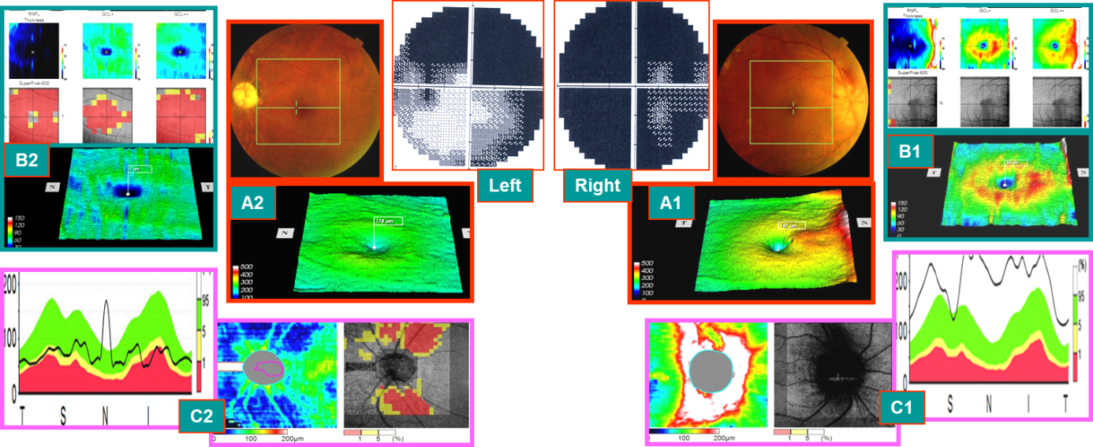
Figure 1 With visual acuity of 0.1 and 0.5 on May 12, 2014 (typical case 1: early onset). Right eye: 1 wk after onset, subnormal eyes of early onset (within 3 wk of onset) and visual field defect of the acute stage. The left eye had attacks more than a year ago, and the disease is now stable (stable atrophy stage) and visual field defect of stable atrophy phase. A: The retinal thickness of the macular area in the eyes, and the right eye had color fundus. Edema of optic disc with hemorrhage, edema affected retinal thickening in the macular area, and an intense yellow ring was observed around the macula (A1). In the left eye, the color fundus phase had the light color of the optic disc, indicating the atrophy of the optic nerve (A2). The macular retinal thickness phase lost the yellow ring around the central fovea; B: Binocular macular ganglion cell complex (mGCC) thickness topographic map and meaningful lesion probability map and the right eye revealed the ring of mGCC, indicating red thickening and swelling period but slightly on the above part and retinal nerve fiber layer (right) of the lesion probability map. GCC (middle), GCC++ showed normal phenotype (B1). (B2) shows that peripheral mGCC ring shape of the macular center disappeared, which was in accordance with the findings in (A2). The probability figure of the lesion showed the central macular red atrophy thinning area, and retinal nerve fiber layer and ganglion cell layer++ (retinal nerve fiber layer + retinal ganglion cells + inner plexus layer) were almost all red thinning areas. Ganglion cell layer + (retinal ganglion cells + inner plexus layer) was only severely damaged in the central fovea of the macula; C: The thickness of the nerve fibers around the optic disc of the eyes and the probability of the lesion in the eyes. The right eye indicated that the optic disc had edema, and the peripheral nerve fibers were swollen and thicker than that of the normal high limit. The mGCC swelling of the fundus in this stage was thicker than that of the normal fundus, which could not be explained due to severe horizontal visual field defects in the upper and lower parts. This suggested that visual field changes occur before mGCC atrophy. The swollen mGCC was a mixture of functional and nonfunctional cells, and a small fraction of the visual field disappeared that could be restored with a healing process (C1). The left eye showed that the nerve fibers around the optic disc were shrunk and thinned, and the arch area of the superior and temporal vessels of the optic disc was severe, which was consistent with the changes in the horizontal defect of the upper and lower side of the left visual field (even less perfect at the lower level) (C2).
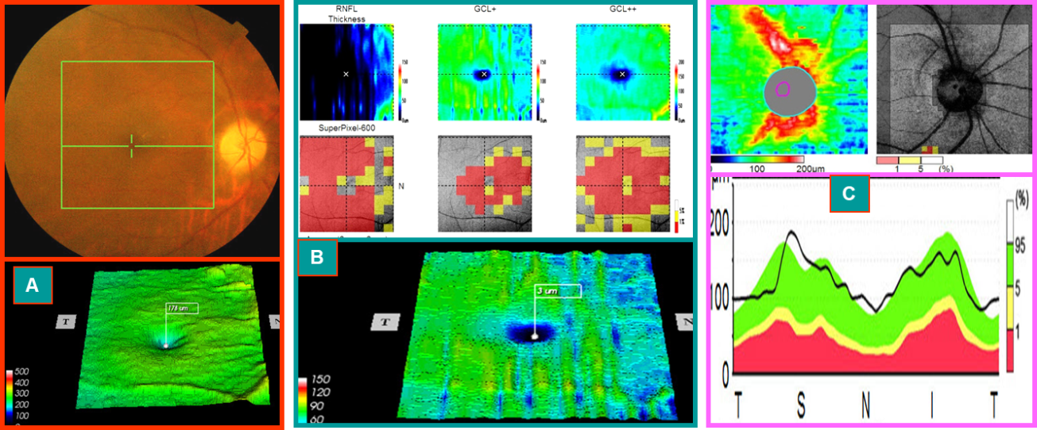
Figure 2 The mid-stage progression of the right eye and segregation phase (optical coherence tomography image at 1 mo after the onset of this case) (On June 9, 2014, typical case 1). A: The optical disk was lighter, the boundary was distinct, and the circular area around the fovea of the macula had disappeared (obviously different from that of Figure 1A1); B: Macular ganglion cell complex ring disappeared, and three probabilistic maps (retinal nerve fiber layer, retinal ganglion cells + inner plexus layer, retinal nerve fiber layer + retinal ganglion cells + inner plexus layer) showed central red damage, which coincided with that of (A); C: The nerve fibers around the optic disc were swollen and thickened, and a few were beyond the normal high limit. The macular ganglion cell complex shrank and thinned. However, the nerve fibers around the optic disc were still swollen (swelling of the axons of the superficial ganglion cells), which occurred only 3 wk after onset and is known as the stage of progression-separation phenomenon in the middle stage of the onset. Moreover, the patient’s vision and visual field improved with treatment during this period.
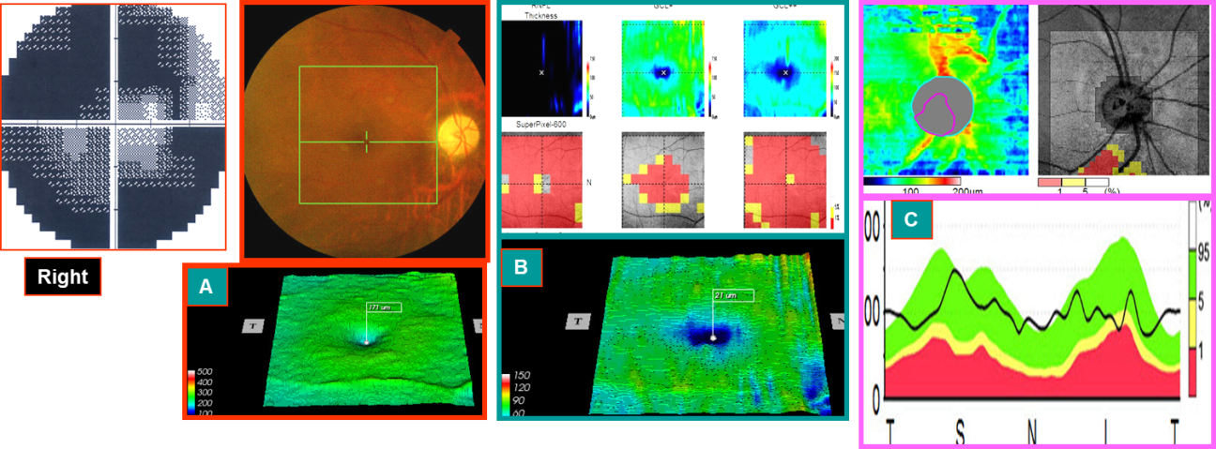
Figure 3 August 11, 2014, the stable atrophy of right eye in the late stage of onset (3 mo after onset): visual acuity was 0.5 (typical case 1). A and B: Compared to Figure 2A and 2B, more shrinking and thinning were observed; C: Compared to Figure 2C, the nerve fibers around the optic disc were shrunk and thinned, especially in the lower part. This was consistent with the visual field showing that the horizontal defect above was more severe than the horizontal defect at the bottom. Right eye visual field: compared to that of the early stage of onset, the central area expanded. Hence, the visual acuity increased. The visual field of the left eye did not change before and after treatment.
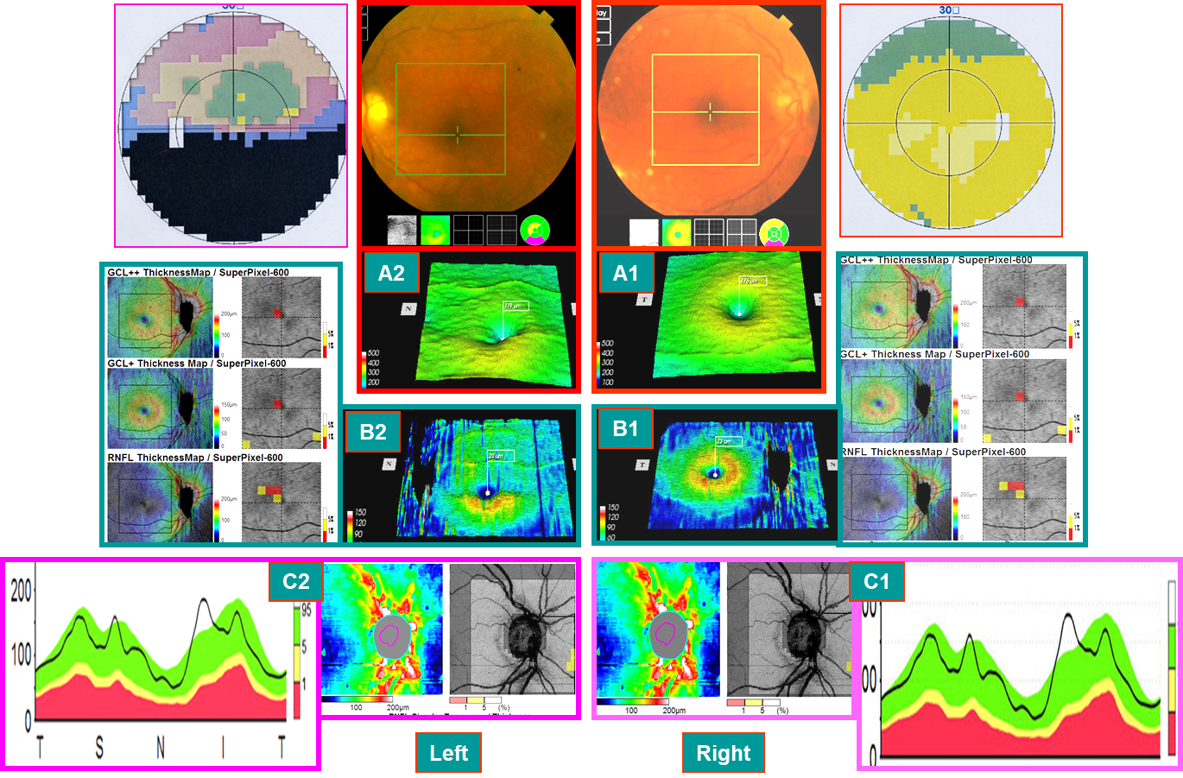
Figure 4 Sjögren’s syndrome patient on September 3, 2014 (typical case 2). Hormones and immunosuppressants were administered to control the stability of the condition, and both eyes were subnormal by 3D-optical coherence tomography examination on December 31, 2013. A-C: Preclinical or latent subnormal eye of the right eye. The mGCC (A1 and B1) and the thickness of the nerve fibers around the optic disc (C1) were swollen and thickened, and no clinical symptoms were found. Late atrophy of the left eye AION disease (2 mo after onset): The mGCC delineated by horizontal sutures above the macular area were shrunk (A2 and B2), and optic disc showed a superior temporal nerve fiber atrophy (C2), which was consistent with that of the horizontal defect below the visual field. However, the mGCC under the macula of the left eye and thickness of the nerve fibers beneath the optic disc were still swollen and thickened (A2-C2). However, some nerve tract defects were noted above the field of vision, suggesting that the time may not be stable and might alter with the treatment.
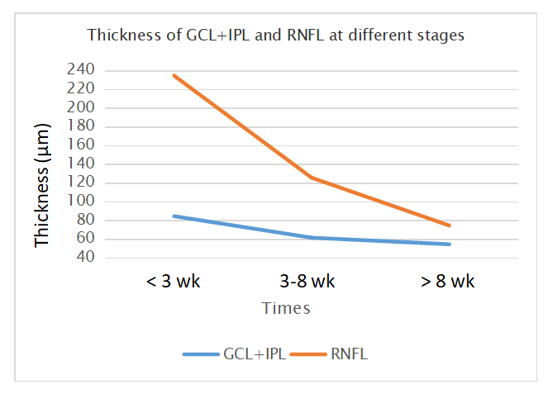
Figure 5 Thickness of ganglion cell layer + inner plexus layer and retinal nerve fiber layer at different stages. GCL: Ganglion cell layer; IPL: Inner plexus layer; RNFL: Retinal nerve fiber layer.
Table 1 Thickness of ganglion cell layer + inner plexus layer and retinal nerve fiber layer at different stages
 | Thickness in μm | < 3 wk | 3-8 wk | > 8 wk
Affected eyes | GCL + IPL | 85 ± 8 | 62 ± 10 | 55 ± 11
 | RNFL | 235 ± 72, ﻿﻿P = 0.001 | 126 ± 45, P = 0.03 | 75 ± 9, P = 0.095
Unaffected eyes | GCL + IPL | 89 ± 6 | 89 ± 6 | 88 ± 5
 | RNFL | 99 ± 11 | 98 ± 11 | 100 ± 12
GCL: Ganglion cell layer; IPL: Inner plexus layer; RNFL: Retinal nerve fiber layer.

