Name of Journal: World Journal of Clinical Cases
Manuscript NO: 65828
Manuscript Type: EDITORIAL

Advances in deep learning for computed tomography denoising

Park SB. Deep learning-based CT images denoising

Sung Bin Park

Sung Bin Park, Department of Radiology, Chung-Ang University Hospital, Seoul 06973, South Korea

Author contributions: Park SB solely contributed to this paper.

Corresponding author: Sung Bin Park, MD, PhD, Chief Physician, Full Professor, Department of Radiology, Chung-Ang University Hospital, 102, Heukseok-ro, Dongjak-gu, Seoul 06973, South Korea. pksungbin@paran.com

Received: March 16, 2021
Revised: May 12, 2021
Accepted: August 17, 2021
Published online: September 16, 2021

Abstract
Computed tomography (CT) has seen a rapid increase in use in recent years. Radiation from CT accounts for a significant proportion of total medical radiation. However, given the known harmful impact of radiation exposure to the human body, the excessive use of CT in medical environments raises concerns. Concerns over increasing CT use and its associated radiation burden have prompted efforts to reduce radiation dose during the procedure. Therefore, low-dose CT has attracted major attention in the radiology, since CT-associated x-ray radiation carries health risks for patients. The reduction of the CT radiation dose, however, compromises the signal-to-noise ratio, which affects image quality and diagnostic performance. Therefore, several denoising methods have been developed and applied to image processing technologies with the goal of reducing image noise. Recently, deep learning applications that improve image quality by reducing the noise and artifacts have become commercially available for diagnostic imaging. Deep learning image reconstruction shows great potential as an advanced reconstruction method to improve the quality of clinical CT images. These improvements can provide significant benefit to patients regardless of their disease, and further advances are expected in the near future.

Key Words: Denoising; Deep learning; Computer-assisted imaging processing; Iterative reconstruction; Radiation dose

©The Author(s) 2021. Published by Baishideng Publishing Group Inc. All rights reserved.

Citation: Park SB. Advances in deep learning for computed tomography denoising. World J Clin Cases 2021; 9(26): 7614-7619
URL: https://www.wjgnet.com/2307-8960/full/v9/i26/7614.htm
DOI: https://dx.doi.org/10.12998/wjcc.v9.i26.7614

Core Tip: Early application of deep learning techniques have shown success in the denoising of computed tomography (CT) images, especially low-dose CT images, and future advances are expected to provide additional benefit.

INTRODUCTION
In radiography, decreases in radiation dosage result in the debasement of image quality, basically due to an increment in image noise^{[1]}. Increased image noise can compromise the diagnostic performance of computed tomography (CT) images. Hence, much exertion has been invested in designing image processing techniques that reduce image noise. By applying data handling and image reconstruction methods that diminish image noise whereas keeping up spatial resolution, it is conceivable to move forward the quality and diagnostic value of low-dose CT (LDCT) images, which are inherently noisy^{[2]}. Recently, deep learning (DL) techniques have been increasingly applied to many aspects of medical imaging and are showing promise as an effective solution for the problem of noise^{[3-5]}. This is particularly true in their application to denoising CT images, where DL techniques have appeared noteworthy performance in moving forward imaging quality by noise suppression, structural preservation, and lesion detection^{[1,6]}.

CT use and radiation hazard
CT has seen a rapid increase in use in recent years^{[2,7,8]}. Radiation from CT accounts for a significant proportion of total medical radiation. However, given the known harmful impact of radiation exposure to the human body, the excessive use of CT in medical environments raises concerns^{[7]}. Concerns over increasing CT use and its associated radiation burden have prompted efforts to reduce radiation dose during the procedure^{[9-11]}.

LDCT imaging
Recently, LDCT has attracted significant interest in the radiography community^{[8,12,13]}. Several approaches can be used to reduce radiation exposure as follows: avoiding unnecessary examinations and superfluous acquisitions; optimizing CT acquisition parameters (i.e., lowering tube voltage or current and pitch); routinely using size adaptation techniques, such as automatic tube current modulation; and progressing the postprocessing and reconstruction of CT images^{[2]}. In any case, the diminishment of radiation dosage increases noise and presents artifacts in reconstructed images^{[7,8]}. In other words, reductions in radiation dose lead to decreases in image quality, which may adversely affect diagnosis using LDCT images^{[1,8]}. Therefore, much exertion has been made to plan better image processing techniques that can further diminish image noise after image capture^{[1]}.

Denoising of CT imaging
Image noise reduction, generally called “image denoising,” is an important but challenging task. In the midst of the denoising handle, the noise component must be expelled without debasing the true signal component^{[14]}. Clinical applications with characteristic high-contrast abnormalities (e.g., CT for urolithiasis, CT enterography) can accomplish noteworthy dosage decreases by applying denoising strategies (Figure 1)^{[2,12]}. In low-contrast cases, such as detection of metastases in solid organs, dose reduction is considerably more restricted by loss of lesion conspicuity due to a loss of low-contrast spatial resolution and coarsening of noise texture^{[2]}.
Noise reduction algorithms for LDCT can be categorized into three types: (1) handling the raw data gotten from sinogram (projection space denoising); (2) iterative reconstruction (IR) strategies; and (3) handling reconstructed CT image (image space denoising)^{[2,8,13]}.
In projection space denoising, the noise expulsion algorithm is connected to the CT sinogram information gotten from low-dose CT. These strategies join system physics and photon statistics to diminish both image noise and artifacts. In any case, this process uses an algorithm supplied by the vendor. These strategies too require get to sinogram information, which isn’t accessible for commercial CT scanners. At last, these procedures ought to be actualized within the scanner reconstruction system, which increments the taken a toll of denoising^{[2]}.
IR strategies refer to another group of techniques to make strides the image quality of LDCT. For the past 30 years, filtered back-projection (FBP) has been the prevailing strategy of reconstruction due to its computational proficiency and precision. FBP requires noteworthy amounts of high-quality projection data to get precise reconstructions^{[15]}. At low-dose settings, challenges emerge with increased image noise and artifacts. Thus, IR was presented to overcome these restrictions of FBP (Figure 1). These methods consider the system model geometry, photon counting statistics, as well as the x-ray beam spectrum. They generally beat projection space denoising strategies. They can expel artifacts and give great spatial resolution. Be that as it may, like projection space denoising, they require get to the projection information, are vendor subordinate, and ought to be actualized on the reconstruction system of the scanner. Additionally, images with high reconstruction strength levels (Figure 1) have a waxy, plastic-looking unfamiliar noise texture or blotchy, unnatural appearance^{[2,15,16]}. It influences the assessment of CT scan images, and apparently, the interpretation of imaging findings^{[17]}.
In contrast to these first two strategies, image space denoising algorithms don’t require raw projection information. They work straightforwardly on the reconstructed CT images and are by and large quick, free of the scanner vendor and can be effectively coordinates into a workflow. They get a low-dose CT image as an input and foresee the normal-dose CT image as the yield^{[2]}.

DL imaging reconstruction
Recently, promising results in low-dose CT denoising have been achieved using DL-based algorithms, especially convolutional neural networks (CNNs) and generative adversarial network architectures^{[7,8]}. With the rapid development of CNNs, denoising models have achieved impressive denoising results for LDCT^{[3,6,7,18]}.
DL has recently appeared the potential for making stride image reconstruction in CT since it can oversee a higher number of models and parameters more successfully and proficiently than statistics-based reconstruction methods^{[15]}. DL-based image reconstruction (DLIR) can incorporate complex models and a gigantic number of parameters through training processes, overcoming the modeling restrictions of IR^{[15]}. As of late, several clinical studies on deep CNN-based reconstruction methods have detailed that DLIR yields favorable noise texture, prevalent image quality, and significantly reduced image noise (Figure 1)^{[15]}.
Currently, two available vendor-specific DLIR technologies, TrueFidelity (GE Healthcare) and Advanced intelligent Clear-IQ Engine (AiCE, Canon Medical System) have been trained with high-quality FBP or statistical IR images produced with high-level X-ray dose^{[11,14-16]}.
ClariCT (ClariPi, Seoul, South Korea) is based on the CNN algorithm noise reduction approach and features digital imaging and communications in medicine (DICOM)-based sinogram blend and crossover IR. It offers the advantage in terms of denoising from both projection and image space^{[1,19,20]}.
The crossover algorithm in ClariCT is completed taking after a special handle. The primary stage is forward projection of CT image from FBP to form a synthesized sinogram, which is similar to other crossover reconstruction technologies. The geometry of the CT system is determined indirectly from the DICOM header and related data. In the second stage, the algorithm investigates the synthesized sinogram and recognizes the noisiest portion of sinogram (i.e., the photon-starved area). This can be taken after by a removal of noise sinogram through an iterative handle. At last, the denoised image is adaptively mixed with the original FBP image utilizing the local noise statistic. This acts to limit the waxy appearance of the handled image that is due to over-the-top noise subtraction. Thus, overall noise is decreased without over-smoothing and loss of details in the image (Figure 1). Extraordinary in ClariCT, the forward projection and FBP reconstruction steps are carried out as it were utilizing DICOM information; subsequently, the whole crossover IR is performed in a vendor neutral way^{[20]}.
Although DLIR algorithms appear to be exceedingly compelling for moving forward image quality, there are a few issues or obstacles to be talked about. Firstly, further external validation of DLIR is vital. Secondly, actual radiation dose reduction in the clinical practice because of altering procurement parameters whereas performing diagnostic investigations has yet to be affirmed. Thirdly, the decision-making process of trained algorithms may be a black box to human discernment^{[21]}.

CONCLUSION
The use of DLIR methods employing deep CNNs has been proposed to encourage dose reduction whereas keeping up the image quality and diagnostic performance of CT imaging.

REFERENCES
1 Hong JH, Park EA, Lee W, Ahn C, Kim JH. Incremental Image Noise Reduction in Coronary CT Angiography Using a Deep Learning-Based Technique with Iterative Reconstruction. Korean J Radiol 2020; 21: 1165-1177 [PMID: 32729262 DOI: 10.3348/kjr.2020.0020]
2 Ehman EC, Yu L, Manduca A, Hara AK, Shiung MM, Jondal D, Lake DS, Paden RG, Blezek DJ, Bruesewitz MR, McCollough CH, Hough DM, Fletcher JG. Methods for clinical evaluation of noise reduction techniques in abdominopelvic CT. Radiographics 2014; 34: 849-862 [PMID: 25019428 DOI: 10.1148/rg.344135128]
3 Chen H, Zhang Y, Zhang W, Liao P, Li K, Zhou J, Wang G. Low-dose CT via convolutional neural network. Biomed Opt Express 2017; 8: 679-694 [PMID: 28270976 DOI: 10.1364/BOE.8.000679]
4 Du W, Chen H, Wu Z, Sun H, Liao P, Zhang Y. Stacked competitive networks for noise reduction in low-dose CT. PLoS One 2017; 12: e0190069 [PMID: 29267360 DOI: 10.1371/journal.pone.0190069]
5 Kang E, Min J, Ye JC. A deep convolutional neural network using directional wavelets for low-dose X-ray CT reconstruction. Med Phys 2017; 44: e360-e375 [PMID: 29027238 DOI: 10.1002/mp.12344]
6 Chen H, Zhang Y, Kalra MK, Lin F, Chen Y, Liao P, Zhou J, Wang G. Low-Dose CT With a Residual Encoder-Decoder Convolutional Neural Network. IEEE Trans Med Imaging 2017; 36: 2524-2535 [PMID: 28622671 DOI: 10.1109/TMI.2017.2715284]
7 Lee D, Choi S, Kim HJ. High quality imaging from sparsely sampled computed tomography data with deep learning and wavelet transform in various domains. Med Phys 2019; 46: 104-115 [PMID: 30362117 DOI: 10.1002/mp.13258]
8 Shan H, Zhang Y, Yang Q, Kruger U, Kalra MK, Sun L, Cong W, Wang G. 3-D Convolutional Encoder-Decoder Network for Low-Dose CT via Transfer Learning From a 2-D Trained Network. IEEE Trans Med Imaging 2018; 37: 1522-1534 [PMID: 29870379 DOI: 10.1109/TMI.2018.2832217]
9 Kalra MK, Becker HC, Enterline DS, Lowry CR, Molvin LZ, Singh R, Rybicki FJ. Contrast Administration in CT: A Patient-Centric Approach. J Am Coll Radiol 2019; 16: 295-301 [PMID: 30082238 DOI: 10.1016/j.jacr.2018.06.026]
10 Singh R, Szczykutowicz TP, Homayounieh F, Vining R, Kanal K, Digumarthy SR, Kalra MK. Radiation Dose for Multiregion CT Protocols: Challenges and Limitations. AJR Am J Roentgenol 2019; 213: 1100-1106 [PMID: 31339351 DOI: 10.2214/AJR.19.21201]
11 Singh R, Digumarthy SR, Muse VV, Kambadakone AR, Blake MA, Tabari A, Hoi Y, Akino N, Angel E, Madan R, Kalra MK. Image Quality and Lesion Detection on Deep Learning Reconstruction and Iterative Reconstruction of Submillisievert Chest and Abdominal CT. AJR Am J Roentgenol 2020; 214: 566-573 [PMID: 31967501 DOI: 10.2214/AJR.19.21809]
12 Park SB, Kim YS, Lee JB, Park HJ. Knowledge-based iterative model reconstruction (IMR) algorithm in ultralow-dose CT for evaluation of urolithiasis: evaluation of radiation dose reduction, image quality, and diagnostic performance. Abdom Imaging 2015; 40: 3137-3146 [PMID: 26197735 DOI: 10.1007/s00261-015-0504-y]
13 Gholizadeh-Ansari M, Alirezaie J, Babyn P. Deep Learning for Low-Dose CT Denoising Using Perceptual Loss and Edge Detection Layer. J Digit Imaging 2020; 33: 504-515 [PMID: 31515756 DOI: 10.1007/s10278-019-00274-4]
14 Higaki T, Nakamura Y, Tatsugami F, Nakaura T, Awai K. Improvement of image quality at CT and MRI using deep learning. Jpn J Radiol 2019; 37: 73-80 [PMID: 30498876 DOI: 10.1007/s11604-018-0796-2]
15 Kim I, Kang H, Yoon HJ, Chung BM, Shin NY. Deep learning-based image reconstruction for brain CT: improved image quality compared with adaptive statistical iterative reconstruction-Veo (ASIR-V). Neuroradiology 2021; 63: 905-912 [PMID: 33037503 DOI: 10.1007/s00234-020-02574-x]
16 Kim JH, Yoon HJ, Lee E, Kim I, Cha YK, Bak SH. Validation of Deep-Learning Image Reconstruction for Low-Dose Chest Computed Tomography Scan: Emphasis on Image Quality and Noise. Korean J Radiol 2021; 22: 131-138 [PMID: 32729277 DOI: 10.3348/kjr.2020.0116]
17 Padole A, Ali Khawaja RD, Kalra MK, Singh S. CT radiation dose and iterative reconstruction techniques. AJR Am J Roentgenol 2015; 204: W384-W392 [PMID: 25794087 DOI: 10.2214/AJR.14.13241]
18 Wolterink JM, Leiner T, Viergever MA, Isgum I. Generative Adversarial Networks for Noise Reduction in Low-Dose CT. IEEE Trans Med Imaging 2017; 36: 2536-2545 [PMID: 28574346 DOI: 10.1109/TMI.2017.2708987]
19 Lee S, Choi YH, Cho YJ, Lee SB, Cheon JE, Kim WS, Ahn CK, Kim JH. Noise reduction approach in pediatric abdominal CT combining deep learning and dual-energy technique. Eur Radiol 2021; 31: 2218-2226 [PMID: 33030573 DOI: 10.1007/s00330-020-07349-9]
20 Lim WH, Choi YH, Park JE, Cho YJ, Lee S, Cheon JE, Kim WS, Kim IO, Kim JH. Application of Vendor-Neutral Iterative Reconstruction Technique to Pediatric Abdominal Computed Tomography. Korean J Radiol 2019; 20: 1358-1367 [PMID: 31464114 DOI: 10.3348/kjr.2018.0715]
21 Arndt C, Güttler F, Heinrich A, Bürckenmeyer F, Diamantis I, Teichgräber U. Deep Learning CT Image Reconstruction in Clinical Practice. Rofo 2021; 193: 252-261 [PMID: 33302311 DOI: 10.1055/a-1248-2556]

Footnotes
Conflict-of-interest statement: The author has no conflicts of interest.

Open-Access: This article is an open-access article that was selected by an in-house editor and fully peer-reviewed by external reviewers. It is distributed in accordance with the Creative Commons Attribution NonCommercial (CC BY-NC 4.0) license, which permits others to distribute, remix, adapt, build upon this work non-commercially, and license their derivative works on different terms, provided the original work is properly cited and the use is non-commercial. See: http://creativecommons.org/Licenses/by-nc/4.0/

Manuscript source: Invited manuscript

Peer-review started: March 16, 2021
First decision: April 24, 2021
Article in press: August 17, 2021

Specialty type: Radiology, nuclear medicine and medical imaging
Country/Territory of origin: South Korea
Peer-review report’s scientific quality classification
Grade A (Excellent): 0
Grade B (Very good): 0
Grade C (Good): C
Grade D (Fair): 0
Grade E (Poor): 0

P-Reviewer: Karavaş E S-Editor: Ma YJ L-Editor: A P-Editor: Yuan YY

Figure Legends
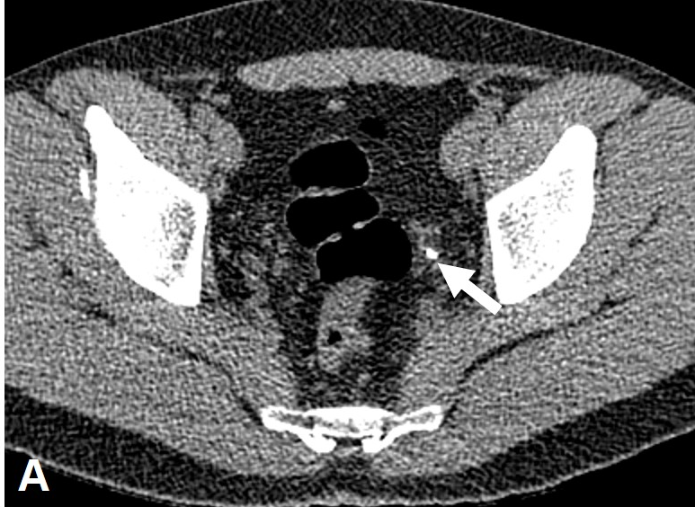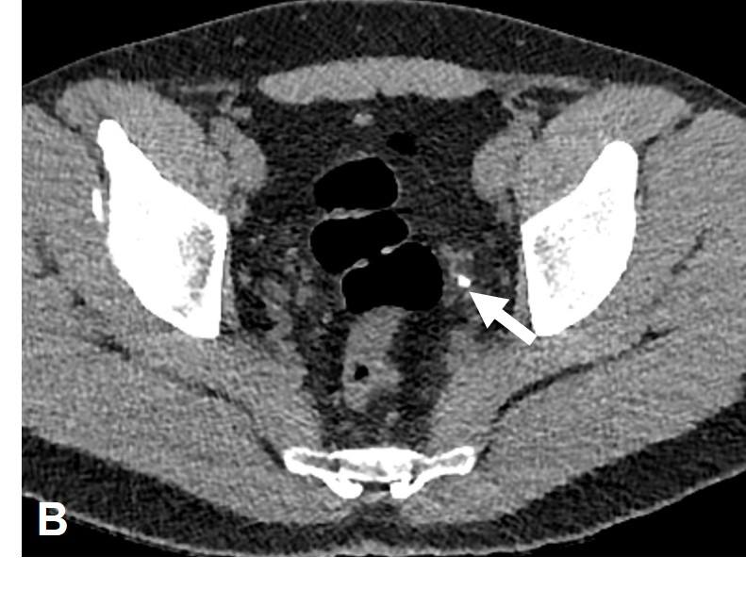
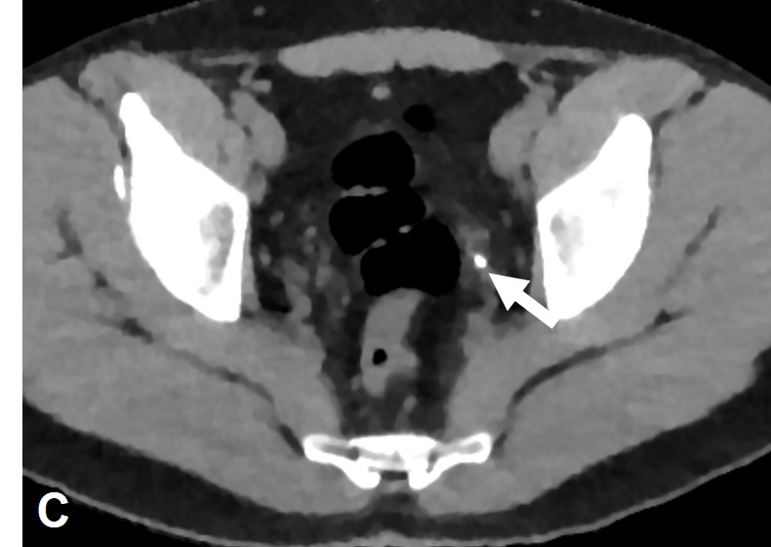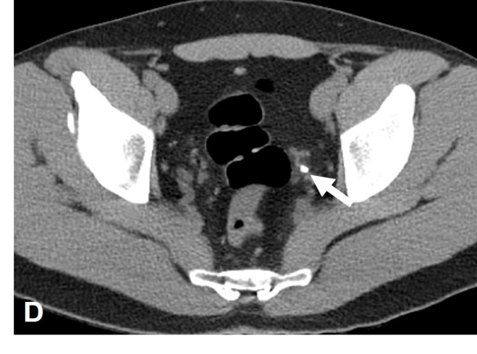
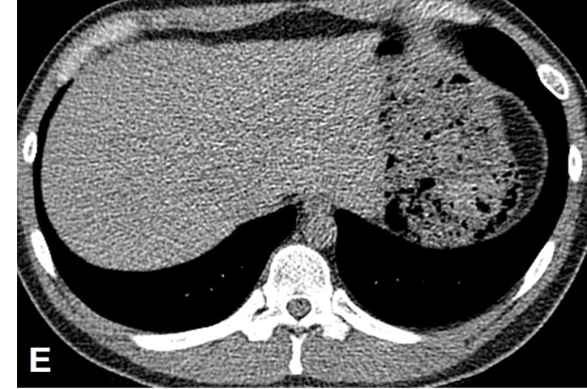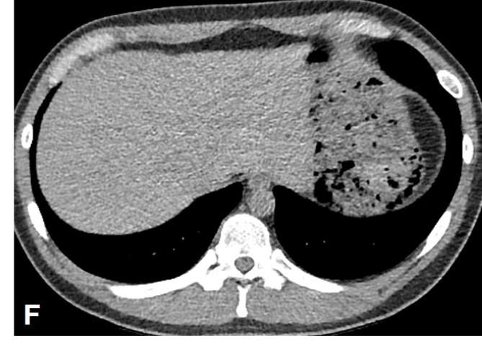
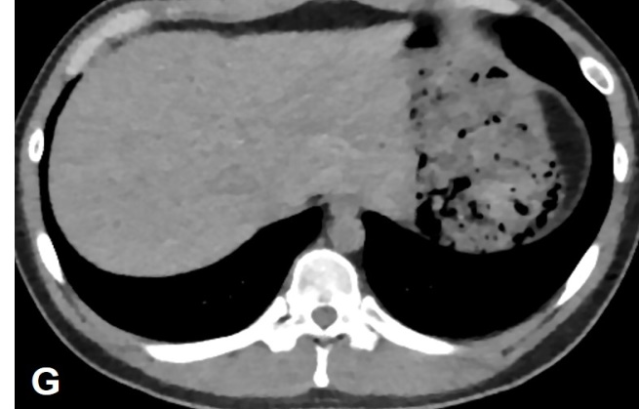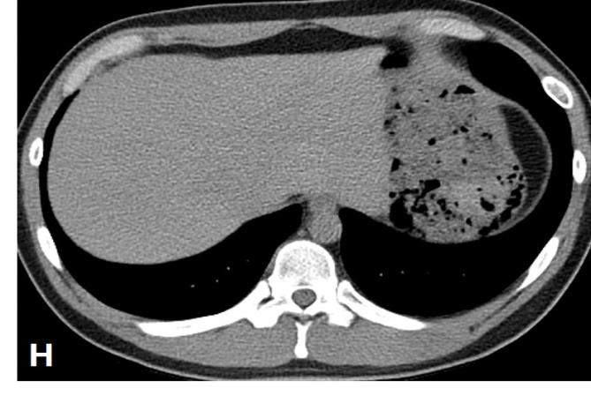
Figure 1 Representative low-dose computed tomography images at 100 kV and 30 mAs (dose length product, approximately 93.4 mGy· cm; effective radiation dose, approximately 1.401 mSv) using four image reconstruction techniques: Filtered back projection; iDose4, hybrid iterative reconstruction; iterative model reconstruction, fully iterative reconstruction; ClariCT, deep learning based image reconstruction. The arrows point to a left distal ureter stone of 5-mm diameter. The noise in the images produced by FBP (A, E), iDose4 (B, F), IMR (C, G) and ClariCT (D, H) is decreased and the image quality, improved. An unfamiliar plastic-looking noise texture is observed in the high-level iterative reconstruction (C, G). On the other hand, deep learning-based image reconstruction (D, H) sharpened structural margins and produced favorable images.

Published by Baishideng Publishing Group Inc
7041 Koll Center Parkway, Suite 160, Pleasanton, CA 94566, USA
Telephone: +1-925-3991568
E-mail: bpgoffice@wjgnet.com
Help Desk: https://www.f6publishing.com/helpdesk
https://www.wjgnet.com

© 2021 Baishideng Publishing Group Inc. All rights reserved.

