Name of Journal: World Journal of Hepatology
Manuscript NO: 44859
Manuscript Type: CASE REPORT

Intraperitoneal rupture of the hydatid cyst: Four case reports and review of literature

Akbulut S et al. Management of perforated hydatid cyst

Sami Akbulut, Fatih Ozdemir

Sami Akbulut, Fatih Ozdemir, Department of Surgery and Liver Transplant Institute, Inonu University Faculty of Medicine, Malatya 44280, Turkey

ORCID number: Sami Akbulut (0000-0002-6864-7711); Fatih Ozdemir (0000-0003-0292-3602).

Author contributions: Akbulut S designed the report; Akbulut S and Ozdemir F collected the patient’s clinical data; Akbulut S and Ozdemir F analyzed the data and wrote the paper.

Informed consent statement: The patients involved in this study gave his informed written consent prior to study enrollment, authorizing the use and disclosure of his protected health information.

Conflict-of-interest statement: The author declares no potential conflict of interest.

CARE Checklist (2016) statement: The authors have read the CARE Checklist (2013), and the manuscript was prepared and revised according to the CARE Checklist (2016).

Open-Access: This article is an open-access article which was selected by an in-house editor and fully peer-reviewed by external reviewers. It is distributed in accordance with the Creative Commons Attribution Non Commercial (CC BY-NC 4.0) license, which permits others to distribute, remix, adapt, build upon this work non-commercially, and license their derivative works on different terms, provided the original work is properly cited and the use is non-commercial. See: http://creativecommons.org/licenses/by-nc/4.0/

Manuscript source: Unsolicited manuscript

Corresponding author: Sami Akbulut, MD, Associate Professor, FICS, FACS, Department of Surgery and Liver Transplant Institute, Inonu University Faculty of Medicine, Elazig Yolu 10. Km, Malatya 44280, Turkey. sami.akbulut@inonu.edu.tr
Telephone: +90-422-3410660
Fax: +90-422-3410036

Received: November 29, 2018
Peer-review started: November 30, 2018
First decision: December 17, 2018
Revised: January 19, 2019
Accepted: January 29, 2019
Article in press: January 30, 2019
Published online: March 27, 2019

Abstract
BACKGROUND
Most patients with hydatid cysts are asymptomatic, and they are diagnosed incidentally during radiological evaluations performed for other reasons. However, some patients develop symptoms and complications due to the cyst size, location, and the relations between the adjacent structures and the cysts. Most serious complications consist of rupture of the cysts into the biliary tract, vascular structures, hollow viscus, and peritoneal cavity. We aimed to describe the management of four cases of intraperitoneal rupture of hydatid cysts.

CASE SUMMARIES
Four patients aged between 27 and 44 (2 men and 2 women) were admitted to our clinic with sudden abdominal pain (n = 4), hypotension (n = 3), and anaphylaxis (n = 2). Three of the perforated cysts were located in the liver and the last one was located in the spleen. Two patients developed cyst rupture after minor trauma and the other two developed spontaneous rupture. Enzyme-linked immunosorbent assay IgG results were positive for two patients and negative for the other two. All patients received albendazole treatment after surgical intervention (range: 2-6 mo). Two patients developed hepatic abscesses requiring drainage; one of these patients also developed hydatid cyst recurrence during postoperative follow-up (range: 25-80 mo).

CONCLUSION
Intraperitoneal rupture is a life-threatening complication of hydatid cysts. It is important to manage patients with surgical intervention as soon as possible with aggressive medical treatment for anaphylactic reactions.

Key words: Hydatid cyst; Complication; Inraperitoneal rupture; Spontaneous rupture; Traumatic rupture; Anaphylactic reactions; Case report

© The Author(s) 2019. Published by Baishideng Publishing Group Inc. All rights reserved.

Core tip: Spontaneous or traumatic intraperitoneal hydatid cyst rupture is a rare but life-threatening complication. Therefore, hydatid cyst rupture should be considered as a differential diagnosis in patients who have sudden onset abdominal pain and allergic reactions like urticaria, especially those in regions endemic to the disease. Deteriorated hemodynamic parameters due to anaphylactic reactions should be corrected quickly with subsequent emergent surgery for a life-saving procedure. Herein, we aimed to present the management algorithm of four patients diagnosed with intraperitoneal hydatid cyst rupture.

Akbulut S, Ozdemir F. Intraperitoneal rupture of the hydatid cyst: Four case reports and review of literature. World J Hepatol 2019; 11(3): 318-329
URL: https://www.wjgnet.com/1948-5182/full/v11/i3/318.htm
DOI: https://dx.doi.org/10.4254/wjh.v11.i3.318

INTRODUCTION
Hydatic disease is a zoonotic disease caused by parasites of echinococcus, which is a member of the Taeniidae family. Most common echinococcus species that cause hydatid disease in humans are Echinococcus granulosus (cystic echinococcosis) and Echinococcus multilocularis (alveolar echinococcosis). Cystic echinococcosis, also known as hydatid cysts, constitute 95% of all hydatid diseases^{[1-3]}. Hidatid diseases can develop in almost all organs and tissues of the human body but the most frequently involved organs are the liver (50%-77%), lungs (15%-47%), spleen (0.5%-8%), and kidneys (2%-4%), respectively^{[1-6]}. Humans who have no role in the biological life cycle of echinococcosis can accidentally become intermediate hosts by ingesting the eggs of the tapeworm^{[1,4]}. Hydatid cysts can grow at an average of 10-50 mm/year depending on the location of the cyst, so most patients remain asymptomatic for years^{[3,7,8]}. Usually, asymptomatic patients are diagnosed incidentally by radiological evaluations that are performed for some other reasons. Nevertheless, some patients have signs and symptoms like mild or severe abdominal pain, nausea, vomiting, jaundice due to size, location, and/or involvement of the adjacent structures and organs of the cystic lesions^{[1]}. The most frequently reported complications are rupture (perforation), bacterial infection, anaphylactic reaction, compression of the vascular and biliary structures, and compression of the neighboring organs^{[4,5]}. Hydatid cyst rupture can be internal (cysto-biliary fistula, rupture into the hollow viscus, broncho-biliary fistula, bronchopleural fistula, intrapericardial rupture, intrapleural rupture, intraperitoneal rupture) and it can be rarely external (cysto-cutaneous fistula)^{[3]}. Intraperitoneal rupture is a rare but life-threatening, severe complication of hidatid cyst disease^{[3]}. We aim to describe the cases of four patients who developed intraperitoneal rupture accompanied by review of the medical literature.

CASE PRESENTATION
The summary information of the four cases described below is given in Table 1.

Case 1: Chief complaints
A 44-year-old man was admitted to the emergency department with sudden onset abdominal pain, skin flushing at some areas of the abdomen and hypotensive shock without any history of trauma.

History of present illness
The patient was diagnosed with obstructive jaundice complicated by a hydatid cyst approximately one month ago. The connection between the biliary tract and hydatid cyst was visualized by radiological examinations. Endoscopic retrograde cholangio pancreatography (ERCP) was performed to decompress the biliary tract before the surgical intervention. Albendazole treatment was initiated before the surgery.

History of past illness
The patient had no medical disease other than the hydatid cyst.

Laboratory examinations
Complete blood count (CBC) was as follows: White blood cells (WBCs): 12900/mL, neutrophils: 80%, and eosinophils: 0.9%. Test results for biochemical analysis were as follows: Aspartate aminotransferase (AST), 152 (5-34 U/L); alanine aminotransferase (ALT), 58 (5-34 U/L); alkaline phosphatase (ALP), 260 (40-150 U/L); gamma-glutamyl transferase (GGT) 125, (12-64 U/L); and total bilirubin, 1.03 (0.2-1.2 mg/dL).

Imaging examinations
Abdominal ultrasonography (US) and contrast-enhanced abdominal computed tomography (CT) showed that multiple cystic lesions compatible with hydatid cyst disease (largest size 165 mm × 100 mm × 80 mm) were localized in the liver. CT scans also showed that the ruptured cystic lesion was localized in the segment VI of the liver (Figures 1 and 2).

FINAL DIAGNOSIS
The final diagnosis of the present case was intraperitoneal liver hydatid cyst rupture.

TREATMENT
Fluid resuscitation, antihistaminic, and corticosteroid treatment was initiated at the emergency department. Laparotomy was decided due to the patient’s general condition. Intraoperatively, the cyst located in the liver ruptured and 2500 mL of fluid containing cyst material was aspirated from the peritoneal cavity. The peritoneal cavity was washed with saline solution and partial cystectomy, omentoplasty, and common bile duct exploration with T-tube placement were performed.

OUTCOME AND FOLLOW-UP
The patient developed an abscess that required drainage in the postoperative period. Six cures of albendazole treatment with 3-wk cycles were administered as medical treatment. The T-tube was removed when normal biliary tract anatomy was visualized during cholangiography approximately at 3 weeks postoperatively.

Case 2: Chief complaints
A 37-year-old man presented to our emergency unit with severe abdominal pain and anaphylactic shock signs/symptoms such as hypotension and allergic reaction.

History of present illness
The patient suddenly felt sharp abdominal pain after playing with and tossing his nephew, and felt like something was leaking inside him simultaneously. Subsequently, dizziness and diffuse flushing occurred.

Laboratory examinations
CBC analysis revealed leukocytosis (18800/mL), with predominant neutrophils (86.4%) and normal eosinophils (0.1%). Biochemical blood test results were within normal limits except for total bilirubin (1.5 mg/dL).

Imaging examinations
US showed massive intraabdominal fluid collections in the perihepatic and perisplenic area. Additionally, a ruptured and degenerated cyst with a germinative membrane collapse near the spleen was visualized.

FINAL DIAGNOSIS
The final diagnosis of the present case was intraperitoneal splenic hydatid cyst rupture.

TREATMENT
Fluid resuscitation, antihistaminic, and corticosteroid treatment was initiated at the emergency department. The patient was then taken to the operating room and laparotomy was performed with a midline incision. An exophytic, ruptured hydatid cyst originating from the spleen, which had adhesions to adjacent structures, was explored; thus, total splenectomy was performed (Figures 3 and 4). An iatrogenic left diaphragm injury due to intraabdominal adhesions occurred during surgery. A left-sided chest tube was inserted after the primary repair of the diaphragm. Additionally, some other cystic lesions located at the posterior side of the urinary bladder (60 mm × 50 mm) and at the retroperitoneum (50 mm× 40 mm) were excised totally. A chest tube was removed postoperatively on the fourth day.

OUTCOME AND FOLLOW-UP
The patient had an uneventful postoperative clinical course. Pneumococcus vaccination was administered 14 d after surgery. Continuous albendazole treatment was administered for two months after surgery.

Case 3: Chief complaints
A 27-year-old woman experienced sudden onset abdominal pain at another medical center. She was diagnosed with a ruptured hydatid cyst and was referred to our medical center. She had hypotension during her first evaluation at the emergency unit.

History of present illness
She had no history of hydatid cyst.

Laboratory examinations
CBC analysis showed leukocytosis (24100/mL), with predominant neutrophils (94.5%) and normal eosinophils (0.2%). Biochemical blood tests were within normal limits.

Imaging examinations
Contrast-enhanced abdominal CT revealed that one lesion was compatible with a hydatid cyst in the anterior sector of the liver (80 mm × 75 mm × 70 mm) and another one at segment III (40 mm × 10 mm). Additionally, several daughter cystic lesions (largest diameter 130 mm × 60 mm × 50 mm) secondary to the rupture of the cystic lesion near segment III were observed in the pelvic cavity (Figure 5).

FINAL DIAGNOSIS
The final diagnosis of the present case was an intraperitoneal liver hydatid cyst rupture.

TREATMENT
Fluid resuscitation was initiated at the emergency department. The patient was then taken to the operating room. The anterior wall of the cyst that located in the anterior sector of the liver was excised, following which the cystic components were totally evacuated. Three bile ducts that opened into the cystic cavity were closed with polypropylene sutures. Afterwards, the wall of the hydatid cyst localized next to segment III was excised and the components of the cyst were totally evacuated. Cholecystectomy was performed to place high pressure saline solution into the common bile duct via cystic duct; there was no bile leak. Daughter vesicles located in the pelvic cavity were also removed and the peritoneal cavity was washed with hypertonic saline solution.

OUTCOME AND FOLLOW-UP
The patient had an uneventful postoperative clinical course. Postoperative albendazole treatment was administered for two months.

Case 4: Chief complaints
A 40-year-old woman was suffering from abdominal pain for one month and her pain became aggravated for two days prior to admission. Physical examination revealed widespread tenderness in all quadrants of the abdomen.

History of present illness
The patient stated that she had received antihelmintic medical treatment several times.

Laboratory examinations
CBC analysis showed leukocytosis (WBC: 23400/mm³, neutrophils: 90.6%, and eosinophils: 0.4%). Biochemical results were not deteriorated except for ALP and GGT levels (AST: 18 U/L, ALT: 18 U/L, ALP: 197 U/L, GGT: 114 U/L, and total bilirubin 0.87 mg/dL).

Imaging examinations
Contrast-enhanced abdominal CT revealed several hydatid cysts (largest diameter 10 mm × 85 mm × 60 mm) in the left lobe of the liver. Cysts located in the left lobe of the liver compressed the main bile duct so the intrahepatic bile ducts of the left liver lobe were slightly dilated (Figure 6). Several cystic lesions were also observed in the pelvic cavity.

FINAL DIAGNOSIS
The final diagnosis of the present case was intraperitoneal liver hydatid cyst rupture.

TREATMENT
There were several adhesions secondary to the ruptured cyst and they were diagnosed as sclerosing encapsulated peritonitis during laparotomy (Figure 7). After adhesiolysis, the perforated wall of the cyst was excised and components of the cyst were totally evacuated (Figure 8). Additionally, cystic components that were located in the pelvic cavity were also removed.

OUTCOME AND FOLLOW-UP
The patient had an uneventful postoperative clinical course and was treated with continuous albendazole for two months. The patient developed left lobe liver abscess requiring percutaneous drainage in the third postoperative year.

DISCUSSION
About 5%-40% of the hydatid cysts located in the liver and other organs of the body may cause various complications. The most common complications related with hydatid cysts include superinfection, cysto-biliary fistula (obstructive jaundice, cholangitis), allergic reactions, rupture into the gastrointestinal system (duodenum, small intestine, colon), Budd Chiari syndrome, portal hypertension, gastric outlet obstruction, membranous glomerulonephritis, broncho-biliary fistula, bronchopleural fistula, intrapericardial rupture, intrapleural rupture, and intraperitoneal rupture^{[1,3,7,9]}.
Intraperitoneal hydatid cyst rupture may result from trauma or may occur spontaneously due to increased intracystic pressure^{[1,10,11]}. Sometimes, iatrogenic hydatid cyst rupture may occur during elective surgery. Some studies have concluded that most of the intraperitoneal ruptures develop after trauma; nevertheless, some other studies pointed out that spontaneous ruptures may develop more frequently^{[6,7,12]}.
Intraperitoneal rupture is the third most common complication (0.9%-16%) after intrabiliary rupture (5%-25%) and allergic reactions (1%-25%)^{[1,4,7]}. Most studies regarding intraperitoneal hydatid cyst rupture have been published as case reports. To our knowledge, four or more cases were reported in a limited number of studies (Table 2). Risk factors for rupture include young age, diameter of the cyst (> 10 cm), and superficial localization^{[1,4,7]}. Hydatid cysts are more common in younger individuals because they are exposed to traffic accidents more often than older individuals. Intracystic pressure increases with increasing cyst dimension. When intracystic pressure increases to more than 50 cmH₂O, spontaneous or traumatic rupture risk also increases^{[6,10]}. Most cyst walls that are located superficially are not protected by liver parenchyma. This is a facilitating factor for rupture of the cyst into peritoneal cavity or gastrointestinal hollow organs^{[1,4]}. The aims of emergent surgical treatment include prevention or minimization of anaphylactic reactions in the early term and prevention of the development of long-term secondary peritoneal hydatidosis^{[4,7]}.
Clinical signs and symptoms of intraperitoneal cyst ruptures may vary widely among patients. Most frequent symptoms are mild or severe abdominal pain, vomiting, nausea, and some allergic reactions that span a wide range. If the content of the ruptured cyst is purulent or associated with biliary tract, it may cause peritoneal irritation. Therefore, clinical signs of acute abdomen may occur^{[1,4]}. Life-threatening immunologic reactions in a wide spectrum, such as allergic reactions and/or anaphylactic shock, develop against the cyst content, which spread into the peritoneal cavity^{[1,4]}. Therefore, some patients may have complaints such as hypotension, tachycardia, and respiratory distress^{[1]}.
While 16.7%-25% of patients with hydatid cyst rupture develop minor allergic reactions, such as urticaria and macular eruption, 1%-12.5% of patients develop more severe allergic reactions such as peripheral edema, syncope, and anaphylaxis^{[1,6]}. The life-threatening anaphylactic shock incidence rate is about 1.4%. Allergic reactions may develop not only in macroscopic ruptures, but also when the cyst content passes into the biliary tract after trauma, iatrogenic interventions, or spontaneously. Even allergic reactions may occur after direct communication when the cyst content enters the systemic circulation^{[1]}. Anaphylactic reactions during cyst hidatid surgery may develop in 0.2%-3.3% of patients who do not experience rupture^{[1]}.
Most patients who have intraperitoneal rupture are admitted to the emergency unit with symptoms such as severe abdominal pain, hypotension, tachycardia, and allergic reactions^{[1,10,11]}. Therefore, US is the most common radiologic tool for diagnosis. If patients are hemodynamically stable, contrast enhanced CT may be used. The sensitivity of US and CT is 85% and 100%, respectively^{[1,8,9]}.
Medical treatment should be initiated as soon as possible at the emergency unit after confirming the diagnosis of intraperitoneal rupture. Moreover, it should be continued during surgery. To minimize the morbidity and mortality, patients should be stabilized hemodynamically before surgery and they should undergo surgery as soon as possible. The medical treatment is aimed at stabilizing hemodynamic status with fluid resuscitation and treating anaphylactic reactions with corticosteroids, antihistaminic, and vasopressor drugs.
There is no consensus in the literature about surgical treatment options for intraperitoneal cyst rupture^{[7,12]}. According to us, each case should be evaluated separately in accordance with general principles of hydatid cyst surgery. If we summarize simply, hemodynamically stable patients should undergo either laparoscopic or open surgery as soon as possible and hemodynamically unstable patients should undergo open surgery. Cyst content that triggers anaphylactic reactions should be removed outside the abdominal cavity as soon as possible^{[1,5-7]}. The peritoneal cavity should be washed with scolicidal solutions such as formaldehyde, hypertonic saline (3%-10%-15%-30%), silver nitrate (0.5%), cetrimide, chlorhexidine, cetrimide plus chlorhexidine (1.5%/0.15%), hydrogen peroxide (1.5%-3%), povidone iodine (10%-50%), and ethyl alcohol (70%-95%). Each solution has different time frame for possible scolicidal effect^{[1,5-7]}. We usually prefer hypertonic saline or cetrimide plus chlorhexidine to wash the peritoneal cavity at least two times 10 min apart for 10-15 min possible^{[1]}. Allergens that lead to anaphylactic reactions can be removed out in this way. Perforated cystic cavity should be evaluated carefully. Remaining cystic contents should also be evacuated and the free edges of the cystic cavity should be excised widely. Perforated cysts that are located in the liver should be examined via a leakage test, which can be performed with a saline solution administered through the common bile duct/cystic duct to observe the relationship between the cyst and the biliary tract. Bile duct orificies that lead to bile leakage should be repaired primarily with different suture materials. Common bile duct and T-tube placement for high flow output bile fistulas can be performed simultaneously. Sometimes, ERCP can be selected instead of T-tube application to complete the surgery as soon as possible. The biliary tract can be visualized via ERCP. If possible, spleen-preserving surgical interventions should be preferred^{[5]}. Abdominal drains should be placed both into the cystic cavity and in the abdomen before surgery completion. We would like to discuss the question: ‘’do we need any intervention for the other unperforated cystic lesions that are explored during emergency surgery?’’
Antihelmintic treatment should be administered as soon as possible for patients diagnosed with intraperitoneal rupture to prevent disease recurrence because of the overlooked cystic contents during surgery. The most preferred antihelmintic agent is albendazole (10-15 mg/kg per day). The treatment period is advised to last between 1 and 12 mo, according to the literature^{[1,4,6,8]}. Patients who were diagnosed with intraperitoneal hydatid cyst rupture should be followed-up more frequently than patients without complications. Morbidity and mortality rates after intraperitoneal rupture are 10-35.3% and 0-23.5%, respectively, in the medical literature^{[7,9]}. Clinical follow-up should be performed once in a month, especially during the early period after surgery and once a year in the long-term. US, echinococcus IgG enzyme-linked immunosorbent assay, indirect hemagglutination, and CT can be selected during follow-up. If there is no recurrence after 5 years, clinical follow-up can be terminated. The recurrence rate after intraperitoneal hydatid cyst rupture is reported between 0-28.6%^{[1,4,6,7,9]}. There was only one case of recurrence in our series.

CONCLUSION
Intraperitoneal hydatid cyst rupture is a life-threatening complication because it causes serious hemodynamic instability and allergic reactions. Therefore, hydatid cyst rupture should be considered as a differential diagnosis in patients who have sudden onset abdominal pain and allergic reactions, like urticaria, especially at endemic regions for the disease. Deteriorated hemodynamic parameters due to anaphylactic reactions should be corrected quickly so that emergent surgery can be life-saving.

REFERENCES
1 Yilmaz M, Akbulut S, Kahraman A, Yilmaz S. Liver hydatid cyst rupture into the peritoneal cavity after abdominal trauma: case report and literature review. Int Surg 2012; 97: 239-244 [PMID: 23113853 DOI: 10.9738/CC116.1]
2 Akbulut S, Sogutcu N, Eris C. Hydatid disease of the spleen: single-center experience and a brief literature review. J Gastrointest Surg 2013; 17: 1784-1795 [PMID: 23949423 DOI: 10.1007/s11605-013-2303-5]
3 Akbulut S. Parietal complication of the hydatid disease: Comprehensive literature review. Medicine (Baltimore) 2018; 97: e10671 [PMID: 29794743 DOI: 10.1097/MD.0000000000010671]
4 Toumi O, Noomen F, Salem R, Rabeh H, Jabra SB, Korbi I, Bannani S, Nasr M, Zouari K, Mondher G, Hamdi A. Intraperitoneal rupture of hydatid cysts. Eur J Trauma Emerg Surg 2017; 43: 387-391 [PMID: 27084544 DOI: 10.1007/s00068-016-0662-9]
5 Belli S, Akbulut S, Erbay G, Koçer NE. Spontaneous giant splenic hydatid cyst rupture causing fatal anaphylactic shock: a case report and brief literature review. Turk J Gastroenterol 2014; 25: 88-91 [PMID: 24918138 DOI: 10.5152/tjg.2014.3521]
6 Unalp HR, Yilmaz Y, Durak E, Kamer E, Tarcan E. Rupture of liver hydatid cysts into the peritoneal cavity. A challenge in endemic regions. Saudi Med J 2010; 31: 37-42 [PMID: 20062897 DOI: 10.1016/j.revmed.2009.02.027]
7 Tinsley B, Abbara A, Kadaba R, Sheth H, Sandhu G. Spontaneous intraperitoneal rupture of a hepatic hydatid cyst with subsequent anaphylaxis: a case report. Case Reports Hepatol 2013; 2013: 320418 [PMID: 25431702 DOI: 10.1155/2013/320418]
8 Sozuer E, Akyuz M, Akbulut S. Open surgery for hepatic hydatid disease. Int Surg 2014; 99: 764-769 [PMID: 25437585 DOI: 10.9738/INTSURG-D-14-00069.1]
9 Mouaqit O, Hibatallah A, Oussaden A, Maazaz K, Taleb KA. Acute intraperitoneal rupture of hydatid cysts: a surgical experience with 14 cases. World J Emerg Surg 2013; 8: 28 [PMID: 23885766 DOI: 10.1186/1749-7922-8-28]
10 Malik AA, Bari SU, Amin R, Jan M. Surgical management of complicated hydatid cysts of the liver. World J Gastrointest Surg 2010; 2: 78-84 [PMID: 21160854 DOI: 10.4240/wjgs.v2.i3.78]
11 Karakaya K. Spontaneous rupture of a hepatic hydatid cyst into the peritoneum causing only mild abdominal pain: a case report. World J Gastroenterol 2007; 13: 806-808 [PMID: 17278209 DOI: 10.3748/wjg.v13.i5.806]
12 Erel S, Kilicoglu B, Kismet K, Gollu A, Akkus MA. Peritoneal hydatid cyst perforation: a rare cause of emergency abdominal surgeries. Adv Ther 2008; 25: 943-950 [PMID: 18758698 DOI: 10.1007/s12325-008-0088-9]

Specialty type: Gastroenterology and hepatology
Country of origin: Turkey
Peer-review report classification
Grade A (Excellent): 0
Grade B (Very good): B, B
Grade C (Good): 0
Grade D (Fair): 0
Grade E (Poor): 0
P-Reviewer: Farshadpour F, Jarcuska P S-Editor: Ji FF L-Editor: Filipodia E-Editor: Zhang YL

Table 1 Demographic and clinical characteristics of four patients with hydatid cyst perforation

Parameters | Case 1 | Case 2 | Case 3 | Case 4
Age | 44 | 37 | 27 | 40
Gender | Male | Male | Female | Female
Cause of perforation | Spontaneous | Trauma | Spontaneous | Trauma
Clinical presentation | Pain (sudden) | Pain (sudden) | Pain (sudden) | Pain (sudden)
 | Hypotension | Hypotension | Hypotension | Anaphylaxis
 | Anaphylaxis | Anaphylaxis |  | Not clear
Serology | ELISA IgG (+) | ELISA IgG (+) | Negative | Negative
History of HD | Known | Unknown | Unknown | Known
Cyst location | Liver (Bilobar) | Spleen | Liver (Bilobar) | Liver (Bilobar)
 |  | Retroperitoneum
 |  | Retrovesical
Perforated cyst location | Liver (VI) | Spleen | Liver (III) | Liver (II-VI)
Cysts size (mm) | 165 × 100 × 80 | 50 × 45 | 80 × 75 | 110 × 85
 | 130 × 100 × 95 | 50 × 40 | 40 × 10 | 30 × 25
 | 85 × 70 × 65 | 60 × 50
Preop antihelmintic | ALBZ (1 mo) | No | No | ALBZ (? mo)
Postop antihelmintic | ALBZ (6 mo) | ALBZ (2 mo) | ALBZ (2 mo) | ALBZ (2 mo)
Diagnostic tools | US + CT | US | US + CT | CT
Surgical approach | Partial Cystectomy+ | Splenectomy+ | Partial Cystectomy+ | Partial Cystectomy+
 | CBD exploration+ | Retroperitoneal+ | Omentopexy | Omentopexy
 | T-tube insertion+ | Retrovesical
 | Omentopexy | Cystectomy
Recurrence | Yes | No | No | No
Postop complication | Liver abscess | Bleeding | No | Liver abscess
Follow up (mo) | 80 | 34 | 25 | 36
HD: Hydatid disease; ALBZ: Albendazole; US: Ultrasonography; CT: Computed tomography; CBD: Common bile duct.

Table 2 Short analysis of studies that published four or more cases of intraperitoneal hydatid cyst rupture

Authors | Years | Country | City | Study period | Perforated HC | Total HC surgery | Rate (%)
Toumi | 2017 | Tunusia | Monastir | 1990-2015 | 12 | 1350 | 0,9
Sakcak | 2015 | Turkey | Ankara | 1996-2013 | 16 | 756 | 2,1
Ozturk | 2007 | Turkey | Erzurum | 1979-2004 | 20 | 653 | 3,1
Mouqait | 2013 | Morocco | Fes | 2008-2012 | 14 | 306 | 4,6
Derici | 2007 | Turkey | Izmir | 1988-2005 | 17 | 306 | 5,6
Unalp | 2010 | Turkey | Izmir | 2000-2009 | 21 | 368 | 5,7
Kurt | 2003 | Turkey | Istanbul | 1995-2001 | 7 | 99 | 7,1
Akcan | 2010 | Turkey | Kayseri | 1990-2008 | 28 | 372 | 7,5
Bozdag | 2016 | Turkey | Diyarbakir | 2005-2015 | 16 | NA | NA
Ozturk | 2016 | Turkey | Izmir | 2008-2012 | 13 | NA | NA
Dirican | 2010 | Turkey | Malatya | 2003-2008 | 10 | NA | NA
Rami | 2009 | Morocco | Fes | NA | 4 | NA | NA
Gunay | 1999 | Turkey | Istanbul | 1985-1997 | 16 | NA | NA

NA: Not available.

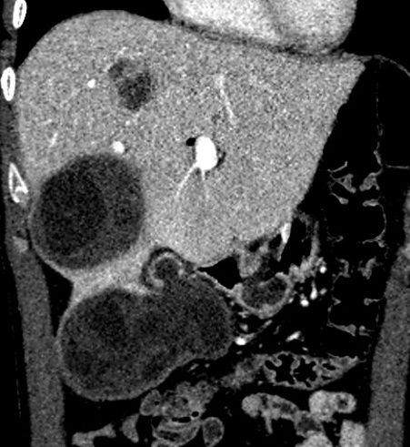
Figure 1 Coronal reformatted contrast-enhanced computed tomography shows that fluid collection and daughter vesicles adjacent to the hydatid cyst located in segment VI of the liver. This finding is consistent with a perforated hydatid cyst.

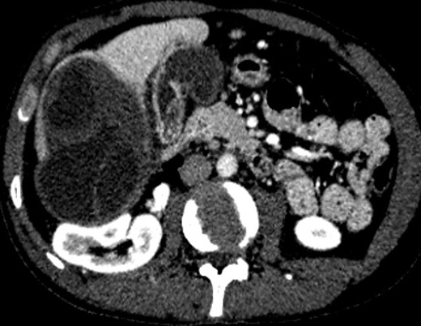
Figure 2 Axial plane computed tomography of the same patient shows exophytic extension of the giant hydatid cyst located right lobe of the liver.
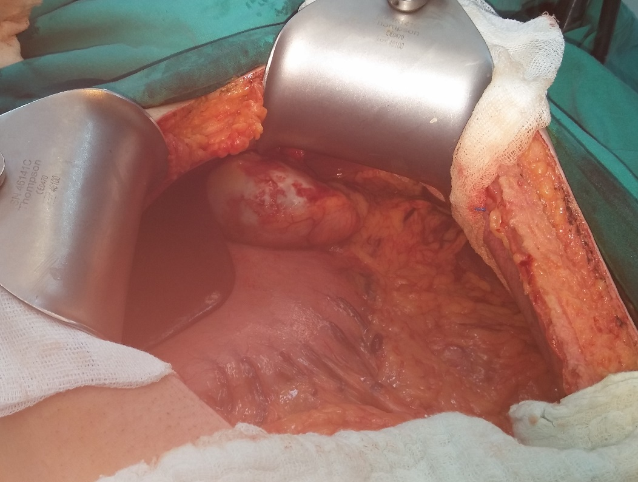
Figure 3 Intraoperative appearance of the hydatid cyst compatible lesion that originated and ruptured from the spleen. This image was taken after aspiration of the hydatid cyst fluid in the abdominal cavity.
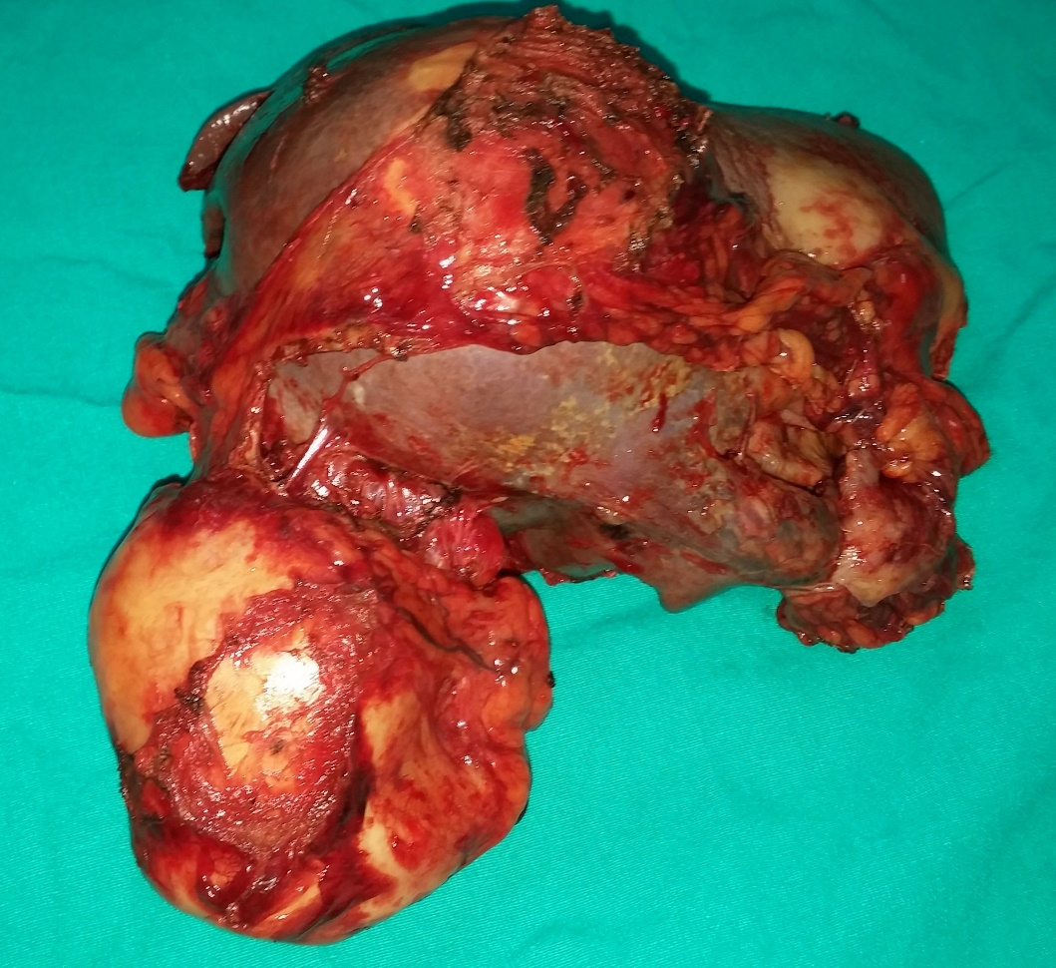
Figure 4 Apearance of the spleen and ruptured cyst specimens obtained from the same patient.
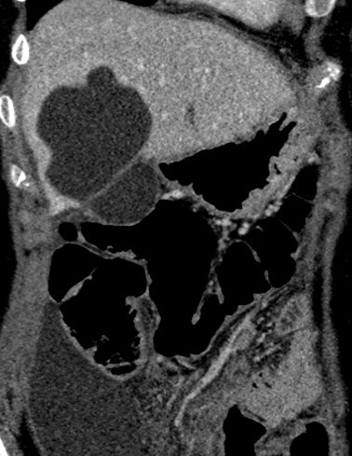
Figure 5 Coronal reformat images of the venous phase of computed tomography shows perforated hydatid cyst located on the segment V of the liver. This image also shows fluid collection in the right paracolic area.

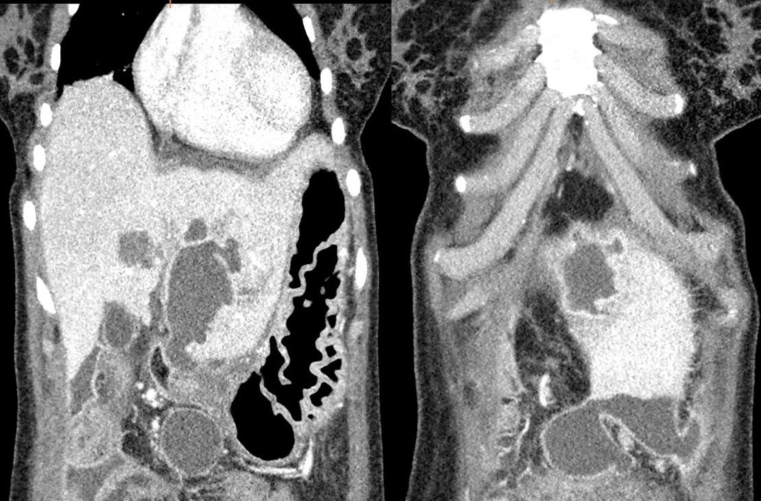
Figure 6 Two different coronals reformat contrast-enhanced computed tomography images of the same patient show a perforated hydatid cyst located in segment III of the liver and fluid collection in the perihepatic/pelvic area.

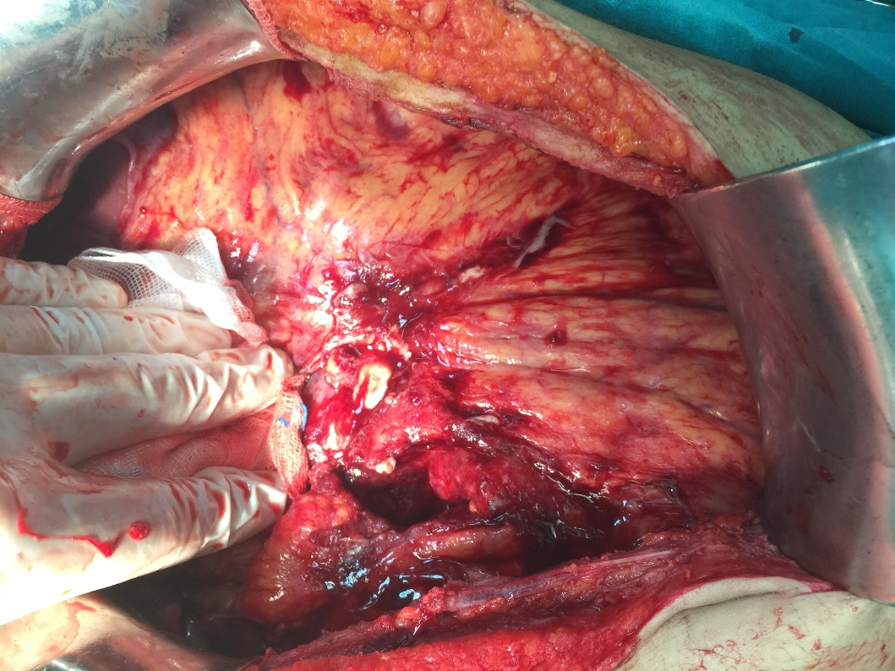
Figure 7 Intraoperative appearance of severe adhesions like sclerosing encapsulating peritonitis in the abdominal cavity secondary to hydatid cyst perforation.
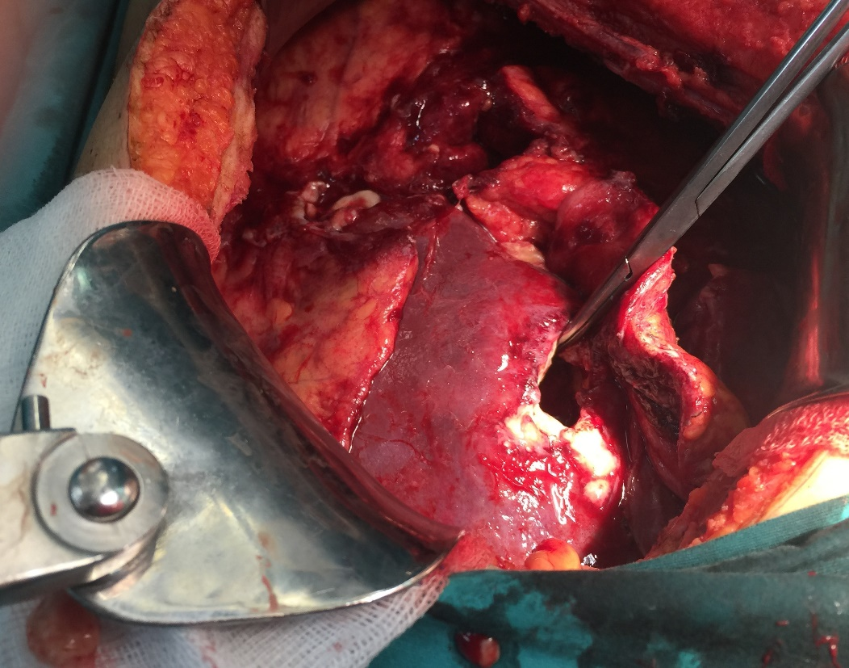
Figure 8 Intraoperative image obtained after evacuating the cystic contents.

