Name of Journal: World Journal of Clinical Cases
Manuscript NO: 62415
Manuscript Type: CASE REPORT

Geleophysic dysplasia caused by a mutation in FBN1: A case report

Tao Y et al. Case report of geleophysic dysplasia

Ying Tao, Qing Wei, Xun Chen, Guang-Min Nong

Ying Tao, Qing Wei, Xun Chen, Guang-Min Nong, Department of Pediatrics, The First Affiliated Hospital of Guangxi Medical University, Nanning 530021, Guangxi Zhuang Autonomous Region, China

Author contributions: Tao Y, Wei Q, and Nong GM conceptualized and designed the study; Tao Y and Wei Q drafted the initial manuscript; Chen X collected and analyzed the data; Tao Y, Wei Q, and Chen X reviewed and revised the manuscript; Nong GM coordinated and supervised the data collection, and critically reviewed the manuscript; All authors approved the final manuscript as submitted and agree to be accountable for all aspects of the work.

Corresponding author: Guang-Min Nong, MD, Professor, Department of Pediatrics, The First Affiliated Hospital of Guangxi Medical University, No. 6 Shuangyong Road, Nanning 530021, Guangxi Zhuang Autonomous Region, China. ngm8525@163.com

Received: February 23, 2021
Revised: May 19, 2021
Accepted: July 7, 2021
Published online: August 26, 2021

Abstract
BACKGROUND
Geleophysic dysplasia (GD) presents the characterized clinical manifestations of acromelic dysplasia, including extremely short stature, short limbs, small hands and feet, stubby fingers and toes, joint stiffness and others. It is clinically distinct from the other acromelic dysplasia in terms of symptoms such as cardiac valvular abnormalities, progressive hepatomegaly and tracheal stenosis.

CASE SUMMARY
We report on a Chinese 9-year-old girl with GD with the c.5243G>T (p.C1748F) mutation in FBN1 (fibrillin 1, OMIM 134797). She was born in Guangxi Zhuang Autonomous Region of China. The patient presented with typical clinical features of GD and recurrent respiratory tract infections over 6 years. Laboratory studies and chest computed tomography (CT) scan indicated bronchopneumonia. Her echocardiography revealed mild mitral valve thickening with regurgitation. Laryngopharyngeal CT and electronic bronchoscopy revealed severe glottic stenosis. Echocardiography examination displayed mild mitral valve thickening and regurgitation. Ophthalmic examination did not reveal myopia or lens dislocation. Treated with ceftriaxone sodium and methylprednisolone sodium succinate for injection as well as methylprednisolone orally, patient’s symptoms had improved.

CONCLUSION
GD is a rare genetic condition that can cause life-threatening cardiovascular and respiratory problems. This study also found that the identified genotype of GD could be related to different clinical phenotypes.

Key Words: Fibrillin 1; Geleophysic dysplasia; Acromelic dysplasia; Short stature; Tracheal stenosis; Case report

©The Author(s) 2021. Published by Baishideng Publishing Group Inc. All rights reserved.

Citation: Tao Y, Wei Q, Chen X, Nong GM. Geleophysic dysplasia caused by a mutation in FBN1: A case report. World J Clin Cases 2021; 9(24): 7175-7180
URL: https://www.wjgnet.com/2307-8960/full/v9/i24/7175.htm
DOI: https://dx.doi.org/10.12998/wjcc.v9.i24.7175

Core Tip: We aim to report a 9-year-old girl with geleophysic dysplasia (GD) with mutation c.5243G>T (p.C1748F) in FBN1. Other than the patient we reported, a total of 9 acromelic dysplasia cases due to mutations in c.5242T, c.5243G or c.5244T of FBN1 have been reported, which all are predicted to result in the substitution of cysteine at codon 1748. This study also found that the identified genotype of GD could be related to different clinical phenotypes.

INTRODUCTION
Geleophysic dysplasia (GD) belongs to acromelic dysplasia and has unique features^{[1]}. GD is clinically distinct from other acromelic dysplasia in its symptoms such as cardiac valvular abnormalities, progressive hepatomegaly and tracheal stenosis^{[1]} . Three genes, ADAMTSL2 (OMIM 612277), FBN1 and LTBP2 (OMIM 602091), have been associated with GD^{[2-4]}. Nearly all the mutations in FBN1 associated with GD are located in exons 41 and 42^{[5]}. FBN1, located at 15q21, encodes an extracellular matrix protein that forms a major component of microfibrils of the extracellular matrix in connective tissues^{[6]}. The most common inherited disease caused by FBN1 mutations is Marfan syndrome. In contrast to the bone overgrowth and tall stature in individuals with Marfan syndrome, heterozygous mutations in the transforming growth factor (TGF)-β-binding protein-like domain 5 (TB5) of FBN1 have been identified as the underlying etiology of acromelic dysplasia, including GD, which manifest as heritable short stature syndromes^{[7]}. Both Marfan syndrome and FBN1-related acromelic dysplasia have autosomal dominant inheritance^{[6,8]}. We reviewed the literature of reported acromelic dysplasia cases due to mutations at c.5242T, c.5243G and c.5244T of FBN1 by searching PubMed from 2000 onwards.

CASE PRESENTATION
Chief complaints
A 9-year-old Chinese girl presented with labored breathing, cough with wheeze and nasal discharge.

History of present illness
The patient had no intellectual development disorder, hepatomegaly or hand joint stiffness.

History of past illness
The patient had a history of hypothyroidism, short stature, obstructive sleep apnea hypopnea syndrome and recurrent respiratory tract infections (RRTIs).

Personal and family history
The patient was born in Guangxi Zhuang Autonomous Region of China and had no special personal or family history.

Physical examination
The patient had extremely short stature (94 cm, < -3 SD) (Figure 1A), low weight (17 kg, < -3 SD)^{[9]}, unique facial features (round face, small nose with anteverted nostrils, broad and depressed nasal bridge and thin upper lip) (Figure 1B), short limbs, and short hands and feet (Figure 1C and D).

Laboratory examinations
Laboratory tests suggested inflammation.

Imaging examinations
Her chest computed tomography (CT) scan indicated bronchopneumonia. Laryngopharyngeal CT revealed tracheal stenosis (Figure 2A and B).

FINAL DIAGNOSIS
GD.

TREATMENT
The patient presented an oxygen saturation of 96% with a nasal catheter giving 0.5-1 L/min oxygen inhalation. She received human immunoglobulin (50 mL: 2.5 g [5%]) intravenously on the second and the last day of admission. Isopropyl compound ipratropium bromide solution (inhalation of Combivent aerosol budesonide) 1.25 mL + (Pulmicort) 200 μg + normal saline 1 mL atomization inhalation were continued daily during the hospital stay. The patient received 500 mg/d ceftriaxone sodium for injection until day 11, when the symptoms of the infection were resolved. For antiasthma management, the patient received methylprednisolone sodium succinate for injection at 40 mg/d up to day 10 and methylprednisolone at 16 mg/d orally daily until discharge. The patient was discharged on day 13 after progressive improvement in respiratory function.

OUTCOME AND FOLLOW-UP
When discharged, patient’s symptoms of RRTIs had improved by using methylprednisolone 20 mg/d orally. Patient returned to the outpatient department regularly.

DISCUSSION
GD, acromicric dysplasia (AD) and Weill-Marchesani syndrome (WMS) are kinds of acromelic dysplasia^{[1]}, but these three disorders have their own unique features. GD is clinically distinct from AD and WMS in its symptoms such as cardiac valvular abnormalities, progressive hepatomegaly and tracheal stenosis. Ordinarily, conditions that resemble GD but without cardiac valvular abnormality are diagnosed as AD, and those accompanied by distinguishing eye anomalies, including lenticular myopia, ectopia lentis, glaucoma and spherophakia, are diagnosed as WMS^{[1]}.
Like the patients who have been reported to have FBN1-related diseases, the present patient also displayed an autosomal dominant inheritance pattern and had a mutation in the TB5 domain of FBN1. The inheritance method of FBN1 shows autosomal dominance, whereas the inheritance of ADAMTS10, ADAMTS17 and LTBP2 is autosomal recessive^{[3]}. Mutations in these genes are reported to cause WMS^{[10]}, which has similar clinical manifestations as GD. ADAMTS10, ADAMTS17 and LTBP2 were all included in our genetic analysis, and none of them had mutations.
We reviewed the literature of reported acromelic dysplasia cases, including GD, AD and WMS, due to mutations at c.5242T, c.5243G and c.5244T of FBN1, which all are predicted to result in the substitution of cysteine at codon 1748. Other than the patient we reported, a total of 9 patients were found, including one family with 7 patients. Patient 1^{[2]} had the heterozygous mutation c.5243G>C (p.Cys1748Ser). Patient 2^{[1]}, like the girl we reported, had the same heterozygous mutation c.5243G>T (p.C1748F). Patient 3^{[11]}, the proband of the family, had the heterozygous mutation c.5242T>C (p.C1748R). There was no mutation reported at position c.5244T. All the patients had progressive growth delays from an early age and presented dysmorphic features such as short stature, short limbs and stubby fingers and toes. No severe abnormities were mentioned in either the mitral or tricuspid valve. However, Patient 3^{[11]} developed a life-threatening subacute aortic dissection extending from the aortic root to the left subclavian artery of the thoracic aortic arch. Severe tracheal stenosis developed in our patient and Patient 1^{[2]}. Thyroid hypofunction was found in both our patient and Patient 2^{[1]}. It is worth noting that Patient 2, who had the same mutation as our patient, was diagnosed with WWS and had small, round lenses and moderate myopia but did not develop tracheal stenosis (Table 1).
The present patient was diagnosed with GD due to the presence of mitral valve abnormalities and tracheal stenosis. However, Patient 2^{[1]}, with the same mutation as our patient, was diagnosed with WMS and lacked either mitral valve abnormalities or tracheal stenosis. These findings demonstrate that an identified genotype can be related to different clinical phenotypes. In addition to genotypes, environmental factors also play an important role in phenotype development. In this study, both the patient we reported and Patient 1^{[2]} developed persistent tracheal stenosis with age. It is noteworthy that both of them had a history of RRTIs at an early age before having developed persistent tracheal stenosis. However, none of the same conditions were mentioned in Patient 2^{[1]}. RRTIs might play an important role in tracheal stenosis development at an early age.
Progressive cardiac valvular abnormality is a common cause of death in patients with GD^{[12,13]}. In this study, no severe abnormality was found in the mitral or tricuspid valve. However, Patient 3 developed a life-threatening subacute aortic dissection extending from the aortic root to the left subclavian artery of the thoracic aortic arch, which might be caused by aortic valve abnormalities. Moreover, severe tracheal stenosis developed in our patient and Patient 1, the latter of whom needed tracheostomy permanently. This demonstrated that respiratory problems, especially tracheal stenosis, might also be the cause of death in patients with GD. We should pay attention to cardiovascular and respiratory problems in patients with GD to prevent a severe, even life-threatening, event from occurring and to treat complications as early as possible.
Other than Patient 2^{[1]}, none of the patients with acromelic dysplasia were reported to present thyroid hypofunction. Our patient had mild thyroid hypofunction without impaired intelligence. The patient took Euthyrox orally and regularly, but her growth delay showed no improvement. This result indicates that thyroid hypofunction is one of the accompanying manifestations, rather than a causative factor, of GD. Interestingly, both our patient and Patient 2^{[1]} had the same mutation, c.5243G>T (p.C1748F) of FBN1, which demonstrates that thyroid hypofunction may be specific to patients with the c.5243G>T (p.C1748F) of FBN1 in acromelic dysplasia.

CONCLUSION
GD is a rare genetic condition that can cause life-threatening cardiovascular and respiratory problems. This study also found that the identified genotype of GD could be related to different clinical phenotypes.

REFERENCES
1 Wang Y, Zhang H, Ye J, Han L, Gu X. Three novel mutations of the FBN1 gene in Chinese children with acromelic dysplasia. J Hum Genet 2014; 59: 563-567 [PMID: 25142510 DOI: 10.1038/jhg.2014.73]
2 Globa E, Zelinska N, Dauber A. The Clinical Cases of Geleophysic Dysplasia: One Gene, Different Phenotypes. Case Rep Endocrinol 2018; 2018: 8212417 [PMID: 30057829 DOI: 10.1155/2018/8212417]
3 Li D, Dong H, Zheng H, Song J, Li X, Jin Y, Liu Y, Yang Y. A chinese boy with geleophysic dysplasia caused by compound heterozygous mutations in ADAMTSL2. Eur J Med Genet 2017; 60: 685-689 [PMID: 28917829 DOI: 10.1016/j.ejmg.2017.09.003]
4 McInerney-Leo AM, Le Goff C, Leo PJ, Kenna TJ, Keith P, Harris JE, Steer R, Bole-Feysot C, Nitschke P, Kielty C, Brown MA, Zankl A, Duncan EL, Cormier-Daire V. Mutations in LTBP3 cause acromicric dysplasia and geleophysic dysplasia. J Med Genet 2016; 53: 457-464 [PMID: 27068007 DOI: 10.1136/jmedgenet-2015-103647]
5 Sakai LY, Keene DR, Renard M, De Backer J. FBN1: The disease-causing gene for Marfan syndrome and other genetic disorders. Gene 2016; 591: 279-291 [PMID: 27437668 DOI: 10.1016/j.gene.2016.07.033]
6 Le Goff C, Mahaut C, Wang LW, Allali S, Abhyankar A, Jensen S, Zylberberg L, Collod-Beroud G, Bonnet D, Alanay Y, Brady AF, Cordier MP, Devriendt K, Genevieve D, Kiper PÖ, Kitoh H, Krakow D, Lynch SA, Le Merrer M, Mégarbane A, Mortier G, Odent S, Polak M, Rohrbach M, Sillence D, Stolte-Dijkstra I, Superti-Furga A, Rimoin DL, Topouchian V, Unger S, Zabel B, Bole-Feysot C, Nitschke P, Handford P, Casanova JL, Boileau C, Apte SS, Munnich A, Cormier-Daire V. Mutations in the TGFβ binding-protein-like domain 5 of FBN1 are responsible for acromicric and geleophysic dysplasias. Am J Hum Genet 2011; 89: 7-14 [PMID: 21683322 DOI: 10.1016/j.ajhg.2011.05.012]
7 Sakai LY, Keene DR. Fibrillin protein pleiotropy: Acromelic dysplasias. Matrix Biol 2019; 80: 6-13 [PMID: 30219651 DOI: 10.1016/j.matbio.2018.09.005]
8 Yang H, Ma Y, Luo M, Zhao K, Zhang Y, Zhu G, Sun X, Luo F, Wang L, Shu C, Zhou Z. Identification of gross deletions in FBN1 gene by MLPA. Hum Genomics 2018; 12: 46 [PMID: 30286810 DOI: 10.1186/s40246-018-0178-y]
9 Li H, Ji CY, Zong XN, Zhang YQ. [Height and weight standardized growth charts for Chinese children and adolescents aged 0 to 18 years]. Zhonghua Er Ke Za Zhi 2009; 47: 487-492 [PMID: 19951507 DOI: 10.3760/cma.j.issn.0578-1310.2009.07.003]
10 Cheng SW, Luk HM, Chu YWY, Tung YL, Kwan EY, Lo IF, Chung BH. A report of three families with FBN1-related acromelic dysplasias and review of literature for genotype-phenotype correlation in geleophysic dysplasia. Eur J Med Genet 2018; 61: 219-224 [PMID: 29191498 DOI: 10.1016/j.ejmg.2017.11.018]
11 Cecchi A, Ogawa N, Martinez HR, Carlson A, Fan Y, Penny DJ, Guo DC, Eisenberg S, Safi H, Estrera A, Lewis RA, Meyers D, Milewicz DM. Missense mutations in FBN1 exons 41 and 42 cause Weill-Marchesani syndrome with thoracic aortic disease and Marfan syndrome. Am J Med Genet A 2013; 161A: 2305-2310 [PMID: 23897642 DOI: 10.1002/ajmg.a.36044]
12 Legare JM, Modaff P, Strom SP, Pauli RM, Bartlett HL. Geleophysic dysplasia: 48 year clinical update with emphasis on cardiac care. Am J Med Genet A 2018; 176: 2237-2242 [PMID: 30195254 DOI: 10.1002/ajmg.a.40377]
13 Lee T, Takeshima Y, Okizuka Y, Hamahira K, Kusunoki N, Awano H, Yagi M, Sakai N, Matsuo M, Iijima K. A Japanese child with geleophysic dysplasia caused by a novel mutation of FBN1. Gene 2013; 512: 456-459 [PMID: 23124041 DOI: 10.1016/j.gene.2012.10.060]

Footnotes
Informed consent statement: Informed written consent was obtained from the patients for publication of this report and any accompanying images.

Conflict-of-interest statement: The authors have no potential conflicts of interest to disclose.

CARE Checklist (2016) statement: The authors have read the CARE Checklist (2016), and the manuscript was prepared and revised according to the CARE Checklist (2016).

Open-Access: This article is an open-access article that was selected by an in-house editor and fully peer-reviewed by external reviewers. It is distributed in accordance with the Creative Commons Attribution NonCommercial (CC BY-NC 4.0) license, which permits others to distribute, remix, adapt, build upon this work non-commercially, and license their derivative works on different terms, provided the original work is properly cited and the use is non-commercial. See: http://creativecommons.org/Licenses/by-nc/4.0/

Manuscript source: Unsolicited manuscript

Peer-review started: February 23, 2021
First decision: May 11, 2021
Article in press: July 7, 2021

Specialty type: Pediatrics
Country/Territory of origin: China
Peer-review report’s scientific quality classification
Grade A (Excellent): 0
Grade B (Very good): B
Grade C (Good): C
Grade D (Fair): 0
Grade E (Poor): 0

P-Reviewer: Malik S, Zavras N S-Editor: Liu M L-Editor: Filipodia P-Editor: Yuan YY

Figure Legends
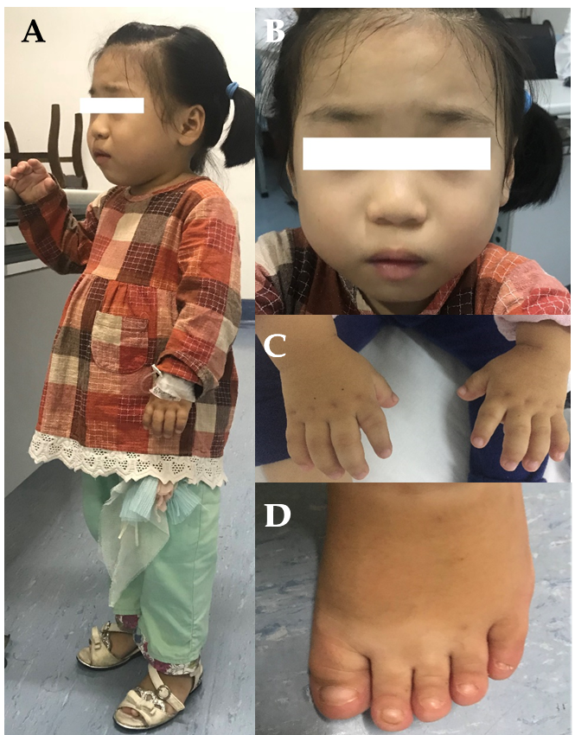
Figure 1 Clinical characters of the patient. A, C and D: Patient presented extreme short stature, short limbs, short hands and feet; B: Patient had unique facial features including round face, small nose with anteverted nostrils, broad and depressed nasal bridge and thin upper lip.
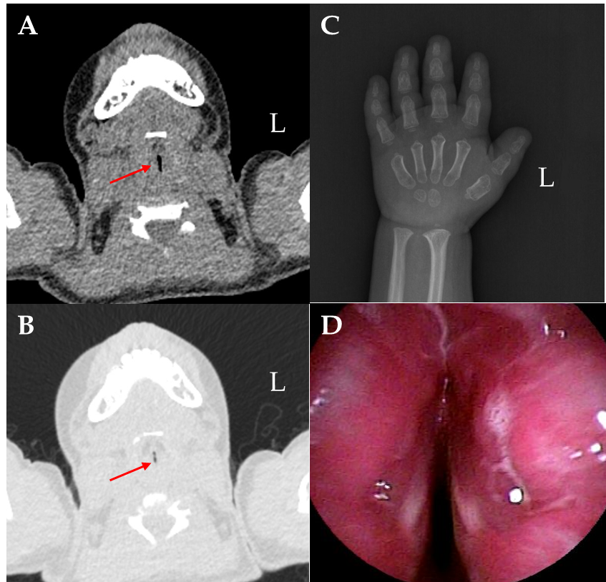
Figure 2 Representative radiographic and flexible bronchofiberscope images. A and B: Laryngopharynx computed tomography presented trachea stenosis; C: Skeletal X-ray was taken at age 6 and revealed a delayed bone age and epiphyseal dysplasia; D: Electronic bronchoscope demonstrated severe glottic stenosis.

Table 1 Clinical and genetic characteristics of acromelic dysplasia cases due to mutations in c5242T, c5243G of FBN1 (+: Present, -: Absent, NA: Not available)^{[1,2,11]}
 | Our patient | Patient 1^{[2]} | Patient 2^{[1]} | Family^{[11]}
 |  |  |  | Patient 3 (proband) | Proband’s father | Proband’s sister | Proband’s children
Mutation | c.5243G>T (p.C1748F) | c.5242T>C (p.Cys1748Ser) | c.5243G>T (p.C1748F) | c.5242T>C (p.C1748R)
Disorder | GD | GD | WMS | WMS
Short stature | + | + | + | + | + | + | +
Short limbs | + | + | + | + | + | + | +
Stubby fingers and toes | + | + | + | + | + | + | +
Mitral valve thickening and regurgitation | Mild | - | NA | - | NA | NA | NA
Aortic dissection | - | - | - | + | - | - | -
Tracheal stenosis | + | + | - | - | - | - | -
Myopia | - | + | + | + | + | + | NA
Ectopia lentis | - | + | + | + | + | + | NA
Thyroid hypofunction | + | - | + | NA | NA | NA | NA
Hepatosplenomegaly | - | - | - | NA | NA | NA | NA
NA: Not available; GD: Geleophysic dysplasia; WMS: Weill-Marchesani syndrome.

Published by Baishideng Publishing Group Inc
7041 Koll Center Parkway, Suite 160, Pleasanton, CA 94566, USA
Telephone: +1-925-3991568
E-mail: bpgoffice@wjgnet.com
Help Desk: https://www.f6publishing.com/helpdesk
https://www.wjgnet.com

© 2021 Baishideng Publishing Group Inc. All rights reserved.

