Name of Journal: World Journal of Clinical Cases
Manuscript NO: 73874
Manuscript Type: CASE REPORT

Vertical direction impaction of kissing molars: A case report

Wen C et al. Vertical direction impaction of kissing molars

Cai Wen, Rong Jiang, Zhi-Qiang Zhang, Bo Lei, Yuan-Zheng Yan, Ying-Quan Zhong, Long Tang

Cai Wen, Department of Oral Implantology, The Affiliated Stomatological Hospital of Southwest Medical University, Luzhou 646000, Sichuan Province, China

Cai Wen, Department of VIP Dental Service, The Affiliated Stomatological Hospital of Southwest Medical University, Luzhou 646000, Sichuan Province, China

Cai Wen, Yuan-Zheng Yan, Luzhou Key Laboratory of Oral & Maxillofacial Reconstruction and Regeneration, The Affiliated Stomatological Hospital of Southwest Medical University, Luzhou 646000, Sichuan Province, China

Rong Jiang, Zhi-Qiang Zhang, Bo Lei, Ying-Quan Zhong, Department of Dentistry, People's Hospital of Aba Tibetan and Qiang Autonomous Prefecture, Ma'erkang 624000, Sichuan Province, China

Long Tang, Department of Radiology, People's Hospital of Aba Tibetan and Qiang Autonomous Prefecture, Ma'erkang 624000, Sichuan Province, China

Author contributions: Wen C proposed the study, conducted literature review and wrote the manuscript; Wen C and Jiang R applied support; Zhang ZQ, Lei B, Yan YZ and Zhong YQ conducted the data collection; Tang L analyzed the imaging result; All authors have read and approved the final manuscript.

Supported by Strategic Cooperation Project between Sichuan University and Luzhou Municipal Government, No. 2018CDLZ-14; and Aba Tibetan and Qiang Autonomous Prefecture Science and Technology Bureau, No. 21YYJSYJ0052.

Corresponding author: Cai Wen, MD, PhD, Lecturer, Assistant Professor, Department of Oral Implantology, The Affiliated Stomatological Hospital of Southwest Medical University, No. 2 South Jiangyang Road, Luzhou 646000, Sichuan Province, China. wencai@swmu.edu.cn

Received: December 7, 2021
Revised: January 29, 2022
Accepted: March 6, 2022
Published online:

Abstract
BACKGROUND
Kissing molars (KMs) are a scarcely reported form of molar impaction in which the occlusal surfaces contact each other within a single dental follicle and the roots point in opposite directions. The direction of KMs impaction is generally tilted. KMs with vertical direction impaction have not been reported in the literature.

CASE SUMMARY
A 25-year-old female visited a dentist for right maxillary wisdom teeth extraction and was diagnosed with two vertically impacted KMs in the left mandible on panoramic radiography. After cone-beam computed tomography examination confirmed no secondary complication, the patient chose to undergo observation and regular follow-up. A literature review of KMs revealed that vertical impacted KMs are rare; high-quality evidence regarding their prevalence is still lacking. At present, the causality of KMs is controversial. In this study, we have tried to provide a detailed definition of KMs to allow an accurate evaluation of their prevalence and classification based on their impaction direction which may be related to their pathogenesis. The treatment plan of KMs depends on the condition and location of the affected teeth and associated complications; they may be either directly extracted or treated using a multidisciplinary approach including maxillofacial surgeons and orthodontists.

CONCLUSION
KMs are a rare clinical condition of impacted teeth with unclear pathogenesis. Vertically impacted KMs were seldom reported. Reasonable definition and classification of KMs can help in the understanding of their causes and prevalence.

Key Words: Kissing molars; Impacted tooth; Pathogenesis; Prevalence; Classification; Case report

Wen C, Jiang R, Zhang ZQ, Lei B, Yan YZ, Zhong YQ, Tang L. Vertical direction impaction of kissing molars: A case report. World J Clin Cases 2022; In press

Core Tip: Kissing molars (KMs) are a rare type of impacted teeth. This study reported a case of KMs with a vertical impaction direction which was different from those of previous cases. Despite the unclear pathogenic mechanism, they cause secondary complications such as cysts and other odontogenic tumors; hence, they should be actively treated by a multi-disciplinary team. Reasonable definition and classification of KMs can help us to better understand their causes and prevalence.

INTRODUCTION
The term kissing molars (KMs) refers to a rare molar impaction disease^{[1]} in which the occlusal surfaces contact each other within a single dental follicle and the roots point in opposite directions. The condition generally shows in the lower jaw as an impaction. Essentially, KMs are considered specially formed supernumerary and impacted teeth. The impacted position and the involved teeth may vary and their etiology is unclear.
In this study, we report for the first time a rare type of KMs, vertically impacted and pointing in opposite directions. We reviewed the available literature in the PubMed database to analyze the classification and possible pathological causes of KMs to provide data and recommendations for dealing with such cases. The search terms were” kissing molars” OR” rosette formation” OR” cuddling tooth.” Article titles and abstracts were screened to find reports related to this topic and the full texts of eligible articles were reviewed.
The existing definition of KMs is limited to their morphological features and their inclusion criteria are not strict in some reports. Furthermore, the existing classification of KMs is unclear and only based on teeth numbering without considering the impaction situation and position. Therefore, it is necessary to impose more accurate restrictions on the morphological definition of KMs. In addition, we attempted to classify KMs according to their direction.

CASE PRESENTATION
Chief complaints
The patient was a female of Han ethnicity aged 25 years; she visited the People’s Hospital of Aba Tibetan and Qiang Autonomous Prefecture for treatment of the right maxillary wisdom tooth.

History of present illness
The patient was in good health; the left maxillary wisdom tooth had been extracted.

History of past illness
The patient had no history of trauma, serious or metabolic diseases.

Personal and family history
The patient denied any relevant personal or family history.

Physical examination
Oral examination showed good oral hygiene except for mesial caries in the right maxillary wisdom tooth due to food impaction.

Laboratory examinations
The routine blood count and coagulation profile were within normal limits.

Imaging examinations
A panoramic radiograph showed that apart from the horizontally impacted #32, there were two impacted molars pointing in opposite directions distal to the second molar in the left mandible. According to the tooth morphology and the Universal Numbering System, we inferred that the tooth in the lower position was #17 and the tooth in the higher position was the supernumerary fourth molar #67. The occlusal surfaces of the two teeth completely coincided and were opposite to each other in the vertical direction (Figure 1).
We then examined the patient using cone-beam computed tomography (CBCT). CBCT revealed bone resorption on the lingual side and sharp proximity of tooth #17 to the inferior alveolar nerve. The occlusal surfaces of teeth #17 and #67 were in close contact and the distal bone of tooth #18 was absorbed; no other complications were observed (Figure 2).

FINAL DIAGNOSIS
KMs involving teeth #17 and #67.

TREATMENT
After the examination, the patient was advised to have the KMs and other impacted teeth removed. After fully informing the patient of the benefits and risks of treatment, the patient accepted removal of tooth #1 and refused the removal of both KMs and the impacted tooth #32, choosing instead to undergo observation and regular follow-up.

DISCUSSION
KMs are a rare form of impacted teeth first reported by Van Hoof et al^{[1]} in 1973. Other scholars used different terms to describe the condition; Nakamura et al^{[2]} referred to it as “rosette formation,” while Agarwal et al^{[3]} used the term “cuddling tooth.” Since there is no standard naming system for this condition, in this report, we used the term “kissing molars” as originally described.
Most reported KMs occur in the mandibular molar area. The classification of KMs by Gulses et al^{[4]} indicated that according to the tooth position, KMs can be divided into three different types: first and second molars (Class I), second and third molars (Class II) and third and fourth molars (Class III). Although this classification method is relatively imprecise, there is no other widely accepted classification. In this study, we tried to classify KMs by the teeth’s impacted direction, which can include the complete vertical direction (Type A), tilted direction (Type B) and complete horizontal direction (Type C, Figure 3). In Type A, the root side teeth could originally erupt normally despite being impacted, whereas Type B shows a slight axial dislocation of both teeth, or slight axial dislocation of one tooth and severe axial dislocation of the other and Type C shows severe transverse dislocation of both teeth. Although this classification method still does not cover all possibilities, it may better reflect the causes and severity of axial dislocation which are related to the difficulty of extraction, treatment strategies and incidence of complications.
Owing to the low prevalence of KMs, most literature includes only case reports and studies on the prevalence from large sample sizes are rare. However, studies used different definitions and inclusion criteria. Some studies have reported teeth in which the occlusal surfaces slightly overlap should only be regarded as ordinary impacted teeth rather than KMs. Therefore, the real prevalence rates of KMs remain unclear. We believe that the overlapping region of the occlusal surfaces and the acute angle formed by the long axis of the two teeth should be considered when identifying KMs (Figure 4).
Yanik et al^{[5]} reported a prevalence rate of KMs of 0.06% in a large sample size of 6,570 Turkish individuals, without significant differences between men and women. However, according to their images, at least 1 case did not seem to be that of KMs in the strict sense, which was more like teeth with severe tilt. Gulses et al^{[4]} found nine KMs among 2,381 patients with impacted third molars (0.37%); however, the included participants in this study were not ordinary people but patients with impacted molars, conforming a significantly different population from that in Yanik et al^{[5]}’s study. Thus, although the studies included large populations, their heterogeneity precluded direct comparisons or data merging.
KMs may occur alone or there could be multiple KMs in 1 individual, either unilateral or bilateral^{[6]}. The potential complications caused by KMs are related to the teeth location and their relationship with the adjacent teeth, including root resorption, adjacent tooth caries, ectopic eruption and dentition crowding, as well as odontoma, periodontal diseases, progressive bone resorption and cystic lesions such as dentigerous cyst, etc.^{[5,7,8]}.
Currently, the causes of KMs are equivocal. Some researchers believe that the occurrence of KMs is an independent event due to the abnormal development of adjacent tooth germs. During molar development from a lower position, contact and impaction with distal molar germs may lead to an abnormal growth direction of tooth germs resulting in abnormal teeth eruption direction and eventually KMs formation^{[9]}. Some scholars hypothesized that bone resorption caused by cysts leads to KMs. Krishnan et al^{[10]} believed that cyst swelling may lead to mesial bone resorption of the impacted teeth resulting in tooth migration, rotation and displacement. However, bone resorption caused by cystic lesions does not always occur in KMs. Therefore, the relationship between KMs and cystic lesions may be due to KMs causing cystic lesions rather than the other way around. Additionally, Kiran et al^{[11]} correlated hyperplastic dental follicle (HDF) with KMs; with the proliferation of dental follicles, HDF disease would expand the follicles around the unerupted crown by about 3-5 mm and the enlarged dental follicles may then affect the eruption direction of the distal teeth.
On the other hand, some scholars believe that the formation of KMs is related to systemic diseases. Nakamura et al^{[2]} studied 4 patients with mucopolysaccharidosis (MPS), in which panoramic radiographs showed that 3 had KMs. Therefore, Nakamura et al^{[2]} concluded that KMs may be associated with MPS. Similarly, two other studies reported impacted molars just like KMs with MPS^{[12]} or Gargoylism (MPS type I)^{[13]}. Therefore, it was proposed that MPS may affect the connective and bone tissue surrounding the tooth germ, lock the crown during tooth germ development, impact normal tooth eruption and affect the tooth development direction^{[14]}. However, in this case, the personal and family history showed that the patient and her family did not present with MPS or other systemic diseases. Simultaneously, other reports have shown that KMs mostly occur in patients without systemic diseases and do not see a direct association with these diseases. Therefore, MPS and other connective tissue diseases may just be some of the factors inducing KMs.
The treatment plan for KMs depends on the condition and location of the affected teeth^{[15,16]}. Affected teeth which cannot be retained or show complications, should be removed promptly^{[17]}. Teeth with therapeutic value can be retained, for instance, in KMs TYPE A, the lower tooth may sprout to the normal position through natural eruption or orthodontic traction after removing resistance of the upper impacted tooth^{[18,19]}. While devising a tooth extraction plan, protecting the neurovascular bundle with minimally invasive techniques should be considered. Additionally, the presence of cystic disease, root absorption of adjacent teeth, root shape and tightness of contacting teeth should be considered^{[20]}. The surgical approach for KMs extraction requires an exhaustive understanding of the anatomy of this region, advanced surgical abilities and rigorous planning^{[21]}. The impaction depth is the main factor affecting tooth extraction. In Type A and B KMs, the lower tooth is relatively more difficult to extract because of their deep position and proximity to the nerve. For Type C KMs, the difficulty is mainly determined by its embedding depth. The deeper the embedding depth, the more bone needs to be removed. Additionally, because of the large volume of the two impacted teeth, especially when combined with bone absorption formed by cystic lesions, fracture caused by fragile structure of the remaining mandible should be avoided during the extraction process^{[22]}. When the area around KMs is accompanied by dilated cystic shadow in radiography, it is necessary to distinguish whether it is a proliferative dental follicle, dentigerous cyst, keratocyst, ameloblastoma or other cystic or malignant lesions, and treat it from a multidisciplinary perspective.

CONCLUSION
KMs are rare and complex impacted teeth of unclear etiology. Vertically impacted KMs were seldom reported. Proper classification and definition are essential for accurate clinical diagnosis and appropriate treatment. Further research is needed to evaluate both their etiology and treatment management strategies.

ACKNOWLEDGEMENTS
The author Cai Wen thanks the warm and kind Tibetan and Qiang people of Ma’erkang for their assistance during his 1-year health poverty alleviation work. Thanks also to Hua-Jun Jing, Zhao-Zhong Tu, Yun-Fei Liu and Chun-Yi Xu from Sichuan Academy of Medical Sciences and Sichuan Provincial People's Hospital for their help during that difficult time.

REFERENCES
1 Van Hoof RF. Four kissing molars. Oral Surg Oral Med Oral Pathol 1973; 35: 284 [PMID: 4513074 DOI: 10.1016/0030-4220(73)90297-1]
2 Nakamura T, Miwa K, Kanda S, Nonaka K, Anan H, Higash S, Beppu K. Rosette formation of impacted molar teeth in mucopolysaccharidoses and related disorders. Dentomaxillofac Radiol 1992; 21: 45-49 [PMID: 1397452 DOI: 10.1259/dmfr.21.1.1397452]
3 Agarwal A, Mittal G, Uppada UK. Cuddling Teeth: A New Terminology. Ann Maxillofac Surg 2019; 9: 53-56 [PMID: 31293930 DOI: 10.4103/ams.ams_254_18]
4 Gulses A, Varol A, Sencimen M, Dumlu A. A study of impacted love: kissing molars. Oral Health Dent Manag 2012; 11: 185-188 [PMID: 23208595]
5 Yanik S, Ayranci F, İşman Ö, Büyükçikrikci Ş, Aras MH. Study of kissing molars in Turkish population sample. Niger J Clin Pract 2017; 20: 659-664 [PMID: 28656918 DOI: 10.4103/1119-3077.183243]
6 Nedjat-Shokouhi B, Webb RM. Bilateral kissing molars involving a dentigerous cyst: report of a case and discussion of terminology. Oral Surg 2014; 7: 107-110 [DOI: 10.1111/ors.12118]
7 Matzen LH, Schropp L, Spin-Neto R, Wenzel A. Radiographic signs of pathology determining removal of an impacted mandibular third molar assessed in a panoramic image or CBCT. Dentomaxillofac Radiol 2017; 46: 20160330 [PMID: 27681861 DOI: 10.1259/dmfr.20160330]
8 Demiriz L, Durmuşlar MC, Mısır AF. Prevalence and characteristics of supernumerary teeth: A survey on 7348 people. J Int Soc Prev Community Dent 2015; 5: S39-S43 [PMID: 25984466 DOI: 10.4103/2231-0762.156151]
9 Shahista P, Mascarenhas R, Shetty S, Husain A. Kissing molars: An unusual unexpected impaction. Arch Med Health Sci 2013; 1: 52-53 [DOI: 10.4103/2321-4848.113570]
10 Krishnan B. Kissing molars. Br Dent J 2008; 204: 281-282 [PMID: 18356855 DOI: 10.1038/bdj.2008.216]
11 Kiran HY, Bharani KS, Kamath RA, Manimangalath G, Madhushankar GS. Kissing molars and hyperplastic dental follicles: report of a case and literature review. Chin J Dent Res 2014; 17: 57-63 [PMID: 25028691]
12 Cavaleiro RM, Pinheiro Md, Pinheiro LR, Tuji FM, Feio Pdo S, de Souza IC, Feio RH, de Almeida SC, Schwartz IV, Giugliani R, Pinheiro JJ, Santana-da-Silva LC. Dentomaxillofacial manifestations of mucopolysaccharidosis VI: clinical and imaging findings from two cases, with an emphasis on the temporomandibular joint. Oral Surg Oral Med Oral Pathol Oral Radiol 2013; 116: e141-e148 [PMID: 23849382 DOI: 10.1016/j.oooo.2013.04.021]
13 Cawson RA. The oral changes in gargoylism. Proc R Soc Med 1962; 55: 1066-1070 [PMID: 14019505]
14 Menditti D, Laino L, Cicciù M, Mezzogiorno A, Perillo L, Menditti M, Cervino G, Lo Muzio L, Baldi A. Kissing molars: report of three cases and new prospective on aetiopathogenetic theories. Int J Clin Exp Pathol 2015; 8: 15708-15718 [PMID: 26884840]
15 Udagawa G, Kataoka T, Amemiya K, Kina H, Okamoto T. Bilateral kissing molars involving a dentigerous cyst: A case report and literature review. J Oral Maxillofac Surg Med Pathol 2022; 34: 40-44 [DOI: 10.1016/j.ajoms.2021.06.004]
16 Singh G, Daga D, Vignesh U, Agrawal R. Unusual location of molars called as kissing molars: A case report. Int J Oral Health Dentist 2018; 4: 49-51 [DOI: 10.18231/2395-499x.2018.0012]
17 Boffano P, Gallesio C. Kissing molars. J Craniofac Surg 2009; 20: 1269-1270 [PMID: 19625844 DOI: 10.1097/SCS.0b013e3181abb271]
18 Almpani K, Kolokitha OE. Role of third molars in orthodontics. World J Clin Cases 2015; 3: 132-140 [PMID: 25685759 DOI: 10.12998/wjcc.v3.i2.132]
19 Dhuvad JM, Kshirsagar RA. Impacted love: mandibular kissing molars advisable to remove or not. J Clin Diagn Res 2015; 9: ZL01 [PMID: 25738105 DOI: 10.7860/JCDR/2015/11226.5384]
20 Nakamori K, Tomihara K, Noguchi M. Clinical significance of computed tomography assessment for third molar surgery. World J Radiol 2014; 6: 417-423 [PMID: 25071882 DOI: 10.4329/wjr.v6.i7.417]
21 Arjona-Amo M, Torres-Carranza E, Batista-Cruzado A, Serrera-Figallo MA, Crespo-Torres S, Belmonte-Caro R, Albisu-Andrade C, Torres-Lagares D, Gutiérrez-Pérez JL. Kissing molars extraction: Case series and review of the literature. J Clin Exp Dent 2016; 8: e97-e101 [PMID: 26855716 DOI: 10.4317/jced.52741]
22 Kouhsoltani M, Mesgarzadeh AH, Moradzadeh Khiavi M. Mandibular Fracture Associated with a Dentigerous Cyst: Report of a Case and Literature Review. J Dent Res Dent Clin Dent Prospects 2015; 9: 193-198 [PMID: 26697153 DOI: 10.15171/joddd.2015.035]

Footnotes
Informed consent statement: Written informed consent was obtained from the patient for publication of this report and any accompanying images.

Conflict-of-interest statement: The authors declare that they have no conflicts of interest.

CARE Checklist (2016) statement: The authors have read the CARE Checklist (2016), and the manuscript was prepared and revised according to the CARE Checklist (2016).

Open-Access: This article is an open-access article that was selected by an in-house editor and fully peer-reviewed by external reviewers. It is distributed in accordance with the Creative Commons Attribution NonCommercial (CC BY-NC 4.0) license, which permits others to distribute, remix, adapt, build upon this work non-commercially, and license their derivative works on different terms, provided the original work is properly cited and the use is non-commercial. See: https://creativecommons.org/Licenses/by-nc/4.0/

Provenance and peer review: Unsolicited article; Externally peer reviewed.
Peer-review model: Single blind

Corresponding Author's Membership in Professional Societies: Committeeman (youth) of Geriatric Stomatology of Chinese Stomatological Association; Committeeman of Sichuan Provincial Committee of Oral Implantology; and Committeeman of Sichuan Provincial Committee of Oral Genetics.

Peer-review started: December 7, 2021
First decision: January 25, 2022
Article in press:

Specialty type: Dentistry, oral surgery and medicine
Country/Territory of origin: China
Peer-review report’s scientific quality classification
Grade A (Excellent): 0
Grade B (Very good): B
Grade C (Good): C
Grade D (Fair): 0
Grade E (Poor): 0

P-Reviewer: Primadhi RA, Indonesia; Soni S, United States S-Editor: Gong ZM L-Editor: Filipodia P-Editor: Gong ZM

Figure Legends
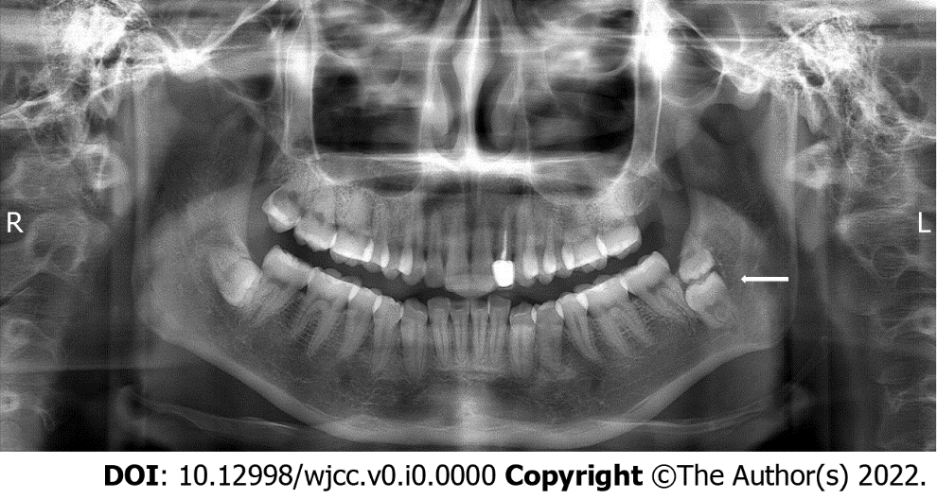
Figure 1 Teeth #17 and #67 in the vertical direction, showing impacted kissing molars.

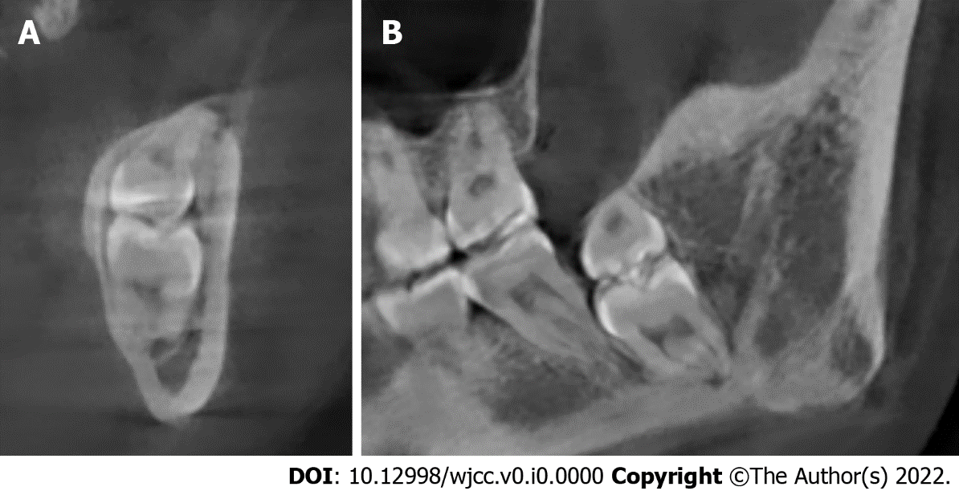
Figure 2 Cone-beam computed tomography image of kissing molars, the root of tooth #17 appears close to the inferior alveolar nerve, the kissing molars and tooth #18 were close, and the distal bone of tooth #18 was absorbed. A: Coronal plane; B: Sagittal plane.
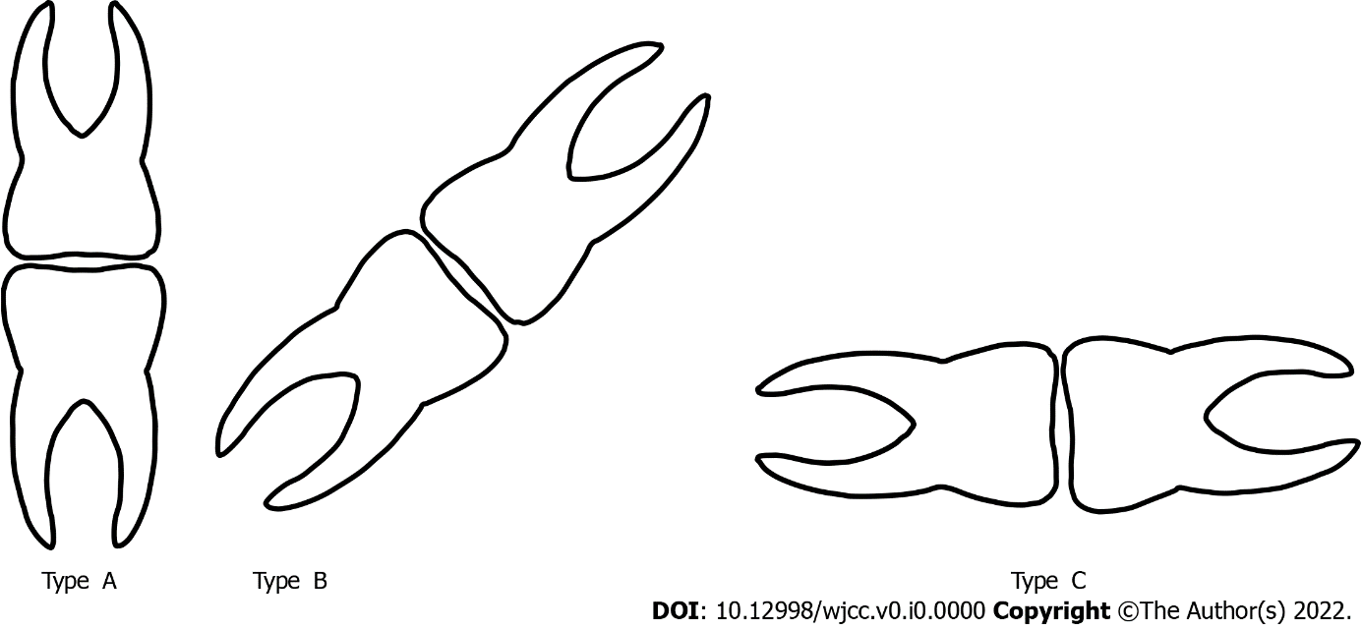
Figure 3 Classification of kissing molars according to the impaction direction (from left to right: Type A, vertical, Type B, tilted, Type C, transverse).

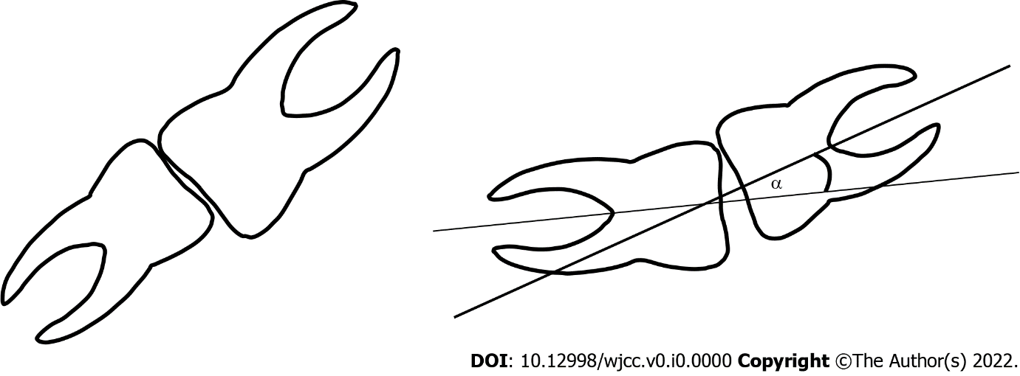
Figure 4 Kissing molars; the overlapping region of the two teeth, and the acute angle formed by the long axis of the two teeth should be considered when identifying kissing molars.

