Name of Journal: World Journal of Gastrointestinal Oncology
Manuscript NO: 52619
Manuscript Type: ORIGINAL ARTICLE

Prospective Study
Expression and significance of miR-654-5p and miR-376b-3p in patients with colon cancer

Li P et al. Value of miR-654-5p and miR-376b-3p

Ping Li, Jia-Xun Cai, Fei Han, Jie Wang, Jia-Jie Zhou, Kai-Wen Shen, Liu-Hua Wang

Ping Li, Department of Central Laboratory, Huaian Tumor Hospital & Huaian Hospital of Huaian City, Huaian 223200, Jiangsu Province, China
Ping Li, Department of General Surgery, Huaian Tumor Hospital & Huaian Hospital of Huaian City, Huaian 223200, Jiangsu Province, China

Jia-Xun Cai, Department of Anorectal, Clinical Medical College of Yangzhou University and Northern Jiangsu People’s Hospital, Yangzhou 225001, Jiangsu Province, China

Fei Han, Jie Wang, Jia-Jie Zhou, Kai-Wen Shen, Clinical Medical College, Yangzhou University, Yangzhou 225009, Jiangsu Province, China

Liu-Hua Wang, Department of General Surgery, General Surgery Institute of Yangzhou, Northern Jiangsu Province Hospital, Clinical Medical College, Yangzhou University, Yangzhou 225001, Jiangsu Province, China

Author contributions: Li P, Cai JX, Wang J and Han F contributed equally to this work. Li P, Wang J and Han F conceived, designed and drafted the paper; Wang LH provided supervision and review; Wang J and Han F conducted the statistical analyses; Zhou JJ and Shen KW contacted the authors of the included studies to obtain additional information; All of the authors approved the final version of the manuscript submitted for publication.

Corresponding author: Liu-Hua Wang, FRCS (Hon), MD, Doctor, Surgeon, Department of General Surgery, General Surgery Institute of Yangzhou, Northern Jiangsu Province Hospital, Clinical Medical College, Yangzhou University, Nantong Road No. 98, Yangzhou 225001, Jiangsu Province, China. wlh1118ok@sina.com

Received: November 26, 2019
Revised: February 5, 2020
Accepted: March 12, 2020
Published online: April 15, 2020

Abstract
BACKGROUND
The relationship between microRNAs, such as miR-654-5p and miR-376b-3p, and the prognosis of colon cancer has not been studied until now.

AIM
To evaluate the expression levels of miR-654-5p and miR-376b-3p and their clinical significance in colon cancer.

METHODS
RT-qPCR was performed to evaluate miR-654-5p and miR-376b-3p expression in 34 pairs of colon cancer and adjacent noncancerous tissues. Subsequently, the association of miR-654-5p and miR-376b-3p expression with clinical factors or the survival of patients suffering from colon cancer was determined by using The Cancer Genome Atlas.

RESULTS
miR-654-5p was upregulated and miR-376b-3p was downregulated in colon cancer tissues compared with adjacent noncancerous tissues (P < 0.001). Increased miR-654-5p and decreased miR-376b-3p expression levels were significantly associated with metastasis and clinical stage. Moreover, a univariate analysis demonstrated that colon cancer patients with high miR-654-5p or low miR-376b-3p expression (P = 0.044 and 0.007, respectively) had a poor overall survival rate. A multivariate analysis identified high miR-654-5p expression and low miR-376b-3p expression as independent predictors of poor survival in colon cancer patients.

CONCLUSION
Upregulated miR-654-5p and downregulated miR-376b-3p may be associated with tumour progression in colon cancer, and these microRNAs may serve as independent prognostic markers for colon cancer.

Key words: Colorectal cancer; Colon cancer; Rectal cancer; MiR-654-3p; MiR-376b-5p; Prognosis; Survival; The Cancer Genome Atlas

Citation: Li P, Cai JX, Han F, Wang J, Zhou JJ, Shen KW, Wang LH. Expression and significance of miR-654-5p and miR-376b-3p in patients with colon cancer. World J Gastrointest Oncol 2020; 12(4): 492-502
URL: https://www.wjgnet.com/1948-5204/full/v12/i4/492.htm
DOI: https://dx.doi.org/10.4251/wjgo.v12.i4.492

Core tip: This was a prospective study. The relationship between microRNAs, such as miR-654-5p and miR-376b-3p, and the prognosis of colon cancer has not been studied until now. In this present study, we found that upregulated miR-654-5p and downregulated miR-376b-3p may be associated with tumour progression in colon cancer, and these microRNAs may serve as independent prognostic markers for colon cancer.

INTRODUCTION
Colon cancer is the third most common malignancy and a major cause of cancer-related deaths worldwide^{[1]}. Approximately 600000 patients die from colon cancer every year. Despite the availability of effective diagnostic and treatment modalities, most patients are at a risk of recurrence and progression of this cancer^{[2]}. Extensive studies have revealed new diagnostic and prognostic markers based on novel molecular networks, but only a few of these tests are recommended for daily practice because of their limited diagnostic and prognostic performance^{[3]}. The identification of more reliable and accurate prognostic mediators of tumour occurrence, development, invasion and metastasis is necessary to define the progression of patients with colon cancer and to improve postoperative treatment strategies.
MicroRNAs (miRNAs) regulate gene expression and are involved in numerous cellular and physiological processes, including tumour growth, proliferation, apoptosis, and angiogenesis; they have a high degree of sequence conservation among distantly related organisms and may participate in critical biological processes^{[4-6]}. Some miRNAs are differentially expressed in colon cancer tissues, body fluids, serum and plasma and may be useful as biomarkers for diagnosis and as therapeutic targets and are clinically important^{[7-10]}. However, few miRNA expression profiling studies have been conducted in colon cancer to reveal diagnostic and prognostic biomarkers.
miR-654-5p and miR-376b-3p play a major role in regulating various biological activities, including cancer progression, liver regeneration, angiogenesis, and cardioprotection. miR-654-5p has been implicated in breast cancer, prostate cancer, Hodgkin lymphoma, and oral squamous cell carcinoma^{[11-14]}. miR-376b-3p plays major roles in cancer progression, liver regeneration, angiogenesis, and cardioprotection^{[15,16]}. Some studies have suggested that miR-654-5p and miR-376b-3p are metastasis-associated miRNAs in colon cancer^{[17]}. However, the diagnostic and prognostic role of miR-654-5p and miR-376b-3p in colon cancer remains largely unknown. In this study, our primary aim was to investigate the expression of miR-654-5p and miR-376b-3p in colon cancer. Consequently, we studied the association between the expression of miR-654-5p and miR-376b-3p and the clinical features of colon cancer patients, including survival, and biomarkers that could be used as factors to predict prognosis. We investigated mainly the miR-654-5p and miR-376b-3p expression levels in colon cancer tissues by using an open source database, The Cancer Genome Atlas (TCGA). Our findings indicate that miR-654-5p and miR-376b-3p might provide a novel prognostic approach for colon cancer.

MATERIALS AND METHODS
Patient material and acquisition of genetic information
Tumour and adjacent noncancerous tissue samples of 34 patients (68 samples in total) were obtained from the Department of General Surgery, Northern Jiangsu Province Hospital. All samples from patients were obtained by taking their informed consent, and this project was approved by the Clinical Research Ethics Committees of the participating institutions. We retrieved the registered data of colon cancer patients from the TCGA data portal (https://https://cancergenome.nih.gov/) in January 2019. Demographic information, such as age and sex, and cancer characteristics, such as cancer location and status, were collected. We followed the TNM Classification of Malignant Tumors (TNM) staging according to the AJCC 7th edition, and patients whose TNM stage and age were not described in the data registry were excluded from the analysis.

RNA isolation from patient tissue samples
RNA isolation encapsulates all steps required for purifying total RNA, including small RNAs from tissues. RNA isolation was performed for the 34 patient samples using a miRNeasy Mini Kit (Qiagen, Hilden, Germany) according to the manufacturer’s instructions. After RNA extraction, the total RNA samples were stored at -80 °C until required. RNA concentrations were measured using a NanoDrop spectrophotometer.

Real-time quantitative PCR analysis of gene expression
Real-time quantitative PCR (RT-qPCR) was performed using the SYBR detection system. A total of 68 samples were tested for the estimation of miRNAs. Primers used for the detection of gene expression (miR-654-5p and miR-376b-3p) were purchased from the QuantiTect Primer Collection (Qiagen, Germany). The lyophilized primers were dissolved in 10× Tris-EDTA buffer (TE buffer; pH 8.0), and RNU6 was selected as a housekeeping gene for miR-654-5p and miR-376b-3p. The PCR programme used for the detection of miRNAs was as follows: Segment 1 (1 cycle), 95 °C for 15 min; segment 2, 94 °C for 15 s, 55 °C for 30 s and 70 °C for 30 s; 40 cycles.

Relative quantification of miRNA expression
miRNA expression was quantified using the delta delta CT (∆∆Ct) method as previously described. Average crossing point (Ct) values were obtained for the housekeeping gene of the selected miRNAs under control and experimental conditions. The four sets of values included the housekeeping gene under the experimental condition, the housekeeping gene under the control condition, and the selected miRNA under both experimental and control conditions. The calculated differences between the control and experimental values signified the ∆Ct values under the experimental (∆CTE) and control (∆CTC) conditions. The difference between ∆CTE and ∆CTC was calculated to derive the ∆∆Ct value, and the value of (2^-∆∆Ct) was calculated to obtain fold changes in miRNA expression.

Statistical analysis
SPSS software (v.19.0; IBM SPSS, Chicago, IL, United States) was used to statistically analyse all the results. Analysis of variance and least significance difference post hoc tests were used to analyse miR-654-5p and miR-376b-3p expression. Student’s t-test, Pearson’s χ² test, and Fisher’s exact test were used to compare measurement data. The Kaplan-Meier method was used to analyse overall survival, and the log-rank test was uses to evaluate differences in survival. Cox’s proportional hazards regression model was performed for an independent prognosis. P ≤ 0.05 indicated a statistically significant difference.

RESULTS
miR-654-5p and miR-376b-3p showed significant differences between tumour tissues and adjacent noncancerous tissues
The expression levels of miR-654-5p and miR-376b-3p were detected by RT-qPCR. The expression level of miR-654-5p was significantly higher (1.698 ± 0.952) in colon cancer tissues than in adjacent noncancerous tissues (1.062 ± 0.329) (P < 0.001) (Figure 1A). However, the expression level of miR-376b-3p was lower (0.562 ± 0.564) in colon cancer tissues than in adjacent noncancerous tissues (1.02 ± 0.226) (P < 0.001) (Figure 1C).

Correlation of miR-654-5p and miR-376b-3p expression in colon cancer with clinicopathological features
To validate the outcomes of the RT-qPCR analysis, data from the TCGA were used to evaluate miR-654-5p and miR-376b-3p expression in 413 colon cancer tissues (Table 1 and Table 2). Patients with colon cancer were divided into 2 groups (low and high groups) according to miR-654-5p and miR-376b-3p expression levels, and the results were compared by analysis of variance and least significance difference tests. In the miR-654-5p group, the results revealed that the expression of miR-654-5p was upregulated in colon cancer tissues and positively associated with miR-376b-3p (P = 0.005), metastasis (P = 0.036), race (P = 0.016), organ in which the cancer was detected (P = 0.044), and TNM stage (P = 0.043). In the miR-376b-3p group, the results revealed that the expression of miR-376b-3p was downregulated in colon cancer tissues and positively associated with miR-552-5p, TNM stage, and metastasis (P = 0.001, 0.002, and 0.049, respectively).

High miR-654-5p expression and low miR-376b-3p expression are associated with a poor prognosis and the aggressive progression of colon cancer
The prognostic value of miR-654-5p and miR-376b-3p relative to the survival time of colon cancer patients was evaluated by the Kaplan-Meier method. The overall survival rate of all colon cancer patients with high miR-654-5p expression was significantly lower than that of patients with low miR-654-5p expression (P = 0.044) (Figure 1B). Similarly, the overall survival rate of all colon cancer patients with high miR-376b-3p expression was significantly lower than that of patients with low miR-376b-3p expression (P = 0.007) (Figure 1D). A similar result was also obtained in the survival rate of patients with advanced colon cancer. At stage Ⅳ of colon cancer, patients with high miR-654-5p expression had low survival rates (P = 0.025) (Figure 2D). In contrast, at stages Ⅱ and Ⅳ of colon cancer, patients with low miR-376b-3p expression had low survival rates (P = 0.042 and 0.05, respectively) (Figure 3B, Figure 3D). However, differences in miR-654-5p expression in patients with colon cancer were not significant at stages Ⅰ, Ⅱ, or Ⅲ, and the differences in miR-376b-3p expression were not significant at stages Ⅰ or Ⅲ (Figure 2 and 3).

miR-654-5p and miR-376b-3p serve as independent prognostic markers for the survival of patients with colon cancer
Cox’s proportional hazards model was used to decipher data obtained from the TCGA and determine whether miR-654-5p and miR-376b-3p could be used as independent prognostic markers for the survival rate of colon cancer patients. The univariate analysis revealed that miR-654-5p and miR-376b-3p expression levels were significant prognostic markers for the overall survival rate of patients with colon cancer: miR-654-5p (HR = 0.655; 95%CI: 0.434-0.989; P = 0.044); miR-376b-3p (HR = 1.782; 95%CI: 1.173-2.707; P = 0.007); TNM stage (HR = 0.305; 95%CI: 0.200-0.465; P = 0.000); metastasis (HR = 0.093; 95%CI: 0.048-0.180; P = 0.000). The multivariate analysis demonstrated that high miR-654-5p expression and low miR-376b-3p expression were significant independent prognostic markers in colon cancer: miR-654-5p (HR = 0.725; 95%CI: 0.421-1.372; P = 0.058); miR-376b-3p (HR = 0.518; 95%CI: 0.339-0.792; P = 0.012); TNM stage (HR = 2.199; 95%CI: 1.323-3.656; P = 0.002), metastasis (HR = 2.886; 95%CI: 1.739-4.790; P = 0.000) (Table 3).

DISCUSSION
With improvements in living standards and changes in the living environment, the incidence of colon cancer has significantly improved^{[18]}. Multiple genetic mutations, multiple factors and multiple stages lead to a poor prognosis and an aggressive progression of colon cancer in which multiple tumour suppressor genes and oncogenes are involved. Alterations in the expression of miRNAs in cancer and correlations between miRNA expression profiles and clinicopathological features could be used in the diagnosis and therapies of different types of malignancies^{[19,20]}. A number of deregulated miRNAs have been studied by expression analyses in colon cancer and compared with adjacent noncancerous tissues in patients with colon cancer and have indicated that such classes of miRNAs are closely associated with colon cancer.
However, no reports describing the biological role of miR-654-5p and miR-376b-3p in patients with colon cancer are available. Our study is the first of its kind to examine the expression of miR-654-5p and miR-376b-3p in patients with colon cancer. In this prospective study, we analysed the expression levels of miR-654-5p and miR-376b-3p using tissues from patients with colon cancer and adjacent noncancerous tissues. We performed experiments in which 68 tissue samples (cancer tissues and adjacent noncancerous tissues) were obtained from 34 cancer patients from the Department of General Surgery, Northern Jiangsu Province Hospital. Our findings reveal that miR-654-5p and miR-376b-3p are promising candidates that could be used as markers for colon cancer given that they demonstrated well-defined patterns of expression in the tested tissue samples.
Metastasis is a main cause of the majority of colon cancer-related deaths. Metastasis is a major prognostic factor that should be considered in patients with colon cancer^{[21,22]}. Our research suggests that high miR-654-5p expression and low miR-376b-3p expression in tumours may impact tumour aggression and prognosis. When we tested the effects of both the upregulated and downregulated expression levels of miR-654-5p and miR-376b-3p, we observed that they are closely related to metastasis in tumours. We observed that miR-654-5p and miR-376b-3p were associated with the overall survival rate of colon cancer patients and were likely to have different levels of expression depending on the stage of cancer at diagnosis. When interpreting these results, several aspects of the study need to be considered. One of the drawbacks of this study was that the number of samples taken was small. Another factor was the difficulty encountered when carrying out follow-ups of cancer patients, and because such follow-ups are important, they were likely to have affected overall survival. Additionally, since we used an open source database, we had several limitations to our analysis. Incomplete information on cancer patients limited our understanding of the relationship between miR-654-5p, miR-376b-3p and colon cancer prognosis.
Transforming growth factor β (TGF-β) plays important pathological and physiological roles in regulating cell differentiation and proliferation, invasion, apoptosis, migration and modification of the microenvironment and cancer metastasis^{[23]}. Interestingly, the TGF-β signalling pathway has a paradoxical effect on biology. It maintains proliferation, apoptosis and differentiation in normal cells and early-stage cancer cells but promotes cancer cell invasion, migration and metastasis in advanced-stage cancer cells. miR-654-5p plays a major role in regulating various biological activities, including cancer progression^{[11-14]}. Similarly, miR-376b-3p is also implicated in regulating various biological activities, such as cancer progression, liver regeneration, angiogenesis, and cardioprotection^{[15,16]}. To date, no report has demonstrated the roles of miR-654-5p and miR-376b-3p in colon diseases; however, our study revealed that miR-654-5p and miR-376b-3p participate in regulating the progression of colon cancer. To explain the relation between miR-654-5p and miR-376b-3p and metastasis, we used miRWalk (http://mirwalk.umm.uni-heidelberg.de/) to identify the targets of miR-654-5p and miR-376b-3p. We found that miR-654-5p is related to mothers against decapentaplegic homologue 2 (SMAD2), SMAD6, SMAD7, and SMAD9 and that miR-376b-3p is related to SMAD1, SMAD4, SMAD2, and SMAD7. SMADs are a crucial part of the TGF-β signalling pathway. Dysregulated miRNA expression targets SMAD7, which has been shown to be a TGF-β receptor type 1 antagonist. In contrast, the inhibition of SMAD7 led to an increase in the expression of the TGF-β pathway member TGF-β receptor type 1. This pattern of regulation indicates that the dysregulation of miRNAs may provide a positive feedback mechanism to the TGF-β pathway through SMAD7^{[24,25]}.
The results of this study showed that the expression levels of miR-654-5p and miR-376b-3p in colon cancer tissues were significantly higher and lower, respectively, than those in adjacent healthy tissues (P < 0.01). The expression levels of miR-654-5p and miR-376b-3p were associated with TNM stage and metastasis (P < 0.05). The survival rate of patients with high miR-654-5p expression was significantly low. The survival time of the group with high miR-376b-3p expression was long (P ≤ 0.05). In addition, the Cox multivariate regression analysis showed that TNM stage, metastasis, and miR-654-5p and miR-376b-3p expression were independent risk factors for a poor prognosis and the aggressive progression of colon cancer (Table 3). The expression of miR-654-5p was positively associated with the risk of disease progression and the degree of malignancy and negatively associated with the survival time of patients, while miR-376b-3p demonstrated the opposite effect. Thus, it is apparent that the expression of miR-654-5p and miR-376b-3p in colon cancer is an essential index that can be used determine the prognosis of colon cancer. The combination of miR-654-5p and miR-376b-3p expression and an immunohistochemical pathological examination may improve the diagnosis and prognosis of colon cancer and is worth pursuing further for clinical applications.
Our results have shown the association of the expression levels of miR-654-5p and miR-376b-3p with clinicopathologic features and prognosis in colon cancer patients. Nevertheless, we should further perform both in vitro analyses of molecular mediators and in vivo analyses in animal models of colon cancer to evaluate whether genes, inflammatory molecules, gastrointestinal tract microbiota, and the extracellular matrix could together contribute to carcinogenesis of the colon.
In conclusion, our study provides sensitive and accurate biomarkers that may aid in the prognosis of colon cancer. However, sustained effort is required to clarify the underlying molecular mechanisms by which miR-654-5p and miR-376b-3p may improve colon cancer metastasis.

Limitations
Our study found that Upregulated miR-654-5p and downregulated miR-376b-3p may be associated with tumour progression in colon cancer. However, incomplete information on cancer patients limited our understanding of the relationship between miR-654-5p, miR-376b-3p and colon cancer prognosis. Sustained effort is required to clarify the underlying molecular mechanisms by which miR-654-5p and miR-376b-3p may improve colon cancer metastasis.

ARTICLE HIGHLIGHTS
The relationship between microRNAs (miRNAs), such as miR-654-5p and miR-376b-3p, and the prognosis of colon cancer has not been studied until now. It is the first time that our study found that Upregulated miR-654-5p and downregulated miR-376b-3p may be associated with tumour progression in colon cancer.

Research background
Colon cancer is the third most common malignancy and a major cause of cancer-related deaths worldwide. Extensive studies have revealed new diagnostic and prognostic markers based on novel molecular networks, but only a few of these tests are recommended for daily practice because of their limited diagnostic and prognostic performance. This study evaluated the expression levels of miR-654-5p and miR-376b-3p and their clinical significance in colon cancer. In this present study, we found that upregulated miR-654-5p and downregulated miR-376b-3p may be associated with tumour progression in colon cancer, and these miRNAs may serve as independent prognostic markers for colon cancer.

Research objectives
Evaluated the expression levels of miR-654-5p and miR-376b-3p and their clinical significance in colon cancer.

Research methods
Tumour and adjacent noncancerous tissue samples of 34 patients (68 samples in total) were obtained from the Department of General Surgery, Northern Jiangsu Province Hospital. We retrieved the registered data of colon cancer patients from the TCGA data portal (https://https://cancergenome.nih.gov/) in January 2019. Demographic information, such as age and sex, and cancer characteristics, such as cancer location and status, were collected. RT-qPCR was performed using the SYBR detection system. A total of 68 samples were tested for the estimation of miRNAs. miRNA expression was quantified using the delta delta CT (∆∆Ct) method. Average crossing point (Ct) values were obtained for the housekeeping gene of the selected miRNAs under control and experimental conditions. SPSS software (v.19.0; IBM SPSS, Chicago, IL, United States) was used to statistically analyse all the results. Analysis of variance and least significance difference post hoc tests were used to analyse miR-654-5p and miR-376b-3p expression. Student’s t-test, Pearson’s χ² test, and Fisher’s exact test were used to compare measurement data. The Kaplan-Meier method was used to analyse overall survival, and the log-rank test was uses to evaluate differences in survival. Cox’s proportional hazards regression model was performed for an independent prognosis. P ≤ 0.05 indicated a statistically significant difference.

Research results
miR-654-5p and miR-376b-3p showed significant differences between tumour tissues and adjacent noncancerous tissues. Correlation of miR-654-5p and miR-376b-3p expression in colon cancer with clinicopathological features. High miR-654-5p expression and low miR-376b-3p expression are associated with a poor prognosis and the aggressive progression of colon cancer. miR-654-5p and miR-376b-3p serve as independent prognostic markers for the survival of patients with colon cancer.

Research conclusions
Upregulated miR-654-5p and downregulated miR-376b-3p may be associated with tumour progression in colon cancer, and these miRNAs may serve as independent prognostic markers for colon cancer.

Research perspectives
Our study provides sensitive and accurate biomarkers that may aid in the prognosis of colon cancer. However, sustained effort is required to clarify the underlying molecular mechanisms by which miR-654-5p and miR-376b-3p may improve colon cancer metastasis.

ACKNOWLEDGEMENTS
The authors thank Xiang-Ming Li for data analysis.

REFERENCES
1 Ferlay J, Soerjomataram I, Dikshit R, Eser S, Mathers C, Rebelo M, Parkin DM, Forman D, Bray F. Cancer incidence and mortality worldwide: sources, methods and major patterns in GLOBOCAN 2012. Int J Cancer 2015; 136: E359-E386 [PMID: 25220842 DOI: 10.1002/ijc.29210]
2 Gong C, Yao Y, Wang Y, Liu B, Wu W, Chen J, Su F, Yao H, Song E. Up-regulation of miR-21 mediates resistance to trastuzumab therapy for breast cancer. J Biol Chem 2011; 286: 19127-19137 [PMID: 21471222 DOI: 10.1074/jbc.M110.216887]
3 Jung SB, Lee HI, Oh HK, Shin IH, Jeon CH. Clinico-pathologic Parameters for Prediction of Microsatellite Instability in Colorectal Cancer. Cancer Res Treat 2012; 44: 179-186 [PMID: 23091444 DOI: 10.4143/crt.2012.44.3.179]
4 Amirkhah R, Schmitz U, Linnebacher M, Wolkenhauer O, Farazmand A. MicroRNA-mRNA interactions in colorectal cancer and their role in tumor progression. Genes Chromosomes Cancer 2015; 54: 129-141 [PMID: 25620079 DOI: 10.1002/gcc.22231]
5 Iorio MV, Croce CM. Causes and consequences of microRNA dysregulation. Cancer J 2012; 18: 215-222 [PMID: 22647357 DOI: 10.1097/PPO.0b013e318250c001]
6 Carrington JC, Ambros V. Role of microRNAs in plant and animal development. Science 2003; 301: 336-338 [PMID: 12869753 DOI: 10.1126/science.1085242]
7 Carter JV, Galbraith NJ, Yang D, Burton JF, Walker SP, Galandiuk S. Blood-based microRNAs as biomarkers for the diagnosis of colorectal cancer: a systematic review and meta-analysis. Br J Cancer 2017; 116: 762-774 [PMID: 28152545 DOI: 10.1038/bjc.2017.12]
8 Strubberg AM, Madison BB. MicroRNAs in the etiology of colorectal cancer: pathways and clinical implications. Dis Model Mech 2017; 10: 197-214 [PMID: 28250048 DOI: 10.1242/dmm.027441]
9 Mármol I, Sánchez-de-Diego C, Pradilla Dieste A, Cerrada E, Rodriguez Yoldi MJ. Colorectal Carcinoma: A General Overview and Future Perspectives in Colorectal Cancer. Int J Mol Sci 2017; 18 [PMID: 28106826 DOI: 10.3390/ijms18010197]
10 Moridikia A, Mirzaei H, Sahebkar A, Salimian J. MicroRNAs: Potential candidates for diagnosis and treatment of colorectal cancer. J Cell Physiol 2018; 233: 901-913 [PMID: 28092102 DOI: 10.1002/jcp.25801]
11 Tan YY, Xu XY, Wang JF, Zhang CW, Zhang SC. MiR-654-5p attenuates breast cancer progression by targeting EPSTI1. Am J Cancer Res 2016; 6: 522-532 [PMID: 27186421]
12 Östling P, Leivonen SK, Aakula A, Kohonen P, Mäkelä R, Hagman Z, Edsjö A, Kangaspeska S, Edgren H, Nicorici D, Bjartell A, Ceder Y, Perälä M, Kallioniemi O. Systematic analysis of microRNAs targeting the androgen receptor in prostate cancer cells. Cancer Res 2011; 71: 1956-1967 [PMID: 21343391 DOI: 10.1158/0008-5472.CAN-10-2421]
13 Paydas S, Acikalin A, Ergin M, Celik H, Yavuz B, Tanriverdi K. Micro-RNA (miRNA) profile in Hodgkin lymphoma: association between clinical and pathological variables. Med Oncol 2016; 33: 34 [PMID: 26951445 DOI: 10.1007/s12032-016-0749-5]
14 Lu M, Wang C, Chen W, Mao C, Wang J. miR-654-5p Targets GRAP to Promote Proliferation, Metastasis, and Chemoresistance of Oral Squamous Cell Carcinoma Through Ras/MAPK Signaling. DNA Cell Biol 2018; 37: 381-388 [PMID: 29364705 DOI: 10.1089/dna.2017.4095]
15 Huang Q, Wang C, Hou Z, Wang G, Lv J, Wang H, Yang J, Zhang Z, Zhang H. Serum microRNA-376 family as diagnostic and prognostic markers in human gliomas. Cancer Biomark 2017; 19: 137-144 [PMID: 28211798 DOI: 10.3233/CBM-160146]
16 Pan Z, Guo Y, Qi H, Fan K, Wang S, Zhao H, Fan Y, Xie J, Guo F, Hou Y, Wang N, Huo R, Zhang Y, Liu Y, Du Z. M3 subtype of muscarinic acetylcholine receptor promotes cardioprotection via the suppression of miR-376b-5p. PLoS One 2012; 7: e32571 [PMID: 22396777 DOI: 10.1371/journal.pone.0032571]
17 Mudduluru G, Abba M, Batliner J, Patil N, Scharp M, Lunavat TR, Leupold JH, Oleksiuk O, Juraeva D, Thiele W, Rothley M, Benner A, Ben-Neriah Y, Sleeman J, Allgayer H. A Systematic Approach to Defining the microRNA Landscape in Metastasis. Cancer Res 2015; 75: 3010-3019 [PMID: 26069251 DOI: 10.1158/0008-5472.CAN-15-0997]
18 Ji BC, Yu CC, Yang ST, Hsia TC, Yang JS, Lai KC, Ko YC, Lin JJ, Lai TY, Chung JG. Induction of DNA damage by deguelin is mediated through reducing DNA repair genes in human non-small cell lung cancer NCI-H460 cells. Oncol Rep 2012; 27: 959-964 [PMID: 22227970 DOI: 10.3892/or.2012.1622]
19 Masuda T, Hayashi N, Kuroda Y, Ito S, Eguchi H, Mimori K. MicroRNAs as Biomarkers in Colorectal Cancer. Cancers (Basel) 2017; 9 [PMID: 28902152 DOI: 10.3390/cancers9090124]
20 Moridikia A, Mirzaei H, Sahebkar A, Salimian J. MicroRNAs: Potential candidates for diagnosis and treatment of colorectal cancer. J Cell Physiol 2018; 233: 901-913 [PMID: 28092102 DOI: 10.1002/jcp.25801]
21 Cao H, Xu E, Liu H, Wan L, Lai M. Epithelial-mesenchymal transition in colorectal cancer metastasis: A system review. Pathol Res Pract 2015; 211: 557-569 [PMID: 26092594 DOI: 10.1016/j.prp.2015.05.010]
22 Tauriello DV, Calon A, Lonardo E, Batlle E. Determinants of metastatic competency in colorectal cancer. Mol Oncol 2017; 11: 97-119 [PMID: 28085225 DOI: 10.1002/1878-0261.12018]
23 García-Vizcaíno EM, Liarte S, Alonso-Romero JL, Nicolás FJ. Sirt1 interaction with active Smad2 modulates transforming growth factor-β regulated transcription. Cell Commun Signal 2017; 15: 50 [PMID: 29187201 DOI: 10.1186/s12964-017-0205-y]
24 Yu J, Lei R, Zhuang X, Li X, Li G, Lev S, Segura MF, Zhang X, Hu G. MicroRNA-182 targets SMAD7 to potentiate TGFβ-induced epithelial-mesenchymal transition and metastasis of cancer cells. Nat Commun 2016; 7: 13884 [PMID: 27996004 DOI: 10.1038/ncomms13884]
25 Luo M, Tan X, Mu L, Luo Y, Li R, Deng X, Chen N, Ren M, Li Y, Wang L, Wu J, Wan Q. MiRNA-21 mediates the antiangiogenic activity of metformin through targeting PTEN and SMAD7 expression and PI3K/AKT pathway. Sci Rep 2017; 7: 43427 [PMID: 28230206 DOI: 10.1038/srep43427]

Footnotes
Institutional review board statement: This project was approved by the Clinical Research Ethics Committees of the participating institutions.

Clinical trial registration statement: This study is registered at clinical hospital center "Clinical Medical College of Yangzhou University (Northern Jiangsu Province Hospital)" Trial registry. The registration identification number is 2018KY-138.A separate document was uploaded as a proof of registry.

Informed consent statement: All study participants, or their legal guardian, provided written consent prior to study enrollment.

Conflict-of-interest statement: The authors declare that they have no competing interests.

Data sharing statement: There is no additional data available.

CONSORT 2010 statement: The authors have read the CONSORT 2010 Statement, and the manuscript was prepared and revised according to the CONSORT 2010 Statement.

Open-Access: This article is an open-access article that was selected by an in-house editor and fully peer-reviewed by external reviewers. It is distributed in accordance with the Creative Commons Attribution NonCommercial (CC BY-NC 4.0) license, which permits others to distribute, remix, adapt, build upon this work non-commercially, and license their derivative works on different terms, provided the original work is properly cited and the use is non-commercial. See: http://creativecommons.org/licenses/by-nc/4.0/

Manuscript source: Invited manuscript

Peer-review started: November 26, 2019
First decision: January 14, 2020
Article in press: March 12, 2020

Specialty type: Oncology
Country of origin: China
Peer-review report classification
Grade A (Excellent): A
Grade B (Very good): B
Grade C (Good): 0
Grade D (Fair): 0
Grade E (Poor): 0

P-Reviewer: Ahmed M, Aykan NF S-Editor: Dou Y L-Editor: A E-Editor: Qi LL

Figure Legends
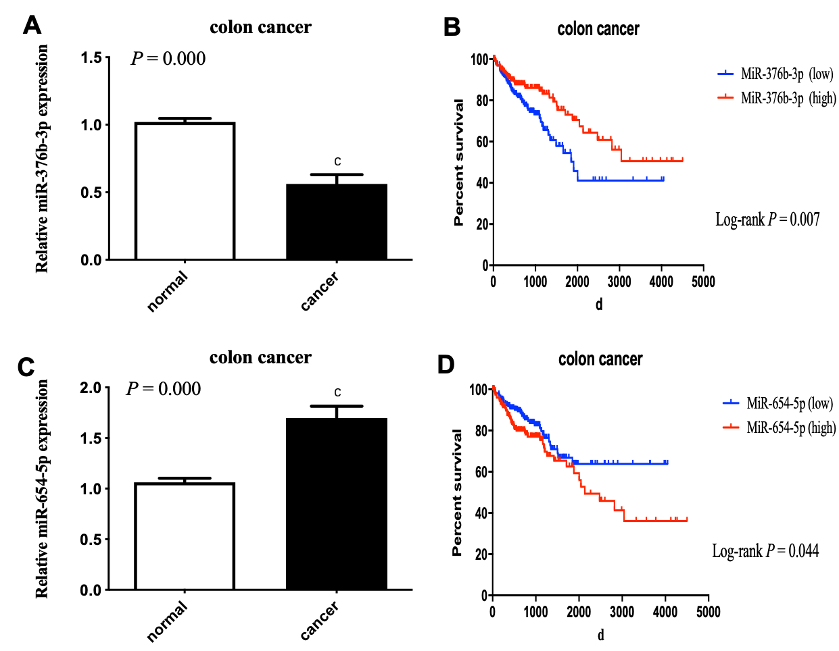
Figure 1 MiR-654-5p and miR-376b-3p showed significance differences between tumor specimens and adjacent noncancerous tissues and associated with aggressive progression and poor prognosis of colon cancer. A: MiR-654-5p is up-regulated in colon tumor tissues. The miR-654-5p significantly increased in colon tumor samples compared to in matched noncancerous tissues; B: Kaplan-Meier curves of different miR-654-5p expression levels based on The Cancer Genome Atlas data. The overall survival of patients with colon varies with different miR-654-5p expression levels; C: MiR-376b-3p is downregulated in colon tumor tissues. The miR-376b-3p significantly decreased in colon tumor samples compared to in matched noncancerous tissues; D: Kaplan-Meier curves of different miR-376b-3p expression levels based on The Cancer Genome Atlas data. The overall survival of patients with colon varies with different miR-376b-3p expression levels.
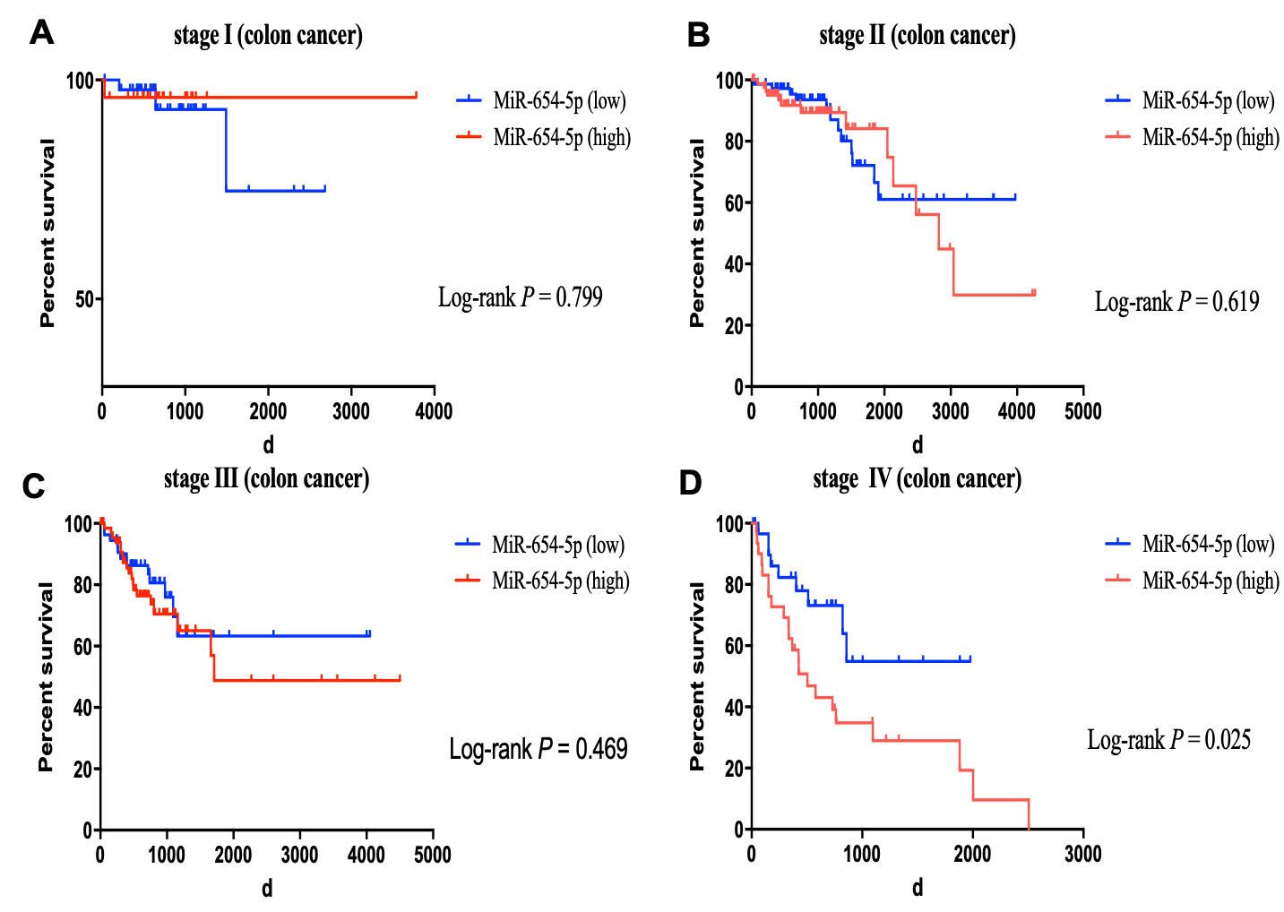
Figure 2 Kaplan-Meier curves of different miR-654-5p expression levels based on The Cancer Genome Atlas data. A: The overall survival of stage Ⅰpatients with colon varies with different miR-654-5p expression levels; B: The overall survival of stage Ⅱ patients with colon varies with different miR-654-5p expression levels; C: The overall survival of stage Ⅲ patients with colon varies with different miR-654-5p expression levels; D: The overall survival of stage Ⅳ patients with colon varies with different miR-654-5p expression levels.
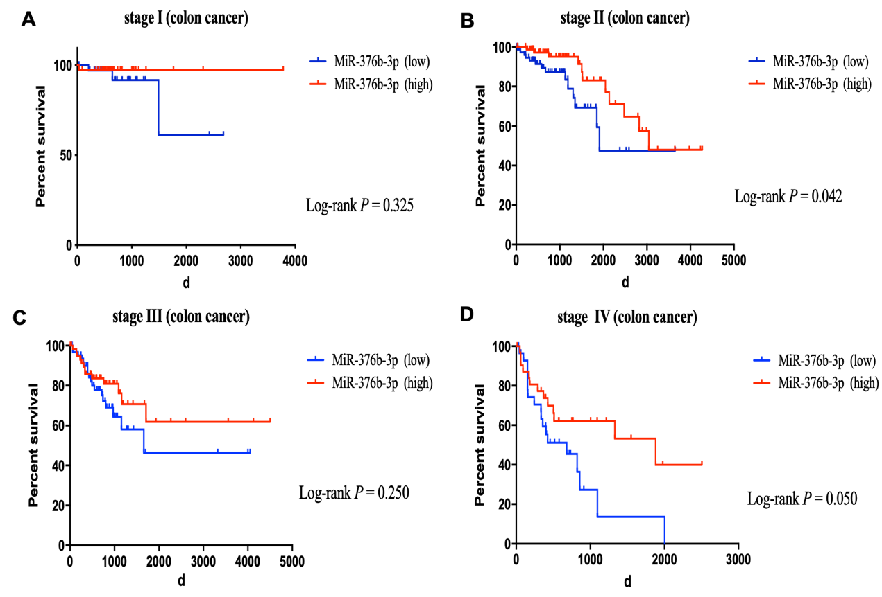
Figure 3 Kaplan-Meier curves of different miR-376b-3p expression levels based on The Cancer Genome Atlas data. A: The overall survival of stage Ⅰ patients with colon varies with different miR-376b-3p expression levels; B: The overall survival of stage Ⅱ patients with colon varies with different miR-376b-3p expression levels; C: The overall survival of stage Ⅲ patients with colon varies with different miR-376b-3p expression levels; D: The overall survival of stage Ⅳ patients with colon varies with different miR-376b-3p expression levels.

Table 1 Association between clinical or pathological factors and miR-654-5p expression levels in colon cancer using data from The Cancer Genome Atlas
 | n | MiR-654-5p expression
 |  | low | high | χ² | P-value
Age |  |  |  | 0.006 | 0.938
≤ 60 | 119 | 59 | 60
> 60 | 294 | 147 | 147
Gender |  |  |  | 0.414 | 0.520
Female | 195 | 94 | 101
Male | 218 | 112 | 106
Race |  |  |  | 4.613 | 0.099
White | 202 | 90 | 112
African | 57 | 30 | 27
Asian | 11 | 7 | 4
Site |  |  |  | 0.144 | 0.931
Ascending | 162 | 81 | 81
Transverse | 36 | 17 | 19
Descending | 122 | 62 | 60
TNM stage |  |  |  | 9.759 | 0.002
Ⅰ-Ⅱ | 229 | 130 | 99
Ⅲ-Ⅳ | 184 | 86 | 108
Metastasis |  |  |  | 5.463 | 0.019
M0 | 352 | 184 | 168
M1 | 61 | 22 | 39
MiR-376b-3p expression |  |  |  | 7.866 | 0.005
Low | 206 | 117 | 89
High | 207 | 89 | 118
Table 2 Association between clinical or pathological factors and miR-376b-3p expression levels in colon cancer using data from The Cancer Genome Atlas
 | n | MiR-376b-3p expression
 |  | low | high | χ² | P value
Age |  |  |  | 0.087 | 0.768
≤ 60 | 119 | 58 | 61
> 60 | 294 | 148 | 146
Gender |  |  |  | 0.707 | 0.4
Female | 195 | 93 | 102
Male | 218 | 113 | 105
Race |  |  |  | 8.274 | 0.016
White | 202 | 91 | 111
African | 57 | 20 | 37
Asian | 11 | 9 | 2
Site |  |  |  | 6.251 | 0.044
Ascending | 162 | 84 | 78
Transverse | 36 | 11 | 25
Descending | 122 | 52 | 70
TNM stage |  |  |  | 4.097 | 0.043
Ⅰ-Ⅱ | 229 | 104 | 125
Ⅲ-Ⅳ | 184 | 102 | 82
Metastasis |  |  |  | 4.413 | 0.036
M0 | 352 | 168 | 184
M1 | 61 | 38 | 23
MiR-654-5p expression |  |  |  | 7.866 | 0.005
Low | 206 | 117 | 89
High | 207 | 89 | 118

Table 3 Prognosis‑associated clinical characteristics in colon cancer using data from The Cancer Genome Atlas
 | Univariate analysis |  | Multi variate analysis
 | P value | HR (95%CI) | P value | HR (95%CI)
Age | 0.354 | 0.806(0.511-1.272)
Gender | 0.575 | 0.889(0.588-1.343)
Race | 0.671 | 0.911(0.592-1.403)
TNM stage | 0.000 | 0.305(0.200-0.465) | 0.002 | 2.199 (1.323-3.656)
Metastasis | 0.000 | 0.093(0.048-0.180) | 0.000 | 2.886 (1.739-4.790)
MiR-376b-3p expression | 0.007 | 1.782(1.173-2.707) | 0.012 | 0.518 (0.339-0.792)
MiR-654-5p  expression | 0.044 | 0.655(0.434-0.989) | 0.058 | 0.725 (0.421-1.372)

