Name of Journal: World Journal of Gastroenterology
Manuscript NO: 37088
Manuscript Type: ORIGINAL ARTICLE

Retrospective Study
PIK3CA and TP53 mutations predict overall survival of stage II/III colorectal cancer patients

Li AJ et al. PIK3CA/TP53 co-mutation in CRC

A-Jian Li, Hua-Guang Li, Er-Jiang Tang, Wei Wu, Ying Chen, Hui-Hong Jiang, Mou-Bin Lin, Lu Yin

A-Jian Li, Lu Yin, Department of General Surgery, Shanghai Tenth People’s Hospital, Tongji University School of Medicine, Shanghai 200072, China

Hua-Guang Li, Er-Jiang Tang, Ying Chen, Center for Translational Medicine, Yangpu Hospital, Tongji University School of Medicine, Shanghai 200090, China

Wei Wu, Hui-Hong Jiang, Mou-Bin Lin, Department of General Surgery, Yangpu Hospital, Tongji University School of Medicine, Shanghai 200090, China

ORCID number: A-Jian Li (0000-0001-8242-1084); Hua-Guang Li (0000-0002-0735-3613); Er-Jiang Tang (0000-0002-8042-5994); Wei Wu (0000-0002-9050-3255); Ying Chen (0000-0001-5084-7507); Hui-Hong Jiang (0000-0002-7391-1767); Mou-Bin Lin (0000-0002-0686-688X); Lu Yin (0000-0002-9351-3811).

Author contributions: Li AJ, Lin MB and Yin L designed the research; Li AJ, Li HG, Chen Y and Jiang HH performed the research; Li AJ, Wu W, Tang EJ and Li HG contributed to the analysis; Lin MB, Chen Y and Yin L supervised the study; Li AJ and Li HG wrote the paper.

Supported by the National Natural Science Foundation of China, No. 81272480; and Science and Technology Commission of Shanghai Municipality, No. 15411969900 and No. 16DZ2342200.

Institutional review board statement: This study was reviewed and approved by the Yangpu Hospital Institutional Review Board.

Informed consent statement: All study participants, or their legal guardian, provided informed written consent prior to study enrollment.

Conflict-of-interest statement: The authors have no conflicts of interest to declare.

Date sharing statement: No additional data are available.

Open-Access: This article is an open-access article which was selected by an in-house editor and fully peer-reviewed by external reviewers. It is distributed in accordance with the Creative Commons Attribution Non Commercial (CC BY-NC 4.0) license, which permits others to distribute, remix, adapt, build upon this work non-commercially, and license their derivative works on different terms, provided the original work is properly cited and the use is non-commercial. See: http://creativecommons.org/licenses/by-nc/4.0/

Manuscript source: Unsolicited manuscript

Correspondence to: Lu Yin, PhD, Doctor, Surgeon, Department of General Surgery, Shanghai Tenth People’s Hospital, Tongji University School of Medicine, No.301 Yanchang Road, Shanghai 200072, China. yindalu@tongji.edu.cn
Telephone: +86-21-66301051
Fax: +86-21-66301090

Received: November 13, 2017

Peer-review started: November 13, 2017

First decision: December 3, 2017

Revised: December 13, 2017

Accepted: December 20, 2017

Article in press:

Published online:

Abstract
AIM
To investigate the predictive value of PIK3CA and TP53 status in colorectal cancer (CRC) patients treated with 5-fluorouracil-based chemotherapy.

METHODS
In this study, a total of 315 CRC patients with histologically proven diagnoses were enrolled from Yangpu Hospital affiliated with Shanghai Tongji University between 2007 and 2011. Of patients, 241 patients with stage II/III CRC received 5-fluorouracil-based adjuvant chemotherapy. Formalin-fixed paraffin-embedded lesion samples of the patients with curatively resected CRC were collected. Next-generation sequencing was performed to identify somatic gene mutations. The correlation of PIK3CA and TP53 status to overall survival (OS) was analyzed using a Cox proportional hazard model and the Kaplan-Meier method.

RESULTS
Among the 241 patients with stage II/III in this cohort, the PIK3CA and/or TP53 mutation was detected in 177 patients, among which 54 patients had PIK3CA and TP53 double mutations. The PIK3CA or TP53 mutation was not significantly correlated with OS in univariate and multivariate analyses. Compared with patients without PIK3CA and TP53 mutations, those with double PIK3CA-TP53 mutations showed a significant association with worse survival (univariate HR = 2.21; 95%CI: 1.15-4.24; multivariate HR = 2.02; 95%CI: 1.04-3.91). The PIK3CA mutation located in a kinase domain showed a trend toward a shorter OS compared with wild-type tumors (multivariate HR = 1.56; 95%CI: 1.00-2.44; P = 0.052). The Kaplan-Meier curve showed that patients harboring the PIK3CA mutation located in a kinase domain had a worse clinical outcome than those with wild-type status (Log-rank P = 0.041)

CONCLUSION
Double mutation of PIK3CA and TP53 is correlated with shorter OS in stage II/III CRC patients treated with 5-fluorouracil-based therapy.

Key words: Colorectal cancer; PIK3CA; TP53; 5-fluorouracil; Overall survival; Double mutation

© The Author(s) 2017. Published by Baishideng Publishing Group Inc. All rights reserved.

Core tip: Targeted next-generation sequencing was used to detect gene mutations rather than mutational hotspots in the present study. This manuscript is by far the first to report the predictive value of the combined mutation status of PIK3CA and TP53 in colorectal cancer patients receiving 5-FU-based adjuvant chemotherapy. Our data revealed that the double mutation of PIK3CA and TP53 is an independent predictive factor for overall survival in stage II/III patients receiving 5-FU-based chemotherapy.

Li AJ, Li HG, Tang EJ, Wu W, Chen Y, Jiang HH, Lin MB, Yin L. PIK3CA and TP53 mutations predict overall survival of stage II/III colorectal cancer patients. World J Gastroenterol 2017; In press

INTRODUCTION
Colorectal cancer (CRC) is now the third most common cancer worldwide^{[1]}[Ferlay, 2010 #165]. The genesis of colorectal cancer is a multi-step, multi-gene process, receiving a great deal of interactive influence from genetic and environmental factors. Attributed to advancements in surgical techniques and the popularization of chemotherapy and targeted therapy, the treatment of CRC has rapidly evolved over several decades. Five-fluorouracil-based (5-FU-based) adjuvant chemotherapy is regarded as a first-line chemotherapy in both adjuvant and palliative settings for advanced CRC. Regrettably, however, a considerable number of patients not only fail to show an objective response to first-line chemotherapy treatment but also suffer from side effects^{[2,3]}. Hence, studies of the biomarkers related to clinical outcome are in urgent demand as a way to identify whether patients benefit from adjuvant chemotherapy.
At present, the response rate of CRC patients receiving 5-FU-based adjuvant thermotherapy is approximately 40%-50%^{[3-7]}, and despite much research on the prediction of response, it has not been possible to identify a predictive biomarker as an indicator of the likely benefit of patients of receiving 5-FU-based adjuvant chemotherapy. Thus, an early, quick, efficient and accurate study is of great clinical significance and value to identify new predictive markers.
It is widely known that the multi-drug resistance (MDR) to anticancer drugs is the main cause of chemotherapy failure. Recent studies have indicated that activation of the PI3K/AKT signaling pathway can result in disturbance of cellular growth, proliferation and survival in a variety of solid tumors^{[8]} and can cause MDR of cancer cells through multiple mechanisms^{[9]}. It is well documented that the effect of the aberrant regulation of the PI3K/AKT signaling pathway on cell growth and apoptosis induced by anti-cancer drugs was observed in vitro and in vivo^{[10-14]}. Given the role of the PI3K/AKT signaling pathway in the development of resistance to anticancer drugs, it is conceivable that genetic mutations (such as PIK3CA) within the PI3K/AKT signaling pathway could be a promising predictive biomarker of chemotherapy efficacy. TP53, the widely studied tumor suppressor gene, which has an intimate connection with the occurrence and progression of many tumors in humans, mainly regulates several cellular processes, including cell cycle regulation, DNA repair and apoptosis^{[15,16]}. Multiple studies have bolstered the notion that TP53 is correlated with the drug resistance of tumor cells and could emerge as a biomarker with predictive value and potential clinical utility^{[17-20]}. Thus, we propose that PIK3CA and TP53 status are likely well associated with clinical outcome in patients undergoing chemotherapy.
In the present study, we evaluated the predictive value of PIK3CA and TP53 status in CRC patients undergoing 5-FU-based chemotherapy after curative surgery and identified subgroups of patients who greatly benefit from specific treatment regimens.
MATERIALS AND METHODS
Study population
In this study, a total of 315 CRC patients with histologically proven diagnoses were enrolled from Yangpu Hospital affiliated with Shanghai Tongji University between 2007 and 2011. Among these patients, 241 patients with stage II/III CRC received 5-FU-based adjuvant chemotherapy as a first-line treatment for at least six cycles. Tumor staging was strictly abided by the TNM classification of the American Joint Committee on Cancer. Formalin-fixed paraffin-embedded (FFPE) lesion samples of the patients with curatively resected CRC were collected from the pathology department where the primary colorectal tumors from the patients in this study were preserved. Histopathological diagnosis by an experienced pathologist was performed for all tissue samples, and at least 70% of tumor cells could be observed in the whole section through light microscopy. Any case that did not meet the experimental standard was excluded from this study. The clinicopathological features, including pathologic stage, tumor location and date of diagnosis and death, were collected. The definition of proximal colon cancer included the cecum and ascending and transverse colon, while tumors located in the splenic flexure and descending and sigmoid colon were characterized as distal colon cancer, and the rectum was defined from the rectosigmoid junction (the end of the sigmoid colon) to the dentate line. Written informed consent was obtained from all participants at the time of study enrollment. This study was approved by the Medical Ethics Committee of Yangpu Hospital.

DNA extraction and target next-generation sequencing
Genomic DNA was extracted from FFPE sections of the 315 tumors. The 10-μm-thick sections were subjected to standard deparaffinization procedures and proteinase K digestion overnight. Genomic DNA was isolated using QIAamp DNA FFPE Tissue kit (Qiagen). All extracted DNA was quantified by a Qubit 3.0 fluorometer (Thermo Fisher Scientific) and Bioanalyzer 2100 (Agilent) before targeted next-generation sequencing (NGS)^{[21,22]}.
Next-generation mutational analysis was performed using an Ion Torrent platform (Thermo Fisher Scientific) in CRC and matched normal tissues of 315 patients to identify somatic gene mutation profiling. DNA library was generated using Ion Ampliseq DNA library kit (Thermo Fisher Scientific). According to the manufacturer’s protocols, 10 ng of DNA was used as the template to amplify targets with sequencing primer panel (Thermo Fisher Scientific). Amplified targets were digested by Fupa enzyme and subsequently ligated with adapters. Library was quantified by quantitative PCR kit and loaded into chips in Ion Chef (Thermo Fisher Scientific). Chips were loaded into an Ion S5 XL sequencer (Thermo Fisher Scientific) for sequencing. Sequencing data was processed and analyzed on the bioinformatics analysis server termed as Ion Reporter (Thermo Fisher Scientific)^{[23]}.

Statistical analysis
The study endpoint was overall survival (OS). OS was calculated from pathologic diagnosis to death, regardless of cause. All statistical analyses were performed using Stata software (version 14.2). We used Cox proportional hazards models to estimate the hazard ratios (HRs) of survival adjusted for baseline patient variables. The Kaplan-Meier method was performed to generate a survival curve, with significance evaluated using a log-rank test. Where appropriate, categorical and continuous variables were estimated by the χ² test. P < 0.05 was considered statistically significant.

RESULTS
Patient characteristics
Altogether, 315 CRC patients were enrolled in this study; 14.6% of the 315 affected individuals (n = 46) had stage I CRC, while 40.6% (n = 128), 35.9% (n = 113) and 8.9% (n = 28) had stages II, III and IV CRC, respectively. The clinicopathological features of the study population are summarized in Table 1. Genomic DNA from formalin-fixed paraffin-embedded lesion samples of the patients with curatively resected CRC was screened for somatic mutations in the PIK3CA and TP53 genes. Among 315 patients, the incidence of PIK3CA and TP53 mutations was 38.4% (n = 121) and 65.1% (n = 205), while 61.6% (n = 194) and 34.9% (n = 110) wild type was detected, respectively. In the study cohort, PIK3CA-mutated tumors were significantly correlated with proximal location (P = 0.036), while TP53-mutated tumors were not significantly associated with any examined clinical features. The frequency of PIK3CA mutations in the proximal, distal and rectum location was 50% (39/78), 38.7% (29/75) and 32.7% (53/162), respectively.
Among the 241 patients with stage II/III in this cohort, the PIK3CA and/or TP53 mutation was detected in 177 patients, among which 54 patients had PIK3CA and TP53 double mutations. As reported in Table 1, mutation status of the PIK3CA and TP53 genes was comparable in baseline characteristics. No significant difference was observed between these variables and baseline characteristics (Table 1).
For individual sites of PIK3CA mutation, the most frequent mutation in CRC was the mutation of Glu545Lys (5.1%), followed by Glu542Lys (2.2%). The most frequent TP53 mutation included: Arg175His (5.1%), Arg282Trp (3.5%), Gly245Ser (2.9%), Arg248Gln (2.9%) (Table 2).

Predictive value of PIK3CA or TP53 mutation in stage II/III CRC patients
All stage II/III patients (n = 241) received 5-FU-based adjuvant chemotherapy for at least six cycles as first-line treatment after operation. In univariate and multivariate analyses, neither PIK3CA nor TP53 mutation was significantly correlated with patient survival (Table 3). The Kaplan-Meier curve showed that patients harboring the TP53 mutation had a worse clinical outcome than patients with wild-type status (Log-rank P = 0.046; Figure 1A), and no association was found between PIK3CA and clinical outcome (Log-rank P = 0.150; Figure 1B).

Predictive value of double PIK3CA-TP53 mutations in stage II/III patients
We assessed the predictive value of double PIK3CA-TP53 mutations on survival in stage II/III patients treated with 5-FU-based chemotherapy according to the statistical results of Cox proportional hazards and Kaplan-Meier analyses. Compared with concomitant PIK3CA and TP53 wild-type tumors, double PIK3CA-TP53 mutations were significantly poor predictive factors for OS (univariate HR = 2.21; 95%CI: 1.15-4.24; multivariate HR = 2.02; 95%CI: 1.04-3.91) (Table 3). In contrast, no association was found between the mutational status of a single gene, either PIK3CA or TP53, and OS (P = 0.629; Table 3). The Kaplan-Meier curve showed shorter OS in patients harboring double PIK3CA and TP53 mutations compared with concomitant PIK3CA and TP53 wild-type patients (Log-rank P = 0.034; Figure 1C).

PIK3CA mutation in a functional domain with clinical outcome in stage II/III patients
In the multivariable analysis of PIK3CA functional domain mutation with OS, no significant difference was observed. The results of multivariable analysis were shown in Table 4. As suggested by the results, the PIK3CA mutation located in a kinase domain showed a trend toward a shorter OS compared with wild-type tumors (multivariate HR = 1.56; 95%CI: 1.00-2.44; P = 0.052). The Kaplan-Meier curve showed that patients harboring the PIK3CA mutation located in a kinase domain had a worse clinical outcome than those with wild-type status (Log-rank P = 0.041; Figure 2).

DISCUSSION
CRC is one of the most common malignancies. Despite much research on biomarkers in patients with cancer, the number of biomarkers with predictive value and potential clinical utility is pitifully small^{[24-27]}. Moreover, co-occurring genetic alterations have been detected in multiple malignancies^{[28]}. In the present study, we evaluated two biomarkers with predictive value to identify subgroups of patients who would greatly benefit from 5-FU-based chemotherapy. We found that the double mutation of PIK3CA and TP53 was greatly associated with worse clinical outcomes in 241 stage II/III CRC patients receiving 5-FU-based adjuvant chemotherapy. In contrast, mutations in PIK3CA or TP53 alone had no effect on the OS of CRC patients.
Although mutations in these two genes have been widely researched, the present study is by far the first to report the predictive role of the combined mutation status of PIK3CA and TP53 in CRC patients. Targeted next-generation sequencing was used to detect gene mutations rather than mutational hotspots in the present study. In the present study, the frequency of PIK3CA and TP53 mutations was 35% (85/241) and 65% (156/241), which is consistent with previously published studies reporting PIK3CA and TP53 mutations in 10%-32% and 40%-60% of CRC patients, respectively, in western studies^{[29-32]}. The present results were consistent with those of two previous studies, showing that the proximal colon showed a higher frequency of PIK3CA mutations than any other sites^{[33,34]}.
Several studies on the predictive roles of the PIK3CA mutation for response have been published^{[35-37]}. A meta-analysis showed that the PIK3CA mutation in KRAS wild-type patients with metastatic CRC could predict responses to anti-EGFR monoclonal antibody therapy^{[38]}, while another study identified the PIK3CA mutation of exon 20^{[39]}. Moreover, recent studies have suggested that the PIK3CA mutation might serve as a predictive biomarker for adjuvant aspirin therapy in CRC^{[40,41]}. Thus, the PIK3CA mutation has a plausible role as a predictive marker of drugs. In clinical studies, there was no evidence that a mutation in PIK3CA was associated with 5-FU-based treatment benefits in colorectal cancer^{[42]}. The present results were consistent with those of a previous study, showing that PIK3CA was limited as a marker for predicting responses to 5-FU-based treatment in CRC.
The inactivation of tumor suppressor genes plays a key role in tumorigenesis^{[43]}. Obviously, the detection of TP53 status in view of one of the most common tumor suppressor genes is important in the research of cancer^{[44]}. TP53 could serve as a potential biomarker for prognosis and predictive value with potential clinical utility. However, the controversial results of the available literature make it difficult to achieve a chorus of approval^{[45-49]}. Several studies have shown that the TP53 status was an independent predictive factor for responses to 5-FU^{[47,50,51]}, although other studies showed null association^{[46]}. Many reasons account for these discrepant results, such as lack of reproducibility, underpowered robust statistical analysis, poor study design and general methodological differences. There is no consensus on whether or not TP53 emerged as critical selection criteria to predict chemotherapy efficacy in CRC patients. Interestingly, our results showed that no association was found between clinical outcome and TP53 status in univariate and multivariate analysis. Based on the results of the Kaplan-Meier curve, patients with wild-type TP53 were significantly related to prolonged survival compared to those harboring the TP53 mutation.
The effect of a single gene variation as a predictive biomarker is often modest, but sometimes an additive or powerful prediction effect can be achieved by combining multiple gene alterations with the same function. Indeed, gene alteration of PIK3CA or TP53 can result in cell apoptosis and drug-resistance of tumor cells through activating specific signaling pathways. Recent studies have reported that PIK3CA expression was correlated with the expression of MDR-1 (encoding the MDR-associated protein P-glycoprotein)^{[52,53]}. Additionally, the up-regulation of MRP-1 (encoding the MDR-associated protein) induced by the activation of PI3K could cause the chemoresistance of cells in prostatic carcinomas^{[54]}. This same regulation mechanism also occurred in TP53, as studies have shown that wild-type TP53 could serve as a negative regulator of both MDR-1 and MRP-1^{[18,55]}, implicating potential associations of combined PIK3CA and TP53 with clinical outcomes to comprehend the value of their combination in predicting the benefit of patients receiving 5-FU-based chemotherapy. Interestingly, the double mutation of PIK3CA and TP53 has previously been correlated with shorter OS. Remarkably, multivariate analysis showed that this correlation was independent of age, gender, stage, and tumor location, thereby confirming that the combined analysis of PIK3CA and TP53 mutation status could become a marker to identify subgroups of patients who had poor prognosis and provide valuable information for more clinical therapy projects.
The PIK3CA gene is divided into five functional domains: p85 binding domain, Ras binding domain, C2 domain, helical domain and kinase domain^{[30]}. The main mutation of PIK3CA occurs in exons 9 and 20, corresponding to the helical and kinase domains^{[56]}. Recent studies have shown that patients treated with anti-EGFR monoclonal antibodies (MoAbs) and harboring PIK3CA mutations in exon 20 were significantly associated with worsening outcomes in KRAS wild-type mCRC^{[39,57]}. In the present study, the Cox proportional hazard model analysis of the effects of the PIK3CA mutation occurring in the kinase domain on clinical outcome reached approximately statistical significance (P = 0.052), whereas the Kaplan-Meier curve achieved statistical significance (Log-rank P = 0.041; Figure 2). The trend for statistical significance was evident for worsening clinical outcomes with mutations occurring in the kinase domain.
Thus far, with regard to research on PIK3CA or TP53 mutations, obviously, the tumor samples of patients with CRC were collected from a single hospital in most studies, even for many multi-centered clinical trials, patients were enrolled on the basis of epidemiological settings. Similarly, in the present study, we used tumor samples from a single hospital to reduce selection bias. Additionally, genetic heterogeneity is a reality of all tumors and is decreased by limiting the study to stage II/III patients receiving the same chemotherapy regimens. In addition, considering that a small number of total samples could lead to a less robust statistical analysis, a large sample size (n = 241) warranted adequate statistical power in the present study.
In conclusion, the present study suggests that the double mutation of PIK3CA and TP53 is correlated with a shorter OS of CRC patients receiving 5-FU-based therapy in stage II/III and hence serves as a novel biomarker to identify subgroups of patients who have poor clinical outcome, with potential clinical utility.

ARTICLE HIGHLIGHTS
Research background
5-fluorouracil (5-FU) remains one of the most effective and commonly used chemotherapeutic agents in both adjuvant and palliative settings for advanced colorectal cancer (CRC). However, many patients of CRC treated with 5-FU-based adjuvant chemotherapy not only fail to show an objective response to chemotherapy treatment but also suffer from side effects. Therefore, predictive markers are in urgent demand to identify whether patients can benefit from adjuvant chemotherapy.

Research motivation
Multiple studies have indicated that PIK3CA and TP53 mutation status were correlated with drug resistance of tumor cells. By analyzing the associations between mutation status of these two genes and overall survival (OS), we may be able to identify subgroups of patients who had poor prognosis, and help clinicians make suitable treatment of patients.

Research objectives
The objectives of this study were to detect gene mutations of PIK3CA and TP53 by using targeted next-generation sequencing (NGS) in a large cohort of CRC patients, and to investigate the predictive value of the mutational status of PIK3CA and TP53, respectively and in combination.

Research methods
A total of 315 CRC patients with histologically proven diagnoses between 2007 and 2011 were retrospectively analyzed. Formalin-fixed paraffin-embedded (FFPE) lesion samples of the patients with curatively resected CRC were collected from the pathology department. 10-μm-thick sections from FFPE tumor samples were used for DNA extraction with QIAamp DNA FFPE Tissue kit (Qiagen). Targeted NGS was performed using the Ion Torrent platform to characterize the mutational spectrum of PIK3CA and TP53 genes. The distribution of gene mutation according to clinicopathologic variables was analyzed using Chi-square test. The associations between mutation status of PIK3CA and TP53 and OS were evaluated using Cox proportional hazards models adjusted for clinicopathologic variables. The Kaplan-Meier method was performed to generate a survival curve, with significance evaluated using a long-rank test.

Research results
Among 315 patients, the incidence of PIK3CA and TP53 mutations was 38.4% (n = 121) and 65.1% (n = 205). Significant difference was observed in the distribution of PIK3CA mutations according to tumor location (P = 0.036). The frequency of PIK3CA mutations in the proximal, distal and rectum location was 50% (39/78), 38.7% (29/75) and 32.7% (53/162), respectively. The PIK3CA and/or TP53 mutation was detected in 177 out of 241 patients with stage II/III CRC receiving 5-FU-based adjuvant chemotherapy, among which 54 patients had PIK3CA and TP53 double mutations. In both univariate and multivariate analyses, neither PIK3CA nor TP53 mutation was significantly correlated with OS. In Kaplan-Meier survival curve, patients with the TP53 mutation had a worse clinical outcome than patients with wild-type TP53 (Log-rank P = 0.046). Compared with patients without PIK3CA and TP53 mutations, those with double PIK3CA-TP53 mutations had significantly poorer OS (univariate HR = 2.21; 95%CI: 1.15-4.24; multivariate HR = 2.02; 95%CI: 1.04-3.91). In contrast, the presence of a single gene mutation, either PIK3CA or TP53, was not significantly associated with OS. The Kaplan-Meier curve showed that shorter OS was detected in patients harboring double PIK3CA and TP53 mutations (Log-rank P = 0.034). In Kaplan-Meier survival curve, patients harboring the PIK3CA mutation located in a kinase domain experienced significantly shorter OS when compared with wild-type status (Log-rank P = 0.041).

Research conclusions
This study is by far the first to report the predictive role of the combined mutation status of PIK3CA and TP53 in CRC patients receiving 5-FU-based adjuvant chemotherapy. Our data revealed that the double mutation of PIK3CA and TP53 is correlated with a shorter OS of colorectal cancer patients receiving 5-FU-based therapy in stage II/III and hence serves as a novel biomarker to identify subgroups of patients who have poor clinical outcome, with potential clinical utility.

ACKNOWLEDGMENTS
We thank Jia-Hui Huang for valuable discussion and our funders for financially supporting this research.

REFERENCES
1 Ferlay J, Shin HR, Bray F, Forman D, Mathers C, Parkin DM. Estimates of worldwide burden of cancer in 2008: GLOBOCAN 2008. Int J Cancer 2010; 127: 2893-2917 [PMID: 21351269 DOI: 10.1002/ijc.25516]
2 Moertel CG, Fleming TR, Macdonald JS, Haller DG, Laurie JA, Goodman PJ, Ungerleider JS, Emerson WA, Tormey DC, Glick JH. Levamisole and fluorouracil for adjuvant therapy of resected colon carcinoma. N Engl J Med 1990; 322: 352-358 [PMID: 2300087 DOI: 10.1056/NEJM199002083220602]
3 Giacchetti S, Perpoint B, Zidani R, Le Bail N, Faggiuolo R, Focan C, Chollet P, Llory JF, Letourneau Y, Coudert B, Bertheaut-Cvitkovic F, Larregain-Fournier D, Le Rol A, Walter S, Adam R, Misset JL, Lévi F. Phase III multicenter randomized trial of oxaliplatin added to chronomodulated fluorouracil-leucovorin as first-line treatment of metastatic colorectal cancer. J Clin Oncol 2000; 18: 136-147 [PMID: 10623704 DOI: 10.1200/JCO.2000.18.1.136]
4 de Gramont A, Figer A, Seymour M, Homerin M, Hmissi A, Cassidy J, Boni C, Cortes-Funes H, Cervantes A, Freyer G, Papamichael D, Le Bail N, Louvet C, Hendler D, de Braud F, Wilson C, Morvan F, Bonetti A. Leucovorin and fluorouracil with or without oxaliplatin as first-line treatment in advanced colorectal cancer. J Clin Oncol 2000; 18: 2938-2947 [PMID: 10944126 DOI: 10.1200/JCO.2000.18.16.2938]
5 Adlard JW, Richman SD, Seymour MT, Quirke P. Prediction of the response of colorectal cancer to systemic therapy. Lancet Oncol 2002; 3: 75-82 [PMID: 11902527]
6 Douillard JY, Cunningham D, Roth AD, Navarro M, James RD, Karasek P, Jandik P, Iveson T, Carmichael J, Alakl M, Gruia G, Awad L, Rougier P. Irinotecan combined with fluorouracil compared with fluorouracil alone as first-line treatment for metastatic colorectal cancer: a multicentre randomised trial. Lancet 2000; 355: 1041-1047 [PMID: 10744089]
7 Longley DB, Harkin DP, Johnston PG. 5-fluorouracil: mechanisms of action and clinical strategies. Nat Rev Cancer 2003; 3: 330-338 [PMID: 12724731 DOI: 10.1038/nrc1074]
8 Chang F, Lee JT, Navolanic PM, Steelman LS, Shelton JG, Blalock WL, Franklin RA, McCubrey JA. Involvement of PI3K/Akt pathway in cell cycle progression, apoptosis, and neoplastic transformation: a target for cancer chemotherapy. Leukemia 2003; 17: 590-603 [PMID: 12646949 DOI: 10.1038/sj.leu.2402824]
9 McCubrey JA, Steelman LS, Chappell WH, Abrams SL, Franklin RA, Montalto G, Cervello M, Libra M, Candido S, Malaponte G, Mazzarino MC, Fagone P, Nicoletti F, Bäsecke J, Mijatovic S, Maksimovic-Ivanic D, Milella M, Tafuri A, Chiarini F, Evangelisti C, Cocco L, Martelli AM. Ras/Raf/MEK/ERK and PI3K/PTEN/Akt/mTOR cascade inhibitors: how mutations can result in therapy resistance and how to overcome resistance. Oncotarget 2012; 3: 1068-1111 [PMID: 23085539 DOI: 10.18632/oncotarget.659]
10 Westfall SD, Skinner MK. Inhibition of phosphatidylinositol 3-kinase sensitizes ovarian cancer cells to carboplatin and allows adjunct chemotherapy treatment. Mol Cancer Ther 2005; 4: 1764-1771 [PMID: 16275998 DOI: 10.1158/1535-7163.MCT-05-0192]
11 Abdul-Ghani R, Serra V, Györffy B, Jürchott K, Solf A, Dietel M, Schäfer R. The PI3K inhibitor LY294002 blocks drug export from resistant colon carcinoma cells overexpressing MRP1. Oncogene 2006; 25: 1743-1752 [PMID: 16288223 DOI: 10.1038/sj.onc.1209201]
12 Hu L, Hofmann J, Lu Y, Mills GB, Jaffe RB. Inhibition of phosphatidylinositol 3'-kinase increases efficacy of paclitaxel in in vitro and in vivo ovarian cancer models. Cancer Res 2002; 62: 1087-1092 [PMID: 11861387]
13 Bar J, Lukaschuk N, Zalcenstein A, Wilder S, Seger R, Oren M. The PI3K inhibitor LY294002 prevents p53 induction by DNA damage and attenuates chemotherapy-induced apoptosis. Cell Death Differ 2005; 12: 1578-1587 [PMID: 15933740 DOI: 10.1038/sj.cdd.4401677]
14 Wang Q, Li N, Wang X, Kim MM, Evers BM. Augmentation of sodium butyrate-induced apoptosis by phosphatidylinositol 3'-kinase inhibition in the KM20 human colon cancer cell line. Clin Cancer Res 2002; 8: 1940-1947 [PMID: 12060639]
15 Muller PA, Vousden KH. p53 mutations in cancer. Nat Cell Biol 2013; 15: 2-8 [PMID: 23263379 DOI: 10.1038/ncb2641]
16 Soussi T, Béroud C. Assessing TP53 status in human tumours to evaluate clinical outcome. Nat Rev Cancer 2001; 1: 233-240 [PMID: 11902578 DOI: 10.1038/35106009]
17 Li S, Li B, Wang J, Zhang D, Liu Z, Zhang Z, Zhang W, Wang Y, Bai D, Guan J, Zhang Y. Identification of Sensitivity Predictors of Neoadjuvant Chemotherapy for the Treatment of Adenocarcinoma of Gastroesophageal Junction. Oncol Res 2017; 25: 93-97 [PMID: 28081737 DOI: 10.3727/096504016X14719078133564]
18 Wang Q, Beck WT. Transcriptional suppression of multidrug resistance-associated protein (MRP) gene expression by wild-type p53. Cancer Res 1998; 58: 5762-5769 [PMID: 9865734]
19 Toscano F, Parmentier B, Fajoui ZE, Estornes Y, Chayvialle JA, Saurin JC, Abello J. p53 dependent and independent sensitivity to oxaliplatin of colon cancer cells. Biochem Pharmacol 2007; 74: 392-406 [PMID: 17559811 DOI: 10.1016/j.bcp.2007.05.001]
20 Bunz F, Hwang PM, Torrance C, Waldman T, Zhang Y, Dillehay L, Williams J, Lengauer C, Kinzler KW, Vogelstein B. Disruption of p53 in human cancer cells alters the responses to therapeutic agents. J Clin Invest 1999; 104: 263-269 [PMID: 10430607 DOI: 10.1172/JCI6863]
21 Mardis E, McCombie WR. Library Quantification: Fluorometric Quantitation of Double-Stranded or Single-Stranded DNA Samples Using the Qubit System. Cold Spring Harb Protoc 2017; 2017: pdb.prot094730 [PMID: 27803271 DOI: 10.1101/pdb.prot094730]
22 Panaro NJ, Yuen PK, Sakazume T, Fortina P, Kricka LJ, Wilding P. Evaluation of DNA fragment sizing and quantification by the agilent 2100 bioanalyzer. Clin Chem 2000; 46: 1851-1853 [PMID: 11067828]
23 Shin S, Kim Y, Chul Oh S, Yu N, Lee ST, Rak Choi J, Lee KA. Validation and optimization of the Ion Torrent S5 XL sequencer and Oncomine workflow for BRCA1 and BRCA2 genetic testing. Oncotarget 2017; 8: 34858-34866 [PMID: 28422718 DOI: 10.18632/oncotarget.16799]
24 Altman DG, McShane LM, Sauerbrei W, Taube SE. Reporting Recommendations for Tumor Marker Prognostic Studies (REMARK): explanation and elaboration. PLoS Med 2012; 9: e1001216 [PMID: 22675273 DOI: 10.1371/journal.pmed.1001216]
25 McShane LM, Altman DG, Sauerbrei W, Taube SE, Gion M, Clark GM; Statistics Subcommittee of the NCI-EORTC Working Group on Cancer Diagnostics. Reporting recommendations for tumor marker prognostic studies (REMARK). J Natl Cancer Inst 2005; 97: 1180-1184 [PMID: 16106022 DOI: 10.1093/jnci/dji237]
26 Schilsky RL, Taube SE. Tumor markers as clinical cancer tests--are we there yet? Semin Oncol 2002; 29: 211-212 [PMID: 12063673]
27 Hayes DF, Bast RC, Desch CE, Fritsche H Jr, Kemeny NE, Jessup JM, Locker GY, Macdonald JS, Mennel RG, Norton L, Ravdin P, Taube S, Winn RJ. Tumor marker utility grading system: a framework to evaluate clinical utility of tumor markers. J Natl Cancer Inst 1996; 88: 1456-1466 [PMID: 8841020]
28 Thomas RK, Baker AC, Debiasi RM, Winckler W, Laframboise T, Lin WM, Wang M, Feng W, Zander T, MacConaill L, Lee JC, Nicoletti R, Hatton C, Goyette M, Girard L, Majmudar K, Ziaugra L, Wong KK, Gabriel S, Beroukhim R, Peyton M, Barretina J, Dutt A, Emery C, Greulich H, Shah K, Sasaki H, Gazdar A, Minna J, Armstrong SA, Mellinghoff IK, Hodi FS, Dranoff G, Mischel PS, Cloughesy TF, Nelson SF, Liau LM, Mertz K, Rubin MA, Moch H, Loda M, Catalona W, Fletcher J, Signoretti S, Kaye F, Anderson KC, Demetri GD, Dummer R, Wagner S, Herlyn M, Sellers WR, Meyerson M, Garraway LA. High-throughput oncogene mutation profiling in human cancer. Nat Genet 2007; 39: 347-351 [PMID: 17293865 DOI: 10.1038/ng1975]
29 Ogino S, Nosho K, Kirkner GJ, Shima K, Irahara N, Kure S, Chan AT, Engelman JA, Kraft P, Cantley LC, Giovannucci EL, Fuchs CS. PIK3CA mutation is associated with poor prognosis among patients with curatively resected colon cancer. J Clin Oncol 2009; 27: 1477-1484 [PMID: 19237633 DOI: 10.1200/JCO.2008.18.6544]
30 Samuels Y, Wang Z, Bardelli A, Silliman N, Ptak J, Szabo S, Yan H, Gazdar A, Powell SM, Riggins GJ, Willson JK, Markowitz S, Kinzler KW, Vogelstein B, Velculescu VE. High frequency of mutations of the PIK3CA gene in human cancers. Science 2004; 304: 554 [PMID: 15016963 DOI: 10.1126/science.1096502]
31 Iacopetta B. TP53 mutation in colorectal cancer. Hum Mutat 2003; 21: 271-276 [PMID: 12619112 DOI: 10.1002/humu.10175]
32 Bosari S, Viale G, Roncalli M, Graziani D, Borsani G, Lee AK, Coggi G. p53 gene mutations, p53 protein accumulation and compartmentalization in colorectal adenocarcinoma. Am J Pathol 1995; 147: 790-798 [PMID: 7677190]
33 Rosty C, Young JP, Walsh MD, Clendenning M, Sanderson K, Walters RJ, Parry S, Jenkins MA, Win AK, Southey MC, Hopper JL, Giles GG, Williamson EJ, English DR, Buchanan DD. PIK3CA activating mutation in colorectal carcinoma: associations with molecular features and survival. PLoS One 2013; 8: e65479 [PMID: 23785428 DOI: 10.1371/journal.pone.0065479]
34 Yamauchi M, Morikawa T, Kuchiba A, Imamura Y, Qian ZR, Nishihara R, Liao X, Waldron L, Hoshida Y, Huttenhower C, Chan AT, Giovannucci E, Fuchs C, Ogino S. Assessment of colorectal cancer molecular features along bowel subsites challenges the conception of distinct dichotomy of proximal versus distal colorectum. Gut 2012; 61: 847-854 [PMID: 22427238 DOI: 10.1136/gutjnl-2011-300865]
35 Ogino S, Liao X, Imamura Y, Yamauchi M, McCleary NJ, Ng K, Niedzwiecki D, Saltz LB, Mayer RJ, Whittom R, Hantel A, Benson AB 3rd, Mowat RB, Spiegelman D, Goldberg RM, Bertagnolli MM, Meyerhardt JA, Fuchs CS; Alliance for Clinical Trials in Oncology. Predictive and prognostic analysis of PIK3CA mutation in stage III colon cancer intergroup trial. J Natl Cancer Inst 2013; 105: 1789-1798 [PMID: 24231454 DOI: 10.1093/jnci/djt298]
36 De Roock W, De Vriendt V, Normanno N, Ciardiello F, Tejpar S. KRAS, BRAF, PIK3CA, and PTEN mutations: implications for targeted therapies in metastatic colorectal cancer. Lancet Oncol 2011; 12: 594-603 [PMID: 21163703 DOI: 10.1016/S1470-2045(10)70209-6]
37 Price TJ, Bruhn MA, Lee CK, Hardingham JE, Townsend AR, Mann KP, Simes J, Weickhardt A, Wrin JW, Wilson K, Gebski V, Van Hazel G, Robinson B, Cunningham D, Tebbutt NC. Correlation of extended RAS and PIK3CA gene mutation status with outcomes from the phase III AGITG MAX STUDY involving capecitabine alone or in combination with bevacizumab plus or minus mitomycin C in advanced colorectal cancer. Br J Cancer 2015; 112: 963-970 [PMID: 25742472 DOI: 10.1038/bjc.2015.37]
38 Wu S, Gan Y, Wang X, Liu J, Li M, Tang Y. PIK3CA mutation is associated with poor survival among patients with metastatic colorectal cancer following anti-EGFR monoclonal antibody therapy: a meta-analysis. J Cancer Res Clin Oncol 2013; 139: 891-900 [PMID: 23435830 DOI: 10.1007/s00432-013-1400-x]
39 Mao C, Yang ZY, Hu XF, Chen Q, Tang JL. PIK3CA exon 20 mutations as a potential biomarker for resistance to anti-EGFR monoclonal antibodies in KRAS wild-type metastatic colorectal cancer: a systematic review and meta-analysis. Ann Oncol 2012; 23: 1518-1525 [PMID: 22039088 DOI: 10.1093/annonc/mdr464]
40 Liao X, Lochhead P, Nishihara R, Morikawa T, Kuchiba A, Yamauchi M, Imamura Y, Qian ZR, Baba Y, Shima K, Sun R, Nosho K, Meyerhardt JA, Giovannucci E, Fuchs CS, Chan AT, Ogino S. Aspirin use, tumor PIK3CA mutation, and colorectal-cancer survival. N Engl J Med 2012; 367: 1596-1606 [PMID: 23094721 DOI: 10.1056/NEJMoa1207756]
41 Domingo E, Church DN, Sieber O, Ramamoorthy R, Yanagisawa Y, Johnstone E, Davidson B, Kerr DJ, Tomlinson IP, Midgley R. Evaluation of PIK3CA mutation as a predictor of benefit from nonsteroidal anti-inflammatory drug therapy in colorectal cancer. J Clin Oncol 2013; 31: 4297-4305 [PMID: 24062397 DOI: 10.1200/JCO.2013.50.0322]
42 Souglakos J, Philips J, Wang R, Marwah S, Silver M, Tzardi M, Silver J, Ogino S, Hooshmand S, Kwak E, Freed E, Meyerhardt JA, Saridaki Z, Georgoulias V, Finkelstein D, Fuchs CS, Kulke MH, Shivdasani RA. Prognostic and predictive value of common mutations for treatment response and survival in patients with metastatic colorectal cancer. Br J Cancer 2009; 101: 465-472 [PMID: 19603024 DOI: 10.1038/sj.bjc.6605164]
43 Weinberg RA. Tumor suppressor genes. Science 1991; 254: 1138-1146 [PMID: 1659741]
44 Hollstein M, Sidransky D, Vogelstein B, Harris CC. p53 mutations in human cancers. Science 1991; 253: 49-53 [PMID: 1905840]
45 Hoff PM. Is there a role for routine p53 testing in colorectal cancer? J Clin Oncol 2005; 23: 7395-7396 [PMID: 16186590 DOI: 10.1200/JCO.2005.07.021]
46 Munro AJ, Lain S, Lane DP. P53 abnormalities and outcomes in colorectal cancer: a systematic review. Br J Cancer 2005; 92: 434-444 [PMID: 15668707 DOI: 10.1038/sj.bjc.6602358]
47 Elsaleh H, Powell B, McCaul K, Grieu F, Grant R, Joseph D, Iacopetta B. P53 alteration and microsatellite instability have predictive value for survival benefit from chemotherapy in stage III colorectal carcinoma. Clin Cancer Res 2001; 7: 1343-1349 [PMID: 11350904]
48 Iacopetta B, Russo A, Bazan V, Dardanoni G, Gebbia N, Soussi T, Kerr D, Elsaleh H, Soong R, Kandioler D, Janschek E, Kappel S, Lung M, Leung CS, Ko JM, Yuen S, Ho J, Leung SY, Crapez E, Duffour J, Ychou M, Leahy DT, O'Donoghue DP, Agnese V, Cascio S, Di Fede G, Chieco-Bianchi L, Bertorelle R, Belluco C, Giaretti W, Castagnola P, Ricevuto E, Ficorella C, Bosari S, Arizzi CD, Miyaki M, Onda M, Kampman E, Diergaarde B, Royds J, Lothe RA, Diep CB, Meling GI, Ostrowski J, Trzeciak L, Guzinska-Ustymowicz K, Zalewski B, Capellá GM, Moreno V, Peinado MA, Lönnroth C, Lundholm K, Sun XF, Jansson A, Bouzourene H, Hsieh LL, Tang R, Smith DR, Allen-Mersh TG, Khan ZA, Shorthouse AJ, Silverman ML, Kato S, Ishioka C; TP53-CRC Collaborative Group. Functional categories of TP53 mutation in colorectal cancer: results of an International Collaborative Study. Ann Oncol 2006; 17: 842-847 [PMID: 16524972 DOI: 10.1093/annonc/mdl035]
49 Warren RS, Atreya CE, Niedzwiecki D, Weinberg VK, Donner DB, Mayer RJ, Goldberg RM, Compton CC, Zuraek MB, Ye C, Saltz LB, Bertagnolli MM. Association of TP53 mutational status and gender with survival after adjuvant treatment for stage III colon cancer: results of CALGB 89803. Clin Cancer Res 2013; 19: 5777-5787 [PMID: 23983256 DOI: 10.1158/1078-0432.CCR-13-0351]
50 Kandioler D, Mittlböck M, Kappel S, Puhalla H, Herbst F, Langner C, Wolf B, Tschmelitsch J, Schippinger W, Steger G, Hofbauer F, Samonigg H, Gnant M, Teleky B, Kührer I; p53 Research Group and the Austrian Breast and Colorectal Study Group (ABCSG). TP53 Mutational Status and Prediction of Benefit from Adjuvant 5-Fluorouracil in Stage III Colon Cancer Patients. EBioMedicine 2015; 2: 825-830 [PMID: 26425688 DOI: 10.1016/j.ebiom.2015.06.003]
51 Russo A, Bazan V, Iacopetta B, Kerr D, Soussi T, Gebbia N; TP53-CRC Collaborative Study Group. The TP53 colorectal cancer international collaborative study on the prognostic and predictive significance of p53 mutation: influence of tumor site, type of mutation, and adjuvant treatment. J Clin Oncol 2005; 23: 7518-7528 [PMID: 16172461 DOI: 10.1200/JCO.2005.00.471]
52 Wu S, Wen F, Li Y, Gao X, He S, Liu M, Zhang X, Tian D. PIK3CA and PIK3CB silencing by RNAi reverse MDR and inhibit tumorigenic properties in human colorectal carcinoma. Tumour Biol 2016; 37: 8799-8809 [PMID: 26747178 DOI: 10.1007/s13277-015-4691-5]
53 Wen F, He S, Sun C, Li T, Wu S. PIK3CA and PIK3CB expression and relationship with multidrug resistance in colorectal carcinoma. Int J Clin Exp Pathol 2014; 7: 8295-8303 [PMID: 25550888]
54 Lee JT Jr, Steelman LS, McCubrey JA. Phosphatidylinositol 3'-kinase activation leads to multidrug resistance protein-1 expression and subsequent chemoresistance in advanced prostate cancer cells. Cancer Res 2004; 64: 8397-8404 [PMID: 15548710 DOI: 10.1158/0008-5472.CAN-04-1612]
55 Chin KV, Ueda K, Pastan I, Gottesman MM. Modulation of activity of the promoter of the human MDR1 gene by Ras and p53. Science 1992; 255: 459-462 [PMID: 1346476]
56 Samuels Y, Waldman T. Oncogenic mutations of PIK3CA in human cancers. Curr Top Microbiol Immunol 2010; 347: 21-41 [PMID: 20535651 DOI: 10.1007/82_2010_68]
57 Yang ZY, Wu XY, Huang YF, Di MY, Zheng DY, Chen JZ, Ding H, Mao C, Tang JL. Promising biomarkers for predicting the outcomes of patients with KRAS wild-type metastatic colorectal cancer treated with anti-epidermal growth factor receptor monoclonal antibodies: a systematic review with meta-analysis. Int J Cancer 2013; 133: 1914-1925 [PMID: 23494461 DOI: 10.1002/ijc.28153]

P-Review: Vymetalkova V S-Editor: Li-Jun Cui L-Editor: E-Editor:
Specialty type: Gastroenterology and Hepatology
Country of origin: China
Peer-review report classification
Grade A (Excellent): 0
Grade B (Very good): B
Grade C (Good): 0
Grade D (Fair): 0
Grade E (Poor): 0

Table 1 Patient demographics and disease characteristics n (%)
Clinicopathological features | PIK3CA |  | P value | TP53 |  | P value | Both PIK3CA and TP53 wild-type | Both PIK3CA and TP53 mutation | Others | P value
 | Wild-type | Mutation |  | Wild-type | Mutation
Age (yr)
< 60 | 52 (26.80) | 29 (23.97) |  | 31 (28.18) | 50 (24.39) |  | 26 (31.33) | 22 (28.57) | 33 (21.29)
60-70 | 47 (24.23) | 33 (27.27) |  | 28 (25.45) | 52 (25.37) |  | 20 (24.10) | 18 (23.38) | 42 (27.10)
≥ 70 | 95 (48.97) | 59 (48.76) | 0.776 | 51 (46.36) | 103 (50.24) | 0.733 | 37 (44.58) | 37 (48.05) | 80 (51.61) | 0.500
Sex
Male | 107 (55.15) | 73 (60.33) |  | 67 (60.91) | 113 (55.12) |  | 47 (56.63) | 45 (58.44) | 88 (56.77)
Female | 87 (44.85) | 48 (39.67) | 0.367 | 43 (39.09) | 92 (44.88) | 0.322 | 36 (43.37) | 32 (41.56) | 67 (43.23) | 0.965
Tumor location
Rectum | 109 (56.19) | 53 (43.80) |  | 53 (48.18) | 109 (53.17) |  | 48 (57.83) | 41 (53.25) | 73 (47.10)
Proximal | 39 (20.10) | 39 (32.23) |  | 32 (29.09) | 46 (22.44) |  | 17 (20.48) | 19 (24.68) | 42 (27.10)
Distal | 46 (23.71) | 29 (23.97) | 0.036 | 25 (22.73) | 50 (24.39) | 0.426 | 18 (21.69) | 17 (22.08) | 40 (25.81) | 0.601
Stage T
T1-T2 | 34 (17.53) | 26 (21.49) |  | 20 (18.18) | 40 (19.51) |  | 15 (18.07) | 16 (20.78) | 29 (18.71)
T3 | 38 (19.59) | 19 (15.70) |  | 21 (19.09) | 36 (17.56) |  | 17 (20.48) | 11 (14.29) | 29 (18.71)
T4 | 122 (62.89) | 76 (62.81) | 0.539 | 69 (62.73) | 129 (62.93) | 0.923 | 51 (61.45) | 50 (64.94) | 97 (62.58) | 0.884
Stage N
N0 | 118 (60.82) | 70 (57.85) |  | 68 (61.82) | 120 (58.54) |  | 53 (63.86) | 45 (58.44) | 90 (58.06)
N1 | 55 (28.35) | 35 (28.93) |  | 28 (25.45) | 62 (30.24) |  | 20 (24.10) | 23 (29.87) | 47 (30.32)
N2 | 21 (10.82) | 16 (13.22) | 0.785 | 14 (12.73) | 23 (11.22) | 0.656 | 10 (12.05) | 9 (11.69) | 18 (11.61) | 0.889
Stage
I | 23 (11.86) | 23 (19.01) |  | 16 (14.55) | 30 (14.63) |  | 12 (14.46) | 14 (18.18) | 20 (12.90)
II | 86 (44.33) | 42 (34.71) |  | 47 (42.73) | 81 (39.51) |  | 37 (44.58) | 28 (36.36) | 63 (40.65)
III | 70 (36.08) | 43 (35.54) |  | 38 (34.55) | 75 (36.59) |  | 27 (32.53) | 26 (33.77) | 60 (38.71)
IV | 15 (7.73) | 13 (10.74) | 0.166 | 9 (8.18) | 19 (9.27) | 0.948 | 7 (8.43) | 9 (11.69) | 12 (7.74) | 0.774

Table 2 Top ten mutations of PIK3CA and TP53 in this study
PIK3CA |  |  | TP53
 | n | % |  | n | %
Glu545Lys | 16 | 5.1 | Arg175His | 16 | 5.1
Glu542Lys | 7 | 2.2 | Arg282Trp | 11 | 3.5
Val105Ile | 6 | 1.9 | Gly245Ser | 9 | 2.9
Met1004Ile | 6 | 1.9 | Arg248Gln | 9 | 2.9
His1047Arg | 6 | 1.9 | Arg273His | 8 | 2.5
Glu218Lys | 6 | 1.9 | Arg273Cys | 7 | 2.2
Trp552Ter | 5 | 1.6 | Arg248Trp | 7 | 2.2
Ser438Phe | 5 | 1.6 | Ser260Phe | 6 | 1.9
Pro835Leu | 5 | 1.6 | Glu358Lys | 6 | 1.9
Asp1029Asn | 5 | 1.6 | Pro153Ser | 5 | 1.6
Table 3 Univariate and multivariate analysis (Cox proportional hazards model) of OS for patients with stage II/III CRC treated with 5-FU-based chemotherapy according to PIK3CA and/or TP53 mutation status n (%)
 | Alive | Dead | Univariate HR (95%CI) | P value | Multivariate HR (95%CI) | P value
PIK3CA
Wild-type | 114 (73.08) | 42 (26.92) | 1 (Ref.) |  | 1 (Ref.)
Occasional | 5 (55.56) | 4 (44.44) | 1.93 (0.69-5.39) | 0.208 | 1.40 (0.49-4.05) | 0.530
Recurrent | 48 (63.16) | 28 (36.84) | 1.50 (0.93-2.42) | 0.096 | 1.29 (0.79-2.11) | 0.314
TP53
Wild-type | 63 (74.12) | 22 (25.88) | 1 (Ref.) |  | 1 (Ref.)
Occasional | 32 (80.00) | 8 (20.00) | 0.80 (0.35-1.79) | 0.583 | 0.84 (0.37-1.94) | 0.687
Recurrent | 72 (62.07) | 44 (37.93) | 1.65 (0.99-2.76) | 0.055 | 1.68 (0.98-2.87) | 0.057
PIK3CA and TP53
Both PIK3CA and TP53 Wild-type | 49 (76.56) | 15 (23.44) | 1 (Ref.) |  | 1 (Ref.)
Both PIK3CA and TP53 Mutation | 31 (57.41) | 23 (42.59) | 2.21 (1.15-4.24) | 0.017 | 2.02 (1.04-3.91) | 0.037
Others | 87 (70.73) | 36 (29.27) | 1.31 (0.72-2.40) | 0.376 | 1.16 (0.63-2.16) | 0.629
Occasional mutation was defined as a single tumor with mutation of PIK3CA or TP53, while recurrent was mutations detected in two or more tumors. HR: Hazard ratio; 95%CI: 95% confidence interval; OS: Overall survival; CRC: Colorectal cancer.

Table 4 PIK3CA mutation in functional domain with overall survival in stage II/III patients n (%)
Domain | Alive | Dead | Multivariate HR (95%CI) | P value
Kinase domain
Wild-type | 116 (60.42) | 76 (39.58) | 1 (Ref.)
Mutation | 23 (46.94) | 26 (53.06) | 1.56 (1.00-2.44) | 0.052
C2 domain
Wild-type | 118 (58.71) | 83 (41.29) | 1 (Ref.)
Mutation | 21 (52.50) | 19 (47.50) | 1.13 (0.68-1.86) | 0.638
Helical domain
Wild-type | 110 (59.14) | 76 (40.86) | 1 (Ref.)
Mutation | 29 (52.73) | 26 (47.27) | 1.30 (0.83-2.05) | 0.248
p85 binding domain
Wild-type | 127 (57.73) | 93 (42.27) | 1 (Ref.)
Mutation | 12 (57.14) | 9 (42.86) | 1.05 (0.53-2.08) | 0.894
Ras binding domain
Wild-type | 123 (58.57) | 87 (41.43) | 1 (Ref.)
Mutation | 16 (51.61) | 15 (48.39) | 1.27 (0.73-2.20) | 0.404
HR: Hazard ratio; 95%CI: 95% confidence interval.

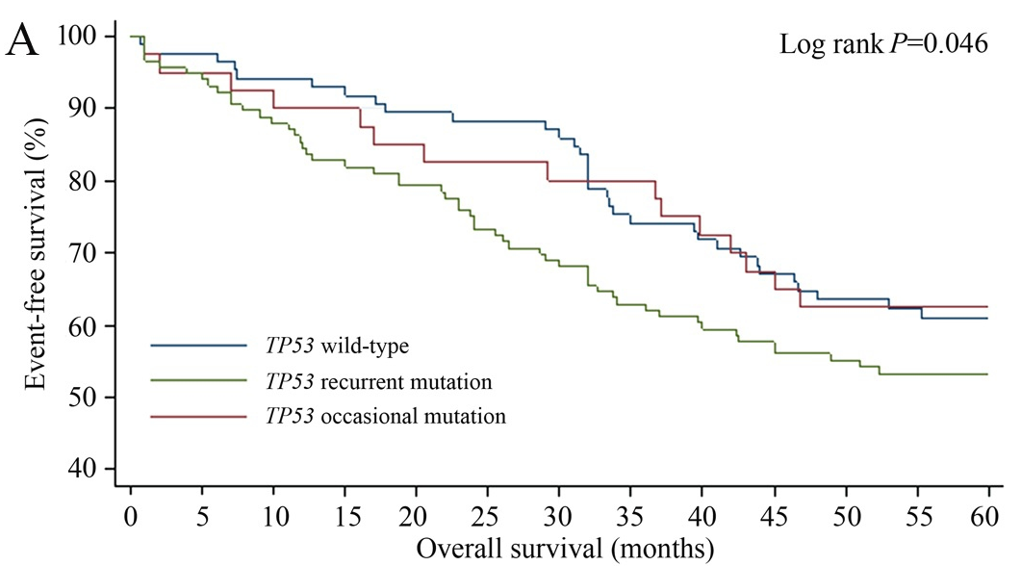
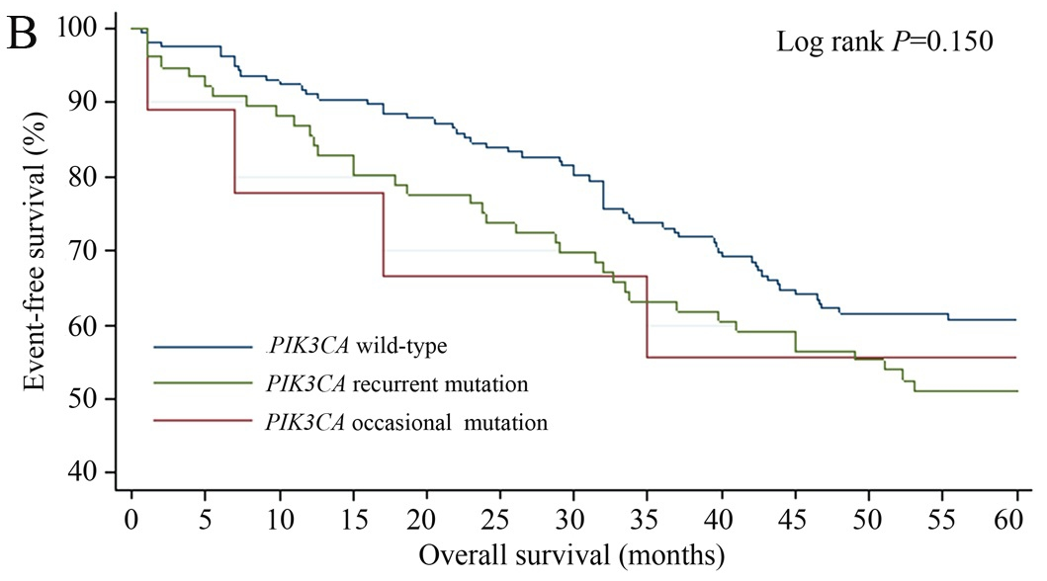

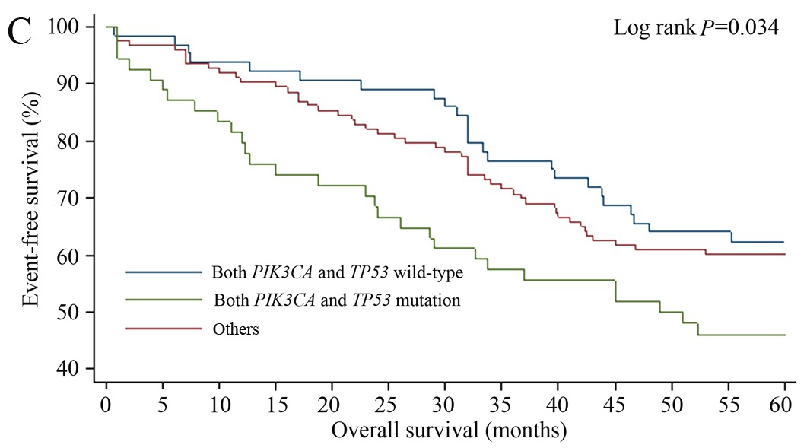
Figure 1 Kaplan-Meier survival analysis for overall survival in patients with stage II/III colorectal cancer. According to A: TP53 mutation status; B: PIK3CA mutation status; C: PIK3CA and TP53 mutation status.

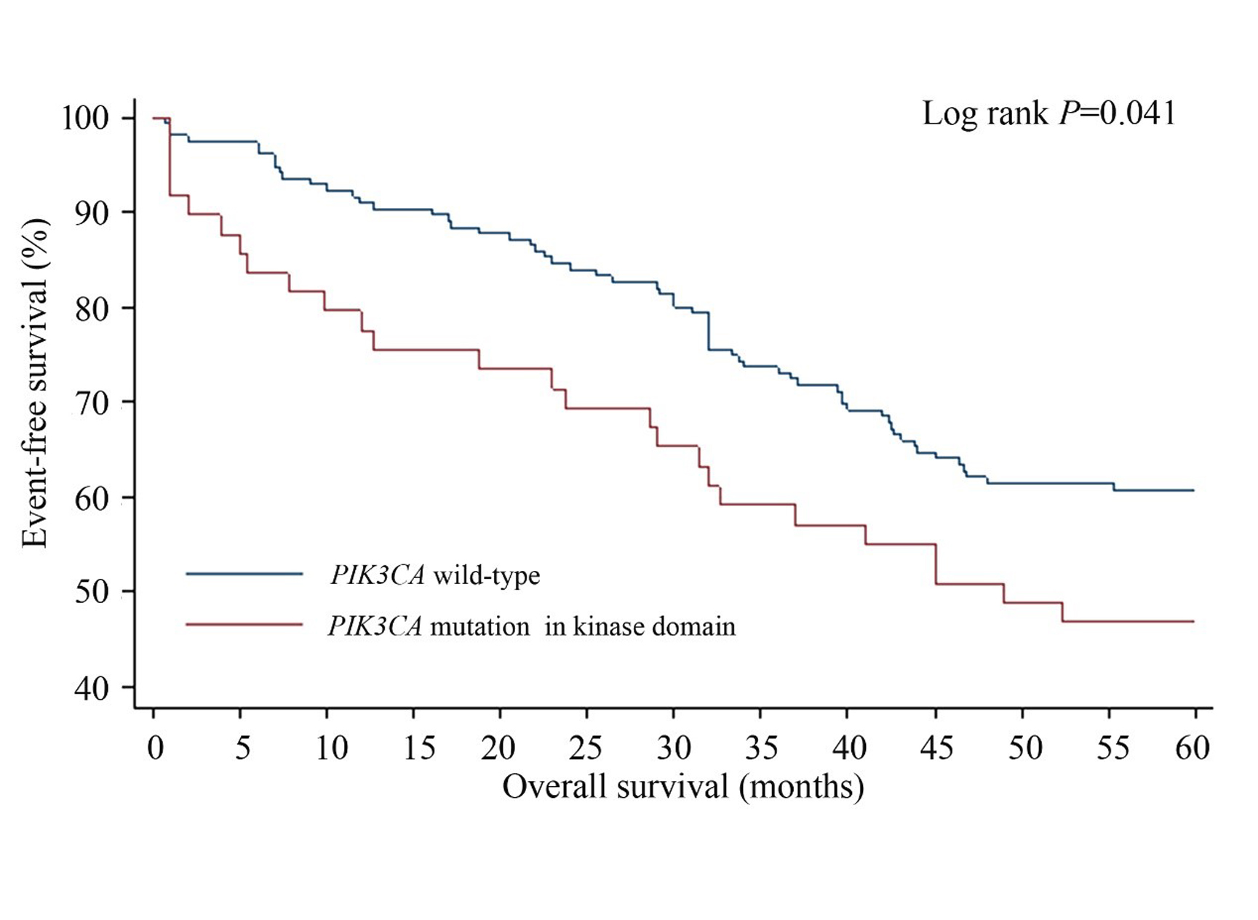Figure 2 Kaplan-Meier survival analysis for overall survival according to the PIK3CA kinase domain mutation status in stage II/III patients.

