Name of Journal: World Journal of Gastrointestinal Surgery
Manuscript NO: 87254
Manuscript Type: SYSTEMATIC REVIEWS

Effect of perioperative branched chain amino acids supplementation in liver cancer patients undergoing surgical intervention: A systematic review

Yap KY et al. Perioperative BCAA in HCC: Systematic review

Kwan Yi Yap, HongHui Chi, Sherryl Ng, Doris HL Ng, Vishal G Shelat

Kwan Yi Yap, HongHui Chi, Sherryl Ng, Vishal G Shelat, Yong Loo Lin School of Medicine, National University of Singapore, Singapore 117597, Singapore

Doris HL Ng, Department of Gastroenterology and Hepatology, Tan Tock Seng Hospital, Singapore 308433, Singapore

Doris HL Ng, Vishal G Shelat, Lee Kong Chian School of Medicine, Nanyang Technological University, Singapore 636921, Singapore

Vishal G Shelat, Department of General Surgery, Tan Tock Seng Hospital, Singapore 308433, Singapore

Co-first authors: Kwan Yi Yap and HongHui Chi.

Author contributions: Yap KY acquisition of data, analysis and interpretation of data,
drafting the article, revising the article, final approval; Chi H acquisition of data, analysis and interpretation of data, drafting the article, revising the article, final approval; Ng S acquisition of data, interpretation of data, final approval; Ng DH revising the article; Shelat VG supervision, critical revision, final approval. Yap KY and Chi H contributed equally to this work as co-first authors. This research is the product of the collaborative effort of the team, and the designation of co-first authors authorship is reflective of the time and effort invested by the co-first authors into the completion of the research. Furthermore, the decision of co-first authors authorship acknowledges and respects the equal contribution made by both co-first authors throughout the process of writing the paper. As a whole, the team believes that designating Yap KY and Chi H as co-first authors is appropriate and reflective of the team’s collective spirit and wishes.

Corresponding author: Vishal G Shelat, DNB, FICS, FRCS (Gen Surg), MBBS, MMed, MNAMS, MS, Associate Professor, Director, Surgical Oncologist, Department of General Surgery, Tan Tock Seng Hospital, No. 11 Jalan Tan Tock Seng, Singapore 308433, Singapore. vgshelat@gmail.com

Received: July 31, 2023
Revised: September 15, 2023
Accepted: October 23, 2023
Published online:

Abstract
BACKGROUND
Branched chain amino acid (BCAA) supplementation has been associated with favourable outcomes in liver malignancies requiring definitive resection or liver transplantation. Currently, there are no updated systematic reviews evaluating the efficacy of perioperative BCAA supplementation in patients undergoing surgery for liver cancer.

AIM
To evaluate the efficacy of perioperative BCAA supplementation in patients undergoing surgery for liver cancer.

METHODS
A systematic review of randomized control trials and observational studies was conducted on PubMed, Embase, Cochrane Library, Scopus, and Web of Science to evaluate the effect of perioperative BCAA supplementation compared to standard in-hospital diet, in liver cancer patients undergoing surgery. Clinical outcomes were extracted, and a meta-analysis was performed on relevant outcomes.

RESULTS
16 studies including 1389 patients were included. Perioperative BCAA administration was associated with reduced postoperative infection [risk ratio (RR) = 0.58 95% confidence intervals (CI): 0.39, 0.84, P = 0.005] and ascites [RR = 0.57 (95%CI: 0.38, 0.85), P = 0.005]. There was also a reduction in length of hospital stay (LOS) [weighted mean difference (WMD) = -3.03 d (95% CI: -5.49, -0.57), P = 0.02] and increase in body weight [WMD = 1.98 kg (95%CI: 0.35, 3.61, P = 0.02]. No significant differences were found in mortality, cancer recurrence and overall survival. No significant safety concerns were identified.

CONCLUSION
Perioperative BCAA administration is efficacious in reducing postoperative infection, ascites, LOS, and increases body weight in liver cancer patients undergoing surgical resection.

Key Words: Branched-chain amino acid; Liver cancer; Liver surgery; Nutritional supplement; Perioperative supplementation

Yap KY, Chi H, Ng S, Ng DH, Shelat VG. Effect of perioperative branched chain amino acids supplementation in liver cancer patients undergoing surgical intervention: A systematic review. World J Gastrointest Surg 2023; In press

Core Tip: Liver surgery has been associated with anthropometric disturbances and systemic catabolism, which can be improved with perioperative branched chain amino acid (BCAA) supplementation. However, it remains undetermined if the reported advantages of BCAA supplementation warrant routine perioperative use. This systematic review compares sixteen studies including 1389 patients. We found that perioperative BCAA supplementation was efficacious in reducing postoperative infection, ascites, length of hospital stay and increases body weight in liver cancer patients undergoing surgical resection.

INTRODUCTION
Liver cancer is a global health issue with an estimated incidence of over 1 million cases by 2025^{[1]}. Secondary liver cancer is more prevalent than primary liver cancer^{[2-4]}. Lung and colorectal primaries account for half of the cases^{[5]}. Hepatocellular carcinoma (HCC) accounts for approximately 90 percent of all primary liver cancers^{[1]}, and is the third most common cause of cancer mortality in the world^{[6]}. Hepatectomy and liver transplant are the predominant curative treatments for liver cancers^{[7,8]}.
Although technological innovation and adoption of prehabilitation strategies have made hepatic surgery safe, there are still substantial morbidity risks, especially in cirrhotic patients^{[9]}. Emerging evidence suggests that levels of branched chain amino acids (BCAAs), namely valine (Val), leucine (Leu) and isoleucine (Ile), are decreased in various forms of hepatic injury^{[10]}. As important substrates for protein synthesis and regulators of protein turnover, BCAAs are involved in the pathophysiology of HCC by affecting gene expression, apoptosis, and regeneration of hepatocytes^{[10]}. Additionally, advanced liver diseases are usually associated with systemic catabolism and depletion of muscle mass^{[11]}.
In rat model studies, BCAAs have been reported to promote hepatocyte proliferation and suppress growth of HCC. Kim et al^{[12]} reported that after major hepatectomy, supplementation with BCAAs helps not only to maintain a stable plasma BCAA/aromatic amino acids ratio, but also promotes liver regeneration in rats. BCAAs delay progression of carbon tetrachloride(CCl₄)-induced chronic liver injury by attenuating hepatic apoptosis and stimulating the production of hepatocyte growth factors^{[13,14]}. Miuma et al^{[15]} reported that all three BCAAs down-regulate vascular endothelial growth factor (VEGF) expression during HCC development. Through these mechanisms, supplementation with BCAA may potentially suppress HCC development and accelerate post-surgical recovery. Furthermore, many studies have reported that preoperative malnutrition increases the risks of postoperative morbidity and mortality^{[16-19]}. The benefits of administering BCAA to patients with HCC undergoing surgical treatment appear clear and promising.
Despite studies favouring BCAA supplementation, evidence of actual and measurable benefit is lacking. A 2012 Cochrane review showed that nutritional interventions for patients undergoing liver transplant did not offer benefits^{[20]}. Another review demonstrated that oral BCAA supplementation improved 3-year mortality in HCC patients, but without impact on cancer recurrence^{[21]}. In a meta-analysis on the use of supplemental BCAAs during the perioperative period in gastrointestinal cancer patients, Cogo et al^{[22]} reported an improvement in morbidity from postoperative infection but no reduction in cancer recurrence.
Therefore, from current literature, it is unclear if the reported advantages of BCAA supplementation during surgical interventions in liver cancer warrant routine perioperative administration. Given these knowledge gaps, it is necessary to appraise the current evidence to determine if BCAA supplementation has beneficial impact on patients undergoing liver resection for various oncological indications. Thus, the aim of this systematic review and meta-analysis is to evaluate the role of perioperative BCAA supplementation in patients undergoing liver resection.

MATERIALS AND METHODS
Literature search
This systematic review was performed in accordance with the Preferred Reporting Items of Systematic Reviews and Meta-Analyses (PRISMA) guidelines^{[23]}. This review is part of a systematic review protocol registered on PROSPERO (CRD42022341658). Search of five databases (PubMed, Embase, Cochrane Library, Scopus, and Web of Science) was conducted on July 6, 2022 for articles published since inception up to 6 July 2022. Keywords related to the terms (“BCAA” or “Branched-chain amino acid” or “Leu” or “Val” or “Ile” or “amino acid”), [(“liver” or “hepatic” or “hepatocellular”) and (“carcinoma” or “cancer” or “malignancy” or “tumour” or “neoplasm”)], (“resection” or “surgery” or “preoperative” or “perioperative” or “postoperative” or “hepatectomy” or “liver transplantation”) were used in literature search. The full search strategy is available in Supplementary Table 1.

Study selection
Studies comparing outcomes of BCAA vs no supplementation in the perioperative period among liver cancer patients were considered for inclusion. Clinical trials and observational studies fulfilling the following criteria were included in the review: (1) Patients with a diagnosis of primary or secondary cancer in the liver; (2) patients underwent either hepatectomy or liver transplant; and (3) study has a control arm (placebo or normal usual diet). We excluded studies with patients undergoing liver surgery for other indications, or undergoing treatment procedures for liver cancer, such as radiofrequency ablation or transarterial chemoembolisation, without surgical intervention. All other studies were included, and details of source databases used in each included study were collected. The details of inclusion and exclusion criteria of this review according to the Population, Intervention, Comparison, Outcomes and Study framework are documented in Supplementary Table 2.

Data extraction
Three reviewers (Yap KY, Chi H, Ng S) independently performed the literature search and data extraction and all disagreements were resolved by mutual consensus. Data extracted include information on patient demographics (number of patients, age, sex, comorbid liver disease), cancer type and histopathology (HCC or metastatic or other cancers, tumour size and number, stage of cancer), surgical details (extent of hepatectomy, type of liver transplant) and mean duration of follow-up.

Risk of bias
Risk of bias and quality of studies were assessed. For randomised control trials (RCTs), quality control was performed by two co-authors (Yap KY and Chi H) using the Cochrane Risk of Bias tool 2^{[24]}, which assesses five domains: randomization process, deviations from intended interventions, missing outcome data, measurement of the outcome, and selection of the reported result. For observational studies, quality control was performed using the ROBINS-1 tool^{[25]}, which assesses seven domains in total: for pre-intervention (confounding and participation selection), during intervention (classification of intervention) and post-intervention (deviations from intended interventions, missing data, measurement of outcomes and selection of reported results) stages.

Outcomes of review
Primary outcomes of interest in this review were perioperative and oncological outcomes. Perioperative outcomes include postoperative morbidity, mortality, and length of stay (LOS). Oncological outcomes include recurrence and overall survival (OS). Secondary outcomes were changes in serum albumin, anthropometrics, and overall quality of life (QOL) in patients.
Postoperative infections were defined as any infectious complication arising in the postoperative period, including surgical site infections, septic complications, urinary tract infections, chest infections, liver abscesses and infected ascites. Ascites was defined as either new onset postoperative ascites or refractory ascites requiring diuretic agent for control. All-cause mortality was derived from OS in most studies, with a minimal follow-up time of 3 years (Supplementary Table 3). Recurrence was defined as reappearance of tumour with typical findings on imaging modalities. Changes in serum albumin were determined by comparing preoperative to postoperative measurements reported at 6- and 12-mo intervals. Anthropometrics reported by studies include body weight change, triceps skin-fold thickness and mid-arm circumference, but only body weight changes were included in this analysis.

Statistical analysis
Review Manager version 5.4 was used to pool and analyse results with reference to approaches from the Cochrane Handbook^{[26]}. In studies without SD, P-values or confidence intervals (CI) were converted to SD. For studies without SD, P-values, and CI, we used the square-root of weighted mean variance of all other studies to estimate the SD^{[27]}. Pre-intervention baseline imbalances were corrected using the simple analysis of change scores method for panel data and longitudinal outcomes. In studies reporting the outcome in different scales, a simple unit conversion was performed. Inverse variance was used to derive the pooled outcomes. The random-effects model was used in accounting for between-study variance. I² and τ² statistics were used to present between-study heterogeneity: Low heterogeneity (I² < 30%), moderate heterogeneity (I² 30%-60%), and substantial heterogeneity (I² > 60%). Two-sided P value of < 0.05 was regarded as significant^{[26,28,29]}. The statistical methods of this study were reviewed by Vishal G Shelat from National University of Singapore.

RESULTS
Study selection
A systematic search identified 8024 studies, of which 2949 duplicate studies were excluded. Subsequent screening of title and abstract performed independently by authors (Yap KY, Chi H, Ng S) identified 50 studies for full-text evaluation. Finally, 12 prospective RCTs and 4 non-randomised studies (1 non-randomised trial and 3 observational studies) were included. A detailed PRISMA diagram is shown in Figure 1. The studies included were assessed for risk of bias, with a summary of the assessment shown in Figures 2 and Table 1 for trials and non-interventional studies, respectively. The PRISMA checklist is appended in Supplementary Figure 1.

Baseline characteristics
The sixteen studies comprised a total cohort of 1389 patients. 645 patients were randomized into the intervention group, consisting of various perioperative regimens of BCAA supplementation, and 744 patients into the control group. The total sample mean age is 60.5 years, intervention mean age is 62.3 years, control mean age is 58.9 years, and the total sample male is 78.7%. Table 2 summarises the baseline data of included studies. The subsequent tables outline surgical details (Table 3) and the presence and severity of comorbid liver diseases (Table 4).

Use of BCAA supplementation
The BCAA supplementation used were mainly Aminoleban EN (Ajinomoto Pharma, Tokyo, Japan)^{[30-37]} and Livact (Otsuka Pharmaceutical Co., Ltd., Tokyo, Japan)^{[37-42]}. The compositions of Aminoleban EN and Livact are compared in Supplementary Table 4. Three studies used generic BCAA supplements^{[43-45]}. The BCAA supplements were administered perioperatively in varying dose and duration, while patients in the control groups did not receive BCAA supplements for the same specified duration. Table 5 summarises the intervention and control protocol of all included studies. Patients were not blinded due to the lack of suitable placebos that share similar taste to the BCAA supplements.

Postoperative infections
Seven out of sixteen studies^{[30,31,35,36,40,41,43]} including 473 patients (227 in the BCAA group and 246 in the control group) reported data on postoperative infections. There was low statistical heterogeneity between studies (I² = 0%). Postoperative infections were found to be significantly lower in the BCAA group [risk ratio (RR) = 0.58 (95%CI: 0.39, 0.84), P = 0.005] (Figure 3).
In a study involving BCAA supplementation in liver transplant patients, Shirabe et al^{[37]} discovered that normal usual diet without BCAA supplementation significantly increased the risk of postoperative bacteraemia [OR = 4.32 (95%CI: 1.137, 16.483), P = 0.031]. Although more than half of the study population had liver cancer, the study was not included in the meta-analysis as it was unclear if the effect of BCAA supplementation was generalisable to liver cancer patients.

Postoperative ascites
Five out of sixteen studies^{[35,40-43]} including 412 patients (190 in the BCAA group and 222 in the control group) reported data on postoperative ascites. There was low statistical heterogeneity between studies (I² = 0%). Postoperative ascites was found to be significantly lower in the BCAA group [RR = 0.57 (95%CI: 0.38, 0.85), P = 0.005] (Figure 4). Additionally, Kikuchi et al^{[41]} reported that the incidence of refractory ascites and/or pleural effusion in the BCAA group was significantly lower than in the non-BCAA group (P = 0.047).

All-cause mortality (> 3 years follow-up)
Six out of sixteen studies^{[31,32,35,36,39,40]} including 534 patients (254 in the BCAA group and 280 in the control group) reported data on mortality due to all causes (> 3 years follow-up). Follow-up periods were between 3-4 years for most included studies, and 3.5-6 years for one study. There was low statistical heterogeneity between included studies (I² = 14%). There was no evidence of significant difference between the BCAA and control groups for all-cause mortality [RR = 1.05 (95%CI: 0.79, 1.40), P = 0.72] (Figure 5). A separate analysis did not find any significant difference in 90-day mortality between the BCAA and control group [RR = 1.69 (95%CI: 0.23, 12.24), P = 0.60] (Supplementary Figure 2).

LOS
Six out of sixteen studies^{[31,35,40,41,43,45]} including 787 patients (303 in the BCAA group and 484 in the control group) reported LOS data. There was considerable statistical heterogeneity between studies (I² = 69%), and a random effects model was employed. LOS was reduced by 3.03 d in the BCAA group compared to controls [weighted mean difference (WMD) = -3.03 d (95%CI: -5.49, -0.57), P = 0.02] (Figure 6).

Recurrence
Five out of sixteen studies ^{[31,32,39,40,42]} including 429 patients (209 in the BCAA group and 220 in the control group) reported data on cancer recurrence. Median follow-up period varied from 12 to 30 mo. One author reported recurrence but was not included in analysis as recurrence was not an end point in the original study^{[34]}. A subgroup analysis in Hachiya et al^{[39]} of patients under 72 years of age with haemoglobin A1C levels below 6.4% revealed that recurrence-free survival was higher in the BCAA group compared to the control group (P = 0.015). There was low statistical heterogeneity between included studies (I² = 0%). There was no statistically significant difference between the BCAA and control groups for recurrence [RR = 0.88 (95%CI: 0.71, 1.08), P = 0.22] (Figure 7).

OS
Four out of sixteen studies^{[35,36,39,40]} reported OS data. There was low statistical heterogeneity (I² = 0%). OS did not differ significantly between the BCAA and control groups [hazard ratio = 1.26 (95%CI: 0.72, 2.21), P = 0.41] (Figure 8).

Postoperative change in serum albumin
Five out of sixteen studies^{[31,32,34,35,42]} including 427 patients (197 in the BCAA group and 230 in the control group) reported data on change in serum albumin. There was low statistical heterogeneity (I² = 0%). While individual studies reported faster albumin increase in the intervention group compared to the control group^{[22]}, change in serum albumin was not significant at 6 mo [WMD = 0.10 (95%CI: -0.08, 0.29), P = 0.28] and 12 mo [WMD = -0.05 (95%CI: -0.24, 0.15), P = 0.63] (Figures 9 and 10).

Anthropometrics
Four out of sixteen studies^{[34,36,40,43]} including 292 patients (156 in the BCAA group and 136 in the control group) reported data on postoperative body weight change. There was considerable heterogeneity between studies (I² = 74%), and a random effects model was employed. Postoperative body weight increased significantly by 1.98 kg in the BCAA group [WMD = 1.98 kg (95%CI: 0.35, 3.61), P = 0.02] (Figure 11).

QOL
Three out of sixteen studies^{[32,34,44]} reported data on QOL measures. Krapf et al^{[44]} used the European Organisation for Research and Treatment of Cancer QOL Questionnaire Core 30 (EORTC QLQ-C30) to look at physical, psychological, and social functions across 30 questions, and found that there was no significant difference between study groups. However, the study authors noted that patients in the BCAA group had a greater amount of food intake and significantly better subjective rating of the meals.
Okabayashi et al^{[34]} using the short-form 36 (SF-36) health sheet reported significant improvement in all 8 parameters (physical functioning, role physical, bodily pain, general health perceptions, vitality, social functioning, role emotional and mental health) in the BCAA group at the 12-month follow-up while the control group shown no significant differences in postoperative QOL.
Nagasue et al^{[32]} used the Kanovsky scale to evaluate performance status and reported that the percentage change from baseline to the 12 mo follow-up was significantly higher in the BCAA group.

Other outcomes
It is worth nothing that two of the sixteen studies included in this review described unique outcomes of BCAA supplementation. Beppu et al^{[38]} found that patients undergoing portal vein embolisation (PVE) and subsequent major hepatectomy had significantly greater functional liver regeneration after PVE (P = 0.079) and better postoperative outcomes in the BCAA group compared to controls. A 2010 study by Okabayashi et al^{[33]} concluded that BCAA supplementation resulted in significantly reduced immediate postoperative insulin resistance (P = 0.039), improved blood glucose levels and decreased need for insulin therapy in liver cancer patients.

DISCUSSION
This study shows perioperative BCAAs supplementation increases body weight, reduces infection, LOS and ascites in cancer patients undergoing liver surgery.
BCAAs are essential amino acids and contribute to protein synthesis, act as precursors of the tricarboxylic acid cycle intermediates and are involved in key signalling pathways^{[46-48]}. Figure 12A summarises the molecular effects of BCAA on skeletal muscle and liver. Figure 12B summarises the cellular signalling pathways involving BCAA with downstream effects. Leu, the most abundant amino acid, plays a major role in protein synthesis and cellular growth. It promotes mammalian target of rapamycin (mTOR) pathway activation by binding to Sestrin2, preventing the latter from inhibiting mTOR complex 1 activity^{[49]}. This contributes to downstream phosphorylation of ribosomal proteins and upregulates mRNA translation^{[50]}. Val catabolites also serve signalling functions, particularly 3-hydroxyisobutyrate (3-HIB) and beta-amino-isobutyric acid (BAIBA). 3-HIB promotes the endothelial uptake of fatty acids into muscle, acting as an intermediary between protein and lipid metabolism^{[51]}. BAIBA promotes hepatic beta-oxidation and reduce hepatic endoplasmic reticulum stress^{[52]}. Ile is less well-studied. Some authors have postulated its immune modulating role in inducing the expression of host defence peptides and improving innate immunity by maintaining skin mucus barrier^{[53,54]}.

BCAAs in liver disease
Over 85% of liver cancer patients are cachectic^{[55]}, resulting from malignancy and protein energy malnutrition on a background of cirrhosis^{[56]}. Liver surgeries are often associated with ischemia-reperfusion periods. Poor nutritional status further exacerbates ischemic injury by accelerating glycolysis and rapidly depleting adenosine triphosphate, leading to irreversible cellular necrosis^{[57-59]}. BCAA supplementation is well-established in liver disease. The European Society for Clinical Nutrition and Metabolism^{[60]} recommend long-term oral BCAA supplements (0.25 g × kg⁻¹ × d⁻¹) in patients with advanced cirrhosis to improve event-free survival or QOL. The American Association for the Study of Liver^{[61]} recommend BCAA administration as an alternative or additional agent to treat hepatic encephalopathy in patients who are unresponsive to conventional therapy. However, the evidence of benefit for BCAAs in liver cancer patients managed by surgical approaches is less clear.

Importance of optimising nutrition in perioperative patients
Despite many studies reporting a strong association between malnutrition and poor surgical outcomes, oncological patients often lack opportune time to delay treatment for nutritional optimisation. In a study of nutrition and HCC, Huang et al^{[62]} noted that patients assessed by dietitians to be malnourished had a significantly higher rate of major complications^{[63]}. With an increasing focus on optimisation of postoperative surgical recovery, enhanced recovery after surgery protocols and prehabilitation initiatives have also emphasised the importance of perioperative nutrition^{[64]}.

Relevance of BCAAs to outcomes
This review investigated perioperative and oncological outcomes of BCAA supplementation in patients undergoing surgery for liver cancers unlike the previous review that included diverse oncological diagnoses^{[22]}. We demonstrated that BCAA supplementation significantly reduced postoperative complications, with over 40% relative risk reduction of postoperative infection and ascites. The BCAA group also had slightly higher body weight and performed better on both perceived and actual QOL metrics, suggesting that BCAA intake can optimise recovery and function after surgery.

Effect of BCAA on oncological outcomes
BCAA supplementation had no impact on cancer recurrence and OS. This is consistent with the conclusions of recent meta-analyses^{[22,65]}. The relationship between BCAA and liver cancer at the molecular level has been explored^{[66-68]}. BCAAs suppress the development of liver cancers in rodent models^{[69,70]}, presumably improving insulin resistance in obesity or diabetes mellitus. Insulin resistance is involved in the pathogenesis of HCC, as insulin has oncogenic properties on HCC cells, stimulating cell growth and inducing anti-apoptotic activity^{[71,72]}. Another study postulated suppression of VEGF expression in tumour cells as an alternative mechanism^{[73]}. The catabolism of BCAAs has also been extensively implicated in carcinogenesis^{[67]} through various molecular pathways, including accumulation of branched-chain α-ketoacids and activation of the mTORC1 pathway^{[74,75]}. Ericksen et al^{[76]} validated oncogenic pathways and linked high dietary BCAA intake to tumour burden and mortality specifically in HCC patients.
Given the apparent contradictory effects of BCAA on liver cancer development and prognosis, it may be challenging to interpret our findings. BCAAs may potentially improve liver function and body weight postoperatively but also contribute to tumour recurrence via the above-mentioned pathways. The beneficial oncological effects of BCAA supplementation remain inconclusive.

Effect of BCAA on postoperative complications
While oncological outcomes do not support routine use of BCAA supplementation in the perioperative period, our review found that the risk of postoperative infection and ascites were significantly lowered in BCAA groups.
Postoperative infection is a frequent complication of hepatic resection, with reported rates of up to 25%^{[77,78]}. It can be associated with significant morbidity in the absence of early recognition and treatment^{[79]}. After major liver surgery, impairment of innate immune function increases host susceptibility to infection^{[80]}. Furthermore, surgery in HCC patients results in higher risk of infectious sequelae, presumably due to underlying cirrhosis and chronic liver dysfunction, bile leak with risk of abdominal sepsis, and postoperative pneumonia due to upper abdominal incision^{[81]}. Another major risk factor for infection is malnutrition^{[82-85]}. BCAA supplementation directly improves patients’ preoperative nutritional status^{[86]}. BCAAs also play an essential role in immune cell function relating to protein synthesis^{[87]}, and in immune regulation in patients with advanced cirrhosis^{[88-90]}.
Postoperative ascites is reported in 5% to 56% patients undergoing hepatectomy^{[91]}, and is associated with liver failure^{[92,93]}. Chan et al^{[94]} described higher 1-year mortality and lower recurrence-free survival rates attributed to postoperative ascites.
BCAAs increase the synthesis and secretion of albumin by hepatocytes^{[95]}, and improve impaired metabolic turnover of albumin in cirrhotic patients^{[96]}. Fukushima et al^{[97]} reported that BCAAs effectively improved the oxidisation/reduction imbalance of albumin in cirrhosis. In our study, BCAA supplementation did not significantly increase postoperative serum albumin levels. The underlying mechanisms behind the demonstrated efficacy of BCAA supplementation in reducing postoperative ascites remain uncertain.

Effect of BCAA on QOL
2 out of 3 included studies^{[34,44]} demonstrated significant improvement in QOL with BCAAs, but differing methodologies and domains for assessment were employed. Krapf et al^{[44]} noted a significantly higher subjective rating of high BCAA content diet compared to normal usual diet, despite similar preparation methods and staff. If such an outcome is indeed replicated in future QOL studies, it may represent a potential benefit of BCAA supplementation in improving oral intake and avoiding malnutrition in post-surgical patients. These results are consistent with QOL improvements seen in RCTs on BCAA supplementation in cirrhosis^{[98,99]}.
Overall, more robust, large-scale clinical studies of surgical patients with liver cancer would need to be conducted with standardisation of total calorie and protein intake in intervention and control groups to conclude on the risk-benefit calculation of BCAA supplementation. Future studies should report BCAA to total protein intake ratio, protein to calorie ratio and type of BCAA to understand cause effect relation on perioperative outcomes of BCAA supplementation.

Side effects of BCAA
We reviewed side effects reported from routine BCAA ingestion in the included studies. Most studies did not report side effects with the exception that one RCT^{[43]} reported 2 events (3%) relating to intravenous administration, while another^{[32]} reported that 3 patients were unable to continue with BCAA administration due to adverse reactions. Overall, BCAAs have an extremely low incidence of side effects in the included studies.

Strengths and limitations
The strengths of this study include data pooling from newer RCTs and multiple real-world observational studies. While RCTs are considered the gold standard for ascertaining the efficacy and safety of a treatment, their methodologies may limit generalizability. The inclusion of observational studies provides more generalizable results applicable in the real-world situation. Since both types of study design have their strengths and limitations, they provide insight into the efficacy of BCAA supplementation.
Though many Japanese studies were included, exclusion of non-English articles may have led to language biases as a potential confounding factor in our conclusions. The included studies had varying doses of BCAA supplementation and a lack of data on composition of normal usual diet in the participating institutions. Most of the patients in this review had Child-Pugh score A cirrhosis and thus might not be malnourished. Further, there is no population data to suggest that HCC patients have deficiency of BCAA. A lack of long-term follow-up data in the included studies makes it difficult to study the impact of BCAA supplementation on oncological outcomes.

CONCLUSION
Perioperative BCAA administration increases body weight and reduces postoperative infection, ascites, and LOS in liver cancer patients undergoing surgery.

ARTICLE HIGHLIGHTS
Research background
Branched chain amino acids (BCAA) show promising results in improving surgical outcomes in liver cancer patients and potential for routine use.

Research motivation
Current studies on BCAA supplementation show varying results but with no clear conclusion and no updated reviews on the matter.

Research objectives
To provide the most updated review on whether BCAA supplementation provides measurable benefits in liver cancer patients for surgical intervention.

Research methods
Current trials and studies on BCAA supplementation in liver cancer patients undergoing surgery were appraised by three independent authors. Studies were identified and data extracted for meta-analysis of the relevant outcomes.

Research results
Perioperative BCAA supplementation reduced postoperative infections, length of stay and increased body weight in the studied patient groups but did not improve mortality, oncological recurrence, and long-term survival.

Research conclusions
This review has shown that BCAA supplementation improves postoperative outcomes with no significant side effects. However, benefits on oncological outcomes remain inconclusive.

Research perspectives
This review highlights the possible routine use of BCAA for liver cancer patients for surgical intervention. Further clinical research can be directed at assessing optimal BCAA supplementation regime for such patients.

REFERENCES
1 Llovet JM, Kelley RK, Villanueva A, Singal AG, Pikarsky E, Roayaie S, Lencioni R, Koike K, Zucman-Rossi J, Finn RS. Hepatocellular carcinoma. Nat Rev Dis Primers 2021; 7: 6 [PMID: 33479224 DOI: 10.1038/s41572-020-00240-3]
2 Ananthakrishnan A, Gogineni V, Saeian K. Epidemiology of primary and secondary liver cancers. Semin Intervent Radiol 2006; 23: 47-63 [PMID: 21326720 DOI: 10.1055/s-2006-939841]
3 Ahmed I, Lobo DN. Malignant tumours of the liver. Surgery (Oxford) 2009; 27: 30-37 [DOI: 10.1016/j.mpsur.2008.12.005]
4 Kasper HU, Drebber U, Dries V, Dienes HP. [Liver metastases: incidence and histogenesis]. Z Gastroenterol 2005; 43: 1149-1157 [PMID: 16220456 DOI: 10.1055/s-2005-858576]
5 Wang ZG, He ZY, Chen YY, Gao H, Du XL. Incidence and survival outcomes of secondary liver cancer: a Surveillance Epidemiology and End Results database analysis. Transl Cancer Res 2021; 10: 1273-1283 [PMID: 35116454 DOI: 10.21037/tcr-20-3319]
6 Sheriff S, Madhavan S, Lei GY, Chan YH, Junnarkar SP, Huey CW, Low JK, Shelat VG. Predictors of mortality within the first year post-hepatectomy for hepatocellular carcinoma. J Egypt Natl Canc Inst 2022; 34: 14 [PMID: 35368234 DOI: 10.1186/s43046-022-00113-8]
7 Lim MS, Goh GB, Chang JP, Low JK, Shelat VG, Huey TC, Dan YY, Kow A, Shridhar I, Tan PS, Junnarkar SP, Tan CK. A study of 3013 cases of hepatocellular carcinoma: Etiology and therapy before and during the current decade. JGH Open 2021; 5: 1015-1018 [PMID: 34584969 DOI: 10.1002/jgh3.12624]
8 Tsim NC, Frampton AE, Habib NA, Jiao LR. Surgical treatment for liver cancer. World J Gastroenterol 2010; 16: 927-933 [PMID: 20180230 DOI: 10.3748/wjg.v16.i8.927]
9 Lei GY, Shen L, Junnarkar SP, Huey CT, Low J, Shelat VG. Predictors of 90-Day Mortality following Hepatic Resection for Hepatocellular Carcinoma. Visc Med 2021; 37: 102-109 [PMID: 33981750 DOI: 10.1159/000510811]
10 Tajiri K, Shimizu Y. Branched-chain amino acids in liver diseases. Transl Gastroenterol Hepatol 2018; 3: 47 [PMID: 30148232 DOI: 10.21037/tgh.2018.07.06]
11 Choudry HA, Pan M, Karinch AM, Souba WW. Branched-chain amino acid-enriched nutritional support in surgical and cancer patients. J Nutr 2006; 136: 314S-318S [PMID: 16365105 DOI: 10.1093/jn/136.1.314S]
12 Kim SJ, Kim DG, Lee MD. Effects of branched-chain amino acid infusions on liver regeneration and plasma amino acid patterns in partially hepatectomized rats. Hepatogastroenterology 2011; 58: 1280-1285 [PMID: 21937393 DOI: 10.5754/hge10389]
13 Kuwahata M, Kubota H, Kanouchi H, Ito S, Ogawa A, Kobayashi Y, Kido Y. Supplementation with branched-chain amino acids attenuates hepatic apoptosis in rats with chronic liver disease. Nutr Res 2012; 32: 522-529 [PMID: 22901560 DOI: 10.1016/j.nutres.2012.06.007]
14 Tomiya T, Omata M, Fujiwara K. Significance of branched chain amino acids as possible stimulators of hepatocyte growth factor. Biochem Biophys Res Commun 2004; 313: 411-416 [PMID: 14684177 DOI: 10.1016/j.bbrc.2003.07.017]
15 Miuma S, Ichikawa T, Arima K, Takeshita S, Muraoka T, Matsuzaki T, Ootani M, Shibata H, Akiyama M, Ozawa E, Miyaaki H, Taura N, Takeshima F, Nakao K. Branched-chain amino acid deficiency stabilizes insulin-induced vascular endothelial growth factor mRNA in hepatocellular carcinoma cells. J Cell Biochem 2012; 113: 3113-3121 [PMID: 22581719 DOI: 10.1002/jcb.24188]
16 Zheng HL, Lu J, Li P, Xie JW, Wang JB, Lin JX, Chen QY, Cao LL, Lin M, Tu R, Huang CM, Zheng CH. Effects of Preoperative Malnutrition on Short- and Long-Term Outcomes of Patients with Gastric Cancer: Can We Do Better? Ann Surg Oncol 2017; 24: 3376-3385 [PMID: 28699132 DOI: 10.1245/s10434-017-5998-9]
17 Chan KS, Chia CLK, Ng FKL, Seow WHJ, Leong DY, Shelat VG. Impaired Handgrip Strength Does Not Predict Postoperative Morbidity in Major Hepatobiliary Surgery. J Surg Res 2020; 256: 549-556 [PMID: 32799004 DOI: 10.1016/j.jss.2020.07.012]
18 Lee B, Han HS, Yoon YS, Cho JY, Lee JS. Impact of preoperative malnutrition, based on albumin level and body mass index, on operative outcomes in patients with pancreatic head cancer. J Hepatobiliary Pancreat Sci 2021; 28: 1069-1075 [PMID: 33128839 DOI: 10.1002/jhbp.858]
19 Leide da Silva Nunes F, Calado Ferreira Pinheiro Gadelha P, Damasceno de Souza Costa M, Carolina Ribeiro de Amorim AC, Bezerra da Silva Mda G. Nutritional status and its impact on time and relocation in postoperative complications of abdominal patients undergoing surgery. Nutr Hosp 2014; 30: 629-635 [PMID: 25238841 DOI: 10.3305/nh.2014.30.3.7628]
20 Langer G, Großmann K, Fleischer S, Berg A, Grothues D, Wienke A, Behrens J, Fink A. Nutritional interventions for liver-transplanted patients. Cochrane Database Syst Rev 2012: CD007605 [PMID: 22895962 DOI: 10.1002/14651858.CD007605.pub2]
21 Chen L, Chen Y, Wang X, Li H, Zhang H, Gong J, Shen S, Yin W, Hu H. Efficacy and safety of oral branched-chain amino acid supplementation in patients undergoing interventions for hepatocellular carcinoma: a meta-analysis. Nutr J 2015; 14: 67 [PMID: 26155840 DOI: 10.1186/s12937-015-0056-6]
22 Cogo E, Elsayed M, Liang V, Cooley K, Guerin C, Psihogios A, Papadogianis P. Are Supplemental Branched-Chain Amino Acids Beneficial During the Oncological Peri-Operative Period: A Systematic Review and Meta-Analysis. Integr Cancer Ther 2021; 20: 1534735421997551 [PMID: 33648360 DOI: 10.1177/1534735421997551]
23 Page MJ, McKenzie JE, Bossuyt PM, Boutron I, Hoffmann TC, Mulrow CD, Shamseer L, Tetzlaff JM, Akl EA, Brennan SE, Chou R, Glanville J, Grimshaw JM, Hróbjartsson A, Lalu MM, Li T, Loder EW, Mayo-Wilson E, McDonald S, McGuinness LA, Stewart LA, Thomas J, Tricco AC, Welch VA, Whiting P, Moher D. The PRISMA 2020 statement: an updated guideline for reporting systematic reviews. BMJ 2021; 372: n71 [PMID: 33782057 DOI: 10.1136/bmj.n71]
24 Sterne JAC, Savović J, Page MJ, Elbers RG, Blencowe NS, Boutron I, Cates CJ, Cheng HY, Corbett MS, Eldridge SM, Emberson JR, Hernán MA, Hopewell S, Hróbjartsson A, Junqueira DR, Jüni P, Kirkham JJ, Lasserson T, Li T, McAleenan A, Reeves BC, Shepperd S, Shrier I, Stewart LA, Tilling K, White IR, Whiting PF, Higgins JPT. RoB 2: a revised tool for assessing risk of bias in randomised trials. BMJ 2019; 366: l4898 [PMID: 31462531 DOI: 10.1136/bmj.l4898]
25 Sterne JA, Hernán MA, Reeves BC, Savović J, Berkman ND, Viswanathan M, Henry D, Altman DG, Ansari MT, Boutron I, Carpenter JR, Chan AW, Churchill R, Deeks JJ, Hróbjartsson A, Kirkham J, Jüni P, Loke YK, Pigott TD, Ramsay CR, Regidor D, Rothstein HR, Sandhu L, Santaguida PL, Schünemann HJ, Shea B, Shrier I, Tugwell P, Turner L, Valentine JC, Waddington H, Waters E, Wells GA, Whiting PF, Higgins JP. ROBINS-I: a tool for assessing risk of bias in non-randomised studies of interventions. BMJ 2016; 355: i4919 [PMID: 27733354 DOI: 10.1136/bmj.i4919]
26 Higgins JPT, Thomas J, Chandler J, Cumpston M, Li T, Page MJ, Welch VA, editors. Cochrane Handbook for Systematic Reviews of Interventions version 6.4. Aug 2023. [cited August 2023]. Available from: https://training.cochrane.org/handbook
27 Furukawa TA, Barbui C, Cipriani A, Brambilla P, Watanabe N. Imputing missing standard deviations in meta-analyses can provide accurate results. J Clin Epidemiol 2006; 59: 7-10 [PMID: 16360555 DOI: 10.1016/j.jclinepi.2005.06.006]
28 Walter SD, Yao X. Effect sizes can be calculated for studies reporting ranges for outcome variables in systematic reviews. J Clin Epidemiol 2007; 60: 849-852 [PMID: 17606182 DOI: 10.1016/j.jclinepi.2006.11.003]
29 Council for International Organizations of Medical Sciences (CIOMS). Evidence Synthesis and Meta-Analysis for Drug Safety: Report of CIOMS Working Group X. 2016; [DOI: 10.56759/Lela7055]
30 Ishikawa Y, Yoshida H, Mamada Y, Taniai N, Matsumoto S, Bando K, Mizuguchi Y, Kakinuma D, Kanda T, Tajiri T. Prospective randomized controlled study of short-term perioperative oral nutrition with branched chain amino acids in patients undergoing liver surgery. Hepatogastroenterology 2010; 57: 583-590 [PMID: 20698232]
31 Meng WC, Leung KL, Ho RL, Leung TW, Lau WY. Prospective randomized control study on the effect of branched-chain amino acids in patients with liver resection for hepatocellular carcinoma. Aust N Z J Surg 1999; 69: 811-815 [PMID: 10553972 DOI: 10.1046/j.1440-1622.1999.01701.x]
32 Nagasue N, Yu-Chung C, Fukuda T, Hamazoe R, Handa Y, Hayashi T, Horisawa H, Kanamori H, Kawaguchi H, Kishi K, Kishimoto H, Kohno H, Kubota H, Kudo H, Kuratsuka H, Mishima I, Miyazaki Y, Nishimura O, Okita K, Takeuchi T, Taniguchi H, Yoshioka H, Yukaya H, Yumura M, Watanabe S. Long-term oral administration of branched chain amino acids after curative resection of hepatocellular carcinoma: a prospective randomized trial. The San-in Group of Liver Surgery. Br J Surg 1997; 84: 1525-1531 [PMID: 9393270 DOI: 10.1002/bjs.1800841109]
33 Okabayashi T, Nishimori I, Yamashita K, Sugimoto T, Namikawa T, Maeda H, Yatabe T, Hanazaki K. Preoperative oral supplementation with carbohydrate and branched-chain amino acid-enriched nutrient improves insulin resistance in patients undergoing a hepatectomy: a randomized clinical trial using an artificial pancreas. Amino Acids 2010; 38: 901-907 [PMID: 19399583 DOI: 10.1007/s00726-009-0297-9]
34 Okabayashi T, Iyoki M, Sugimoto T, Kobayashi M, Hanazaki K. Oral supplementation with carbohydrate- and branched-chain amino acid-enriched nutrients improves postoperative quality of life in patients undergoing hepatic resection. Amino Acids 2011; 40: 1213-1220 [PMID: 20852905 DOI: 10.1007/s00726-010-0748-3]
35 Okabayashi T, Nishimori I, Sugimoto T, Maeda H, Dabanaka K, Onishi S, Kobayashi M, Hanazaki K. Effects of branched-chain amino acids-enriched nutrient support for patients undergoing liver resection for hepatocellular carcinoma. J Gastroenterol Hepatol 2008; 23: 1869-1873 [PMID: 18717761 DOI: 10.1111/j.1440-1746.2008.05504.x]
36 Kobayashi K, Kaneko J, Yamaguchi T, Kawaguchi Y, Arita J, Akamatsu N, Ishizawa T, Sekine R, Ijichi H, Kubota N, Fukatsu K, Kokudo N, Hasegawa K. Late-Evening Carbohydrate and Branched-Chain Amino Acid Snacks Improve the Nutritional Status of Patients Undergoing Hepatectomy Based on Bioelectrical Impedance Analysis of Body Composition. Gastrointest Tumors 2019; 6: 81-91 [PMID: 31768352 DOI: 10.1159/000501452]
37 Shirabe K, Yoshimatsu M, Motomura T, Takeishi K, Toshima T, Muto J, Matono R, Taketomi A, Uchiyama H, Maehara Y. Beneficial effects of supplementation with branched-chain amino acids on postoperative bacteremia in living donor liver transplant recipients. Liver Transpl 2011; 17: 1073-1080 [PMID: 21542128 DOI: 10.1002/lt.22324]
38 Beppu T, Nitta H, Hayashi H, Imai K, Okabe H, Nakagawa S, Hashimoto D, Chikamoto A, Ishiko T, Yoshida M, Yamashita Y, Baba H. Effect of branched-chain amino acid supplementation on functional liver regeneration in patients undergoing portal vein embolization and sequential hepatectomy: a randomized controlled trial. J Gastroenterol 2015; 50: 1197-1205 [PMID: 25847401 DOI: 10.1007/s00535-015-1067-y]
39 Hachiya H, Aoki T, Iso Y, Shimizu T, Tago K, Park KH, Sakuraoka Y, Shiraki T, Mori S, Kubota K. Effects of branched-chain amino acids on postoperative tumor recurrence in patients undergoing curative resection for hepatocellular carcinoma: A randomized clinical trial. J Hepatobiliary Pancreat Sci 2020; 27: 819-829 [PMID: 32949091 DOI: 10.1002/jhbp.830]
40 Ichikawa K, Okabayashi T, Maeda H, Namikawa T, Iiyama T, Sugimoto T, Kobayashi M, Mimura T, Hanazaki K. Oral supplementation of branched-chain amino acids reduces early recurrence after hepatic resection in patients with hepatocellular carcinoma: a prospective study. Surg Today 2013; 43: 720-726 [PMID: 22890582 DOI: 10.1007/s00595-012-0288-4]
41 Kikuchi Y, Hiroshima Y, Matsuo K, Kawaguchi D, Murakami T, Yabushita Y, Endo I, Taguri M, Koda K, Tanaka K. A Randomized Clinical Trial of Preoperative Administration of Branched-Chain Amino Acids to Prevent Postoperative Ascites in Patients with Liver Resection for Hepatocellular Carcinoma. Ann Surg Oncol 2016; 23: 3727-3735 [PMID: 27338747 DOI: 10.1245/s10434-016-5348-3]
42 Togo S, Tanaka K, Morioka D, Sugita M, Ueda M, Miura Y, Kubota T, Nagano Y, Matsuo K, Endo I, Sekido H, Shimada H. Usefulness of granular BCAA after hepatectomy for liver cancer complicated with liver cirrhosis. Nutrition 2005; 21: 480-486 [PMID: 15811769 DOI: 10.1016/j.nut.2004.07.017]
43 Fan ST, Lo CM, Lai EC, Chu KM, Liu CL, Wong J. Perioperative nutritional support in patients undergoing hepatectomy for hepatocellular carcinoma. N Engl J Med 1994; 331: 1547-1552 [PMID: 7969324 DOI: 10.1056/nejm199412083312303]
44 Krapf J, Schuhbeck A, Wendel T, Fritz J, Scholl-Bürgi S, Bösmüller C, Oberhuber R, Margreiter C, Maglione M, Stättner S, Messner F, Berchtold V, Braunwarth E, Primavesi F, Cardini B, Resch T, Karall D, Öfner D, Margreiter R, Schneeberger S. Assessment of the Clinical Impact of a Liver-Specific, BCAA-Enriched Diet in Major Liver Surgery. Transplant Proc 2021; 53: 624-629 [PMID: 33139038 DOI: 10.1016/j.transproceed.2020.09.013]
45 Ardito F, Lai Q, Rinninella E, Mimmo A, Vellone M, Panettieri E, Adducci E, Cintoni M, Mele MC, Gasbarrini A, Giuliante F. The impact of personalized nutritional support on postoperative outcome within the enhanced recovery after surgery (ERAS) program for liver resections: results from the NutriCatt protocol. Updates Surg 2020; 72: 681-691 [PMID: 32410162 DOI: 10.1007/s13304-020-00787-6]
46 Mattick JSA, Kamisoglu K, Ierapetritou MG, Androulakis IP, Berthiaume F. Branched-chain amino acid supplementation: impact on signaling and relevance to critical illness. Wiley Interdiscip Rev Syst Biol Med 2013; 5: 449-460 [PMID: 23554299 DOI: 10.1002/wsbm.1219]
47 Matthews DE. Observations of branched-chain amino acid administration in humans. J Nutr 2005; 135: 1580S-1584S [PMID: 15930473 DOI: 10.1093/jn/135.6.1580S]
48 Harper AE, Miller RH, Block KP. Branched-chain amino acid metabolism. Annu Rev Nutr 1984; 4: 409-454 [PMID: 6380539 DOI: 10.1146/annurev.nu.04.070184.002205]
49 Wolfson RL, Chantranupong L, Saxton RA, Shen K, Scaria SM, Cantor JR, Sabatini DM. Sestrin2 is a leucine sensor for the mTORC1 pathway. Science 2016; 351: 43-48 [PMID: 26449471 DOI: 10.1126/science.aab2674]
50 Kimball SR, Jefferson LS. Signaling pathways and molecular mechanisms through which branched-chain amino acids mediate translational control of protein synthesis. J Nutr 2006; 136: 227S-231S [PMID: 16365087 DOI: 10.1093/jn/136.1.227S]
51 Jang C, Oh SF, Wada S, Rowe GC, Liu L, Chan MC, Rhee J, Hoshino A, Kim B, Ibrahim A, Baca LG, Kim E, Ghosh CC, Parikh SM, Jiang A, Chu Q, Forman DE, Lecker SH, Krishnaiah S, Rabinowitz JD, Weljie AM, Baur JA, Kasper DL, Arany Z. A branched-chain amino acid metabolite drives vascular fatty acid transport and causes insulin resistance. Nat Med 2016; 22: 421-426 [PMID: 26950361 DOI: 10.1038/nm.4057]
52 Shi CX, Zhao MX, Shu XD, Xiong XQ, Wang JJ, Gao XY, Chen Q, Li YH, Kang YM, Zhu GQ. β-aminoisobutyric acid attenuates hepatic endoplasmic reticulum stress and glucose/lipid metabolic disturbance in mice with type 2 diabetes. Sci Rep 2016; 6: 21924 [PMID: 26907958 DOI: 10.1038/srep21924]
53 Yin L, Zhao Y, Zhou XQ, Yang C, Feng L, Liu Y, Jiang WD, Wu P, Zhou J, Zhao J, Jiang J. Effect of dietary isoleucine on skin mucus barrier and epithelial physical barrier functions of hybrid bagrid catfish Pelteobagrus vachelli × Leiocassis longirostris. Fish Physiol Biochem 2020; 46: 1759-1774 [PMID: 32654084 DOI: 10.1007/s10695-020-00826-4]
54 Gu C, Mao X, Chen D, Yu B, Yang Q. Isoleucine Plays an Important Role for Maintaining Immune Function. Curr Protein Pept Sci 2019; 20: 644-651 [PMID: 30843485 DOI: 10.2174/1389203720666190305163135]
55 Wie GA, Cho YA, Kim SY, Kim SM, Bae JM, Joung H. Prevalence and risk factors of malnutrition among cancer patients according to tumor location and stage in the National Cancer Center in Korea. Nutrition 2010; 26: 263-268 [PMID: 19665873 DOI: 10.1016/j.nut.2009.04.013]
56 Stickel F, Inderbitzin D, Candinas D. Role of nutrition in liver transplantation for end-stage chronic liver disease. Nutr Rev 2008; 66: 47-54 [PMID: 18254884 DOI: 10.1111/j.1753-4887.2007.00005.x]
57 Caraceni P, Nardo B, Domenicali M, Turi P, Vici M, Simoncini M, De Maria N, Trevisani F, Van Thiel DH, Derenzini M, Cavallari A, Bernardi M. Ischemia-reperfusion injury in rat fatty liver: role of nutritional status. Hepatology 1999; 29: 1139-1146 [PMID: 10094958 DOI: 10.1002/hep.510290407]
58 Gasbarrini A, Borle AB, Farghali H, Caraceni P, Van Thiel D. Fasting enhances the effects of anoxia on ATP, Cai2+ and cell injury in isolated rat hepatocytes. Biochim Biophys Acta 1993; 1178: 9-19 [PMID: 8329459 DOI: 10.1016/0167-4889(93)90105-x]
59 Cornide-Petronio ME, Álvarez-Mercado AI, Jiménez-Castro MB, Peralta C. Current Knowledge about the Effect of Nutritional Status, Supplemented Nutrition Diet, and Gut Microbiota on Hepatic Ischemia-Reperfusion and Regeneration in Liver Surgery. Nutrients 2020; 12 [PMID: 31973190 DOI: 10.3390/nu12020284]
60 Bischoff SC, Bernal W, Dasarathy S, Merli M, Plank LD, Schütz T, Plauth M. ESPEN practical guideline: Clinical nutrition in liver disease. Clin Nutr 2020; 39: 3533-3562 [PMID: 33213977 DOI: 10.1016/j.clnu.2020.09.001]
61 Vilstrup H, Amodio P, Bajaj J, Cordoba J, Ferenci P, Mullen KD, Weissenborn K, Wong P. Hepatic encephalopathy in chronic liver disease: 2014 Practice Guideline by the American Association for the Study of Liver Diseases and the European Association for the Study of the Liver. Hepatology 2014; 60: 715-735 [PMID: 25042402 DOI: 10.1002/hep.27210]
62 Huang TH, Hsieh CC, Kuo LM, Chang CC, Chen CH, Chi CC, Liu CH. Malnutrition associated with an increased risk of postoperative complications following hepatectomy in patients with hepatocellular carcinoma. HPB (Oxford) 2019; 21: 1150-1155 [PMID: 30765200 DOI: 10.1016/j.hpb.2019.01.003]
63 Clavien PA, Barkun J, de Oliveira ML, Vauthey JN, Dindo D, Schulick RD, de Santibañes E, Pekolj J, Slankamenac K, Bassi C, Graf R, Vonlanthen R, Padbury R, Cameron JL, Makuuchi M. The Clavien-Dindo classification of surgical complications: five-year experience. Ann Surg 2009; 250: 187-196 [PMID: 19638912 DOI: 10.1097/SLA.0b013e3181b13ca2]
64 Wang B, Shelat VG, Chow JJL, Huey TCW, Low JK, Woon WWL, Junnarkar SP. Prehabilitation Program Improves Outcomes of Patients Undergoing Elective Liver Resection. J Surg Res 2020; 251: 119-125 [PMID: 32135382 DOI: 10.1016/j.jss.2020.01.009]
65 McKay BP, Larder AL, Lam V. Pre-Operative vs. Peri-Operative Nutrition Supplementation in Hepatic Resection for Cancer: A Systematic Review. Nutr Cancer 2019; 71: 179-198 [PMID: 30741015 DOI: 10.1080/01635581.2018.1560479]
66 Wang J, Wang W, Zhu F, Duan Q. The role of branched chain amino acids metabolic disorders in tumorigenesis and progression. Biomed Pharmacother 2022; 153: 113390 [PMID: 36076478 DOI: 10.1016/j.biopha.2022.113390]
67 Ananieva EA, Wilkinson AC. Branched-chain amino acid metabolism in cancer. Curr Opin Clin Nutr Metab Care 2018; 21: 64-70 [PMID: 29211698 DOI: 10.1097/MCO.0000000000000430]
68 Lo EKK, Felicianna, Xu JH, Zhan Q, Zeng Z, El-Nezami H. The Emerging Role of Branched-Chain Amino Acids in Liver Diseases. Biomedicines 2022; 10 [PMID: 35740464 DOI: 10.3390/biomedicines10061444]
69 Iwasa J, Shimizu M, Shiraki M, Shirakami Y, Sakai H, Terakura Y, Takai K, Tsurumi H, Tanaka T, Moriwaki H. Dietary supplementation with branched-chain amino acids suppresses diethylnitrosamine-induced liver tumorigenesis in obese and diabetic C57BL/KsJ-db/db mice. Cancer Sci 2010; 101: 460-467 [PMID: 19906067 DOI: 10.1111/j.1349-7006.2009.01402.x]
70 Cha JH, Bae SH, Kim HL, Park NR, Choi ES, Jung ES, Choi JY, Yoon SK. Branched-chain amino acids ameliorate fibrosis and suppress tumor growth in a rat model of hepatocellular carcinoma with liver cirrhosis. PLoS One 2013; 8: e77899 [PMID: 24223741 DOI: 10.1371/journal.pone.0077899]
71 Kang S, Song J, Kang H, Kim S, Lee Y, Park D. Insulin can block apoptosis by decreasing oxidative stress via phosphatidylinositol 3-kinase- and extracellular signal-regulated protein kinase-dependent signaling pathways in HepG2 cells. Eur J Endocrinol 2003; 148: 147-155 [PMID: 12534368 DOI: 10.1530/eje.0.1480147]
72 Hagiwara A, Nishiyama M, Ishizaki S. Branched-chain amino acids prevent insulin-induced hepatic tumor cell proliferation by inducing apoptosis through mTORC1 and mTORC2-dependent mechanisms. J Cell Physiol 2012; 227: 2097-2105 [PMID: 21769869 DOI: 10.1002/jcp.22941]
73 Yoshiji H, Noguchi R, Kitade M, Kaji K, Ikenaka Y, Namisaki T, Yoshii J, Yanase K, Yamazaki M, Tsujimoto T, Akahane T, Kawaratani H, Uemura M, Fukui H. Branched-chain amino acids suppress insulin-resistance-based hepatocarcinogenesis in obese diabetic rats. J Gastroenterol 2009; 44: 483-491 [PMID: 19319465 DOI: 10.1007/s00535-009-0031-0]
74 Tian Q, Yuan P, Quan C, Li M, Xiao J, Zhang L, Lu H, Ma T, Zou L, Wang F, Xue P, Ni X, Wang W, Liu L, Wang Z, Zhu F, Duan Q. Phosphorylation of BCKDK of BCAA catabolism at Y246 by Src promotes metastasis of colorectal cancer. Oncogene 2020; 39: 3980-3996 [PMID: 32238881 DOI: 10.1038/s41388-020-1262-z]
75 Chi R, Yao C, Chen S, Liu Y, He Y, Zhang J, Ellies LG, Wu X, Zhao Q, Zhou C, Wang Y, Sun H. Elevated BCAA Suppresses the Development and Metastasis of Breast Cancer. Front Oncol 2022; 12: 887257 [PMID: 35785192 DOI: 10.3389/fonc.2022.887257]
76 Ericksen RE, Lim SL, McDonnell E, Shuen WH, Vadiveloo M, White PJ, Ding Z, Kwok R, Lee P, Radda GK, Toh HC, Hirschey MD, Han W. Loss of BCAA Catabolism during Carcinogenesis Enhances mTORC1 Activity and Promotes Tumor Development and Progression. Cell Metab 2019; 29: 1151-1165.e6 [PMID: 30661928 DOI: 10.1016/j.cmet.2018.12.020]
77 Lai HF, Chau IY, Lei HJ, Chou SC, Hsia CY, Kao YC, Chau GY. Postoperative fever after liver resection: Incidence, risk factors, and characteristics associated with febrile infectious complication. PLoS One 2022; 17: e0262113 [PMID: 35025947 DOI: 10.1371/journal.pone.0262113]
78 Moreno Elola-Olaso A, Davenport DL, Hundley JC, Daily MF, Gedaly R. Predictors of surgical site infection after liver resection: a multicentre analysis using National Surgical Quality Improvement Program data. HPB (Oxford) 2012; 14: 136-141 [PMID: 22221576 DOI: 10.1111/j.1477-2574.2011.00417.x]
79 D'Amico D, Cillo U. Impact of severe infections on the outcome of major liver surgery: a pathophysiologic and clinical analysis. J Chemother 1999; 11: 513-517 [PMID: 10678793 DOI: 10.1179/joc.1999.11.6.513]
80 Schindl MJ, Redhead DN, Fearon KC, Garden OJ, Wigmore SJ; Edinburgh Liver Surgery and Transplantation Experimental Research Group (eLISTER). The value of residual liver volume as a predictor of hepatic dysfunction and infection after major liver resection. Gut 2005; 54: 289-296 [PMID: 15647196 DOI: 10.1136/gut.2004.046524]
81 Uchiyama K, Ueno M, Ozawa S, Kiriyama S, Kawai M, Hirono S, Tani M, Yamaue H. Risk factors for postoperative infectious complications after hepatectomy. J Hepatobiliary Pancreat Sci 2011; 18: 67-73 [PMID: 20676699 DOI: 10.1007/s00534-010-0313-1]
82 Figueiredo F, Dickson ER, Pasha T, Kasparova P, Therneau T, Malinchoc M, DiCecco S, Francisco-Ziller N, Charlton M. Impact of nutritional status on outcomes after liver transplantation. Transplantation 2000; 70: 1347-1352 [PMID: 11087151 DOI: 10.1097/00007890-200011150-00014]
83 Merli M, Giusto M, Gentili F, Novelli G, Ferretti G, Riggio O, Corradini SG, Siciliano M, Farcomeni A, Attili AF, Berloco P, Rossi M. Nutritional status: its influence on the outcome of patients undergoing liver transplantation. Liver Int 2010; 30: 208-214 [PMID: 19840246 DOI: 10.1111/j.1478-3231.2009.02135.x]
84 Harrison J, McKiernan J, Neuberger JM. A prospective study on the effect of recipient nutritional status on outcome in liver transplantation. Transpl Int 1997; 10: 369-374 [PMID: 9287402 DOI: 10.1007/s001470050072]
85 Kaido T, Mori A, Oike F, Mizumoto M, Ogura Y, Hata K, Yoshizawa A, Iida T, Uemoto S. Impact of pretransplant nutritional status in patients undergoing liver transplantation. Hepatogastroenterology 2010; 57: 1489-1492 [PMID: 21443108 DOI: 10.1016/j.ijid.2010.02.2072]
86 Masuda T, Shirabe K, Yoshiya S, Matono R, Morita K, Hashimoto N, Ikegami T, Yoshizumi T, Baba H, Maehara Y. Nutrition support and infections associated with hepatic resection and liver transplantation in patients with chronic liver disease. JPEN J Parenter Enteral Nutr 2013; 37: 318-326 [PMID: 22898793 DOI: 10.1177/0148607112456041]
87 Calder PC. Branched-chain amino acids and immunity. J Nutr 2006; 136: 288S-293S [PMID: 16365100 DOI: 10.1093/jn/136.1.288S]
88 Nakamura I, Ochiai K, Imawari M. Phagocytic function of neutrophils of patients with decompensated liver cirrhosis is restored by oral supplementation of branched-chain amino acids. Hepatol Res 2004; 29: 207-211 [PMID: 15288012 DOI: 10.1016/j.hepres.2004.04.005]
89 Nakamura I, Ochiai K, Imai Y, Moriyasu F, Imawari M. Restoration of innate host defense responses by oral supplementation of branched-chain amino acids in decompensated cirrhotic patients. Hepatol Res 2007; 37: 1062-1067 [PMID: 17608669 DOI: 10.1111/j.1872-034X.2007.00166.x]
90 Tsukishiro T, Shimizu Y, Higuchi K, Watanabe A. Effect of branched-chain amino acids on the composition and cytolytic activity of liver-associated lymphocytes in rats. J Gastroenterol Hepatol 2000; 15: 849-859 [PMID: 11022824 DOI: 10.1046/j.1440-1746.2000.02220.x]
91 Ishizawa T, Hasegawa K, Kokudo N, Sano K, Imamura H, Beck Y, Sugawara Y, Makuuchi M. Risk factors and management of ascites after liver resection to treat hepatocellular carcinoma. Arch Surg 2009; 144: 46-51 [PMID: 19153324 DOI: 10.1001/archsurg.2008.511]
92 Fernández-Esparrach G, Sánchez-Fueyo A, Ginès P, Uriz J, Quintó L, Ventura PJ, Cárdenas A, Guevara M, Sort P, Jiménez W, Bataller R, Arroyo V, Rodés J. A prognostic model for predicting survival in cirrhosis with ascites. J Hepatol 2001; 34: 46-52 [PMID: 11211907 DOI: 10.1016/s0168-8278(00)00011-8]
93 Heuman DM, Abou-Assi SG, Habib A, Williams LM, Stravitz RT, Sanyal AJ, Fisher RA, Mihas AA. Persistent ascites and low serum sodium identify patients with cirrhosis and low MELD scores who are at high risk for early death. Hepatology 2004; 40: 802-810 [PMID: 15382176 DOI: 10.1002/hep.20405]
94 Chan KM, Lee CF, Wu TJ, Chou HS, Yu MC, Lee WC, Chen MF. Adverse outcomes in patients with postoperative ascites after liver resection for hepatocellular carcinoma. World J Surg 2012; 36: 392-400 [PMID: 22131090 DOI: 10.1007/s00268-011-1367-1]
95 Okuno M, Moriwaki H, Kato M, Muto Y, Kojima S. Changes in the ratio of branched-chain to aromatic amino acids affect the secretion of albumin in cultured rat hepatocytes. Biochem Biophys Res Commun 1995; 214: 1045-1050 [PMID: 7575508 DOI: 10.1006/bbrc.1995.2391]
96 Moriwaki H, Miwa Y, Tajika M, Kato M, Fukushima H, Shiraki M. Branched-chain amino acids as a protein- and energy-source in liver cirrhosis. Biochem Biophys Res Commun 2004; 313: 405-409 [PMID: 14684176 DOI: 10.1016/j.bbrc.2003.07.016]
97 Fukushima H, Miwa Y, Shiraki M, Gomi I, Toda K, Kuriyama S, Nakamura H, Wakahara T, Era S, Moriwaki H. Oral branched-chain amino acid supplementation improves the oxidized/reduced albumin ratio in patients with liver cirrhosis. Hepatol Res 2007; 37: 765-770 [PMID: 17573945 DOI: 10.1111/j.1872-034X.2007.00123.x]
98 Muto Y, Sato S, Watanabe A, Moriwaki H, Suzuki K, Kato A, Kato M, Nakamura T, Higuchi K, Nishiguchi S, Kumada H; Long-Term Survival Study Group. Effects of oral branched-chain amino acid granules on event-free survival in patients with liver cirrhosis. Clin Gastroenterol Hepatol 2005; 3: 705-713 [PMID: 16206505 DOI: 10.1016/s1542-3565(05)00017-0]
99 Marchesini G, Bianchi G, Merli M, Amodio P, Panella C, Loguercio C, Rossi Fanelli F, Abbiati R; Italian BCAA Study Group. Nutritional supplementation with branched-chain amino acids in advanced cirrhosis: a double-blind, randomized trial. Gastroenterology 2003; 124: 1792-1801 [PMID: 12806613 DOI: 10.1016/s0016-5085(03)00323-8]

Footnotes
Conflict-of-interest statement: The authors deny any conflict of interest.

PRISMA 2009 Checklist statement: The authors have read the PRISMA 2009 Checklist, and the manuscript was prepared and revised according to the PRISMA 2009 Checklist.

Open-Access: This article is an open-access article that was selected by an in-house editor and fully peer-reviewed by external reviewers. It is distributed in accordance with the Creative Commons Attribution NonCommercial (CC BY-NC 4.0) license, which permits others to distribute, remix, adapt, build upon this work non-commercially, and license their derivative works on different terms, provided the original work is properly cited and the use is non-commercial. See: https://creativecommons.org/Licenses/by-nc/4.0/

Provenance and peer review: Invited article; Externally peer reviewed.

Peer-review model: Single blind
Corresponding Author's Membership in Professional Societies: Singapore Medical Association, 12617I.

Peer-review started: July 31, 2023
First decision: September 5, 2023
Article in press:

Specialty type: Gastroenterology and hepatology
Country/Territory of origin: Singapore
Peer-review report’s scientific quality classification
Grade A (Excellent): A
Grade B (Very good): B
Grade C (Good): 0
Grade D (Fair): 0
Grade E (Poor): 0

P-Reviewer: Giacomelli L, Italy; Goja S, India S-Editor: Qu XL L-Editor: P-Editor:
Figure Legends
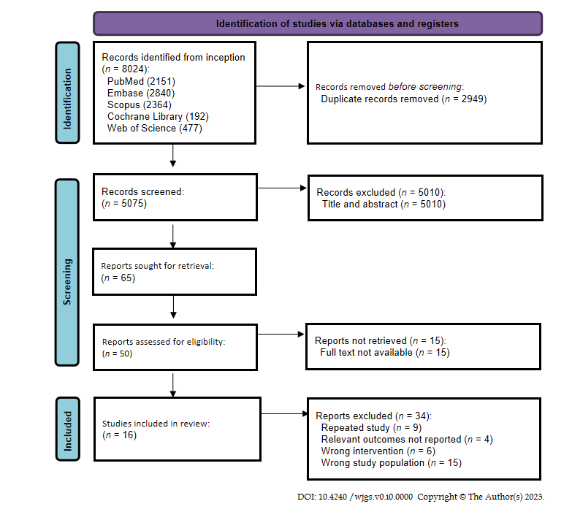
Figure 1 Preferred reporting items of systematic reviews and meta-analyses flow diagram of study selection.
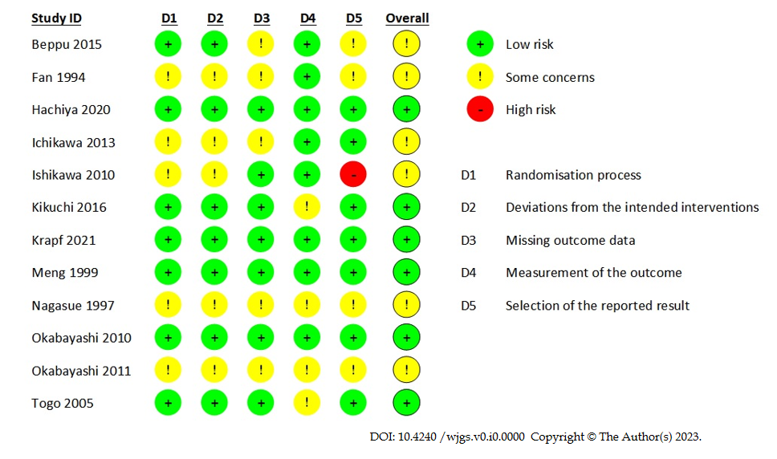
Figure 2 Risk of bias assessment of included randomised control trials, using version 2 of the Cochrane risk-of-bias tool for randomized trials (RoB 2).

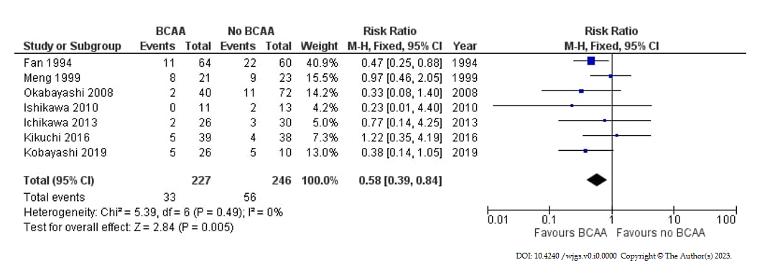
Figure 3 Forest plot of meta-analysis on postoperative infection. BCAA: Branched chain amino acid; CI: Confidence interval.

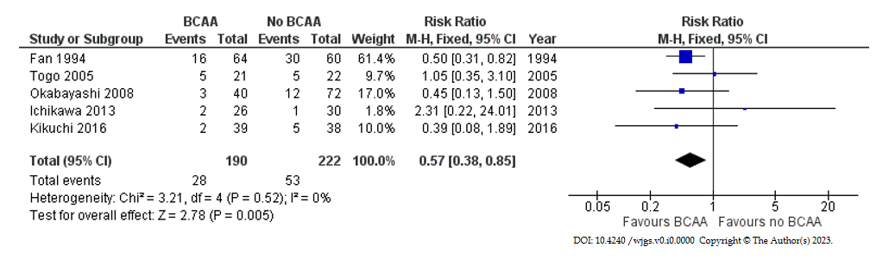
Figure 4 Forest plot of meta-analysis on all-cause postoperative ascites. BCAA: Branched chain amino acid; CI: Confidence interval.

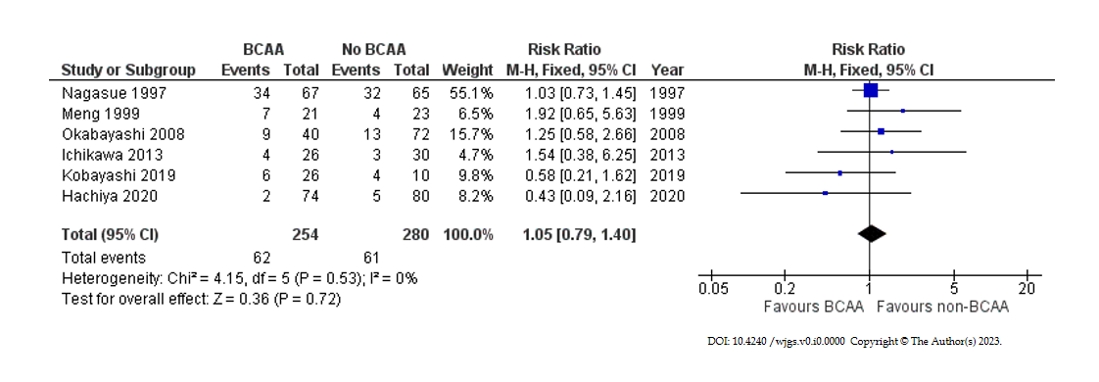
Figure 5 Forest plot of meta-analysis on all-cause mortality. BCAA: Branched chain amino acid; CI: Confidence interval.

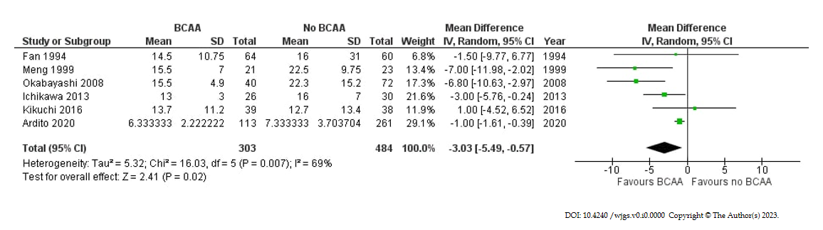
Figure 6 Forest plot of meta-analysis on length of hospital stay. BCAA: Branched chain amino acid; CI: Confidence interval.

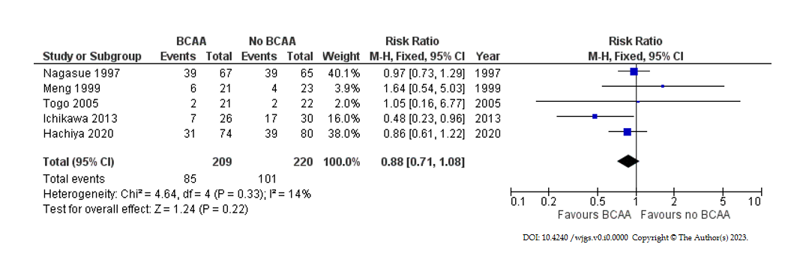
Figure 7 Forest plot of meta-analysis on recurrence. BCAA: Branched chain amino acid; CI: Confidence interval.

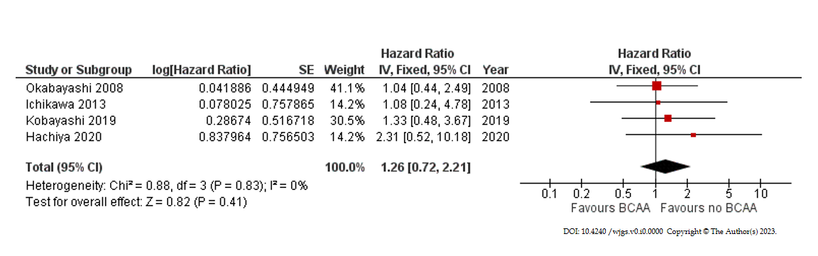
Figure 8 Forest plot of meta-analysis on overall survival. BCAA: Branched chain amino acid; CI: Confidence interval.

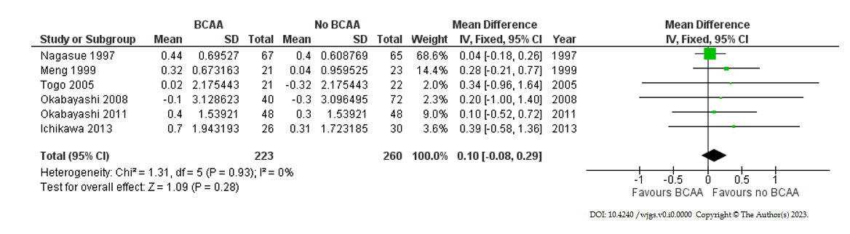
Figure 9 Forest plot of meta-analysis on change in serum albumin at 6 mo postoperatively. BCAA: Branched chain amino acid; CI: Confidence interval.

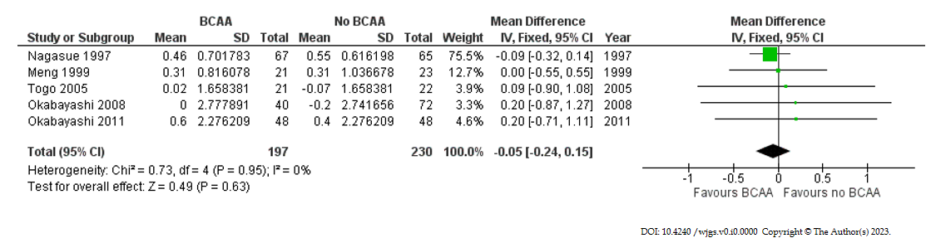
Figure 10 Forest plot of meta-analysis on change in serum albumin at 12 mo postoperatively. BCAA: Branched chain amino acid; CI: Confidence interval.

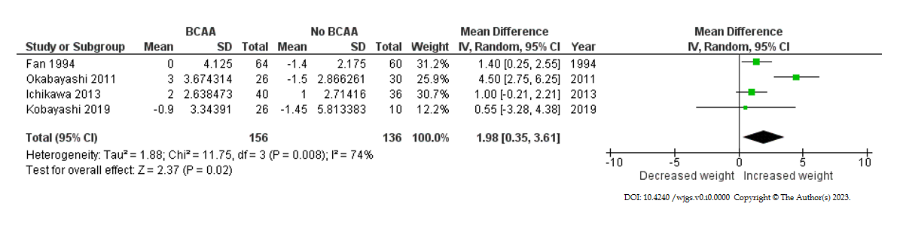
Figure 11 Forest plot of meta-analysis on postoperative body weight change for branched chain amino acid group relative to control. BCAA: Branched chain amino acid; CI: Confidence interval.

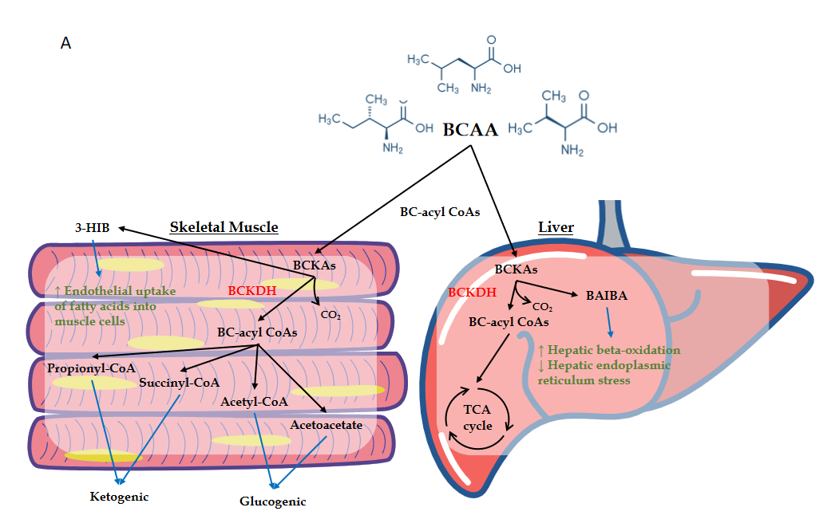
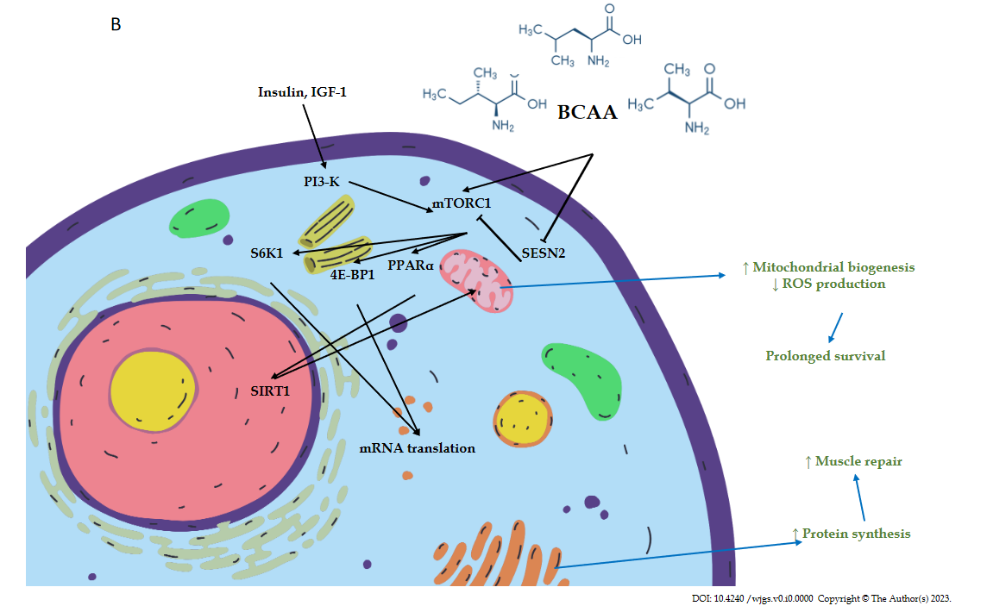
Figure 12 Branched chain amino acid. A: Biochemical effect of Branched chain amino acid (BCAA) on skeletal muscles and the liver; B: Signalling pathways involving BCAA.
BCAAs: Branched chain amino acids; BCKAs: Branched chain α-ketoacids; BCKDH: Branched chain α-ketoacid dehydrogenase; BC-acyl CoAs: Branched chain acyl-coenzyme As; CO₂: Carbon dioxide; Propionyl-CoA: Propionyl Coenzyme A; Succinyl-CoA: Succinyl Coenzyme A; Acetyl-CoA: Acetyl Coenzyme A; TCA cycle: Tricarboxylic Acid cycle; 3-HIB: 3-Hydroxyisobutyrate; BAIBA: Beta-amino-isobutyric acid; IGF-1: Insulin-like growth factor-1; PI3-K: Phosphoinositide 3-kinase; mTORC1: Mammalian target of rapamycin complex 1; SESN2: Sestrin2; PPARα: Peroxisome proliferator-activated receptor alpha; S6K1: S6 kinase beta-1; 4E-BP1: Eukaryotic translation initiation factor 4E-binding protein 1; SIRT1: Sirtuin 1; ROS: Reactive oxygen species.
Table 1 Risk of bias assessment of non-randomised studies, using Cochrane ROBINS-1 tool
Ref. | Confounding factor bias | Selection bias | Bias in classification of interventions | Bias due to deviations from intended intervention | Bias due to missing data | Bias in measurement of outcomes | Bias in selection of the reported result | Overall bias
Ardito et al^{[45]} | Low | Low | Low | Low | Low | Low | Low | Low
Kobayashi et al^{[36]} | Low | Moderate | Low | Low | Low | Low | Moderate | Moderate
Okabayashi et al^{[33]} | Low | Low | Low | Low | Low | Low | Low | Low
Shirabe et al^{[37]} | Low | Low | Low | Low | Low | Low | Low | Low

Table 2 Baseline participant information of included randomised control trials, observational studies and non-randomised trials
Ref. | Country/year | Study design | Sample size |  |  | Gender (M/F) |  | Male (%) |  | Age (yr) |  | Pathology
 |  |  | Intervention | Control | Total | Intervention | Control | Intervention | Control | Intervention | Control |  | Intervention | Control
Beppu et al^{[38]} | Japan, 2015 | RCT | 13 | 15 | 28 | 9/4 | 10/5 | 69.2 | 66.7 | 64.7 (30.0) | 68.4 (18.0) | Metastasis | 1 | 2
 |  |  |  |  |  |  |  |  |  |  |  | HCC | 11 | 10
 |  |  |  |  |  |  |  |  |  |  |  | Cholangiocarcinoma | 1 | 3
 |  |  |  |  |  |  |  |  |  |  |  | Others | 0 | 0
Fan et al^{[43]} | Hong Kong, 1994 | RCT | 64 | 60 | 124 | 56/9 | 53/7 | 87.5 | 88.3 | 51 (33.4) | 53 (35) | Metastasis | 0 | 0
 |  |  |  |  |  |  |  |  |  |  |  | HCC | 64 | 60
 |  |  |  |  |  |  |  |  |  |  |  | Cholangiocarcinoma | 0 | 0
 |  |  |  |  |  |  |  |  |  |  |  | Others | 0 | 0
Hachiya et al^{[39]} | Japan, 2020 | RCT | 74 | 80 | 154 | 59/15 | 66/14 | 79.7 | 82.5 | NR | NR | Metastasis | 0 | 0
 |  |  |  |  |  |  |  |  |  |  |  | HCC | 74 | 80
 |  |  |  |  |  |  |  |  |  |  |  | Cholangiocarcinoma | 0 | 0
 |  |  |  |  |  |  |  |  |  |  |  | Others | 0 | 0
Ichikawa et al^{[40]} | Japan, 2013 | RCT | 26 | 30 | 56 | 20/6 | 18/12 | 76.9 | 60 | 64.5 (11.4) | 64.7 (9.8) | Metastasis | 0 | 0
 |  |  |  |  |  |  |  |  |  |  |  | HCC | 26 | 30
 |  |  |  |  |  |  |  |  |  |  |  | Cholangiocarcinoma | 0 | 0
 |  |  |  |  |  |  |  |  |  |  |  | Others | 0 | 0
Ishikawa et al^{[30]} | Japan, 2010 | RCT | 10 | 10 | 20 | NR | NR | NR | NR | NR | NR | Metastasis | 2 | 1
 |  |  |  |  |  |  |  |  |  |  |  | HCC | 7 | 7
 |  |  |  |  |  |  |  |  |  |  |  | Cholangiocarcinoma | 1 | 2
 |  |  |  |  |  |  |  |  |  |  |  | Others¹ | 1 | 3
Kikuchi et al^{[41]} | Japan, 2016 | RCT | 39 | 38 | 77 | 31/8 | 29/9 | 79.5 | 76.3 | 69.4 (7.5) | 71.9 (7.4) | Metastasis | 0 | 0
 |  |  |  |  |  |  |  |  |  |  |  | HCC | 39 | 38
 |  |  |  |  |  |  |  |  |  |  |  | Cholangiocarcinoma | 0 | 0
 |  |  |  |  |  |  |  |  |  |  |  | Others | 0 | 0
Krapf et al^{[44]} | Austria, 2021 | RCT | 12 | 9 | 21 | NR | NR | NR | NR | NR | NR | Metastasis | NR | NR
 |  |  |  |  |  |  |  |  |  |  |  | HCC | NR | NR
 |  |  |  |  |  |  |  |  |  |  |  | Cholangiocarcinoma | NR | NR
 |  |  |  |  |  |  |  |  |  |  |  | Others | NR | NR
Meng et al^{[31]} | Hong Kong, 1999 | RCT | 21 | 23 | 44 | 19/2 | 18/5 | 90.5 | 78.3 | 51.5 (10.8) | 53.3 (12.8) | Metastasis | 0 | 0
 |  |  |  |  |  |  |  |  |  |  |  | HCC | 21 | 23
 |  |  |  |  |  |  |  |  |  |  |  | Cholangiocarcinoma | 0 | 0
 |  |  |  |  |  |  |  |  |  |  |  | Others | 0 | 0
Nagasue et al^{[32]} | Japan, 1997 | RCT | 67 | 65 | 132 | 54/13 | 55/10 | 80.6 | 84.6 | NR | NR | Metastasis | NR | NR
 |  |  |  |  |  |  |  |  |  |  |  | HCC | NR | NR
 |  |  |  |  |  |  |  |  |  |  |  | Cholangiocarcinoma | NR | NR
 |  |  |  |  |  |  |  |  |  |  |  | Others | NR | NR
Okabayashi et al^{[33]} | Japan, 2010 | RCT | 13 | 13 | 26 | 9/4 | 8/5 | 69.2 | 61.5 | 68.2 (11.0) | 63.5 (5.7) | Metastasis | 0 | 0
 |  |  |  |  |  |  |  |  |  |  |  | HCC | 8 | 7
 |  |  |  |  |  |  |  |  |  |  |  | Adenocarcinoma | 5 | 6
 |  |  |  |  |  |  |  |  |  |  |  | Cholangiocarcinoma | 0 | 0
 |  |  |  |  |  |  |  |  |  |  |  | Others | 0 | 0
Okabayashi et al^{[34]} | Japan, 2011 | RCT | 40 | 36 | 76 | 29/11 | 24/12 | 72.5 | 66.7 | 68.7 (7.6) | 65.1 (11.3) | Metastasis | 0 | 0
 |  |  |  |  |  |  |  |  |  |  |  | HCC | 32 | 26
 |  |  |  |  |  |  |  |  |  |  |  | Cholangiocarcinoma | 8 | 10
 |  |  |  |  |  |  |  |  |  |  |  | Others | 0 | 0
Togo et al^{[42]} | Japan, 2005 | RCT | 21 | 22 | 43 | 17/5 | 17/6 | 81 | 77.3 | 66.5 (4.5) | 64.3 (9.1) | Metastasis | NR | NR
 |  |  |  |  |  |  |  |  |  |  |  | HCC | NR | NR
 |  |  |  |  |  |  |  |  |  |  |  | Cholangiocarcinoma | NR | NR
 |  |  |  |  |  |  |  |  |  |  |  | Others | NR | NR
Ardito et al^{[45]} | Japan, 2020 | Retrospective | 107 | 205 | 312 | NR | NR | NA | NA | NR | NR | Metastasis | 83 | 163
 |  | Cohort |  |  |  |  |  |  |  |  |  | HCC | 18 | 36
 |  |  |  |  |  |  |  |  |  |  |  | Cholangiocarcinoma | 6 | 6
 |  |  |  |  |  |  |  |  |  |  |  | Others² | 6 | 48
Okabayashi et al^{[35]} | Japan, 2008 | Retrospective | 40 | 72 | 112 | 29/11 | 55/17 | 72.5 | 76.4 | 65.7 (8.6) | 68.3 (8.1) | Metastasis | 0 | 0
 |  | Cohort |  |  |  |  |  |  |  |  |  | HCC | 40 | 72
 |  |  |  |  |  |  |  |  |  |  |  | Cholangiocarcinoma | 0 | 0
 |  |  |  |  |  |  |  |  |  |  |  | Others | 0 | 0
Shirabe et al^{[37]} | Japan, 2011 | Retrospective | 72 | 56 | 128 | NR | NR | NR | NR | NR | NR | Metastasis | NR | NR
 |  | Cohort |  |  |  |  |  |  |  |  |  | HCC | 72 | 56
 |  |  |  |  |  |  |  |  |  |  |  | Cholangiocarcinoma | NR | NR
 |  |  |  |  |  |  |  |  |  |  |  | Others | NR | NR
Kobayashi et al^{[36]} | Japan, 2019 | Non- randomised trial | 26 | 10 | 36 | 21/5 | 5/5 | 80.8 | 50 | 69.2 (29.0) | 64.8 (26.7) | Metastasis | 4 | 2
 |  |  |  |  |  |  |  |  |  |  |  | HCC | 22 | 8
 |  |  |  |  |  |  |  |  |  |  |  | Cholangiocarcinoma | 0 | 0
 |  |  |  |  |  |  |  |  |  |  |  | Others | 0 | 0
¹Benign; ²Benign, intra-hepatic stones, others. RCT: Randomised controlled trial; HCC: Hepatocellular carcinoma; NR: Not reported.
Table 3 Relevant surgical details of included studies
Ref. | Surgical method |  | Intervention |  | Control | Blood loss/mL¹
 |  |  |  |  |  | Intervention | Control
Ardito et al^{[45]}, 2020 | Hepatectomy | Minimally invasive liver surgery | 33 | 74 |  | NR | NR
 |  | Major hepatic resection | 16 | 62
 |  | Multiple resections | 43 | 44
 |  | Total | 92 | 180
Beppu et al^{[38]}, 2015 | Hepatectomy | Right hemihepatectomy | 8 | 7 |  | NR | NR
 |  | Left hemihepatectomy | 0 | 1
 |  | Sectionectomy | 1 | 3
 |  | Left hemihepatectomy + sectionectomy | 0 | 1
 |  | Total | 9 | 12
Fan et al^{[43]}, 1994 | Hepatectomy | Major hepatic resection | 47 | 42 |  | 2600 (300-20000) | 1900 (400-10500)
 |  | Minor hepatic resection | 17 | 18
 |  | Total | 64 | 60
Hachiya et al^{[39]}, 2020 | Hepatectomy | Non-anatomical resections | 19 | 25 |  | 348 (5-3400) | 359 (5-3741)
 |  | Anatomical resections | 55 | 55
 |  | Total | 74 | 80
Ichikawa et al^{[40]}, 2013 | Hepatectomy | Major hepatic resection | 10 | 14 |  | 716 +/- 704 | 492 +/- 329
 |  | Limited resection of the liver | 16 | 16
 |  | Total | 26 | 30
Ishikawa et al^{[30]}, 2010 | Hepatectomy | Major hepatic resection | 7 | 5 |  | 802.7 +/- 350.6 | 838.8 +/- 597.6
 |  | Minor hepatic resection | 6 | 8
 |  | Total | 13 | 13
Kikuchi et al^{[41]}, 2016 | Hepatectomy | Partial hepatectomy | 13 | 12 |  | 665.7 +/- 528.9 | 578.5 +/- 492.1
 |  | Segmentectomy | 0 | 6
 |  | Bisgmentectomy/sectionectomy | 13 | 10
 |  | Bisectionectomy or more | 13 | 10
 |  | Total | 39 | 38
Kobayashi et al^{[36]}, 2019 | Hepatectomy | Major hepatic resection | 4 | 0 |  | 454 (140-5103) | 365 (35-3650)
 |  | Minor hepatic resection | 22 | 10
 |  | Total | 26 | 10
Krapf et al^{[44]}, 2021 | Liver transplant | Major hepatic resection | 24 | 12 |  | NR | NR
 | Hepatectomy | Hepatic resection | 9 | 12
 |  | Total | 33 | 24
Meng et al^{[31]}, 1999 | Hepatectomy | Major hepatic resection | 13 | 18 |  | NR | NR
 |  | Minor hepatic resection | 8 | 5
 |  | Total | 21 | 23
Nagasue et al^{[32]}, 1997 | Hepatectomy | Major hepatic resection | 19 | 26 |  | NR | NR
 |  | Minor hepatic resection | 48 | 39
 |  | Total | 67 | 65
Okabayashi et al^{[35]}, 2008 | Hepatectomy | Major hepatic resection | 10 | 19 |  | 516 +/- 354 | 821 +/- 552
 |  | Minor hepatic resection | 30 | 53
 |  | Total | 40 | 72
Okabayashi et al^{[33]}, 2010 | Hepatectomy | Major hepatic resection | 5 | 7 |  | 1252 +/- 1205 | 669 +/- 575
 |  | Minor hepatic resection | 8 | 6
 |  | Total | 13 | 13
Okabayashi et al^{[34]}, 2011 | Hepatectomy | Hemihepatectomy | 4 | 4 |  | 945 +/- 827 | 676 +/- 695
 |  | Segmentectomy | 12 | 10
 |  | Limited hepatic resection | 24 | 22
 |  | Total | 40 | 36
Shirabe et al^{[37]}, 2011 | Liver transplant | Total | 129 | 107 |  | 7388 +/- 9031 | 6448 +/- 6547
Togo et al^{[42]}, 2005 | Hepatectomy | Partial hepatectomy | 8 | 8 |  | 1163 +/- 853 | 1209 +/- 872
 |  | Segmentectomy | 7 | 8
 |  | Sectionectomy | 4 | 3
 |  | Hemihepatectomy | 2 | 3
 |  | Total | 21 | 22
¹Data is expressed as n or mean +/- SD (median, range). NR: Not reported.
Table 4 Presence and severity of liver diseases in patients of included studies
Ref. | Hepatitis |  | Cirrhosis |  | Child-Pugh Score
 | Intervention | Control | Intervention | Control |  | Intervention | Control
Ardito et al^{[45]}, 2020 | NR | NR | NR | NR | A | NR | NR
 |  |  |  |  | B | NR | NR
 |  |  |  |  | C | NR | NR
Beppu et al^{[38]}, 2015¹ | 9 | 8 | NR | NR | A | NR | NR
 |  |  |  |  | B | NR | NR
 |  |  |  |  | C | NR | NR
Fan et al^{[43]}, 1994 | 18 | 12 | 39 | 33 | A | NR | NR
 |  |  |  |  | B | NR | NR
 |  |  |  |  | C | NR | NR
Hachiya et al^{[39]}, 2020 | 74 | 80 | NR | NR | A | 61 | 64
 |  |  |  |  | B | 13 | 16
 |  |  |  |  | C | 0 | 0
Ichikawa et al^{[40]}, 2013 | 10 | 7 | 16 | 23 | A | 21 | 25
 |  |  |  |  | B | 5 | 5
 |  |  |  |  | C | 0 | 0
Ishikawa et al^{[30]}, 2010¹ | 4 | 2 | 5 | 5 | A | 10 | 12
 |  |  |  |  | B | 1 | 1
 |  |  |  |  | C | 0 | 0
Kikuchi et al^{[41]}, 2016 | 39 | 38 | NR | NR | A | 39 | 38
 |  |  |  |  | B | 0 | 0
 |  |  |  |  | C | 0 | 0
Kobayashi et al^{[36]}, 2019¹ | 20 | 6 | 12 | 8 | A | NR | NR
 |  |  |  |  | B | NR | NR
 |  |  |  |  | C | NR | NR
Krapf et al^{[44]}, 2021 | NR | NR | NR | NR | A | NR | NR
 |  |  |  |  | B | NR | NR
 |  |  |  |  | C | NR | NR
Meng et al^{[31]}, 1999 | 18 | 19 | 15 | 15 | A | 17 | 20
 |  |  |  |  | B | 4 | 3
 |  |  |  |  | C | 0 | 0
Nagasue et al^{[32]}, 1997 | 21 | 10 | 46 | 53 | A | 53 | 50
 |  |  |  |  | B | 13 | 14
 |  |  |  |  | C | 1 | 1
Okabayashi et al^{[35]}, 2008 | 33 | 54 | NR | NR | A | 33 | 62
 |  |  |  |  | B | 7 | 10
 |  |  |  |  | C | 0 | 0
Okabayashi et al^{[33]}, 2010 | 8 | 7 | NR | NR | A | 10 | 11
 |  |  |  |  | B | 3 | 2
 |  |  |  |  | C | 0 | 0
Okabayashi et al^{[34]}, 2011¹ | 22 | 16 | NR | NR | A | 28 | 25
 |  |  |  |  | B | 12 | 10
 |  |  |  |  | C | 0 | 0
Shirabe et al^{[37]}, 2011 | NR | NR | 26 | 18 | A | 3 | 18
 |  |  |  |  | B | 36 | 39
 |  |  |  |  | C | 90 | 50
Togo et al^{[42]}, 2005 | 21 | 22 | 21 | 22 | A | 15 | 17
 |  |  |  |  | B | 7 | 5
 |  |  |  |  | C | 0 | 0
¹All participants, including non-hepatocellular carcinoma patients were included. NR: Not reported.
Table 5 Intervention and control protocol for all included studies
Ref. | Intervention type | Intervention protocol¹ |  |  |  |  |  | Control protocol | Follow up period²
 |  | Pre-operative regime |  |  | Post-operative regime |  |  |  | Intervention |  | Control
 |  |  | Total BCAA received (g)/d | Duration |  | Total BCAA received (g)/d | Duration |  | Mean | Range | Mean | Range
Ardito et al^{[45]}, 2020 | Preoperative, postoperative | BCAA 500 mg 2 tablets TDS with personalised diet (ERAS) | 3 | 2/52 | BCAA 500 mg 2 tablets TDS (ERAS) | 3 | 1/12 | Normal usual diet (ERAS) | NR | NR | NR | NR
Beppu et al^{[38]}, 2015 | Preoperative, postoperative | Livact 4.15 g BD | 8 | 6/12 | NIL | NIL | NIL | Normal usual diet | NR | NR | NR | NR
Fan et al^{[43]}, 1994 | Preoperative, postoperative | BCAA 1.5 g/kg | Weight dependent | 1/52 | BCAA 1.5 g/kg | Weight dependent | 1/52 | Normal usual diet | NR | NR | NR | NR
Hachiya et al^{[39]}, 2020 | Postoperative | NIL | NIL | NIL | Livact 4 g TDS | 12 | 4 yr | Normal usual diet | 21.8 | 1.2-48 | NR | NR
Ichikawa et al^{[40]}, 2013 | Preoperative, postoperative | Livact 4.74 g TDS | 12 | 2/52 | Livact 4.74 g TDS | 12 | ≥ 6/12 | Normal usual diet | 39.5 mo | 7-48 mo | 36.0 mo | 6-50 mo
Ishikawa et al^{[30]}, 2010 | Preoperative, postoperative | Aminoleban EN 50 g BD | 11.123 | 2/52 | Aminoleban EN 50 g BD | 11.123 | 1/52 | Normal usual diet | NR | NR | NR | NR
Kikuchi et al^{[41]}, 2016 | Preoperative, postoperative | Livact 4.74 g TDS | 12 | 1/12 | Livact 4.74 g TDS | 12 | 1 yr | Normal usual diet (35-40 kcal/kg/d) + 4.74 g Livact TDS × 1 yr post-operatively | NR | NR | NR | NR
Kobayashi et al^{[36]}, 2019 | Preoperative, postoperative | Aminoleban EN 50 g ON | 5.5615 | 2/52 | Aminoleban EN ON | 5.5615 | 12/52 | Normal usual diet | NR | NR | NR | NR
Krapf et al^{[44]}, 2021 | Postoperative | NIL | NIL | NIL | High BCAA diet | NA | 2/52 | Normal usual diet (standard isocaloric meal plan) | NR | NR | NR | NR
Meng et al^{[31]}, 1999 | Postoperative | NIL | NIL | NIL | Aminoleban EN TDS with 40 g protein/d + 6300 kJ/d | NA | 12/52 | Normal usual diet (80 g protein/d + 6300 kJ/d) | 511.6d | 6-982 d | 512.7d | 48-983 d
Nagasue et al^{[32]}, 1997 | Postoperative | NIL | NIL | 2/52 | Aminoleban EN 50 g BD | 11.123 | ≥ 1 yr | Normal usual diet | 35.8 mo (17.9) | NR | 36.0 mo (17.7) | NR
Okabayashi et al^{[35]}, 2008 | Preoperative | Aminoleban EN 50 g BD | 11.123 | 2/52 | NIL | NIL | NIL | Normal usual diet | 16.3 mo | 2-47 mo | 23.3 mo | 2-84 mo
Okabayashi et al^{[33]}, 2010 | Preoperative | Aminoleban EN 50 g BD | 11.123 | 2/52 | NIL | NIL | NIL | Normal usual diet | NR | NR | NR | NR
Okabayashi et al^{[34]}, 2011 | Preoperative, postoperative | Aminoleban EN 50 g BD | 11.123 | 2/52 | Aminoleban EN 50 g BD | 11.123 | ≥ 6/12 | Normal usual diet | NR | NR | NR | NR
Shirabe et al^{[37]}, 2011 | Preoperative | Regime 1: Livact 3 packets OD  Regime 2: Aminoleban EN 50 g 1 to 3 packets | Regime 1: 12  Regime 2: 5.5615-16.6845 | > 1/12 | NIL | NIL | NIL | Normal usual diet | NR | NR | NR | NR
Togo et al^{[42]}, 2005 | Post-operative | NIL | NIL | NIL | Livact 4.74 g TDS | 12 | 1 yr | Normal usual diet | NR | NR | NR | NR
¹Composition of livact and Aminoleban described in supplementary table 4; ²Data is expressed as n or mean +/- SD (median, range). Participants on branched chain amino acid supplementation were also taking normal usual diet. BCAA: Branched chain amino acid; ERAS: Enhanced recovery after surgery; TDS: Ter die sumendum ; NR: Not reported; NIL: Nothing.

