Name of Journal: World Journal of Gastroenterology
Manuscript NO: 71456
Manuscript Type: ORIGINAL ARTICLE

Case Control Study
Atrophic gastritis and gastric cancer tissue miRNome analysis reveal hsa-miR-129-1 and hsa-miR-196a as potential early diagnostic biomarkers

Varkalaite G et al. AG and GC tissue miRNomes

Greta Varkalaite, Evelina Vaitkeviciute, Ruta Inciuraite, Violeta Salteniene, Simonas Juzenas, Vytenis Petkevicius, Rita Gudaityte, Antanas Mickevicius, Alexander Link, Limas Kupcinskas, Marcis Leja, Juozas Kupcinskas, Jurgita Skieceviciene

Greta Varkalaite, Evelina Vaitkeviciute, Ruta Inciuraite, Violeta Salteniene, Simonas Juzenas, Limas Kupcinskas, Jurgita Skieceviciene, Institute for Digestive Research, Lithuanian University of Health Sciences, Kaunas 44307, Lithuania

Vytenis Petkevicius, Juozas Kupcinskas, Department of Gastroenterology, Lithuanian University of Health Sciences, Kaunas 44307, Lithuania

Rita Gudaityte, Antanas Mickevicius, Department of Surgery, Lithuanian University of Health Sciences, Kaunas 44307, Lithuania

Alexander Link, Department of Gastroenterology, Hepatology and Infectious Diseases, Otto-von-Guericke University Hospital, Magdeburg 39120, Germany

Marcis Leja, Institute of Clinical and Preventive Medicine & Faculty of Medicine, University of Latvia, Riga 1586, Latvia

Author contributions: Varkalaite G, Leja M, Kupcinskas L, Kupcinskas J and Skieceviciene J contributed to study conception and designed the research; Gudaityte R, Petkevicius V and Mickevicius A collected material and clinical data from the participants; Varkalaite G and Vaitkeviciute E performed all the investigations, analysis of data and drafted the manuscript; Juzenas S and Inciuraite R reviewed and edited the manuscript; Salteniene V revised the article for important intellectual content; Link A, Kupcinskas J and Skieceviciene J approved the final version of the manuscript.

Supported by the MULTIOMICS project that has received funding from European Social Fund (No. 09.3.3-LMT-K-712-01-0130) under grant agreement with the Research Council of Lithuania (LMTLT).

Corresponding author: Jurgita Skieceviciene, PhD, Senior Researcher, Institute for Digestive Research, Lithuanian University of Health Sciences, A. Mickeviciaus street 9, Kaunas 44307, Lithuania. jurgita.skieceviciene@lsmuni.lt

Received: September 13, 2021
Revised: November 19, 2021
Accepted: January 19, 2022
Published online: February 14, 2022

Abstract
BACKGROUND
Gastric cancer (GC) is one of the most frequently diagnosed tumor globally. In most cases, GC develops in a stepwise manner from chronic gastritis or atrophic gastritis (AG) to cancer. One of the major issues in clinical settings of GC is diagnosis at advanced disease stages resulting in poor prognosis. MicroRNAs (miRNAs) are small noncoding molecules that play an essential role in a variety of fundamental biological processes. However, clinical potential of miRNA profiling in the gastric cancerogenesis, especially in premalignant GC cases, remains unclear.

AIM
To evaluate the AG and GC tissue miRNomes and identify specific miRNAs’ potential for clinical applications (e.g., non-invasive diagnostics).

METHODS
Study included a total of 125 subjects: Controls (CON), AG, and GC patients. All study subjects were recruited at the Departments of Surgery or Gastroenterology, Hospital of Lithuanian University of Health Sciences and divided into the profiling (n = 60) and validation (n = 65) cohorts. Total RNA isolated from tissue samples was used for preparation of small RNA sequencing libraries and profiled using next-generation sequencing (NGS). Based on NGS data, deregulated miRNAs hsa-miR-129-1-3p and hsa-miR-196a-5p were analyzed in plasma samples of independent cohort consisting of CON, AG, and GC patients. Expression level of hsa-miR-129-1-3p and hsa-miR-196a-5p was determined using the quantitative real-time polymerase chain reaction and 2^{-ΔΔCt} method.

RESULTS
Results of tissue analysis revealed 20 differentially expressed miRNAs in AG group compared to CON group, 129 deregulated miRNAs in GC compared to CON, and 99 altered miRNAs comparing GC and AG groups. Only 2 miRNAs (hsa-miR-129-1-3p and hsa-miR-196a-5p) were identified to be step-wise deregulated in healthy-premalignant-malignant sequence. Area under the curve (AUC)-receiver operating characteristic analysis revealed that expression level of hsa-miR-196a-5p is significant for discrimination of CON vs AG, CON vs GC and AG vs GC and resulted in AUCs: 88.0%, 93.1% and 66.3%, respectively. Comparing results in tissue and plasma samples, hsa-miR-129-1-3p was significantly down-regulated in GC compared to AG (P = 0.0021 and P = 0.024, tissue and plasma, respectively). Moreover, analysis revealed that hsa-miR-215-3p/5p and hsa-miR-934 were significantly deregulated in GC based on Helicobacter pylori (H. pylori) infection status [log2 fold change (FC) = -4.52, P-adjusted = 0.02; log2FC = -4.00, P-adjusted = 0.02; log2FC = 6.09, P-adjusted = 0.02, respectively].

CONCLUSION
Comprehensive miRNome study provides evidence for gradual deregulation of hsa-miR-196a-5p and hsa-miR-129-1-3p in gastric carcinogenesis and found hsa-miR-215-3p/5p and hsa-miR-934 to be significantly deregulated in H. pylori carrying GC patients.

Key Words: Gastric cancer; Atrophic gastritis; Tumorigenesis; Helicobacter pylori; MicroRNAs; Biomarkers

©The Author(s) 2022. Published by Baishideng Publishing Group Inc. All rights reserved.

Citation: Varkalaite G, Vaitkeviciute E, Inciuraite R, Salteniene V, Juzenas S, Petkevicius V, Gudaityte R, Mickevicius A, Link A, Kupcinskas L, Leja M, Kupcinskas J, Skieceviciene J. Atrophic gastritis and gastric cancer tissue miRNome analysis reveal hsa-miR-129-1 and hsa-miR-196a as potential early diagnostic biomarkers. World J Gastroenterol 2022; 28(6): 653-664
URL: https://www.wjgnet.com/1007-9327/full/v28/i6/653.htm
DOI: https://dx.doi.org/10.3748/wjg.v28.i6.653

Core Tip: In this research we aimed to evaluate microRNAs profiles of premalignant and malignant stages of gastric cancer (GC). To date this is the first study analyzing atrophic gastritis (AG) and GC tissue miRNomes in the subjects of European origin using next-generation sequencing approach. We showed that hsa-miR-196a-5p expression in tissue is significant for discrimination between controls and AG or GC, while hsa-miR-129-1-3p is potential candidate for non-invasive GC diagnostic. This study provides novel insights into complex GC pathogenesis cascade and might be highly significant for future studies of new AG or GC associated epigenetic markers or even diagnostic targets.

INTRODUCTION
Gastric cancer (GC) is the one of the most common malignancy and the fourth leading cause of cancer-related death worldwide^{[1]}. Studies show, that in most cases GC development is a stepwise process: Chronic gastric mucosa inflammation progresses to atrophic gastritis (AG) or intestinal metaplasia (IM), which eventually may become predisposition to GC. This complex cascade involves many factors: Helicobacter pylori (H. pylori) infection, lifestyle, dietary habits, and genetic or epigenetic alterations, including miRNA expression changes^{[2,3]}. One of the major concerns in diagnostics of GC is poor survival rate and prognosis, while this tumor is usually diagnosed at late stages. Therefore, investigation of the molecular mechanisms that are critical in the complex GC pathological cascade may help to identify novel therapeutic targets and consequently improve the disease prognosis. MicroRNAs (miRNAs) are small (approx 22 nt) non-coding RNA molecules that regulate gene expression by binding to the specific sites within 3’ untranslated regions of target mRNAs^{[4,5]}. MiRNAs play very important role in many physiological and pathological processes as well as tumorigenesis and may function as either tumor-suppressors or as oncogenic miRNAs^{[6-8]}. Studies have reported numerous differentially expressed miRNAs in malignant gastric tissues including members of miR-20, miR-451, miR-148, miR-223 families^{[9-11]}. Despite the previous efforts and conducted miRNA studies in GC, the miRNome characterization of premalignant gastric condition - AG - remains largely unknown.
In this study, we aimed to investigate miRNome profile through GC tumorigenesis cascade including precancerous lesions, such as AG. Also, expression of two miRNAs (hsa-miR-129-1 and hsa-miR-196a) was analyzed in plasma samples of the independent cohort of AG and GC patients. Tissue miRNome analysis results revealed distinct miRNA profiles comparing controls (CON), AG, and GC groups. Also, our study findings show that two miRNAs: Hsa-miR-129-1 and hsa-miR-196a may be a relevant biomarker for GC diagnostics.

MATERIALS AND METHODS
Study population
The study included a total of 125 CON and patients diagnosed with AG and GC, who were divided into the profiling cohort of 60 subjects and validation cohort of 65 subjects. Tissue samples of profiling cohort were collected during the years 2007-2015, while plasma of participants in validation cohort was collected from years 2011-2019 at the Departments of Surgery and Gastroenterology, Hospital of Lithuanian University of Health Sciences (Kaunas, Lithuania). Clinical and phenotypic characteristics of subjects investigated in profiling and validation cohorts are presented in Table 1. H. pylori status was assessed using indirect ELISA to detect serum-specific IgG antigen (Virion/Serion GmbH, Germany). Control group consisted of subjects, who had no signs of atrophy or IM according to Operative Link on Gastritis Assessment (OLGA) staging system (stage 0)^{[12]}. AG group consisted of individuals that had stage I-IV atrophy score in gastric mucosa by OLGA classification. Gastric adenocarcinoma in GC patients was verified by histology and classified according to the American Joint Committee on Cancer TNM Staging Classification and Lauren Classification^{[13,14]}. Adjacent GC (GCaj) samples were biopsy samples obtained from endoscopically healthy appearing gastric mucosa at least 2 cm away from the primary tumor.
The study was approved by the Kaunas Regional Biomedical Research Ethics Committee (approval No BE-2-10 and BE-2-31) and performed in accordance with the Declaration of Helsinki. All study participants provided written informed consent before enrollment.

Total RNA extraction
Total RNA, including small RNA fraction, was isolated from CON, AG and GC tissues using miRNeasy Mini Kit (Qiagen, Germany) according to the manufacturer’s instructions. Quantification of RNA was performed using Nanodrop2000 spectrophotometer (Thermo Fisher Scientific, United States) and quality of RNA samples was evaluated by Agilent 2100 Bioanalyzer (Agilent Technologies, United States). Circulating nucleic acids, including circulating miRNA fraction, was isolated using QIAamp Circulating Nucleic Acid Kit (Qiagen, Germany) according to manufacturer’s instructions. All isolated samples were stored at -80 °C prior to further analysis.

Small RNA-seq library preparation and next-generation sequencing
Small RNA libraries were prepared using Illumina TruSeq Small RNA Sample Preparation Kit (Illumina, United States) according to the manufacturer’s protocol with 1 μg RNA input per sample followed by RNA 3’ adapter ligation, RNA 5’ adapter ligation, cDNA synthesis, polymerase chain reaction (PCR) amplification using unique barcode sequences for each sample and gel size-selection of small RNA library. The yield and quality of sequencing libraries were assessed using the Agilent 2100 Bioanalyzer (Agilent Technologies, United States). The small RNA libraries were randomized, pooled 24 samples per lane and sequenced using Illumina HiSeq 2500 (1 × 50 bp single-end reads).

Bioinformatics analysis of small RNA-seq data
Analysis of raw small RNA-seq data was performed by nf-core/smrnaseq pipeline v.1.0.0 including Nextflow v.20.07.1^{[15]}, Java v.11.0.7, and Docker v.19.03.12. In brief, all steps consisted of read quality control using FastQC v.0.11.9, removing 3’ adapter sequences with TrimGalore! v.0.6.5, mapping to mature and hairpin miRNAs (miRBase v.22.1^{[16]}), and GRCh37 human reference genome with Bowtie v.1.3.0^{[17]}. After alignment and trimming sorted BAM files were used for further analysis with edgeR v.3.32.1^{[18]} and mirtop v.0.4.23. MiRNA quality was assessed and summarized using MultiQC v.1.9^{[19]}. Normalized counts were generated using isomiRs package and differential expression analysis was carried out using the DESeq2 Bioconductor package v.1.26.0^{[20]}. The threshold for significant differential expression was Bonferroni^{[21]} adjusted P-value < 0.05 and absolute value of log2 fold change (FC) |log2FC| > 1.

Validation of miRNA expression in plasma by reverse transcription quantitative real-time PCR
To validate differentially expressed miRNAs in plasma samples, isolated plasma circulating microRNA was reverse transcribed to cDNA using the TaqMan™ MicroRNA Reverse Transcription Kit (Thermo Fisher Scientific, United States). The material was preamplified using the TaqMan PreAmp Master Mix (Applied Biosystems, United States) according to the manufacturer’s protocol. Quantitative real-time PCR (RT-PCR) was performed using the TaqMan MicroRNA Assays: Hsa-miR-129* (Assay ID: 002298), hsa-miR-196a (Assay ID: 241070_mat) on 7500 Fast Real-Time PCR System (Applied Biosystems, United States). All RT-qPCR reactions were run in duplicate in a 20 μL reaction and the relative fold change in miRNA expression was estimated using the 2^{-ΔΔCt} method^{[22]}. Ct values were normalized to the RNU6B (Assay ID: 001093, Thermo Fisher Scientific, United States) endogenous control.

Statistical analysis
Statistical analysis was performed using RStudio software (R v.3.6.3). Shapiro-Wilk normality test was used to test the normal distribution of data. For normally distributed data, statistical significance was assessed by Student's t-test. If the data did not pass normality tests was performed non-parametric Wilcoxon rank-sum test. A P < 0.05 was considered statistically significant. Area under the receiver operating characteristic curve (AUC-ROC) analysis was performed using pROC R package.

RESULTS
Small RNA sequencing reveals distinct miRNomes of healthy, premalignant, and malignant stages of GC
Small RNA sequencing of CON, AG, and paired GC (cancerous and adjacent) tissues in total identified 1037 miRNAs annotated in the miRBase v22.1. Sequencing yielded approx 250 M raw sequencing reads (from 359 K to 16 M reads per sample). After quality control steps 396 low-abundant and non-variable miRNAs and 5 outlying samples were removed resulting in 641 miRNAs and 75 samples which were used for further analysis (Supplementary Figures 1 and 2). The number of deregulated miRNAs corresponded to pathological cascade of GC development. The highest number of deregulated miRNAs were determined when comparing GC and CON groups (129 differentially expressed miRNAs, 82 up-regulated and 47 down-regulated; Supplementary Table 1). Next, 99 differentially expressed miRNAs were identified analyzing GC compared to AG (67 up-regulated and 32 down-regulated; Supplementary Table 2). The lowest number, 20 miRNAs, were found to be deregulated comparing AG and CON (6 up-regulated and 14 down-regulated; Supplementary Table 3). Differential expression results comparing GC vs GCaj, AG vs GCaj, and CON vs GCaj are presented in Supplementary Tables 4, 5 and 6 respectively.
Differential expression results and top five deregulated miRNAs in each case are represented in Figure 1A. Multidimensional scaling analysis of normalized expression values, assessing the similarity structure of miRNomes (Spearman’s correlation distance), revealed 4 clusters, corresponding to the CON, AG, GC cancerous and adjacent tissues (Figure 1B). The AG cluster was intermediate between GC and CON, whereas GCaj was overlapping with AG and CON groups.

Hsa-miR-129-1-3p and hsa-miR-196a-5p may be employed for discrimination of healthy, premalignant, and malignant GC cases
To further study miRNome profiles, altered expression of miRNAs was analyzed in three main comparison groups: AG vs CON, GC vs CON and AG vs GC according to clinical significance. Analyzing uniquely deregulated miRNAs, 40 differentially expressed miRNAs were found when compared GC to CON (25.8% of all deregulated miRNAs), 18 (11.6%) - AG compared to GC, and 6 (3.9%) - AG compared to CON (Figure 2). Most of the deregulated miRNAs (n = 79, 68.7%) were similar between GC vs CON and GC vs AG comparison groups. 12 miRNAs (7.7%) were deregulated in both AG and GC groups when compared to CON. Four miRNAs (2.6%) were similarly deregulated between AG vs CON and AG vs GC groups. Finally, only 2 miRNAs (hsa-miR-129-1-3p and hsa-miR-196a-5p) (1.29%) were identified as deregulated between all comparison groups. AUC-ROC analysis revealed that expression level of hsa-miR-129-1-3p in tissues resulted in AUCs: 68.1%; 86.3%, and 78.1%, CON vs AG, CON vs GC, and AG vs GC, respectively (Figures 3A, 3B and 3C). In addition to this, expression level of hsa-miR-196a-5p could be significant for discrimination of CON vs AG, CON vs GC and AG vs GC and resulted in AUCs: 88.0%, 93.1% and 66.3% (Figures 3D, 3E and 3F).

Hsa-miR-129-1-3p and hsa-miR-196a-5p expression in the plasma follows the expression pattern of CON, AG, and GC tissues
Differential expression analysis of NGS data in tissue samples revealed that hsa-miR-129-1-3p was significantly down-regulated and hsa-miR-196a-5p was up-regulated in AG and GC tissues compared to CON (P = 0.002 and P = 0.00018; P = 1.2 × 10⁻⁵ and P = 3.1 × 10⁻⁵, respectively). Moreover, hsa-miR-129-1-3p was significantly down-regulated in the case of AG compared to GC (P = 0.0021) and reflected a stepwise process of a pathology (Figure 4A). Therefore, to identify whether the expression changes of these two miRNAs can be detected noninvasively in the body fluids of the patients, hsa-miR-129-1-3p and hsa-miR-196a-5p were selected for RT-qPCR analysis in plasma samples of independent cohort. The analysis showed similar expression patterns in the case of hsa-miR-129-1-3p, which was significantly down-regulated when comparing AG and GC groups (P = 0.024). There were no other significant findings between the groups (Figure 4B).

Hsa-miR-215-3p/5p and hsa-miR-934 may be associated with H. pylori-induced GC
To investigate role of miRNAs in AG atrophy progression (OLGA classification) and H. pylori-induced GC, differential miRNAs profile analysis in the subgroups of the study was performed. The analysis revealed a minor clustering in AG tissues corresponding to OLGA stages (Supplementary Figures 3A and 3H). H. pylori status in GC tissues (Supplementary Figure 3B). However, no significantly deregulated miRNAs were determined comparing I-II OLGA stages vs III-IV OLGA stages (AG tissue samples). On the other hand, analyzing GC group based on H. pylori infection status [H. pylori (neg.) vs H. pylori (pos.)], three miRNAs were shown to be significantly deregulated: Hsa-miR-215-3p (log2FC = -4.52, P-adjusted = 0.02), hsa-miR-215-5p (log2FC = -4.00, P-adjusted = 0.02), and hsa-miR-934 (log2FC = 6.09, P-adjusted = 0.02).

DISCUSSION
This study represents comprehensive miRNome profiling of premalignant and malignant GC cases by implementing high throughput technologies such as NGS. Although there are several studies reporting profiles of GC tissue miRNAs^{[23,24]}, analysis of the association between miRNA expression and AG is very scarce reporting only individual miRNAs^{[25]}. Moreover, based on small RNA-seq findings, two miRNAs were analyzed in subjects’ plasma samples to investigate potential non-invasive markers. To our best knowledge this is the first study analyzing AG and GC tissue miRNomes in the subjects of European origin.
First, our study showed different profiles of deregulated miRNAs between tissue samples of studied groups. In total, 20 differentially expressed miRNAs were identified in AG and 129 - in GC comparing to CON; also 99 deregulated miRNAs - comparing GC and AG groups. MiRNAs such as hsa-miR-3131, hsa-miR-483, hsa-miR-150, hsa-miR-200a-3p, hsa-miR-873-5p were previously reported by the GC profiling studies of Pereira et al^{[23]} and Assumpção et al^{[24]}. Yet, we were able to identify number of novel miRNAs (of which hsa-miR-548ba, hsa-miR-4521, hsa-miR-549a were the most deregulated). There are no data showing the role of these novel miRNAs in inflammatory or tumorous processes of gastric tissue. However, recent studies have shown that hsa-miR-548ba was associated with bladder cancer, hsa-miR-549a with the metastasis of renal cancer, and hsa-miR-4521 with H. pylori infection in esophageal epithelial cells^{[26-28]}. Taking into consideration miRNome of AG, hsa-miR-3591-3p, hsa-miR-122-3p and hsa-miR-122-5p, hsa-miR-451a miRNAs were already reported by Liu et al^{[29]}, while the most deregulated miRNAs including hsa-miR-215, hsa-miR-4497, and hsa-miR-1251 were reported for the first time in our study. Previous research showed that hsa-miR-215-5p was deregulated in different lesions of the gastrointestinal tract (Barrett’s esophagus, intraepithelial neoplastic lesions, ulcerative colitis)^{[30-32]}. However, hsa-miR-4497 and hsa-miR-452 were not previously associated with AG but were reported to play an important role in GC development^{[33,34]}.
Next, we identified hsa-miR-215-3p and hsa-miR-215-5p to be down-regulated while hsa-miR-934 - up-regulated in GC group comparing negative and positive H. pylori infection status. Studies revealed the altered expression of various miRNAs in H. pylori-induced GC tissue samples, including miR-934, miR-146a, miR-375, miR-204^{[35-37]}. Although, hsa-miR-215 deregulation was previously associated with GC^{[38-40]}, there is no data showing its link with H. pylori infection.
In addition to this, we showed that two miRNAs (hsa-miR-129-1-3p and hsa-miR-196a-5p) were gradually deregulated comparing all three study groups (CON, AG, and GC) which also corresponds to pathological cascade of GC. In concordance to our results, it has already been shown that hsa-miR-129-1-3p was down-regulated in GC tissues, function as a tumor suppressor in GC and even corresponds to the same expression pattern in gastric juice^{[41,42]}. There is no data regarding the hsa-miR-196a expression in AG tissue, however, investigators have revealed that hsa-miR-196a is overexpressed in GC tissue, plasma, commercial cell lines and promotes cell proliferation^{[43,44]}. ROC-AUC analysis suggests great potential of hsa-miR-196a-5p expression in tissue for discrimination of AG and GC in contrast to CON (AUC = 89.5% and AUC = 89.5%, respectively). Therefore, further studies are needed to confirm this finding.
Finally, selected miRNAs were analyzed in independent cohort of CON, AG, and GC plasma samples by using RT-qPCR. Results showed similar deregulation direction in plasma samples as in the tissue samples. However, significant differences were only determined comparing the expression of hsa-miR-129-1-3p between AG and GC suggesting its potential role in non-invasive diagnostics of malignant cases. No significant expression changes were observed between study groups and hsa-miR-196a-5p. Other studies have shown controversial results: Tsai et al^{[45]} reported that miR-196a/b was up-regulated in both the plasma and tissue of metastatic GC patients, while miRNome profiling study revealed that miR-196a-5p was found to be down-regulated in plasma of patients with precursor lesions of GC compared to non-active gastritis^{[46]}.
In our study, using NGS and RT-qPCR techniques we have shown the distinct miRNome profiles of CON, AG, GC, GCaj tissues, and potential of specific miRNAs as non-invasive biomarkers. In addition to this, novel miRNAs not previously reported as AG or GC associated epigenetic markers were identified. We have shown that hsa-miR-196a-5p expression in tissue could be significant for discrimination between CON and AG or GC, confirmed hsa-miR-129-1-3p as non-invasive biomarker in disease progression monitoring, and showed that miRNAs could be a great candidate for future research of new diagnostic approaches.

CONCLUSION
In conclusion, we showed gradual deregulation of hsa-miR-196a-5p and hsa-miR-129-1-3p in the gastric carcinogenesis pathway and confirmed hsa-miR-129-1-3p as a possible non-invasive biomarker. We also found hsa-miR-215-3p/5p and hsa-miR-934 to be significantly deregulated in GC based on H. pylori infection status. These data provide novel insights into complex GC pathogenesis cascade which could be highly significant for future studies of new diagnostic GC targets.

ARTICLE HIGHLIGHTS
Research background
Gastric cancer (GC) is a complex disease arising from the interaction of environmental (e.g., diet, smoking, etc.) and host-associated factors [e.g., Helicobacter pylori (H. pylori) infection, genetics, etc.]. Due to its silent course, it is also one of the most lethal cancers worldwide as it is usually diagnosed at the advanced stages.

Research motivation
Novel biomarkers that would help to improve GC patients’ diagnosis and prognosis are highly needed. Studies show that microRNAs (miRNAs) play an important role in many cancers and could be a promising biomarker or even therapeutic target.

Research objectives
The objectives of the study were to analyze whole miRNome profiles of control, premalignant and malignant gastric tissues, and select the potential miRNA markers that could have a potential for minimally invasive GC diagnostics.

Research methods
Total RNA from gastric tissue samples was subjected for small RNA sequencing (smRNA-seq). Plasma total circulating nucleic acids were used for the expression analysis of the most tissue deregulated miRNAs by real-time quantitative polymerase chain reaction. Statistical analysis involved the differential expression and discrimination analyses.

Research results
The abundance of altered expression miRNAs corresponded to a pathological cascade of GC development. Hsa-miR-129-1-3p and has-miR-196a-5p were shown to be deregulated in healthy-premalignant-malignant sequence. In addition to this, we showed that down-regulation of hsa-miR-129-1-3p could also be detected non-invasively in GC patients’ plasma samples. Finally, results indicated that hsa-miR-215-3p/5p and hsa-miR-934 were significantly deregulated based on H. pylori infection status for GC patients.

Research conclusions
Gastric tissue miRNome study provides extensive profiling of control, premalignant and malignant cases. Based on smRNA-seq results several miRNAs were shown as potential gastric carcinogenesis (hsa-miR-196a-5p and hsa-miR-129-1-3p); and H. Pylori-related (hsa-miR-215-3p/5p and hsa-miR-934) biomarkers.

Research perspectives
This study provides novel insights into complex GC pathogenesis cascade and could serve as a reference for future research to support our findings.

REFERENCES
1 Sung H, Ferlay J, Siegel RL, Laversanne M, Soerjomataram I, Jemal A, Bray F. Global Cancer Statistics 2020: GLOBOCAN Estimates of Incidence and Mortality Worldwide for 36 Cancers in 185 Countries. CA Cancer J Clin 2021; 71: 209-249 [PMID: 33538338 DOI: 10.3322/caac.21660]
2 McLean MH, El-Omar EM. Genetics of gastric cancer. Nat Rev Gastroenterol Hepatol 2014; 11: 664-674 [PMID: 25134511 DOI: 10.1038/nrgastro.2014.143]
3 Tan P, Yeoh KG. Genetics and Molecular Pathogenesis of Gastric Adenocarcinoma. Gastroenterology 2015; 149: 1153-1162.e3 [PMID: 26073375 DOI: 10.1053/j.gastro.2015.05.059]
4 Bartel DP. Metazoan MicroRNAs. Cell 2018; 173: 20-51 [PMID: 29570994 DOI: 10.1016/j.cell.2018.03.006]
5 Bartel DP. MicroRNAs: target recognition and regulatory functions. Cell 2009; 136: 215-233 [PMID: 19167326 DOI: 10.1016/j.cell.2009.01.002]
6 Bracken CP, Scott HS, Goodall GJ. A network-biology perspective of microRNA function and dysfunction in cancer. Nat Rev Genet 2016; 17: 719-732 [PMID: 27795564 DOI: 10.1038/nrg.2016.134]
7 Farazi TA, Hoell JI, Morozov P, Tuschl T. MicroRNAs in human cancer. Adv Exp Med Biol 2013; 774: 1-20 [PMID: 23377965 DOI: 10.1007/978-94-007-5590-1_1]
8 Gyvyte U, Juzenas S, Salteniene V, Kupcinskas J, Poskiene L, Kucinskas L, Jarmalaite S, Stuopelyte K, Steponaitiene R, Hemmrich-Stanisak G, Hübenthal M, Link A, Franke S, Franke A, Pangonyte D, Lesauskaite V, Kupcinskas L, Skieceviciene J. MiRNA profiling of gastrointestinal stromal tumors by next-generation sequencing. Oncotarget 2017; 8: 37225-37238 [PMID: 28402935 DOI: 10.18632/oncotarget.16664]
9 Streleckiene G, Inciuraite R, Juzenas S, Salteniene V, Steponaitiene R, Gyvyte U, Kiudelis G, Leja M, Ruzgys P, Satkauskas S, Kupcinskiene E, Franke S, Thon C, Link A, Kupcinskas J, Skieceviciene J. miR-20b and miR-451a Are Involved in Gastric Carcinogenesis through the PI3K/AKT/mTOR Signaling Pathway: Data from Gastric Cancer Patients, Cell Lines and Ins-Gas Mouse Model. Int J Mol Sci 2020; 21 [PMID: 32013265 DOI: 10.3390/ijms21030877]
10 Link A, Kupcinskas J. MicroRNAs as non-invasive diagnostic biomarkers for gastric cancer: Current insights and future perspectives. World J Gastroenterol 2018; 24: 3313-3329 [PMID: 30122873 DOI: 10.3748/wjg.v24.i30.3313]
11 Juzėnas S, Saltenienė V, Kupcinskas J, Link A, Kiudelis G, Jonaitis L, Jarmalaite S, Kupcinskas L, Malfertheiner P, Skieceviciene J. Analysis of Deregulated microRNAs and Their Target Genes in Gastric Cancer. PLoS One 2015; 10: e0132327 [PMID: 26172537 DOI: 10.1371/journal.pone.0132327]
12 Rugge M, Correa P, Di Mario F, El-Omar E, Fiocca R, Geboes K, Genta RM, Graham DY, Hattori T, Malfertheiner P, Nakajima S, Sipponen P, Sung J, Weinstein W, Vieth M. OLGA staging for gastritis: a tutorial. Dig Liver Dis 2008; 40: 650-658 [PMID: 18424244 DOI: 10.1016/j.dld.2008.02.030]
13 Amin MB, Greene FL, Edge SB, Compton CC, Gershenwald JE, Brookland RK, Meyer L, Gress DM, Byrd DR, Winchester DP. The Eighth Edition AJCC Cancer Staging Manual: Continuing to build a bridge from a population-based to a more "personalized" approach to cancer staging. CA Cancer J Clin 2017; 67: 93-99 [PMID: 28094848 DOI: 10.3322/caac.21388]
14 Lauren P. The two histological main types of gastric carcinoma: diffuse and so-called intestinal-type carcinoma. An attempt at a histo-clinical classification. Acta Pathol Microbiol Scand 1965; 64: 31-49 [PMID: 14320675 DOI: 10.1111/apm.1965.64.1.31]
15 Kozomara A, Birgaoanu M, Griffiths-Jones S. miRBase: from microRNA sequences to function. Nucleic Acids Res 2019; 47: D155-D162 [PMID: 30423142 DOI: 10.1093/nar/gky1141]
16 Di Tommaso P, Chatzou M, Floden EW, Barja PP, Palumbo E, Notredame C. Nextflow enables reproducible computational workflows. Nat Biotechnol 2017; 35: 316-319 [PMID: 28398311 DOI: 10.1038/nbt.3820]
17 Langmead B, Trapnell C, Pop M, Salzberg SL. Ultrafast and memory-efficient alignment of short DNA sequences to the human genome. Genome Biol 2009; 10: R25 [PMID: 19261174 DOI: 10.1186/gb-2009-10-3-r25]
18 Ewels P, Magnusson M, Lundin S, Käller M. MultiQC: summarize analysis results for multiple tools and samples in a single report. Bioinformatics 2016; 32: 3047-3048 [PMID: 27312411 DOI: 10.1093/bioinformatics/btw354]
19 Robinson MD, McCarthy DJ, Smyth GK. edgeR: a Bioconductor package for differential expression analysis of digital gene expression data. Bioinformatics 2010; 26: 139-140 [PMID: 19910308 DOI: 10.1093/bioinformatics/btp616]
20 Love MI, Huber W, Anders S. Moderated estimation of fold change and dispersion for RNA-seq data with DESeq2. Genome Biol 2014; 15: 550 [PMID: 25516281 DOI: 10.1186/s13059-014-0550-8]
21 Ranstam J. Multiple P-values and Bonferroni correction. Osteoarthritis Cartilage 2016; 24: 763-764 [PMID: 26802548 DOI: 10.1016/j.joca.2016.01.008]
22 Livak KJ, Schmittgen TD. Analysis of relative gene expression data using real-time quantitative PCR and the 2(-Delta Delta C(T)) Method. Methods 2001; 25: 402-408 [PMID: 11846609 DOI: 10.1006/meth.2001.1262]
23 Pereira A, Moreira F, Vinasco-Sandoval T, Cunha A, Vidal A, Ribeiro-Dos-Santos AM, Pinto P, Magalhães L, Assumpção M, Demachki S, Santos S, Assumpção P, Ribeiro-Dos-Santos Â. miRNome Reveals New Insights Into the Molecular Biology of Field Cancerization in Gastric Cancer. Front Genet 2019; 10: 592 [PMID: 31275362 DOI: 10.3389/fgene.2019.00592]
24 Assumpção MB, Moreira FC, Hamoy IG, Magalhães L, Vidal A, Pereira A, Burbano R, Khayat A, Silva A, Santos S, Demachki S, Ribeiro-Dos-Santos Â, Assumpção P. High-Throughput miRNA Sequencing Reveals a Field Effect in Gastric Cancer and Suggests an Epigenetic Network Mechanism. Bioinform Biol Insights 2015; 9: 111-117 [PMID: 26244015 DOI: 10.4137/BBI.S24066]
25 Link A, Schirrmeister W, Langner C, Varbanova M, Bornschein J, Wex T, Malfertheiner P. Differential expression of microRNAs in preneoplastic gastric mucosa. Sci Rep 2015; 5: 8270 [PMID: 25652892 DOI: 10.1038/srep08270]
26 Zhao F, Ge YZ, Zhou LH, Xu LW, Xu Z, Ping WW, Wang M, Zhou CC, Wu R, Jia RP. Identification of hub miRNA biomarkers for bladder cancer by weighted gene coexpression network analysis. Onco Targets Ther 2017; 10: 5551-5559 [PMID: 29200870 DOI: 10.2147/OTT.S146479]
27 Xuan Z, Chen C, Tang W, Ye S, Zheng J, Zhao Y, Shi Z, Zhang L, Sun H, Shao C. TKI-Resistant Renal Cancer Secretes Low-Level Exosomal miR-549a to Induce Vascular Permeability and Angiogenesis to Promote Tumor Metastasis. Front Cell Dev Biol 2021; 9: 689947 [PMID: 34179017 DOI: 10.3389/fcell.2021.689947]
28 Teng G, Dai Y, Chu Y, Li J, Zhang H, Wu T, Shuai X, Wang W. Helicobacter pylori induces caudal-type homeobox protein 2 and cyclooxygenase 2 expression by modulating microRNAs in esophageal epithelial cells. Cancer Sci 2018; 109: 297-307 [PMID: 29215765 DOI: 10.1111/cas.13462]
29 Liu H, Li PW, Yang WQ, Mi H, Pan JL, Huang YC, Hou ZK, Hou QK, Luo Q, Liu FB. Identification of non-invasive biomarkers for chronic atrophic gastritis from serum exosomal microRNAs. BMC Cancer 2019; 19: 129 [PMID: 30736753 DOI: 10.1186/s12885-019-5328-7]
30 Fassan M, Croce CM, Rugge M. miRNAs in precancerous lesions of the gastrointestinal tract. World J Gastroenterol 2011; 17: 5231-5239 [PMID: 22219591 DOI: 10.3748/wjg.v17.i48.5231]
31 Fassan M, Volinia S, Palatini J, Pizzi M, Baffa R, De Bernard M, Battaglia G, Parente P, Croce CM, Zaninotto G, Ancona E, Rugge M. MicroRNA expression profiling in human Barrett's carcinogenesis. Int J Cancer 2011; 129: 1661-1670 [PMID: 21128279 DOI: 10.1002/ijc.25823]
32 Wijnhoven BP, Hussey DJ, Watson DI, Tsykin A, Smith CM, Michael MZ; South Australian Oesophageal Research Group. MicroRNA profiling of Barrett's oesophagus and oesophageal adenocarcinoma. Br J Surg 2010; 97: 853-861 [PMID: 20301167 DOI: 10.1002/bjs.7000]
33 Bibi F, Naseer MI, Alvi SA, Yasir M, Jiman-Fatani AA, Sawan A, Abuzenadah AM, Al-Qahtani MH, Azhar EI. microRNA analysis of gastric cancer patients from Saudi Arabian population. BMC Genomics 2016; 17: 751 [PMID: 27766962 DOI: 10.1186/s12864-016-3090-7]
34 Yin C, Zheng X, Xiang H, Li H, Gao M, Meng X, Yang K. Differential expression profile analysis of cisplatin-regulated miRNAs in a human gastric cancer cell line. Mol Med Rep 2019; 20: 1966-1976 [PMID: 31257509 DOI: 10.3892/mmr.2019.10430]
35 Chang H, Kim N, Park JH, Nam RH, Choi YJ, Lee HS, Yoon H, Shin CM, Park YS, Kim JM, Lee DH. Different microRNA expression levels in gastric cancer depending on Helicobacter pylori infection. Gut Liver 2015; 9: 188-196 [PMID: 25167801 DOI: 10.5009/gnl13371]
36 Prinz C, Mese K, Weber D. MicroRNA Changes in Gastric Carcinogenesis: Differential Dysregulation during Helicobacter pylori and EBV Infection. Genes (Basel) 2021; 12 [PMID: 33921696 DOI: 10.3390/genes12040597]
37 Wang F, Sun G, Zou Y, Zhong F, Ma T, Li X. Protective role of Helicobacter pylori infection in prognosis of gastric cancer: evidence from 2,454 patients with gastric cancer. PLoS One 2013; 8: e62440 [PMID: 23667477 DOI: 10.1371/journal.pone.0062440]
38 Jin Z, Selaru FM, Cheng Y, Kan T, Agarwal R, Mori Y, Olaru AV, Yang J, David S, Hamilton JP, Abraham JM, Harmon J, Duncan M, Montgomery EA, Meltzer SJ. MicroRNA-192 and -215 are upregulated in human gastric cancer in vivo and suppress ALCAM expression in vitro. Oncogene 2011; 30: 1577-1585 [PMID: 21119604 DOI: 10.1038/onc.2010.534]
39 Deng Y, Huang Z, Xu Y, Jin J, Zhuo W, Zhang C, Zhang X, Shen M, Yan X, Wang L, Wang X, Kang Y, Si J, Zhou T. MiR-215 modulates gastric cancer cell proliferation by targeting RB1. Cancer Lett 2014; 342: 27-35 [PMID: 23981575 DOI: 10.1016/j.canlet.2013.08.033]
40 Li N, Zhang QY, Zou JL, Li ZW, Tian TT, Dong B, Liu XJ, Ge S, Zhu Y, Gao J, Shen L. miR-215 promotes malignant progression of gastric cancer by targeting RUNX1. Oncotarget 2016; 7: 4817-4828 [PMID: 26716895 DOI: 10.18632/oncotarget.6736]
41 Wang D, Luo L, Guo J. miR-129-1-3p inhibits cell migration by targeting BDKRB2 in gastric cancer. Med Oncol 2014; 31: 98 [PMID: 25008064 DOI: 10.1007/s12032-014-0098-1]
42 Yu X, Luo L, Wu Y, Yu X, Liu Y, Yu X, Zhao X, Zhang X, Cui L, Ye G, Le Y, Guo J. Gastric juice miR-129 as a potential biomarker for screening gastric cancer. Med Oncol 2013; 30: 365 [PMID: 23307240 DOI: 10.1007/s12032-012-0365-y]
43 Treece AL, Duncan DL, Tang W, Elmore S, Morgan DR, Dominguez RL, Speck O, Meyers MO, Gulley ML. Gastric adenocarcinoma microRNA profiles in fixed tissue and in plasma reveal cancer-associated and Epstein-Barr virus-related expression patterns. Lab Invest 2016; 96: 661-671 [PMID: 26950485 DOI: 10.1038/labinvest.2016.33]
44 Sun M, Liu XH, Li JH, Yang JS, Zhang EB, Yin DD, Liu ZL, Zhou J, Ding Y, Li SQ, Wang ZX, Cao XF, De W. MiR-196a is upregulated in gastric cancer and promotes cell proliferation by downregulating p27(kip1). Mol Cancer Ther 2012; 11: 842-852 [PMID: 22343731 DOI: 10.1158/1535-7163.MCT-11-1015]
45 Tsai MM, Wang CS, Tsai CY, Huang CG, Lee KF, Huang HW, Lin YH, Chi HC, Kuo LM, Lu PH, Lin KH. Circulating microRNA-196a/b are novel biomarkers associated with metastatic gastric cancer. Eur J Cancer 2016; 64: 137-148 [PMID: 27420607 DOI: 10.1016/j.ejca.2016.05.007]
46 Lario S, Brunet-Vega A, Quílez ME, Ramírez-Lázaro MJ, Lozano JJ, García-Martínez L, Pericay C, Miquel M, Junquera F, Campo R, Calvet X. Expression profile of circulating microRNAs in the Correa pathway of progression to gastric cancer. United European Gastroenterol J 2018; 6: 691-701 [PMID: 30083331 DOI: 10.1177/2050640618759433]

Footnotes
Institutional review board statement: The study was approved by the Kaunas Regional Biomedical Research Ethics Committee.

Informed consent statement: All study participants provided informed consent prior to study enrollment.

Conflict-of-interest statement: The authors have declared no conflicts of interest.

Data sharing statement: Technical appendix, statistical code, and dataset available from the corresponding author at jurgita.skieceviciene@lsmuni.lt.

STROBE statement: The authors have read the STROBE Statement-checklist of items, and the manuscript was prepared and revised according to the STROBE Statement-checklist of items.

Open-Access: This article is an open-access article that was selected by an in-house editor and fully peer-reviewed by external reviewers. It is distributed in accordance with the Creative Commons Attribution NonCommercial (CC BY-NC 4.0) license, which permits others to distribute, remix, adapt, build upon this work non-commercially, and license their derivative works on different terms, provided the original work is properly cited and the use is non-commercial. See: https://creativecommons.org/Licenses/by-nc/4.0/

Provenance and peer review: Unsolicited article; Externally peer reviewed.
Peer-review model: Single blind

Peer-review started: September 13, 2021
First decision: November 16, 2021
Article in press: January 19, 2022

Specialty type: Gastroenterology and hepatology
Country/Territory of origin: Lithuania
Peer-review report’s scientific quality classification
Grade A (Excellent): 0
Grade B (Very good): B, B
Grade C (Good): 0
Grade D (Fair): D
Grade E (Poor): 0

P-Reviewer: Gao W, Kotelevets SM S-Editor: Wang JJ L-Editor: A P-Editor: Wang JJ
Figure Legends
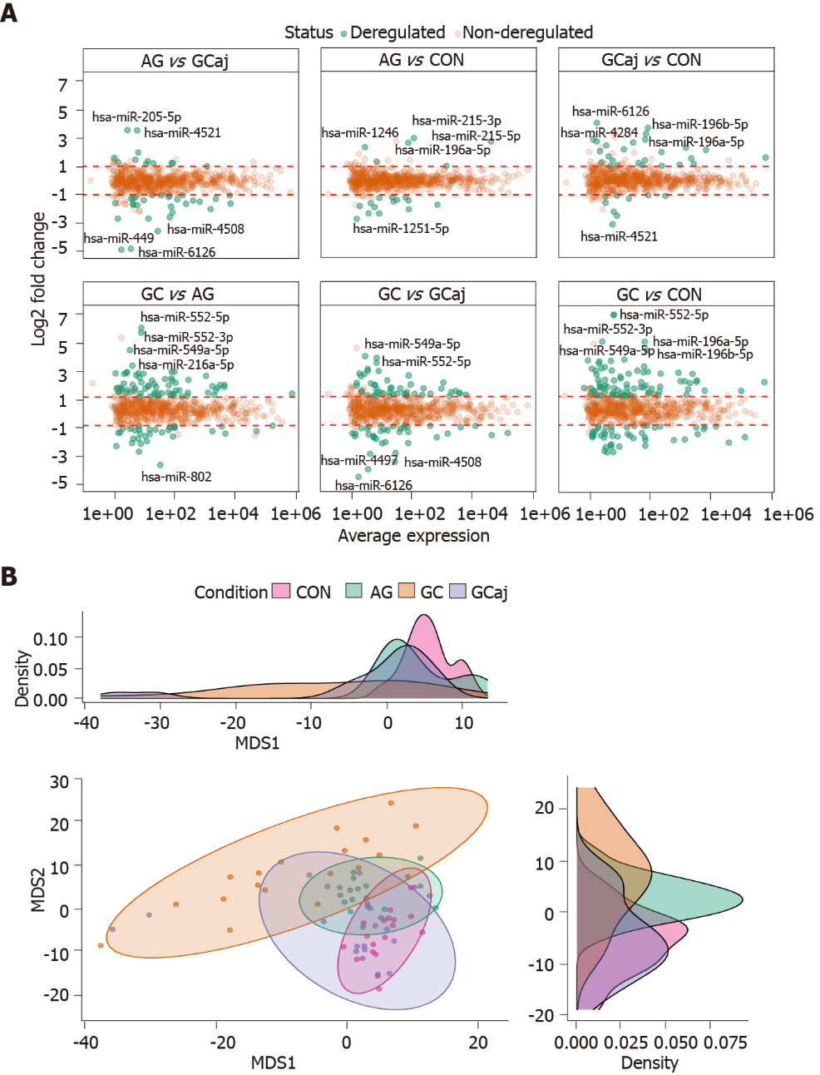
Figure 1 Results of microRNA differential expression analysis. A: Differentially expressed gastric tissue microRNAs among different conditions. P-adjusted < 0.05 and |log2 fold change| > 1; B: Multidimensional scaling plot based on normalized data showing a clustering corresponding to control, atrophic gastritis, gastric cancerous and adjacent tissues. The density plots show distributions of the first and second dimensions. CON: Control; AG: Atrophic gastritis; GC: Gastric cancerous; GCaj: Gastric adjacent tissue; MDS: Multidimensional scaling.

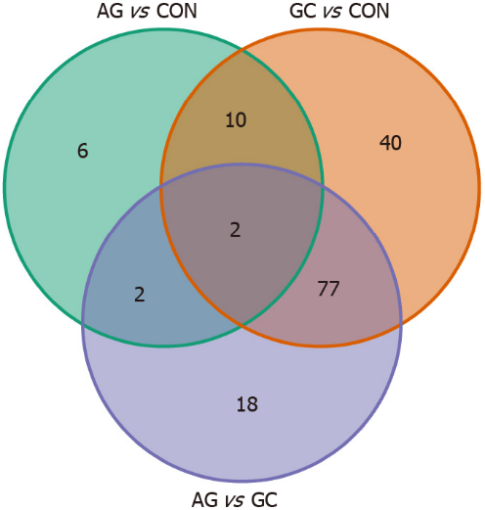
Figure 2 Venn diagram representing the number of commonly and uniquely differentially expressed microRNAs in three different comparison groups. P-adjusted < 0.05 and |log2 fold change| > 1. CON: Control; AG: Atrophic gastritis; GC: Gastric cancer.

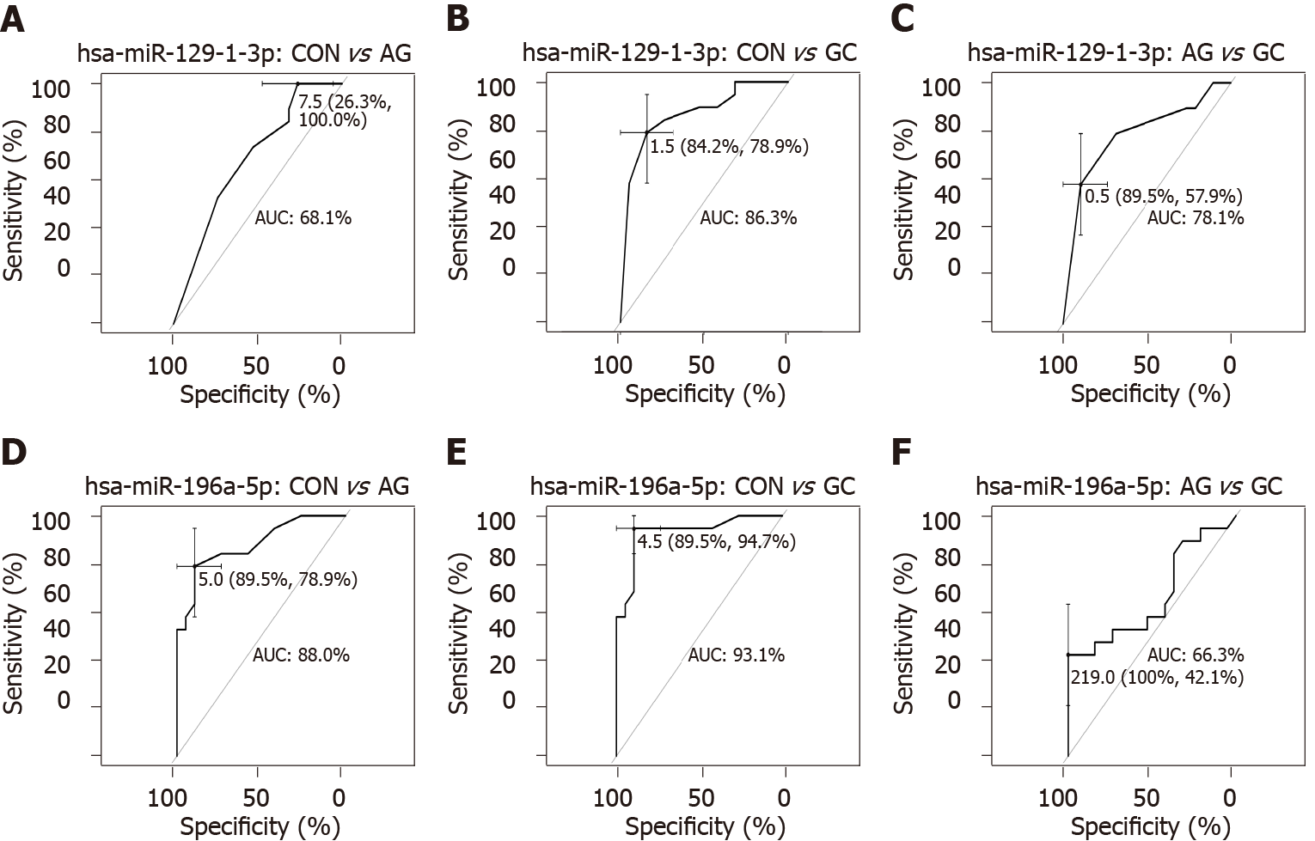
Figure 3 Receiver operating characteristic curves showing prediction performances of expression levels. A-C: Hsa-miR-129-1-3p; D-F: Hsa-miR-196a-5p in tissue samples between different comparison groups: Control vs atrophic gastritis; control vs gastric cancer; and atrophic gastritis vs gastric cancer. AUC: Area under the curve; CON: Control; AG: Atrophic gastritis; GC: Gastric cancer.
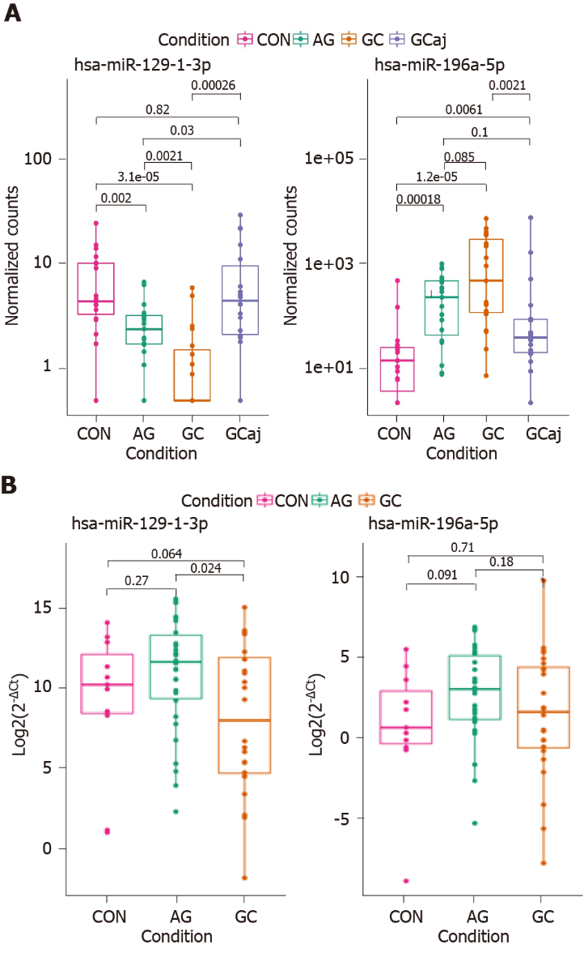
Figure 4 Hsa-miR-129-1-3p and hsa-miR-196a-5p expression levels in study comparison groups. A: Atrophic gastritis and gastric cancer tissue samples compared to controls; B: Atrophic gastritis and gastric cancer plasma samples compared to controls. Box plot graphs; boxes correspond to the median value and interquartile range. CON: Control; AG: Atrophic gastritis; GC: Gastric cancerous; GCaj: Gastric adjacent tissue.
Table 1 Demographic characteristics of profiling and validation cohorts
 |  | Profiling cohort (n = 60) |  |  | Validation cohort (n = 65)
 |  | CON (n = 21) | AG (n = 19) | GC (n = 20) | CON (n = 11) | AG (n = 30) | GC (n = 24)
Age | Mean ± SD | 58.29 ± 15.52 | 69.21 ± 8.78 | 64.95 ± 10.89 | 42.27 ± 12.89 | 68.01 ± 11.81 | 68.33 ± 11.27
Gender (n) | Male | 5 | 3 | 15 | 5 | 9 | 18
 | Female | 16 | 16 | 5 | 6 | 21 | 6
Helicobacter pylori infection (n) | Negative | 12 | 10 | 8 | - | 17 | 9
 | Positive | 9 | 9 | 9 | - | 10 | 4
 | Unknown | - | - | 3 | 11 | 3 | 11
Differentiation grade (n) | G1 | - | - | 4 | - | - | -
 | G2 | - | - | 4 | - | - | 12
 | G3 | - | - | 12 | - | - | 12
Lauren classification (n) | Diffuse | - | - | 10 | - | - | 8
 | Intestinal | - | - | 10 | - | - | 13
 | Mixed | - | - | - | - | - | 2
 | Unknown | - | - | - | - | - | 1
T (n) | T1 | - | - | 6 | - | - | 3
 | T2 | - | - | 2 | - | - | 5
 | T3 | - | - | 8 | - | - | 9
 | T4 | - | - | 4 | - | - | 6
 | Unknown | - | - | - | - | - | 1
N (n) | N0 | - | - | 10 | - | - | 6
 | N1 | - | - | 2 | - | - | 5
 | N2 | - | - | 3 | - | - | 4
 | N3 | - | - | 5 | - | - | 8
 | Unknown | - | - | - | - | - | 1
M (n) | M0 | - | - | 7 | - | - | 14
 | M1 | - | - | 2 | - | - | 9
 | Unknown | - | - | 11 | - | - | 1
SD: Standard deviation; CON: Control; AG: Atrophic gastritis; GC: Gastric cancer.

Published by Baishideng Publishing Group Inc
7041 Koll Center Parkway, Suite 160, Pleasanton, CA 94566, USA
Telephone: +1-925-3991568
E-mail: bpgoffice@wjgnet.com
Help Desk: https://www.f6publishing.com/helpdesk
https://www.wjgnet.com

© 2022 Baishideng Publishing Group Inc. All rights reserved.

