Name of Journal: World Journal of Clinical Cases
Manuscript NO: 78045
Manuscript Type: CASE REPORT

Spontaneous bilateral femur neck fracture secondary to grand mal seizure: A case report

Senocak E. Epilepsy related femur neck fracture

Eyup Senocak

Eyup Senocak, Department of Orthopedics and Traumatology, Erzurum City Hospital, Erzurum 25144, Turkey

Author contributions: Senocak E contributed to the writing and data analysis.

Corresponding author: Eyupsenocak, MD, Doctor, Department of Orthopedics and Traumatology, Erzurum City Hospital, Catyolu Caddesi Erzurum Sehir Hastanesi Ortopedi Klinigi, Erzurum 25144, Turkey. eyupsenocakmd@gmail.com

Received: June 4, 2022
Revised: July 29, 2022
Accepted: September 20, 2022
Published online:

Abstract
BACKGROUND
Spontaneous bilateral femur neck fracture is a rare entity in the general population.

CASE SUMMARY
A 17-year-old immobile, developmentally delayed male with the sequelae of cerebral palsy fractured both femoral necks during a grand mal epileptic seizure. He had been treated with valproic acid as an antiseizure medication for about 10 years; otherwise, he had no history of drug use. The laboratory analysis was normal except a marked vitamin D deficiency. Closed reduction and osteosynthesis with percutaneous cannulated screws were performed. Solid union was observed at 6 mo, and rapid postoperative rehabilitation was started.

CONCLUSION
A femoral neck fracture may occur in a person with epilepsy presenting with hip pain in the emergency department.

Key Words: Grand mal seizure; Bilateral femur neck fracture; Antiepileptic drugs; Immobile patient; Valproic acid use; Spontan fracture; Case report

Senocak E. Spontaneous bilateral femur neck fracture secondary to grand mal seizure: A case report. World J Clin Cases 2022; In press

Core Tip: Spontaneous bilateral femoral neck fracture is a very rare entity and may develop in association with metabolic diseases, bone diseases, high-energy traumas, and epileptic seizures. It should be predicted that complications such as nonunion, loss of reduction, and avascular necrosis may develop secondary to these fractures, which are theoretically considered to be associated with metabolic diseases.

INTRODUCTION
Femoral neck fractures in young patients account for approximately 3% of all femoral neck fractures and are usually secondary to high-energy trauma^{[1,2]}. Spontaneous bilateral femoral neck fracture is very rare and may occur in association with metabolic or bone diseases, high-energy trauma, and epileptic seizures^{[3]}. Complications of these fractures include nonunion, loss of reduction, and avascular necrosis, which are potentially associated with metabolic diseases. Early anatomical reduction, fixation, and rehabilitation are the primary goals. Spontaneous bilateral femoral neck fractures have been rarely reported^{[4,5]}.

CASE PRESENTATION
Chief complaints
A 17-year-old developmentally delayed immobile male with epilepsy as a sequela of cerebral palsy was brought to the emergency service due to pain in both hips after a sudden generalized tonic-clonic seizure 3 d previously.

History of present illness
The patient had pain in both hips after a sudden generalized tonic-clonic seizure 3 d previously, as reported by his family (Figure 1).

History of past illness
The patient had epilepsy as a sequela of cerebral palsy, and he had been treated with the antiseizure medication valproic acid for 10 years.

Personal and family history
The patient had no history of drug use other than valproic acid.

Physical examination
On physical examination, both lower extremities were in external rotation and there was pain and tenderness with movement.

Laboratory examinations
The patient’s vitamin D level was relatively low (9 nmol/L), because he lacked sun exposure due to immobility (Table 1).

Imaging examinations
The patient had bilateral femur subcapital Garden type 4 fracture as revealed by a direct pelvis anteroposterior radiograph (Figure 1A).

FINAL DIAGNOSIS
The patient was diagnosed as having bilateral Garden type 4 femur neck fracture secondary to a grand mal seizure.

TREATMENT
Both hips were reduced anatomically and fixed with three 6.5-mm titanium cannulated screws. The hip joint capsules were not opened during surgery. Acceptable reduction and fixation were confirmed in the anteroposterior and lateral planes in the postoperative radiographs (Figure 1C and D).

OUTCOME AND FOLLOW-UP
A rapid rehabilitation program was initiated to prevent hip stiffness in the patient, who was normally immobile. After a neurology consultation, the antiseizure treatment was revised due to the potential osteoporotic effect of valproic acid. Maintenance treatment was started with phenytoin, which is a less osteolytic agent. Since his hormone levels were normal according to an endocrinology consultation, only vitamin D replacement therapy was started (Table 1).

DISCUSSION
We present a 17-year-old immobile patient who took antiseizure medication and fractured both femoral necks during an epileptic seizure. Spontaneous bilateral femoral neck fractures are extremely rare. All reported cases were secondary to high-energy trauma, epileptic seizures, electric shock, and bone metabolism disorders^{[4,6,7]}. Several cases of bilateral femoral neck fracture secondary to epileptic seizures have been reported^{[8-10]}. It is thought that the rigid shear force between the femoral shaft and neck, together with the sudden muscle contractions secondary to the seizure, cause the fractures^{[11]}. Our case suggested that the femoral neck fractures resulted from the strong tonic-clonic contractions that occurred despite the use of antiseizure medication. However, we think that the long-term use of valproic acid exacerbated the fractures by decreasing bone mineral density. Our patient’s immobility promoted fracture development due to the associated decrease in bone quality.
Bilateral femoral neck fractures treated by total hip replacement have been reported in elderly patients^{[12,13]}. Another study reported closed reduction and percutaneous screw fixation in a 30-year-old patient with bilateral femoral neck fractures after a hypoglycemic attack^{[14]}. A 24-year-old Turkish patient with bilateral femoral neck fractures and osteopenia on postoperative bone densitometry was treated with closed reduction and percutaneous cannulated screws^{[5]}.
Since our patient was immobile, used antiseizure drugs, and had sequelae of cerebral palsy, we deemed it appropriate to perform closed reduction with three percutaneous cannulated screws after considering the patient’s condition, as it is the least invasive rigid fixation and also protects the bone. The risk of avascular necrosis in femoral neck fractures is 12%-40% in Garden type 3-4 displaced fractures^{[15]}. Our patient was brought to our clinic 3 d after the fracture and treated quickly. Callus formation was seen 6 mo postoperatively and there was no avascular necrosis. With regular rehabilitation, there were no problems with the hip movements.

CONCLUSION
As antiseizure medication may decrease bone density, bone densitometry should be performed regularly in cases with long-term use of these drugs. Although the fixation method varies by patient age and activity level, bone-sparing surgery is preferred in young patients. Patients with epilepsy who have dislocated shoulders should also be evaluated for femoral neck fractures.

REFERENCES
1 Robinson CM, Court-Brown CM, McQueen MM, Christie J. Hip fractures in adults younger than 50 years of age. Epidemiology and results. Clin Orthop Relat Res 1995: 238-246 [PMID: 7634609]
2 Askin SR, Bryan R. Femoral neck fractures in young adults. Clin Orthop Relat Res 1976; 114: 259-264 [DOI: 10.1097/00003086-197601000-00029]
3 Kalaci A, Yanat AN, Sevinç TT, Doğramaci Y. Insufficiency fractures of both femoral necks in a young adult caused by osteoporosis: a case report. Arch Orthop Trauma Surg 2008; 128: 865-868 [PMID: 18449548 DOI: 10.1007/s00402-008-0647-1]
4 Haronian E, Silver JW, Mesa J. Simultaneous bilateral femoral neck fracture and greater tuberosity shoulder fracture resulting from seizure. Orthopedics 2002; 25: 757-758 [PMID: 12138963 DOI: 10.3928/0147-7447-20020701-17]
5 Cagırmaz T, Yapici C, Orak MM, Guler O. Bilateral femoral neck fractures after an epileptic attack: A case report. Int J Surg Case Rep 2015; 6C: 107-110 [PMID: 25528038 DOI: 10.1016/j.ijscr.2014.12.003]
6 Yoon BH, Kwon MS. Atraumatic Bilateral Fracture of the Femoral Neck in Young Male Patient with Suspected Osteomalacia. J Bone Metab 2017; 24: 197-200 [PMID: 28955696 DOI: 10.11005/jbm.2017.24.3.197]
7 Nekkanti S, C V, Js ST, R R, Raj S. An unusual case of simultaneous bilateral neck of femur fracture following electrocution injury-A case report and review of literature. J Orthop Case Rep 2016; 6: 70-72 [PMID: 28116275 DOI: 10.13107/jocr.2250-0685.514]
8 Rahman MM, Awada A. Bilateral simultaneous hip fractures secondary to an epileptic seizure. Saudi Med J 2003; 24: 1261-1263 [PMID: 14647567]
9 Pappademos PC, Hamilton WG. Bilateral displaced femoral neck fractures after myoclonic seizure treated with bilateral total hip arthroplasties. Am J Orthop (Belle Mead NJ) 2009; 38: 88-89 [PMID: 19340371]
10 Grimaldi M, Vouaillat H, Tonetti J, Merloz P. Simultaneous bilateral femoral neck fractures secondary to epileptic seizures: treatment by bilateral total hip arthroplasty. Orthop Traumatol Surg Res 2009; 95: 555-557 [PMID: 19801211 DOI: 10.1016/j.otsr.2009.04.018]
11 Finelli PF, Cardi JK. Seizure as a cause of fracture. Neurology 1989; 39: 858-860 [PMID: 2725885 DOI: 10.1212/wnl.39.6.858]
12 Sood A, Rao C, Holloway I. Bilateral femoral neck fractures in an adult male following minimal trauma after a simple mechanical fall: a case report. Cases J 2009; 2: 92 [PMID: 19173750 DOI: 10.1186/1757-1626-2-92]
13 McGoldrick NP, Dodds MK, Green C, Synnott K. Management of simultaneous bilateral neck of femur fractures in an elderly patient. Geriatr Orthop Surg Rehabil 2013; 4: 71-73 [PMID: 24319617 DOI: 10.1177/2151458513511626]
14 M Shah H, Grover A, Gadi D, Sudarshan K. Bilateral neck femur fracture following a generalized seizure- a rare case report. Arch Bone Jt Surg 2014; 2: 255-257 [PMID: 25692154]
15 Kawasaki M, Hasegawa Y, Sakano S, Sugiyama H, Tajima T, Iwasada S, Iwata H. Prediction of osteonecrosis by magnetic resonance imaging after femoral neck fractures. Clin Orthop Relat Res 2001: 157-164 [PMID: 11302307 DOI: 10.1097/00003086-200104000-00024]

Footnotes
Informed consent statement: Informed written consent was obtained from the patient for the publication of this report and any accompanying images.

Conflict-of-interest statement: The author has no conflict of interest to disclose.

CARE Checklist (2016) statement: The authors have read the CARE Checklist (2016), and the manuscript was prepared and revised according to the CARE Checklist (2016).

Open-Access: This article is an open-access article that was selected by an in-house editor and fully peer-reviewed by external reviewers. It is distributed in accordance with the Creative Commons Attribution NonCommercial (CC BY-NC 4.0) license, which permits others to distribute, remix, adapt, build upon this work non-commercially, and license their derivative works on different terms, provided the original work is properly cited and the use is non-commercial. See: https://creativecommons.org/Licenses/by-nc/4.0/

Provenance and peer review: Unsolicited article; Externally peer reviewed.
Peer-review model: Single blind
Corresponding Author's Membership in Professional Societies: TOTBID, No. 2323.

Peer-review started: June 4, 2022
First decision: July 29, 2022
Article in press:

Specialty type: Orthopedics
Country/Territory of origin: Turkey
Peer-review report’s scientific quality classification
Grade A (Excellent): 0
Grade B (Very good): 0
Grade C (Good): C, C
Grade D (Fair): 0
Grade E (Poor): 0

P-Reviewer: Beran RG, Australia; Liu J, United States S-Editor: Chen YL L-Editor: Wang TQ P-Editor: Chen YL

Figure Legends
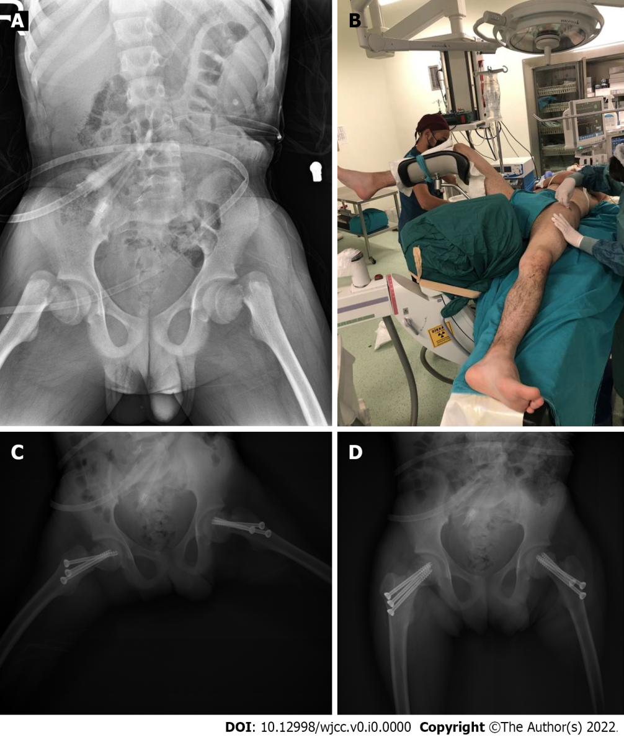
Figure 1 Images. A: Preoperative anteroposterior radiographic view of bilateral femur neck fracture of the patient; B: The patient’s surgery position; C and D: Postoperative anteroposterior and frog leg radiographic view of the patient.

Table 1 Preoperative biochemical blood values of the patient
 | Value | Referans value
Ca | 9.9 nmol/L | 8.6 nmol/L-10.2 nmol/L
ALP | 91 nmol/L | 46 nmol/L-116 nmol/L
P | 4.3 nmol/L | 2.4 nmol/L-5.1 nmol/L
PTH | 45 nmol/L | 38 nmol/L-78 nmol/L
25-OH D VİT | 9 nmol/L | 20 nmol/L-60 nmol/L
Mg | 2.1 nmol/L | 1.6 nmol/L-2.6 nmol/L
ALP: Alkaline phosphatase.

