Name of Journal: World Journal of Clinical Cases
Manuscript NO: 66435
Manuscript Type: CASE REPORT

Multidisciplinary diagnostic dilemma in differentiating Madelung’s disease — the value of superb microvascular imaging technique: A case report

Seskute G et al. Madelung’s disease case report

Goda Seskute, Austeja Dapkute, Dominyka Kausaite, Sandra Strainiene, Andrius Talijunas, Irena Butrimiene

Goda Seskute, Irena Butrimiene, Clinic of Rheumatology, Orthopaedics Traumatology, and Reconstructive Surgery, Institute of Clinical Medicine, Faculty of Medicine, Vilnius University, Vilnius 01513, Lithuania

Austeja Dapkute, Clinic of Neurology and Neurosurgery, Institute of Clinical Medicine, Faculty of Medicine, Vilnius University, Vilnius 01513, Lithuania

Dominyka Kausaite, Faculty of Medicine, Vilnius University, Vilnius 01513, Lithuania

Sandra Strainiene, Clinic of Gastroenterology, Nephrourology and Surgery, Institute of Clinical Medicine, Faculty of Medicine, Vilnius University, Vilnius 01513, Lithuania

Andrius Talijunas, Institute of Dentistry, Faculty of Medicine, Vilnius University, Vilnius 01512, Lithuania

Author contributions: Seskute G was the rheumatologist who followed up with the patient; Seskute G, Dapkute A, and Kausaite D performed the patient’s data extraction, wrote the original manuscript, and reviewed the literature; Strainiene S, Talijunas A, and Butrimiene I reviewed and edited the manuscript; Butrimiene I was responsible for the revision of the manuscript for important intellectual content; All authors issued final approval for the version to be submitted and agreed to be accountable for all aspects of the work.

Corresponding author: Goda Seskute, MD, Doctor, Clinic of Rheumatology, Orthopaedics Traumatology, and Reconstructive Surgery, Institute of Clinical Medicine, Faculty of Medicine, Vilnius University, 3 Universiteto Street, Vilnius 01513, Lithuania. goda.seskute@santa.lt

Received: March 28, 2021
Revised: May 13, 2021
Accepted: May 26, 2021
Published online:

Abstract
BACKGROUND
Madelung’s disease, also known as multiple symmetrical lipomatosis, is a rare, underrecognized disorder of fat metabolism that results in unusual accumulation of subcutaneous fat deposits around the neck, shoulders, upper arms, trunk, hips, and upper thighs. Our case demonstrates the importance of differential diagnosis and the value of a superb microvascular imaging technique for suspecting and confirming Madelung’s disease. Timely diagnosis and alcohol abstinence could prevent the progression of growing fatty masses and prevent surgery.

CASE SUMMARY
A 62-year-old male was admitted to the Rheumatology center complaining of symmetric subcutaneous tumors in the area of the parotid and submandibular salivary glands, small soft masses in the occiput and upper third of the forearm, rashes on calves. A high titer of rheumatoid factor and low concentrations of serum complements were detected. The high-end ultrasound and magnetic resonance imaging examinations of all affected areas of the soft tissues showed predominantly adipose tissue (lipomas) without suspicion of liposarcoma. The biopsy from the small salivary gland revealed no pathology. After evaluating the patient’s clinical presentation (symmetrical lipomatosis, cirrhosis, gynecomastia, anemia, hyperuricemia), Madelung‘s disease, type I, along with the psoriatic rash and psoriatic arthritis and secondary liver cirrhosis were established.

CONCLUSION
Madelung’s disease consists of many co-occurring disorders imitating and overlapping with other conditions. Ultrasonography is the first choice for suspecting and confirming symmetrical lipomatosis.

Key Words: Madelung‘s disease; Multiple symmetrical lipomatosis; Cirrhosis; Salivary gland tumors; Superb microvascular imaging; Case report

Seskute G, Dapkute A, Kausaite D, Strainiene S, Talijunas A, Butrimiene I. Multidisciplinary diagnostic dilemma in differentiating Madelung’s disease — the value of superb microvascular imaging technique: A case report. World J Clin Cases 2021; In press

Core Tip: Madelung’s disease, also known as benign symmetrical lipomatosis, is a rare disorder of fat metabolism resulting in unusual accumulation of subcutaneous fat deposits in different areas of the body and is mostly predisposed by alcohol abuse. The disease mimics and overlaps with other pathologies such as obesity, and oncological and connective tissue diseases and is associated with cirrhosis. High-end ultrasonography techniques have an important role in evaluating fatty tumors, and its importance for confirming diagnosis and follow-up for malignancy is unquestionable. A comprehensive approach to the patient and innovative ultrasound techniques are the key components for making an accurate diagnosis.
INTRODUCTION
Madelung’s disease (rare disease code ORPHA:2398) is also known as familial benign symmetrical lipomatosis, multiple symmetric lipomatosis (MSL), cephalothoracic lipodystrophy, or Launois-Bensaude syndrome^{[1]}. It is characterized by symmetrical accumulation of fatty tissue, usually around the head and neck, the trunk, upper arms, and other less common places according to the type of disease. Patients with a history of chronic alcoholism comprise 60%-90% of cases and suffer from secondary liver cirrhosis^{[2,3]}. Mediterranean men from 30-year-old to 60-year-old appear to be at highest risk^{[1,4]}. The exact prevalence and incidence are unknown, but estimates are available for certain countries (e.g., the prevalence for males in Italy is 1/25.000)^{[1,2]}. A vast complex of life-threatening disorders often occurs with Madelung’s disease including liver cirrhosis, diabetes, dyslipidemia, hyperuricemia, gynecomastia, neuropathy, hypothyroidism, chronic obstructive pulmonary disease, and adrenal dysfunction^{[1,5]}.
There are no specific tests for diagnosing this disorder, and the diagnosis is mostly based on history, clinical appearance, and the results of imaging examinations. Due to the slow growth of fat masses and alcohol-influenced decreased self-care, the disease is often recognized late. The changes in a patient’s facial appearance due to fat accumulation are often mistaken with the widely known chronic alcoholism-induced pseudo-Cushing syndrome (also known as “facies alcoholica”)^{[6]}. Early diagnosis and alcohol cessation might prevent the progression of growing fatty masses and avoid surgery.
We report a case of a patient diagnosed with liver cirrhosis and progressive symmetrical fat accumulation, showing difficult differential diagnosis and the value of high-end ultrasound imaging for making an accurate diagnosis.

CASE PRESENTATION
Chief complaints
A 62-year-old male was admitted to the Vilnius University Hospital Santaros Clinics Rheumatology department presenting with growing symmetric subcutaneous tumors in the area of the parotid and submandibular salivary glands, small soft masses in the occiput, and the upper third of the forearm. The patient also complained about bilateral small hand joint pain and morning stiffness for 6 mo, dryness of the mouth, rash on calves, and nail deformations for several years.

History of present illness
The subcutaneous tumors in the area of the parotid and submandibular salivary glands were present for 2 years and grew more rapidly in the last 7 mo. The patient had a history of moderate alcohol consumption (mostly beer) and was diagnosed with metabolic liver cirrhosis (Child-Turcotte-Pugh [CTP] B class; Model for the End-Stage Liver Disease [MELD] score equal to 9), portal hypertension (splenomegaly, hypersplenism, paraumbilical shunt), and secondary megaloblastic anemia in 2019. Since then, he was followed up by a gastroenterologist. In 2019, the ultrasound examination of the neck and salivary glands’ soft tissues discovered only small, lush adipose tissue around the neck without enlarged lymph nodes. At first, facial changes were associated with phenotypical changes due to alcohol-induced hypercortisolism. However, as the masses continued to grow, the patient was referred for a rheumatologist’s consult. In September 2020, the patient consulted with the rheumatologist and was hospitalized in the Rheumatology department for further diagnosis.

History of past illness
The patient was previously diagnosed with primary arterial hypertension and polyneuropathy, effectively treated with alpha-lipoic acid. No oncological history was reported. Past exposure to chemical substances of unknown origin in a working environment at a fertilizer factory was noted.

Personal and family history
The patient had a history of moderate alcohol consumption, but he abstained from consuming alcohol for approximately > 6 mo. He claimed to have no other hazardous habits, and no allergies to food or medicines. There was no history of surgical treatment and congenital or similar disorders in his family.
Physical examination
During the examination, egg-sized hard and painless subcutaneous tumors in the area of the parotid and submandibular salivary glands, soft and small masses in the occiput, hump, the upper third of the forearm. Occipital and neck area masses were difficult to notice without a meticulous inspection. Minor gynecomastia (elastic masses, which could be moved without causing the patient any pain and had no definite margins) was suspected (Figure 1A-C). The palpation of the small joints of both hand was painful. Onychodystrophy, rashes on calves — red patches of skin covered with thick, silvery scales, and dry tongue were observed. The patient was a bit overweight (body mass index 25.5 kg/m²).

Laboratory examinations
Changes in the blood test results showed elevated erythrocyte sedimentation rate (ESR) by 26 mm/h, a high titer of rheumatoid factor (RF) 235.0 U/mL, low levels of complement C4, normal immunoglobulin (Ig) G4 1.26 g/L, and a normal cyclic citrullinated peptide antibody test. Extractable nuclear antigen antibodies and anti-neutrophil cytoplasmic antibodies were negative. Schirmer’s test was positive (right eye: 6 mm/5 min, left eye: 5 mm/5 min). Laboratory test results were also compatible with the diagnosis of alcohol-related liver cirrhosis (aspartate aminotransferase > 2× alanine aminotransferase, slightly elevated γ-glutamyl transferase, mild coagulopathy, and megaloblastic anemia). Calculated alcoholic liver disease/nonalcoholic fatty liver disease index was 14.2, meaning 100% probability of alcohol-related liver disease. Viral hepatitis markers were negative. Hyperglycemia and hyperuricemia were also noted (Table 1).

Imaging examinations
Ultrasound examination of the soft tissues of the parotid glands and neck area showed fatty solid masses close to parotid glands and thickening of the subcutaneous adipose tissue layer above the chin, right and left part of the neck in II-III vertebrae zone. Face and neck lipomatosis was suspected. However, small vascularity in the parotid gland tumor area was alleged. Figure 2 shows high-resolution ultrasound images (using Canon Aplio i800 14 MHz linear probe with power Doppler [PD] and color superb microvascular imaging [SMI] techniques) of the fatty tumor close to the left parotid gland area. Grayscale ultrasound showed typical superficial lipoma well-circumscribed with parallel linear and thin echogenic lines (Figure 2A). Features that suggest malignancy include: the presence of thick septa (> 2 mm), the presence of nodular and/or globular or non-adipose mass-like areas, and decreased percentage of fat composition (< 75% fat)^{[7]}. Lipomatous soft tissue lesions with only thin septa that do not enhance at magnetic resonance imaging (MRI) can be confidently confirmed as a lipoma^{[8]}. PD detected several small internal dots — more than minimal flow/vascularity (Figure 2B). Liposarcoma is characterized mostly by an ill-defined and usually vascularized margin, heterogeneous texture^{[9]}. SMI confirmed several unrelated vascular dots, which caused only weak suspicion of liposarcoma (Figure 2C). The random noise during the examination was minimized. Ultrasound examination of the breasts displayed mild bilateral gynecomastia: left 22 mm × 6 mm and right 28 mm × 7 mm. Head and neck MRI showed the significantly thickened subcutaneous fat layer at the damaged areas and confirmed ultrasound diagnosis — it is more likely lipomatosis than liposarcoma (Figure 3A and B).

Further diagnostic work-up
Other possible comorbidities were excluded: spirometry for chronic pulmonary disease and electroneuromyography for polyneuropathy were without changes. A small salivary gland biopsy was performed and showed no histological signs of Sjogren’s syndrome or amyloid deposition.
Psoriasis was confirmed by a dermatologist, and high-resolution ultrasound imaging (using Canon Aplio i800 24 MHz linear probe) showed active synovial arthritis in the metacarpophalangeal joints (Figure 4A-C).

FINAL DIAGNOSIS
Benign symmetrical lipomatosis (Madelung’s disease), type I, metabolic liver cirrhosis (CTP B, MELD 9), megaloblastic anemia, toxic peripheral polyneuropathy, hyperuricemia, gynecomastia along with psoriasis and moderate activity psoriatic arthritis (DAS28 — 4.94 points), were diagnosed.

TREATMENT
The patient was informed about the importance of alcohol abstinence and weight control. The symptomatic treatment for comorbidities was recommended: hepatoprotection for cirrhosis, alpha-lipoic acid for previously diagnosed polyneuropathy, allopurinol for hyperuricemia, small doses of methylprednisolone 6 mg per day for psoriatic arthritis.

OUTCOME AND FOLLOW-UP
Although the patient did not consume alcohol for > 6 mo, and his liver enzymes normalized, he noticed that fatty masses continued to grow. He felt tremendous and socially isolating cosmetic discomfort due to the changed physical appearance around the neck. Therefore, he was referred to a maxillofacial surgeon for surgical treatment, and a lipectomy was performed. A histological examination of the removed tissue confirmed the diagnosis of benign symmetrical lipomatosis.
The patient was referred to an endocrinologist due to hyperglycemia. We also recommended getting an appointment with a dietologist to manage the diet. As the patient doesn’t have dyslipidemia yet, prevention and a healthy lifestyle must be the priority. The gastroenterologist should also observe the patient every 3-6 mo due to cirrhosis and its complications. The follow-up visit to the rheumatologist was set after a month. Repeated check-ups and ultrasound imaging are needed to observe possible disease regression and evaluate the progression of other fatty masses.

DISCUSSION
MSL is a very rare lipid metabolism disorder described by the localization of fat masses in different combinations of distribution. Donhauser et al^{[10]} classified it into three types: first type — dominant cervical localization, second — pseudo athletic appearance, third — changes are located mostly in the abdomen area (Figure 5). The pathogenesis of the disease is unclear. It is thought that the disease might develop as a result of defects in mitochondrial function of adipose tissues, decreases in cytochrome C oxidase activity, and catecholamine-induced fat deposition. Alcohol consumption influences a decreased number and activity of β-adrenergic receptors and promotes fat synthesis^{[11]}. It can also directly affect mitochondrial activity and cause premature oxidation of mitochondrial DNAs or mitochondrial DNA mutation, resulting in fat accumulation throughout the body^{[12]}. Systemic diseases, such as primary hypothyroidism, Cushing’s syndrome, giant cell anemia, diabetes, epilepsy, and malignant diseases, may also be associated with the development of Madelung's disease^{[11,13]}.
Precise physical examination of the whole body is essential for suspected symmetrical lipomas as patients usually complain only about the most obvious discomforting masses, while other affected areas are missed. In our case, the patient had dominant masses in the head and neck area. Gynecomastia in men with MSL is very rare, and in most cases, is not a presenting symptom^{[14]}. Other masses of fat were not so expressed visually.
The differential diagnosis of systemic rheumatic diseases, such as Sjogren’s syndrome and IgG4-related disease, was performed due to salivary glands’ masses, elevated ESR and RF, low complements, positive Shirmer’s test, and arthritis. According to the classification criteria, Sjogren’s syndrome was excluded: immunological and histopathological tests were negative^{[15]}. Common features of IgG4 syndrome, like IgG4-related autoimmune pancreatitis, swelling of or within an organ system (an inflammatory pseudotumor), salivary gland disease (material from salivary glands didn’t show lymphoplasmacytic infiltrate enriched in IgG4-positive plasma cells and fibrosis), lymphadenopathy, skin manifestations (only psoriasis was confirmed), and symptoms consistent with allergies or asthma were not detected. Also, serum IgG4 concentration was not elevated^{[16]}.
Ultrasound imaging is usually the first step in the investigation, differentiation, and confirmation of lipomas. SMI is an innovative ultrasound Doppler technique that provides visualization of low velocity and microvascular flow never seen before with the ultrasound^{[17]}. SMI can suppress noise caused by motion artifacts with an intelligent filter system without eliminating the weak signal arising from small vessel blood flow and using any contrast agent. Hence it achieves a greater sensitivity than the conventional PD technique. There are two modes: color (cSMI, which demonstrates B-mode and color information simultaneously) and monochrome (SMI, which focuses only on the vasculature)^{[18]}. Both modes demonstrate the value in differentiating a wide variety of clinical situations: benign and malign tumors (density and shape of tumor vessels), the therapeutic effect of the treatment (chemotherapy or immunosuppressive treatment), inflammatory diseases (synovial vascularity in arthritis, colitis) many other medical conditions^{[19,20]}. The main disadvantage is that there are no studies and standards on the application of SMI for liposarcoma. The main tips for evaluation lipomatous tissue are comparing SMI and PD images with focusing on mSMI mode, which is more sensitive for vasculature, adjusting gain, and other settings.
In this case, SMI was used for better visualization of vascularity in differentiating lipomas and arthritis. If pathological vascularity and heterogeneous echotexture are suspected, then MRI is preferred over computed tomography for excluding liposarcoma. Malignant degeneration of fatty tissue into liposarcoma has only been reported in two MSL cases^{[21,22]}. Also, ultrasound tools help to confirm even a small accumulation of adipose tissue in the most common areas according to the type of disease when it is not visually expressed. Confirmed symmetrical lipomatosis helps to differentiate Madelung’s disease, and ultrasound is the most useful tool for determining the disease type.
Comorbidities, such as dyslipidemia, hypertension, chronic obstructive pulmonary disease, hypothyroidism, and diabetes mellitus, often co-occur with Madelung’s disease^{[1,13]}. Diseases related to alcohol abuse, such as chronic liver disease, macrocytic anemia, and peripheral neuropathy, are also common in MSL patients. In our case, the patient was firstly diagnosed with metabolic liver cirrhosis and was continuously followed up by a gastroenterologist. His facial appearance due to adipose tissue accumulation was assumed to be alcohol-related, although he was not a heavy drinker. Additionally, clinically significant neuropathy was also diagnosed, which is also highly relevant to alcohol abuse. Also, several new metabolic disorders were diagnosed: hyperglycemia and hyperuricemia. Although our patient stopped alcohol consumption and cirrhosis was under control, fatty masses continued to grow (while it is expected that alcohol withdrawal stops Madelung’s disease progression). Active psoriatic arthritis (DAS28 — 4.94 points) could have been a trigger of the fatty masses’ growth after alcohol abstinence.
Madelung‘s disease is difficult to diagnose at the early stages, as patients mostly seek medical help due to obvious cosmetic disorders or when liver cirrhosis and other comorbidities have already been developed. The main challenge for the doctors is to combine all the co-occurring symptoms into one disorder. In our case, predominant masses looked like solid tumors in the area of parotid glands imitating Sjogren’s syndrome and IgG4-related disease (Mikulicz disease). Ultrasound confirmed that tumors in the parotid glands area were not related to salivary glands and were closely located in front of them.
The primary treatment of Madelung’s disease is symptomatic. Alcohol withdrawal and weight loss are essential to control MSL. However, it does not guarantee the inhibition or reversion of the disease^{[5,23]}. There is no effective pharmacotherapy in treating Madelung’s disease to date^{[5]}. Lipectomy or liposuction is the only available effective treatment^{[23,24]}. However, there is no consensus on the optimal surgical approach, and the overall recurrence rate is up to 63%^{[23,25]}. Despite the high recurrence rate, the surgical approach must be considered as MSL also affects social life and worsens overall quality of life^{[26]}. The histological investigation of the surgical material is essential, as there is always a small risk of liposarcoma. If the patient refuses surgery, ultrasound imaging control is strongly recommended, especially in cases of rapid mass growth.
Patients with Madelung’s disease need long-term observation and multidisciplinary systemic management of comorbidities^{[27]}. It is also important to observe these patients due to disease relapse, the need for re-operation, and possible liposarcoma by ultrasonography. There are no established intervals for the patient’s surveillance.

CONCLUSION
Ultrasonography has an important role in differentiating fatty tumors, particularly when evaluating tissue homogeneity and vascularity. Nevertheless, high-end ultrasound imaging value for confirming the diagnosis and/or follow-up for malignancy is unquestionable. However, wider and further large scale investigations are needed to standardize this technique. The further evaluation of active psoriatic arthritis as a trigger of fatty mass growth is also a question of interest. Increasing awareness of the presence of Madelung’s disease could prevent misdiagnosis and misleading care management. Due to its variety of manifestations, it still remains a multidisciplinary diagnostic dilemma.

ACKNOWLEDGEMENTS
We wish to thank the patient and Vilnius University Hospital Santaros Clinics for giving the consent and providing the data to report this case.

REFERENCES
1 Vantyghem MC. Multiple symmetric lipomatosis. Orphanet encyclopedia 2019. [cited 14 March 2021]. In: orpha.net [Internet]. Available from: https://www.orpha.net/consor/cgi-bin/OC_Exp.php?Expert=2398&lng=EN
2 González-García R, Rodríguez-Campo FJ, Sastre-Pérez J, Muñoz-Guerra MF. Benign symmetric lipomatosis (Madelung's disease): case reports and current management. Aesthetic Plast Surg 2004; 28: 108-112; discussion 113 [PMID: 15164232 DOI: 10.1007/s00266-004-3123-5]
3 Meningaud JP, Pitak-Arnnop P, Bertrand JC. Multiple symmetric lipomatosis: case report and review of the literature. J Oral Maxillofac Surg 2007; 65: 1365-1369 [PMID: 17577504 DOI: 10.1016/j.joms.2005.10.045]
4 Chuang CC, Cheng YF, Chang HP, Lin CZ. Madelung's disease. J Chin Med Assoc 2004; 67: 591-594 [PMID: 15720076]
5 Szewc M, Sitarz R, Moroz N, Maciejewski R, Wierzbicki R. Madelung's disease - progressive, excessive, and symmetrical deposition of adipose tissue in the subcutaneous layer: case report and literature review. Diabetes Metab Syndr Obes 2018; 11: 819-825 [PMID: 30538518 DOI: 10.2147/DMSO.S181154]
6 Besemer F, Pereira AM, Smit JW. Alcohol-induced Cushing syndrome. Hypercortisolism caused by alcohol abuse. Neth J Med 2011; 69: 318-323 [PMID: 21934176]
7 Kransdorf MJ, Bancroft LW, Peterson JJ, Murphey MD, Foster WC, Temple HT. Imaging of fatty tumors: distinction of lipoma and well-differentiated liposarcoma. Radiology 2002; 224: 99-104 [PMID: 12091667 DOI: 10.1148/radiol.2241011113]
8 Murphey MD, Carroll JF, Flemming DJ, Pope TL, Gannon FH, Kransdorf MJ. From the archives of the AFIP: benign musculoskeletal lipomatous lesions. Radiographics 2004; 24: 1433-1466 [PMID: 15371618 DOI: 10.1148/rg.245045120]
9 Shimamori N, Kishino T, Morii T, Okabe N, Motohashi M, Matsushima S, Yamasaki S, Ohtsuka K, Shibahara J, Ichimura S, Ohnishi H, Watanabe T. Sonographic Appearances of Liposarcoma: Correlations with Pathologic Subtypes. Ultrasound Med Biol 2019; 45: 2568-2574 [PMID: 31202456 DOI: 10.1016/j.ultrasmedbio.2019.05.020]
10 Donhauser G, Vieluf D, Ruzicka T, Braun-Falco O. [Benign symmetric Launois-Bensaude type III lipomatosis and Bureau-Barrière syndrome]. Hautarzt 1991; 42: 311-314 [PMID: 1874620]
11 Gao H, Xin ZY, Yin X, Zhang Y, Jin QL, Wen XY. Madelung disease: A case report. Medicine (Baltimore) 2019; 98: e14116 [PMID: 30653136 DOI: 10.1097/MD.0000000000014116]
12 Gámez J, Playán A, Andreu AL, Bruno C, Navarro C, Cervera C, Arbós MA, Schwartz S, Enriquez JA, Montoya J. Familial multiple symmetric lipomatosis associated with the A8344G mutation of mitochondrial DNA. Neurology 1998; 51: 258-260 [PMID: 9674814 DOI: 10.1212/wnl.51.1.258]
13 Brea-García B, Cameselle-Teijeiro J, Couto-González I, Taboada-Suárez A, González-Álvarez E. Madelung's disease: comorbidities, fatty mass distribution, and response to treatment of 22 patients. Aesthetic Plast Surg 2013; 37: 409-416 [PMID: 23435503 DOI: 10.1007/s00266-012-9874-5]
14 Jang JH, Lee A, Han SA, Ryu JK, Song JY. Multiple Symmetric Lipomatosis (Madelung's Disease) Presenting as Bilateral Huge Gynecomastia. J Breast Cancer 2014; 17: 397-400 [PMID: 25548590 DOI: 10.4048/jbc.2014.17.4.397]
15 Rasmussen A, Ice JA, Li H, Grundahl K, Kelly JA, Radfar L, Stone DU, Hefner KS, Anaya JM, Rohrer M, Gopalakrishnan R, Houston GD, Lewis DM, Chodosh J, Harley JB, Hughes P, Maier-Moore JS, Montgomery CG, Rhodus NL, Farris AD, Segal BM, Jonsson R, Lessard CJ, Scofield RH, Sivils KL. Comparison of the American-European Consensus Group Sjogren's syndrome classification criteria to newly proposed American College of Rheumatology criteria in a large, carefully characterised sicca cohort. Ann Rheum Dis 2014; 73: 31-38 [PMID: 23968620 DOI: 10.1136/annrheumdis-2013-203845]
16 Wallace ZS, Naden RP, Chari S, Choi HK, Della-Torre E, Dicaire JF, Hart PA, Inoue D, Kawano M, Khosroshahi A, Lanzillotta M, Okazaki K, Perugino CA, Sharma A, Saeki T, Schleinitz N, Takahashi N, Umehara H, Zen Y, Stone JH; Members of the ACR/EULAR IgG4-RD Classification Criteria Working Group. The 2019 American College of Rheumatology/European League Against Rheumatism classification criteria for IgG4-related disease. Ann Rheum Dis 2020; 79: 77-87 [PMID: 31796497 DOI: 10.1136/annrheumdis-2019-216561]
17 Jiang ZZ, Huang YH, Shen HL, Liu XT. Clinical Applications of Superb Microvascular Imaging in the Liver, Breast, Thyroid, Skeletal Muscle, and Carotid Plaques. J Ultrasound Med 2019; 38: 2811-2820 [PMID: 30953387 DOI: 10.1002/jum.15008]
18 Hata J. Seeing the Unseen. New Techniques in Vascular Imaging 2014. [cited 14 March 2021]. In: Toshiba Medical Systems Corporation [Internet]. Available from: https://us.medical.canon/download/aplio-500-wp-smi-seeing-the-unseen
19 Artul S, Nseir W, Armaly Z, Soudack M. Superb Microvascular Imaging: Added Value and Novel Applications. J Clin Imaging Sci 2017; 7: 45 [PMID: 29404197 DOI: 10.4103/jcis.JCIS_79_17]
20 He MN, Lv K, Jiang YX, Jiang TA. Application of superb microvascular imaging in focal liver lesions. World J Gastroenterol 2017; 23: 7765-7775 [PMID: 29209117 DOI: 10.3748/wjg.v23.i43.7765]
21 Borriello M, Lucidi A, Carbone A, Iannone V, Ferrandina G. Malignant transformation of Madelung's disease in a patient with a coincidental diagnosis of breast cancer: a case report. Diagn Pathol 2012; 7: 116 [PMID: 22937763 DOI: 10.1186/1746-1596-7-116]
22 Tizian C, Berger A, Vykoupil KF. Malignant degeneration in Madelung's disease (benign lipomatosis of the neck): case report. Br J Plast Surg 1983; 36: 187-189 [PMID: 6831098 DOI: 10.1016/0007-1226(83)90089-9]
23 Sharma N, Hunter-Smith DJ, Rizzitelli A, Rozen WM. A surgical view on the treatment of Madelung's disease. Clin Obes 2015; 5: 288-290 [PMID: 26246230 DOI: 10.1111/cob.12111]
24 Pinto CI, Carvalho PJ, Correia MM. Madelung's Disease: Revision of 59 Surgical Cases. Aesthetic Plast Surg 2017; 41: 359-368 [PMID: 28032179 DOI: 10.1007/s00266-016-0759-x]
25 Enzi G, Busetto L, Ceschin E, Coin A, Digito M, Pigozzo S. Multiple symmetric lipomatosis: clinical aspects and outcome in a long-term longitudinal study. Int J Obes Relat Metab Disord 2002; 26: 253-261 [PMID: 11850759 DOI: 10.1038/sj.ijo.0801867]
26 Maximiano LF, Gaspar MT, Nakahira ES. Madelung disease (multiple symmetric lipomatosis). Autops Case Rep 2018; 8: e2018030 [PMID: 30101135 DOI: 10.4322/acr.2018.030]
27 Suito M, Kitazawa T, Takashimizu I, Ikeda T. Madelung's disease: long-term follow-up. J Surg Case Rep 2019; 2019: rjy356 [PMID: 30647898 DOI: 10.1093/jscr/rjy356]

Footnotes
Informed consent statement: Informed written consent was obtained from the patient for the publication of this report and any accompanying images.

Conflict-of-interest statement: The authors declare no conflicts of interest.

CARE Checklist (2016) statement: The authors have read the CARE Checklist (2016), and the manuscript was prepared and revised according to the CARE Checklist (2016).

Open-Access: This article is an open-access article that was selected by an in-house editor and fully peer-reviewed by external reviewers. It is distributed in accordance with the Creative Commons Attribution NonCommercial (CC BY-NC 4.0) license, which permits others to distribute, remix, adapt, build upon this work non-commercially, and license their derivative works on different terms, provided the original work is properly cited and the use is non-commercial. See: http://creativecommons.org/Licenses/by-nc/4.0/

Manuscript source: Unsolicited manuscript

Corresponding Author's Membership in Professional Societies: The Emerging European League Against Rheumatism Network; and Lithuanian Rheumathologists Association.

Peer-review started: March 28, 2021
First decision: May 7, 2021
Article in press:

Specialty type: Rheumatology
Country/Territory of origin: Lithuania
Peer-review report’s scientific quality classification
Grade A (Excellent): 0
Grade B (Very good): B
Grade C (Good): C
Grade D (Fair): 0
Grade E (Poor): 0

P-Reviewer: Ali SM, Zhou S S-Editor: Gao CC L-Editor: Filipodia P-Editor:

Figure Legends
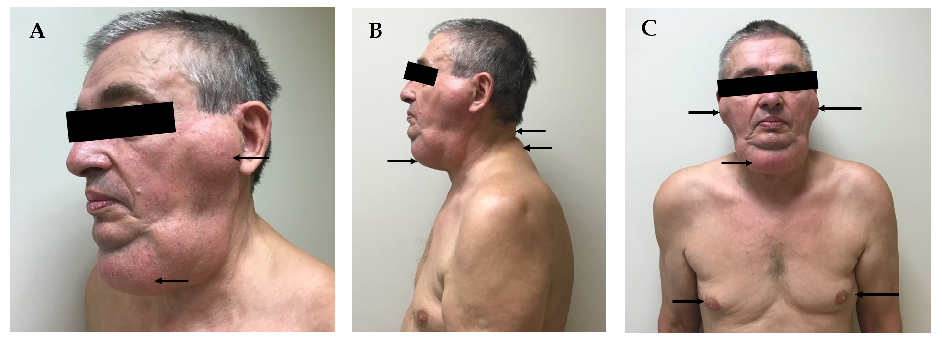
Figure 1 Photos of the patient showing multiple tumorous masses. A: Profile view: symmetrical, firm, and non-tender fatty masses in the area of parotid salivary glands (upper arrow); soft and highly mobile submandibular mass (lower arrow); B: Side view: occipital and neck area masses (arrows); C: Frontal view: submandibular, parotid masses and gynecomastia (arrows).
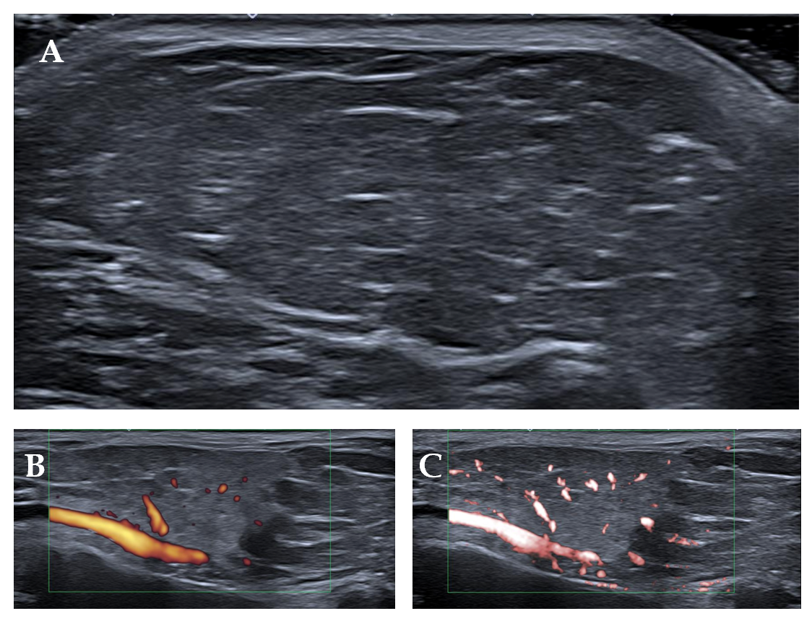
Figure 2 Ultrasound images of tumor masses in the area of the parotid gland. A: Grayscale ultrasound showing typical superficial lipoma well-circumscribed with parallel linear and thin echogenic lines; B: Power Doppler showing several small internal dots minimal flow/vascularity; C: Superb microvascular imaging confirming low vascularity (several unrelated dots), which is a weak suspicious for liposarcoma.
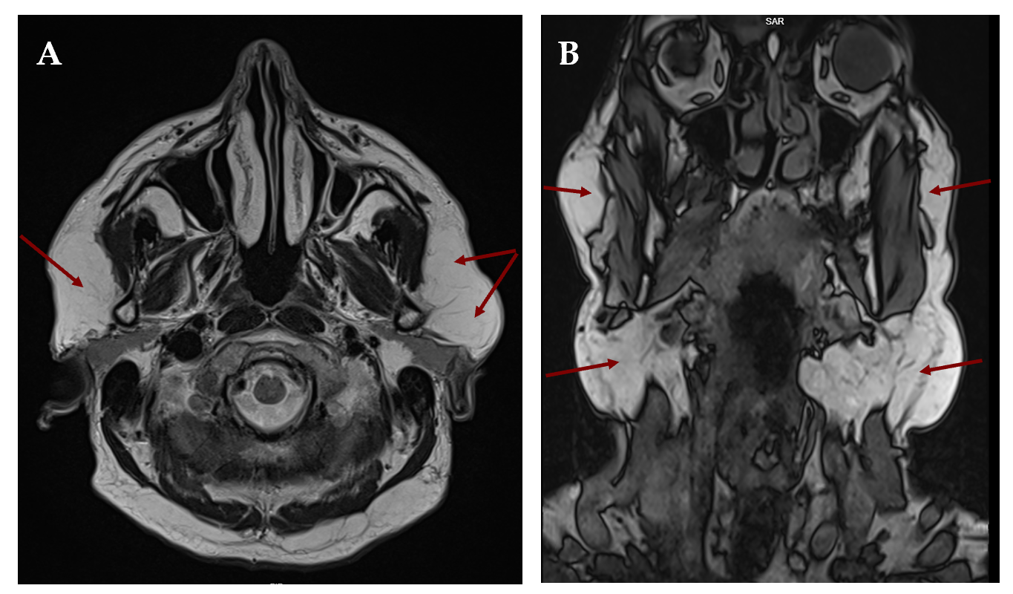
Figure 3 Head and neck magnetic resonance imaging images showing the localization of fat masses in parotid and submandibular areas. A: Axial plane: fat deposits adjacent to parotid salivary glands (arrows); B: Coronal plane: significantly enlarged subcutaneous fat tissue, lipomatous masses below the mandible, in the upper part of the neck and in the area of parotid salivary glands (arrows).
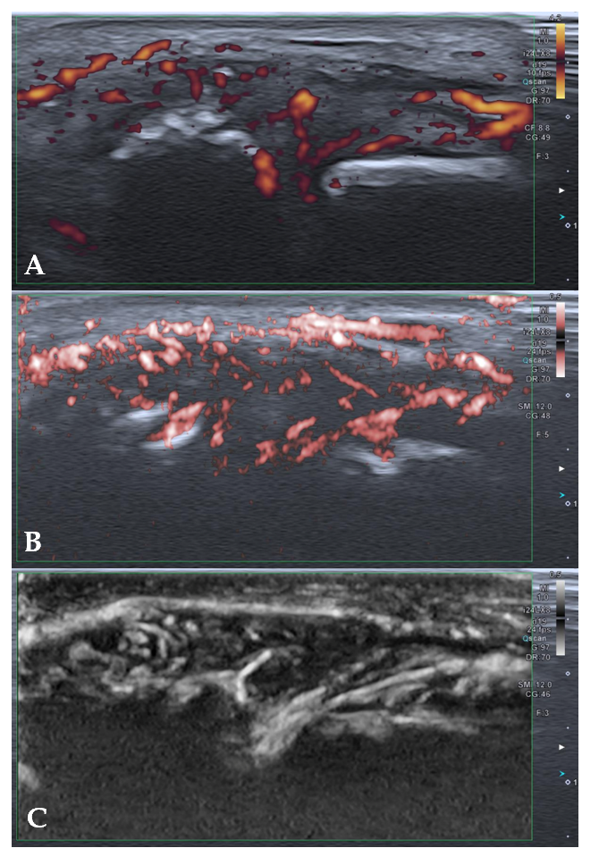
Figure 4 High-resolution ultrasound images of the second metacarpophalangeal joint showing signs of active psoriatic arthritis using. A: Power Doppler; B: Color superb microvascular imaging; C: Monochrome superb microvascular imaging.
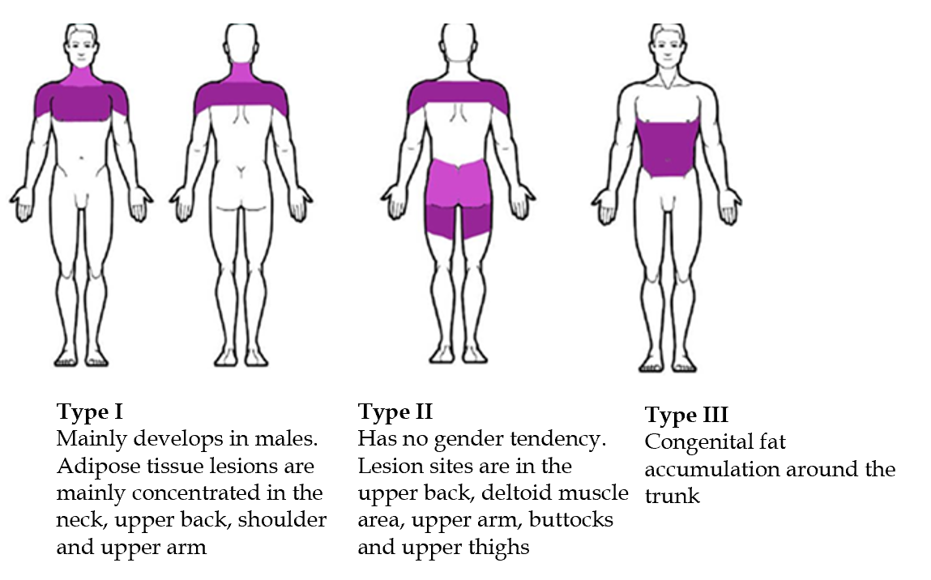
Figure 5 Classification of multiple symmetric lipomatosis according to fatty tissue localization in the body.
Table 1 Main laboratory findings
Main laboratory findings | Value | Normal range
Hemoglobin (g/L) | 109 | 128-160
MCV (fl) | 102 | 78-96
MCH (pg) | 34.1 | 26-31
Platelet count (/L) | 70 | 130-400 × 10⁹
C reactive protein (mg/L) | 4.22 | < 5
Erythrocyte sedimentation rate (mm/h) | 26 | ≤ 10
Glucose (mmol/L) | 6.70 | 4.2-6.1
Aspartate aminotransferase (U/L) | 57 | < 40
Alanine aminotransferase (U/L) | 22 | < 40
γ- glutamyl transferase (U/L) | 123 | ≤ 36
Alkaline phosphatase (U/L) | 181 | 40-150
Total bilirubin (mol) | 17.5 | < 21
Albumin (g/L) | 37 | 36-52
SPA (%) | 62 | 70-130
Creatinine (µmol/L) | 68 | 62-110
Uric acid (µmol/L) | 510 | 208-428
INR by Owren | 1.24 | 0.90-1.19
Complement C4 (g/L) | 0.14 | 0.15-0.57
Complement C3c (g/L) | 0.7 | 0.9-1.8
INR: International normalized ratio; MCH: Mean corpuscular hemoglobin; MCV: Mean corpuscular volume; SPA: Stago prohrombin assay.

