Name of Journal: World Journal of Diabetes
Manuscript NO: 80163
Manuscript Type: MINIREVIEWS

Association of vitamin D and magnesium with insulin sensitivity and their influence on glycemic control

Wan Nik WNFH et al. Vitamin D and magnesium in diabetes

Wan Nor Fazila Hafizan Wan Nik, Hani Ajrina Zulkeflee, Siti Nadirah Ab Rahim, Tuan Salwani Tuan Ismail

Wan Nor Fazila Hafizan Wan Nik, Tuan Salwani Tuan Ismail, Department of Chemical Pathology, School of Medical Sciences, Universiti Sains Malaysia, Kota Bharu 16150, Kelantan, Malaysia

Hani Ajrina Zulkeflee, Faculty of Medicine and Health Sciences, Universiti Sains Islam Malaysia, Bandar Baru Nilai, Nilai 71800, Negeri Sembilan, Malaysia

Siti Nadirah Ab Rahim, Pathology Unit, Faculty of Medicine and Defence Health, National Defence University of Malaysia, Kem Perdana Sungai Besi 57000, Kuala Lumpur, Malaysia

Author contributions: Wan Nik WNFH, Zulkeflee HA, Ab Rahim SN, and Tuan Ismail TS contributed equally to this work; Tuan Ismail TS supervised and directed the focus of this review; Wan Nik WNFH, Zulkeflee HA, Ab Rahim SN, and Tuan Ismail TS performed the literature review and wrote the review; Zulkeflee HA designed the graphical figures; Ab Rahim SN refined the format of the review; Wan Nik WNFH performed the major work in structuring and harmonizing the overall review content; all authors have read and approved the final version of the manuscript.

Corresponding author: Tuan Salwani Tuan Ismail, MBBS, Doctor, Senior Lecturer, Department of Chemical Pathology, School of Medical Sciences, Universiti Sains Malaysia, No. 11800 Jalan Sasaran, Kota Bharu 16150, Kelantan, Malaysia. tusti@usm.my

Received: September 19, 2022
Revised: November 3, 2022
Accepted: December 21, 2022
Published online:

Abstract
Insulin resistance increases the risk of developing diabetes, and the degree of resistance influences the glycemic control of patients with diabetes. Numerous researchers have focused on improving insulin sensitivity in order to prevent diabetes-related complications and other chronic diseases. Several studies have also linked vitamin D levels to insulin secretion and resistance, given that both vitamin D and its receptor complex play important roles in regulating pancreatic β-cells. It has been suggested that vitamin D supplementation improves vitamin D levels, but further research is needed to confirm this as neither insulin function nor glycemic control improves when vitamin D levels increase. Magnesium is a cofactor for many enzymes. Although the role of magnesium in the management of diabetes has long been evaluated, it has not yet been determined whether magnesium supplements improve insulin function. However, several researchers have found that patients with good glycemic control have high magnesium levels. Magnesium is closely related to vitamin D and is necessary for the transport and activation of vitamin D in humans. Combined supplementation with vitamin D and magnesium improves glycemic control in patients with diabetes.

Key Words: Vitamin D; Magnesium; Diabetes; Insulin sensitivity; Insulin resistance; Glycemic control

Wan Nik WNFH, Zulkeflee HA, Ab Rahim SN, Tuan Ismail TS. Association of vitamin D and magnesium with insulin sensitivity and their influence on glycemic control. World J Diabetes 2022; In press

Core Tip: The effect of vitamin D and magnesium level on insulin sensitivity and glycemic control is reviewed. Many previous studies have focused on vitamin D and magnesium levels and supplementation. Recently, researchers have found that vitamin D and magnesium play different roles in diabetes; thus, a combination of adequate vitamin D and magnesium is most likely required to enhance insulin secretion and action and promote glycemic control.

INTRODUCTION
Many studies have proven that vitamin D has broader physiological functions besides maintaining bone health. Vitamin deficiency is widely prevalent among humans, and the association of vitamin D deficiency with diabetes and glycemic control has been extensively studied^{[1,2]}. However, it has been shown that increasing vitamin D levels through supplementation does not necessarily improve glycemic control^{[3]}. Therefore, many researchers have suggested that other factors or cofactors are required to enhance insulin sensitivity. Magnesium can be considered a neglected analyte in the monitoring of patients with diabetes in general wards or outpatient departments. However, several studies have shown that magnesium significantly promotes insulin secretion and action^{[4,5]}. Magnesium is important for the proper functioning of various metabolic pathways and ion channels in pancreatic cells. Despite extensive research on the relationship between magnesium and diabetes, it is not customary for medical practitioners to determine the magnesium levels of their patients during their regular visits to the clinic.
Based on the literature, it is conclusive that vitamin D and magnesium have an important role in enhancing insulin sensitivity and promoting glycemic control, but data on the association of vitamin D and magnesium levels is insufficient. Thus, the aim of this review is to determine the influence of vitamin D and magnesium in enhancing insulin sensitivity and glycemic control.

VITAMIN D AND DIABETES
Vitamin D deficiency and diabetes both have a high prevalence worldwide. The International Diabetes Federation estimated the number of people with diabetes worldwide to be nearly 537 million (20-79 years old), implying that 1 in 10 people is living with diabetes. This number is expected to rise to 643 million by 2030 and 783 million by 2045^{[6]}. Vitamin D deficiency has been reported to affect approximately 1 billion people worldwide, and around 50% of the global population has vitamin D insufficiency. This is a problem for both developed and developing countries, as the prevalence of vitamin D deficiency in Europe, the USA, and the Middle East has been reported to range from 20% to 90%, while similar trends have been observed in other countries such as Australia, India, and South Asia^{[7,8]}.
Diabetes mellitus (DM) is a chronic metabolic disease that results from the impairment of insulin release, resistance to peripheral insulin action, or both leading to persistent hyperglycemia. Genetic predisposition and behavioral and environmental risk factors are interrelated and contribute to the development of DM^{[9,10]}. Moreover, evidence shows that nutritional factors play a vital role in pancreatic β-cell physiology and have particularly strong effects on insulin secretion as well as insulin action at target organs. This risk factor, i.e., certain nutrients related to insulin secretion and function, should be considered in treating and/or preventing DM^{[11]}.
The “sunshine vitamin”, or vitamin D, has received widespread attention in recent decades because it has been linked to not only skeletal health but also many non-skeletal diseases, such as certain types of cancer, metabolic syndrome, immune diseases, and cardiovascular disease^{[12]}. This is because the expression of vitamin D receptors (VDR), which are commonly found in nuclear and cellular membrane of tissues with no direct role in calcium and bone metabolism (e.g., pancreatic β-cells and immune cells), has expanded the view of its physiological roles^{[13,14]}. Vitamin D levels are influenced by modifiable factors, e.g., nutritional and sunlight exposure, as well as unmodifiable factors, e.g., race, sex, age, and disease that impairs vitamin D synthesis and metabolism. Current guidelines, such as the European Food Safety Authority, Endocrine Society, Institute of Medicine, and Scientific Advisory Committee on Nutrition guidelines, recommend the 25-hydroxyvitamin D [25(OH)D] level measurement as an indicator of the body’s vitamin D level^{[15]}. Although several different cutoffs have been used to characterize the risk of deficiency, most studies defined deficiency as a serum 25 (OH)D level of < 30 nmol/L which often falls within the range of 25-30 nmol/L, while insufficiency is defined as a serum 25(OH)D level between 30 and 50 nmol/L^{[7,16]}.
Different studies have reported that vitamin D deficiency is widespread in patients with DM, suggesting a possible correlation between low vitamin D levels and pancreatic insulin secretion and action^{[1,2]}. Some mechanisms have been extensively studied to clarify the function of vitamin D in both insulin properties. The association between vitamin D and DM can be explained by the following: (1) The expression of VDR and presence of 1α-hydroxylase enzymes within pancreatic β-cell^{[17]}; (2) the presence of vitamin D binding protein in the pancreatic β-cell; and (3) the activation of acquired and innate immunity in DM^{[2,18,19]}.
The mechanism by which active vitamin D might act on insulin secretion is suggested by the significant rise in intracellular calcium (Ca²⁺) levels following the vitamin D-stimulated secretion of insulin by pancreatic islet β-cells [The basis to biochemistry of raised intracellular (Ca²⁺) levels in relation to vitamin D activity is illustrated in Figure 1]. The presence of calbindin (calcium-binding proteins) in these cells also suggests that Ca²⁺ may be a mediator for insulin secretion. Moreover, the active vitamin D metabolite may stimulate β-cell growth and differentiation, thus promoting insulin secretion^{[20]}. With regard to insulin action, vitamin D is known to have immunomodulatory and anti-inflammatory effects, which could improve peripheral insulin resistance by altering the low-grade chronic inflammation involved in insulin resistance, especially in type 2 DM (T2DM). Furthermore, low vitamin D levels increase parathyroid hormone concentration, resulting in secondary hyperparathyroidism, which in turn results in glucose intolerance^{[2,21]}. Other potential mechanisms associated with vitamin D-mediated amelioration of DM include an improvement in insulin action by the expression of insulin receptors and the enhancement of insulin response to glucose transport^{[22]}.
Various studies have reported the association of low vitamin D with DM. The 3rd National Health and Nutrition Examination Survey reported that in 6228 people, a 25(OH)D level of (≥ 81 nmol/L) provides protection against the development of T2DM and has shown a mechanistic link between serum vitamin D levels, glucose homeostasis, and the evolution of DM^{[23]}. In the 1958 British Birth Cohort, a strong inverse relationship between serum 25(OH)D and glycated hemoglobin A1C (HbA1c) was observed. When the group with a serum 25(OH)D level of < 25 nmol/L was compared with the group with a serum 25(OH)D level of ≥ 75 nmol/L, the HbA1c level was lower in the latter group (5.37% vs 5.12%)^{[24]}. In the Longitudinal Aging Study Amsterdam, a low 25(OH)D level was associated with the risk of metabolic syndrome^{[25]}. Iqbal et al^{[26]} proved that hypovitaminosis D, hyperinsulinism, and high homeostasis model assessment-estimated insulin resistance (HOMA-IR) index (indicating insulin resistance) are more prevalent in overweight and obese individuals.

VITAMIN D SUPPLEMENTATION AND GLYCEMIC CONTROL
As the incidence of DM continues to increase, new treatment methods are needed to effectively manage this disease. Conflicting evidence on the effect of vitamin D supplementation on glucose metabolism in subjects with DM has been presented. Some studies have reported a significant reduction in fasting blood glucose (FBG) and HbA1c, while others have shown no statistically significant improvement in vitamin D compared with the placebo groups. A study conducted by Breslavsky et al^{[27]} showed that vitamin D supplementation not only reduced the blood glucose levels but also increased the insulin sensitivity of DM patients, which is hence considered a useful adjunct to insulin therapy^{[28]}. Early supplementation of vitamin D has also been documented to lower the risk of developing Type 1 DM (T1DM) in genetically inclined pediatric patients^{[28]}. It has also been suggested that vitamin D intake is inversely associated with the development of T2DM complications^{[29]}. Another study reported that vitamin D deficiency was significantly linked with poorer quality of life and lower satisfaction with the treatment of DM^{{3]}.
On the other hand, Angellotti et al^{[30]} reported a lack of correlation between the use of vitamin D supplementation and both insulin secretion and HbA1c in T2DM patients. Other authors concluded that evidence on the beneficial effects of vitamin D supplementation is not enough to recommend it as a means of improving glycemic control in patients with T2DM, as it impairs fasting glucose or normal glucose tolerance^{[31]}. Additionally, Seida et al^{[32]} suggested that vitamin D supplementation had no effect in improving glucose homeostasis and preventing diabetes among adults with normal glucose tolerance, prediabetic individuals, and/or T2DM patients.
These inconsistent results might be partly due to the small number of eligible participants, the different study populations (normal glucose tolerance, impaired glucose tolerance, and T2DM), small sample sizes, and different dosage regimes of vitamin D supplementation. Another important consideration is the important role of cofactors, such as magnesium, in the pathogenesis and response to diabetes treatments. This limitation should be addressed to further benefit diabetes patients.

MAGNESIUM AND DIABETES
Magnesium is the second most abundant intracellular cation after potassium^{[33]}. Its important role in the regulation of insulin actions at the cellular level explains the association of magnesium deficiency with T2DM and T1DM^{[33,34]}. While hypomagnesemia contributes to insulin deficiency and insulin resistance, the latter is also a risk factor for magnesium deficiency^{[33,34]}.

Effect of hypomagnesemia on pancreatic β-cell insulin secretion
Physiologically, an increase in the blood glucose level triggers glucose influx into pancreatic β-cells, which is mediated through the glucose transporter 2 (GLUT-2) channel. Intracellular glucokinase converts glucose to glucose-6-phosphate, which is further metabolized for adenosine triphosphate (ATP) generation. The increase in ATP closes the potassium-ATP channel (K_{ATP}), hence increasing the cellular potassium levels^{[34,35]}. This results in plasma membrane depolarization, thus opening the voltage-gated calcium channel. The raised intracellular calcium level subsequently triggers insulin release. Magnesium in the form of MgATP regulates the action of glucokinase (Figure 1)^{[35]}. A suboptimal magnesium level reduces glucokinase activity and glucose binding to glucokinase, hindering insulin release, which then results in insulin deficiency^{[33,34]}.

Hypomagnesemia-induced hyperinsulinism and insulin resistance
While the binding of ATP to Kir6.2 subunits of the pancreatic β-cells closes the K_{ATP} channel, paradoxically, MgATP and Mg adenosine diphosphate (MgADP) binding to nucleotide-binding sites of sulfonylurea receptor 1 subunits opens the channel^{[34]}. Therefore, a prolonged state of magnesium depletion reduces the MgATP and MgADP levels, hence stimulating uninhibited insulin release and hyperinsulinism^{[33,34]}.
Meanwhile, magnesium is essential for the autophosphorylation of β-subunits of insulin receptor tyrosine kinase, which is responsible for initiating an intracellular signaling pathway (Figure 2)^{[35]}. However, magnesium deficiency impedes this process and, consequently, induces the downregulation of surface insulin receptors^{[34]}. This then produces insulin resistance in the setting of hyperinsulinism.

Insulin resistance-mediated hypomagnesemia
Hypomagnesemia in patients with diabetes is primarily caused by the excessive loss of urinary magnesium^{[36]}. Insulin binding to the transient receptor potential melastatin type 6 (TRPM6) channel triggers a series of intracellular signaling cascades that further upregulate the TRPM6 expression^{[34]}. As up to 15% of filtered magnesium is reabsorbed at the distal convoluted tubule of the kidney via the TRPM6 channel^{[37]}, insulin deficiency and resistance both predispose an individual to renal magnesium wasting^{[34,38]}. Furthermore, hyperinsulinism mediates the shift of extracellular magnesium to intracellular space, further reducing the magnesium levels^{[39]}.

Hypomagnesemia and magnesium supplementation in diabetes patients
A significant association of hypomagnesemia with DM has been proven in many studies. A Canadian study proves that both T1DM and T2DM patients have a serum magnesium level of 0.049-0.07 mmol/L lower than that of non-diabetics^{[39,40]}. A magnesium level of 1.3 ± 0.3 mmol/L has also been observed in patients with a HbA1c level of > 9% compared with a magnesium level of 1.9 ± 0.4 mmol/L in those with a HbA1c level of 7%-8%^{[41]}. The occurrence of early diabetic kidney disease has also been observed to be more common in patients with a magnesium level of ≤ 0.741 mmol/L^{[42]}.
The risk of developing T2DM decreases by 15% with a magnesium intake of approximately 100 mg/d^{[39]}. In a gestational DM (GDM) patient, 250 mg/day of oral magnesium evidently lowers the fasting plasma glucose (FPG) levels^{[43]}. Despite the significant improvement of HbA1c following magnesium supplementation, an insignificant decrease in FBG was also observed^{[44]}. This might be attributed to the limitations in measuring the serum magnesium levels, as it reflects only 1% of total body magnesium level^{[38]}.

ASSOCIATION OF VITAMIN D AND MAGNESIUM IN INSULIN SENSITIVITY AND GLYCEMIC CONTROL
The effect of vitamin D and magnesium in insulin sensitivity and glycemic control in isolation has been well known for decades. In recent years, special attention has been paid to the effect of magnesium in association with vitamin D and DM. An increasing number of studies have reported the link between these molecules and glycemic control. As previously mentioned, magnesium is a micronutrient that acts as a cofactor in many physiological processes, including the action of vitamin D on pancreatic beta cells and, thus, glycemic control^{[2,33]}.
Most studies agree that both vitamin D and magnesium are important regulators of glucose homeostasis and, in turn, play a crucial role in the management of T2DM. Vitamin D and magnesium levels were found to be significantly lower among T2DM cases (12.29 ng/mL + 2.32 ng/mL and 1.60 mg/dL + 0.59 mg/dL) compared with healthy controls (19.55 ng/mL + 0.50 ng/mL and 3.36 mg/dL + 0.15 mg/dL) in a study by Gandhe et al^{[4]}. This finding was supported by a study on diabetes patients which showed that those with poor glycemic control had significantly lower mean vitamin D and serum magnesium levels than those with good glycemic control^{[5]}. Moreover, Ismail et al^{[45]} reported that a hypomagnesemia of 0.88 mmol/L ± 0.10 mmol/L was commonly observed in the poor glycemic control group, while patients with good glycemic control had a higher magnesium level of 0.94 mmol/L ± 0.10 mmol/L.
A cross-sectional study by Huang et al^{[46]} showed that the association of serum vitamin D with the incidence of T2DM appeared to differ between the low magnesium intake group (< 267 mg/d) and the high magnesium intake group (> 267 mg/d). It is reported that the interaction between vitamin D levels and high magnesium intake decreases the incidence of T2DM^{[46]}. Jamilian et al^{[47]} also evaluated the efficacy of simultaneous supplementation of vitamin D and magnesium together with zinc and calcium in glycemic control. They found a significant decrease in FBG in the supplemented group (200 mg vitamin D and 100 mg magnesium twice daily for 8 wk) compared with the control group^{[47]}.
Apart from studies on the general healthy population, the association of vitamin D and magnesium has also been assessed among pregnant women and the pediatric age group. A meta-analysis conducted by Li et al^{[48]} evaluated the effects of vitamin and mineral supplementation on glycemic control for women with GDM. Their findings showed that 100 mg magnesium plus 200 IU vitamin D supplementation twice a day causes a significant decrease in the FPG and HOMA-IR levels. On the other hand, Luay et al^{[49]} conducted a double-blind placebo-controlled study among T1DM pediatric patients to assess for tight glycemic control and decrement in symptoms and signs of T1DM using vitamin D3 800 IU/d and magnesium 3 mg/kg/d for 180 d. They reported that the supplementation of both micronutrients was safe and effective in reducing the symptoms and signs of T1DM compared with those in the placebo group^{[49]}. Both hypomagnesemia and hypovitaminosis D were also found to be inversely proportionate to triglyceride levels, thus highlighting their role as cardiometabolic risk factors^{[26,50,51]}.

CONCLUSION
The role of vitamin D and magnesium in enhancing insulin sensitivity has been confirmed by previous studies. Vitamin D supplementation increases the vitamin D level. However, the effect of increased vitamin D level on glycemic control needs to be investigated further. In contrast, supplementation of magnesium alone in patients with diabetes shows insignificant effects on glycemic control. Nevertheless, studies have confirmed that combined supplementation with vitamin D and magnesium improves glycemic control in patients with diabetes.

ACKNOWLEDGEMENTS
We thank Dr. Aniza Mohammed Jelani, Head of the Department of Chemical Pathology, for her support.

REFERENCES
1 Chiu KC, Chu A, Go VL, Saad MF. Hypovitaminosis D is associated with insulin resistance and beta cell dysfunction. Am J Clin Nutr 2004; 79: 820-825 [PMID: 15113720 DOI: 10.1093/ajcn/79.5.820]
2 Takiishi T, Gysemans C, Bouillon R, Mathieu C. Vitamin D and diabetes. Endocrinol Metab Clin North Am 2010; 39: 419-446, table of contents [PMID: 20511061 DOI: 10.1016/j.ecl.2010.02.013]
3 Alcubierre N, Castelblanco E, Martínez-Alonso M, Granado-Casas M, Esquerda A, Traveset A, Martinez-Gonzalez D, Franch-Nadal J, Mauricio D. Vitamin D deficiency is associated with poorer satisfaction with diabetes-related treatment and quality of life in patients with type 2 diabetes: a cross-sectional study. Health Qual Life Outcomes 2018; 16: 44 [PMID: 29530048 DOI: 10.1186/s12955-018-0873-3]
4 Gandhe MB, Jain K, Gandhe SM. Evaluation of 25(OH) Vitamin D3 with Reference to Magnesium Status and Insulin Resistance in T2DM. J Clin Diagn Res 2013; 7: 2438-2441 [PMID: 24392366 DOI: 10.7860/JCDR/2013/6578.3568]
5 Zakaria WNA, Mohd Yunus N, Yaacob NM, Omar J, Wan Mohamed WMI, Sirajudeen KNS, Tuan Ismail TS. Association between Vitamin D Receptor Polymorphisms (BsmI and FokI) and Glycemic Control among Patients with Type 2 Diabetes. Int J Environ Res Public Health 2021; 18 [PMID: 33567588 DOI: 10.3390/ijerph18041595]
6 Sun H, Saeedi P, Karuranga S, Pinkepank M, Ogurtsova K, Duncan BB, Stein C, Basit A, Chan JCN, Mbanya JC, Pavkov ME, Ramachandaran A, Wild SH, James S, Herman WH, Zhang P, Bommer C, Kuo S, Boyko EJ, Magliano DJ. IDF Diabetes Atlas: Global, regional and country-level diabetes prevalence estimates for 2021 and projections for 2045. Diabetes Res Clin Pract 2022; 183: 109119 [PMID: 34879977 DOI: 10.1016/j.diabres.2021.109119]
7 Amrein K, Scherkl M, Hoffmann M, Neuwersch-Sommeregger S, Köstenberger M, Tmava Berisha A, Martucci G, Pilz S, Malle O. Vitamin D deficiency 2.0: an update on the current status worldwide. Eur J Clin Nutr 2020; 74: 1498-1513 [PMID: 31959942 DOI: 10.1038/s41430-020-0558-y]
8 Lips P, Cashman KD, Lamberg-Allardt C, Bischoff-Ferrari HA, Obermayer-Pietsch B, Bianchi ML, Stepan J, El-Hajj Fuleihan G, Bouillon R. Current vitamin D status in European and Middle East countries and strategies to prevent vitamin D deficiency: a position statement of the European Calcified Tissue Society. Eur J Endocrinol 2019; 180: P23-P54 [PMID: 30721133 DOI: 10.1530/EJE-18-0736]
9 Galicia-Garcia U, Benito-Vicente A, Jebari S, Larrea-Sebal A, Siddiqi H, Uribe KB, Ostolaza H, Martín C. Pathophysiology of Type 2 Diabetes Mellitus. Int J Mol Sci 2020; 21 [PMID: 32872570 DOI: 10.3390/ijms21176275]
10 Goyal R, Jialal I. Diabetes Mellitus Type 2. 2022 Jun 19. In: StatPearls [Internet]. Treasure Island (FL): StatPearls Publishing; 2022 Jan- [PMID: 30020625]
11 Moore WT, Bowser SM, Fausnacht DW, Staley LL, Suh KS, Liu D. Beta Cell Function and the Nutritional State: Dietary Factors that Influence Insulin Secretion. Curr Diab Rep 2015; 15: 76 [PMID: 26294335 DOI: 10.1007/s11892-015-0650-1]
12 Chang SW, Lee HC. Vitamin D and health - The missing vitamin in humans. Pediatr Neonatol 2019; 60: 237-244 [PMID: 31101452 DOI: 10.1016/j.pedneo.2019.04.007]
13 Papandreou D, Hamid ZT. The Role of Vitamin D in Diabetes and Cardiovascular Disease: An Updated Review of the Literature. Dis Markers 2015; 2015: 580474 [PMID: 26576069 DOI: 10.1155/2015/580474]
14 Khashim Alswailmi F, Shah SIA, Nawaz H, Al-Mazaideh GM. Molecular Mechanisms of Vitamin D-Mediated Immunomodulation. Galen Med J 2021; 10: e2097 [PMID: 35572849 DOI: 10.31661/gmj.v10i0.2097]
15 Roth DE, Abrams SA, Aloia J, Bergeron G, Bourassa MW, Brown KH, Calvo MS, Cashman KD, Combs G, De-Regil LM, Jefferds ME, Jones KS, Kapner H, Martineau AR, Neufeld LM, Schleicher RL, Thacher TD, Whiting SJ. Global prevalence and disease burden of vitamin D deficiency: a roadmap for action in low- and middle-income countries. Ann N Y Acad Sci 2018; 1430: 44-79 [PMID: 30225965 DOI: 10.1111/nyas.13968]
16 Md Isa Z, Mohd Nordin NR, Mahmud MH, Hashim S. An Update on Vitamin D Deficiency Status in Malaysia. Nutrients 2022; 14 [PMID: 35276926 DOI: 10.3390/nu14030567]
17 Mohamad MI, El-Sherbeny EE, Bekhet MM. The Effect of Vitamin D Supplementation on Glycemic Control and Lipid Profile in Patients with Type 2 Diabetes Mellitus. J Am Coll Nutr 2016; 35: 399-404 [PMID: 26391639 DOI: 10.1080/07315724.2015.1026427]
18 Mathieu C, Gysemans C, Giulietti A, Bouillon R. Vitamin D and diabetes. Diabetologia 2005; 48: 1247-1257 [PMID: 15971062 DOI: 10.1007/s00125-005-1802-7]
19 Bilezikian JP, Formenti AM, Adler RA, Binkley N, Bouillon R, Lazaretti-Castro M, Marcocci C, Napoli N, Rizzoli R, Giustina A. Vitamin D: Dosing, levels, form, and route of administration: Does one approach fit all? Rev Endocr Metab Disord 2021; 22: 1201-1218 [PMID: 34940947 DOI: 10.1007/s11154-021-09693-7]
20 Lips P, Eekhoff M, van Schoor N, Oosterwerff M, de Jongh R, Krul-Poel Y, Simsek S. Vitamin D and type 2 diabetes. J Steroid Biochem Mol Biol 2017; 173: 280-285 [PMID: 27932304 DOI: 10.1016/j.jsbmb.2016.11.021]
21 Kolb H, Mandrup-Poulsen T. An immune origin of type 2 diabetes? Diabetologia 2005; 48: 1038-1050 [PMID: 15864529 DOI: 10.1007/s00125-005-1764-9]
22 Pittas AG, Lau J, Hu FB, Dawson-Hughes B. The role of vitamin D and calcium in type 2 diabetes. A systematic review and meta-analysis. J Clin Endocrinol Metab 2007; 92: 2017-2029 [PMID: 17389701 DOI: 10.1210/jc.2007-0298]
23 Scragg R, Sowers M, Bell C; Third National Health and Nutrition Examination Survey. Serum 25-hydroxyvitamin D, diabetes, and ethnicity in the Third National Health and Nutrition Examination Survey. Diabetes Care 2004; 27: 2813-2818 [PMID: 15562190 DOI: 10.2337/diacare.27.12.2813]
24 Hyppönen E, Power C. Vitamin D status and glucose homeostasis in the 1958 British birth cohort: the role of obesity. Diabetes Care 2006; 29: 2244-2246 [PMID: 17003300 DOI: 10.2337/dc06-0946]
25 Oosterwerff MM, Eekhoff EM, Heymans MW, Lips P, van Schoor NM. Serum 25-hydroxyvitamin D levels and the metabolic syndrome in older persons: a population-based study. Clin Endocrinol (Oxf) 2011; 75: 608-613 [PMID: 21595731 DOI: 10.1111/j.1365-2265.2011.04110.x]
26 Iqbal S, Ali Shah SI, Sikandar MZ. Relationship between serum vitamin D and insulin resistance in normal weight and overweight or obese men. Professional Med J 2019; 26: 1810-1814
27 Breslavsky A, Frand J, Matas Z, Boaz M, Barnea Z, Shargorodsky M. Effect of high doses of vitamin D on arterial properties, adiponectin, leptin and glucose homeostasis in type 2 diabetic patients. Clin Nutr 2013; 32: 970-975 [PMID: 23561637 DOI: 10.1016/j.clnu.2013.01.020]
28 Alswailmi FK, Shah SIA, Nawaz H. Immunomodulatory role of vitamin D: Clinical implications in infections and autoimmune disorders. Gomal J Med Sci 2020; 18: 132-138
29 Mattila C, Knekt P, Männistö S, Rissanen H, Laaksonen MA, Montonen J, Reunanen A. Serum 25-hydroxyvitamin D concentration and subsequent risk of type 2 diabetes. Diabetes Care 2007; 30: 2569-2570 [PMID: 17626891 DOI: 10.2337/dc07-0292]
30 Angellotti E, D'Alessio D, Dawson-Hughes B, Nelson J, Cohen RM, Gastaldelli A, Pittas AG. Vitamin D Supplementation in Patients With Type 2 Diabetes: The Vitamin D for Established Type 2 Diabetes (DDM2) Study. J Endocr Soc 2018; 2: 310-321 [PMID: 29577107 DOI: 10.1210/js.2018-00015]
31 George PS, Pearson ER, Witham MD. Effect of vitamin D supplementation on glycaemic control and insulin resistance: a systematic review and meta-analysis. Diabet Med 2012; 29: e142-e150 [PMID: 22486204 DOI: 10.1111/j.1464-5491.2012.03672.x]
32 Seida JC, Mitri J, Colmers IN, Majumdar SR, Davidson MB, Edwards AL, Hanley DA, Pittas AG, Tjosvold L, Johnson JA. Clinical review: Effect of vitamin D3 supplementation on improving glucose homeostasis and preventing diabetes: a systematic review and meta-analysis. J Clin Endocrinol Metab 2014; 99: 3551-3560 [PMID: 25062463 DOI: 10.1210/jc.2014-2136]
33 Kostov K. Effects of Magnesium Deficiency on Mechanisms of Insulin Resistance in Type 2 Diabetes: Focusing on the Processes of Insulin Secretion and Signaling. Int J Mol Sci 2019; 20 [PMID: 30889804 DOI: 10.3390/ijms20061351]
34 Gommers LM, Hoenderop JG, Bindels RJ, de Baaij JH. Hypomagnesemia in Type 2 Diabetes: A Vicious Circle? Diabetes 2016; 65: 3-13 [PMID: 26696633 DOI: 10.2337/db15-1028]
35 de Sousa Melo SR, Dos Santos LR, da Cunha Soares T, Cardoso BEP, da Silva Dias TM, Morais JBS, de Paiva Sousa M, de Sousa TGV, da Silva NC, da Silva LD, Cruz KJC, do Nascimento Marreiro D. Participation of Magnesium in the Secretion and Signaling Pathways of Insulin: an Updated Review. Biol Trace Elem Res 2022; 200: 3545-3553 [PMID: 35666386 DOI: 10.1007/s12011-021-02966-x]
36 Bertinato J, Wu Xiao C, Ratnayake WM, Fernandez L, Lavergne C, Wood C, Swist E. Lower serum magnesium concentration is associated with diabetes, insulin resistance, and obesity in South Asian and white Canadian women but not men. Food Nutr Res 2015; 59: 25974 [PMID: 25947295 DOI: 10.3402/fnr.v59.25974]
37 de Baaij JH, Hoenderop JG, Bindels RJ. Magnesium in man: implications for health and disease. Physiol Rev 2015; 95: 1-46 [PMID: 25540137 DOI: 10.1152/physrev.00012.2014]
38 Nair AV, Hocher B, Verkaart S, van Zeeland F, Pfab T, Slowinski T, Chen YP, Schlingmann KP, Schaller A, Gallati S, Bindels RJ, Konrad M, Hoenderop JG. Loss of insulin-induced activation of TRPM6 magnesium channels results in impaired glucose tolerance during pregnancy. Proc Natl Acad Sci U S A 2012; 109: 11324-11329 [PMID: 22733750 DOI: 10.1073/pnas.1113811109]
39 Al Alawi AM, Majoni SW, Falhammar H. Magnesium and Human Health: Perspectives and Research Directions. Int J Endocrinol 2018; 2018: 9041694 [PMID: 29849626 DOI: 10.1155/2018/9041694]
40 Bertinato J, Wang KC, Hayward S. Serum Magnesium Concentrations in the Canadian Population and Associations with Diabetes, Glycemic Regulation, and Insulin Resistance. Nutrients 2017; 9 [PMID: 28304338 DOI: 10.3390/nu9030296]
41 Ramadass S, Basu S, Srinivasan AR. SERUM magnesium levels as an indicator of status of Diabetes Mellitus type 2. Diabetes Metab Syndr 2015; 9: 42-45 [PMID: 25470649 DOI: 10.1016/j.dsx.2014.04.024]
42 Arpaci D, Tocoglu AG, Ergenc H, Korkmaz S, Ucar A, Tamer A. Associations of serum Magnesium levels with diabetes mellitus and diabetic complications. Hippokratia 2015; 19: 153-157 [PMID: 27418765]
43 Jamilian M, Samimi M, Faraneh AE, Aghadavod E, Shahrzad HD, Chamani M, Mafi A, Asemi Z. Magnesium supplementation affects gene expression related to insulin and lipid in patients with gestational diabetes. Magnes Res 2017; 30: 71-79 [PMID: 29256406 DOI: 10.1684/mrh.2017.0425]
44 ELDerawi WA, Naser IA, Taleb MH, Abutair AS. The Effects of Oral Magnesium Supplementation on Glycemic Response among Type 2 Diabetes Patients. Nutrients 2018; 11 [PMID: 30587761 DOI: 10.3390/nu11010044]
45 Ismail TST, Yaacob N, Omar J, Mustapha Z, Yusuff H, Nordin H. Serum magnesium levels patients with Type 2 diabetes mellitus : comparisons between good and poor glycaemic control. Brunei Int Med J 2015; 11: 23-29
46 Huang W, Ma X, Liang H, Li H, Chen J, Fang L, Yang Q, Zhang Z. Dietary Magnesium Intake Affects the Association Between Serum Vitamin D and Type 2 Diabetes: A Cross-Sectional Study. Front Nutr 2021; 8: 763076 [PMID: 34901114 DOI: 10.3389/fnut.2021.763076]
47 Jamilian M, Mirhosseini N, Eslahi M, Bahmani F, Shokrpour M, Chamani M, Asemi Z. The effects of magnesium-zinc-calcium-vitamin D co-supplementation on biomarkers of inflammation, oxidative stress and pregnancy outcomes in gestational diabetes. BMC Pregnancy Childbirth 2019; 19: 107 [PMID: 30922259 DOI: 10.1186/s12884-019-2258-y]
48 Li D, Cai Z, Pan Z, Yang Y, Zhang J. The effects of vitamin and mineral supplementation on women with gestational diabetes mellitus. BMC Endocr Disord 2021; 21: 106 [PMID: 34030674 DOI: 10.1186/s12902-021-00712-x]
49 Luay F, Alosy B, Ibrahim HM, Hadeethi E. Double-Blind Placebo-Controlled Effectiveness of Cholecalciferol (Vitamin D3) Plus Magnesium and Zinc in Management of Type 1 Diabetes (T1d) In Pediatric Age Group. Systematic Reviews in Pharmacy 2020; 11: 543-8
50 Ali Shah SI, lqbal S, Sikandar MZ, Yaqub Qazi U, Haq I. Serum Vitamin D and Cardiometabolic Markers: A Comparative Study in Adult Men Based on Body Mass Index. IIUM Med J Malaysia 2021; 20 [DOI: 10.31436/imjm.v20i2.1640]
51 Ali Shah SI, Sikandar MZ, Yaqub Qazi U, Haq I. Comparative assessment of vitamin D and parathyroid hormone as risk factors of myocardial infarction and their correlation with lipid profile. Med Sci 2021; 25: 185-91

Footnotes
Conflict-of-interest statement: All the authors report no relevant conflicts of interest for this article.

Open-Access: This article is an open-access article that was selected by an in-house editor and fully peer-reviewed by external reviewers. It is distributed in accordance with the Creative Commons Attribution NonCommercial (CC BY-NC 4.0) license, which permits others to distribute, remix, adapt, build upon this work non-commercially, and license their derivative works on different terms, provided the original work is properly cited and the use is non-commercial. See: https://creativecommons.org/Licenses/by-nc/4.0/

Provenance and peer review: Invited article; Externally peer reviewed.

Peer-review model: Single blind

Peer-review started: September 19, 2022
First decision: October 21, 2022
Article in press:

Specialty type: Endocrinology and metabolism
Country/Territory of origin: Malaysia
Peer-review report’s scientific quality classification
Grade A (Excellent): 0
Grade B (Very good): B, B
Grade C (Good): C
Grade D (Fair): 0
Grade E (Poor): 0

P-Reviewer: Popovic DS, Serbia; Shah SIA, Saudi Arabia S-Editor: Chen YL L-Editor: Wang TQ P-Editor: Chen YL

Figure Legends
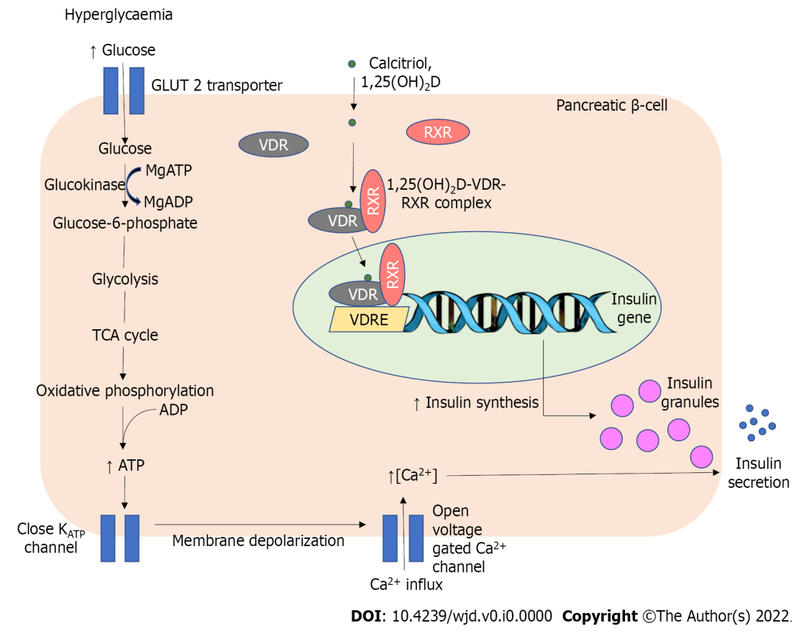
Figure 1 Interrelation of vitamin D and magnesium in the regulation of insulin synthesis and release from pancreatic β-cells. Calcitriol, an activated form of vitamin D, enters pancreatic β-cells and binds to vitamin D receptors (VDR) to form a heterodimer complex with retinoid X receptor (RXR). The calcitriol-VDR-RXR complex later binds to the vitamin D response element which is located in the promoter region of the insulin gene in the nucleus. This is followed by increased insulin gene transcription to enhance its synthesis. Magnesium in the form of magnesium adenosine triphosphate and magnesium adenosine diphosphate plays vital roles in regulating glucokinase, an enzyme that converts glucose to glucose-6-phosphate. Adequacy of intracellular magnesium level is paramount to allow optimal glucokinase activity. The subsequent process in glycolytic pathway, tricarboxylic acid cycle, and oxidative phosphorylation yields adenosine triphosphate (ATP). The rise in ATP results in the closure of potassium-ATP-channel which increases intracellular potassium level. The resulting membrane depolarization causes the opening of voltage-gated calcium channel that triggers insulin degranulation and secretion. GLUT 2: Glucose transporter type 2; RXR: Retinoid X receptor; VDRE: Vitamin D response element; MgATP: Magnesium adenosine triphosphate; MgADP: Magnesium adenosine diphosphate; ATP: Adenosine triphosphate; Ca²⁺: Calcium; TCA: Tricarboxylic acid; ADP: Adenosine diphosphate; K_{ATP}: Potassium-ATP-channel; VDR: Vitamin D receptors; 1,25(OH)₂ D: 1,25-dihydroxy vitamin D.

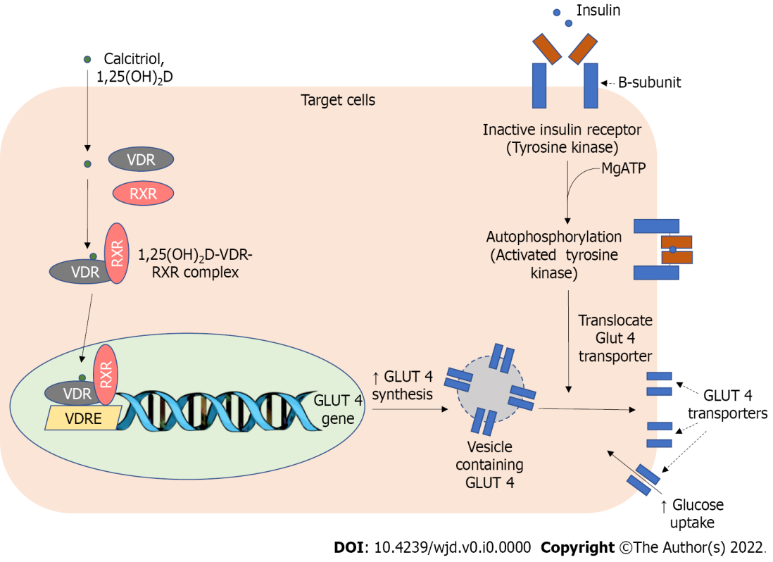
Figure 2 Interrelation of vitamin D and magnesium in the action of insulin at target organs. Magnesium adenosine triphosphate plays a role in the autophosphorylation process of B-subunits of insulin receptor tyrosine kinase, a crucial step in initiating an intracellular signaling pathway. The calcitriol-vitamin D receptors-retinoid X receptor-vitamin D response element complex also modulates the synthesis of glucose transporter type 4 (GLUT4), a predominant glucose transporter present in muscle cells and adipocytes. Upon stimulation by insulin, the activated tyrosine kinase receptor will stimulate the fusion of vesicles containing GLUT4 to the cellular membrane. This process increases cellular glucose uptake. GLUT/4: Glucose transporter type 4; RXR: Retinoid X receptor; VDRE: Vitamin D response element; MgATP: Magnesium adenosine triphosphate; Ca²⁺: Calcium; VDR: Vitamin D receptors; 1,25(OH)₂ D: 1,25-dihydroxy vitamin D.

