Name of Journal: World Journal of Clinical Cases
Manuscript NO: 81767
Manuscript Type: CASE REPORT

Bow-and-arrow sign on point-of-care ultrasound for diagnosis of pacemaker lead-induced heart perforation: A case report and literature review

Chen N et al. POCUS and lead perforation

Ni Chen, Guang-Xian Miao, Liang-Qin Peng, Yun-Hang Li, Juan Gu, Ying He, Tao Chen, Xiao-Yun Fu, Zhou-Xiong Xing

Ni Chen, Ying He, Tao Chen, Xiao-Yun Fu, Zhou-Xiong Xing, Department of Critical Care Medicine, Affiliated Hospital of Zunyi Medical University, Zunyi 563000, Guizhou Province, China

Guang-Xian Miao, Liang-Qin Peng, Department of Ultrasound, Affiliated Hospital of Zunyi Medical University, Zunyi 563000, Guizhou Province, China

Yun-Hang Li, Department of Cardiology, Affiliated Hospital of Zunyi Medical University, Zunyi 563000, Guizhou Province, China

Juan Gu, Department of Pharmacy, Affiliated Hospital of Zunyi Medical University, Zunyi 563000, Guizhou Province, China

Author contributions: Chen N was the attending physician for the patient, reviewed the literature, and contributed to manuscript drafting; Miao GX and Peng LQ performed the bedside ultrasound, interpreted the imaging findings, and contributed to manuscript drafting; Li YH, Gu J, and He Y summarized the clinical features and drafted the manuscript; Chen T and Fu XY helped draft the manuscript and review the literature; Xing ZX helped review the literature and made important contributions to the manuscript; All authors have approved the final version of the manuscript.

Supported by Foundation of Guizhou Science and Technology Department, No. QIANKEHEZHICHEN[2022]YIBAN179; National Natural Science Foundation of China, No. 82160370; and Guizhou Education Department, No. Qian Jiao He KY Zi[2018]239.

Corresponding author: Zhou-Xiong Xing, Doctor, MD, Chief Physician, Researcher, Department of Critical Care Medicine, Affiliated Hospital of Zunyi Medical University, No. 149 Dalian Road, Huichuan District, Zunyi 563000, Guizhou Province, China. xingzhouxiong111@126.com

Received: November 24, 2022
Revised: December 17, 2022
Accepted: February 10, 2023
Published online:

Abstract
BACKGROUND
Pacemaker lead-induced heart perforation is a rare but life-threatening complication of pacemaker implantation, and timely diagnosis remains a challenge for clinicians. Here, we report a case of pacemaker lead-induced cardiac perforation rapidly diagnosed by a “bow-and-arrow” sign on point-of-care ultrasound (POCUS).

CASE SUMMARY
A 74-year-old Chinese woman who had undergone permanent pacemaker implantation 26 d before suddenly developed severe dyspnea, chest pain, and hypotension. The patient had received emergency laparotomy for an incarcerated groin hernia and was transferred to the intensive care unit 6 d before. Computed tomography was not available due to unstable hemodynamic status, so POCUS was performed at the bedside and revealed severe pericardial effusion and cardiac tamponade. Subsequent pericardiocentesis yielded a large volume of bloody pericardial fluid. Further POCUS by an ultrasonographist revealed a unique “bow-and-arrow” sign indicating right ventricular (RV) apex perforation by the pacemaker lead, which facilitated the rapid diagnosis of lead perforation. Given the persistent drainage of pericardial bleeding, urgent off-pump open chest surgery was performed to repair the perforation. However, the patient died of shock and multiple organ dysfunction syndrome within 24 h post-surgery. In addition, we also performed a literature review on the sonographic features of RV apex perforation by lead.

CONCLUSION
POCUS enables the early diagnosis of pacemaker lead perforation at the bedside. A step-wise ultrasonographic approach and the “bow-and-arrow” sign on POCUS are helpful for rapid diagnosis of lead perforation.

Key Words: Point-of-care ultrasound; Heart perforation; Pacemaker lead; Cardiac pacemaker; Review; Case report

Chen N, Miao GX, Peng LQ, Li YH, Gu J, He Y, Chen T, Fu XY, Xing ZX. Bow-and-arrow sign on point-of-care ultrasound for diagnosis of pacemaker lead-induced heart perforation: A case report and literature review. World J Clin Cases 2023; In press

Core Tip: Pacemaker lead-induced heart perforation is a rare but life-threatening complication of pacemaker implantation. Further, timely diagnosis remains a challenge for clinicians. Here, we report a novel case of right ventricular apex perforation by pacemaker lead associated with pericardial tamponade, which was rapidly diagnosed by a unique “bow-and-arrow” sign on point-of-care ultrasound (POCUS). We also propose a step-wise diagnostic approach using POCUS to enhance diagnostic speed and accuracy for lead-induced heart perforation. This step-wise ultrasonographic approach and the “bow-and-arrow” sign on POCUS are helpful for rapid diagnosis of lead perforation.

INTRODUCTION
Cardiac pacing has revolutionized the care of severe bradycardia^{[1]}. However, patients receiving pacemaker therapy are at high risk of complications such as infection, bleeding, pneumothorax, deep venous thrombosis, lead dislodgement, and heart perforation^{[2]}. While heart perforation by lead occurs in only about 1% of implantation cases, it is one of the most life-threatening complications^{[3]}. The clinical manifestations of lead perforation vary markedly, ranging from chest pain, dyspnea, and syncope to lethal cardiac tamponade and arrest^{[4]}. Presently, there is no consensus on the optimal diagnostic procedure for lead-related heart perforation, and timely diagnosis remains a great concern for cardiologists and emergency and critical care professionals^{[5]}.
Point-of-care ultrasound (POCUS) has become a valuable tool for diagnosis in the acute care setting over the past two decades, especially for heart-related conditions; indeed, POCUS has been referred to as “the new stethoscope”^{[6]}. POCUS using small and portable ultrasound machines provides real-time, low-cost, non-invasive, and non-radiative diagnostic information at the bedside, and has proven especially beneficial for the early diagnosis of critically ill patients unable to receive other imaging examinations, such as computed tomography (CT)^{[7]}. Here, we report a rare case of pacemaker lead-induced right ventricular (RV) apex perforation associated with acute cardiac tamponade diagnosed based on a distinctive “bow-and-arrow” sign on POCUS. We also describe a step-wise POCUS-based approach for diagnosis of RV apex perforation, and present a literature review on the sonographic features of lead-induced RV apex perforation.

CASE PRESENTATION
Chief complaints
A 74-year-old Chinese woman [body mass index (BMI) of 20 kg/m²] suddenly developed chest pain, dyspnea, and cyanosis 26 d after permanent pacemaker implantation.

History of present illness
The patient had received permanent pacemaker implantation with an active fixation mechanism (a helical screw lead) and a dual chamber pacing mechanism for progressive worsening of bradycardia 26 d before the index presentation. The patient had also undergone emergency laparotomy and enterectomy for closed-loop intestinal obstruction caused by left groin hernia 6 d previously, and was then transferred to the intensive care unit (ICU) to receive critical care until the onset of chest pain and dyspnea. On ICU admission, chest X-ray revealed a mildly enlarged heart but proper positioning of both pacemaker leads (Figure 1). The electrocardiogram (ECG) revealed atrial fibrillation but satisfactory sensing and pacing of the pacemaker (pacing ventricular rate of 60 bpm).

History of past illness
The patient had a 10-year history of poorly controlled hypertension and a 1-year history of bradycardia and atrial fibrillation untreated with oral anticoagulants.

Personal and family history
The patient was retired without a history of smoking, drinking, and drug abuse.

Physical examination
On physical examination, the patient was pale, restlessness, and in acute respiratory distress. Examination of vital signs revealed hypotension (88/60 mmHg) with infusion of noradrenaline (1.4 μg/kg/min) as measured by an arterial catheter, elevated respiratory rate (38 breaths/min), and severe dyspnea with decreased oxygen saturation as measured by pulse finger oximetry (SpO₂ 85% on room air), but a normal pacing heart rate of 60 bpm. Given the patient’s recent abdominal surgery, acute abdomen, such as gut perforation, gut necrosis, and septic shock, was initially suspected. However, there was no distension or tenderness with rebound on abdominal examination. Cardiovascular examination revealed remarkable jugular venous distention and distant heart sounds without murmurs. These findings indicated acute hypoxic respiratory failure and circulatory shock. In addition, cardiac tamponade was suspected given the jugular venous distention and hypotension.

Laboratory examinations
Laboratory studies prior to and after the onset of chest pain and dyspnea were obtained and are summarized in Table 1. After symptom onset, blood analysis revealed leukocytosis (white blood cell count 25.85 × 10⁹/L), decreased hemoglobin (103 g/L), normal platelet count (144 × 10⁹/L), significantly elevated alanine aminotransferase (2840 IU/L) and aspartate aminotransferase (9650 IU/L), and slightly elevated serum creatinine (1.14 mg/dL), indicating acute kidney injury. Blood plasma coagulation tests revealed prolonged activated partial thromboplastin time (36.9 s) and prothrombin time (27.2 s). In addition, cardiac injury markers were elevated, including hypersensitive troponin T (46.65 ng/L) and myohemoglobin (201 ng/mL). Arterial blood gas measurements while receiving an inspiratory oxygen concentration (FiO₂) of 30% prior to symptom onset and while receiving 50% FiO₂ after onset by high-flow nasal cannula, respectively, were as follows: pH, 7.29 and 7.12; PaCO₂, 61 and 38.8 mmHg; PaO₂, 47.6 and 36.3 mmHg; lactate, 1.1 and 17 mmol/L; HCO₃⁻, 25 and 11.5 mmol/L. In general, these findings suggested acute hypoxic respiratory failure, severe circulatory shock, and metabolic acidosis.

Imaging examinations
CT scan was not obtained due to the critical status of the patient. Urgent POCUS using a portable machine (Mindray M9, Shenzhen, China) to assess hemodynamic status at the bedside revealed a large volume of pericardial effusion associated with diastolic collapse of the RV free wall, supporting a diagnosis of cardiac tamponade. The patient then received emergency percutaneous pericardiocentesis with POCUS guidance. Briefly, a pig-tail catheter was successfully implanted into the pericardial sac at the cardiac apex and drainage yielded a large amount (600 mL) of bloody pericardial effusion within half an hour. Drainage markedly improved the dyspnea and increased blood pressure (140/71 mmHg) with decreased infusion of noradrenaline (1.1 μg/kg/min). However, there was still ongoing pericardial bleeding with an accumulative total of 970 mL within 7 h after the initial drainage, strongly suggesting life-threatening active bleeding in the pericardial cavity.
An urgent ultrasonography consultation was obtained and cardiac POCUS was conducted by an experienced ultrasonographist at the bedside. This examination revealed elevated left ventricular ejection fraction (62%) and roughly normal-sized heart chambers. Given the recent history of cardiac pacemaker implantation, lead-related complications were suspected, and we focused subsequent imaging investigations on the pacemaker lead in the RV. The parasternal four-chamber view showed mild pericardial effusion and the outline of a pacemaker lead projecting across the RV toward the cardiac apex (Figure 2A). A nonstandard RV view precisely at the cardiac apex showed pericardial effusion and the lead tip penetrating the RV wall at the apex (Figure 2B), an imaging manifestation that we termed the “bow-and-arrow” sign (Figure 3) as the RV wall formed the outline of a bow, the lead in the ventricular chamber appeared as an arrow shaft, and the lead tip associated with a hematoma at the perforation resembled an arrowhead. Other localized and zoomed views demonstrated that the lead tip penetrated into the free pericardial space, confirming the diagnosis of lead perforation (Figure 2C and D).

FINAL DIAGNOSIS
Lead-induced RV apex perforation associated with active pericardial bleeding and pericardial tamponade was diagnosed based on the findings of POCUS.

TREATMENT
The timeline in Figure 4 illustrates the clinical course of the patient. Urgent off-pump cardiac surgery was conducted and revealed a large hematoma on the RV surface at the cardiac apex near the interventricular septum. After removal of the hematoma, the tip of the cardiac pacemaker lead was observed on the surface of the RV associated with ongoing bleeding. Thus, lead-induced heart perforation was definitively diagnosed. The perforation was repaired by the mattress suture method, and the chest was closed after confirming the absence of residual bleeding. During the operation, blood pressure fluctuated between 128/85 and 108/65 mmHg with infusion of norepinephrine (1.3–2.0 μg/kg/min). After the operation, the patient presented with refractory circulatory shock as evidenced by decreased blood pressure (75/41 mmHg) during infusion of high-dose norepinephrine (2.2 μg/kg/min), as well as hypothermia (35.5 °C), coma, and anuria. The patient received blood transfusion, fluid resuscitation, continuous renal replacement therapy, and advanced life support treatment including invasive mechanical ventilation and cardiac inotropic support with venous pumped milrinone (0.5 μg/kg/min).

OUTCOME AND FOLLOW-UP
On the second postoperative day, the patient developed recurrent ventricular tachycardia, fibrillation, and cardiac arrest. Cardiac pulmonary resuscitation was attempted and both intravenous epinephrine and an antiarrhythmic drug (lidocaine) were administered; however, the patient died from shock and multiple organ failure syndrome.

DISCUSSION
More than one million permanent pacemaker implantation procedures are performed annually across the globe, of which approximately 1% result in lead-induced heart perforation^{[8]}. Lead perforation may involve numerous structures, including the right atrium, interventricular septum, and tricuspid valve, but the RV apex is the most common site^{[9]}, as exemplified by the current case. The onset of cardiac perforation may be acute (within one day of implantation), subacute (within 30 d), or chronic (more than 30 d after implantation)^{[5]}. Predictors of lead-induced cardiac perforation include steroid use for 7 d prior to implant, older age, female sex, BMI < 20 kg/m², longer fluoroscopy time, ventricular lead in an apical position, temporary pacemaker placement, and use of helical screw ventricular leads^{[10]}. In this patient, female sex, older age, a helical screw lead tip, and an apical lead position may have increased vulnerability to lead perforation.
Most acute cardiac perforations by pacemaker lead occur soon after implantation and are relatively easy to detect by routine postoperative chest radiography and fluoroscopy. However, the diagnoses of subacute and chronic perforations remain a challenge due to an insidious or a sudden onset and a spectrum of heterogenous clinical presentations^{[11-13]}. As demonstrated by the current case, the classical manifestations of lead-induced heart perforation include chest pain, dyspnea, and hypotension caused by pericardial effusion and cardiac tamponade. Chest pain is the most frequent symptom of lead perforation, but numerous other presentations are reported, such as hiccups, dizziness, syncope, pneumopericardium, hemothorax, and pneumothorax^{[4,11,13,14]}. This heterogeneity of symptom presentation reflects not only variation in intra-cardiac perforation site, but also possible lung, liver, or chest wall perforation. Moreover, these symptoms alone do not distinguish heart perforation by lead from acute pulmonary embolism, diaphragmatic stimulation, and myocardial infarction^{[12,15]}. In addition, many asymptomatic cardiac perforation cases with or without malfunction of pacing have been reported^{[16]}. Given this heterogeneity of presentations, lead perforation should be included in the differential diagnosis when patients with a history of pacemaker therapy present with any of the aforementioned symptoms regardless of time since implantation.
To date, there is no consensus on the optimal diagnostic approach for lead perforation^{[5]}. For suspected cases, chest CT, chest radiography, and transthoracic echocardiography (TTE) are usually recommended. Although chest radiography is conducted routinely to assess lead perforation, its accuracy is low according to a recent report^{[5]}. Alternatively, TTE can detect pericardial effusion and visualize the pacemaker lead within cardiac chambers on several imaging planes with a documented accuracy of 82.7%^{[17]}. However, TTE is limited in some cases by a poor acoustic window and artifacts produced by lead reverberations^{[9]}. Also, transesophageal echocardiography (TEE) can provide better visualization of the entire lead path in the cardiac chambers^{[18]}. Recent studies have reported that chest CT, especially ECG-gated contrast-enhanced cardiac CT, has greater diagnostic accuracy (> 90%) than either TTE or chest radiography^{[5,17]}. Additionally, three-dimensional (3-D) reconstruction by cardiac CT has been reported helpful for diagnosis of lead perforation^{[19]}. In our case, however, CT scan was not obtained due to unstable hemodynamic status.
POCUS is among the most important recent developments for the management of critically ill patients. A recommended approach to goal-directed POCUS for rapidly identifying the causes of respiratory failure and circulatory shock is to assess cardiac function first^{[20]}. Therefore, POCUS was performed at the bedside using a portable device, and revealed cardiac tamponade and a pacemaker lead penetrating the RV apex. We summarize the main steps in the diagnosis of lead-induced RV apex perforation by POCUS in Figure 5. Most RV apex perforation cases result in pericardial effusion, which is detected using our diagnostic protocol in the first step. However, the operator should recognize that pericardial effusion may be absent in some cases with RV apex perforation by lead, and that lead perforation involving other intra-cardiac structures rather than the free wall of the heart chambers usually does not lead to pericardial effusion^{[21]}. The position and orientation of the lead within the cardiac chambers are then visualized in the parasternal or apical four-chamber view. Subsequently, the operator precisely adjusts the transducer at the cardiac apex to capture the lead penetrating the ventricular wall. The final diagnosis is reached based in part on the appearance of a “bow-and-arrow” sign (Figure 3) consisting of the curved outline of the ventricular wall (the bow), the lead shaft (arrow shaft), and the lead tip (arrowhead). Finally, local and zoomed imaging confirms lead perforation by identifying the lead tip penetrating through the ventricular wall and into the free pericardial space.
A systematic English language literature search of PubMed and China National Knowledge Infrastructure was conducted for the period 2002–2022 using key words “heart perforation”, “cardiac perforation”, “pacemaker lead”, and “ultrasound” with reasonable Boolean connectors to identify previous cases of RV apex perforation by lead diagnosed using ultrasound. Eventually, a total of 22 cases^{[18,22-42]} diagnosed by ultrasound with definite imaging information were identified. These cases are summarized in Table 2. Most cases of RV apex perforation included three ultrasound manifestations, pericardial effusion, passage of the lead through the RV wall, and the tip reaching the free pericardial space. The RV apex is the free wall of the right ventricle, so pericardial effusion occurred in most of these cases. However, absence of pericardial effusion was also reported in four cases of RV apex perforation^{[18,26,27,30]}. In addition, these cases reported distinct features such as lead mimicking a “spear”^{[22]}, the lead entering and retracting from the RV with each cardiac movement^{[29]}, and discontinuation of the RV wall^{[35]}. 3-D ultrasound^{[23,24,36]} and TEE^{[18]} may facilitate the diagnosis of lead perforation by improving the visualization of the lead and intra-cardiac structures. Overall, these reports indicate that RV apex perforation by lead presents a very wide range of imaging variations depending on the sonographic features of the perforated myocardium, the route and orientation of the lead, the ultrasound system used, and operator skill. Knowledge of these representative imaging features as well as the “bow-and-arrow” sign described in this report can help clinicians rapidly reach a diagnosis of lead perforation.
The optimal management of lead perforation is also a matter of ongoing debate. Asymptomatic cases without pacing malfunction may not require special management^{[16]}. However, an expert consensus statement recommends that lead extraction should be performed in cases with significant manifestations such as pericardial bleeding, chest pain, and device malfunction^{[43]}. Surgical repair and percutaneous transvenous lead extraction (TLE) are the two major approaches to remove the culprit lead. A number of recent reports have suggested that surgical repair is useful and reliable, especially for lead perforation beyond the pericardial sac, delayed perforation with severe bleeding, chronically implanted devices, and when there is suspicion of adjacent organ injuries^{[39,44]}. There is also mounting evidence that TLE is an efficacious, safe, and convenient tool to manage most patients who are hemodynamically stable without visceral organ injury^{[5]}. In specific cases, TLE may be superior to surgery for reducing length of hospital stay, medical costs, morbidity, and mortality, but requires trained operators to achieve satisfactory outcome. Nevertheless, the case patient required thoracotomy to repair the heart perforation given the severe pericardial bleeding.
The strengths of this study are as follows: (1) We present the complete clinical course of subacute lead perforation rapidly diagnosed by POCUS; (2) We propose a step-wise diagnostic approach using POCUS; and (3) We identify a “bow-and-arrow” sign on POCUS that facilitates the rapid diagnosis of RV apex perforation by lead. This study also has several limitations. First, the diagnostic efficacy of POCUS compared to CT examination and other imaging modalities must be supported by a retrospective observational trial or more ideally by a randomized clinical trial. Second, the step-wise approach and the “bow-and-arrow” sign on POCUS have not been validated in other cases.

CONCLUSION
Delayed heart perforation by pacemaker lead is difficult to diagnose and manage due to sudden onset, complex clinical presentation, and the potential for life-threatening cardiac tamponade and arrest. POCUS is a useful tool for the real-time evaluation of suspected lead perforation, especially for critically ill patients with severe respiratory failure and circulatory shock. A “bow-and-arrow” sign on POCUS can be easily recognized that facilitates the rapid diagnosis of lead perforation. A step-wise POCUS training program to improve detection of this “bow-and-arrow” sign and other ultrasound manifestations may enhance diagnostic speed and accuracy for improved clinical outcomes of lead perforation.

ACKNOWLEDGEMENTS
We would like to acknowledge the patient and her family. We also thank Yu-Xin Wang for help in painting the sketch.

REFERENCES
1 Mond HG, Sloman JG. The Cardiac Pacemaker Clinic: Memories From a Bygone Era. Heart Lung Circ 2021; 30: 216-224 [PMID: 33032899 DOI: 10.1016/j.hlc.2020.08.020]
2 Glikson M, Nielsen JC, Kronborg MB, Michowitz Y, Auricchio A, Barbash IM, Barrabés JA, Boriani G, Braunschweig F, Brignole M, Burri H, Coats AJS, Deharo JC, Delgado V, Diller GP, Israel CW, Keren A, Knops RE, Kotecha D, Leclercq C, Merkely B, Starck C, Thylén I, Tolosana JM; ESC Scientific Document Group. [2021 ESC Guidelines on cardiac pacing and cardiac resynchronization therapy Developed by the Task Force on cardiac pacing and cardiac resynchronization therapy of the European Society of Cardiology (ESC) With the special contribution of the European Heart Rhythm Association (EHRA)]. G Ital Cardiol (Rome) 2022; 23: e1-e94 [PMID: 35771031 DOI: 10.1714/3824.38087]
3 Mahapatra S, Bybee KA, Bunch TJ, Espinosa RE, Sinak LJ, McGoon MD, Hayes DL. Incidence and predictors of cardiac perforation after permanent pacemaker placement. Heart Rhythm 2005; 2: 907-911 [PMID: 16171740 DOI: 10.1016/j.hrthm.2005.06.011]
4 Kumar P, Skrabal J, Frasure SE, Pourmand A. Pacemaker lead related myocardial perforation. Am J Emerg Med 2022; 53: 281.e1-281.e3 [PMID: 34511285 DOI: 10.1016/j.ajem.2021.08.081]
5 Rajkumar CA, Claridge S, Jackson T, Behar J, Johnson J, Sohal M, Amraoui S, Nair A, Preston R, Gill J, Rajani R, Rinaldi CA. Diagnosis and management of iatrogenic cardiac perforation caused by pacemaker and defibrillator leads. Europace 2017; 19: 1031-1037 [PMID: 27353321 DOI: 10.1093/europace/euw074]
6 Bledsoe A, Zimmerman J. Ultrasound: The New Stethoscope (Point-of-Care Ultrasound). Anesthesiol Clin 2021; 39: 537-553 [PMID: 34392884 DOI: 10.1016/j.anclin.2021.03.011]
7 Osterwalder J. [COVID-19 - More Lung Pocus and Sparing Use of Stethoscope, Chest X-Ray and Lung CT]. Praxis (Bern 1994) 2020; 109: 583-591 [PMID: 32356672 DOI: 10.1024/1661-8157/a003512]
8 Mond HG, Proclemer A. The 11th world survey of cardiac pacing and implantable cardioverter-defibrillators: calendar year 2009--a World Society of Arrhythmia's project. Pacing Clin Electrophysiol 2011; 34: 1013-1027 [PMID: 21707667 DOI: 10.1111/j.1540-8159.2011.03150.x]
9 Almomani A, Siddiqui K, Ahmad M. Echocardiography in patients with complications related to pacemakers and cardiac defibrillators. Echocardiography 2014; 31: 388-399 [PMID: 24341293 DOI: 10.1111/echo.12483]
10 Cano Ó, Andrés A, Alonso P, Osca J, Sancho-Tello MJ, Olagüe J, Martínez-Dolz L. Incidence and predictors of clinically relevant cardiac perforation associated with systematic implantation of active-fixation pacing and defibrillation leads: a single-centre experience with over 3800 implanted leads. Europace 2017; 19: 96-102 [PMID: 26847075 DOI: 10.1093/europace/euv410]
11 Nichols J, Berger N, Joseph P, Datta D. Subacute right ventricle perforation by pacemaker lead presenting with left hemothorax and shock. Case Rep Cardiol 2015; 2015: 983930 [PMID: 25785204 DOI: 10.1155/2015/983930]
12 Farooqui A, Key T, Ihekwaba U, Hogrefe K. Pacemaker Lead Perforation Mimicking Symptoms of Acute Pulmonary Embolism. Acute Med 2020; 19: 145-148 [PMID: 33020758]
13 Madershahian N, Wippermann J, Wahlers T. The bite of the lead: multiorgan perforation by an active-fixation permanent pacemaker lead. Interact Cardiovasc Thorac Surg 2010; 11: 93-94 [PMID: 20388699 DOI: 10.1510/icvts.2010.234542]
14 Khan JA, Abdul Karim Khan S. Fatigue and Syncope Caused by Right Ventricular Perforation by a Pacemaker Lead. Cureus 2022; 14: e22634 [PMID: 35371762 DOI: 10.7759/cureus.22634]
15 Celik T, Kose S, Bugan B, Iyisoy A, Akgun V, Cingoz F. Hiccup as a result of late lead perforation: report of two cases and review of the literature. Europace 2009; 11: 963-965 [PMID: 19359331 DOI: 10.1093/europace/eup071]
16 Hirschl DA, Jain VR, Spindola-Franco H, Gross JN, Haramati LB. Prevalence and characterization of asymptomatic pacemaker and ICD lead perforation on CT. Pacing Clin Electrophysiol 2007; 30: 28-32 [PMID: 17241311 DOI: 10.1111/j.1540-8159.2007.00575.x]
17 Zhang X, Zheng C, Wang P, Wang D, Huang B, Li G, Hu H, Yang Z, Duan X, Zheng S, Liu P, Wang J, Shen J. Assessment of Cardiac Lead Perforation: Comparison Among Chest Radiography, Transthoracic Echocardiography and Electrocardiography-gated Contrast-enhanced Cardiac CT. Eur Radiol 2019; 29: 963-974 [PMID: 30019144 DOI: 10.1007/s00330-018-5633-6]
18 Madanat L, Shah K, Bloomingdale R, Williamson BD. Diaphragmatic Pacing as an Initial Presentation of Delayed Ventricular Lead Perforation. J Innov Card Rhythm Manag 2022; 13: 5004-5008 [PMID: 35655806 DOI: 10.19102/icrm.2022.130504]
19 Sebastián CG, Sanz AP, Gómez JLZ. Follow my lead: multimodality imaging in cardiac tamponade due to coronary sinus perforation by pacemaker. Eur Heart J Cardiovasc Imaging 2022; 23: e277 [PMID: 35512118 DOI: 10.1093/ehjci/jeac073]
20 Walley PE, Walley KR, Goodgame B, Punjabi V, Sirounis D. A practical approach to goal-directed echocardiography in the critical care setting. Crit Care 2014; 18: 681 [PMID: 25672460 DOI: 10.1186/s13054-014-0681-z]
21 Holmes DR Jr, Nishimura R, Fountain R, Turi ZG. Iatrogenic pericardial effusion and tamponade in the percutaneous intracardiac intervention era. JACC Cardiovasc Interv 2009; 2: 705-717 [PMID: 19695538 DOI: 10.1016/j.jcin.2009.04.019]
22 Vasavada A, Vinchurkar M, Agrawal N, Parekh P. 'Spear' through the right ventricle: pericardial tamponade caused by delayed pacemaker lead-related perforation of a normal thickness free wall which was managed percutaneously using the same lead. BMJ Case Rep 2014; 2014 [PMID: 24403395 DOI: 10.1136/bcr-2013-202665]
23 Shen X, Holmberg MJ, Sype J, Hunter C, Mooss AN, Mohiuddin SM. Real-time three-dimensional echocardiography in diagnosis of right ventricular pseudoaneurysm after pacemaker implantation. Echocardiography 2006; 23: 240-243 [PMID: 16524396 DOI: 10.1111/j.1540-8175.2006.00156.x]
24 Stefanidis AS, Margos PN, Kotsakis AA, Papasteriadis EG. Three-dimensional echocardiographic documentation of pacemaker lead perforation presenting as acute pericarditis. Hellenic J Cardiol 2009; 50: 335-337 [PMID: 19622505]
25 Truscelli G, Galea N, Barillà F, Pellicori P, Toscano F, Gaudio C, Carbone I, Torromeo C. ECHO and magnetic resonance imaging in a patient with high bleeding risk and ventricular perforation: a case report and literature review. Eur Rev Med Pharmacol Sci 2011; 15: 721-724 [PMID: 21796878]
26 Boxma RPJ, Kolff-Kamphuis MGM, Gevers RMM, Boulaksil M. Subacute right ventricular pacemaker lead perforation: evaluation by echocardiography and cardiac CT. J Echocardiogr 2017; 15: 188-190 [PMID: 28466446 DOI: 10.1007/s12574-017-0337-5]
27 Allouche E, Chargui S, Fathi M, Bezdah L. Subacute right ventricle perforation: a pacemaker lead complication. BMJ Case Rep 2021; 14 [PMID: 33980566 DOI: 10.1136/bcr-2021-242489]
28 Abdelhafez A, Wassef N, Hogrefe K, Farooq M. Unexpected early complication of implantable-cardioverter defibrillator. BMJ Case Rep 2018; 2018 [PMID: 29880624 DOI: 10.1136/bcr-2018-224521]
29 Ferrero-de-Loma-Osorio A, Albors-Martín J, Ruiz-Granell R, Domínguez-Mafé E, Bahamonde-Romano JA, Palau-Sampio P, Boix-Garibo R. Images in cardiovascular medicine: Delayed right ventricular perforation by a transvenous active fixation implantable cardioverter-defibrillator lead: echocardiographic diagnosis and surgical management. Circulation 2009; 119: 2112-2113 [PMID: 19380633 DOI: 10.1161/CIRCULATIONAHA.108.829788]
30 Ramirez MF, Ching CK, Ho KL, Teo WS. "The attack of the 52 cm lead": an unusual case of late cardiac perforation by a passive-fixation permanent pacemaker lead. Int J Cardiol 2007; 115: e5-e7 [PMID: 16901560 DOI: 10.1016/j.ijcard.2006.05.064]
31 Addison D, Wosik J, Birnbaum I, Virani SS. Case report: a lead you can't miss: a case of right ventricular perforation. Methodist Debakey Cardiovasc J 2015; 11: 51-52 [PMID: 25793031 DOI: 10.14797/mdcj-11-1-51]
32 Hardzina M, Ząbek A, Laskowicz B, Rydlewska A, Boczar K, Małecka B. Heart perforation by pro-MRI right ventricular lead in a 26-year-old woman. Kardiol Pol 2014; 72: 466 [PMID: 24859064 DOI: 10.5603/KP.2014.0095]
33 Trehan V, Mehta V, Mukhopadhyay S, Yusuf J, Rastogi V, Yaduvanshi A, Tyagi S. Nonsurgical management of cardiac tamponade caused by a temporary pacemaker lead. Pacing Clin Electrophysiol 2005; 28: 242-244 [PMID: 15733187 DOI: 10.1111/j.1540-8159.2005.09503.x]
34 Velibey Y, Tekkeşin Aİ, Alper AT, Şahin S. Case Images: Multimodality imaging in a patient with lead perforation. Turk Kardiyol Dern Ars 2017; 45: 298 [PMID: 28429703 DOI: 10.5543/tkda.2016.58701]
35 Chen CC, Ho SW. Usage of point-of-care Ultrasonography for Rapid Diagnosis of Cardiac Perforation by Pacemaker Lead. J Med Ultrasound 2022; 30: 221-222 [PMID: 36484041 DOI: 10.4103/jmu.jmu_131_21]
36 Sugano A, Seo Y, Atsumi A, Yamamoto M, Machino-Ohtuska T, Kawamura R, Nakajima H, Ishizu T, Aonuma K. Three-dimensional echocardiography in the diagnosis of pacemaker lead perforation. J Echocardiogr 2012; 10: 141-142 [PMID: 27278351 DOI: 10.1007/s12574-012-0140-2]
37 Vandenberk B, Letourneau-Shesaf S, Colbert JD, Sumner G, Kuriachan V. Late ventricular pacemaker lead perforation after electrical cardioversion-A case report. HeartRhythm Case Rep 2022; 8: 501-504 [PMID: 35860770 DOI: 10.1016/j.hrcr.2022.04.012]
38 Caiati C, Pollice P, Truncellito L, Lepera ME, Favale S. Minimal Cardiac Perforation by Lead Pacemaker Complicated with Pericardial Effusion and Impending Tamponade: Optimal Management with No Pericardiocentesis Driven by Echocardiography. Diagnostics (Basel) 2020; 10 [PMID: 32235447 DOI: 10.3390/diagnostics10040191]
39 Noguchi M, Nakai T, Kawano Y, Shibayama K, Obunai K, Tabata M, Watanabe H. Delayed right ventricular defibrillation lead perforation presenting as cardiac tamponade and treated surgically. Clin Case Rep 2017; 5: 458-462 [PMID: 28396769 DOI: 10.1002/ccr3.865]
40 Nash G, Williams JM, Nekkanti R, Movahed A. Case of early right ventricular pacing lead perforation and review of the literature. World J Clin Cases 2014; 2: 206-208 [PMID: 24945007 DOI: 10.12998/wjcc.v2.i6.206]
41 Velasco E, Martín M, Barriales V, Díaz E, Pun F, Soto MI. Active fixation pacemaker lead perforating cardiac wall. Rev Port Cardiol 2014; 33: 477-478 [PMID: 25155005 DOI: 10.1016/j.repc.2014.01.021]
42 Kourireche N, Boutakhrit A, Chikhi F, Fellat I, Cherti M. Delayed right ventricular lead perforation complicated by tamponade in biventricular hypertrophic cardiomyopathy. Clin Case Rep 2017; 5: 1945-1947 [PMID: 29225831 DOI: 10.1002/ccr3.1224]
43 Kusumoto FM, Schoenfeld MH, Wilkoff BL, Berul CI, Birgersdotter-Green UM, Carrillo R, Cha YM, Clancy J, Deharo JC, Ellenbogen KA, Exner D, Hussein AA, Kennergren C, Krahn A, Lee R, Love CJ, Madden RA, Mazzetti HA, Moore JC, Parsonnet J, Patton KK, Rozner MA, Selzman KA, Shoda M, Srivathsan K, Strathmore NF, Swerdlow CD, Tompkins C, Wazni O. 2017 HRS expert consensus statement on cardiovascular implantable electronic device lead management and extraction. Heart Rhythm 2017; 14: e503-e551 [PMID: 28919379 DOI: 10.1016/j.hrthm.2017.09.001]
44 Laborderie J, Barandon L, Ploux S, Deplagne A, Mokrani B, Reuter S, Le Gal F, Jais P, Haissaguerre M, Clementy J, Bordachar P. Management of subacute and delayed right ventricular perforation with a pacing or an implantable cardioverter-defibrillator lead. Am J Cardiol 2008; 102: 1352-1355 [PMID: 18993154 DOI: 10.1016/j.amjcard.2008.07.025]

Footnotes
Informed consent statement: Informed written consent was obtained from the patient’s son for publication of this report and any accompanying images.

Conflict-of-interest statement: All the authors report no relevant conflicts of interest for this article.

CARE Checklist (2016) statement: The authors have read CARE Checklist (2016), and the manuscript was prepared and revised according to CARE Checklist (2016).

Open-Access: This article is an open-access article that was selected by an in-house editor and fully peer-reviewed by external reviewers. It is distributed in accordance with the Creative Commons Attribution NonCommercial (CC BY-NC 4.0) license, which permits others to distribute, remix, adapt, build upon this work non-commercially, and license their derivative works on different terms, provided the original work is properly cited and the use is non-commercial. See: https://creativecommons.org/Licenses/by-nc/4.0/

Provenance and peer review: Unsolicited article; Externally peer reviewed.

Peer-review model: Single blind

Peer-review started: November 24, 2022
First decision: December 13, 2022
Article in press:

Specialty type: Medicine, research and experimental
Country/Territory of origin: China
Peer-review report’s scientific quality classification
Grade A (Excellent): 0
Grade B (Very good): B, B
Grade C (Good): C
Grade D (Fair): D
Grade E (Poor): 0

P-Reviewer: Brigode WM, United States; Hakimi T, Afghanistan; Knuf KM, United States S-Editor: Li L L-Editor: Wang TQ P-Editor: Li L

Figure Legends
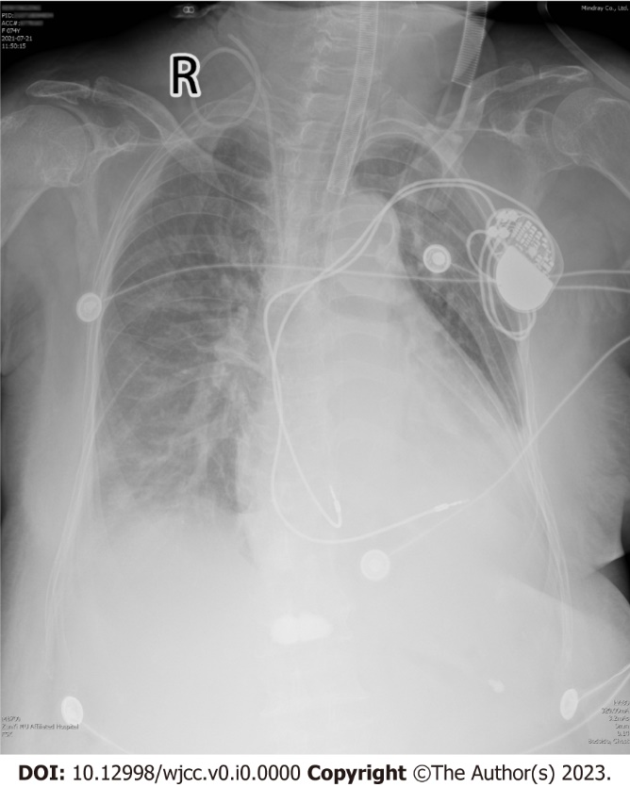
Figure 1 Chest X-ray of the patient on intensive care unit admission. Chest X-ray performed on intensive care unit admission revealed a mildly enlarged heart and proper positioning of both pacemaker leads.
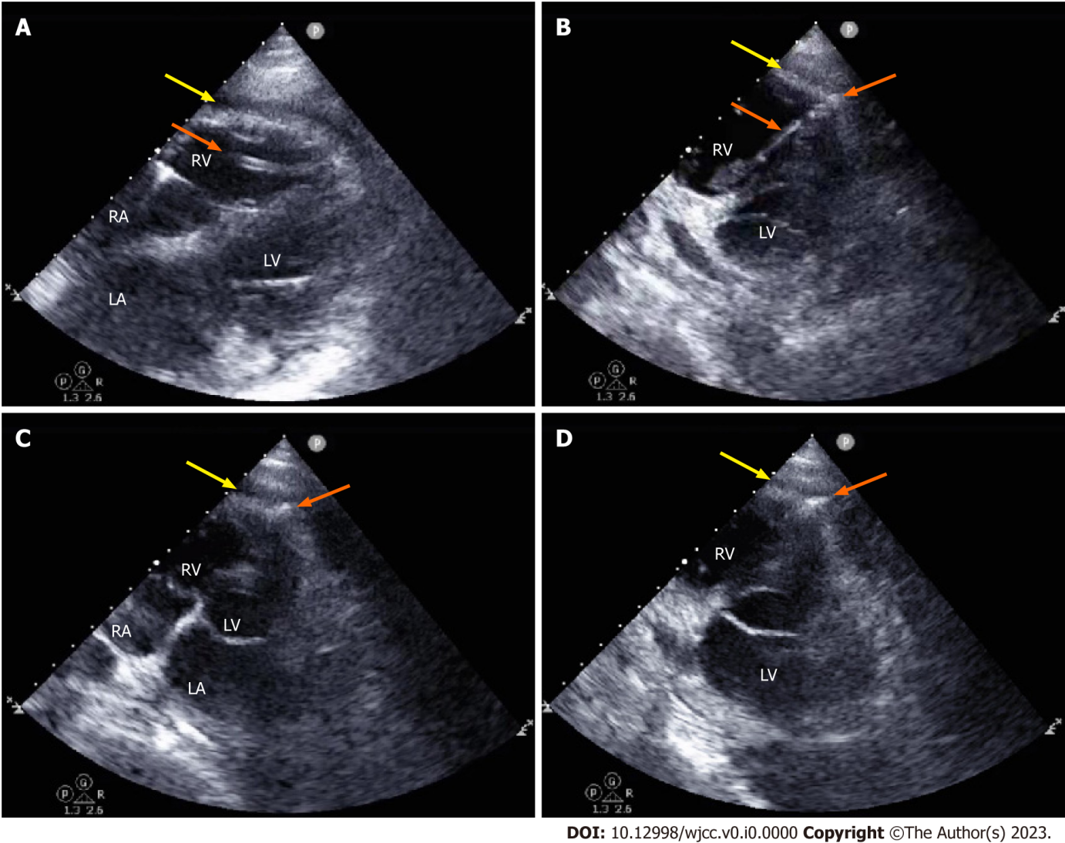
Figure 2 Imaging manifestations on point-of-care ultrasound indicating pacemaker lead perforation of the right ventricle. A: Parasternal four-chamber view showing pericardial effusion and the outline of a pacemaker lead in the right ventricle (RV) chamber; B: Nonstandard apical RV view showing pericardial effusion and the lead with its tip penetrating the RV wall at the apex, producing a “bow-and-arrow” sign; C and D: Apical four-chamber view (C) and nonstandard apical RV view (D) focusing on the tip and showing the lead penetrating the apical wall and projecting into the free pericardial space. Yellow arrows denote pericardial effusion and orange arrows denote the pacemaker lead; RA: Right atrium; RV: Right ventricle; LA: Left atrium; LV: Left ventricle.

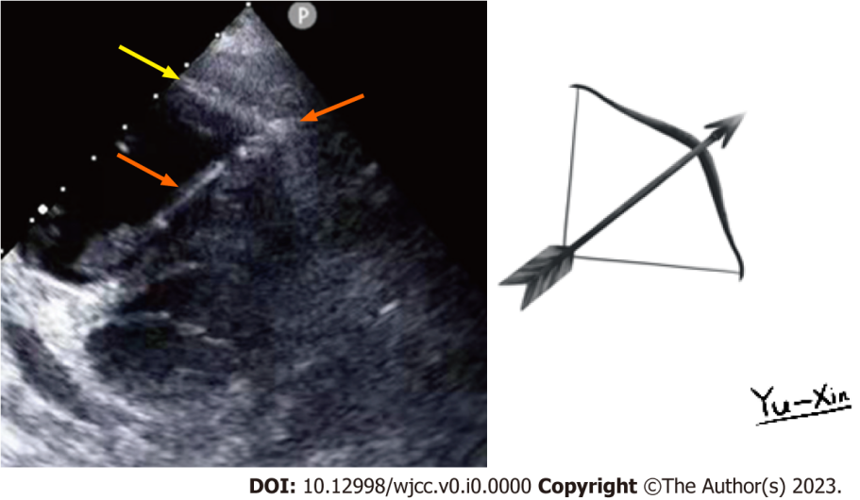
Figure 3 A “bow-and-arrow” sign on point-of-care ultrasound and a sketch of this sign. The sign consists of the curved outline of the ventricular wall (the bow), the lead shaft (arrow shaft), and the lead tip (arrowhead). The sketch was painted by Yu-Xin Wang.
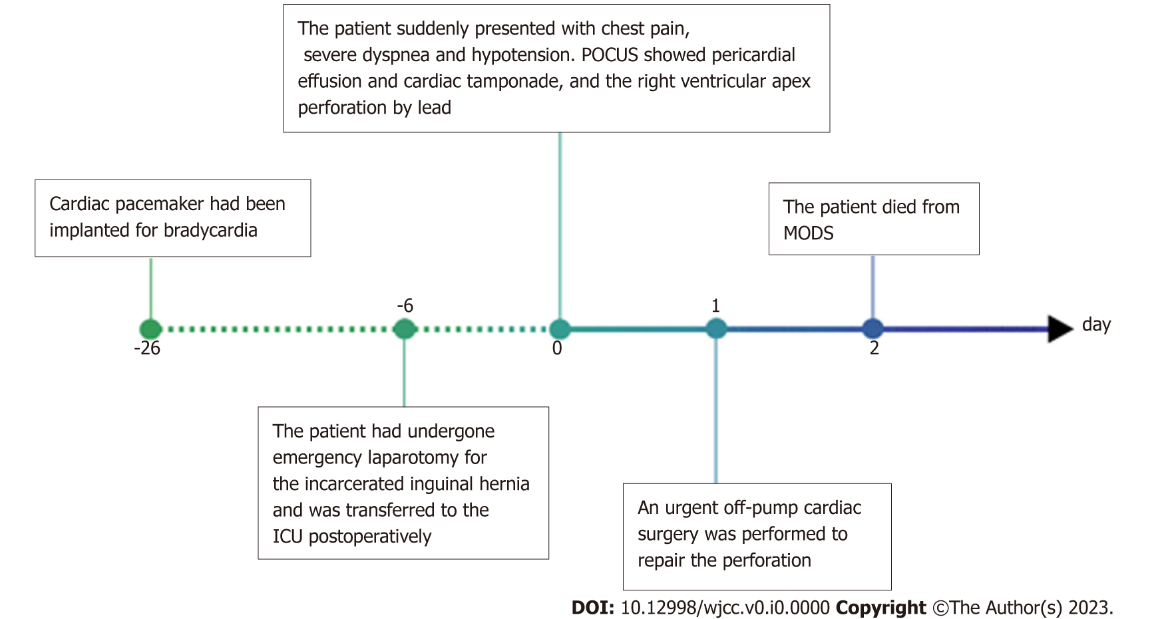
Figure 4 Timeline of the clinical course. ICU: Intensive care unit; POCUS: Point-of-care ultrasound; MODS: Multiple organ dysfunction syndrome.
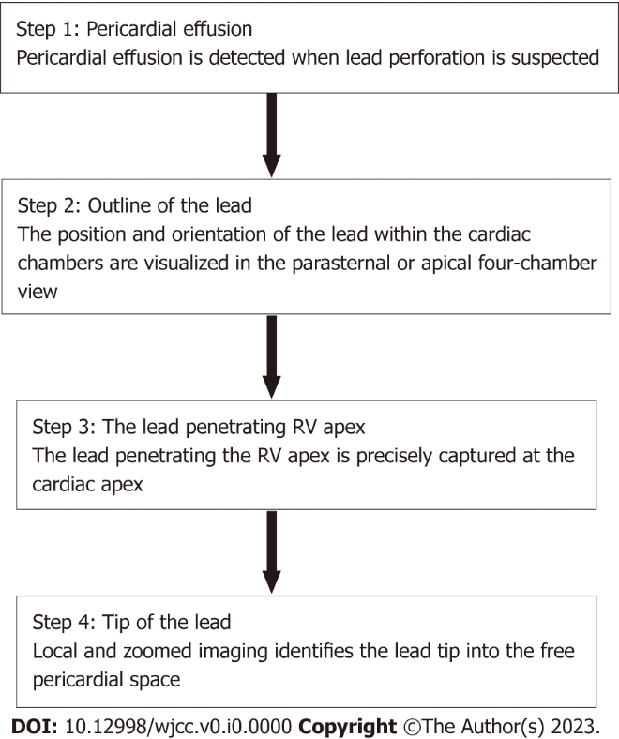
Figure 5 A step-wise approach for rapid diagnosis of lead-induced right ventricular apex perforation by point-of-care ultrasound. RV: Right ventricle.

Table 1 Laboratory values prior to and after the onset of heart perforation by lead
Variables | Results (prior to the onset) | Results (after the onset) | Normal range
White blood cells | 10.04 × 10⁹/L | 25.85 × 10⁹/L | 3.5-9.5 × 10⁹/L
Hemoglobin | 113 g/L | 103 g/L | 115-150 g/L
Platelets | 123 × 10⁹/L | 144 × 10⁹/L | 100-300 × 10⁹/L
Alanine aminotransferase | 12 IU/L | 2840 IU/L | 7-40 IU/L
Aspartate aminotransferase | 17 IU/L | 9650 IU/L | 13-35 IU/L
Creatinine | 0.67 mg/dL | 1.14 mg/dL | 0.34-1.02 mg/dL
Prothrombin time | 10.8 s | 27.2 s | 9-14 s
Activated partial thromboplastin time | 33.5 s | 36.9 s | 23-32 s
Myohemoglobin | Not tested | 201 ng/mL | 25-58 ng/mL
Hypersensitive troponin T | Not tested | 46.65 ng/L | < 14 ng/L

Table 2 Cases of right ventricular apex perforation by lead diagnosed using ultrasonography
Ref. | Age (yr)/Sex | Types of perforation | Pericardial effusion | Lead passing through RV wall | Lead tip location | Features on ultrasound
Vasavada et al^{[22]}, 2014 | 58/NM | Chronic | Positive | Positive | Pericardial space | Lead passing through the myocardium like a “spear”
Shen et al^{[23]}, 2006 | 97/Woman | Chronic | Positive | Positive | At the perforation | 3-D echo enhancing visualization of the pseudoaneurysm by lead
Stefanidis et al^{[24]}, 2009 | 83/Woman | Subacute | Positive | Positive | Pericardial space | 3-D echo confirming the lead perforation
Truscelli et al^{[25]}, 2011 | 68/Man | Acute | Positive | Positive | Pericardial space | Lead protrusion through myocardium of RV
Boxma et al ^{[26]}, 2017 | 77/Woman | Subacute | Negative | Positive | Pericardial space | Absence of pericardial effusion
Allouche et al^{[27]}, 2021 | 85/Woman | Subacute | Negative | Positive | Pericardial space | Absence of pericardial effusion
Abdelhafez et al^{[28]}, 2018 | 41/Woman | Acute | Positive | Positive | NM | NM
Ferrero-de-Loma-Osorio et al^{[29]}, 2009 | 27/Woman | Chronic | Positive | Positive | Pericardial space | Lead going in and out of RV  with each cardiac movement
Ramirez et al^{[30]}, 2007 | 68/Man | Chronic | Negative | Positive | NM | Absence of pericardial effusion
Addison et al^{[31]}, 2015 | 65/Man | Chronic | Positive | Positive | Pericardial space | NM
Hardzina et al^{[32]}, 2014 | 26/Woman | Chronic | Positive | Positive | Pericardial space | NM
Trehan et al^{[33]}, 2005 | 80/Woman | Acute | Positive | Positive | Pericardial space | NM
Velibey et al^{[34]}, 2017 | 92/Woman | Subacute | Positive | Positive | Pericardial space | NM
Chen and Ho^{[35]}, 2022 | 73/Man | Subacute | Positive | Positive | NM | Discontinuation of RV free wall
Sugano et al^{[36]}, 2012 | 73/Man | Acute | Positive | Positive | Pericardial space | 3-D echo confirming the lead perforation
Vandenberk et al^{[37]}, 2022 | 81/Man | Chronic | Positive | Positive | Epicardial fat | Lead projecting in the epicardial fat
Caiati et al^{[38]}, 2020 | 51/Man | Subacute | Positive | Positive | Pericardial space | Showing characteristics of the fixating screw and the electrode
Noguchi et al^{[39]}, 2017 | 62/Woman | Subacute | Positive | Positive | Pericardial space | NM
Nash et al^{[40]}, 2014 | 77/Woman | Acute | Positive | NM | Pericardial space | An echo bright structure within the pericardial effusion
Madanat et al^{[18]}, 2022 | 77/Woman | Chronic | Negative | Positive | Pericardial space | TEE showing the lead perforating through the apex
Velasco et al^{[41]}, 2014 | 90/Man | Chronic | Positive | Positive | Pericardial space | NM
Kourireche et al^{[42]}, 2017 | 47/Woman | Chronic | Positive | Positive | Pericardial space | NM
RV: Right ventricle; NM: Not mentioned; 3-D: Three-dimensional; TEE: Transesophageal echocardiography.

