Name of Journal: World Journal of Clinical Cases
Manuscript NO: 73929
Manuscript Type: CASE REPORT

Malignant transformation of primary mature teratoma of colon: A case report

Liu J et al. Malignant transformation, mature teratoma, colon

Jie Liu

Jie Liu, Department of Pathology, The First Affiliated Hospital of Anhui Medical University, Hefei 230000, Anhui Province, China

Author contributions: Liu J contributed to manuscript writing, picture processing, data analysis and constructive discussions.

Corresponding author: Jie Liu, MM, Doctor, Department of Pathology, The First Affiliated Hospital of Anhui Medical University, No. 218 Jixi Street, Shushan District, Hefei 230000, Anhui Province, China. lj_ayfy@126.com

Received: December 19, 2021
Revised: February 21, 2022
Accepted: May 27, 2022
Published online:

Abstract
BACKGROUND
Mature teratoma is a common benign ovarian germ cell tumor, accounting for about 20% of ovarian tumors. The malignant transformation of this tumor is less than 2%. The most common type is squamous cell carcinoma, followed by adenocarcinoma. Malignant transformation of colonic mature teratoma is extremely rare. We here report a case of malignant transformation of primary mature teratoma of the colon. The type of malignant transformation was adenocarcinoma.

CASE SUMMARY
A 63-year-old woman was admitted to our hospital due to persistent pain in her right lower abdomen for 1 mo, and she had no nausea, vomiting, blood in the stools, or other symptoms. Preoperative colonoscopy showed uplift of the sigmoid colon mucosa and submucosa. The biopsy showed squamous epithelium. However, contrast-enhanced computed tomography of abdomen and pelvis showed a localized thickening of the sigmoid wall, suggesting colon cancer. Endoscopic ultrasonography (EUS) revealed that the structure of the intestinal wall at the base of the lesion was destroyed, and the boundary between the lesion and the surroundings was unclear. According to the findings of the EUS, the patient did not undergo endoscopic submucosal dissection, but underwent radical resection of the tumor. Histologically, squamous epithelium was seen on the mucosal surface of the colon wall, cartilage and glands were seen under the epithelium, and adenocarcinoma was seen on the muscular layer and serous surface. The final pathological diagnosis was malignant teratoma of the colon. We have followed up the patient for 2 mo since the operation, and the patient recovered well.

CONCLUSION
This case suggests the possibility of mature teratoma in the colon and recognition of malignant types, and it should not be considered as an exclusively ovarian tumor.

Key Words: Colon; Mature teratoma; Malignant transformation; Adenocarcinoma; Squamous epithelium; Case report

Liu J. Malignant transformation of primary mature teratoma of colon: A case report. World J Clin Cases 2022; In press

Core Tip: Mature teratoma is a benign tumor that originates from germ cells. The most common site of mature teratoma is the ovaries, and it rarely occurs in the colorectum and rarely undergoes malignant transformation. We report a case of malignant transformation of mature teratoma of the sigmoid colon. Through the analysis of the symptoms, treatment and prognosis, clinicians and pathologists can be aware of the disease, and should prompt patients to receive early clinical intervention and treatment to obtain better therapeutic effect and prognosis.

INTRODUCTION
Mature teratoma is a common benign ovarian germ cell tumor, accounting for about 20% of ovarian tumors^{[1]}, and it rarely occurs in the colorectum and rarely undergoes malignant transformation^{[2]}. It is a benign tumor that originates from germ cells, and it derived from mature tissues of two or three germ layers of the inner, middle and ectodermal components. It usually occurs in the ovaries and testes, and sometimes occurs in the midline position, such as retroperitoneum and mediastinum. Teratomas that occur in the ovaries are mostly mature teratomas. The extragonadal teratomas are rare, with a rate of malignant transformation of less than 2%^{[3]}. Primary mature teratoma of the colon may be caused by abnormal migration of primordial germ cells and staying outside the gonads during embryogenesis^{[1]}.

CASE PRESENTATION
Chief complaints
A 63-year-old woman presented to our hospital, with persistent right lower abdominal pain.

History of present illness
The patient had on obvious cause for the sudden and persistent pain in the right lower abdomen 1 mo ago. She had no other symptoms such as nausea, vomiting, or bloody stools.

History of past illness
The patient had no previous medical history.

Personal and family history
The patient had no other significant history or family history.

Physical examination
The patient had deep tenderness in the right lower abdomen; bowel sounds 4 times/min, body temperature 36.5 °C, pulse 87 beats/min, breathing 20 beats/min, and blood pressure 138/78 mmHg.

Laboratory examinations
Blood analysis and urinalysis were normal, as were electrocardiography, chest radiography and arterial blood gas analysis.

Imaging examinations
Computed tomography (CT) showed limited thickening of the sigmoid colon wall, which made it difficult to exclude colon cancer (Figure 1A). Endoscopic ultrasound (EUS) showed a mixed echogenic mass in the bulge of the lesion, the structure of the intestinal wall at the base of the lesion was destroyed, and the boundary between the lesion and the surroundings was unclear (Figure 1B). Based on the findings of the EUS, the patient did not undergo endoscopic submucosal dissection. Colonoscopy showed mixed uplift of sigmoid colon mucosa and submucosa (Figure 1C and D), and the size of the bulge was about 2.5 cm × 2.5 cm × 2.5 cm. However, there was no evidence of cancerous tissue, and colonoscopic biopsy showed squamous epithelium. Besides, ultrasound results showed that the patients’ ovaries were tumor-free.

FINAL DIAGNOSIS
Gross specimen observation showed that a round bulge was seen in the colon mucosal layer, with a size of about 2.3 cm × 2.1 cm × 2.0 cm, the surface was smooth, the cut surface was yellow, the muscular and serosal layers of the intestinal wall were thickened and rigid, the lesion size was about 2.8 cm × 2.0 cm × 2.0 cm, and the cut surface was gray and solid (Figure 1E and F). Histopathological examination showed mature tissues derived from three germ layers and cancerous components in different layers of the sigmoid colon (Figure 2A). The squamous epithelium was seen in the mucosal layer of the colon (Figure 2B). The sebaceous glands (Figure 2C), cartilage and fat (Figure 2D), respiratory tract and digestive gland epithelium (Figure 2E and F) were seen in the submucosa of the colon. And the muscular layer and the serosal layer could be seen in poorly differentiated adenocarcinoma (Figure 2G). The final diagnosis was a primary mature malformation of the sigmoid colon with malignant transformation.

TREATMENT
Based on the CT and EUS findings, the patient underwent radical resection of the sigmoid colon tumor.

OUTCOME AND FOLLOW-UP
We followed the patient for 2 mo after operation. The patient recovered well.

DISCUSSION
Mature teratomas originate from germ cells, and the most common site is the ovaries, but it rarely occurs in the colon. Therefore, it should not be considered merely an ovarian tumor. The incidence of mature teratoma with malignant transformation is less than 2%^{[4,5]}, the most common type of malignant transformation is squamous cell carcinoma, which exceeds 80%, followed by adenocarcinoma^{[6,7]}. Colorectal primary mature teratoma is extremely rare, most of which is reported as individual cases, and mostly in the rectum. Cases of malignant transformation that originated in the colon have not been reported to date.
Most of the patients have abdominal pain, diarrhea and blood in the stools as symptoms, which are not different from those of other colorectal tumors. Ovarian teratomas are mostly cystic, while primary rectal teratomas are mostly solid^{[1]}. The tumor of the present patient was also solid, which is consistent with previous reports. Serological markers carbohydrate antigen (CA) 125, CA199 and carcinoembryonic antigen (CEA) are usually higher in malignant teratoma, but CA125 and CA199 can also be higher in benign diseases, thus, their diagnostic value is low^{[8]}. Studies have shown that an increase in serum CEA is related to the malignant transformation of mature teratoma into squamous cell carcinoma^{[8]}, and the serum CEA value of our patient was within the normal range, and CA125 and CA199 were not detected. In the future, we will test these serological markers for the confirmation of similar cases.
In the present case, the patient presented with persistent pain in the right lower abdomen. The colonoscopy only revealed a bulge on the intestinal mucosa with a regular shape and smooth surface. The biopsy result showed that it was squamous epithelium, and there was no evidence of a malignant tumor. Colonoscopy and biopsy results are confusing and can easily cause misunderstandings among clinicians. Therefore, for colon occupancy, teratoma should be highly suspected when squamous epithelium is seen in the biopsy sample. Mature teratoma originates from germ cells, but its malignant transformation occurs in somatic cells, which is essentially different from immature teratoma.
However, due to the rarity of colonic teratoma, it is easy to ignore this diagnosis. The diagnosis of primary colonic teratoma should be distinguished from the rupture of tumors locally involving teratomas in adjacent organs^{[3,9]}, such as mature ovarian teratoma. Imaging examination helps to distinguish between adjacent structures and tumors. The present case shows the only reported case of malignant transformation of a rectal mature teratoma that was distinguished from the rupture of a locally involved teratoma of an adjacent organ^{[1]}. There is no report of malignant transformation of a colonic teratoma. Therefore, diagnosis of this tumor becomes important for prognosis. It also accumulates data for understanding the malignant transformation of colorectal mature teratoma.
Moreover, no follow-up for this disease was made prior to this diagnosis, our case report has some limitations. In the case of malignant transformation of mature teratoma of the colorectum, surgical resection is the first choice. Our patient underwent radical mastectomy and was in good health 2 mo after the operation. We will continue to follow up the patient.

CONCLUSION
Primary mature colorectal teratomas are extremely rare, and the possibility of teratomas should be considered when squamous epithelium is seen in the biopsy specimen. The diagnosis of malignant transformation of mature teratoma should be distinguished from local involvement of the teratoma of the adjacent organs and rupture of the tumor. Complete resection is the first choice of treatment. Our patient underwent radical mastectomy and was in good health after the operation. We will continue to follow up the patient.

ACKNOWLEDGEMENTS
We thank the endoscopy center of our hospital for providing the data related to this case.

REFERENCES
1 Tseng CJ, Chou HH, Huang KG, Chang TC, Liang CC, Lai CH, Soong YK, Hsueh S, Pao CC. Squamous cell carcinoma arising in mature cystic teratoma of the ovary. Gynecol Oncol 1996; 63: 364-370 [PMID: 8946873 DOI: 10.1006/gyno.1996.0337]
2 Nam KH, Kim B. Primary Mature Teratoma of the Rectum: A Case Report. Am J Case Rep 2021; 22: e930272 [PMID: 33518697 DOI: 10.12659/AJCR.930272]
3 Gooneratne AT, James AO, Gupta J, Abdulaal Y. Squamous cell carcinoma arising in a mature cystic teratoma invading the sigmoid colon: a rare presentation. BMJ Case Rep 2015; 2015 [PMID: 25935913 DOI: 10.1136/bcr-2014-208472]
4 Ribeiro G, Hughesdon P, Wiltshaw E. Squamous carcinoma arising in dermoid cysts and associated with hypercalcemia: a clinicopathologic study of six cases. Gynecol Oncol 1988; 29: 222-230 [PMID: 3276581 DOI: 10.1016/0090-8258(88)90216-8]
5 Lai PF, Hsieh SC, Chien JC, Fang CL, Chan WP, Yu C. Malignant transformation of an ovarian mature cystic teratoma: computed tomography findings. Arch Gynecol Obstet 2005; 271: 355-357 [PMID: 15551144 DOI: 10.1007/s00404-004-0676-0]
6 Belaid I, Khechine W, Ben Abdelkader A, Bedioui A, Ezzairi F, Chabchoub I, Boujnah R, Tlili T, Hochlaf M, Ben Fatma L, Mokni M, Ben Ahmed S. Adenocarcinoma of intestinal type arising in mature cystic teratoma of ovary: A diagnostic dilemma. Clin Case Rep 2020; 8: 644-647 [PMID: 32274027 DOI: 10.1002/ccr3.2718]
7 Chiang AJ, Chen MY, Weng CS, Lin H, Lu CH, Wang PH, Huang YF, Chiang YC, Yu MH, Chang CL. Malignant transformation of ovarian mature cystic teratoma into squamous cell carcinoma: a Taiwanese Gynecologic Oncology Group (TGOG) study. J Gynecol Oncol 2017; 28: e69 [PMID: 28657230 DOI: 10.3802/jgo.2017.28.e69]
8 Hackethal A, Brueggmann D, Bohlmann MK, Franke FE, Tinneberg HR, Münstedt K. Squamous-cell carcinoma in mature cystic teratoma of the ovary: systematic review and analysis of published data. Lancet Oncol 2008; 9: 1173-1180 [PMID: 19038764 DOI: 10.1016/S1470-2045(08)70306-1]
9 Bužinskienė D, Mongirdas M, Mikėnas S, Drąsutienė G, Andreika L, Sakalauskaitė I. Chemical peritonitis resulting from spontaneous rupture of a mature ovarian cystic teratoma: a case report. Acta Med Litu 2019; 26: 217-226 [PMID: 32355460 DOI: 10.6001/actamedica.v26i4.4207]

Footnotes
Informed consent statement: Written informed consent was obtained from the patient for publication of this case report and accompanying images.

Conflict-of-interest statement: The author has no conflict of interest to disclose.

CARE Checklist (2016) statement: The author has read the CARE Checklist (2016), and the manuscript was prepared and revised according to the CARE Checklist (2016).

Open-Access: This article is an open-access article that was selected by an in-house editor and fully peer-reviewed by external reviewers. It is distributed in accordance with the Creative Commons Attribution NonCommercial (CC BY-NC 4.0) license, which permits others to distribute, remix, adapt, build upon this work non-commercially, and license their derivative works on different terms, provided the original work is properly cited and the use is non-commercial. See: https://creativecommons.org/Licenses/by-nc/4.0/

Provenance and peer review: Unsolicited article; Externally peer reviewed.
Peer-review model: Single blind

Peer-review started: December 19, 2021
First decision: February 8, 2022
Article in press:

Specialty type: Pathology
Country/Territory of origin: China
Peer-review report’s scientific quality classification
Grade A (Excellent): 0
Grade B (Very good): B, B
Grade C (Good): C
Grade D (Fair): 0
Grade E (Poor): 0

P-Reviewer: Abdalla AN, Saudi Arabia; Farouk S, Egypt; Nakaji K, Japan A-Editor: Liu X, China S-Editor: Chang KL L-Editor: A P-Editor:

Figure Legends
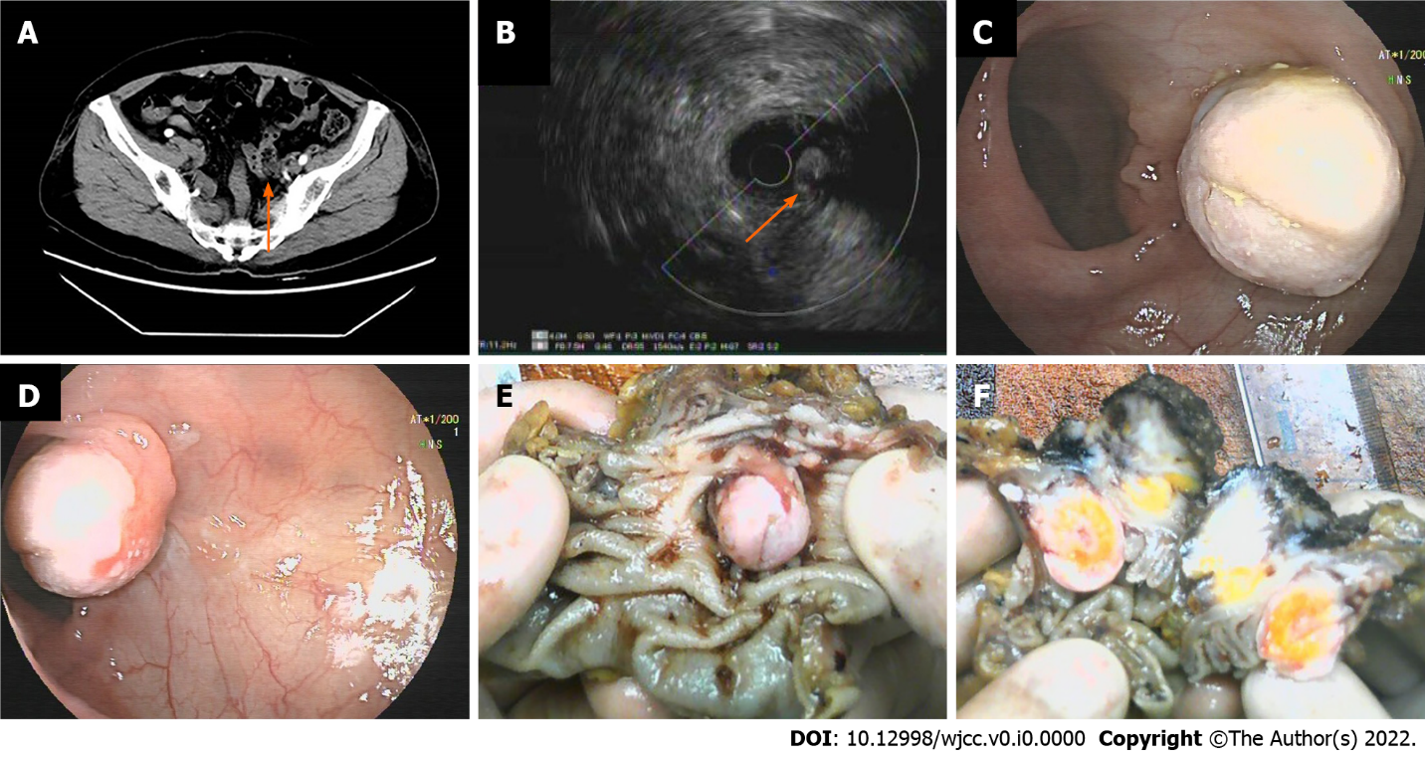
Figure 1 Computed tomography, endoscopic ultrasonography, preoperative colonoscopy and gross specimen pictures. A: Computed tomography scan revealed that the sigmoid colon wall was thick (arrow); B: Endoscopic ultrasonography showed a mixed echogenic mass in the bulge of the lesion, and the structure of the intestinal wall at the base of the lesion was destroyed (arrow); C and D: Preoperative enteroscopic examination showed a mixed bulge in the intestinal mucosa and submucosa; E and F: Postoperative gross specimens showed a round bulge in the colon mucosa and submucosa, the cut surface was yellow, the muscular layer and the serosal layer of the intestinal wall were thickened and rigid.

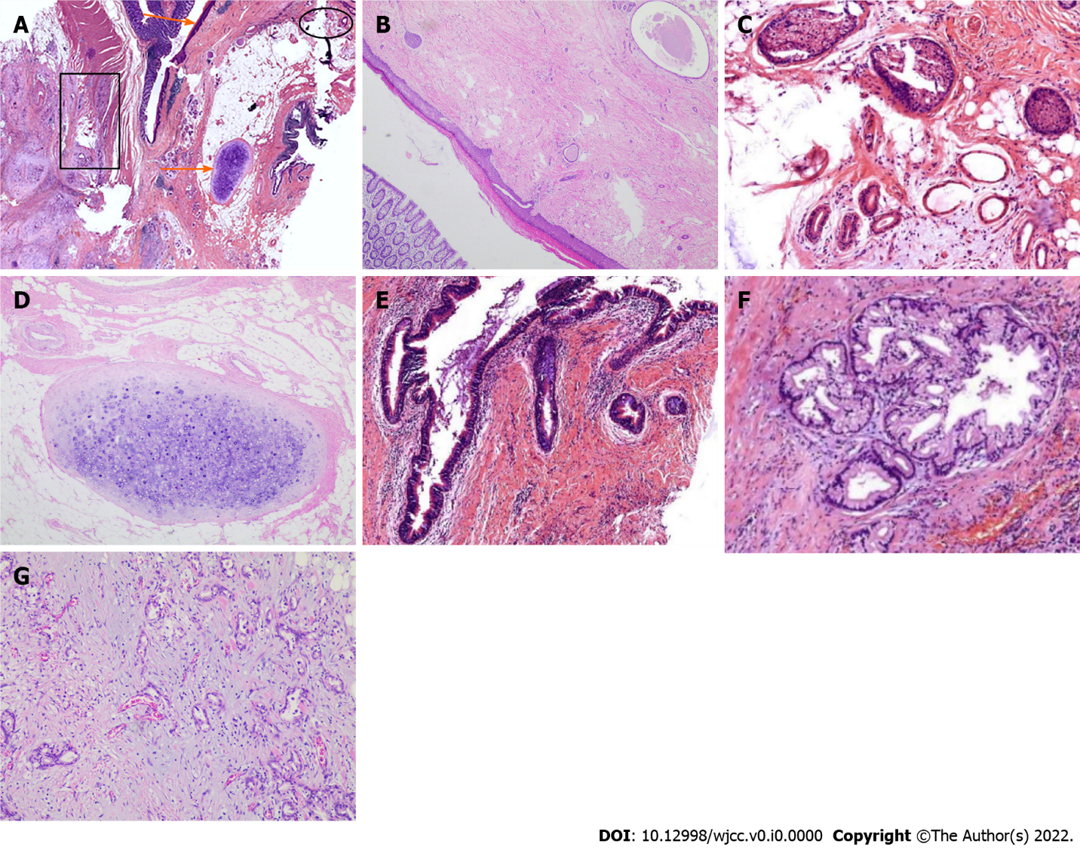
Figure 2 Histological images with hematoxylin and eosin stain. A: Panoramic view of the mass, squamous epithelium (upper orange arrow), sebaceous glands (elliptical outline), cartilage and adipose tissue (lower orange arrow), adenocarcinoma (rectangular outline); B: Squamous epithelium (× 100); C: Sebaceous glands and sweat glands (× 100); D: Cartilage and adipose tissue (× 100); E: Respiratory tract epithelium (× 100); F: Digestive gland epithelium (× 100); G: Moderately–poorly differentiated adenocarcinoma (× 100).

