Name of Journal: World Journal of Orthopedics
Manuscript NO: 61761
Manuscript Type: MINIREVIEWS

Dual antibiotic loaded bone cement in patients at high infection risks in arthroplasty: Rationale of use for prophylaxis and scientific evidence

Berberich CE et al. Minireview prophylactic efficacy of dual ALBC

Christof Ernst Berberich, Jérôme Josse, Frédéric Laurent, Tristan Ferry

Christof Ernst Berberich, Department of Medical Training, Heraeus Medical GmbH, Wehrheim 612173, Hessen, Germany

Jérôme Josse, Frédéric Laurent, Tristan Ferry, Institut des Sciences Pharmaceutiques et Biologiques de Lyon (ISPB), International Center for Research in Infectiology, Inserm U1111, CNRS UMR5308, ENS de Lyon, UCBL1, Lyon 69008, France

Jérôme Josse, Frédéric Laurent, Tristan Ferry, Interregional Reference Center for the Management of Complex Osteo-Articular Infections, Hospices Civils de Lyon, Lyon 69008, France

Frédéric Laurent, Bacteriology Laboratory, Institute of Infectious Agents, Croix-Rousse Hospital, Hospices Civils de Lyon, Lyon 69008, France

Tristan Ferry, Infectious and Tropical Diseases Department, Croix-Rousse Hospital, Hospices Civils de Lyon, Lyon 69008, France

Author contributions: Berberich CE and Josse J have performed the literature and data analysis and have made substantial contributions to the drafting of the manuscript; Ferry T and Laurent F have made substantial contributions to the interpretation of the data and final approval of the manuscript.

Corresponding author: Christof Ernst Berberich, MSc, PhD, Lecturer, Senior Scientist, Department of Medical Training, Heraeus Medical GmbH, Philipp-Reis-Str. 8/11, Wehrheim 612173, Hessen, Germany. christof.berberich@heraeus.com

Received: December 18, 2020
Revised: January 20, 2021
Accepted: March 8, 2021
Published online: March 18, 2021

Abstract
In view of the demographic changes and projected increase of arthroplasty procedures worldwide, the number of prosthetic joint infection cases will naturally grow. Therefore, in order to counteract this trend more rigid rules and a stricter implementation of effective preventive strategies is of highest importance. In the absence of a “miracle weapon” priorities should lie in evidence-based measures including preoperative optimization of patients at higher infection risks, the fulfilment of strict hygiene rules in the operating theatre and an effective antibiotic prophylaxis regimen. Instead of a “one size fits all” philosophy, it has been proposed to adjust the antibiotic prophylaxis protocol to major infection risks taking into account important patient- and procedure-related risk factors. A stronger focus on the local application mode via use of high dose dual antibiotic-loaded bone cement in such risk situations may have its advantages and is easy to apply in the theatre. The more potent antimicrobial growth inhibition in vitro and the strong reduction of the prosthetic joint infection rate in risk for infection patients with aid of dual antibiotic-loaded bone cement in clinical studies align with this hypothesis.

Key Words: Prosthetic joint infection; Antibiotic-loaded bone cement; Single low dose antibiotic-loaded bone cement; Dual high dose antibiotic-loaded bone cement; Antibiotic prophylaxis; Risk-for-infection patients

©The Author(s) 2021. Published by Baishideng Publishing Group Inc. All rights reserved.

Berberich CE, Josse J, Laurent F, Ferry T. Dual antibiotic loaded bone cement in patients at high infection risks in arthroplasty: Rationale of use for prophylaxis and scientific evidence. World J Orthop 2021; 12(3): 119-128 URL: https://www.wjgnet.com/2218-5836/full/v12/i3/119.htm DOI: https://dx.doi.org/10.5312/wjo.v12.i3.119

Core Tip: The objective of an effective antibiotic prophylaxis in arthroplasty may be best achieved through the combination of a systemic and local application route via antibiotic-loaded bone cement. Based on the observation of strong synergistic effects in antibiotic elution and antimicrobial efficacy of dual antibiotic-loaded bone cements, the hypothesis of a clinically more meaningful prophylaxis has been tested against gentamicin-only containing bone cements. Evidence is provided that this easy-to-apply strategy might be successful, if important comorbidities or procedure-related factors predispose patients to higher infection risks than usual.
INTRODUCTION
Prosthetic joint infection (PJI) is one of the most dreadful complications of arthroplasty. Effective prophylactic strategies are essential to reduce the incidence of these difficult to treat and burdensome infections. The mode of prophylactic use of antibiotic-loaded bone cement (ALBC) is a frequent surgical practice in cemented hip and knee replacement. The idea behind delivering antibiotics directly into the vulnerable joint compartment is that local concentrations well above the minimum inhibitory concentration of the pathogen can be achieved without exposing the patient to major risks of side effects. With this mechanism ALBC may form an additional antimicrobial frontline in situ and complement the routine systemic antibiotic prophylaxis. The combined systemic and local antibiotic administration may be even more important in situations where the efficacy of the systemic prophylaxis is experiencing increasing limitations due to the spread of resistant bacteria to the commonly used perioperative antibiotics cefazolin or cefuroxime^{[1,2]}. The Scandinavian registries and, most recently, the National Registry of United Kingdom have demonstrated that the additional use of ALBC reduces the revision risk in cemented hip and knee replacement^{[3-6]}. It can be further speculated that this effect is more significant if specific cement brands are analyzed due to different antibiotic elution capacities of the cement polymers in commercial ALBC brands^{[7,8]}.
In view of the demographic changes, arthroplasty surgeons today face the challenge to operate on an increasing number of older patients suffering from several major comorbidities. Numerous clinical studies have provided evidence that important patient-related disorders predispose patients to a higher operational risk of infections than on average^{[9-11]}. This is also true for the more complex surgical procedures of revision arthroplasty which is frequently associated with longer operation times and a higher invasiveness leading to a PJI incidence of 5% and more^{[12]}. Significantly increased infection rates of 4%-6% are also reported in the frail cohort of femoral neck fracture (FNF) patients on an emergency trauma track which does not leave time for preoperative health optimization strategies or for decolonization protocols of multi-drug resistant bacteria^{[13,14]}. In order to counteract the higher infection risks in such patient cohorts, one may hypothesize that a more optimized and risk-adjusted antibiotic prophylaxis strategy may have a positive impact on the PJI incidence. This may include (1) modification of the routine perioperative antibiotic prophylaxis regimen by either extending the duration^{[15]} or by adding a second antibiotic to the standard drug (e.g., vancomycin or teicoplanin to a cephalosporin)^{[16]} or (2) use of high dose local antibiotic combinations. Given the controversial outcomes regarding the first option and the substantial risks of side effects associated with prolonged systemic antibiotic exposure^{[17]}, a risk-adjusted strategy with dual ALBC might be a more attractive and “easy-to-apply” option in the theatre. The more potent antimicrobial growth inhibition found in vitro and the significantly reduced PJI rates in high infection risk patients receiving dual ALBC strongly argue for the latter option. This review summarizes the literature and evaluates the evidence from preclinical and clinical studies for the use of dual ALBC for PJI prevention in risk for infection patients and orthopaedic risk procedures. For that purpose, the PubMed and EMBASE literature databases were screened for publications pertaining to the clinical utilization of dual antibiotics in cement for infection prophylaxis. Use of dual ALBC in treatment of septic cases was excluded from the evaluation. Only four in vitro and five original clinical studies were identified which met the inclusion criteria. The latter were also stratified by level of clinical evidence (I-IV). The combination of gentamicin and clindamycin in commercial bone cement was the only referenced dual ALBC in these clinical studies. To the best of our knowledge there are no clinical outcome studies published which have compared the PJI rate in hand-made (theatre-admixed) dual ALBC vs single ALBC.

COMMERCIALLY PREMIXED VS HAND-MIXED DUAL ALBC
There are several Food and Drug Administration and European Medicines Agency approved ALBC which are available as “ready-to-use” commercial products. According to their antibiotic contents they can be grouped in single low dose ALBC [e.g., impregnated with either 0.5 g or 1 g of gentamicin or loaded with 1 g of tobramycin in 40 g polymethyl methacrylate (PMMA) powder] or in dual high dose ALBC (e.g., impregnated with 1 g of gentamicin and 1 g of clindamycin or loaded with 0.5 g of gentamicin and 2 g of vancomycin). In addition, there is widespread non-standardized, off-label and surgeon-directed use involving hand-mixing various antibiotics into bone cement. Reasons for this practice are economic considerations, lack of availability of specific ALBC, limited local regulatory approval or need for specific customized solutions in septic revision arthroplasty^{[18]}. However, manual admixture of antibiotics into bone cement has raised some concerns with regards to unknown elution kinetics, toxicity, efficacy and mechanical stability of such in-theatre made ALBC^{[18]}. The latter aspect is particularly important if the cement is intended for fixation. In fact, the manual addition of higher amounts of some antibiotics in powder- or in liquid-form has been shown to affect the fatigue strength of PMMA prompting fears of premature aseptic loosening of the joint^{[19]}. It should also be noted that some antibiotics are not stable at the bone cement curing temperature (e.g., many beta-lactam antibiotics) or chemically interfere with the polymerization process (e.g., rifampicin)^{[20]}. Given these uncertainties, the majority of surgeons still prefer the use of commercial single or dual ALBC for prosthesis fixation.

stronger antimicrobial activity with the dual ALBC COPAL gentamicin + clindamycin in vitro
Gentamicin is the most frequently used antibiotic for impregnating bone cement because of its broad and concentration-dependent bactericidal effect, its relatively good elution in comparison to other antibiotics and its ability to withstand the high temperatures reached during polymerization of the bone cement^{[21]}. Its antimicrobial spectrum covers non-gentamicin resistant gram-positive staphylococci, enterococci and several gram-negative bacilli^{[22]}. Clindamycin is also an attractive antibiotic for local delivery which shares several features of gentamicin, but shows in addition a potent antimicrobial activity against intraosteoblastic Staphylococcus aureus^{[23]}. Its spectrum overlaps with gentamicin on staphylococci and furthermore covers non-clindamycin resistant streptococci and anaerobic bacteria^{[24]}. In combination, both antibiotics may target up to 90% of all pathogens typically found in PJI^{[25,26]}. Given these antibiotic properties it is therefore not surprising that a dual ALBC bone cement using these antibiotics has been developed. This bone cement COPAL G+C (gentamicin + clindamycin) (Heraeus-Medical GmbH, Wehrheim, Germany) is simultaneously loaded with 1.68 g of gentamicin sulfate (= 1 g of active gentamicin) and 1.18 g of clindamycin hydrochloride (= 1 g of active clindamycin) within the polymer basis of the successful PALACOS bone cement. Soon after the commercialization of COPAL G+C, Kuehn et al^{[7]} and Neut et al^{[27]} compared the antibiotic elution from this product with several single antibiotic loaded low dose cement brands on the market in two independent studies. It was found that COPAL G+C exhibited a much stronger synergistic release of both antibiotics exceeding that of gentamicin alone in single ALBC by a factor of at least 10^{[7,27]}.
Ensing et al^{[28]} then combined these elution experiments with antimicrobial growth inhibition tests comparing the dual high dose COPAL G+C and the single low dose PALACOS R+G cement (containing 0.5 g of gentamicin). For that purpose, antibiotic-containing eluates from bone cement samples were collected at different time points and spotted onto agar plates which had been priorly inoculated either with a gentamicin-sensitive Staphylococcus aureus or with a gentamicin-resistant coagulase-negative Staphylococcus epidermidis strain. Both bacterial test strains were originally derived from PJI patients. COPAL G+C was observed to inhibit bacterial growth much more strongly when compared to PALACOS R+G. In more detail, the single low dose ALBC was effective in inhibiting growth of the gentamicin-sensitive Staphylococcus aureus for a period of 72 h of elution. However, the G+C containing cement yielded a stronger and more prolonged bacterial inhibition for at least 28 d, which was the entire duration of the experiment. In case of the gentamicin-resistant Staphylococcus epidermidis strain PALACOS R+G was not able to inhibit the bacteria while COPAL G+C prevented growth of these bacteria at all times after elution.
Cara et al^{[29]} expanded on these studies and compared the inhibitory effect on staphylococcal biofilm formation of plain cement (no antibiotic) with the three ready-to-use commercial ALBC brands PALACOS R+G, COPAL G+C and COPAL G+V (the latter contains a combination of 0.5 g gentamicin and 2 g vancomycin, Heraeus Medical GmbH, Wehrheim, Germany). In total, ten different strains of Staphylococcus aureus and Staphylococcus epidermidis, some with specific resistance to gentamicin, were analyzed. It was observed that all the tested ALBC can inhibit biofilm formation of methicillin-susceptible staphylococci (without antibiotic resistances) up to day 9 (end of observation period). However, the inhibition of the dual ALBC brands at day 9 appeared more potent and sustained than that of the single ALBC product (Figure 1A). Strong antimicrobial effect of all 3 ALBC — at least up to day 3 — was also evident for methicillin-resistant staphylococci if they were still susceptible to gentamicin. However, a strong difference could be noticed for such strains which were highly resistant to gentamicin. In these cases, only the dual loaded products were able to exert a potent anti-biofilm activity with a tendency of even stronger and longer lasting inhibition for the G+C combination (Figure 1B). The most reliable and most sustained inhibition effect of the G+C combination against gentamicin-resistant coagulase-negative staphylococci is of important clinical relevance since regular antibiotic surveillance data from several countries point to an increasing gentamicin resistance level of these bacteria^{[30]}.

Lower PJI rate with dual ALBC (COPAL G+C) — hemiarthroplasty in FNF patients
These promising in vitro observations with dual ALBC prompted surgeons at the Northumbria NHS Trust hospitals in the United Kingdom to test the hypothesis of a clinically more meaningful infection prophylaxis with COPAL G+C in the setting of a randomized clinical trial. For this they chose the particularly frail patient cohort of FNF patients known to suffer from higher infection risks. The study comprised of 848 patients with intracapsular fractures who were treated with cemented hemiarthroplasty according to the United Kingdom trauma guidelines. It was found that the primary study endpoint, incidence of deep surgical site infections (SSI), was significantly lower in the intervention group receiving the dual ALBC COPAL G+C (1.1% deep SSI rate) compared to the standard group receiving the single low dose ALBC PALACOS R+G (3.5% deep SSI rate, P = 0.041, evidence level I, Figure 2)^{[31]}. If also considering the number of superficial SSI occurring in both groups, the difference was even more significant (1.7% in the intervention group vs 5.3% in control group). Tyas et al^{[32]} later extended the patient number from this randomized study and analyzed 1941 FNF-patients in the same way. The lower PJI rate in the dual ALBC group was maintained (1.2% vs 3.4%). Savage et al^{[33]} independently reported a PJI rate of 0% in the dual ALBC FNF-patient cohort vs 2.9% in the single ALBC group. This study compared bone cements from two different manufacturers in a mixed prospective and retrospective study design (n = 206), (evidence level II).
Concerns that the use of a dual antibiotic loaded cement with higher drug content may trigger more antibiotic-mediated side effects in these fragile patient cohorts could not be confirmed. In fact, the comparison of complications including renal failure or percentage of Clostridium difficile infections did not reveal differences between the standard and intervention group^{[31]}. There was even a statistically significant decrease in the need for critical care treatment in the COPAL G+C group (0.5% vs 4.7%) reflecting the clinical impact of the much lower PJI rate in the intervention group receiving dual ALBC^{[31]}.

lower PJI rate with dual ALBC (COPAL G+C) — aseptic knee revision arthroplasty
Inspired by the promising results from the FNF studies, Sanz-Ruiz et al^{[34]} tested the study hypothesis of a more potent infection prophylaxis with the dual ALBC COPAL G+C in the field of aseptic revision knee arthroplasty. All septic and oncologic revision causes were excluded in this study. On basis of 246 patients analyzed in this retrospective study no case of PJI was observed in the COPAL G+C group compared to six cases occurring in the PALACOS R+G group (PJI rate = 4.1%, P = 0.035, evidence level III). The use of the dual ALBC in all patients undergoing aseptic revision arthroplasty was further found to be cost-effective despite the additional cost of dual ALBC. A hospital saving of approximately 1200 € per patient was calculated due to 3.9 avoided PJI cases per 100 aseptic knee revision patients^{[34]}.

lower PJI rate with dual ALBC (COPAL G+C) — risk for infection patients in primary arthroplasty
Sanz-Ruiz and Berberich^{[35]} further analyzed the infection rate in presumed risk for infection patients by comparing the influence of single ALBC vs dual ALBC on the PJI incidence after primary cemented joint replacement. Patients were defined as risk for infection individuals if they presented a combination of at least two or three major risk factors for total hip arthroplasty and total knee arthroplasty, respectively, using a simple scoring system. The risk algorithm included specific patient-related comorbidities (e.g., severe anemia, severe obesity, diabetes mellitus, chronic immunosuppression) and further general risk factors (e.g., hip-fractures or prior arthroplasty surgeries)^{[35]}. The study analyzed 2551 patients and found a trend towards fewer PJI cases in the dual ALBC (COPAL G+C) group containing exclusively patients at higher infection risk compared to the mixed risk profile (low and high risk) in the single ALBC (PALACOS R+G) group (PJI rate 2.45% vs 3.7%) (level of evidence III/IV). This was a particularly interesting observation as one would expect an even higher PJI incidence in the higher infection risk cohort of patients. Further studies are needed to confirm whether this trend to fewer PJI cases in presumed risk for infection patients can be generalized on a broader basis for dual ALBC.

lower rate of re-revisions with dual ALBC in spacer and/or fixation cement for revision prosthesis — septic revision arthroplasty
For many surgeons it is common clinical practice to use ALBC for the manufacture of block or articulating spacers in staged PJI treatment protocols and/or for the fixation of the revision prosthesis. Such ALBC spacers are meant to prevent bacterial recolonization of the foreign body and assist in the successful eradication of the infected joint in combination with systemic antibiotics. In order to increase the depot effect of the local antibiotics and to counteract the risk of antibiotic resistances in septic cases, the use of combinations of local antibiotics has been suggested^{[36]}. The selection of antibiotics should be based on the antibiogram of the PJI organisms found after culture of synovial fluid and tissue biopsies. Vancomycin is the most common antibiotic added to aminoglycoside-containing single ALBC either in form of commercial dual ALBC brands or manually admixed in the theatre. The rationale of its use is to further target gentamicin-resistant methicillin-resistant Staphylococcus aureus (MRSA) and methicillin-resistant Staphylococcus epidermidis (MRSE). pathogens which are frequent in some regions, such as the United States^{[37]}. Although several questions remain regarding optimal dosage for the possible therapeutic effects on biofilm-bacteria and/or contribution to renal injury if admixing large amounts of antibiotics into cement^{[18,36]}, its contribution to successful infection eradication appears conclusive^{[38]}. Wouthuyzen-Bakker et al^{[39]} have recently demonstrated on a large number of PJI cases to which extent the addition of vancomycin into the cement spacer influences the amount of growth-positive cultures taken at reimplantation of the revision prosthesis. The rate of unsterile biopsies dropped from 21.7% to 9.5% if combinations of vancomycin and gentamicin in the cement were used instead of aminoglycoside monotherapy spacers. On a single bacteria level, the strongest antimicrobial effect by such dual ALBC spacers was evident for coagulase-negative staphylococci (reduction of growth-positive samples from 13.3% to 2.5%).
Abdelaziz et al^{[40]} have also provided evidence that the strategy of using the broad spectrum dual ALBC COPAL G+C (with or without additional admixing of vancomycin or ofloxacin) led to complete cure of PJI in one-stage treatment protocols. At five years follow-up, no patient required a repeated revision arthroplasty with exchange of the cemented prosthesis because of either infection or loosening. This was particularly remarkable as 33% of the included PJI cases in this study were caused by polymicrobial infections.

CONCLUSION
The current literature including in vitro and in vivo studies supports the additional benefits of dual ALBC, with synergy of drug elution and improved antibacterial activity on a wide range of pathogens related to orthopedic infections. While its therapeutic efficacy on mature biofilm-bacteria is still not entirely clear, more and more data have now demonstrated that it may confer better protection from infection in particularly vulnerable patients or in higher risk procedures (see Figure 3 for summary of clinical evidence). However, this conclusion is based on a mix of prospective and retrospective cohort studies, the latter with a lower evidence level and inherent limitations with regard to possible study bias and higher risk of confounding factors. A generalization of the observed effect of a stronger antibiotic prophylaxis by dual ALBC may also be problematic given that the ready-to-use brands of bone cements differ in their antibiotic elution properties as well as in the nature and amount of pre-mixed antibiotics.
The idea of an infection risk-adapted antibiotic prophylaxis strategy may be one interesting option among other preoperative optimization protocols to decrease the burden of PJI. In addition to the use of dual ALBC this can also be achieved by temporary or permanent antibacterial implant coatings including surface modifications with silver ions or manual spreading of a fast-resorbable, antibiotic-loaded hydrogel^{[41]}. Both strategies have been shown to reduce early post-surgical infections in uncemented implants in orthopedic surgery. Further studies are needed to truly elucidate the effect of dual ALBC and other local antibiotic delivery systems for infection prevention and to weigh possible benefits against potential adverse effects and costs.

REFERENCES
1 Hickson CJ, Metcalfe D, Elgohari S, Oswald T, Masters JP, Rymaszewska M, Reed MR, Sprowson AP. Prophylactic antibiotics in elective hip and knee arthroplasty: an analysis of organisms reported to cause infections and National survey of clinical practice. Bone Joint Res 2015; 4: 181-189 [PMID: 26585304 DOI: 10.1302/2046-3758.411.2000432]
2 Nodzo SR, Boyle KK, Frisch NB. Nationwide Organism Susceptibility Patterns to Common Preoperative Prophylactic Antibiotics: What Are We Covering? J Arthroplasty 2019; 34: S302-S306 [PMID: 30745218 DOI: 10.1016/j.arth.2019.01.017]
3 Engesaeter LB, Lie SA, Espehaug B, Furnes O, Vollset SE, Havelin LI. Antibiotic prophylaxis in total hip arthroplasty: effects of antibiotic prophylaxis systemically and in bone cement on the revision rate of 22,170 primary hip replacements followed 0-14 years in the Norwegian Arthroplasty Register. Acta Orthop Scand 2003; 74: 644-651 [PMID: 14763692 DOI: 10.1080/00016470310018135]
4 Jämsen E, Huhtala H, Puolakka T, Moilanen T. Risk factors for infection after knee arthroplasty. A register-based analysis of 43,149 cases. J Bone Joint Surg Am 2009; 91: 38-47 [PMID: 19122077 DOI: 10.2106/JBJS.G.01686]
5 Jameson SS, Asaad A, Diament M, Kasim A, Bigirumurame T, Baker P, Mason J, Partington P, Reed M. Antibiotic-loaded bone cement is associated with a lower risk of revision following primary cemented total knee arthroplasty: an analysis of 731,214 cases using National Joint Registry data. Bone Joint J 2019; 101-B: 1331-1347 [PMID: 31674244 DOI: 10.1302/0301-620X.101B11.BJJ-2019-0196.R1]
6 Leong JW, Cook MJ, O'Neill TW, Board TN. Is the use of antibiotic-loaded bone cement associated with a lower risk of revision after primary total hip arthroplasty? Bone Joint J 2020; 102-B: 997-1002 [PMID: 32731820 DOI: 10.1302/0301-620X.102B8.BJJ-2020-0120.R1]
7 Kuehn KD, Ege W, Gopp U. Acrylic bone cements: composition and properties. Orthop Clin North Am 2005; 36: 17-28, v [PMID: 15542119 DOI: 10.1016/j.ocl.2004.06.010]
8 Sanz-Ruiz P, Matas-Diez JA, Sanchez-Somolinos M, Villanueva-Martinez M, Vaquero-Martín J. Is the Commercial Antibiotic-Loaded Bone Cement Useful in Prophylaxis and Cost Saving After Knee and Hip Joint Arthroplasty? The Transatlantic Paradox. J Arthroplasty 2017; 32: 1095-1099 [PMID: 27919578 DOI: 10.1016/j.arth.2016.11.012]
9 Lenguerrand E, Whitehouse MR, Beswick AD, Kunutsor SK, Foguet P, Porter M, Blom AW; National Joint Registry for England, Wales, Northern Ireland and the Isle of Man. Risk factors associated with revision for prosthetic joint infection following knee replacement: an observational cohort study from England and Wales. Lancet Infect Dis 2019; 19: 589-600 [PMID: 31005559 DOI: 10.1016/S1473-3099(18)30755-2]
10 Marmor S, Kerroumi Y. Patient-specific risk factors for infection in arthroplasty procedure. Orthop Traumatol Surg Res 2016; 102: S113-S119 [PMID: 26867708 DOI: 10.1016/j.otsr.2015.05.012]
11 Kunutsor SK, Whitehouse MR, Blom AW, Beswick AD; INFORM Team. Patient-Related Risk Factors for Periprosthetic Joint Infection after Total Joint Arthroplasty: A Systematic Review and Meta-Analysis. PLoS One 2016; 11: e0150866 [PMID: 26938768 DOI: 10.1371/journal.pone.0150866]
12 Quinlan ND, Werner BC, Brown TE, Browne JA. Risk of Prosthetic Joint Infection Increases Following Early Aseptic Revision Surgery of Total Hip and Knee Arthroplasty. J Arthroplasty 2020; 35: 3661-3667 [PMID: 32712119 DOI: 10.1016/j.arth.2020.06.089]
13 de Jong L, Klem TMAL, Kuijper TM, Roukema GR. Factors affecting the rate of surgical site infection in patients after hemiarthroplasty of the hip following a fracture of the neck of the femur. Bone Joint J 2017; 99-B: 1088-1094 [PMID: 28768787 DOI: 10.1302/0301-620X.99B8.BJJ-2016-1119.R1]
14 Gallardo-Calero I, Larrainzar-Coghen T, Rodriguez-Pardo D, Pigrau C, Sánchez-Raya J, Amat C, Lung M, Carrera L, Corona PS. Increased infection risk after hip hemiarthroplasty in institutionalized patients with proximal femur fracture. Injury 2016; 47: 872-876 [PMID: 26857632 DOI: 10.1016/j.injury.2015.12.032]
15 DeFrancesco CJ, Fu MC, Kahlenberg CA, Miller AO, Bostrom MP. Extended Antibiotic Prophylaxis May Be Linked to Lower Peri-prosthetic Joint Infection Rates in High-Risk Patients: An Evidence-Based Review. HSS J 2019; 15: 297-301 [PMID: 31624486 DOI: 10.1007/s11420-019-09698-8]
16 Tornero E, García-Ramiro S, Martínez-Pastor JC, Bori G, Bosch J, Morata L, Sala M, Basora M, Mensa J, Soriano A. Prophylaxis with teicoplanin and cefuroxime reduces the rate of prosthetic joint infection after primary arthroplasty. Antimicrob Agents Chemother 2015; 59: 831-837 [PMID: 25403662 DOI: 10.1128/AAC.03949-14]
17 Courtney PM, Melnic CM, Zimmer Z, Anari J, Lee GC. Addition of Vancomycin to Cefazolin Prophylaxis Is Associated With Acute Kidney Injury After Primary Joint Arthroplasty. Clin Orthop Relat Res 2015; 473: 2197-2203 [PMID: 25421958 DOI: 10.1007/s11999-014-4062-3]
18 Iarikov D, Demian H, Rubin D, Alexander J, Nambiar S. Choice and doses of antibacterial agents for cement spacers in treatment of prosthetic joint infections: review of published studies. Clin Infect Dis 2012; 55: 1474-1480 [PMID: 22918993 DOI: 10.1093/cid/cis735]
19 Dunne N, Hill J, McAfee P, Todd K, Kirkpatrick R, Tunney M, Patrick S. In vitro study of the efficacy of acrylic bone cement loaded with supplementary amounts of gentamicin: effect on mechanical properties, antibiotic release, and biofilm formation. Acta Orthop 2007; 78: 774-785 [PMID: 18236183 DOI: 10.1080/17453670710014545]
20 Samara E, Moriarty TF, Decosterd LA, Richards RG, Gautier E, Wahl P. Antibiotic stability over six weeks in aqueous solution at body temperature with and without heat treatment that mimics the curing of bone cement. Bone Joint Res 2017; 6: 296-306 [PMID: 28515059 DOI: 10.1302/2046-3758.65.BJR-2017-0276.R1]
21 Chang Y, Tai CL, Hsieh PH, Ueng SW. Gentamicin in bone cement: A potentially more effective prophylactic measure of infectionin joint arthroplasty. Bone Joint Res 2013; 2: 220-226 [PMID: 24128666 DOI: 10.1302/2046-3758.210.2000188]
22 Krause KM, Serio AW, Kane TR, Connolly LE. Aminoglycosides: An Overview. Cold Spring Harb Perspect Med 2016; 6 [PMID: 27252397 DOI: 10.1101/cshperspect.a027029]
23 Valour F, Trouillet-Assant S, Riffard N, Tasse J, Flammier S, Rasigade JP, Chidiac C, Vandenesch F, Ferry T, Laurent F. Antimicrobial activity against intraosteoblastic Staphylococcus aureus. Antimicrob Agents Chemother 2015; 59: 2029-2036 [PMID: 25605365 DOI: 10.1128/AAC.04359-14]
24 Spízek J, Rezanka T. Lincomycin, clindamycin and their applications. Appl Microbiol Biotechnol 2004; 64: 455-464 [PMID: 14762701 DOI: 10.1007/s00253-003-1545-7]
25 Peel TN, Cheng AC, Buising KL, Choong PF. Microbiological aetiology, epidemiology, and clinical profile of prosthetic joint infections: are current antibiotic prophylaxis guidelines effective? Antimicrob Agents Chemother 2012; 56: 2386-2391 [PMID: 22314530 DOI: 10.1128/AAC.06246-11]
26 Osmon DR. Microbiology and Antimicrobial Challenges of Prosthetic Joint Infection. J Am Acad Orthop Surg 2017; 25 Suppl 1: S17-S19 [PMID: 27922947 DOI: 10.5435/JAAOS-D-16-00639]
27 Neut D, de Groot EP, Kowalski RS, van Horn JR, van der Mei HC, Busscher HJ. Gentamicin-loaded bone cement with clindamycin or fusidic acid added: biofilm formation and antibiotic release. J Biomed Mater Res A 2005; 73: 165-170 [PMID: 15761830 DOI: 10.1002/jbm.a.30253]
28 Ensing GT, van Horn JR, van der Mei HC, Busscher HJ, Neut D. Copal bone cement is more effective in preventing biofilm formation than Palacos R-G. Clin Orthop Relat Res 2008; 466: 1492-1498 [PMID: 18338216 DOI: 10.1007/s11999-008-0203-x]
29 Cara A, Ballet M, Hemery C, Ferry T, Laurent F, Josse J. Antibiotics in Bone Cements Used for Prosthesis Fixation: An Efficient Way to Prevent Staphylococcus aureus and Staphylococcus epidermidis Prosthetic Joint Infection. Front Med (Lausanne) 2020; 7: 576231 [PMID: 33553196 DOI: 10.3389/fmed.2020.576231]
30 Molina-Manso D, del Prado G, Ortiz-Pérez A, Manrubia-Cobo M, Gómez-Barrena E, Cordero-Ampuero J, Esteban J. In vitro susceptibility of Staphylococcus aureus and Staphylococcus epidermidis isolated from prosthetic joint infections. J Antibiot (Tokyo) 2012; 65: 505-508 [PMID: 22854340 DOI: 10.1038/ja.2012.62]
31 Sprowson AP, Jensen C, Chambers S, Parsons NR, Aradhyula NM, Carluke I, Inman D, Reed MR. The use of high-dose dual-impregnated antibiotic-laden cement with hemiarthroplasty for the treatment of a fracture of the hip: The Fractured Hip Infection trial. Bone Joint J 2016; 98-B: 1534-1541 [PMID: 27803231 DOI: 10.1302/0301-620X.98B11.34693]
32 Tyas B, Marsh M, Oswald T, Refaie R, Molyneux C, Reed M. Antibiotic resistance profiles of deep surgical site infections in hip hemiarthroplasty; comparing low dose single antibiotic vs high dose dual antibiotic impregnated cement. J Bone Jt Infect 2018; 3: 123-129 [PMID: 30013893 DOI: 10.7150/jbji.22192]
33 Savage P, McCormick M, Al-Dadah O. Arthroplasty infection rates in fractured neck of femur: single vs dual antibiotic cement. Ann R Coll Surg Engl 2019; 101: 514-518 [PMID: 31155899 DOI: 10.1308/rcsann.2019.0054]
34 Sanz-Ruiz P, Matas-Diez JA, Villanueva-Martínez M, Santos-Vaquinha Blanco AD, Vaquero J. Is Dual Antibiotic-Loaded Bone Cement More Effective and Cost-Efficient Than a Single Antibiotic-Loaded Bone Cement to Reduce the Risk of Prosthetic Joint Infection in Aseptic Revision Knee Arthroplasty? J Arthroplasty 2020; 35: 3724-3729 [PMID: 32682594 DOI: 10.1016/j.arth.2020.06.045]
35 Sanz-Ruiz P, Berberich C. Infection Risk-Adjusted Antibiotic Prophylaxis Strategies in Arthroplasty: Short Review of Evidence and Experiences of a Tertiary Center in Spain. Orthop Res Rev 2020; 12: 89-96 [PMID: 32821178 DOI: 10.2147/ORR.S256211]
36 Anagnostakos K. Therapeutic Use of Antibiotic-loaded Bone Cement in the Treatment of Hip and Knee Joint Infections. J Bone Jt Infect 2017; 2: 29-37 [PMID: 28529862 DOI: 10.7150/jbji.16067]
37 Aggarwal VK, Bakhshi H, Ecker NU, Parvizi J, Gehrke T, Kendoff D. Organism profile in periprosthetic joint infection: pathogens differ at two arthroplasty infection referral centers in Europe and in the United States. J Knee Surg 2014; 27: 399-406 [PMID: 24414388 DOI: 10.1055/s-0033-1364102]
38 Langlais F. Can we improve the results of revision arthroplasty for infected total hip replacement? J Bone Joint Surg Br 2003; 85: 637-640 [PMID: 12892181]
39 Wouthuyzen-Bakker M, Kheir MM, Moya I, Rondon AJ, Kheir M, Lozano L, Parvizi J, Soriano A. Failure After 2-Stage Exchange Arthroplasty for Treatment of Periprosthetic Joint Infection: The Role of Antibiotics in the Cement Spacer. Clin Infect Dis 2019; 68: 2087-2093 [PMID: 30281077 DOI: 10.1093/cid/ciy851]
40 Abdelaziz H, von Förster G, Kühn KD, Gehrke T, Citak M. Minimum 5 years' follow-up after gentamicin- and clindamycin-loaded PMMA cement in total joint arthroplasty. J Med Microbiol 2019; 68: 475-479 [PMID: 30702418 DOI: 10.1099/jmm.0.000895]
41 Romanò CL, Malizos K, Capuano N, Mezzoprete R, D'Arienzo M, Van Der Straeten C, Scarponi S, Drago L. Does an Antibiotic-Loaded Hydrogel Coating Reduce Early Post-Surgical Infection After Joint Arthroplasty? J Bone Jt Infect 2016; 1: 34-41 [PMID: 28529851 DOI: 10.7150/jbji.15986]

Footnotes
Conflict-of-interest statement: All authors have nothing to disclose.

Open-Access: This article is an open-access article that was selected by an in-house editor and fully peer-reviewed by external reviewers. It is distributed in accordance with the Creative Commons Attribution NonCommercial (CC BY-NC 4.0) license, which permits others to distribute, remix, adapt, build upon this work non-commercially, and license their derivative works on different terms, provided the original work is properly cited and the use is non-commercial. See: http://creativecommons.org/Licenses/by-nc/4.0/

Manuscript source: Invited manuscript

Peer-review started: December 18, 2020
First decision: January 11, 2021
Article in press: March 8, 2021

Specialty type: Orthopedics
Country/Territory of origin: Germany
Peer-review report’s scientific quality classification
Grade A (Excellent): 0
Grade B (Very good): 0
Grade C (Good): C
Grade D (Fair): D
Grade E (Poor): 0

P-Reviewer: Veltman ES, Weng X S-Editor: Gao CC L-Editor: A P-Editor: Xing YX

Figure Legends
A
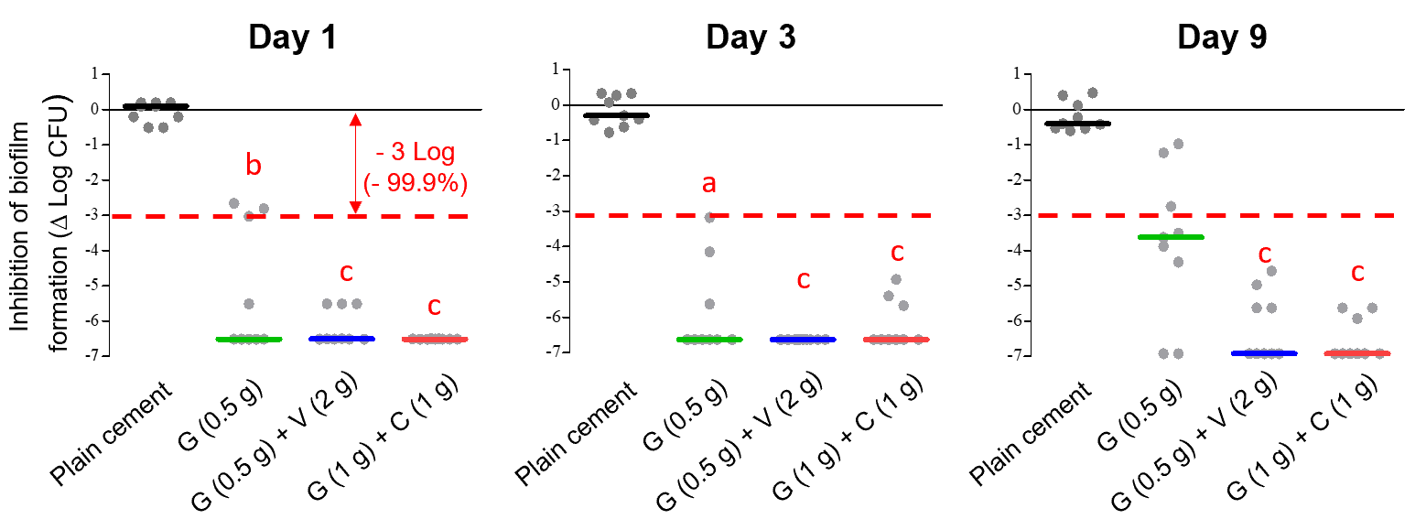
B
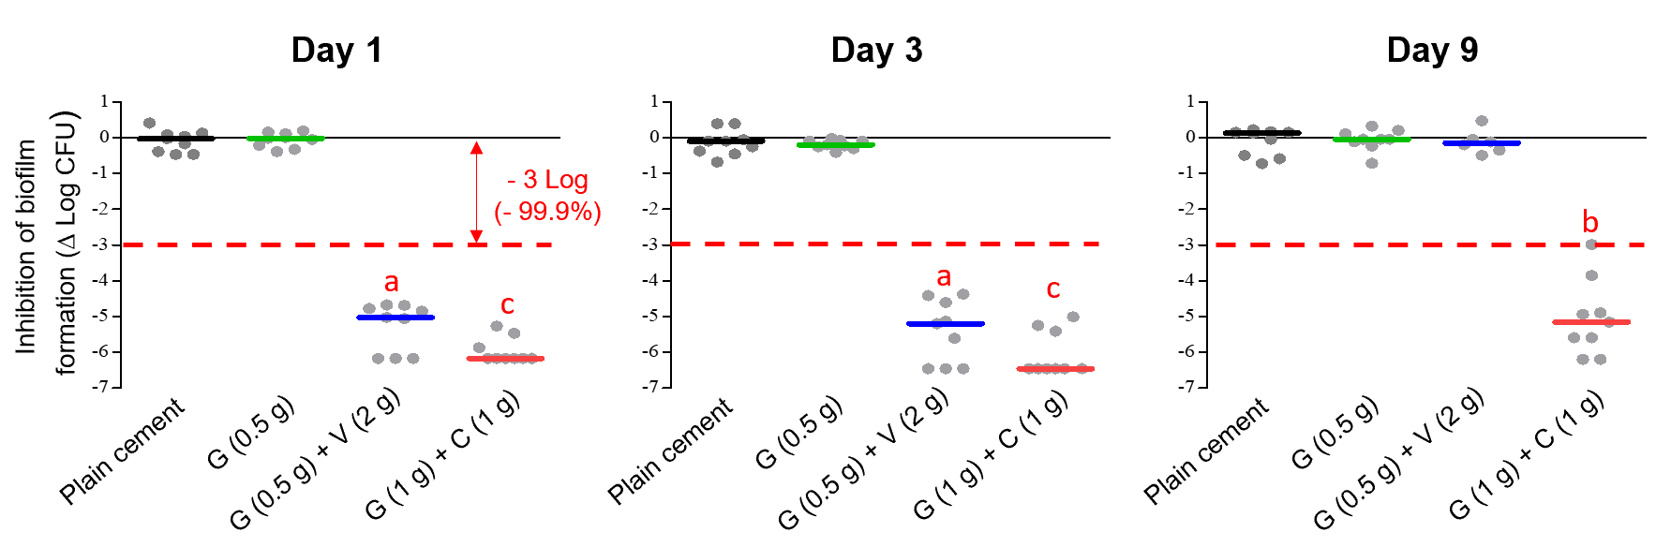
Figure 1 In vitro biofilm inhibition experiments with different bone cement types (plain, single and dual antibiotic-loaded bone cement). A: Prophylactic anti-biofilm effect of three different antibiotic-loaded bone cements against a gentamicin and methicillin-susceptible Staphyloccus aureus strain at day 1, day 3 and day 9 on basis of three independent experiments; B: Prophylactic anti-biofilm effect of three different antibiotic-loaded bone cements against a gentamicin- and methicillin-resistant Staphylococcus epidermidis strain on basis of three independent experiments. ªP < 0.05, ^{b}P < 0.01, or ^{c}P < 0.001 respectively in comparison with PALACOS R (cement without antibiotic). G: Gentamicin; C: Clindamycin; V: Vancomycin.
A
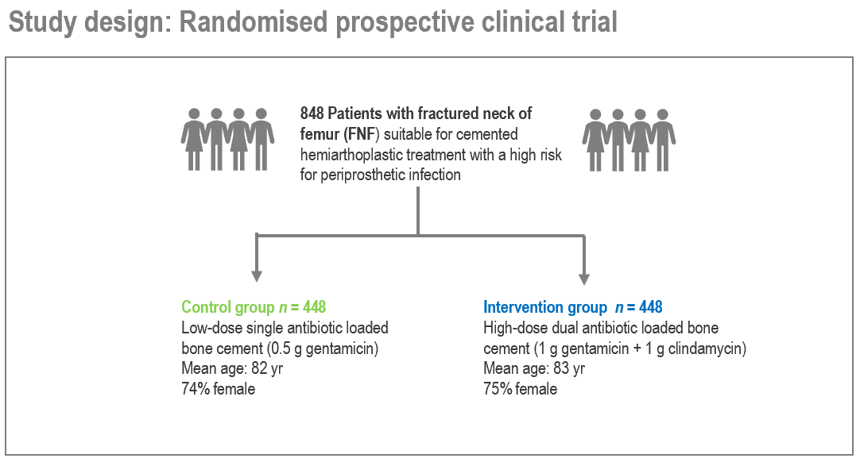
B
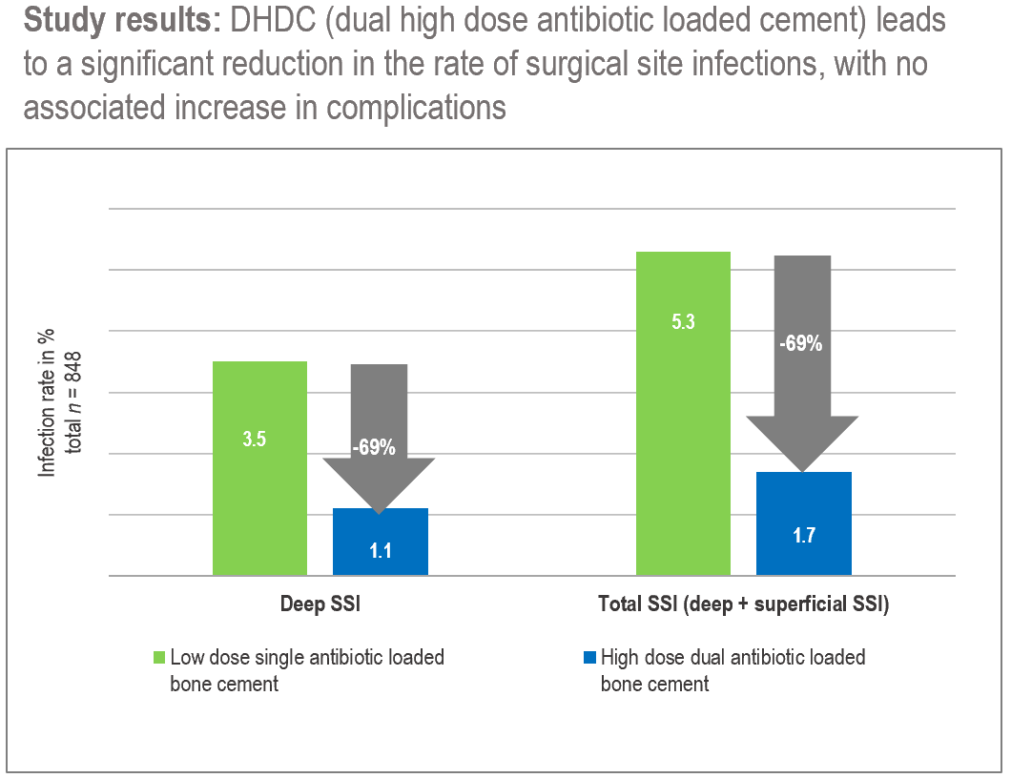
Figure 2 Randomized clinical trial in femoral neck fracture patients comparing prosthetic joint infection rate in low dose single antibiotic loaded bone cement group with high dose dual antibiotic loaded bone cement group. A: Study design, 848 patients were randomised to receive either hemiprostheses cemented with a low dose single antibiotic-loaded bone cement (PALACOS R + gentamicin = control group) or with a high dose dual antibiotic-loaded bone cement (COPAL gentamicin + clindamycin = intervention group); B: Study results: Primary endpoint was the deep surgical site infection rate (SSI) in the observation period of ≥ 1 yr in each group. Secondary endpoint was the rate of superficial SSI. For the calculation of the total SSI, both deep and superficial SSI cases in each group were combined. SSI: Surgical site infection.
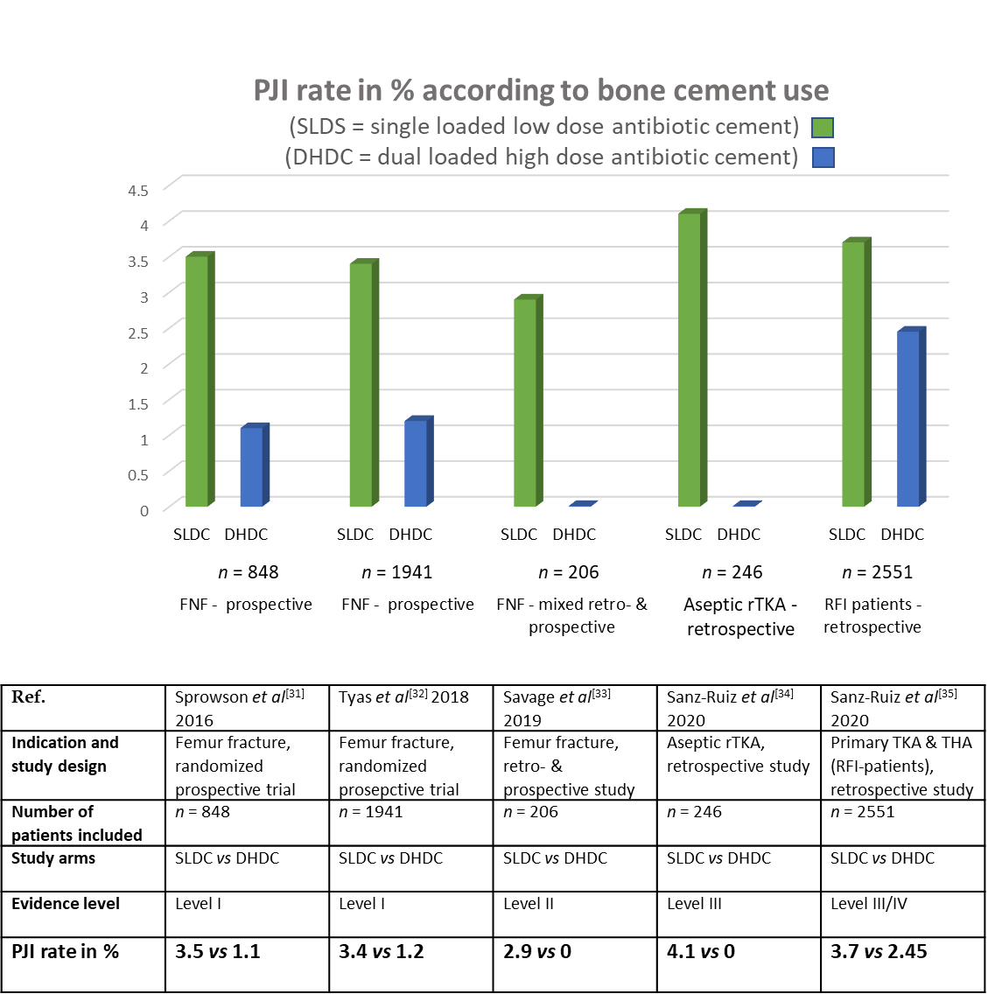
Figure 3 Overview of published clinical study results comparing prosthetic joint infection rate in patients in single low dose cement and dual high dose cement group across different indications. The table below lists the main study authors, indication and study design, number of patients included, evidence level of clinical study and prosthetic joint infection rate in % in both study groups. PJI: Prosthetic joint infection; SLDC: Single low dose cement = PALACOS R+G (containing 0.5 g of gentamicin); DHDC: Dual high dose cement = COPAL G+C (gentamicin + clindamycin); FNF: Femoral neck fracture; rTKA: Revision total knee arthroplasty; RFI: Risk for infection; THA: Total hip arthroplasty.

Published by Baishideng Publishing Group Inc
7041 Koll Center Parkway, Suite 160, Pleasanton, CA 94566, USA
Telephone: +1-925-3991568
E-mail: bpgoffice@wjgnet.com
Help Desk: https://www.f6publishing.com/helpdesk
https://www.wjgnet.com

© 2021 Baishideng Publishing Group Inc. All rights reserved.

