Name of Journal: World Journal of Hepatology
Manuscript NO: 81123
Manuscript Type: ORIGINAL ARTICLE

Basic Study
mRNA transcriptome profiling of human hepatocellular carcinoma cells HepG2 treated with Catharanthus roseus-silver nanoparticles

Azhar NA et al. Transcriptome profiling of HepG2 treated with C. roseus-AgNPs

Nur Asna Azhar, Siti Aishah Abu Bakar, Marimuthu Citartan, Nor Hazwani Ahmad

Nur Asna Azhar, Siti Aishah Abu Bakar, Marimuthu Citartan, Nor Hazwani Ahmad, Department of Biomedical Science, Advanced Medical and Dental Institute, Universiti Sains Malaysia, Kepala Batas 13200, Pulau Pinang, Malaysia

Nur Asna Azhar, Nor Hazwani Ahmad, Liver Malignancies Research Program, Advanced Medical and Dental Institute, Universiti Sains Malaysia, Kepala Batas 13200, Pulau Pinang, Malaysia

Siti Aishah Abu Bakar, Faculty of Bioresources and Food Industry, Universiti Sultan Zainal Abidin, Besut Campus, Besut 22200, Terengganu, Malaysia

Author contributions: Ahmad NH contributed to the methodology; Ahmad NH contributed to the validation; Azhar NA contributed to the conceptualisation; Azhar NA and Abu Bakar SA contributed to the formal analysis; Azhar NA contributed to the investigation; Ahmad NH contributed to the resources; Azhar NA, Abu Bakar SA, Citartan M and Ahmad NH contributed to the data curation; Azhar NA contributed to original draft preparation; Ahmad NH and Citartan M contributed to the review and editing; Ahmad NH and Citartan M contributed to the supervision; Ahmad NH contributed to project administration; Ahmad NH contributed to funding acquisition; all authors have read and agreed to the published version of the manuscript.

Supported by Fundamental Research Grant Scheme from the Malaysian Ministry of Higher Education, No. FRGS/1/2015/SG03/USM/03/1.

Corresponding author: Nor Hazwani Ahmad, PhD, Senior Lecturer, Department of Biomedical Science, Advanced Medical and Dental Institute, Universiti Sains Malaysia, Jalan Tun Hamdan Sheikh Tahir, Kepala Batas 13200, Pulau Pinang, Malaysia. norhazwani@usm.my

Received: October 27, 2022
Revised: January 17, 2023
Accepted: March 3, 2023
Published online: March 27, 2023

Abstract
BACKGROUND
The demand for the development of cancer nanomedicine has increased due to its great therapeutic value that can overcome the limitations of conventional cancer therapy. However, the presence of various bioactive compounds in crude plant extracts used for the synthesis of silver nanoparticles (AgNPs) makes its precise mechanisms of action unclear.

AIM
To assessed the mRNA transcriptome profiling of human HepG2 cells exposed to Catharanthus roseus G. Don (C. roseus)-AgNPs.

METHODS
The proliferative activity of hepatocellular carcinoma (HepG2) and normal human liver (THLE3) cells treated with C. roseus-AgNPs were measured using MTT assay. The RNA samples were extracted and sequenced using BGIseq500 platform. This is followed by data filtering, mapping, gene expression analysis, differentially expression genes analysis, Gene Ontology analysis, and pathway analysis.

RESULTS
The mean IC₅₀ values of C. roseus-AgNPs on HepG2 was 4.38 ± 1.59 μg/mL while on THLE3 cells was 800 ± 1.55 μg/mL. Transcriptome profiling revealed an alteration of 296 genes. C. roseus-AgNPs induced the expression of stress-associated genes such as MT, HSP and HMOX-1. Cellular signalling pathways were potentially activated through MAPK, TNF and TGF pathways that are responsible for apoptosis and cell cycle arrest. The alteration of ARF6, EHD2, FGFR3, RhoA, EEA1, VPS28, VPS25, and TSG101 indicated the uptake of C. roseus-AgNPs via both clathrin-dependent and clathrin-independent endocytosis.

CONCLUSION
This study provides new insights into gene expression study of biosynthesised AgNPs on cancer cells. The cytotoxicity effect is mediated by the aberrant gene alteration, and more interestingly the unique selective antiproliferative properties indicate the C. roseus-AgNPs as an ideal anticancer candidate.

Key Words: Catharanthus roseus; HepG2; Silver nanoparticles; Transcriptome; oxidative stress; Apoptosis; Cell cycle

©The Author(s) 2023. Published by Baishideng Publishing Group Inc. All rights reserved.

Citation: Azhar NA, Abu Bakar SA, Citartan M, Ahmad NH. mRNA transcriptome profiling of human hepatocellular carcinoma cells HepG2 treated with Catharanthus roseus-silver nanoparticles. World J Hepatol 2023; 15(3): 393-409
URL: https://www.wjgnet.com/1948-5182/full/v15/i3/393.htm
DOI: https://dx.doi.org/10.4254/wjh.v15.i3.393

Core Tip: Despite the increased attention on cancer nanomedicine which is advantageous to overcome the limitations of conventional cancer treatment, the information on the selectivity and detailed mechanisms at the cellular and molecular level remain unclear. To evaluate its selectivity effects, the proliferative activity of both liver cancer cells HepG2 and normal liver cells THLE-3 in response to Catharanthus roseus-silver nanoparticles (C. roseus-AgNPs) was assessed. To determine the possible signalling pathways induced by the C. roseus-AgNPs, the mRNA transcriptome profiling of hepatocellular carcinoma cell line HepG2 was performed, highlighting the expression of genes associated with oxidative stress, apoptosis, and cell cycle arrest. The elucidation of its selectivity effects and detailed wide genome screening would enlighten the cellular and molecular signalling pathways and provide a strong basis towards the development of C. roseus-AgNPs as an anticancer drug for liver cancer.

INTRODUCTION
Nanoparticles are materials or discrete clusters of atoms having dimensions within 1-100 nm^{[1]}. Having a large surface area-to-volume ratio with unique biological properties, nanoparticles have gained immense usage in the early diagnosis and treatment of cancer, the application of which is termed nano oncology^{[2,3]}. Nanoparticles can offer an alternative to the current conventional chemotherapeutic agents which although exhibit high efficacy in killing cancer cells, still suffer from significant drawbacks due to the poor specificity in causing severe damage to healthy cells^{[4]}. Amongst various nanoparticles, silver nanoparticles (AgNPs) have been reported to demonstrate a significant biological effect, particularly in the healthcare industry^{[5,6]}. Concurrently, the market demand for eco-friendly, hazard-free, and cost-effective synthesis of AgNPs was higher as many of the common nanoparticle production methods involved hazardous chemicals and high energy- consumption^{[7]}. One of the most effective biogenic approaches is to use plant extract that contains metabolites, which can enhance the reduction of silver ions. Plant extract-mediated silver nanoparticle synthesis is found to have a promising anticancer property. Plant extract-based synthesis is largely favoured due to the lower degree of adverse effect as well as the low cost of synthesis that enables large-scale production. Moreover, biologically active ingredients or phytomolecules in the plant extract act as reducing agents to promote the synthesis of AgNPs^{[8]}. A previous study has corroborated the anticancer property of AgNPs, for example, biosynthesised AgNPs using Acalypha Indica, which exhibited anti-cancer activity against human breast cancer cell line MDA-MB-231^{[9]}. In another study, AgNPs synthesised using leaf extract of Tropaeolum majus L. also demonstrated anti-cancer properties on the MCF7 cell line^{[10]}. These findings cumulatively proved the anti-cancer property of the biogenic AgNPs.
Previously, an herbal plant Catharanthus roseus (C. roseus) G. Don has demonstrated its ability as a reducing agent to synthesise AgNPs. This plant is commonly known as periwinkle which belongs to the Apocynaceae family^{[11]}. This plant is very synonymous with its content, indolomonoterpenic alkaloids vincristine and vinblastine^{[12]}. These compounds are commonly used in the treatment of several malignant conditions, such as Hodgkin’s and non-Hodgkin’s lymphomas, acute lymphoblastic leukaemia, neuroblastoma and breast carcinoma^{[13]}. These alkaloids may be responsible for the reduction of the silver ions to AgNPs and at the same time exert their function by disrupting the mitotic spindle apparatus of microtubules through tubulin interaction, thus blocking the mitosis process, and arresting the cancer cells during metaphase^{[14]}.
An understanding of the anti-cancer mechanisms of AgNPs at the molecular level would provide detailed insight into various physiological processes involved. This is achievable via transcriptome analysis, a holistic view of gene expression. An overview or snapshot of the gene expression landscape could reveal the intricate molecular network that underlies the myriad of biological processes in a cell. As compared to hybridisation-based RNA quantification methods such as microarray analysis, this sequencing-based transcriptome detection can perform well within a wide range of circumstances, where this method could quantify gene expression with low background, high accuracy, and high reproducibility levels with significant dynamic range transcriptome analysis can detect subtle changes in gene expression, mutations, splice variants and fusion genes that cannot be identified by microarrays^{[15]}.
Fuelled by the intriguing capacity of the transcriptome analysis, in this study, we endeavoured to carry out an mRNA transcriptome profiling of the human hepatocellular carcinoma cell (HepG2) treated with AgNPs synthesised using an aqueous extract of C. roseus G. Don. The human hepatocellular carcinoma cell (HepG2) was used as a representative in vitro cancer cell line model, due to its known well-characterised property of cell line and its wide usage in many toxicity studies for screening hepatotoxic compounds^{[16]}. To the best of our knowledge, there was no study reported on the transcriptome profiling of cancer cells treated with plant extract-mediated synthesised AgNPs. As such, this study is the first study that focuses on the transcriptome profiling of cancer cells treated with AgNPs synthesised using plant extract. This study can be a significant step in identifying potential genes that are regulated by the treatment of C. roseus-AgNPs on HepG2 cells, which will lead to the establishment of the underlying molecular network of the mechanistic actions of the AgNPs.

MATERIALS AND METHODS
Preparation of cell line
The hepatocellular carcinoma cell line HepG2 used in this study was purchased from American Type Culture Collection (ATCC, Cat. HB-8065™, Rockville, MD, United States). Complete RPMI-1640 medium supplemented with 10% heat-inactivated foetal bovine serum, 1% penicillin-streptomycin (v/v) and 1% L-glutamine (v/v) was used to culture and maintain the cells. All the reagents were purchased from Nacalai Tesque (Kyoto, Japan). Meanwhile, a normal liver cell line (THLE-3) (ATCC) was cultured in Bronchial Epithelial Cell Growth Basal Medium (Lonza, Basel, Switzerland) supplemented with frozen additives without gentamycin/Amphotericin and Epinephrine, 5 ng/mL EGF, 70 ng/mL Phosphoethanolamine and 10% fetal bovine serum. The incubator used for the cell culture work was set at 37 °C with 5% CO₂ (Shellab, Cornelius, OR, United States). Upon reaching 80% confluency, the cells were subcultured and transferred into new cell culture flasks. The cells were seeded at a concentration of 1 × 10⁵ cells/mL.

Preparation of C. roseus G. Don aqueous extract
The C. roseus aqueous extract was prepared according to our previous study^{[17]}. A voucher specimen of C. roseus plant was deposited at the Herbarium of Universiti Sains Malaysia with reference number 10933. The leaves were washed using free-flowing clean water and left dried in an oven at 40 °C. The leaves were first ground before mixing with double distilled water with a ratio of 50 g: 1 L in a conical flask. Following overnight incubation in a water bath at 40 °C, the mixture was centrifuged at 2000 rpm for 15 min. The filtered supernatant was freeze-dried and ready to be used for the preparation of C. roseus-AgNPs.

Preparation of C. roseus G. Don-AgNPs
The C. roseus-AgNPs used in this study have been successfully synthesised, optimised, and characterised in our previous study^{[5]}. The optimised C. roseus-AgNPs consist of 10% of C. roseus aqueous extract and 5 mmol/L of silver nitrate (AgNO₃) solution. The mixture was allowed to react in a dark environment at room temperature for 24 h until the colour changes from light yellowish to dark brownish. The mixture was then collected and centrifuged for 15 min at 10000 rpm. The supernatant was discarded while the pellet was collected and freeze-dried.

Cell viability
The proliferative activity of HepG2 and THLE-3 cells was assessed using Cell Titer 96® AQueous Non-Radioactive Cell Proliferation Assay Kit (Promega, Madison, WI, United States) which consists of (3-(4,5-Dimethylthiazol-2-yl)-2,5-Diphenyltetrazolium Bromide) dye solution or also known as MTT and solubilisation solution. The method was performed according to the manufacturer’s protocol. HepG2 cells and THLE-3 cells were seeded in a 96-well plate (Eppendorf, Hamburg, Germany) at a concentration of 1 × 10⁵ cells/mL. Cells were treated with C. roseus-AgNPs (Merck, Billerica, MA, United States) in serial dilution manner which was 1.96 μg/mL, 3.91 μg/mL, 7.82 μg/mL, 15.63 μg/mL, 31.25 μg/mL, 62.5 μg/mL, 125 μg/mL, 250 μg/mL, 500 μg/mL, and 1000 μg/mL. The cells were incubated for 24, 48, and 72 h at 37 °C, 5% incubator. Untreated cells were used as a control. Each sample size was prepared in triplicate. Following the indicated incubation time, each well was added with 20 μL of MTT reagent and further incubated for 4 h in a humidified 5% CO₂ incubator at 37 °C. After 4 h of incubation, 100 μL of stop solution was added to each well and incubated for 1 h to solubilise the formazan. The absorbance at 570 nm was recorded using a microplate reader (Bio Tek, Winooski, VT, United States). The half-maximal inhibitory concentration (IC₅₀) values were calculated based on the following formula:
% Cell Viability = [Mean OD _{sample} - OD _{blank}]/[Mean OD _{control} - OD _{blank}] × 100
OD = Optical Density

Treatment of HepG2 cells with C. roseus-AgNPs and total RNA extraction
The HepG2 cells were seeded approximately at 1 × 10⁵ cells/mL. The seeded cells were treated with C. roseus-AgNPs at a concentration of 4.95 μg/mL, which is the IC₅₀ value used in our previous study^{[5]} and incubated for 72 h at 37 °C in a humidified atmosphere of 5% CO₂. Untreated HepG2 cells were used as a control. After 72 h of exposure, the cells were washed with PBS and immediately lysed and homogenised in TRIzol™ Reagent (Thermo Fisher, Waltham, MA, United States). Total RNA extraction was carried out using the manufacturer’s protocol. The resulting pellet was solubilised in RNAse-free water and was kept at -80 °C until further processing. The purity and concentration of RNA (260/280 ratio) were determined using Nanodrop 2000 spectrophotometer (NanoDrop Products, Wilmington, DE, United States). The integrity of the total isolated RNA was assessed by Agilent 2100 Bioanalyser (Agilent RNA 6000 Nano Kit, Santa Clara, CA, United States).

Beijing Genomics Institute sequencing
All RNA samples were sent to Beijing Genomics Institute (BGI, Shenzen, China) for sequencing. The total RNA extracted was pre-processed for transcriptome sequencing. The poly-A-containing mRNA molecules were captured and purified using a technique probe. The purified RNA molecules were reverse-transcribed into the first-strand cDNA, subsequently followed by the second-strand cDNA synthesis using Polymerase I and treatment with RNase H. The resulting product was purified and enriched with PCR amplification. The PCR amplicon was quantified by Invitrogen Qubit 2.0 Fluorometer (Thermo Fisher). The amplicon libraries were pooled together to make a single-strand DNA circle (ssDNA circle). DNA nanoballs (DNBs) were generated from the ssDNA circle by rolling circle amplification and loaded into a flow cell in which DNB binding sites are patterned nano-arrays. Sequencing was carried out using a paired-end 100 bp sequencing strategy on the BGIseq500 platform.

Bioinformatics analysis
High-quality genome sequencing data was developed by removing the adapter, poor quality and low complexity reads. The cleaned sequences were mapped onto the reference genome (hg19), subsequently followed by the identification of the novel genes, SNP (single nucleotide polymorphism), InDels (insertions and deletions) and the detection of gene splicing. Differential Gene Expressions were obtained by applying a paired, two-tailed t-test to the calculated expression data of the treated and untreated samples. Gene Ontology (GO) analysis was used to analyse the enrichment of gene sets associated with biological processes, molecular functions, and cellular components. Kyoto Encyclopedia of Genes and Genomes (KEGG) analysis was carried out to permit the pathway annotation to the differentially expression genes (DEGs). A P-value less than 0.1 is considered a statistically significant difference.

RESULTS
Cytotoxicity of C. roseus-AgNPs on HepG2 Cells
In this study, the cytotoxic effects of C. roseus-AgNPs were assessed on HepG2 cells and normal liver epithelial cells, THLE-3 cells. Figure 1A shows the cytotoxicity effects of HepG2 cells after treatment with C. roseus-AgNPs. In comparison to the untreated cells, C. roseus-AgNPs significantly (P < 0.001) inhibited the proliferation of HepG2 cells at all concentrations and incubation periods in time- and dose-dependent manner, indicating the cytotoxic effect of C. roseus-AgNPs towards HepG2, with 7.79 %, 21.59%, and 30.15% of cells were inhibited at the lowest concentration of C. roseus-AgNPs at 24, 48 and 72 h, respectively. HepG2 cells showed a consistent percentage decrement of cell viability upon the treatment, and only 1.78 % average of the cells survived between 24 to 72 h of incubation at the highest concentration of C. roseus-AgNPs. The percentage of C. roseus-AgNPs cytotoxicity compared to the untreated cells was used to determine the IC₅₀ values as illustrated in Figure 1B where the IC₅₀ were 7.81 ± 0.02 μg/mL, 3.87 ± 0.02 μg/mL, and 3.20 ± 0.04 μg/mL at 24, 48, and 72 h of incubation, respectively. Figure 1C shows the effect of THLE-3 treated with C. roseus-AgNPs. The results demonstrate an intriguing finding, where the C. roseus-AgNPs demonstrated a substantial (P < 0.001) increment in THLE3 proliferation at concentrations of 1.96 μg/mL and 7.81 μg/mL for all incubation times. On the contrary, during all incubation times, there was no significant difference at concentrations of 15.63 μg/mL. However, at concentrations 31.25 μg/mL to 1000 μg/mL, C. roseus-AgNPs significantly (P < 0.001) inhibited the proliferation of THLE3 cells as compared to untreated THLE3 cells. After 72 h, approximately 55.78% of cells survived at the highest concentration of C. roseus-AgNPs. There were no IC₅₀ values at concentrations for 24 and 48 h, but at 72 h, the IC₅₀ was recorded at 615 ± 0.05μg/mL μg/mL, as depicted in Figure 1D. Based on the results, we observed that C. roseus-AgNPs was found to inhibit the growth of the HepG2 cell line with a mean IC₅₀ value of 4.95 ± 0.03 μg/mL. Contrarily, C. roseus-AgNPs showed very weak inhibition activity toward THLE3 cells with IC₅₀ value of 615 ± 0.05 μg/mL.

Quantitative and qualitative measurement of total RNA
Total isolated RNA was quantified using Bioanalyser. As depicted in Supplementary Figure 1, the representative electropherogram indicated two intact bands that are visible in each sample. These two bands represent 28s and 18s ribosomal RNA, respectively. RNA integrity number (RIN) was then determined, which is the value of the RNA integrity. The value that falls within a range between 8 to 10 showed an acceptable value of RIN^{[18]}. The RIN and ribosomal ratio values acquired for both untreated and C. roseus-AgNPs treated HepG2 cells were 9.6 and 9.4, respectively. Both RIN values were within the acceptable range.

mRNA Transcriptome sequencing
Sequencing data filtering: Two samples were sequenced using the DNBseq platform and the result was about 6.98 Gb bases per sample. The distribution of the base quality was shown in Supplementary Figure 2. As observed in both Supplementary Figure 2A and B, the percentage of clean reads was 93.69% and 94.03%, respectively.

Genome mapping: After read filtering, the clean reads were mapped to the reference genome using HISAT2^{[19]}. On average, 95.88 % of reads were found to be mapped to the population of human genomes and the consistency of the mapping result for each sample suggests that the samples were comparable. The mapping details are shown in Table 1.

Gene expression analysis: To get a complete reference for the gene mapping and expression, novel coding transcripts were merged with the reference transcripts, and clean reads were mapped to them using Bowtie2^{[20]}. The gene expression level for each sample was calculated with RSEM^{[21]}. The result of this analysis is summarised in Table 2.
The sufficiency of sequencing data for bioinformatics analysis was approached using sequencing data saturation analysis. As the number of sequenced reads increased, the number of identified genes also increased. On the other hand, when the number of sequenced reads reached a certain amount, the determining gene growth curve flattens, indicating the identified gene reached saturation. Supplementary Figure 3 displays the saturation analysis for each sample.
Reads coverage and distribution of each detected transcript are shown in Supplementary Figure 4 and Supplementary Figure 5, respectively. This approach allows access to the excellent quality of the samples and sequencing data sufficiency by showing the completely covered transcripts and evenly distributed reads throughout the transcript. These results suggest that both untreated and treated HepG2 had excellent sample quality and sufficient sequencing. Correlation between samples was assessed by Pearson correlation coefficient calculations for all gene expressions between the samples, as shown in Figure 2.

The identification of differentially expressed genes: DEGs were determined by using DEseq2 and passion Dis algorithms. The distribution of DEGs is summarised using the volcano plot as shown in Figure 3. The treatment of HepG2 cells with C. roseus-AgNPs revealed 296 DEGs, with 182 genes were upregulated while 114 genes were downregulated (Figure 3A).

Gene ontology analysis of DEGs: The identified DEGs were subjected to Gene ontology analysis. GO unveiled three ontologies which are related to molecular biological function, cellular components, and biological processes. The classification result is depicted in Figure 4.

Pathway analysis of DEGs: KEGG pathway classification and functional enrichment were generated based on DEGs. Pathway enrichment result is shown in Table 3 and the network enrichment is depicted in Figure 5.

DISCUSSION
C. roseus-AgNPs exhibited anti-cancer properties with negligible effect on normal cells
Our group has previously demonstrated the anti-cancer properties of C. roseus-AgNPs on cancer cells^{[22]}. The anti-cancer properties of the C. roseus-AgNPs were estimated by IC₅₀, which represents the concentration of C. roseus-AgNPs required to inhibit 50% of the total cells^{[23]}. According to the IC₅₀ value (800 ± 1.55 μg/mL) observed at 72 h, the THLE3 cells substantially (P < 0.001) inhibited only at very high concentrations of C. roseus-AgNPs. On the other hand, the IC₅₀ of the C. roseus-AgNPs on the HepG2 cells was 4.38 ± 1.59 μg/mL. This study revealed that C. roseus-AgNPs showed a significant (P < 0.001) cytotoxicity towards HepG2 cells as compared to THLE3 cells. C. roseus-AgNPs can inhibit the progressive development of HepG2 while causing very insignificant toxicity to normal cells at low concentrations. Several studies have also shown that biosynthesised AgNPs show no toxicity against normal cells while demonstrating cytotoxic effects against cancer cells^{[24-29]}. For example, a study by Halkai et al^{[24]} showed that fungal-derived AgNPs exerted minimal cytotoxicity against human gingival fibroblast cell line. Additionally, Sriram et al^{[25]} also reported similar observations in their experiments, where AgNPs acted as an anti-proliferative agent by effectively inhibiting the development of Dalton’s lymphoma ascites cell lines without causing toxicity on normal cell lines. The findings from our study agreed with the previous reports, corroborating the potentiality of C. roseus-AgNPs as an anti-cancer agent.

mRNA transcriptome analysis identified 296 protein-coding genes
An in-depth understanding of the anti-cancer properties of the C. roseus-AgNPs entails the identification of the genes that act in concert in orchestrating the effect. As transcriptome analysis can provide an overarching view of the gene expression profile under a certain condition or state, it was adopted in our effort to comprehend the underlying mechanisms of the anti-cancer activity of C. roseus-AgNPs against HepG2 cells. In the present study, the untreated HepG2 cells and C. roseus-AgNPs treated HepG2 cells were subjected to mRNA transcriptome analysis using the BGI DNBseq Platform. As revealed by the mRNA transcriptome analysis, it was found that the treatment of HepG2 cells with C. roseus-AgNPs has resulted in the regulation of 296 protein-coding genes, of which 182 genes were upregulated while 114 genes were downregulated, as shown in Figure 3.
GO analysis exhibited that the highest fraction of the regulated genes were involved in “cellular and signalling response” followed by “biological regulation”, “regulation of biological process”, “metabolic process” and “response to stimulus” (Figure 4). The underlying pathways regulated by the genes are the p53 signalling pathway, pathway in cancer, apoptosis pathway, endocytic pathway, MAPK signalling pathway, TNF signallingg pathway, TGF signallingg pathway, cell cycle pathway and mineral absorption pathway.

C. roseus-AgNPs induced the expression of stress-associated genes such as MT, HSP and HMOX-1
C. roseus-AgNPs treatment of the HepG2 cells was found to upregulate several members of the gene isoforms that encode metallothionein (MT), such as MT1F, MT1X, MT1H, and MT1B. MTs are intracellular proteins that contain approximately 30% thiol-containing cysteine residues, which can bind several cytotoxic agents, including platinum compounds, alkylating agents, and metal ions such as zinc and copper^{[30]}. MTs also regulate various pathophysiological processes such as apoptosis, and angiogenesis and could also act as radical scavengers by protecting the cells from free radicals^{[31]}. As such, an increased level of MT is an indicator that the cells were undergoing ‘stress’ and the cells are striving to mitigate the cytotoxic effect of the anticancer drug, in this case, C. roseus-AgNPs^{[32]}. This finding is also in agreement with the findings by Woo et al^{[33]}, who reported that Javanese medaka, a type of seawater organism showed MT upregulation upon exposure to AgNPs. On the other hand, heat-shock genes such as HSPA1L, HSPB1, and HSPA6 were also found to be upregulated in HepG2 cells exposed to C. roseus-AgNPs. HSPs are upregulated by stress signals such as high temperature, decreased availability of oxygen, infectious agents, and inflammatory mediators^{[34]}. The increased expression level of HSPs is needed to counteract the stress, which is induced by C. roseus-AgNPs in this study. Furthermore, the up-regulation of oxidative stress-related genes HMOX-1 was also documented in our experiment. HMOX-1 is a reactive oxygen species (ROS) sensor that has antioxidant and anti-inflammatory properties^{[35]}. During stress conditions, HMOX-1 catalyse the degradation of the Heme group into biliverdin, carbon monoxide, and iron^{[36]}. Similar increased expression of HMOX-1 was also observed by Gurunathan et al^{[37]}, in mouse embryonic fibroblast cells upon treatment with AgNPs. Collectively, the upregulation of stress-response genes such as MTs, HSPs, and HMOX-1 in this study indicates that C. roseus-AgNPs exposure invokes the cell’s defensive response in negating effects of cellular stresses caused by C. roseus-AgNPs. The increased expression of stress-response genes indirectly reflects the cytotoxic effect of C. roseus-AgNPs. We have also observed significant production of NO and ROS in our previous study upon treatment of HepG2 cells with C. roseus-AgNPs^{[38]}. These findings are substantial and in agreement with the previous findings, whereby upregulation of MTs, HSPs, and HMOX-1 was observed in cells exposed to AgNPs^{[39-41]}.

C. roseus-AgNPs increased expression of tumour suppressor genes and apoptotic genes
The most intriguing finding in our study is that C. roseus-AgNps treatment on HepG2 cells induces the expression of growth arrest and DNA damage-inducible alpha (GADD45A) gene, which is a type of tumour suppressor gene that regulates processes such as DNA repair, cell cycle control, senescence, and genotoxic stress^{[42]}. The expression of the GADD45A gene in cell cycle inhibition is also regulated by p53. p53 protein is involved in maintaining genetic integrity and regulating the cellular response towards genotoxic stress by inducing cell cycle arrest or apoptosis to prevent tumorigenesis^{[43]}. p53 is negatively regulated by MDM2. Interestingly, our experimental findings demonstrated that MDM2 was downregulated in C. roseus-AgNPs treated HepG2 cells, suggesting that its inhibitory effect against p53 was ameliorated, causing the upregulation of the p53 gene. As such, the expression of the p53 gene elevates, causing the suppression of the proliferation of cancer cells. Sahu et al^{[44]} reported similar observations in their study where under normal conditions, p53 was constitutively expressed, but inactivated by its negative regulator, MDM2. However, during cellular stresses, MDM2 was downregulated which in turn caused the upregulation of p53 gene. The upregulation of the p53 gene is indicative of the anticancer effect of C. roseus-AgNPs in amplifying the tumour suppressor activity of the cancer cells. Besides the upregulation of the tumour-suppressor genes, apoptotic-related genes BAX and FAS were also found to be upregulated, suggesting the anticancer efficacy of the C. roseus-AgNPs in promoting apoptosis in cancer cells.

C. roseus-AgNPs activated signal transduction pathways such as MAPK signalling pathway
The MAPK pathway is a series of protein kinase cascade essential in regulating numerous physiological functions including inflammation, cell stress response, cell differentiation, cell division, cell proliferation, metabolism, motility, and apoptosis^{[45]}. Treatment with C. roseus-AgNPs activated MAPK signalling pathway in HepG2 cells. In this study, several genes that are involved in MAPK pathways were found to be regulated such as FAS, GADD45A, P53, JUN, and FOS. As indicated previously, GADD45A, a tumour suppressor gene which could also be involved in the MAPK signalling pathway was found to be upregulated upon treatment of the HepG2 cells with C. roseus-AgNPs. Increased expression of GADD45A conduces to baicalein-induced apoptosis and activation of MAPK signalling pathway^{[46]}. In this study, activation of MAPK signalling pathway also upregulates the p53 gene as mentioned previously, as MAP kinase phosphorylates and activates the p53 protein in response to stressful stimuli induced by C. roseus-AgNPs^{[47]}. Taken together, activation of MAPK pathway prepares the cell for counteracting actions such as inflammation, cell stress response, and apoptosis upon treatment with C. roseus-AgNPs, which indirectly implies the anticancer properties harboured by these nanoparticles.

C. roseus-AgNPs activated TNF signalling pathway
TNF alpha is a pro-inflammatory cytokine that acts by binding to TNF-R1 and TNF-R2 receptors, resulting in the recruitment of signal transducers that activate the effector, leading to the activation of caspases and two transcription factors, NF-κB, as well as MAPKs such as ERK, p38, and JNK, which will induce apoptosis and necrosis^{[48]}. In this study, the treatment of C. roseus-AgNPs caused the upregulation of several genes related to TNF signalling pathway such as FADD, NF-κbia), ATF4, CCL2, NOD2. FADD protein interacts directly with TRADD, which are signal transducers that activate NF-κB and trigger apoptosis^{[49]}. The overexpression of the FADD genes in our study suggests that treatment with C. roseus-AgNPs eventually promotes apoptosis. Similar overexpression was also reported in the previous study, whereby AgNPs treated MDA-MB-436 cells showed an increase in the level of FADD gene^{[50]}. In this study, the upregulation of ATF4 was also found. The overexpression of ATF4 was reported by Iwasaki et al^{[51]}, which happens in response to metabolic stresses caused by SFAs and ER stressors. RIPK1 gene is involved in the system that controls cell survival, signalling nodes in cell death and inflammation and cytokine production. The downregulation of the RIPK1 gene in this study upon treatment with C. roseus-AgNPs can induce apoptosis via the cleavage activity of the caspase 3 associated pathway^{[52]}. Qiu et al^{[53]} reported similar observations in their experiments. CCL20 is known to enhance cancer cell progression^{[54]}. The downregulation of the CCL20 gene in this study suggests that C. roseus-AgNPs are able to induce inflammation through TRAIL as reported by a previous study^{[55]}.

C. roseus-AgNPs elicited the activation of TGF-β signalling pathway
TGF-β signalling pathway plays a crucial role in controlling various fundamental aspects of cellular activities such as cellular growth, development, differentiation, and apoptosis^{[56]}. As a secreted polypeptide, TGF-β functions via receptor serine/threonine kinases and intracellular SMAD effectors^{[57]}. TGF-β acts as a tumour suppressor at the early stage of cancer while it also acts as a pro-metastatic factor in the later stages of cancer^{[58]}. Exposure of HepG2 cells to C. roseus-AgNPs activates TGF-β signalling pathway. The effect of C. roseus-AgNPs is analogous to a previous study, whereby ellagic acid was found to exert anti-proliferation effects by activating TGF-β/Smad3 signalling pathway^{[59]}. Transcriptome analysis also showed that isoforms of SMAD, which are part of TGF-β pathway were also upregulated. Moreover, BMPs such as BMP4 and BAMP6, which are extracellular signalling molecules that belong to the TGF-β pathway, were also upregulated. The tumour suppressor effect mediated by TGF-β pathway was imparted upon treatment with C. roseus-AgNPs, which corroborates its anticancer property.

The uptake of C. roseus-AgNPs occurred via endocytosis
Endocytosis involves the formation of small membrane vesicles (60-120 nm) that transports various molecules or cargo from the plasma membrane to the cytoplasm. Though there are several types of endocytosis, previous studies have shown that clathrin-dependent endocytosis and macropinocytosis are the major routes of transportation of AgNPs into the cells^{[60]}. The observations also agree with the results reported by Treuel et al^{[61]} that endocytosis has been demonstrated to be a key mechanism in driving the cellular uptake of AgNPs, with NPs entering cells via early endosomes, late endosomes, and lysosomes. In this study, a few genes such as ARF6, EHD2, FGFR3, RhoA, EEA1, VPS28, VPS25, and TSG101, were upregulated, suggesting that the uptake of C. roseus-AgNPs can occur via the clathrin-dependent or clathrin-independent endocytosis pathway. ARF6 gene, also known as ADP-ribosylation factor 6, is a small GTPase that regulates endocytic membrane trafficking and actin remodelling^{[62]}. The upregulation of ARF6 gene in this study is consistent with the findings of Tanabe et al^{[62]}, which suggest that ARF6 gene regulates the membrane trafficking between the plasma membrane and endosome via clathrin-dependent or clathrin-independent endocytosis^{[63]}. A previous study by Morén et al^{[63]} showed that the overexpression of EHD2 gene inhibited the formation of caveolae. Interestingly, our study demonstrated an upregulation of EHD2 gene, which encodes a member of the EH domain-containing protein family. EHD2 protein has an N-terminal domain that interacts with the actin cytoskeleton and a C-terminal EH domain that binds to an EH domain-binding protein^{[64]}. This interaction appears to link clathrin-dependent endocytosis and actin, implying that this gene is involved in the endocytic pathway, particularly clathrin-dependent endocytosis^{[65]}. These findings suggest that clathrin-dependent endocytosis was one of the major uptake mechanisms of C. roseus-AgNPs while ruling out the involvement of possible involvement of caveolin-dependant endocytosis.
Another interesting finding in this study is the potential involvement of macropinocytosis, attributable to the upregulation of RhoA gene macropinocytosis. This gene encodes a member of the Rho family of small GTPases, which regulates macropinocytosis via active and inactive GTP-binding while simultaneously playing an important role in the remodelling of the actin skeleton during macropinocytosis^{[66,67]}. According to Patel et al^{[67]}, after the macropinocytic cups closed to form macropinosomes, the expression of another Rho subtype, RhoA, increased significantly. This corroborates our findings in this study on the RhoA gene upregulation, which suggests that C. roseus-AgNPs uptake also could occur via macropinocytosis. The overexpression of EEA1 in this study indicated that the formation of early endosomes occurs during the uptake of C. roseus-AgNPs. This finding is consistent with prior work, which demonstrated the high frequency of the EEA1 gene in early endosomes that are the primary sorting station in the endocytic pathway^{[68]}. On the other hand, TSG101 and VPS28 genes are involved in late endosomal trafficking^{[69]}; the upregulation of TSG101 and VPS28 genes in this study suggests that late endosome was formed during the C. roseus-AgNPs uptake. This finding was in line with a previous study, where the expression of TSG101 and VPS28 was found to be increased^{[70]}. The upregulation of the stress-responsive genes as mentioned previously in our study is also indicative of the successful uptake of C. roseus-AgNPs into the HepG2 cells, as the generation of free radicals that induced stress in the cells can be caused by the leaching of Ag⁺ from AgNPs into the cytosol, because of high acidic lysosome rupture. TFRC gene encodes a cell surface receptor necessary for cellular uptake by the process of receptor-mediated endocytosis^{[71]}. The downregulation of the TFRC gene in this study suggests that the expression of the gene was induced to reduce endocytosis via negative feedback regulation as a response to cellular homeostasis. Our finding also is in tandem with the findings of Wang et al^{[72]}, who have also noticed a drop in the expression of the TFRC gene, which could be due to negative feedback for defensive actions.

The uptake of C. roseus-AgNPs arrested cell cycle
Cancer progression is associated with aberrancy in the cell cycle, such as the anomalous expression of CDKs^{[73]}. CDKs are usually highly expressed, causing the uncontrolled proliferation of cancer cells^{[74]}. Upon the treatment of the HepG2 cells with C. roseus-AgNPs, CDK4, and CDK2 were found to be downregulated, implying the antagonistic effect of the nanoparticles against the cell cycle protein. A previous study reported that the blockage of Go/G1 was accompanied by the downregulation of the cell cycle regulators CDK4 and CDK2^{[75]}. In this study, the downregulation of CDK4 and CDK2 suggested that C. roseus-AgNPs was arrested at Go/G1. Another important observation is the upregulation of GADD45A, which caused a decrease in the SKP2 expression. Overexpression of SKP2 is associated with the cell cycle progression and as the SKP2 expression was found to be reduced in the present study, it is surmised that the cell proliferation is being forestalled. Moreover, the reduced expression of SKP2 is also associated with the increased expression of CDKN1A, which is an inhibitor of cell cycle progression by inhibiting the activity of cyclin-dependent kinase expression^{[76]}. The upregulation of CDKN1A corroborates the anticancer activities of C. roseus-AgNPs that can induce cell cycle arrest. MCM3 is a member of minichromosome maintenance family that is associated with tumour invasiveness^{[77]}. The treatment of the C. roseus-AgNPs caused the downregulation of MCM3, in HepG2 cells, ratifying the anticancer activities of C. roseus-AgNPs in alleviating tumour aggressiveness.
The overall proposed mechanism as depicted in Figure 6, consists of clathrin-dependent and clathrin-independent endocytosis. The signalling pathways indicate the involvement of the up and down-regulated genes in various cellular organelles. The understanding of cellular and molecular mechanisms would provide a strong justification of the rationale of C. roseus G. Don-AgNPs as anticancer compounds for liver cancer therapy.

CONCLUSION
In this study, the treatment of HepG2 cells with C. roseus-AgNPs has resulted in the increase of the expression of tumour suppressor genes, apoptotic genes, and activation of signal transduction pathway such as mitogen-activated protein kinase (MAPK) signalling pathway, endocytosis signalling pathway, TNF signalling pathway, TGF-Beta signalling pathway as well as cell cycle arrest. Collectively, the findings from our study have demonstrated the anti-cancer properties of C. roseus-AgNPs, with insignificant effects on normal cells. The therapeutic property of the C. roseus G. Don-AgNPs should be further explored in the future as part of the endeavours to surrogate or complement the current conventional chemotherapeutic-based intervention.

ARTICLE HIGHLIGHTS
Research background
Conventional chemotherapy and radiotherapies based on x-ray and gamma-ray radiations are the most widespread techniques in the world for the treatment of malignant diseases due to their ability to penetrate tissues and thus allow them to reach deep sites. The only limitation of these treatments is the lack of selectivity between the tumour and the healthy surrounding tissues. Interestingly, previous studies have shown that silver nanoparticles (AgNPs) have the ability to selectively induce cytotoxic effects on cancer cells, as compared to normal cells. Therefore, the present study aims to evaluate the cytotoxic effects of AgNPs synthesised by C. roseus aqueous extract against liver carcinoma cells HepG2 and normal liver cells THLE-3, by assessing the proliferative activity followed by the mRNA transcriptome profiling analysis.

Research motivation
Due to the limitations of the conventional treatment like non-specificity and less effectiveness, novel strategies are in demand to solve these issues. Amongst all, the use of plant-synthesised silver nanoparticles has gained attention as they are known for non-toxic properties, are cost-effective, are easily assessable and environmentally friendly. The unique properties of nano-sized nanoparticles have been reported can penetrate cancer cells effectively. In this study, the anticancer activity was evaluated at both cellular and molecular levels to gain insight into its mechanisms.

Research objectives
To evaluate the proliferative activity of the human hepatocellular carcinoma cells HepG2 in response to the Catharanthus roseus-silver nanoparticles (C. roseus-AgNPs), in comparison to the normal liver cells THLE-3 cells.

Research methods
To evaluate the proliferative activity, the hepatocellular carcinoma cells HepG2 and normal human liver cells THLE3 were treated with standardised Catharanthus roseus-silver nanoparticles (C. roseus-AgNPs) in a double dilution manner and analysed using MTT assay. To elucidate the gene expression study, the RNA samples were extracted and sequenced using BGIseq500 platform. This is followed by data filtering, mapping, gene expression analysis, DEGs analysis, GO analysis, and pathway analysis.

Research results
The proliferative activity revealed selective effects, indicating that the Catharanthus roseus-silver nanoparticles were cytotoxic on hepatocellular carcinoma cells HepG2 cells but not on the normal liver cells THLE3 cells. The transcriptome analysis has resulted in the regulation of 296 protein-coding genes, of which 182 genes were upregulated while 114 genes were downregulated. The most intriguing finding is the expression of tumour suppressor gene GADD45A, responsible for the regulation of DNA repair, cell cycle control and genotoxic stress. The expression of this gene is regulated by p53. The upregulated GADD45A was supported by the downregulated MDM2, which is the negative regulator for p53. Our findings revealed the activation of several signalling pathways including the mitogen-activated protein kinase signalling pathway, TNF signalling pathway and TGF-β signalling pathway. These pathways are the main regulator in fundamental intracellular activities such as apoptosis, cell cycle and cellular growth. The upregulation of ARF6, EHD2, FGFR3, RhoA, EEA1, VPS28, VPS25 and TSG101 indicated that the C. roseus-AgNPs were taken up by HepG2 cells via both clathrin-dependent and clathrin-independent.

Research conclusions
The selective proliferative activity between cancerous and normal liver cells indicates a promising potential of Catharanthus roseus-silver nanoparticles (C. roseus-AgNPs) as an effective anticancer agent. The understanding of the molecular signalling pathways induced by the genes associated with oxidative stress, apoptosis and cell cycle arrest provides the novelty towards the development and establishment of C. roseus-AgNPs as an anticancer drug for hepatocellular carcinoma. Moreover, we propose that the uptake was via both clathrin-dependent and clathrin-independent endocytosis. These findings would explain the cytotoxicity mechanisms of the C. roseus-AgNPs at cellular and molecular level towards hepatocellular carcinoma cells HepG2.

Research perspectives
While the endocytic pathways emphasise the action of the selectively permeable plasma membrane on the nanomaterials, cytotoxicity of silver nanoparticles (AgNPs) generally involves the cells’ downstream activity, including reactive oxygen species (ROS)- dependent pathway, cell cycle arrest and genotoxicity. Moreover, the small-sized AgNPs can easily penetrate the cells and bind to macromolecules including proteins and DNA, either directly or indirectly although the exact mechanism for this interaction has not been clarified. The physicochemical characteristics that make AgNPs so useful can be the main reason they might be dangerous to cells, and at a higher level to human health. Therefore, to avoid these problems, the AgNPs must be engineered from either biocompatible, nontoxic, biodegradable material or materials have with minimal toxic effects.

ACKNOWLEDGEMENTS
We would like to offer special appreciation to all laboratory staff and postgraduate students under the laboratory of the Advanced Medical and Dental Institute for their guidance, assistance, and support. A preprint has previously been published by Azhar et al, 2018 (Available from: Preprints:2021090431, [DOI: 10.20944/preprints202109.0431.v1]).

REFERENCES
1 Sankar R, Karthik A, Prabu A, Karthik S, Shivashangari KS, Ravikumar V. Origanum vulgare mediated biosynthesis of silver nanoparticles for its antibacterial and anticancer activity. Colloids Surf B Biointerfaces 2013; 108: 80-84 [PMID: 23537829 DOI: 10.1016/j.colsurfb.2013.02.033]
2 Zhang Y, Li M, Gao X, Chen Y, Liu T. Nanotechnology in cancer diagnosis: progress, challenges and opportunities. J Hematol Oncol 2019; 12: 137 [PMID: 31847897 DOI: 10.1186/s13045-019-0833-3]
3 Piao MJ, Kang KA, Lee IK, Kim HS, Kim S, Choi JY, Choi J, Hyun JW. Silver nanoparticles induce oxidative cell damage in human liver cells through inhibition of reduced glutathione and induction of mitochondria-involved apoptosis. Toxicol Lett 2011; 201: 92-100 [PMID: 21182908 DOI: 10.1016/j.toxlet.2010.12.010]
4 Ferrari M. Cancer nanotechnology: opportunities and challenges. Nat Rev Cancer 2005; 5: 161-171 [PMID: 15738981 DOI: 10.1038/nrc1566]
5 Ghozali SZ, Ismail MN, Ahmad NH. Characterisation of Silver Nanoparticles using a Standardised C. roseus Aqueous Extract. Malays J Med Health Sci 2018; 14: 120-125
6 Ahmad N, Sharma S. Green Synthesis of Silver Nanoparticles Using Extracts of Ananas comosus. Green Sust Chem 2012 [DOI: 10.4236/gsc.2012.24020]
7 Jeyaraj M, Rajesh M, Arun R, MubarakAli D, Sathishkumar G, Sivanandhan G, Dev GK, Manickavasagam M, Premkumar K, Thajuddin N, Ganapathi A. An investigation on the cytotoxicity and caspase-mediated apoptotic effect of biologically synthesized silver nanoparticles using Podophyllum hexandrum on human cervical carcinoma cells. Colloids Surf B Biointerfaces 2013; 102: 708-717 [PMID: 23117153 DOI: 10.1016/j.colsurfb.2012.09.042]
8 Khan M, Khan M, Adil SF, Tahir MN, Tremel W, Alkhathlan HZ, Al-Warthan A, Siddiqui MR. Green synthesis of silver nanoparticles mediated by Pulicaria glutinosa extract. Int J Nanomedicine 2013; 8: 1507-1516 [PMID: 23620666 DOI: 10.2147/IJN.S43309]
9 Kavitha S, Kalai Kovan T, Vijaya Bharathi R. In vitro antioxidant and anticancer studies on the leaf of Acalypha indica. Biomed Pharmacol J 2009; 2: 431-435
10 Valsalam S, Agastian P, Arasu MV, Al-Dhabi NA, Ghilan AM, Kaviyarasu K, Ravindran B, Chang SW, Arokiyaraj S. Rapid biosynthesis and characterization of silver nanoparticles from the leaf extract of Tropaeolum majus L. and its enhanced in-vitro antibacterial, antifungal, antioxidant and anticancer properties. J Photochem Photobiol B 2019; 191: 65-74 [PMID: 30594044 DOI: 10.1016/j.jphotobiol.2018.12.010]
11 Meek B, Doull J. Pragmatic challenges for the vision of toxicity testing in the 21st century in a regulatory context: another Ames test? ...or a new edition of "the Red Book"? Toxicol Sci 2009; 108: 19-21 [PMID: 19168570 DOI: 10.1093/toxsci/kfp008]
12 Schoonen WG, de Roos JA, Westerink WM, Débiton E. Cytotoxic effects of 110 reference compounds on HepG2 cells and for 60 compounds on HeLa, ECC-1 and CHO cells. II mechanistic assays on NAD(P)H, ATP and DNA contents. Toxicol In Vitro 2005; 19: 491-503 [PMID: 15826807 DOI: 10.1016/j.tiv.2005.01.002]
13 Dhyani P, Quispe C, Sharma E, Bahukhandi A, Sati P, Attri DC, Szopa A, Sharifi-Rad J, Docea AO, Mardare I, Calina D, Cho WC. Anticancer potential of alkaloids: a key emphasis to colchicine, vinblastine, vincristine, vindesine, vinorelbine and vincamine. Cancer Cell Int 2022; 22: 206 [PMID: 35655306 DOI:10.1186/s12935-022-02624-9]
14 Wang CH, Wang GC, Wang Y, Zhang XQ, Huang XJ, Zhang DM, Chen MF, Ye WC. Cytotoxic dimeric indole alkaloids from Catharanthus roseus. Fitoterapia 2012; 83: 765-769 [PMID: 22445552 DOI: 10.1016/j.fitote.2012.03.007]
15 Arisha MH, Aboelnasr H, Ahmad MQ, Liu Y, Tang W, Gao R, Yan H, Kou M, Wang X, Zhang Y, Li Q. Transcriptome sequencing and whole genome expression profiling of hexaploid sweetpotato under salt stress. BMC Genomics 2020; 21: 197 [PMID: 32131729 DOI: 10.1186/s12864-020-6524-1]
16 Coward SM, Selden C, Mantalaris A, Hodgson HJ. Proliferation rates of HepG2 cells encapsulated in alginate are increased in a microgravity environment compared with static cultures. Artif Organs 2005; 29: 152-158 [PMID: 15670284 DOI: 10.1111/j.1525-1594.2005.29026.x]
17 Ahmad NH, Rahim RA, Mat I. Catharanthus roseus Aqueous Extract is Cytotoxic to Jurkat Leukaemic T-cells but Induces the Proliferation of Normal Peripheral Blood Mononuclear Cells. Trop Life Sci Res 2010; 21: 101-113 [PMID: 24575203]
18 Schroeder A, Mueller O, Stocker S, Salowsky R, Leiber M, Gassmann M, Lightfoot S, Menzel W, Granzow M, Ragg T. The RIN: an RNA integrity number for assigning integrity values to RNA measurements. BMC Mol Biol 2006; 7: 3 [PMID: 16448564 DOI: 10.1186/1471-2199-7-3]
19 Kim D, Langmead B, Salzberg SL. HISAT: a fast spliced aligner with low memory requirements. Nat Methods 2015; 12: 357-360 [PMID: 25751142 DOI: 10.1038/nmeth.3317]
20 Langmead B, Salzberg SL. Fast gapped-read alignment with Bowtie 2. Nat Methods 2012; 9: 357-359 [PMID: 22388286 DOI: 10.1038/nmeth.1923]
21 Li B, Dewey CN. RSEM: accurate transcript quantification from RNA-Seq data with or without a reference genome. BMC Bioinformatics 2011; 12: 323 [PMID: 21816040 DOI: 10.1186/1471-2105-12-323]
22 Ghozali SZ, Vuanghao L NA. Biosynthesis and Characterization of Silver Nanoparticles using C. roseus Leaf Extract and its Proliferative Effects on Cancer Cell Lines. J Nanomed Nanotechnol 2015; 6: 1-10 [DOI: 10.4172/2157-7439.1000305]
23 Rosarin FS, Arulmozhi V, Nagarajan S, Mirunalini S. Antiproliferative effect of silver nanoparticles synthesized using amla on Hep2 cell line. Asian Pac J Trop Med 2013; 6: 1-10 [PMID: 23317879 DOI: 10.1016/S1995-7645(12)60193-X]
24 Halkai KR, Mudda JA, Shivanna V, Patil V, Rathod V, Halkai R. Cytotoxicity evaluation of fungal-derived silver nanoparticles on human gingival fibroblast cell line: An in vitro study. J Conserv Dent 2019; 22: 160-163 [PMID: 31142986 DOI: 10.4103/JCD.JCD_518_18]
25 Sriram MI, Kanth SB, Kalishwaralal K, Gurunathan S. Antitumor activity of silver nanoparticles in Dalton's lymphoma ascites tumor model. Int J Nanomedicine 2010; 5: 753-762 [PMID: 21042421 DOI: 10.2147/IJN.S11727]
26 Alharbi NS, Alsubhi NS. Green synthesis and anticancer activity of silver nanoparticles prepared using fruit extract of Azadirachta indica. J Radiat Res Appl Sci 2022; 15: 335-345 [DOI: 10.1016/j.jrras.2022.08.009]
27 Składanowski M, Golinska P, Rudnicka K, Dahm H, Rai M. Evaluation of cytotoxicity, immune compatibility and antibacterial activity of biogenic silver nanoparticles. Med Microbiol Immunol 2016; 205: 603-613 [PMID: 27620485 DOI: 10.1007/s00430-016-0477-7]
28 Mohanta YK, Panda SK, Bastia AK, Mohanta TK. Biosynthesis of Silver Nanoparticles from Protium serratum and Investigation of their Potential Impacts on Food Safety and Control. Front Microbiol 2017; 8: 626 [PMID: 28458659 DOI: 10.3389/fmicb.2017.00626]
29 Khorrami S, Zarrabi A, Khaleghi M, Danaei M, Mozafari MR. Selective cytotoxicity of green synthesized silver nanoparticles against the MCF-7 tumor cell line and their enhanced antioxidant and antimicrobial properties. Int J Nanomedicine 2018; 13: 8013-8024 [PMID: 30568442 DOI: 10.2147/IJN.S189295]
30 Siddiqui S, Singh A, Ali S, Yadav M, Pandey V, Sharma D. Metallothionein: Potential therapeutic target for osteosarcoma. J Oncol Sci 2019; 5: 13-18 [DOI: 10.1016/j.jons.2019.02.002]
31 Zuberek M, Paciorek P, Bartosz G, Grzelak A. Silver nanoparticles can attenuate nitrative stress. Redox Biol 2017; 11: 646-652 [PMID: 28157664 DOI: 10.1016/j.redox.2017.01.011]
32 Min KS. [Physiological significance of metallothionein in oxidative stress]. Yakugaku Zasshi 2007; 127: 695-702 [PMID: 17409699 DOI: 10.1248/yakushi.127.695]
33 Woo S, Yum S, Jung JH, Shim WJ, Lee CH, Lee TK. Heavy metal-induced differential gene expression of metallothionein in Javanese medaka, Oryzias javanicus. Mar Biotechnol (NY) 2006; 8: 654-662 [PMID: 16967182 DOI: 10.1007/s10126-006-6046-0]
34 Maheshwari K, Silva RM, Guajardo-Morales L, Garlet GP, Vieira AR, Letra A. Heat Shock 70 Protein Genes and Genetic Susceptibility to Apical Periodontitis. J Endod 2016; 42: 1467-1471 [PMID: 27567034 DOI: 10.1016/j.joen.2016.07.010]
35 Jiang X, Miclăuş T, Wang L, Foldbjerg R, Sutherland DS, Autrup H, Chen C, Beer C. Fast intracellular dissolution and persistent cellular uptake of silver nanoparticles in CHO-K1 cells: implication for cytotoxicity. Nanotoxicology 2015; 9: 181-189 [PMID: 24738617 DOI: 10.3109/17435390.2014.907457]
36 Araujo JA, Zhang M, Yin F. Heme oxygenase-1, oxidation, inflammation, and atherosclerosis. Front Pharmacol 2012; 3: 119 [PMID: 22833723 DOI: 10.3389/fphar.2012.00119]
37 Gurunathan S, Qasim M, Park C, Yoo H, Choi DY, Song H, Park C, Kim JH, Hong K. Cytotoxicity and Transcriptomic Analysis of Silver Nanoparticles in Mouse Embryonic Fibroblast Cells. Int J Mol Sci 2018; 19 [PMID: 30453526 DOI: 10.3390/ijms19113618]
38 Azhar NA, Ghozali SZ, Abu Bakar SA, Lim V, Ahmad NH. Suppressing growth, migration, and invasion of human hepatocellular carcinoma HepG2 cells by Catharanthus roseus-silver nanoparticles. Toxicol In Vitro 2020; 67: 104910 [PMID: 32526345 DOI: 10.1016/j.tiv.2020.104910]
39 Xue Y, Wang J, Huang Y, Gao X, Kong L, Zhang T, Tang M. Comparative cytotoxicity and apoptotic pathways induced by nanosilver in human liver HepG2 and L02 cells. Hum Exp Toxicol 2018; 37: 1293-1309 [PMID: 29658330 DOI: 10.1177/0960327118769718]
40 de Lima R, Seabra AB, Durán N. Silver nanoparticles: a brief review of cytotoxicity and genotoxicity of chemically and biogenically synthesized nanoparticles. J Appl Toxicol 2012; 32: 867-879 [PMID: 22696476 DOI: 10.1002/jat.2780]
41 Wang J, Che B, Zhang LW, Dong G, Luo Q, Xin L. Comparative genotoxicity of silver nanoparticles in human liver HepG2 and lung epithelial A549 cells. J Appl Toxicol 2017; 37: 495-501 [PMID: 27601426 DOI: 10.1002/jat.3385]
42 Appella E, Anderson CW. Post-translational modifications and activation of p53 by genotoxic stresses. Eur J Biochem 2001; 268: 2764-2772 [PMID: 11358490 DOI: 10.1046/j.1432-1327.2001.02225.x]
43 Elston R, Inman GJ. Crosstalk between p53 and TGF-β Signalling. J Signal Transduct 2012; 2012: 294097 [PMID: 22545213 DOI: 10.1155/2012/294097]
44 Sahu SC, Zheng J, Yourick JJ, Sprando RL, Gao X. Toxicogenomic responses of human liver HepG2 cells to silver nanoparticles. J Appl Toxicol 2015; 35: 1160-1168 [PMID: 26014281 DOI: 10.1002/jat.3170]
45 Eom HJ, Choi J. p38 MAPK activation, DNA damage, cell cycle arrest and apoptosis as mechanisms of toxicity of silver nanoparticles in Jurkat T cells. Environ Sci Technol 2010; 44: 8337-8342 [PMID: 20932003 DOI: 10.1021/es1020668]
46 Su MQ, Zhou YR, Rao X, Yang H, Zhuang XH, Ke XJ, Peng GY, Zhou CL, Shen BY, Dou J. Baicalein induces the apoptosis of HCT116 human colon cancer cells via the upregulation of DEPP/Gadd45a and activation of MAPKs. Int J Oncol 2018; 53: 750-760 [PMID: 29749481 DOI: 10.3892/ijo.2018.4402]
47 Brown L, Benchimol S. The involvement of MAPK signaling pathways in determining the cellular response to p53 activation: cell cycle arrest or apoptosis. J Biol Chem 2006; 281: 3832-3840 [PMID: 16330547 DOI: 10.1074/jbc.M507951200]
48 Liu ZG. Molecular mechanism of TNF signaling and beyond. Cell Res 2005; 15: 24-27 [PMID: 15686622 DOI: 10.1038/sj.cr.7290259]
49 Zhu N, Ware CF, Lai MM. Hepatitis C virus core protein enhances FADD-mediated apoptosis and suppresses TRADD signaling of tumor necrosis factor receptor. Virology 2001; 283: 178-187 [PMID: 11336543 DOI: 10.1006/viro.2001.0896]
50 Matysiak-Kucharek M, Czajka M, Jodłowska-Jędrych B, Sawicki K, Wojtyła-Buciora P, Kruszewski M, Kapka-Skrzypczak L. Two Sides to the Same Coin-Cytotoxicity vs. Potential Metastatic Activity of AgNPs Relative to Triple-Negative Human Breast Cancer MDA-MB-436 Cells. Molecules 2020; 25 [PMID: 32443890 DOI: 10.3390/molecules25102375]
51 Iwasaki Y, Suganami T, Hachiya R, Shirakawa I, Kim-Saijo M, Tanaka M, Hamaguchi M, Takai-Igarashi T, Nakai M, Miyamoto Y, Ogawa Y. Activating transcription factor 4 links metabolic stress to interleukin-6 expression in macrophages. Diabetes 2014; 63: 152-161 [PMID: 23990363 DOI: 10.2337/db13-0757]
52 Jaco I, Annibaldi A, Lalaoui N, Wilson R, Tenev T, Laurien L, Kim C, Jamal K, Wicky John S, Liccardi G, Chau D, Murphy JM, Brumatti G, Feltham R, Pasparakis M, Silke J, Meier P. MK2 Phosphorylates RIPK1 to Prevent TNF-Induced Cell Death. Mol Cell 2017; 66: 698-710.e5 [PMID: 28506461 DOI: 10.1016/j.molcel.2017.05.003]
53 Qiu X, Zhuang M, Lu Z, Liu Z, Cheng D, Zhu C, Liu J. RIPK1 suppresses apoptosis mediated by TNF and caspase-3 in intervertebral discs. J Transl Med 2019; 17: 135 [PMID: 31029152 DOI: 10.1186/s12967-019-1886-3]
54 Wei W, Zhao X, Zhu J, Zhang L, Chen Y, Zhang B, Li Y, Wang M, Zhang Z, Wang C. lncRNA-u50535 promotes the progression of lung cancer by activating CCL20/ERK signaling. Oncol Rep 2019; 42: 1946-1956 [PMID: 31545478 DOI: 10.3892/or.2019.7302]
55 Zaba LC, Fuentes-Duculan J, Eungdamrong NJ, Johnson-Huang LM, Nograles KE, White TR, Pierson KC, Lentini T, Suárez-Fariñas M, Lowes MA, Krueger JG. Identification of TNF-related apoptosis-inducing ligand and other molecules that distinguish inflammatory from resident dendritic cells in patients with psoriasis. J Allergy Clin Immunol 2010; 125: 1261-1268.e9 [PMID: 20471070 DOI: 10.1016/j.jaci.2010.03.018]
56 Ramesh S, Wildey GM, Howe PH. Transforming growth factor beta (TGFbeta)-induced apoptosis: the rise & fall of Bim. Cell Cycle 2009; 8: 11-17 [PMID: 19106608 DOI: 10.4161/cc.8.1.7291]
57 Pardali K, Moustakas A. Actions of TGF-beta as tumor suppressor and pro-metastatic factor in human cancer. Biochim Biophys Acta 2007; 1775: 21-62 [PMID: 16904831 DOI: 10.1016/j.bbcan.2006.06.004]
58 Syed V. TGF-β Signaling in Cancer. J Cell Biochem 2016; 117: 1279-1287 [PMID: 26774024 DOI: 10.1002/jcb.25496]
59 Zhang T, Chen HS, Wang LF, Bai MH, Wang YC, Jiang XF, Liu M. Ellagic acid exerts anti-proliferation effects via modulation of Tgf-β/Smad3 signaling in MCF-7 breast cancer cells. Asian Pac J Cancer Prev 2014; 15: 273-276 [PMID: 24528038 DOI: 10.7314/apjcp.2014.15.1.273]
60 Kaksonen M, Roux A. Mechanisms of clathrin-mediated endocytosis. Nat Rev Mol Cell Biol 2018; 19: 313-326 [PMID: 29410531 DOI: 10.1038/nrm.2017.132]
61 Treuel L, Jiang X, Nienhaus GU. New views on cellular uptake and trafficking of manufactured nanoparticles. J R Soc Interface 2013; 10: 20120939 [PMID: 23427093 DOI: 10.1098/rsif.2012.0939]
62 Tanabe K, Torii T, Natsume W, Braesch-Andersen S, Watanabe T, Satake M. A novel GTPase-activating protein for ARF6 directly interacts with clathrin and regulates clathrin-dependent endocytosis. Mol Biol Cell 2005; 16: 1617-1628 [PMID: 15659652 DOI: 10.1091/mbc.e04-08-0683]
63 Morén B, Shah C, Howes MT, Schieber NL, McMahon HT, Parton RG, Daumke O, Lundmark R. EHD2 regulates caveolar dynamics via ATP-driven targeting and oligomerization. Mol Biol Cell 2012; 23: 1316-1329 [PMID: 22323287 DOI: 10.1091/mbc.E11-09-0787]
64 Benjamin S, Weidberg H, Rapaport D, Pekar O, Nudelman M, Segal D, Hirschberg K, Katzav S, Ehrlich M, Horowitz M. EHD2 mediates trafficking from the plasma membrane by modulating Rac1 activity. Biochem J 2011; 439: 433-442 [PMID: 21756249 DOI: 10.1042/BJ20111010]
65 Yang X, Ren H, Yao L, Chen X, He A. Role of EHD2 in migration and invasion of human breast cancer cells. Tumour Biol 2015; 36: 3717-3726 [PMID: 25557791 DOI: 10.1007/s13277-014-3011-9]
66 Ridley AJ. Rho GTPases and actin dynamics in membrane protrusions and vesicle trafficking. Trends Cell Biol 2006; 16: 522-529 [PMID: 16949823 DOI: 10.1016/j.tcb.2006.08.006]
67 Patel JC, Galán JE. Differential activation and function of Rho GTPases during Salmonella-host cell interactions. J Cell Biol 2006; 175: 453-463 [PMID: 17074883 DOI: 10.1083/jcb.200605144]
68 Kamentseva R, Kosheverova V, Kharchenko M, Zlobina M, Salova A, Belyaeva T, Nikolsky N, Kornilova E. Functional cycle of EEA1-positive early endosome: Direct evidence for pre-existing compartment of degradative pathway. PLoS One 2020; 15: e0232532 [PMID: 32357161 DOI: 10.1371/journal.pone.0232532]
69 Wagenaar TR, Tolstykh T, Shi C, Jiang L, Zhang J, Li Z, Yu Q, Qu H, Sun F, Cao H, Pollard J, Dai S, Gao Q, Zhang B, Arlt H, Cindhuchao M, Hoffmann D, Light M, Jensen K, Hopke J, Newcombe R, Garcia-Echeverria C, Winter C, Zabludoff S, Wiederschain D. Identification of the endosomal sorting complex required for transport-I (ESCRT-I) as an important modulator of anti-miR uptake by cancer cells. Nucleic Acids Res 2015; 43: 1204-1215 [PMID: 25550434 DOI: 10.1093/nar/gku1367]
70 Bishop N, Woodman P. TSG101/mammalian VPS23 and mammalian VPS28 interact directly and are recruited to VPS4-induced endosomes. J Biol Chem 2001; 276: 11735-11742 [PMID: 11134028 DOI: 10.1074/jbc.M009863200]
71 Yang C, Li J, Guo Y, Gan D, Zhang C, Wang R, Hua L, Zhu L, Ma P, Shi J, Li S, Su H. Role of TFRC as a Novel Prognostic Biomarker and in Immunotherapy for Pancreatic Carcinoma. Front Mol Biosci 2022; 9: 756895 [PMID: 35372510 DOI: 10.3389/fmolb.2022.756895]
72 Wang Y, Xiong L, Wu T, Zhang T, Kong L, Xue Y, Tang M. Analysis of differentially changed gene expression in EA.hy926 human endothelial cell after exposure of fine particulate matter on the basis of microarray profile. Ecotoxicol Environ Saf 2018; 159: 213-220 [PMID: 29753823 DOI: 10.1016/j.ecoenv.2018.05.002]
73 Otto T, Sicinski P. Cell cycle proteins as promising targets in cancer therapy. Nat Rev Cancer 2017; 17: 93-115 [PMID: 28127048 DOI: 10.1038/nrc.2016.138]
74 Kleinsimon S, Longmuss E, Rolff J, Jäger S, Eggert A, Delebinski C, Seifert G. GADD45A and CDKN1A are involved in apoptosis and cell cycle modulatory effects of viscumTT with further inactivation of the STAT3 pathway. Sci Rep 2018; 8: 5750 [PMID: 29636527 DOI: 10.1038/s41598-018-24075-x]
75 Tamura RE, de Vasconcellos JF, Sarkar D, Libermann TA, Fisher PB, Zerbini LF. GADD45 proteins: central players in tumorigenesis. Curr Mol Med 2012; 12: 634-651 [PMID: 22515981 DOI: 10.2174/156652412800619978]
76 Besson A, Dowdy SF, Roberts JM. CDK inhibitors: cell cycle regulators and beyond. Dev Cell 2008; 14: 159-169 [PMID: 18267085 DOI: 10.1016/j.devcel.2008.01.013]
77 Yu S, Wang G, Shi Y, Xu H, Zheng Y, Chen Y. MCMs in Cancer: Prognostic Potential and Mechanisms. Anal Cell Pathol (Amst) 2020; 2020: 3750294 [PMID: 32089988 DOI: 10.1155/2020/3750294]

Footnotes
Conflict-of-interest statement: The authors declare no conflict of interest.

Data sharing statement: No additional data are available.

Open-Access: This article is an open-access article that was selected by an in-house editor and fully peer-reviewed by external reviewers. It is distributed in accordance with the Creative Commons Attribution NonCommercial (CC BY-NC 4.0) license, which permits others to distribute, remix, adapt, build upon this work non-commercially, and license their derivative works on different terms, provided the original work is properly cited and the use is non-commercial. See: https://creativecommons.org/Licenses/by-nc/4.0/

Provenance and peer review: Invited article; Externally peer reviewed.
Peer-review model: Single blind

Peer-review started: October 27, 2022
First decision: December 31, 2022
Article in press: March 3, 2023

Specialty type: Nanoscience and Nanotechnology
Country/Territory of origin: Malaysia
Peer-review report’s scientific quality classification
Grade A (Excellent): A
Grade B (Very good): B
Grade C (Good): 0
Grade D (Fair): 0
Grade E (Poor): 0

P-Reviewer: Liu W, China; Rajeshwari K, India S-Editor: Chang KL L-Editor: A P-Editor: Chang KL
Figure Legends
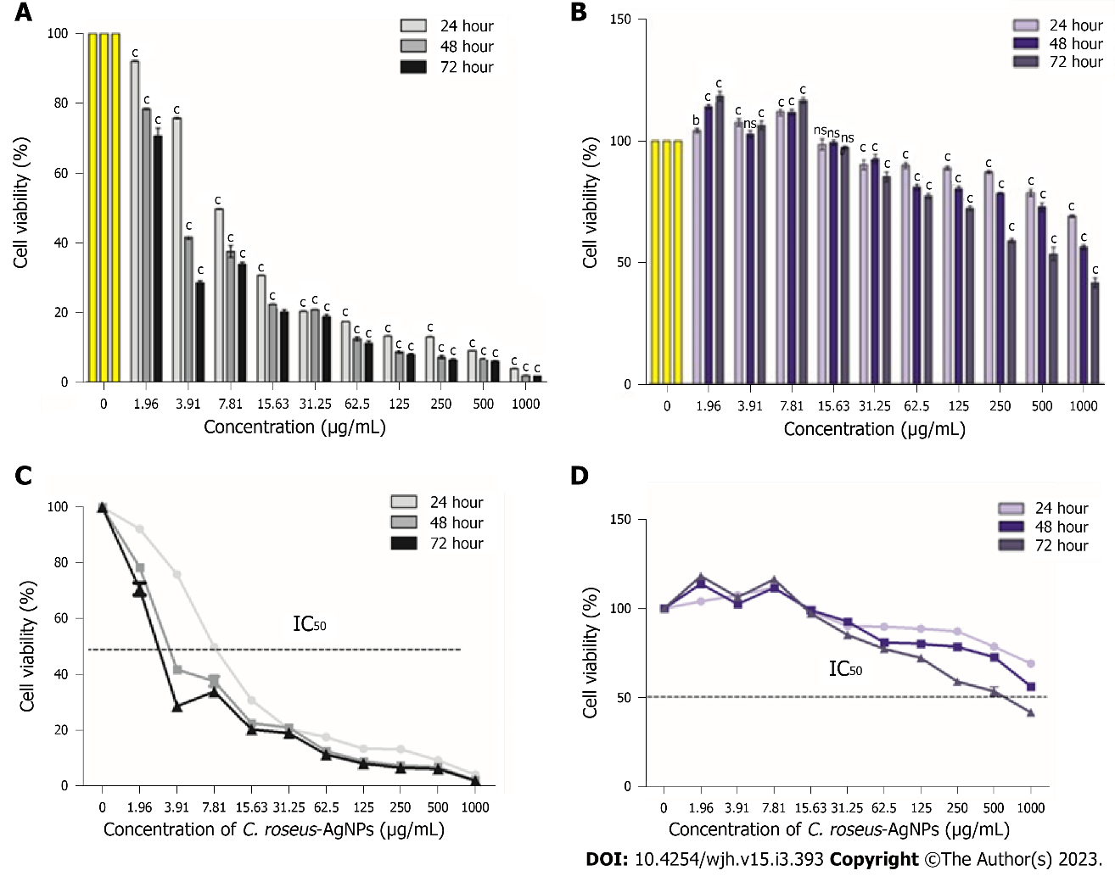
Figure 1 Cytotoxicity evaluation of Catharanthus roseus-silver nanoparticles on HepG2 and THLE-3 cells. A: The cytotoxicity of HepG2 cell lines treated with different concentrations of Catharanthus roseus-silver nanoparticles (C. roseus-AgNPs); B: The IC₅₀ of C. roseus-AgNPs on HepG2 cells; C: The cytotoxicity of THLE3 cell lines treated with different concentrations of C. roseus-AgNPs; D: The IC₅₀ of C. roseus-AgNPs on THLE-3 cells. All experiments were done in triplicate, and the data represent means ± standard deviations. The comparison between each concentration with untreated cells was done using two-way ANOVA with Dunnet post-test to detect any significant differences (^{b}P < 0.01; ^{c}P < 0.001; ns not significant). C. roseus-AgNPs: Catharanthus roseus-silver nanoparticles.

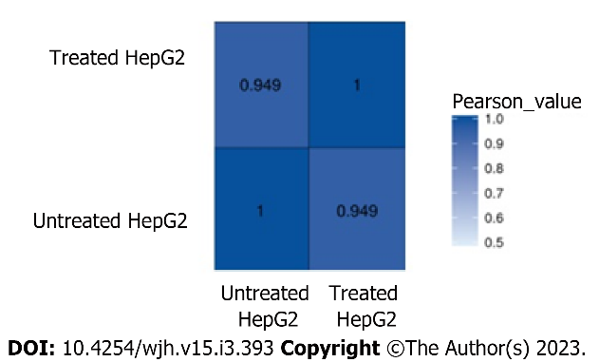
Figure 2 The correlation analysis between samples. The colour represents the correlation coefficient.

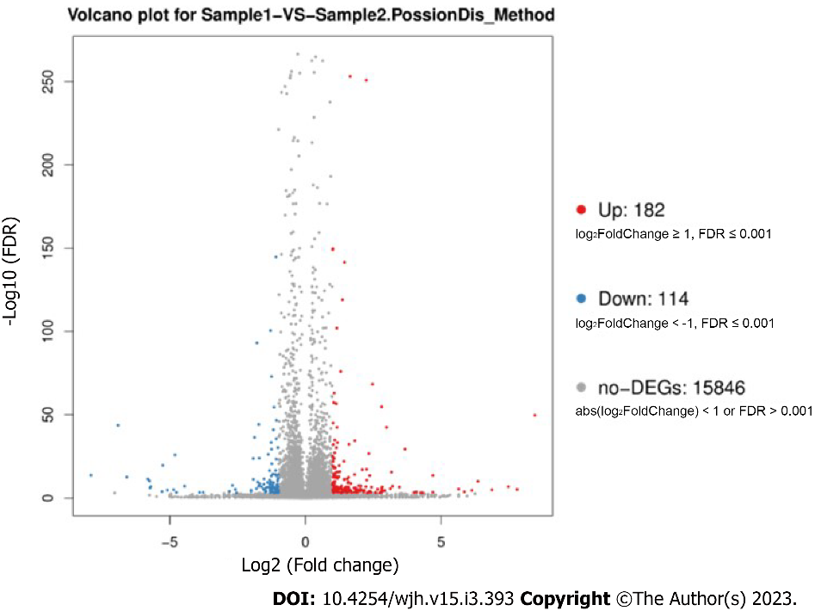
Figure 3 Volcano plot of differentially expression genes. Red points represent upregulated differentially expression genes (DEGs). Blue points represent down-regulated DEGs. Grey points represent non-DEGs. DEGs: Differentially expression genes.

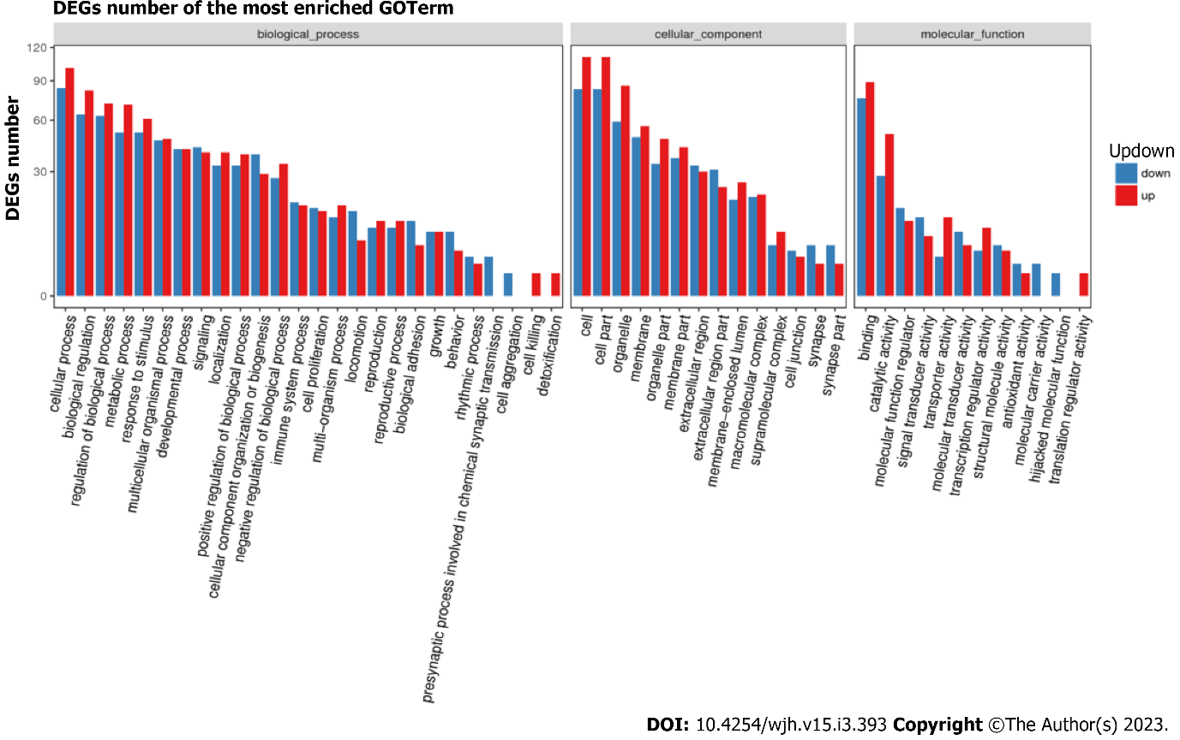
Figure 4 Gene Ontology classification of upregulated and downregulated differentially expression genes.

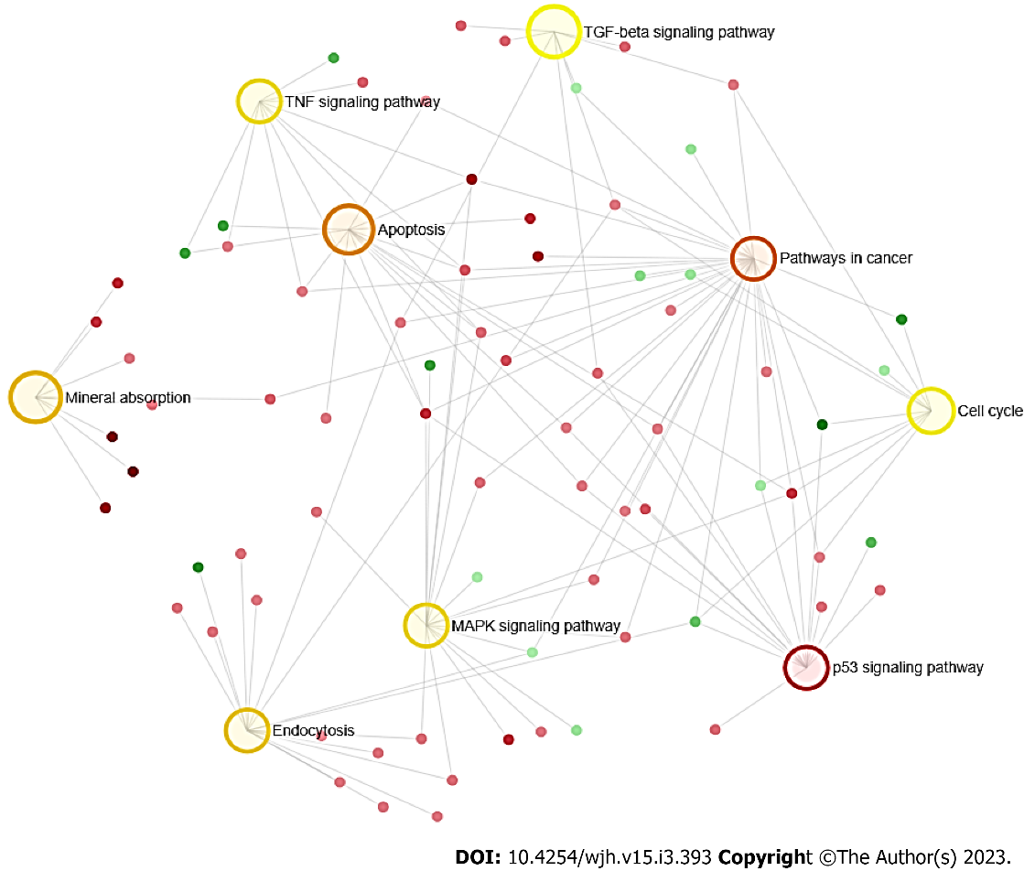
Figure 5 Network enrichment result. The darker the colour indicates the highest enrichment pathways. The larger the area, the higher the degree of enrichment.

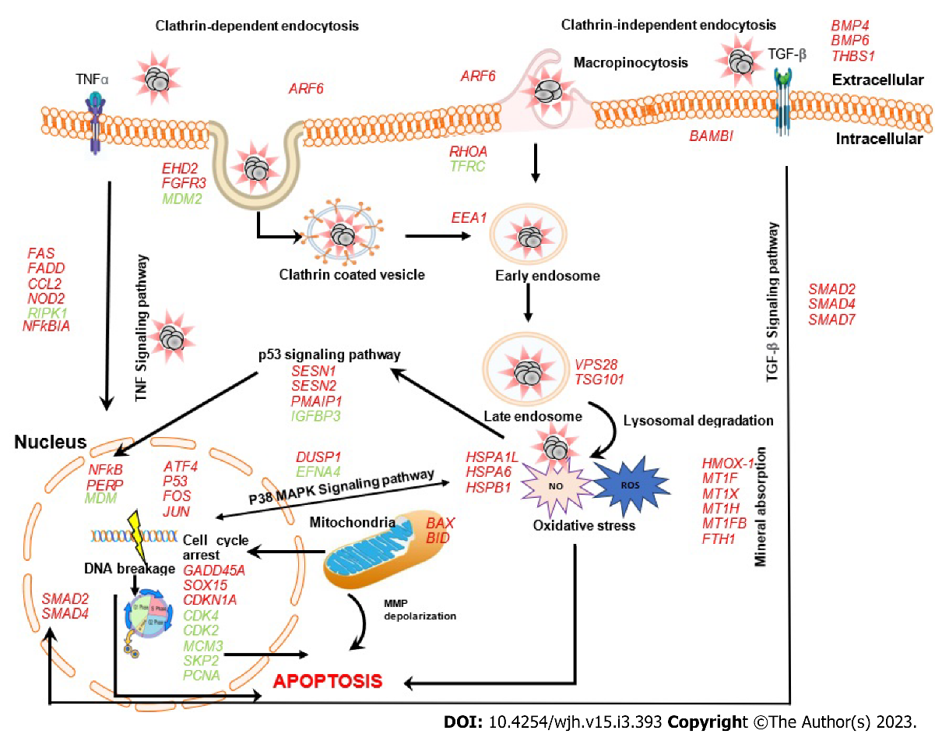
Figure 6 Model of cytotoxicity mechanism in HepG2 cell treated with C. roseus-AgNPs that involves the upregulated genes (in red) and downregulated genes (in green).

Table 1 Summary of genome mapping
Sample | Total clean reads | Total mapping ratio | Uniquely mapping ratio
Untreated HepG2 | 70025052 | 95.94% | 76.60%
C. roseus-AgNPs treated HepG2 | 72598578 | 95.82% | 75.94%
C. roseus-AgNPs: Catharanthus roseus-silver nanoparticles.

Table 2 Summary of gene mapping ratio
Sample | Total clean reads | Total mapping ratio | Uniquely mapping ratio
Untreated HepG2 | 70025052 | 66.79% | 63.92%
C. roseus-AgNPs treated HepG2 | 72598578 | 62.94% | 60.15%
C. roseus-AgNPs: Catharanthus roseus-silver nanoparticles.

Table 3 Pathway functional enrichment results
Pathway ID | Pathway | Genes | Hits | Adj P value
K05200 | Pathway in cancer | FAS, GADD45A, BAX, PMAIP, BID, JUN, CXCL8, HMOX1, STAT1, FOS, CEBPA, VEGFA, FGF5, EGF, RHOA, FADD, FH, SMAD, MTOR, NFκBIA, CDKN1A, WNT4ª, WNT7Aª, FGFR3ª, BMP4ª, CDK4ª, CDK2ª, MDMª | 29/530 | 3.28E-12
K04115 | p53 signaling pathway | FAS, GADD45A, SERPINE, THBS1, CDK4, BAX, CDK2, PERP, SESN1, SESN2, PMAIP1, BID, IGFBP3ª, MDM2ª | 14/72 | 1.28E-13
K04210 | Apoptosis | FAS, GADD45A, BAX, PMAIP1, BID, JUN, FOS, FADD, NFKBIA, BCL2A1, ATF4, MCL1, TNFSF10ª, RIPK1ª | 14/136 | 9.61E-10
K04144 | Endocytosis | ARF6, RHOA, EHD2, FGFR3, HSPA6, HSPA1L, VPS28, EEA1, VPS25, TSG101, STAM, SMAD, EHD4, LDLR, TFRCª, MDM2ª | 16/244 | 4.08E-08
K04010 | MAPK signaling pathway | FAS, GADD45A, JUN, FOS, VEGFA, FGF5, CDKN1A, EGF, ATF4, HSPA6, HSPA1L, CDKN1A, HSPB1, DUSP1, NR4A1, EFNA4ª, FGFR3ª, ERBB3ª, SKP2ª | 16/295 | 5.58E-07
K04668 | TNF signalling pathway | FAS, JUN, FOS, FADD, NFKBIA, ATF4, RIPK1ª, CCL2, NOD2, CCL20ª | 10/110 | 9.07E-07
K04350 | TGF beta signaling pathway | THBS1, RHOA, SMAD2, SMAD4, BMP4, SMAD7, BAMBI, BMP6 | 8/90 | 1.66E-05
K02010 | Cell cycle | GADD45A, SOX15, CDK4ª, CDK2ª, MDM2, SMAD2, SMAD4, CDKN1A, PCNAª, MCM3ª, SKP2ª | 9/124 | 2.09E-05
K04978 | Mineral absorption | HMOX1, MT1F, MT1X, MT1H, MT1B, FTH1 | 6/51 | 3.58E-05
ªDownregulated genes.

Published by Baishideng Publishing Group Inc
7041 Koll Center Parkway, Suite 160, Pleasanton, CA 94566, USA
Telephone: +1-925-3991568
E-mail: bpgoffice@wjgnet.com
Help Desk: https://www.f6publishing.com/helpdesk
https://www.wjgnet.com

© 2023 Baishideng Publishing Group Inc. All rights reserved.

