Name of Journal: World Journal of Biological Chemistry
ESPS Manuscript NO: 20584
Manuscript Type: FRONTIER

Discovery and characterization of the first non-coding RNA that regulates gene expression, micF RNA: A historical perspective

Delihas N. History of discovery of regulatory RNA

Nicholas Delihas

Nicholas Delihas, Department of Molecular Genetics and Microbiology, School of Medicine, Stony Brook University, Stony Brook, NY 11794-5222, United States

Author contributions: Delihas N initiated and participated in the previous research design, experiments, and data analysis, and wrote the current manuscript.

Conflict-of-interest statement: The author declares no conflict of interest.

Open-Access: This article is an open-access article which was selected by an in-house editor and fully peer-reviewed by external reviewers. It is distributed in accordance with the Creative Commons Attribution Non Commercial (CC BY-NC 4.0) license, which permits others to distribute, remix, adapt, build upon this work non-commercially, and license their derivative works on different terms, provided the original work is properly cited and the use is non-commercial. See: http://creativecommons.org/licenses/by-nc/4.0/

Correspondence to: Nicholas Delihas, Professor Emeritus, Department of Molecular Genetics and Microbiology, School of Medicine, Stony Brook University, Stony Brook, NY 11794-5222, United States. nicholas.delihas@stonybrook.edu
Telephone: +1-631-2869427
Fax: +1-631-6328779

Received: June 11, 2015
Peer-review started: June 11, 2015
First decision: August 25, 2015
Revised: September 5, 2015
Accepted: October 1, 2015
Article in press:
Published online:

Abstract
The first evidence that RNA can function as a regulator of gene expression came from experiments with prokaryotes in the 1980s. It was shown that E. coli micF is an independent gene, has its own promoter, and encodes a small non-coding RNA that base pairs with and inhibits translation of a target messenger RNA in response to environmental stress conditions. The micF RNA was isolated, sequenced and shown to be a primary transcript. In vitro experiments showed binding to the target ompF mRNA. Secondary structure probing revealed an imperfect micF RNA/ompF RNA duplex interaction and the presence of a non-canonical base pair. Several transcription factors, including OmpR, regulate micF transcription in response to environmental factors. micF has also been found in other bacterial species, however, recently Gerhart Wagner and Jörg Vogel showed pleiotropic effects and found micF inhibits expression of multiple target mRNAs; importantly, one is the global regulatory gene lrp. In addition, micF RNA was found to interact with its targets in different ways; it either inhibits ribosome binding or induces degradation of the message. Thus the concept and initial experimental evidence that RNA can regulate gene expression was born with prokaryotes.

Key words: Non-coding RNAs; Regulation of gene expression; micF RNA; RNA/RNA interaction; Trans-acting RNA gene

© The Author(s) 2015. Published by Baishideng Publishing Group Inc. All rights reserved.

Core tip: The original discovery and characterization of the first non-coding RNA gene and its transcript was with prokaryotes in the 1980s. At that time the Escherichia coli micF RNA gene was characterized in terms of properties, its promoter region, and activation by environmental stress conditions; and the micF RNA transcript structure as well as the micF RNA/target messenger RNA duplex interaction were elucidated. This occurred over 5 years before the discovery of the first eukaryotic regulatory miRNA, which is not generally recognized. Prokaryotic and eukaryotic non-coding RNAs greatly differ in terms of RNA processing, but the basic principle of an RNA gene locus encoding a regulatory RNA that targets gene expression in trans via RNA/target RNA duplex formation is similar. Thus the concept and discovery of regulatory non-coding RNAs and their functions in messenger RNA inhibition originated with prokaryotes.

Delihas N. Discovery and characterization of the first non-coding RNA that regulates gene expression, micF RNA: A historical perspective. World J Biol Chem 2015; In press

INTRODUCTION
It is now recognized that regulation of gene expression by non-coding RNAs via RNA/mRNA interactions is a vastly widespread phenomena that occurs in all biological domains, including viruses, and it has become a basic principle in biology. Current research on non-coding RNAs has essentially “exploded”^{[1-7]}. Yet before the 1980s, RNAs were thought of as macromolecules that primarily supported the protein synthesis machinery, were considered inert, and the concept of RNA as a regulator was unheard of.
In this review we focus on early history of the experimental work that showed that RNA is a regulator of gene expression, and this occurred approximately 30 years ago in the 1980s. micF RNA was the first regulatory RNA discovered^{[8-11]}. This preceded the discovery of regulation of gene expression by RNAs in eukaryotes, which was in the 1990s^{[12]}. Prokaryotic non-coding RNAs that regulate gene expression are termed sRNAs; the eukaryotic RNAs are termed microRNAs (miRNAs).
The second bacterial regulatory RNA discovered was DsrA. This RNA transcript was found to mediate rpoS expression in 1995^{[13]} but its mechanism of action via RNA/RNA binding was not determined until 1998^{[14,15]}.

E. COLI 6S RNA, SPOT 42, EUKARYOTIC 7SK RNA AND CRISPRS
The discovery that RNA can serve a regulatory role was in the 1980s, however, three regulatory RNAs were found before that but were uncharacterized: E. coli 6S RNA, Spot 42 and the eukaryotic 7SK RNA. These RNAs were discovered and sequenced about 40 years ago but their functions were not elucidated until decades later. The 6S RNA was first detected in 1967^{[16]} and was sequenced by George Brownlee in 1971^{[17]}. Its function was determined approximately 30 years later in 2000 by Wassarman and Storz^{[18]} who showed that 6S RNA binds the RNA polymerase-sigma70 complex and inhibits sigma factor-dependent gene transcription.
The second non-coding RNA found and also uncharacterized until decades later was the transcript termed Spot 42 encoded by the E.coli spf gene. It was first found in 1973 as a transcript on two-dimensional gel electrophoresis by Dahlberg et al^{[19]}, but its function as a regulatory non-coding RNA was not determined until 2002 when Valentine-Hansen’s lab showed that Spot 42 binds the galK mRNA and inhibits the galactose operon^{[20]}; however, more recently it has been shown to also target fourteen other operons^{[21]}.
As to eukaryotic RNAs, in 1976 Gary Zieve and Sheldon Penman found several small RNAs in HeLa cells, one was the 7SK RNA, but its function and the function of the other RNAs were unknown at the time^{[22]}. Almost 30 years later it was shown that 7SK RNA binds to a HEXIM1 protein complex, which then binds to the transcription elongation factor P-TEFb and inhibits transcription^{[23,24]}.
There are parallels between the prokaryotic 6S RNA and the eukaryotic 7SK RNA – both were found decades before any functional roles were determined and both bind proteins resulting in inhibit of transcription. The majority of small non-coding RNAs regulate post-transcriptionally by binding target mRNAs.
Clustered regularly interspaced short palindromic repeats (CRISPRs) were discovered in E.coli in 1987 by Ishino et al^{[25]}. CRISPRs are an array of genomic repeat sequences, which are separated by spacer sequences that originate from viral or plasmid DNA. They represent an acquired bacterial immune system. Similar to the RNAs discussed above, functions and mechanism of regulation of the CRISPR system as small RNA/target DNA inhibitors were not elucidated until about two to three decades later^{[26-29]} (references shown represent only a partial list of contributors).
The bacterial CRISPR-specific RNA processing and targeting mechanism has been compared to the eukaryotic RNAi mechanism and they display striking similarities, although they are not homologous^{[30]}. The CRISPR system currently represents one of the fastest moving fields in molecular biology, primarily because of its potential to alter gene structure and induce chromosomal rearrangements. On the other hand, Morange points out that some earlier pioneer work with the CRISPR system went underappreciated^{[31]}.

COLE1 RNAI
In 1981 two labs showed that antisense RNAs can inhibit plasmid replication in E. coli ^{[32,33]}. These are milestone experiments as they were the first to demonstrate a regulatory function for RNA. In addition, Tomizawa et al^{[34]}, working with ColE1 plasmid replication, demonstrated that antisense RNA I binds to and inhibits the primer RNA II that is involved in initiating DNA replication.
Subsequently, Tomizawa et al^{[34]} presented a model of antisense RNA/primer RNA recognition by the so-called “kissing interaction”. This involves a two-step process, whereby initially there is a loop-loop interaction via Watson-Crick base-pairing between the short stem loops of RNA I and RNA II, followed by pairing of unstructured single-stranded segments of the two RNAs and eventual melting of the stem loops and formation of an antisense/sense RNA/RNA duplex (Figure 1).
The kissing interaction was another pioneer proposal by Tomizawa et al^{[34]} whereby we now know there is board significance to the initial recognition of two RNAs via stem loop interactions^{[35-39]}. The loop-loop interaction has also been predicted to occur in both the prokaryotic and eukaryotic non-coding RNA/target RNA recognition process^{[40-42]}.
There were also other significant plasmid-related experiments at that time. In 1981 Rosen et al^{[43]} found three RNA transcripts encoded by plasmids R100 and R1, one a counter transcript, but RNA functions were not fully elucidated. Additionally, Simons et al^{[44]} and Kleckner et al^{[45]} showed that an antisense counter transcript from the insertion sequence of transposon IS10 inhibits transposase expression via RNA/RNA interactions and predicting an initial a loop interaction.

MICF RNA
In 1984, Mizuno et al^{[8]} were the first to present the concept of a regulatory RNA gene that controls expression of another gene via RNA/RNA base-pairing. This is the E. coli micF gene whose transcript inhibits the expression of the target gene ompF. This was based on multicopy plasmid repression of OmpF protein from a sequence upstream of the ompC gene. This sequence has complementarity ompF mRNA^{[8]}. OmpF is an outer membrane protein, a porin protein that allows small molecules to diffuse passively through the cell. Thus it is an important protein to regulate in terms of protecting the cell from deleterious molecules.
At that time it was a rather bold and innovative proposal that an RNA can regulate gene expression, There were no role models for such a function, and RNA was for the most part still considered a passive macromolecule that participates in the protein synthesis process and formed the scaffolding for ribosomal proteins, notwithstanding the previous work on antisense RNA repression of plasmid replication^{[32,33]}.
Dr. Inouye should be credited for his creativity in first proposing the existence of a regulatory RNA gene. But his lab had only multicopy plasmid effects and had not isolated the RNA transcript. An RNA molecular biologist was needed and I was asked to contribute to the work. Subsequently my lab isolated and sequenced the chromosomal-encoded micF RNA, found that micF is an independent gene with its own promoter, determined the regulatory RNA/target RNA base-pairing by structure probing, and determined its function in terms of regulation of target gene in response to environmental stress conditions^{[9,10]}.
By using in vivo P³² labeling, isolating low molecular weight RNAs and separation on gels, we found a 4.5S RNA transcript. Its sequence showed that it was micF RNA and that it was 93 nt long with a rho independent termination site^{[9]}.To characterize the micF promoter regions, lacZ was fused at different sites upstream of the micF gene and micF was found to have a strong promoter based on beta galactosidase activity.

MICF RESPONSE TO STRESS CONDITIONS
A search for function was initiated by looking at the response of micF expression to various environmental factors. A major effect was found with temperature change and other factors. Levels of micF RNA increased dramatically in response to cell growth at high temperature^{[10]}. The levels of ompF mRNA and the OmpF protein were also measured and found to decrease under these conditions. Figure 2 shows a marked decrease in ompF mRNA levels with temperature increase in the wild type strain, but no significant change in the micF deletion strain (SM3001). The findings revealed that micF RNA plays a major role in the thermal regulation of ompF mRNA and OmpF protein. However, the mechanism of thermal regulation of micF expression is still an open question, but temperature has been shown to regulate DNA supercoiling that is associated with the induction of stress related genes^{[46-49]}. micF expression was also found to respond to other environmental stress conditions such as osmolarity change and exposure to ethanol^{[10,50]}.
The upstream micF regulatory region is complex in that it contains binding sites for a number of transcription factors; these regulate micF expression in response to different environmental stress factors^{[51]}. Five transcription factors are known to bind in the upstream regulatory region (Figure 3). With respect to osmolarity change, there are three binding sites (C1-C3) for transcription factor OmpR that activates expression of micF in response to osmolarity increase^{[50]}. MarA responds to weak acids^{[52]}, SoxS to oxidative stress^{[53]}, Rob to peptide antibiotics^{[54,55]} and Lrp to nutritionally poor media^{[56]}. These four transcription factors share the same binding site on the micF promoter region (Figure 3). MarA, SoxS and Rob are related proteins that activate micF. Rowena Matthews’ lab showed that Lrp represses micF transcription^{[56]}; Lrp is part of the nucleoid-associated protein goup^{[57]}. The crystal structure of transcription factor Rob bound to the micF promoter region has been elucidated (by Kwon et al^{[58]}). The model shows one protein helix-turn-helix motif bound to the major groove of micF DNA. Additional biochemical studies showed a high affinity of binding^{[58]}.
micF is also regulated at the post-translational level when cells are grown in a nutrient poor medium^{[59]}. Dorman and co-workers hypothesized that Stp induces a conformational change in micF RNA that makes it is susceptible to degradation by nucleases^{[59]}. Stp is also a nucleoid-associated protein and a paralogue of H-NS^{[60,61]}. Thus micF gene expression is regulated at both the transcriptional and post-transcriptional levels in response to different environmental conditions.

MICF RNA/TARGET OMPF MRNA DUPLEX
It was demonstrated that an RNA/RNA duplex could be formed in vitro between micF RNA and the target ompF mRNA^{[62]}. Full length micF RNA and a 150 nt 5’ end fragment of ompF mRNA were synthesized in vitro and the RNA/RNA duplex was formed by annealing at 55 ºC and 37 ºC. Subsequently, in vitro formed duplexes were used for secondary structure probing^{[63]}. Single and double stranded specific RNases and chemical modification with a NiCR complex that is single strand G-specific^{[64]} were used for probing. As nuclease probes can be sensitive to steric hindrance, chemical modification was performed using the NiCR reagent to try to gain additional information^{[63-65]}. A schematic of the deduced micF RNA/ompF mRNA duplex base-pairing is in Figure 4.
The RNA/RNA interaction shows an imperfect duplex, and a non-canonical G₉₉-G₂₉ base-pair that was determined from the absence of RNase T1 cleavage and NiCR reaction, but also the presence of double stranded specific RNase V1 cleavages^{[63,65]}. The Shine-Dalgarno (S-D) ribosome binding site is blocked, which implies that micF RNA inhibits ribosome binding. In vivo experiments show that ompF mRNA levels decrease with temperature increase in an E. coli strain carrying micF (Figure 2); however, micF RNA has not been shown to directly participate in degradation of the message, but to block ribosome binding.
Long-range pairing based on the Maximum Weighted Matching computational program of Tabaska et al^{[66]} was predicted to also contribute to the RNA/RNA interaction (Figure 4). The pairing is supported by phylogenetic comparisons and for the most part, by structure probing. Long-range pairings should contribute to the three-dimensional structure of the interacting RNAs.

MICF RNA HAS MULTIPLE TARGETS AND PARTICIPATES IN GLOBAL GENE REGULATION
Recently it has been shown that the functions of micF RNA are multifaceted and extend far beyond regulation of ompF expression. Gerhart Wagner and his lab showed that micF is part of a global regulatory network involving the leucine responsive protein (Lrp)^{[67]}, and Jörg Vogel and co-workers at the University of Würzburg in Germany showed that micF targets different mRNAs and base-pairs with these RNAs in different ways^{[68]}.
Approximately 10% of all genes in Escherichia coli are controlled by Lrp, a transcription factor which responds to nutrient availability. Wagner’s group^{[67]} showed participation of micF RNA in a circular regulatory pathway, i.e., Lrp regulates transcription of micF RNA and micF RNA regulate lrp expression post-transcriptionally, depending on the nutritional content of the cell growth media (Figure 5). Both Lrp and micF RNA function as repressors. micF RNA participates in this global regulatory network by regulating lrp mRNA; thus this greatly expands its role in regulation of gene expression and cell metabolism.
On the other hand, using Salmonella as a model, Vogel and his lab demonstrated that micF RNA targets multiple mRNAs in addition to ompF mRNA and lrp mRNA (Figure 5). Interestingly, its mode of binding to different mRNAs is multifaceted. On the one hand, micF RNA can induce destabilization of the yahO mRNA by unfolding a stem-loop structure located at the 5′-terminus, and thus make the mRNA accessible to exonuclease action. With lpxR mRNA, micF RNA binds at two sites. One site is within the coding region of the message, and when micF RNA binds at this site, it induces a conformational change exposing an AU region that can be targeted by the endonuclease RNase E, which then degrades the message^{[68]}. yahO encodes a periplasmic protein and lpxR encodes an outer membrane lipid A-modifying enzyme.

HFQ PROTEIN
In vitro studies showed that micF RNA binds to a protein based on mobility shifts of protein-RNA complexes on non-denaturing gels^{[62]}. UV-cross-crosslinking experiments suggested that the protein was 80-kDa, however the protein was not further characterized. It is well known that many sRNAs bind the Hfq protein and that Hfq facilitates the binding of sRNAs to their target mRNAs, including micF RNA^{[70]}. The molecular weight of Hfq is 11.2-KDa^{[71]}, but the 80-kDa protein found to bind micF RNA^{[62]} is inconsistent with this and there is a need for further investigation.
Hfq is a central component of the pairing of bacterial non-coding RNAs with their target messenger RNAs. The multifaceted ways that Hfq, together with sRNAs can participate in the inhibition of translation and/or mRNA degradation has been outlined^{[72]}. Hfq also interacts with another protein, catalase HPII. The crystal structure of Hfq bound to catalase HPII has been solved^{[71]}, but the crystal structure of an Hfq-sRNA complex has not been determined,

OTHER NON-CODING RNA FUNCTIONS
In this paper we focused on initial findings involving the regulation of gene expression by RNA, however, there is a wealth of discoveries with other functions of non-coding RNAs that also occurred during the 1980s, and it is important to mention this. Table 1 lists several initial findings that include enzymatic RNA, catalytic RNA and RNA functions in protein translocation. The work on regulation of gene expression by RNA and the studies outlined in Table 1 provide a breakthrough on understanding functions of RNAs whereby before the 1980s, RNAs such largely considered inert with no dynamic functions.

CONCLUSION
The initial discovery that RNA can function as a regulatory molecule occurred in the 1980s. Table 2 summarizes the chronology. Bacterial plasmid RNAs were first shown by two labs to regulate DNA replication via sense/antisense RNA/RNA base-pairing^{[32,33]} and the E. coli micF gene was the first found to regulate expression of another gene in trans via imperfect RNA/RNA base-pairing, also by two labs^{[8-10]}. These finding were major breakthroughs that came approximately 5-10 years before the discovery of eukaryotic microRNAs and their functions. Subsequently, numerous labs added to the molecular genetics of micF and to functional properties of the transcript that greatly advanced our knowledge of the role of this gene in cell survival. So it was essentially work with prokaryotes that first opened the door to a new form of regulation of gene expression by RNA that is now found in all biological kingdoms, including viruses. However, there are many different types of regulatory RNAs that are found only in eukaryotes (e.g., piRNA, siRNA, lncRNA), and the prospects of finding new and unique functions of RNAs may lie primarily with eukaryotic RNAs. Looking towards the future, there are tens of thousands of lncRNAs that have been detected, and for the most part are uncharacterized. But the few that have been characterized display very diverse and intricate functions^{[78-82]}.

ACKNOWLEDGEMENTS
The author is grateful for support from the Department of Molecular Genetics and Microbiology, Stony Brook University.

REFERENCES
1 Gottesman S, Storz G. Bacterial small RNA regulators: versatile roles and rapidly evolving variations. Cold Spring Harb Perspect Biol 2011; 3: [PMID: 20980440 DOI: 10.1101/cshperspect.a003798]
2 Fu XD. Non-coding RNA: a new frontier in regulatory biology. Natl Sci Rev 2014; 1: 190-204 [PMID: 25821635 DOI: 10.1093/nsr/nwu008]
3 Ha M, Kim VN. Regulation of microRNA biogenesis. Nat Rev Mol Cell Biol 2014; 15: 509-524 [PMID: 25027649 DOI: 10.1038/nrm3838]
4 Fatica A, Bozzoni I. Long non-coding RNAs: new players in cell differentiation and development. Nat Rev Genet 2014; 15: 7-21 [PMID: 24296535 DOI: 10.1038/nrg3606]
5 Xie M, Zhang S, Yu B. microRNA biogenesis, degradation and activity in plants. Cell Mol Life Sci 2015; 72: 87-99 [PMID: 25209320 DOI: 10.1007/s00018-014-1728-7]
6 Hoogstrate SW, Volkers RJ, Sterken MG, Kammenga JE, Snoek LB. Nematode endogenous small RNA pathways. Worm 2014; 3: e28234 [PMID: 25340013 DOI: 10.4161/worm.28234]
7 Scaria V, Hariharan M, Maiti S, Pillai B, Brahmachari SK. Host-virus interaction: a new role for microRNAs. Retrovirology 2006; 3: 68 [PMID: 17032463]
8 Mizuno T, Chou MY, Inouye M. A unique mechanism regulating gene expression: translational inhibition by a complementary RNA transcript (micRNA). Proc Natl Acad Sci USA 1984; 81: 1966-1970 [PMID: 6201848]
9 Andersen J, Delihas N, Ikenaka K, Green PJ, Pines O, Ilercil O, Inouye M. The isolation and characterization of RNA coded by the micF gene in Escherichia coli. Nucleic Acids Res 1987; 15: 2089-2101 [PMID: 2436145]
10 Andersen J, Forst SA, Zhao K, Inouye M, Delihas N. The function of micF RNA. micF RNA is a major factor in the thermal regulation of OmpF protein in Escherichia coli. J Biol Chem 1989; 264: 17961-17970 [PMID: 2478539]
11 Inouye M, Delihas N. Small RNAs in the prokaryotes: a growing list of diverse roles. Cell 1988; 53: 5-7 [PMID: 2450678]
12 Lee RC, Feinbaum RL, Ambros V. The C. elegans heterochronic gene lin-4 encodes small RNAs with antisense complementarity to lin-14. Cell 1993; 75: 843-854 [PMID: 8252621]
13 Sledjeski D, Gottesman S. A small RNA acts as an antisilencer of the H-NS-silenced rcsA gene of Escherichia coli. Proc Natl Acad Sci USA 1995; 92: 2003-2007 [PMID: 7534408]
14 Lease RA, Cusick ME, Belfort M. Riboregulation in Escherichia coli: DsrA RNA acts by RNA: RNA interactions at multiple loci. Proc Natl Acad Sci USA 1998; 95: 12456-12461 [PMID: 9770507]
15 Majdalani N, Cunning C, Sledjeski D, Elliott T, Gottesman S. DsrA RNA regulates translation of RpoS message by an anti-antisense mechanism, independent of its action as an antisilencer of transcription. Proc Natl Acad Sci USA 1998; 95: 12462-12467 [PMID: 9770508]
16 Hindley J. Fractionation of 32P-labelled ribonucleic acids on polyacrylamide gels and their characterization by fingerprinting. J Mol Biol 1967; 30: 125-136 [PMID: 4865141]
17 Brownlee GG. Sequence of 6S RNA of E. coli. Nat New Biol 1971; 229: 147-149 [PMID: 4929322]
18 Wassarman KM, Storz G. 6S RNA regulates E. coli RNA polymerase activity. Cell 2000; 101: 613-623 [PMID: 10892648]
19 Ikemura T, Dahlberg JE. Small ribonucleic acids of Escherichia coli. I. Characterization by polyacrylamide gel electrophoresis and fingerprint analysis. J Biol Chem 1973; 248: 5024-5032 [PMID: 4577761]
20 Møller T, Franch T, Udesen C, Gerdes K, Valentin-Hansen P. Spot 42 RNA mediates discoordinate expression of the E. coli galactose operon. Genes Dev 2002; 16: 1696-1706 [PMID: 12101127]
21 Beisel CL, Storz G. The base-pairing RNA spot 42 participates in a multioutput feedforward loop to help enact catabolite repression in Escherichia coli. Mol Cell 2011; 41: 286-297 [PMID: 21292161 DOI: 10.1016/j.molcel.2010.12.027]
22 Zieve G, Penman S. Small RNA species of the HeLa cell: metabolism and subcellular localization. Cell 1976; 8: 19-31 [PMID: 954090]
23 Michels AA, Fraldi A, Li Q, Adamson TE, Bonnet F, Nguyen VT, Sedore SC, Price JP, Price DH, Lania L, Bensaude O. Binding of the 7SK snRNA turns the HEXIM1 protein into a P-TEFb (CDK9/cyclin T) inhibitor. EMBO J 2004; 23: 2608-2619 [PMID: 15201869]
24 Diribarne G, Bensaude O. 7SK RNA, a non-coding RNA regulating P-TEFb, a general transcription factor. RNA Biol 2009; 6: 122-128 [PMID: 19246988]
25 Ishino Y, Shinagawa H, Makino K, Amemura M, Nakata A. Nucleotide sequence of the iap gene, responsible for alkaline phosphatase isozyme conversion in Escherichia coli, and identification of the gene product. J Bacteriol 1987; 169: 5429-5433 [PMID: 3316184]
26 Tang TH, Bachellerie JP, Rozhdestvensky T, Bortolin ML, Huber H, Drungowski M, Elge T, Brosius J, Hüttenhofer A. Identification of 86 candidates for small non-messenger RNAs from the archaeon Archaeoglobus fulgidus. Proc Natl Acad Sci USA 2002; 99: 7536-7541 [PMID: 12032318]
27 Mojica FJ, Díez-Villaseñor C, García-Martínez J, Soria E. Intervening sequences of regularly spaced prokaryotic repeats derive from foreign genetic elements. J Mol Evol 2005; 60: 174-182 [PMID: 15791728]
28 Kunin V, Sorek R, Hugenholtz P. Evolutionary conservation of sequence and secondary structures in CRISPR repeats. Genome Biol 2007; 8: R61 [PMID: 17442114]
29 Jinek M, Chylinski K, Fonfara I, Hauer M, Doudna JA, Charpentier E. A programmable dual-RNA-guided DNA endonuclease in adaptive bacterial immunity. Science 2012; 337: 816-821 [PMID: 22745249 DOI: 10.1126/science.1225829]
30 Marraffini LA, Sontheimer EJ. CRISPR interference: RNA-directed adaptive immunity in bacteria and archaea. Nat Rev Genet 2010; 11: 181-190 [PMID: 20125085 DOI: 10.1038/nrg2749]
31 Morange M. What history tells us XXXVII. RISPR-Cas: The discovery of an immune system in prokaryotes. J Biosci 2015; 40: 221-223 [PMID: 25963251 DOI: 10.1007/s12038-015-9532-6]
32 Stougaard P, Molin S, Nordström K. RNAs involved in copy-number control and incompatibility of plasmid R1. Proc Natl Acad Sci USA 1981; 78: 6008-6012 [PMID: 6171808]
33 Tomizawa J, Itoh T, Selzer G, Som T. Inhibition of ColE1 RNA primer formation by a plasmid-specified small RNA. Proc Natl Acad Sci USA 1981; 78: 1421-1425 [PMID: 6165011]
34 Tomizawa J. Control of ColE1 plasmid replication: the process of binding of RNA I to the primer transcript. Cell 1984; 38: 861-870 [PMID: 6207934]
35 Wagner EG, Simons RW. Antisense RNA control in bacteria, phages, and plasmids. Annu Rev Microbiol 1994; 48: 713-742 [PMID: 7826024]
36 Paillart JC, Skripkin E, Ehresmann B, Ehresmann C, Marquet R. A loop-loop "kissing" complex is the essential part of the dimer linkage of genomic HIV-1 RNA. Proc Natl Acad Sci USA 1996; 93: 5572-5577 [PMID: 8643617]
37 Wagner EG, Brantl S. Kissing and RNA stability in antisense control of plasmid replication. Trends Biochem Sci 1998; 23: 451-454 [PMID: 9868360]
38 Brunel C, Marquet R, Romby P, Ehresmann C. RNA loop-loop interactions as dynamic functional motifs. Biochimie 2002; 84: 925-944 [PMID: 12458085]
39 Bouchard P, Legault P. A remarkably stable kissing-loop interaction defines substrate recognition by the Neurospora Varkud Satellite ribozyme. RNA 2014; 20: 1451-1464 [PMID: 25051972 DOI: 10.1261/rna.046144.114]
40 Altuvia S, Wagner EG. Switching on and off with RNA. Proc Natl Acad Sci USA 2000; 97: 9824-9826 [PMID: 10963653]
41 Long D, Lee R, Williams P, Chan CY, Ambros V, Ding Y. Potent effect of target structure on microRNA function. Nat Struct Mol Biol 2007; 14: 287-294 [PMID: 17401373]
42 Cao S, Chen SJ. Predicting kissing interactions in microRNA-target complex and assessment of microRNA activity. Nucleic Acids Res 2012; 40: 4681-4690 [PMID: 22307238 DOI: 10.1093/nar/gks052]
43 Rosen J, Ryder T, Ohtsubo H, Ohtsubo E. Role of RNA transcripts in replication incompatibility and copy number control in antibiotic resistance plasmid derivatives. Nature 1981; 290: 794-797 [PMID: 6163994]
44 Simons RW, Kleckner N. Translational control of IS10 transposition. Cell 1983; 34: 683-691 [PMID: 6311438]
45 Kittle JD, Simons RW, Lee J, Kleckner N. Insertion sequence IS10 anti-sense pairing initiates by an interaction between the 5' end of the target RNA and a loop in the anti-sense RNA. J Mol Biol 1989; 210: 561-572 [PMID: 2482367]
46 Dorman CJ. Flexible response: DNA supercoiling, transcription and bacterial adaptation to environmental stress. Trends Microbiol 1996; 4: 214-216 [PMID: 8795154]
47 Hurme R, Rhen M. Temperature sensing in bacterial gene regulation--what it all boils down to. Mol Microbiol 1998; 30: 1-6 [PMID: 9786180]
48 Dorman CJ. DNA supercoiling and bacterial gene expression. Sci Prog 2006; 89: 151-166 [PMID: 17338437]
49 Prakash JS, Sinetova M, Zorina A, Kupriyanova E, Suzuki I, Murata N, Los DA. DNA supercoiling regulates the stress-inducible expression of genes in the cyanobacterium Synechocystis. Mol Biosyst 2009; 5: 1904-1912 [PMID: 19763333 DOI: 10.1039/B903022k]
50 Coyer J, Andersen J, Forst SA, Inouye M, Delihas N. micF RNA in ompB mutants of Escherichia coli: different pathways regulate micF RNA levels in response to osmolarity and temperature change. J Bacteriol 1990; 172: 4143-4150 [PMID: 1695892]
51 Delihas N, Forst S. MicF: an antisense RNA gene involved in response of Escherichia coli to global stress factors. J Mol Biol 2001; 313: 1-12 [PMID: 11601842]
52 Rosner JL, Chai TJ, Foulds J. Regulation of ompF porin expression by salicylate in Escherichia coli. J Bacteriol 1991; 173: 5631-5638 [PMID: 1715858]
53 Chou JH, Greenberg JT, Demple B. Posttranscriptional repression of Escherichia coli OmpF protein in response to redox stress: positive control of the micF antisense RNA by the soxRS locus. J Bacteriol 1993; 175: 1026-1031 [PMID: 7679383]
54 Oh JT, Cajal Y, Skowronska EM, Belkin S, Chen J, Van Dyk TK, Sasser M, Jain MK. Cationic peptide antimicrobials induce selective transcription of micF and osmY in Escherichia coli. Biochim Biophys Acta 2000; 1463: 43-54 [PMID: 10631293]
55 Ariza RR, Li Z, Ringstad N, Demple B. Activation of multiple antibiotic resistance and binding of stress-inducible promoters by Escherichia coli Rob protein. J Bacteriol 1995; 177: 1655-1661 [PMID: 7896685]
56 Ferrario M, Ernsting BR, Borst DW, Wiese DE, Blumenthal RM, Matthews RG. The leucine-responsive regulatory protein of Escherichia coli negatively regulates transcription of ompC and micF and positively regulates translation of ompF. J Bacteriol 1995; 177: 103-113 [PMID: 8002608]
57 Dillon SC, Dorman CJ. Bacterial nucleoid-associated proteins, nucleoid structure and gene expression. Nat Rev Microbiol 2010; 8: 185-195 [PMID: 20140026 DOI: 10.1038/nrmicro2261]
58 Kwon HJ, Bennik MH, Demple B, Ellenberger T. Crystal structure of the Escherichia coli Rob transcription factor in complex with DNA. Nat Struct Biol 2000; 7: 424-430 [PMID: 10802742]
59 Deighan P, Free A, Dorman CJ. A role for the Escherichia coli H-NS-like protein StpA in OmpF porin expression through modulation of micF RNA stability. Mol Microbiol 2000; 38: 126-139 [PMID: 11029695]
60 Zhang A, Belfort M. Nucleotide sequence of a newly-identified Escherichia coli gene, stpA, encoding an H-NS-like protein. Nucleic Acids Res 1992; 20: 6735 [PMID: 1480493]
61 Lim CJ, Whang YR, Kenney LJ, Yan J. Gene silencing H-NS paralogue StpA forms a rigid protein filament along DNA that blocks DNA accessibility. Nucleic Acids Res 2012; 40: 3316-3328 [PMID: 22187157 DOI: 10.1093/nar/gkr1247]
62 Andersen J, Delihas N. micF RNA binds to the 5' end of ompF mRNA and to a protein from Escherichia coli. Biochemistry 1990; 29: 9249-9256 [PMID: 1702997]
63 Schmidt M, Zheng P, Delihas N. Secondary structures of Escherichia coli antisense micF RNA, the 5'-end of the target ompF mRNA, and the RNA/RNA duplex. Biochemistry 1995; 34: 3621-3631 [PMID: 7534474]
64 Burrows CJ, Rokita SE. Nickel complexes as probes of guanine sites in nucleic acid folding. Met Ions Biol Syst 1996; 33: 537-560 [PMID: 8742855]
65 Delihas N, Rokita SE, Zheng P. Natural antisense RNA/target RNA interactions: possible models for antisense oligonucleotide drug design. Nat Biotechnol 1997; 15: 751-753 [PMID: 9255788]
66 Tabaska JE, Cary RB, Gabow HN, Stormo GD. An RNA folding method capable of identifying pseudoknots and base triples. Bioinformatics 1998; 14: 691-699 [PMID: 9789095]
67 Holmqvist E, Unoson C, Reimegård J, Wagner EG. A mixed double negative feedback loop between the sRNA MicF and the global regulator Lrp. Mol Microbiol 2012; 84: 414-427 [PMID: 22324810 DOI: 10.1111/j.1365-2958.2012.07994.x]
68 Corcoran CP, Podkaminski D, Papenfort K, Urban JH, Hinton JC, Vogel J. Superfolder GFP reporters validate diverse new mRNA targets of the classic porin regulator, MicF RNA. Mol Microbiol 2012; 84: 428-445 [PMID: 22458297 DOI: 10.1111/j.1365-2958.2012.08031.x]
69 Delihas N. Regulating the regulator: MicF RNA controls expression of the global regulator Lrp. Mol Microbiol 2012; 84: 401-404 [PMID: 22380658 DOI: 10.1111/j.1365-2958.2012.08030.x]
70 Zhang A, Wassarman KM, Rosenow C, Tjaden BC, Storz G, Gottesman S. Global analysis of small RNA and mRNA targets of Hfq. Mol Microbiol 2003; 50: 1111-1124 [PMID: 14622403]
71 Yonekura K, Watanabe M, Kageyama Y, Hirata K, Yamamoto M, Maki-Yonekura S. Post-transcriptional regulator Hfq binds catalase HPII: crystal structure of the complex. PLoS One 2013; 8: e78216 [PMID: 24223139 DOI: 10.1371/journal.pone.0078216]
72 Vogel J, Luisi BF. Hfq and its constellation of RNA. Nat Rev Microbiol 2011; 9: 578-589 [PMID: 21760622 DOI: 10.1038/nrmicro2615]
73 Stark BC, Kole R, Bowman EJ, Altman S. Ribonuclease P: an enzyme with an essential RNA component. Proc Natl Acad Sci USA 1978; 75: 3717-3721 [PMID: 358197]
74 Guerrier-Takada C, Gardiner K, Marsh T, Pace N, Altman S. The RNA moiety of ribonuclease P is the catalytic subunit of the enzyme. Cell 1983; 35: 849-857 [PMID: 6197186]
75 Kruger K, Grabowski PJ, Zaug AJ, Sands J, Gottschling DE, Cech TR. Self-splicing RNA: autoexcision and autocyclization of the ribosomal RNA intervening sequence of Tetrahymena. Cell 1982; 31: 147-157 [PMID: 6297745]
76 Lerner MR, Steitz JA. Snurps and scyrps. Cell 1981; 25: 298-300 [PMID: 6169438]
77 Walter P, Blobel G. Signal recognition particle contains a 7S RNA essential for protein translocation across the endoplasmic reticulum. Nature 1982; 299: 691-698 [PMID: 6181418]
78 Khorkova O, Hsiao J, Wahlestedt C. Basic biology and therapeutic implications of lncRNA. Adv Drug Deliv Rev 2015; 87: 15-24 [PMID: 26024979 DOI: 10.1016/j.addr.2015.05.012]
79 Milligan MJ, Lipovich L. Pseudogene-derived lncRNAs: emerging regulators of gene expression. Front Genet 2014; 5: 476 [PMID: 25699073 DOI: 10.3389/fgene.2014.00476]
80 Gong C, Maquat LE. "Alu"strious long ncRNAs and their role in shortening mRNA half-lives. Cell Cycle 2011; 10: 1882-1883 [PMID: 21487233]
81 Casa V, Gabellini D. A repetitive elements perspective in Polycomb epigenetics. Front Genet 2012; 3: 199 [PMID: 23060903 DOI: 10.3389/fgene.2012.00199]
82 Charles Richard JL, Ogawa Y. Understanding the Complex Circuitry of lncRNAs at the X-inactivation Center and Its Implications in Disease Conditions. Curr Top Microbiol Immunol 2015; Epub ahead of print [PMID: 25982976]

P-Reviewer: Cho SG, Song LT, Samulski RJ S-Editor: Ji FF L-Editor: E-Editor:
Table 1 Discovery of other non-coding RNA functions
Non-coding RNA | Date discovered | Function | Ref.
RNase P RNA | 1978, 1983 | Catalytic RNA | [73,74]
Tetrahymena intron | 1982 | RNA self-splicing | [75]
snRNA | 1982 | Involved in RNA splicing | [76]
7SL RNA | 1982 | Participates in protein translocation | [77]

Table 2 Discovery of regulatory non-coding RNA functions

 | Date determined to be a regulator | Function | Ref.
Non-coding RNA (prokaryotic)
ColE I RNA I | 1981 | Inhibits DNA replication | [31,32]
micF RNA | 1984/1987 | Inhibits ompF mRNA + other mRNAs | [8-10]
6S RNA | 2000 | Binds RNA polymerase (transcription inhibitor) | [18]
Spot 42 | 2002 | Inhibits galK mRNA + other mRNAs | [20]
Non-coding RNA (eukaryotic)
lin 4 | 1993 | Inhibits lin14 | [12]
7SK RNA | 2004 | Binds pTEFb (transcription inhibitor) | [23]

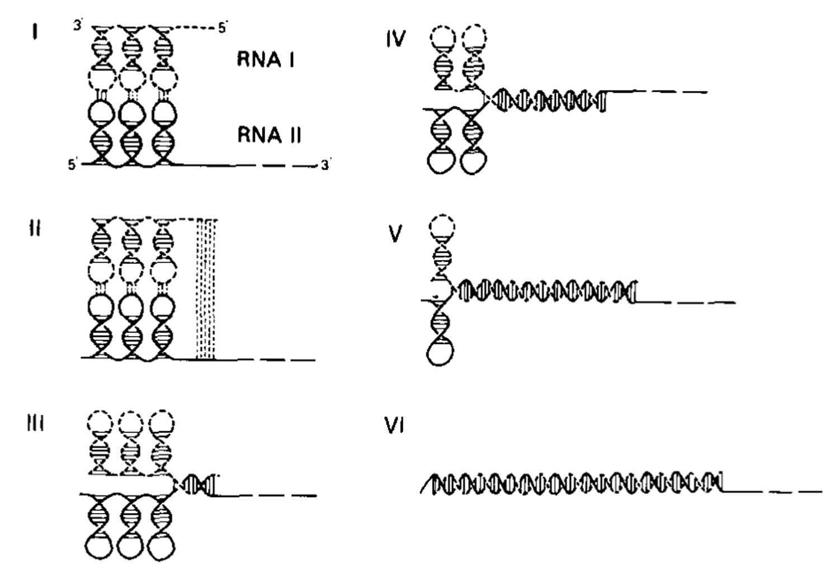
Figure 1 Model of two step interaction between antisense RNA I and sense RNA II-initial stem loop recognition followed by antisense/sense RNA/RNA duplex formation. Reproduced from ref. [34] with permission.
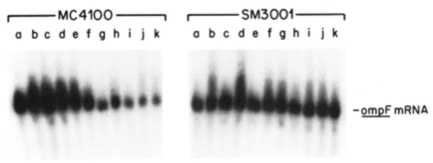
Figure 2 ompF mRNA levels after temperature shift from 24 ºC to 42 ºC. Lanes marked a-k correspond to time 0’-120’. Left, RNA from strain MC4100 that has the micF gene; right, strain SM3001 that is a micF deletion strain. Data from Andersen et al^{[10]}. Reproduced with permission.
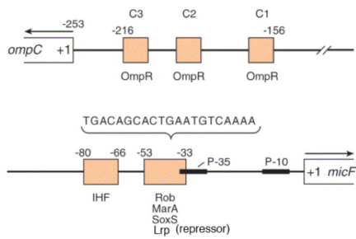
Figure 3 Schematic of micF gene, upstream P-10, P-35 promoter region and transcription factor binding sites. Diagram modified from Delihas and Forst^{[51]}.
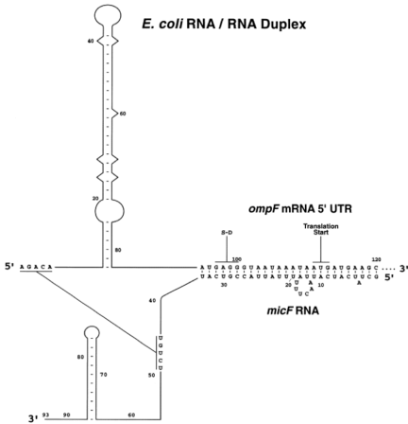
Figure 4 Model of micF RNA/ompF mRNA interaction. Duplex based on secondary structure probing; the long range pairing of five bases at the 5’ end of ompF mRNA with positions 45-49 of micF RNA was based on computational analysis^{[66]}. Reproduced from Delihas and Forst^{[51]}.
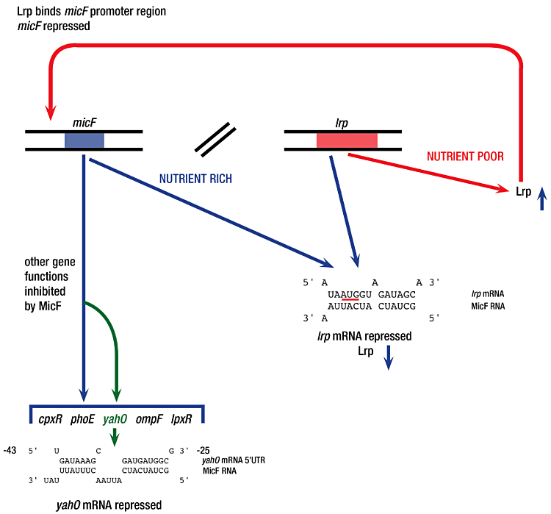
Figure 5 Multifaceted functions of micF RNA showing a “circular” regulatory process involving Lrp and micF RNA. Also shown are multiple mRNAs targeted by micF RNA. Based on work of Holmqvist et al^{[64]} and Corcoran et al^{[65]}. Drawing reproduced from Delihas^{[69]}.

