Name of journal: World Journal of Gastrointestinal Endoscopy
Manuscript NO: 33762
Manuscript Type: ORIGINAL ARTICLE

Case Control Study
Clinical predictors for sessile serrated polyposis syndrome: A case control study

Wu Y et al. Clinical predictors of sessile serrated polyposis syndrome
Yang Wu, Alexander Mullin, Alina Stoita

Yang Wu, Alina Stoita, Gastroenterology and Hepatology, St Vincent's Hospital, University of NSW, Sydney, NSW 2010, Australia

Alexander Mullin, University of Notre Dame, Sydney, NSW 2010, Australia

Author contributions: All authors contributed to the manuscript. Wu Y and Stoita A designed the study; Wu Y and Mullin A performed data collection; Wu Y performed statistical analysis with supervision from statistical consulting unit Stats Central at University of NSW; Wu Y wrote the manuscript and Alina Stoita edited the manuscript.

Institutional review board statement: The study was approved by the Institutional Review Board. St Vincent’s Hospital Research office approved of the study as a low negligible risk research project.

Informed consent statement: Patients were not required to give informed consent to the study because the analysis used anonymous clinical data that were obtained after each patient agreed to treatment by written consent.

Conflict-of-interest statement: There is no conflict of interest

Data sharing statement: Technical appendix, statistical code, and dataset available from the corresponding author at astoita@stvincents.com.au. Consent was not obtained but the presented data are anonymized and risk of identification is low.

Open Access: This article is an open-access article which was selected by an in-house editor and fully peer-reviewed by external reviewers. It is distributed in accordance with the Creative Commons Attribution Non Commercial (CC BY-NC 4.0) license, which permits others to distribute, remix, adapt, build upon this work non-commercially, and license their derivative works on different terms, provided the original work is properly cited and the use is non-commercial.

Manuscript source: Invited manuscript

Correspondence to: Dr. Yang Wu, Department of Gastroenterology, St Vincent’s Hospital 390 Victoria St, Darlinghurst, NSW 2010, Australia, Yangwu_22@hotmail.com
Telephone: +61-2-8382111
Fax: +61-2-83823983

Received: February 28, 2017
Peer-review started: March 2, 2017
First decision: May 26, 2017
Revised: June 15, 2017
Accepted: July 14, 2017
Article in press:
Published online:

Abstract
AIM
To compared individuals with serrated polyposis syndrome (SPS) to those with Sessile Serrated adenoma (SSA) and adenomas in the setting of endoscopists with high adenoma detection rates at a secondary and tertiary academic centre.

METHOD
Retrospectively we collated the clinical, endoscopic and histological features of all patients with SPS at St Vincent’s public and private hospital in the last 3 years. Patients were identified by searching through 2 pathology databases. Variables explored included smoking status, symptoms, and family history of concurrent colorectal cancer, number and location of polyps. Patients with SPS were matched to two cohorts (1) patients with SSA not meeting World Health Organization (WHO) criteria for SPS over 3 years; and (2) patients with exclusively adenomas. The control cases were also matched according to gender and endoscopist. Adenoma detection rates ranged from 25% to 40%.

RESULTS
Forty patients with SPS were identified and matched with 40 patients in each control group. In total 15452 colonoscopies were performed over the study period which amounts to a prevalence of 1: 384 patients (0.26%) with SPS. 14 patients (35%) required more than 1 year to accumulate enough polyps to reach WHO criteria for SPS. The diagnosis of SPS was largely incidental and 5% SPS patients were diagnosed with colorectal cancer over 3 years. The chance of detecting a meta-synchronous adenoma was similar in those with SPS (42%) and those with SSA (55%), P = 0.49. The majority of patients (75%) meeting criteria for SPS were women. The mean age of those with SPS (45 years) was significantly lower than both cohorts with SSA (57 years) and adenomas (63 years), P = 0.01. On univariate analysis cigarette exposure, first-degree family history of colorectal cancer and a high BMI weren’t significantly more associated with SPS compared to patients with SSA or patients with adenomas. However, patients with SPS (97%) and patients with SSAs not meeting SPS criteria (98%) were significantly more likely to be Caucasian compared to patients with adenomas (79%), P = 0.01.

CONCLUSION
The prevalence of SPS in our study was 0.26%. The vast majority of patients diagnosed with SPS were women. As a group, they were significantly younger compared to patients with SSA not meeting WHO criteria and patients with adenomatous polyps by more than a decade. Patients with SPS were no more likely to have a first degree relative with colorectal cancer or smoking history than the other two groups. Patients with serrated polyps were more likely to be Caucasian than patients with adenomas.

Key words: Serrated lesions; Polyposis syndrome; Colonoscopy; Colorectal polyps; Colorectal cancer

© The Author(s) 2017. Published by Baishideng Publishing Group Inc. All rights reserved.

Core tip: At the time of diagnosis, Sessile Serrated Polyposis Syndrome (SPS) is associated with a high risk of concurrent colorectal cancer. Early diagnosis of SPS is crucial and this case-control study aim to delineate differences in risk factors for SPS and other types of polyps. The vast majority of patients diagnosed with SPS in our study were women. They were younger and more likely to be Caucasian compared to patients with adenomatous and patients with serrated adenomas not meeting WHO criteria. SPS patients were no more likely to have a family history of colorectal cancer or cigarette exposure than other polyp groups.

Wu Y, Mullin A, Stoita A. Clinical predictors for the diagnosis of sessile serrated polyposis syndrome: A case control study. World J Gastrointest Endosc 2017; In press

INTRODUCTION
In the past decade, serrated polyps have garnered rapid interest as they cause colorectal cancer via a different pathway compared to adenomas. This pathway features hyper-methylation, CpG island methylator phenotype (CIMP) and mutations in proto-oncogene BRAF. Sessile Serrated adenoma (SSA), hyperplastic polyps and traditional serrated adenoma all fall under the classification of serrated polyps.
Serrated Polyposis Syndrome (SPS), distinguished by numerous serrated polyps distributed throughout the colon is associated with increased risk of colorectal cancer. Its prevalence is unclear. In a systematic review, it ranges from as low as 1:1800 in average risk screening population and as high as 1:150 in patients in a Faecal immunochemical testing programme^{[1,2]}. In comparison, Familial Adenomatous Polyposis Syndrome (FAP), has lower prevalence rate of 1:13,000 in average risk screening population and has a known genetic mutation^{[3]}. However a genetic basis for SPS has not been discovered despite large multi-centre studies looking into a variety of germline mutations^{[4]}. The definition of SPS is essentially a clinical one, based on endoscopic findings and histopathology of polyps removed. In 2010, the condition was arbitrarily defined by the World Health Organization (WHO) as follows: (1) at least 5 histologically diagnosed serrated lesions proximal to the sigmoid colon, of which 2 should be > 10 mm in diameter; (2) any number of serrated polyps proximal to the sigmoid colon in an individual who has a first-degree relative (FDR) with SPS; or (3) > 20 serrated polyps distributed throughout the colon. The definition is a cumulative one, whereas many years and multiple colonoscopies can pass before patient reach the criteria for the diagnosis of SPS^{[5]}.
Concurrent colorectal cancer (CRC) is often encountered at the time of SPS diagnosis, at rates as high as 16%-29%^{[5]}. The propensity for a delay in diagnosis in SPS and the inclusion of patients with symptoms suspicious for cancer accounts for the high prevalence rates in these previous studies. Once patients enter a surveillance program and undergo the recommended yearly colonoscopies, the absolute 5-year CRC risk falls to 1.5%^{[2]}. Hence, early diagnosis of SPS is crucial as it radically change the natural history of patients with the disorder. Serrated and adenomatous polyps share many clinical risk factors, however it is unclear if certain risk factors have a stronger association with one polyp subtype compared to another^{[6]}. Despite there being a small number of studies investigating the differences in risk factors for distinct polyp subtypes, no study to date has included SPS as one of the comparators.

MATERIALS AND METHODS
A case-control retrospective study was conducted in 2 centres; St Vincent’s public hospital, Sydney, Australia a tertiary referral teaching hospital and St Vincent’s clinic, a secondary referral private centre in the same campus. The colonoscopies were performed by 7 experienced endoscopists, each performing more than 450 colonoscopies per year and having high adenoma detection rate between 25% - 40%. Patients undergoing a colonoscopy with polypectomy with a diagnosis of SPS between December 2013 and December 2016 were identified by searching through two pathology databases. The colonoscopies were performed with high definition white light endoscope with NBI capability (190 series, Evis Extera III CV190 processor Olympus, Tokyo, Japan). Bowel preparation was used using either Moviprep split dose (a polyethylene glycol preparation) or Prep Kit C (Sodium picosulfate and Glycoprep). Bowel preparation was considered adequate if the Boston scale score was more than 6 points. Those with poor bowel preparation were excluded. Procedures were performed with the patients under deep sedation with Propofol administered by an anaesthetist. We collated the clinical, endoscopic and histological features of all SPS patients and matched them to two cohorts (1) patients with SSA not meeting WHO criteria for SPS over 3 years; and (2) patients with exclusively adenomas. The control cases were matched according to gender and endoscopist in order to minimise bias secondary to variations in endoscopic recognition and technique.
Variables collected for each patient included age, ethnicity, smoking status, weight, height, symptoms, family history of colorectal cancer, presence/absence of concurrent colorectal cancer, number, size and location of polyps. Since the diagnosis of SPS is dependent on a cumulative polyp count, the number of colonoscopies and years required to meet criteria were also analysed. Whether the diagnosis of SPS was made on the first “index” colonoscopy or subsequent followup colonoscopy during followup was also distinguished. Adenoma detection rates for each endoscopist involved in the study was extracted from Quality Assurance data from each centre. The study was approved by the Institutional Review Board.

Statistical analysis
Univariate analysis of co-variates was analysed using Fisher’s exact test or chi-square test as appropriate. Age and BMI was assessed using the Independent student T-test. Quantitative variables were summarized using mean standard variation and mean values. Frequencies were used to summarise categorical values. SPSS statistics software version X (SPSS, Inc Chicagi, Illionois, United States) was used to analyze the data. The statistical methods of this study were reviewed by Dr. Yang Wu from Department of Gastroenterology, St Vincent’s Hospital, NSW, Australia. Nancy Briggs from Stats Central, statistical consulting unit established at University of NSW, also reviewed the statistical methods of this study.

RESULTS
During the 3 years period, 40 patients were diagnosed with SPS and equal number of patients matched in the control groups: patients with SSA not meeting the WHO criteria for SPS and patients with only adenomatous polyps. Bowel prep was reported as adequate in all the cases. The majority, 26 patients had enough polyps to meet criteria at their first “index” colonoscopy. However 14 patients (35%) required more than 1 year to accumulate enough polyps to reach WHO criteria for SPS, with 7 patients requiring 2 years and 7 patients requiring 3 years to reach criteria. In total 15452 colonoscopies were performed over the study period across the two sites which amounts to a prevalence of 1: 384 patients (0.26%) with SPS.
The mean age of the patients with SPS was 45 years old and women made up 75% of the cohort. Characteristics of the 40 patients with SPS are included in table 1. There was substantial heterogeneity in the indications for colonoscopy in patients with SPS, ranging from abdominal pain to per rectal bleeding. 7/40 patients underwent colonoscopy due to a history of colonic polyps in the past, sometimes discovered at other endoscopy centres not involved in the study. For the remaining patients, SPS diagnosis was largely unrelated to the pretest suspicion of the referring doctor. Only 1/40 patient had their procedure initiated by a positive Faecal Occult Blood Test (FOBT). The indication for colonoscopy is not a reliable predictor factor for finding SPS.
The mean number of serrated polyps removed during the first colonoscopy was 7 (range 1 to 30) and the mean total number of polyps detected over 3 years was 13 (range 6 to 30). The mean size of the largest serrated polyp removed was 17mm, ranging from 10mm to 40 mm. Interestingly, 17/40 patients with SPS also had concurrent adenomas ranging from 1-6 adenomas detected over 3 years. The age of this subpopulation ranged from 32 to 72 years old.
A small proportion 5% (2/40), were diagnosed with colorectal cancer during the 3 years and neither of the patient displayed symptoms classic of malignancy. Interestingly, both patients met WHO criteria for SPS not during their index colonoscopy but during the followup colonoscopy when their colorectal cancer was diagnosed. Neither patients had a family history of colorectal cancer. One patient was a 76 years old woman with history of one SSA removed from ascending colon in 2014 and subsequently developed a colorectal cancer in hepatic flexure plus five right-sided SSA in 2016. Molecular markers for the colorectal cancer showed positivity for BRAF, Microsatellite instability (MSI) and MLH1. The second patient was a 64 years old woman with one SSA removed in 2013 at different endoscopy centre and subsequently developed a colorectal cancer in the ascending colon along with three adenomas and thirteen SSAs in 2016. This cancer was BRAF and MSI negative. Both patients had localised disease and had surgery with curative intent in 2016.
The mean age of patients with SPS was 45 years (SD: 18.54), significantly lower than 57 years (SD 15.56) in patients SSAs not meeting SPS criteria and 63 years (SD 10.58) in patients with adenomas, P = 0.01. Figures 1 and 2 shows the difference in age distribution between the three polyp groups. The SPS polyp group had a higher rate of family history of colorectal cancer in a first degree relative (31%) compared to the SSA group (26%) and adenoma group (30%), but this didn’t reach statistically significance. Patients with SPS (97%) and patients with SSAs not meeting SPS criteria (98%) were significantly more likely to be Caucasian compared to patients with adenomas (79%), P = 0.01. Past or present cigarette exposure was reported at a higher proportion in patients with SPS (47%) compared to SSA group (32%) and Adenoma group (33%) but this wasn’t statistically significant, P = 0.39. BMI wasn’t significantly different across the three groups with the SPS group associated with mean BMI of 26kg/m², SSA group associated with mean BMI of 23kg/m² and Adenoma group with mean BMI of 25 kg/m², P = 0.61.
Evaluating clinical risk factors between the 26 patients who met WHO criteria for SPS at their first “index” vs 14 patients who required more than 1 year to accumulated enough polyps to be diagnosed with SPS, there was no significant difference in rates of family history of colorectal cancer, smoking or age.
Endoscopically, each polyp group has distinct characteristics. Polyps were predominantly discovered in the right colon in 84% of SPS patients versus 46% of patients with SSAs and 43% of patients with exclusively adenomas, P = 0.003.
In 4/40 patients with SPS and in 4/40 patients with SSA not meeting WHO criteria, an adenoma was the largest polyp discovered, not a serrated polyp. In the rest of the group, 36 patients, the largest polyp was a serrated polyp. Concentrating only on patients whose largest polyp was serrated, the distribution of largest or dominant polyp was significantly different between the SPS patients and SSA patients.
Figure 3 illustrates the differences in the distribution of the largest Serrated polyp in the SPS group compared with the SSA group. In both groups, the largest serrated polyp was most frequently found in ascending colon. However in SSA group, there was a more even spread of large serrated polyps throughout the colonic segments with 5 patients having their largest polyp in his/her sigmoid colon.
The proportion concurrent adenoma 17 (42%) in patients who were diagnosed with SPS was comparable to those with SSAs not meeting SPS criteria 21 (52%). Table 2 describes that patients with SPS have a mean total polyp count significantly higher than the other two groups, but this is expected given the intrinsic requirement of multiple polyps to meet the criteria for SPS. Similarly a greater proportion of patients with SPS have a polyp > 15 mm compared to the other groups. The mean size of largest polyp for SPS (17 mm) was significantly greater than the mean size of largest polyp found in the SSA group (14.3 mm) and the adenoma group (7.8 mm), P = 0.014.
Missing data was most frequently encountered in collating BMI (10%) and documentation of family history of colorectal cancer (15%). Information on smoking status and indication for colonoscopy were almost universally available. Alcohol intake of the patients were sparsely and inconsistently documented in the clinical records. We were unable to precisely quantify alcohol intake for the majority of the patients, hence this variable, an important risk factor for adenoma polyp development, wasn’t analysed in our study.

DISCUSSION
It is estimated that 20%-30% of all CRCs develop through the serrated neoplasia pathway^{[7]}. It has been hypothesised that the imperceptible nature of serrated polyps and inconsistent bowel preparation have been responsible for the relative failure of colonoscopy to protect from proximal colon carcinoma.
In this study, we describe the phenotypic features in a group of patients with SPS from a secondary and tertiary gastroenterology centre over 3 years. The prevalence of SPS in our study, 1:384, is higher than the measurements reported in previous studies performed in screening populations 1:1800^{[1]}. The contrast between these figures may reflect the expertise and vigilance of the local gastroenterologist in detecting serrated lesions. All adenoma detection rates of the endoscopists involved in this study were above the national benchmark on quality in colonoscopy. A shift towards switching split preparation in recent years may have also influenced the ability to detect serrated lesions. Another strength in our data is that there is little ascertainment bias as our data isn’t collected from genetic clinics or bowel cancer screening programs. Limitations in our study include the retrospective assessment of the data, the smaller number of patients with SPS relative to recent multi-center studies^{[8]}, and the inability to analyse alcohol intake as a variable due to missing data points.
Two of our 40 patient with SPS (5%) were diagnosed with colorectal cancer during the 3 year evaluation period, neither of whom reported symptoms suggestive of malignancy. Quantification of the magnitude in which SPS increases the risk of CRC is difficult. Early case series have reported rates of 16-29% in synchronous cancer at the time of SPS diagnosis, however theses risk estimates were likely inflated due to inclusion of many patients symptomatic of cancer not patients undergoing screening. In 2015 Carballal et al^{[8]} described a cumulative CRC incidence of 1.9% over 5 years in a group of 296 patients with SPS in Spain. Forty-seven patients (15.8%) developed cancer during follow-up, with 4/47 (8.5%) developing tumours during surveillance. One of our two patients who developed colorectal cancer had a previous colonoscopy at a different endoscopy centre, where the optical training of the endoscopist and bowel preparation quality is unclear and the diagnosis of SPS could have been missed.
Consistent with previous reports, our cohort with SPS demonstrated some phenotypic heterogeneity^{[9]}. Patients diagnosed with the syndrome were aged from 23 years to 73 years and had an overall polyp count ranging from 7 to 40 polyps, with the largest polyp resected ranging from 10mm to 40mm. However, there were some clinical features that were distinct for patients with SPS compared to those with SSAs not meeting WHO criteria and patients with adenomas. SPS patients were significantly younger and more likely to be caucasian. The polyp groups were matched according to gender hence the gender distribution across the three groups were identical, but the over-representation of women in 75% of patients with SPS suggests that being a women is likely a positive predictor for SPS. Having a first degree relative with CRC was no more strongly associated with SPS than any other polyp groups, somewhat supportive of the lack of genetic causality found in SPS patients so far. Cigarette exposure was found in greater number of patients with SPS than other groups but this didn’t reach statistical significance. Our data adds to the controversy in current literature on whether or not smoking is a risk factor in the serrated pathway^{[10,11]}. Past population-based studies have shown that cancers arising from serrated pathways are specifically associated with cigarette smoking but Liang et al^{[12]} published a meta-analysis in 2009 showing a stronger association with smoking and distal/rectal cancer.
The endoscopic features of our SPS cohort were intrinsic to definition of the disease. Compared to other polyp groups, a greater total number of polyps were discovered in SPS and the size of the dominant polyp was also bigger. SPS was also significantly associated with polyps found with predominance for the right colon. Somewhat surprisingly, the spread of the largest polyp in patients with SSA not meeting WHO criteria was evenly across both right and left colon. In Carballal’s study on CRC risk factors, 53% of the cancers found in a cohort of 293 patients with SPS were discovered in the distal colon^{[8]}. Coupled with the fact that 42% of our SPS patients and 52% of our SSA patients had concurrent adenomas, it seems the pathway to colorectal cancer is indeed a complex interplay between various carcinogenic pathways we are yet to fully untangle.
The cumulative definition of SPS isn’t widely known as it not consistently included in published versions of the WHO criteria. In our study, 14/40 patients could have potentially been mis-diagnosed if the endoscopist didn’t recognise that their cumulative polyp load over successive colonoscopy during the study period were enough to qualify for SPS diagnosis. Although no pre-endoscopic risk factors was found be distinguish the subgroup of SPS diagnosed at index colonoscopy from the subgroup with cumulated polyp count, the fact that both patients with colorectal cancer were diagnosed at a follow-up colonoscopy suggest that there may be important differences in the two groups. Discussion about how to manage patients who may soon develop SPS seems to be sparse. Currently ASGE and ESGE guidelines for patients with SSAs that don’t meet WHO criteria is very similar to adenomas, stratified according to size and number. The earliest recommended followup colonoscopy for serrated polyps without dysplasia is 3 years^{[13]}. Contrasting this with patients with established SPS, the recommended followup colonoscopy is 1 year. Recently, Rivera-Sanchez et al assessed the incremental rate of SPS diagnosis in 191 patients with proximal serrated lesions larger than 5mm after a positive FOBT^{[14]}. One year after the index colonoscopy s where they found 11 patients with SPS, they performed a reassessment colonoscopy in 71 patients and found 20 new patients with SPS. It is postulated that the polyps found on reassessment colonoscopy were either missed during initial colonoscopy or newly grown and early reassessment colonoscopy at 1 year substantially improved SPS detection rate in patients with proximal serrated lesions. Results of our study indicate that there is a substantial number of patients with a polyp load that is borderline for fulfilling WHO criteria and Rivera-Sanchez showed there is good yield in performing reassessment colonoscopy as early as 1 year. Hence, we suggest that there is a population of patients with SSAs that are at risk of developing SPS in near future or have missed serrated polyps that would benefit from earlier endoscopic follow up than currently recommended. Larger prospective studies are required to stratify exactly which threshold qualify a patient for earlier screening, but a revision of guidelines to encourage more accurate and earlier detection SPS would be prudent.

COMMENTS
Background
At the time of diagnosis, Sessile Serrated Polyposis Syndrome (SPS) is associated with high risk of concurrent colorectal cancer. However once patients enter a surveillance program and undergo the recommended yearly colonoscopies, the absolute 5-year colorectal cancer (CRC) risk falls dramatically. Hence, early diagnosis of SPS is crucial as it radically change the natural history of patients with the disorder. Serrated and adenomatous polyps share many clinical risk factors; however it is unclear if certain risk factors have a stronger association with one polyp subtype compared to another.

Research frontiers
Despite there being a small number of studies investigating the differences in risk factors for distinct polyp subtypes, no study to date has included SPS as one of the comparators.

Innovations and breakthroughs
Patients diagnosed with SPS were younger and more likely to be Caucasian compared to patients with adenomatous polyps and patients with serrated adenomas not meeting World Health Organization (WHO) criteria. The vast majority of SPS patients diagnosed were women. Patients with SPS were no more likely to have a family history of colorectal cancer or cigarette exposure than other polyp groups. In addition, 14 out of 40 patients with SPS could have potentially been mis-diagnosed if the endoscopist didn’t recognise that their cumulative polyp load over successive colonoscopy over 3 years were enough to qualify for the diagnosis. This suggest that patients with a polyp load that is borderline for fulfilling WHO criteria have a good chance of qualifying for a SPS diagnosis if reassessment colonoscopy is performed as early as 1 year.

Applications
There is a population of patients with sessile Serrated adenoma that are at risk of developing SPS in near future or have missed serrated polyps that would benefit from earlier endoscopic follow up than currently recommended. Larger prospective studies are required to stratify exactly which threshold qualifies a patient for earlier screening, but a revision of guidelines to encourage more accurate and earlier detection SPS would be prudent.

Terminology
SPS refers to Sessile Serrated Polyposis Syndrome. It is defined by a set of clinical and histo-pathological features by World Helath Organisation.

Peer-review
Well-documented study highlighting the main possible risk factors which could interfere in SPS development. Even though the number of participants in the study is small, the statistical analysis seems to reveal interesting information as concerns the SPS background and the potential of shortening the surveillance interval of the syndrome.
REFERENCES
1 van Herwaarden YJ, Verstegen MH, Dura P, Kievit W, Drenth JP, Dekker E, IJspeert JE, Hoogerbrugge N, Nagengast FM, Nagtegaal ID, Bisseling TM. Low prevalence of serrated polyposis syndrome in screening populations: a systematic review. Endoscopy 2015; 47: 1043-1049 [PMID: 26126164 DOI: 10.1055/s-0034-1392411]
2 Biswas S, Ellis AJ, Guy R, Savage H, Madronal K, East JE. High prevalence of hyperplastic polyposis syndrome (serrated polyposis) in the NHS bowel cancer screening programme. Gut 2013; 62: 475 [PMID: 22851664 DOI: 10.1136/gutjnl-2012-303233]
3 Bisgaard ML, Fenger K, Bülow S, Niebuhr E, Mohr J. Familial adenomatous polyposis (FAP): frequency, penetrance, and mutation rate. Hum Mutat 1994; 3: 121-125 [PMID: 8199592 DOI: 10.1002/humu.1380030206]
4 Clendenning M, Young JP, Walsh MD, Woodall S, Arnold J, Jenkins M, Win AK, Hopper JL, Sweet K, Gallinger S, Rosty C, Parry S, Buchanan DD. Germline Mutations in the Polyposis-Associated Genes BMPR1A, SMAD4, PTEN, MUTYH and GREM1 Are Not Common in Individuals with Serrated Polyposis Syndrome. PLoS One 2013; 8: e66705 [PMID: 23805267 DOI: 10.1371/journal.pone.0066705]
5 Buchanan DD, Sweet K, Drini M, Jenkins MA, Win AK, Gattas M, Walsh MD, Clendenning M, McKeone D, Walters R, Roberts A, Young A, Hampel H, Hopper JL, Goldblatt J, George J, Suthers GK, Phillips K, Young GP, Chow E, Parry S, Woodall S, Tucker K, Muir A, Field M, Greening S, Gallinger S, Green J, Woods MO, Spaetgens R, de la Chapelle A, Macrae F, Walker NI, Jass JR, Young JP. Phenotypic diversity in patients with multiple serrated polyps: a genetics clinic study.Int J Colorectal Dis 2010; 25: 703-712 [PMID: 20213458 DOI: 10.1007/s00384-010-0907-8]
6 Burnett-Hartman AN, Passarelli MN, Adams SV, Upton MP, Zhu LC, Potter JD, Newcomb PA. Differences in epidemiologic risk factors for colorectal adenomas and serrated polyps by lesion severity and anatomical site. Am J Epidemiol 2013; 177: 625-637 [PMID: 23459948 DOI: 10.1093/aje/kws282]
7 Kahi CJ, Hewett DG, Norton DL, Eckert GJ, Rex DK. Prevalence and variable detection of proximal colon serrated polyps during screening colonoscopy. Clin Gastroenterol Hepatol 2011; 9: 42-46 [PMID: 20888435 DOI: 10.1016/j.cgh.2010.09.013]
8 Carballal S, Rodríguez-Alcalde D, Moreira L, Hernández L, Rodríguez L, Rodríguez-Moranta F, Gonzalo V, Bujanda L, Bessa X, Poves C, Cubiella J, Castro I, González M, Moya E, Oquiñena S, Clofent J, Quintero E, Esteban P, Piñol V, Fernández FJ, Jover R, Cid L, López-Cerón M, Cuatrecasas M, López-Vicente J, Leoz ML, Rivero-Sánchez L, Castells A, Pellisé M, Balaguer F; Gastrointestinal Oncology Group of the Spanish Gastroenterological Association. Colorectal cancer risk factors in patients with serrated polyposis syndrome: a large multicentre study. Gut 2016; 65: 1829-1837 [PMID: 26264224 DOI: 10.1136/gutjnl-2015-309647]
9 Hazewinkel Y, Koornstra JJ, Boparai KS, van Os TA, Tytgat KM, Van Eeden S, Fockens P, Dekker E. Yield of screening colonoscopy in first-degree relatives of patients with serrated polyposis syndrome. J Clin Gastroenterol 2015; 49: 407-412 [PMID: 24583756 DOI: 10.1097/MCG.0000000000000103]
10 Samowitz WS, Albertsen H, Sweeney C, Herrick J, Caan BJ, Anderson KE, Wolff RK, Slattery ML. Association of smoking, CpG island methylator phenotype, and V600E BRAF mutations in colon cancer. J Natl Cancer Inst 2006; 98: 1731-1738 [PMID: 17148775 DOI: 10.1093/jnci/djj468]
11 Barault L, Charon-Barra C, Jooste V, de la Vega MF, Martin L, Roignot P, Rat P, Bouvier AM, Laurent-Puig P, Faivre J, Chapusot C, Piard F. Hypermethylator phenotype in sporadic colon cancer: study on a population-based series of 582 cases. Cancer Res 2008; 68: 8541-8546 [PMID: 18922929 DOI: 10.1158/0008-5472.CAN-08-1171]
12 Liang PS, Chen TY, Giovannucci E. Cigarette smoking and colorectal cancer incidence and mortality: systematic review and meta-analysis. Int J Cancer 2009; 124: 2406-2415 [PMID: 19142968 DOI: 10.1002/ijc.24191]
13 Lieberman DA, Rex DK, Winawer SJ, Giardiello FM, Johnson DA, Levin TR; United States Multi-Society Task Force on Colorectal Cancer. Guidelines for colonoscopy surveillance after screening and polypectomy: a consensus update by the US Multi-Society Task Force on Colorectal Cancer. Gastroenterology 2012; 143: 844-857 [PMID: 22763141 DOI: 10.1053/j.gastro.2012.06.001]
14 Rivero-Sanchez L, Lopez-Ceron M, Carballal S, Moreira L, Bessa X, Serradesanferm A, Pozo A, Augé JM, Ocaña T, Sánchez A, Leoz ML, Cuatrecasas M, Grau J, Llach J, Castells A, Balaguer F, Pellisé M; Procolon Group. Reassessment colonoscopy to diagnose serrated polyposis syndrome in a colorectal cancer screening population. Endoscopy 2017; 49: 44-53 [PMID: 27741536 DOI: 10.1055/s-0042-115640]

P-Reviewer: Galanopoulos M S-Editor: Qi Y L-Editor: E-Editor:
Specialty type: Gastroenterology and hepatology
Country of origin: Australia
Peer-review report classification
Grade A (Excellent): 0
Grade B (Very good): B
Grade C (Good): 0
Grade D (Fair): 0
Grade E (Poor): 0

Table 1 Characteristics of patients with serrated polyposis syndrome n (%)
Study population (n = 40)
Women | 30 (75)
Age in years, mean ± SD | 45 ± 18.54
Ethnicity  Caucasian  Other | 39 (98)  1(2)
First Degree Relative with CRC  Present  Absent | 12 (35)  22 (65)
Smoking status  Current Smoker/Ex-smoker | 318 (48)
BMI (kg/m²), mean ± SD | 25 ± 4.7
WHO Criteria  1  2  3 | 30 (75)  0  10 (25)
Mean number of total polyps | 13
Mean number of serrated polyps during first colonoscopy | 7
Mean size of largest polyp (mm) | 17
Location of largest polyp  Caecum  Ascending colon  Transverse colon  Descending colon  Sigmoid colon | 13 (32)  16 (40)  5 (13)  2 (5)  4 (10)
SPS: Serrated Polyposis Syndrome.

Table 2 Endoscopic features of each polyp groups
 | SPS  n = 40  Number/mean | Adenoma  n = 40  Number/mean | SSA  n = 40  Number/mean | P value for comparison between groups
Patients with concurrent adenoma  Yes  No | 17 (42)  23 (58) |  | 21 (52)  19 (48) | 0.49
Total Number of Polyps | 13 | 1.4 | 3.4 | 0.001
Patients with a polyp > 15 mm  Yes  No | 30 (75)  10 (25) | 3 (7.5)  37 (92.5) | 21 (52)  19 (48) | 0.04
Size of largest polyp (mm) | 17 | 7.8 | 13.5 | 0.014

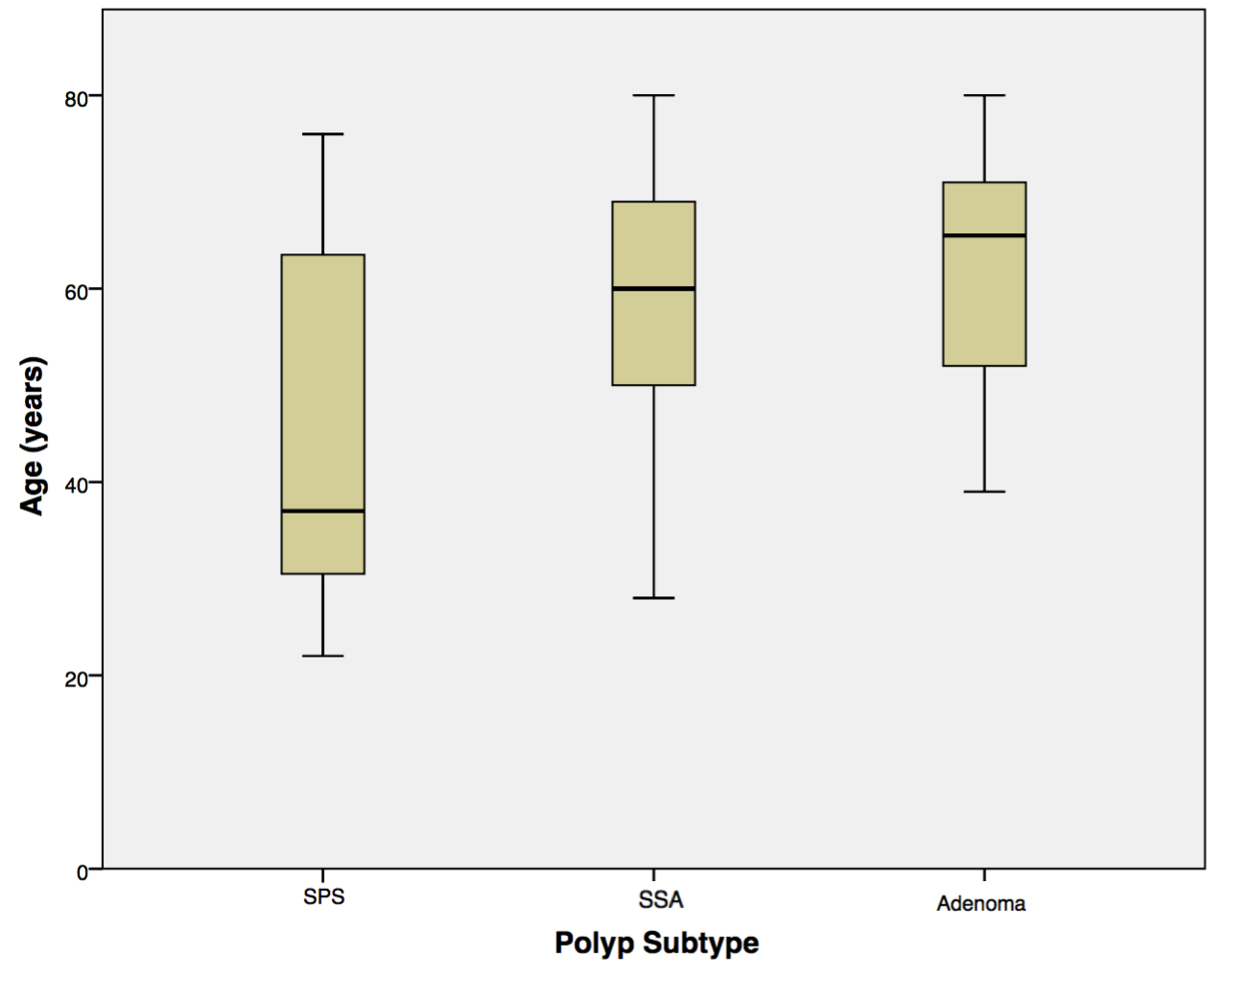

Figure 1 Polyp groups according to age distribution.
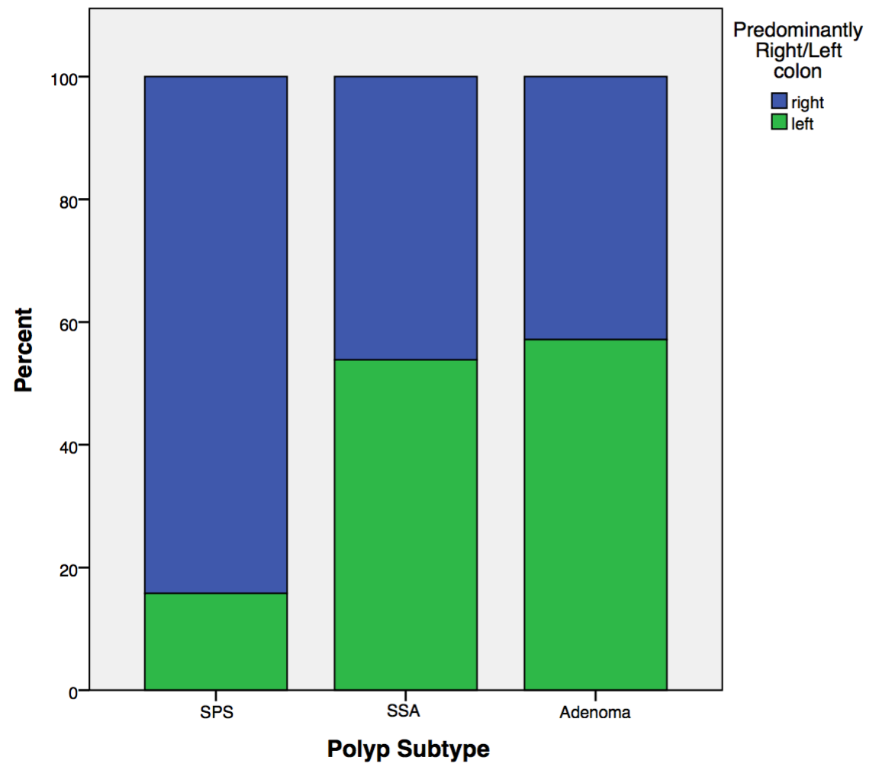

Figure 2 Relationship between polyp groups and predominance for polyp location in right/left colon.

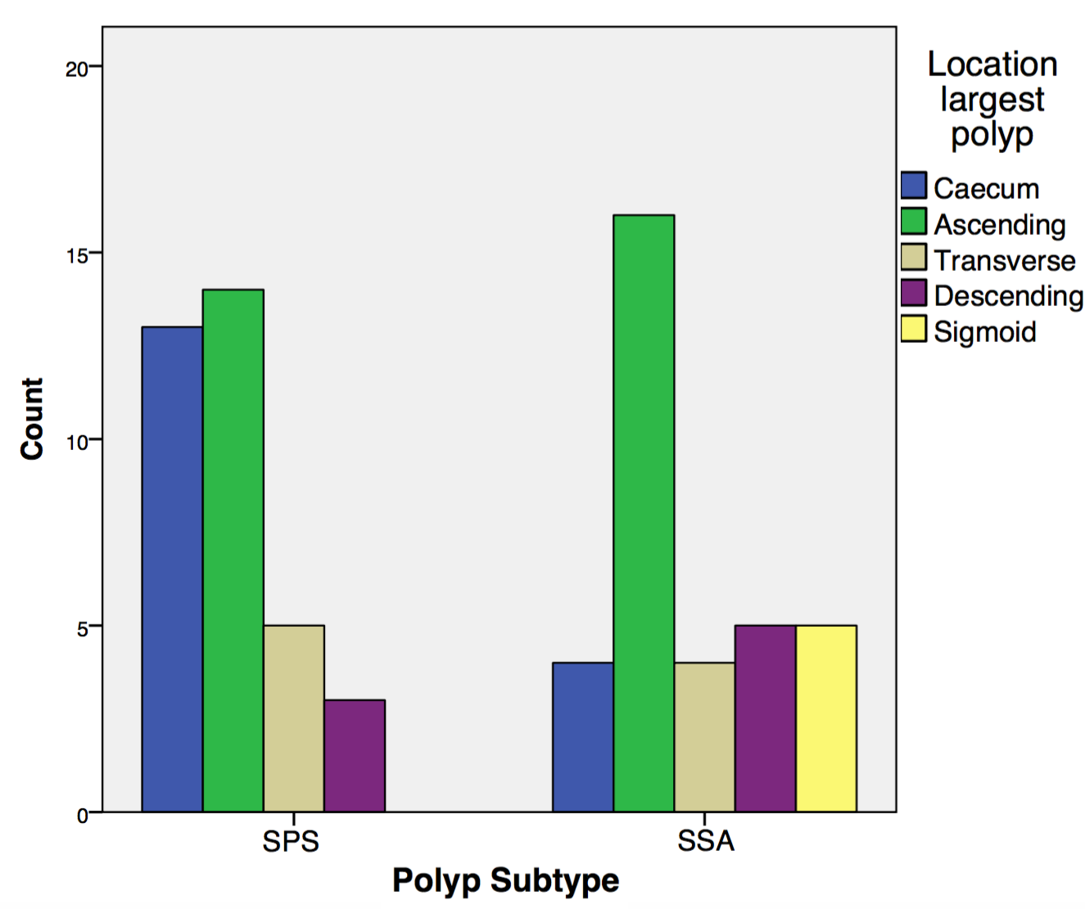

Figure 3 Distribution of the largest serrated polyp according to colonic segments in serrated polyposis syndrome patients and patients with sessile serrated polyps not meeting serrated polyposis syndrome criteria.

