Name of Journal: World Journal of Orthopedics
Manuscript NO: 68849
Manuscript Type: ORIGINAL ARTICLE

Retrospective Cohort Study
Preseason elimination impact on anterior cruciate ligament injury in the national football league

Patetta M et al. Preseason impact on ACL injury in NFL

Michael Patetta, Benjamin Mayo, Omar Zaki Martini, Breanna Sullivan, Leonard Onsen, Mark Hutchinson

Michael Patetta, Benjamin Mayo, Omar Zaki Martini, Breanna Sullivan, Leonard Onsen, Mark Hutchinson, Department of Orthopaedics, University of Illinois Chicago College of Medicine, Chicago, IL 60612, United States

Author contributions: All authors solely contributed to this paper.

Corresponding author: Omar Zaki Martini, BSc, Research Fellow, Department of Orthopaedics, University of Illinois Chicago College of Medicine, 835 S. Wolcott Avenue E270 MSS MC 844, Chicago, IL 60612, United States. omarti29@uic.edu

Received: June 6, 2021
Revised: August 3, 2021
Accepted: September 15, 2021
Published online:

Abstract
BACKGROUND
Anterior cruciate ligament (ACL) injuries represent detrimental injuries in the National Football League (NFL). A significant portion of these injuries often occur in preseason exhibitions. The Coronavirus disease 2019 (COVID-19) pandemic presented a unique disruption to preseason NFL football with the cancelation of all preseason games.

AIM
To compare the incidence of ACL tears through the first eight weeks of the NFL season in 2020 to the mean incidence over the previous 5 seasons (2015-2019) and determine if there was any change in incidence with the elimination of the preseason.

METHODS
NFL players who suffered ACL tears during the preseason and first eight weeks of the NFL season from 2015-2020 were identified. The number of ACL injuries for the 2015-2019 seasons was compared to the 2020 season for four different timeframes. For each analysis, the cumulative number of ACL injuries to that time point was used to calculate the percent difference for descriptive analysis. Additionally, the number of teams with at least one player suffering an ACL tear were identified and compared using Chi-Squared testing. Finally, a cumulative relative risk was calculated for each week played.

RESULTS
There were 14 ACL tears through the first four games of the 2020 season, a 118.8% (14 vs 6.4) increase in comparison to the 5-year average over the first 4 regular season weeks of 2015-2019. However, when accounting for injuries occurring during the preseason from 2015-2019, there were 18.6% (14 vs 17.2) fewer total ACL injuries through regular season week 4 with no significant difference in percentage of teams impacted when these preseason injuries were accounted for P = 0.394. Results were similar (19 vs 17.2) over 8 total games played (whether regular season or preseason), and over 8 regular season games (P = 0.196, P = 0.600).

CONCLUSION
The elimination of the NFL preseason resulted in a higher rate of injuries during the first 4 games of the regular season. However, these increases are offset by the injuries typically sustained during the preseason. This suggests there may be front-loading of injuries over the course of an NFL season, such that players may be more prone to injury when the intensity of play suddenly increases, whether in the preseason or regular season.

Key Words: Anterior cruciate ligament; National football league; Player safety; Ligamentous injury; Preseason; COVID-19

Patetta M, Mayo B, Martini OZ, Sullivan B, Onsen L, Hutchinson M. Preseason elimination impact on anterior cruciate ligament injury in the national football league. World J Orthop 2021; In press

Core Tip: The coronavirus disease 2019 (COVID-19) pandemic presented a unique disruption to preseason National Football League (NFL) football with the cancelation of all preseason games. This study compared the incidence of anterior cruciate ligament (ACL) tears through the first eight weeks of the NFL season in 2020 to the mean incidence over the previous 5 seasons and found that there was indeed an increase in ACL tears through the first four games of the 2020 season with no significant difference when accounting for the preseason. This suggests that there may be front-loading of injuries over the course of an NFL season. In summary, this study suggests that if preseason games are eliminated, players can expect similar rates of ACL tears overall when compared to conventional seasons, but with more ACL tears in the first four weeks of the regular season.

INTRODUCTION
Anterior cruciate ligament (ACL) injuries are among the most common knee injuries in American football players, and their incidence increases with increased level of competition. In one survey, 14.2% of retired National Football League (NFL) players reported a history of ACL injury^{[1]}. Because of the high incidence of ACL injuries and their potential to end players’ seasons or careers, extensive research has been conducted to identify risk factors that may contribute to ACL injury and modifications to improve player safety. One of these modifiable risk factors may be preseason training.
Over the last decade, NFL and National Football League Players Association have disputed the importance and number of preseason games necessary before the NFL season. Since 1978, NFL teams participated in a 4-game stretch of weekly exhibition games to prepare for the upcoming season. However, in 2020 the coronavirus disease 2019 (COVID-19) pandemic presented a unique disruption to this sequence, with all preseason games cancelled prior to the beginning of the season.
ACL tears are catastrophic and common injuries in football, with athletes estimated to have a ten times higher risk of rupture in participation when compared to other sports^{[2]}. A recent systematic review reported the overall return to play rate in NFL athletes after an ACL tear at only 67.2%, with significant variability depending on the position and experience of the athlete^{[3-5]}. Additionally, of players able to return, the financial impact of these injuries on player earning potentials is well documented, with salary losses of roughly $2 million per year after injury^{[6]}.
The purpose of this study was to compare the incidence of ACL tears through the first eight games played of the NFL season in 2020 to the mean incidence over the previous 5 seasons (2015-2019) and determine if there was any change in incidence with the elimination of the preseason.

MATERIALS AND METHODS
NFL players who suffered ACL tears during preseason games and first eight regular season games played of the NFL season for the years 2015-2020 were identified and confirmed using reports from official NFL team websites. Only injuries occurring during regular and preseason games were included. Injuries occurring in organized team activities, practices, or individual training sessions were not included in the analysis, as regimens and activities of individual players and teams inherently vary considerably. The five-year total and yearly mean number of ACL injuries were calculated for the 2015-2019 seasons and compared to the 2020 season for four different timeframes.
First, the first four regular season games of the 2020 season were compared to the first four regular season games of 2015-2019 season, excluding any preseason injuries. Second, the first four regular season games for the 2020 season were compared to first four regular season games played of the 2015-2019 season, including injuries sustained in the four preseason games accrued in 2015-219. Third, the first 8 regular season games played for the 2020 season were compared to the first eighth regular season games played of the 2015-2019 season, including injuries sustained in the four preseason games. Lastly, the cumulative number of injuries through 8 wk of any gameplay were compared, and a relative risk was calculated for player injuries per game played by each week. In other words, the first 4 preseason games of 2015-2019 were analyzed in combination with the first 4 games of their respective regular seasons and compared to the first 8 regular season games of 2020.
For each analysis, the cumulative number of ACL injuries to that time point was used to calculate the percent difference for a descriptive analysis. Additionally, the number of teams with at least one player suffering an ACL tear were identified and compared using Chi-Squared testing. All collected data was then analyzed using IBM SPSS Statistics Version 25 (Armonk, NY, United States). P values < 0.05 were considered statistically significant.

RESULTS
Comparison of first four regular season games
There was a total of 14 ACL tears through the first four games of the 2020 season, a 118.8% increase in comparison to the 5-year average over the first 4 wk of the 2015-2019 seasons (Table 1 and Figure 1A). More teams (11) were impacted with an ACL tear in 2020 during the first 4 wk of the season than any season from 2015-2019. Chi squared testing demonstrated a significant difference in rates of teams impacted (Table 1; P = 0.039) in 2020 compared to 2015-2019.

Comparison through the first four regular season games, including preseason
When accounting for injuries occurring during the preseason from 2015-2019, there were 18.6% fewer total ACL injuries through regular season week 4 (Table 1 and Figure 1B). There no significant difference in percentage of teams impacted when these preseason injuries were accounted for (Table 1; P = 0.394).

Comparison through the first eight regular season games, including preseason
Repeat analysis through 8 wk comparing the 2020 season to the 2015-2019 averages including the preseason demonstrated similar results to week 4 analysis, with overall tears down 16.7% with no significant difference in the number of teams affected (Table 1; P = 0.196).

Comparison of the first eight games played
When comparing an equivalent number of games, regardless of regular or preseason designation, there was a 10.5% increase in ACL tear occurrence in the 2020 season (Table 1 and Figure 1C), but no significant difference in the number of teams impacted (Table 1; P = 0.600), or injury rate at any timepoint through eight weeks (Table 2).

DISCUSSION
The results of this study demonstrate that without participation in preseason games, NFL players sustain ACL injuries at a higher rate during the early portion of the regular season. However, when accounting for injuries sustained in preseason, the differences quickly equilibrate and there is no difference in the total number of ACL injuries, or the ACL injuries per game played. Additionally, the injury rate per game played is not statistically different between seasons with and without a preseason.
Recent studies of rugby, Australian rules football, and European soccer teams showed that increased participation in preseason training sessions was associated with a lower in-season injury burden^{[7-9]}. One study of European soccer teams found that every 10 additional preseason training sessions that team members participated in was associated with significantly fewer in-season layoff days due to injury and significantly fewer severe in-season injuries^{[9]}. This highlights the potential benefits of increased preseason training in reducing in-season injury burden. With no preseason games in the 2020 season, NFL players participated in less preseason training. This was associated with an increased risk of injury during their early regular season games compared to a traditional year. However, when comparing the first games played of the 2020 season vs the preseason games in prior seasons, there is no significant difference in total number of injuries or injury rate.
The above information suggests that the elimination of preseason and pre-season training would increase the incidence of ACL injury, which is consistent with the results of our study. Additionally, some studies suggest that targeted training and warm-up exercises can reduce the incidence and risk of ACL injuries^{[10,11]}. One study of American National Collegiate Athletic Association soccer by Silvers-Granelli et al^{[10]} demonstrated that the FIFA 11+ injury prevention program, a 15-20 min dynamic warm-up program performed before training and games, resulted in a 4.25-fold reduction in the likelihood of ACL injury. This highlights the importance of warm-up training directly before vigorous training or exercise. Currently, the NFL does not have a standardized warm-up program, and there have been little to no studies on the impact of warm-up training in the NFL. Thus, the implementation of a similar program into NFL preseason training, regular season training, and NFL games should be explored in future studies, as it may help reduce the incidence of ACL injury.
Another study by Li et al^{[12]} investigated the relationship between soft tissue injury and training load in American football. Player training load was measured using wearable global position system devices outfitted to record acceleration in various axes. They found that a sudden increase in training load was associated with more soft tissue injuries, including ankle ligamentous injury, knee ligamentous injury, hamstring strain and other muscle strain. They concluded that soft tissue injuries during the regular season occurred most often during weeks with increased training loads, as compared to the training load over the month prior to injury.¹² These findings are consistent with the results demonstrated in our study, as a large workload increase in 2020 relative to limited offseason participation may have predisposed NFL athletes to early-season injury. The results of our study show a significant increase in the number of teams with ACL tears in the first four weeks of the 2020 season, as compared to the average number of teams with ACL tears from the first four regular season weeks of the 2015 through 2019 seasons (Table 2). Seeing as regular season games are often played with greater intensity due to the increased level of competition^{[12]}, it is likely that NFL players in the first four weeks of the 2020 season experienced increased physical demands, or in the words of Li et al^{[12]}, “training loads”, as compared to the weeks leading up to the regular season since there were no preseason games. This sudden increase in physical demand may contribute to the increased ACL tears in the first four weeks of the 2020 regular season in comparison to the recent historic average.
However, it is notable that when including ACL injuries from the preseason and the first four weeks of the regular season in 2015 to 2019 in comparison to injuries in the first four weeks of the 2020 season, there was no significant increase in teams impacted by ACL injury through the first four or eight regular season games of the season. Thus, this higher susceptibility to ACL injury due to increased training demand may simply occur in the preseason instead of the regular season historically. In fact, when including preseason games, descriptive reports in this study demonstrated an 18.6% decrease in ACL injuries in the first four weeks of the 2020 season in comparison to 2015-2019 and a 16.7% decrease through the first eight weeks. Results remained inconclusive when looking at injury incidence over an equivalent timespan, with a 10.5% increase in 2020 ACL tear frequency compared to the running average of the preceding 5 NFL seasons with no significant difference in the number of teams impacted. This highlights that there may be front-loading of injuries, such that players may be more prone to injury when the intensity of play suddenly increases, whether that is in the preseason or regular season. This is further supported in our chronologic analysis, which demonstrated no change in the relative risk at any timepoint in the first 8 games of NFL play, regardless if they were preseason or regular season games. Thus, players are likely at increased risk of injury when they engage in full contact play, whether it is in the preseason or regular season. Steiner et al^{[13]} found that full contact preseason practice and scrimmages correlated with a significant increase in practice injuries among college football players, as compared to non-contact practice. This was true of in-season full contact practices and scrimmages as well. This is substantiated by the fact that the majority of ACL injuries in American football are from contact^{[1]}.
The major limitation of the current study is that it is observational and retrospective. While this data shows an interesting association between the number of ACL injuries, as well as number of teams with ACL injuries with and without a preseason, we cannot draw conclusions on the causative effect of a preseason since many factors affect a player’s risk for ACL injury. These include external factors, such as playing surface and cleat design, as well as internal factors, such as previous injury, age, body composition, knee alignment, intercondylar notch width, muscle flexibility, foot biomechanics, and movement patterns^{[14-17]}. This study also did not account for injuries that occurred during practices, off-season training, and organized team activities, though these occur at much lower rates than in-game injuries. Additionally, we only have one season of data in which no preseason games were played. Finally, there are additional variables that complicate the 2020 season, including multiple players opting out of the season entirely, other players missing time due to COVID-19 protocols, and game scheduling delays as a result of COVID-19.

CONCLUSION
While the COVID-19 pandemic is first and foremost a calamity, it has provided a unique opportunity to examine the rates of ACL injuries in the NFL with a complete elimination of the preseason. The results of this study suggest that if preseason games are eliminated, players can expect similar rates of ACL tears overall when compared to conventional seasons, but with more ACL tears in the first four weeks of the regular season.

ARTICLE HIGHLIGHTS
Research background
In 2020, the National Football League (NFL) preseason was eliminated due to the coronavirus disease 2019 pandemic. The purpose of this study was to determine if this unique elimination of the preseason resulted in a change in incidence of anterior cruciate ligament (ACL) tears.

Research motivation
Prior to the pandemic, there had been many discussions regarding the need of the NFL preseason, with the main concern being player safety. Our goal was to obtain relevant data on the impact of the preseason on ACL injuries that can be used for future discussions around that topic.

Research objectives
The main objective of this study was to compare the incidence of ACL tears through the first eight weeks of the 2020 NFL season to the mean incidence over the previous 5 seasons (2015-2019) and determine if there was any change in incidence in 2020. Though this objective was realized, this data can be strengthened if future studies are performed for a greater number of NFL seasons, as we were only able to obtain 5 years of data for this study.

Research methods
NFL players who sustained ACL tears during the preseason and first eight weeks of the NFL season from 2015-2020 were identified using online publicly available data. The number of ACL injuries for the 2015-2019 seasons was compared to the 2020 season.

Research results
A 118.8% increase in ACL tears was noted through the first four games of the 2020 season in comparison to the previous 5-year average over the first four regular season weeks of 2015-2019. However, when accounting for injuries occurring during the preseason from 2015-2019, there were 18.6% fewer ACL injuries through regular season week 4.

Research conclusions
There may be front-loading of injuries over the course of an NFL season, such that players may be more prone to injury when the intensity of play suddenly increases, whether in the preseason or regular season. This study also suggests that although the elimination of the preseason results in similar rates of ACL tears overall, it is correlated with increased ACL tears in the first four weeks of the regular season.

Research perspectives
Future research should be performed comparing the 2020 NFL season with a greater number of NFL seasons, as further data is needed to obtain more definitive results. Additionally, warm-up training has not been studied extensively in American football and is certainly a topic that should be studied for ACL injury prevention.

REFERENCES
1 Rothenberg P, Grau L, Kaplan L, Baraga MG. Knee Injuries in American Football: An Epidemiological Review. Am J Orthop (Belle Mead NJ) 2016; 45: 368-373 [PMID: 27737282]
2 Dragoo JL, Braun HJ, Durham JL, Chen MR, Harris AH. Incidence and risk factors for injuries to the anterior cruciate ligament in National Collegiate Athletic Association football: data from the 2004-2005 through 2008-2009 National Collegiate Athletic Association Injury Surveillance System. Am J Sports Med 2012; 40: 990-995 [PMID: 22491794 DOI: 10.1177/0363546512442336]
3 Ross BJ, Savage-Elliott I, Brown SM, Mulcahey MK. Return to Play and Performance After Primary ACL Reconstruction in American Football Players: A Systematic Review. Orthop J Sports Med 2020; 8: 2325967120959654 [PMID: 33195714 DOI: 10.1177/2325967120959654]
4 Cinque ME, Hannon CP, Bohl DD, Erickson BJ, Verma NN, Cole BJ, Bach BR Jr. Return to Sport and Performance After Anterior Cruciate Ligament Reconstruction in National Football League Linemen. Orthop J Sports Med 2017; 5: 2325967117711681 [PMID: 28680893 DOI: 10.1177/2325967117711681]
5 Shah VM, Andrews JR, Fleisig GS, McMichael CS, Lemak LJ. Return to play after anterior cruciate ligament reconstruction in National Football League athletes. Am J Sports Med 2010; 38: 2233-2239 [PMID: 20610771 DOI: 10.1177/0363546510372798]
6 Secrist ES, Bhat SB, Dodson CC. The Financial and Professional Impact of Anterior Cruciate Ligament Injuries in National Football League Athletes. Orthop J Sports Med 2016; 4: 2325967116663921 [PMID: 27631017 DOI: 10.1177/2325967116663921]
7 Windt J, Gabbett TJ, Ferris D, Khan KM. Training load--injury paradox: is greater preseason participation associated with lower in-season injury risk in elite rugby league players? Br J Sports Med 2017; 51: 645-650 [PMID: 27075963 DOI: 10.1136/bjsports-2016-095973]
8 Murray NB, Gabbett TJ, Townshend AD. Relationship Between Preseason Training Load and In-Season Availability in Elite Australian Football Players. Int J Sports Physiol Perform 2017; 12: 749-755 [PMID: 27834571 DOI: 10.1123/ijspp.2015-0806]
9 Ekstrand J, Spreco A, Windt J, Khan KM. Are Elite Soccer Teams' Preseason Training Sessions Associated With Fewer In-Season Injuries? A 15-Year Analysis From the Union of European Football Associations (UEFA) Elite Club Injury Study. Am J Sports Med 2020; 48: 723-729 [PMID: 31990574 DOI: 10.1177/0363546519899359]
10 Silvers-Granelli HJ, Bizzini M, Arundale A, Mandelbaum BR, Snyder-Mackler L. Does the FIFA 11+ Injury Prevention Program Reduce the Incidence of ACL Injury in Male Soccer Players? Clin Orthop Relat Res 2017; 475: 2447-2455 [PMID: 28389864 DOI: 10.1007/s11999-017-5342-5]
11 Acevedo RJ, Rivera-Vega A, Miranda G, Micheo W. Anterior cruciate ligament injury: identification of risk factors and prevention strategies. Curr Sports Med Rep 2014; 13: 186-191 [PMID: 24819011 DOI: 10.1249/JSR.0000000000000053]
12 Li RT, Salata MJ, Rambhia S, Sheehan J, Voos JE. Does Overexertion Correlate With Increased Injury? The Relationship Between Player Workload and Soft Tissue Injury in Professional American Football Players Using Wearable Technology. Sports Health 2020; 12: 66-73 [PMID: 31469616 DOI: 10.1177/1941738119868477]
13 Steiner ME, Berkstresser BD, Richardson L, Elia G, Wang F. Full-Contact Practice and Injuries in College Football. Sports Health 2016; 8: 217-223 [PMID: 26755741 DOI: 10.1177/1941738115626689]
14 Hewett TE, Zazulak BT, Krosshaug T, Bahr R. Clinical basis: Epidemiology, risk factors, mechanisms of injury, and prevention of ligament injuries of the knee. In: The Knee Joint. Springer; 2012: 53-70 [DOI: 10.1007/978-2-287-99353-4_6]
15 Kiesel K, Plisky PJ, Voight ML. Can Serious Injury in Professional Football be Predicted by a Preseason Functional Movement Screen? N Am J Sports Phys Ther 2007; 2: 147-158 [PMID: 21522210]
16 Mehl J, Diermeier T, Herbst E, Imhoff AB, Stoffels T, Zantop T, Petersen W, Achtnich A. Evidence-based concepts for prevention of knee and ACL injuries. 2017 guidelines of the ligament committee of the German Knee Society (DKG). Arch Orthop Trauma Surg 2018; 138: 51-61 [PMID: 28983841 DOI: 10.1007/s00402-017-2809-5]
17 Nessler T, Denney L, Sampley J. ACL Injury Prevention: What Does Research Tell Us? Curr Rev Musculoskelet Med 2017; 10: 281-288 [PMID: 28656531 DOI: 10.1007/s12178-017-9416-5]

Footnotes
Institutional review board statement: This study was exempt from institutional board review as it was conducted using publicly available information.

Informed consent statement: This study does not require informed consent statement.

Conflict-of-interest statement: None of the authors feature potential conflicts of interest nor have they received any sort of support to carry out this study.

Data sharing statement: No individual participant data was shared.

STROBE statement: The authors have read the STROBE Statement—checklist of items, and the manuscript was prepared and revised according to the STROBE Statement—checklist of items.

Open-Access: This article is an open-access article that was selected by an in-house editor and fully peer-reviewed by external reviewers. It is distributed in accordance with the Creative Commons Attribution NonCommercial (CC BY-NC 4.0) license, which permits others to distribute, remix, adapt, build upon this work non-commercially, and license their derivative works on different terms, provided the original work is properly cited and the use is non-commercial. See: http://creativecommons.org/Licenses/by-nc/4.0/

Manuscript source: Unsolicited manuscript

Peer-review started: June 6, 2021
First decision: July 28, 2021
Article in press:

Specialty type: Sport sciences
Country/Territory of origin: United States
Peer-review report’s scientific quality classification
Grade A (Excellent): 0
Grade B (Very good): B
Grade C (Good): 0
Grade D (Fair): 0
Grade E (Poor): 0

P-Reviewer: Kurniawan A S-Editor: Wu YXJ L-Editor: P-Editor:

Figure Legends
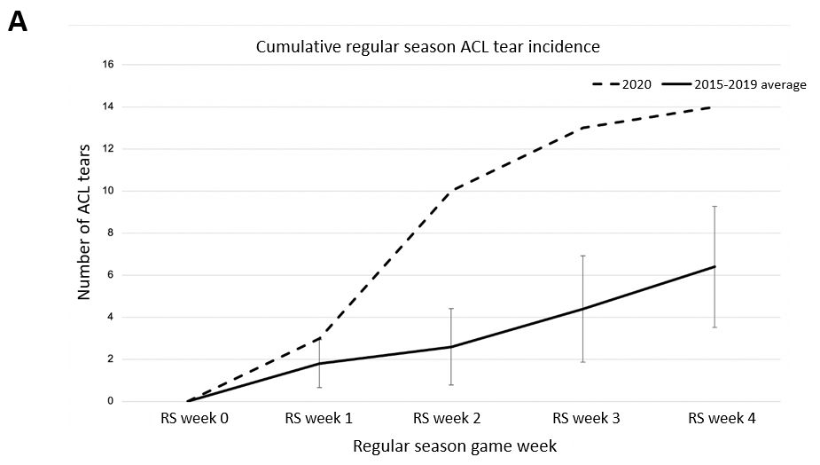
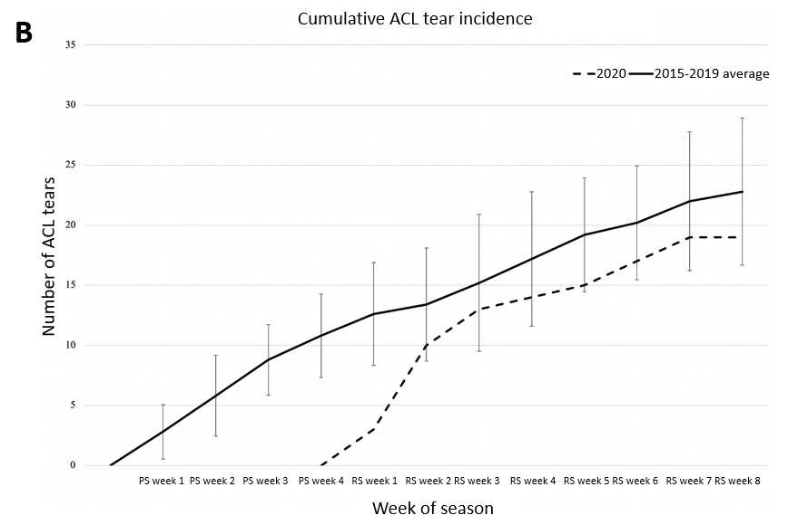
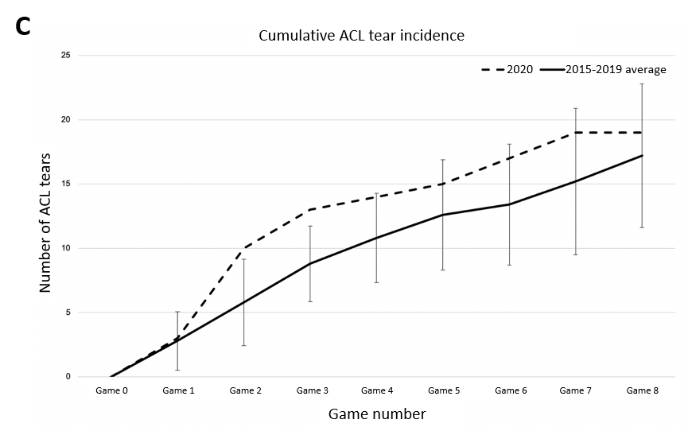
Figure 1 Cumulative plot comparing the number of anterior cruciate ligament tears. A: In the first four regular season (RS) games of the 2020 season to the 2015-2019 RS; B: In the 2020 season to the 2015-2019 average for the preseason (PS) and first 8 wk of the RS. C: In the 2020 season to the 2015-2019 average over the first 8 games played (PS or RS) in each group. Error bars designate the confidence interval above and below the mean. ACL: Anterior cruciate ligament; RS: Regular season; PS: Preseason.
Table 1 Cumulative anterior cruciate ligament tear count
Season | Total ACL tears | Percent difference | Teams impacted | P value¹
Through four regular season games, excluding preseason
2020 | 14 | +118.8% | 11 | 0.039
2015-2019 average | 6.4 |  | 5.8
Through four regular season games, including preseason injuries
2020 | 14 | -18.6% | 11 | 0.394
2015-2019 average | 17.2 |  | 13.6
Through eight regular season games, including preseason injuries
2020 | 19 | -16.7% | 12 | 0.196
2015-2019 average | 22.8 |  | 16.0
Through eight games played, regular or preseason
2020 | 19 | +10.5% | 12 | 0.600
2015-2019 average | 17.2 |  | 13.6
¹P value calculated using Chi-squared analysis. Bold indicated statistical significance. ACL: Anterior cruciate ligament.

Table 2 Week by week comparison of cumulative anterior cruciate ligament tear rate for the first 8 games played
 | Year | Total injuries | Total games | Rate | RR | 95%CI | P value
Game 1 | 2020 | 3 | 16 | 0.188 | 1.071 | 0.348-3.302 | 0.904
 | 2015-2019 | 14 | 80 | 0.175
Game 2 | 2020 | 10 | 32 | 0.313 | 1.724 | 0.937-3.174 | 0.08
 | 2015-2019 | 29 | 160 | 0.181
Game 3 | 2020 | 13 | 48 | 0.271 | 1.477 | 0.865-2.524 | 0.153
 | 2015-2019 | 44 | 240 | 0.183
Game 4 | 2020 | 14 | 63 | 0.222 | 1.317 | 0.781-2.22 | 0.301
 | 2015-2019 | 54 | 320 | 0.169
Game 5 | 2020 | 15 | 77 | 0.195 | 1.237 | 0.745-2.055 | 0.412
 | 2015-2019 | 63 | 400 | 0.158
Game 6 | 2020 | 17 | 91 | 0.187 | 1.338 | 0.826-2.169 | 0.237
 | 2015-2019 | 67 | 480 | 0.140
Game 7 | 2020 | 19 | 105 | 0.181 | 1.333 | 0.844-2.107 | 0.218
 | 2015-2019 | 76 | 560 | 0.136
Game 8 | 2020 | 19 | 119 | 0.160 | 1.181 | 0.748-1.864 | 0.476
 | 2015-2019 | 86 | 636 | 0.135
RR: Relative risk; CI: Confidence interval.

