Name of Journal: World Journal of Gastroenterology
Manuscript NO: 81650
Manuscript Type: ORIGINAL ARTICLE

Retrospective Study
Prolonged hyperthermic intraperitoneal chemotherapy duration with 90 minutes cisplatin might increase overall survival in gastric cancer patients with peritoneal metastases

Steinhoff H et al. CRS + HIPEC in gastric cancer

Heinrich Steinhoff, Miklos Acs, Sebastian Blaj, Magdolna Dank, Magdolna Herold, Zoltan Herold, Jonas Herzberg, Patricia Sanchez-Velazquez, Tim Strate, Attila Marcell Szasz, Pompiliu Piso

Heinrich Steinhoff, Miklos Acs, Sebastian Blaj, Pompiliu Piso, Department of General and Visceral Surgery, Hospital Barmherzige Brüder, Regensburg 93049, Germany

Magdolna Dank, Zoltan Herold, Attila Marcell Szasz, Division of Oncology, Department of Internal Medicine and Oncology, Semmelweis University, Budapest 1083, Hungary

Magdolna Herold, Department of Internal Medicine and Hematology, Semmelweis University, Budapest 1088, Hungary

Jonas Herzberg, Tim Strate, Department of Surgery, Krankenhaus Reinbek St. Adolf-Stift, Reinbek 21465, Germany

Patricia Sanchez-Velazquez, Department of General Surgery, Hospital del Mar, Barcelona 08003, Spain

Author contributions: Steinhoff H, Acs M, Szasz AM and Piso P built the study design; Steinhoff H, Acs M, Blaj S and Sanchez-Velazquez P were involved in the collection of patient data; Herold Z performed the statistical analysis of data; Steinhoff H, Acs M, Herold Z, Herold M, Herzberg J, Strate T and Szasz AM interpreted the data; Steinhoff H, Blaj S, Acs M, Sanchez-Velazquez P and Piso P were involved in patient selection; Steinhoff H, Acs M and Herold Z prepared the draft of the manuscript; All authors were involved in the manuscript editing and reviewing; Dank M and Piso P supervised the study; all authors have read and agreed to the published version of the manuscript.

Corresponding author: Heinrich Steinhoff, MD, Doctor, Surgeon, Department of General and Visceral Surgery, Hospital Barmherzige Brüder, Prüfeninger Str. 86, Regensburg 93049, Germany. heinrich.steinhoff@barmherzige-regensburg.de

Received: November 18, 2022
Revised: February 27, 2023
Accepted: April 10, 2023
Published online: May 14, 2023
Abstract
BACKGROUND
Advanced gastric cancer with synchronous peritoneal metastases (GC-PM) is associated with a poor prognosis. Although cytoreductive surgery with hyperthermic intraperitoneal chemotherapy (CRS-HIPEC) is a promising approach, only a limited number of Western studies exist.

AIM
To investigate the clinicopathological outcomes of patients who underwent CRS-HIPEC for GC-PM.

METHODS
A retrospective analysis of patients with GC-PM was conducted. All patients were seen at the Department of General and Visceral Surgery, Hospital Barmherzige Brüder, Regensburg, Germany between January 2011 and July 2021 and underwent CRS-HIPEC. Preoperative laboratory results, the use of neoadjuvant trastuzumab, and the details of CRS-HIPEC, including peritoneal carcinomatosis index, completeness of cytoreduction, and surgical procedures were recorded. Disease-specific (DSS), and overall survival (OS) of patients were calculated.

RESULTS
A total of 73 patients were included in the study. Patients treated with neoadjuvant trastuzumab (n = 5) showed longer DSS (P = 0.0482). Higher white blood cell counts (DSS: P = 0.0433) and carcinoembryonic antigen levels (OS and DSS: P < 0.01), and lower hemoglobin (OS and DSS: P < 0.05) and serum total protein (OS: P = 0.0368) levels were associated with shorter survival. Longer HIPEC duration was associated with more advantageous median survival times [60-min (n = 59): 12.86 mo; 90-min (n = 14): 27.30 mo], but without statistical difference. To obtain additional data from this observation, further separation of the study population was performed. First, propensity score-matched patient pairs (n = 14 in each group) were created. Statistically different DSS was found between patient pairs (hazard ratio = 0.2843; 95% confidence interval: 0.1119-0.7222; P = 0.0082). Second, those patients who were treated with trastuzumab and/or had human epidermal growth factor receptor 2 positivity (median survival: 12.68 mo vs 24.02 mo), or had to undergo the procedure before 2016 (median survival: 12.68 mo vs 27.30 mo; P = 0.0493) were removed from the original study population.

CONCLUSION
Based on our experience, CRS-HIPEC is a safe and secure method to improve the survival of advanced GC-PM patients. Prolonged HIPEC duration may serve as a good therapy for these patients.

Key Words: Cytoreductive surgery; Hyperthermic intraperitoneal chemotherapy; Peritoneal metastasis; Stomach neoplasms; Gastric cancer

©The Author(s) 2023. Published by Baishideng Publishing Group Inc. All rights reserved.

Citation: Steinhoff H, Acs M, Blaj S, Dank M, Herold M, Herold Z, Herzberg J, Sanchez-Velazquez P, Strate T, Szasz AM, Piso P. Prolonged hyperthermic intraperitoneal chemotherapy duration with 90 min cisplatin might increase overall survival in gastric cancer patients with peritoneal metastases. World J Gastroenterol 2023; 29(18): 2850-2863
URL: https://www.wjgnet.com/1007-9327/full/v29/i18/2850.htm
DOI: https://dx.doi.org/10.3748/wjg.v29.i18.2850

Core Tip: Advanced gastric cancer (GC) cases with peritoneal metastases are known for their poor survival rates. It has been previously reported that these patients benefit from cytoreductive surgery (CRS) with hyperthermic intraperitoneal chemotherapy (HIPEC) but available data on this treatment are scarce. In this study, we retrospectively analyzed the clinicopathological and laboratory data of 73 patients with advanced GC and synchronous peritoneal metastases. It was found that prolonged HIPEC duration after macroscopic complete CRS in the scope of multimodal treatment along with advanced perioperative chemotherapy and biologicals may serve as the best currently available therapy for these patients.
INTRODUCTION
Gastric cancer (GC) is the fifth most common cancer, with a worldwide incidence of 1,089,103 new cases and 768,793 deaths based on the 2020 GLOBOCAN results^{[1,2]}. The majority of the new cases are diagnosed in Asia, where occurrence is 6-fold higher than in Europe; a similar distribution is observed in GC mortality^{[1]}. In Germany, 15,322 new cases and 9,196 deaths were reported in 2020^{[1]}. GC is known for its morphological diversity^{[3]}, and the most commonly used classifications are those outlined by Nakamura et al^{[4]}, Lauren^{[5]}, and the World Health Organization (WHO)^{[6]}. The treatment of gastric cancer is multidisciplinary and depends on the clinical staging of the tumor. While early-stage GC (stage T1a) can be endoscopically resected^{[7]}, stage T1 with positive lymph node(s) and T2-T4a tumors regardless of lymph node status are treated by surgical resection and peri- or postoperative chemotherapy^{[8]}. Advanced resectable GCs are typically treated with neoadjuvant chemotherapy followed by gastrectomy and adjuvant chemotherapy^{[9]}; if not amenable to resection, then the treatment of choice is chemotherapy^{[8]}.
A recent analysis of 18,000 United States patients showed that advanced GC with PM has a median survival of 8.6 mo if treated with chemotherapy only^{[10]}, while studies from the United States^{[11]}, China^{[12]} and Germany^{[13]} have shown that advanced GCs with peritoneal carcinomatosis benefit significantly from cytoreductive surgery (CRS) and hyperthermic intraperitoneal chemotherapy (HIPEC)^{[11-15]} when complete macroscopic resection of the tumor tissue can be achieved^{[16]}. Nevertheless, the available data regarding the use of CRS and HIPEC in advanced GC with PM is scarce, and this multimodal therapy has infrequently been recommended in any national or international guidelines. To date, the Japanese^{[17]} and the United States^{[18]} guidelines do not include CRS and HIPEC as therapeutic options. In France, the guidelines for treatment of advanced GC with PM^{[19]} are yet to be defined in future randomized phase III studies. The same is true in Germany, where an expert consensus-based recommendation calls for the implementation of CRS and HIPEC in clinical studies^{[8]}. The European Society for Medical Oncology guidelines for the treatment of gastric cancer describe CRS and HIPEC as safe procedures, but with unclear oncological outcomes^{[20]}. Accordingly, the aim of this retrospective study was to investigate the clinical outcome after administration of this multimodal therapy in a tertiary center to treat patients with primary advanced GC with PM.

MATERIALS AND METHODS
Patients and study design
The HIPEC database of a single tertiary care center was analyzed in a retrospective manner. A total of 73 patients seen at the Department of General and Visceral Surgery, Hospital Barmherzige Brüder, Regensburg, Germany between January 2011 and July 2021 with primary GC and synchronous PM were included (Figure 1). All patients gave written and verbal informed consent to be included in the national HIPEC registry, administered by the German Society for General and Visceral Surgery (DGAV), and for the use of their anonymized data for research purposes and quality assurance prior to any study-specific procedures. All 73 patients underwent CRS + HIPEC and were treated according to national or international multidisciplinary recommendations^{[8,20]}.

Details of CRS + HIPEC
Each of the 73 cases was discussed by a multidisciplinary board of experts (oncologists, surgeons and anesthesiologists) before any treatment decision was made. Preoperatively, the extent of peritoneal dissemination was assessed using abdominal and chest computed tomography (CT) scans. The peritoneal carcinomatosis index (PCI)^{[21]} was calculated based on diagnostic laparoscopy performed on tumors of T3 stage or higher or CT evidence of peritoneal carcinomatosis^{[22]}. Prior to surgery, all patients were preconditioned as per the enhanced recovery after surgery (ERAS) protocol. During CRS, the completeness of cytoreduction (CC) was scored as proposed by Jacquet and Sugarbaker^{[21]}: no residual disease, residual nodules measuring less than 2.5 mm, between 2.5 mm and 2.5 cm, or greater than 2.5 cm were defined as CC-0, CC-1, CC-2, and CC-3, respectively.
Closed HIPEC with a goal temperature of 42 °C with bidirectional HIPEC with cisplatin (75 mg/m²) and doxorubicin (15 mg/m²) was administered immediately after CRS for 60 min or 90 min duration (Figure 1). The duration of HIPEC was changed from 60 min to 90 min in 2018 based on the findings of van Driel’s study^{[23]}. The cytotoxic agents were added to a 3000 mL-4000 mL isotonic saline solution with a mean flow rate of 1400 mL/min-1800 mL/min. During the treatment, temperature probes for monitoring the 42 °C goal temperature were placed in the right subphrenic and pelvic areas.

Clinicopathological and laboratory data measurements
Clinicopathological and laboratory data were obtained from the DGAV HIPEC registry and the electronic medical system of Hospital Barmherzige Brüder, Regensburg, Germany. The staging of the tumors was unified using the 8th American Joint Committee on Cancer (AJCC) TNM system^{[24]}. Histopathology types of the tumors were categorized as diffuse type adenocarcinoma (ACD), intestinal type adenocarcinoma (ACI), or signet-ring cell adenocarcinoma (SRC)^{[3]}. Neoadjuvant chemotherapeutic treatment of patients was recorded as the latest lineage the patient received prior to CRS + HIPEC. Except for a single patient, all study participants were treated with at least docetaxel-based first-line chemotherapy (FLOT protocol: 5-fluorouracil, leucovorin, oxaliplatin, and docetaxel; or DCF protocol: docetaxel, cisplatin, and 5-fluorouracil). Chemotherapy was administered in accordance with the German guidelines on GC; when recommendation changed from EFC/ECX (Epirubicin, Cisplatin, Fluorouracil/Epirubicin, Cisplatin, Capecitabine) to FLOT after Al-Batran’s FLOT-4 study in 2019^{[25]}, chemotherapy was accordingly changed. The additional use of trastuzumab (trade name: Herceptin) was also recorded.
Complete blood count, liver enzyme, lipase, creatinine, and tumor marker blood tests were performed at the Department of Laboratory Medicine, Microbiology, and Hospital Hygiene, Hospital Barmherzige Brüder, Regensburg, Germany. The Chronic Kidney Disease Epidemiology Collaboration equations were used to calculate estimated glomerular filtration rate^{[26]}. The Clavien–Dindo Classification^{[27]} was used to assess postoperative adverse events. Although some recent publications have suggested including all patient deaths within 90 d as post-procedure deaths^{[28,29]}, HIPEC-related post-procedure deaths were defined as follows: (1) Those occurring during the observation period at the intensive care unit or at the surgical inpatient unit prior to discharge; or (2) Between discharge and adjuvant chemotherapy. If a patient had started adjuvant chemotherapy, their death was defined as GC-related. Recurrence-free (RFS), disease-specific (DSS), and overall survival (OS) were calculated from the date of surgery (CRS + HIPEC) to the date of tumor recurrence, cancer-related death, or death from any cause, respectively. The follow-up of patients was terminated on 30 September 2022 and the patients alive at this time point were right censored (Figure 1).

Statistical analysis
Statistical analyses were performed within the R for Windows version 4.2.1 environment (R Foundation for Statistical Computing, 2022, Vienna, Austria). Wilcoxon rank sum test and Fisher’s exact test were used for group comparisons. Linear models were used to investigate whether there was an improvement in the duration of the procedure (learning curve). Matching of patient pairs was done via propensity score matching (R-package “Matching” version 4.10-8). DSS, OS, and RFS were determined using the cause-specific competing risk Cox survival model (R packages “survival” version 3.4-0 and “survminer” version 0.4.9). Parameter selection for multivariate survival models was not based on univariate P value, but on literature data and the medical/clinical importance of the given parameter. P < 0.05 was considered statistically significant, and P values were corrected with the Holm method^{[30]} for the multiple-comparisons problem. Continuous, survival, and count data were expressed as the mean ± standard deviation (SD), the hazard ratio (HR) with a 95% confidence interval (95%CI), and the number of observations (percentage), respectively.

RESULTS
A total of 73 GC patients with PM were included in the study. Sixty-four cancer-related death events, 13 tumor recurrence events, and 1 death due to postoperative complications occurred. The complete list of pre-, peri- and postoperative clinicopathological characteristics of study participants are listed in Supplementary Table 1. In general, the average operating times (excluding the time for HIPEC) improved significantly over observation period (P = 0.0097; Figure 2).
First, it was investigated whether any of the CRS + HIPEC-related or clinicopathological features had a significant effect on patient survival. The need to remove any further organs, such as the removal of the bladder or the appendix during CRS (n = 9), was associated with a negative effect on DSS (HR: 2.0538; 95%CI: 1.2715-3.3179; P = 0.0033). Those patients who received additional trastuzumab treatment during neoadjuvant chemotherapy (n = 5) before the CRS + HIPEC procedure had better DSS (HR: 0.4446; 95%CI: 0.1989-0.9937; P = 0.0482). A trend towards longer RFS was found in patients who did not require pelvic peritonectomy (HR: 0.3382; 95%CI: 0.1099-1.0410; P = 0.0588). OS was significantly better in patients without pelvic peritonectomy (HR: 0.5459; 95%CI: 0.3152-0.9454; P = 0.0307).
Longer HIPEC duration (60 min vs 90 min) was associated with more advantageous median survival times: 12.86 mo (95%CI: 11.01 mo-17.31 mo) for the 60 min and 27.30 mo (95%CI: 16.20 mo-NA mo) for the 90 min cohorts (Supplementary Table 1). However, despite the clinically different median survival times, the survival of the groups did not differ based on the results of the statistical models with respect to DSS (HR: 0.6239; 95%CI: 0.3413-1.1410; P = 0.1250; Figure 3), OS (HR: 0.6134; 95%CI: 0.3007-1.2510; P = 0.1790), or RFS (P = 0.9650). Furthermore, the type of histology (ACD vs ACI vs SRC) did not affect DSS (P = 0.4096; Supplementary Figure 1), OS (P = 0.2422), or RFS (P = 0.2799). However, the RFS survival curves of the different histology types seemed to be visually different (Figure 4).
The effect of pre-HIPEC laboratory results on patient survival was also investigated. Higher white blood cell counts (HR: 1.1319; 95%CI: 1.0037-1.2770; P = 0.0433) and carcinoembryonic antigen (CEA) levels (HR: 1.1490; 95%CI: 1.0422-1.2667; P = 0.0053) were associated with an increased risk for shorter DSS. In contrast, higher hemoglobin (HR: 0.7897; 95%CI: 0.6562-0.9505; P = 0.0125) and serum total protein (HR: 0.6795; 95%CI: 0.4330-1.0660; P = 0.0928) levels were associated with a significant and marginally decreased risk for shorter survival, respectively. The same results were found for OS (white blood cell count: P = 0.0945; CEA: P = 0.0052; hemoglobin: P = 0.0087; serum total protein: P = 0.0368), while shorter RFS times were observed in patients with higher RDW levels (HR: 1.2190; 95%CI: 1.0030-1.4810; P = 0.0466). Moreover, similar to that observed with respect to OS and DSS, marginally advantageous RFS was justified for higher serum total protein levels (P = 0.0875).
The effect of clinicopathological and laboratory data on survival was also further investigated in a multivariate setting (Table 1). DSS was marginally affected by the duration of HIPEC [60 min (ref.) vs 90 min: HR: 0.5252; 95%CI: 0.2565-1.0750; P = 0.0781] and by PCI (HR: 1.0630; 95%CI: 0.9982-1.1310; P = 0.0569), and significantly by preoperative serum CEA levels (HR: 1.2220; 95%CI: 1.0880-1.3720; P = 0.0007). Similar trends were observed for OS, while worse RFS was more likely associated with lower preoperative white blood cell count (HR: 0.4616; 95%CI: 0.2270-0.9385; P = 0.0327), lower T stage (HR: 13.1182; 95%CI: 1.0285-167.3080; P = 0.0475), and higher N stage (HR: 5.6893; 95%CI: 0.7616-42.4972; P = 0.0902).

Comparison of the 60 and 90-min-long HIPEC patient groups
Further comparison was performed by creating 2 groups according to the duration of HIPEC. Fifty-nine and 14 study participants were enrolled in the 60 min and 90 min groups, respectively. Except for the above-described median survival differences (12.86 mo vs 27.30 mo; Figure 3), no difference was found in any clinicopathological characteristic between the two groups after P value adjustment (Supplementary Table 1).
By investigating the results without P value adjustment, several observations were made. The length of CRS trended toward being shorter in the 90 min group (299 ± 76 min vs 264 ± 82 min; crude P = 0.0718). Peritonectomy of the omental bursa was more frequently performed in the 60-min group (30.5% vs 0%; crude P = 0.0157), while lesser omentectomy was more common in the 90-min group (33.9% vs 71.4%; crude P = 0.0153). Fresh frozen plasma (FFP) transfusion was needed only once in the 90 min group, while in the 60-min group, FFP was administered in 32 patients (7.1% vs 54.2%; crude P = 0.0009). On average, the length of hospital stay was shorter in the 90 min group (crude P = 0.0134); a more detailed examination of the data revealed that hospitalization longer than 20 d was more common in the 60 min group (39.0% vs 7.1%; crude P = 0.0276). Moreover, abnormal serum levels of gamma-glutamyl transferase (crude P = 0.0407, Figure 5A) and serum total protein (crude P = 0.0570, Figure 5B) levels were observed more often in the 60-min group (Supplementary Table 1).
To further investigate the cause of the clinically significant difference in median survival, the following adjustments to the groups were performed with consideration of any possible confounding effects. First, propensity score-matched patient pairs (n = 14) were created in which patients were matched by age, sex, PCI score, CC score, time spent in the intensive care unit after CRS + HIPEC, duration of CRS, and the presence of lymph node metastasis (stage N = 0 vs stage N ≥ 1). No differences in adjusted or in crude P values were found in any of the preoperative, perioperative, and postoperative parameters between propensity score-matched groups. However, the seemingly different survival between the 2 groups became statistically significant [60 min (ref.) vs 90 min: HR = 0.2843; 95%CI: 0.1119-0.7222; P = 0.0082; Figure 6] with 10.91 mo (95%CI: 9.56 mo-17.77 mo) and 27.30 mo (95%CI: 16.20 mo-NA mo) median survivals for the 60 min and 90 min groups, respectively.
We also investigated whether results changed if patients who received trastuzumab and/or had immunohistochemically positive pathological results against human epidermal growth factor receptor 2 (HER2; n = 7) or had the procedure before 2016 (n = 44) were removed from the original cohort. For the former, we obtained the same results as those for the full cohort. Median survivals of 12.68 mo and 24.02 mo were observed for the 60-min and 90-min groups, respectively, and no statistical difference was detected in the survival models (DSS: P = 0.1540; OS: P = 0.2040; Supplementary Figure 2A). However, the same difference was seen for the modified patient population that seen with propensity-matched pairs. Median survivals of 12.52 mo and 27.30 mo were found for the 60 min and 90 min groups, respectively (HR: 0.4225; 95%CI: 0.1789-0.9975; P = 0.0493; Supplementary Figure 2B).

DISCUSSION
There are only a few Western studies concerning the treatment of advanced GC with CRS and HIPEC. Although the positive effects of cytoreduction and HIPEC on survival have been described^{[11-13,31]}, the practical nonexistence of prospective clinical studies (except for two studies with small sample sizes^{[12,32]}) on CRS and HIPEC highlights the need for additional primary research. Moreover, more randomized trials are required to substantiate the effect of CRS and HIPEC. For example, the results of the German phase III PREVENT study, in which the effect of HIPEC applied for prevention in lieu of FLOT-chemotherapy, is currently recruiting patients, and results are eagerly anticipated^{[33]}.
In the current retrospective study, we demonstrated prolonged survival with multimodal therapy in the treatment of primary GC patients with PM. The 27.3 mo median survival that we observed is in line with similar studies. For example, in the phase II trial by Badgwell et al^{[11]}, the median OS was 24.2 mo from the date of diagnosis and 16.1 mo from the date of CRS and HIPEC. Similarly, a recent Spanish multicenter study found a median survival of 21.2 mo^{[34]}, while in the German retrospective HIPEC-register study the median survival times ranged from 7.9 mo to 21.2 mo^{[35]}. The same is true of median PCI-scores; median PCI was 2, 6, 6, and 8 in the studies of Badgwell et al^{[11]}, Bonnot et al^{[31]}, Manzanedo et al^{[34]}, and Rau et al^{[35]}, respectively; a median PCI of 3 was calculated in the current study. In addition, Rau et al^{[35]} reported OS of 18 mo, 12 mo, and 5 mo for the 3 patient groups, with corresponding PCI scores of 0-6, 7-15, and 16-39, respectively; this finding suggests that significantly better outcomes are associated with higher CC. In our study, 93.2% of patients underwent complete macroscopic tumor reduction. An important conclusion of the above presented studies is that patients with small tumor burden (PCI < 6, but maximally 9) benefit the most from this multimodal therapy. Although in the current study we could not confirm the benefit of reduced PCI scores, our results were in line with the previously described observations (i.e. patients with higher PCI scores trended toward shorter survival). Furthermore, an interesting observation emerged during the analysis of our data over time and with an increasing number of cases: the duration of surgery to reach complete cytoreduction became significantly shorter. These findings match with the results of a study outlining the technical aspects and learning curve of CRS/HIPEC by Vining et al^{[36]}, where the authors describe a steep learning curve and a correlation between CC and surgeon expertise. This observation underscores the idea that treatment of advanced GC with PM should be performed in specialized centers by expert surgeons. Recent studies have also found that sodium thiosulfate can prevent impairment of renal function following HIPEC^{[37,38]}. In the patient population analyzed in the current study, sodium thiosulfate was not used; however, since January 2022, we have started to use it routinely in our center.
There is still no consensus regarding the ideal duration of HIPEC. In the current analysis, the median survival time was 27.30 mo in the 90 min group, which was significantly longer than that of the 60 min group (12.86 mo). Near the publication date of the van Driel et al^{[23]} study for ovarian cancer and the PRODIGE-7 trial^{[39]} for HIPEC in colorectal cancer, our institutional HIPEC protocol was changed in favor of the 90 min HIPEC perfusion. Our group has recently described the advantages of prolonged HIPEC duration have been recently described for primary peritoneal carcinoma, primary advanced epithelial carcinoma, and ovarian or fallopian tube carcinoma^{[40,41]}. Longer HIPEC duration does not adversely affect perioperative morbidity and mortality, and a potential survival benefit could be realized by the application of prolonged HIPEC^{[40]}. However, a recent study found that a secondary inflammatory reaction might occur after 90 min HIPEC with mitomycin C/doxorubicin or cisplatin, but not with shorter duration and oxaliplatin^{[41]}. These and the current findings suggest that a prolonged peritoneal perfusion time may be more advantageous after complete cytoreduction; however, as the study of Roth et al^{[41]} has shown, gathering additional data is essential.
Another possible reason for better survival in patients with longer HIPEC duration is enhanced cytotoxicity and anti-tumor effects of chemotherapeutic drugs in hyperthermia; the longer exposure may allow for more effective drug action^{[42]}. The effect of cytoreductive surgery with macroscopic complete tumor reduction followed by HIPEC with effective neoadjuvant chemotherapy extends survival time of patients with advanced GC with PM, as recently shown in the CYTO-CHIP study^{[31]}. Since 2016, the most frequently used neoadjuvant chemotherapy for advanced GC with PM is the FLOT-protocol; however, due to differences in cytochrome P450 family 2 subfamily A member 6^{[43]}, the S-1 regime (tegafur, gimeracil, and oteracil) is the standard adjuvant treatment in Asia^{[44,45]}. The latest advancements in preoperative chemotherapy with^{[46]} or without^{[25]} biological agents can significantly extend the survival of GC patients. Recently, it has also been demonstrated that the 15%-20% of GC cases that overexpresses HER2 should be treated with monoclonal antibodies like trastuzumab in a neoadjuvant setting due to the positive influence of these drugs on patient survival and fewer side effects than traditional chemotherapies^{[47]}. In the current study, the individual responses to pre- and/or postoperative chemotherapy were not known for most patients, which was one of the biasing factors affecting patient survival in our study.
SRC differentiation is described as a tumor with aggressive growth and a poorer prognosis than non-SRC carcinomas of the stomach^{[48]}. In contrast, we found that the type of histology did not affect DSS, OS, or RFS. A similar finding was reported in an Asian study of 136 advanced GC patients, in which the authors described no difference in median survival between the histopathologic entities after R0-resection^{[49]}. Moreover, we observed that if pelvic peritonectomy during CRS is not necessary, the OS of the patient improved. We hypothesize that the extent of the tumor may have a greater influence on patient survival than the histopathological differentiation. Improvement in patient survival may also be influenced by the experience of the surgical team; this factor may have also introduced additional bias in the current study.
We also investigated whether any preoperative laboratory result was predictive of patient survival. Strong correlations were found between patient survival and white blood cell count, hemoglobin, CEA, and serum total protein. These findings match with previously reported data of non-HIPEC-treated GC patients^{[50-55]}. Furthermore, results of a recent German multi-center study^{[56]} and the WHO urgent call^{[57]} to implement blood management in surgical patients have shown that preoperative anemia is a serious threat to patient survival. Preoperative iron supplementation in preoperative anemia is also an important part of the recently published ERAS protocol for CRS and HIPEC^{[58]}. As such, emphasis should be placed on iron supplementation and normalization of hemoglobin prior to surgery^{[58]}.

Limitations
The current study had a few limitations, including the small sample size, the retrospective nature of the study, the fact that data were available from a single center only, and the heterogeneity of the data. Also, during the study period, preoperative chemotherapy protocols changed and surgeon expertise grew. Furthermore, in this small cohort of patients with GC and PM, there were limited data regarding post-HIPEC treatment. Our follow-up data could only differentiate between alive and dead patients and tumor recurrence or no recurrence. Efforts were made to collect post-HIPEC patient data; however, we could not collect these in a timely manner, as routine oncological treatments were often performed in other hospitals. Moreover, the lack of chemotherapy-only control patients should also be mentioned as a limiting factor.

CONCLUSION
In summary, we conducted a single-center retrospective observational study to investigate what factors influence the survival of advanced GC patients with PM who underwent CRS and HIPEC. We confirmed that CRS followed by HIPEC applied over 90 min has a positive impact on DSS in comparison with CRS followed by 60 min of HIPEC. Of note, the learning curve of surgeons may confound the interpretation of this observation. Furthermore, the preparation of patients for surgery based on preoperative laboratory testing according to the current ERAS protocol might optimize the positive effect of CRS and HIPEC. To further expand upon our findings, multi-institutional and cooperative randomized group trials should be organized to further support and confirm survival and safety outcomes.

ARTICLE HIGHLIGHTS
Research background
Cytoreductive surgery (CRS) with hyperthermic intraperitoneal chemotherapy (HIPEC) is one of the last options in the treatment of advanced gastric cancer (GC) with peritoneal metastasis (PM); however, most national and international guidelines only recommend it to be performed within clinical trials. Despite this, CRS with HIPEC is a safe and effective method to treat advanced GC with PM, and recent studies have shown encouraging results with respect to increased patient survival.

Research motivation
CRS and HIPEC are safe and effective therapeutic options for the treatment of advanced GC with PM. To investigate the optimal length of HIPEC procedure, it is important to provide a basis for further research. Improving the composition of HIPEC medications could further improve the outcomes of this modern multimodal therapy. It is expected that ongoing research regarding antibody and checkpoint inhibitor therapies will strongly influence not only perioperative therapy but also the therapeutic agents used during HIPEC itself.

Research objectives
The aim of the study was to explore the effect of CRS and HIPEC in the treatment of advanced GC with PM and find parameters that could further improve patient survival.

Research methods
We conducted a retrospective observational study with the inclusion of 73 GC patients with synchronous PM. Details of CRS + HIPEC, preoperative laboratory results, and pre-, peri-, and postoperative surgical details of the patients were recorded. Overall survival (OS), disease-specific survival (DSS), and recurrence-free survival (RFS) were calculated.

Research results
In line with recently published data, we found that CRS + HIPEC had a measurable impact on the survival of advanced GC patients without significantly elevating the rate of postoperative complications. The effects of longer HIPEC duration, higher white blood cell count, lower hemoglobin and serum total protein, and higher carcinoembryonic antigen levels with respect to the survival of patients were found.

Research conclusions
In general agreement with previously published findings, we concluded that 90 min HIPEC treatment correlates with improvement in the OS and DSS of patients compared to that of 60 min HIPEC. Moreover, more complete cytoreduction also contributes to longer patient survival and better disease management.

Research perspectives
The improvement of CRS and HIPEC with respect to the duration and composition of HIPEC therapeutic agents is a controversial research topic. The current report provides evidence from a single center retrospective study that could be implemented in future randomized multicenter studies.

ACKNOWLEDGEMENTS
We are grateful to Madar-Dank V, research assistant of the Department of the Institute for Dispute Resolution of New Jersey City University, for English proofreading.

REFERENCES
1 Ferlay J, Ervik M, Lam F, Colombet M, Mery L, Piñeros M, Znaor A, Soerjomataram I, Bray F. Global Cancer Observatory: Cancer Today. [cited 22 Oct 2022]. In: International Agency for Research on Cancer [Internet]. Available from: https://gco.iarc.fr/today
2 Sung H, Ferlay J, Siegel RL, Laversanne M, Soerjomataram I, Jemal A, Bray F. Global Cancer Statistics 2020: GLOBOCAN Estimates of Incidence and Mortality Worldwide for 36 Cancers in 185 Countries. CA Cancer J Clin 2021; 71: 209-249 [PMID: 33538338 DOI: 10.3322/caac.21660]
3 Berlth F, Bollschweiler E, Drebber U, Hoelscher AH, Moenig S. Pathohistological classification systems in gastric cancer: diagnostic relevance and prognostic value. World J Gastroenterol 2014; 20: 5679-5684 [PMID: 24914328 DOI: 10.3748/wjg.v20.i19.5679]
4 Nakamura K, Sugano H, Takagi K. Carcinoma of the stomach in incipient phase: its histogenesis and histological appearances. Gan 1968; 59: 251-258 [PMID: 5726267]
5 Lauren P. The two histological main types of gastric carcinoma: diffuse and so-called intestinal-type carcinoma. An attempt at a histo-clinical classification. Acta Pathol Microbiol Scand 1965; 64: 31-49 [PMID: 14320675 DOI: 10.1111/apm.1965.64.1.31]
6 Fukayama M, Rugge M, Washington MK. Tumours of the stomach. In: WHO Classification of Tumours Editorial Board. Digestive System Tumours (WHO Classification of Tumours) 5th ed. Lyon, France: International Agency for Research on Cancer, 2019: 59-104
7 Pimentel-Nunes P, Dinis-Ribeiro M, Ponchon T, Repici A, Vieth M, De Ceglie A, Amato A, Berr F, Bhandari P, Bialek A, Conio M, Haringsma J, Langner C, Meisner S, Messmann H, Morino M, Neuhaus H, Piessevaux H, Rugge M, Saunders BP, Robaszkiewicz M, Seewald S, Kashin S, Dumonceau JM, Hassan C, Deprez PH. Endoscopic submucosal dissection: European Society of Gastrointestinal Endoscopy (ESGE) Guideline. Endoscopy 2015; 47: 829-854 [PMID: 26317585 DOI: 10.1055/s-0034-1392882]
8 Mönig S, Ott K, Gockel I, Lorenz D, Ludwig K, Messmann H, Moehler M, Piso P, Weimann A, Meyer HJ. [S3 guidelines on gastric cancer-diagnosis and treatment of adenocarcinoma of the stomach and esophagogastric junction : Version 2.0-August 2019. AWMF register number: 032/009OL]. Chirurg 2020; 91: 37-40 [PMID: 31950198 DOI: 10.1007/s00104-020-01112-y]
9 Al-Batran SE, Goetze TO, Mueller DW, Vogel A, Winkler M, Lorenzen S, Novotny A, Pauligk C, Homann N, Jungbluth T, Reissfelder C, Caca K, Retter S, Horndasch E, Gumpp J, Bolling C, Fuchs KH, Blau W, Padberg W, Pohl M, Wunsch A, Michl P, Mannes F, Schwarzbach M, Schmalenberg H, Hohaus M, Scholz C, Benckert C, Knorrenschild JR, Kanngießer V, Zander T, Alakus H, Hofheinz RD, Roedel C, Shah MA, Sasako M, Lorenz D, Izbicki J, Bechstein WO, Lang H, Moenig SP. The RENAISSANCE (AIO-FLOT5) trial: effect of chemotherapy alone vs. chemotherapy followed by surgical resection on survival and quality of life in patients with limited-metastatic adenocarcinoma of the stomach or esophagogastric junction - a phase III trial of the German AIO/CAO-V/CAOGI. BMC Cancer 2017; 17: 893 [PMID: 29282088 DOI: 10.1186/s12885-017-3918-9]
10 Greco SH, Chao JC, Heath NG, Lin Y, Gall VA, Grandhi MS, Kennedy TJ, Carpizo DR, Alexander HR, Langan RC, August DA. Surgery is Associated With Improved Overall Survival in Patients With Metastatic Gastric Cancer: A National Cancer Database Analysis. Am Surg 2022; 88: 2637-2643 [PMID: 35649712 DOI: 10.1177/00031348221086800]
11 Badgwell B, Ikoma N, Murphy MB, Wang X, Estrella J, Roy-Chowdhuri S, Das P, Minsky BD, Lano E, Song S, Mansfield P, Ajani J. A Phase II Trial of Cytoreduction, Gastrectomy, and Hyperthermic Intraperitoneal Perfusion with Chemotherapy for Patients with Gastric Cancer and Carcinomatosis or Positive Cytology. Ann Surg Oncol 2021; 28: 258-264 [PMID: 32556731 DOI: 10.1245/s10434-020-08739-5]
12 Yang XJ, Huang CQ, Suo T, Mei LJ, Yang GL, Cheng FL, Zhou YF, Xiong B, Yonemura Y, Li Y. Cytoreductive surgery and hyperthermic intraperitoneal chemotherapy improves survival of patients with peritoneal carcinomatosis from gastric cancer: final results of a phase III randomized clinical trial. Ann Surg Oncol 2011; 18: 1575-1581 [PMID: 21431408 DOI: 10.1245/s10434-011-1631-5]
13 Gronau F, Jara M, Feldbrügge L, Wolf V, Oeff A, Rau B. [Cytoreductive surgery and hyperthermic intraperitoneal chemotherapy in gastric cancer]. Chirurg 2021; 92: 522-527 [PMID: 33620502 DOI: 10.1007/s00104-021-01371-3]
14 Yan TD, Black D, Sugarbaker PH, Zhu J, Yonemura Y, Petrou G, Morris DL. A systematic review and meta-analysis of the randomized controlled trials on adjuvant intraperitoneal chemotherapy for resectable gastric cancer. Ann Surg Oncol 2007; 14: 2702-2713 [PMID: 17653801 DOI: 10.1245/s10434-007-9487-4]
15 Granieri S, Bonomi A, Frassini S, Chierici AP, Bruno F, Paleino S, Kusamura S, Germini A, Facciorusso A, Deraco M, Cotsoglou C. Prognostic impact of cytoreductive surgery (CRS) with hyperthermic intraperitoneal chemotherapy (HIPEC) in gastric cancer patients: A meta-analysis of randomized controlled trials. Eur J Surg Oncol 2021; 47: 2757-2767 [PMID: 34001385 DOI: 10.1016/j.ejso.2021.05.016]
16 Di Vita M, Cappellani A, Piccolo G, Zanghì A, Cavallaro A, Bertola G, Bolognese A, Facchini G, D'Aniello C, Di Francia R, Cardì F, Berretta M. The role of HIPEC in the treatment of peritoneal carcinomatosis from gastric cancer: between lights and shadows. Anticancer Drugs 2015; 26: 123-138 [PMID: 25406023 DOI: 10.1097/CAD.0000000000000179]
17 Japanese Gastric Cancer Association. Japanese gastric cancer treatment guidelines 2018 (5th edition). Gastric Cancer 2021; 24: 1-21 [PMID: 32060757 DOI: 10.1007/s10120-020-01042-y]
18 Ajani JA, D'Amico TA, Bentrem DJ, Chao J, Cooke D, Corvera C, Das P, Enzinger PC, Enzler T, Fanta P, Farjah F, Gerdes H, Gibson MK, Hochwald S, Hofstetter WL, Ilson DH, Keswani RN, Kim S, Kleinberg LR, Klempner SJ, Lacy J, Ly QP, Matkowskyj KA, McNamara M, Mulcahy MF, Outlaw D, Park H, Perry KA, Pimiento J, Poultsides GA, Reznik S, Roses RE, Strong VE, Su S, Wang HL, Wiesner G, Willett CG, Yakoub D, Yoon H, McMillian N, Pluchino LA. Gastric Cancer, Version 2.2022, NCCN Clinical Practice Guidelines in Oncology. J Natl Compr Canc Netw 2022; 20: 167-192 [PMID: 35130500 DOI: 10.6004/jnccn.2022.0008]
19 Zaanan A, Bouché O, Benhaim L, Buecher B, Chapelle N, Dubreuil O, Fares N, Granger V, Lefort C, Gagniere J, Meilleroux J, Baumann AS, Vendrely V, Ducreux M, Michel P; Thésaurus National de Cancérologie Digestive (TNCD). Gastric cancer: French intergroup clinical practice guidelines for diagnosis, treatments and follow-up (SNFGE, FFCD, GERCOR, UNICANCER, SFCD, SFED, SFRO). Dig Liver Dis 2018; 50: 768-779 [PMID: 29886081 DOI: 10.1016/j.dld.2018.04.025]
20 Lordick F, Carneiro F, Cascinu S, Fleitas T, Haustermans K, Piessen G, Vogel A, Smyth EC; ESMO Guidelines Committee. Electronic address: clinicalguidelines@esmo.org. Gastric cancer: ESMO Clinical Practice Guideline for diagnosis, treatment and follow-up. Ann Oncol 2022; 33: 1005-1020 [PMID: 35914639 DOI: 10.1016/j.annonc.2022.07.004]
21 Jacquet P, Sugarbaker PH. Clinical research methodologies in diagnosis and staging of patients with peritoneal carcinomatosis. Cancer Treat Res 1996; 82: 359-374 [PMID: 8849962 DOI: 10.1007/978-1-4613-1247-5_23]
22 Segura-Sampedro JJ, Morales-Soriano R, Pineño Flores C, Craus-Miguel A, Sugarbaker PH. Laparoscopy technique in the setting of peritoneal metastases to avoid port site relapse. Surg Oncol 2021; 37: 101543 [PMID: 33773282 DOI: 10.1016/j.suronc.2021.101543]
23 van Driel WJ, Koole SN, Sikorska K, Schagen van Leeuwen JH, Schreuder HWR, Hermans RHM, de Hingh IHJT, van der Velden J, Arts HJ, Massuger LFAG, Aalbers AGJ, Verwaal VJ, Kieffer JM, Van de Vijver KK, van Tinteren H, Aaronson NK, Sonke GS. Hyperthermic Intraperitoneal Chemotherapy in Ovarian Cancer. N Engl J Med 2018; 378: 230-240 [PMID: 29342393 DOI: 10.1056/NEJMoa1708618]
24 Ajani JA, In H, Sano T, Gaspar LE, Erasmus JJ, Tang LH, Washington MK, Gerdes H, Wittekind CW, Mansfield PF, Rimmer C, Hofstetter WL, Kelsen D. Stomach. In: Amin M, Edge S, Greene F, Byrd D, Brookland R, Washington M, Gershenwald J, Compton C, Hess K, Sullivan D, Jessup J, Brierley J, Gaspar L, Schilsky R, Balch C, Winchester D, Asare E, Madera M, Gress D, Meyer L. AJCC Cancer Staging Manual. 8th ed. Chicago, IL, United States: Springer International Publishing, 2018: 203-220
25 Al-Batran SE, Homann N, Pauligk C, Goetze TO, Meiler J, Kasper S, Kopp HG, Mayer F, Haag GM, Luley K, Lindig U, Schmiegel W, Pohl M, Stoehlmacher J, Folprecht G, Probst S, Prasnikar N, Fischbach W, Mahlberg R, Trojan J, Koenigsmann M, Martens UM, Thuss-Patience P, Egger M, Block A, Heinemann V, Illerhaus G, Moehler M, Schenk M, Kullmann F, Behringer DM, Heike M, Pink D, Teschendorf C, Löhr C, Bernhard H, Schuch G, Rethwisch V, von Weikersthal LF, Hartmann JT, Kneba M, Daum S, Schulmann K, Weniger J, Belle S, Gaiser T, Oduncu FS, Güntner M, Hozaeel W, Reichart A, Jäger E, Kraus T, Mönig S, Bechstein WO, Schuler M, Schmalenberg H, Hofheinz RD; FLOT4-AIO Investigators. Perioperative chemotherapy with fluorouracil plus leucovorin, oxaliplatin, and docetaxel vs fluorouracil or capecitabine plus cisplatin and epirubicin for locally advanced, resectable gastric or gastro-oesophageal junction adenocarcinoma (FLOT4): a randomised, phase 2/3 trial. Lancet 2019; 393: 1948-1957 [PMID: 30982686 DOI: 10.1016/S0140-6736(18)32557-1]
26 Schwandt A, Denkinger M, Fasching P, Pfeifer M, Wagner C, Weiland J, Zeyfang A, Holl RW. Comparison of MDRD, CKD-EPI, and Cockcroft-Gault equation in relation to measured glomerular filtration rate among a large cohort with diabetes. J Diabetes Complications 2017; 31: 1376-1383 [PMID: 28711195 DOI: 10.1016/j.jdiacomp.2017.06.016]
27 Dindo D, Demartines N, Clavien PA. Classification of surgical complications: a new proposal with evaluation in a cohort of 6336 patients and results of a survey. Ann Surg 2004; 240: 205-213 [PMID: 15273542 DOI: 10.1097/01.sla.0000133083.54934.ae]
28 Passot G, Vaudoyer D, Villeneuve L, Kepenekian V, Beaujard AC, Bakrin N, Cotte E, Gilly FN, Glehen O. What made hyperthermic intraperitoneal chemotherapy an effective curative treatment for peritoneal surface malignancy: A 25-year experience with 1,125 procedures. J Surg Oncol 2016; 113: 796-803 [PMID: 27110915 DOI: 10.1002/jso.24248]
29 Alyami M, Kim BJ, Villeneuve L, Vaudoyer D, Képénékian V, Bakrin N, Gilly FN, Cotte E, Glehen O, Passot G. Ninety-day post-operative morbidity and mortality using the National Cancer Institute's common terminology criteria for adverse events better describe post-operative outcome after cytoreductive surgery and hyperthermic intraperitoneal chemotherapy. Int J Hyperthermia 2018; 34: 532-537 [PMID: 28838265 DOI: 10.1080/02656736.2017.1367846]
30 Holm S. A Simple Sequentially Rejective Multiple Test Procedure. Scand J Stat 1979; 6: 65-70
31 Bonnot PE, Piessen G, Kepenekian V, Decullier E, Pocard M, Meunier B, Bereder JM, Abboud K, Marchal F, Quenet F, Goere D, Msika S, Arvieux C, Pirro N, Wernert R, Rat P, Gagnière J, Lefevre JH, Courvoisier T, Kianmanesh R, Vaudoyer D, Rivoire M, Meeus P, Passot G, Glehen O; FREGAT and BIG-RENAPE Networks. Cytoreductive Surgery With or Without Hyperthermic Intraperitoneal Chemotherapy for Gastric Cancer With Peritoneal Metastases (CYTO-CHIP study): A Propensity Score Analysis. J Clin Oncol 2019; 37: 2028-2040 [PMID: 31084544 DOI: 10.1200/JCO.18.01688]
32 Rudloff U, Langan RC, Mullinax JE, Beane JD, Steinberg SM, Beresnev T, Webb CC, Walker M, Toomey MA, Schrump D, Pandalai P, Stojadinovic A, Avital I. Impact of maximal cytoreductive surgery plus regional heated intraperitoneal chemotherapy (HIPEC) on outcome of patients with peritoneal carcinomatosis of gastric origin: results of the GYMSSA trial. J Surg Oncol 2014; 110: 275-284 [PMID: 25042700 DOI: 10.1002/jso.23633]
33 Götze TO, Piso P, Lorenzen S, Bankstahl US, Pauligk C, Elshafei M, Amato G, Reim D, Bechstein WO, Königsrainer A, Mönig SP, Rau B, Schwarzbach M, Al-Batran SE. Preventive HIPEC in combination with perioperative FLOT vs FLOT alone for resectable diffuse type gastric and gastroesophageal junction type II/III adenocarcinoma - the phase III "PREVENT"- (FLOT9) trial of the AIO /CAOGI /ACO. BMC Cancer 2021; 21: 1158 [PMID: 34715810 DOI: 10.1186/s12885-021-08872-8]
34 Manzanedo I, Pereira F, Rihuete Caro C, Pérez-Viejo E, Serrano Á, Gutiérrez Calvo A, Regueira FM, Casado-Adam Á, Cascales-Campos PA, Arteaga X, García-Fadrique A, Gómez Sanz R, López García A, Zozaya G, Arjona Á, Gil Martínez J. Cytoreductive Surgery and Hyperthermic Intraperitoneal Chemotherapy (HIPEC) for Gastric Cancer with Peritoneal Carcinomatosis: Multicenter Study of Spanish Group of Peritoneal Oncologic Surgery (GECOP). Ann Surg Oncol 2019; 26: 2615-2621 [PMID: 31115852 DOI: 10.1245/s10434-019-07450-4]
35 Rau B, Brandl A, Piso P, Pelz J, Busch P, Demtröder C, Schüle S, Schlitt HJ, Roitman M, Tepel J, Sulkowski U, Uzunoglu F, Hünerbein M, Hörbelt R, Ströhlein M, Beckert S, Königsrainer I, Königsrainer A; Peritoneum Surface Oncology Group and members of the StuDoQ|Peritoneum Registry of the German Society for General and Visceral Surgery (DGAV). Peritoneal metastasis in gastric cancer: results from the German database. Gastric Cancer 2020; 23: 11-22 [PMID: 31228044 DOI: 10.1007/s10120-019-00978-0]
36 Vining CC, Izquierdo F, Eng OS, Turaga KK. Cytoreductive surgery and hyperthermic intraperitoneal chemotherapy: Technical considerations and the learning curve. J Surg Oncol 2020; 122: 85-95 [PMID: 32436240 DOI: 10.1002/jso.25939]
37 Laplace N, Kepenekian V, Friggeri A, Vassal O, Ranchon F, Rioufol C, Gertych W, Villeneuve L, Glehen O, Bakrin N. Sodium thiosulfate protects from renal impairement following hyperthermic intraperitoneal chemotherapy (HIPEC) with Cisplatin. Int J Hyperthermia 2020; 37: 897-902 [PMID: 32689832 DOI: 10.1080/02656736.2020.1795277]
38 Kurreck A, Gronau F, Alberto Vilchez ME, Abels W, Enghard P, Brandl A, Francis R, Föhre B, Lojewski C, Pratschke J, Thuss-Patience P, Modest D, Rau B, Feldbrügge L. Sodium Thiosulfate Reduces Acute Kidney Injury in Patients Undergoing Cytoreductive Surgery Plus Hyperthermic Intraperitoneal Chemotherapy with Cisplatin: A Single-Center Observational Study. Ann Surg Oncol 2022; 29: 152-162 [PMID: 34350529 DOI: 10.1245/s10434-021-10508-x]
39 Quénet F, Elias D, Roca L, Goéré D, Ghouti L, Pocard M, Facy O, Arvieux C, Lorimier G, Pezet D, Marchal F, Loi V, Meeus P, Juzyna B, de Forges H, Paineau J, Glehen O; UNICANCER-GI Group and BIG Renape Group. Cytoreductive surgery plus hyperthermic intraperitoneal chemotherapy vs cytoreductive surgery alone for colorectal peritoneal metastases (PRODIGE 7): a multicentre, randomised, open-label, phase 3 trial. Lancet Oncol 2021; 22: 256-266 [PMID: 33476595 DOI: 10.1016/S1470-2045(20)30599-4]
40 Acs M, Herold Z, Szasz AM, Mayr M, Häusler S, Piso P. Prolonged Exposition with Hyperthermic Intraperitoneal Chemotherapy (HIPEC) May Provide Survival Benefit after Cytoreductive Surgery (CRS) in Advanced Primary Epithelial Ovarian, Fallopian Tube, and Primary Peritoneal Cancer. Cancers (Basel) 2022; 14 [PMID: 35884361 DOI: 10.3390/cancers14143301]
41 Roth L, Eshmuminov D, Laminger F, Koppitsch C, Schneider M, Graf TR, Gupta A, Kober F, Roka S, Gertsch P, Lehmann K. Systemic inflammatory response after hyperthermic intraperitoneal chemotherapy (HIPEC): The perfusion protocol matters!. Eur J Surg Oncol 2019; 45: 1734-1739 [PMID: 30954352 DOI: 10.1016/j.ejso.2019.03.036]
42 Helderman RFCPA, Löke DR, Kok HP, Oei AL, Tanis PJ, Franken NAPK, Crezee J. Variation in Clinical Application of Hyperthermic Intraperitoneal Chemotherapy: A Review. Cancers (Basel) 2019; 11 [PMID: 30641919 DOI: 10.3390/cancers11010078]
43 Shimada T, Yamazaki H, Guengerich FP. Ethnic-related differences in coumarin 7-hydroxylation activities catalyzed by cytochrome P4502A6 in liver microsomes of Japanese and Caucasian populations. Xenobiotica 1996; 26: 395-403 [PMID: 9173680 DOI: 10.3109/00498259609046718]
44 Shirasaka T, Shimamato Y, Ohshimo H, Yamaguchi M, Kato T, Yonekura K, Fukushima M. Development of a novel form of an oral 5-fluorouracil derivative (S-1) directed to the potentiation of the tumor selective cytotoxicity of 5-fluorouracil by two biochemical modulators. Anticancer Drugs 1996; 7: 548-557 [PMID: 8862723 DOI: 10.1097/00001813-199607000-00010]
45 Yamada Y, Higuchi K, Nishikawa K, Gotoh M, Fuse N, Sugimoto N, Nishina T, Amagai K, Chin K, Niwa Y, Tsuji A, Imamura H, Tsuda M, Yasui H, Fujii H, Yamaguchi K, Yasui H, Hironaka S, Shimada K, Miwa H, Hamada C, Hyodo I. Phase III study comparing oxaliplatin plus S-1 with cisplatin plus S-1 in chemotherapy-naïve patients with advanced gastric cancer. Ann Oncol 2015; 26: 141-148 [PMID: 25316259 DOI: 10.1093/annonc/mdu472]
46 Högner A, Moehler M. Immunotherapy in Gastric Cancer. Curr Oncol 2022; 29: 1559-1574 [PMID: 35323331 DOI: 10.3390/curroncol29030131]
47 Bang YJ, Van Cutsem E, Feyereislova A, Chung HC, Shen L, Sawaki A, Lordick F, Ohtsu A, Omuro Y, Satoh T, Aprile G, Kulikov E, Hill J, Lehle M, Rüschoff J, Kang YK; ToGA Trial Investigators. Trastuzumab in combination with chemotherapy vs chemotherapy alone for treatment of HER2-positive advanced gastric or gastro-oesophageal junction cancer (ToGA): a phase 3, open-label, randomised controlled trial. Lancet 2010; 376: 687-697 [PMID: 20728210 DOI: 10.1016/S0140-6736(10)61121-X]
48 Zaafouri H, Jouini R, Khedhiri N, Khanchel F, Cherif M, Mesbahi M, Daghmouri A, Mahmoudi W, Akremi S, Sabbah M, Benzarti Y, Hadded D, Gargouri D, Bader MB, Maamer AB. Comparison between signet-ring cell carcinoma and non-signet-ring cell carcinoma of the stomach: clinicopathological parameters, epidemiological data, outcome, and prognosis-a cohort study of 123 patients from a non-endemic country. World J Surg Oncol 2022; 20: 238 [PMID: 35858903 DOI: 10.1186/s12957-022-02699-8]
49 Kim KH, Kim MC, Jung GJ, Kim SJ. The differences in clinicopathological features and prognosis among the subtypes of signet ring cell, mucinous, papillary, and lymphoepithelioma-like carcinoma in advanced gastric cancer. Hepatogastroenterology 2014; 61: 2149-2155 [PMID: 25713922]
50 Xue W, Xu X, Tan Y, Qian Y, Wang H, Wang Y, Xu Y, Zhu X, Jiang P, Ding W. Evaluating and validating the predictive ability of preoperative systemic inflammatory/immune cells in gastric cancer following R0 resection. Oncol Lett 2019; 18: 5205-5214 [PMID: 31612031 DOI: 10.3892/ol.2019.10867]
51 Huang XZ, Yang YC, Chen Y, Wu CC, Lin RF, Wang ZN, Zhang X. Preoperative Anemia or Low Hemoglobin Predicts Poor Prognosis in Gastric Cancer Patients: A Meta-Analysis. Dis Markers 2019; 2019: 7606128 [PMID: 30719182 DOI: 10.1155/2019/7606128]
52 Mao MJ, Wei XL, Sheng H, Wang XP, Li XH, Liu YJ, Xing S, Huang Q, Dai SQ, Liu WL. Clinical Significance of Preoperative Albumin and Globulin Ratio in Patients with Gastric Cancer Undergoing Treatment. Biomed Res Int 2017; 2017: 3083267 [PMID: 28424782 DOI: 10.1155/2017/3083267]
53 Polat E, Duman U, Duman M, Derya Peker K, Akyuz C, Fatih Yasar N, Uzun O, Akbulut S, Birol Bostanci E, Yol S. Preoperative serum tumor marker levels in gastric cancer. Pak J Med Sci 2014; 30: 145-149 [PMID: 24639849 DOI: 10.12669/pjms.301.3968]
54 Wang K, Jiang X, Ren Y, Ma Z, Cheng X, Li F, Xiao J, Yu Z, Jiao Z. The significance of preoperative serum carcinoembryonic antigen levels in the prediction of lymph node metastasis and prognosis in locally advanced gastric cancer: a retrospective analysis. BMC Gastroenterol 2020; 20: 100 [PMID: 32276616 DOI: 10.1186/s12876-020-01255-6]
55 Nakane Y, Okamura S, Akehira K, Boku T, Okusa T, Tanaka K, Hioki K. Correlation of preoperative carcinoembryonic antigen levels and prognosis of gastric cancer patients. Cancer 1994; 73: 2703-2708 [PMID: 8194009 DOI: 10.1002/1097-0142(19940601)73:11<2703::aid-cncr2820731109>3.0.co;2-x]
56 Judd L, Hof L, Beladdale L, Friederich P, Thoma J, Wittmann M, Zacharowski K, Meybohm P, Choorapoikayil S; prevalence of pre-operative anaemia in surgical patients (PANDORA) study collaborators. Prevalence of pre-operative anaemia in surgical patients: a retrospective, observational, multicentre study in Germany. Anaesthesia 2022; 77: 1209-1218 [PMID: 36108174 DOI: 10.1111/anae.15847]
57 World Health Organization. The urgent need to implement patient blood management: policy brief. [cited 10 Oct 2022]. In: World Health Organization [Internet]. Available from: https://apps.who.int/iris/handle/10665/346655
58 Hübner M, Kusamura S, Villeneuve L, Al-Niaimi A, Alyami M, Balonov K, Bell J, Bristow R, Guiral DC, Fagotti A, Falcão LFR, Glehen O, Lambert L, Mack L, Muenster T, Piso P, Pocard M, Rau B, Sgarbura O, Somashekhar SP, Wadhwa A, Altman A, Fawcett W, Veerapong J, Nelson G. Guidelines for Perioperative Care in Cytoreductive Surgery (CRS) with or without hyperthermic IntraPEritoneal chemotherapy (HIPEC): Enhanced recovery after surgery (ERAS®) Society Recommendations - Part I: Preoperative and intraoperative management. Eur J Surg Oncol 2020; 46: 2292-2310 [PMID: 32873454 DOI: 10.1016/j.ejso.2020.07.041]

Footnotes
Institutional review board statement: The study was conducted according to the guidelines of the Declaration of Helsinki. Ethical review and approval were waived for this study due to the retrospective nature of the study. All the patients had agreed to data recording for the national HIPEC registry and to the use of their anonymized data for quality assurance and research purposes by written and verbal informed consent prior to surgery. Therefore, no institutional or further approval of a review board was necessary.

Informed consent statement: Informed consent was obtained from all subjects before cytoreductive surgery with hyperthermic intraperitoneal chemotherapy (CRS + HIPEC). All patients agreed to their data being recorded for the national HIPEC registry, administered by the German Society for General and Visceral Surgery.

Conflict-of-interest statement: All the authors report having no relevant conflicts of interest for this article.

Data sharing statement: The datasets used and/or analyzed during the current study are available from the corresponding author upon reasonable request.

Open-Access: This article is an open-access article that was selected by an in-house editor and fully peer-reviewed by external reviewers. It is distributed in accordance with the Creative Commons Attribution NonCommercial (CC BY-NC 4.0) license, which permits others to distribute, remix, adapt, build upon this work non-commercially, and license their derivative works on different terms, provided the original work is properly cited and the use is non-commercial. See: https://creativecommons.org/Licenses/by-nc/4.0/

Provenance and peer review: Invited article; Externally peer reviewed.
Peer-review model: Single blind

Peer-review started: November 18, 2022
First decision: February 15, 2023
Article in press: April 10, 2023

Specialty type: Gastroenterology and hepatology
Country/Territory of origin: Hungary
Peer-review report’s scientific quality classification
Grade A (Excellent): A
Grade B (Very good): B, B
Grade C (Good): C, C, C
Grade D (Fair): 0
Grade E (Poor): 0

P-Reviewer: Karaca CA, Turkey; Li K, China; Li L, New Zealand; Luo W, China; Segura-Sampedro JJ, Spain S-Editor: Gao CC L-Editor: Filipodia P-Editor: Yu HG
Figure Legends
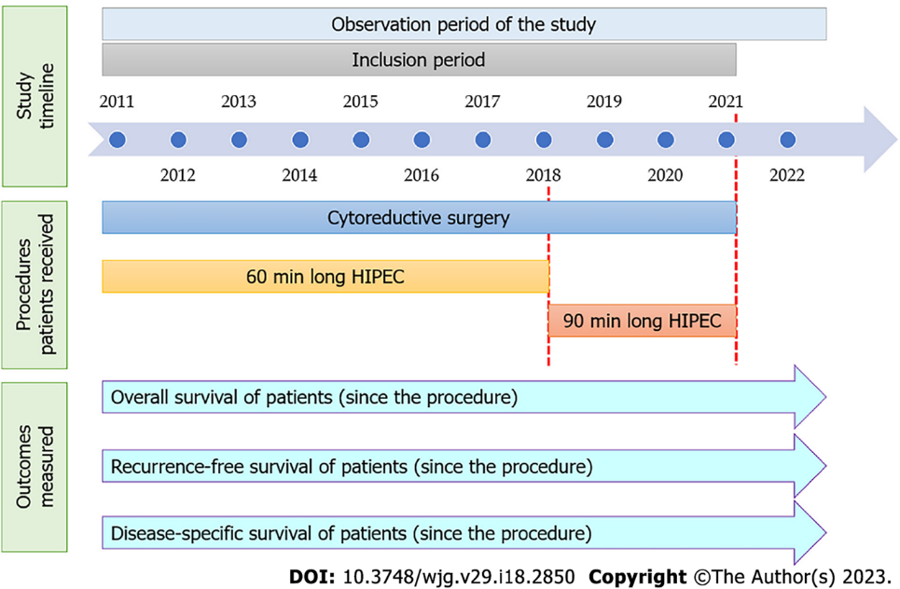
Figure 1 Timeline of the study. HIPEC: Hyperthermic intraperitoneal chemotherapy.

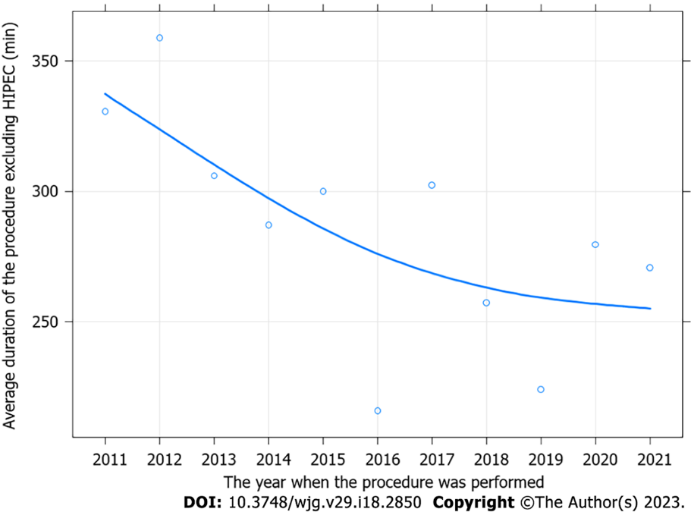
Figure 2 Improvement of the operating times of cytoreductive surgery (excluding hyperthermic intraperitoneal chemotherapy) in our surgical center during the study period. HIPEC: Hyperthermic intraperitoneal chemotherapy.

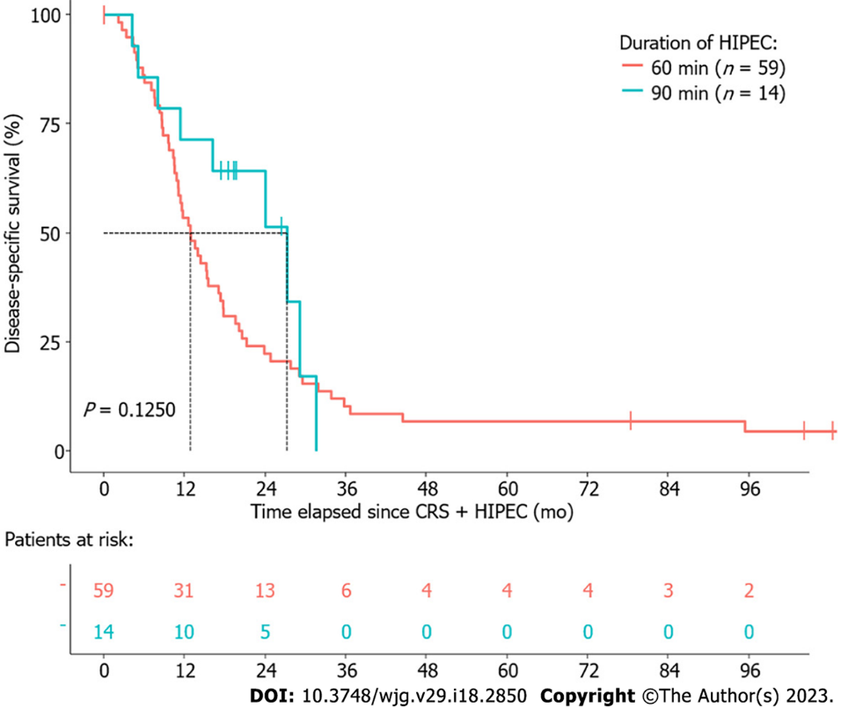
Figure 3 Differences in disease-specific survival between patients with gastric cancer who underwent cytoreductive surgery and 60 min or 90 min hyperthermic intraperitoneal chemotherapy. The dotted line represents median survival. CRS: Cytoreductive surgery; HIPEC: Hyperthermic intraperitoneal chemotherapy.

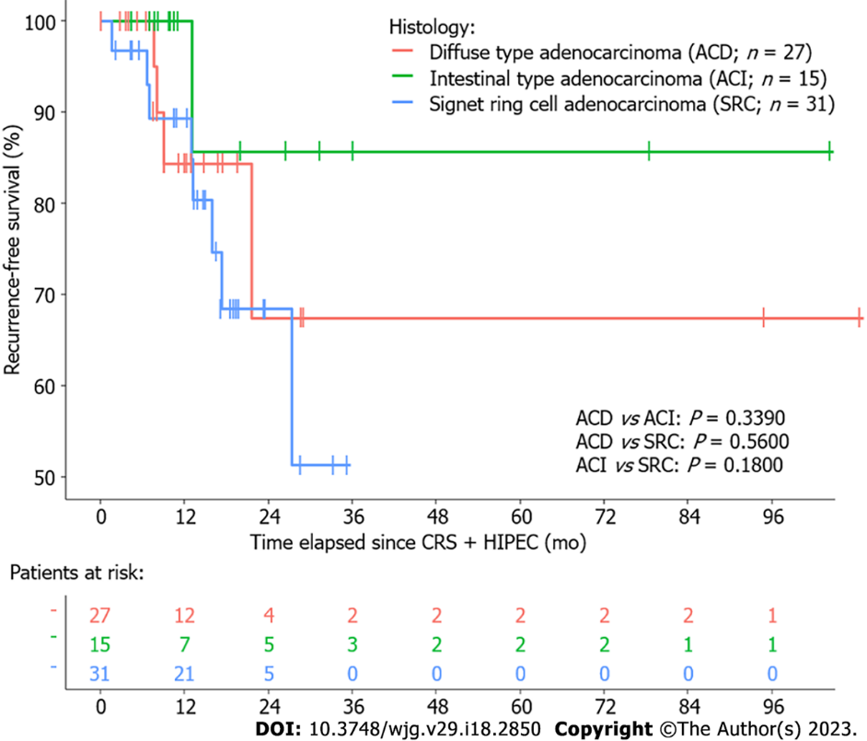
Figure 4 Differences in recurrence-free survival between patients with gastric cancer of different histological types who underwent cytoreductive surgery and hyperthermic intraperitoneal chemotherapy. ACD: Diffuse type adenocarcinoma; ACI: Intestinal type adenocarcinoma; CRS: Cytoreductive surgery; HIPEC: Hyperthermic intraperitoneal chemotherapy; SRC: Signet-ring cell adenocarcinoma.

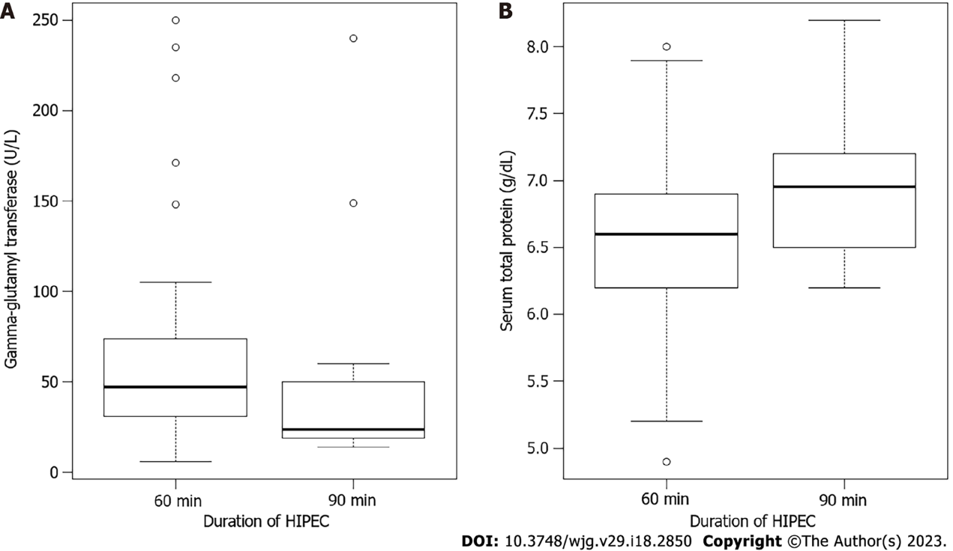
Figure 5 Gamma-glutamyl transferase and total protein levels in 60 min and 90 min hyperthermic intraperitoneal chemotherapy groups. Clinically abnormal serum levels of gamma-glutamyl transferase (crude P = 0.0407) and total protein (crude P = 0.0570) were observed more often in those gastric cancer patients who received hyperthermic intraperitoneal chemotherapy (HIPEC) for 60 min after the cytoreductive surgery. Thick lines and hollow circles represent the median and outliers, respectively. A: Gamma-glutamyl transferase; B: Total protein.

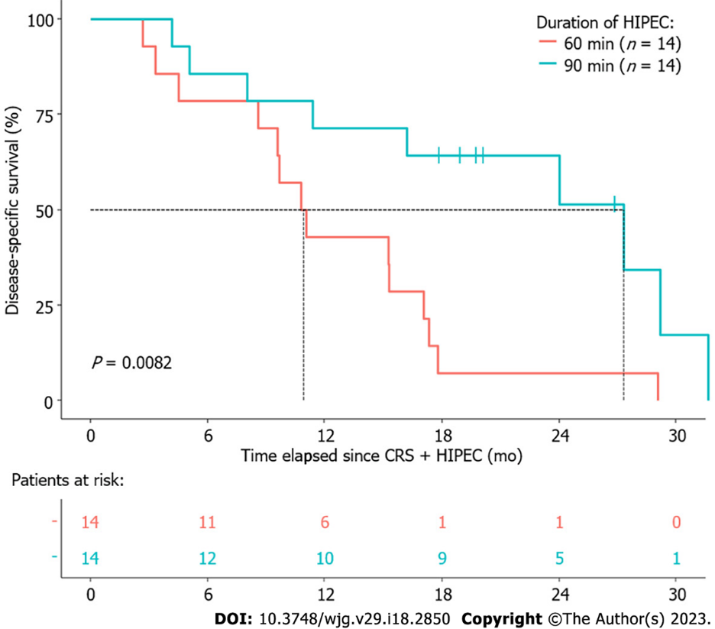
Figure 6 Differences in disease-specific survival between propensity score in matched gastric cancer patient-pairs. Patients were matched by age, sex, peritoneal carcinomatosis index score, Jacquet and Sugarbaker’s completeness of cytoreduction score, time spent in the intensive care unit after cytoreductive surgery (CRS) + hyperthermic intraperitoneal chemotherapy (HIPEC), duration of CRS, and presence of lymph node metastasis (stage N = 0 vs stage N ≥ 1). The dotted line represents median survival.
Table 1 P values of the multivariate survival model
Parameter | DSS | OS | RFS
HIPEC duration [60 min (ref.) vs 90 min] | 0.0781 | 0.1541 | 0.5578
Age (yr) | 0.1870 | 0.1331 | 0.3691
Sex [male vs female (ref.)] | 0.3327 | 0.2943 | 0.8681
Stage T [1-2 (ref.) vs 3-4] | 0.1205 | 0.1857 | 0.0475
Stage N [0 (ref.) vs 1-3] | 0.5071 | 0.4511 | 0.0902
Histology
ACD (ref.) vs ACI | 0.3092 | 0.2335 | 0.2471
ACD (ref.) vs SRC | 0.9456 | 0.8638 | 0.2227
Body-mass index (kg/m²) | 0.6394 | 0.8365 | 0.3049
Peritoneal carcinomatosis index | 0.0569 | 0.2530 | 0.2752
White blood cell count (10⁹/L) | 0.1843 | 0.2387 | 0.0327
Hemoglobin (g/dL) | 0.2783 | 0.2924 | 0.7656
Carcinoembryonic antigen (ng/mL) | 0.0007 | 0.0005 | 0.1089
ACD: Diffuse type adenocarcinoma; ACI: Intestinal type adenocarcinoma; DSS: Disease-specific survival; ref.: Reference category; RFS: Recurrence-free survival; OS: Overall survival; SRC: Signet-ring cell adenocarcinoma.

Published by Baishideng Publishing Group Inc
7041 Koll Center Parkway, Suite 160, Pleasanton, CA 94566, USA
Telephone: +1-925-3991568
E-mail: bpgoffice@wjgnet.com
Help Desk: https://www.f6publishing.com/helpdesk
https://www.wjgnet.com

© 2023 Baishideng Publishing Group Inc. All rights reserved.

