Name of Journal: World Journal of Clinical Cases
Manuscript NO: 76631
Manuscript Type: CASE REPORT

Synchronous primary duodenal papillary adenocarcinoma and gallbladder carcinoma: A case report and review of literature

Chen J et al. Synchronous primary duodenal papillary and gallbladder cancers

Jing Chen, Ming-Yuan Zhu, Yan-Hua Huang, Zhong-Cheng Zhou, Yi-Yu Shen, Quan Zhou, Ming-Jian Fei, Fan-Chuang Kong

Jing Chen, Ming-Yuan Zhu, Yan-Hua Huang, Zhong-Cheng Zhou, Yi-Yu Shen, Fan-Chuang Kong, Department of General Surgery, The Second Affiliated Hospital of Jiaxing University, Jiaxing 314000, Zhejiang Province, China

Quan Zhou, Ming-Jian Fei, Department of Pathology, The Second Affiliated Hospital of Jiaxing University, Jiaxing 314000, Zhejiang Province, China

Author contributions: Chen J and Zhu MY were the patient’s surgeons, reviewed the literature and contributed to drafting the manuscript; Huang YH and Zhou ZC reviewed the literature and contributed to drafting the manuscript; Zhou Q and Fei MJ performed the pathological analyses and interpretation; and Shen YY and Kong FC revised the manuscript for important intellectual content. All authors issued final approval for the submitted version.

Supported by the Jiaxing Science and Technology Plan Project (Civil Science and Technology Innovation Project), No. 2019AY32028.

Corresponding author: Ming-Yuan Zhu, MD, Attending Doctor, Department of General Surgery, The Second Affiliated Hospital of Jiaxing University, No. 1518 Huancheng North Road, Jiaxing 314000, Zhejiang Province, China. hnzhumingyuan@163.com

Received: April 14, 2022
Revised: June 20, 2022
Accepted: August 16, 2022
Published online: September 26, 2022

Abstract
BACKGROUND
Synchronous primary cancers (SPCs) have become increasingly frequent over the past decade. However, the coexistence of duodenal papillary and gallbladder cancers is rare, and such cases have not been previously reported in the English literature. Here, we describe an SPC case with duodenal papilla and gallbladder cancers and its diagnosis and successful management.

CASE SUMMARY
A 68-year-old Chinese man was admitted to our hospital with the chief complaint of dyspepsia for the past month. Contrast-enhanced computed tomography of the abdomen performed at the local hospital revealed dilatation of the bile and pancreatic ducts and a space-occupying lesion in the duodenal papilla. Endoscopy revealed a tumor protruding from the duodenal papilla. Pathological findings for the biopsied tissue revealed tubular villous growth with moderate heterogeneous hyperplasia. Surgical treatment was selected. Macroscopic examination of this surgical specimen revealed a 2-cm papillary tumor and another tumor protruding by 0.5 cm in the gallbladder neck duct. Intraoperative rapid pathology identified adenocarcinoma in the gallbladder neck duct and tubular villous adenoma with high-grade intraepithelial neoplasia and local canceration in the duodenal papilla. After an uneventful postoperative recovery, the patient was discharged without complications.

CONCLUSION
It is essential for clinicians and pathologists to maintain a high degree of suspicion while evaluating such synchronous cancers.

Key Words: Synchronous primary cancers; Gallbladder carcinoma; Duodenal papillary adenocarcinoma; Surgical treatment; Case report

©The Author(s) 2022. Published by Baishideng Publishing Group Inc. All rights reserved.

Citation: Chen J, Zhu MY, Huang YH, Zhou ZC, Shen YY, Zhou Q, Fei MJ, Kong FC. Synchronous primary duodenal papillary adenocarcinoma and gallbladder carcinoma: A case report and review of literature. World J Clin Cases 2022; 10(27): 9790-9797
URL: https://www.wjgnet.com/2307-8960/full/v10/i27/9790.htm
DOI: https://dx.doi.org/10.12998/wjcc.v10.i27.9790

Core Tip: Synchronous primary cancers (SPCs) of the duodenal papilla and gallbladder are rarely reported. Here, we report such a case. The lesion in the duodenal papilla was discovered by imaging examination of a 68-year-old man. Endoscopic biopsy was performed, and the pathological findings revealed moderate heterogeneous hyperplasia. The patient underwent pancreaticoduodenectomy, and intraoperative rapid histopathological examination surprisingly revealed adenocarcinoma in the papillary region and another adenocarcinoma in the gallbladder neck duct. SPC involving both the gallbladder and duodenal papilla is regarded as a rare occurrence. It is essential for the clinician and pathologist to maintain a high degree of suspicion while evaluating such lesions.

INTRODUCTION
With the widespread improvement in early diagnosis and regular medical check-ups, the occurrence of synchronous primary cancers (SPCs) has become increasingly frequent over the past decade^{[1]}. However, it is very rare for duodenal papillary and gallbladder cancers to coexist, and no cases have been reported in the English literature. Here, we describe a case of SPC of the duodenal papilla and gallbladder and its diagnosis and successful management.

CASE PRESENTATION
Chief complaints
A 68-year-old Chinese man was admitted to a local hospital with the chief complaint of dyspepsia.

History of present illness
The patient’s symptoms started a month prior to dyspepsia.

History of past illness
The patient had a history of distal gastric resection with Billroth II anastomosis for a bleeding marginal ulcer 30 years ago.

Personal and family history
The patient denied any family history.

Physical examination
After hospitalization, the patient’s temperature was 37°C, heart rate was 88 beats per minute, respiratory rate was 19 breaths per minute, blood pressure was 127/79 mmHg and oxygen saturation in room air was 100%. The clinical examination showed no pathological signs.

Laboratory examinations
Blood tests, including tumor markers, showed that levels were completely normal except for glutamyl transpeptidase (GGT; 379 U/L, normal: 10-60 U/L) and alkaline phosphatase (ALP; 174 U/L, normal: 45-125 U/L).

Imaging examinations
Contrast-enhanced computed tomography of the upper abdomen performed at the local hospital revealed dilatation of the intrahepatic bile duct, common bile duct and pancreatic duct and a space-occupying lesion in the duodenal papilla (Figure 1).
Endoscopic biopsy was performed because of the unclear nature of this occupancy. Endoscopy showed a tumor protruding from the duodenal papilla (Figure 2), and the pathological findings revealed that the biopsy tissue presented tubular villous growth with moderate heterogeneous hyperplasia (Figure 3).

FINAL DIAGNOSIS
Based on the above physical examination features and imaging data, a provisional diagnosis of space-occupying lesion in the duodenal papilla was made. After surgical resection, the final diagnoses were gall bladder adenocarcinoma and duodenal papilla adenocarcinoma.

TREATMENT
Since malignancy of the space-occupying lesion in the duodenal papilla could not be ruled out, surgical treatment was selected after communication with the patient and his family members. The patient was informed of the possible risks involved in this surgery before consent for the operation was obtained. Based on a careful preoperative evaluation and no obvious findings of contraindications of the surgery, the patient underwent a pancreaticoduodenectomy (Whipple’s procedure) on July 11, 2019. Macroscopic examination of this surgical specimen revealed a 2-cm papillary tumor and another tumor with a 0.5-cm protrusion in the gallbladder neck duct (Figure 4). Intraoperative rapid pathology revealed adenocarcinoma without basement membrane breakthrough in the gallbladder neck duct and tubular villous adenoma with high-grade intraepithelial neoplasia and local canceration in the duodenal papilla. The examination also showed that no metastases were found in the resected lymph nodes. The cooccurrence of duodenal papillary and gallbladder cancers is very rare. The two tumors were independent of each other, and there was no relationship with metastasis.

OUTCOME AND FOLLOW-UP
The final pathological tumor stage was pT1bN0M0 for adenocarcinoma of the gall bladder and pT1N0M0 for adenocarcinoma of the duodenal papilla, and the patient was not provided adjuvant therapy. After an uneventful recovery, the patient was discharged without complications on postoperative Day 20. After one year, he was followed up by us, and there was no evidence of tumor recurrence.

DISCUSSION
The most common synchronous cancers are colorectum (37.2%), lung (18.6%), esophagus (16.8%), liver (9.7%), kidney (4.4%) and stomach (3.4%)^{[2]}. The simultaneous occurrence of multiple cancers in the papilla of Vater and ampulla of Vater is rare, with approximately 7 cases and 14 cases, respectively, reported thus far in the English-language medical literature^{[3-21]} (Table 1). However, this report is the first to detail the SPC of the duodenal papilla and gallbladder. The incidence of SPC from the biliary tree has been reported to vary from 5.0 to 7.4%^{[22]}, and it is important to distinguish between SPC and secondary deposits. The following diagnostic criteria have been adopted by most clinicians to differentiate synchronous primaries from malignant deposits: (1) Lack of anatomical continuity between two tumors; (2) a growth pattern typical of a primary tumor; and (3) clear histological differences between two tumors^{[23,24]}. According to the above criteria, this case was determined to be SPC. Ultimately, both the gallbladder and duodenal papilla were labeled as primary adenocarcinomas by the pathologist as they had histological differences and a growth pattern typical of a primary tumor.
To date, the pathogenesis of SPC has not been elucidated. Several factors are involved, including genetic factors, environmental carcinogens, hormones, dietary factors, previous therapy, infective agents, smoking and alcohol use^{[25,26]}. First, gallbladder cancer may be caused by infectious agents or gallstones due to chronic inflammation and recurrent trauma^{[27,28]}. A reasonable assumption indicates that chronic irritation of the mucosa leads to dysplasia and causes malignant changes^{[29]}. Additionally, 62.5% of SPCs of the biliary tract have been reported to be associated with abnormal pancreaticobiliary junction (APBJ) caused by persistent reflux of pancreatic juice with subsequent biliary inflammation^{[30-32]}. In our case, the cystic duct was too long and had low confluence with the common bile duct. An excessively long cystic duct is adverse to bile outflow, and the duct can be easily blocked and infected by gram-negative bacilli. Eventually, these factors may lead to tumorigenesis. Second, duodenal papillary adenocarcinoma is a relatively uncommon malignant tumor that accounts for less than 1% of all gastrointestinal cancers^{[33]}. Smoking is an important risk factor, and chronic infection and heredity are considered important susceptibility factors^{[18]}. In the process of canceration, mutations in genes such as K-ras, p53 and p21/Waf1 play an important role^{[34,35]}.
Preoperative diagnosis of duodenal papilla occupancy is useful for making therapeutic decisions. Endoscopic biopsy has become a popular diagnostic tool and is used in a diverse range of digestive tract diseases. Histopathology from biopsy remains the gold standard for diagnosis. The positive rate of endoscopic biopsy is low, although the diagnostic value of the endoscopic appearance seems to be superior to that of endoscopic biopsy^{[36]}. In the study case, endoscopy revealed a tumor protruding from the duodenal papilla, and endoscopic biopsy did not diagnose a malignant tumor. These findings demonstrated the importance of the endoscopic description of duodenal papilla. In addition, we were unable to diagnose this gallbladder carcinoma preoperatively. The presence of SPC was a histological surprise.
Few reports have focused on the treatment of patients with this rare disease, which remains a key challenge^{[37]}. Curative resection, if possible, is the most effective method of prolonging patient survival. It is also important to note that surgical procedures may not necessarily lead to better prognosis in patients with SPC. Hepatopancreatoduodenectomy is indicated in locally advanced GBC patients with extensive retropancreatic lymphadenopathy that cannot be cleared without pancreatoduodenectomy. Moreover, HPD is associated with significant morbidity, with an overall major complication rate of approximately 50%. Thus, avoiding extensive hepatectomy has reduced morbidity after HPD^{[38,39]}.
In this case, a malignant tumor of the duodenal papilla could not be excluded, and the patient successfully underwent pancreaticoduodenectomy. To our surprise, adenocarcinoma of the gallbladder neck duct and involvement in the muscularis were discovered. Because the cystic duct presents low confluency with the common bile duct and the tumor was located on the gallbladder neck duct, no further treatment was needed, and an R0 resection was achieved with the classical Whipple’s procedure. After an uneventful postoperative recovery, the patient was discharged without complications. The follow-up data 1 year after the operation were collected, and no tumor recurrence or metastasis was found.

CONCLUSION
SPC involving both the gallbladder and duodenal papilla is regarded as a rare occurrence but is becoming increasingly common during hepatobiliary surgery. It is essential for clinicians and pathologists to maintain a high degree of suspicion while evaluating these lesions and to look for the existence of APBJ. At the same time, it is necessary to develop a more accurate diagnostic tool and implement more refined treatment strategies to correctly diagnose SPC.

REFERENCES
1 Jin K, Xu J, Chen J, Chen M, Chen R, Chen Y, Chen Z, Cheng B, Chi Y, Feng ST, Fu D, Hou B, Huang D, Huang H, Huang Q, Li J, Li Y, Liang H, Lin R, Liu A, Liu J, Liu X, Lu M, Luo J, Mai G, Ni Q, Qiu M, Shao C, Shen B, Sheng W, Sun J, Tan C, Tan H, Tang Q, Tang Y, Tian X, Tong D, Wang X, Wang J, Wang J, Wang W, Wang W, Wang Y, Wu Z, Xue L, Yan Q, Yang N, Yang Y, Yang Z, Yin X, Yuan C, Zeng S, Zhang R, Yu X. Surgical management for non-functional pancreatic neuroendocrine neoplasms with synchronous liver metastasis: A consensus from the Chinese Study Group for Neuroendocrine Tumors (CSNET). Int J Oncol 2016; 49: 1991-2000 [PMID: 27826620 DOI: 10.3892/ijo.2016.3711]
2 Lee JH, Bae JS, Ryu KW, Lee JS, Park SR, Kim CG, Kook MC, Choi IJ, Kim YW, Park JG, Bae JM. Gastric cancer patients at high-risk of having synchronous cancer. World J Gastroenterol 2006; 12: 2588-2592 [PMID: 16688807 DOI: 10.3748/wjg.v12.i16.2588]
3 Ueno G, Ishikawa S, Ichikawa Y, Hagi T, Taniura N, Chong H, Kanazawa A, Takayama S, Nishihara M, Maruyama K, Shimada M, Lee K, Oka H, Maeda T. [A case of synchronous cancer of the gall bladder, common bile duct, and the papilla of vater]. Gan To Kagaku Ryoho 2014; 41: 1521-1523 [PMID: 25731239]
4 Seo YK, Choi JS. Endoscopic Papillectomy for Synchronous Major and Minor Duodenal Papilla Neuroendocrine Tumors. Korean J Gastroenterol 2018; 72: 217-221 [PMID: 30419648 DOI: 10.4166/kjg.2018.72.4.217]
5 Parthasarathy S, Pottakkat B, Yootla M, Reddy SN, Reddy KM. Synchronous adenocarcinomas of the papilla major and minor. JOP 2008; 9: 332-334 [PMID: 18469449]
6 Matheus AS, Jukemura J, Montagnini AL, Kunitake T, Patzina RA, da Cunha JE. Synchronous adenocarcinoma of the major and minor duodenal papilla. J Gastrointest Surg 2008; 12: 1301-1303 [PMID: 17876672 DOI: 10.1007/s11605-007-0317-6]
7 Tamura K, Takamori S, Hayashi A, Miwa K, Fukunaga M, Maeshiro K, Nakamura H, Tamae T, Isomoto H, Shirouzu K. Resection of synchronous lung and Vater's papilla cancer. Kurume Med J 2003; 50: 143-146 [PMID: 14768477 DOI: 10.2739/kurumemedj.50.143]
8 Takahashi T, Kazama Y, Shimizu H, Yoshimoto M, Tsujisaki M, Aoki S, Imai K. Myelodysplastic syndrome progresses rapidly into erythroleukemia associated with synchronous double cancers of the stomach and the papilla of Vater. Int J Hematol 2001; 74: 64-69 [PMID: 11530807 DOI: 10.1007/BF02982551]
9 Nishihara K, Tsuneyoshi M, Shimura H, Yasunami Y. Three synchronous carcinomas of the papilla of Vater, common bile duct and pancreas. Pathol Int 1994; 44: 325-332 [PMID: 8044300 DOI: 10.1111/j.1440-1827.1994.tb03371.x]
10 de Garcia de la Vega M, Faber B, Schalbar C, Foxius A, Groot-Koerkamp H, Decker G. Combined one-stage esophagectomy and duodeno-pancreatectomy for synchronous cancers of the esophagus and pancreatic ampulla in an elderly patient. Acta Chir Belg 2021; 121: 46-50 [PMID: 31230557 DOI: 10.1080/00015458.2019.1631628]
11 Sastry A, Wayne M, Steele J, Iskandar M, Yuan S, Cooperman AM. Three synchronous, sporadic and separate periampullary and pancreatic tumors: more than a coincidence? World J Surg Oncol 2014; 12: 382 [PMID: 25494951 DOI: 10.1186/1477-7819-12-382]
12 Cokmert S, Demir L, Akder Sari A, Kucukzeybek Y, Can A, Akyol M, Bayoglu IV, Dirican A, Erten C, Tarhan MO. Synchronous appearance of a high-grade neuroendocrine carcinoma of the ampulla vater and sigmoid colon adenocarcinoma. Case Rep Oncol Med 2013; 2013: 930359 [PMID: 24368955 DOI: 10.1155/2013/930359]
13 Fukaya M, Abe T, Yokoyama Y, Itatsu K, Nagino M. Two-stage operation for synchronous triple primary cancer of the esophagus, stomach, and ampulla of Vater: report of a case. Surg Today 2014; 44: 967-971 [PMID: 23504004 DOI: 10.1007/s00595-013-0549-x]
14 Wohlauer MV, McManus MC, Brauer B, Hedges J, Gajdos C. Synchronous presentation of ampullary adenocarcinoma and common bile duct cancer: report of a case and review of literature. JOP 2012; 13: 536-539 [PMID: 22964962 DOI: 10.6092/1590-8577/836]
15 Rajalingam R, Javed A, Gondal R, Arora A, Nag HH, Agarwal AK. Non-familial double malignancy of the colon and ampulla of Vater: a case report and review of literature. Saudi J Gastroenterol 2012; 18: 143-145 [PMID: 22421722 DOI: 10.4103/1319-3767.93823]
16 Aurello P, Petrucciani N, D'Angelo F, Nigri G, Picchetto A, Cicchini C, Maglio R, Ramacciato G. Synchronous signet-ring cell carcinoma of the duodenum and ampullary intestinal-type carcinoma. Am Surg 2011; 77: E262-E264 [PMID: 22273189]
17 Athanasopoulos PG, Arkadopoulos N, Stafyla V, Tympa A, Kairi E, Ryzman-Louloudis C, Smyrniotis V. A rare combination of an endocrine tumour of the common bile duct and a follicular lymphoma of the ampulla of Vater: a case report and review of the literature. World J Surg Oncol 2011; 9: 4 [PMID: 21232154 DOI: 10.1186/1477-7819-9-4]
18 Eriguchi N, Aoyagi S, Tamae T, Nishimura K, Hamada S, Kawabata M, Kodama T, Jimi A. Carcinoma of the ampulla of Vater associated with other organ malignancies. Kurume Med J 2001; 48: 255-259 [PMID: 11830924 DOI: 10.2739/kurumemedj.48.255]
19 Mafune K, Tanaka Y, Ma YY, Takubo K. Synchronous cancers of the esophagus and the ampulla of Vater after distal gastrectomy: successful removal of the esophagus, gastric remnant, duodenum, and pancreatic head. J Surg Oncol 1995; 60: 277-281 [PMID: 8551739 DOI: 10.1002/jso.2930600412]
20 González Sánchez JA, López-Ríos Fernández F, González Conde R, Miguel Velasco JE, Casas Pinillos MS, Larrauri Martínez J. [Carcinoma of the Vater's ampulla and colonic carcinoma with synchronous onset]. Rev Esp Enferm Dig 1993; 83: 459-461 [PMID: 8338711]
21 Yoshida J, Morisaki T, Yamaguchi K, Itoh T, Yokohata K, Kishikawa H, Iino H. Carcinoma in adenoma of the ampulla of Vater synchronous with cancer of the sigmoid colon. Dig Dis Sci 1990; 35: 271-275 [PMID: 2406114 DOI: 10.1007/BF01536776]
22 Kodaganur S, Hosamani IR. Synchronous malignancies of the gall bladder and common bile duct: a case report. World J Surg Oncol 2016; 14: 106 [PMID: 27059701 DOI: 10.1186/s12957-016-0848-y]
23 Gertsch P, Thomas P, Baer H, Lerut J, Zimmermann A, Blumgart LH. Multiple tumors of the biliary tract. Am J Surg 1990; 159: 386-388 [PMID: 2180336 DOI: 10.1016/s0002-9610(05)81278-4]
24 Demandante CG, Troyer DA, Miles TP. Multiple primary malignant neoplasms: case report and a comprehensive review of the literature. Am J Clin Oncol 2003; 26: 79-83 [PMID: 12576929 DOI: 10.1097/00000421-200302000-00015]
25 Park SL, Caberto CP, Lin Y, Goodloe RJ, Dumitrescu L, Love SA, Matise TC, Hindorff LA, Fowke JH, Schumacher FR, Beebe-Dimmer J, Chen C, Hou L, Thomas F, Deelman E, Han Y, Peters U, North KE, Heiss G, Crawford DC, Haiman CA, Wilkens LR, Bush WS, Kooperberg C, Cheng I, Le Marchand L. Association of cancer susceptibility variants with risk of multiple primary cancers: The population architecture using genomics and epidemiology study. Cancer Epidemiol Biomarkers Prev 2014; 23: 2568-2578 [PMID: 25139936 DOI: 10.1158/1055-9965.EPI-14-0129]
26 Kim C, Chon H, Kang B, Kim K, Jeung HC, Chung H, Noh S, Rha S. Prediction of metachronous multiple primary cancers following the curative resection of gastric cancer. BMC Cancer 2013; 13: 394 [PMID: 23967865 DOI: 10.1186/1471-2407-13-394]
27 Kim JW, Han JW, Jung SY, Jung JP, Kim JW. Synchronous double primary malignant tumor of the gallbladder and liver: a case report. World J Surg Oncol 2011; 9: 84 [PMID: 21812959 DOI: 10.1186/1477-7819-9-84]
28 Zhang ZG, Chen Y, Ji R, Zhao YJ, Wang J, Robinson L, Chen XP, Zhang L. Synchronous cancers of gallbladder carcinoma and combined hepatocellular cholangiocarcinoma: an unusual case and literature review. BMC Cancer 2018; 18: 1046 [PMID: 30373546 DOI: 10.1186/s12885-018-4969-2]
29 Stinton LM, Shaffer EA. Epidemiology of gallbladder disease: cholelithiasis and cancer. Gut Liver 2012; 6: 172-187 [PMID: 22570746 DOI: 10.5009/gnl.2012.6.2.172]
30 Fujii T, Kaneko T, Sugimoto H, Okochi O, Inoue S, Takeda S, Nagasaka T, Nakao A. Metachronous double cancer of the gallbladder and common bile duct. J Hepatobiliary Pancreat Surg 2004; 11: 280-285 [PMID: 15368115 DOI: 10.1007/s00534-003-0880-5]
31 Hara H, Morita S, Ishibashi T, Sako S, Dohi T, Otani M, Iwamoto M, Inoue H, Tanigawa N. Studies on biliary tract carcinoma in the case with pancreaticobiliary maljunction. Hepatogastroenterology 2002; 49: 104-108 [PMID: 11941930]
32 Agarwal N, Kumar S, Sharma S. Synchronous adenocarcinoma of the gall bladder and pancreas in a young woman. Trop Gastroenterol 2013; 34: 50-52 [PMID: 23923380 DOI: 10.7869/tg.2012.96]
33 Tsuji S, Itoi T, Sofuni A, Mukai S, Tonozuka R, Moriyasu F. Tips and tricks in endoscopic papillectomy of ampullary tumors: single-center experience with large case series (with videos). J Hepatobiliary Pancreat Sci 2015; 22: E22-E27 [PMID: 25688984 DOI: 10.1002/jhbp.207]
34 Kimura W, Futakawa N, Zhao B. Neoplastic diseases of the papilla of Vater. J Hepatobiliary Pancreat Surg 2004; 11: 223-231 [PMID: 15368105 DOI: 10.1007/s00534-004-0894-7]
35 Fischer HP, Zhou H. Pathogenesis of carcinoma of the papilla of Vater. J Hepatobiliary Pancreat Surg 2004; 11: 301-309 [PMID: 15549428 DOI: 10.1007/s00534-004-0898-3]
36 DeOliveira ML, Triviño T, de Jesus Lopes Filho G. Carcinoma of the papilla of Vater: are endoscopic appearance and endoscopic biopsy discordant? J Gastrointest Surg 2006; 10: 1140-1143 [PMID: 16966033 DOI: 10.1016/j.gassur.2006.05.005]
37 Cartapatti M, Machado RD, Muller RL, Magnabosco WJ, Santos AC, Chapin BF, Melani A, Talvane A, Tobias-Machado M, Faria EF. Synchronous abdominal tumors: is combined laparoscopic surgery in a single approach a safe option? Int Braz J Urol 2018; 44: 483-490 [PMID: 29219275 DOI: 10.1590/S1677-5538.IBJU.2017.0429]
38 Sakamoto Y, Nara S, Kishi Y, Esaki M, Shimada K, Kokudo N, Kosuge T. Is extended hemihepatectomy plus pancreaticoduodenectomy justified for advanced bile duct cancer and gallbladder cancer? Surgery 2013; 153: 794-800 [PMID: 23415082 DOI: 10.1016/j.surg.2012.11.024]
39 Vijayaraj P, Chandrasekar S, Kalayarasan R, Pottakkat B. Double Trouble: Synchronous Adenocarcinoma of Gallbladder and Pancreas. J Gastrointest Cancer 2018; 49: 358-360 [PMID: 28168400 DOI: 10.1007/s12029-017-9922-0]

Footnotes
Informed consent statement: Written informed written consent was obtained from the patient for publication of this report and any accompanying images.

Conflict-of-interest statement: All authors declare that they have no conflicts of interest.

CARE Checklist (2016) statement: The authors have read the CARE Checklist (2013), and the manuscript was prepared and revised according to the CARE Checklist (2016).

Open-Access: This article is an open-access article that was selected by an in-house editor and fully peer-reviewed by external reviewers. It is distributed in accordance with the Creative Commons Attribution NonCommercial (CC BY-NC 4.0) license, which permits others to distribute, remix, adapt, build upon this work non-commercially, and license their derivative works on different terms, provided the original work is properly cited and the use is non-commercial. See: https://creativecommons.org/Licenses/by-nc/4.0/

Provenance and peer review: Unsolicited article; Externally peer reviewed.
Peer-review model: Single blind

Peer-review started: April 14, 2022
First decision: June 7, 2022
Article in press: August 16, 2022

Specialty type: Gastroenterology and hepatology
Country/Territory of origin: China
Peer-review report’s scientific quality classification
Grade A (Excellent): 0
Grade B (Very good): B
Grade C (Good): C, C
Grade D (Fair): 0
Grade E (Poor): 0

P-Reviewer: Hasan A, Egypt; Rakić M, Croatia S-Editor: Liu JH L-Editor: A P-Editor: Liu JH

Figure Legends
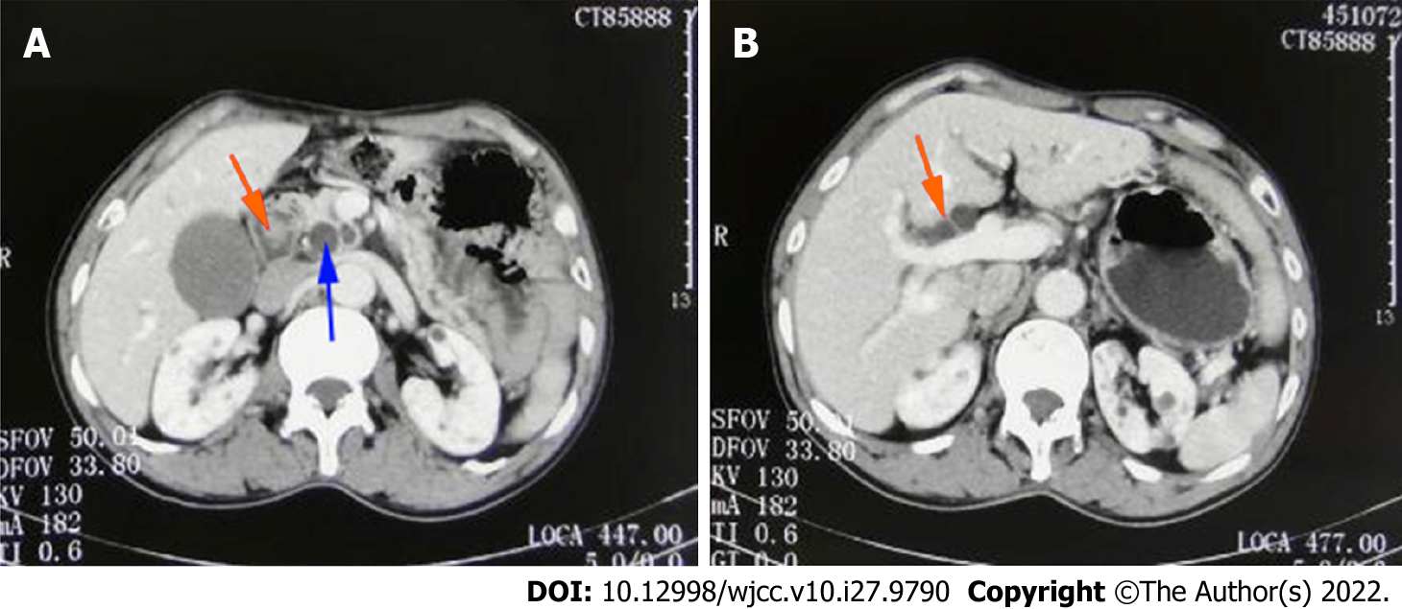
Figure 1 Contrast-enhanced computed tomography of the abdomen. A: Space-occupying lesion in the duodenal papilla (orange arrowheads) and dilatation of the common bile duct (blue arrowheads); B: dilatation of extrahepatic bile duct (orange arrowheads).

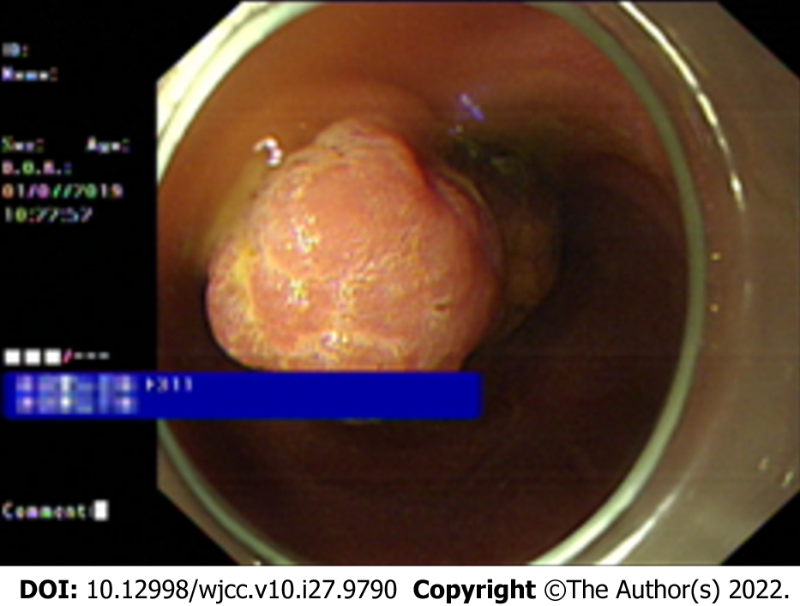
Figure 2 Endoscopic biopsy. Tumor protruding from the duodenal papilla.

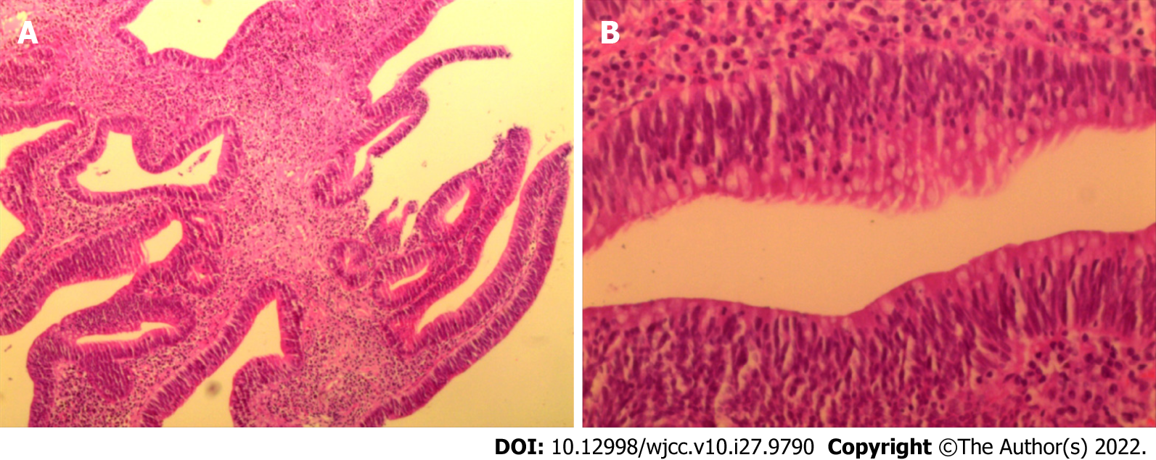
Figure 3 Histopathological findings of endoscopic biopsy. A: Tubular villous growth. B: Moderate heterogeneous hyperplasia.

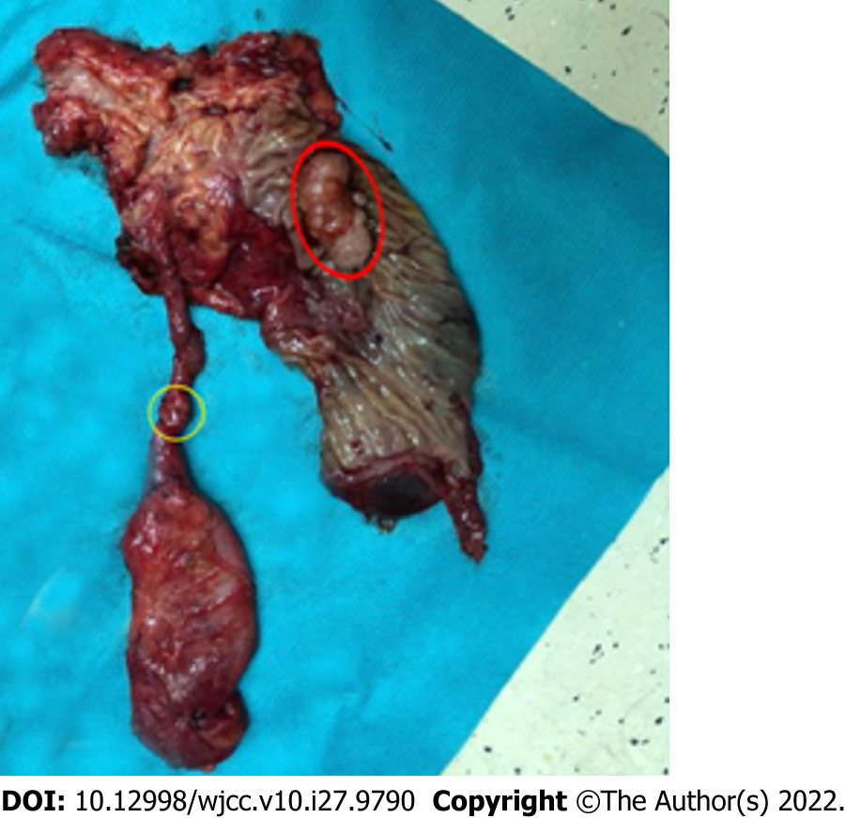
Figure 4 Macroscopic appearance of the surgical specimen. Papillary tumor (red circle) and gallbladder neck duct tumor (yellow circle) were present in the specimen.

Table 1 Literature review of synchronous primary cancers occurring in the papilla/ampulla of Vater and other organs
Cases | Age (yr)/Sex | Tumor location | Treatment | Prognosis (mo)
Ueno et al^{[3]} | 58/M | Common bile duct, gallbladder, papilla of Vater (severe dysplasia) | Surgical resection | 30/Disease-free survival
Seo et al^{[4]} | 42/F | Major and minor duodenal papilla of Vater | Endoscopic papillectomy | 16/Disease-free survival
Parthasarathy et al^{[5]} | 60/F | Major and minor duodenal papilla of Vater | Surgical resection | 8/Disease-free survival
Matheus et al^{[6]} | 50/F | Major and minor duodenal papilla of Vater | Surgical resection | 24/Disease-free survival
Tamura et al^{[7]} | 78/M | Lung, papilla of Vater | Surgical resection | 60/Disease-free survival
Takahashi et al^{[8]} | 66/M | Erythroleukemia,  stomach, papilla of Vater | Jejuno-choledochostomy | N/A
Nishihara et al^{[9]} | 53/M | common bile duct, pancreas,  papilla of Vater | Surgical resection | N/A
de Garcia de la Vega et al^{[10]} | 77/M | Esophagus, ampulla of Vater | Surgical resection | 24/Recurrence due to liver metastasis
Sastry et al^{[11]} | 81/M | Pancreas, ampulla of Vater | Surgical resection | 10/Die of liver metastasis
Cokmert et al^{[12]} | 63/F | sigmoid colon, ampulla of Vater | Surgical resection | N/A
Fukaya et al^{[13]} | 69/M | esophagus, stomach, ampulla of Vater | Surgical resection | 12/Die of progressive disease
Wohlauer et al^{[14]} | 76/M | common bile duct, ampulla of Vater | Surgical resection | N/A
Rajalingam et al^{[15]} | 72/M | right colon, ampulla of Vater | Surgical resection | 8/Disease-free survival
Aurello et al^{[16]} | 33/F | Duodenum, ampulla of Vater | Surgical resection | 24/Disease-free survival
Athanasopoulos et al^{[17]} | 43/M | common bile duct, ampulla of Vater | Surgical resection | 18/Disease-free survival
Eriguchi et al^{[18]} | 83/M | Stomach, ampulla of Vater | Surgical resection | 3/Disease-free survival
Eriguchi et al^{[18]} | 74/M | Colon, ampulla of Vater | Surgical resection | 24/ Die of liver metastasis
Eriguchi et al^{[18]} | 68/M | Renal pelvis, ampulla of Vater | Surgical resection | 14/ Die of progressive disease
Mafune et al^{[19]} | 64/M | Esophagus, ampulla of Vater | Surgical resection | 13/Disease-free survival
González Sánchez et al^{[20]} | 50/F | Colon, ampulla of Vater | Surgical resection | N/A
Yoshida et al^{[21]} | 58/M | Sigmoid colon, ampulla of Vater | Surgical resection | N/A
N/A: Not applicable.

Published by Baishideng Publishing Group Inc
7041 Koll Center Parkway, Suite 160, Pleasanton, CA 94566, USA
Telephone: +1-925-3991568
E-mail: bpgoffice@wjgnet.com
Help Desk: https://www.f6publishing.com/helpdesk
https://www.wjgnet.com

© 2022 Baishideng Publishing Group Inc. All rights reserved.

