Name of Journal: World Journal of Clinical Cases
Manuscript NO: 87730
Manuscript Type: SCIENTOMETRICS

Emerging trends and hotspots of Nuclear factor erythroid 2-related factor 2 in nervous system diseases

Chang XQ et al. NRF2 in neurological diseases

Xue-Qin Chang, Ling Xu, Yi-Xuan Zuo, Yi-Guo Liu, Jia Li, Hai-Tao Chi

Xue-Qin Chang, Ling Xu, Yi-Xuan Zuo, Yi-Guo Liu, Jia Li, Hai-tao Chi, Department of Neurology, Xinhua Hospital Affiliated with Dalian University, Dalian 116011, Liaoning Province, China

Author contributions: Chang XQ designed and performed the research; Zuo YX, Liu YG, and Li J conducted the statistical analysis.

Corresponding author: Hai-Tao Chi, Doctor, Chief Doctor, Department of Neurology, Xinhua Hospital Affiliated with Dalian University, No. 156 Wansui Street, Shahekou District, Dalian 116011, Liaoning Province, China. 723290269@qq.com

Received: August 24, 2023
Revised: October 4, 2023
Accepted: October 30, 2023
Published online:

Abstract
BACKGROUND
The Nuclear factor erythroid 2-related factor 2 (NRF2) transcription factor has attracted much attention in the context of neurological diseases. However, none of the studies have systematically clarified this field's research hotspots and evolution rules.

AIM
To investigate the research hotspots, evolution patterns, and future research trends in this field in recent years.

METHODS
We conducted a comprehensive literature search in the Web of Science Core Collection database using the following methods: (((((TS=(NFE2 L2)) OR TS=(Nfe2 L2 protein, mouse)) OR TS=(NF-E2-Related Factor 2)) OR TS=(NRF2)) OR TS=(NFE2L2)) OR TS=(Nuclear factor erythroid2-related factor 2) AND (((((((TS=(neurological diseases)) OR TS=(neurological disorder)) OR TS=(brain disorder)) OR TS=(brain injury)) OR TS=(central nervous system disease)) OR TS=(CNS disease)) OR TS=(central nervous system disorder)) OR TS=(CNS disorder) AND Language = English from 2010 to 2022. There are just two forms of literature available: Articles and reviews. Data were processed with the software Cite-Space (version 6.1. R6).

RESULTS
We analyzed 1884 articles from 200 schools in 72 countries/regions. Since 2015, the number of publications in this field has increased rapidly. China has the largest number of publications, but the articles published in the United States have better centrality and H-index. Among the top ten authors with the most published papers, five of them are from China, and the author with the most published papers is Wang Handong. The institution with the most articles was Nanjing University. To their credit, three of the top 10 most cited articles were written by Chinese scholars. The keyword co-occurrence map showed that "oxidative stress", "NRF2", "activation", "expression" and "brain" were the five most frequently used keywords.

CONCLUSION
Research on the role of NRF2 in neurological diseases continues unabated. Researchers in developed countries published more influential papers, while Chinese scholars provided the largest number of articles. There have been numerous studies on the mechanism of NRF2 transcription factor in neurological diseases. NRF2 is also emerging as a potentially effective target for the treatment of neurological diseases. However, despite decades of research, our knowledge of NRF2 transcription factor in nervous system diseases is still limited. Further studies are needed in the future.

Key Words: Nuclear factor erythroid 2-related factor 2; Nervous system diseases; Brain; Expression; Activation; Ferroptosis

Chang XQ, Xu L, Zuo YX, Liu YG, Li J, Chi HT. Emerging trends and hotspots of nuclear factor erythroid 2-related factor 2 in nervous system diseases. World J Clin Cases 2023; In press

Core Tip: In this paper, the research progress of nuclear factor erythroid 2-related factor 2 (NRF2) expression, activation, mechanism of action, and related targets in nervous system diseases is explored based on related articles published in the past decade. Oxidative stress plays a crucial role in their pathological process, and there have been many studies on the treatment of nervous system diseases based on oxidative stress targets. As a key factor against oxidative stress, NRF2 plays an important role in the nervous system. Through computational analysis of the literature, we will present the research hotspots and possible future research directions of NRF2 in the nervous system.

INTRODUCTION
The physiology and pathology of the central nervous system are significantly influenced by oxidative stress^{[1]}. Free radicals play a physiological role in neuroplasticity and communication in the healthy brain. However, an excessive buildup of free radicals can cause cell mortality and neurotoxicity^{[2]}. Oxidative stress is an important target for the successful treatment of nervous system diseases^{[3]}. The increased oxygen demand in the brain, the high concentration of polyunsaturated fatty acids, and the peroxidation of polyunsaturated fatty acids to create lipid peroxides all make the brain susceptible to oxidative damage. Additionally, compared to other organs, the brain has lower amounts of antioxidant enzymes^{[4]}. Both acute and chronic inflammation interact with oxidative stress throughout the progression of nervous system diseases. Oxidative stress plays a significant role in the pathogenesis of nervous system diseases. Endogenous antioxidant protection mechanisms are numerous in cells. Among them, nuclear factor erythroid 2-related factor 2 (NRF2) mediates an important mechanism of cellular anti-oxidative damage. NRF2 is a basic leucine zipper (bZIP) cap 'n' collar transcription factor. NRF2 binds to the cytoplasmic Kelch-like epichlorohydrin-related protein 1 (Keap1) in the absence of oxidative stress, and in reaction to the E3-ubiquitin ligase complex, degrades and maintains low levels^{[5]}. When the body is under oxidative stress, which includes proteotoxic stress and an excessive buildup of Reactive Oxygen Species (ROS) electrophilic molecules, NRF2 is released from the E3-ubiquitin ligase complex and moves into the nucleus. There, it forms a heterodimer with the small Maf protein (sMaf) and attaches to AU-rich elements (AREs) on DNA to regulate the expression of cytoprotective genes. A variety of cytoprotective genes, such as biotransformation enzymes, antioxidant proteins, drug transporters, anti-apoptotic proteins, and proteasome proteins, are synergistically activated by the NRF2/Keap1 pathway. Examples include glutamate cysteine ligase, Multidrug Resistance-associated Protein, Glutathione S-Transferase (GST), Quinone Oxidoreductase 1 (NQO1), Sulfiredoxin 1, and UDP-galactose translocator^{[6]}. Therefore, mice lacking NRF2 are susceptible to various oxidative stress-related pathologies. NRF2 not only plays a role in maintaining proper Oxidation-Reduction (REDOX) homeostasis but also plays a role in metabolic pathways such as protein balance, iron/heme metabolism, carbohydrate and lipid metabolism, as well as apoptosis. NRF2 has also been demonstrated to regulate ferroptosis in recent years. Therefore, proper NRF2 function is essential for cell survival, particularly when oxidative or metabolic stress is increased.
NRF2 has seven highly conserved NRF2-ech homology (Neh) domains, each of which performs different functions^{[7]}. The Neh1 domain has a conserved Cnc-bZIP motif that allows small Muscle aponeurotic fibrosarcoma (Maf) proteins or other transcriptional proteins to link NRF2 to form heterodimers, and the NRF2-Maf heterodimers can then bind to DNA sequences that encode downstream proteins. The Neh2 domain is rich in lysine, which is important for ubiquitin-binding because it contains two Keap1 binding sites, The two binding sites are the high-affinity ETGE motif and the low-affinity DLG motif, which contribute to the formation of the NRF2- Keap1 complex, so Neh2 also acts as a negative regulatory domain of NRF2. The C-terminal Neh3 region controls the transcriptional activation of ARE genes. The transcriptional activation regions include Neh4 and Neh5. It can interact with the nuclear hormone receptor transcriptional coactivator AIB1, enhancing NRF2-ARE gene expression, and attach to co-activating cAMP response element binding protein, promoting NRF2 transcription^{[8]}. In addition, a redox-sensitive Nuclear Export Signal in the Neh5 region regulates the intracellular location of NRF2. Neh6, a serine-rich domain with DSGIS and DSAPGS motifs, binds to proteins that contain Transduction Repetitions and serves as a substrate receptor for the E3 (substrate-specific ubiquitin ligase) complex, which is a negative regulator of NRF2 activity. The Neh7 region of NRF2 can bind to the Retinol X Receptor and prevent NRF2 transcriptional activation. With increasing research on NRF2-specific agonists, NRF2 is considered to be a potential drug target for the treatment of nervous system diseases. In recent years, research in this area has flourished. A method is needed to explore the research hotspot and progress of NRF2 in the nervous system. A time-varying map of research growth from its frontier to its knowledge base can be created using bibliometric analysis^{[9]}. Our research seeks to provide accurate and understandable images of the evolution trends of research hotspots in this field using the bibliometric tool Cite-Space and to help researchers better comprehend research trends of NRF2 in nervous system diseases.

MATERIALS AND METHODS
Data collection
The Web of Science Core Collection (WoSCC) database was used to conduct a preliminary systematic screening of the literature. The following search method was used: TS = NFE2 L2 or TS = NFE2 L2 protein, mouse OR TS = NF-E2 associated factor 2 OR TS = NRF2 OR TS = NFE2L2 OR TS = nuclear factor erythroid 2 associated factor 2 and TS = AND TS = neurological diseases OR TS = neurological disorder OR TS = brain disorder OR TS = brain injury OR TS = central nervous system disease OR TS = CNS disease OR TS = central nervous system disorder OR TS = CNS disorder AND Language = English from 2010 to 2022. Articles and critiques were the only forms of literature allowed. To prevent the effects of database updates, all data collection was completed on October 4, 2022, in a single day. A total of 37 records, including conference abstracts, book chapters, proceedings papers, edited materials, corrected publications, and retracted publications, were removed from our collection of 1921 records. For further review and processing, data were imported into the Cite-Space program (version 6.1. R6). Figure 1 illustrates the recruitment approach.

Data analysis
Thirty-seven records, including conference abstracts, book chapters, proceedings articles, and edited books, were not included in our collection of 1884 records. The WoSCC database was used mainly for the analysis of publications per year, publication year, H-index, and subject category. The H-index obtained from WoSCC more correctly depicts academic achievement on an individual, national, or institutional level. A higher H-index shows a paper's, scholar's, or country's greater impact. Cite-Space software was used to evaluate the research institutions, nations, authors, keywords, and other relevant indicators. Authors, institutions, and contributing nations/regions were charted. In addition, phrase bursts, keyword cluster timelines, and co-occurring keywords were described. The nodes in the resulting maps correspond to particular projects like Countries, Institutions, keywords, and Authors. The quantity of literature increases with node size. Collaborative networks are represented by links between notes. The level of collaboration increases as the line becomes thicker. The significance of a node in the network is indicated by its centrality. Nodes with centrality numbers greater than 0.1 are typically thought to be more important. The greater the node's centrality and frequency of co-occurrence (Count), the more significant it is in the area. The present state of the research and its focus were determined using a keyword clustering timeline, co-occurring keywords, and highly cited literature. The keyword burst results are applied to look for new frontiers in this field and show a sharp rise in the heat of a particular research path over time.

RESULTS
Global trends in publication output
A total of 1884 articles, including 1621 articles and 285 reviews, were collected. After removing self-citations, 34995 articles were cited. The overall frequency of citations excluding self-citations was 46799. The average frequency of citations per article was 27.78 and the H-index was 91. The number of publications per year is shown in Figure 2. Before 2015, the number of articles issued per year did not reach 100; it grew rapidly from 2015, with 316 publications by 2021. The arc of growth increased significantly in 2020, and research in 2020 still focused on the anti-inflammatory and anti-oxidative stress of NRF2, which shows that NRF2 plays an important role in inflammation and oxidative stress. The main research fields included Neuroscience (585, 31.05%), Biochemical Molecular Biology (437, 23.20%), Pharmacology Pharmacy (381, 20.22%), Cell Biology 223, 11.84%), Medical Research Experimental (152, 8.07%), etc. The journals with the most published articles in this field were Oxidative Medicine and Cell Longevity (63, 3.344%), Frontiers in Pharmacology (44, 2.335%), Antioxidants (43, 2.282%), Molecular Neurobiology (37, 1.964%), and International Journal of Molecular Sciences (35, 1.858%). The National Natural Science Foundation of China (NSFC) provided funding for most research (517, 27.442%), followed by the United States Department of Health and Human Services (220, 11.677%) and the National Institutes of Health (NIH) United States (219, 11.624%) (Table 1).

Contribution of countries and institutions
Researchers from 200 institutions and 72 countries/regions took part in this study. According to Table 2, which lists 67 countries/regions, China (972, 51.592%), the United States (384, 20.382%), South Korea (106, 5.626%), Italy (87, 4.618%), and India (71, 3.769%) contributed most articles. The results and connections between the nations are shown in Figure 3. According to the connections shown in this figure, there is little cooperation between countries. As the largest country with the greatest number of articles published, China has less close cooperation with other countries. The number of articles published is related to the node size. The node's purple exterior circle reveals that its centrality is greater than 0.1, indicating that it is an important node in the network. Although China leads in the number of articles published, its centrality is lower than that of the United States, indicating that the latter is more significant in cooperative networks. The annual number of publications are shown by nation in Figure 4. The leading five institutions are depicted in Table 2 and Figure 5, and are as follows: Nanjing University (53, 2.813%), the Fourth Military Medical University (41, 2.281%), Nanjing Medical University (32, 1.804%), China Medical University (31, 1.645%), and Chongqing Medical University (29, 1.539%). Surprisingly, the top five institutions with the largest number of publications are all from China, indicating that despite the relative lack of cooperation between China and other countries, China's output in this field cannot be ignored. Figure 5 shows only 489 links and 394 nodes indicating that there is a lack of cooperation between institutions.
Authors and co-cited authors
A total of 8482 authors were involved in the study of NRF2 function in nervous system diseases. Supplementary material Table 1 lists the five most productive authors, including Handong Wang (Nanjing University, Count 39), Dore, Sylvain (Nagoya University, Count 11), Cucullo, Luca (Texas Tech University, Count 11), Ding Ke (Nanjing University, Count 10), and Aschner, Michael (Albert Einstein College of Medicine, Count 9). Of these, two authors were from China. The second most published author began to publish papers in 2015 and continued to produce papers in recent years. Figure 2 shows that the number of articles has been steadily increasing over the years.
When a paper cites two or more authors simultaneously, these two or more authors are part of a network of co-cited authors. Twenty-five of the 754 co-cited authors were cited more than 100 times. The most frequently referenced co-cited author was SHIH AY (186), followed by ITOH K (272) (Supplementary material Table 1). The top 20 co-cited authors are shown in Figure 6, which demonstrates the writers' tight cooperation.

Research areas and frontiers
The top 10 highly cited literature: The term "highly cited literature" refers to works that have received numerous citations and have significant influence, highlighting the importance and breadth of research in this field. Supplementary material Table 2 lists the top 10 most popular articles on NRF2 research in nervous system diseases from 2010 to 2022. Two of them were published in 2015. Furthermore, Figure 1 shows that there has been a steady increase in the literature on this topic since 2015. It can be seen that these two articles in 2015 have a profound impact on subsequent studies. Two articles in 2015 investigated the molecular crosstalk between NRF2 and the nuclear factor-kappa B (NF-κB) pathway and the interaction between NRF2 and autophagy and the molecular regulatory mechanism, respectively. In these ten papers, Sies, H, and colleagues ranked first in the article published in the journal Nature Reviews Molecular Cell Biology with a high number of 1015 citations, This paper shows that physiological doses of ROS play a central role in REDOX signaling, but when the body is under pathological attack, excessive accumulation of ROS can aggravate the pathological process. This article also highlights the important function of NRF2 in the antioxidant system. The second and seventh-ranked articles discuss the role of NRF2 in neuroinflammation and neuroprotection, indicating that NRF2 not only plays a role in oxidative stress but also has an essential role in neuroinflammation. The fourth and fifth-ranked articles discuss the role of NRF2 in various chronic neurological and immunological diseases. These findings suggest that researchers have had a strong interest in the targets of NRF2 in the pathology of neurological diseases over the past decade.

Co-occurrence of keywords
The frequency of keyword co-occurrence in the literature is the basis for the keyword co-occurrence graph. When two or more keywords appeared in the same text, they were considered to be co-occurring. Keyword co-occurrence analysis was used to identify research hotspots and predict future research trends. High-frequency keywords are displayed in Table 3. The top 10 co-occurring keywords were Oxidative Stress (1140), NRF2 (503), Activation (400), Expression (327), Brain (271), Stroke (265), NF-κB (206), Alzheimer's Disease (195), and Pathways (192). We have created a keyword co-occurrence network figure to aid comprehension (Figure 7). NRF2 is involved in regulating the pathological processes of many central nervous system diseases, such as: "multiple sclerosis", "Alzheimer's disease", "Parkinson's disease", "stroke", and "traumatic brain injury". NRF2 is closely associated with several pathophysiological processes, as shown by the Keyword Co-Occurrence Map, such as: "apoptosis", "cell death", "inflammation", " neuroprotection "and "oxidative stress". Similarly, the focus of research in the past decade has been on the neuroprotective effects of NRF2 and its mechanism of action after activation of the corresponding signaling pathways. NRF2 may be the target of many antioxidants. The NRF2 pathway also has much crosstalk with other pathways, including but not limited to the NF-κB pathway.

Keyword clustering timeline and keyword burstiness
The grouping based on keyword relevance is called keyword clustering. "Multiple sclerosis", "subarachnoid hemorrhage", "heme oxygenase-1", "carnosic acid", "major depressive disorder", "blood-brain barrier", and "metabolism" are the seven clusters that are produced. The largest cluster in Cite-Space is Cluster 0, and the second largest cluster is Cluster 1. Keyword clustering timelines are created when drawing clusters (Figure 8). The timeline view presents the year in which keywords appeared in each cluster. The horizontal solid line which is the length of each point represents the time range in which it appeared. The timeline view is used to follow the development of research trends and visually displays the historical scope of the literature. We further used Cite-Space to draw a keyword citation burst map (Figure 9), in which the blue line indicates the cycle. The red line indicates the duration of the keyword and shows the progress of the hot topic. As shown in Figure 9, keywords with strong burst strength included the following, among which "heme oxygenase 1" (12.35) was the most intense, followed by "Gene Expression" (9.92), "In Vivo" (6.71) and "Antioxidant Response Element" (6.70) ". The keywords with longer duration were "Heme oxygenase 1" (2010-2016) "Arterial Occlusion" (2011-2017) and "Protection" (2011-2017), demonstrating that scholars have given these investigations a lot of thought. "Neuronal apoptosis" (2019-2020) and "goal" (2020-2022) have emerged as prominent keywords in recent research, indicating that more and more attention has been paid to its importance as a therapeutic target for diseases.

DISCUSSION
Study trends
Figure 2 shows that there has been an increase in the number of studies in this field since 2015. It is also evident from Supplementary material Table 2 that the most cited literature was published in the journal Molecular Sciences for Natural Review in 2020, with an impact factor of 94.44. It can be seen that in recent years NRF2 has aroused great interest in researchers. Therefore, it is foreseeable that the number of articles on NRF2 will continue to grow after 2020, and this will broaden the depth and breadth of research in neurological diseases. From Table 2, it can be seen that in terms of the number of publications, China, the United States, South Korea, Italy, and the United Kingdom are the top five contributors. It is noteworthy that nearly half (985/1884) of the papers published on this topic were from China. The top five institutions with the largest number of articles published were from China, which were Nanjing University, the Fourth Military Medical University, Nanjing Medical University, China Medical University, and Chongqing Medical University. Authors with the largest number of articles published were also from China. Thus, China has contributed a large number of articles. The funding support for most research was from the NSFC. This suggests that high-yielding authors, important countries, institutions, and investment funds are all consistent. Thanks to significant financial support, a solid academic climate at top schools and universities, and a high author output, since 2013, China has surpassed the United States in terms of publication quantity and has consistently maintained its dominant position (Figure 4). Although the United States ranked second in the total number of publications, it ranked first in the H-index, outperforming China. In addition, although Chinese authors account for three of the top ten cited literature, they rank low. A possible reason for the lack of influence of Chinese research articles is that their research started late. This means that Chinese researchers still have great potential in this area of research, and should intensively study this research field to enhance their influence. Moreover, China has less cooperation with other countries (Figure 3). This echoes its small influence and may later promote its research depth and breadth by increasing cooperation with other countries. In contrast, there are fewer articles published in the United States, the United Kingdom, Canada, and Egypt, but cooperation with other countries is closer and the influence is higher, indicating that cooperation is very important.

Study focus and frontiers
According to the keyword burst diagram (Figure 9), researchers focused on the relationship between NRF2 and heme oxygenase-1 in central nervous system diseases before and after 2010, as well as the antioxidant mechanism as a transcription factor in vivo and the expression and activation of related signaling pathways. Therefore, keywords that appeared more frequently during this period included "oxidative stress", "activation", "expression", "nf kappa b", "pathway", "apoptosis", "inflammation", and "mechanism". It can be seen that the enthusiasm for the study on its mechanism and other pathway crosstalk only increased in the following years and the appearance of "iron" in the keywords in 2017 heralds its close connection with ferroptosis in the future. In recent years, researchers have paid more attention to the feasibility of NRF2 as a target for the treatment of central nervous system diseases. Among the many targets, apoptosis has attracted the attention of researchers. However, it can be found that attention to apoptosis began to decline after 2020, whether the reason for this phenomenon is due to researchers paying more attention to its role in iron metabolism is unclear, but what is clear is that recent studies have found that NRF2 plays a key role in iron metabolism. Currently, NRF2 is being extensively studied in central nervous system diseases such as Alzheimer's disease (AD), Parkinson's disease, hemorrhagic/ischemic stroke, and other diseases. Studies have shown that its ability to reduce inflammation and oxidative stress is the main mechanism of action in treating neurological diseases. The Keyword co-occurrence map (Figure 7) leads to similar conclusions. Molecular biology, pharmacology, cell biology, and other fields are included in the research direction of NRF2 as indicated in Table 1, which also represents the potential clinical utility of investigating NRF2. Traditional Chinese medicine (TCM) has the characteristics of multi-target treatment. Following further reading of the literature searched, we found that many studies involved research on TCM, and some studies discussed the efficacy of sulforaphane in the treatment of diffuse axonal injury and its ability to reduce oxidative stress. These studies revealed that sulforaphane reduced oxidative stress by activating the NRF2/heme oxygenase 1 (HO-1) pathway to reduce ROS generation and activate antioxidant factors such as superoxide dismutase (SOD) and GPX. They also found that sulforaphane prevented brain injury by inhibiting apoptosis by activating the NRF2/HO-1 pathway^{[10]}. In addition, in diabetic patients, curcumin reduced urinary albumin excretion in type II diabetic patients by inhibiting inflammatory signaling through activating the NRF2 signaling pathway, demonstrating that curcumin alleviated the progression of diabetic nephropathy by activating the NRF2 antioxidant system in T2DM patients^{[11]}. These experiments further revealed the regulatory effects of TCM on oxidative stress, inflammation, and apoptosis by regulating NRF2 signaling, which is shown in Figure 7.

The importance of NRF2 in regulating ferroptosis
Ferroptosis is a type of regulatory cell death, and the accumulation of iron ions and lipid peroxides are essential conditions for ferroptosis. Increases in lipid peroxides are dealt with by a range of defense mechanisms in cells, including glutathione and enzymes that use glutathione. Free iron accumulation and peroxidation of polyunsaturated fatty acids are regarded as "markers of ferroptosis". The role of glutathione peroxidase in the regulation of ferroptosis cannot be ignored, especially glutathione peroxidase 4, which catalyzes the reduction of lipid peroxides to lipid alcohols and inhibits ferroptosis. During iron metabolism, the light and heavy chains of the key iron storage protein ferritin (FTL/FTH1), as well as the Ferroportin responsible for iron efflux cells, are controlled by NRF2^{[12]}. In addition, enzymes associated with heme synthesis and metabolism have also been shown to be up-regulated following NRF2 activation, such as heme oxygenase 1 (HMOX1, a key enzyme in heme synthesis), Ferrochelatase, and adenosine triphosphate (ATP) Binding Cassette Subfamily B Member 6, and heme transporter Solute Carrier Family 48 Member 1^{[13]}. During glutathione anabolism, the catalytic and regulatory subunits of glutamate-cysteine ligase (GCLC/GCLM), glutathione synthase, and Solute Carrier Family 7 Member 11 (SLC7A11) have all been shown to be downstream gene products of NRF2, and these subunits are necessary for glutathione synthesis^{[14]}. This suggests an important link between NRF2 function and ferroptosis-related molecules. This echoes "iron" and "cell death" in the keywords. Further studies should explore the effect of drugs on the NRF2 signaling pathway in multiple dimensions, as well as the effects of related drugs targeting this pathway on the ferroptosis of nerve cells and clinical outcomes of nervous system diseases.

Role of NRF2 in regulating autophagy
The term "Autophagy" was frequently mentioned, appearing up to 40 times. Autophagy is an important biological process for cells to achieve self-repair and control cellular homeostasis. Autophagy eliminates short-lived or improperly folded proteins, lipid droplets, and damaged organelles, and is important in cell development, metabolism, and defense against oxidative stress^{[15]}. The autophagy pathway is typically split into three distinct types: Macroautophagy, chaperone-mediated autophagy (CMA; occurring only in mammals), and microautophagy, depending on how substances are delivered to lysosomes for degradation^{[16]}. The most characteristic form of autophagy is macroautophagy (hereafter referred to as "autophagy"). Autophagy forms characteristic autophagosomes, which are composed of double-membrane structures enclosing cytoplasmic components. The autophagosomes then fuse with lysosomal membranes and are degraded by hydrolytic enzymes. Under nutrient deprivation, autophagy is activated, providing amino acids and ATP^{[17]}. Large numbers of prostacyclin 62 (P62) aggregates are produced in the cytoplasm as a result of the transcription of autophagy-related gene P62 which is activated by oxidative stress, metabolic issues, and illness. P62 directly interacted with Keap1 to activate NRF2, aggregates of p62 maintain chronic activation of NRF2, and p62 induces permanent destruction of Keap1 in the specific autophagy pathway. As a result, the NRF2 signaling pathway is activated, which causes the transcription of genes encoding antioxidant enzymes to increase^{[18]}. Additionally, intranuclear NRF2 encourages p62 gene overexpression and creates the p62-Keap1-NRF2 positive feedback axis, which leads to persistent NRF2 activation. In addition, NRF2 can promote autophagy. The autophagy-related genes Autophagy Related Protein 5 (ATG5) and Microtubule-associated protein 1 Light chain 3 beta (MAP1 LC3B), whose promoters are located in ARE nucleotide sequences, are upregulated when NRF2 is translocated into the nucleus in large quantities. This is accomplished by binding to ARE through small MAFs proteins and increasing the expression of ATG5, p62, and Microtubule-Associated Protein 1 Light Chain 3 (LC3B) proteins^{[19]}. Recent studies have shown that NRF2 binds to ARE and can also induce the expression of the proteasome, and autophagy-related genes gastrin 2 and p62^{[20]}, and Sestrin2 can activate autophagy by inhibiting the expression of mTORC1. Therefore NRF2 can directly or indirectly trigger selective autophagy. In summary, there is a reciprocal regulatory relationship between the NRF2 pathway and autophagy through the p62-Keap1-NRF2 positive feedback loop^{[21]}. At present, in vivo studies have found crosstalk between NRF2 and autophagy^{[22]}, but there is no relevant clinical data, which proves that research in this area has great potential.

Role of NRF2 in ischemic stroke
It can be seen on the right of Figure 7 that stroke occupies a very high position in the keyword co-occurrence map. Analysis by Cite-Space software showed that its occurrence frequency was up to 265 times, which also demonstrated the researchers' attention to the role of NRF2 in stroke. Ischemic stroke is marked by a sudden reduction or termination of cerebral blood flow in a specific brain region. The major ischemia-induced metabolic alteration is an insufficient level of ATP, as the brain's energy source is primarily glucose metabolism, the brain relies heavily on blood-derived glucose and oxygen to maintain the normal function of glycolysis, the tricarboxylic acid cycle, and the mitochondrial electron transport chain^{[23]}, hypoxia is particularly harmful to neurons. Although rapid reoxygenation via reperfusion is an essential step to alleviate metabolic stress in ischemic stroke, reperfusion may also contribute to the generation of ROS^{[24]}, thereby exacerbating ischemia-reperfusion oxidative damage. On the other hand, increased levels of ROS following ischemia-reperfusion can up-regulate NRF2^{[25]} and promote NRF2 downstream protein expression to mitigate the deleterious effects of excess oxidants following cerebral ischemia-reperfusion. Studies have shown that NRF2 knockout animals (NRF2 ^{−/−}) are more likely to develop cerebral ischemic stroke after NRF2 downregulation, and the expression of cytoplasmic Thioredoxin interacting protein (TXNIP)-NOD-like receptor protein 3 inflammasome (NLRP3) and downstream elements caspase-1, interleukin-18 and interleukin-1β (IL-1β) are significantly increased^{[26]}. At present, it is recognized that the NLRP3 inflammasome-mediated inflammatory cascade can lead to brain edema, bleeding, blood-brain barrier injury, and more neuronal death; thus, RF2 can be used as a protective mediator of NLRP3 inflammasome activation. In a randomized controlled clinical trial, patients with ischemic cardiomyopathy were randomly divided into a soybean isoflavone treatment group and a control group. It was found that soybean isoflavones significantly increased the levels of NRF2 and SOD, and decreased the levels of serum C-reactive protein, 8-isoprostane, malondialdehyde, IL-6 and tumor necrosis factor-α (TNF-α). Therefore, its clinical therapeutic effect was confirmed^{[27]}. The in vivo and in vitro experimental studies of NRF2 in ischemic stroke are now relatively mature^{[28]}. Although some progress has been made, there is still a lack of clinical trials. The above clinical trials based on the cardiovascular system may provide encouragement and inspiration to researchers, to facilitate people to better study the role of NRF2 targets in the clinical treatment of ischemic stroke.

Role of NRF2 in hemorrhagic stroke
NRF2 has also been shown to affect hemorrhagic stroke such as cerebral hemorrhage and subarachnoid hemorrhage (SAH). Following analysis using Cite-Space software, it was found that the two keywords "intracerebral hemorrhage" and "subarachnoid hemorrhage" appeared 65 times and 49 times, respectively, and the frequency of their occurrence was very high. As shown in Figure 8, among the 7 clusters generated, SAH occupied the second largest cluster, which was sufficient to determine the important role of NRF2 in hemorrhagic stroke. Intracerebral hemorrhage is a common clinical nervous system disease, which refers to the primary non-traumatic rupture of blood vessels in the brain parenchyma, and accounts for 15% to 30% of strokes and 20% to 30% of sudden brain deaths. It is currently a cerebrovascular disease^{[29]}. Studies have shown that Isoliquiritigenin relieves early brain injury after experimental intracerebral hemorrhage by promoting the NRF2 antioxidant pathway to inhibit ROS or NF-κB-mediated NLRP3 inflammasome activation. NRF2 on the other hand, boosts the expression of anti-oxidant genes while lowering the expression of pro-inflammatory genes^{[30]}. Dexmedetomidine inhibits neuroprotection by inhibiting neuronal apoptosis in rat brain tissue by activating the NRF2/HO-1/NQO1 signaling pathway in a rat intracerebral hemorrhage model^{[31]}. Mitophagy driven by NRF2/Optineurin (OPTN) prevents intracerebral hemorrhage-induced NLRP3 inflammasome activation^{[32]}. Through the Extracellular regulated protein kinases (ERK)/NRF2/HO-1 pathway, albumin lowers oxidative stress and neuronal apoptosis following intracerebral hemorrhage in rats^{[33]}. Through the Sirtuin-3 (Sirt3)/NRF2/HO-1 pathway, intermittent fasting decreases neuroinflammation in intracerebral hemorrhage^{[34]}. Aneurysmal subarachnoid hemorrhage (aSAH) is a very dangerous and devastating cerebrovascular event that has a mortality rate as high as 50%^{[35]}. aSAH is associated with a greater social and medical burden than ischemic stroke, and patients with this disease have a lower quality of life^{[36]}. In the SAH model, NRF2 agonist RTA408 reversed vasospasm by increasing the expression of NRF2 and decreased the expression of the cytokine TNF-α and apoptosis-related protein caspase-3 to exert neuronal protection^{[37]}. Luteolin further inhibits the NLRP3 inflammasome signaling pathway by activating NRF2 to produce neuroprotection in mice with SAH^{[38]}. A multicenter, randomized, double-blind, placebo-controlled clinical trial has confirmed the efficacy of SFX-01 (Evgen Pharma) in patients with SAH. SFX-01 is a novel compound consisting of α-cyclodextrin and sulforaphane that releases sulforaphane after human intake. It acts on the NRF2 signaling pathway to provide sulforaphane for SAH patients and improve their condition^{[39]}. These experiments are sufficient to illustrate that NRF2 may be a potential therapeutic target for cerebral hemorrhage and SAH.

Role of NRF2 in multiple sclerosis
Figure 8 shows that among the seven clusters generated, multiple sclerosis (MS) was the largest cluster, showing that the research on NRF2 in MS is very hot. MS is an autoimmune disease of the central nervous system, characterized by axonal damage, demyelination, and chronic inflammation. By oxidizing lipids, proteins, and DNA, oxidative stress directly adds to demyelination and neurodegeneration. The Keap1-NRF2 signaling pathway, which is a master regulator of antioxidant and phase II detoxification genes, governs many of the functions of this tightly regulated network. This pathway has significant promise for use in the treatment of MS as it also plays a crucial role in inflammation. Autopsy studies in MS patients have shown elevated expression of NRF2 and the NRF2-responsive genes HO-1 and NQO-1 in and around the injured brain and spinal cord^{[40]}. Experimental autoimmune encephalomyelitis (EAE) models and copper ion models are two frequently used MS animal models. NRF2 and its downstream target proteins were observed to increase after 1 to 3 wk of copper ion treatment and to decrease after 5 wk in the copper ion model^{[41]}. This suggests that NRF2 is activated early in the disease but suppressed as the disease develops. Withametelin has significant neuroprotective potential in EAE mouse MS models by modulating NRF2-mediated oxidative stress in EAE models^{[42]}. There are also many clinical trials related to the NRF2 agonist dimethyl fumarate (DMF) in the treatment of MS^{[43-47]}, and the efficacy of DMF in the treatment of MS has been certified by the European Medicines Agency. Since the European Medicines Agency approved the NRF2 activator DMF (brand name Tecfidera®) for the treatment of remission-relapse MS, the pharmaceutical industry's interest in NRF2 as a pharmacological target for other diseases has also increased^{[48]}.

Role of NRF2 in Alzheimer's disease
As shown in Figure 7 and Table 3, "Alzheimer's disease" is prominent in this figure, with a high frequency of 195 times. AD, a neurological disorder that worsens with age, is the most typical cause of dementia. The hallmark signs of AD include amyloid-peptide aggregation, increased levels of hyperphosphorylated tau protein (p-tau), and the absence of redox homeostasis. As all proposed treatments that target p-tau have so far failed in clinical trials, it is imperative to identify new therapeutic targets. The pathogenic features of AD are numerous. Examples include significant lipid peroxidation, high levels of neurotoxic trace elements, and increased Aβ levels^{[49-51]}. All of these elements contribute to an increase in ROS or free radicals. In AD brains, reduced expression of NRF2 and its driver genes NQO1, HO-1, and GCLC were observed. NRF2 is crucial for preserving cellular redox homeostasis and controlling inflammatory reactions. Spatial memory impairment and neuronal death are reduced by NRF2 activation^{[52]}. Oxyphylla A ameliorated cognitive deficits and neuropathology in mice through the NRF2-Keap1-HO-1 pathway in vitro and in vivo AD mouse models^{[53]}. Via the NRF2- TXNIP- thioredoxin (TrX) axis, DL-3-n-butylphthalide suppresses NLRP3 inflammasomes and reduces pathology similar to AD^{[54]}. By inhibiting the Keap1/NRF2 and mitogen-activated protein kinases (MAPK)-38p/ERK signaling pathways, vitamin D analogs reduce the neurodegenerative effects of rat AD^{[55]}. Also, it has been demonstrated that the NRF2/ARE signaling pathway is involved in the protective effects of 3H-1, 2-dithio-3-thione in AD cell models. By working on the Phosphatidylinositol 3-kinase (PI3K)/ Protein Kinase B (Akt)/NRF2/HO-1 pathway, anthocyanin supplements added to a natural diet reduces oxidative stress in mouse models of AD^{[56]}. According to a study published in 2020, artemether activates the AMPK- Glycogensynthasekinase3β (GSK3β) -NRF2 signaling pathway and inhibits β-amyloid-induced neurotoxicity in a mouse model of AD^{[57]}. Inducing NRF2 expression in AD model mice can improve cognitive impairment by reducing oxidative stress and neuroinflammation^{[58]}. The in vivo and in vitro experiments on the therapeutic effect of NRF2 in AD have been relatively mature, but clinical trials are still relatively scarce. In the future, researchers can further study the application value of NRF2-related drugs in the clinical treatment of AD.

Role of NRF2 in Parkinson's disease
As shown in Figure 7 and Table 3, the keyword "Parkinson's disease" also appeared many times, up to 129 times. It can be seen that research on Parkinson’s disease (PD) is no less hot than stroke. Following AD, PD is the second most common neurodegenerative disease. PD is frequently distinguished by progressive dyskinesia (rigidity, resting tremor, postural instability, hypokinesia, and bradykinesia), as well as variable degrees of cognitive dysfunction and dementia^{[59]}. Typical PD symptoms are mediated by the loss of dopamine neurons in the SN. However, the cause of PD is still not fully known. According to studies, oxidative stress plays a significant role in the development and progression of PD, notably by accelerating membrane lipid peroxidation and protein degradation^{[60]}. We have reason to believe that NRF2 regulates a large number of cytoprotective genes with anti-inflammatory and antioxidant properties and is a potential target for PD-related neuronal cell death. In the rotenone-induced rodent PD model, dapagliflozin may significantly alleviate neuronal oxidative stress by reducing lipid peroxides via activation of the DJ-1/NRF2 pathway. Ultimately, it reduces neuronal damage and motor dysfunction^{[61]}. Celastrol's neuroprotective effects in PD are mediated by the NRF2-NLRP3-caspase-1 pathway^{[62]}. The DJ1-NRF2-STING axis regulates ingested solanine A's neuroprotective impact in PD^{[63]}. Polydatin controls the AKT/GSK3-NRF2/NF-κB signaling pathway to protect against PD brought on by lipopolysaccharide^{[64]}. In the 6-hydroxydopamine model of PD, the induction of NRF2 in astrocytes protects against brain injury^{[65]}. In the postmortem brain of PD patients, proteins p62 and NQO1 are partially sequestered in Lewy bodies, indicating that NRF2 neuroprotective capacity is impaired. In the same study, pharmacological activation of NRF2 by DMF protected SN neurons from α-synuclein toxicity in a mouse PD model, but was not significant in NRF2 knockout mice^{[66]}. Earlier studies also found that NRF2 activation up-regulated brain HO1 and NQO1 expression and prevented MPTP-induced SN neuron death in a neurotoxin PD model^{[67]}. Related clinical trials have also studied the clinical treatment effect of NRF2-related drugs in PD, and DMF has a good effect on the treatment of Parkinson's symptoms in patients with psoriasis^{[68]}. All the above studies indicate the widespread use of NRF2 in PD.

Role of NRF2 in traumatic brain injury
As shown in Figure 7 and Table 3, the study of traumatic brain injury (TBI) has also recently gained popularity among scholars. TBI has emerged as a significant public health issue in modern society as the primary cause of death and disability in the young adult population^{[69]}. TBI results in primary mechanical damage to brain cells and triggers secondary brain injury, such as oxidative stress, inflammation, and apoptosis, which occur immediately after primary injury. Secondary brain injury exacerbates the effects of TBI, which is the major factor affecting prognosis. The prognosis for TBI patients is still poor despite decades of collaborative efforts and improvements in surgical and therapeutic procedures. New, efficient treatment alternatives must be created immediately. Studies have revealed that in mice with TBI, loss of NRF2 activity worsens endoplasmic reticulum (ER) stress-induced apoptosis^{[70]}. A study has shown that tert-butylhydroquinone, a novel NRF2 activator, significantly improves neurological function and reduces brain edema in mice with TBI^{[71,72]}. In addition, it has been shown that atorvastatin prevents ER stress-mediated apoptosis through the NRF2/HO-1 signaling pathway in mice with TBI^{[73]}. The possible mechanisms of NRF2 action in TBI may be as follows: First, by interacting with ARE, up-regulation of the antioxidant enzyme SOD to activate HO-1, NQO-1, and NOX-2 inhibits cellular and mitochondrial oxidative stress. Astrocyte-derived exosomes protect hippocampus neurons following traumatic brain damage by reducing mitochondrial oxidative stress^{[74]}. Evodiamine reduces oxidative stress by blocking the PGK1/NRF2 pathway, which protects against TBI^{[75]}. Another study reported that SOD activity was dramatically reduced in NRF2 (−/−) mice after TBI compared to NRF2 (+/+) animals, but nicotinamide adenine dinucleotide phosphate oxidase (NOX2) protein expression and MDA levels were significantly elevated^{[76]}. Melatonin receptor activation attenuates oxidative stress and inflammation through the NRF2 signaling pathway, thereby providing brain protection after TBI^{[77]}. Second: reduces apoptosis by reducing cell foaming, chromosomal DNA fragmentation, and apoptotic body formation^{[70]}; third, inhibits inflammation and attenuates inflammatory responses by reducing inflammatory factors such as NF-κB, TNF-α, IL-1β, IL-6, ICAM-1, and Matrix metalloproteinase-9 (MMP-9). Jin et al^{[78]} found that NRF2(−/−) mice had higher levels of inflammatory factors than NRF2(+/+) mice, and reported the role of NRF2 in inhibiting inflammation in TBI for the first time. In addition, they suggested that NRF2 depletion also worsens inflammatory responses in the lung and intestine of mice with TBI in their subsequent study^{[76]}. In in vitro TBI models, NRF2 deletion increased the expression of TNF-α, IL-1β, IL-6, and MMP-9, further aggravating brain injury. Astaxanthin improves neurological status after TBI injury by up-regulating the expression of NRF2 and HO-1 mRNA and the levels of NRF2, HO-1, and NQO1 protein^{[74]}. Fourth: Reduces the loss of endothelial cell markers and tight junction proteins including GST3, GPx, and HO-1 to maintain the blood-brain barrier's function^{[79]}. Although both in vivo and in vitro experiments have emphasized the importance of targeting NRF2 in the treatment of TBI, there is still a lack of clinical studies in this area. Given the abundant in vitro and in vivo studies, researchers should next focus on the clinical efficacy and significance of NRF2 agonists in TBI.

Future studies
Animal experimentation has produced a wealth of evidence that NRF2 is emerging as a new target for the treatment of central nervous system diseases. However, the clinical application of NRF2-related drugs in neurological diseases remains to be further explored. TBHQ is carcinogenic, so we have to reconsider drugs acting on this target. For reasons of safety, another Phase 3 investigation of the promising candidate CDDO-Me was stopped. However, it is gratifying that in 2008, the NRF2 activator DMF was approved by the FDA as a new first-line oral drug for the treatment of patients with relapsing MS. It is exciting that many Chinese herbal components and plant extracts have been shown to act on the central nervous system by activating NRF2. Resveratrol is a polyphenol complex extracted from natural plants, and is mainly present in red grape skin and wine. Resveratrol enhances the signaling of NRF2 by blocking Keap1 thereby regulating NRF2 expression and nuclear translocation^{[80]}. Studies have shown that resveratrol can improve the antioxidant capacity of AD models via the NRF2/HO-1 signaling pathway^{[81]} with beneficial effects in oxidative stress-mediated cerebral ischemic injury^{[82]}, which are closely related to the regulation of NRF2. The active ingredient dl-3-n-butylphthalide (Dl-NBP) has been isolated from Chinese herbal celery seeds, and has been used to treat ischemic stroke. In recent years, great progress has been made in the study of Dl-NBP in the central nervous system. Dl-NBP therapy improves oxidative stress injury in APP/PS1 mice by improving neuronal apoptosis, decreasing TXNIP-NLRP3 interaction, and inhibiting NLRP3 inflammasome-mediated inflammation^{[54]}. Given the few toxic side effects of Chinese herbal medicines, it may provide new perspectives in the treatment of central nervous system diseases.

Intensity and limitations
In comparison to conventional literature reviews, analysis of the bibliometric tool Cite-Space can provide more in-depth information on the development of research hotspots and trends as well as fairly thorough and impartial data analysis. Although our study is the first to bibliometrically analyze NRF2 in neurological illnesses, it is not without certain restrictions. Initially, the Web of Science database was used to access the literature data. Nevertheless, due to the database's ongoing updates, the study's findings may not accurately reflect the number of publications that are actually in existence. Second, the search topic is only chosen to appear in the title, abstract, and keywords due to Web of Science's technical restrictions; the pertinent terms in the text are not searched. Also, as only articles and reviews were chosen for this study, there is a range in the caliber of the publications that were gathered. The aforementioned factors might prevent our analysis from being thorough. Notwithstanding such drawbacks, we think that our visual analysis can still help researchers evaluate the state of the field's overall research and its future directions.

CONCLUSION
In this study, the role of NRF2 in central nervous system diseases was systematically assessed by bibliometric analysis. The bibliometric analysis of 1884 papers from the Web of Science database in the past decade showed that China had the largest number of papers published in this field, while Western scholars represented by Kimura et al^{[83]} and Ishii et al^{[84]} had a greater influence in this field. In summary, the important role of NRF2 inflammasomes in central nervous system diseases has been fully recognized. Experimental trials and animal models have both demonstrated the therapeutic benefits of NRF2 activators in neurological disorders. However, more research is required to demonstrate their effectiveness and allow for their use in the treatment of illnesses of the central nervous system while taking into account their low risk of side effects. New possibilities for challenging disorders are provided by traditional Chinese medicine and ingredients derived from plants. We think that in the future, tailored therapy against NRF2 might be an effective way to treat conditions of the central nervous system and that it will be promptly implemented in clinical practice to benefit patients.

ARTICLE HIGHLIGHTS
Research background
As a key transcription factor in the antioxidant network, the nuclear factor erythroid 2-related factor 2 (NRF2) plays an important role in nervous system diseases that are susceptible to oxidative damage. In recent years, research on a variety of new cell death modes in nervous system diseases has been very popular. A large number of studies have explored the regulatory role of NRF2 in these cell death modes and its clinical application in nervous system diseases.

Research motivation
Although a large number of studies have explored the potential value of NRF2 in neurological diseases, there is still a lack of large-scale bibliometric analyses to summarize its research hotspots and future research trends

Research objectives
Based on the bibliometric analysis, this paper summarizes the research hotspots and future research trends of NRF2 in nervous system diseases, in order to provide enlightenment for subsequent researchers.

Research methods
We searched and screened the literature related to NRF2 and nervous system diseases in the past decade, and then analyzed the literature using the bibliometric tool Cite-Space, read the literature, and summarized the research progress, hotspots, and research trends in this field.

Research results
China ranks first in both the number of articles published and the amount of funds invested. In addition, the author with the largest number of publications is also from China, which shows that China's influence in this field cannot be ignored. In recent years, research on the application of traditional Chinese medicine in neurological diseases by acting on NRF2 targets has become more and more popular. In addition, NRF2 not only regulates inflammation, apoptosis, autophagy, and oxidative stress of nerve cells, but also plays a crucial regulatory role in the ferroptosis of nerve cells

Research conclusions
The role of NRF2 in nervous system diseases is mainly focused on its anti-oxidative stress, anti-inflammation, and anti-apoptosis action. Although China has published the greatest number of papers, its centrality is low and its influence is small compared with the United States and other countries. The cooperation between China and other countries is also less, indicating that cooperation can identify breakthroughs. In recent years, research on the therapeutic effect of traditional Chinese medicine on nervous system diseases by acting on the NRF2 pathway has become more and more popular. However, although some progress has been made in related clinical trials, clinical research on the NRF2 pathway in nervous system diseases is still lacking. Researchers should perform more clinical studies to explore the clinical significance of NRF2-related drugs.

Research perspectives
More attention should be paid to the role of NRF2 in regulating ferroptosis. Most importantly, researchers should pay more attention to the clinical efficacy of NRF2 agonists in neurological diseases. More high-quality randomized controlled trials should be conducted to promote the clinical application of NRF2 agonists

REFERENCES
1 Patel M. Targeting Oxidative Stress in Central Nervous System Disorders. Trends Pharmacol Sci 2016; 37: 768-778 [PMID: 27491897 DOI: 10.1016/j.tips.2016.06.007]
2 Ng SCW, Furman R, Axelsen PH, Shchepinov MS. Free Radical Chain Reactions and Polyunsaturated Fatty Acids in Brain Lipids. ACS Omega 2022; 7: 25337-25345 [PMID: 35910174 DOI: 10.1021/acsomega.2c02285]
3 Salim S. Oxidative Stress and the Central Nervous System. J Pharmacol Exp Ther 2017; 360: 201-205 [PMID: 27754930 DOI: 10.1124/jpet.116.237503]
4 Mecocci P, Boccardi V, Cecchetti R, Bastiani P, Scamosci M, Ruggiero C, Baroni M. A Long Journey into Aging, Brain Aging, and Alzheimer's Disease Following the Oxidative Stress Tracks. J Alzheimers Dis 2018; 62: 1319-1335 [PMID: 29562533 DOI: 10.3233/JAD-170732]
5 Liddell JR. Are Astrocytes the Predominant Cell Type for Activation of Nrf2 in Aging and Neurodegeneration? Antioxidants (Basel) 2017; 6 [PMID: 28820437 DOI: 10.3390/antiox6030065]
6 Farina M, Vieira LE, Buttari B, Profumo E, Saso L. The Nrf2 Pathway in Ischemic Stroke: A Review. Molecules 2021; 26 [PMID: 34443584 DOI: 10.3390/molecules26165001]
7 Taguchi K, Yamamoto M. The KEAP1-NRF2 System in Cancer. Front Oncol 2017; 7: 85 [PMID: 28523248 DOI: 10.3389/fonc.2017.00085]
8 Nioi P, Nguyen T, Sherratt PJ, Pickett CB. The carboxy-terminal Neh3 domain of Nrf2 is required for transcriptional activation. Mol Cell Biol 2005; 25: 10895-10906 [PMID: 16314513 DOI: 10.1128/mcb.25.24.10895-10906.2005]
9 Chen C, Song M. Visualizing a field of research: A methodology of systematic scientometric reviews. PLoS One 2019; 14: e0223994 [PMID: 31671124 DOI: 10.1371/journal.pone.0223994]
10 Wu DM, Zheng ZH, Fan SH, Zhang ZF, Chen GQ, Lu J. Sulforaphane administration alleviates diffuse axonal injury (DAI) via regulation signaling pathway of NRF2 and HO-1. J Cell Biochem 2020; 121: 430-442 [PMID: 31232487 DOI: 10.1002/jcb.29203]
11 Yang H, Xu W, Zhou Z, Liu J, Li X, Chen L, Weng J, Yu Z. Curcumin attenuates urinary excretion of albumin in type II diabetic patients with enhancing nuclear factor erythroid-derived 2-like 2 (Nrf2) system and repressing inflammatory signaling efficacies. Exp Clin Endocrinol Diabetes 2015; 123: 360-367 [PMID: 25875220 DOI: 10.1055/s-0035-1545345]
12 Agyeman AS, Chaerkady R, Shaw PG, Davidson NE, Visvanathan K, Pandey A, Kensler TW. Transcriptomic and proteomic profiling of KEAP1 disrupted and sulforaphane-treated human breast epithelial cells reveals common expression profiles. Breast Cancer Res Treat 2012; 132: 175-187 [PMID: 21597922 DOI: 10.1007/s10549-011-1536-9]
13 Campbell MR, Karaca M, Adamski KN, Chorley BN, Wang X, Bell DA. Novel hematopoietic target genes in the NRF2-mediated transcriptional pathway. Oxid Med Cell Longev 2013; 2013: 120305 [PMID: 23766848 DOI: 10.1155/2013/120305]
14 Dodson M, Castro-Portuguez R, Zhang DD. NRF2 plays a critical role in mitigating lipid peroxidation and ferroptosis. Redox Biol 2019; 23: 101107 [PMID: 30692038 DOI: 10.1016/j.redox.2019.101107]
15 Liu J, Kuang F, Kroemer G, Klionsky DJ, Kang R, Tang D. Autophagy-Dependent Ferroptosis: Machinery and Regulation. Cell Chem Biol 2020; 27: 420-435 [PMID: 32160513 DOI: 10.1016/j.chembiol.2020.02.005]
16 Suzuki H, Osawa T, Fujioka Y, Noda NN. Structural biology of the core autophagy machinery. Curr Opin Struct Biol 2017; 43: 10-17 [PMID: 27723509 DOI: 10.1016/j.sbi.2016.09.010]
17 Yang J, Zhou R, Ma Z. Autophagy and Energy Metabolism. Adv Exp Med Biol 2019; 1206: 329-357 [PMID: 31776993 DOI: 10.1007/978-981-15-0602-4_16]
18 Deng M, Huang L, Zhong X. β-asarone modulates Beclin-1, LC3 and p62 expression to attenuate Aβ40 and Aβ42 levels in APP/PS1 transgenic mice with Alzheimer's disease. Mol Med Rep 2020; 21: 2095-2102 [PMID: 32186763 DOI: 10.3892/mmr.2020.11026]
19 Frias DP, Gomes RLN, Yoshizaki K, Carvalho-Oliveira R, Matsuda M, Junqueira MS, Teodoro WR, Vasconcellos PC, Pereira DCA, Conceição PRD, Saldiva PHN, Mauad T, Macchione M. Nrf2 positively regulates autophagy antioxidant response in human bronchial epithelial cells exposed to diesel exhaust particles. Sci Rep 2020; 10: 3704 [PMID: 32111854 DOI: 10.1038/s41598-020-59930-3]
20 Dikic I. Proteasomal and Autophagic Degradation Systems. Annu Rev Biochem 2017; 86: 193-224 [PMID: 28460188 DOI: 10.1146/annurev-biochem-061516-044908]
21 Zhang W, Feng C, Jiang H. Novel target for treating Alzheimer's Diseases: Crosstalk between the Nrf2 pathway and autophagy. Ageing Res Rev 2021; 65: 101207 [PMID: 33144123 DOI: 10.1016/j.arr.2020.101207]
22 Tang Y, Liu Y, Zhou H, Lu H, Zhang Y, Hua J, Liao X. Esketamine is neuroprotective against traumatic brain injury through its modulation of autophagy and oxidative stress via AMPK/mTOR-dependent TFEB nuclear translocation. Exp Neurol 2023; 366: 114436 [PMID: 37187276 DOI: 10.1016/j.expneurol.2023.114436]
23 Dienel GA. Brain Glucose Metabolism: Integration of Energetics with Function. Physiol Rev 2019; 99: 949-1045 [PMID: 30565508 DOI: 10.1152/physrev.00062.2017]
24 Saito A, Maier CM, Narasimhan P, Nishi T, Song YS, Yu F, Liu J, Lee YS, Nito C, Kamada H, Dodd RL, Hsieh LB, Hassid B, Kim EE, González M, Chan PH. Oxidative stress and neuronal death/survival signaling in cerebral ischemia. Mol Neurobiol 2005; 31: 105-116 [PMID: 15953815 DOI: 10.1385/mn:31:1-3:105]
25 Marinho HS, Real C, Cyrne L, Soares H, Antunes F. Hydrogen peroxide sensing, signaling and regulation of transcription factors. Redox Biol 2014; 2: 535-562 [PMID: 24634836 DOI: 10.1016/j.redox.2014.02.006]
26 Shih AY, Li P, Murphy TH. A small-molecule-inducible Nrf2-mediated antioxidant response provides effective prophylaxis against cerebral ischemia in vivo. J Neurosci 2005; 25: 10321-10335 [PMID: 16267240 DOI: 10.1523/jneurosci.4014-05.2005]
27 Li Y, Zhang H. Soybean isoflavones ameliorate ischemic cardiomyopathy by activating Nrf2-mediated antioxidant responses. Food Funct 2017; 8: 2935-2944 [PMID: 28745354 DOI: 10.1039/c7fo00342k]
28 Bian KY, Jin HF, Sun W, Sun YJ. DCA can improve the ACI-induced neurological impairment through negative regulation of Nrf2 signaling pathway. Eur Rev Med Pharmacol Sci 2019; 23: 343-351 [PMID: 30657576 DOI: 10.26355/eurrev_201901_16782]
29 Veltkamp R, Purrucker J. Management of Spontaneous Intracerebral Hemorrhage. Curr Neurol Neurosci Rep 2017; 17: 80 [PMID: 28887767 DOI: 10.1007/s11910-017-0783-5]
30 Zeng J, Chen Y, Ding R, Feng L, Fu Z, Yang S, Deng X, Xie Z, Zheng S. Isoliquiritigenin alleviates early brain injury after experimental intracerebral hemorrhage via suppressing ROS- and/or NF-κB-mediated NLRP3 inflammasome activation by promoting Nrf2 antioxidant pathway. J Neuroinflammation 2017; 14: 119 [PMID: 28610608 DOI: 10.1186/s12974-017-0895-5]
31 Shao G. Dexmedetomidine inhibits cerebral nerve cell apoptosis after cerebral hemorrhage in rats via the Nrf2/HO-1/NQO1 signaling pathway. Eur Rev Med Pharmacol Sci 2022; 26: 4574-4582 [PMID: 35856346 DOI: 10.26355/eurrev_202207_29178]
32 Cheng Y, Liu M, Tang H, Chen B, Yang G, Zhao W, Cai Y, Shang H. iTRAQ-Based Quantitative Proteomics Indicated Nrf2/OPTN-Mediated Mitophagy Inhibits NLRP3 Inflammasome Activation after Intracerebral Hemorrhage. Oxid Med Cell Longev 2021; 2021: 6630281 [PMID: 33628368 DOI: 10.1155/2021/6630281]
33 Deng S, Liu S, Jin P, Feng S, Tian M, Wei P, Zhu H, Tan J, Zhao F, Gong Y. Albumin Reduces Oxidative Stress and Neuronal Apoptosis via the ERK/Nrf2/HO-1 Pathway after Intracerebral Hemorrhage in Rats. Oxid Med Cell Longev 2021; 2021: 8891373 [PMID: 33708336 DOI: 10.1155/2021/8891373]
34 Dai S, Wei J, Zhang H, Luo P, Yang Y, Jiang X, Fei Z, Liang W, Jiang J, Li X. Intermittent fasting reduces neuroinflammation in intracerebral hemorrhage through the Sirt3/Nrf2/HO-1 pathway. J Neuroinflammation 2022; 19: 122 [PMID: 35624490 DOI: 10.1186/s12974-022-02474-2]
35 Macdonald RL, Schweizer TA. Spontaneous subarachnoid haemorrhage. Lancet 2017; 389: 655-666 [PMID: 27637674 DOI: 10.1016/S0140-6736(16)30668-7]
36 Petridis AK, Kamp MA, Cornelius JF, Beez T, Beseoglu K, Turowski B, Steiger HJ. Aneurysmal Subarachnoid Hemorrhage. Dtsch Arztebl Int 2017; 114: 226-236 [PMID: 28434443 DOI: 10.3238/arztebl.2017.0226]
37 Tsai TH, Lin SH, Wu CH, Tsai YC, Yang SF, Lin CL. Mechanisms and therapeutic implications of RTA 408, an activator of Nrf2, in subarachnoid hemorrhage-induced delayed cerebral vasospasm and secondary brain injury. PLoS One 2020; 15: e0240122 [PMID: 33017422 DOI: 10.1371/journal.pone.0240122]
38 Zhang ZH, Liu JQ, Hu CD, Zhao XT, Qin FY, Zhuang Z, Zhang XS. Luteolin Confers Cerebroprotection after Subarachnoid Hemorrhage by Suppression of NLPR3 Inflammasome Activation through Nrf2-Dependent Pathway. Oxid Med Cell Longev 2021; 2021: 5838101 [PMID: 34777689 DOI: 10.1155/2021/5838101]
39 Zolnourian AH, Franklin S, Galea I, Bulters DO. Study protocol for SFX-01 after subarachnoid haemorrhage (SAS): a multicentre randomised double-blinded, placebo controlled trial. BMJ Open 2020; 10: e028514 [PMID: 32217557 DOI: 10.1136/bmjopen-2018-028514]
40 Licht-Mayer S, Wimmer I, Traffehn S, Metz I, Brück W, Bauer J, Bradl M, Lassmann H. Cell type-specific Nrf2 expression in multiple sclerosis lesions. Acta Neuropathol 2015; 130: 263-277 [PMID: 26087903 DOI: 10.1007/s00401-015-1452-x]
41 Draheim T, Liessem A, Scheld M, Wilms F, Weißflog M, Denecke B, Kensler TW, Zendedel A, Beyer C, Kipp M, Wruck CJ, Fragoulis A, Clarner T. Activation of the astrocytic Nrf2/ARE system ameliorates the formation of demyelinating lesions in a multiple sclerosis animal model. Glia 2016; 64: 2219-2230 [PMID: 27641725 DOI: 10.1002/glia.23058]
42 Khan A, Shal B, Khan AU, Bibi T, Islam SU, Baig MW, Haq IU, Ali H, Ahmad S, Khan S. Withametelin, a novel phytosterol, alleviates neurological symptoms in EAE mouse model of multiple sclerosis via modulation of Nrf2/HO-1 and TLR4/NF-κB signaling. Neurochem Int 2021; 151: 105211 [PMID: 34688804 DOI: 10.1016/j.neuint.2021.105211]
43 Alroughani R, Das R, Penner N, Pultz J, Taylor C, Eraly S. Safety and Efficacy of Delayed-Release Dimethyl Fumarate in Pediatric Patients With Relapsing Multiple Sclerosis (FOCUS). Pediatr Neurol 2018; 83: 19-24 [PMID: 29681490 DOI: 10.1016/j.pediatrneurol.2018.03.007]
44 Gold R, Arnold DL, Bar-Or A, Fox RJ, Kappos L, Mokliatchouk O, Jiang X, Lyons J, Kapadia S, Miller C. Long-term safety and efficacy of dimethyl fumarate for up to 13 years in patients with relapsing-remitting multiple sclerosis: Final ENDORSE study results. Mult Scler 2022; 28: 801-816 [PMID: 34465252 DOI: 10.1177/13524585211037909]
45 Højsgaard Chow H, Talbot J, Lundell H, Gøbel Madsen C, Marstrand L, Lange T, Mahler MR, Buhelt S, Holm Hansen R, Blinkenberg M, Romme Christensen J, Soelberg Sørensen P, Rode von Essen M, Siebner HR, Sellebjerg F. Dimethyl Fumarate Treatment in Patients With Primary Progressive Multiple Sclerosis: A Randomized, Controlled Trial. Neurol Neuroimmunol Neuroinflamm 2021; 8 [PMID: 34429340 DOI: 10.1212/NXI.0000000000001037]
46 Okuda DT, Kantarci O, Lebrun-Frénay C, Sormani MP, Azevedo CJ, Bovis F, Hua LH, Amezcua L, Mowry EM, Hotermans C, Mendoza J, Walsh JS, von Hehn C, Vargas WS, Donlon S, Naismith RT, Okai A, Pardo G, Repovic P, Stüve O, Siva A, Pelletier D. Dimethyl Fumarate Delays Multiple Sclerosis in Radiologically Isolated Syndrome. Ann Neurol 2023; 93: 604-614 [PMID: 36401339 DOI: 10.1002/ana.26555]
47 Svenningsson A, Frisell T, Burman J, Salzer J, Fink K, Hallberg S, Hambraeus J, Axelsson M, Nimer FA, Sundström P, Gunnarsson M, Johansson R, Mellergård J, Rosenstein I, Ayad A, Sjöblom I, Risedal A, de Flon P, Gilland E, Lindeberg J, Shawket F, Piehl F, Lycke J. Safety and efficacy of rituximab versus dimethyl fumarate in patients with relapsing-remitting multiple sclerosis or clinically isolated syndrome in Sweden: a rater-blinded, phase 3, randomised controlled trial. Lancet Neurol 2022; 21: 693-703 [PMID: 35841908 DOI: 10.1016/S1474-4422(22)00209-5]
48 Michaličková D, Hrnčíř T, Canová NK, Slanař O. Targeting Keap1/Nrf2/ARE signaling pathway in multiple sclerosis. Eur J Pharmacol 2020; 873: 172973 [PMID: 32017935 DOI: 10.1016/j.ejphar.2020.172973]
49 Markesbery WR, Kryscio RJ, Lovell MA, Morrow JD. Lipid peroxidation is an early event in the brain in amnestic mild cognitive impairment. Ann Neurol 2005; 58: 730-735 [PMID: 16240347 DOI: 10.1002/ana.20629]
50 Pradeepkiran JA, Reddy PH. Defective mitophagy in Alzheimer's disease. Ageing Res Rev 2020; 64: 101191 [PMID: 33022416 DOI: 10.1016/j.arr.2020.101191]
51 Mezzaroba L, Alfieri DF, Colado Simão AN, Vissoci Reiche EM. The role of zinc, copper, manganese and iron in neurodegenerative diseases. Neurotoxicology 2019; 74: 230-241 [PMID: 31377220 DOI: 10.1016/j.neuro.2019.07.007]
52 Sun X, Suo X, Xia X, Yu C, Dou Y. Dimethyl Fumarate is a Potential Therapeutic Option for Alzheimer's Disease. J Alzheimers Dis 2022; 85: 443-456 [PMID: 34842188 DOI: 10.3233/JAD-215074]
53 Bian Y, Chen Y, Wang X, Cui G, Ung COL, Lu JH, Cong W, Tang B, Lee SM. Oxyphylla A ameliorates cognitive deficits and alleviates neuropathology via the Akt-GSK3β and Nrf2-Keap1-HO-1 pathways in vitro and in vivo murine models of Alzheimer's disease. J Adv Res 2021; 34: 1-12 [PMID: 35024177 DOI: 10.1016/j.jare.2021.09.002]
54 Wang CY, Xu Y, Wang X, Guo C, Wang T, Wang ZY. Dl-3-n-Butylphthalide Inhibits NLRP3 Inflammasome and Mitigates Alzheimer's-Like Pathology via Nrf2-TXNIP-TrX Axis. Antioxid Redox Signal 2019; 30: 1411-1431 [PMID: 29634349 DOI: 10.1089/ars.2017.7440]
55 Saad El-Din S, Rashed L, Medhat E, Emad Aboulhoda B, Desoky Badawy A, Mohammed ShamsEldeen A, Abdelgwad M. Active form of vitamin D analogue mitigates neurodegenerative changes in Alzheimer's disease in rats by targeting Keap1/Nrf2 and MAPK-38p/ERK signaling pathways. Steroids 2020; 156: 108586 [PMID: 31982424 DOI: 10.1016/j.steroids.2020.108586]
56 Ali T, Kim T, Rehman SU, Khan MS, Amin FU, Khan M, Ikram M, Kim MO. Natural Dietary Supplementation of Anthocyanins via PI3K/Akt/Nrf2/HO-1 Pathways Mitigate Oxidative Stress, Neurodegeneration, and Memory Impairment in a Mouse Model of Alzheimer's Disease. Mol Neurobiol 2018; 55: 6076-6093 [PMID: 29170981 DOI: 10.1007/s12035-017-0798-6]
57 Li S, Zhao X, Lazarovici P, Zheng W. Artemether Activation of AMPK/GSK3β(ser9)/Nrf2 Signaling Confers Neuroprotection towards β-Amyloid-Induced Neurotoxicity in 3xTg Alzheimer's Mouse Model. Oxid Med Cell Longev 2019; 2019: 1862437 [PMID: 31871541 DOI: 10.1155/2019/1862437]
58 Uruno A, Matsumaru D, Ryoke R, Saito R, Kadoguchi S, Saigusa D, Saito T, Saido TC, Kawashima R, Yamamoto M. Nrf2 Suppresses Oxidative Stress and Inflammation in App Knock-In Alzheimer's Disease Model Mice. Mol Cell Biol 2020; 40 [PMID: 31932477 DOI: 10.1128/MCB.00467-19]
59 Armstrong MJ, Okun MS. Diagnosis and Treatment of Parkinson Disease: A Review. JAMA 2020; 323: 548-560 [PMID: 32044947 DOI: 10.1001/jama.2019.22360]
60 Dionísio PA, Amaral JD, Rodrigues CMP. Oxidative stress and regulated cell death in Parkinson's disease. Ageing Res Rev 2021; 67: 101263 [PMID: 33540042 DOI: 10.1016/j.arr.2021.101263]
61 Arab HH, Safar MM, Shahin NN. Targeting ROS-Dependent AKT/GSK-3β/NF-κB and DJ-1/Nrf2 Pathways by Dapagliflozin Attenuates Neuronal Injury and Motor Dysfunction in Rotenone-Induced Parkinson's Disease Rat Model. ACS Chem Neurosci 2021; 12: 689-703 [PMID: 33543924 DOI: 10.1021/acschemneuro.0c00722]
62 Zhang C, Zhao M, Wang B, Su Z, Guo B, Qin L, Zhang W, Zheng R. The Nrf2-NLRP3-caspase-1 axis mediates the neuroprotective effects of Celastrol in Parkinson's disease. Redox Biol 2021; 47: 102134 [PMID: 34600334 DOI: 10.1016/j.redox.2021.102134]
63 Zhao M, Wang B, Zhang C, Su Z, Guo B, Zhao Y, Zheng R. The DJ1-Nrf2-STING axis mediates the neuroprotective effects of Withaferin A in Parkinson's disease. Cell Death Differ 2021; 28: 2517-2535 [PMID: 33762743 DOI: 10.1038/s41418-021-00767-2]
64 Huang B, Liu J, Meng T, Li Y, He D, Ran X, Chen G, Guo W, Kan X, Fu S, Wang W, Liu D. Polydatin Prevents Lipopolysaccharide (LPS)-Induced Parkinson's Disease via Regulation of the AKT/GSK3β-Nrf2/NF-κB Signaling Axis. Front Immunol 2018; 9: 2527 [PMID: 30455692 DOI: 10.3389/fimmu.2018.02527]
65 Jakel RJ, Townsend JA, Kraft AD, Johnson JA. Nrf2-mediated protection against 6-hydroxydopamine. Brain Res 2007; 1144: 192-201 [PMID: 17336276 DOI: 10.1016/j.brainres.2007.01.131]
66 Lastres-Becker I, García-Yagüe AJ, Scannevin RH, Casarejos MJ, Kügler S, Rábano A, Cuadrado A. Repurposing the NRF2 Activator Dimethyl Fumarate as Therapy Against Synucleinopathy in Parkinson's Disease. Antioxid Redox Signal 2016; 25: 61-77 [PMID: 27009601 DOI: 10.1089/ars.2015.6549]
67 Filippi F, Zengarini C, Sacchelli L, Bardazzi F. Unexpected improvements of Parkinson's symptoms in a psoriatic patient during dimethyl fumarate therapy. Ital J Dermatol Venerol 2022; 157: 106-107 [PMID: 33228343 DOI: 10.23736/S2784-8671.20.06871-6]
68 Jazwa A, Rojo AI, Innamorato NG, Hesse M, Fernández-Ruiz J, Cuadrado A. Pharmacological targeting of the transcription factor Nrf2 at the basal ganglia provides disease modifying therapy for experimental parkinsonism. Antioxid Redox Signal 2011; 14: 2347-2360 [PMID: 21254817 DOI: 10.1089/ars.2010.3731]
69 Capizzi A, Woo J, Verduzco-Gutierrez M. Traumatic Brain Injury: An Overview of Epidemiology, Pathophysiology, and Medical Management. Med Clin North Am 2020; 104: 213-238 [PMID: 32035565 DOI: 10.1016/j.mcna.2019.11.001]
70 Sun G, Zhao Z, Lang J, Sun B, Zhao Q. Nrf2 loss of function exacerbates endoplasmic reticulum stress-induced apoptosis in TBI mice. Neurosci Lett 2022; 770: 136400 [PMID: 34923041 DOI: 10.1016/j.neulet.2021.136400]
71 Lu XY, Wang HD, Xu JG, Ding K, Li T. Pretreatment with tert-butylhydroquinone attenuates cerebral oxidative stress in mice after traumatic brain injury. J Surg Res 2014; 188: 206-212 [PMID: 24387843 DOI: 10.1016/j.jss.2013.11.1106]
72 Zhang ZW, Liang J, Yan JX, Ye YC, Wang JJ, Chen C, Sun HT, Chen F, Tu Y, Li XH. TBHQ improved neurological recovery after traumatic brain injury by inhibiting the overactivation of astrocytes. Brain Res 2020; 1739: 146818 [PMID: 32275911 DOI: 10.1016/j.brainres.2020.146818]
73 Feng Y, Lang J, Sun B, Yan Z, Zhao Z, Sun G. Atorvastatin prevents endoplasmic reticulum stress-mediated apoptosis via the Nrf2/HO-1 signaling pathway in TBI mice. Neurol Res 2023; 45: 590-602 [PMID: 36681943 DOI: 10.1080/01616412.2023.2170905]
74 Zhang W, Hong J, Zhang H, Zheng W, Yang Y. Astrocyte-derived exosomes protect hippocampal neurons after traumatic brain injury by suppressing mitochondrial oxidative stress and apoptosis. Aging (Albany NY) 2021; 13: 21642-21658 [PMID: 34516406 DOI: 10.18632/aging.203508]
75 Xu M, Wang W, Lu W, Ling X, Rui Q, Ni H. Evodiamine prevents traumatic brain injury through inhibiting oxidative stress via PGK1/NRF2 pathway. Biomed Pharmacother 2022; 153: 113435 [PMID: 36076551 DOI: 10.1016/j.biopha.2022.113435]
76 Jin W, Wang H, Ji Y, Zhu L, Yan W, Qiao L, Yin H. Genetic ablation of Nrf2 enhances susceptibility to acute lung injury after traumatic brain injury in mice. Exp Biol Med (Maywood) 2009; 234: 181-189 [PMID: 19176347 DOI: 10.3181/0807-RM-232]
77 Wang J, Jiang C, Zhang K, Lan X, Chen X, Zang W, Wang Z, Guan F, Zhu C, Yang X, Lu H, Wang J. Melatonin receptor activation provides cerebral protection after traumatic brain injury by mitigating oxidative stress and inflammation via the Nrf2 signaling pathway. Free Radic Biol Med 2019; 131: 345-355 [PMID: 30553970 DOI: 10.1016/j.freeradbiomed.2018.12.014]
78 Jin W, Zhu L, Guan Q, Chen G, Wang QF, Yin HX, Hang CH, Shi JX, Wang HD. Influence of Nrf2 genotype on pulmonary NF-kappaB activity and inflammatory response after traumatic brain injury. Ann Clin Lab Sci 2008; 38: 221-227 [PMID: 18715849]
79 Zhang L, Wang H. Targeting the NF-E2-Related Factor 2 Pathway: a Novel Strategy for Traumatic Brain Injury. Mol Neurobiol 2018; 55: 1773-1785 [PMID: 28224478 DOI: 10.1007/s12035-017-0456-z]
80 Farkhondeh T, Folgado SL, Pourbagher-Shahri AM, Ashrafizadeh M, Samarghandian S. The therapeutic effect of resveratrol: Focusing on the Nrf2 signaling pathway. Biomed Pharmacother 2020; 127: 110234 [PMID: 32559855 DOI: 10.1016/j.biopha.2020.110234]
81 Kong D, Yan Y, He XY, Yang H, Liang B, Wang J, He Y, Ding Y, Yu H. Effects of Resveratrol on the Mechanisms of Antioxidants and Estrogen in Alzheimer's Disease. Biomed Res Int 2019; 2019: 8983752 [PMID: 31016201 DOI: 10.1155/2019/8983752]
82 Chiang MC, Nicol CJB, Lo SS, Hung SW, Wang CJ, Lin CH. Resveratrol Mitigates Oxygen and Glucose Deprivation-Induced Inflammation, NLRP3 Inflammasome, and Oxidative Stress in 3D Neuronal Culture. Int J Mol Sci 2022; 23 [PMID: 36232980 DOI: 10.3390/ijms231911678]
83 Kimura Y, Ekuban FA, Zong C, Sugie S, Zhang X, Itoh K, Yamamoto M, Ichihara S, Ohsako S, Ichihara G. Role of Nrf2 in 1,2-dichloropropane-induced cell proliferation and DNA damage in the mouse liver. Toxicol Sci 2023; 195: 28-41 [PMID: 37326970 DOI: 10.1093/toxsci/kfad059]
84 Ishii T, Itoh K, Ruiz E, Leake DS, Unoki H, Yamamoto M, Mann GE. Role of Nrf2 in the regulation of CD36 and stress protein expression in murine macrophages: activation by oxidatively modified LDL and 4-hydroxynonenal. Circ Res 2004; 94: 609-616 [PMID: 14752028 DOI: 10.1161/01.Res.0000119171.44657.45]

Footnotes
Conflict-of-interest statement: The authors declare that they have no conflict of interest.

PRISMA 2009 Checklist statement: The authors have read the PRISMA 2009 checklist and the manuscript was prepared and revised according to the PRISMA 2009 Checklist.

Open-Access: This article is an open-access article that was selected by an in-house editor and fully peer-reviewed by external reviewers. It is distributed in accordance with the Creative Commons Attribution NonCommercial (CC BY-NC 4.0) license, which permits others to distribute, remix, adapt, build upon this work non-commercially, and license their derivative works on different terms, provided the original work is properly cited and the use is non-commercial. See: https://creativecommons.org/Licenses/by-nc/4.0/

Provenance and peer review: Unsolicited article; Externally peer reviewed.
Peer-review model: Single blind

Peer-review started: August 24, 2023
First decision: September 28, 2023
Article in press:

Specialty type: Neurosciences
Country/Territory of origin: China
Peer-review report’s scientific quality classification
Grade A (Excellent): 0
Grade B (Very good): B
Grade C (Good): C
Grade D (Fair): 0
Grade E (Poor): 0

P-Reviewer: Manautou JE, United States; Pitton Rissardo J, Brazil S-Editor: Liu JH L-Editor: Webster JR P-Editor:
Figure Legends
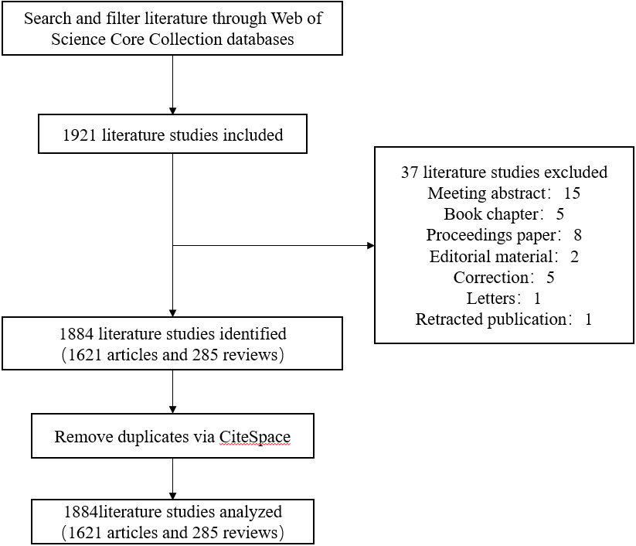
Figure 1 Schematic for reviewing literature. One day was dedicated to data collection. (04 October 2022). The Web of Science Core Collection database yielded 1921 entries in total. 37 articles were then removed, including conference abstracts, book chapters, proceedings papers, edited materials, revised publications, and publications that had retracted earlier versions. 1884 statistics were ultimately collected. For further research, data were imported into Cite-Space software (version 6.1. R6).

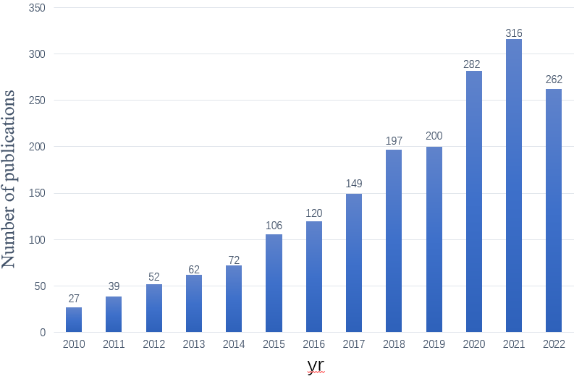
Figure 2 Publications by year (2010-2022).
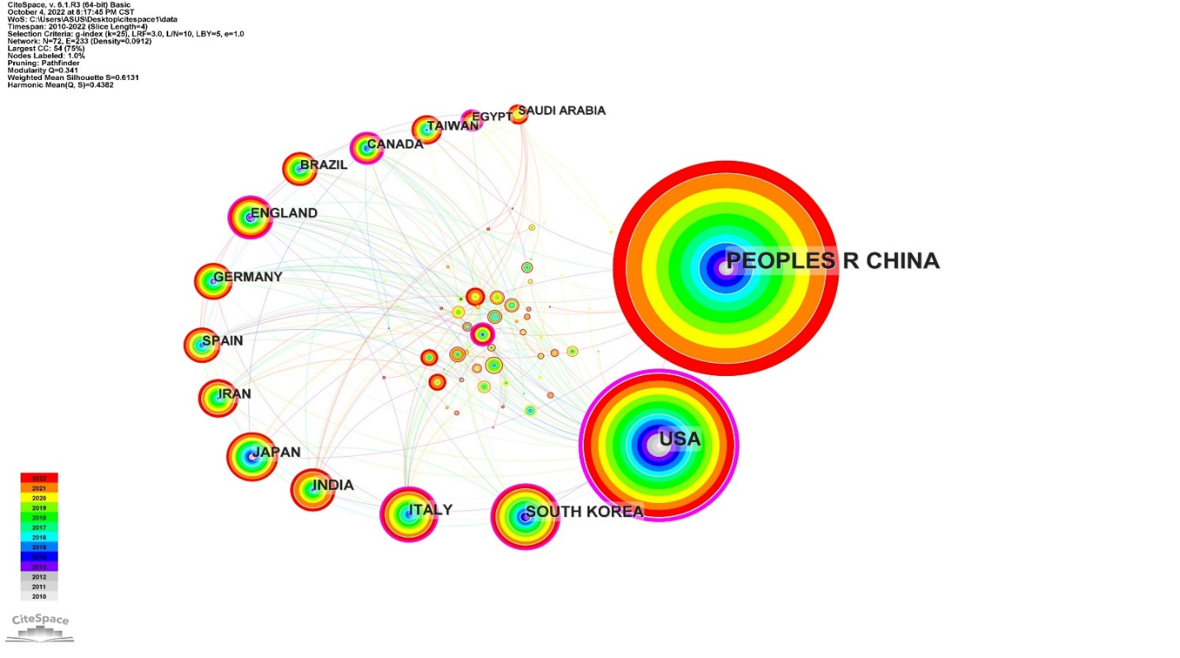
Figure 3 Publications by country. The quantity of articles is indicated by the node size. The quantity of articles published by a nation is shown by an increase in node size. The top 20 publishing-producing nations are depicted in the graph. China tops the chart, followed by the United States, South Korea, Italy, Japan, India, Ireland, Spain, Germany, and the United Kingdom in clockwise order. The collaboration between various nations is represented by lines between nodes.

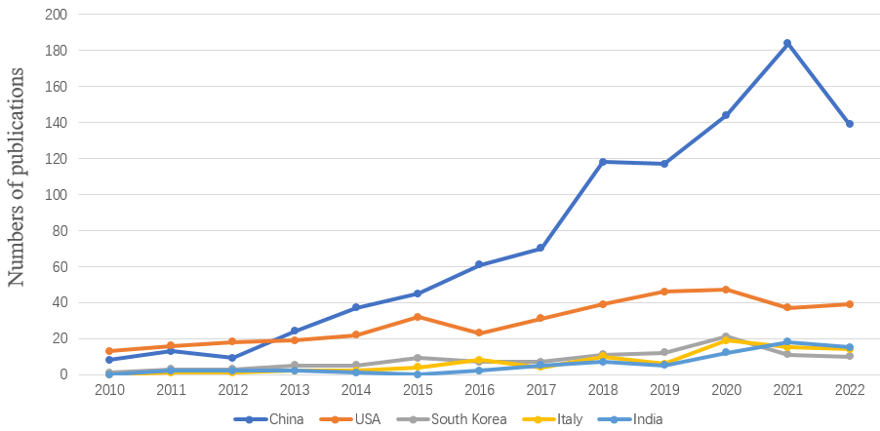
Figure 4 The number of publications by each of the five nations each year. China, the United States, South Korea, Italy, and India were the five countries with the most articles released. Estimation of the annual quantity of publications in each of these five nations. Different hue lines denote various countries.
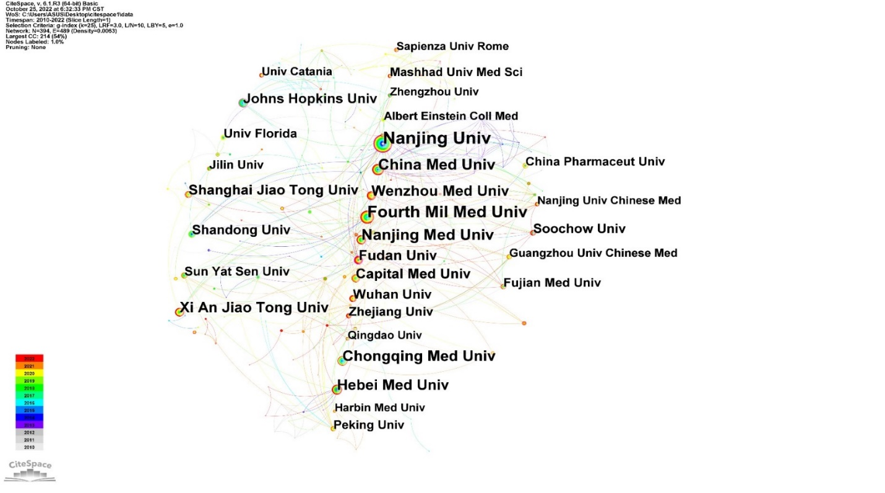Figure 5 Institutional publications. The quantity of articles is indicated by the node size. The quantity of articles increases with node size. Nanjing University produced most papers, followed by Fourth Military Medical University, Nanjing Medical University, China Medical University, and Chongqing Medical University. Additional nations are displayed in a counterclockwise sequence. The cooperation between various institutions is represented by lines between the nodes.

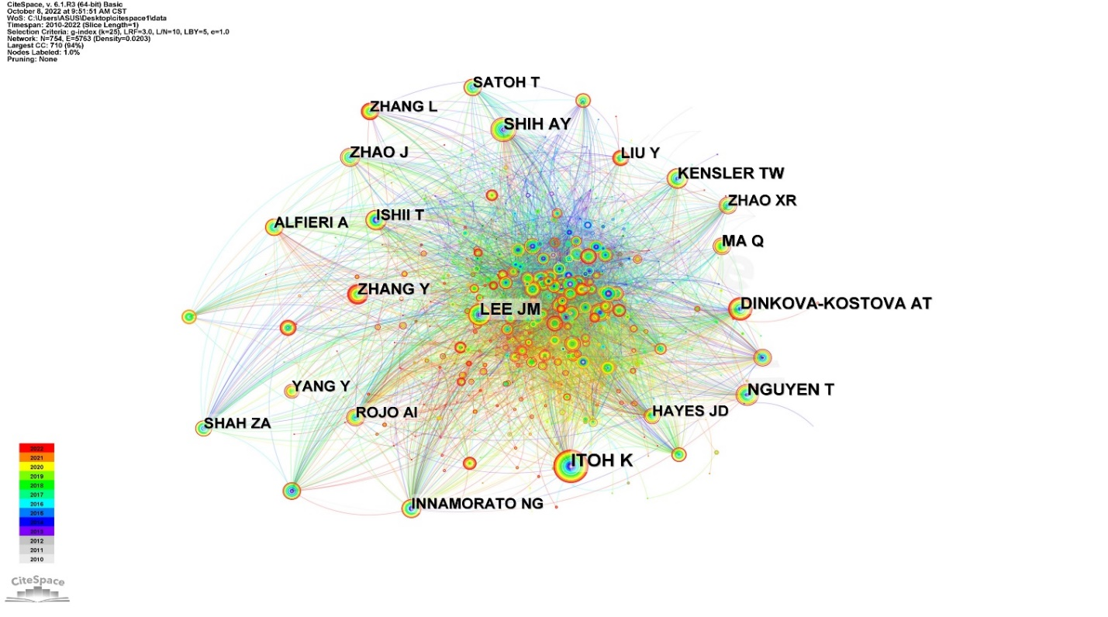Figure 6 Network of co-cited authors. Co-cited authors are represented by nodes. The number of citations is indicated by the size of the node. Collaboration between authors is represented by lines connecting nodes.
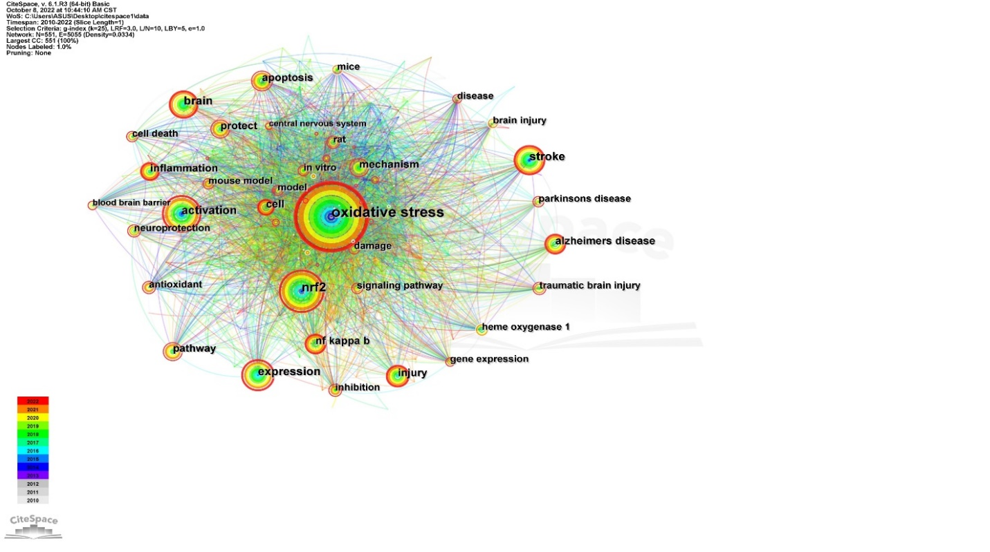
Figure 7 Co-occurrence network of keywords. The number of keywords is indicated by the node size. Multiple sclerosis, Alzheimer's disease, Parkinson's disease, stroke, and traumatic brain injury are the top 8 comorbid keywords. The primary disorders linked to nuclear factor erythroid 2-related factor 2 (NRF2) are depicted in the right side of the diagram, including "Alzheimer's disease," "stroke," "traumatic brain injury," and "Parkinson's disease." Apoptosis, neuroprotection, and inflammation are some of the key terms associated with the mechanism of NRF2 activation that are depicted on the left side of the figure.

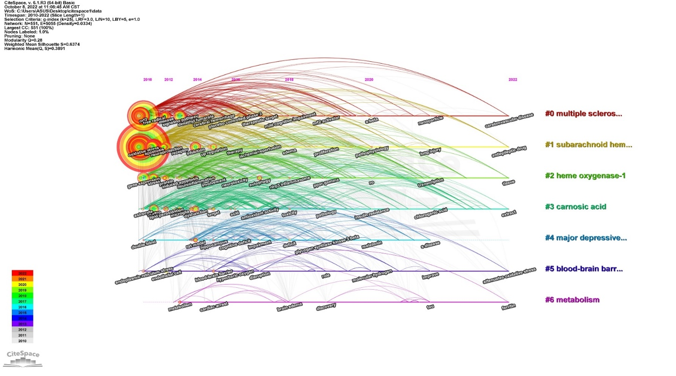 Figure 8 Timeline analysis with keyword clustering (2010-2022). Eight clusters altogether, each identified by a unique color. The biggest cluster is cluster 0, then cluster 1, and so on. The keywords contained in the cluster are spread out by this timeline map as it forms. The label color of the cluster to which a keyword belongs is the same as that of the cluster.

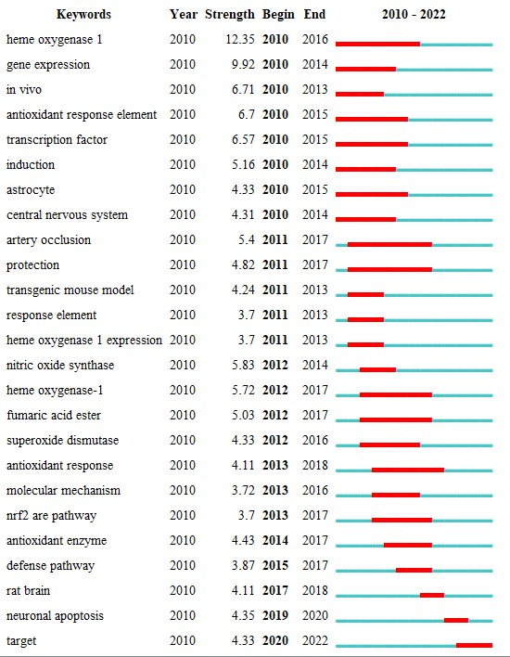
Figure 9 Top 25 terms with the most citations. Burst data indicate an increase in citations for particular keywords over time. In other words, research in this area has received a lot of attention. This is a sign of the state of the scientific frontier at any given time. Blue lines indicate cycles and red lines indicate the duration of citation bursts. Numbers in parentheses represent higher burst strength values.

Table 1 Top 5 research areas/journals/funding agencies according to the number of documents
Field |  | Record count (%)
Research areas | Neurosciences | 585, 31.05
 | Biochemistry Molecular Biology | 437, 23.20
 | Pharmacology Pharmacy | 381, 20.22
 | Cell Biology | 223, 11.84
 | Medicine Research Experimental | 152, 8.07
Journals | Oxidative Medicine and Cellular Longevity | 63, 3.34
 | Antioxidants | 43, 2.28
 | Frontiers in Pharmacology | 43, 2.28
 | Molecular Neurobiology | 37, 1.96
 | International Journal of Molecular Sciences | 35, 1.86
Funding agencies | National Natural Science Foundation Of China | 517, 27.44
 | United States Department Of Health Human Services | 220, 11.68
 | National Institutes Of Health United States | 219, 11.62
 | National Institute Of Neurological Disorders Stroke Ninds | 81, 4.30
 | European Commission | 61, 3.24

Table 2 Top 5 countries and institutions in terms of the number of documents
Field |  | Record count (%) | Centrality
Countries | China | 972, 51.59 | 0.14
 | United States | 384, 20.38 | 0.78
 | South Korea | 106, 5.63 | 0.11
 | Italy | 87, 4.62 | 0.12
 | India | 71, 3.77 | 0.06
Affiliations | Nanjing University | 53, 2.81 | 0.18
 | Fourth Military Medical University | 41, 2.18 | 0.06
 | Nanjing Medical University | 32, 1.70 | 0.04
 | China Medical University | 31, 1.65 | 0.06
 | Chongqing Medical University | 29, 1.54 | 0.01
Table 3 Frequency of keyword co-occurrence (top 25 counts, 2010–2022)
Keywords | Count | Centrality
Oxidative stress | 1140 | 0.01
NRF2 | 473 | 0.00
Activation | 400 | 001
Expression | 327 | 0 01
Brain | 271 | 0 03
Stroke | 265 | 0.02
Nf kappa B | 206 | 0.02
Alzheimer’s disease | 195 | 0.02
Pathway | 192 | 0.02
Apoptosis | 187 | 0.02
Protect | 186 | 0.02
Injury | 186 | 003
Inflammation | 169 | 0.03
Mechanism | 168 | 0.02
Cell | 152 | 0.01
Traumatic brain injury | 147 | 0.03
Damage | 143 | 0.02
Model | 141 | 0.03
Heme oxygenase 1 | 132 | 0.03
Brain injury | 132 | 0.03
Parkinson’s disease | 129 | 10.01
Antioxidant | 129 | 0.00
Signaling pathway | 124 | 0.01
Mouse model | 119 | 0.04
Rat | 116 | 0.03
NRF2: Nuclear factor erythroid 2-related factor 2.

