Name of journal: World Journal of Hepatology
ESPS Manuscript NO: 15928
Columns: CASE REPORT

First jejunal artery, an alternative graft for right hepatic artery reconstruction

Aryal B et al. First jejunal artery graft for right hepatic artery reconstruction

Bibek Aryal, Teruo Komokata, Jun Kadono, Hiroyuki Motodaka, Tetsuya Ueno, Akira Furoi, Yutaka Imoto

Bibek Aryal, Teruo Komokata, Jun Kadono, Hiroyuki Motodaka, Tetsuya Ueno, Akira Furoi, Yutaka Imoto, Department of Cardiovascular and Gastroenterological Surgery, Kagoshima University Graduate School of Medical and Dental Sciences, Kagoshima-shi, Kagoshima 890-8520, Japan

Author contributions: Aryal B, Komokata T and Kadono J followed the case and designed the report; Motodaka H involved in in-patient care and collected the patient’s clinical data; Ueno T assisted the vascular reconstruction; Kadono J, Komokata T, Furoi A and Imoto Y reviewed the paper; Aryal B wrote the paper; Imoto Y approved the paper.

Conflict-of-interest: None of the authors in the manuscript has any conflict of interest to declare.

Open-Access: This article is an open-access article which was selected by an in-house editor and fully peer-reviewed by external reviewers. It is distributed in accordance with the Creative Commons Attribution Non Commercial (CC BY-NC 4.0) license, which permits others to distribute, remix, adapt, build upon this work non-commercially, and license their derivative works on different terms, provided the original work is properly cited and the use is non-commercial. See: http://creativecommons.org/licenses/by-nc/4.0/

Correspondence to: Teruo Komokata, MD, PhD, Department of Cardiovascular and Gastroenterological Surgery, Kagoshima University Graduate School of Medical and Dental Sciences, 8-35-1 Sakuragaoka, Kagoshima-shi, Kagoshima 890-8520, Japan. komokata@kagomc2.hosp.go.jp

Telephone: +81-99-2755368
Fax: +81-99-2658177
Received: December 17, 2014
Peer-review started: December 18, 2014
First decision: December 27, 2014
Revised: January 9, 2015
Accepted: February 10, 2015
Article in press:
Published online:

Abstract
Common bile duct cancer invading right hepatic artery is sometimes diagnosed intraoperatively. Excision and safe reconstruction of the artery with suitable graft is essential. Arterial reconstruction with autologous saphenous vein graft is the preferred method practiced routinely. However the right hepatic reconstruction has also been carried out with several other vessels like gastroduodenal artery, right gastroepiploic artery or the splenic artery. We report a case of 63-year-old man presenting with history of progressive jaundice, pruritus and impaired appetite. Following various imaging modalities including computed tomography, endoscopic retrograde cholangiopancreatography, magnetic resonance cholangiopancreatography, intraductal ultrasound extrahepatic bile duct cancer was diagnosed; however, none of those detected vessel invasion. Intraoperatively, right hepatic artery invasion was revealed. Right hepatic artery was resected and reconstructed with a graft harvested from the first jejunal artery. Postoperative outcome was satisfactory with a long-term graft patency. First jejunal artery can be a reliable graft option for right hepatic artery reconstruction.

Key words: Common bile duct cancer; Right hepatic artery; Arterial reconstruction; Jejunal artery; Arterial graft

© The Author(s) 2015. Published by Baishideng Publishing Group Inc. All rights reserved.

Core tip: Common bile duct (CBD) cancers frequently invade the surrounding vessels like the right hepatic artery (RHA). The arterial excision with tumor free margins followed by the reconstruction remains the mainstay treatment for a better outcome and long-term survival. Various grafts including saphenous vein, splenic artery, right gastroepiploic artery or gastroduodenal artery have been practiced for RHA reconstruction. In our case, the RHA invasion by CBD cancer was detected intra-operatively. We performed the RHA reconstruction using the autologous first jejunal artery graft. The use of first jejunal artery graft during RHA reconstruction seems to be technically feasible leading to an acceptable outcome.

Aryal B, Komokata T, Kadono J, Motodaka H, Ueno T, Furoi A, Imoto Y. First jejunal artery, an alternative graft for right hepatic artery reconstruction. World J Hepatol 2015; In press

INTRODUCTION
Common Bile duct (CBD) cancers invading hepatic artery are sometimes diagnosed intraoperatively. Resection of the artery should be considered with efforts to perform a safe reconstruction procedure. A good reconstruction procedure is expected to preserve the blood flow and ensure long-term patency. Arterial reconstruction with an autologous saphenous vein graft (SVG) has been the method of choice for decades. Hepatic artery reconstruction has also been carried out with gastroduodenal artery (GDA)^{[1]}, right gastroepiploic artery (RGEPA)^{[2,3]} or splenic artery^{[4]}.
Here, we report a case of advanced extrahepatic bile duct cancer invading right hepatic artery (RHA). Subtotal stomach preserving pancreaticoduodenectomy (SSPPD) accompanied by resection of RHA was performed. Arterial reconstruction was performed with the autologous first jejunal artery graft. Postoperative course was satisfactory with no complications. The first jejunal artery can be considered as an alternative graft for RHA reconstruction.

CASE REPORT
A 63-year-old male patient presented to a private hospital with a history of progressive jaundice, pruritus, and loss of appetite. He underwent computed tomography (CT) scan where bile duct stenosis from superior (Bs) to inferior (Bi) duct was evident. The patient was referred to our department for further evaluation and management.
We carried out diagnostic imagings; endoscopic retrograde cholangiopancreatography (ERCP), magnetic resonance cholangiopancreatography (MRCP), intraductal ultrasound (IDUS). MRCP displayed bile duct cancer from Bs to middle duct (Bm). ERCP showed an irregular stricture extending from Bs to Bi (Figure 1A). IDUS revealed pancreatic invasion of the tumor. However, there was no evidence of tumor invasion to the portal vein and RHA (Figure 1B) nor the CT showed any signs of RHA invasion (Figure 2). Preoperative diagnosis of CBD cancer with positive pancreatic invasion was made and SSPPD was proposed.
Following opening of the peritoneal cavity, ascites, liver metastasis and peritoneal dissemination were ruled out. We could palpate the hard tumor in the CBD. While scrutinizing around the hepatoduodenal ligament, we perceived that the bile duct cancer had directly invaded RHA. No invasion or metastasis to duodenum, portal vein, gall bladder, common hepatic artery or other surrounding structures were observed. After dividing RHA and CBD, we resected RHA, 2.8 cm in length. Frozen section revealed cancer cells in adventitia of RHA extending to 15mm in depth with grossly negative stump’s margins.
The back flow from the cut end of the RHA was noted to be poor, so the collateral circulation between RHA and left hepatic artery in the hilar plate was considered to be inadequate. Preoperatively we were not prepared for RHA resection; hence, saphenous vein had not been arranged for reconstruction. We selected the first jejunal artery (JA) as an alternate graft. A graft of 2 cm from first jejunal artery was harvested after transection of jejunum. We interposed the jejunal artery in an end-to-end fashion with 7-0 prolene using interrupted suturing technique (Figure 3). Doppler blood flow study displayed a good flow in the graft at a rate of 120 mL/min. SSPPD was completed with pancreatogastrostomy and hepatico-jejunostomy. Total intraoperative blood loss was 2420 mL and time of reconstruction of RHA with first JA was about an hour.
Anticoagulant therapy with heparin was started from fourth postoperative day for a week, and aspirin was continued until 6 months after operation. Histological examination showed moderately differentiated tubular adenocarcinoma with pancreatic invasion; stage III-B (T3N1M0) (Union for International Cancer Control/UICC classification). No postoperative complications were noted. Following operation, the patient was put on adjuvant chemotherapy with Gemcitabine. After 2 years of surgery, the jejunal artery graft was noted to be patent on CT examination with no signs of stenosis. Unfortunately, the patient had evidence of recurrence with multiple para aortic lymph node metastases and died 3 years after the surgery.

DISCUSSION
The pancreatic or biliary cancers potentially invade hepatic artery either by direct extension or by lymphatic metastasis, and the invasion is sometimes detected intraoperatively. Additionally, during radical resection of the pancreatic or biliary tumors the hepatic artery may require excision to achieve tumor-free margins. Various methods for reconstruction of the hepatic artery have already been described: interposition of venous (greater saphenous vein/GSV) and prosthetic grafts; transposition of the native arteries to the distal stump of the hepatic artery, i.e., splenic artery, right gastroepiploic artery, and even primary repair to avoid prosthetics with combined major visceral resections^{[5-9]}. The suitable technique should be adapted in regard to the specific situation posed by the resection.
In our case, preoperative imagings including IDUS didn't clue the hepatic artery invasion, and by the time RHA invasion was detected, RGEPA had already been resected. We decided to use the first JA for RHA reconstruction. Our concern regarding the anastomosis was a relatively small caliber of the jejunal artery. However, no broad caliber discrepancy between the graft and recipient artery made it acceptable. To our knowledge, this is the first case in the literature where JA was used as a free graft in reconstruction of hepatic artery.
The histological disparities between the wall of artery and vein with the long-term patency have been frequently discussed in context of coronary artery bypass grafting (CABG). Radial artery was introduced in 1971^{[10]}, and the use was soon discouraged for higher occlusion rates as compared to SVG. The propensity of the RA to go into spasm along with severe intimal hyperplasia contributed to poor results obtained with RA grafting^{[11]}. At the same time the use of SVG is limited with its poor patency following intimal hyperplasia and accelerated atherosclerosis. There are growing evidences and it is now clear that SVG deteriorates with time and the occlusion rate reaches up to 50% in 10 years after CABG, mainly due to atherosclerosis in the graft called “vein graft disease”^{[12]}. Subsequently internal mammary artery (IMA)^{[13]}, internal thoracic artery (ITA)^{[14]} and RGEPA^{[15]} grafts emerged as better choices for their markedly superior long-term patency.
Specific to jejunal artery, one review has demonstrated jejunal artery of Roux- en –Y limb being used in hepatic artery reconstruction during living related liver transplantation as an in-situ graft. The report together presents successful HA reconstruction with the jejunal artery of the Roux- en- Y limb (in pediatric living donor liver transplantation)^{[16]}. Likewise, use of jejunal artery graft with anastomosis to neck vessels like carotid artery during pharyngo-jejunostomy has been practiced^{[17]}.
This is the first report to describe the utility of isolated jejunal artery graft in arterial reconstruction for malignant invasion. The postoperative course was uneventful, and the graft had been patent for more than 2 years.
When the use of SVG is restricted in conditions like varicose vein, vasculitis, or it has already been used for bypass conduit, as an interposition graft, or patch graft, JA can be considered as a preferable graft of choice for the RHA reconstruction. JA can also be preferred in the conditions precluding the use of other candidate vessel RGEPA, such as prior resection for gastrectomy or lymph node metastasis around RGEPA. JA graft is readily accessible, is of adequate length to access the hepatic artery, and has an adequate diameter to facilitate the anastomoses. In cases like ours when the RHA invasion is detected intraoperatively, the JA graft can ensure a fast, easy, and safe reconstruction procedure with an extendable patency.Meantime, the caliber discrepancy between the RHA and the JA should always be considered during the reconstruction.
Although SVG has been the preferred graft, this report concludes that the first JA may provide a local autologous graft for RHA reconstruction when an alternative is required.

COMMENTS
Case characteristics
A 63-year-old male with a history of progressive jaundice presented with pruritus and loss of appetite.

Clinical diagnosis
No positive clinical signs were noted.

Differential diagnosis
Pancreatic Carcinoma, Gallbladder cancer.

Laboratory diagnosis
WBC: 5300/uL; HGB: 14.20 gm/dL; T-Bil: 1.2 mg/dL; D-Bil: 0.6 mg/dL; GT: 168 IU/L; AST: 18 IU/L; ALT: 21 IU/L; Albumin: 4.1 g/dL; CEA: 2.1 ng/mL; CA19-9: 20 IU/mL.

Imaging diagnosis
MRCP showed bile duct cancer from superior (Bs) to middle duct (Bm). ERCP showed an irregular stricture extending from Bs to Bi. IDUS revealed pancreatic invasion of the tumor

Pathological diagnosis
Histological examination showed moderately differentiated tubular adenocarcinoma with pancreatic invasion.

Treatment
Subtotal stomach preserving pancreaticoduodenectomy (SSPPD) accompanied by resection of
Right hepatic artery

Related reports
JA of Roux-en-y limb has been previously used for hepatic artery reconstruction.

Experiences and lessons
This case report presents the applicability of first jejunal artery in right hepatic artery reconstruction. The hepatic artery reconstruction with graft from first JA should be a feasible and promising procedure.

Peer-review
This article demonstrates the use of first jejunal artery graft in right hepatic artery reconstruction.

REFERENCES
1 Sarmiento JM, Panneton JM, Nagorney DM. Reconstruction of the hepatic artery using the gastroduodenal artery. Am J Surg 2003; 185: 386-387 [PMID: 12657395 DOI: 10.1016/S0002-9610(02)01416-2]
2 Kusano T, Furukawa M, Nakata T, Kusaba E, Yamauchi H, Tsukasa T, Tsuchiya R. [Hepatic artery reconstruction grafting with the right gastroepiploic artery for surgical treatment of upper bile duct cancer]. Nihon Geka Gakkai Zasshi 1990; 91: 1749-1751 [PMID: 2277623]
3 Ikegami T, Kawasaki S, Hashikura Y, Miwa S, Kubota T, Mita A, Iijima S, Terada M, Miyagawa S, Furuta S. An alternative method of arterial reconstruction after hepatic arterial thrombosis following living-related liver transplantation. Transplantation 2000; 69: 1953-1955 [PMID: 10830238 DOI: 10.1097/00007890-200005150-00036]
4 Figueras J, Parés D, Aranda H, Rafecas A, Fabregat J, Torras J, Ramos E, Lama C, Lladó L, Jaurrieta E. Results of using the recipient's splenic artery for arterial reconstruction in liver transplantation in 23 patients. Transplantation 1997; 64: 655-658 [PMID: 9293883 DOI: 10.1097/00007890-199708270-00020]
5 Hamazaki K, Mimura H, Kobayashi T, Kim H, Sakagami K, Orita K. Hepatic artery reconstruction after resection of the hepatoduodenal ligament. Br J Surg 1991; 78: 1366-1367 [PMID: 1662104 DOI: 10.1002/bjs.1800781131]
6 Garcia-Valdecasas JC, Grande L, Rimola A, Fuster J, Lacy A, Visa J. The use of the saphenous vein for arterial reconstruction in orthotopic liver transplant. Transplant Proc 1990; 22: 2376-2377 [PMID: 2219406]
7 Takenaka H, Iwase K, Ohshima S, Hiranaka T. A new technique for the resection of gastric cancer: modified Appleby procedure with reconstruction of hepatic artery. World J Surg 1992; 16: 947-951 [PMID: 1462635 DOI: 10.1007/BF02066997]
8 Itabashi Y, Hakamada K, Narumi S, Toyoki Y, Totsuka E, Umehara Y, Aoki K, Sasaki M. A case of living-related partial liver transplantation using the right gastroepiploic artery for hepatic artery reconstruction. Hepatogastroenterology 2000; 47: 512-513 [PMID: 10791224]
9 Ahn CS, Hwang S, Moon DB, Song GW, Ha TY, Park GC, Namgoong JM, Yoon SY, Jung SW, Jung DH, Kim KH, Park YH, Park HW, Lee HJ, Park CS, Lee SG. Right gastroepiploic artery is the first alternative inflow source for hepatic arterial reconstruction in living donor liver transplantation. Transplant Proc 2012; 44: 451-453 [PMID: 22410041 DOI: 10.1016/j.transproceed.2012.01.057]
10 Carpentier A, Guermonprez JL, Deloche A, Frechette C, DuBost C. The aorta-to-coronary radial artery bypass graft. A technique avoiding pathological changes in grafts. Ann Thorac Surg 1973; 16: 111-121 [PMID: 4582222 DOI: 10.1016/S0003-4975(10)65825-0]
11 Curtis JJ, Stoney WS, Alford WC, Burrus GR, Thomas CS. Intimal hyperplasia. A cause of radial artery aortocoronary bypass graft failure. Ann Thorac Surg 1975; 20: 628-635 [PMID: 1082316 DOI: 10.1016/S0003-4975]
12 Taggart DP. Current status of arterial grafts for coronary artery bypass grafting. Ann Cardiothorac Surg 2013; 2: 427-430 [PMID: 23977618 DOI: 10.3978/j.issn.2225-319X.2013.07.21]
13 Endo M, Nishida H, Tomizawa Y, Kasanuki H. Benefit of bilateral over single internal mammary artery grafts for multiple coronary artery bypass grafting. Circulation 2001; 104: 2164-2170 [PMID: 11684625 DOI: 10.1161/hc4301.098283]
14 Raja SG, Dreyfus GD. Internal thoracic artery: to skeletonize or not to skeletonize? Ann Thorac Surg 2005; 79: 1805-1811 [PMID: 15854993 DOI: 10.1016/j.athoracsur.2004.05.053]
15 Suma H. Gastroepiploic artery graft in coronary artery bypass grafting. Ann Cardiothorac Surg 2013; 2: 493-498 [PMID: 23977628 DOI: 10.3978/j.issn.2225-319X.2013.06.04]
16 Wakiya T, Sanada Y, Mizuta K, Umehara M, Urahashi T, Egami S, Hishikawa S, Nakata M, Hakamada K, Yasuda Y, Kawarasaki H. Hepatic artery reconstruction with the jejunal artery of the Roux-en-Y limb in pediatric living donor liver re-transplantation. Pediatr Transplant 2012; 16: E86-E89 [PMID: 21496191 DOI: 10.1111/j.1399-3046.2010.01442.x]
17 Lee HS, Park SY, Jang HJ, Kim MS, Lee JM, Zo JI. Free jejunal graft for esophageal reconstruction using end-to-side vascular anastomosis and extended pharyngo-jejunostomy. Ann Thorac Surg 2012; 93: 1850-1854 [PMID: 22440367 DOI: 10.1016/j.athoracsur.2012.01.068]
P-Reviewer: Solinas A, Zhang Q S-Editor: Tian YL
L-Editor: E-Editor:

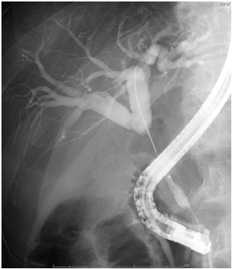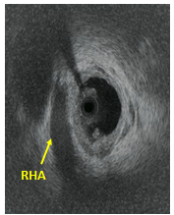
Figure 1 A: Endoscopic retrograde cholangiopancreatography shows an irregular stenosis from superior to inferior bile duct. B: Intraductal ultrasound showing no cancer invasion to the right hepatic artery (arrow).
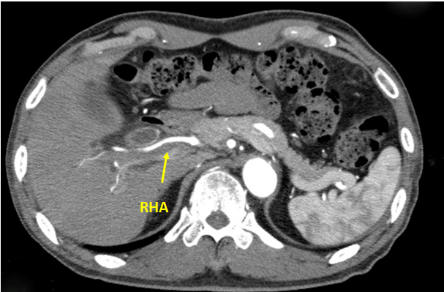
Figure 2 Computed tomography showing right hepatic artery with no signs of cancer invasion.
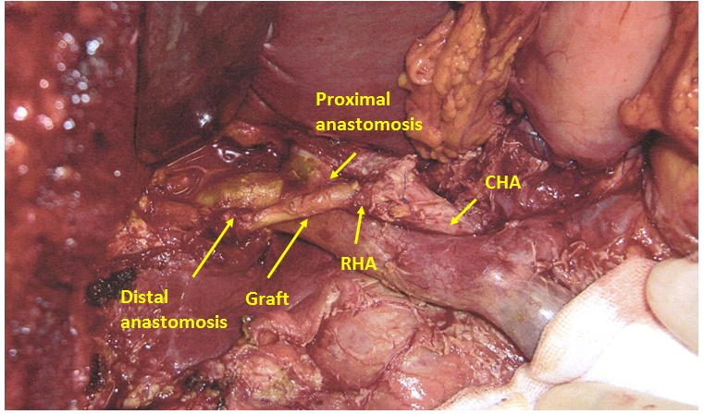
Figure 3 First jejunal artery graft interposed to the right hepatic artery. RHA: Right hepatic artery.

