Hepatitis B Program: Pre / Post Session Survey
What is your home country?
How many years have you been in the U.S.?
What is your gender?
How old are you?
For the next section, please answer on a scale of 1 to 5, as indicated:
- How high is your risk for having Hepatitis B infection (1 = low risk; 5 = high risk)?
- How important is it to test people at risk for Hepatitis B (1 = not important; 5 = very important)?
- How easy is it for you to access medical care (1 = very difficult; 5 = very easy)?
- How comfortable do you feel asking a doctor about Hepatitis B testing (1 = very uncomfortable; 5 = very comfortable)?
- How easy would it be for you to get tested for Hepatitis B (1 = very difficult; 5 = very easy)?
- How easy would it be for you to get treated for Hepatitis B if you tested positive (1 = very difficult; 5 = very easy)?
For the next section, please write a brief open response:
- If you consider yourself at high risk of Hepatitis B infection, what makes your risk higher? (Examples: country of origin; needle exposures; sexual exposures; other factors

- If you think it is important to test those at risk for Hepatitis B, why is it important?

- If you do not think it is important to test for Hepatitis B, why not?

- If you find it difficult to access medical care, why is it difficult? (Examples: insurance coverage; lack of available doctors; other reasons)

- If you find it uncomfortable to ask your doctor about Hepatitis B testing, why is it uncomfortable?

- If you think it would be difficult for you to get tested for Hepatitis B, why would it be difficult? (Examples: insurance coverage; cost of the test; fear of the blood draw; fear of the results; concerns about confidentiality; lack of time to get tested; other reasons)

- If you think it would be difficult for you to get treated for Hepatitis B, why would it be difficult? (Examples: insurance coverage; cost of treatment; lack of treatment providers; treatment side-effects; the treatment does not work; other reasons)

For the next section, please indicate whether each statement is True or False:
- Hepatitis B is an infection that affects the kidneys.
- Hepatitis A turns into Hepatitis B, which then turns into Hepatitis C.
- Hepatitis B is the most common liver infection in the world.
- You can get Hepatitis B from touching, sharing food utensils, or drinking too much alcohol.
- The only way to get Hepatitis B is through sexual contact.
- The test for Hepatitis B involves taking a small sample of blood.
- If you have Hepatitis B but do not have symptoms, you do not have to worry about your liver.
- Hepatitis B infection can cause scarring of the liver and liver cancer.
- There is no treatment for Hepatitis B infection.
- If you do not have Hepatitis B, there is a vaccine that can prevent you from getting it in the future.

Figure S1. Participant Questionnaire. Participants were asked to complete the same questionnaire prior to and following the study.
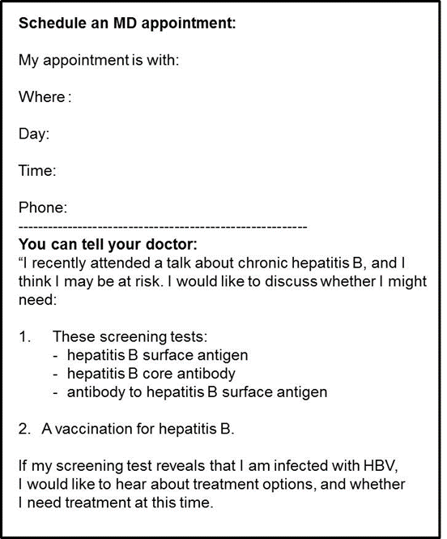
Figure S2. Navigator Card. All participants were provided with navigator card in English to facilitate HBV discussions with their health care provider and decrease language as barrier to HBV care.

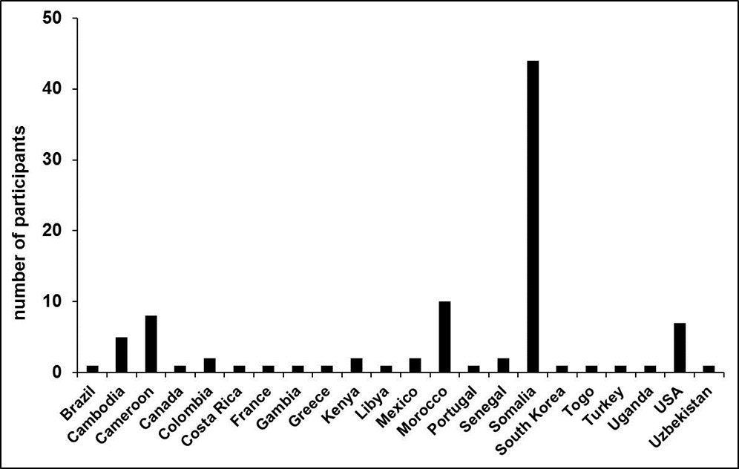
Figure S3. Country of Origin as reported by participants in pre-session questionnaire.

