Name of Journal: World Journal of Biological Chemistry
Manuscript NO: 87028
Manuscript Type: ORIGINAL ARTICLE

Basic Study
Protein arginine methyltransferase 6 is a novel substrate of protein arginine methyltransferase 1

Cao MT et al. Mechanism of PRMT1-PRMT6 Interaction

Meng-Tong Cao, You Feng, Y. George Zheng

Meng-Tong Cao, You Feng, Y. George Zheng, Department of Pharmaceutical and Biomedical Sciences, University of Georgia, Athens, GA 30602, United States

Author contributions: Cao MT, Feng Y and Zheng YG designed the research study; Cao MT and Feng Y performed the experiments; All authors analyzed the data, wrote the manuscript, and have read and approve the final manuscript.

Supported by National Institutes of Health, No. 5R01GM126154 and No. 1R35GM149230.

Corresponding author: Y. George Zheng, PhD, Professor, Department of Pharmaceutical and Biomedical Sciences, University of Georgia, No. 250 W. Green St., Athens, GA 30602, United States. yzheng@uga.edu

Received: July 19, 2023
Revised: September 8, 2023
Accepted: September 26, 2023
Published online:

Abstract
BACKGROUND
Post-translational modifications play key roles in various biological processes. Protein arginine methyltransferases (PRMTs) transfer the methyl group to specific arginine residues. Both PRMT1 and PRMT6 have emerges as crucial factors in the development and progression of multiple cancer types. We posit that PRMT1 and PRMT6 might interplay directly or in-directly in multiple ways accounting for shared disease phenotypes.

AIM
To investigate the mechanism of the interaction between PRMT1 and PRMT6.

METHODS
Gel electrophoresis autoradiography was performed to test the methyltranferase activity of PRMTs and characterize the kinetics parameters of PRMTs. Liquid chromatography-tandem mass spectrometryanalysis was performed to detect the PRMT6 methylation sites.

RESULTS
In this study we investigated the interaction between PRMT1 and PRMT6, and PRMT6 was shown to be a novel substrate of PRMT1. We identified specific arginine residues of PRMT6 that are methylated by PRMT1, with R106 being the major methylation site. Combined biochemical and cellular data showed that PRMT1 downregulates the enzymatic activity of PRMT6 in histone H3 methylation.

CONCLUSION
PRMT6 is methylated by PRMT1 and R106 is a major methylation site induced by PRMT1. PRMT1 methylation suppresses the activity of PRMT6.

Key Words: Posttranslational modification; Arginine methylation; Protein arginine methyltransferase 1; Protein arginine methyltransferase 6; Cross-talk; Protein-protein interaction

Cao MT, Feng Y, Zheng YG. Protein arginine methyltransferase 6 is a novel substrate of protein arginine methyltransferase 1. World J Biol Chem 2023; In press

Core Tip: We reported the interplay between protein arginine methyltransferase (PRMT) 1 and PRMT6, and PRMT6 is a substrate of PRMT1. The major methylation site in PRMT6 is R106 for PRMT1 catalysis and the methylation by PRMT1 regulates the enzymatic activity of PRMT6. This study is important for understanding the cross-talking relationship between PRMTs.

INTRODUCTION
Protein arginine methylation is a widespread post-translational modification that regulates various biological processes in cellular physiology^{[1,2]}. Protein arginine methyltransferases (PRMTs) act as the controller of arginine methylation that transfers the methyl group from S-adenosyl methionine (SAM) to specific arginine residues on histone or nonhistone protein substrates^{[3-6]}. The PRMT members are categorized into three types according to the stereochemical specificity of their product^{[7,8]}. The type I enzymes [PRMT1, PRMT2, PRMT3, coactivator associated arginine methyltransferase (CARM1), PRMT6, and PRMT8] catalyze the formation of ω-NG-monomethyl arginine (MMA) and ω-N^{G}, N^{G}-asymmetric dimethylarginine (ADMA)^{[9,10]}. The type II enzymes (PRMT 5 and PRMT9) catalyze the formation of MMA and ω-N^{G}, N’^{G}-symmetric dimethylarginines^{[11,12]}. PRMT7 belongs to the type III enzyme and exclusively generates MMA^{[13]}.
Upregulation of PRMTs expression level is commonly observed in clinical oncology and is correlated with poor prognosis of patients^{[14-17]}. Therefore, PRMTs emerge as potential novel molecular targets in cancer therapy development^{[18-21]}. PRMT1 and PRMT6 both belong to the Type I PRMT family and the activities of PRMT1 and PRMT6 have been associated with distinct cellular functions. PRMT1 contributes to most of the ADMA in proteins^{[22]} and plays key roles in regulating such biological processes as transcriptional regulation, signal transduction, cell proliferation, DNA damage repair owing to its action on numerous histone and non-histone substrates. On the chromatin, PRMT1 generates ADMA marks on histone H4 arginine 3, H2AR3, and H2AR11^{[23-25]}. Currently, seven PRMT1 isoforms (PRMT1-v1 to v7) have been identified: PRMT1-v1 and PRMT1-v7 are predominantly located in the nucleus, while PRMT1-v2 is primarily situated in the cytoplasm^{[26]}. In gene expression regulation, PRMT1 is an activating transcription cofactor^{[27]}. PRMT6 is another type-I PRMT member and is involved in a broad spectrum of biological and pathological processes, such as transcriptional regulation, DNA repair, cell movement, embryonic stem cell pluripotency, human immunodeficiency virus pathogenesis, and cardiovascular-associated diseases^{[28-33]}. PRMT6 generates ADMA modifications on H2AR29, H3R2, H3R17 and H3R42^{[30,34-38]}. When PRMT6 adds H3R2me2a to the promoters, it suppresses transcription; however, when H3R2me2a is added to enhancers, PRMT6 promotes transcription^{[39]}. The subcellular localization analysis shows PRMT6 is predominantly present in the nucleus^{[40]}.
Both PRMT1 and PRMT6 have emerged as crucial factors in the development and progression of multiple cancer types such as breast cancer, colorectal cancer, lung cancer, and bladder cancer. Notably, experimental knockdown of PRMT1 and PRMT6 using siRNAs has been shown to significantly inhibit the growth of bladder and lung cancer cells^{[41]}. The tumor-promoting roles of PRMT1 and PRMT6 in oncology are executed through their methylation of histone and non-histone substrates^{[41-45]}. Expression profile analysis suggests that PRMT1 and PRMT6 are both involved in multiple pathways which are fundamental for cell proliferation^{[41]}. We posit that PRMT1 and PRMT6 might interplay directly or in-directly in multiple ways accounting for shared disease phenotypes. Thereby, neutralizing these enzymes’ activities or their interactions may interfere with tumor progression and lead to anticancer beneficial effects.
The structural analysis of PRMTs using X-ray crystallography has revealed a consistent homodimeric structure across all the type I PRMT isoforms, representing the active unit for their catalytic activity^{[46-48]}. PRMT5 homodimer is further extended into a hetero-octameric state with methylosome protein 50 included in the complex^{[49]}. In addition to homodimerization, several studies have provided evidence for the existence of PRMTs heterological complex formation with other PRMT members. For instance, Pak et al^{[50]} found that PRMT1 forms heterodimers or oligomers with PRMT2, and this interaction synergistically enhances the catalytic activities of both enzymes. PRMT8 was shown to form homodimers and heterodimers with PRMT1^{[51]}. CARM1 was found to interact with PRMT5 to repress human γ-globin gene expression^{[52]}. PRMT5 was found to interact with PRMT6 to promote colorectal cancer progression^{[53]}. However, the structures, mechanisms, and consequences of those interactions and their downstream effects on gene regulation and cellular processes require substantial investigation. In the present study, we reported a novel heteromeric interaction between PRMT1 and PRMT6. Remarkably, our new finding showed that PRMT6 acts as a new substrate of PRMT1, and the arginine methylation induced by PRMT1 led to a decrease in the enzymatic activity of PRMT6.

MATERIALS AND METHODS
Cell culture and transfection
About 0.3 × 10⁶ human embryonic kidney 293T cells were seeded in the 6-well culture plate containing 2 mL of 1X Dulbecco’s modiﬁed Eagle’s medium (Cellgro) supplemented with 10% Fetal Bovine Serum (Cellgro) before incubating them at 37 ℃ with 5% CO₂. When about 80% confluence was reached, 1 × 10⁶ cells were obtained. Transfection was performed using Lipofectamine 3000 (L3000008, Thermofisher) reagent. For the overexpression of PRMT1 or PRMT6, 2.5 µg HA-PRMT1 or Myc-PRMT6 or the mixture of HA-PRMT1 and Myc-PRMT6 was added in 125 µL of Opti-MEM medium with 5 µL P3000 reagent to get the diluted DNA. 10 µL of L3000008 reagent was diluted by 125 µL of Opti-MEM medium. Diluted DNA was mixed with diluted L3000008 at 1:1 ratio. After 15 min, the DNA-lipid complex was added to the cells. For the knock down of PRMT1, 5 µg shPRMT1 or shScramble were incubated with the reagents instead. The mixtures were added into each well of the 6-well plate to transfect HEK-293T cells.

Coimmunoprecipitation of PRMT1 and PRMT6
Myc-PRMT6 single-transfected HEK-293T cells or HA-PRMT1 and Myc-PRMT6 co-transfected 293T cells were collected by centrifugation at 1500 rpm at 4 ℃ for 10 min, washed with 1 mL [phosphate-buffered saline (PBS), Cellgro] twice, and lysed in M-PER mammalian protein extraction reagent (Thermo Scientific) containing 1% protease inhibitor cocktail (Thermo Scientific). The lysate was frozen and thawed once and centrifuged at 12000 rpm for 20 min. The supernatant was aliquoted with 100 µg protein and immunoprecipitated with (1): 2 µg anti-HA antibody or mouse [immunoglobulin G (IgG), Santa Cruz] at 4 ℃ for 2 h followed by 50 µL protein A/G plus agarose beads (Santa Cruz) at 4 ℃ overnight, and or (2): 2 µg anti-myc antibody (Origene) or mouse IgG at 4 ℃ for 2 h followed by 50 µL protein A/G plus agarose beads at 4 ℃ overnight. The beads were washed with 500 µL TBS buffer with 0.05% tween-20 for 3 times. The protein on the beads were eluted with sodium dodecyl sulfate (SDS) loading buffer and separated on 12 % SDS-polyacrylamide gel electrophoresis (PAGE). Then the protein bands were immunoblotted with: (1) Anti-PRMT6 (Santa Cruz); (2): anti-PRMT1; (3): anti-HA antibody, and or (4) anti-Myc antibody.

Methyltransferase activity of PRMTs
Radioactive methyltransferase assays were conducted to test the methylation of PRMT6 and its activity on histone H3. The reactions were carried out at 30 ℃ in a reaction buffer containing 50 mmol/L 4-(2-hydroxyethyl)-1-piperazineethanesulfonic acid (HEPES) (pH 8.0), 50 mmol/L NaCl, 1 mmol/L ethylenediaminetetraacetic acid (EDTA), and 0.5 mmol/L dithienothiophene (DTT) 3 µM PRMT1 or H3.1 (New England Biolabs) or H3.3 (New England Biolabs) together with 20 µM ¹⁴C-SAM (Perkin Elmer) were incubated with 1 µM PRMT6 for 1 h. Control reaction with only PRMT6 and ¹⁴C-SAM was performed to test its automethylation activity. The reactions were quenched with SDS loading buffer and the methylated products were separated by 12% SDS-PAGE. The radioactive gel was dried and stored for 16 h for a phosphor image scan. The methylated bands were quantified with ImageJ for data analysis.
For characterization of PRMT6 methylation mediated by PRMT1, the varied concentration of PRMT6 (0-4 µM) was incubated with 10 µM ¹⁴C-SAM with 0.2 µM PRMT1^{WT} or PRMT1^{E153Q} at 30 ℃ for 1 h. For time-dependent PRMT6 methylation assay, 1.5 µM of PRMT6 and 10 µM of ¹⁴C-SAM were incubated with 0.4 µM of PRMT1^{WT} or PRMT1^{E153Q}. The reactions were quenched at different time points (0-120 min) by SDS loading buffer. The methylation intensity data were normalized according to the reading of 5 µM ¹⁴C-BSA in liquid scintillation and the PRMT6 automethylation intensity was subtracted from the total PRMT6 methylation intensity in the presence of PRMT1 to derive the data of methylation mediated by PRMT1. For comparison of PRMT6 mutant methylation, 5 µM of each PRMT6 mutant was incubated with 30 µM ¹⁴C-SAM with or without 1 µM PRMT1 at 30 ℃ for 2 h. The methylation intensity data were normalized against PRMT6^{WT}.

Pull down assay of PRMT6
Amylose resin was washed with 5 volumes of column buffer to remove the storage buffer. 20 µg PRMT1 was incubated with the amylose beads under 4 ℃ for 30 min while rotating. The amylose resin with PRMT1 was centrifuged at 500 g for 5 min, the supernatant was discarded and the beads were washed by PBS 3 times. After that, 20 µg PRMT6 was incubated with the amylose beads bond with PRMT1 or amylose beads only under 4 ℃ for 4 h while rotating. The resin was centrifuged and washed by PBS 5 times to remove the excess PRMT6 that not binding with PRMT1. The pulled-down proteins were eluted by SDS-PAGE loading buffer and a western blot was performed to detect PRMT1 and PRMT6.

Liquid chromatography-tandem mass spectrometry (LC-MS/MS) analysis of the PRMT 6 methylation sites
The methylation sites on PRMT6, either mediated by PRMT1 or by itself, were detected by in-gel digestion and LC-MS/MS analysis following the methylation reaction. 5.5 µM PRMT6 and 200 µM regular SAM were incubated with 1 µM PRMT1 at 30 ℃ for 3 h in the same reaction buffer as mentioned above. SDS loading dye was added to quench the reaction and 10% SDS-PAGE was conducted to separate the protein. The PRMT6 band was cut from the gel, washed with distaining solution (800 µL), 0.1 M NH₄CO₃ in 50% acetonitrile (400 µL), and 100% acetonitrile (60 µL), and vacuum dried. Then the methylated PRMT6 sample was sent to UAB Proteomics and Mass Spectrometry Facility (Birmingham, AL 35294) for in-gel digestion (Trypsin) and LC-MS/MS detection.

Site-directed mutagenesis of PRMT6
The individually designed primers for the site-directed mutagenesis of potential methylation sites of PRMT6 were synthesized and desalted by integrated DNA technologies. The forward and reverse primers are 5’-gaagatggcgcggagaaggaggcggccctggag-3’ and 5’-ctccagggccgcctccttctccgcgccatcttc-3’ for PRMT6-R29K, 5’-gaactgggcagcactgaaaggcaagacggtactgg-3’ and 5’-ccagtaccgtcttgcctttcagtgctgcccagttc-3’ for PRMT6-R82K, 5’-cccaggccggggccaagcgc-gtgtacgcgg-3’ and 5’ -ccgcgtacacgcgcttggccccggcctggg-3’ for PRMT6-R106K, 5’-ggagggctt-cgccacgaagtgtctcatgggccactc-3’ and 5’-gagtgg-cccatgagacacttcgtggcga-agccctcc-3’ for PRMT6-R228K, 5’-gctccgtcctccacgcgaaaaccaagtggctga-agg-3’ and 5’-ccttcagccacttggttttcgcgtggaggacg-gagc-3’ for PRMT6-R174K, 5’-cggtccacgaggagttgatcgcggaccgc-3’ and 5’-gcggtccgcgat-caactcctcgtggaccg-3’ for PRMT6-M60L, 5’-ctc-ctgcacgagtccgcgctgagctccgtcctc-3’ and 5’-gaggacg-gagctcagcgcggactcgtgcaggag-3’ for PRMT6-M166A. Mutation of each codon was accomplished by polymerase chain reaction (PCR) amplification with native pfu polymerase, synthesized primers, and His6 × PRMT6-pET28a (+) as a template. Following PCR reactions, Dpn1 was added to digest the original methylated plasmid. Then the plasmid with each mutation was heat-shock transformed to XL1blue super-competent cells, which were selected on agar plates with Kanamycin at 37 ℃ overnight. The single colonies were picked up and incubated in 4 mL LB media with Kanamycin for 16 h. The mutant DNA was extracted with Wizard Plus SV Minipreps DNA purification system (Promega) and the correct mutations were confirmed by DNA sequencing with Genscript Inc.

Expression and purification of PRMT1, PRMT1 mutant, PRMT6 and PRMT6 mutants
His-tagged PRMT1, maltose-binding protein (MBP)-tagged PRMT1, His-tagged PRMT6, and the mutants were expressed by recombinant DNA technology in E. coli, and then affinity-purified with nickel-nitrilotriacetic acid (Ni-NTA) his binding resin (Novagen). PRMT1-pET28b or PRMT6/mutant-pET28a (+) plasmid was transformed into E. coli BL21 (DE3) (Stratagene) through heat shock. One colony of the bacteria was inoculated into 4 mL LB media containing kanamycin or ampicillin and incubated at 37 ℃ overnight. The next day, the culture was added to 1 L of LB media and incubated until OD₅₉₅ reached 0.6-0.8. Protein expression was induced with 0.3 mmol/L isopropyl beta-D-1 thiogalactopyranoside at 16 ℃ overnight. After that, the culture was centrifuged at 5000 rpm for 10 min and the cell pellet was resuspended in lysis buffer [25 mmol/L Na-HEPES, pH 8.0, 150 mmol/L NaCl, 1 mmol/L MgSO₄, 5% ethylene glycol, 5% glycerol, and 0.5 mmol/L phenylmethylsulfonyl fluoride (PMSF)]. Cell lysis was carried out by high-pressure cell disruptor. The lysate was centrifuged and then the supernatant was loaded onto Ni-NTA beads equilibrated with column buffer (25 mmol/L Na-HEPES (pH 7.0), 300 mmol/L NaCl, 1 mmol/L PMSF, and 30 mmol/L imidazole). Following protein loading, the beads were washed thoroughly with 10 volumes of column buffer and 10 volumes of washing buffer (25 mmol/L Na-HEPES (pH 7.0), 300 mmol/L NaCl, 1 mmol/L PMSF, and 70 mmol/L imidazole), and then the bound protein was eluted with elution buffer (25 mmol/L Na-HEPES (pH 7.0), 300 mmol/L NaCl, 1 mmol/L PMSF, 100 mmol/L EDTA, and 200 mmol/L imidazole). Different eluants were checked on 12% SDS-PAGE gel. Elution fractions with target protein were combined and concentrated with 10000 molecular weight cut-off centrifugal filters (Millipore), and then dialyzed against storage buffer (25 mmol/L Na-HEPES (pH 7.0), 300 mmol/L NaCl, 1 mmol/L EDTA, 10 mmol/L DTT and 10% glycerol) at 4 ℃. After dialysis, protein concentration was determined using Bradford assay. The final protein samples were aliquoted, flash-frozen, and stored at -80 ℃. For each enzymatic assay, a fresh aliquot was melted on ice and diluted to the assay concentration as needed.

Steady-state kinetics characterization of PRMT6 mutants
The steady-state kinetics of selected PRMT6 mutants were also studied in the radioactive assays at 30 ℃ in the same reaction buffer. The concentration is 0.6 µM for the PRMT6 mutant and 30 µM for ¹⁴C-SAM. Synthesized H3 (1-31) peptide (sequence: ARTKQTARKSTGGKAPRKQLATKVARKSAPA) was used as a substrate, the concentration of which ranged from 0 to 200 µM. The reaction was initiated by adding the enzyme once the other components were incubated at 30 ℃ for 5 min. After continuous incubation for 60 min, the reaction was quenched by spreading the reaction mixture onto the surface of the P81 filter paper (Whatman). The paper was washed with 50 mmol/L NaHCO₃ (pH 9.0) and air dried. Then liquid scintillation was performed to quantify the amount of methylated products.

RESULTS
PRMT6 interacts with PRMT1
To investigate potential interactions between different PRMT members, PRMT6 was incubated with one of the other PRMT members in the presence of (³H) SAM. The reaction mixture was resolved on SDS-PAGE and subjected to autoradiography imaging. We clearly observed PRMT6 underwent automethylation (Figure 1A), which coincides with the literature reports^{[40,54]}. Of surprise, when mixed with PRMT1, the methylation of PRMT6 was significantly augmented (Figure 1A). This finding provided the initial evidence that PRMT1 interacted with PRMT6 and methylated the latter.
To validate the interaction between PRMT1 and PRMT6 in vivo, HEK293T cells were transfected with HA-PRMT1 or Myc-PRMT6, the cell lysate was extracted after transfection. The anti-Myc antibody or anti-HA antibody was respectively bound to A/G agarose beads then the whole cell lysate was added. The proteins immunoprecipitated by the anti-Myc or anti-HA were eluted and western blot analysis was performed to detect PRMT1 or PRMT6. The result shown in Figure 1B clearly proved that the transfected Myc-PRMT6 immunoprecipitated endogenous PRMT1 and reciprocally, the transfected HA-PRMT1 immunoprecipitated endogenous PRMT6 in HEK293T cells. Moreover, in the HEK293T cells co-transfected with HA-PRMT1, Myc-PRMT6 plasmids, HA-PRMT1 and Myc-PRMT6 were capable of reciprocally immunoprecipitated each other from the co-transfected cell lysate (Figure 1C).
To further verify a direct physical interaction exists between PRMT1 and PRMT6, MBP pull-down assay was performed in vitro using recombinant MBP-tagged PRMT1 protein. MBP-PRMT1 was incubated with amylose beads first and PRMT6 was incubated with the beads after washing. The resin was washed and protein was eluted by SDS-loading buffer. As shown in Figure 1D, PRMT6 was pulled down on MBP-PRMT1-bound amylose resin. Thus, this pull-down analysis supported that there was a direct interaction between PRMT6 and PRMT1.

PRMT6 is methylated by PRMT1
Having known that PRMT1 interacts with PRMT6 in vitro and in vivo, we next examined more details about the activity of PRMT1 in transferring methyl group (s) to PRMT6 by performing gel electrophoresis autoradiography. The inactive PRMT1^{E153Q} was expressed and used a negative control to validate PRMT1 activity on PRMT6 methylation. As displayed in Figure 2A, PRMT6 itself in the presence of ¹⁴C-SAM exhibited automethylation activity of PRMT6, confirming the result in Figure 1A. PRMT6 methylation band was much stronger in the presence of PRMT1^{WT}, but not the inactive E153Q mutant, clearly showing that PRMT6 was a substrate of PRMT1^{WT}. Notably, when histone H3, a substrate of PRMT6, was introduced, the automethylation of PRMT6 diminished significantly (Figure 2A), implying that PRMT6 prefers methylating its histone substrate rather than itself. To further verify PRMT6 methylation by PRMT1, we knocked down the PRMT1 level in HEK293T cells by shPRMT1 (Figure 2B) and then performed the immunoprecipitation of PRMT6. The result showed that both ADMA and MMA levels in PRMT6 was decreased as a result of PRMT1 knockdown (Figure 2C). Furthermore, we overexpressed PRMT1 in HEK293T cells and immunoprecipitated endogenous PRMT6. The immunoblot clearly showed an increase in the ADMA level in PRMT6 (Figure 2D). These biochemical and cellular assay data collectively demonstrated that PRMT6 was a substrate of PRMT1.

PRMT1-mediated methylation of PRMT6 goes much faster than PRMT6 automethylation
We then sought to further quantify PRMT1-catayzed PRMT6 methylation and compared this activity with PRMT6 automethylation. PRMT6 methylation level was checked at different time points in the presence of PRMT1^{WT} (Figure 3A). At each time point, we observed that the existence of PRMT1^{WT} led to an increasingly darker ¹⁴C-labeled PRMT6 methylation band. In contrast, under the same condition, PRMT6 methylation level was barely invisible at different time points in the presence of PRMT1^{E153Q} which was the inactive form of PRMT1 (Figure 3B). This data further proved that the observed methylation of PRMT6 in Figure 1A was resulted from PRMT1 activity.
Although the automethylation band was not strong when the final concentration of PRMT6 was at 1.5 µM (Figure 3B), once the concentration of PRMT6 was increased to 4.5 µM, the methylation band became very clear when the incubation time was higher than 30 min (Figure 3C). In addition, the automethylation of PRMT6 appeared to be affected slightly by the addition of PRMT1^{E153Q} (Figure 3C). The quantification of the band intensities of Figure 3A was shown in Figure 3D. We also analyzed PRMT1-catalyzed PRMT6 methylation at different PRMT6 concentrations (Figure 3E). The quantification of band intensities was shown in Figure 3F. PRMT6 automethylation was subtracted from the total methylation to calculate PRMT1-catalyzed methylation. The data were fit with the Michaelis-Menton kinetic equation, yielding k_{cat} of 0.066 ± 0.009 min⁻¹ and K_{m} of 0.3765 ± 0.06 µM. PRMT6 automethylation activity showed k_{cat} of 0.040 ± 0.006 min⁻¹ and K_{m} of 0.1403 ± 0.05 µM. Clearly, PRMT6 methylation by PRMT1 is much stronger than PRMT6 automethylation.

The major methylation site in PRMT6 is R106 for PRMT1 catalysis
It is critical to know the residue site (s) in PRMT6 methylated by PRMT1 in order to understand the nature and consequence of this methylation event. Toward this goal, we incubated PRMT6 and SAM together with PRMT1, resolved the mixture on the SDS-PAGE gel, cut out the PRMT6 band and detected the modification sites by LC-MS/MS analysis. From the database search, PRMT6 was identified (Homo sapiens, Gene ID 55170, 41937.4 Da), with 29 unique peptides, 57 unique spectra, 462 total spectra, and 307/375 amino acids (82% coverage). Two arginine residues were detected to be dimethylated: Arg-82 and arg-174, and three arginine residues were detected to be mono-methylated: Arg-29, arg-106, and arg-228 (Figure 4A and B).
To confirm these methylation sites in PRMT6, we generated several mutants, PRMT6^{R29K}, PRMT6^{R82K}, PRMT6^{R106K}, PRMT6^{R174K} and PRMT6^{R228K}, by performing site-directed mutagenesis. A previous study showed that PRMT1 has two important conserved methionine residues and both PRMT1^{M48L} and PRMT1^{M155A} mutants showed an automethylation activity compared to wild-type PRMT1^{[55]}. These results indicated that M48 and M155 are important for PRMT1 substrate recognition and relevant to the automethylation activity of mutant PRMT1. Thus, the two corresponding mutations in PRMT6, i.e. PRMT6^{M60L} and PRMT6^{M166A}, were also generated for the following tests. The mutants were expressed as his6x-tagged proteins in Escherichia coli (E. coli) BL21 (DE3) and purified with Ni-charged affinity chromatography. All the mutants were tested in the radioactive autography assay for detecting their methylation levels. Two sets of methylation tests, with and without PRMT1, were run in parallel, so that the automethylation can be subtracted from the total methylation to obtain the PRMT1-mediated methylation (Figure 5A and B).
Compared to wt-PRMT6, PRMT6^{R106K} mutant showed significantly weaker methylation by PRMT1 (-23% methylation left) but still underwent automethylation. On the other hand, PRMT6^{R174K} mutant retained -80% PRMT1-catalyzed methylation but showed little automethylation activity (-4% methylation left). This indicates that R106 is likely the major targeting site for PRMT1, but not a major PRMT6 automethylation site. On the other hand, R174 may be the major automethylation site in PRMT6, but not a major PRMT1-mediated methylation site. It might also be possible is that R174 was critical for PRMT6 catalysis and thus R174K mutation compromised its enzymatic activity. PRMT6^{R82K}, unexpectedly, showed equal PRMT1-catalyzed methylation and even higher automethylation. In addition, M60L methylation by PRMT1 was lowered to -33% and M166A automethylation was decreased to -38%, indicating their moderate roles in these two types of methylation processes.

Methylation by PRMT1 regulates the enzymatic activity of PRMT6
To determine the possible effect of arginine methylation on PRMT6 by PRMT1, selected mutants were tested for their differences in methyltransferase activity on H3 (1-31) peptide. The Michaelis-Menton kinetic curves and catalytic parameters for each mutant were compared in Figure 6A and Table 1. PRMT6^{WT} had a k_{cat} of 0.0063 ± 0.0006 min⁻¹ and a K_{m} of 8.4 ± 0.7 µM. Notably, PRMT6R^{106K} which was a poor substrate of PRMT1 showed -2-fold increase in turnover rate (k_{cat} = 0.0122 ± 0.0004 min⁻¹) compared with PRMT6^{WT}. This raised the possibility that PRMT1-mediated methylation on R106 suppressed the activity of PRMT6. To confirm the effect of PRMT1 on PRMT6 activity, radioactive gel methylation assay was performed with PRMT6 being incubated with histone H3 and varying concentrations of PRMT1^{WT}. The result showed that as the PRMT1 amount increased, the PRMT6 methylation level increased while histone H3 methylation level decreased gradually (Figure 6B). Additionally, we analyzed the level of H3R2 methylation, a key target of PRMT6, in HEK293T cells transfected with the HA-PRMT1 plasmid. Immunoblotting of the cell lysate showed that H3R2me2a level was appreciably lower in the PRMT1 overexpressed cells (Figure 6C). These data together demonstrated that PRMT1-mediated methylation of PRMT6 suppressed the enzymatic activity of PRMT6 on H3 substrate. Notably, PRMT6^{R174K} gave no detectable activity on H3 methylation which means R174 is critical for PRMT6 catalytic activity and coincides with that R174K mutation abolishes its automethylation activity as well (Figure 6A). PRMT6^{M60L} and PRMT6^{M166A} mutations also lowered the activity of PRMT6 significantly. Overall, methylation of PRMT6 at the major site R106 induced by PRMT1 negatively regulates PRMT6 enzymatic methyltransferase activity.
Inspired by the previous work which had demonstrated the interaction between PRMT1 and PRMT2 affects PRMT1 enzymatic activity, we wondered if the interaction between PRMT1 and PRMT6 affects PRMT1 enzymatic activity or not. For this purpose, PRMT1 was incubated with inactive PRMT6^{VLD:KLA} mutant, and then histone H4 was added. As showed in Figure 6D, H4 methylation band intensity was constant as PRMT6 concentrations were varied. Thus, PRMT6 did not affect PRMT1 activity.

DISCUSSION
PRMT enzymes interact with various cellular proteins to regulate biological processes such as gene transcription, DNA repair, and RNA splicing and signal transduction^{[10,56]}. In particular, a few studies have shown the probability that one PRMT interacts with another member in the PRMT family, forming heterological complexes. Pak et al^{[50]} demonstrated the formation of a heterodimer between PRMT1 and PRMT2, which increases PRMT1 enzymatic activity. Chen et al^{[53]} showed that PRMT5 is an interactive partner of PRMT6, and PRMT6 functionally associates with PRMT5 to promote the progression of colorectal cancer by downregulating the expression of CDKN2B and CCNG1. A recent study showed that CARM1 interacts with PRMT5 and PRMT5 is methylated by CARM1 at R505^{[52]}. In the current work, we found that PRMT1 interacts with PRMT6 and methylates PRMT6. In the course of our studies, a recent study by Schneider et al^{[57]} found that PRMT1 was co-precipitated with PRMT6, which is in good agreement with this work. The intricate interplay between PRMTs could be a common biochemical strategy that eukaryotic cells utilize to fine tune enzymatic activities of these enzymes for arginine methylation control on the global scale as well as on specific proteins.
In our immunoprecipitation experiments, PRMT1 and PRMT6 were reciprocally pulled down from the co-transfected as well as single-transfected cells. The interaction between PRMT1 and PRMT6 hint at that multiple heterological interactions may exist between different PRMT isoforms. When using eukaryotic systems to express PRMTs, caution should be taken that one or more other PRMT family members may be co-eluted, complicating the subsequent enzymatic activity analysis.
A few PRMT family members have been demonstrated to undergo automethylation, including PRMT1 mutants M48L and M155A, CARM1, PRMT6, and PRMT8^{[40,56,58,59]}. Among these PRMTs, PRMT6 has been reported to methylate itself at site R35^{[40]}. In our study, PRMT6 methylation level was significantly enhanced by the addition of PRMT1. To substantiate PRMT1-catalyzed PRMT6 methylation, we compared PRMT6 total methylation with the automethylation. The presence of PRMT1^{WT} rather than the inactive PRMT1^{E153Q} mutant significantly enhanced the methylation level of PRMT6, demonstrating that PRMT6 is a novel substrate of PRMT1. Our quantitative catalytic rate measurements showed that 0.4 mM PRMT1 was able to accelerate the methylation rate of 5 mM PRMT6 by -4 fold. It is conceivable to speculate that PRMT1 may be largely responsible for the observed PRMT6 methylation in mammalian cells wherein PRMT1 acts as the predominant arginine methyltransferase in vivo. PRMT1-catalyzed PRMT6 methylation showed a K_{m} of 1.5 ± 0.6 mM, comparable to that of PRMT1-H4 interaction (K_{m} = 1.69 ± 0.39 mM)^{[60]}.
LC-MS/MS analysis of methylated PRMT6 by PRMT1 exhibited high sequence coverage and identified five target arginine residues. Among those residues, R106 was found as the major PRMT1-mediated methylation site through the site-directed mutagenesis study (Figure 5B). Additionally, R29 seemed to be slightly methylated by PRMT1. However, no significant changes in PRMT1-mediated methylation were observed for R82K, R174K and R228K. Notably, R106 was not the automethylation site since PRMT6^{R106K} still retains similar automethylation level as the PRMT6^{WT}. The steady-state kinetic measurement showed no detectable methylation activity of R174K on the H3 peptide (Figure 6). This suggests that either the R174 residue or methylation of R174 is essential for PRMT6 activity. A previous study showed that PRMT6 automethylation occurred at R29, R35, and R37, with R35 confirmed as the automethylation site regulating PRMT6 stability^{[61]}. However, in our study, R35 was not identified as a methylation site by LC-MS/MS. Nevertheless, we showed that R29 is not a major methylation site since PRMT6R29A still exhibited similar automethylation level as PRMT6^{WT} and R29 was still efficiently methylated by PRMT1. Further investigation is required to determine the other automethylation site (s) on PRMT6 and their effects.
According to the sequence alignment, PRMT1 and PRMT6 have reasonably high sequence similarity (54% positives). The corresponding sites of R82, R106, R174, R228 in PRMT6 are conserved as K70, R94, R163, K215 in PRMT1, respectively (Figure 7). R29 is on the flexible N-terminal tail of PRMT6. It is interesting to see that R106 and R174 of PRMT6 are methylated but methylation of the corresponding residues R94 and R163 of PRMT1 are not found. In the crystal structure of PRMT6, R106 (aligned with R94 of PRMT1) is located on the surface loop connecting helix A and strand 2 of the SAM-binding domain. The flexibility of this loop region may make R106 of PRMT6 accessible to the active site of PRMT1. R174 (aligned with R163 of PRMT1) is located on Helix D and faces the interface between the SAM-binding domain and the barrel-like domain. Likely R174 on PRMT6 is important for maintaining the α-helix structure which is critical for catalysis.
From a biochemical perspective, methylation of arginine residues can introduce steric hindrance of the guanidino group and compromise its H-bonding capacity, thus altering protein local structure or protein-protein interaction or regulating the enzymatic activity. PRMT6-R106K, which significantly lost PRMT1-mediated methylation compared to PRMT6-WT, showed a 2-fold increase in its catalytic activity (Figure 6), highlighting that PRMT1-mediated methylation suppresses the enzymatic activity of PRMT6. Indeed, the quantitative biochemical assays showed that PRMT1-mediated PRMT6 methylation significantly decreased the enzymatic activity of PRMT6 on its substrate histone H3. Further, cellular assays showed that PRMT1 overexpression suppressed H3R2 methylation, an important cellular target of PRMT6. Interestingly, a previous study showed that PRMT6 automethylation is important for its stability and its activity which is involved in inhibiting HIV-1 replication^{[54]}. Therefore, PRMT1-mediated PRMT6 methylation and PRMT6 itself-mediated automethylation have opposite effects on PRMT6 activity. Our results support that PRMT1 counteracts both PRMT6 automethylation activity and its histone substrate methylation activity. This observation may be physiologically significant. It is known that PRMT1 activates transcription but PRMT6 represses transcription^{[37]}. Based on our finding, we propose that PRMT1 regulates gene transcription on the chromatin through dual mechanisms: Direct action of histone methylation and repressive methylation of PRMT6. Thus, PRMT1’s impact on transcription extends beyond its primary histone methylation function, fine-tuning gene expression is further achieved by counteracting the activity of a repressive transcriptional cofactor, i.e. PRMT6. The previous research has identified a number of gene targets regulated by PRMT6. For instance, PRMT6 downregulates tumor suppressor genes p53, p21, p16 and p27 through the generation of H3R2me2a marks^{[61-64]}. PRMT6 is capable of downregulating HOXA genes^{[65]}. In the U2OS cells, PRMT6 is shown to repress the expression of TSP-1^{[32]}. Furthermore, the presence of the H3R2me2a mark impedes the recognition of the H3K4me3 modification by reader proteins^{[38]}. Of great interest, Choi et al^{[66]} recently observed the suppressive effect of PRMT1 on PRMT6 in skeletal muscle and myoblasts, which is well in line with our results.
In conclusion, this current investigation presented a new finding about the interaction between two important PRMT members PRMT1 and PRMT6, and intriguingly, PRMT6 was shown to be a novel substrate of PRMT1. We identified specific arginine residues of PRMT6 that are methylated by PRMT1, with R106 being the major methylation site. Combined biochemical and cellular data showed that PRMT1 downregulates the enzymatic activity of PRMT6 in histone H3 methylation. Understanding the intricate interplays between PRMT1 and PRMT6 will be crucial for deciphering the complex regulatory networks governing gene expression. Future research is warranted to elucidate whether and how various signaling pathways regulated by PRMT6 can be counteracted by PRMT1. Priority should be given on the examination of functional consequences of PRMT6 methylation mediated by PRMT1 on different protein substrates and in different biological contexts.

CONCLUSION
In conclusion, this current investigation presented a new finding about the interaction between two important PRMT members PRMT1 and PRMT6, and intriguingly, PRMT6 was shown to be a novel substrate of PRMT1. We identified specific arginine residues of PRMT6 that are methylated by PRMT1, with R106 being the major methylation site. Combined biochemical and cellular data showed that PRMT1 downregulates the enzymatic activity of PRMT6 in histone H3 methylation. Understanding the intricate interplays between PRMT1 and PRMT6 will be crucial for deciphering the complex regulatory networks governing gene expression. Future research is warranted to elucidate whether and how various signaling pathways regulated by PRMT6 can be counteracted by PRMT1. Priority should be given on the examination of functional consequences of PRMT6 methylation mediated by PRMT1 on different protein substrates and in different biological contexts.

ARTICLE HIGHLIGHTS
Research background
Post-translational modifications play key roles in various biological processes. Protein arginine methyltransferases (PRMTs) transfer the methyl group to specific arginine residues. Both PRMT1 and PRMT6 have emerges as crucial factors in the development and progression of multiple cancer types. We posit that PRMT1 and PRMT6 might interplay directly or in-directly in multiple ways accounting for shared disease phenotypes.

Research motivation
The tumor-promoting roles of PRMT1 and PRMT6 in oncology are executed through their methylation of histone and non-histone substrates. Expression profile analysis suggests that PRMT1 and PRMT6 are both involved in multiple pathways which are fundamental for cell proliferation. We posit that PRMT1 and PRMT6 might interplay directly or in-directly for shared disease phenotypes. Thereby, neutralizing these enzymes’ activities or their interactions may interfere with tumor progression and lead to anticancer beneficial effects.

Research objectives
Understanding the role and function of PRMTs and how they interact with each other, identification of the methylation site (s) on PRMT6. Knowing the mechanism of this intercommunication will help develop inhibitor of tumor progression and increase cancer therapeutic effect. Knowing the interaction between PRMT1 and PRMT6 regulate the enzymatic activity of PRMT6.

Research methods
Gel electrophoresis autoradiography was performed to test the methyltranferase activity of PRMTs and characterize the kinetics parameters of PRMTs. Liquid chromatography-tandem mass spectrometry analysis was performed to detect the PRMT6 methylation sites.

Research results
In this study we investigated the interaction between PRMT1 and PRMT6, and PRMT6 was shown to be a novel substrate of PRMT1. We identified specific arginine residues of PRMT6 that are methylated by PRMT1, with R106 being the major methylation site. Combined biochemical and cellular data showed that PRMT1 downregulates the enzymatic activity of PRMT6 in histone H3 methylation.

Research conclusions
PRMT6 is methylated by PRMT1 and R106 is a major methylation site induced by PRMT1. PRMT1 methylation suppresses the activity of PRMT6.

Research perspectives
Future research is warranted to elucidate whether and how various signaling pathways regulated by PRMT6 can be counteracted by PRMT1. Priority should be given on the examination of functional consequences of PRMT6 methylation mediated by PRMT1 on different protein substrates and in different biological contexts.

REFERENCES
1 Blanc RS, Richard S. Arginine Methylation: The Coming of Age. Mol Cell 2017; 65: 8-24 [PMID: 28061334 DOI: 10.1016/j.molcel.2016.11.003]
2 Brown T, Nguyen T, Zhou B, Zheng YG. Chemical probes and methods for the study of protein arginine methylation. RSC Chem Biol 2023; 4: 647-669 [PMID: 37654509 DOI: 10.1039/d3cb00018d]
3 Al-Hamashi AA, Diaz K, Huang R. Non-Histone Arginine Methylation by Protein Arginine Methyltransferases. Curr Protein Pept Sci 2020; 21: 699-712 [PMID: 32379587 DOI: 10.2174/1389203721666200507091952]
4 Di Lorenzo A, Bedford MT. Histone arginine methylation. FEBS Lett 2011; 585: 2024-2031 [PMID: 21074527 DOI: 10.1016/j.febslet.2010.11.010]
5 Shishkova E, Zeng H, Liu F, Kwiecien NW, Hebert AS, Coon JJ, Xu W. Global mapping of CARM1 substrates defines enzyme specificity and substrate recognition. Nat Commun 2017; 8: 15571 [PMID: 28537268 DOI: 10.1038/ncomms15571]
6 Fulton MD, Cao M, Ho MC, Zhao X, Zheng YG. The macromolecular complexes of histones affect protein arginine methyltransferase activities. J Biol Chem 2021; 297: 101123 [PMID: 34492270 DOI: 10.1016/j.jbc.2021.101123]
7 Fulton MD, Brown T, Zheng YG. The Biological Axis of Protein Arginine Methylation and Asymmetric Dimethylarginine. Int J Mol Sci 2019; 20 [PMID: 31284549 DOI: 10.3390/ijms20133322]
8 Fuhrmann J, Clancy KW, Thompson PR. Chemical biology of protein arginine modifications in epigenetic regulation. Chem Rev 2015; 115: 5413-5461 [PMID: 25970731 DOI: 10.1021/acs.chemrev.5b00003]
9 Bedford MT, Richard S. Arginine methylation an emerging regulator of protein function. Mol Cell 2005; 18: 263-272 [PMID: 15866169 DOI: 10.1016/j.molcel.2005.04.003]
10 Bedford MT, Clarke SG. Protein arginine methylation in mammals: who, what, and why. Mol Cell 2009; 33: 1-13 [PMID: 19150423 DOI: 10.1016/j.molcel.2008.12.013]
11 Yang Y, Hadjikyriacou A, Xia Z, Gayatri S, Kim D, Zurita-Lopez C, Kelly R, Guo A, Li W, Clarke SG, Bedford MT. PRMT9 is a type II methyltransferase that methylates the splicing factor SAP145. Nat Commun 2015; 6: 6428 [PMID: 25737013 DOI: 10.1038/ncomms7428]
12 Branscombe TL, Frankel A, Lee JH, Cook JR, Yang Z, Pestka S, Clarke S. PRMT5 (Janus kinase-binding protein 1) catalyzes the formation of symmetric dimethylarginine residues in proteins. J Biol Chem 2001; 276: 32971-32976 [PMID: 11413150 DOI: 10.1074/jbc.M105412200]
13 Zurita-Lopez CI, Sandberg T, Kelly R, Clarke SG. Human protein arginine methyltransferase 7 (PRMT7) is a type III enzyme forming ω-NG-monomethylated arginine residues. J Biol Chem 2012; 287: 7859-7870 [PMID: 22241471 DOI: 10.1074/jbc.M111.336271]
14 Stopa N, Krebs JE, Shechter D. The PRMT5 arginine methyltransferase: many roles in development, cancer and beyond. Cell Mol Life Sci 2015; 72: 2041-2059 [PMID: 25662273 DOI: 10.1007/s00018-015-1847-9]
15 Yang Y, Bedford MT. Protein arginine methyltransferases and cancer. Nat Rev Cancer 2013; 13: 37-50 [PMID: 23235912 DOI: 10.1038/nrc3409]
16 Xu J, Richard S. Cellular pathways influenced by protein arginine methylation: Implications for cancer. Mol Cell 2021; 81: 4357-4368 [PMID: 34619091 DOI: 10.1016/j.molcel.2021.09.011]
17 Guccione E, Richard S. The regulation, functions and clinical relevance of arginine methylation. Nat Rev Mol Cell Biol 2019; 20: 642-657 [PMID: 31350521 DOI: 10.1038/s41580-019-0155-x]
18 Hu H, Qian K, Ho MC, Zheng YG. Small Molecule Inhibitors of Protein Arginine Methyltransferases. Expert Opin Investig Drugs 2016; 25: 335-358 [PMID: 26789238 DOI: 10.1517/13543784.2016.1144747]
19 Kaniskan HÜ, Konze KD, Jin J. Selective inhibitors of protein methyltransferases. J Med Chem 2015; 58: 1596-1629 [PMID: 25406853 DOI: 10.1021/jm501234a]
20 Luo M. Inhibitors of protein methyltransferases as chemical tools. Epigenomics 2015; 7: 1327-1338 [PMID: 26646500 DOI: 10.2217/epi.15.87]
21 Wu Q, Schapira M, Arrowsmith CH, Barsyte-Lovejoy D. Protein arginine methylation: from enigmatic functions to therapeutic targeting. Nat Rev Drug Discov 2021; 20: 509-530 [PMID: 33742187 DOI: 10.1038/s41573-021-00159-8]
22 Tang J, Frankel A, Cook RJ, Kim S, Paik WK, Williams KR, Clarke S, Herschman HR. PRMT1 is the predominant type I protein arginine methyltransferase in mammalian cells. J Biol Chem 2000; 275: 7723-7730 [PMID: 10713084 DOI: 10.1074/jbc.275.11.7723]
23 Strahl BD, Briggs SD, Brame CJ, Caldwell JA, Koh SS, Ma H, Cook RG, Shabanowitz J, Hunt DF, Stallcup MR, Allis CD. Methylation of histone H4 at arginine 3 occurs in vivo and is mediated by the nuclear receptor coactivator PRMT1. Curr Biol 2001; 11: 996-1000 [PMID: 11448779 DOI: 10.1016/s0960-9822(01)00294-9]
24 Waldmann T, Izzo A, Kamieniarz K, Richter F, Vogler C, Sarg B, Lindner H, Young NL, Mittler G, Garcia BA, Schneider R. Methylation of H2AR29 is a novel repressive PRMT6 target. Epigenetics Chromatin 2011; 4: 11 [PMID: 21774791 DOI: 10.1186/1756-8935-4-11]
25 Zhang Y, Reinberg D. Transcription regulation by histone methylation: interplay between different covalent modifications of the core histone tails. Genes Dev 2001; 15: 2343-2360 [PMID: 11562345 DOI: 10.1101/gad.927301]
26 Goulet I, Gauvin G, Boisvenue S, Côté J. Alternative splicing yields protein arginine methyltransferase 1 isoforms with distinct activity, substrate specificity, and subcellular localization. J Biol Chem 2007; 282: 33009-33021 [PMID: 17848568 DOI: 10.1074/jbc.M704349200]
27 Wang H, Huang ZQ, Xia L, Feng Q, Erdjument-Bromage H, Strahl BD, Briggs SD, Allis CD, Wong J, Tempst P, Zhang Y. Methylation of histone H4 at arginine 3 facilitating transcriptional activation by nuclear hormone receptor. Science 2001; 293: 853-857 [PMID: 11387442 DOI: 10.1126/science.1060781]
28 Boulanger MC, Liang C, Russell RS, Lin R, Bedford MT, Wainberg MA, Richard S. Methylation of Tat by PRMT6 regulates human immunodeficiency virus type 1 gene expression. J Virol 2005; 79: 124-131 [PMID: 15596808 DOI: 10.1128/JVI.79.1.124-131.2005]
29 El-Andaloussi N, Valovka T, Toueille M, Steinacher R, Focke F, Gehrig P, Covic M, Hassa PO, Schär P, Hübscher U, Hottiger MO. Arginine methylation regulates DNA polymerase beta. Mol Cell 2006; 22: 51-62 [PMID: 16600869 DOI: 10.1016/j.molcel.2006.02.013]
30 Hyllus D, Stein C, Schnabel K, Schiltz E, Imhof A, Dou Y, Hsieh J, Bauer UM. PRMT6-mediated methylation of R2 in histone H3 antagonizes H3 K4 trimethylation. Genes Dev 2007; 21: 3369-3380 [PMID: 18079182 DOI: 10.1101/gad.447007]
31 Lee YH, Ma H, Tan TZ, Ng SS, Soong R, Mori S, Fu XY, Zernicka-Goetz M, Wu Q. Protein arginine methyltransferase 6 regulates embryonic stem cell identity. Stem Cells Dev 2012; 21: 2613-2622 [PMID: 22455726 DOI: 10.1089/scd.2011.0330]
32 Michaud-Levesque J, Richard S. Thrombospondin-1 is a transcriptional repression target of PRMT6. J Biol Chem 2009; 284: 21338-21346 [PMID: 19509293 DOI: 10.1074/jbc.M109.005322]
33 Invernizzi CF, Xie B, Richard S, Wainberg MA. PRMT6 diminishes HIV-1 Rev binding to and export of viral RNA. Retrovirology 2006; 3: 93 [PMID: 17176473 DOI: 10.1186/1742-4690-3-93]
34 Casadio F, Lu X, Pollock SB, LeRoy G, Garcia BA, Muir TW, Roeder RG, Allis CD. H3R42me2a is a histone modification with positive transcriptional effects. Proc Natl Acad Sci U S A 2013; 110: 14894-14899 [PMID: 23980157 DOI: 10.1073/pnas.1312925110]
35 Chen Z, Gan J, Wei Z, Zhang M, Du Y, Xu C, Zhao H. The Emerging Role of PRMT6 in Cancer. Front Oncol 2022; 12: 841381 [PMID: 35311114 DOI: 10.3389/fonc.2022.841381]
36 Cheng D, Gao G, Di Lorenzo A, Jayne S, Hottiger MO, Richard S, Bedford MT. Genetic evidence for partial redundancy between the arginine methyltransferases CARM1 and PRMT6. J Biol Chem 2020; 295: 17060-17070 [PMID: 33008887 DOI: 10.1074/jbc.RA120.014704]
37 Guccione E, Bassi C, Casadio F, Martinato F, Cesaroni M, Schuchlautz H, Lüscher B, Amati B. Methylation of histone H3R2 by PRMT6 and H3K4 by an MLL complex are mutually exclusive. Nature 2007; 449: 933-937 [PMID: 17898714 DOI: 10.1038/nature06166]
38 Iberg AN, Espejo A, Cheng D, Kim D, Michaud-Levesque J, Richard S, Bedford MT. Arginine methylation of the histone H3 tail impedes effector binding. J Biol Chem 2008; 283: 3006-3010 [PMID: 18077460 DOI: 10.1074/jbc.C700192200]
39 Bouchard C, Sahu P, Meixner M, Nötzold RR, Rust MB, Kremmer E, Feederle R, Hart-Smith G, Finkernagel F, Bartkuhn M, Savai Pullamsetti S, Nist A, Stiewe T, Philipsen S, Bauer UM. Genomic Location of PRMT6-Dependent H3R2 Methylation Is Linked to the Transcriptional Outcome of Associated Genes. Cell Rep 2018; 24: 3339-3352 [PMID: 30232013 DOI: 10.1016/j.celrep.2018.08.052]
40 Frankel A, Yadav N, Lee J, Branscombe TL, Clarke S, Bedford MT. The novel human protein arginine N-methyltransferase PRMT6 is a nuclear enzyme displaying unique substrate specificity. J Biol Chem 2002; 277: 3537-3543 [PMID: 11724789 DOI: 10.1074/jbc.M108786200]
41 Yoshimatsu M, Toyokawa G, Hayami S, Unoki M, Tsunoda T, Field HI, Kelly JD, Neal DE, Maehara Y, Ponder BA, Nakamura Y, Hamamoto R. Dysregulation of PRMT1 and PRMT6, Type I arginine methyltransferases, is involved in various types of human cancers. Int J Cancer 2011; 128: 562-573 [PMID: 20473859 DOI: 10.1002/ijc.25366]
42 Dowhan DH, Harrison MJ, Eriksson NA, Bailey P, Pearen MA, Fuller PJ, Funder JW, Simpson ER, Leedman PJ, Tilley WD, Brown MA, Clarke CL, Muscat GE. Protein arginine methyltransferase 6-dependent gene expression and splicing: association with breast cancer outcomes. Endocr Relat Cancer 2012; 19: 509-526 [PMID: 22673335 DOI: 10.1530/ERC-12-0100]
43 He L, Hu Z, Sun Y, Zhang M, Zhu H, Jiang L, Zhang Q, Mu D, Zhang J, Gu L, Yang Y, Pan FY, Jia S, Guo Z. PRMT1 is critical to FEN1 expression and drug resistance in lung cancer cells. DNA Repair (Amst) 2020; 95: 102953 [PMID: 32861926 DOI: 10.1016/j.dnarep.2020.102953]
44 Lim Y, Yu S, Yun JA, Do IG, Cho L, Kim YH, Kim HC. The prognostic significance of protein arginine methyltransferase 6 expression in colon cancer. Oncotarget 2018; 9: 9010-9020 [PMID: 29507670 DOI: 10.18632/oncotarget.23809]
45 Mathioudaki K, Papadokostopoulou A, Scorilas A, Xynopoulos D, Agnanti N, Talieri M. The PRMT1 gene expression pattern in colon cancer. Br J Cancer 2008; 99: 2094-2099 [PMID: 19078953 DOI: 10.1038/sj.bjc.6604807]
46 Tewary SK, Zheng YG, Ho MC. Protein arginine methyltransferases: insights into the enzyme structure and mechanism at the atomic level. Cell Mol Life Sci 2019; 76: 2917-2932 [PMID: 31123777 DOI: 10.1007/s00018-019-03145-x]
47 Fulton MD, Brown T, Zheng YG. Mechanisms and Inhibitors of Histone Arginine Methylation. Chem Rec 2018; 18: 1792-1807 [PMID: 30230223 DOI: 10.1002/tcr.201800082]
48 Schapira M, Ferreira de Freitas R. Structural biology and chemistry of protein arginine methyltransferases. Medchemcomm 2014; 5: 1779-1788 [PMID: 26693001 DOI: 10.1039/c4md00269e]
49 Antonysamy S, Bonday Z, Campbell RM, Doyle B, Druzina Z, Gheyi T, Han B, Jungheim LN, Qian Y, Rauch C, Russell M, Sauder JM, Wasserman SR, Weichert K, Willard FS, Zhang A, Emtage S. Crystal structure of the human PRMT5:MEP50 complex. Proc Natl Acad Sci U S A 2012; 109: 17960-17965 [PMID: 23071334 DOI: 10.1073/pnas.1209814109]
50 Pak ML, Lakowski TM, Thomas D, Vhuiyan MI, Hüsecken K, Frankel A. A protein arginine N-methyltransferase 1 (PRMT1) and 2 heteromeric interaction increases PRMT1 enzymatic activity. Biochemistry 2011; 50: 8226-8240 [PMID: 21851090 DOI: 10.1021/bi200644c]
51 Lee J, Sayegh J, Daniel J, Clarke S, Bedford MT. PRMT8, a new membrane-bound tissue-specific member of the protein arginine methyltransferase family. J Biol Chem 2005; 280: 32890-32896 [PMID: 16051612 DOI: 10.1074/jbc.M506944200]
52 Nie M, Wang Y, Guo C, Li X, Wang Y, Deng Y, Yao B, Gui T, Ma C, Liu M, Wang P, Wang R, Tan R, Fang M, Chen B, He Y, Huang DCS, Ju J, Zhao Q. CARM1-mediated methylation of protein arginine methyltransferase 5 represses human γ-globin gene expression in erythroleukemia cells. J Biol Chem 2018; 293: 17454-17463 [PMID: 30257864 DOI: 10.1074/jbc.RA118.004028]
53 Chen Y, Liang W, Du J, Ma J, Liang R, Tao M. PRMT6 functionally associates with PRMT5 to promote colorectal cancer progression through epigenetically repressing the expression of CDKN2B and CCNG1. Exp Cell Res 2023; 422: 113413 [PMID: 36400182 DOI: 10.1016/j.yexcr.2022.113413]
54 Singhroy DN, Mesplède T, Sabbah A, Quashie PK, Falgueyret JP, Wainberg MA. Automethylation of protein arginine methyltransferase 6 (PRMT6) regulates its stability and its anti-HIV-1 activity. Retrovirology 2013; 10: 73 [PMID: 23866860 DOI: 10.1186/1742-4690-10-73]
55 Gui S, Wooderchak WL, Daly MP, Porter PJ, Johnson SJ, Hevel JM. Investigation of the molecular origins of protein-arginine methyltransferase I (PRMT1) product specificity reveals a role for two conserved methionine residues. J Biol Chem 2011; 286: 29118-29126 [PMID: 21697082 DOI: 10.1074/jbc.M111.224097]
56 Wei H, Mundade R, Lange KC, Lu T. Protein arginine methylation of non-histone proteins and its role in diseases. Cell Cycle 2014; 13: 32-41 [PMID: 24296620 DOI: 10.4161/cc.27353]
57 Schneider L, Herkt S, Wang L, Feld C, Wesely J, Kuvardina ON, Meyer A, Oellerich T, Häupl B, Seifried E, Bonig H, Lausen J. PRMT6 activates cyclin D1 expression in conjunction with the transcription factor LEF1. Oncogenesis 2021; 10: 42 [PMID: 34001852 DOI: 10.1038/s41389-021-00332-z]
58 Kuhn P, Chumanov R, Wang Y, Ge Y, Burgess RR, Xu W. Automethylation of CARM1 allows coupling of transcription and mRNA splicing. Nucleic Acids Res 2011; 39: 2717-2726 [PMID: 21138967 DOI: 10.1093/nar/gkq1246]
59 Sayegh J, Webb K, Cheng D, Bedford MT, Clarke SG. Regulation of protein arginine methyltransferase 8 (PRMT8) activity by its N-terminal domain. J Biol Chem 2007; 282: 36444-36453 [PMID: 17925405 DOI: 10.1074/jbc.M704650200]
60 Feng Y, Xie N, Jin M, Stahley MR, Stivers JT, Zheng YG. A transient kinetic analysis of PRMT1 catalysis. Biochemistry 2011; 50: 7033-7044 [PMID: 21736313 DOI: 10.1021/bi200456u]
61 Gupta S, Kadumuri RV, Singh AK, Chavali S, Dhayalan A. Structure, Activity and Function of the Protein Arginine Methyltransferase 6. Life (Basel) 2021; 11 [PMID: 34575100 DOI: 10.3390/Life11090951]
62 Kleinschmidt MA, de Graaf P, van Teeffelen HA, Timmers HT. Cell cycle regulation by the PRMT6 arginine methyltransferase through repression of cyclin-dependent kinase inhibitors. PLoS One 2012; 7: e41446 [PMID: 22916108 DOI: 10.1371/journal.pone.0041446]
63 Neault M, Mallette FA, Vogel G, Michaud-Levesque J, Richard S. Ablation of PRMT6 reveals a role as a negative transcriptional regulator of the p53 tumor suppressor. Nucleic Acids Res 2012; 40: 9513-9521 [PMID: 22904064 DOI: 10.1093/nar/gks764]
64 Stein C, Riedl S, Rüthnick D, Nötzold RR, Bauer UM. The arginine methyltransferase PRMT6 regulates cell proliferation and senescence through transcriptional repression of tumor suppressor genes. Nucleic Acids Res 2012; 40: 9522-9533 [PMID: 22904088 DOI: 10.1093/nar/gks767]
65 Stein C, Nötzold RR, Riedl S, Bouchard C, Bauer UM. The Arginine Methyltransferase PRMT6 Cooperates with Polycomb Proteins in Regulating HOXA Gene Expression. PLoS One 2016; 11: e0148892 [PMID: 26848759 DOI: 10.1371/journal.pone.0148892]
66 Choi S, Jeong HJ, Kim H, Choi D, Cho SC, Seong JK, Koo SH, Kang JS. Skeletal muscle-specific Prmt1 deletion causes muscle atrophy via deregulation of the PRMT6-FOXO3 axis. Autophagy 2019; 15: 1069-1081 [PMID: 30653406 DOI: 10.1080/15548627.2019.1569931]

Footnotes
Institutional review board statement: The study was reviewed and approved by the University of Georgia Institutional Biosafety Committee protocol number.

Conflict-of-interest statement: We have no financial relationships to disclose.

Data sharing statement: No additional data are available.

Open-Access: This article is an open-access article that was selected by an in-house editor and fully peer-reviewed by external reviewers. It is distributed in accordance with the Creative Commons Attribution NonCommercial (CC BY-NC 4.0) license, which permits others to distribute, remix, adapt, build upon this work non-commercially, and license their derivative works on different terms, provided the original work is properly cited and the use is non-commercial. See: https://creativecommons.org/Licenses/by-nc/4.0/

Provenance and peer review: Unsolicited article; Externally peer reviewed.

Peer-review model: Single blind

Peer-review started: July 19, 2023
First decision: August 31, 2023
Article in press:

Specialty type: Biochemistry and molecular biology
Country/Territory of origin: United States
Peer-review report’s scientific quality classification
Grade A (Excellent): 0
Grade B (Very good): 0
Grade C (Good): C, C, C
Grade D (Fair): 0
Grade E (Poor): 0

P-Reviewer: Arumugam VA, India; Chen Z S-Editor: Qu XL L-Editor: P-Editor:
Figure Legends
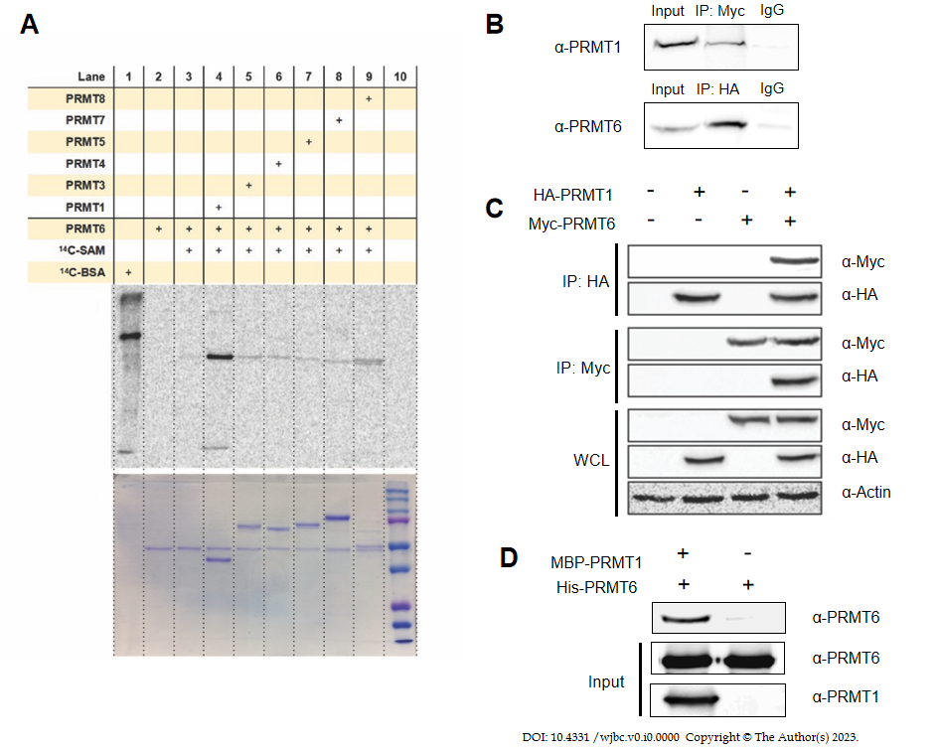
Figure 1 Protein arginine methyltransferase 1 interacts with protein arginine methyltransferase 6 in vitro and in vivo. A: Gel electrophoresis-autoradiographic image analysis of protein arginine methyltransferase (PRMT) 6 methylation incubated with other PRMT family members. 0.5 µM of PRMT6 was incubated with 1 µM of PRMT1, PRMT3, coactivator associated arginine methyltransferase (PRMT4), PRMT5, PRMT7 and PRMT8. Reactions were held for 30 min at 30 ℃, the samples were resolved by sodium dodecyl sulfate-polyacrylamide gel electrophoresis (SDS-PAGE) with a 12% polyacrylamide gel; B: Co-immunoprecipitation assay was performed between HA-PRMT1 and endogenous PRMT6 or Myc-PRMT6 and endogenous PRMT1 in HEK293T cells. Co-transfected HEK293T cell lysate was immunoprecipitated with anti-HA antibody or anti-Myc antibody followed by protein A/G plus agarose beads, proteins on the beads were eluted and separated on 12% SDS-PAGE and were detected by anti-PRMT1 or anti-PRMT6 antibody; C: Immunoprecipitation assay was performed between HA-PRMT1 and Myc-PRMT6. Single transfected HEK293T Cell lysate was immunoprecipitated with anti-HA antibody or anti-Myc antibody followed by protein A/G plus agarose beads, proteins on the beads were eluted and separated on 12% SDS-PAGE and were detected by anti-Myc or anti-HA antibody; D: Western blot analysis of maltose-binding protein (MBP) pull down assay. PRMT6 binds to purified Amylose beads or MBP-PRMT1 was detected. PRMT1 was incubated with the amylose beads for 30 min, followed by washing by phosphate-buffered saline and incubated with PRMT6 for 4h. The resin was washed and the pulled-down proteins were eluted and separated by 12% SDS-PAGE and detected by anti-PRMT1 or anti-PRMT6. IgG: Immunoglobulin G; PRMT: Protein arginine methyltransferase; SAM: S-adenosyl methionine.
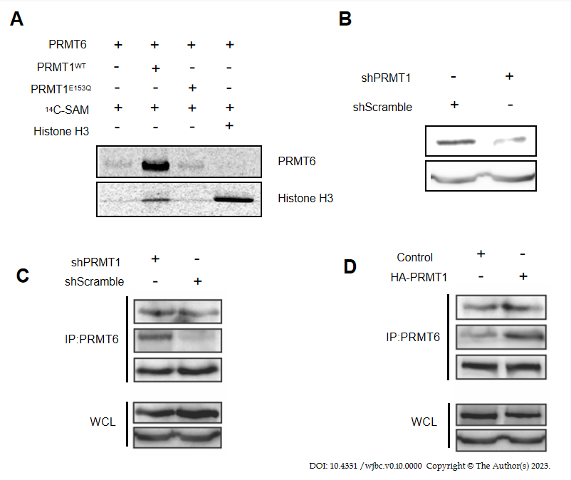
Figure 2 Protein arginine methyltransferase 6 is methylated by protein arginine methyltransferase 1. A: Gel electrophoresis-autoradiographic image analysis of histone H3 methylation level change in the presence of protein arginine methyltransferase (PRMT) 1WT or PRMT1E153Q. 1 µM PRMT6 and 20 µM 14C-S-adenosyl methionine were incubated with or without 3 µM PRMT1WT, PRMT1E153Q or H3 protein respectively at 30 ℃ in the reaction buffer for 1h. The samples were separated on 12% sodium dodecyl sulfate (SDS)-polyacrylamide gel electrophoresis polyacrylamide gel. The radioactive SDS gel was dried and stored for two days and then scanned for the phosphor image; B: Western blot was performed to analysis PRMT1 level in HEK293T cells transfected by hPRMT1 or shScramble; C and D: Immunoprecipitation was performed to precipitate PRMT6 in HEK293T cell lysate transfected by shPRMT1 or shScramble or HA-PRMT1, followed by western blot to analysis monomethyl arginine and asymmetric dimethylarginine level of precipitated PRMT6. PRMT: Protein arginine methyltransferase.

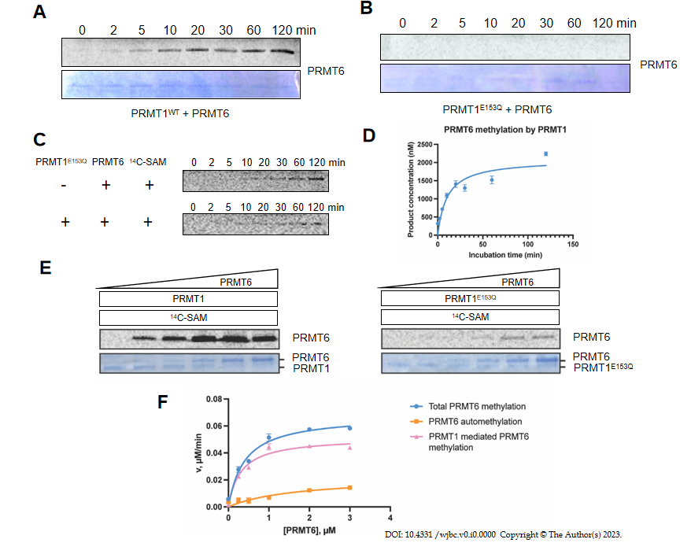
Figure 3 Time-dependent and concentration-dependent protein arginine methyltransferase 6 methylation catalyzed by protein arginine methyltransferase 1. A and B: Time-dependent radioactive gel methyltransferase assays were carried out at 30 ℃ in an incubation system of 30 µL. 1.5 µM of protein arginine methyltransferase (PRMT) 6 and 10 µM of 14C-S-adenosyl methionine (SAM) were incubated with 0.4 µM of PRMT1WT or PRMT1E153Q, and the reactions were quenched at different time points (0-120 min) by sodium dodecyl sulfate (SDS) loading buffer. The reaction mixture was separated on 12% SDS-polyacrylamide gel electrophoresis (PAGE) and methylated PRMT6 were visualized by Coomassie blue staining and phosphor image scanning, respectively; C: Gel electrophoresis autoradiography assays were performed at 30 ℃ in an incubation system of 30 µL. 4.5 µM PRMT6 was incubated with 10 µM 14C-SAM with or without 0.4 µM of PRMT1E153Q; D: Time course of PRMT6 methylation with PRMT1, the linear part of the curve was used to calculate the steady-state rate; E: Concentration-dependent radioactive gel methyltransferase assay was performed. Different concentration of PRMT6 (0, 0.25, 0.5, 1, 2, 4 M) was incubated with 10 M 14C-SAM in the presence of 0.2 M of PRMT1WT or PRMT1E153Q in the reaction buffer at 30 ℃ for 1h. The reaction mixture was separated on 12% SDS-PAGE and the phosphor image was quantified by ImageJ. Data were normalized according to the reading of 5 M 14C-BSA and the reaction yield was calculated according to the reading of 5 M reaction mixture in liquid scintillation; F: Comparison of the total PRMT6 methylation in the presence of PRMT1, PRMT6 automethylation, and PRMT1-mediated PRMT6 methylation at different concentration of PRMT6. SAM: S-adenosyl methionine; PRMT: Protein arginine methyltransferase.
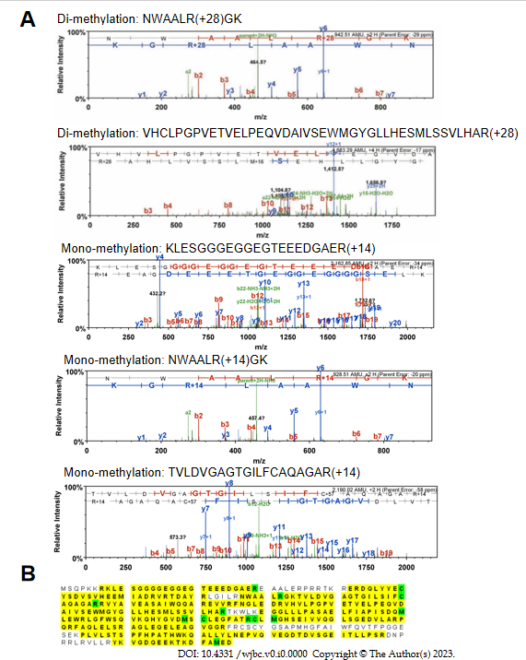
Figure 4 Liquid chromatography with tandem mass spectrometry analysis of the methylation sites on protein arginine methyltransferase 6. A: 5.5 M protein arginine methyltransferase (PRMT) 6 and 200 M S-adenosyl methionine were incubated with 1 M PRMT1 at 30 ℃ for 3 h in the reaction buffer. The methylated PRMT6 band was separated by 10% sodium dodecyl sulfate-polyacrylamide gel electrophoresis, cut from the gel, washed and vacuum-dried. The sample was sent to UAB proteomics and mass spectrometry facility (Birmingham, AL 35294) for in-gel digestion and liquid chromatography-tandem mass spectrometry (MS/MS) detection. Tandem MS spectra showing the arginine-dimethylated peptides; B: PRMT6 protein sequence coverage (yellow) and the modified residues (green) detected by tandem MS analysis. Green "C" is with carboamidomethylation, and green "M" is with oxidation.

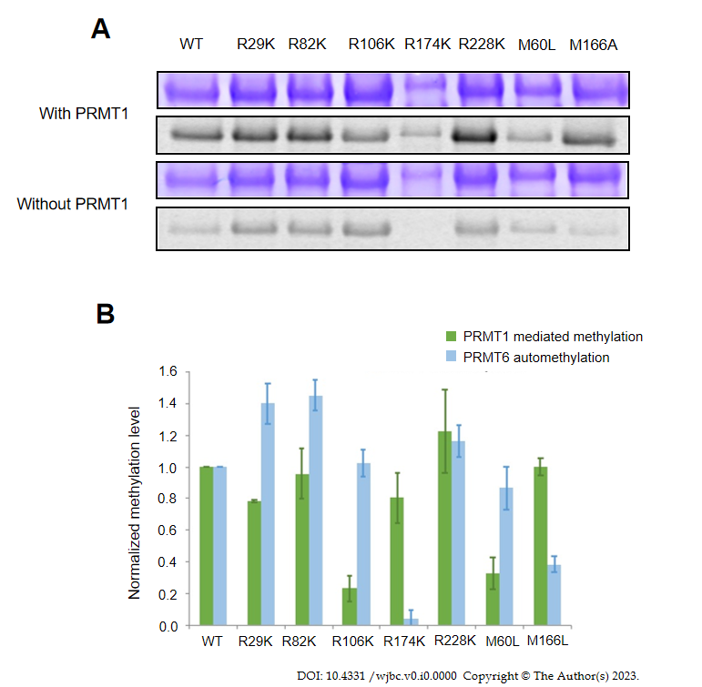
Figure 5 Comparison of protein arginine methyltransferase 1-mediated methylation and automethylation among different protein arginine methyltransferase 6 mutants. A: Radioactive methyltransferase assay was performed to compare protein arginine methyltransferase (PRMT) 1-mediated methylation level and automethylation level of PRMT6 mutants. 5 M of each PRMT6 mutant was incubated with 30 M 14C-S-adenosyl methionine in the presence or absence of 1 M PRMT1 in the reaction buffer at 30 ℃ for 2 h. The products were separated on 12% sodium dodecyl sulfate polyacrylamide gel electrophoresis and visualized by Coomassie blue staining and phosphor image scanning. The methylation intensity of each mutant was quantified with Quantity One and normalized against PRMT6WT. The assay was repeated at least three times. Coomassie blue staining and phosphor image of methylated PRMT6 mutants in the presence or absence of PRMT1; B: Column graph comparing the methylation of PRMT6 m. PRMT: Protein arginine methyltransferase.

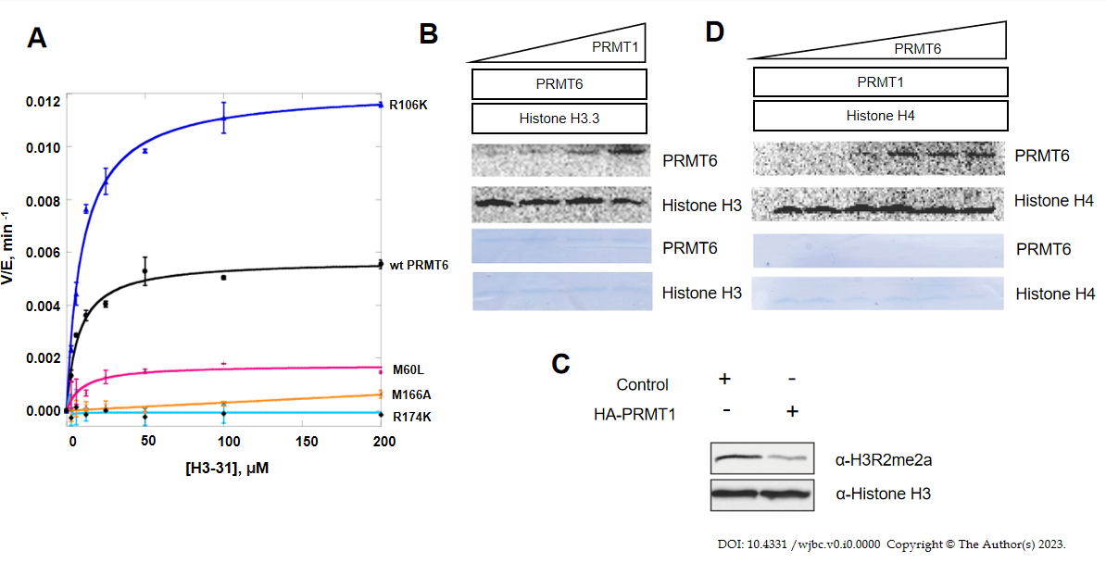
Figure 6 Methylation by protein arginine methyltransferase 1 may regulate the enzymatic activity of protein arginine methyltransferase 6. A: Radioactive methyltransferase assay was performed to show activity of protein arginine methyltransferase (PRMT) 6 wild type and PRMT6 mutants on histone H3 (1-31). 0.6 M PRMT6 mutant and 30 µM 14C-S-adenosyl methionine (SAM) were incubated with 0 to 200 µM of H3 (1-31). After the enzyme was added, the reaction was continuously incubated for 60 min and then quenched by spreading the mixture onto P81 filter paper. Following washing and drying the paper, liquid scintillation was performed to quantify the methylated products. The data were fit to the Michaelis-Menten curve; B: Radioactive methyltransferase assay was performed to show histone H3 methylation level change as PRMT1 concentration change. Different concentration of PRMT1 was incubated with 30 µM 14C-SAM and 1 µM PRMT6 for 1 h, histone H3 was added and incubated for another 1 h. The systems were separated by 12% sodium dodecyl sulfate-polyacrylamide gel electrophoresis (SDS-PAGE) gel and the phosphor image was captured after 72 h; C: Histone H3 methylation of HEK293T cell lysate was detected by western blot using anti-H3R2me2a antibody. HEK293T cell was transfected with HA-PRMT1 or control and cell lysate was extracted; D: Radioactive methyltransferase assay was performed to show histone H4 methylation level change as PRMT6 concentration change. Different concentration of PRMT6 was incubated with PRMT1 and 30 µM 14C-SAM, then 1 µM histone H4 was added and incubated for another 1 h. The systems were separated by 12% SDS-PAGE gel and the phosphor image was captured after 72 h. PRMT: Protein arginine methyltransferase.

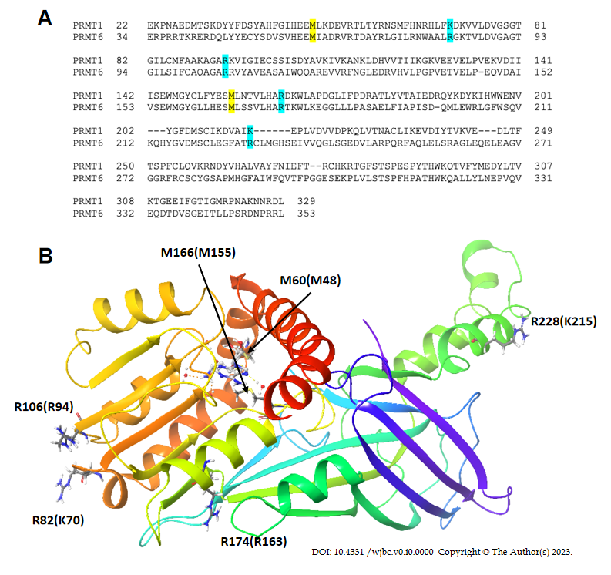
Figure 7 The mutation sites of protein arginine methyltransferase 6 and corresponding residues on protein arginine methyltransferase 1. A: Sequence alignment of protein arginine methyltransferase (PRMT) 1 and PRMT6 showing the corresponding mutation sites; B: The corresponding mutation sites are highlighted on PRMT6 structure. hPRMT6 monomer (PDB: 4Y30) is shown in a cartoon model. The mutation sites of PRMT6 with their corresponding residues on PRMT1 and the S-Adenosyl-L-homocysteine molecule are shown in a stick model.

Table 1 Steady-state kinetic parameters of protein arginine methyltransferase 6 mutants
PRMT6 mutant | kcat (min-1) | Km (M) | kcat/Km (M-1 min-1)
WT | 0.0063 ± 0.0006 | 8.4 ± 0.7 | 0.00075 ± 0.00009
R106K | 0.0122 ± 0.0004 | 9.9 ± 1.2 | 0.0012 ± 0.00015
R174K | N/A | N/A | N/A
M60L | 0.0017 ± 0.0002 | 10.0 ± 3.5 | 0.00017 ± 0.00006
M166A | 0.00031 ± 0.00003 | 40 ± 19 | 0.0000077 ± 0.0000037
PRMT6: Protein arginine methyltransferase 6.

