Name of Journal: World Journal of Virology
Manuscript NO: 65819
Manuscript Type: MINIREVIEWS

Ambisense polarity of genome RNA of orthomyxoviruses and coronaviruses

Zhirnov O. Ambisense strategy of viruses

Oleg Zhirnov

Oleg Zhirnov, Gamaleya Microbiology and Epidemiology Research Center, Ivanovsky Institute of Virology, Moscow 123098, Russia

Author contributions: Zhirnov O is the author of the idea; Zhirnov O has prepared the manuscript text and all materials, has formulated the conclusions and scientific content of the manuscript.

Corresponding author: Oleg Zhirnov, DSc, MD, PhD, Professor, Gamaleya Microbiology and Epidemiology Research Center, Ivanovsky Institute of Virology, 16 Gamaleya Street, Moscow 123098, Russia. zhirnov@inbox.ru

Received: March 23, 2021
Revised: May 17, 2021
Accepted: July 26, 2021
Published online: September 25, 2021

Abstract
Influenza viruses and coronaviruses have linear single-stranded RNA genomes with negative and positive sense polarities and genes encoded in viral genomes are expressed in these viruses as positive and negative genes, respectively. Here we consider a novel gene identified in viral genomes in opposite direction, as positive in influenza and negative in coronaviruses, suggesting an ambisense genome strategy for both virus families. Noteworthy, the identified novel genes colocolized in the same RNA regions of viral genomes, where the previously known opposite genes are encoded, a so-called ambisense stacking architecture of genes in virus genome. It seems likely, that ambisense gene stacking in influenza and coronavirus families significantly increases genetic potential and virus diversity to extend virus-host adaptation pathways in nature. These data imply that ambisense viruses may have a multivirion mechanism, like "a dark side of the Moon", allowing production of the heterogeneous population of virions expressed through positive and negative sense genome strategies.

Key Words: Virus genome; Ambisense RNA; Influenza; Coronavirus; Virus diversity; Virus genes

©The Author(s) 2021. Published by Baishideng Publishing Group Inc. All rights reserved.

Citation: Zhirnov O. Ambisense polarity of genome RNA of orthomyxoviruses and coronaviruses. World J Virol 2021; 10(5): 256-263
URL: https://www.wjgnet.com/2220-3249/full/v10/i5/256.htm
DOI: https://dx.doi.org/10.5501/wjv.v10.i5.256

Core Tip: A novel genes identified in viral genomes in opposite direction, as positive in influenza and negative in coronaviruses, are considered. The identified novel genes colocolized in the same RNA regions of viral genomes, where the previously known opposite genes are encoded, a so-called ambisense stacking architecture of genes in virus genome. It seems likely, that ambisense gene stacking in influenza and coronavirus families significantly increases genetic potential and virus diversity to extend virus-host adaptation pathways in nature. These data imply that ambisense viruses may have a multivirion mechanism, like "a dark side of the Moon", allowing production of the heterogeneous population of virions expressed through positive and negative sense genome strategies.

INTRODUCTION
Orthomyxo- and coronaviruses are two families of enveloped viruses containing single stranded linear RNA genomes. Orthomyxovirus family includes seven genera: Alphainfluenzavirus, Betainfluenzavirus, Deltainfluenzavirus, Gammainfluenzavirus, Isavirus, Thogotovirus, and Quaranjavirus. These viruses infect wide range of hosts including mammals, birds, rodents, fish, ticks and mosquitoes. Orthomyxoviridae viruses contain six to eight segments of negative-sense single stranded RNA with a total genome length of 10-15 Kb^{[1]}. Coronaviridae is divided into the four genera: Alphacoronavirus, Betacoronavirus, Gammacoronavirus and Deltacoronavirus. Alpha- and betacoronaviruses infect mammals, while gamma- and deltacoronaviruses primarily infect birds. The size of genomic positive sense RNA of coronaviruses ranges from 26 to 32 kilobases, one of the largest genome among RNA viruses^{[2]}. Here we mainly consider alphainfluenza viruses and betacoronaviruses as a typical members in both families.

Influenza A virus ambisense genes
Genome of influenza A viruses is composed of 8 segments of single-stranded RNAs with mol. wt. 0.7-2.8 × 10³ kilobases/segment. Each segment encodes one or several unique polypeptides through the canonical negative sense genome strategy (Table 1). It means that genome RNA of negative sense polarity is transcribed by the virus polymerase to produce positive sense mRNAs, which recognized by ribosomes to translate individual viral proteins (Figure 1). In addition to the negative sense genes, influenza A virus genome segments were found to contain long open reading frames (ORFs, genes) in opposite positive sense orientation. These ORFs have all ribosome translation elements: canonical start codon AUG or noncanonical CUG, termination codons (UAG, UAA, or UGA), internal ribosome entry sites (IRES), and Kozak-like sequences at the initial start codon^{[3-9]}.
There are three groups of data showing in vivo expression potential of these negative stranded genes. (1) The template function of the full length “negative sense” genome RNA of segment 8 (NS) was demonstrated in a cell-free translation system of rabbit reticulocyte lysate. It was shown that influenza A virion RNA of segment 8 can initiate synthesis of major polypeptide negative stranded protein (NSP8) (mol.wt. 23 kD) specifically reacted with antibody to the central domain of the NSP8^{[10]}; (2) The NSP8 encoded in the 8’th influenza A virus segment NS could be expressed in vivo, in insect cells (ovary cell line of Trichplusia ni) infected with recombinant baculovirus (insect nuclear polyhedrosis virus) carrying influenza virus sequence NSG8 in the virus DNA genome. This gene appeared to express ~20 kD influenza-specific polypeptide NSP8, which was intracellularly stable and accumulated in the perinuclear zone of infected cells^{[11]}. Later, it was also supported that influenza A virus NSP8 could be efficiently expressed from either a plasmid or a recombinant vaccinia virus in mammalian cells and the synthetized NSP8 was localized in the perinuclear endoplasmic reticulum (ER) and post-ER cellular compartments^{[12]}; and (3) There are data that mice infected with influenza virus produce CTL response specific to epitopes presented in the influenza NSP8 protein^{[12-14]}. These findings also demonstrate that translation of sequences locating on the negative RNA strand of a single-stranded RNA genome of influenza A virus can develop in vivo and can initiate antiviral CTL response and immunosurveillance.
The mature product of the NSP8 gene has not been yet identified in biological systems such virus-infected cells and animals. The failure to detect NEG8 protein could be due to a number of factors other than the complete absence of translation from genomic RNA. The properties of the NSP8 as an “escaping protein” may be explained either by its low synthesis and a short period of life or/and strong tissue-specific expression in certain cell types containing factors which are necessary for the regulation of expression of these “negative sense” genes. It would not be surprising if negative polarity genes are only expressed physiologically under special circumstances in vivo determining host cell tropism of influenza viruses.

Novel negative sense genes in the RNA genome of coronaviruses
Recently, similar ambisense polarity has been revealed in coronaviruses genomes^{[15]}. It is well known that these viruses possesses a linear positive sense genome RNA of 25-29 × 10³ kb length^{[2]}. The coronavirus genome RNA contains two groups of genes expressing proteins through the positive sense strategy. The first ones (nonstructural genes for nsp1-nsp19 proteins) are localized at the 5’-region of the virion genome RNA and directly translated by host ribosomes. The second ones (mostly the structural proteins genes N, S, HE, M, E and several accessorial proteins, such as 3a/b, 6, 7a/b, 8a/b, 9b, etc.) occupy a 3’-region of the virion RNA and express proteins through the translation of subgenomic mRNAs, which was transcribed on the anti-genomic RNA template^{[16]} (Figure 2A). In addition to the positive sense genes, we have identified numerous long open reading frames in negative sense orientation (Table 2; Figure 2B). Like in the case of the ambisense genes of flu viruses, coronavirus negative sense genes have all elements characteristic of the mRNA molecules which are recognized by host ribosomes: classical AUG or alternative CUG^{[17]} start codons, termination codons, IRES, and Kozak-like sequences at the start area^{[18,19]}. However, unlike to influenza A viruses, coronavirus ambisense polarity has opposite configuration: a positive sense genome strategy and a negative sense orientation of the novel negative sense genes, so called a negative sense genes or negative gene proteins (NGPs).
The identification of coronavirus negative-polarity genes implies two possible mechanisms of their expression and synthesis of the corresponding mRNAs and proteins. These mechanisms include either direct translation of a replicative (-)copy of genomic (+)RNA (replication pathway II) or the transcription of genomic (+)RNA by viral polymerase with the formation of subgenomic mRNAs of “negative polarity” for their subsequent translation to synthesize specific viral polypeptides (transcription pathway I). To realize pathway I coronavirus genome contains poly A sequence (positions 11935-1194 nt) functioning as a viral polymerase binding site and transcription initiation signal (Figure 2B).

Biological significance of the ambisense genes
The function and role of the newly discovered ambipolar viral genes have not yet been determined. In the case of influenza viruses, there are indirect data that the identified new ambisense genes can be involved in the regulation of the host immune response against viral proteins and/or in the regulation of the stability of viral proteins in infected cells through the protein deubiquitinating system^{[5,12]}. The possible functional significance of the novel ambisense genes is not yet generally clear. However, the stability and retaining of these type of genes in field viruses genomes for more than 100 years at the high variability of virus population suggest the functional necessity of these genes and their biological evolutionary determination^{[20]}. Notably, the influenza NSP8 has high synonymous/nonsynonymous (dN/dS) mutations rate (> 1.5), which was similar to that one for the most variable surface virus glycoproteins HA and NA representing major target for antiviral host adaptive immune response. The elevated variability of the NSP8 implies that it undergoes positive selection and host adaptation, which influence its evolution^{[5]}.
The discovery of new ambisense genes has raised a number of important questions regarding its origin, functions, and evolutionary variability. One of the essential questions is how the novel genes have emerged in the genomic region to encode two opposite sense genes. The appearance of the ambipolar gene suggests the existence of yet unknown correspondence principle (or reverse determination rule) for the expression of oppositely directing genes locating in the same region of RNA molecule. This principle implies that a certain pre-existing gene can predetermine the emergence mechanism and the properties of a new ambipolar gene^{[5]}. Without this rule, chaotic accumulation of mutations will result in the appearance of a new functional gene and its further evolutionary selection, that seems to be unlikely. Moreover, the probability for such chaotic event is low, considering the ambipolar overlapping of several preexisting genes, when changes in one of them would cause changes in the coupled ambipolar genes. In this case, gene variability and selection of mutations should be interconnected in all opposite viral genes (in the case of influenza virus for NS1, NEP, and NSP8). These considerations incline to the assumption of the existence of a rule of reverse determination, when both ambipolar genes can have linked structural motives and functions. Further studies are necessary to clarify this idea.
Ambisense stacking of genes revealed in coronavirus and influenza virus genomes significantly increases virus diversity, genetic potential and extend virus-host adaptation pathway possibilities. Existence of numerous ambisense genes opens up a new avenue for virus reproduction where one virus genome can produce a multiple progeny population of virions possessing identical genome RNA and different protein compositions. In this case, a part of virions decorated with one of the NGPs proteins (in the case of coronaviruses) could be hidden from us, as “the dark side of the Moon”. The expression of coronavirus “negative” and flu “positive” genes may have a host (tissue)-dependent regulation facilitating immune escape of overcovered virions and specific pathogenetic pathways in the host(s) where the up-expression of the virus NGP or NSP genes occurs. Further studies will shed light on this ambisense concept of human and animal orthomyxo- and coronaviruses.
For the current time, there are four ambisense virus genera (phlebo-, tospo-, arena-, and bunyaviruses), which are well known to realize both positive- and negative-sense genome RNA strategies to encode viral proteins^{[12,21]}. Ambisense genes of these virus genera locate in separate areas of the genome RNA without their overlapping and stacking. The ambisense genes locating in the genome in the stacking manner were found in influenza viruses, in which, similarly to coronaviruses, direct expression of these genes has not yet been identified, but there are indirect signs of such expression during natural viral infection in vivo^{[12-14]}. Location of genes with opposite polarity in the same region of the RNA molecule makes it possible to significantly increase the genetic capacity of the viral genome and opens new ways for virus diversity, increasing virus adaptability to the host and biological evolution in nature^{[15]}. The presence of potential ambisense genes in genomes of influenza and coronaviruses raises the question of the classification of these families. The detection in infected cells or infected organisms of protein products expressed by the ambisense manner will give grounds for classifying the coronavirus and orthomyxovirus families as the ambisense viruses with a bipolar genome strategy.

CONCLUSION
The manuscript data suggest that ambisense gene stacking in influenza and coronavirus families significantly increases genetic potential and virus diversity to extend virus-host adaptation pathways in nature. These data imply that ambisense viruses may have a multivirion mechanism, like "a dark side of the Moon", allowing production of the heterogeneous population of virions expressed through positive and negative sense genome strategies.

ACKNOWLEDGEMENTS
Zhirnov O acknowledges academicians Lvov DK and Georgiev GP for the support of this work and Dr. Chernyshova A for assistance with figures preparation.

REFERENCES
1 Pinto RM, Lycett S, Gaunt E, Digard P. Accessory Gene Products of Influenza A Virus. Cold Spring Harb Perspect Med 2020 [PMID: 32988983 DOI: 10.1101/cshperspect.a038380]
2 Woo PC, Huang Y, Lau SK, Yuen KY. Coronavirus genomics and bioinformatics analysis. Viruses 2010; 2: 1804-1820 [PMID: 21994708 DOI: 10.3390/v2081803]
3 Zhirnov OP, Poyarkov SV, Vorob'eva IV, Safonova OA, Malyshev NA, Klenk HD. Segment NS of influenza A virus contains an additional gene NSP in positive-sense orientation. Dokl Biochem Biophys 2007; 414: 127-133 [PMID: 17695319 DOI: 10.1134/s1607672907030106]
4 Gong YN, Chen GW, Chen CJ, Kuo RL, Shih SR. Computational analysis and mapping of novel open reading frames in influenza A viruses. PLoS One 2014; 9: e115016 [PMID: 25506939 DOI: 10.1371/journal.pone.0115016]
5 Zhirnov OP. Unique Bipolar Gene Architecture in the RNA Genome of Influenza A Virus. Biochemistry (Mosc) 2020; 85: 387-392 [PMID: 32564743 DOI: 10.1134/S0006297920030141]
6 Baez M, Zazra JJ, Elliott RM, Young JF, Palese P. Nucleotide sequence of the influenza A/duck/Alberta/60/76 virus NS RNA: conservation of the NS1/NS2 overlapping gene structure in a divergent influenza virus RNA segment. Virology 1981; 113: 397-402 [PMID: 6927848 DOI: 10.1016/0042-6822(81)90166-5]
7 Clifford M, Twigg J, Upton C. Evidence for a novel gene associated with human influenza A viruses. Virol J 2009; 6: 198 [PMID: 19917120 DOI: 10.1186/1743-422X-6-198]
8 Yang CW, Chen MF. Uncovering the Potential Pan Proteomes Encoded by Genomic Strand RNAs of Influenza A Viruses. PLoS One 2016; 11: e0146936 [PMID: 26761196 DOI: 10.1371/journal.pone.0146936]
9 Sabath N, Morris JS, Graur D. Is there a twelfth protein-coding gene in the genome of influenza A? A selection-based approach to the detection of overlapping genes in closely related sequences. J Mol Evol 2011; 73: 305-315 [PMID: 22187135 DOI: 10.1007/s00239-011-9477-9]
10 Zhirnov OP, Akulich KA, Lipatova AV, Usachev EV. Negative-sense virion RNA of segment 8 (NS) of influenza a virus is able to translate in vitro a new viral protein. Dokl Biochem Biophys 2017; 473: 122-127 [PMID: 28510127 DOI: 10.1134/S1607672917020090]
11 Zhirnov OP, Klenk HD. [Integration of influenza A virus NSP gene into baculovirus genome and its expression in insect cells]. Vopr Virusol 2010; 55: 4-8 [PMID: 20455463]
12 Hickman HD, Mays JW, Gibbs J, Kosik I, Magadán JG, Takeda K, Das S, Reynoso GV, Ngudiankama BF, Wei J, Shannon JP, McManus D, Yewdell JW. Correction: Influenza A Virus Negative Strand RNA Is Translated for CD8⁺ T Cell Immunosurveillance. J Immunol 2018; 201: 2187 [PMID: 30143590 DOI: 10.4049/jimmunol.1801100]
13 Zhirnov OP, Konakova TE, Anhlan D, Ludwig S, Isaeva EI, Cellular immune response in infected mice to nsp protein encoded by the negative strand NS RNA of influenza A virus. MIR J 2019; 6: 28-36 [DOI: 10.18527/2500-2236-2019-6-1-28-36]
14 Zhong W, Reche PA, Lai CC, Reinhold B, Reinherz EL. Genome-wide characterization of a viral cytotoxic T lymphocyte epitope repertoire. J Biol Chem 2003; 278: 45135-45144 [PMID: 12960169 DOI: 10.1074/jbc.M307417200]
15 Zhirnov OP, Poyarkov SV. Novel Negative Sense Genes in the RNA Genome of Coronaviruses. Dokl Biochem Biophys 2021; 496: 27-31 [PMID: 33689070 DOI: 10.1134/S1607672921010130]
16 Zhirnov OP. Molecular Targets in the Chemotherapy of Coronavirus Infection. Biochemistry (Mosc) 2020; 85: 523-530 [PMID: 32571182 DOI: 10.1134/S0006297920050016]
17 Kearse MG, Wilusz JE. Non-AUG translation: a new start for protein synthesis in eukaryotes. Genes Dev 2017; 31: 1717-1731 [PMID: 28982758 DOI: 10.1101/gad.305250.117]
18 Bartas M, Adriana Volná A, Červeň J, Brázda V, Pečinka P. Unheeded SARS-CoV-2 protein? Look deep into negative-sense RNA. 2020 Preprint. Available from: bioRxiv:2020.11.27.400788 [DOI: 10.1101/2020.11.27.400788]
19 Zhirnov OP, Poyarkov SV. Unknown negative genes in the positive RNA genomes of coronaviruses. Authorea 2020 [DOI: 10.22541/au.160614900.06870227/v2]
20 Zhirnov OP, Vorobjeva IV, Saphonova OA, Poyarkov SV, Ovcharenko AV, Anhlan D, Malyshev NA. Structural and evolutionary characteristics of HA, NA, NS and M genes of clinical influenza A/H3N2 viruses passaged in human and canine cells. J Clin Virol 2009; 45: 322-333 [PMID: 19546028 DOI: 10.1016/j.jcv.2009.05.030]
21 Nguyen M, Haenni AL. Expression strategies of ambisense viruses. Virus Res 2003; 93: 141-150 [PMID: 12782362 DOI: 10.1016/s0168-1702(03)00094-7]
22 Kolekar P, Pataskar A, Kulkarni-Kale U, Pal J, Kulkarni A. IRESPred: Web Server for Prediction of Cellular and Viral Internal Ribosome Entry Site (IRES). Sci Rep 2016; 6: 27436 [PMID: 27264539 DOI: 10.1038/srep27436]

Footnotes
Conflict-of-interest statement: The author declares that he does do not have any conflict of interest. The author declares that he has no known competing financial interests or personal relationships that could have appeared to influence the work reported in this paper.

Open-Access: This article is an open-access article that was selected by an in-house editor and fully peer-reviewed by external reviewers. It is distributed in accordance with the Creative Commons Attribution NonCommercial (CC BY-NC 4.0) license, which permits others to distribute, remix, adapt, build upon this work non-commercially, and license their derivative works on different terms, provided the original work is properly cited and the use is non-commercial. See: http://creativecommons.org/Licenses/by-nc/4.0/

Manuscript source: Invited manuscript

Peer-review started: March 23, 2021
First decision: May 5, 2021
Article in press: July 26, 2021

Specialty type: Virology
Country/Territory of origin: Russia
Peer-review report’s scientific quality classification
Grade A (Excellent): 0
Grade B (Very good): 0
Grade C (Good): C
Grade D (Fair): 0
Grade E (Poor): 0

P-Reviewer: Cao G S-Editor: Wang JL L-Editor: A P-Editor: Ma YJ

Figure Legends

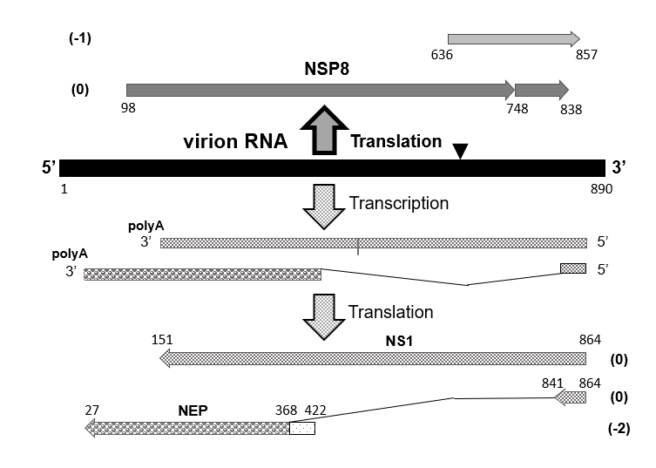
Figure 1 The scheme of expression of the genome negative sense segment of influenza A virus. The negative sense (NS) segment of influenza A/Aichi/2/68 (H3N2) virus is displayed. The horizontal arrows show the open reading frames (ORFs) of the negative strand protein 8, non-structural anti-interferon protein (NS1), and nuclear export protein (NEP). Numbers in brackets indicate the ORF translation phase. Numbers under the lines indicate nucleotide positions from the 5’ end of the virion genome RNA. The broken line shows the splicing segment of the NEP gene mRNA. Triangle in the virion RNA molecule shows a site position of possible translation frameshifting^{[10]}. NS: Negative sense; NSP8: Negative strand protein 8; NS1: non-structural anti-interferon protein.

A
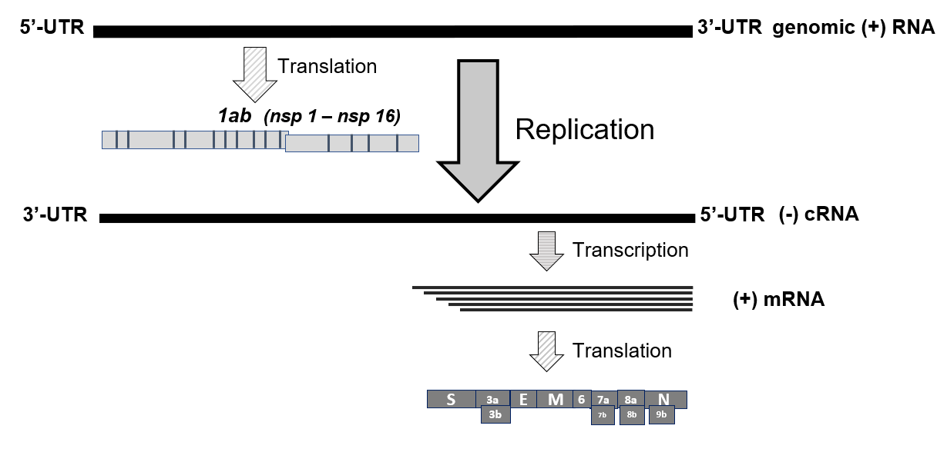
B
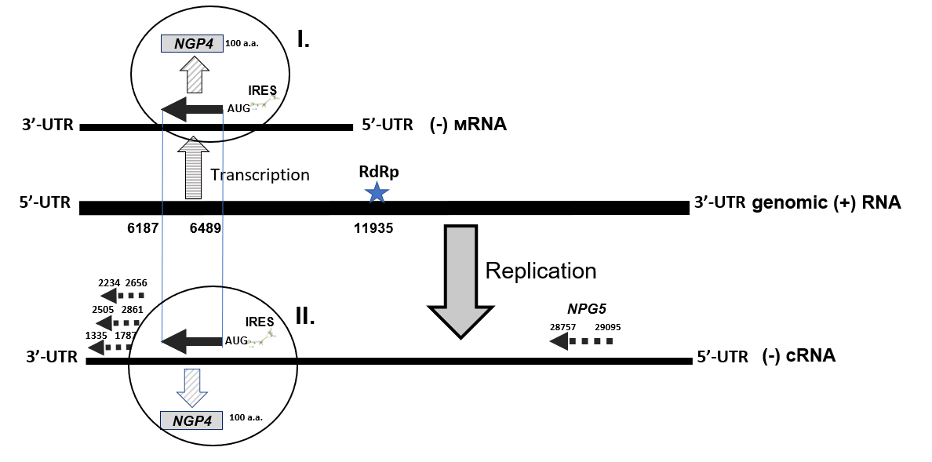

C
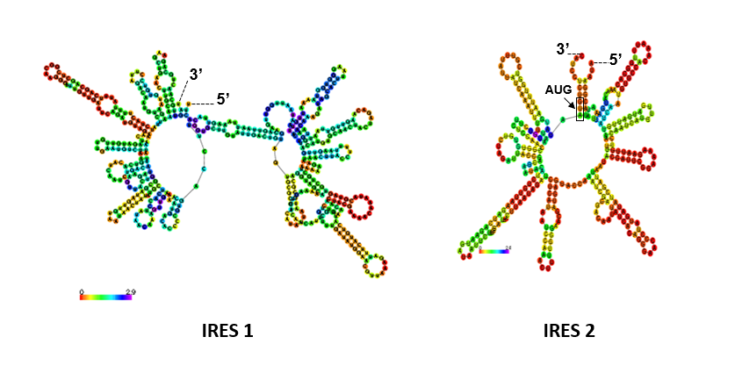
Figure 2 Positive sense genome strategy and translation cassette unit at the 3’ end of the negative sense complimentary RNA of coronavirus severe acute respiratory syndrome coronavirus 2 genome. A: Replication scheme of the RNA genome of severe acute respiratory syndrome coronavirus 2 (SARS-CoV-2) coronavirus (ac.n. MT890462.1). UTR means untranslated RNA region; B: A 3’ end area of the subgenomic (-)cRNA complimentary to the virus genome 5’ end (+)vRNA of SARS-CoV-2 (ac.n. MT635445.1) is displayed. Five ORF containing cassette for NGP1-NGP5 beginning either with classical AUG (NGP4) or noncanonical CUG (NGP1-3, NGP5) codons are shown by arrows. Nucleotides counting from the 5’ end of (+)vRNA are shown for each ORFs. Phases of the translation frame (fr) are estimated regarding the frame of NGP4 (fr.0) as follows: NGP1and 2 (fr. +1), NGP3 (fr.0). Poly A tract (11935-11940 nt) functioning as a viral RNA dependent RNA polymerase binding site is shown by star; C: IRES-like structures enriched with 16 and 10 canonical “hair-pins” RNA elements in the regions 8100-8599 nt (IRES 1) and 6488-6792 nt (IRES 2), respectively, were predicted by the IRESpred program^{[22]}. The IRES-like structures 1 and 2 have significant free energy value as low as -99,4 and -73,8 kkal/mol, respectively. The data were partially presented in^{[15]}. These partial elements were used here with the Publisher’s permission.

Table 1 RNA segments of influenza A virus genome and encoded polypeptides
Viral RNA segments and their length (nt)¹ | Positive sense polypeptides (mol. wt., kDa)² | Negative stranded polypeptides, NSPs (mol. wt.; a.a.)³
PB1 (2341) | PB1 (86.6); PB1-N40 (89.4); PB1-F2 (10.5) | NSP1 (174, 239)
PB2 (2341) | PB2 (85.7); PB2-S1 (55) | NSP2 (116, 121, 130, 137)
PA (2223) | PA (84.2); PA-X (29); PA-N155 (62); PA-N182 (60) | NSP3 (95, 109)
HA (1778) | HA (61.5) | NSP4 (n.d.)
NP (1565) | NP (56.1); eNP (56.8) | NSP5 (117, 154)
NA (1413) | NA (50.1); NA43 (48.6) | NSP6 (91, 154)
M (1097) | M1 (27.8); M2 (11); M42 (13) | NSP7 (99, 102, 109)
NS (890) | NS1 (26.8); NEP (14.2); NS3 (21); tNS1 (17) | NSP8 (93, 167, 216)
¹RNA segments and nucleotide (nt) calculations were made for the A/PR8/34 (H1N1) virus.
²Canonical influenza A virus polypeptides synthesized through the negative genome strategy (Figure 1; for review see^{[1]}).
³Negative stranded genomic open reading frames (ORFs) and predicted negative stranded proteins (NSPs) have been calculated for A/PR8/34 (H1N1) and A/Aichi/2/68 (H3N2) viruses^{[3-8]}. Negative stranded ORFs were identified by in silico approach using the Open Reading Frame Finder program (https://www.ncbi.nlm.nih.gov/orffinder/). These ORFs can be realized through the positive genome strategy. The amino acid length (a.a.) of NSPs were based on the data presented mainly in ref.^{[8]}. A.a. values reflect variations among human, avian and other mammalian virus strains. N.d. means the absence of ORFs longer than 90 a.a. NSP: Negative stranded protein.
Table 2 Negative sense genes in genomes of coronaviruses
Virus genera | Viral genomes | Number of NSGs in virus genome^{1,3} | M.W. range of the NGPs²
Alpha-coronaviruses | HCov-229E: https://www.ncbi.nlm.nih.gov/nuccore/NC_002645.1 | 29/1/29/5 | 12.4-14.4
Beta-coronaviruses | SARS-CoV-1: https://www.ncbi.nlm.nih.gov/nuccore/NC_004718.3 | 34/0/35/2 | 11.5- 15.0
 | SARS-CoV-2: https://www.ncbi.nlm.nih.gov/nuccore/MT635445.1 | 21/1/26/4 | 10.9- 17.2
 | MERS: https://www.ncbi.nlm.nih.gov/nuccore/NC_019843.3 | 32/8/23/3 | 11.1- 18.6
 | Pangolin-CoV: https://www.ncbi.nlm.nih.gov/nuccore/MT040335.1 | 29/3/17/4 | 10.8-19.9
 | HCov-HKU1: https://www.ncbi.nlm.nih.gov/nuccore/NC_006577.2 | 15/1/13/2 | 11.5- 15.0
 | Bat coronavirus RATG13: https://www.ncbi.nlm.nih.gov/nuccore/MN996532.1 | 17/2/29/1 | 10.9- 19.7
 | Bovine coronavirus BCoV-ENT: https://www.ncbi.nlm.nih.gov/nuccore/NC_003045.1 | 25/1/26/0 | 20.8
 | Murine hepatitis virus A59: https://www.ncbi.nlm.nih.gov/nuccore/FJ884687.1 | 29/5/42/7 | 11.2-36.8
Gamma-coronaviruses | Avian infectious bronchitis virus: https://www.ncbi.nlm.nih.gov/nuccore/NC_001451.1 | 20/6/8/3 | 12.7- 26.5
Delta-coronaviruses | Porcine coronavirus HKU15: https://www.ncbi.nlm.nih.gov/nuccore/NC_039208.1 | 26/5/29/3 | 11.2- 17.4
¹Negative sense genes (NSGs) were identified by in silico approach using the Open Reading Frame Finder program (https://www.ncbi.nlm.nih.gov/orffinder/). First and second digits show overall and numbers of the large gene open reading frames (ORFs) starting with classical AUG, respectively. Third and fourth numbers show overall and large gene numbers ORFs having noncanonical CUG, respectively. Large genes were assumed to have more than 300 nt long. GenBank ac.n. of the viral genomes are indicated.
²A range of mol. wt. (kDa) of negative gene proteins encoded by the large negative sense genes (≥ 300 nt) starting either with AUG or CUG codons are outlined.
³The data were partially presented in^{[15]}. These partial elements were used here with the Publisher’s permission. NSGs: Negative sense genes; SARS-CoV: Severe acute respiratory syndrome coronavirus.

Published by Baishideng Publishing Group Inc
7041 Koll Center Parkway, Suite 160, Pleasanton, CA 94566, USA
Telephone: +1-925-3991568
E-mail: bpgoffice@wjgnet.com
Help Desk: https://www.f6publishing.com/helpdesk
https://www.wjgnet.com

© 2021 Baishideng Publishing Group Inc. All rights reserved.

