Name of Journal: World Journal of Clinical Cases
Manuscript NO: 80672
Manuscript Type: CASE REPORT

Intragastric fish bones migrate into the liver: A case report

Dai MG et al. Abscess induced by foreign body

Mu-Gen Dai, Jing-Jing Zheng, Jie Yang, Bin Ye

Mu-Gen Dai, Bin Ye, Department of Gastroenterology, The Fifth Affiliated Hospital of Wenzhou Medical University, Lishui 323000, Zhejiang Province, China

Jing-Jing Zheng, Department of Gastrointestinal Surgery, The Fifth Affiliated Hospital of Wenzhou Medical University, Lishui 323000, Zhejiang Province, China

Jie Yang, Department of Infectious Disease, The Fifth Affiliated Hospital of Wenzhou Medical University, Lishui 323000, Zhejiang Province, China

Author contributions: Dai MG, Zheng JJ, Yang J, and Ye B designed the research, performed the research, analyzed the data, and wrote the manuscript; all authors read and approved the final manuscript.

Supported by Zhejiang Province Administration Foundation of Traditional Chinese Medicine, No. 2020ZB305

Corresponding author: Bin Ye, MD, PhD, Chief Doctor, Chief Physician, Doctor, Department of Gastroenterology, The Fifth Affiliated Hospital of Wenzhou Medical University, No. 289 Kuocang Road, Lishui 323000, Zhejiang Province, China. 408252097@qq.com

Received: October 9, 2022
Revised: January 29, 2023
Accepted: April 7, 2023
Published online: May 16, 2023

Abstract
BACKGROUND
A foreign body in the digestive tract is a common disease in the clinic. However, it is rare for a foreign body to migrate into the liver. Most patients are diagnosed before or after perforation of the digestive tract. Laparoscopic removal of intrahepatic foreign bodies is an effective treatment method.

CASE SUMMARY
A 55-year-old male patient was admitted to the hospital due to fever for 3 d, in addition to pain and discomfort in the right side of his waist. After admission, abdominal computed tomography showed a foreign body in the liver, and gastroscopy did not indicate obvious erosion or ulcers. The patient then underwent laparoscopic surgery. During the operation, an abscess was seen near the gastric antrum and between the caudate lobes of the liver. It was approximately 30 mm × 31 mm × 23 mm in size. The abscess was cut open, and a fish bone was found inside. The fish bone had penetrated the liver and was successfully removed. It was confirmed that the fish bone migrated from the stomach to the liver.

CONCLUSION
Although intrahepatic foreign bodies are rare, they should be diagnosed and treated as early as possible to avoid serious complications such as intrahepatic abscess, which may lead to liver resection and even life-threatening events.

Key Words: Foreign body; Intrahepatic; Migrate; Stomach; Case report

©The Author(s) 2023. Published by Baishideng Publishing Group Inc. All rights reserved.

Citation: Dai MG, Zheng JJ, Yang J, Ye B. Intragastric fish bones migrate into the liver: A case report. World J Clin Cases 2023; 11(14): 3256-3260
URL: https://www.wjgnet.com/2307-8960/full/v11/i14/3256.htm
DOI: https://dx.doi.org/10.12998/wjcc.v11.i14.3256

Core Tip: Foreign bodies migrating into the liver are rare, but they may lead to liver resection and even life-threatening events. They should be diagnosed and treated as early as possible. We report a patient with a fish bone that migrated from the stomach to the liver and was successfully removed by laparoscopic surgery in the early stage. Early management is a prerequisite to ensure treatment efficacy.

INTRODUCTION
Foreign bodies in the digestive tract are common clinical diseases. Most foreign bodies enter the digestive tract consciously, or the patients are aware of foreign body ingestion. Therefore, this can be removed through endoscopy in a timely manner. Perforation of hollow viscus by a foreign body is rare, representing 1% of cases of accidental foreign body ingestion. A few sharp foreign bodies can cause perforation, bleeding, or obstruction of the digestive tract. However, sharp foreign bodies can enter the digestive tract and pass through the stomach and duodenal mucosa and enter the liver, but this is even less common. We report a patient with a fish bone that migrated from the stomach to the liver and was successfully removed by laparoscopic surgery in the early stage, which avoided liver resection. There was no serious infection, bleeding, or other complications.

CASE PRESENTATION
Chief complaints
A 55-year-old male was hospitalized due to fever for 3 d.

History of present illness
The patient developed fever 3 d previously; the highest temperature was 39 °C. The patient also experienced paroxysmal dull pain and discomfort in the right waist, without chills, shivering, or any other digestive tract and respiratory tract symptoms. He self-administered antipyretic drugs, but his temperature did not significantly decrease. Therefore, he came to the hospital for treatment.

History of past illness
The patient’s past medical history included hypertension, kidney stones, and gout but no history of the digestive system or other system diseases.

Personal and family history
The patient’s personal and family history revealed no information relevant to the current case.

Physical examination
Upon initial evaluation, the patient was 170 cm tall and weighed 65 kg. The patient’s temperature was 38.2 °C, heart rate was 90 bpm, and blood pressure (measured with an electronic cuff) was 146/96 mmHg. Heart and lung auscultation was normal, the abdomen was soft, without tenderness, rebound pain, or muscle tension, and percussion pain in the renal area was negative. The remaining examination showed no obvious positive signs.

Laboratory examinations
Laboratory examination results were as follows: C-reactive protein, 153.31 mg/L; white blood cells, 11.93 × 10⁹/L (normal: 3.5-9.5 × 10⁹/L); procalcitonin, 1.04 ng/mL (normal: < 0.05 ng/mL); and glutamic pyruvic transaminase, 57 U/L (normal: 9-50 U/L). All other tests were normal.

Imaging examinations
Abdominal computed tomography (CT) was performed after admission. It indicated a strip-shaped high-density focus in the stomach that had penetrated the caudate lobe of the liver. This was considered to be a foreign body in the stomach that had penetrated the liver (Figure 1). Emergency gastroscopy was performed to determine whether there were foreign bodies in the stomach. No obvious erosion or ulcers of the gastric mucosa was found during gastroscopy (Figure 2).

FINAL DIAGNOSIS
The patient was finally diagnosed with intrahepatic foreign body.

TREATMENT
After receiving routine intravenous antibiotics treatment, his temperature decreased but did not return to normal. Abdominal CT demonstrated that the foreign body in the stomach had migrated into the liver. Emergency gastroscopy was carried out, and no residue of the foreign body was found in the stomach. Therefore, the patient underwent emergency laparoscopic surgery. During the operation, abscess formation was seen in the hepatogastric space, the abscess was cut, and one end of the fish bone was visible. The fish bone was completely removed. Following removal of the abscess, the gastric wall was examined, and no obvious damage was found (Video 1). The operation went smoothly, and the patient recovered.

OUTCOME AND FOLLOW-UP
Following surgery, the patient’s temperature gradually decreased to normal, without abdominal pain and other symptoms. He was discharged 1 wk after the operation and was followed up for 2 wk without experiencing obvious discomfort.

DISCUSSION
Chintamani et al^{[1]} reported the world’s first case of foreign body in the digestive tract migrating into the liver, causing liver abscess in 1898. Since then only 59 cases have been reported in the literature^{[1,2]}. However, with the development of digestive endoscopy technology^{[3]}, most foreign bodies in the digestive tract can be removed. A small number of foreign bodies, such as fish bones, toothpicks, iron wires, etc^{[4]}, are thin and sharp. Most do not cause obvious symptoms when penetrating the gastrointestinal tract, making them difficult to find. The most common site of perforation is the stomach^{[5]}. After penetrating the digestive tract, the foreign body often migrates into the left liver^{[6]}. The patient still has no obvious symptoms at this time. With time, bacteria can undergo microbial replication and dissemination, causing liver abscess. The patient may develop fever, abdominal pain, and other symptoms, including serious infection, liver bleeding, etc, resulting in serious consequences^{[7]}.
Although intragastric foreign body migration into the liver is rare^{[8]}, it occurs occasionally. Most patients cannot recall the history of foreign body ingestion^{[3]}. Clinicians need to be alert, and diagnosis depends on ultrasound, CT, etc. Ultrasound may be a convenient and radiation-free screening tool that can be used to identify abscesses and possible foreign bodies. On the other hand, CT is the first choice for diagnosis^{[7]} due to its high resolution and accuracy in identifying foreign bodies. It can also be used to assess the depth of penetration and complications.
When it is suspected that a foreign body in the digestive tract has migrated into the liver, it is necessary to conduct timely digestive endoscopy. Some patients may have residues in the digestive tract. Foreign bodies can be removed by digestive endoscopy to avoid traumatic surgery. If necessary, before the foreign body is removed, endoscopic ultrasonography should be performed to determine the relationship between the foreign body and the surrounding blood vessels^{[9]} to avoid massive bleeding and protect the safety of patients. In addition, surgical treatment should be carried out as early as possible for foreign bodies without residues in the gastrointestinal tract^{[10]} rather than after the abscess has liquefied. Timely surgical^{[11]} removal of foreign bodies can reduce the occurrence of complications and preserve the liver.
In the present case, the fish bone transferred from the stomach to the liver, and gastroscopy was performed in a timely manner. No obvious wound was found in the stomach; thus, it could not be removed under endoscopy. Therefore, laparoscopic foreign body removal was selected. Because it was a short amount of time that the foreign body had entered the liver, no obvious damage was found on the gastric wall, hepatogastric space, or liver during the operation. Following removal of the foreign body, complete debridement was conducted to ensure a good treatment effect. Therefore, for liver abscesses of unknown cause, clinicians should consider the possibility of foreign bodies^{[12]}, carefully observe the patient’s imaging findings, repeatedly ask about relevant medical history regarding ingestion of foreign bodies, carry out endoscopy as soon as possible when there is a high degree of suspicion of foreign bodies in the liver, and perform laparotomy if necessary. Surgery is the most effective method of treatment^{[13]}. Early management is a prerequisite to ensure treatment efficacy.

CONCLUSION
We reported a case of intragastric foreign body that migrated into the liver. Although this is rare, it may cause serious infection and bleeding if not treated in time. This can lead to liver resection and can even be life-threatening, which should stimulate vigilance in clinicians.

REFERENCES
1 Chintamani, Singhal V, Lubhana P, Durkhere R, Bhandari S. Liver abscess secondary to a broken needle migration--a case report. BMC Surg 2003; 3: 8 [PMID: 14531934 DOI: 10.1186/1471-2482-3-8]
2 Sobnach S, Castillo F, Blanco Vinent R, Kahn D, Bhyat A. Penetrating cardiac injury following sewing needle ingestion. Heart Lung Circ 2011; 20: 479-481 [PMID: 21315651 DOI: 10.1016/j.hlc.2011.01.006]
3 Burkholder R, Samant H. Management of Fish Bone-Induced Liver Abscess with Foreign Body Left In Situ. Case Reports Hepatol 2019; 2019: 9075198 [PMID: 31285930 DOI: 10.1155/2019/9075198]
4 Subasinghe D, Jayasinghe R, Kodithuwakku U, Fernandopulle N. Hepatic abscess following foreign body perforation of the colon: A case report. SAGE Open Med Case Rep 2022; 10: 2050313X221103357 [PMID: 35707053 DOI: 10.1177/2050313X221103357]
5 Yan TD, Leung PHY, Zwirewich C, Harris A, Chartier-Plante S. An unusual cause of pericardial effusion: A case report of a hepatic abscess following foreign body migration and duodenal perforation. Int J Surg Case Rep 2022; 93: 106931 [PMID: 35279521 DOI: 10.1016/j.ijscr.2022.106931]
6 Chong LW, Sun CK, Wu CC, Sun CK. Successful treatment of liver abscess secondary to foreign body penetration of the alimentary tract: a case report and literature review. World J Gastroenterol 2014; 20: 3703-3711 [PMID: 24707157 DOI: 10.3748/wjg.v20.i13.3703]
7 Pan W, Lin LJ, Meng ZW, Cai XR, Chen YL. Hepatic abscess caused by esophageal foreign body misdiagnosed as cystadenocarcinoma by magnetic resonance imaging: A case report. World J Clin Cases 2021; 9: 6781-6788 [PMID: 34447825 DOI: 10.12998/wjcc.v9.i23.6781]
8 Sim GG, Sheth SK. Retained Foreign Body Causing a Liver Abscess. Case Rep Emerg Med 2019; 2019: 4259646 [PMID: 31934467 DOI: 10.1155/2019/4259646]
9 Zhang F, Xu J, Zhu Y, Shi Y, Wu B, Wang H, Huang C. Endoscopic ultrasonography guided cutting scar of esophageal stricture after endoscopic injection sclerotherapy. BMC Gastroenterol 2022; 22: 343 [PMID: 35840909 DOI: 10.1186/s12876-022-02420-9]
10 Beckers G, Magema JP, Poncelet V, Nita T. Successful laparoscopic management of a hepatic abscess caused by a fish bone. Acta Chir Belg 2021; 121: 135-138 [PMID: 31433267 DOI: 10.1080/00015458.2019.1658353]
11 Nassif AT, Granella VH, Rucinski T, Cavassin BL, Bassani A, Nassif LT. Laparoscopy treatment of liver abscess secondary to an unusual foreign body (rosemary twig). Autops Case Rep 2021; 11: e2021317 [PMID: 34458185 DOI: 10.4322/acr.2021.317]
12 Dangoisse C, Laterre PF. Tracking the foreign body, a rare cause of hepatic abscess. BMC Gastroenterol 2014; 14: 167 [PMID: 25262330 DOI: 10.1186/1471-230X-14-167]
13 Costa Almeida CE, Caroço T, Silva M, Baião JM, Guimarães A, Ângelo M. Hepatic resection due to a fish bone. Int J Surg Case Rep 2021; 81: 105722 [PMID: 33714000 DOI: 10.1016/j.ijscr.2021.105722]

Footnotes
Informed consent statement: Written informed consent was obtained from the patient for the publication of this case report.

Conflict-of-interest statement: All authors report having no relevant conflicts of interest for this article.

CARE Checklist (2016) statement: The authors have read the CARE Checklist (2016), and the manuscript was prepared and revised according to the CARE Checklist (2016).

Open-Access: This article is an open-access article that was selected by an in-house editor and fully peer-reviewed by external reviewers. It is distributed in accordance with the Creative Commons Attribution NonCommercial (CC BY-NC 4.0) license, which permits others to distribute, remix, adapt, build upon this work non-commercially, and license their derivative works on different terms, provided the original work is properly cited and the use is non-commercial. See: https://creativecommons.org/Licenses/by-nc/4.0/

Provenance and peer review: Unsolicited article; Externally peer reviewed.
Peer-review model: Single blind

Peer-review started: October 9, 2022
First decision: January 17, 2023
Article in press: April 7, 2023

Specialty type: Medicine, research and experimental
Country/Territory of origin: China
Peer-review report’s scientific quality classification
Grade A (Excellent): A
Grade B (Very good): 0
Grade C (Good): C, C
Grade D (Fair): D
Grade E (Poor): 0

P-Reviewer: Baryshnikova NV, Russia; Garbuzenko DV, Russia; Krishnan A, United States; Shelat VG, Singapore S-Editor: Liu GL L-Editor: Filipodia P-Editor: Yu HG

Figure Legends
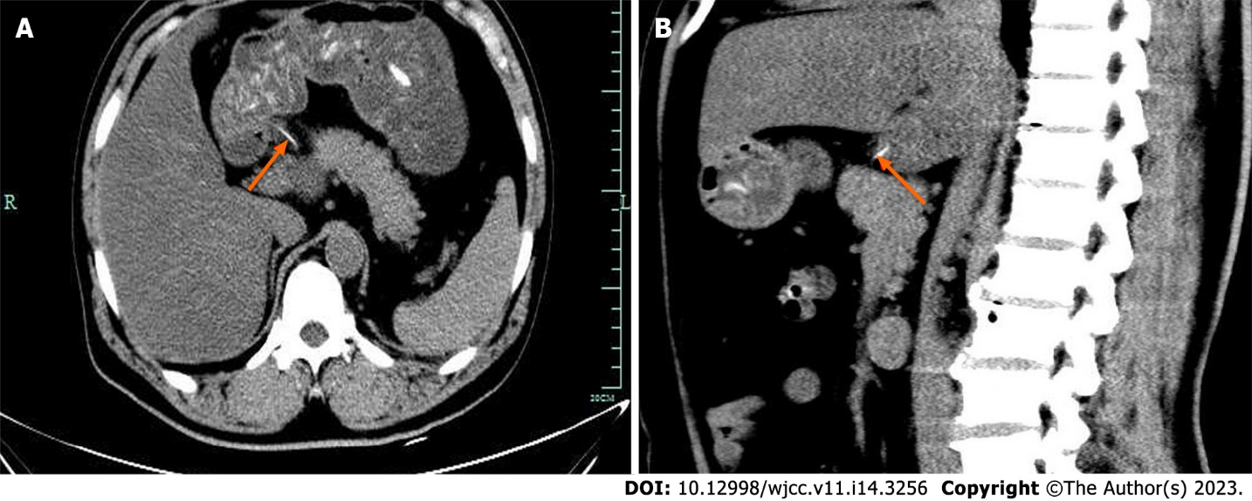
Figure 1 Contrast-enhanced computed tomography. A: Gastric perforation caused by a foreign body in the stomach (arrow); B: The foreign body in the stomach had penetrated the liver (arrow).

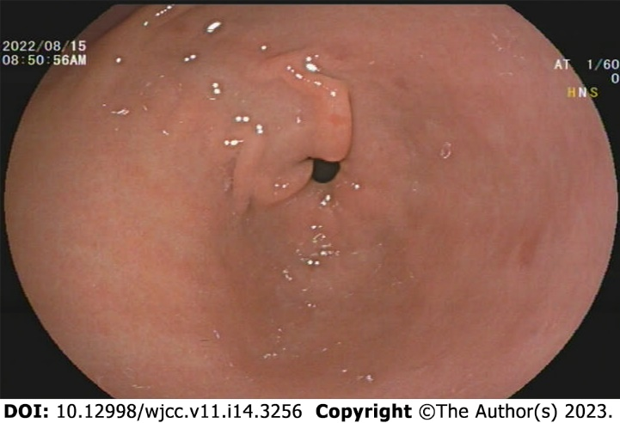
Figure 2 No obvious erosion or ulcers of the gastric mucosa was found during gastroscopy.

Published by Baishideng Publishing Group Inc
7041 Koll Center Parkway, Suite 160, Pleasanton, CA 94566, USA
Telephone: +1-925-3991568
E-mail: bpgoffice@wjgnet.com
Help Desk: https://www.f6publishing.com/helpdesk
https://www.wjgnet.com

© 2023 Baishideng Publishing Group Inc. All rights reserved.

