Name of Journal: World Journal of Clinical Cases
Manuscript NO: 78026
Manuscript Type: CASE REPORT

Multiple bilateral and symmetric C1-2 ganglioneuromas: A case report

Wang S et al. Multiple bilateral and symmetric C1-2 ganglioneuromas

Shuang Wang, Jun-Xiong Ma, Liang Zheng, Shao-Tong Sun, Liang-Bi Xiang, Yu Chen

Shuang Wang, Jun-Xiong Ma, Liang Zheng, Shao-Tong Sun, Liang-Bi Xiang, Yu Chen, Department of Orthopedics, General Hospital of Northern Theater Command, Shenyang 110006, Liaoning Province, China

Author contributions: Wang S, Ma JX, Zheng L contributed equally to this work; Wang S, Chen Y designed the report; Ma JX, Zheng L, Sun ST collected the clinical data of the patient; Xiang LB and Chen Yu analyzed the data and wrote the paper.

Corresponding author: Yu Chen, MD, Associate Chief Physician, Department of Orthopedics, General Hospital of Northern Theatre Command, No. 83 Wenhua Road, Shenhe District, Shenyang 110000, Liaoning Province, China. spinechenyu@163.com

Received: June 22, 2022
Revised: August 8, 2022
Accepted: October 9, 2022
Published online: November 6, 2022

Abstract
BACKGROUND
Ganglioneuromas are rare tumors of the sympathetic nervous system that originate from neural crest sympathogonia. Since the cervical spine has rarely been reported as a site for ganglioneuroma, we present a case report on this uncommon manifestation.

CASE SUMMARY
A 34-year-old male presented with a 4-month history of progressive paralysis of both upper limbs along with an unsteady gait. The touch sensitivity of both hands was reduced, and there was conspicuously high muscle tonus in his upper and lower limbs, along with hyperactive physiological reflection and deep reflexes. Magnetic resonance imaging showed several nodules around the C2-7 intervertebral foramena, among which the masses lying between C1 and C2 were obviously bilaterally compressing the spinal cord. Successful posterior decompression was performed without fixation and the tumors in the upper cervical spine were removed intact, with rapid relief of symptoms. The pathological diagnosis was ganglioneuroma.

CONCLUSION
Multiple and bilateral ganglioneuroams are a rare occurrence in the cervical spine. In this case report, timely resection of the neoplasms around C1 and C2 resulted in spinal cord decompression, with rapid relief of symptoms and a good prognosis. Including the current case, we are aware of only seven such cases in the literature, of which four arose from Japan, one from China, and one from Spain. We suppose that ethnicity and geographic associations with this rare disease presentation may be an aspect for future consideration and investigation.

Key Words: Ganglioneuroma; Cervical cord; Dumbbell tumor; Symmetric; Surgery; Case report

©The Author(s) 2022. Published by Baishideng Publishing Group Inc. All rights reserved.

Citation: Wang S, Ma JX, Zheng L, Sun ST, Xiang LB, Chen Y. Multiple bilateral and symmetric C1-2 ganglioneuromas: A case report. World J Clin Cases 2022; 10(31): 11549-11554
URL: https://www.wjgnet.com/2307-8960/full/v10/i31/11549.htm
DOI: https://dx.doi.org/10.12998/wjcc.v10.i31.11549

Core Tip: Ganglioneuromas is common benign tumor but uncommonly existing in the upper cervical spine. Meanwhile, this kind of tumor is rare to be multiple or bilateral. We present a 34-year-old male with the 4 mo history of paralysis in upper limbs and unsteady gait. The magnetic resonance imaging showed bilateral nodes from C2 to C7 intervertebral foramens, among which the bulks between C1 and C2 compressed the spinal cord obviously. The operation of posterior decompression was performed successfully without fixation and the tumors was removed integrally. The pathological diagnosis was ganglioneuromas. Including the current case, we are aware of only seven such cases in the literature, of which four arose from Japan, one from China, and one from Spain. We suppose that ethnicity and geographic associations with this rare disease presentation may be an aspect for future consideration and investigation.

INTRODUCTION
Ganglioneuroma (GN) is a type of benign tumor composed of mature ganglion and nerve sheath cells, which generally arises in association with sympathetic nerves or sympathetic nervous tissue^{[1]}. Very rarely, the neoplasm occurs bilaterally in the upper cervical spine, presenting as a dumb-bell shaped mass surrounding the spinal cord. In these circumstances, the spinal cord is potentially compressed by the neoplasm, resulting in symptoms of limb numbness and weakness, potentially progressing to paralysis and respiratory failure^{[2]}. Surgical resection is required to relieve the symptoms and recover limb function.
Here, we present a rare case of bilateral and symmetric dumb-bell ganglioneuromas in the region of C1-2. We discuss this case in the context of only six previously reported cases of ganglioneuroma affecting the upper cervical spine bilaterally.

CASE PRESENTATION
Chief complaints
The patient provided written informed consent for this case study. A 34-year-old male presented with a history of paralysis in both upper limbs and unsteady gait in the last 4 mo.

History of present illness
The symptoms had progressed rapidly in severity in the past 1 mo preceding his hospital visit.

History of past illness
The symptoms had progressed rapidly in severity in the past 1 mo preceding his hospital visit.

Personal and family history
The patient was an index case of his family about the history of neurofibromatosis.

Physical examination
He presented with multiple cafe-au-lait spots on his body (Figure 1A). The vibrotactile sensitivities of both hands were reduced, which indicating that the spinal cord was affected, and the limb strength was normal. Since there was not numbness or pain in specific area of the limbs, we inferred that none of the exact nerve root was oppressed heavily. Muscle tonus was notably elevated in the upper and lower limbs, the muscular tension of the upper and lower limbs was high, and he showed hyperactive deep tendon reflexes. Additionally, his examination shows positive Hoffman and Babinski signs.

Laboratory examinations
None important laboratory examinations were referred for this case.

Imaging examinations
Magnetic resonance imaging (MRI) of the cervical spine revealed several nodules around the C2-7 intervertebral foramens (Figure 1B). Each nodule presented with low signal intensity on T1-weighted images, but with high intensity on T2-weighted and enhanced images. Among the masses, the nodes around C1 and C2 were clearly compressing the spinal cord bilaterally (Figure 1C). The dimension of the lesion in the right side was 17.1 mm × 22.5 mm × 16.8 mm and the dimension of the lesion in the left side was 16.9 mm × 19.8 mm × 17.2 mm. The nodules of both sides between C1 and C2 were removed entirely after the operation and the compression of the spinal cord was relieved thoroughly (Figure 2).

FINAL DIAGNOSIS
Histological examination confirmed diagnosis of ganglioneuroma (Figure 3).

TREATMENT
Surgical Procedure
The operation was performed under general anesthesia with endotracheal intubation, with the patient kept in a prone position. A standard posterior midline surgical approach was performed. The laminae of C2 and C1 were partly resected to expose the tumors thoroughly, whereupon they were excision with margins entirely. After excision of the neoplasm, the compression of the spinal cord was immediately relieved.

OUTCOME AND FOLLOW-UP
At the 3-mo follow-up, the patient’s symptoms had completely resolved.

DISCUSSION
Ganglioneuromas are usually benign, slow-growing tumors that arise or differentiate from neuroblastomas or ganglioneuroblastomas^{[3]}. The composition of the tumor includes ganglion cells, Schwann cells, neurites, and fibrous tissue^{[3]}. The common positions of ganglioneuromas are (in descending order of frequency) the posterior mediastinum, retroperitoneum, adrenal gland, and neck, where they are usually a unilateral, solitary lesion. Generally speaking, the prognosis of ganglioneuromas was good, the patients could live without any symptom. But when the lesions were growing in some important areas, the oppression of the bulk could introduce many symptoms. In these cases, operations should be considered and most patients could recover thoroughly after the operations. In reviewing the literature, it can be concluded that multiple or bilateral occurrences of ganglioneuromas are rare^{[4]}, and that location in the upper cervical spine is especially unusual, with literature reports of only six such cases to the best of our knowledge.
In the current case, the patient had multiple ganglioneuromas bilaterally affecting all cervical nerves from C2 to C7. Also, the café-au-lait marks and history of resection of a neurofibromatosis have previously been associated with ganglioneuromas^{[4]}. In our case, most neoplasms of these nodes were asymptomatic, since there was sufficient space for expansion of the tumors. However, the massive bulks in the upper cervical spine caused severe compression to the spinal cord, resulting in serious sensorimotor symptoms. The spine marrow of this region is important not only to the sensory and motor functions of the limbs but also for controlling the respiratory system, which calls for timely relief of compression. Since ganglioneuromas are often solid and have distinct boundaries between surrounding structures, intact resection could be realized without difficulty, with preservation of the bony structures necessary for maintaining the stability of the spine.
To the best of our knowledge, there are only six previous case reports of bilateral and symmetric GNs in the region of upper cervical spine, so we believe it is important to present our case in the context of the limited literature. In 2001, Ugarriza et al^{[5]} reported a case of bilateral and symmetric C1-2 dumbbell ganglioneuroma. Their patient presented with progressive weakness of the limbs, bladder and bowel incontinence, and respiratory difficulty. After an en bloc operative resection of the tumor, there was some persistence of limb weakness, but the respiratory problems disappeared completely. Similarly, Kyoshima et al^{[6]} reported a 35-year-old patient with sensorimotor and respiratory dysfunctions. The tumors extended from C1-C3, consisting of four bilateral C2 and C3 root-related tumors. After expression, the tumors were resected at the dural side, with retention of intraforaminal and extradural parts. In the cases reported by Miyakoshi et al^{[2]} and Ando et al^{[7]}, asymptomatic foraminal and extraforaminal tumors were found in conjunction with bilateral and symmetric C1-2 ganglioneuromas; in both cases, the treatment was removal of the tumors at C1-2. The case of Hioki et al^{[8]}, an elderly man (72 years) had progressive incomplete paraplegia and lightheadedness. The bilateral tumors at the C1-2 Level were removed thoroughly, followed by histopathological diagnosis of ganglioneuroma. In 2019, Tan et al^{[9]} reported a 27-year-old man with gradually progressive right upper extremity weakness and numbness in both hands. After total resection of the tumor, the syndromes were relieved. Interestingly, four of these case reports arose from Japan, one from China, and one from Spain. We presume that ethnicity and geographic associations with this rare disease presentation may be an aspect for future consideration and investigation.

CONCLUSION
We present our case since multiple bilateral ganglioneuromas of the upper cervical spine are a rare occurrence, with scant documentation in the literature. Diagnosis and surgical planning were facile with MRI and computed tomography imaging. We note the need for timely surgery to decompress the spine by removing the bulk of the tumors, while preserving the bony structures required for spinal stabilization. Even in the case of a benign lesion, cord compressive symptoms would mandate surgical excision.

REFERENCES
1 Hussain MH, Iqbal Z, Mithani MS, Khan MN. Retroperitoneal Ganglioneuroma in a Patient Presenting With Vague Abdominal Pain. Cureus 2020; 12: e9133 [PMID: 32789073 DOI: 10.7759/cureus.9133]
2 Miyakoshi N, Hongo M, Kasukawa Y, Misawa A, Shimada Y. Bilateral and symmetric C1-C2 dumbbell ganglioneuromas associated with neurofibromatosis type 1 causing severe spinal cord compression. Spine J 2010; 10: e11-e15 [PMID: 20362242 DOI: 10.1016/j.spinee.2010.01.023]
3 Lonergan GJ, Schwab CM, Suarez ES, Carlson CL. Neuroblastoma, ganglioneuroblastoma, and ganglioneuroma: radiologic-pathologic correlation. Radiographics 2002; 22: 911-934 [PMID: 12110723 DOI: 10.1148/radiographics.22.4.g02jl15911]
4 Bacci C, Sestini R, Ammannati F, Bianchini E, Palladino T, Carella M, Melchionda S, Zelante L, Papi L. Multiple spinal ganglioneuromas in a patient harboring a pathogenic NF1 mutation. Clin Genet 2010; 77: 293-297 [PMID: 19863548 DOI: 10.1111/j.1399-0004.2009.01292.x]
5 Ugarriza LF, Cabezudo JM, Ramirez JM, Lorenzana LM, Porras LF. Bilateral and symmetric C1-C2 dumbbell ganglioneuromas producing severe spinal cord compression. Surg Neurol 2001; 55: 228-231 [PMID: 11358598 DOI: 10.1016/s0090-3019(01)00363-9]
6 Kyoshima K, Sakai K, Kanaji M, Oikawa S, Kobayashi S, Sato A, Nakayama J. Symmetric dumbbell ganglioneuromas of bilateral C2 and C3 roots with intradural extension associated with von Recklinghausen's disease: case report. Surg Neurol 2004; 61: 468-73; discussion 473 [PMID: 15120227 DOI: 10.1016/S0090-3019(03)00393-8]
7 Ando K, Imagama S, Ito Z, Hirano K, Tauchi R, Muramoto A, Matsui H, Matsumoto T, Ishiguro N. Cervical myelopathy caused by bilateral C1-2 dumbbell ganglioneuromas and C2-3 and C3-4 neurofibromas associated with neurofibromatosis type 1. J Orthop Sci 2014; 19: 676-681 [PMID: 23053586 DOI: 10.1007/s00776-012-0315-8]
8 Hioki A, Miyamoto K, Hirose Y, Kito Y, Fushimi K, Shimizu K. Cervical symmetric dumbbell ganglioneuromas causing severe paresis. Asian Spine J 2014; 8: 74-78 [PMID: 24596609 DOI: 10.4184/asj.2014.8.1.74]
9 Tan CY, Liu JW, Lin Y, Tie XX, Cheng P, Qi X, Gao Y, Guo ZZ. Bilateral and symmetric C1-C2 dumbbell ganglioneuromas associated with neurofibromatosis type 1: A case report. World J Clin Cases 2019; 7: 109-115 [PMID: 30637260 DOI: 10.12998/wjcc.v7.i1.109]

Footnotes
Informed consent statement: The patient provided written informed consent for this case study.

Conflict-of-interest statement: The authors have no conflicts of interest to declare.

CARE Checklist (2016) statement: The authors have read the CARE Checklist (2016), and the manuscript was prepared and revised according to the CARE Checklist (2016).

Open-Access: This article is an open-access article that was selected by an in-house editor and fully peer-reviewed by external reviewers. It is distributed in accordance with the Creative Commons Attribution NonCommercial (CC BY-NC 4.0) license, which permits others to distribute, remix, adapt, build upon this work non-commercially, and license their derivative works on different terms, provided the original work is properly cited and the use is non-commercial. See: https://creativecommons.org/Licenses/by-nc/4.0/

Provenance and peer review: Unsolicited article; Externally peer reviewed.
Peer-review model: Single blind

Peer-review started: June 22, 2022
First decision: August 4, 2022
Article in press: October 9, 2022

Specialty type: Orthopedics
Country/Territory of origin: China
Peer-review report’s scientific quality classification
Grade A (Excellent): 0
Grade B (Very good): B
Grade C (Good): C
Grade D (Fair): 0
Grade E (Poor): 0

P-Reviewer: Govindarajan KK, India; Wang F S-Editor: Ma YJ L-Editor: A P-Editor: Ma YJ
Figure Legends

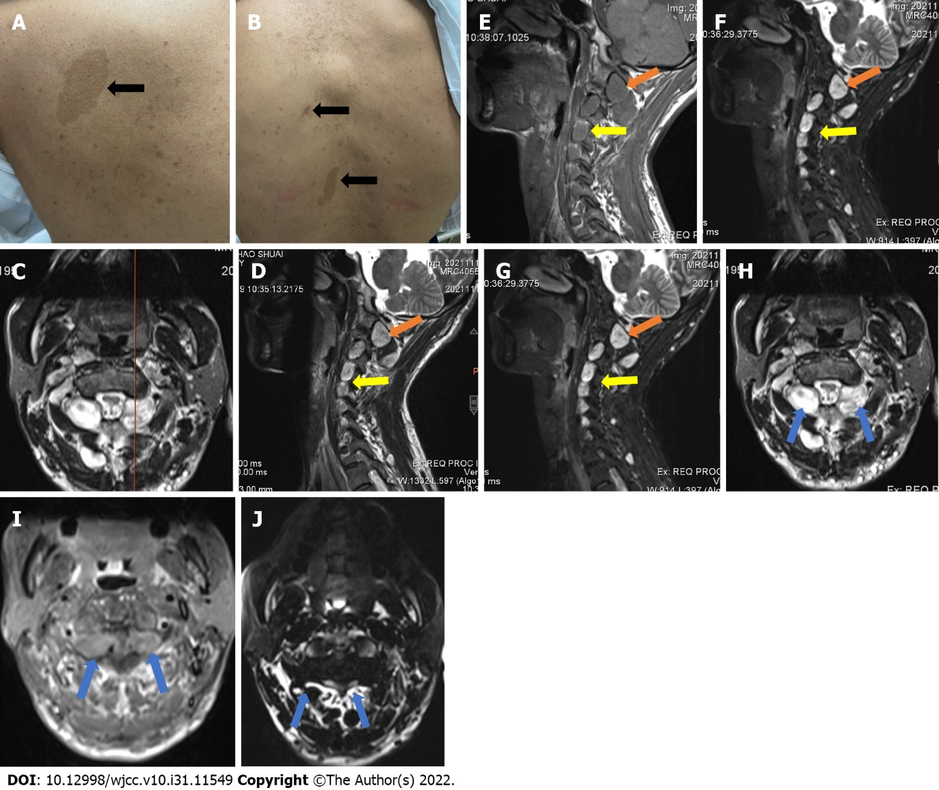
Figure 1 The physical signs and imaging data pre-operation. A: Representative café-au-lait spots near the left scapula and on the back (B); C-J: Preoperative MRI images of the patient, showing conspicuous neoplasms in the upper cervical spine (yellow and blue arrows) and the presence of nodules at C2-7 (yellow arrows); C: At the position line of the sagittal and coronal planes, the neoplasm presents high signal on T1 (D, H), relatively low signal on T2 (E, I); signal enhancement showed high intensity in all nodules (F, J) images.

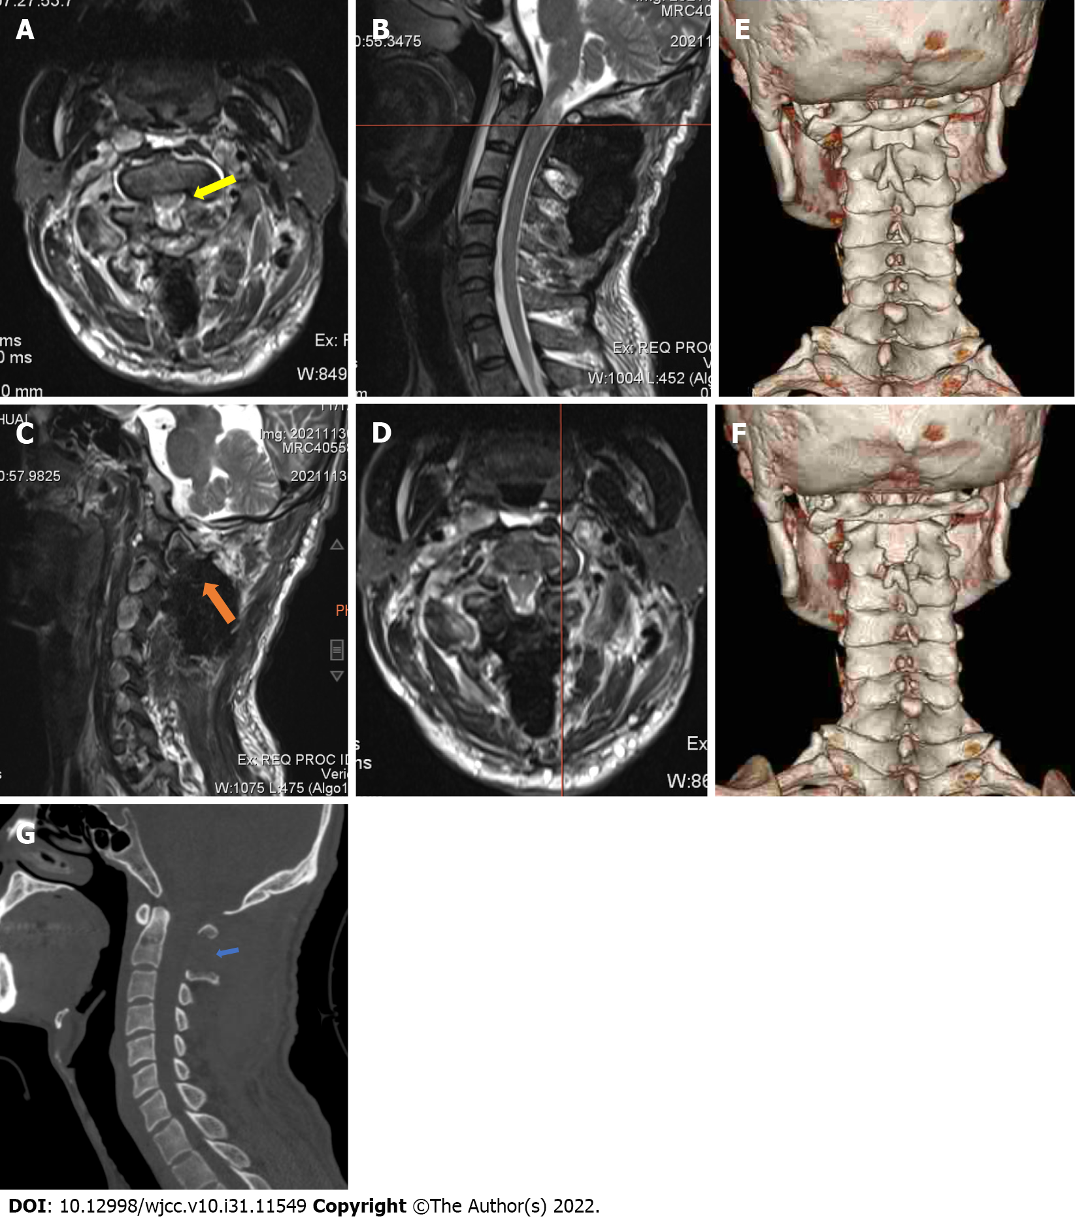
Figure 2 Post-operative images of the patient. A: The coronal plane showed complete removal of the neoplasm and relief from compression of the spinal cord (yellow arrow) at the C1 position line (B); C: The sagittal plane also showed removal of the neoplasm (orange arrow) at the position line (D); Comparison of the pre-operative (E) and post-operative (F) images to three dimensional computed tomography showed limited structural changes on the posterior arch and laminar of the axis, with (G) substantial preservation of the upper cervical spine.
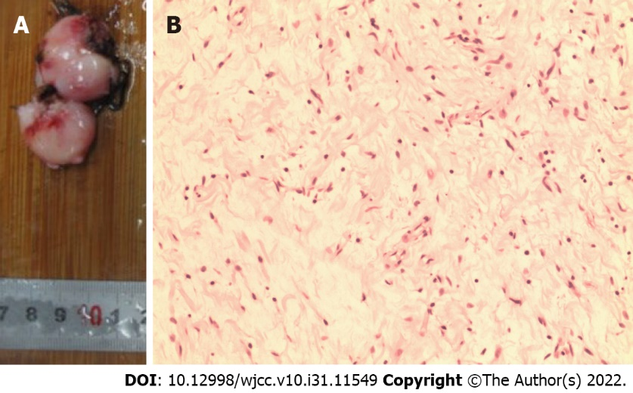
Figure 3 The picture of the resected tumor and the result of histopathological examination. A: The tumor was resected intact as two parts; B: Histopathological examination revealed spindle ganglion cells spreading throughout the tumor, without pleomorphism.

Published by Baishideng Publishing Group Inc
7041 Koll Center Parkway, Suite 160, Pleasanton, CA 94566, USA
Telephone: +1-925-3991568
E-mail: bpgoffice@wjgnet.com
Help Desk: https://www.f6publishing.com/helpdesk
https://www.wjgnet.com

© 2022 Baishideng Publishing Group Inc. All rights reserved.

