Name of Journal: World Journal of Gastrointestinal Surgery
Manuscript NO: 59973
Manuscript Type: ORIGINAL ARTICLE

Retrospective Study
Retrospective research of neoadjuvant therapy on tumor-downstaging, post-operative complications, and prognosis in locally advanced rectal cancer

Li WC et al. Research of neoadjuvant therapy in LARC

Wen-Chang Li, Jing-Kun Zhao, Wen-Qing Feng, Yi-Ming Miao, Zi-Feng Xu, Zhuo-Qing Xu, Han Gao, Jing Sun, Min-Hua Zheng, Ya-Ping Zong, Ai-Guo Lu

Wen-Chang Li, Jing-Kun Zhao, Wen-Qing Feng, Yi-Ming Miao, Zi-Feng Xu, Zhuo-Qing Xu, Han Gao, Jing Sun, Min-Hua Zheng, Ya-Ping Zong, Ai-Guo Lu, Department of General Surgery, Ruijin Hospital, Shanghai Jiaotong University School of Medicine, Shanghai 200025, China

Author contributions: Li WC and Zhao JK contributed equally to this study; Li WC, Zhao JK, Zong YP, and Lu AG designed the research; Feng WQ, Miao YM, and Xu ZF collected the data and prepared the manuscript; Li WC, Zhao JK, Xu ZQ, and Gao H analyzed the data and wrote the manuscript; Sun J and Zheng MH helped design the study with constructive discussions; All authors have read and approved the final manuscript.

Supported by National Science Foundation of China, No. 81871933; and National Science Foundation of China for Youth, No. 81802326.

Corresponding author: Ai-Guo Lu, MD, PhD, Chief Doctor, Professor, Department of General Surgery, Ruijin Hospital, Shanghai Jiaotong University School of Medicine, No. 197 Ruijin 2nd Road, Shanghai 200025, China. luaiguo1965@163.com

Received: October 9, 2020
Revised: December 13, 2020
Accepted: January 15, 2021
Published online: March 27, 2021

Abstract
BACKGROUND
Neoadjuvant therapy (NAT) is becoming increasingly important in locally advanced rectal cancer. Hence, such research has become a problem.

AIM
To evaluate the downstaging effect of NAT, its impact on postoperative complications and its prognosis with different medical regimens.

METHODS
Seventy-seven cases from Shanghai Ruijin Hospital affiliated with Shanghai Jiaotong University School of Medicine were retrospectively collected and divided into the neoadjuvant radiochemotherapy (NRCT) group and the neoadjuvant chemotherapy (NCT) group. The differences between the two groups in tumor regression, postoperative complications, rectal function, disease-free survival, and overall survival were compared using the χ² test and Kaplan-Meier analysis.

RESULTS
Baseline data showed no statistical differences between the two groups, whereas the NRCT group had a higher rate of T4 (30/55 vs 5/22, P < 0.05) than the NCT groups. Twelve cases were evaluated as complete responders, and 15 cases were evaluated as tumor regression grade 0. Except for the reduction rate of T stage (NRCT 37/55 vs NCT 9/22, P < 0.05), there was no difference in effectiveness between the two groups. Preoperative radiation was not a risk factor for poor reaction or anastomotic leakage. No significant difference in postoperative complications and disease-free survival between the two groups was observed, although the NRCT group might have better long-term overall survival.

CONCLUSION
NAT can cause tumor downstaging preoperatively or even complete remission of the primary tumor. Radiochemotherapy could lead to better T downstaging and promising overall survival without more complications.

Key Words: Locally advanced rectal cancer; Neoadjuvant therapy; Tumor downstaging; Postoperative complications; Prognosis

©The Author(s) 2021. Published by Baishideng Publishing Group Inc. All rights reserved.

Citation: Li WC, Zhao JK, Feng WQ, Miao YM, Xu ZF, Xu ZQ, Gao H, Sun J, Zheng MH, Zong YP, Lu AG. Retrospective research of neoadjuvant therapy on tumor-downstaging, post-operative complications, and prognosis in locally advanced rectal cancer. World J Gastrointest Surg 2021; 13(3): 267-278
URL: https://www.wjgnet.com/1948-9366/full/v13/i3/267.htm
DOI: https://dx.doi.org/10.4240/wjgs.v13.i3.267

Core Tip: Neoadjuvant therapy can cause tumor downstaging preoperatively or even complete remission of the primary tumor. Radiochemotherapy had better T downstaging as well as promising overall survival without major complications. This may help clinicians realize the indispensability of preoperative radiation.
INTRODUCTION
After Macfarlane et al^{[1]} and Heald et al^{[2]} promoted the concept of total mesorectal excision (TME), the local recurrence rate of locally advanced rectal cancer (LARC) fell below 30%. The Stockholm I and Stockholm II trials^{[3-6]} showed that preoperative radiation could reduce this rate to less than 15%. The side effects of neoadjuvant therapy (NAT) must not be neglected. Radiation can directly destroy normal rectal tissue^{[7-10]}, and chemotherapy always causes systematic side effects.
Therefore, this study assessed the efficacy of NAT in LARC and retrospectively explored its impact on postoperative complications and prognosis.

MATERIALS AND METHODS
Patients and groups
From January 1, 2016 to January 31, 2019, 1497 patients from Shanghai Ruijin Hospital affiliated with Shanghai Jiaotong University School of Medicine were diagnosed with rectal tumors. Seventy-seven patients met the inclusion criteria and were followed up for 2 years. Patient characteristics included the following: patient age between 18 to 75 years old, tumor location at the anal edge ≤ 15 cm according to endoscopy, histopathologically confirmed adenocarcinoma, tumor staging T3/T4 or N+ with magnetic resonance imaging (MRI), and willingly accepted and finished NAT. All included patients underwent laparoscopic radical rectal cancer surgery. Patients unable to finish NAT, undergoing an emergency operation, with severe organic comorbidities, and with coexisting other malignant tumors were excluded. Patients were divided into the neoadjuvant chemotherapy (NCT) group and the neoadjuvant radiochemotherapy (NRCT) group according to the regimen they received.

Regimen of NAT
The NAT regimen was planned by our multiple discipline team and carried out with the full understanding of patients and their families. NRCT comprised radiation (50 Gy in 25 fractions) with simultaneous capecitabine (1000 mg/m²) plus chemotherapy (Capeox or mFolfox6 for 1-2 cycles). The NCT was Capeox or mFolfox6 for four cycles. The interval time between surgery and NAT was at least 6 wk after NRCT or 2 wk after NCT. Then radical TME of rectal cancer was carried out (Dixon, Miles, or Hartmann procedure).

Data comparison
Patients were divided into the NCT group and NRCT group to compare the baseline data, tumor-related data, operation-related data, and postoperative complication-related data. The tumor downstaging evaluation was based on the Response Evaluation Criteria in Solid Tumors (RECIST) standard^{[11]} according to MRI and tumor regression grade (TRG) from the American Joint Committee on Cancer, 7th edition according to pathology. Postoperative complications included anastomotic leakage (AL), incision complications, and stoma complications.
The Wexner Continence Grading Scale was used to evaluate postoperative rectal function. The time of distal or local recurrence was recorded to assess disease-free survival (DFS). Overall survival (OS) was also compared between groups.

Statistical analysis
All data were analyzed, described, and processed by SPSS 23. P < 0.05 was considered statistically significant. The Mann-Whitney U or Wilcoxon test was used to compare the two groups, and the χ² test was used for comparison of categorical variables. Multivariable analysis was used to reveal the potentially influential factors of the NAT effect and postoperative complications. Kaplan-Meier analysis was used to describe and compare survival, and log-rank and Breslow tests were used to confirm the statistical significance.

RESULTS
General data
A total of 77 cases of LARC were included. General data are shown in Table 1. The average interval between radiotherapy and surgery was 61 ± 16 d (Table 1). The general data were analyzed and compared, as shown in Table 2. No significant difference in general data was found between the two groups.
Oncology data
There was only one significant difference in the preoperative characteristics (T stage) between the two groups before intervention (Table 3). A total of 43 cases showed retraction of the lower edge of the tumors by a median distance of 1.0 cm. Forty-one patients had T downstaging after treatment, and fifty-five patients had N downstaging. According to the RECIST standard, 12 cases were classified as complete response (CR). For TRG according to pathology, 15 cases were classified as TRG-0 (Table 4). Regarding the efficacy of NAT between the two groups (Table 5), there was only a significant difference in T downstaging, with no significant difference in the CR ratio or TRG-0 ratio.

Operation data
All 77 patients received surgical treatment, including Dixon (n = 56), Hartmann (n = 4), and Miles (n = 17) procedures. The organ preservation rate was 77.9%. The median operation duration was 167 min, with a median blood loss of 60 mL. Reoperation was performed in four cases caused by stoma obstruction (1 case), stoma ischemia (2 cases), and stoma bleeding (1 case). Among the 56 patients who underwent Dixon surgery, 48 (85.7%) underwent ileostomy. The average distance of the anastomosis from the anal margin was 5.4 ± 1.6 cm. Comparing the operation-related data between the two groups (Table 6), there were no significant differences in organ-preserving rate, intraoperative bleeding volume, or operation time (P > 0.05). In all cases receiving the Dixon operation, there was no difference in the ratio of ileostomy, but the distance from anastomosis to the anus in the NRCT group was lower than that in the NCT group.

Postoperative data
Among all of the cases included, the median postoperative hospital stay was 8 d, the median postoperative time of consuming a liquid diet was 3 d, and 16 cases had postoperative complications. Among the 56 Dixon cases, 6 (10.7%) had AL. No incision-related complications and two (2/48, 4.2%) stoma-related complications were observed. Among the four Hartmann cases, one had stoma ischemia, and one had stoma obstruction. No incision complications were observed. Of the 17 Miles cases, 4 (23.5%) had incision-related complications, and no stoma-related complications occurred.
The data on perioperative management and complications were compared between the two groups (Table 7). There was no significant difference in the postoperative hospital stay, time of open fluid diet, reoperation rate, or occurrence of complications between the two groups (P > 0.05).

Multivariate analysis of the effectiveness of NAT
TRG-0 or 1 was used as the strain variable. Possibly related factors were selected as independent variables including sex, age, comorbidity, radiotherapy, pre-T stage, and tumor lower edge. The results of logistic regression analysis showed that radiation was not a risk factor, while male sex (odds ratio [OR] = 0.251, 95% confidence interval [CI]: 0.080-0.788; P = 0.02) and age < 60 years (OR = 0.306, 95%CI: 0.101-0.932; P = 0.04) were protective factors for TRG 0 or 1 (Tables 8 and 9).

Multivariate analysis of AL occurrence after NAT
AL occurrence was selected as the strain variable. Possible risk factors were selected as independent variables including age, sex, comorbidities, preoperative radiation administration, anastomotic site location, and TRG-0 or TRG-1 (Table 10). Preoperative radiation (OR = 0.177, 95%CI: 0.014-2.173; P = 0.18) was not a risk factor for AL (Table 11).

NAT and prognosis
The median follow-up time was 26 mo, with three cases that were lost to follow-up. Forty-one patients finished the Wexner scale, while thirty-six patients did not finish the Hartmann or Miles procedure (n = 22), died (n = 8), had a temporary to permanent stoma (n = 5), or were lost to follow-up (n = 1). The median score of the Wexner scale was 3 (0-14), with no significant difference between the NRCT group and NCT group (P = 0.26).
The 2-year DFS (91.7%) and OS (93.4%) are shown in Figure 1. The DFS between the NRCT group and NCT group showed no significant difference (83.1% vs 90.5%, P > 0.05), whereas the NRCT group had significantly better OS (98.2% vs 80.7%; Breslow test P = 0.046) (Figures 2 and 3).

DISCUSSION
NAT has a beneficial effect on tumor downstaging. In this study, preoperative radiation promised a better local tumor reduction rate and OS without increasing operation difficulty and complications or causing worse rectal function.

Tumor downstaging after NAT of LARC
The EXPERT^{[12]} trial showed that chemoradiotherapy had a superior pathological complete remission (PCR) rate compared with chemotherapy alone. Additionally, the FORWARC^{[13]} trial showed the same results. In our study, the effect of NAT was not significantly different between the NCT and NRCT groups except for the T-downstaging rate. To some extent, it revealed the superior effect of the local tumor downstaging effect of preoperative radiation treatment.
Although female sex and age > 60 years were related to better tumor reaction, as shown in Tables 8 and 9, according to multivariate analysis, we failed to draw the same conclusion for preoperative radiation. Some experts have tried to find some clinical predictors of NAT response. Jung et al^{[14]} postulated that apparent diffusion coefficient parameters in MRI could somehow relate to tumor reduction volume. Qiu et al^{[15]} showed a poor response in patients with poor differentiation and T4 staging together.

Impact of NAT on surgery and complications
Studies have previously shown the destruction of local rectal mucosa after radiation^{[7-10]}. Fibrosis is the unfortunate result of previous radiation, causing more difficulties during operation. However, operation duration or blood loss volume showed no difference between groups, in agreement with the results of many studies performed in China^{[16,17]}.
Overall, NAT means more dysfunctioning stoma. No significant difference was shown in this study between the groups. However, two patients had nonclosure stomas due to unfinished systemic therapy or other unclear personal reasons. Andrew revealed a nonclosure rate of 14.5% and was concerned about its physical and psychological impact^{[18]}.
Park et al^{[19]} revealed that NAT increased the incidence of AL (hazard ratio [HR] = 6.284; 95%CI: 2.829-13.961; P < 0.001); another report showed the same findings (OR = 3.05, 95%CI: 1.26-7.37; P = 0.01)^{[20]}. However, some studies have shown opposite results. Rahbari et al^{[21]} conducted a meta-analysis and concluded that the incidence of AL did not increase (HR = 0.96; 95%CI: 0.58-1.60; P = 0.87). Parc et al^{[22]} also found that there was no significant difference in the incidence of AL between groups (P = 0.25). Although no difference in AL was observed in the study, a high proportion of dysfunctioning stoma could be overlooked, as it could conceal grade A AL from clinical observation. AL is also related to many other factors^{[23-25]}.
Incisional complications are mostly a concern for patients after the Miles procedure. El-Gazzaz et al^{[26]} carried out a multivariate analysis and found that preoperative radiation increased the risk of perineal incision infection (OR = 1.66, 95%CI: 1.10-2.48); Musters et al^{[27]} reached the same conclusion (OR = 1.74; 95%CI: 1.29-2.34).

Impact of NAT on prognosis
Rectal function did not show any difference in this study according to the Wexner scale. However, six patients suffered from temporary-to-permanent conversion of their stoma for different reasons. Rosa et al^{[28]} found that most patients could retain relatively good rectal function after NAT. Ghiselli et al^{[29]} observed that female and elderly patients might suffer from worse sphincter function after NAT.
NAT in LARC showed better DFS according to the EORTC 22921 study^{[30]}, while its superiority in OS failed to be observed even with a longer follow-up duration. The concept of total NAT has been raised in recent years. However, randomized clinical evidence for selective preoperative radiation is still lacking. This study did not find any difference in DFS between the groups. The Breslow test confirmed better OS in the NRCT group, implying the advantage of NRCT.

Limitations
Despite its retrospective nature, one limitation of the study was the small sample size. Some of the differences in complications or survival data may not arise with such a small sample. The side effects of NAT were not taken in to account in the research, which may have directly affected patient compliance and survival.

CONCLUSION
NAT can cause tumor downstaging preoperatively or even complete remission of the primary tumor. Radiochemotherapy had better T downstaging as well as promising OS without major complications. This may help clinicians realize the indispensability of preoperative radiation.

ARTICLE HIGHLIGHTS
Research background
Neoadjuvant therapy (NAT) is becoming the standard way to treat locally advanced rectal cancer (LARC). Radiation has been an important part of NAT. More research on preoperative radiation is warranted.

Research motivation
To explore what kind of impact preoperative radiation has on tumor downstaging, postoperative complications, and survival in LARC. To provide more evidence for choosing a NAT regimen.

Research objectives
To compare the downstaging effect, postoperative complications, and prognosis between two different NAT regimens: the combination of radiation and chemotherapy and chemotherapy alone.

Research methods
We retrospectively collected and analyzed the data of the two different regimens of NAT. The χ² test was used to compare the downstaging effect, postoperative complications, etc. Kaplan-Meier analysis was used to describe and compare survival.

Research results
The study found that the primary tumor regression effect was better with the combination of radiation and chemotherapy than chemotherapy alone. This agrees with many previous articles. There were no significant differences in postoperative complications between the two groups, while overall survival was better in the radiochemotherapy group. However, no article comparing survival in LARC with or without radiation before surgery has been carried out. This waits to be confirmed by further studies.

Research conclusions
This study tried to compare two different NAT regimens in LARC. Preoperative radiation may contribute to radical surgery in LARC and improve the prognosis as well.

Research perspectives
A prospective study comparing postoperative complications and survival in NAT with or without preoperative radiation waits to be carried out.

REFERENCES
1 MacFarlane JK, Ryall RD, Heald RJ. Mesorectal excision for rectal cancer. Lancet 1993; 341: 457-460 [PMID: 8094488 DOI: 10.1016/0140-6736(93)90207-w]
2 Heald RJ, Ryall RD. Recurrence and survival after total mesorectal excision for rectal cancer. Lancet 1986; 1: 1479-1482 [PMID: 2425199 DOI: 10.1016/s0140-6736(86)91510-2]
3 Stockholm Rectal Cancer Study Group. Short-term preoperative radiotherapy for adenocarcinoma of the rectum. An interim analysis of a randomized multicenter trial. Am J Clin Oncol 1987; 10: 369-375 [PMID: 2889353 DOI: 10.1097/00000421-198710000-00001]
4 Stockholm Rectal Cancer Study Group. Preoperative short-term radiation therapy in operable rectal carcinoma. A prospective randomized trial. Cancer 1990; 66: 49-55 [PMID: 2191763 DOI: 10.1002/1097-0142(19900701)66:1<49::aid-cncr2820660111>3.0.co;2-1]
5 Cedermark B, Johansson H, Rutqvist LE, Wilking N. The Stockholm I trial of preoperative short term radiotherapy in operable rectal carcinoma. A prospective randomized trial. Stockholm Colorectal Cancer Study Group. Cancer 1995; 75: 2269-2275 [PMID: 7712435 DOI: 10.1002/1097-0142(19950501)75:9<2269::aid-cncr2820750913>3.0.co;2-i]
6 Randomized study on preoperative radiotherapy in rectal carcinoma. Stockholm Colorectal Cancer Study Group. Ann Surg Oncol 1996; 3: 423-430 [PMID: 8876883 DOI: 10.1007/BF02305759]
7 Ehrenpreis ED, Marsh RW, Jr WS. Radiation Therapy for Pelvic Malignancy and its Consequences. Springer New York; 2015: 79-81 [DOI: 10.1007/978-1-4939-2217-8]
8 Yeoh EK, Russo A, Botten R, Fraser R, Roos D, Penniment M, Borg M, Sun WM. Acute effects of therapeutic irradiation for prostatic carcinoma on anorectal function. Gut 1998; 43: 123-127 [PMID: 9771416 DOI: 10.1136/gut.43.1.123]
9 Lim JF, Tjandra JJ, Hiscock R, Chao MW, Gibbs P. Preoperative chemoradiation for rectal cancer causes prolonged pudendal nerve terminal motor latency. Dis Colon Rectum 2006; 49: 12-19 [PMID: 16292664 DOI: 10.1007/s10350-005-0221-7]
10 Da Silva GM, Berho M, Wexner SD, Efron J, Weiss EG, Nogueras JJ, Vernava AM 3rd, Connor JT, Gervaz P. Histologic analysis of the irradiated anal sphincter. Dis Colon Rectum 2003; 46: 1492-1497 [PMID: 14605568 DOI: 10.1007/s10350-004-6800-1]
11 Eisenhauer EA, Therasse P, Bogaerts J, Schwartz LH, Sargent D, Ford R, Dancey J, Arbuck S, Gwyther S, Mooney M, Rubinstein L, Shankar L, Dodd L, Kaplan R, Lacombe D, Verweij J. New response evaluation criteria in solid tumours: revised RECIST guideline (version 1.1). Eur J Cancer 2009; 45: 228-247 [PMID: 19097774 DOI: 10.1016/j.ejca.2008.10.026]
12 Chua YJ, Barbachano Y, Cunningham D, Oates JR, Brown G, Wotherspoon A, Tait D, Massey A, Tebbutt NC, Chau I. Neoadjuvant capecitabine and oxaliplatin before chemoradiotherapy and total mesorectal excision in MRI-defined poor-risk rectal cancer: a phase 2 trial. Lancet Oncol 2010; 11: 241-248 [PMID: 20106720 DOI: 10.1016/S1470-2045(09)70381-X]
13 Deng Y, Chi P, Lan P, Wang L, Chen W, Cui L, Chen D, Cao J, Wei H, Peng X, Huang Z, Cai G, Zhao R, Huang Z, Xu L, Zhou H, Wei Y, Zhang H, Zheng J, Huang Y, Zhou Z, Cai Y, Kang L, Huang M, Peng J, Ren D, Wang J. Modified FOLFOX6 With or Without Radiation Versus Fluorouracil and Leucovorin With Radiation in Neoadjuvant Treatment of Locally Advanced Rectal Cancer: Initial Results of the Chinese FOWARC Multicenter, Open-Label, Randomized Three-Arm Phase III Trial. J Clin Oncol 2016; 34: 3300-3307 [PMID: 27480145 DOI: 10.1200/JCO.2016.66.6198]
14 Jung SH, Heo SH, Kim JW, Jeong YY, Shin SS, Soung MG, Kim HR, Kang HK. Predicting response to neoadjuvant chemoradiation therapy in locally advanced rectal cancer: diffusion-weighted 3 Tesla MR imaging. J Magn Reson Imaging 2012; 35: 110-116 [PMID: 21989997 DOI: 10.1002/jmri.22749]
15 Qiu HZ, Wu B, Xiao Y, Lin GL. Combination of differentiation and T stage can predict unresponsiveness to neoadjuvant therapy for rectal cancer. Colorectal Dis 2011; 13: 1353-1360 [PMID: 21689282 DOI: 10.1111/j.1463-1318.2011.02570.x]
16 Yu ZQ, Zhang C, Gao XH, Zuo ZG, Liu QZ, Dou WL, Xu XW, Fu CG. [Impacts of preoperative radiochemotherapy on operation and postoperative complications in patients with mid-low rectal carcinomas]. Zhonghua Weichang Waike Zazhi 2012; 15: 332-335 [PMID: 22539375]
17 Hu JJ, Zhang XM, Zhou ZX, Liang JW, Zhou HT, Liu FH, Hou HR. Impact of neoadjuvant chemoradiotherapy on short-term outcomes of laparoscopic surgery for rectal cancer. Zhonghuo Zhongliu Linchuang Yu Kangfu Zazhi 2013; 20 [DOI: 10.13455/j.cnki.cjcor.2013.04.023]
18 Chiu A, Chan HT, Brown CJ, Raval MJ, Phang PT. Failing to reverse a diverting stoma after lower anterior resection of rectal cancer. Am J Surg 2014; 207: 708-11; discussion 711 [PMID: 24791631 DOI: 10.1016/j.amjsurg.2013.12.016]
19 Park JS, Choi GS, Kim SH, Kim HR, Kim NK, Lee KY, Kang SB, Kim JY, Lee KY, Kim BC, Bae BN, Son GM, Lee SI, Kang H. Multicenter analysis of risk factors for anastomotic leakage after laparoscopic rectal cancer excision: the Korean laparoscopic colorectal surgery study group. Ann Surg 2013; 257: 665-671 [PMID: 23333881 DOI: 10.1097/SLA.0b013e31827b8ed9]
20 Qin Q, Ma T, Deng Y, Zheng J, Zhou Z, Wang H, Wang L, Wang J. Impact of Preoperative Radiotherapy on Anastomotic Leakage and Stenosis After Rectal Cancer Resection: Post Hoc Analysis of a Randomized Controlled Trial. Dis Colon Rectum 2016; 59: 934-942 [PMID: 27602924 DOI: 10.1097/DCR.0000000000000665]
21 Rahbari NN, Elbers H, Askoxylakis V, Motschall E, Bork U, Büchler MW, Weitz J, Koch M. Neoadjuvant radiotherapy for rectal cancer: meta-analysis of randomized controlled trials. Ann Surg Oncol 2013; 20: 4169-4182 [PMID: 24002536 DOI: 10.1245/s10434-013-3198-9]
22 Parc Y, Zutshi M, Zalinski S, Ruppert R, Fürst A, Fazio VW. Preoperative radiotherapy is associated with worse functional results after coloanal anastomosis for rectal cancer. Dis Colon Rectum 2009; 52: 2004-2014 [PMID: 19934922 DOI: 10.1007/DCR.0b013e3181beb4d8]
23 Riss S, Mittlböck M, Riss K, Chitsabesan P, Stift A. Intraoperative complications have a negative impact on postoperative outcomes after rectal cancer surgery. Int J Surg 2014; 12: 833-836 [PMID: 25014647 DOI: 10.1016/j.ijsu.2014.07.003]
24 Trifunović B, Kršić J, Bezmarević M, Grbović D, Zeljković D, Nešković B, Soldatović I, Prelević R, Mirković D. Relationship between of short-course preoperative radiotherapy and serum albumin level and postoperative complications in rectal cancer surgery. Vojnosanit Pregl 2015; 72: 663-669 [PMID: 26495691 DOI: 10.2298/vsp140616057t]
25 Shekarriz H, Eigenwald J, Shekarriz B, Upadhyay J, Shekarriz J, Zoubie D, Wedel T, Wittenburg H. Anastomotic leak in colorectal surgery: are 75 % preventable? Int J Colorectal Dis 2015; 30: 1525-1531 [PMID: 26319887 DOI: 10.1007/s00384-015-2338-z]
26 El-Gazzaz G, Kiran RP, Lavery I. Wound complications in rectal cancer patients undergoing primary closure of the perineal wound after abdominoperineal resection. Dis Colon Rectum 2009; 52: 1962-1966 [PMID: 19934916 DOI: 10.1007/DCR.0b013e3181b71ef9]
27 Musters GD, Buskens CJ, Bemelman WA, Tanis PJ. Perineal wound healing after abdominoperineal resection for rectal cancer: a systematic review and meta-analysis. Dis Colon Rectum 2014; 57: 1129-1139 [PMID: 25101610 DOI: 10.1097/DCR.0000000000000182]
28 Rosa C, Caravatta L, Di Tommaso M, Ursini1 LA, Allajbej A, Zecca IA, Di Nicola M, Genovesi D. EP-1492: Bowel and anal sphincter function after neoadjuvant chemoradiotherapy in rectal cancer patients. Radiother Oncol 2018; 127: S809-S810 [DOI: 10.1016/s0167-8140(18)31801-2]
29 Ghiselli R, Ortenzi M, Cardinali L, Skrami E, Gesuita R, Guerrieri M. Functional outcomes after TEM in patients with complete clinical response after neoadjuvant chemoradiotherapy. Surg Endosc 2017; 31: 2997-3003 [PMID: 27837319 DOI: 10.1007/s00464-016-5321-z]
30 Bosset JF, Calais G, Mineur L, Maingon P, Stojanovic-Rundic S, Bensadoun RJ, Bardet E, Beny A, Ollier JC, Bolla M, Marchal D, Van Laethem JL, Klein V, Giralt J, Clavère P, Glanzmann C, Cellier P, Collette L; EORTC Radiation Oncology Group. Fluorouracil-based adjuvant chemotherapy after preoperative chemoradiotherapy in rectal cancer: long-term results of the EORTC 22921 randomised study. Lancet Oncol 2014; 15: 184-190 [PMID: 24440473 DOI: 10.1016/S1470-2045(13)70599-0]

Footnotes
Institutional review board statement: The study was reviewed and approved by the Shanghai Ruijin Hospital Ethics Committee (Approval No. 2016-072).

Informed consent statement: All study participants, or their legal guardian, provided informed written consent prior to study enrollment.

Conflict-of-interest statement: The authors declare that they have no conflict of interest.

Data sharing statement: No additional data are available.

Open-Access: This article is an open-access article that was selected by an in-house editor and fully peer-reviewed by external reviewers. It is distributed in accordance with the Creative Commons Attribution NonCommercial (CC BY-NC 4.0) license, which permits others to distribute, remix, adapt, build upon this work non-commercially, and license their derivative works on different terms, provided the original work is properly cited and the use is non-commercial. See: http://creativecommons.org/Licenses/by-nc/4.0/

Manuscript source: Unsolicited manuscript

Peer-review started: October 9, 2020
First decision: December 8, 2020
Article in press: January 15, 2021

Specialty type: Gastroenterology and hepatology
Country/Territory of origin: China
Peer-review report’s scientific quality classification
Grade A (Excellent): 0
Grade B (Very good): 0
Grade C (Good): C
Grade D (Fair): 0
Grade E (Poor): 0

P-Reviewer: Kasztelan-Szczerbinska B S-Editor: Gao CC L-Editor: Filipodia P-Editor: Wang LL

Figure Legends
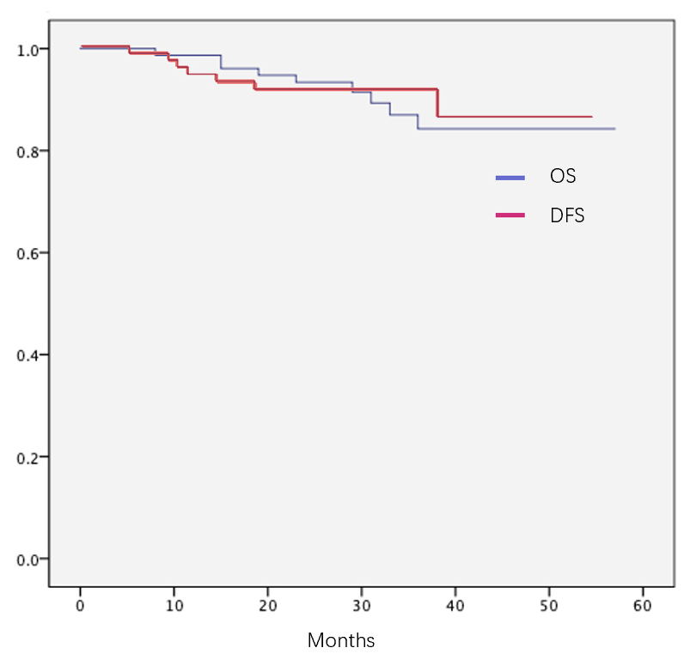
Figure 1 Overall survival and disease-free survival in all cases. DFS: Disease-free survival; OS: Overall survival.
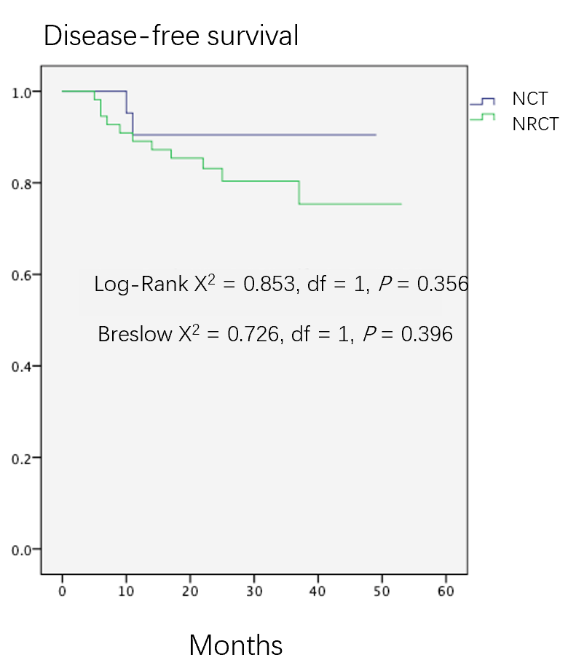
Figure 2 Disease-free survival between the neoadjuvant radiochemotherapy group and neoadjuvant chemotherapy group. NCT: Neoadjuvant chemotherapy; NRCT: Neoadjuvant radiochemotherapy.
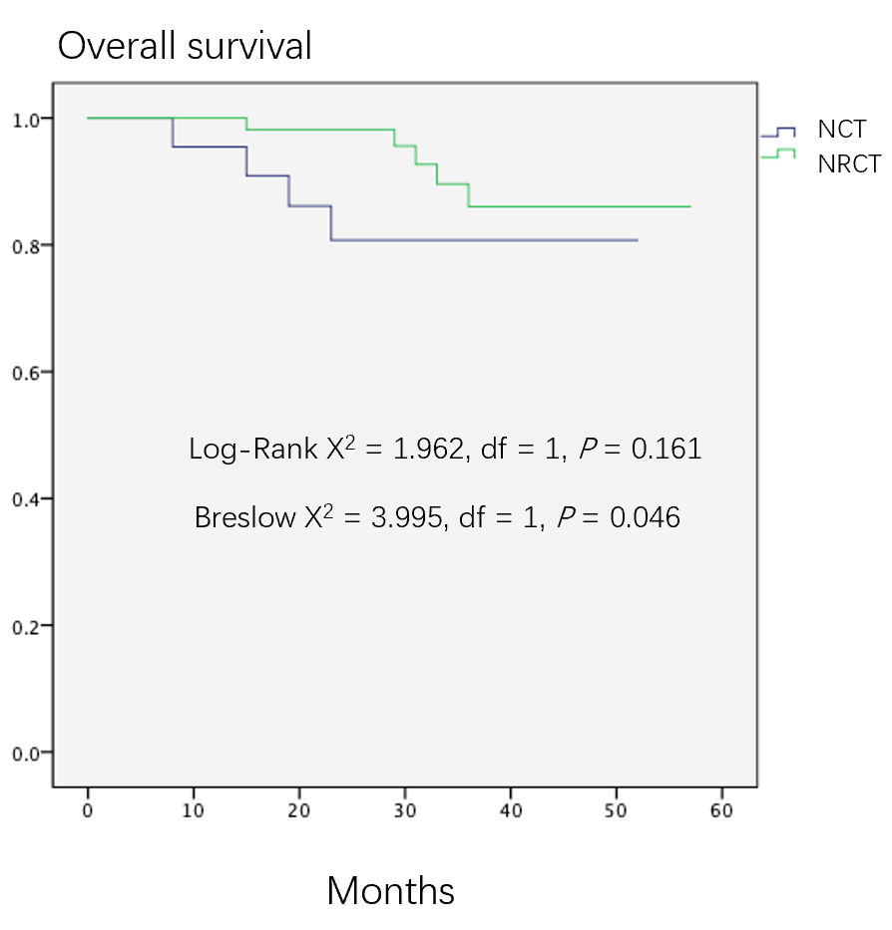
Figure 3 Overall survival between the neoadjuvant radiochemotherapy group and neoadjuvant chemotherapy group. NCT: Neoadjuvant chemotherapy; NRCT: Neoadjuvant radiochemotherapy.
Table 1 General data
 | Case counts
Gender: Male/Female | 62 | 15
Diabetes mellitus: Yes/No | 11 | 66
Hypertension: Yes/No | 19 | 58
Preoperative radiation: Yes/No | 55 | 22

Table 2 General data comparison between neoadjuvant radiochemotherapy and neoadjuvant chemotherapy
 | NRCT | NCT | P value
Median age in yr | 60 | 62 | 0.64
Gender, n |  |  | 1.00
Male | 44 | 18
Female | 11 | 4
Hypertension, n |  |  | 0.80
Yes | 14 | 5
No | 41 | 17
Diabetes mellitus, n |  |  | 0.80
Yes | 7 | 4
No | 48 | 18
NCT: Neoadjuvant chemotherapy; NRCT: Neoadjuvant radiochemotherapy.
Table 3 Baseline comparison of oncology data between neoadjuvant radiochemotherapy and neoadjuvant chemotherapy
 | NRCT | NCT | P value
Pre-operative median distance of tumor lower edge in cm | 5.0 | 6.0 | 0.37
T3 | 25 | 17 | 0.01
T4 | 30 | 5
Pre-operative N stage, n
N0 | 5 | 2 | 1.00
N+ | 50 | 20
NCT: Neoadjuvant chemotherapy; NRCT: Neoadjuvant radiochemotherapy.
Table 4 Effectiveness of neoadjuvant therapy
Neoadjuvant therapy | n
RECIST, n
CR | 12
PR | 45
SD | 20
PD | 0
TRG, n
0 | 15
1 | 12
2 | 23
3 | 27
CR: Complete response; PD: Progressive disease; PR: Partial response; RECIST: Response Evaluation Criteria in Solid Tumors; SD: Stable disease; TRG: Tumor regression grade.
Table 5 Effectiveness comparison between neoadjuvant radiochemotherapy and neoadjuvant chemotherapy
 | NRCT | NCT | P value
Retraction of lower edge, n |  |  | 0.72
Yes | 30 | 9
No | 25 | 13
Median retraction distance of lower edge in cm | 1.0 | 1.0 | 0.97
T-downstaging, n |  |  | 0.03
Yes | 37 | 9
No | 18 | 13
N-downstaging, n |  |  | 0.50
Yes | 37 | 13
No | 18 | 9
CR, n |  |  | 0.71
Yes | 20 | 7
No | 35 | 15
TRG-0, n |  |  | 1.00
Yes | 11 | 4
No | 44 | 18
CR: Complete response; NCT: Neoadjuvant chemotherapy; NRCT: Neoadjuvant radiochemotherapy; TRG-0: Tumor regression grade 0.
Table 6 Comparison of operation data between neoadjuvant radiochemotherapy and neoadjuvant chemotherapy
 | NRCT | NCT | P value
Organ-preservation, n |  |  | 0.15
Yes | 40 | 20
No | 15 | 2
Defunctioning stoma¹, n |  |  | 0.61
Yes | 32 | 16
No | 4 | 4
Median operation duration in min | 168 | 142 | 0.23
Intra-operation blood loss in mL | 70 | 50 | 0.59
Anastomosis site² in cm | 5.0 ± 1.6 | 6.0 ± 1.4 | 0.03
¹Including cases receiving Dixon or Hartmann.
²Including cases receiving Dixon only. NCT: Neoadjuvant chemotherapy; NRCT: Neoadjuvant radiochemotherapy.
Table 7 Comparison of post-operation data between neoadjuvant radiochemotherapy and neoadjuvant chemotherapy
 | NRCT | NCT | P value
Median hospitalization time in d | 7 | 8 | 0.75
Liquid diet time in d | 3 | 2 | 0.96
Re-operation, n |  |  | 0.47
Yes | 4 | 0
No | 51 | 22
Complications, n |  |  | 0.33
Yes | 13 | 3
No | 42 | 19
Anastomotic leakage¹, n |  |  | 0.56
Yes | 5 | 1
No | 31 | 19
Incision complications, n |  |  | 0.47
Yes | 4 | 0
No | 51 | 22
¹Including cases receiving Dixon only. NCT: Neoadjuvant chemotherapy; NRCT: Neoadjuvant radiochemotherapy.
Table 8 Influence factors and assignments for neoadjuvant therapy effectiveness
Factor | Variable | Assignment
Gender | X1 | M = 1, F = 0
Age | X2 | ≤ 60 yr = 1, > 60 yr = 0
Hypertension | X3 | N = 1, Y = 0
Diabetes mellitus | X4 | N = 1, Y = 0
Pre-operative radiation | X5 | N = 1, Y = 0
Pre-T stage | X6 | T3 = 1, T4 = 0
Tumor lower edge | X7 | ≤ 5 cm = 1, > 5 cm = 0
TRG-0 or 1 | Y | Y = 1, N = 0
F: Female; TRG: Tumor regression grade; M: Meal; N: No; Y: Yes.
Table 9 Logistic regression analysis of predictors of neoadjuvant therapy effectiveness
Variable | β | Wals value, χ² | P value | OR | 95%CI
 |  |  |  |  | Lower limit |  | Upper limit
Gender | -1.381 | 5.609 | 0.02 | 0.251 | 0.08 | 0.788
Age | -1.183 | 4.34 | 0.04 | 0.306 | 0.101 | 0.932
Hypertension | 0.725 | 1.245 | 0.26 | 2.065 | 0.578 | 7.385
Diabetes mellitus | 0.527 | 0.622 | 0.43 | 1.694 | 0.457 | 6.273
Pre-operative radiation | -0.601 | 1.012 | 0.31 | 0.548 | 0.17 | 1.768
Pre-T stage | 0.526 | 0.967 | 0.33 | 1.692 | 0.593 | 4.827
Tumor lower edge | 0.073 | 0.021 | 0.89 | 1.075 | 0.401 | 2.884
CI: Confidence interval; OR: Odds ratio.
Table 10 Risk factors and assignments for anastomotic leakage
Factor | Variable | Assignment
Gender | X1 | M = 1, F = 0
Age | X2 | ≤ 60 yr = 1, > 60 yr = 0
Comorbidities | X3 | N = 1, Y = 0
Radiation | X4 | N = 1, Y = 0
Stoma | X5 | N = 1, Y = 0
TRG-0 or 1 | X6 | N = 1, Y = 0
Anastomosis site location | X7 | ≤ 5.4 cm = 1, > 5.4 cm = 0
Anastomotic leakage | Y | Y = 1, N = 0
F: Female; TRG: Tumor regression grade; M: Meal; N: No; Y: Yes.
Table 11 Logistic regression analysis of risk factors for anastomotic leakage after neoadjuvant therapy
Variable | β | Wals value, χ² | P value | OR | 95%CI
 |  |  |  |  | Lower limit | Upper limit
Gender | -0.777 | 0.971 | 0.32 | 0.46 | 0.098 | 2.156
Age | -0.349 | 0.136 | 0.71 | 0.706 | 0.11 | 4.514
Comorbidity | 0.146 | 0.024 | 0.88 | 1.157 | 0.185 | 7.239
Radiation | -1.732 | 1.832 | 0.18 | 0.177 | 0.014 | 2.173
Stoma | 1.176 | 0.917 | 0.34 | 3.241 | 0.292 | 35.961
TRG-0 or 1 | -1.198 | 1.564 | 0.21 | 0.302 | 0.046 | 1.973
Anastomosis site | -1.46 | 2.386 | 0.12 | 0.232 | 0.036 | 1.481
CI: Confidence interval; OR: Odds ratio; TRG-0: tumor regression grade 0.

Published by Baishideng Publishing Group Inc
7041 Koll Center Parkway, Suite 160, Pleasanton, CA 94566, USA
Telephone: +1-925-3991568
E-mail: bpgoffice@wjgnet.com
Help Desk: https://www.f6publishing.com/helpdesk
https://www.wjgnet.com

© 2021 Baishideng Publishing Group Inc. All rights reserved.

