Name of Journal: World Journal of Methodology
Manuscript NO: 84735
Manuscript Type: ORIGINAL ARTICLE

Retrospective Study
Assessing the readability of online information about jones fracture

Al-Kharouf KFK et al. Readability of online information about jones fracture

Khaled Farid Khaled Al-Kharouf, Faisal Idrees Khan, Greg AJ Robertson

Khaled Farid Khaled Al-Kharouf, Orthopaedic Surgery, Portsmouth Hospitals University, Portsmouth PO6 3 LY, United Kingdom

Faisal Idrees Khan, Internal Medicine, Tunbridge Wells Hospital, Tunbridge Wells E10 5NJ, United Kingdom

Greg AJ Robertson, Orthopaedic Surgery, Queen Alexandra Hospital, Portsmouth PO6 3LY, United Kingdom

Author contributions: Al-Kharouf KFK conceived the methodology for the manuscript, performed the literature search and analysis for the study, and wrote the manuscript; Khan FI performed the literature search and analysis for the study and wrote the manuscript; Robertson GA advised on the study, and reviewed and edited the manuscript.

Corresponding author: Khaled Farid Khaled Al-Kharouf, MD, Doctor, Orthopaedic Surgery, Portsmouth Hospitals University, Cosham, Portsmouth PO6 3 LY, United Kingdom. kfk990@gmail.com

Received: March 26, 2023
Revised: July 6, 2023
Accepted: September 14, 2023
Published online:

Abstract
BACKGROUND
Hand in hand with technological advancements, treatment modalities continue to grow. With the turn of the century, the internet has become the number one source of information for almost every topic. Thus, many patients look toward the internet as their primary source of information to learn about their respective medical conditions. The American Medical Association and National Institute of Health strongly recommend that online medical information be written at the 6th to 8th-grade level to aid comprehension by patients of all literacy backgrounds.

AIM
To assess the readability of online information regarding Jones fracture. Our hypothesis is that the reading level of medical information published on websites far exceeds the recommended reading level of 6th-8th grade as proposed by the American Medical Associate and National Institute of Health. The result of this study can help us formulate improved recommendations for publishing more comprehensible material and, thus, eventually improve patient compliance and clinical outcomes.

METHODS
The exact phrase “Jones fracture” was queried on the three most common search engines, Google, Yahoo!, and Bing, on December 28, 2022. As of December 2022, Google held 84%, Bing held 9%, and Yahoo! held 2% of the worldwide search engine market share. Web pages uniform resource locator from the first three pages of search results were recorded from each search engine. These web pages were classified according to academic, physician-sponsored, governmental and non-government organizations (NGO), commercial, and unspecified as per formally defined categories. Websites associated with an educational institution or medical organization were classified as academic. Websites with products for sale, corporate sponsorship, or advertisements were classified as commercial. Governmental websites or NGOs comprised those that received government subsidies or grants. Webpages that were independently owned by physicians or physician groups were respectively classed as physician sponsored. The remainder of websites that did not fall under the above categories were classified as unspecified.

RESULTS
A total of 93 websites were analyzed for reading assessment. A whopping 44% of websites were commercial, followed by 22% of physician-sponsored websites. Third place belonged to non-government organization websites holding a 15% share. The academic website held a meager 9% portion, while unspecified sites were 3%. The table illustrates mean readability scores, along with average cumulative grade level. The average grade level was 10.95 ± 2.28 for all websites, with a range of 6.18 to 18.90. Since P values were more than 0.05, there was not a significant statistical difference between the first page results and the results of all pages. Thus, we can rationalize that readability scores are consistent throughout all pages of a website.

CONCLUSION
Hand in hand with technological advancements, treatment modalities continue to grow. With the turn of the century, the internet has become the number one source of information for almost every topic. Thus, many patients look towards the internet as the primary source of information to learn about their respective medical conditions. Our study demonstrates that current online medical information regarding Jones fracture is written at an extraordinarily high-grade level, with an average grade level of all websites at 10.95, nearly an 10th-grade educational level. The American Medical Association and National Institute of Health strongly recommend that online medical information should be written at the 6th to 8th-grade level to aid comprehension by patients of all literacy backgrounds. On the contrary, most of the medical information evaluated was at an 10th-grade level, which far exceeds recommendations by AMA and NIH. This is particularly relevant because readability scores are directly proportional to the level of comprehension attained by readers, thus directly impacting patient outcomes. In conclusion, we suggest and encourage that all online reading materials should be re-written at the 6th to 8th-grade level in a public service effort to increase compliance with treatment goals and raise awareness of preventive measures.

Key Words: Jones fracture; Jones fracture treatment; Jones fracture management; Jones fracture prevention; Jones fracture types; Jones fracture location

Al-Kharouf KFK, Khan FI, Robertson GA. Assessing the readability of online information about jones fracture. World J Methodol 2023; In press

Core Tip: With technological advancements, many patients look toward the internet as their primary source of information to learn about their respective medical conditions. The American Medical Association and National Institute of Health strongly recommend that online medical information be written at the 6th to 8th-grade level to aid comprehension by patients of all literacy backgrounds. Readability measures how easy a piece of text is to read. This, in turn, affects how much information people can understand and retain. Our study aims to assess the readability of online information regarding Jones fracture. A total of 93 websites were analyzed for reading assessment. The overall mean average grade level of all websites in the study was 10.95230 ± 2.27862, corresponding to a 10th-grade reading level. In Conclusion, most of the medical information evaluated was at an 11th-grade level, far exceeding AMA and NIH recommendations.

INTRODUCTION
Sir Robert Jones originally described the Jones fracture in 1902 as a self-named fracture occurring within 3/4th of an inch from the base of the 5th metatarsal. Generally, the Jones fracture is defined as all fractures of the proximal 5th metatarsal distal to the tuberosity within 1.5 cm of this area^{[1]}. Interestingly, the most common fracture of the foot is the Jones fracture, i.e., fracture of the 5th metatarsal. Many classification systems exist describing the Jones fracture; however, the most widely used is the anatomical classification, dividing the proximal part of the 5th metatarsal into three zones^{[2]}.
Zone 1 is the most proximal area, comprising the 5th metatarsal tuberosity and the metatarsocuboid joint. Injuries in Zone 1 are usually avulsion fractures, which are non-operatively managed to result in adequate clinical outcomes. Zone 2 consists of an area bordering the 4th and 5th intermetatarsal junction, stretching to the metaphyseal-diaphyseal junction and distal to Zone 1. A fracture in Zone 2 is classified as an actual Jones fracture. Finally, we have Zone 3, which contains the proximal 1.5 cm of the metatarsal diaphysis. Fractures in Zone 2 and Zone 3 are known to have high non-union rates with non-operative management, hence, promoting operative management as the preferred treatment^{[2]}.
With the turn of the century, the internet has become a valuable source of medical information for patients^{[3]}. As per the 2022 Health Information National Trends Survey, approximately 74.7% of people initially browsed the internet to gain insight into their medical problems^{[4]}. With increased online dissemination of medical information, the public has turned to the internet as their first source of information regarding medical illnesses. In fact, online resources have been shown to increase compliance with treatment goals and self-governed lifestyle changes^{[5]}.
Readability is the measure of how easy a piece of text is to read^{[6]}. This, in turn, affects how much information people are able to understand and retain. Given that health literacy actively corresponds to positive patient outcomes, the readability of a text comes into play in how effectively a piece of information can be comprehended by patients^{[7]}. The American Medical Association and the National Institute of Health recommend that patient education materials should be written between a 6th and 8th-grade level^{[8,9]}.
Our study aims to assess the readability of online information regarding Jones fracture. Our hypothesis is that the reading level of medical information published on websites far exceeds the recommended reading level of 6th-8th grade as proposed by the American Medical Associate and National Institute of Health. The result of this study can help us formulate improved recommendations for publishing more comprehensible material and, thus, eventually improve patient compliance and clinical outcomes.

MATERIALS AND METHODS
The exact phrase “Jones fracture” was queried on the three most common search engines, Google, Yahoo!, and Bing, on December 28, 2022. As of December 2022, Google held 84%, Bing held 9%, and Yahoo! held 2% of the worldwide search engine market share^{[10]}. Web pages uniform resource locator (URLs) from the first three pages of search results were recorded from each search engine. These web pages were classified according to academic, physician-sponsored, governmental and non-government organizations (NGO), commercial, and unspecified as per formally defined categories^{[11]}. Websites associated with an educational institution or medical organization were classified as academic. Websites with products for sale, corporate sponsorship, or advertisements were classified as commercial. Governmental websites or NGOs comprised those that received government subsidies or grants. Webpages that were independently owned by physicians or physician groups were respectively classed as physician sponsored. The remainder of websites that did not fall under the above categories were classified as unspecified^{[12-14]} (Tables 1-3).

RESULTS
A total of 101 website results were obtained, 49 from Google, 28 from Yahoo!, and 24 from Bing. Only eight websites were excluded, making a total of 93 pages manually analyzed (49 from Google, 21 from Yahoo!, and 23 from Bing; Figures 1 and 2). Exclusions were made due to duplication results. All the text from the images was included as part of the analysis. On pages where there was information about multiple subjects, only information relevant to Jones fracture was selected for analysis.

DISCUSSION
With advances in technology, operative and conservative management options for Jones continue to grow. Vast amounts of information are available on the internet. In fact, in today’s age, patients tend to utilize the internet as their primary source of information before actually seeing a medical practitioner. Therefore, it is of utmost significance how medical information is disseminated to patients.
Our study aimed to assess the readability of online information regarding Jones fracture. A vast majority, 77%, of websites were written above an eighth-grade level, far surpassing recommendations set by AMA and NIH^{[15-17]}. The overall mean average grade level of all websites in the study was 10.9523 ± 2.27862, corresponding to a 10th-grade reading level. Strikingly, governmental and NGO websites were found to have the highest average grade level of 11.51 ± 2.56, representing an 11th-grade level of comprehension. Even though previous studies^{[18]} have shown Academic websites to have the high readability score, in our case, academic websites ranked 2nd with an average grade level of 11.36 ± 3.33, which was still an eleventh-grade reading level. Considering these results, full comprehension of online medical information would require the completion of at least a secondary education.

CONCLUSION
Hand in hand with technological advancements, treatment modalities continue to grow. With the turn of the century, the internet has become the number one source of information for almost every topic. Thus, many patients look towards the internet as the primary source of information to learn about their respective medical conditions. Our study demonstrates that current online medical information regarding Jones fracture is written at an extraordinarily high-grade level, with an average grade level of all websites at 10.95, nearly an 10th-grade educational level. The American Medical Association and National Institute of Health strongly recommend that online medical information should be written at the 6th to 8th-grade level to aid comprehension by patients of all literacy backgrounds. On the contrary, most of the medical information evaluated was at an 10th-grade level, which far exceeds recommendations by AMA and NIH. This is particularly relevant because readability scores are directly proportional to the level of comprehension attained by readers, thus directly impacting patient outcomes. In conclusion, we suggest and encourage that all online reading materials should be re-written at the 6th to 8th-grade level in a public service effort to increase compliance with treatment goals and raise awareness of preventive measures.

ARTICLE HIGHLIGHTS
Research background
Hand in hand with technological advancements, treatment modalities continue to grow. With the turn of the century, the internet has become the number one source of information for almost every topic. Thus, many patients look toward the internet as their primary source of information to learn about their respective medical conditions. The American Medical Association and National Institute of Health strongly recommend that online medical information be written at the 6th to 8th-grade level to aid comprehension by patients of all literacy backgrounds.

Research motivation
With advances in technology, operative and conservative management options for Jones continue to grow. Vast amounts of information are available on the internet. In fact, in today’s age, patients tend to utilize the internet as their primary source of information before actually seeing a medical practitioner. Therefore, it is of utmost significance how medical information is disseminated to patients.

Research objectives
To assess the readability of online information regarding Jones fracture. Our hypothesis is that the reading level of medical information published on websites far exceeds the recommended reading level of 6th-8th grade as proposed by the American Medical Associate and National Institute of Health. The result of this study can help us formulate improved recommendations for publishing more comprehensible material and, thus, eventually improve patient compliance and clinical outcomes.

Research methods
The exact phrase “Jones fracture” was queried on the three most common search engines, Google, Yahoo!, and Bing, on December 28, 2022. As of December 2022, Google held 84%, Bing held 9%, and Yahoo! held 2% of the worldwide search engine market share. Web pages uniform resource locator from the first three pages of search results were recorded from each search engine. These web pages were classified according to academic, physician-sponsored, governmental and non-government organizations (NGO), commercial, and unspecified as per formally defined categories. Websites associated with an educational institution or medical organization were classified as academic. Websites with products for sale, corporate sponsorship, or advertisements were classified as commercial. Governmental websites or NGOs comprised those that received government subsidies or grants. Webpages that were independently owned by physicians or physician groups were respectively classed as physician sponsored. The remainder of websites that did not fall under the above categories were classified as unspecified.

Research results
A total of 101 website results were obtained, 49 from Google, 28 from Yahoo!, and 24 from Bing. Only eight websites were excluded, making a total of 93 pages manually analyzed (49 from Google, 21 from Yahoo!, and 23 from Bing). Exclusions were made due to duplication results. All the text from the images was included as part of the analysis. On pages where there was information about multiple subjects, only information relevant to Jones fracture was selected for analysis.

Research conclusions
Hand in hand with technological advancements, treatment modalities continue to grow. With the turn of the century, the internet has become the number one source of information for almost every topic. Thus, many patients look towards the internet as the primary source of information to learn about their respective medical conditions. Our study demonstrates that current online medical information regarding Jones fracture is written at an extraordinarily high-grade level, with an average grade level of all websites at 10.95, nearly an 10th-grade educational level. The American Medical Association and National Institute of Health strongly recommend that online medical information should be written at the 6th to 8th-grade level to aid comprehension by patients of all literacy backgrounds. On the contrary, most of the medical information evaluated was at an 10th-grade level, which far exceeds recommendations by AMA and NIH. This is particularly relevant because readability scores are directly proportional to the level of comprehension attained by readers, thus directly impacting patient outcomes. In conclusion, we suggest and encourage that all online reading materials should be re-written at the 6th to 8th-grade level in a public service effort to increase compliance with treatment goals and raise awareness of preventive measures.

Research perspectives
We suggest and encourage that all online reading materials should be re-written at the 6th to 8th-grade level in a public service effort to increase compliance with treatment goals and raise awareness of preventive measures.

REFERENCES
1 Dean BJ, Kothari A, Uppal H, Kankate R. The jones fracture classification, management, outcome, and complications: a systematic review. Foot Ankle Spec 2012; 5: 256-259 [PMID: 22547534 DOI: 10.1177/1938640012444730]
2 Ruta DJ, Parker D. Jones Fracture Management in Athletes. Orthop Clin North Am 2020; 51: 541-553 [PMID: 32950224 DOI: 10.1016/j.ocl.2020.06.010]
3 Avra TD, Le M, Hernandez S, Thure K, Ulloa JG. Readability assessment of online peripheral artery disease education materials. J Vasc Surg 2022; 76: 1728-1732 [PMID: 35931399 DOI: 10.1016/j.jvs.2022.07.022]
4 National Cancer Institute. The most recent time you looked for information about health or medical topics, where did you go first? HINTS. [cited 28 December 2022]. Available from: https://hints.cancer.gov/view-questions-topics/question-details.aspx?PK_Cycle=10&qid=688
5 Iverson SA, Howard KB, Penney BK. Impact of internet use on health-related behaviors and the patient-physician relationship: a survey-based study and review. J Am Osteopath Assoc 2008; 108: 699-711 [PMID: 19075034]
6 Readable. What is readability? [cited 28 December 2022]. Available from: https://readable.com/readability/what-is-readability/
7 Rooney MK, Santiago G, Perni S, Horowitz DP, McCall AR, Einstein AJ, Jagsi R, Golden DW. Readability of Patient Education Materials From High-Impact Medical Journals: A 20-Year Analysis. J Patient Exp 2021; 8: 2374373521998847 [PMID: 34179407 DOI: 10.1177/2374373521998847]
8 Weis BD. Health literacy: a manual for clinicians. American Medical Association Foundation and American Medical Association. 2003. [cited 28 December 2022]. Available from: https://www.yumpu.com/en/document/view/8189575/health-literacy-a-manual-for-clinicians
9 National Institutes of Health. Health Literacy National Institutes of Health. U.S. Department of Health and Human Services. [cited 28 December 2022]. Available from: https://www.nih.gov/institutes-nih/nih-office-director/office-communications-public-liaison/clear-communication/health-literacy
10 Bianchi T. Market share of leading desktop search engines worldwide from January 2015 to March 2023. [cited 28 December 2022]. Available from: https://www.statista.com/statistics/216573/worldwide-market-share-of-search-engines/
11 Ellsworth B, Patel H, Kamath AF. Assessment of Quality and Content of Online Information About Hip Arthroscopy. Arthroscopy 2016; 32: 2082-2089 [PMID: 27234649 DOI: 10.1016/j.arthro.2016.03.019]
12 Bruce-Brand RA, Baker JF, Byrne DP, Hogan NA, McCarthy T. Assessment of the quality and content of information on anterior cruciate ligament reconstruction on the internet. Arthroscopy 2013; 29: 1095-1100 [PMID: 23582738 DOI: 10.1016/j.arthro.2013.02.007]
13 Mehta MP, Swindell HW, Westermann RW, Rosneck JT, Lynch TS. Assessing the Readability of Online Information About Hip Arthroscopy. Arthroscopy 2018; 34: 2142-2149 [PMID: 29631940 DOI: 10.1016/j.arthro.2018.02.039]
14 Starman JS, Gettys FK, Capo JA, Fleischli JE, Norton HJ, Karunakar MA. Quality and content of Internet-based information for ten common orthopaedic sports medicine diagnoses. J Bone Joint Surg Am 2010; 92: 1612-1618 [PMID: 20595567 DOI: 10.2106/JBJS.I.00821]
15 National Library of Medicine. How to write easy-to-read health materials. [cited 28 December 2022]. Available from: https://medlineplus.gov/etr.html. Accessed December 28, 2022.
16 Perez OD, Swindell HW, Herndon CL, Noback PC, Trofa DP, Vosseller JT. Assessing the Readability of Online Information About Achilles Tendon Ruptures. Foot Ankle Spec 2020; 13: 470-477 [PMID: 31771353 DOI: 10.1177/1938640019888058]
17 Brophy RH, Gefen AM, Matava MJ, Wright RW, Smith MV. Understanding of Meniscus Injury and Expectations of Meniscus Surgery in Patients Presenting for Orthopaedic Care. Arthroscopy 2015; 31: 2295-300.e5 [PMID: 26163308 DOI: 10.1016/j.arthro.2015.05.003]
18 Rossi MJ, Brand JC, Provencher MT, Lubowitz JH. The Expectation Game: Patient Comprehension Is a Determinant of Outcome. Arthroscopy 2015; 31: 2283-2284 [PMID: 26652147 DOI: 10.1016/j.arthro.2015.09.005]

Footnotes
Institutional review board statement: Not required, no human or animal involved in our study.

Informed consent statement: The dataset consisted of anonymized synthesize evidence from published studies. Thus, no informed consent for data sharing was required.

Conflict-of-interest statement: Khaled Farid Khaled Al-Kharouf, Faisal Idrees Khan, and Greg Robertson have no conflicts of interest to declare. None have received fees for serving as a speaker or a consultant for commercial organizations. None have received research funding from commercial organizations. All are employees of the UK National Health Service, though not of any commercial organizations. None own stocks or shares in related commercial organizations. None own patent related to the topic of this study.

Data sharing statement: Technical appendix and datasets are available from the corresponding author at kfk990@gmail.com.

Open-Access: This article is an open-access article that was selected by an in-house editor and fully peer-reviewed by external reviewers. It is distributed in accordance with the Creative Commons Attribution NonCommercial (CC BY-NC 4.0) license, which permits others to distribute, remix, adapt, build upon this work non-commercially, and license their derivative works on different terms, provided the original work is properly cited and the use is non-commercial. See: https://creativecommons.org/Licenses/by-nc/4.0/

Provenance and peer review: Invited article; Externally peer reviewed.
Peer-review model: Single blind

Peer-review started: March 26, 2023
First decision: May 15, 2023
Article in press:

Specialty type: Orthopedics
Country/Territory of origin: United Kingdom
Peer-review report’s scientific quality classification
Grade A (Excellent): A
Grade B (Very good): 0
Grade C (Good): C
Grade D (Fair): 0
Grade E (Poor): 0

P-Reviewer: Mostafavinia A, Iran; Ravenell RA, United States S-Editor: Chen YL L-Editor: A P-Editor: Chen YL
Figure Legends
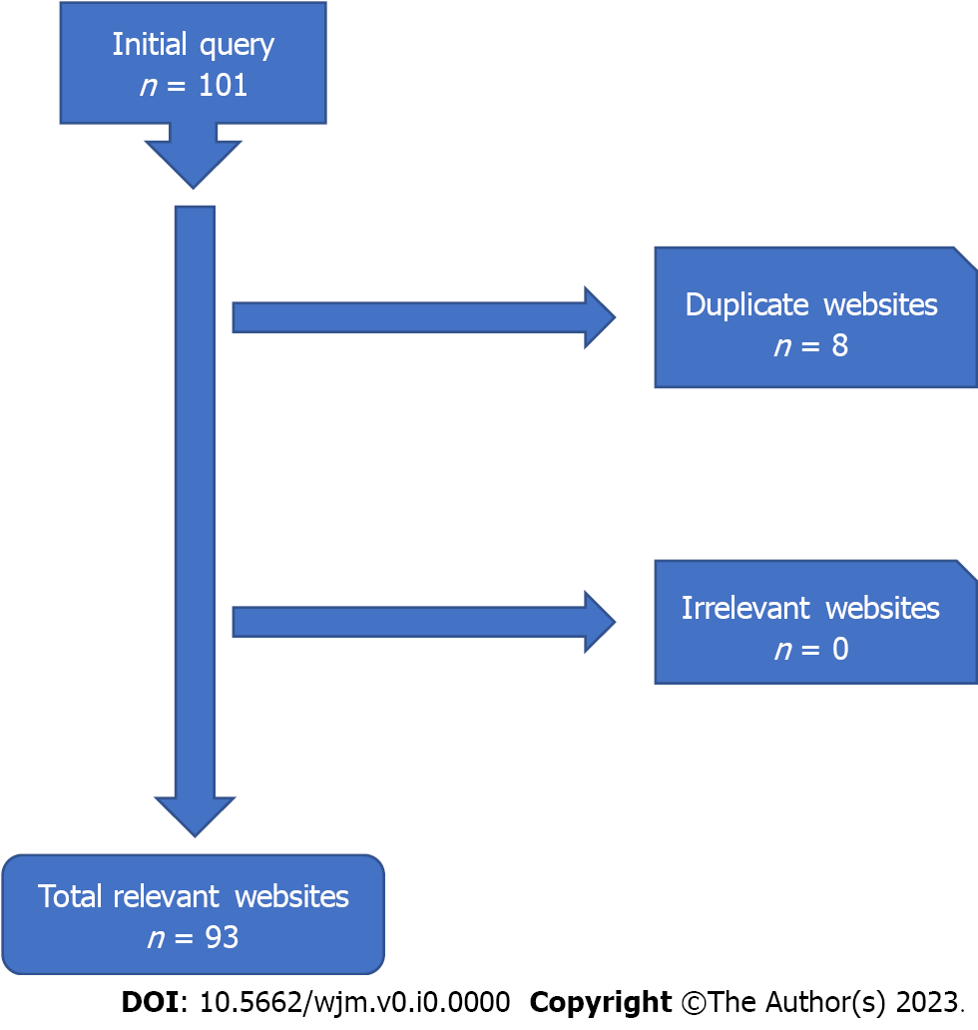
Figure 1 Flow diagram of inclusion and exclusion criteria.

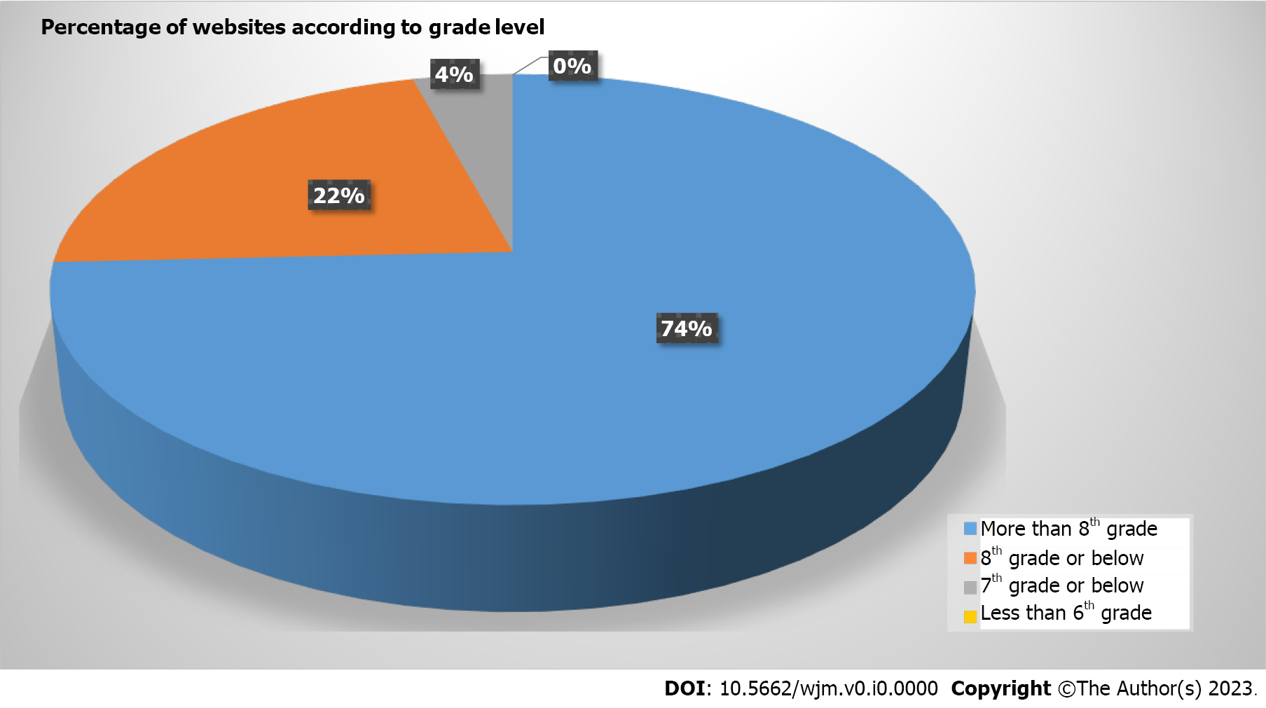
Figure 2 Percentage of websites and their grade level.

Table 1 Unpaired t-test for overall pages vs first page of websites
Readability metric | Overall mean ± SD (range) | First page mean ± SD (range) | Percentage mean difference | P value
Flesch reading ease | 55.3970 ± 12.7618 (23.2-86.1) | 55.3290 ± 15.9812 (9.9-87.4) | 2.32 | 0.553
Flesch-kincaid | 10.1450 ± 2.7082 (5.0-20.1) | 10.3840 ± 3.2056 (4.9-18.9) | 0.47 | 0.915
Gunning fog | 12.7830 ± 2.8099 (8.2-23.5) | 12.4210 ± 3.1772 (7.6-20.7) | 3.86 | 0.287
SMOG | 9.3530 ± 1.9114 (5.6-15.8) | 9.3000 ± 2.3224 (5.1-16.3) | 2.27 | 0.523
Coleman-liau index | 12.2460 ± 1.4778 (7.5-16.1) | 11.9970 ± 2.2096 (8-19) | 4.64 | 0.41
Automated readability | 10.2340 ± 3.0205 (4.6-22.0) | 10.5680 ± 3.6182 (3.8-19.2) | 1.05 | 0.824
Average grade level | 10.95230 ± 2.27862 (6.18-18.88) | 10.93420 ± 2.73413 (6.22-18.48) | 0.09 | 0.888
Table 2 Percentage of websites and their grade level
Classification | n | Percentage | Average grade level | St. Dev. | Maximum | Minimum
Academic | 8 | 0.0860 | 11.36 | ± 3.33 | 18.88 | 8.54
Physician sponsored | 21 | 0.2258 | 10.93 | ± 1.71 | 13.42 | 8.74
Governmental & NGO | 21 | 0.2258 | 11.51 | ± 2.56 | 15.68 | 6.18
Commercial | 40 | 0.4301 | 10.84 | ± 2.06 | 18.02 | 6.46
Unspecified | 3 | 0.0323 | 7.61 | ± 1.24 | 8.32 | 6.18
NGO: Non-government organizations.
Table 3 Unpaired t-test for government non-government organizations vs academic websites
Readability metric | Government & NGO mean ± SD (range) | Academic mean ± SD (range) | Percentage mean difference | P value
Flesch reading ease | 49.0330 ± 17.4883 (28.0-86.1) | 53.5880 ± 14.3224 (23.2-66.6) | 4.438 | 0.276
Flesch-Kincaid | 10.7860 ± 2.9066 (5.0-15.6) | 10.825 ± 4.083 (7.5-20.1) | 0.362 | 0.554
Gunning fog | 13.529 ± 2.869 (8.2-18.5) | 13.1500 ± 4.5056 (9.6-23.5) | 2.838 | 0.475
SMOG | 9.8860 ± 2.1763 (5.6-13.4) | 9.7880 ± 2.8478 (7.2-15.8) | 0.998 | 0.453
Coleman-liau index | 13.1670 ± 2.2265 (7.5-16.1) | 12.0500 ± 0.7051 (11.2-13.0) | 8.857 | 0.086
Automated readability | 10.200 ± 2.8660 (4.6-16.0) | 11.0000 ± 4.7413 (7.2-22.0) | 7.547 | 0.290
Average grade level | 11.51330 ± 2.55634 (6.18-15.68) | 11.36250 ± 3.33421 (8.54-18.88) | 1.319 | 0.665
Complex words | 130.81 ± 117.662 (44-459) | 122.380 ± 51.578 (70-210) | 6.663 | 0.304
Percentage of complex words | 0.1746810 ± 0.0552751 (0.0538-0.2356) | 0.1414500 ± 0.0334975 (0.1063-0.1860) | 21.024 | 0.187
Average words per sentence | 16.90710 ± 3.23038 (14.03-25.71) | 20.32130 ± 8.64815 (14.12-40.74) | 18.341 | 0.090
Average syllables per word | 1.67520 ± 0.19457 (1.21-1.85) | 1.56750 ± 0.07459 (1.49-1.68) | 6.645 | 0.041
NGO: Non-government organizations.

