Name of Journal: World Journal of Gastroenterology
ESPS Manuscript NO: 30075
Manuscript Type: ORIGINAL ARTICLE

Retrospective Study
Therapeutic efficacy and stent patency of transhepatic portal vein stenting after surgery

Jeon UB et al. Transhepatic portal vein stenting after surgery

Ung Bae Jeon, Chang Won Kim, Tae Un Kim, Ki Seok Choo, Joo Yeon Jang, Kyung Jin Nam, Chong Woo Chu, Je Ho Ryu

Ung Bae Jeon, Tae Un Kim, Ki Seok Choo, Joo Yeon Jang, Kyung Jin Nam, Department of Radiology, Pusan National University Yangsan Hospital, Yangsan, Gyeongnam 626-770, South Korea

Chang Won Kim, Department of Radiology, Pusan National University Hospital, Pusan 602-739, South Korea

Chong Woo Chu, Je Ho Ryu, Department of Surgery, Pusan National University Yangsan Hospital, Yangsan, Gyeongnam 626-770, South Korea

Author contributions: Kim CW designed the study; Jeon UB analyzed the data and wrote the paper; Kim TU performed the data analysis; Choo KS, Jang JY and Nam KJ collected the data; Chu CW and Ryu JH designed the study, and revised the paper; all authors have read and approved the final version to be published.

Institutional review board statement: The study was reviewed and approved by the Pusan National University Yangsan Hospital Institutional Review Board.

Informed consent statement: All study participants, or their legal guardian, provided informed written consent prior to study enrollment.

Conflict-of-interest statement: The authors declare no conflict of interest related to this study.

Data sharing statement: No additional data are available.

Open-Access: This article is an open-access article which was selected by an in-house editor and fully peer-reviewed by external reviewers. It is distributed in accordance with the Creative Commons Attribution Non Commercial (CC BY-NC 4.0) license, which permits others to distribute, remix, adapt, build upon this work non-commercially, and license their derivative works on different terms, provided the original work is properly cited and the use is non-commercial. See: http://creativecommons.org/licenses/by-nc/4.0/

Manuscript source: Unsolicited manuscript

Correspondence to: Chang Won Kim, MD, Department of Radiology, Medical Research Institute, Pusan National University School of Medicine and Research Institute for Convergence of Biomedical Science and Technology, Pusan National University Hospital, 10, 1-Ga, Ami-Dong, Seo-Gu, Pusan 602-739, South Korea. radkim@nate.com
Telephone: +82-51-2407354
Fax: +82-51-2447354

Received: September 9, 2016
Peer-review started: September 10, 2016
First decision: September 28, 2016
Revised: October 6, 2016
Accepted: October 30, 2016
Article in press:
Published online:

Abstract
AIM
To evaluate portal vein stenosis and stent patency after hepatobiliary and pancreatic surgery, using abdominal computed tomography (CT).

Methods
Percutaneous portal venous stenting was attempted in 22 patients with significant portal vein stenosis (> 50%) — after hepatobiliary or pancreatic surgery — diagnosed by abdominal CT. Stents were placed in various stenotic lesions after percutaneous transhepatic portography. Pressure gradient across the stenotic segment was measured in 14 patients. Stents were placed when the pressure gradient across the stenotic segment was > 5 mmHg or PV stenosis was > 50%, as observed on transhepatic portography. Patients underwent follow-up abdominal CT and technical and clinical success, complications, and stent patency were evaluated.

Results
Stent placement was successful in 21 patients (technical success rate: 95.5%). Stents were positioned through the main PV and superior mesenteric vein (n = 13), main PV (n = 2), right and main PV (n = 1), left and main PV (n = 4), or main PV and splenic vein (n = 1). Patients showed no complications after stent placement. The time between procedure and final follow-up CT was 41-761 d (mean: 374.5 d). Twenty stents remained patent during the entire follow-up. Stent obstruction — caused by invasion of the PV stent by a recurrent tumor — was observed in 1 patient in a follow-up CT performed after 155 d after the procedure. The cumulative stent patency rate was 95.7%. Small in-stent low-density areas were found in 11 (55%) patients; however, during successive follow-up CT, the extent of these areas had decreased.

Conclusion
Percutaneous transhepatic stent placement can be safe and effective in cases of PV stenosis after hepatobiliary and pancreatic surgery. Stents show excellent patency in follow-up abdominal CT, despite development of small in-stent low-density areas.

Key words: Liver; Vein; Stent; Computed tomography; Surveillance; Efficace

© The Author(s) 2016. Published by Baishideng Publishing Group Inc. All rights reserved.

Core tip: Portal vein (PV) stenosis can occur after hepatobiliary and pancreatic surgery. Portal hypertension due to PV stenosis induces clinical manifestations in many organs, including intractable ascites, esophageal and gastrointestinal bleeding, and liver dysfunction. Percutaneous transhepatic stent placement can be safe and effective in cases of PV stenosis since stents show excellent patency on follow-up abdominal computed tomography despite the presence of small in-stent low-density areas.

Jeon UB, Kim CW, Kim TU, Choo KS, Jang JY, Nam KJ, Chu CW, Ryu JH. Therapeutic efficacy and stent patency of transhepatic portal vein stenting after surgery. World J Gastroenterol 2016; In press

INTRODUCTION
Acquired portal vein (PV) stenosis is most commonly observed after liver transplantation (LT)^{[1-3]}. In the non-transplant population, PV stenosis can present with pancreatitis^{[4]} or tumor encasement^{[5]}, or as a postsurgical complication^{[6]}. Portal hypertension from PV stenosis induces clinical manifestations in many organs, including intractable ascites, esophageal and gastrointestinal bleeding, and liver dysfunction^{[7]}.
Treatment options for patients with PV stenosis or occlusions are limited. In the past, PV complications were managed surgically, such as by thrombectomy or surgical revision. However, surgical management of these complications has been limited by technical difficulties due to the development of postsurgical fibrosis and the length of the involved venous structures^{[8]}. Percutaneous interventional procedures have gained worldwide acceptance for alleviating the symptoms of portal hypertension, due to their minimal invasiveness and high success rates with low number of complications^{[9]}. Abdominal computed tomography (CT) and Doppler ultrasound tests have been the main modalities of patient follow-up after this procedure; the reported stent patency rate has been relatively good, ranging between 60 and 100% during the first year^{[5,7,10,11]}. Abdominal CT scans allow the visualization not only of the status of the original lesion, but also of changes in the PV stent. This study aimed to evaluate the therapeutic efficacy and stent patency of PV stenting after hepatobiliary and pancreatic surgery, using abdominal CT.

MATERIALS AND METHODS
Patients
From January 2011 to December 2012 at a single intitution, percutaneous transhepatic stent placement was attempted in 22 patients [11 women, 11 men; mean age: 65.6 years (range: 26-78 years)] with significant PV stenosis (> 50% of the main PV diameter) diagnosed using abdominal CT after hepatobiliary or pancreatic surgery [pylorus-preserving pancreatoduodenectomy (PPPD; n = 7), Whipple procedure (n = 6), distal pancreatectomy (n = 2), hepatectomy or hepatic segmentectomy (n = 6), and deceased donor liver transplant (DDLT; n = 1)] (Table 1).
The reasons for surgery included pancreatic cancer (n = 7), common bile duct (CBD) cancer (n = 3), Klatskin tumor (n = 2), colon cancer with duodenal invasion (n = 1), colon cancer with liver metastasis (n = 1), hepatocellular carcinoma (HCC; n=1), gall bladder (GB) cancer (n = 1), gastrointestinal stromal tumor (GIST; n = 1), ampulla of Vater cancer (n = 1), chronic pancreatitis (n = 1), intrahepatic bile duct (IHD) stone (n = 1), and hepatic failure after toxic hepatitis (n = 1). Clinical manifestations in patients with PV stenosis included intestinal angina-like abdominal pain (disabling mid-epigastric or central abdominal pain within 10–15 min after eating) and anorexia refractory to medical treatment, ascites, increased Jackson-Pratt (JP) drain output, and abnormal liver function test (LFT). The interval between surgery and stent placement was 5-274 d (mean: 34 d) (Table 2).
One patient was diagnosed with asymptomatic left portal vein stenosis after right hepatectomy, when the pressure gradient on transhepatic portography was 5 mmHg. She had undergone balloon angioplasty only and was excluded from this study.

Procedure
Informed consent was obtained from each patient. This retrospective study was approved by our institutional review board. All patients received local anesthesia consisting on subcutaneous injection of lidocaine and an intravenous injection of pentanyl (pentanyl citrate, Myung Moon Pharmaceutical; Seoul, Korea). Percutaneous transhepatic puncture of the intrahepatic PV was performed with a 21-gauge needle (PTC US needle, A&A M.D.; Seongnam, South Korea) under sonographic and fluoroscopic guidance. The needle was exchanged for a 5-French coaxial dilator, and an 8-French sheath was placed over a 0.035-inch guidewire. A 0.035-inch angled hydrophilic guidewire (Radifocus, Terumo, Tokyo, Japan) and a 5-French cobra catheter were used to traverse the PV stenosis. Direct main portography was performed with 12 mL of contrast medium injected into the patient’s splenic or superior mesenteric vein and the pressure gradient across the stenosis was measured. The criteria for PV stenting were as follows: stenosis > 50% of the main PV diameter revealed by transhepatic portography, or a pressure gradient across the stenosis > 5 mmHg (Table 3).
Stent placement was performed using stents from the following vendors: Smart (Cordis; Miami Lakes, FL, United States), Zilver (Cook; Bloomington, IN, United States), Protégé (Covidien; St. Paul, MN, United States), Hercules (S&G Biotech Inc.; Seongnam, South Korea), Complete SE (Medtronic Inc.; Minneapolis, MN, United States), and Express LD (Boston Scientific; Natick, MA, United States). Stents of the same diameter or with a diameter 1-2 mm larger than that of the non-stenotic extrahepatic PV were used.
Balloon angioplasty following stent placement was not routinely performed; however, balloon angioplasty was performed in cases in which the deployed stent showed an hourglass deformity of < 50% its normal diameter or the pressure gradient across the stenosis was > 5 mmHg. Angioplasty was carefully performed using a balloon catheter of the same (or smaller than the deployed stent to prevent PV rupture.
After transhepatic portography and stent placement, the PV pressure gradient was measured to evaluate whether the stenosis or occlusion was resolved. The transhepatic parenchymal track was embolized with several 0.035-inch stainless steel coils (Cook; Bloomington, IN, United States), gelfoam slurry (Cutanplast, Mascia Brunelli; Milano, Italy), or n-butyl cyanoacrylate (NBCA; Histoacryl, B. Braun; Melsungen, Germany) to prevent bleeding. No routine anticoagulation therapy was administered after the procedure.

Study endpoints
The following parameters were retrospectively documented: technical success, clinical success, development of complications, PV flow after stent placement, and pressure gradient across the area before and after stent placement. Technical success was defined as successful stent placement in the intended location in the PV with subsequent improvement in portal venous flow and < 30% residual stenosis. Clinical success was defined as improvement on patient clinical manifestations, such as nausea, abdominal pain, abnormal liver function, and ascites. Major complications included those requiring increased level of care or additional surgical or interventional manipulation and those resulting in adverse sequelae or death. Minor complications defined self-limiting events.
Patency of the PV stents was evaluated with follow-up abdominal CT 3-6 mo after the procedure and, after that, annually. According to clinician discretion, however, the follow-up schedule could be altered. Axial CT image of portal venous phase (5 mm-thick slice) was routinely used for evaluation. In cases in which the luminal changes caused by the stents were not fully visualized with axial images, some of the axial images were transferred to a workstation in which a PC-based three-dimensional reconstruction software (Aquarius iNtuition 4.4, TeraRecon; San Mateo, CA, United States) was installed. Three-dimensional image reconstruction was performed, which included volume-rendering and multiplanar or curved planar reformation along or across the venous segments of interest. Small in-stent low-density areas, such as the ones observed after carotid stenting^{[12]}, were observed between the stent wall and a contrast-filled PV on follow-up CT scans. Extent, location, and relative time of discovery were recorded.

Statistical analysis
Portal venous pressure gradient was analyzed before and after stent placement using the Wilcoxon rank test; cumulative stent patency rates were calculated using the Kaplan-Meier estimation. Statistical analysis was conducted using the SPSS software (version 18.0); a P < 0.05 indicates a statistically significant difference.

RESULTS
Stenting was successful in 21 out of 22 patients (technical success rate: 95.5%). Guidewire selection failed in 1 patient due to severe PV stenosis (Figure 1). All patients in whom PV stenting was successful (n = 21) showed improvement of clinical manifestations (e.g., disappearance of intestinal angina, ascites, and abnormal LFT, and decreased JP drain output). Remarkably, 6 patients showed increased JP drain output during the early follow-up periods after surgery, with JP drain output decreasing rapidly within 1 week after stenting. Therefore, the clinical success rate was of 100%. The used stents were 37-80 mm long and 8-14 mm in diameter. In 1 patient, 2 stents were used due to stent misplacement. Twenty-one self-expandable and 1 balloon-expandable stents were used, including the Smart (Cordis, Cordis, Inc.; Miami Lakes, FL, United States; n = 8), Zilver (Cook; Bloomington, IN, United States; n = 7), Protégé (Covidien; St. Paul, MN, United States; n = 3), Hercules (S&G Biotech Inc.; Seongnam, South Korea, n = 2), Complete SE (Medtronic Inc.; Minneapolis, MN, United States, n = 1), and Express LD (Boston Scientific; Natick, MA, United States; n = 1).
Stents were positioned as follows: through main PV and superior mesenteric vein (SMV) (n = 13), through main PV (n = 2), through right PV and main PV (n = 1), through left PV and main PV (n = 4), and through main PV and splenic vein (n = 1).
The transhepatic parenchymal track was embolized with coils (n = 15), gelfoam slurry (n = 6) or n-butyl cyanoacrylate (n = 1) to prevent bleeding. There were no procedure-related complications, such as perihepatic hematoma, hemobilia, hemoperitoneum, or pneumoperitoneum.
Pre- and post-stenting pressure gradients across the stenosis (measured in 14 patients) were 8.7 ± 3.4 mmHg (range: 5-16 mmHg) and 2.1 ± 1.1 mmHg (range: 1-5 mmHg), respectively. The decrease in pressure gradient after the procedure was statistically significantly (Wilcoxon rank test; P < 0.05).
The first follow-up CT examination was performed 1-162 d (mean: 40.1 d) after the procedure; sequential follow-up CT were performed in all patients. The interval between procedure and final follow-up CT was 41-761 d (mean: 374.5 d). Twenty stents remained patent during the entire follow-up period. One stent obstruction was identified on a follow-up CT scan 155 d after the procedure; this obstruction was caused by invasion of the PV stent by a recurrent tumor. In a study population, 8/17 patients with malignant tumors showed local recurrence of tumors, but 7 stents that were not directly invaded by the tumor remained patent during the entire follow-up period. The cumulative stent patency rate was 95.7% (Kaplan-Meier estimation; Figure 2). Follow-up CT performed 83-409 d (mean: 180.6 ± 99.5 d) after the procedure revealed small in-stent low-density areas in 11 patients (55%). In all cases, these areas were visualized in patients in whom the stents were placed through PV and SMV, within 25% of the luminal diameter. During consecutive follow-up CT, the extent of these areas slightly decreased (Figure 3). These low-density areas were located in the proximal and distal edge (n = 9) or mid portion (n = 2) of stents.

DISCUSSION
Postoperative PV stenosis is a surgical complication usually observed after concurrent resection and anastomosis of the PV after hepatobiliary and pancreatic surgery^{[7,13]}, and LT^{[1,9]}. Percutaneous intervention through transhepatic approach was firstly introduced in LT patients by Olcott et al^{[14]}. This technique has gained worldwide acceptance for the treatment of PV stenosis after LT due to their minimal invasiveness, low number of complications, and high success rate^{[15,16]}. Nonetheless, the reported stenosis recurrence rate following balloon angioplasty alone has been relatively high (28.6%-36.8%). Stents have usually been used to treat recurrent and elastic portal venous stenoses following balloon angioplasty, as this procedure presents several potential complications, such as PV rupture or recoil^{[15,17,18]}. Therefore, Ko et al^{[11]} suggested performing primary stent placement rather than balloon angioplasty in the early post-transplantation period (< 1 mo) to minimize the potential need of repeat surgery and the risk of anastomotic rupture during balloon angioplasty. In our study, primary stenting was performed in all patients in the same way as done in the study by Ko et al^{[11]}, given that the interval between operation and stenting was relatively short. PV stent placement success in non-transplant populations was similar to that in the LT population^{[7,19,20]}.
In our study, all patients showed minor symptoms and signs of portal hypertension, such as nausea, intestinal angina-like pain, abnormal LFT, ascites, and increased JP drain output (no variceal bleeding was recorded). PV stenosis symptoms were identified after relatively short postoperative follow-up periods (within 2 mo, with the exception of 2 patients). Conservative management and follow-up was performed in patients presenting with intestinal angina only (n = 5, Table 1); however, PV stenosis in these cases was not improved during the follow-up period. Six patients presenting JP drains showed serosanguineous drainage output increase; these findings were different manifestations of ascites. Considering these observations, patients with significant PV stenosis presenting only minor symptoms, such as intestinal angina, ascites, or increased JP drain output, were recommended to be treated early. Woodrum at al^{[20]} reported on a patient that presented with intestinal angina symptoms, with a mesenteric venogram showing near occlusion of the splenic vein and SMV. After PV stent placement, the patient’s symptoms were completely relieved, which is in accordance with the results of our study.
The long-term patency of PV stents has been previously investigated. Reported stent patency was of 60%-100% during 1-2 years follow-up periods^{[5,7,10,11]}. Kim et al^{[7]} performed a stent patency comparison between groups of patients presenting benign and malignant stenosis and observed that the mean patency period in the benign stenosis group was higher than that of the tumor recurrence group. The shorter patency period in the tumor recurrence group seemed to be caused by a shorter survival period rather than by tumor ingrowth into the stent due to tumor recurrence. In our study, even in those cases in which local tumor recurrence was observed, the stent remained patent unless direct tumor invasion to the stent occurred; however, further follow-up was needed for these patients.
A pressure gradient > 5 mmHg across a stenosis has been considered “significant” in some reports^{[3,18,21]}. However, no standard definition regarding a significant pressure gradient currently exists. In our study, the pressure gradient in 3 patients was < 6 mmHg. We observed aggravation of stenosis in one of these patients, kinking of PV in another, and diffuse stenosis (> 50%) in the third one. Several researchers have also reported clinically successful cases of stent placement following balloon angioplasty for the treatment of PV stenosis, using a pressure gradient < 6 mmHg^{[2,15,22]}. Therefore, we consider that treatment is beneficial in patients who have symptoms related to PV inflow abnormalities or portal hypertension, even when the change in pressure gradient is not significant.
In some cases, small in-stent low-density areas were identified on follow-up CT scans, such as after carotid stenting^{[12]}. The size of these areas decreased during consecutive follow-up CT. The exact pathology of these lesions was not fully understood but did not alter the patency of the stents. Additional studies are needed to clarify these observations.
The main limitations of this study are its retrospective nature and the small number of patients. Another limiting factor is that all procedures were usually performed based on clinical manifestations observed on CT and PV pressure gradient, not on clinical manifestations, such as intestinal angina and ascites; however, risk reduction of PV hypertension should also be considered in cases in which early intervention was recommended.
In conclusion, percutaneous transhepatic stent placement can be safe and effective in the treatment of PV stenosis developed after hepatobiliary and pancreatic surgery. Importantly, stents show excellent patency in follow-up abdominal CT scans, despite the development of small in-stent low-density areas.

COMMENTS
Background
Acquired portal vein (PV) stenosis is sometimes observed after hepatobiliary and pancreatic surgery, but treatment options for patients with PV stenosis or occlusions are limited. Surgical management of these complications has been limited by technical difficulties due to the development of postsurgical fibrosis and the lengths of the involved venous structures.

Research frontiers
Percutaneous interventional procedures have gained worldwide acceptance for their ability to alleviate the symptoms of portal hypertension because of their minimal invasiveness and high success rates, with low number of complications.

Innovations and breakthrough
This study aimed to evaluate the therapeutic efficacy and patency of PV stenting after hepatobiliary and pancreatic surgery, using abdominal CT.

Applications
Percutaneous transhepatic stent placement can be safe and effective for the treatmentof PV stenosis after hepatobiliary and pancreatic surgery.

Terminology
Pressure gradient: pressure changes in two different vessels (e.g., the portal vein and superior mesenteric vein). This can be checked between anatomical stenoses.

Peer-review
The authors report their experience with PV/SMV stenting in patients who had previous HPB surgical resections. The study is well written and interesting as there is very little in the medical literature on this topic.
REFERENCES
1 Funaki B, Rosenblum JD, Leef JA, Hackworth CA, Szymski GX, Alonso EM, Piper JB, Whitington PF. Portal vein stenosis in children with segmental liver transplants: treatment with percutaneous transhepatic venoplasty. AJR Am J Roentgenol 1995; 165: 161-165 [PMID: 7785578 DOI: 10.2214/ajr.165.1.7785578]
2 Funaki B, Rosenblum JD, Leef JA, Hackworth CA, Szymski GX, Alonso EM. Angioplasty treatment of portal vein stenosis in children with segmental liver transplants: mid-term results. AJR Am J Roentgenol 1997; 169: 551-554 [PMID: 9242775 DOI: 10.2214/ajr.169.2.9242775]
3 Raby N, Karani J, Thomas S, O'Grady J, Williams R. Stenoses of vascular anastomoses after hepatic transplantation: treatment with balloon angioplasty. AJR Am J Roentgenol 1991; 157: 167-171 [PMID: 1828649 DOI: 10.2214/ajr.157.1.1828649]
4 Mathias K, Bolder U, Löhlein D, Jäger H. Percutaneous transhepatic angioplasty and stent implantation for prehepatic portal vein obstruction. Cardiovasc Intervent Radiol 1993; 16: 313-315 [PMID: 8269429 DOI: 10.1007/BF02629164]
5 Yamakado K, Nakatsuka A, Tanaka N, Fujii A, Terada N, Takeda K. Malignant portal venous obstructions treated by stent placement: significant factors affecting patency. J Vasc Interv Radiol 2001; 12: 1407-1415 [PMID: 11742015 DOI: 10.1016/S1051-0443(07)61699-6]
6 Vogelzang RL, Reddy SG, Braun MA, Nemcek AA. Extrahepatic portal venous stenosis: treatment with percutaneous transhepatic stent placement. J Vasc Interv Radiol 1996; 7: 269-271 [PMID: 9007809 DOI: 10.1016/S1051-0443(96)70777-7]
7 Kim KR, Ko GY, Sung KB, Yoon HK. Percutaneous transhepatic stent placement in the management of portal venous stenosis after curative surgery for pancreatic and biliary neoplasms. AJR Am J Roentgenol 2011; 196: W446-W450 [PMID: 21427310 DOI: 10.2214/AJR.10.5274]
8 Woo DH, Laberge JM, Gordon RL, Wilson MW, Kerlan RK. Management of portal venous complications after liver transplantation. Tech Vasc Interv Radiol 2007; 10: 233-239 [PMID: 18086428 DOI: 10.1053/j.tvir.2007.09.017]
9 Vignali C, Cioni R, Petruzzi P, Cicorelli A, Bargellini I, Perri M, Urbani L, Filipponi F, Bartolozzi C. Role of interventional radiology in the management of vascular complications after liver transplantation. Transplant Proc 2004; 36: 552-554 [PMID: 15110591 DOI: 10.1016/j.transproceed.2004.02.038]
10 Tsukamoto T, Hirohashi K, Kubo S, Tanaka H, Hamba H, Shuto T, Higaki I, Takemura S, Kinoshita H. Percutaneous transhepatic metallic stent placement for malignant portal vein stenosis. Hepatogastroenterology 2003; 50: 453-455 [PMID: 12749245]
11 Ko GY, Sung KB, Yoon HK, Lee S. Early posttransplantation portal vein stenosis following living donor liver transplantation: percutaneous transhepatic primary stent placement. Liver Transpl 2007; 13: 530-536 [PMID: 17394150 DOI: 10.1002/lt.21068]
12 Okahara M, Kiyosue H, Kashiwagi J, Ueda S, Hori Y, Mori H. Small in-stent Low Density on CT Angiography after Carotid Artery Stenting. Interv Neuroradiol 2008; 14 Suppl 2: 41-46 [PMID: 20557800]
13 Hwang S, Sung KB, Park YH, Jung DH, Lee SG. Portal vein stenting for portal hypertension caused by local recurrence after pancreatoduodenectomy for periampullary cancer. J Gastrointest Surg 2007; 11: 333-337 [PMID: 17458607 DOI: 10.1007/s11605-006-0058-y]
14 Olcott EW, Ring EJ, Roberts JP, Ascher NL, Lake JR, Gordon RL. Percutaneous transhepatic portal vein angioplasty and stent placement after liver transplantation: early experience. J Vasc Interv Radiol 1990; 1: 17-22 [PMID: 2151969 DOI: 10.1016/S1051-0443(90)72496-7]
15 Park KB, Choo SW, Do YS, Shin SW, Cho SG, Choo IW. Percutaneous angioplasty of portal vein stenosis that complicates liver transplantation: the mid-term therapeutic results. Korean J Radiol 2005; 6: 161-166 [PMID: 16145291 DOI: 10.3348/kjr.2005.6.3.161]
16 Wang JF, Zhai RY, Wei BJ, Li JJ, Jin WH, Dai DK, Yu P. Percutaneous intravascular stents for treatment of portal venous stenosis after liver transplantation: midterm results. Transplant Proc 2006; 38: 1461-1462 [PMID: 16797333 DOI: 10.1016/j.transproceed.2006.02.113]
17 Shibata T, Itoh K, Kubo T, Maetani Y, Shibata T, Togashi K, Tanaka K. Percutaneous transhepatic balloon dilation of portal venous stenosis in patients with living donor liver transplantation. Radiology 2005; 235: 1078-1083 [PMID: 15845790 DOI: 10.1148/radiol.2353040489]
18 Funaki B, Rosenblum JD, Leef JA, Zaleski GX, Farrell T, Lorenz J, Brady L. Percutaneous treatment of portal venous stenosis in children and adolescents with segmental hepatic transplants: long-term results. Radiology 2000; 215: 147-151 [PMID: 10751480 DOI: 10.1148/radiology.215.1.r00ap38147]
19 Novellas S, Denys A, Bize P, Brunner P, Motamedi JP, Gugenheim J, Caroli FX, Chevallier P. Palliative portal vein stent placement in malignant and symptomatic extrinsic portal vein stenosis or occlusion. Cardiovasc Intervent Radiol 2009; 32: 462-470 [PMID: 18956224 DOI: 10.1007/s00270-008-9455-9]
20 Woodrum DA, Bjarnason H, Andrews JC. Portal vein venoplasty and stent placement in the nontransplant population. J Vasc Interv Radiol 2009; 20: 593-599 [PMID: 19339200 DOI: 10.1016/j.jvir.2009.02.010]
21 Buell JF, Funaki B, Cronin DC, Yoshida A, Perlman MK, Lorenz J, Kelly S, Brady L, Leef JA, Millis JM. Long-term venous complications after full-size and segmental pediatric liver transplantation. Ann Surg 2002; 236: 658-666 [PMID: 12409673 DOI: 10.1097/00000658-200211000-00017]
22 Zajko AB, Sheng R, Bron K, Reyes J, Nour B, Tzakis A. Percutaneous transluminal angioplasty of venous anastomotic stenoses complicating liver transplantation: intermediate-term results. J Vasc Interv Radiol 1994; 5: 121-126 [PMID: 8136588 DOI: 10.1016/S1051-0443(94)71467-6]
P-Reviewer: Fusai G, Garcia-Olmo D, Tarazov PG S-Editor: Gong ZM
L-Editor: E-Editor:
Specialty type: Gastroenterology and hepatology
Country of origin: South korea
Peer-review report classification
Grade A (Excellent): 0
Grade B (Very good): B
Grade C (Good): C, C
Grade D (Fair): 0
Grade E (Poor): 0
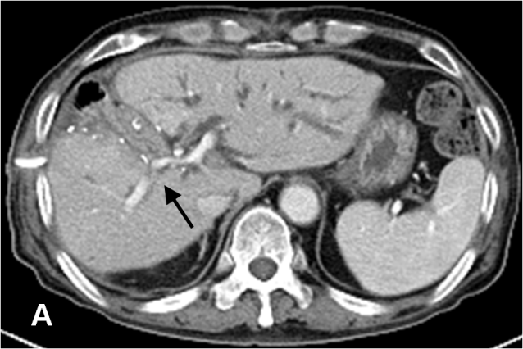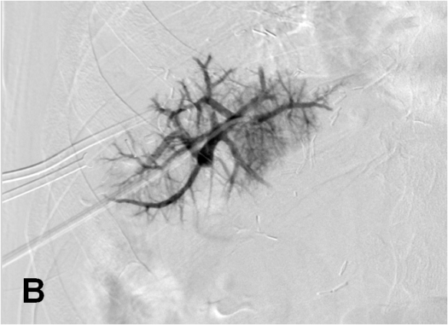
Figure 1 A selection failure case. A 78-year-old man (patient #23) presenting with right PV stenosis after hepatic central segmentectomy with liver metastasis from colon cancer. A: Axial CT scan 40 d after surgery showing severe stenosis (arrow) at the right PV. B: Percutaneous transhepatic portogram showing peripheral right PV. Main PV was not selected due to severe stenosis at the right PV. CT: Computed tomography; PV: portal vein.

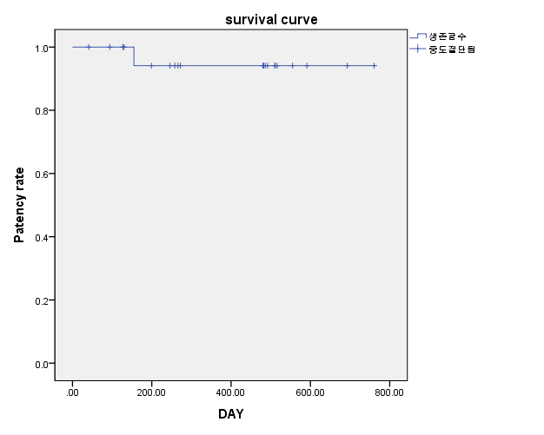
Figure 2 Kaplan-Meier results for cumulative patency rates among 22 patients who underwent portal vein stenting. Initial decrease in patency rate occurred within 155 d after procedure. Further decrease in patency rate was not observed during the entire follow-up period. The cumulative patency rate for PV stent was 95.7%. PV: portal vein.

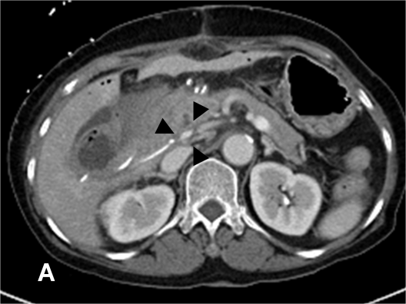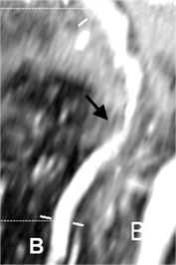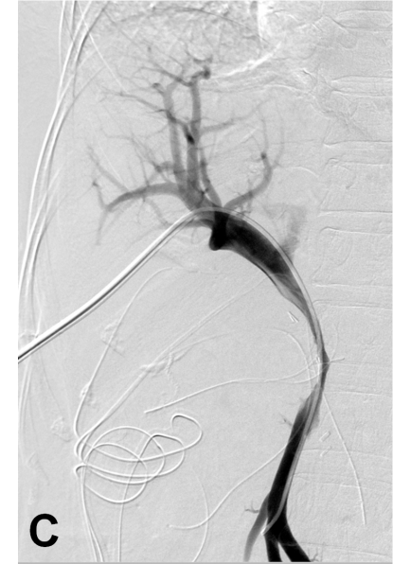
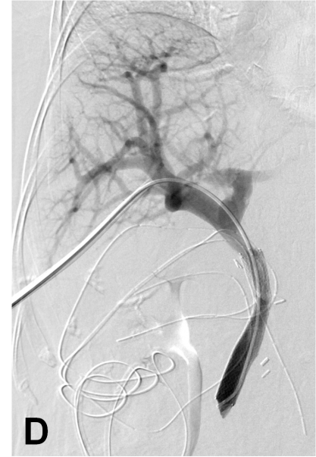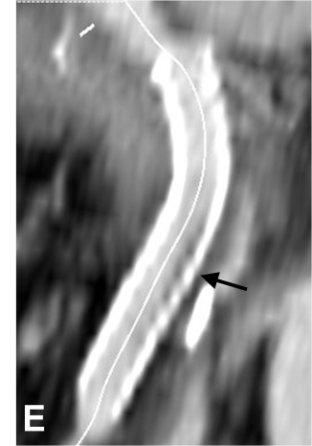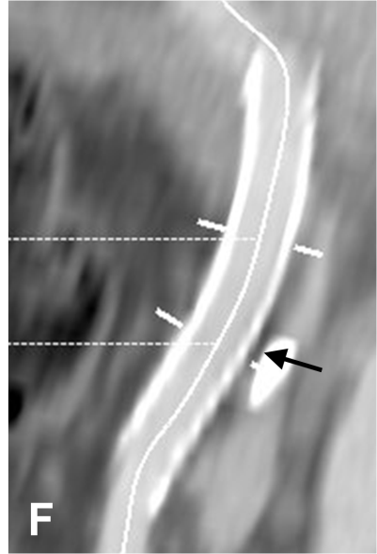
Figure 3 A 68-year-old woman (patient #8) presenting with main portal vein stenosis after pylorus-preserving pancreatoduodenectomy for duodenal gastrointestinal stromal tumor. She presented with anorexia and increased JP drain output during the follow-up period. A: Axial CT image 13 d after surgery showing stenosis at junction between the PV and SMV (arrowheads). B: Curved planar reformatted (CPR) image from abdominal CT 13 d after surgery showing stenosis at junction between the PV and SMV (arrow). C: Percutaneous transhepatic portogram showing severe stenosis (> 50%) at the PV-SMV junction. The pressure gradient was not measured because of definite stagnation of the contrast medium. The contrast medium injected at the distal SMV is clearly stagnant. D: Portogram showing metallic stent in the main PV and SMV and the elimination of stenosis. After the procedure, the patient’s symptoms and signs improved. E: CPR image from abdominal CT 2 d after stenting showing patent stent with small in-stent low-density area (arrow). F: The extent of small in-stent low-density area decreased on CPR image from abdominal CT scan 555 d after stenting (arrow). CT: Computed tomography; PV: portal vein; SMV: superior mesenteric vein.

Table 1 Types of surgery and lesion locations of the patients
patient No. | Age/sex | Surgery | Locations
1 | 65/F | DDLT |  | Main PV
2 | 74/F | Whipple’s op |  | PV-SMV
3 | 58/M | Distal pancreatectomy + Spl-SMV bypass |  | PV-SMV
4 | 73/M | Whipple’s op |  | PV-SMV
5 | 61/F | Whipple’s op |  | PV-SMV
6 | 63/F | PPPD |  | PV-SMV
7 | 75/F | PPPD |  | PV-SMV
8 | 68/F | PPPD |  | PV-SMV
9 | 65/F | PPPD |  | PV-SMV
10 | 70/M | PPPD |  | PV-SMV
11 | 55/M | PPPD |  | PV-SMV
12 | 70/F | PPPD |  | Main PV
13 | 69/F | Whipple’s op |  | PV-SMV
14 | 54/M | Right anterior segmentectomy |  | Right PV
15 | 76/M | Right hemicolectomy + PPPD |  | PV-SpV
16 | 26/M | Right lobectomy |  | Left PV
17 | 55/F | Right + caudate lobectomy |  | Left PV
18 | 66/M | Right + caudate lobectomy |  | Left PV
19 | 74/M | Subtotal pancreatectomy, Splectomy,, partial nephrectomy |  | PV-SMV
20 | 79/F | Trisegmentectomy + caudate lobectomy |  | Left PV
21 | 68/M | Whipple’s op |  | PV-SMV
22 | 78/M | Central segmentectomy |  | Right PV
DDLT: deceased donor liver transplant; PPPD: pylorus-preserving pancreatoduodenectomy; PV: portal vein; SMV: superior mesenteric vein; SpV: splenic vein.

Table 2 Clinical manifestations of patients
Clinical manifestations | No. of patients
Intestinal angina-like abdominal pain refractory to medical treatment
Only pain | 2
Worsening of PVS during the follow-up(>2 wk) | 4
Worsening of PVS during the follow-up(>2 wk) + abnormal LFT | 1
PVT after PCD | 1
Abnormal LFT | 1
Fail to PV anastomosis during the operation | 1
Anorexia refractomy to medical treatment (with increased JPDO) | 1
Ascites | 4
Increased JPDO | 6
Abnormal LFT | 1
Note: “Worsening of PVS” indicates aggravation of the PVS on abdominal CT during the follow-up period. “Increased JPDO” indicates increased serosanguinous JP drain output–suspected ascites. CT: Computed tomography; JPDO: Jackson-Pratt drain output; PVS: portal vein stenosis; PCD: percutaneous drainage; PVT: portal vein thrombosis.

Table 3 The criteria for portal vein stenting - stenosis > 50% of the main portal vein diameter revealed by transhepatic portography, or a pressure gradient across the stenosis > 5 mmHg
Criteria | No. of patients
PVS > 50% with measuring of PrG
PrG > 5 mmHg | 11
PrG = 5 mmHg
Contrast stagnation with collaterals formations | 2
Kinking of PV(stenosis and acute angulation) | 1
PVS > 50% without measuring of PrG
Contrast stagnation with collaterals formations | 3
Kinking of PV | 3
Stenosis and partial PVT | 1
PVS: portal vein stenosis; PrG: pressure gradient; PVT: portal vein thrombosis.

