Name of Journal: World Journal of Gastroenterology
Manuscript NO: 89837
Manuscript Type: ORIGINAL ARTICLE

Basic Study
Bile acids inhibit ferroptosis sensitivity through activating farnesoid X receptor in gastric cancer cells

Liu CX et al. Bile acids inhibit ferroptosis in GC

Chu-Xuan Liu, Ying Gao, Xiu-Fang Xu, Xin Jin, Yun Zhang, Qian Xu, Huan-Xin Ding, Bing-Jun Li, Fang-Ke Du, Lin-Chuan Li, Ming-Wei Zhong, Jian-Kang Zhu, Guang-Yong Zhang

Chu-Xuan Liu, Xin Jin, Guang-Yong Zhang, Department of General Surgery, Shandong Provincial Qianfoshan Hospital, Shandong University, Jinan 250014, Shandong Province, China

Ying Gao, Department of General Surgery, Linyi People's Hospital, Linyi 276034, Shandong Province, China

Xiu-Fang Xu, Department of Nursing, Huantai TCM Hospital, Zibo 256400, Shandong Province, China

Yun Zhang, Center for Translational medical Research, The First Affiliated Hospital of Shandong First Medical University, Jinan 250014, Shandong Province, China

Qian Xu, Huan-Xin Ding, Bing-Jun Li, Fang-Ke Du, Lin-Chuan Li, Ming-Wei Zhong, Jian-Kang Zhu, Guang-Yong Zhang, Department of General Surgery, The First Affiliated Hospital of Shandong First Medical University, Jinan 250014, Shandong Province, China

Author contributions: Zhong MW, Zhu JK and Zhang GY designed and coordinated the study; Liu CX, Gao Y, Jin X and Zhang Y performed the experiments, acquired and analyzed data; Liu CX, Xu Q and Ding HX, interpreted the data; Liu CX, Li BJ, Du FK, Li LC and Zhang GY wrote the manuscript; Xu XF revised this study; all authors approved the final version of the article.

Supported by the Major Basic Research Project of Natural Science Foundation of Shandong Province, No. ZR2020ZD15.

Corresponding author: Guang-Yong Zhang, MD, Chief Doctor, Professor, Department of General Surgery, The First Affiliated Hospital of Shandong First Medical University, No. 16766 Jingshi Road, Jinan 250014, Shandong Province, China. guangyongzhang@hotmail.com

Received: November 21, 2023
Revised: December 12, 2023
Accepted: January 11, 2024
Published online:

Abstract
BACKGROUND
Gastric cancer (GC) is associated with high mortality rates. Bile acids (BAs) reflux is a well-known risk factor for GC, but the specific mechanism remains unclear. During GC development in both humans and animals, BAs serve as signaling molecules that induce metabolic reprogramming. This confers additional cancer phenotypes, including ferroptosis sensitivity. Ferroptosis is a novel mode of cell death characterized by lipid peroxidation that contributes universally to malignant progression. However, it is not fully defined if BAs can influence GC progression by modulating ferroptosis.

AIM
To reveal the mechanism of BAs regulation in ferroptosis of GC cells.

METHODS
In this study, we treated GC cells with various stimuli and evaluated the effect of BAs on the sensitivity to ferroptosis. We used gain and loss of function assays to examine the impacts of farnesoid X receptor (FXR) and BTB and CNC homology 1 (BACH1) overexpression and knockdown to obtain further insights into the molecular mechanism involved.

RESULTS
Our data suggested that BAs could reverse erastin-induced ferroptosis in GC cells. This effect correlated with increased glutathione (GSH) concentrations, a reduced GSH to oxidized GSH ratio, and higher GSH peroxidase 4 (GPX4) expression levels. Subsequently, we confirmed that BAs exerted these effects by activating FXR, which markedly increased the expression of GSH synthetase and GPX4. Notably, BACH1 was detected as an essential intermediate molecule in the promotion of GSH synthesis by BAs and FXR. Finally, our results suggested that FXR could significantly promote GC cell proliferation, which may be closely related to its anti-ferroptosis effect.

CONCLUSION
This study revealed for the first time that BAs could inhibit ferroptosis sensitivity through the FXR-BACH1-GSH-GPX4 axis in GC cells. This work provided new insights into the mechanism associated with BA-mediated promotion of GC and may help identify potential therapeutic targets for GC patients with BAs reflux.

Key Words: Gastric cancer; Ferroptosis; Bile acids; Chenodeoxycholic acid; Farnesoid X receptor; Glutathione

Liu CX, Gao Y, Xu XF, Jin X, Zhang Y, Xu Q, Ding HX, Li BJ, Du FK, Li LC, Zhong MW, Zhu JK, Zhang GY. Bile acids inhibit ferroptosis sensitivity through activating farnesoid X receptor in gastric cancer cells. World J Gastroenterol 2024; In press

Core Tip: Gastric cancer (GC) is the fifth most common cancer worldwide and the third leading cause of cancer-related deaths. Bile acids (BAs) reflux is an essential carcinogenic factor in GC, but its role has not been absolutely elaborated. BAs could serve as signaling molecules to regulate the metabolic state in cells, which is closely related to ferroptosis. In the present experiment, we explored the role of BAs in the regulation of ferroptosis in GC cells. Our data suggested that BAs could significantly inhibit the ferroptosis sensitivity of GC cells and that this effect was exerted through the activation of the farnesoid X receptor-BTB and CNC homology 1-glutathione (GSH)-GSH peroxidase 4 axis.

INTRODUCTION
Gastric cancer (GC) is the fifth most common cancer worldwide and the third leading cause of cancer-related deaths because of the difficulties associated with early diagnosis ^{[1]}. Along with the improvement of life conditions, there is a noticeable decrease in the prevalence of Helicobacter pylori infection, which is the major causative factor of GC^{[2]}. Bile acids (BAs) reflux, another etiologic factor for developing GC, is receiving more attentions^{[3]}. BAs are cholesterol-derived sterols. These small-molecule metabolites play essential roles in the human body. They are amphiphilic and can thus participate in cholesterol absorption and secretion in the intestines^{[4]}. Previous work has shown that BAs reflux is an independent risk factor for precancerous gastric lesions and gastric carcinogenesis^{[5,6]}. For example, gastric mucosal damage can be induced by BAs through activation of the IL-6/JAK1/STAT3 pathway^{[5]}. However, the mechanism by which BAs can promote GC progression remains unknown.
By activating BAs receptors, BAs can modulate immune responses, gastrointestinal mucosal barrier function, gestation, metabolic diseases, and carcinogenesis^{[7-10]}. The farnesoid X receptor (FXR, NR1H4) is a typical BA receptor that has been well investigated. Cholic acid (CA) and chenodeoxycholic acid (CDCA) are the two predominant BAs in the human body^{[11]}, the latter of which is the most potent physiologic agonist of FXR^{[12]}. FXR activation can remodel the metabolic state of cells, including glucose metabolism and lipid metabolism, which in turn is involved in the development of a variety of metabolic diseases and cancers, such as hepatocellular carcinoma^{[13]}. However, further research on the role of FXR in GC patients with BAs reflux is required.
An altered metabolic state, also known as metabolic reprogramming, is a vital factor in cancer progression^{[14]}. Ferroptosis, which is closely related to metabolism, may be involved in the effects of BAs and FXR in GC^{[15]}. Ferroptosis is a novel type of cell death characterized by intracellular phospholipid peroxidation, distinct from apoptosis, pyroptosis, necroptosis, and autophagy^{[16,17]}. This unique mode of cell death is regulated by a variety of factors, particularly oxidative stress. Glutathione (GSH) peroxidase 4 (GPX4) specifically recognizes peroxidized lipids and scavenges them by converting reduced GSH to oxidized GSH (GSSG) for anti-ferroptosis^{[18,19]}. Therefore, GSH, as the substrate of GPX4, also has a key role in the resistance to ferroptosis. Changes in GSH metabolism will eventually lead to alterations in cellular sensitivity to ferroptosis^{[20]}. Although ferroptosis has been reported in GC development and treatment^{[21,22]}, few studies have described ferroptosis in GC with BAs reflux.
In the present study, we investigated the role of BAs, especially CDCA, in the regulation of ferroptosis sensitivity in GC. We subsequently identified the specific receptors for these BAs and further investigated the molecular mechanism.

MATERIALS AND METHODS
Reagents and antibodies
CA (S3742), dehydrocholic acid (DCA, S4562), CDCA (S1843), erastin (S7242), Ferrostatin-1 (Fer-1, S7243), and GW4064 (S2782) were purchased from Selleck Chemicals (Houston, TX, United States). RSL3 (HY-100218A) was purchased from MedChemExpress (Monmouth Junction, NJ, United States). Anti-GPX4 (67763-1-Ig, 1:2500), anti-β-actin (HRP-66009, 1:5000), anti-FXR (25055-1-Ig, 1:1000), anti-GCLC (12601-1-AP, 1:4000), anti-GCLM (14241-1-AP, 1:4000), anti-GSS (67598-1-Ig, 1:4000), and anti-BTB and CNC homology 1 (BACH1, 14018-1-AP, 1:5000) antibodies were purchased from Proteintech (Wuhan, China).

Cell culture
HGC-27 and MKN-45 cells were purchased from Procell (Wuhan, China) and cultured in MEM (for HGC-27) and RPMI-1640 (for MKN-45) medium (Gibco, Carlsbad, CA, United States) containing 10% fetal bovine serum (FBS; Gibco) and 1% Penicillin/Streptomycin (Gibco) at 37°C and 5% CO₂. The cell lines were correctly identified by short tandem repeat (STR) analysis and periodically tested for mycoplasma.

Cell transfection
Cells were seeded in 6-well plates (5 × 10⁵ cells/well) and incubated for 18 h. Then, overexpression or short hairpin RNA plasmids for the indicated genes were transfected using Lipofectamine 2000 (Invitrogen, Carlsbad, CA, United States) for 48 h according to the manufacturer’s instructions.

Cell viability assay
Cells were seeded in 96-well plates (5000 cells/well) in complete medium. After incubation for 18 h, the indicated treatments were added to the cells and incubated for certain times. Then, 100 mL complete medium containing 10 mL cell count kit-8 reagent (CK04, Dojindo Laboratories, Kumamoto, Japan) was added to each well. After incubating the cells for 2 h, the absorbance value for each well was colorimetrically measured at a wavelength of 450 nm.

GSH and Malondialdehyde assay quantification
The cells were collected after indicated stimuli. The GSH concentrations and GSH/GSSG ratio were quantified using the GSSG/GSH Quantification Kit (G263, Dojindo Laboratories, Kumamoto, Japan) according to the manufacturer’s instructions. The results were quantified colorimetrically at a wavelength of 405 nm.
After the indicated treatments, the cells were collected and assayed using the Malondialdehyde (MDA) Assay Kit (S0131S, Beyotime, Shanghai, China) following the manufacturer’s instructions to measure the levels of MDA. The results were quantified colorimetrically at a wavelength of 532 nm.

Lipid reactive oxygen species assay
After the indicated treatments, BODIPY-589/591 C11 (D3861, Thermo Fisher Scientific, Waltham, MA, USA) was added to each well (10 mM). After incubated at 37°C for 30 min, the cells were washed with PBS for three times. Subsequently, the nuclei were stained with DAPI (C1002, Beyotime) for 30 min at room temperature. Finally, the lipid reactive oxygen species was observed under a fluorescence microscope with 488 nm excitation.

5-ethynyl-2′-deoxyuridin staining
Cell proliferation rates under different treatment conditions were assessed using 5-ethynyl-2’-deoxyuridine (EdU) assays (Beyotime) according to the manufacturer’s instructions.

Colony formation assay
Cells were seeded in 6-well plates (500 cells/well), treated with various stimuli, and incubated for 10 to 14 d. The cells were then rinsed three times with PBS and fixed with 4% paraformaldehyde at room temperature for 30 min. Subsequently, the fixed cells were treated with crystal violet at 4°C overnight.

Western blot
Cells were lysed using RIPA buffer containing 1% Phenylmethanesulfonyl fluoride (PMSF, ST505, Beyotime, Shanghai, China) and 2% phosphatase inhibitor. The total protein concentration was quantified using the Bicinchoninic Acid Protein Assay Kit (ST505, Thermo Fisher Scientific, Waltham, MA, United States). Next, protein samples (30 mg) were separated using 10% SDS-PAGE (PG212, EpiZyme, Shanghai, China). Then, the proteins were transferred to PVDF membranes, followed by blocking with 5% BSA (A8020, Solarbio, Beijing, China) at room temperature for 1 h. Afterwards, the membranes were incubated with primary antibodies at 4°C overnight. Subsequently, the membranes were washed with PBST and incubated with a goat anti-mouse or goat anti-rabbit secondary antibody for 1 h at room temperature. Finally, the protein bands were visualized with ECL (Millipore) and quantified with ImageJ software (National Institutes of Health) the manufacturer’s instructions.

Statistical analyses
SPSS 22.0 software (Chicago, IL, United States) was used for data analysis. GraphPad Prism 8.0 (San Diego, CA, United States) software was used to create the images. Data are presented as mean ± SD. One-way ANOVA was used to compare the differences between groups. A P-value of less than 0.05 indicated statistical significance.

RESULTS
BAs can promote GC cell proliferation and inhibit erastin-induced ferroptosis sensitivity in GC cells
It has been shown that BAs tend to induce gastric intestinal metaplasia prior to causing GC^{[23]}. Thus, two GC cell lines, HGC-27 and MKN-45, were chosen because they were both classified as intestinal type GC cells^{[24]}. Three common BAs including CA, DCA, and CDCA, were chosen to stimulate GC cells in vitro. The cell viability assay results suggested that these BAs could significantly promote GC cell proliferation rates, especilly CDCA (Figure 1A and B). Subsequently, to investigate if they could modulate ferroptosis in GC cells, we examined the effects of the three BAs on HGC-27 and MKN-45 cell sensitivity to erastin, a classical inducer of ferroptosis. Interestingly, the GC cells treated with BAs exhibited higher viabilities compared with the controls, suggesting that the BAs possibly could support resistance to the ferroptosis induced by erastin (Figure 1C and D). Because it was the most effective BAs proved by above results and in previous study^{[23]}, CDCA was chosen in subsequent experiments. We then examined the effect of CDCA on the sensitivity to erastin-induced ferroptosis in GC cells at 24 and 48 h, respectively. The anti-ferroptosis effect was confirmed (Figure 1E-H). To exclude interference from other types of cell death, we performed the MDA assays (Figure 1I and J) and BODIPY-589/591 C11 staining (Figure 1K), which directly reflected ferroptosis and reconfirmed the anti-ferroptosis function of the BAs.

BAs significantly upregulated GSH and GPX4 Levels in GC cells
The cystine-glumate antiporter (xCT) is an essential anti-ferroptosis protein located on the cytomembrane that exchanges intracellular glutamate for extracellular cystine in a 1:1 ratio^{[25,26]}. Mechanistically, erastin induces ferroptosis by acting on xCT and inhibiting its function. This thereby downregulates the levels of downstream GSH and GPX4, which inhibit the onset of ferroptosis^{[27]}. Additionally, another classical ferroptosis inducer is RSL3, which targets and inactivates GPX4^{[28]}. Therefore, to explore the anti-ferroptosis mechanism of CDCA, we examined its effect on RSL3-induced cell death using cell viability assays. Interestingly, CDCA did not ameliorate RSL3-induced GC cell death (Figure 2A and B), nor could it ameliorate the ferroptosis caused by RSL3 (Figure 2C-E). We therefore speculated that CDCA possibly exerted its anti-ferroptosis effect by upregulating GSH and GPX4 levels. To verify this hypothesis, we examined the GSH concentrations and GSH/GSSG ratio in CDCA-treated cells, finding that CDCA treatment significantly increased them compared with the control group (Figure 2F-I). Besides, CDCA also significantly attenuated the GPX4 protein expression downregulation induced by erastin, as seen with Western blot (WB) analysis (Figure 2J and K).

BAs exerted its anti-ferroptosis sensitivity function in GC cells by activating FXR
CDCA is the strongest FXR agonist in the human body^{[12]}. Therefore, we hypothesized that CDCA acted through activating FXR to inhibit the sensitization of GC cells to ferroptosis. We firstly used GW4064, an in vitro agonist of FXR, and found that the ferroptosis sensitivity of GC cells treated with GW4064 was significantly reduced (Figure 3A and B). Subsequently, we transfected shFXR and its control plasmid in HGC-27 and MKN-45 cells, constructing a cellular knockdown model of FXR to be successfully constructed by WB analysis (Figure 3C and D). Our data showed that after knocking down FXR, CDCA-induced erastin resistance was not observed (Figure 3E and F) and it could no longer reverse the onset of erastin-induced ferroptosis (Figure 3G-I). We further constructed an overexpression model of FXR in HGC-27 and MKN-45 cells (Figure 3J and K). FXR overexpression resulted in a significant enhancement of resistance to erastin-induced cell death in HGC-27 and MKN-45 (Figure 3L and M), as well as a significant reversal of ferroptosis (Figure 3N-P).

FXR significantly promoted GSH synthesis in GC cells
To investigate whether FXR could likewise increase intracellular GSH concentrations, we examined the effect of FXR on GSH levels. The results showed that GSH concentrations were significantly reduced after FXR knockdown in HGC-27 and MKN-45 cells (Figure 4A and B). The GSH/GSSG ratio, an indicator of cellular antioxidant capacity, was also significantly decreased after FXR knockdown (Figure 4C and D). We next examined the effect of FXR on the protein expression levels of GSH synthesis-related enzymes in GC cells using WB analysis, finding that FXR knockdown significantly reduced the expression of GSH synthases, including GCLC, GCLM and GSS. It also affected GPX4 expression levels, which used GSH as a substrate (Figure 4E and F). To further validate these observations, we repeated the above experiments using the FXR overexpression HGC-27 and MKN-45 cells. The results showed that overexpressing FXR in these GC cells led to increased GSH concentrations (Figure 4G and H), GSH/GSSG ratio (Figure 4I and J), and GSH synthase and GPX4 expression levels (Figure 4K and L).

FXR exerted its anti-ferroptosis and pro-GSH synthesis effects correlating with inhibiting BACH1 in GC cells
Recently, FXR was shown to inhibit heme catabolism and increase heme levels by repressing HO-1 transcription^{[29]}. Heme in high concentrations can inhibit BACH1, which can lead to decreased expression of GSH synthases^{[30,31]}. Therefore, BACH1 is potentially a crucial bridge through which FXR exerted its effects. We firstly detected BACH1 protein expression using WB analysis in HCG-27 and MKN-45 cells with overexpression or knockdown of FXR expression. The results showed that knocking down FXR indeed significantly elevated BACH1 protein levels (Figure 5A and B), while overexpressing FXR significantly downregulated BACH1 expression (Figure 5C and D). To further validate the role of BACH1 in this system, we constructed overexpression models of BACH1 in HGC-27 and MKN-45 cells and verified (Figure 5E and F). We then transfected cells with the FXR overexpression plasmid together with the BACH1 overexpression plasmid and erastin treatment. This rescue experiment suggested that overexpression of BACH1 Led to a significant reduction in ferroptosis resistance mediated by FXR, as seen with the MDA assay and BODIPY-589/591 C11 staining results (Figure 5G-I). Simultaneously, FXR-mediated enhancements of GSH concentrations (Figure 5J and K), GSH/GSSG ratio (Figure 5L and M), GSH synthase expression including GCLC, GCLM, GSS, and GPX4 (Figure 5N and O) were significantly reversed by overexpressed BACH1.

FXR significantly promoted GC cells proliferation
To further determine the role of FXR in GC progression, we analyzed its biological functions in GC cells. As described above, knockdown models of FXR in HGC-27 and MKN-45 cells were constructed (Figure 3C and D). Subsequently, cell viability assays showed that GC cell proliferation rates were significantly reduced after FXR knockdown (Figure 6A and B). This was also confirmed by EdU staining, which showed that the proportion of actively proliferating GC cells was significantly reduced with lower FXR expression levels (Figure 6C and D). Additional assays likewise revealed that the colony formation ability of GC cells was significantly decreased after knocking down FXR (Figure 6E and F). Experiments with the overexpression model showed that FXR promoted GC cell proliferation (Figure 6G and H), facilitated the capacity of DNA replication (Figure 6I and J), and enhanced the colony formation ability (Figure 6K and L).

DISCUSSION
GC is a major cause of cancer-related mortality in East Asia^{[32]}, but the molecular mechanisms and regulatory systems involved still need to be further elucidated. In the present study, we provided evidence that BAs can promote GC progression by inhibiting the ferroptosis sensitivity of GC, then explored the related mechanism in more detail.
BAs are essential small-molecule metabolites that can act as signaling molecules in the onset and progression of many diseases in humans, including various cancers^{[33]}. For example, BAs can promote gastric carcinogenesis via the IL-6/JAK1/STAT3 axis^{[5]}. Since the discovery of ferroptosis, numerous studies have focused on its potential use as a therapeutic target in cancer, including in GC^{[34]}. For instance, activation of the Wnt/beta-catenin signaling pathway significantly enhanced ferroptosis resistance in GC^{[35]}. ACTL6A inhibits the onset of ferroptosis in GC by upregulating GCLC^{[36]}. However, only a few studies have explored whether BAs can affect GC through regulation of ferroptosis. Our data indicated that several BAs, especially CDCA, significantly inhibit erastin-induced GC cell death. Additionally, we confirmed that erastin induced cell death through ferroptosis. Subsequently, we found that the BAs did not reverse cell death induced by RSL3, a ferroptosis inducer that targeted GPX4. This suggested that BAs may exert their anti-ferroptosis activity through GSH, which is downstream of the erastin target xCT and upstream of GPX4. Indeed, both the GSH concentration and the GSH/GSSG ratio were significantly elevated following treatment of GC cells with BAs. This suggested that the BAs increased both GSH and GPX4 levels in GC cells, resulting in resistance to ferroptosis.
We hypothesized that CDCA regulates ferroptosis in GC cells by acting through FXR. FXR is a member of the nuclear hormone receptor superfamily, for which BAs are physiological ligands. Of these, CDCA has the strongest in vivo affinity for FXR^{[11,37]}. Previous work demonstrated that FXR promotes gastric intestinal metaplasia, a precancerous lesion that can lead to GC development, via the FXR/SNAI2/miR-1 axis^{[38]}. However, the role played by FXR in GC progression, and especially in ferroptosis, remained unknown. We found that GW4064, a classical in vitro FXR agonist, had similar effects on GC cell death as BAs. Subsequently, we performed FXR gain and loss of function assays and found that the anti-ferroptosis effect of the BAs was almost completely abolished by FXR knockdown, while FXR overexpression in the absence of BAs decreased GC cell ferroptosis. In addition, our data suggested that FXR can increase the expression of GSH synthases, including GSS, GCLC, and GCLM, as well as significantly increase the GSH concentration, GSH/GSSG ratio, and GPX4 expression in GC cells. These results suggest that BAs may inhibit ferroptosis by promoting GSH synthesis via FXR activation.
To clarify the mechanism by which FXR exerts its effects in the context of GC, we reviewed relevant studies and found that FXR suppresses the expression of HO-1, which can degrade heme, leading to inhibition of BACH1^{[29]}. BACH1 belongs to the CNC b-Zip family of proteins and can inhibit intracellular synthesis of GSH^{[30,31,39]}. Therefore, we considered whether BACH1 acts as a bridge between GSH synthesis and FXR. Our data indicated that FXR and BACH1 expression levels were inversely related, suggesting that FXR inhibits BACH1 expression. Subsequent functional rescue experiments revealed that BACH1 overexpression partially counteracted the pro-GSH synthesis and anti-ferroptosis effects of FXR. Finally, we investigated the effect of FXR on GC cell growth and found that FXR has marked oncogenic capacity, as it significantly increased GC cell proliferation rates, which may be closely related to the inhibition of GC cell ferroptosis by FXR.
This study had some limitations. Because of experimental restrictions, we were unable to perform in vivo experiments to validate our in vitro results. Additionally, we did not investigate the molecular mechanism by which FXR regulates BACH1; this requires further research.

CONCLUSION
Overall, our study illustrates a novel strategy by which BAs regulate ferroptosis in GC cells, and provides new insights into the molecular mechanisms underlying BA-mediated promotion of GC progression. We found that ferroptosis plays an influential role in GC progression, raising the possibility that treatments targeting FXR and BACH1 could improve the outcomes of GC patients with BAs reflux.

ARTICLE HIGHLIGHTS
Research background
Gastric cancer (GC) is the fifth most common cancer worldwide and the third leading cause of cancer-related deaths because of the difficulties associated with early diagnosis. Bile acids (BAs) reflux, as an etiologic factor for GC, is receiving more attentions. BAs are engaged in the regulation of metabolism, and the latter is closely related to the ferroptosis. Thus BAs may be potentially relevant to the regulation of ferroptosis.

Research motivation
To elaborate the relationship between BAs and ferroptosis in GC and to providing new insights into the precise treatment of GC patients with BAs reflux.

Research objectives
In this study, we aimed to explore the role of BAs in regulating ferroptosis in GC and to investigate the underlying molecular mechanisms. The present study helps to further elucidate the pathophysiologic mechanisms in GC patients with BAs reflux.

Research methods
The research methods are as follows: cell transfection, cell viability assay, glutathione (GSH) and Malondialdehyde assay quantification, lipid reactive oxygen species assay, 5-ethynyl-2′-deoxyuridine staining, colony formation assay, Western blot.

Research results
Firstly, we found that BAs can promote GC cell proliferation and inhibit erastin-induced ferroptosis sensitivity through upregulate GSH and GSH peroxidase 4 (GPX4). Secondly, BAs exerted its anti-ferroptosis sensitivity function in GC cells by activating farnesoid X receptor (FXR) which significantly promoted GSH synthesis. Subsequently, BTB and CNC homology 1 (BACH1) provided an essential bridging role in BAs and FXR facilitating GSH synthesis. Finally, the notable oncogenic effects of FXR were discovered.

Research conclusions
BAs could inhibit ferroptosis sensitivity through the FXR-BACH1-GSH-GPX4 axis in GC cells.

Research perspectives
The findings of this basic study will be validated in in vivo experiments and clinical specimens to clarify whether FXR and BACH1 can serve as therapeutic targets for GC patients with BAs reflux.

REFERENCES
1 Bray F, Ferlay J, Soerjomataram I, Siegel RL, Torre LA, Jemal A. Global cancer statistics 2018: GLOBOCAN estimates of incidence and mortality worldwide for 36 cancers in 185 countries. CA Cancer J Clin 2018; 68: 394-424 [PMID: 30207593 DOI: 10.3322/caac.21492]
2 Smyth EC, Nilsson M, Grabsch HI, van Grieken NC, Lordick F. Gastric cancer. Lancet 2020; 396: 635-648 [PMID: 32861308 DOI: 10.1016/S0140-6736(20)31288-5]
3 Oba M, Miwa K, Fujimura T, Harada S, Sasaki S, Hattori T. Chemoprevention of glandular stomach carcinogenesis through duodenogastric reflux in rats by a COX-2 inhibitor. Int J Cancer 2008; 123: 1491-1498 [PMID: 18646190 DOI: 10.1002/ijc.23742]
4 Collins SL, Stine JG, Bisanz JE, Okafor CD, Patterson AD. Bile acids and the gut microbiota: metabolic interactions and impacts on disease. Nat Rev Microbiol 2023; 21: 236-247 [PMID: 36253479 DOI: 10.1038/s41579-022-00805-x]
5 Wang S, Kuang J, Zhang H, Chen W, Zheng X, Wang J, Huang F, Ge K, Li M, Zhao M, Rajani C, Zhu J, Zhao A, Jia W. Bile Acid-Microbiome Interaction Promotes Gastric Carcinogenesis. Adv Sci (Weinh) 2022; 9: e2200263 [PMID: 35285172 DOI: 10.1002/advs.202200263]
6 Dixon MF, Mapstone NP, Neville PM, Moayyedi P, Axon AT. Bile reflux gastritis and intestinal metaplasia at the cardia. Gut 2002; 51: 351-355 [PMID: 12171955 DOI: 10.1136/gut.51.3.351]
7 Hang S, Paik D, Yao L, Kim E, Trinath J, Lu J, Ha S, Nelson BN, Kelly SP, Wu L, Zheng Y, Longman RS, Rastinejad F, Devlin AS, Krout MR, Fischbach MA, Littman DR, Huh JR. Bile acid metabolites control T(H)17 and T(reg) cell differentiation. Nature 2019; 576: 143-148 [PMID: 31776512 DOI: 10.1038/s41586-019-1785-z]
8 McIlvride S, Dixon PH, Williamson C. Bile acids and gestation. Mol Aspects Med 2017; 56: 90-100 [PMID: 28506676 DOI: 10.1016/j.mam.2017.05.003]
9 Mikó E, Kovács T, Sebő É, Tóth J, Csonka T, Ujlaki G, Sipos A, Szabó J, Méhes G, Bai P. Microbiome-Microbial Metabolome-Cancer Cell Interactions in Breast Cancer-Familiar, but Unexplored. Cells 2019; 8 [PMID: 30934972 DOI: 10.3390/cells8040293]
10 Watanabe M, Houten SM, Mataki C, Christoffolete MA, Kim BW, Sato H, Messaddeq N, Harney JW, Ezaki O, Kodama T, Schoonjans K, Bianco AC, Auwerx J. Bile acids induce energy expenditure by promoting intracellular thyroid hormone activation. Nature 2006; 439: 484-489 [PMID: 16400329 DOI: 10.1038/nature04330]
11 Režen T, Rozman D, Kovács T, Kovács P, Sipos A, Bai P, Mikó E. The role of bile acids in carcinogenesis. Cell Mol Life Sci 2022; 79: 243 [PMID: 35429253 DOI: 10.1007/s00018-022-04278-2]
12 Makishima M, Okamoto AY, Repa JJ, Tu H, Learned RM, Luk A, Hull MV, Lustig KD, Mangelsdorf DJ, Shan B. Identification of a nuclear receptor for bile acids. Science 1999; 284: 1362-1365 [PMID: 10334992 DOI: 10.1126/science.284.5418.1362]
13 Sun L, Cai J, Gonzalez FJ. The role of farnesoid X receptor in metabolic diseases, and gastrointestinal and liver cancer. Nat Rev Gastroenterol Hepatol 2021; 18: 335-347 [PMID: 33568795 DOI: 10.1038/s41575-020-00404-2]
14 Martínez-Reyes I, Chandel NS. Cancer metabolism: looking forward. Nat Rev Cancer 2021; 21: 669-680 [PMID: 34272515 DOI: 10.1038/s41568-021-00378-6]
15 Liang D, Minikes AM, Jiang X. Ferroptosis at the intersection of lipid metabolism and cellular signaling. Mol Cell 2022; 82: 2215-2227 [PMID: 35390277 DOI: 10.1016/j.molcel.2022.03.022]
16 Dixon SJ, Lemberg KM, Lamprecht MR, Skouta R, Zaitsev EM, Gleason CE, Patel DN, Bauer AJ, Cantley AM, Yang WS, Morrison B 3rd, Stockwell BR. Ferroptosis: an iron-dependent form of nonapoptotic cell death. Cell 2012; 149: 1060-1072 [PMID: 22632970 DOI: 10.1016/j.cell.2012.03.042]
17 Jiang X, Stockwell BR, Conrad M. Ferroptosis: mechanisms, biology and role in disease. Nat Rev Mol Cell Biol 2021; 22: 266-282 [PMID: 33495651 DOI: 10.1038/s41580-020-00324-8]
18 Zheng J, Conrad M. The Metabolic Underpinnings of Ferroptosis. Cell Metab 2020; 32: 920-937 [PMID: 33217331 DOI: 10.1016/j.cmet.2020.10.011]
19 Stockwell BR, Jiang X, Gu W. Emerging Mechanisms and Disease Relevance of Ferroptosis. Trends Cell Biol 2020; 30: 478-490 [PMID: 32413317 DOI: 10.1016/j.tcb.2020.02.009]
20 Yang WS, SriRamaratnam R, Welsch ME, Shimada K, Skouta R, Viswanathan VS, Cheah JH, Clemons PA, Shamji AF, Clish CB, Brown LM, Girotti AW, Cornish VW, Schreiber SL, Stockwell BR. Regulation of ferroptotic cancer cell death by GPX4. Cell 2014; 156: 317-331 [PMID: 24439385 DOI: 10.1016/j.cell.2013.12.010]
21 Ouyang S, Li H, Lou L, Huang Q, Zhang Z, Mo J, Li M, Lu J, Zhu K, Chu Y, Ding W, Zhu J, Lin Z, Zhong L, Wang J, Yue P, Turkson J, Liu P, Wang Y, Zhang X. Inhibition of STAT3-ferroptosis negative regulatory axis suppresses tumor growth and alleviates chemoresistance in gastric cancer. Redox Biol 2022; 52: 102317 [PMID: 35483272 DOI: 10.1016/j.redox.2022.102317]
22 Lin Z, Song J, Gao Y, Huang S, Dou R, Zhong P, Huang G, Han L, Zheng J, Zhang X, Wang S, Xiong B. Hypoxia-induced HIF-1α/lncRNA-PMAN inhibits ferroptosis by promoting the cytoplasmic translocation of ELAVL1 in peritoneal dissemination from gastric cancer. Redox Biol 2022; 52: 102312 [PMID: 35447413 DOI: 10.1016/j.redox.2022.102312]
23 Li T, Guo H, Li H, Jiang Y, Zhuang K, Lei C, Wu J, Zhou H, Zhu R, Zhao X, Lu Y, Shi C, Nie Y, Wu K, Yuan Z, Fan DM, Shi Y. MicroRNA-92a-1-5p increases CDX2 by targeting FOXD1 in bile acids-induced gastric intestinal metaplasia. Gut 2019; 68: 1751-1763 [PMID: 30635407 DOI: 10.1136/gutjnl-2017-315318]
24 Lee JY, Nam M, Son HY, Hyun K, Jang SY, Kim JW, Kim MW, Jung Y, Jang E, Yoon SJ, Kim J, Kim J, Seo J, Min JK, Oh KJ, Han BS, Kim WK, Bae KH, Song J, Kim J, Huh YM, Hwang GS, Lee EW, Lee SC. Polyunsaturated fatty acid biosynthesis pathway determines ferroptosis sensitivity in gastric cancer. Proc Natl Acad Sci U S A 2020; 117: 32433-32442 [PMID: 33288688 DOI: 10.1073/pnas.2006828117]
25 Bannai S. Exchange of cystine and glutamate across plasma membrane of human fibroblasts. J Biol Chem 1986; 261: 2256-2263 [PMID: 2868011]
26 Tang D, Chen X, Kang R, Kroemer G. Ferroptosis: molecular mechanisms and health implications. Cell Res 2021; 31: 107-125 [PMID: 33268902 DOI: 10.1038/s41422-020-00441-1]
27 Chen X, Li J, Kang R, Klionsky DJ, Tang D. Ferroptosis: machinery and regulation. Autophagy 2021; 17: 2054-2081 [PMID: 32804006 DOI: 10.1080/15548627.2020.1810918]
28 Shin D, Kim EH, Lee J, Roh JL. Nrf2 inhibition reverses resistance to GPX4 inhibitor-induced ferroptosis in head and neck cancer. Free Radic Biol Med 2018; 129: 454-462 [PMID: 30339884 DOI: 10.1016/j.freeradbiomed.2018.10.426]
29 Kim DH, Choi HI, Park JS, Kim CS, Bae EH, Ma SK, Kim SW. Farnesoid X receptor protects against cisplatin-induced acute kidney injury by regulating the transcription of ferroptosis-related genes. Redox Biol 2022; 54: 102382 [PMID: 35767918 DOI: 10.1016/j.redox.2022.102382]
30 Wiel C, Le Gal K, Ibrahim MX, Jahangir CA, Kashif M, Yao H, Ziegler DV, Xu X, Ghosh T, Mondal T, Kanduri C, Lindahl P, Sayin VI, Bergo MO. BACH1 Stabilization by Antioxidants Stimulates Lung Cancer Metastasis. Cell 2019; 178: 330-345.e22 [PMID: 31257027 DOI: 10.1016/j.cell.2019.06.005]
31 Nishizawa H, Yamanaka M, Igarashi K. Ferroptosis: regulation by competition between NRF2 and BACH1 and propagation of the death signal. FEBS J 2023; 290: 1688-1704 [PMID: 35107212 DOI: 10.1111/febs.16382]
32 Huang J, Lucero-Prisno DE 3rd, Zhang L, Xu W, Wong SH, Ng SC, Wong MCS. Updated epidemiology of gastrointestinal cancers in East Asia. Nat Rev Gastroenterol Hepatol 2023; 20: 271-287 [PMID: 36631716 DOI: 10.1038/s41575-022-00726-3]
33 Jia W, Xie G, Jia W. Bile acid-microbiota crosstalk in gastrointestinal inflammation and carcinogenesis. Nat Rev Gastroenterol Hepatol 2018; 15: 111-128 [PMID: 29018272 DOI: 10.1038/nrgastro.2017.119]
34 Hassannia B, Vandenabeele P, Vanden Berghe T. Targeting Ferroptosis to Iron Out Cancer. Cancer Cell 2019; 35: 830-849 [PMID: 31105042 DOI: 10.1016/j.ccell.2019.04.002]
35 Wang Y, Zheng L, Shang W, Yang Z, Li T, Liu F, Shao W, Lv L, Chai L, Qu L, Xu Q, Du J, Liang X, Zeng J, Jia J. Wnt/beta-catenin signaling confers ferroptosis resistance by targeting GPX4 in gastric cancer. Cell Death Differ 2022; 29: 2190-2202 [PMID: 35534546 DOI: 10.1038/s41418-022-01008-w]
36 Yang Z, Zou S, Zhang Y, Zhang J, Zhang P, Xiao L, Xie Y, Meng M, Feng J, Kang L, Lee MH, Fang L. ACTL6A protects gastric cancer cells against ferroptosis through induction of glutathione synthesis. Nat Commun 2023; 14: 4193 [PMID: 37443154 DOI: 10.1038/s41467-023-39901-8]
37 Forman BM, Goode E, Chen J, Oro AE, Bradley DJ, Perlmann T, Noonan DJ, Burka LT, McMorris T, Lamph WW, Evans RM, Weinberger C. Identification of a nuclear receptor that is activated by farnesol metabolites. Cell 1995; 81: 687-693 [PMID: 7774010 DOI: 10.1016/0092-8674(95)90530-8]
38 Wang N, Wu S, Zhao J, Chen M, Zeng J, Lu G, Wang J, Zhang J, Liu J, Shi Y. Bile acids increase intestinal marker expression via the FXR/SNAI2/miR-1 axis in the stomach. Cell Oncol (Dordr) 2021; 44: 1119-1131 [PMID: 34510400 DOI: 10.1007/s13402-021-00622-z]
39 Sun J, Brand M, Zenke Y, Tashiro S, Groudine M, Igarashi K. Heme regulates the dynamic exchange of Bach1 and NF-E2-related factors in the Maf transcription factor network. Proc Natl Acad Sci U S A 2004; 101: 1461-1466 [PMID: 14747657 DOI: 10.1073/pnas.0308083100]

Footnotes
Institutional review board statement: This basic study did not involve human and/or animal subjects.

Conflict-of-interest statement: The authors declare that the research was conducted in the absence of any commercial or financial relationships that could be construed as a potential conflict of interest.

Data sharing statement: No additional data are available.

Open-Access: This article is an open-access article that was selected by an in-house editor and fully peer-reviewed by external reviewers. It is distributed in accordance with the Creative Commons Attribution NonCommercial (CC BY-NC 4.0) license, which permits others to distribute, remix, adapt, build upon this work non-commercially, and license their derivative works on different terms, provided the original work is properly cited and the use is non-commercial. See: https://creativecommons.org/Licenses/by-nc/4.0/

Provenance and peer review: Unsolicited article; Externally peer reviewed.

Peer-review model: Single blind

Peer-review started: November 21, 2023
First decision: December 8, 2023
Article in press:

Specialty type: Gastroenterology and hepatology
Country/Territory of origin: China
Peer-review report’s scientific quality classification
Grade A (Excellent): 0
Grade B (Very good): B
Grade C (Good): 0
Grade D (Fair): 0
Grade E (Poor): 0

P-Reviewer: Kalkum E, Germany S-Editor: Lin C L-Editor: A P-Editor:
Figure Legends
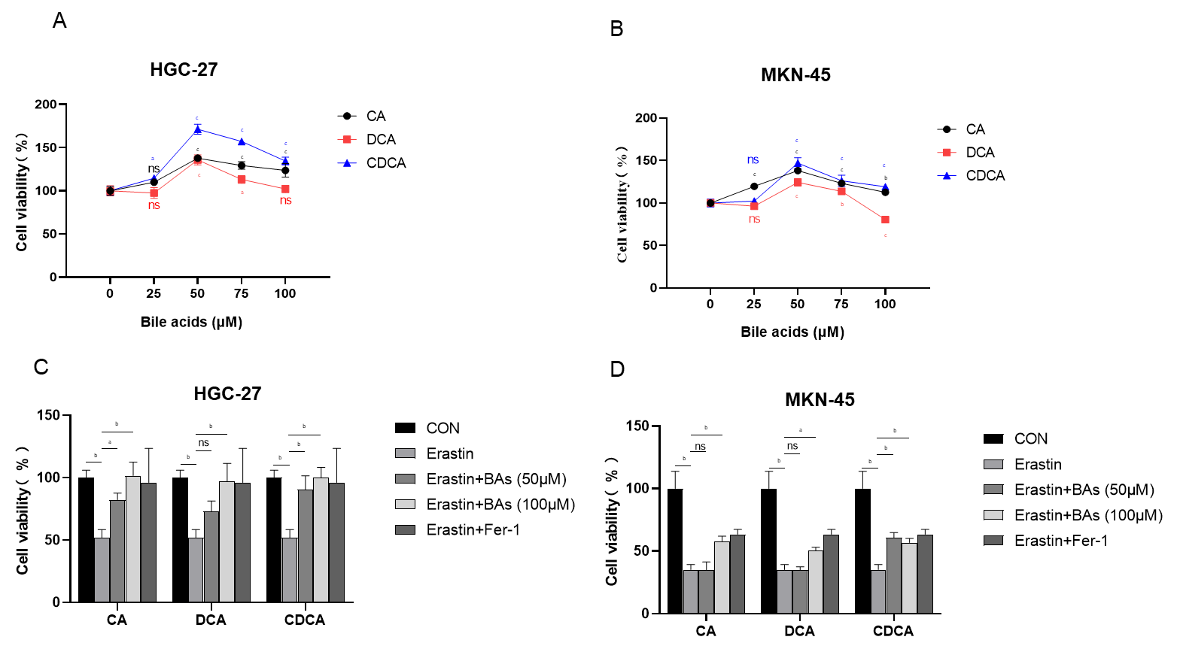
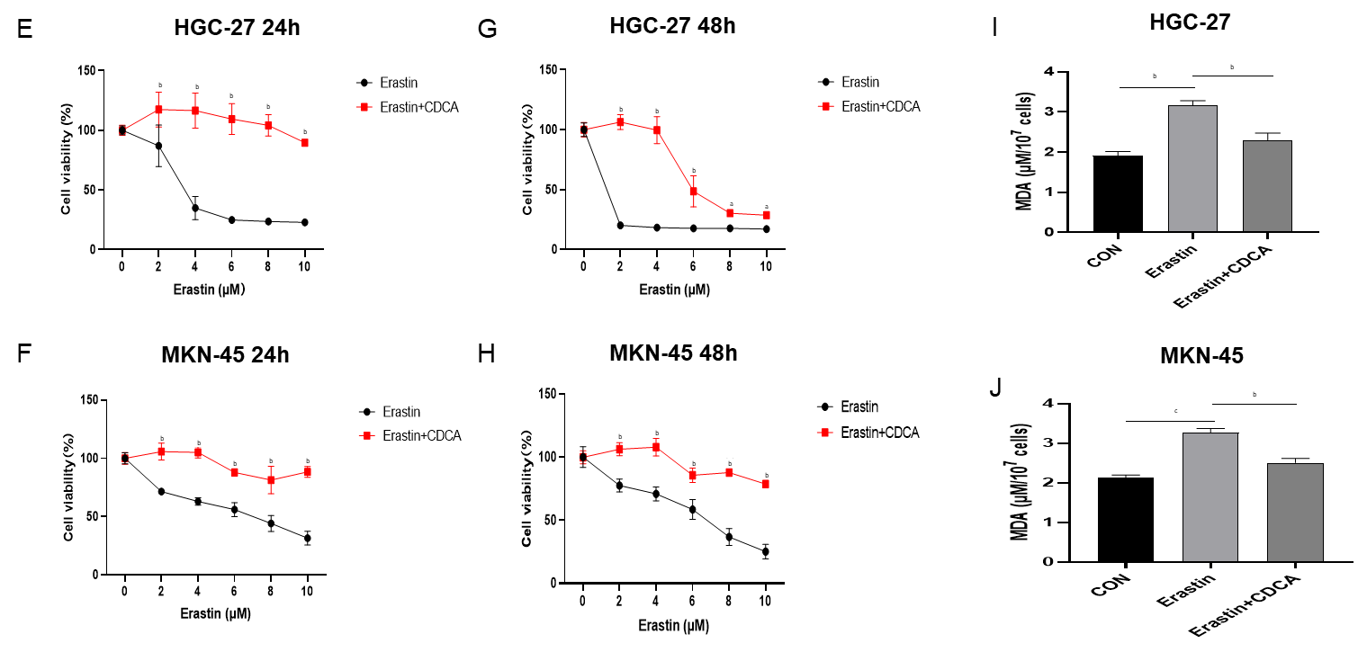
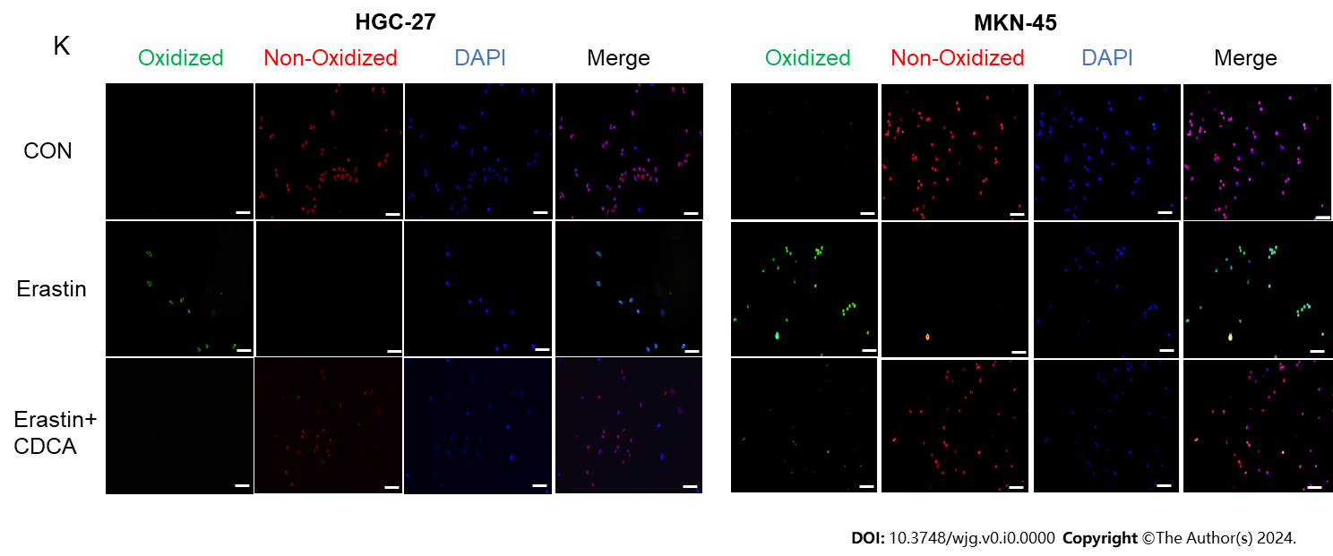
Figure 1 Bile acids enhanced proliferation and inhibited erastin-induced ferroptosis sensitivity in gastric cancer cells. A and B: Cell viability assay for HGC-27 and MKN-45 cells treated with three Bas; C and D: Cell viability assay for HGC-27 and MKN-45 cells treated with different concentration of BAs together with erastin (5 μM); E-H: Cell viability assay for two gastric cancer cell lines stimulated with erastin followed by chenodeoxycholic acid (50 μM) or control for 24 and 48 h; I and J: Malondialdehyde production in HGC-27 and MKN-45 cells; K: BODIPY-589/591 C11 staining to identify lipid reactive oxygen species in the cell lines under different treatments. Scale bar: 100 μm. ªP < 0.05, ^{b}P < 0.01, ^{c}P < 0.001. These experiments were repeated three times. BAs: Bile acids; CA: Cholic acid; DCA: Dehydrocholic acid; CDCA: Chenodeoxycholic acid; MDA: Malondialdehyde; ns: Not significant.
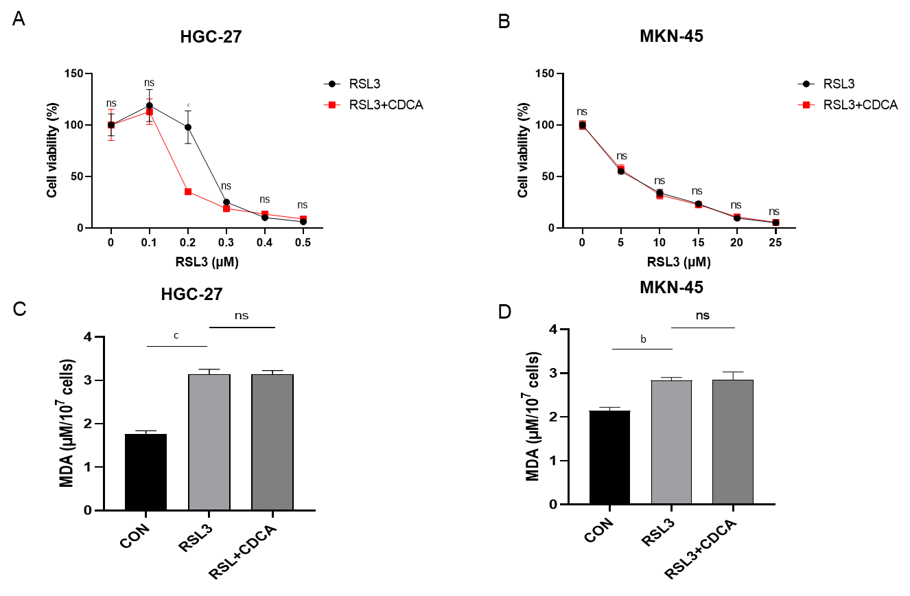
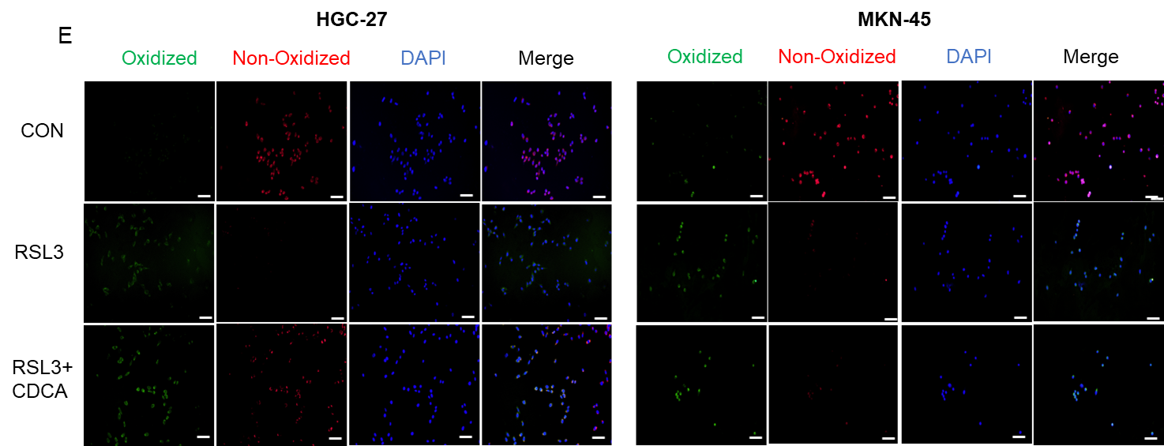
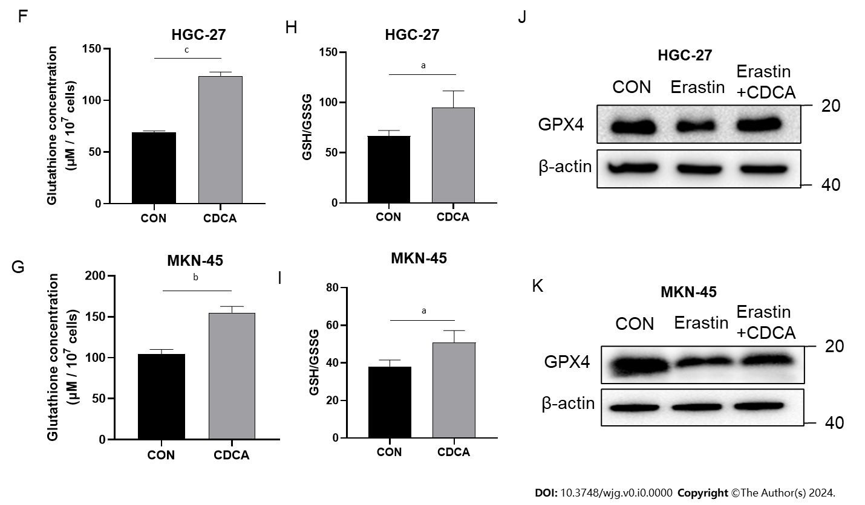
Figure 2 Bile acids significantly upregulated glutathione and glutathione peroxidase 4 in gastric cancer cells. A and B: Cell viability assay of two gastric cancer cell lines treated with RSL3 together with chenodeoxycholic acid (CDCA) or control; C and D: Malondialdehyde production in HGC-27 and MKN-45 cells treated with RSL3 (0.2 μM for HGC-27, 10 μM for MKN-45) followed by CDCA or control; E: BODIPY-589/591 C11 staining to identify lipid reactive oxygen species in the cell lines treated with RSL3 (0.2 μM for HGC-27, 10 μM for MKN-45) followed by CDCA or control; F and G: The glutathione (GSH) concentrations were measured in cells treated with CDCA; H and I: The GSH/oxidized GSH ratio was measured in cells treated with CDCA; J and K: Western blot analysis of GSH peroxidase 4 protein expression in HGC-27 and MKN-45 cells under different stimuli. Scale bar: 100 μm. ªP < 0.05, ^{b}P < 0.01, ^{c}P < 0.001. These experiments were repeated three times. CDCA: Chenodeoxycholic acid; MDA: Malondialdehyde; GPX4: Glutathione peroxidase 4; ns: Not significant.
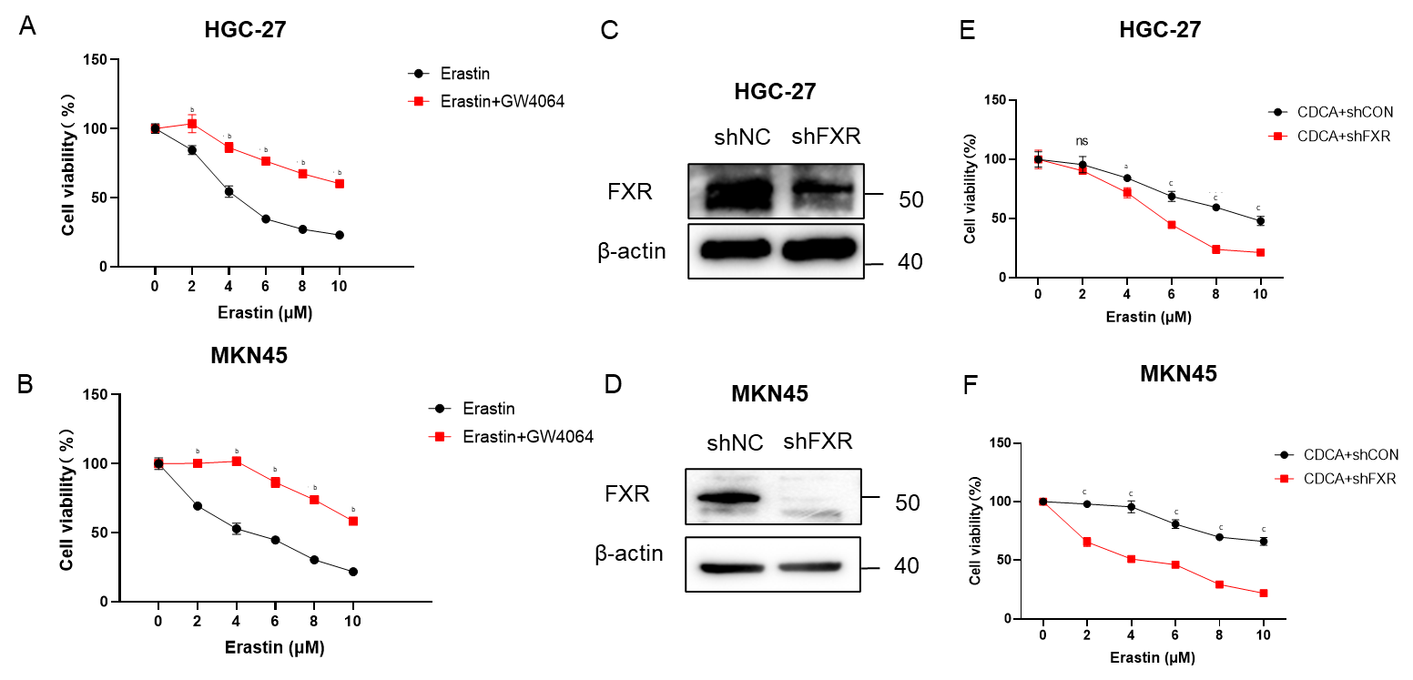
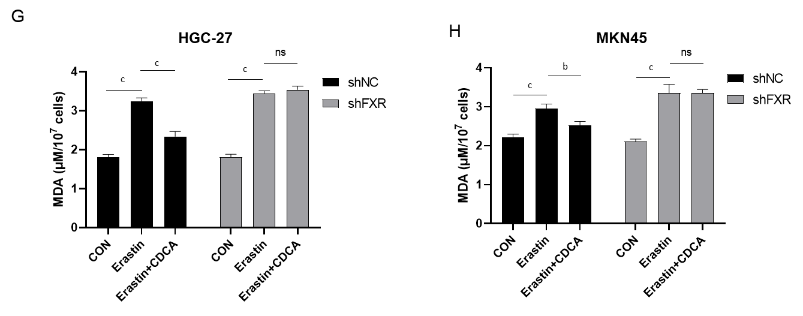
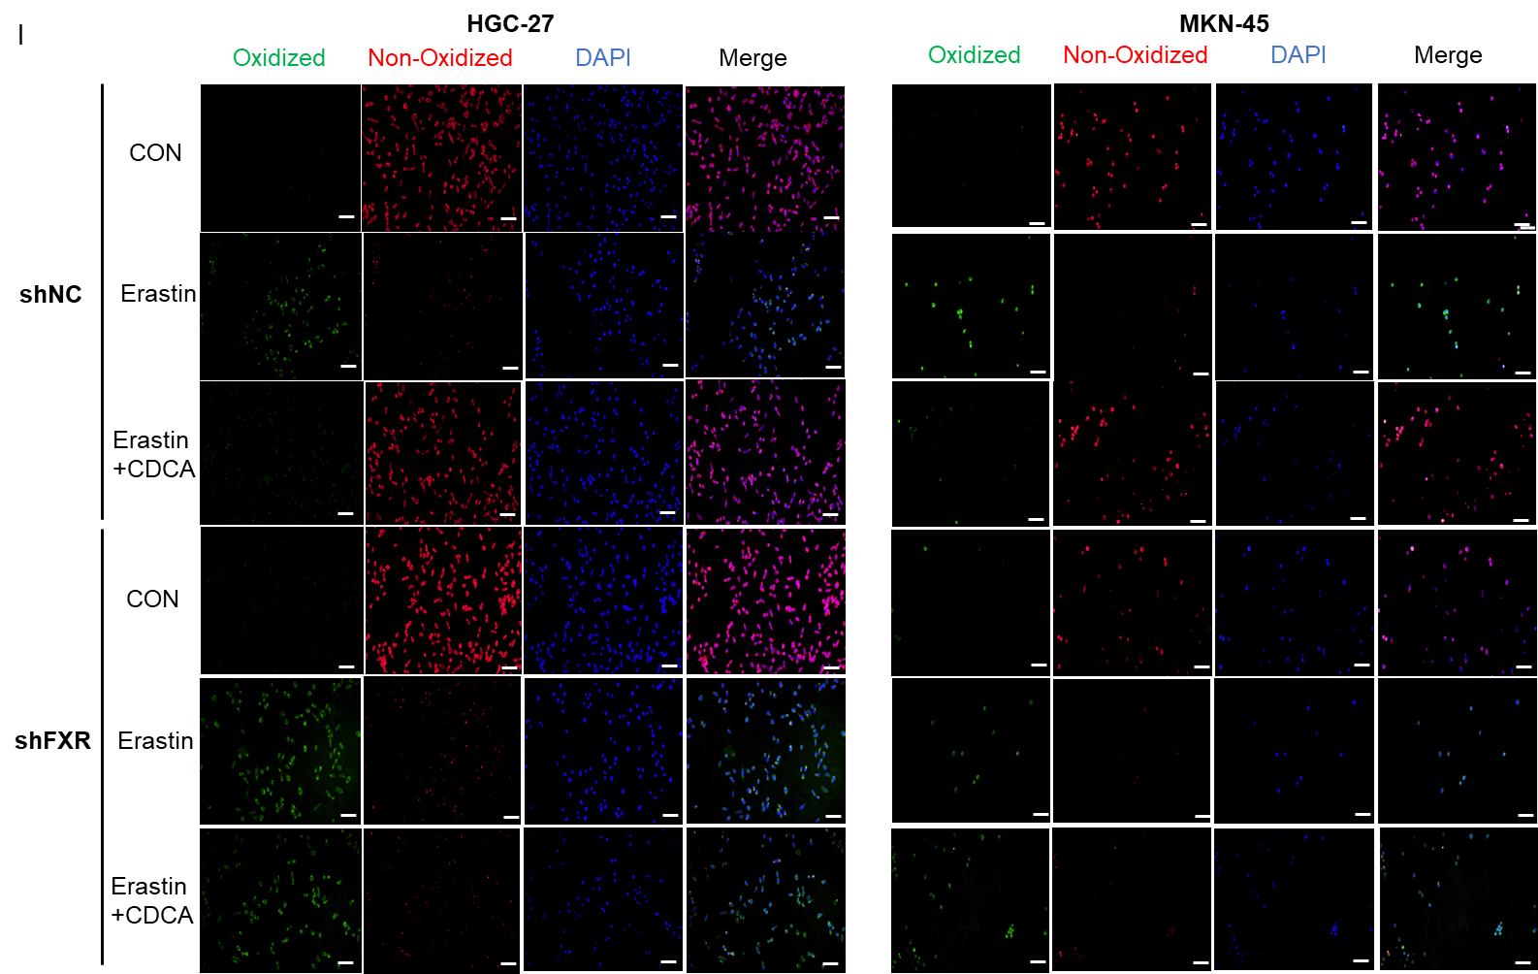
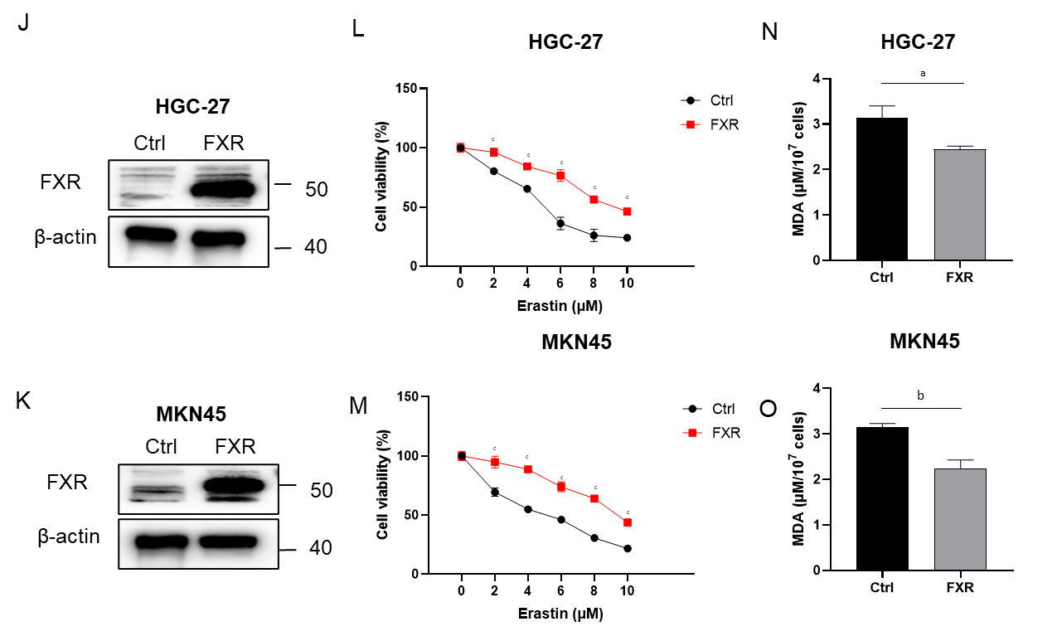
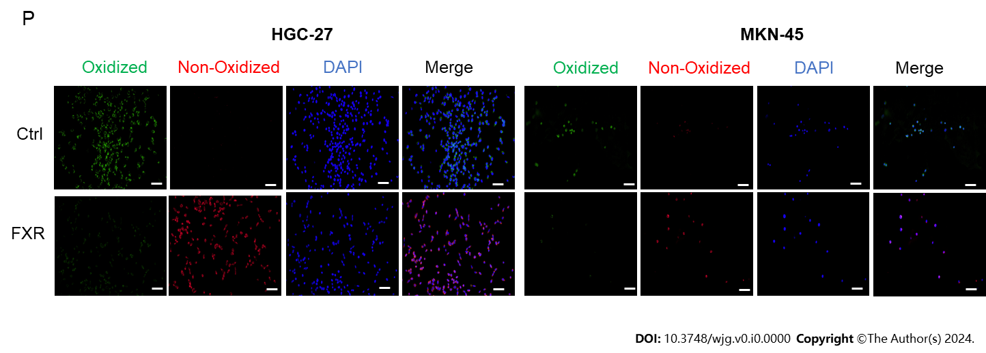
Figure 3 Bile acids inhibited ferroptosis sensitivity of gastric cancer cells by activating farnesoid X receptor. A and B: Cell viability of erastin-treated HGC-27 and MKN-45 cells with or without GW4064 treatment; C and D: HGC-27 and MKN-45 cells were transfected with shFXR or shNC plasmid. Successful construction was confirmed by western blot analysis; E and F: Cell viability assay of GC cells treated with different concentrations of erastin and CDCA (50 μM) transfected with shFXR or shNC for 24 h; G-I: Malondialdehyde (MDA) production and BODIPY-589/591 C11 staining of GC cells transfected with shFXR or shNC plasmid and treated with erastin together with or without CDCA for 24 h; J and K: GC cells were transfected with control or FXR-coding plasmid and confirmed through western blot analysis; L and M: Cell viability assay of GC cells treated with different concentrations of erastin and CDCA (50 μM) transfected with control or FXR-coding plasmid for 24 h.; N-P: MDA production and BODIPY-589/591 C11 staining of GC cells transfected with control or FXR-coding plasmid and treated with erastin together with or without CDCA for 24 h. Scale bar: 100 μm. ªP < 0.05, ^{b}P < 0.01, ^{c}P < 0.001. These experiments were repeated three times. FXR: Farnesoid X receptor; NC: Negative control; CDCA: Chenodeoxycholic acid; MDA: Malondialdehyde; ns: Not significant.
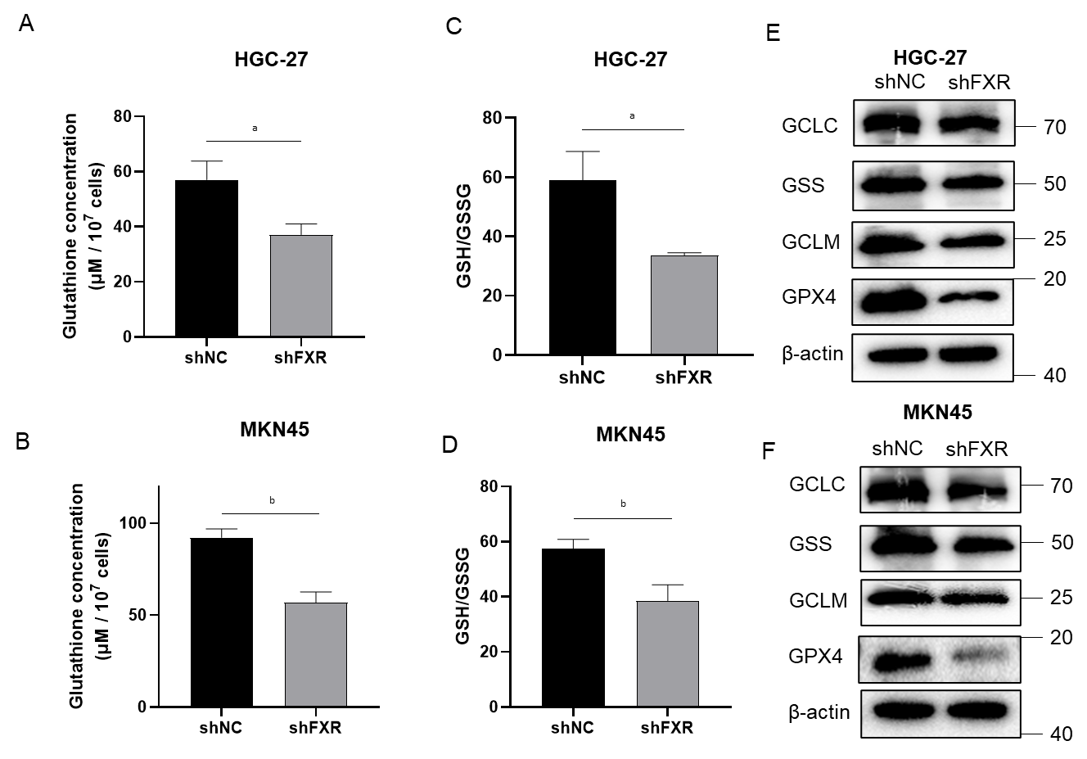
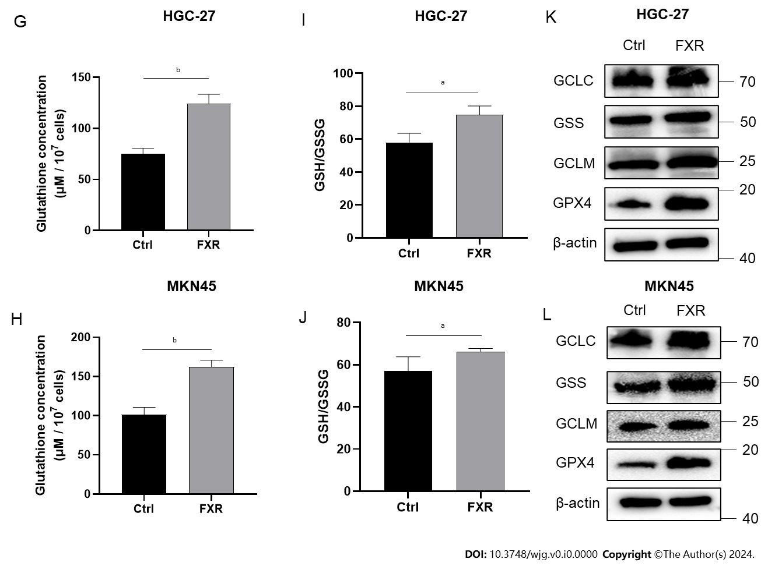
Figure 4 Farnesoid X receptor significantly promoted the synthesis of glutathione and the level of glutathione peroxidase 4 in gastric cancer cells. A-D: Alterations of glutathione (GSH) concentrations and the GSH/oxidized GSH (GSSG) ratio in HGC-27 and MKN-45 cells transfected with the shNC or shFXR plasmid; E and F: Protein expression of GCLC, GSS, GCLM, and GSH peroxidase 4 (GPX4) in HGC-27 and MKN-45 cells transfected with the shNC or shFXR plasmid; G-J: Alterations of GSH concentrations and the GSH/GSSG ratio in HGC-27 and MKN-45 cells transfected with the control or farnesoid X receptor (FXR)-coding plasmid; K and L: Protein expression of GCLC, GSS, GCLM, and GPX4 in HGC-27 and MKN-45 cells transfected with the control or FXR-coding plasmid. ªP < 0.05, ^{b}P < 0.01. These experiments were repeated three times. FXR: Farnesoid X receptor; GPX4: Glutathione peroxidase 4.
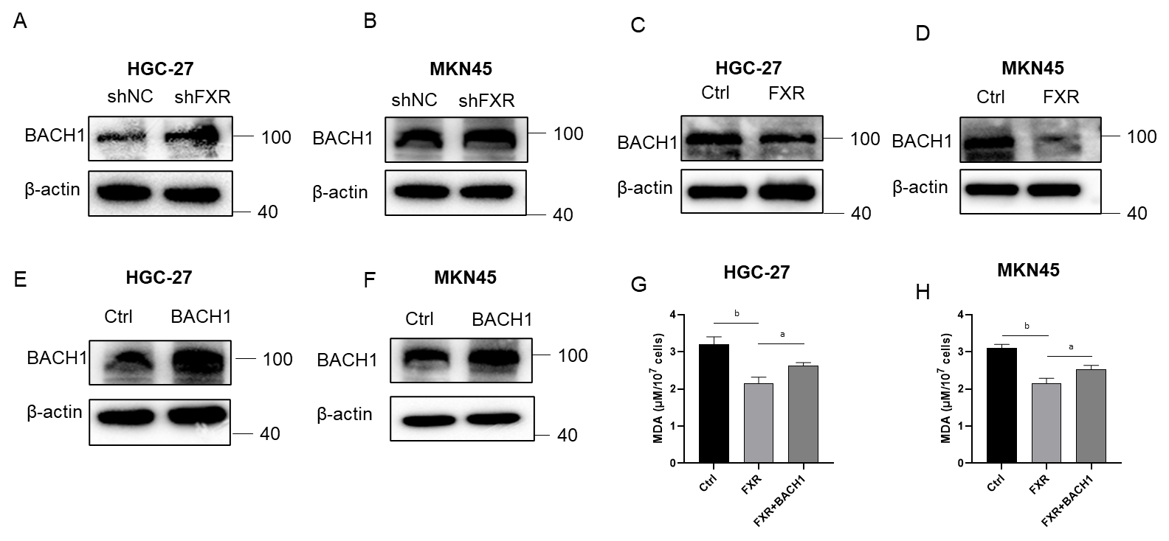
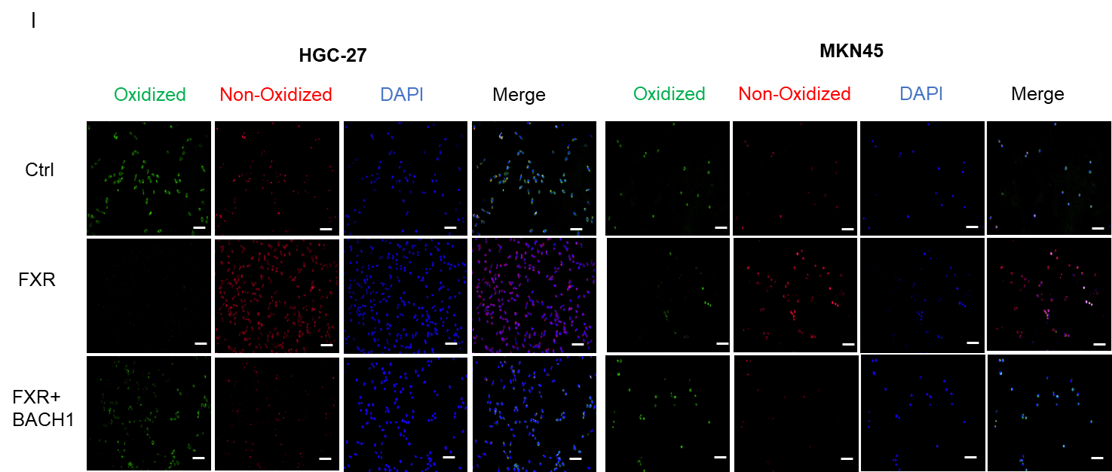
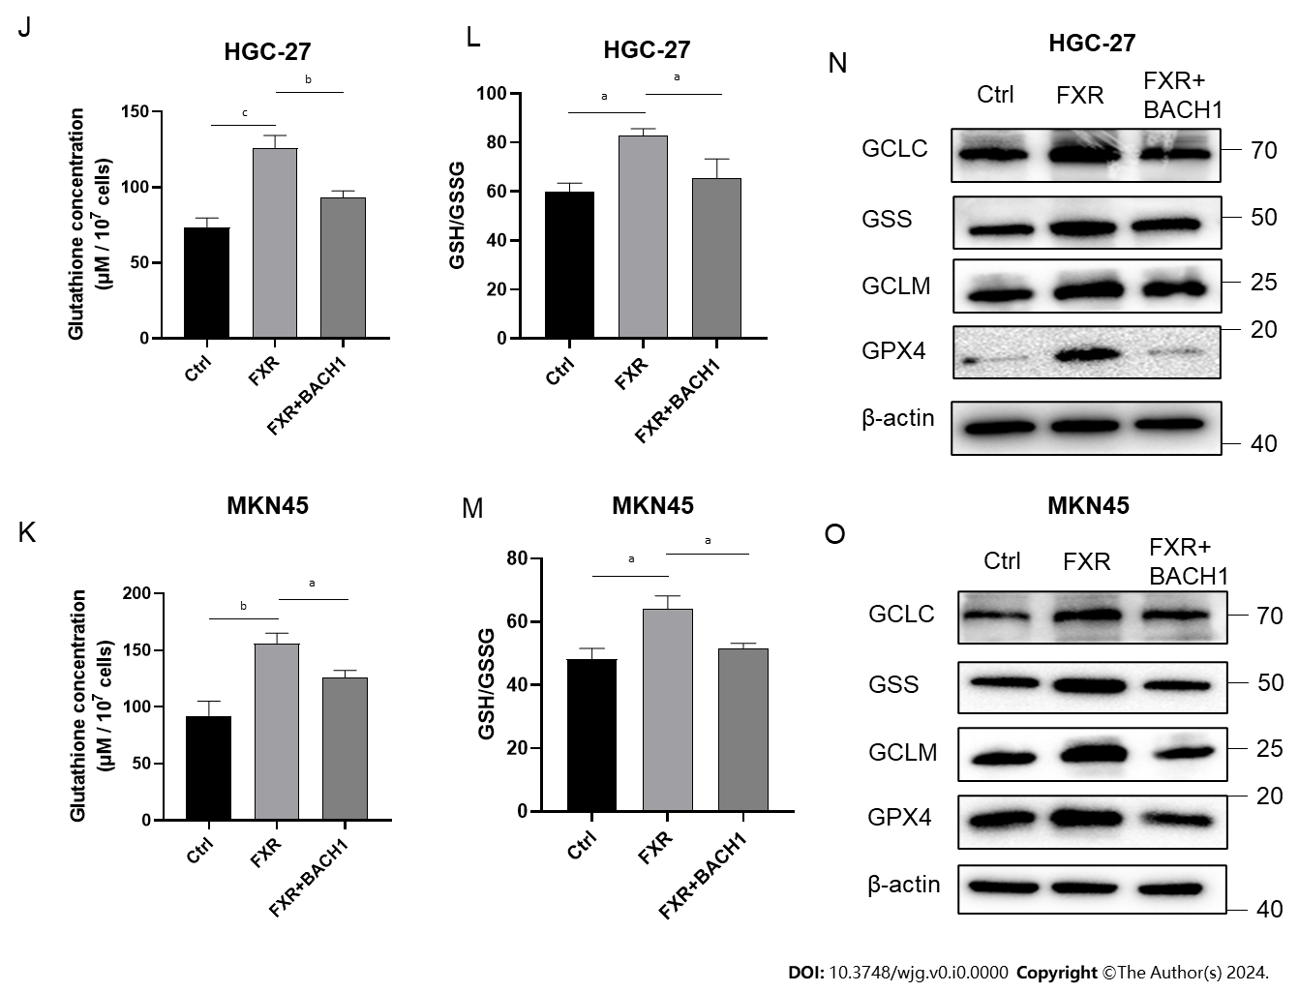
Figure 5 Farnesoid X receptor exerted anti-ferroptosis effects by inhibiting BTB and CNC homology 1. A and B: Protein expression of BTB and CNC homology 1 (BACH1) in gastric cancer (GC) cells transfected with the shNC or shFXR plasmid for 24 h; C and D: Western blot (WB) analysis of BACH1 protein expression in GC cells transfected with the shNC or shFXR plasmid for 24 h; E and F: HGC-27 and MKN-45 cells were transfected with the control or BACH1-coding plasmid and confirmed through WB analysis; G-I: Malondialdehyde production and BODIPY-589/591 C11 staining of GC cells after transfection with the farnesoid X receptor (FXR)-coding plasmid together with or without the BACH1-coding plasmid and erastin treatment (5 μM) for 24 h; J-M: Alterations of glutathione (GSH) concentrations and the GSH/oxidized GSH ratio in HGC-27 and MKN-45 cells after transfection with the FXR-coding plasmid together with or without the BACH1-coding plasmid; N and O: WB analysis of GCLC, GSS, GCLM, and GSH peroxidase 4 protein expression after transfection with the FXR-coding plasmid together with or without the BACH1-coding plasmid. Scale bar: 100 μm. ªP < 0.05, ^{b}P < 0.01, ^{c}P < 0.001. These experiments were repeated three times. FXR: Farnesoid X receptor; BACH1: BTB and CNC homology 1; GSH: Glutathione; GSSG: Oxidized glutathione; GPX4: Glutathione peroxidase 4.
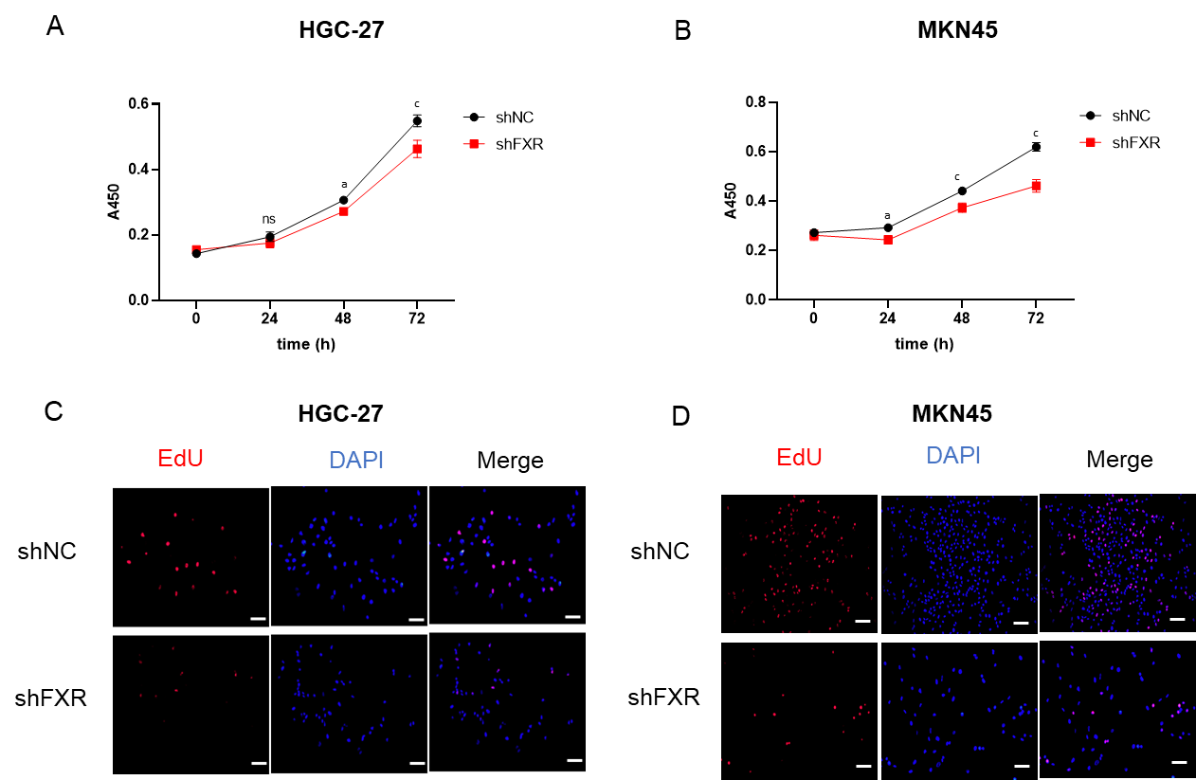
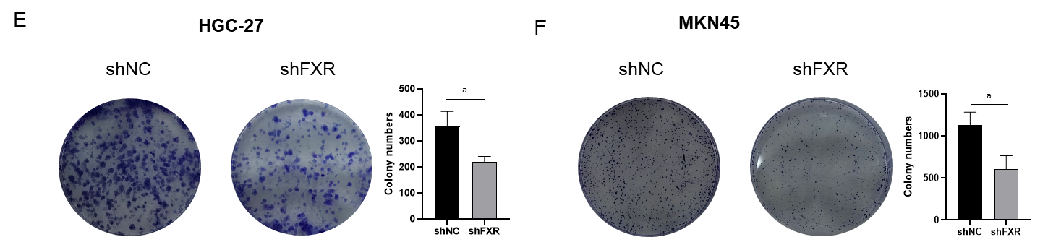
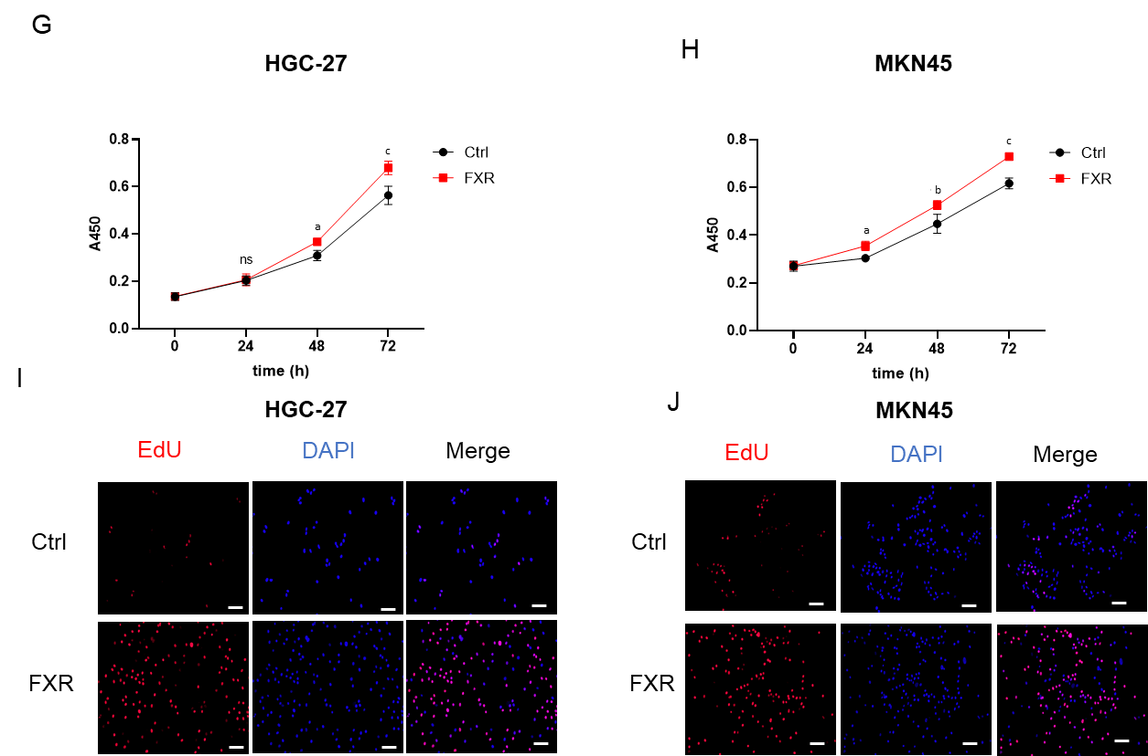
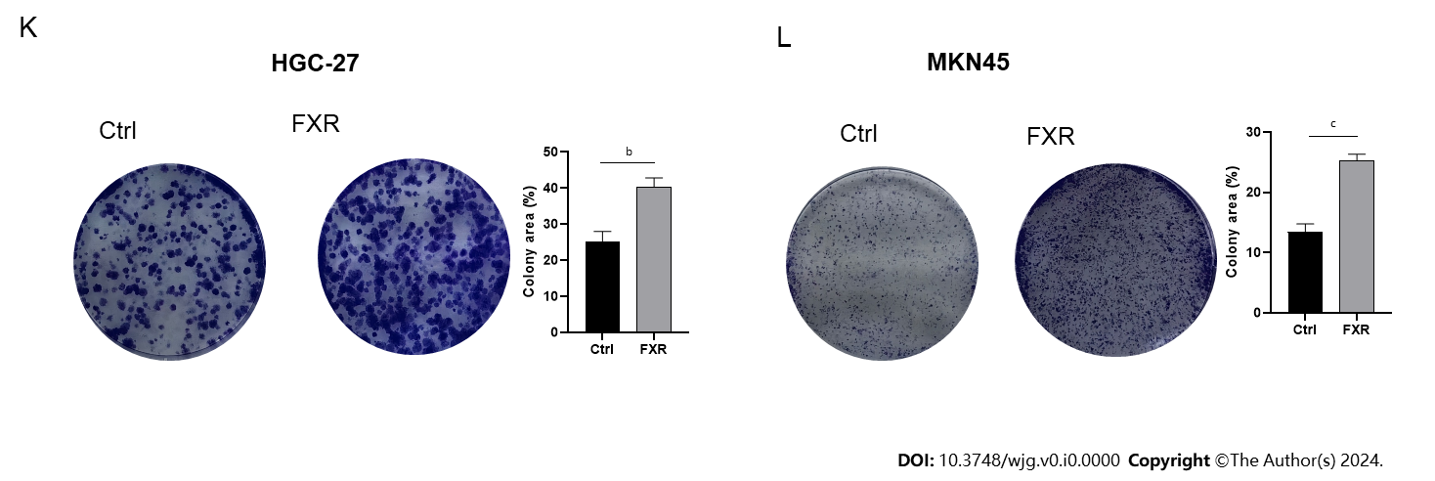
Figure 6 Farnesoid X receptor promoted proliferation of gastric cancer cells. A-F: Malignant proliferation assays, including cell viability (A and B), 5-ethynyl-2′-deoxyuridine (Edu) staining (C and D), andcolony formation assays (E and F), were performed in gastric cancer (GC) cells after transfection with the shNC or shFXR plasmid; G-L: Cell viability (G and H); Edu staining (I and J), andcolony formation assays (K and L) were performed in GC cells after transfection with the control or farnesoid X receptor-coding plasmid. Scale bar: 100 μm. ªP < 0.05, ^{b}P < 0.01, ^{c}P < 0.001. These experiments were repeated three times. FXR: Farnesoid X receptor; Edu: 5-ethynyl-2′-deoxyuridine; NC: Negative control; ns: Not significant.

