Name of Journal: World Journal of Clinical Cases
Manuscript NO: 78530
Manuscript Type: EVIDENCE-BASED MEDICINE

Delineation of a SMARCA4-specific competing endogenous RNA network and its function in hepatocellular carcinoma

Zhang L et al. Competing endogenous RNA network

Lei Zhang, Ting Sun, Xiao-Ye Wu, Fa-Ming Fei, Zhen-Zhen Gao

Lei Zhang, Ting Sun, Xiao-Ye Wu, Department of Clinical Oncology, Jiaxing Second Hospital, Jiaxing 314000, Zhejiang Province, China

Fa-Ming Fei, Zhen-Zhen Gao, Department of Clinical Oncology, The Second Affiliated Hospital of Jiaxing University, Jiaxing 314000, Zhejiang Province, China

Author contributions: Zhang L and Sun T designed the research study; Wu XY performed the research; Gao ZZ and Fei FM contributed new reagents and analytic tools; Zhang L and Gao ZZ analyzed the data and wrote the manuscript; all authors have read and approve the final manuscript.

Corresponding author: Zhen-Zhen Gao, MD, PhD, Director, Department of Clinical Oncology, The Second Affiliated Hospital of Jiaxing University, No. 1518 Huancheng Road, Jiaxing 314000, Zhejiang Province, China. sarrah0112@163.com

Received: July 2, 2022
Revised: August 14, 2022
Accepted: August 30, 2022
Published online:

Abstract
BACKGROUND
Hepatocellular carcinoma (HCC) is a common malignancy worldwide, and the mortality rate continues to rise each year. SMARCA4 expression has been associated with poor prognosis in various types of cancer; however, the specific mechanism of action of SMARCA4 in HCC needs to be fully elucidated.

AIM
To explore the specific mechanism of action of SMARCA4 in HCC.

METHODS
Herein, the expression level of SMARCA4 as well as its association with HCC prognosis were evaluated using transcriptome profiling and clinical data of 18 different types of cancer collected from The Cancer Genome Atlas database. Furthermore, SMARCA4-high and -low groups were identified. Thereafter, gene ontology and Kyoto Encyclopedia of Genes and Genomes enrichment analyses were performed to identify the function of SMARCA4, followed by construction of a SMARCA4-specific competing endogenous RNA (ceRNA) network using starBase database. The role of SMARCA4 in immunotherapy and its association with immune cells were assessed using correlation analysis.

RESULTS
It was observed that SMARCA4 was overexpressed and negatively correlated with prognosis in HCC. Further, SMARCA4 expression was positively associated with tumor mutational burden, microsatellite stability, and immunotherapy efficacy. The SNHG3/THUMP3-AS1-miR-139-5p-SMARCA4 ceRNA network was established and could be assumed to serve as a stimulatory mechanism in HCC.

CONCLUSION
The findings of this study demonstrated that SMARCA4 plays a significant role in progression and immune infiltration in HCC. Moreover, a ceRNA network was detected, which was found to be correlated with poor prognosis in HCC. The findings of this study could contribute towards the identification of predictive markers for immunotherapy and a novel mechanism of action for HCC treatment.

Key Words: Hepatocellular carcinoma; SMARCA4; Prognosis; Immune infiltration; Competing endogenous RNA

Zhang L, Sun T, Wu XY, Fei FM, Gao ZZ. Delineation of a SMARCA4-specific competing endogenous RNA network and its correlation with poor prognosis and immune cell infiltration in hepatocellular carcinoma. World J Clin Cases 2022; In press

Core Tip: Hepatocellular carcinoma (HCC) is a common malignancy worldwide, and the mortality rate continues to rise each year. SMARCA4 expression has been associated with poor prognosis in various types of cancer; however, the specific mechanism of action of SMARCA4 in HCC needs to be fully elucidated. To date, only few studies have successfully elucidated the mechanism of action of SMARCA4 in the progression of HCC. In the present study, we aimed to establish a SMARCA4-related competing endogenous RNA (ceRNA) network by mapping and analyzing the transcription profiles of SMARCA4 in HCC. we observed the overexpression of SMARCA4 in different pathways. Additionally, the overexpression of SMARCA4 was correlated to an increased immune cell infiltration and an augmented sensitivity to immunotherapy. Furthermore, a novel SMARCA4 ceRNA network (SNHG3/THUMP3-AS1-miR-139-5p-SMARCA4) was established in this study. This study could contribute towards the identification of predictive markers for immunotherapy and a novel mechanism of action for HCC treatment.

INTRODUCTION
Liver cancer is a common health concern worldwide, with a marked increase in incidence and mortality rates^{[1]}. Hepatocellular carcinoma (HCC) is, by far, the most common type of liver cancer; however, its origin is still under debate^{[2]}. Presently, there are several hypotheses explaining the occurrence and development of HCC, including liver stem cells, clone-forming cultures, and mature liver cells^{[3-5]}. Previous studies have confirmed that somatic mutations in mature hepatocytes are responsible for HCC; this was further verified using high-throughput next-generation sequencing. Additionally, several mutations or genetic alterations in CTNNB1, APC, RB1, CCNA2, PTEN, ARID1A, ARID2, and TP53 have been reported to promote HCC oncogenesis^{[6,7]}. Furthermore, several pathways, including the Akt/mTOR, receptor tyrosine kinase pathway, and Wnt/β-catenin pathway, were found to be involved in the progression of HCC. Based on the discovery of driver genes, several studies exemplifying the efficacy of different inhibitors are underway^{[8,9]}. There is an urgent need to identify additional important driver genes associated with the initiation and progression of HCC; this information would be valuable in the development of a potential specific targeted therapy in the nearer future.
Several studies have previously reported the activation of transcription of different genes through SMARCA4, also known as BRG1, a member of the SWItch/Sucrose Non-Fermentable (SWI/SNF) chromatin-remodeling complex, by manipulating the structure of chromatin^{[10-13]}. Calderaro et al^{[14]} analyzed more than 363 HCC cases utilizing the whole exome sequencing technique and demonstrated that SMARCA4 was the driver gene associated with HCC. Guerrero et al^{[6]} confirmed that the high expression of SMARCA4 was associated with poor prognosis in HCC. Furthermore, Chen et al^{[7,15]} performed multi-omics analysis and illustrated that SMARCA4 promotes cell proliferation by upregulating SMAD6, by promoting the activation of HIC2 and NR4A2. Another study performed by Wang et al^{[16]} showed that the BRG1/RAS/C-MET axis was involved in hepatocarcinogenesis. The abovementioned findings demonstrated the significant role of SMARCA4 in HCC; however, only few studies have successfully elucidated the mechanism of action of SMARCA4 in the progression of HCC. In the present study, we aimed to establish a SMARCA4-related ceRNA network by mapping and analyzing the transcription profiles of SMARCA4 in HCC. This study might provide valuable insights regarding HCC occurrence and development.

MATERIALS AND METHODS
Data sources and survival analysis
The transcriptome profiling (fragments per kilobase million, FPKM) of 18 different types of cancer were collected from The Cancer Genome Atlas program database through UCBC Xena (http://xena.ucsc.edu/), and the miRNA isoform expression data were downloaded. Differential expression analysis was processed by R limma package. The survival analysis of target RNAs was performed using the R2 database and the R survival package.

Establishment of SMARCA4 related DEGs and delineation of functional enrichment analysis
After ascertaining the critical role of SMARCA4 in HCC, we further conducted differential expression analysis based on the median expression of SMARCA4 to obtain the SMARCA4-related differentially expressed genes (DEGs) with limma package. GO and KEGG enrichment of DEGs were conducted by enrichplot package.

Prediction of miRNAs and lnRNAs upstream of SMARCA4
In parallel, Upstream miRNAs of SMARCA4 were searched by several target gene prediction programs, consisting of PITA, RNA22, miRmap, microT, miRanda, PicTar, and TargetScan from the starBase database^{[16]}. The miRNA-related non-protein-coding RNA (ncRNA) were forecasted by starBase as well (http://starbase.sysu.edu.cn/).

Correlation of SMARCA4 and immune cells and the markers
The association between the target genes and immune infiltrates along with their correlation were evaluated using TIMER2.0 (http://timer.cistrome.org/) and CIBERSORT (https://cibersort.stanford.edu/) databases. Correlation analysis were performed to elucidate the relationship between SMARCA4 and markers of immune cells.

Statistical analysis
The results obtained from the R2 database(https://r2.amc.nl) were analyzed using the signed-rank test and adjusted for P-values. The survival curves were estimated using the Kaplan-Meier method. Furthermore, Spearman’s correlation was used to evaluate the relationship between the gene expression levels. The statistical significance was set at p < 0.05 and the median value of the target RNAs was considered as the cut-off value. All statistical analyses were conducted using the R software (version 4.1.2). The R packages used in this study included limma, reshape2, ggpubr, ggExtra, survival, survminer, and reshape2 whereas Cytoscape was used to establish the ceRNA network.

RESULTS
Pan-cancer expression levels of SMARCA4
First, The SMARCA4 mRNA expression levels, analyzed using the Wilcoxon test¹⁷ and visualized by boxplots in different types of human cancer, were found to be substantially higher than in normal in most of the 18 different types of cancer (Figure 1). Furthermore, the expression levels of SMARCA4 were markedly higher in the patients with HCC, as was confirmed using the GEPIA database (Supplementary Figure 1). This, in turn, demonstrated the role of SMARCA4 as an oncogenic regulator in the progression of HCC.

Differential expression of SMARCA4 and its prognostic value in patients with HCC
Thereafter, Kaplan-Meier survival analysis was performed to analyze the differential expression of SMARCA4. In the present study, we failed to draw the survival curve, however, the prognostic value of SMARCA4 was verified to be related to the 1-year, 3-year, and 5-year survival rates by online R2 database. As demonstrated in Figure 2, higher expression levels of SMARCA4 were correlated with poor prognosis in patients with HCC, and a significant difference was observed. Therefore, by combining the differential expression levels and the survival curves, SMARCA4 was considered an indicator of poor prognosis in patients with HCC.

Identification of differentially expressed genes and enrichment analysis between SMARCA4^{high} and SMARCA4^{low} patients
Furthermore, to figure out the DEGs correlated with SMARCA4, the patients were divided into two groups, SMARCA4^{high} and SMARCA4^{low}, depending on the median expression value of SMARCA4. A total of 3,540 genes were differentially expressed in HCC; among them, 573 were downregulated and 2,947 were upregulated (P < 0.05, |Log₂FC|> 0.5). The top 20 upregulated and downregulated genes were shown in a heatmap (Supplementary Figure 2). Then, we conducted the GO and KEGG pathway enrichment analyses. Among the biological processes involved in patients with HCC, the typical GO terms used were: transcription regulator complex (GO: 0005667), activation of immune response (GO: 0002253), response to hypoxia (GO: 0001666), and carbohydrate catabolic process (GO: 0016052). Moreover, the most notable pathways identified by the KEGG enrichment analysis included carbon metabolism (hsa01200), one carbon pool by folate (hsa00670), mismatch repair (hsa03430), and PPAR signaling pathway (hsa03320) in patients with HCC.

Identification of miRNAs upstream of SMARCA4
Aside from above, we aimed to ensure the modulation mechanism of SMARCA4. Approximately, 20 miRNAs that could potentially bind to SMARCA4 were detected (Table 1). The network was visualized using the Cytoscape software and a Spearman correlation analysis was performed to identify the negative relationship between the miRNAs and SMARCA4 (Figure 3A)^{[17]}. MiR-139-5p was found to be negatively correlated to SMARCA4 (R = -0.43, P < 0.001) (Figure 3B). Additionally, the expression and prognostic values of miR-139-5p were determined. As shown in Figure 3C, miR-139-5p expression was notably downregulated in HCC, and its upregulation was related to a favorable prognosis in patients with HCC (Figure 3D). The abovementioned data demonstrated the role of miR-139-5p as an upstream regulatory ncRNA of SMARCA4.

Detection and analysis of long noncoding RNAs upstream of hsa-miR-139-5p
Meanwhile, the upstream long noncoding RNAs (lncRNAs) of miR-139-5p were predicted using an online database (https://starbase.sysu.edu.cn/). A total of 75 LncRNAs were identified and correlation analysis was performed to identify the upstream lncRNAs (Table 2). Based on the theory of ceRNAs, lncRNAs may increase the expression levels of the target mRNAs by using different combinations of competitive interactions with miRNAs. Four lncRNAs (NUTM2A-AS1, NUTM2B-AS1, SNHG3, and THUMPD3-AS1) were found to be upregulated in patients with HCC (Figure 4). Furthermore, Spearman correlation analysis was used to analyze the four lncRNAs; SNHG3 and THUMPD3-AS1 were found to be positively correlated with the expression of SMARCA4 and negatively correlated with the miR-139-5p levels (Figure 4). Subsequently, the prognostic value of the two lncRNAs was evaluated in the patients with HCC. Taken together, SNHG3 and THUMPD3-AS1 might be present upstream of the miR-139-5p/SMARCA4 axis (Figures 4 and 5).

Relationship between the expression levels of SMARCA4 and immune cell infiltration
As for interpretating its role in immune-regulation, we performed a correlation analysis was to identify the relationship between the expression levels of SMARCA4 and immune cell infiltration in patients with HCC. As shown in Figure 6, the expression levels of SMARCA4 were found to be significantly correlated with all analyzed immune cells, including B cells, CD8+ T cells, CD4+ T cells, macrophages, neutrophils, and dendritic cells, all of which were verified by the CIBERSORT approach in R packages (Supplementary Figure 3).

Relationship between expression levels of SMARCA4 and biomarkers of immune cells
The potential immunotherapy targets that assist in immune escape in various types of cancer include PD1/PD-L1, CTLA4, TIGIT, and LAG3 (Figure 7). At last, the relationships between the expression levels of SMARCA4 and the aforementioned coding genes were identified. The co-expression analysis confirmed the correlation of SMARCA4 with an increased expression of the immune-related genes, which was further verified by correlation analysis (Supplementary Figure 4 and Table 3). Therefore, the results suggested that the enhanced expression levels of SMARCA4 could regulate the immune responses, thereby leading to the progression of metastasis in patients with HCC.

DISCUSSION
The gene encoding SMARCA4, a member of the SWI/SNF family, was found to be essential for embryonic development^{[18-22]}. Several studies demonstrated that the loss of SMARCA4 was associated with a high risk of undifferentiated cancer, implying its anti-cancerous role^{[23-26]}. Other studies detected the overexpression of SMARCA4 in various other types of cancer, including HCC^{[18,27-29]}, small cell lung cancer^{[10,11,30-32]}, acute leukemia^{[3,33-36]} and neuroblastoma^{[37,38]}, thereby exemplifying its oncogenic role. In this study, we identified the overexpression of SMARCA4 Levels in 15 different types of cancer, excluding glioblastoma, kidney chromophobe, and kidney papillary cell carcinoma. Furthermore, the increased expression levels of SMARCA4 were associated with a poor prognosis in patients with HCC. It has been previously demonstrated that SMARCA4 can function as an oncogene in some cancers and as a tumor suppressor in other types of cancer^{[39]}. The alterations in SMARCA4 were classified into two types^{[33,34,40]}: Class I (truncating mutations, fusions, and homozygous deletion) and Class II (missense mutations). The loss of SMARCA4 was found to be involved in the inhibition of carcinogenesis by interacting with the Wnt protein^{[41]}. Mutations in SMARCA4 have been associated with the progression of colorectal cancer by cooperating with PRMT1. Additionally, Mehta et al^{[42-44]} reported that the overexpression of SMARCA4 increased the activity of the ATPase subunit and could enhance SOX4-mediated PI3K/AKT signaling in triple-negative breast cancer. In this study, based on the GO and KEGG enrichment analyses of targeted genes related to the overexpression of SMARCA4, we found that SMARCA4 was involved in oncogenesis through PI3K, IL-17, and TGF-β signaling, which elucidated its oncogenic role in patients with HCC.
Checkpoint inhibitors have been established as regulators of various types of cancer; however, their response rate to immunotherapy was found to be low, ranging from complete remission to super progression. To date, Keytruda (Pembrolizumab) has been considered as a potential inhibitor of the progression death-ligand-1(PD-L1); however, its sensitivity and specificity were found to be limited. Therefore, other biomarkers are urgently required for the treatment of different types of cancer, utilizing the mechanism of action of potential inhibitors. In this study, we found that SMARCA4-related genes were enriched in the PPAR signaling pathway and identified a strong correlation among SMARCA4, CD274, and PDCD1. Furthermore, the expression levels of SMARCA4 were found to be positively correlated with immunotherapy, which were consistent with the study reported by Peng et al^{[22]}, and was further confirmed in the patients with thoracic sarcoma and pancreatic cancer^{[19,45]}.
ceRNAs act as key mediators in the progression of different types of cancer^{[46]}. Although the ceRNA network has been established in HCC, other novel ceRNA mechanisms need to be elucidated^{[47-50]}. To further explore the ncRNAs participating in SMARCA4-related ceRNAs, we predicted ncRNAs using the starBase database. The expression levels of ncRNAs were quantified, and correlation analysis was performed to identify the miRNAs upstream of SMARCA4. Finally, miR-139-5p was found to be a tumor-suppressive miRNA of SMARCA4. Previous studies have shown that miR-139-5p was involved in regulating the proliferation and migration of HCC cells.
Based on the ceRNA theory, downregulated miRNAs were generally accompanied by upregulated lncRNAs. Therefore, we predicted an upstream lncRNAs of miRNAs through an online starBase database and then detected SNHG3 and THUMPD3-AS1 LncRNAs, which were found to be overexpressed and related to poor prognosis in patients with HCC. Thereafter, we established the SNHG3/THUMP3-AS1-miR-139-5p-SMARCA4 axis associated with the poor prognosis of patients with HCC. Utilizing the ceRNA network, Lee et al^{[45]} reported THUMP3-AS1 as an enhancer RNA, promoting the expression of target genes, which can further lead to the progression of HCC. Meanwhile, SNHG3 LncRNAs has been reported to be involved in the hepatogenesis by regulating the levels of different miRNAs^{[51-54]}. However, the NHG3/THUMP3-AS1-miR-139-5p-SMARCA4 axis in HCC was constructed for the first time, and we confirmed that SMARCA4 was associated with an increased infiltration of immune cells as well as checkpoint markers. Therefore, we investigated SMARCA4-related ceRNA as a novel mechanism in HCC and found that SMARCA4 could serve as a biomarker in immunotherapy; however, this needs further validation.
All data of this study were downloaded from open database, and the results were validated using different database. Thereby, our results extrapolated the role of SMARCA4 in HCC. However, there is a major limitation of the study. we established a SMARCA4-related ceRNA and constructed the model NHG3/THUMP3-AS1-miR-139-5p-SMARCA4 axis in HCC, which need external validation. We failed to complete the verification and validation is planned later.
In summary, we observed the overexpression of SMARCA4 in different pathways. Additionally, the overexpression of SMARCA4 was correlated to an increased immune cell infiltration and an augmented sensitivity to immunotherapy. Furthermore, a novel SMARCA4 ceRNA network (SNHG3/THUMP3-AS1-miR-139-5p-SMARCA4) was established in this study. This study could contribute towards the identification of predictive markers for immunotherapy and a novel mechanism of action for HCC treatment.

CONCLUSION
Herein, we demonstrated the overexpression of SMARCA4 in patients with HCC and in several immunotherapy-related pathways. Furthermore, an increased expression of SMARCA4 was found to be positively associated with immune cell infiltration, and a SMARCA4-specific ceRNA network was established, which was found to be involved in the progression of HCC.

ARTICLE HIGHLIGHTS
Research background
Hepatocellular carcinoma (HCC) is a common malignancy worldwide, and the mortality rate continues to rise each year. SMARCA4 expression has been associated with poor prognosis in various types of cancer; however, the specific mechanism of action of SMARCA4 in HCC needs to be fully elucidated.

Research motivation
Only few studies have successfully elucidated the mechanism of action of SMARCA4 in the progression of HCC. In the present study, we aimed to establish a SMARCA4-related competing endogenous RNA (ceRNA) network by mapping and analyzing the transcription profiles of SMARCA4 in HCC.

Research objectives
To provide valuable insights regarding HCC occurrence and development.

Research methods
(1) Data sources and survival analysis; (2) Establishment of SMARCA4 related differentially expressed genes (DEGs) and delineation of functional enrichment analysis; (3) Prediction of miRNAs and lnRNAs upstream of SMARCA4; (4) Correlation of SMARCA4 and immune cells and the markers; and (5) The R packages used in this study included limma, reshape2, ggpubr, ggExtra, survival, survminer, and reshape2 whereas Cytoscape was used to establish the ceRNA network..

Research results
Pan-cancer expression levels of SMARCA4. Differential expression of SMARCA4 and its prognostic value in patients with HCC. Identification of DEGs and enrichment analysis between SMARCA4^{high} and SMARCA4^{low} patients. Identification of miRNAs upstream of SMARCA4. Detection and analysis of long noncoding RNAs (lncRNAs) upstream of hsa-miR-139-5p. Relationship between the expression levels of SMARCA4 and immune cell infiltration. Relationship between expression levels of SMARCA4 and biomarkers of immune cells.

Research conclusions
Herein, we demonstrated the overexpression of SMARCA4 in patients with HCC and in several immunotherapy-related pathways. Furthermore, an increased expression of SMARCA4 was found to be positively associated with immune cell infiltration, and a SMARCA4-specific ceRNA network was established, which was found to be involved in the progression of HCC.

Research perspectives
We observed the overexpression of SMARCA4 in different pathways. Additionally, the overexpression of SMARCA4 was correlated to an increased immune cell infiltration and an augmented sensitivity to immunotherapy. Furthermore, a novel SMARCA4 ceRNA network (SNHG3/THUMP3-AS1-miR-139-5p-SMARCA4) was established in this study. This study could contribute towards the identification of predictive markers for immunotherapy and a novel mechanism of action for HCC treatment.

REFERENCES
1 Cancer Genome Atlas Research Network. Cancer Genome Atlas Research Network. Comprehensive and Integrative Genomic Characterization of Hepatocellular Carcinoma. Cell 2017; 169: 1327-1341.e23 [PMID: 28622513 DOI: 10.1016/j.cell.2017.05.046]
2 Zhou Y, Chen Y, Zhang X, Xu Q, Wu Z, Cao X, Shao M, Shu Y, Lv T, Lu C, Xie M, Wen T, Yang J, Shi Y, Bu H. Brahma-Related Gene 1 Inhibition Prevents Liver Fibrosis and Cholangiocarcinoma by Attenuating Progenitor Expansion. Hepatology 2021; 74: 797-815 [PMID: 33650193 DOI: 10.1002/hep.31780]
3 Wang P, Song X, Cao D, Cui K, Wang J, Utpatel K, Shang R, Wang H, Che L, Evert M, Zhao K, Calvisi DF, Chen X. Oncogene-dependent function of BRG1 in hepatocarcinogenesis. Cell Death Dis 2020; 11: 91 [PMID: 32019910 DOI: 10.1038/s41419-020-2289-3]
4 Seeley JJ, Baker RG, Mohamed G, Bruns T, Hayden MS, Deshmukh SD, Freedberg DE, Ghosh S. Induction of innate immune memory via microRNA targeting of chromatin remodelling factors. Nature 2018; 559: 114-119 [PMID: 29950719 DOI: 10.1038/s41586-018-0253-5]
5 Kim SY, Shen Q, Son K, Kim HS, Yang HD, Na MJ, Shin E, Yu S, Kang K, You JS, Yu KR, Jeong SM, Lee EK, Ahn YM, Park WS, Nam SW. SMARCA4 oncogenic potential via IRAK1 enhancer to activate Gankyrin and AKR1B10 in liver cancer. Oncogene 2021; 40: 4652-4662 [PMID: 34140644 DOI: 10.1038/s41388-021-01875-6]
6 Guerrero-Martínez JA, Reyes JC. High expression of SMARCA4 or SMARCA2 is frequently associated with an opposite prognosis in cancer. Sci Rep 2018; 8: 2043 [PMID: 29391527 DOI: 10.1038/s41598-018-20217-3]
7 Chen Z, Lu X, Jia D, Jing Y, Chen D, Wang Q, Zhao F, Li J, Yao M, Cong W, He X. Hepatic SMARCA4 predicts HCC recurrence and promotes tumour cell proliferation by regulating SMAD6 expression. Cell Death Dis 2018; 9: 59 [PMID: 29352111 DOI: 10.1038/s41419-017-0090-8]
8 Fan Z, Li N, Xu Z, Wu J, Fan X, Xu Y. An interaction between MKL1, BRG1, and C/EBPβ mediates palmitate induced CRP transcription in hepatocytes. Biochim Biophys Acta Gene Regul Mech 2019; 1862: 194412 [PMID: 31356989 DOI: 10.1016/j.bbagrm.2019.194412]
9 Chen Z, Gao Y, Yao L, Liu Y, Huang L, Yan Z, Zhao W, Zhu P, Weng H. LncFZD6 initiates Wnt/β-catenin and liver TIC self-renewal through BRG1-mediated FZD6 transcriptional activation. Oncogene 2018; 37: 3098-3112 [PMID: 29535420 DOI: 10.1038/s41388-018-0203-6]
10 Liu L, Ahmed T, Petty WJ, Grant S, Ruiz J, Lycan TW, Topaloglu U, Chou PC, Miller LD, Hawkins GA, Alexander-Miller MA, O'Neill SS, Powell BL, D'Agostino RB Jr, Munden RF, Pasche B, Zhang W. SMARCA4 mutations in KRAS-mutant lung adenocarcinoma: a multi-cohort analysis. Mol Oncol 2021; 15: 462-472 [PMID: 33107184 DOI: 10.1002/1878-0261.12831]
11 Moison C, Chagraoui J, Caron MC, Gagné JP, Coulombe Y, Poirier GG, Masson JY, Sauvageau G. Zinc finger protein E4F1 cooperates with PARP-1 and BRG1 to promote DNA double-strand break repair. Proc Natl Acad Sci U S A 2021; 118 [PMID: 33692124 DOI: 10.1073/pnas.2019408118]
12 Nambirajan A, Singh V, Bhardwaj N, Mittal S, Kumar S, Jain D. SMARCA4/BRG1-Deficient Non-Small Cell Lung Carcinomas: A Case Series and Review of the Literature. Arch Pathol Lab Med 2021; 145: 90-98 [PMID: 33367658 DOI: 10.5858/arpa.2019-0633-OA]
13 Qi X, Qiu J, Chang J, Ji Y, Yang Q, Cui G, Sun L, Chai Q, Qin J, Qiu J. Brg1 restrains the pro-inflammatory properties of ILC3s and modulates intestinal immunity. Mucosal Immunol 2021; 14: 38-52 [PMID: 32612160 DOI: 10.1038/s41385-020-0317-3]
14 Calderaro J, Ziol M, Paradis V, Zucman-Rossi J. Molecular and histological correlations in liver cancer. J Hepatol 2019; 71: 616-630 [PMID: 31195064 DOI: 10.1016/j.jhep.2019.06.001]
15 Chen L, Zou W, Zhang L, Shi H, Li Z, Ni C. ceRNA network development and tumor-infiltrating immune cell analysis in hepatocellular carcinoma. Med Oncol 2021; 38: 85 [PMID: 34148185 DOI: 10.1007/s12032-021-01534-6]
16 Wang FJ, Jing YH, Cheng CS, Cao ZQ, Jiao JY, Chen Z. HELLS serves as a poor prognostic biomarker and its downregulation reserves the malignant phenotype in pancreatic cancer. BMC Med Genomics 2021; 14: 189 [PMID: 34315468 DOI: 10.1186/s12920-021-01043-5]
17 Shi Y, Liu JB, Deng J, Zou DZ, Wu JJ, Cao YH, Yin J, Ma YS, Da F, Li W. The role of ceRNA-mediated diagnosis and therapy in hepatocellular carcinoma. Hereditas 2021; 158: 44 [PMID: 34758879 DOI: 10.1186/s41065-021-00208-7]
18 Harrod A, Lane KA, Downs JA. The role of the SWI/SNF chromatin remodelling complex in the response to DNA double strand breaks. DNA Repair (Amst) 2020; 93: 102919 [PMID: 33087260 DOI: 10.1016/j.dnarep.2020.102919]
19 Kawachi H, Kunimasa K, Kukita Y, Nakamura H, Honma K, Kawamura T, Inoue T, Tamiya M, Kuhara H, Nishino K, Mizote Y, Akazawa T, Tahara H, Kumagai T. Atezolizumab with bevacizumab, paclitaxel and carboplatin was effective for patients with SMARCA4-deficient thoracic sarcoma. Immunotherapy 2021; 13: 799-806 [PMID: 34030451 DOI: 10.2217/imt-2020-0311]
20 Mardinian K, Adashek JJ, Botta GP, Kato S, Kurzrock R. SMARCA4: Implications of an Altered Chromatin-Remodeling Gene for Cancer Development and Therapy. Mol Cancer Ther 2021; 20: 2341-2351 [PMID: 34642211 DOI: 10.1158/1535-7163.Mct-21-0433]
21 Nambirajan A, Jain D. Recent updates in thoracic SMARCA4-deficient undifferentiated tumor. Semin Diagn Pathol 2021; 38: 83-89 [PMID: 34147303 DOI: 10.1053/j.semdp.2021.06.001]
22 Peng L, Li J, Wu J, Xu B, Wang Z, Giamas G, Stebbing J, Yu Z. A Pan-Cancer Analysis of SMARCA4 Alterations in Human Cancers. Front Immunol 2021; 12: 762598 [PMID: 34675941 DOI: 10.3389/fimmu.2021.762598]
23 Schaefer IM, Hornick JL. SWI/SNF complex-deficient soft tissue neoplasms: An update. Semin Diagn Pathol 2021; 38: 222-231 [PMID: 32646614 DOI: 10.1053/j.semdp.2020.05.005]
24 Sesboue C, Le Loarer F. SWI/SNF-deficient thoraco-pulmonary neoplasms. Semin Diagn Pathol 2021; 38: 183-194 [PMID: 33451916 DOI: 10.1053/j.semdp.2020.12.002]
25 Sholl LM. Biomarkers of response to checkpoint inhibitors beyond PD-L1 in lung cancer. Mod Pathol 2022; 35: 66-74 [PMID: 34608245 DOI: 10.1038/s41379-021-00932-5]
26 Wang Y, Hoang L, Ji JX, Huntsman DG. SWI/SNF Complex Mutations in Gynecologic Cancers: Molecular Mechanisms and Models. Annu Rev Pathol 2020; 15: 467-492 [PMID: 31977292 DOI: 10.1146/annurev-pathmechdis-012418-012917]
27 Anderson WJ, Jo VY. Diagnostic Immunohistochemistry of Soft Tissue and Bone Tumors: An Update on Biomarkers That Correlate with Molecular Alterations. Diagnostics (Basel) 2021; 11 [PMID: 33921435 DOI: 10.3390/diagnostics11040690]
28 Botta GP, Kato S, Patel H, Fanta P, Lee S, Okamura R, Kurzrock R. SWI/SNF complex alterations as a biomarker of immunotherapy efficacy in pancreatic cancer. JCI Insight 2021; 6 [PMID: 34375311 DOI: 10.1172/jci.insight.150453]
29 Chetty R, Serra S. SMARCA family of genes. J Clin Pathol 2020; 73: 257-260 [PMID: 32312722 DOI: 10.1136/jclinpath-2020-206451]
30 Liu M, Sun T, Li N, Peng J, Fu D, Li W, Li L, Gao WQ. BRG1 attenuates colonic inflammation and tumorigenesis through autophagy-dependent oxidative stress sequestration. Nat Commun 2019; 10: 4614 [PMID: 31601814 DOI: 10.1038/s41467-019-12573-z]
31 Liu XD, Kong W, Peterson CB, McGrail DJ, Hoang A, Zhang X, Lam T, Pilie PG, Zhu H, Beckermann KE, Haake SM, Isgandrova S, Martinez-Moczygemba M, Sahni N, Tannir NM, Lin SY, Rathmell WK, Jonasch E. PBRM1 loss defines a nonimmunogenic tumor phenotype associated with checkpoint inhibitor resistance in renal carcinoma. Nat Commun 2020; 11: 2135 [PMID: 32358509 DOI: 10.1038/s41467-020-15959-6]
32 Lou W, Wang W, Chen J, Wang S, Huang Y. ncRNAs-mediated high expression of SEMA3F correlates with poor prognosis and tumor immune infiltration of hepatocellular carcinoma. Mol Ther Nucleic Acids 2021; 24: 845-855 [PMID: 34026328 DOI: 10.1016/j.omtn.2021.03.014]
33 Sobczak M, Pietrzak J, Płoszaj T, Robaszkiewicz A. BRG1 Activates Proliferation and Transcription of Cell Cycle-Dependent Genes in Breast Cancer Cells. Cancers (Basel) 2020; 12 [PMID: 32033115 DOI: 10.3390/cancers12020349]
34 Sobczak M, Pitt AR, Spickett CM, Robaszkiewicz A. PARP1 Co-Regulates EP300-BRG1-Dependent Transcription of Genes Involved in Breast Cancer Cell Proliferation and DNA Repair. Cancers (Basel) 2019; 11 [PMID: 31614656 DOI: 10.3390/cancers11101539]
35 Xue Y, Meehan B, Fu Z, Wang XQD, Fiset PO, Rieker R, Levins C, Kong T, Zhu X, Morin G, Skerritt L, Herpel E, Venneti S, Martinez D, Judkins AR, Jung S, Camilleri-Broet S, Gonzalez AV, Guiot MC, Lockwood WW, Spicer JD, Agaimy A, Pastor WA, Dostie J, Rak J, Foulkes WD, Huang S. SMARCA4 loss is synthetic lethal with CDK4/6 inhibition in non-small cell lung cancer. Nat Commun 2019; 10: 557 [PMID: 30718506 DOI: 10.1038/s41467-019-08380-1]
36 Yan X, Han D, Chen Z, Han C, Dong W, Han L, Zou L, Zhang J, Liu Y, Chai J. RUNX2 interacts with BRG1 to target CD44 for promoting invasion and migration of colorectal cancer cells. Cancer Cell Int 2020; 20: 505 [PMID: 33071648 DOI: 10.1186/s12935-020-01544-w]
37 Angela Bellini NB-B, Jaydutt Bhalshankar, Nathalie Clement, Virginie Raynal, Sylvain Baulande, Virginie Bernard, Adrien Danzon, Mathieu Chicard, Léo Colmet-Daage, Gaelle Pierron, Laura Le Roux, Julien M. Planchon, Valérie Combaret, Eve Lapouble, Nadège Corradini, Estelle Thebaud, Marion Gambart, Dominique Valteau-Couanet, Jean Michon, Caroline Louis-Brennetot, Isabelle Janoueix-Lerosey , Anne-Sophie Defachelles, Franck Bourdeaut, Olivier Delattre and Gudrun Schleiermacher. Study of chromatin remodeling genes implicates SMARCA4 as a putative player in oncogenesis in neuroblastoma. Int J Cancer 2019; 145: 2781-2791
38 Jubierre L, Soriano A, Planells-Ferrer L, París-Coderch L, Tenbaum SP, Romero OA, Moubarak RS, Almazán-Moga A, Molist C, Roma J, Navarro S, Noguera R, Sánchez-Céspedes M, Comella JX, Palmer HG, Sánchez de Toledo J, Gallego S, Segura MF. BRG1/SMARCA4 is essential for neuroblastoma cell viability through modulation of cell death and survival pathways. Oncogene 2016; 35: 5179-5190 [PMID: 26996667 DOI: 10.1038/onc.2016.50]
39 Muthuswami R, Bailey L, Rakesh R, Imbalzano AN, Nickerson JA, Hockensmith JW. BRG1 is a prognostic indicator and a potential therapeutic target for prostate cancer. J Cell Physiol 2019 [PMID: 30667054 DOI: 10.1002/jcp.28161]
40 Sena JA, Wang L, Hu CJ. BRG1 and BRM chromatin-remodeling complexes regulate the hypoxia response by acting as coactivators for a subset of hypoxia-inducible transcription factor target genes. Mol Cell Biol 2013; 33: 3849-3863 [PMID: 23897427 DOI: 10.1128/MCB.00731-13]
41 Hagiwara M, Yasumizu Y, Yamashita N, Rajabi H, Fushimi A, Long MD, Li W, Bhattacharya A, Ahmad R, Oya M, Liu S, Kufe D. MUC1-C Activates the BAF (mSWI/SNF) Complex in Prostate Cancer Stem Cells. Cancer Res 2021; 81: 1111-1122 [PMID: 33323379 DOI: 10.1158/0008-5472.CAN-20-2588]
42 Mehta A, Bansal D, Tripathi R, Jajodia A. SMARCA4/BRG1 protein-deficient thoracic tumors dictate re-examination of small biopsy reporting in non-small cell lung cancer. J Pathol Transl Med 2021; 55: 307-316 [PMID: 34147056 DOI: 10.4132/jptm.2021.05.11]
43 Mehta A, Diwan H, Bansal D, Gupta M. TTF1-positive SMARCA4/BRG1 deficient lung adenocarcinoma. J Pathol Transl Med 2022; 56: 53-56 [PMID: 34775734 DOI: 10.4132/jptm.2021.09.16]
44 Mehta GA, Angus SP, Khella CA, Tong K, Khanna P, Dixon SAH, Verzi MP, Johnson GL, Gatza ML. SOX4 and SMARCA4 cooperatively regulate PI3k signaling through transcriptional activation of TGFBR2. NPJ Breast Cancer 2021; 7: 40 [PMID: 33837205 DOI: 10.1038/s41523-021-00248-2]
45 Lee HJ Jr, Qian CL, Landay SL, O'Callaghan D, Kaslow-Zieve E, Azoba CC, Fuh CX, Temel B, Ufere N, Petrillo LA, Fong ZV, Greer JA, El-Jawahri A, Temel JS, Traeger L, Nipp RD. Communicating the Information Needed for Treatment Decision Making Among Patients With Pancreatic Cancer Receiving Preoperative Therapy. JCO Oncol Pract 2022; 18: e313-e324 [PMID: 34618600 DOI: 10.1200/op.21.00388]
46 Liu Y, Liu N, Bai F, Liu Q. Identifying ceRNA Networks Associated With the Susceptibility and Persistence of Atrial Fibrillation Through Weighted Gene Co-Expression Network Analysis. Front Genet 2021; 12: 653474 [PMID: 34249084 DOI: 10.3389/fgene.2021.653474]
47 Wang T, Zhang XD, Hua KQ. A ceRNA network of BBOX1-AS1-hsa-miR-125b-5p/hsa-miR-125a-5p-CDKN2A shows prognostic value in cervical cancer. Taiwan J Obstet Gynecol 2021; 60: 253-261 [PMID: 33678324 DOI: 10.1016/j.tjog.2020.12.006]
48 Yang J, Xu QC, Wang ZY, Lu X, Pan LK, Wu J, Wang C. Integrated Analysis of an lncRNA-Associated ceRNA Network Reveals Potential Biomarkers for Hepatocellular Carcinoma. J Comput Biol 2021; 28: 330-344 [PMID: 33185458 DOI: 10.1089/cmb.2019.0250]
49 Zhang DD, Shi Y, Liu JB, Yang XL, Xin R, Wang HM, Wang PY, Jia CY, Zhang WJ, Ma YS, Fu D. Construction of a Myc-associated ceRNA network reveals a prognostic signature in hepatocellular carcinoma. Mol Ther Nucleic Acids 2021; 24: 1033-1050 [PMID: 34141458 DOI: 10.1016/j.omtn.2021.04.019]
50 Zhang Q, Sun L, Zhang Q, Zhang W, Tian W, Liu M, Wang Y. Construction of a disease-specific lncRNA-miRNA-mRNA regulatory network reveals potential regulatory axes and prognostic biomarkers for hepatocellular carcinoma. Cancer Med 2020; 9: 9219-9235 [PMID: 33232580 DOI: 10.1002/cam4.3526]
51 Wu J, Liu L, Jin H, Li Q, Wang S, Peng B. LncSNHG3/miR-139-5p/BMI1 axis regulates proliferation, migration, and invasion in hepatocellular carcinoma. Onco Targets Ther 2019; 12: 6623-6638 [PMID: 31692508 DOI: 10.2147/ott.S196630]
52 Zhan T, Gao X, Wang G, Li F, Shen J, Lu C, Xu L, Li Y, Zhang J. Construction of Novel lncRNA-miRNA-mRNA Network Associated With Recurrence and Identification of Immune-Related Potential Regulatory Axis in Hepatocellular Carcinoma. Front Oncol 2021; 11: 626663 [PMID: 34336642 DOI: 10.3389/fonc.2021.626663]
53 Zhang PF, Wang F, Wu J, Wu Y, Huang W, Liu D, Huang XY, Zhang XM, Ke AW. LncRNA SNHG3 induces EMT and sorafenib resistance by modulating the miR-128/CD151 pathway in hepatocellular carcinoma. J Cell Physiol 2019; 234: 2788-2794 [PMID: 30132868 DOI: 10.1002/jcp.27095]
54 Zhao Q, Wu C, Wang J, Li X, Fan Y, Gao S, Wang K. LncRNA SNHG3 Promotes Hepatocellular Tumorigenesis by Targeting miR-326. Tohoku J Exp Med 2019; 249: 43-56 [PMID: 31548493 DOI: 10.1620/tjem.249.43]

Footnotes
Conflict-of-interest statement: All authors declared they have not any competing interests.

PRISMA 2009 Checklist statement: The authors have read the PRISMA 2009 Checklist, and the manuscript was prepared and revised according to the PRISMA 2009 Checklist.

Open-Access: This article is an open-access article that was selected by an in-house editor and fully peer-reviewed by external reviewers. It is distributed in accordance with the Creative Commons Attribution NonCommercial (CC BY-NC 4.0) license, which permits others to distribute, remix, adapt, build upon this work non-commercially, and license their derivative works on different terms, provided the original work is properly cited and the use is non-commercial. See: https://creativecommons.org/Licenses/by-nc/4.0/

Provenance and peer review: Unsolicited article; Externally peer reviewed.
Peer-review model: Single blind

Peer-review started: July 2, 2022
First decision: August 1, 2022
Article in press:

Specialty type: Medicine, research and experimental
Country/Territory of origin: China
Peer-review report’s scientific quality classification
Grade A (Excellent): 0
Grade B (Very good): 0
Grade C (Good): C, C, C
Grade D (Fair): 0
Grade E (Poor): 0

P-Reviewer: Moldogazieva NT, Russia; Yang M, United States S-Editor: Wang LL L-Editor: A P-Editor:

Figure Legends
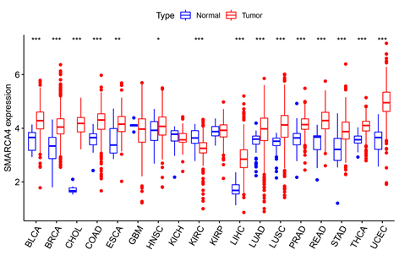
Figure 1 Expression of SMARCA4 in 18 different cancer types. ªP < 0.05, ^{b}P < 0.01, ^{c}P < 0.001. BLCA: Bladder cancer; BRCA: Breast cancer; CHOL: Bile duct cancer; COAD: Colon cancer; ESCA: Esophageal cancer; GBM: Glioblastoma; HNSC: Head and neck cancer; KICH: Kidney chromophobe; KIRC: Kidney clear cell carcinoma; KIRP: Kidney papillary cell carcinoma; LIHC: Liver cancer; LUAD: Lung adenocarcinoma; LUSC: Lung squamous cell carcinoma; PRAD: Prostate cancer; READ: Rectal adenocarcinoma; STAD: Stomach cancer; THCA: Thyroid cancer; EC: Endometrioid cancer.
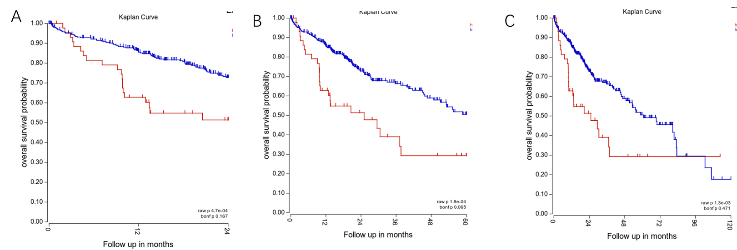
Figure 2 Prognostic value of SMARCA4 in patients with hepatocellular carcinoma. A: 2-year survival analysis, B: 5-year survival analysis, C: 10-year survival analysis.
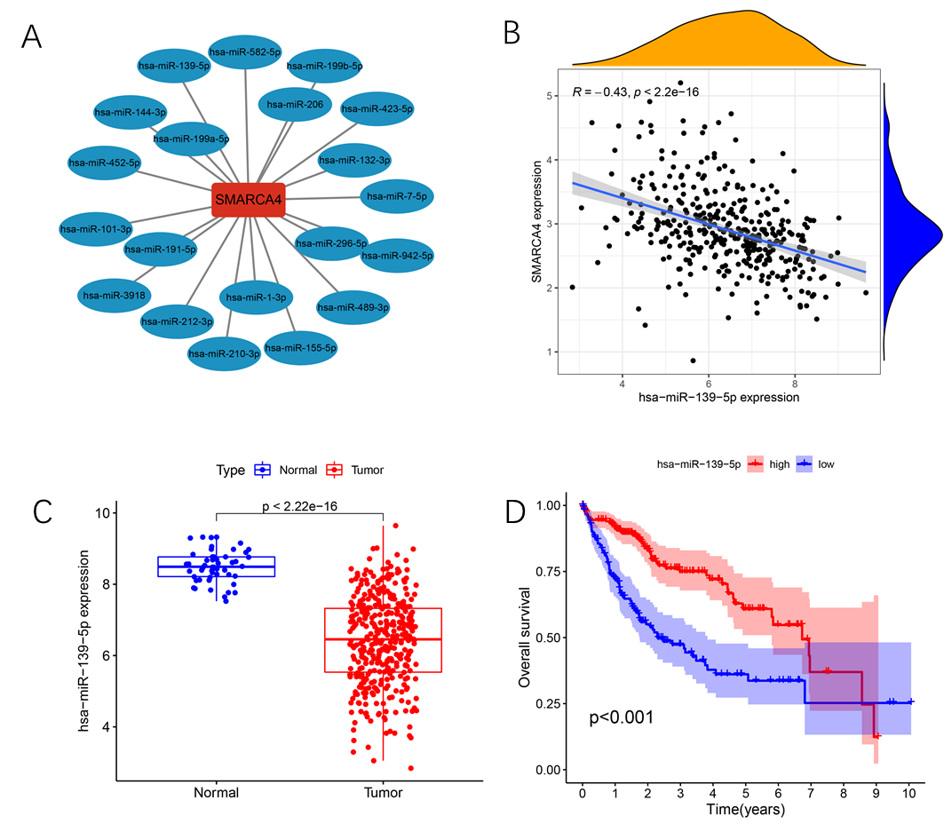
Figure 3 Identification of miRNAs upstream of SMARCA4. A: Upstream miRNAs of SMARCA4; B: Correlation analysis of miR-139-5p and SMARCA4; C: Different expression of SMARCA4 between normal and tumor tissue in hepatocellular carcinoma (HCC) patients; D: Survival analysis of miR-139-5p in patients with HCC.
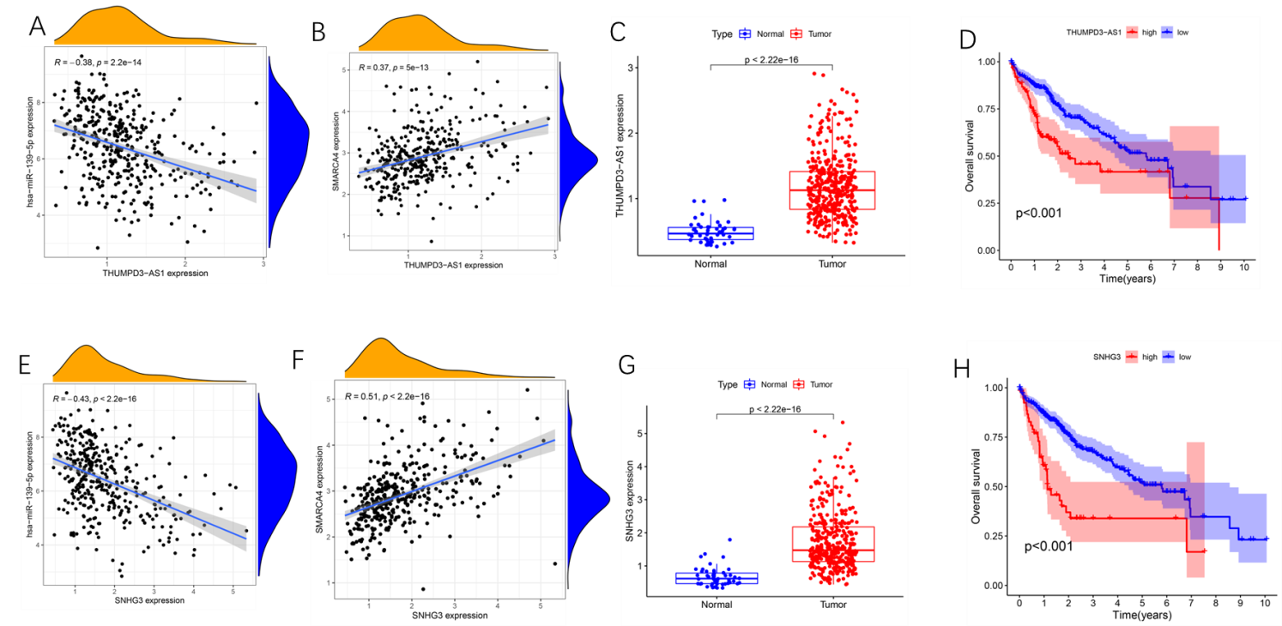
Figure 4 Correlation analysis of long noncoding RNAs upstream of hsa-miR-139-5p. A: Relation between expression of miR-139-5p and THUMPD3-AS1; B: Relation between expression of SMARCA4 and THUMPD3-AS1; C: Expression of THUMPD3-AS1 in tumor and normal tissues in hepatocellular carcinoma (HCC) patients; D: Survival analysis of THUMPD3-AS1 in HCC patients; E: Relation between expression of miR-139-5p and SNHG3; F: Relation between expression of SMARCA4 and SNHG3; G: Different expression of SNHG3 in tumor and normal tissues; H: Survival analysis of SNHG3 in HCC patients.
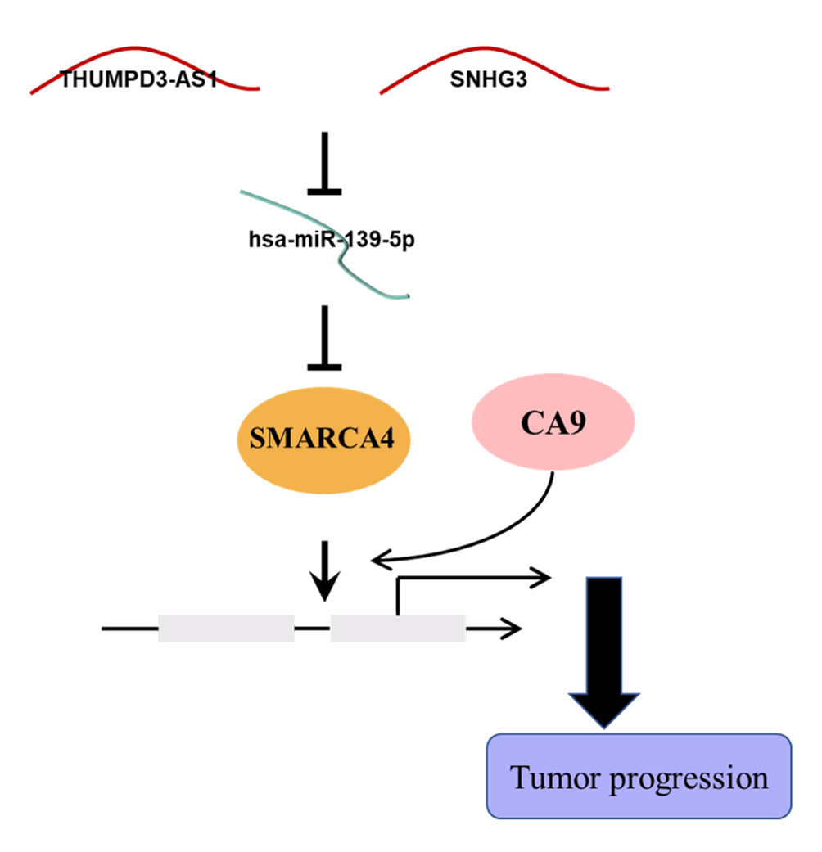
Figure 5 The schematic diagram of SNHG3/THUMP3-AS1-miR-139-5p-SMARCA4- Carbonic Anhydrase 9 in hepatocellular carcinoma.
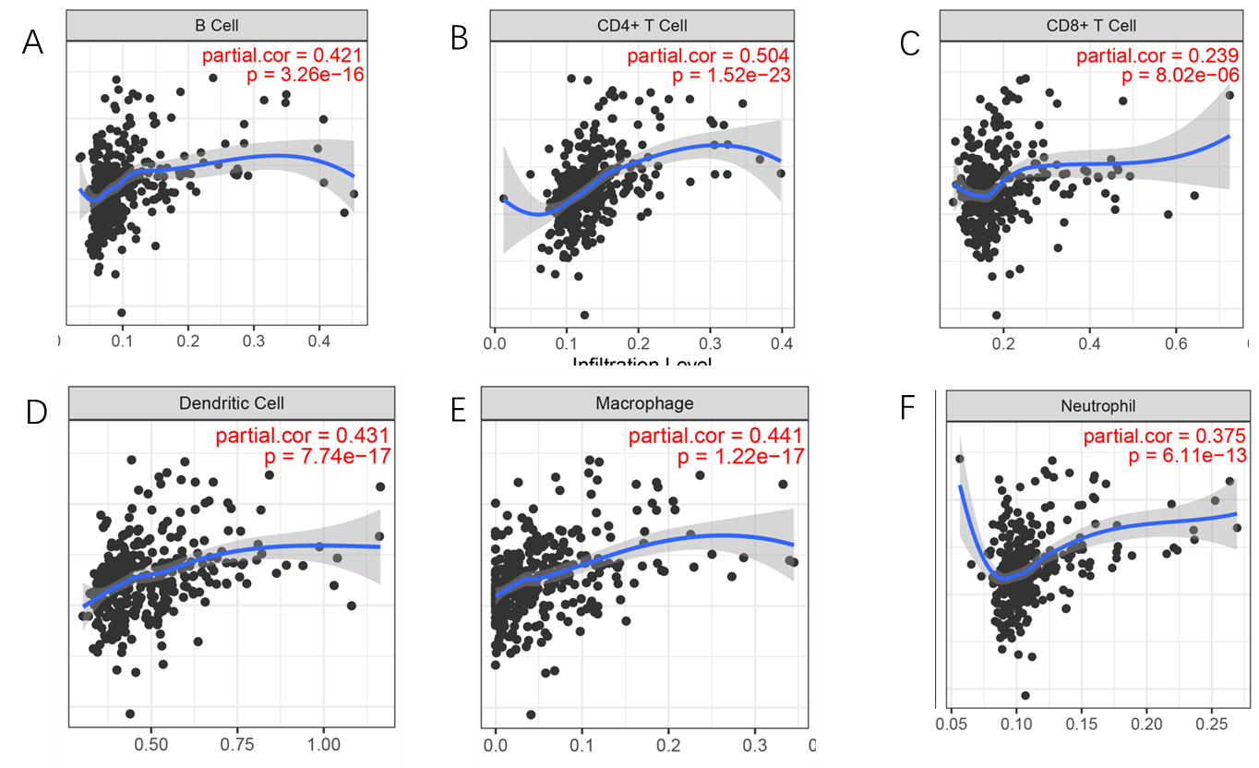
Figure 6 Correlation of expression levels of SMARCA4 with different cells. A: B cells; B: CD4+ T cells; C: CD8+ T cells; D: Dendritic cells; E: Macrophages; F: Neutrophils.
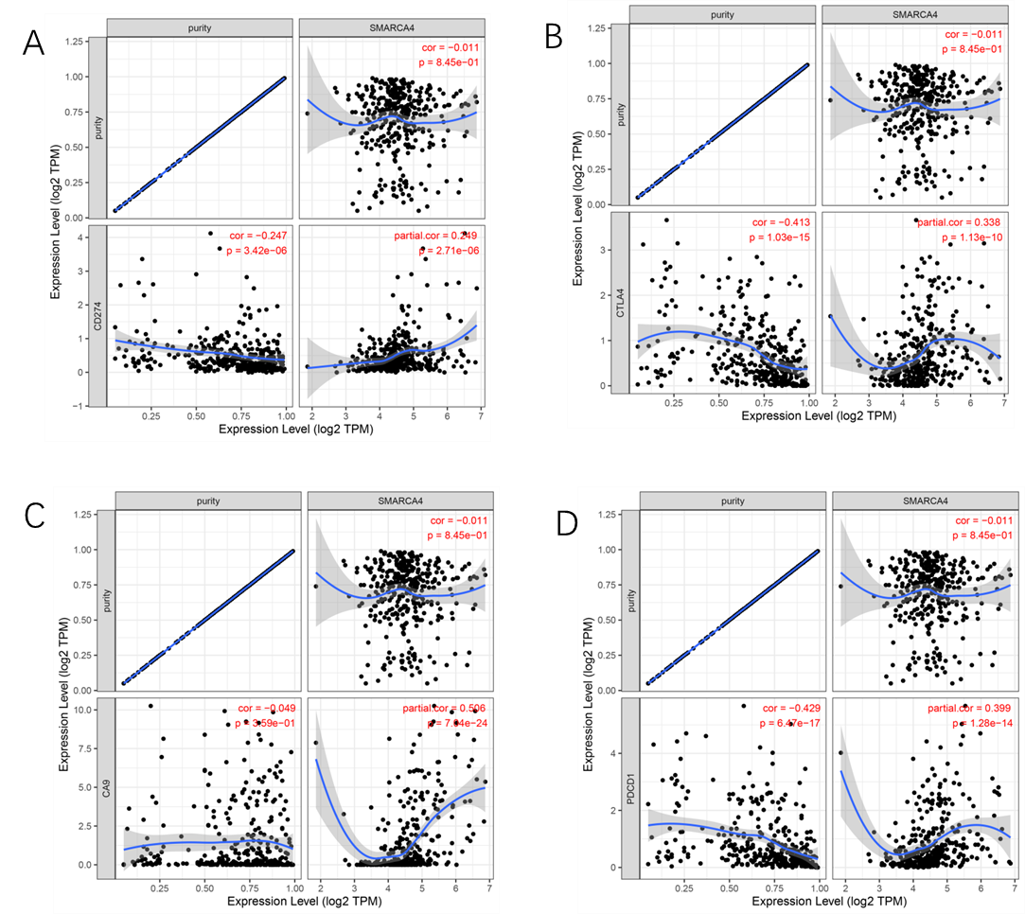
Figure 7 Relationships between the expression levels of SMARCA4 and the aforementioned coding genes. A: CD274; B: CTLA4; C: CA9; D: PDCD1.

Table 1 Correlation analysis of upstream miRNAs of SMARCA4
Gene | miRNA | Correlation | P value
SMARCA4 | hsa-miR-139-5p | -0.43071 | 0
SMARCA4 | hsa-miR-101-3p | -0.35574 | 2.43E-12
SMARCA4 | hsa-miR-144-3p | -0.14422 | 0.005486
SMARCA4 | hsa-miR-206 | 0.010846 | 0.835292
SMARCA4 | hsa-miR-582-5p | 0.011482 | 0.825772
SMARCA4 | hsa-miR-452-5p | 0.013887 | 0.789959
SMARCA4 | hsa-miR-1-3p | 0.059664 | 0.252296
SMARCA4 | hsa-miR-3918 | 0.079807 | 0.12543
SMARCA4 | hsa-miR-489-3p | 0.084322 | 0.105369
SMARCA4 | hsa-miR-191-5p | 0.093233 | 0.073272
SMARCA4 | hsa-miR-199a-5p | 0.113993 | 0.028396
SMARCA4 | hsa-miR-942-5p | 0.143132 | 0.005851
SMARCA4 | hsa-miR-7-5p | 0.176945 | 0.000628
SMARCA4 | hsa-miR-155-5p | 0.183662 | 0.000392
SMARCA4 | hsa-miR-210-3p | 0.199171 | 0.000118
SMARCA4 | hsa-miR-296-5p | 0.276951 | 6.11E-08
SMARCA4 | hsa-miR-423-5p | 0.280627 | 4.59E-08
SMARCA4 | hsa-miR-199b-5p | 0.281593 | 3.59E-08
SMARCA4 | hsa-miR-132-3p | 0.340145 | 2.39E-11
SMARCA4 | hsa-miR-212-3p | 0.350525 | 3.89E-12

Table 2 Correlation analysis of upstream long noncoding RNAs of SMARCA4
lncRNA | miRNA | Correlation | P value
SNHG3 | hsa-miR-139-5p | -0.427905007 | 0
THUMPD3-AS1 | hsa-miR-139-5p | -0.383988472 | 2.16E-14
NUTM2B-AS1 | hsa-miR-139-5p | -0.291498033 | 1.30E-08
NUTM2A-AS1 | hsa-miR-139-5p | -0.249437433 | 1.28E-06
THRB-IT1 | hsa-miR-139-5p | -0.188289895 | 0.000270315
TMEM147-AS1 | hsa-miR-139-5p | -0.182642718 | 0.00042249
ERICD | hsa-miR-139-5p | -0.178277693 | 0.00058107
LINC00641 | hsa-miR-139-5p | -0.168729363 | 0.001138184
LINC00534 | hsa-miR-139-5p | -0.166826573 | 0.001278717
HCP5 | hsa-miR-139-5p | -0.164085024 | 0.001559293
LINC00630 | hsa-miR-139-5p | -0.162703 | 0.001689401
LINC00943 | hsa-miR-139-5p | -0.162451245 | 0.001718019
LINC01579 | hsa-miR-139-5p | -0.158658927 | 0.002206361
RN7SL832P | hsa-miR-139-5p | -0.142762414 | 0.00594314
LINC01278 | hsa-miR-139-5p | -0.132322803 | 0.010883486
XIST | hsa-miR-139-5p | -0.099194046 | 0.056613465
N4BP2L2-IT2 | hsa-miR-139-5p | -0.086285707 | 0.097463633
SLIT2-IT1 | hsa-miR-139-5p | -0.048699898 | 0.35022861
TTN-AS1 | hsa-miR-139-5p | -0.023141977 | 0.657115792
SH3BP5-AS1 | hsa-miR-139-5p | -0.004375804 | 0.933116376
LINC02360 | hsa-miR-139-5p | 0.007581107 | 0.88444703
NEAT1 | hsa-miR-139-5p | 0.011359844 | 0.827521554
DHRS4-AS1 | hsa-miR-139-5p | 0.194299289 | 0.000174124
LINC00885 | hsa-miR-139-5p | 0.221316524 | 1.74E-05
lncRNA: Long noncoding RNAs.
Table 3 Correlation of SMARCA4 with an increased expression of the immune-related genes
Immune cell | Gene | Correlation | P value
B cell | CD19 | 0.229808 | 7.13E-06
B cell | CD79A | 0.240046 | 2.66E-06
CD8+ T cell | CD8A | 0.199613 | 0.000105
CD8+ T cell | CD8B | 0.169187 | 0.001021
CD4+ T cell | CD4 | 0.159602 | 0.001983
M1 macrophage | NOS2 | 0.056408 | 0.276552
M1 macrophage | IRF5 | 0.351521 | 3.50E-12
M1 macrophage | PTGS2 | 0.218218 | 2.07E-05
M2 macrophage | CD163 | 0.041803 | 0.420023
M2 macrophage | VSIG4 | 0.098825 | 0.05623
M2 macrophage | MS4A4A | 0.071163 | 0.169562
Neutrophil | CEACAM8 | 0.089485 | 0.083947
Neutrophil | ITGAM | 0.274952 | 7.38E-08
Neutrophil | CCR7 | 0.155459 | 0.002598
Dendritic cell | HLA-DPB1 | 0.226945 | 9.85E-06
Dendritic cell | HLA-DQB1 | 0.189598 | 0.000232
Dendritic cell | HLA-DRA | 0.195914 | 0.000141
Dendritic cell | HLA-DPA1 | 0.202748 | 8.12E-05
Dendritic cell | CD1C | 0.231224 | 6.24E-06
Dendritic cell | NRP1 | 0.358895 | 1.13E-12
Dendritic cell | ITGAX | 0.292296 | 9.88E-09

