Name of Journal: World Journal of Clinical Cases
Manuscript NO: 68480
Manuscript Type: CASE REPORT

Anticoagulant treatment for pulmonary embolism in patient with cerebral hemorrhage secondary to mechanical thrombectomy: A case report

Chen XT et al. Anticoagulant treatment in pulmonary embolism and cerebral hemorrhage

Xiang-Ting Chen, Qian Zhang, Chang-Qing Zhou, Yu-Fu Han, Qing-Qing Cao

Xiang-Ting Chen, Qian Zhang, Chang-Qing Zhou, Yu-Fu Han, Qing-Qing Cao, Department of Neurology, Bishan Hospital, First Affiliated Hospital of Chongqing Medical University, Chongqing 402760, China

Author contributions: Chen XT, Zhang Q, Zhou CQ, Cao QQ, and Han YF diagnosed, treated, and followed up the patient; Chen XT and Zhou CQ drafted the manuscript and created the figures; Zhou CQ and Zhang Q contributed to the revision of the manuscript; Zhou CQ and Han YF were involved in the surgery; All authors have read and approved the final manuscript to be submitted.

Corresponding author: Chang-Qing Zhou, MD, Chief Doctor, Department of Neurology, Bishan Hospital, First Affiliated Hospital of Chongqing Medical University, Shuangxing Road No.9, Bishan District, Chongqing 402760, China. changqing_zhou@163.com

Received: May 24, 2021
Revised: July 8, 2021
Accepted: August 19, 2021
Published online:

Abstract
BACKGROUND
Cerebral hemorrhage secondary to cerebral embolism after mechanical thrombectomy is characterized by high morbidity, disability and mortality. If the patient also has severe pulmonary embolism (PE) at the same time, the treatment becomes more complex. This report describes the treatment strategy for a patient with PE and cerebral hemorrhage secondary to cerebral embolism after mechanical thrombectomy.

CASE SUMMARY
A 70-year-old woman presented to our emergency department with right-sided hemiplegia and mixed aphasia of 2.5 h duration. She was diagnosed with left cerebral embolism, left internal carotid artery occlusion, PE and left calf intramuscular vein thrombosis. Following mechanical thrombectomy, brain magnetic resonance imaging showed cerebral infarction with basal ganglia hemorrhage. We observed changes in cerebral hemorrhage on serial monitoring of brain computed tomography and adjusted the dose of anticoagulant drugs. After 3 wk of treatment, the patient’s neurological and respiratory symptoms significantly improved, and a favorable prognosis was obtained.

CONCLUSION
Anticoagulation could be a potential option for PE accompanied by hemorrhagic transformation of an ischemic infarct.

Key Words: Pulmonary embolism; Brain embolism; Cerebral hemorrhage; Mechanical thrombectomy; Anticoagulation; Case report

Chen XT, Zhang Q, Zhou CQ, Han YF, Cao QQ. Anticoagulant treatment for pulmonary embolism in patient with cerebral hemorrhage secondary to mechanical thrombectomy: A case report. World J Clin Cases 2021; In press

Core Tip: Pulmonary embolism accompanied by cerebral hemorrhage secondary to cerebral embolism after mechanical thrombectomy is characterized by high disability and mortality. To manage this situation, we adopted a treatment strategy that involved adjustment of anticoagulant drugs according to the changes in cerebral hemorrhage after mechanical thrombectomy. The patient had a favorable prognosis.

INTRODUCTION
Cerebral hemorrhage secondary to cerebral embolism after mechanical thrombectomy is characterized by high morbidity, disability and mortality^{[1]}. If the patient also has severe pulmonary embolism (PE) at the same time, the prognosis may be poor. In this situation, the treatment choice is critical. We report a patient with PE and cerebral hemorrhage secondary to cerebral embolism after thrombectomy who was treated with anticoagulant drugs and her neurological and respiratory symptoms significantly improved. As far as we know, this complex situation has not been described in the literature.

CASE PRESENTATION
Chief complaints
A 70-year-old woman presented to our emergency department with right-sided hemiplegia and mixed aphasia.

History of present illness
This patient had a history of pulmonary hypertension for approximately 2 mo, but her shortness of breath was not relieved. Her right-sided hemiplegia and mixed aphasia started 2.5 h ago.

History of past illness
This patient had no history of allergies, denied tobacco and alcohol use, and was healthy with no history of hypertension, diabetes, coronary heart disease, hyperlipidemia, stroke, or cardiac risk factors.

Personal and family history
This patient has no relevant family history in particular of clotting disorders.

Physical examination
On arrival, her blood pressure was 118/88 mmHg, heart rate was 93 bpm, and respiratory rate was 25 breaths/min. No pathological breath sounds or heart murmurs were noted and no edema in the lower extremities was observed. Neurological examination revealed mixed aphasia, right hemiplegia, and hypoesthesia. Right-side extremity weakness was noted and was graded 0/5 on the Medical Research Council Scale. Her National Institutes of Health Stroke Scale (NIHSS) score was 25.

Laboratory examinations
Laboratory tests revealed high levels of N-terminal pro-brain natriuretic peptide (2308 pg/mL). Her D-dimer level was also elevated (6.23 mg/L). Results of arterial blood gas analysis indicated obvious hypoxemia (PaO₂, 65 mmHg; PaCO₂, 36 mmHg; pH, 7.44). Protein C, protein S, antithrombin III, lupus anticoagulant, and factor V Leiden, prothrombin gene mutation as well as anti-β2-glycoprotein-1 antibodies were within normal limits. Twelve-lead electrocardiography showed a normal sinus rhythm.

Imaging examinations
Brain computed tomography angiography (CTA) showed occlusions of the intracranial segment of the left internal carotid artery and the M1 segment of the left middle cerebral artery. The Alberta Stroke Program Early CT Score was 12. Brain magnetic resonance imaging (MRI) revealed acute multiple cerebral infarctions in the bilateral centrum semiovale, left lateral ventricle, and basal ganglia (Figure 1A). Pulmonary angiography showed that both main trunks and partial branches of bilateral pulmonary arteries were embolized (Figure 2A, 2C). Digital subtraction angiography (DSA) was performed and confirmed the CT findings (Figure 1C). Transesophageal echocardiography did not show any abnormalities. Ultrasound of both lower extremities showed thrombosis in the left muscle calf venous thrombosis (MCVT).

FINAL DIAGNOSIS
Based on these findings, she was diagnosed with left cerebral embolism, left internal carotid artery occlusion, PE, and left MCVT.

TREATMENT
Mechanical thrombectomy was performed, and a large number of thrombi were aspirated with a Penumbra ACE suction catheter, and 100 000 U urokinase was administered locally for thrombolysis. Postoperative angiography showed that the left internal carotid artery, distal middle cerebral artery, and anterior cerebral artery were recanalized (Figure 1D), and the distal blood flow was significantly improved (thrombolysis in cerebral infarction; TICI 2b). After surgery, 4000 U enoxaparin solution was administered.
On the first day after surgery, the patient’s consciousness and symptoms of right hemiplegia improved (NIHSS 15 points). Postoperative brain MRI (Figure 1B) and follow-up brain CT (Figure 3A) showed that the left frontotemporal, occipital, parietal, insula, basal ganglia, and hippocampus had subacute large areas of cerebral infarction with basal ganglia hemorrhage. Anticoagulant therapy was stopped. On the second day after surgery, the follow-up CT scans showed that the cerebral hemorrhage had not enlarged markedly (Figure 3B) and the patient was given a subcutaneous injection of enoxaparin 2000 U twice daily as anticoagulant treatment. On the fourth day after surgery, brain CT scans showed that the cerebral hemorrhage had not enlarged and enoxaparin was changed to 4000 U twice daily. On day 20 after surgery, D-dimer, N-terminal pro-brain natriuretic peptide and blood gas analysis returned to normal levels. Dyspnea gradually resolved. There was no new evidence of cerebral infarction or hemorrhage on repeat CT of the brain (Figure 3C, 3D). Pulmonary angiography showed that the PE had improved (Figure 2B, 2D). Because the patient had left MCVT, combined with PE and cerebral hemorrhage, we suggest considering temporary inferior vena cava filter (IVCF) placement, but the patient’s family refused this treatment.

OUTCOME AND FOLLOW-UP
The patient was discharged to a rehabilitation center 3 wk after admission. The last brain CT scan showed no evidence of new cerebral infarction or hemorrhage. At the time of discharge, the patient showed slight fluid aphasia with right hemiplegia. There was right-sided upper extremity weakness graded 2/5 and lower extremity weakness graded 3/5 on the Medical Research Council Scale. Her NIHSS score was 9 and Modified Rankin Scale was 4. Dyspnea was not observed. The patient was discharged to an oral anticoagulant, namely warfarin, and no recurrence of cerebral infarction or cerebral hemorrhage was found after 6 mo of follow-up.

DISCUSSION
We present the unique case of a patient with PE and cerebral hemorrhage secondary to cerebral embolism after mechanical thrombectomy. However, after anticoagulant treatment, the neurological deficit and dyspnea symptoms gradually resolved, and the patient had a good prognosis. As far as we know, there are no similar case reports.
In this study, MRI revealed that the bilateral brain showed mostly scattered lesions, and the diagnosis of multiple cerebral infarctions was made. However, neither CTA nor DSA showed obvious atherosclerotic plaques. Therefore, it is unlikely that atherosclerotic plaques were present. In addition, the patient did not have common risk factors for stroke, such as diabetes, hyperlipidemia, or hypertension^{[2]}. She was diagnosed with pulmonary hypertension in the other hospital, but because they did not further investigate the cause, this led to subsequent aggravation of the patient’s condition. The patient had cerebral embolism and PE, and both the venous and arterial systems were affected at the same time. Therefore, the patient may have had rare causes leading to chronic PE and further pulmonary hypertension. Pulmonary hypertension may cause a brief right-to-left shunt and emboli from pulmonary arteries to enter the left heart system, finally causing paradoxical cerebral embolism^{[3]}. Although the patient’s cardiac examination showed no abnormal passage between the right heart and left heart, abnormal passages such as patent foramen ovale may be closed or healed as the PE improves^{[4]}. This may be related to the pressure change between the right and left atria.
Based on these findings, combined with the patient’s lower extremity ultrasound, the possibility of PE caused by the left MCVT was considered. MCVT is a peripheral type of deep vein thrombosis (DVT) of the lower extremities and is considered to be the most common origin of DVT. There are related reports that MCVT can spread to the deep veins to form more serious DVT and cause chronic PE^{[5]}, or embolus may become detached and cause chronic PE^{[6]}, so we considered this possibility. At present, there is still a lack of robust evidence-based medical evidence to guide standardized treatment of MCVT; therefore, we still recommended the use of IVCFs to prevent the occurrence of another PE for this patient. It should be noted that the purpose of IVCF is to prevent PE and therefore to reduce associated morbidity and mortality, although randomized trials are needed^{[7,8]}. In patients undergoing anticoagulation for DVT or PE in whom a contraindication to anticoagulation develops, many guidelines and expert consensus suggest^{[9]} that an IVCF be considered in the setting of ongoing significant clinical risk for PE. Furthermore, we have not found the cause of venous thrombosis, so rare causes of venous thrombosis could not be excluded^{[10]}.
This patient had a large area of cerebral embolism caused by acute occlusion of the internal carotid artery and was treated with emergency mechanical thrombectomy. Postoperative CT showed hemorrhagic transformation of an ischemic infarct. However, the patient also had multiple emboli in both pulmonary aortic trunks, and both blood gas analysis and dyspnea indicated severe PE. Anticoagulation is indicated for the treatment of PE^{[11]}, but it may aggravate cerebral hemorrhage. However, if anticoagulation is not administered, PE may gradually worsen and threaten the patient’s life. Furthermore, the recanalized blood vessel may be occluded again. Cerebral hemorrhage secondary to mechanical thrombectomy is not always aggravated after anticoagulation^{[12,13]}, and PE would not improve without anticoagulation. Therefore, the following treatment strategy was adopted. On the first day after surgery, brain CT scan showed hemorrhage in the left basal ganglia area and anticoagulant treatment was stopped. On the second day after surgery, a half-dose of low-molecular-weight heparin was administered twice daily. To adjust the dose of anticoagulant drugs, consecutive brain CT examinations were performed to observe whether the cerebral hemorrhage was progressively aggravated. On the fifth day after surgery, when half-dose anticoagulation therapy did not aggravate cerebral hemorrhage, a full dose was administered. The patient’s neurological symptoms and respiratory symptoms subsequently showed significant improvement.

CONCLUSION
It is unlikely that a specific treatment regimen will work for all patients. In patients with PE combined with cerebral embolism, especially those with cerebral hemorrhage secondary to mechanical thrombectomy, the benefit of anticoagulation and the risk of bleeding should be carefully evaluated to implement an individualized treatment strategy. Disease evolution should be closely monitored to adjust the treatment strategy at any time.

REFERENCES
1 Zi W, Wang H, Yang D, Hao Y, Zhang M, Geng Y, Lin M, Wan Y, Shi Z, Zhou Z, Wang W, Xu H, Tian X, Lv P, Wang S, Liu W, Wang Z, Liu X, Guo F, Zheng D, Li H, Tu M, Jin P, Xiao G, Liu Y, Xu G, Xiong Y, Liu X; ACTUAL Investigators. Clinical Effectiveness and Safety Outcomes of Endovascular Treatment for Acute Anterior Circulation Ischemic Stroke in China. Cerebrovasc Dis 2017; 44: 248-258 [PMID: 28848210 DOI: 10.1159/000478667]
2 Chao TF, Lip GYH, Liu CJ, Lin YJ, Chang SL, Lo LW, Hu YF, Tuan TC, Liao JN, Chung FP, Chen TJ, Chen SA. Relationship of Aging and Incident Comorbidities to Stroke Risk in Patients With Atrial Fibrillation. J Am Coll Cardiol 2018; 71: 122-132 [PMID: 29325634 DOI: 10.1016/j.jacc.2017.10.085]
3 Schäbitz WR, Köhrmann M, Schellinger PD, Minnerup J, Fisher M. Embolic Stroke of Undetermined Source: Gateway to a New Stroke Entity? Am J Med 2020; 133: 795-801 [PMID: 32247819 DOI: 10.1016/j.amjmed.2020.03.005]
4 Ryoo S, Chung JW, Lee MJ, Kim SJ, Lee JS, Kim GM, Chung CS, Lee KH, Hong JM, Bang OY. An Approach to Working Up Cases of Embolic Stroke of Undetermined Source. J Am Heart Assoc 2016; 5: e002975 [PMID: 27006118 DOI: 10.1161/JAHA.115.002975]
5 Kret MR, Liem TK, Mitchell EL, Landry GJ, Moneta GL. Isolated calf muscular vein thrombosis is associated with pulmonary embolism and a high incidence of additional ipsilateral and contralateral deep venous thrombosis. J Vasc Surg Venous Lymphat Disord 2013; 1: 33-38 [PMID: 26993891 DOI: 10.1016/j.jvsv.2012.04.001]
6 Su H, Liu H, Liu J, Wang X. Elderly patients with intertrochanteric fractures after intramedullary fixation : Analysis of risk factors for calf muscular vein thrombosis. Orthopade 2018; 47: 341-346 [PMID: 29556746 DOI: 10.1007/s00132-018-3552-5]
7 Turner TE, Saeed MJ, Novak E, Brown DL. Association of Inferior Vena Cava Filter Placement for Venous Thromboembolic Disease and a Contraindication to Anticoagulation With 30-Day Mortality. JAMA Netw Open 2018; 1: e180452 [PMID: 30646021 DOI: 10.1001/jamanetworkopen.2018.0452]
8 Kakkos SK, Gohel M, Baekgaard N, Bauersachs R, Bellmunt-Montoya S, Black SA, Ten Cate-Hoek AJ, Elalamy I, Enzmann FK, Geroulakos G, Gottsäter A, Hunt BJ, Mansilha A, Nicolaides AN, Sandset PM, Stansby G, Esvs Guidelines Committee, de Borst GJ, Bastos Gonçalves F, Chakfé N, Hinchliffe R, Kolh P, Koncar I, Lindholt JS, Tulamo R, Twine CP, Vermassen F, Wanhainen A, Document Reviewers, De Maeseneer MG, Comerota AJ, Gloviczki P, Kruip MJHA, Monreal M, Prandoni P, Vega de Ceniga M. Editor's Choice - European Society for Vascular Surgery (ESVS) 2021 Clinical Practice Guidelines on the Management of Venous Thrombosis. Eur J Vasc Endovasc Surg 2021; 61: 9-82 [PMID: 33334670 DOI: 10.1016/j.ejvs.2020.09.023]
9 Kaufman JA, Barnes GD, Chaer RA, Cuschieri J, Eberhardt RT, Johnson MS, Kuo WT, Murin S, Patel S, Rajasekhar A, Weinberg I, Gillespie DL. Society of Interventional Radiology Clinical Practice Guideline for Inferior Vena Cava Filters in the Treatment of Patients with Venous Thromboembolic Disease: Developed in collaboration with the American College of Cardiology, American College of Chest Physicians, American College of Surgeons Committee on Trauma, American Heart Association, Society for Vascular Surgery, and Society for Vascular Medicine. J Vasc Interv Radiol 2020; 31: 1529-1544 [PMID: 32919823 DOI: 10.1016/j.jvir.2020.06.014]
10 Hart RG, Diener HC, Coutts SB, Easton JD, Granger CB, O'Donnell MJ, Sacco RL, Connolly SJ; Cryptogenic Stroke/ESUS International Working Group. Embolic strokes of undetermined source: the case for a new clinical construct. Lancet Neurol 2014; 13: 429-438 [PMID: 24646875 DOI: 10.1016/S1474-4422(13)70310-7]
11 Konstantinides SV, Meyer G, Becattini C, Bueno H, Geersing GJ, Harjola VP, Huisman MV, Humbert M, Jennings CS, Jiménez D, Kucher N, Lang IM, Lankeit M, Lorusso R, Mazzolai L, Meneveau N, Ní Áinle F, Prandoni P, Pruszczyk P, Righini M, Torbicki A, Van Belle E, Zamorano JL; ESC Scientific Document Group. 2019 ESC Guidelines for the diagnosis and management of acute pulmonary embolism developed in collaboration with the European Respiratory Society (ERS). Eur Heart J 2020; 41: 543-603 [PMID: 31504429 DOI: 10.1093/eurheartj/ehz405]
12 Charidimou A, Karayiannis C, Song TJ, Orken DN, Thijs V, Lemmens R, Kim J, Goh SM, Phan TG, Soufan C, Chandra RV, Slater LA, Haji S, Mok V, Horstmann S, Leung KT, Kawamura Y, Sato N, Hasebe N, Saito T, Wong LKS, Soo Y, Veltkamp R, Flemming KD, Imaizumi T, Srikanth V, Heo JH; International META-MICROBLEEDS Initiative. Brain microbleeds, anticoagulation, and hemorrhage risk: Meta-analysis in stroke patients with AF. Neurology 2017; 89: 2317-2326 [PMID: 29117953 DOI: 10.1212/WNL.0000000000004704]
13 Sprügel MI, Sembill JA, Kuramatsu JB, Gerner ST, Hagen M, Roeder SS, Endres M, Haeusler KG, Sobesky J, Schurig J, Zweynert S, Bauer M, Vajkoczy P, Ringleb PA, Purrucker JC, Rizos T, Volkmann J, Muellges W, Kraft P, Schubert AL, Erbguth F, Nueckel M, Schellinger PD, Glahn J, Knappe UJ, Fink GR, Dohmen C, Stetefeld H, Fisse AL, Minnerup J, Hagemann G, Rakers F, Reichmann H, Schneider H, Wöpking S, Ludolph AC, Stösser S, Neugebauer H, Röther J, Michels P, Schwarz M, Reimann G, Bäzner H, Schwert H, Classen J, Michalski D, Grau A, Palm F, Urbanek C, Wöhrle JC, Alshammari F, Horn M, Bahner D, Witte OW, Guenther A, Hamann GF, Lücking H, Dörfler A, Schwab S, Huttner HB. Heparin for prophylaxis of venous thromboembolism in intracerebral haemorrhage. J Neurol Neurosurg Psychiatry 2019; 90: 783-791 [PMID: 30992334 DOI: 10.1136/jnnp-2018-319786]

Footnotes
Informed consent statement: Informed written consent was obtained from the patient for publication of this report and any accompanying images.

Conflict-of-interest statement: The authors declare that they have no conflict of interest to disclose.

CARE Checklist (2016) statement: The authors have read the CARE Checklist (2016), and the manuscript was prepared and revised according to the CARE Checklist (2016).

Open-Access: This article is an open-access article that was selected by an in-house editor and fully peer-reviewed by external reviewers. It is distributed in accordance with the Creative Commons Attribution NonCommercial (CC BY-NC 4.0) license, which permits others to distribute, remix, adapt, build upon this work non-commercially, and license their derivative works on different terms, provided the original work is properly cited and the use is non-commercial. See: http://creativecommons.org/Licenses/by-nc/4.0/

Manuscript source: Unsolicited manuscript

Peer-review started: May 24, 2021
First decision: June 25, 2021
Article in press:

Specialty type: Clinical neurology
Country/Territory of origin: China
Peer-review report’s scientific quality classification
Grade A (Excellent): 0
Grade B (Very good): B
Grade C (Good): C
Grade D (Fair): 0
Grade E (Poor): 0

P-Reviewer: Konala VM S-Editor: Ma YJ L-Editor: Kerr C P-Editor:

Figure Legends
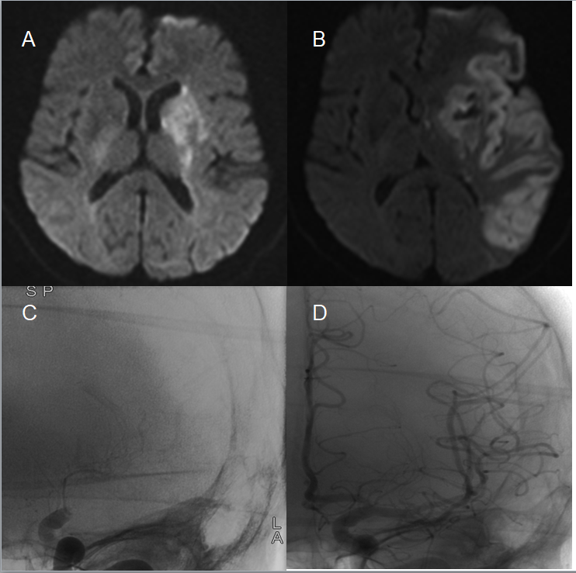
Figure 1 MRI and digital subtraction angiography imaging before and after surgery. A: Axial brain MRI (DWI) on admission showed acute cerebral infarction in the basal ganglia; B: Postoperative brain MRI (DWI) showed subacute large areas of cerebral infarction with basal ganglia hemorrhage; C: Angiogram of the left internal carotid artery showed proximal occlusion of the left middle cerebral artery before mechanical thrombectomy; D: Postoperative angiography showed complete recanalization of the left internal carotid artery and middle cerebral artery. DWI: Diffusion-weighted imaging; MRI: Magnetic resonance imaging.
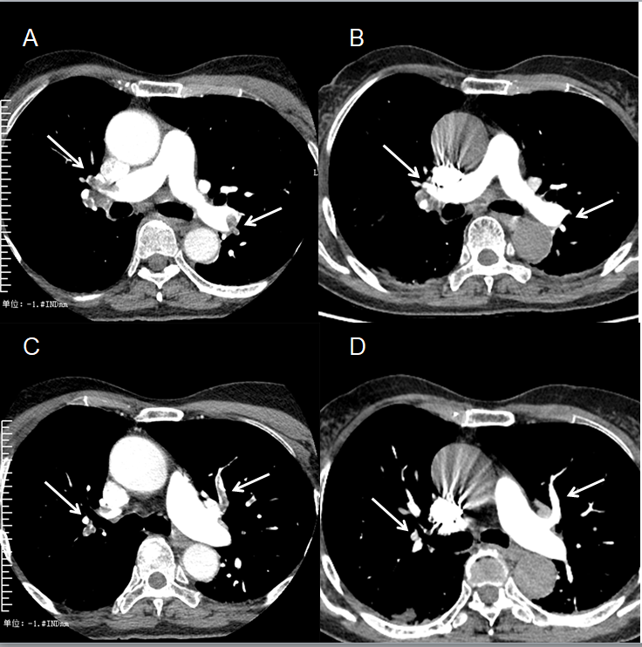
Figure 2 Changes in pulmonary embolism before and after anticoagulation. A, C: Pulmonary angiogram showed multiple repletion defects in both the pulmonary artery trunks and its branches before anticoagulation; B, D: Pulmonary angiogram showed the thrombus was eliminated after 20 d of treatment.
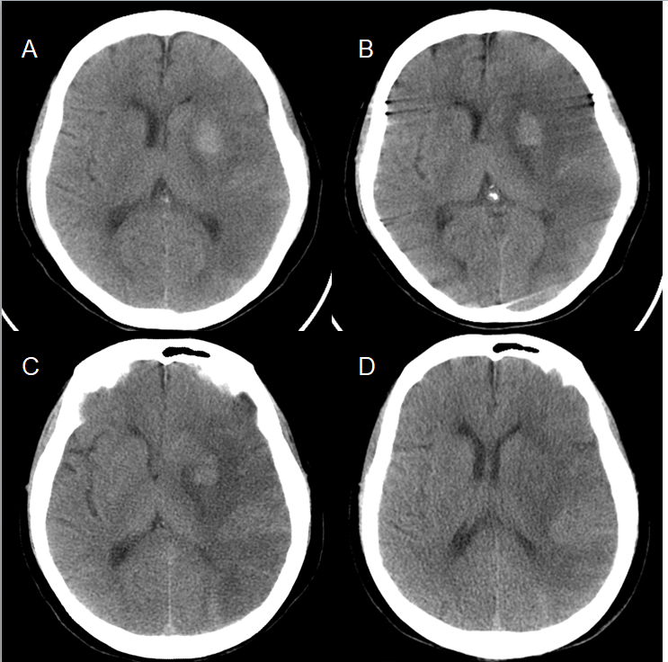
Figure 3 Changes on brain CT scan after surgery. A: Postprocedural brain CT showed large areas of cerebral infarction and hemorrhage in the left basal ganglia area; B–D: Follow-up brain CT showed no new evidence of cerebral infarction or hemorrhage. CT: computed tomography.

