Name of Journal: World Journal of Clinical Cases
Manuscript NO: 78859
Manuscript Type: META-ANALYSIS

Branched-chain amino acids supplementation has beneficial effects on the progression of liver cirrhosis: A meta-analysis

Du JY et al. Branched-chain amino acids use in LC

Jia-Yu Du, Liu Shu, Yu-Tian Zhou, Li Zhang

Jia-Yu Du, School of Clinical Medicine, Chengdu Medical College, Chengdu 610000, Sichuan Province, China

Liu Shu, Department of Neuroscience, College of Veterinary Medicine and Life Sciences, City University of Hong Kong, Hong Kong, China

Yu-Tian Zhou, Department of Geriatrics, Sichuan Provincial People’s Hospital, University of Electronic Science and Technology of China, Chengdu 610000, Sichuan Province, China

Li Zhang, Department of Geriatrics, Sichuan Academy of Medical Sciences & Sichuan Provincial People’s Hospital, Chengdu 610072, Sichuan Province, China

Author contributions: Du JY contributed to conception and design; Zhang L contributed to administrative support; Du JY, Liu S, and Zhou YT contributed to data collection, assembly, analysis and interpretation; all authors contributed to manuscript writing and final approval of the manuscript.

Supported by the Key Research and Development Projects of Sichuan Science and Technology Department, No. 22ZDYF1691, No. 2018FZ0062, and No. 2020YFS0410.

Corresponding author: Li Zhang, MD, Professor, Department of Geriatrics, Sichuan Academy of Medical Sciences & Sichuan Provincial People’s Hospital, No. 32 West Section 2, Yihuan Road, Chengdu 610072, Sichuan Province, China. zhangligbyl@med.uestc.edu.cn

Received: July 18, 2022
Revised: August 19, 2022
Accepted: September 19, 2022
Published online: October 26, 2022

Abstract
BACKGROUND
Liver cirrhosis (LC) is currently the 11th most common cause of death and 15th cause of morbidity globally. The treatment of LC is mainly aimed at etiological intervention, lifestyle intervention, prevention and treatment of complications and nutritional treatment. Nutritional treatment of LC mainly includes increasing dietary intake, food intake time and branched-chain amino acids (BCAAs). Despite the recommendation of BCAAs in some guidelines, adverse effects have been reported in studies so the efficacy and safety of BCAAs remain controversial. Currently, BCAAs have been widely used in chronic liver disease, while the summary of the effect of BCAAs on long-term prognosis is rare.

AIM
To determine the effects of BCAAs in patients with LC.

METHODS
The PubMed, Cochrane Library, Embase and Web of Science databases were searched. The retrieval deadline was 1 October 2021 and there were no language restrictions set in the retrieval. The study was performed in strict accordance with the inclusion and exclusion criteria. Nine studies were finally included. The primary outcome was complications of LC. The secondary outcomes were nutritional status and liver function. This meta-analysis used the Review Manager, version 5 statistical package (Cochrane Collaboration, Oxford, England) for analysis.

RESULTS
The analysis included nine studies that consisted of 1080 patients (554 in the BCAA groups and 526 in the control groups). The nine studies were randomized control trials (RCTs). The quality of the studies was assessed using the risk of bias method recommended by the Cochrane Collaboration. BCAAs reduced the rate of complications in LC patients [Risk ratio: 0.70, 95% confidence interval (CI): 0.56-0.88, P = 0.002] and improved patients’ albumin levels [std mean difference SMD: 0.26, 95%CI: 0.12-0.40, P = 0.0002]. Meanwhile, BCAAs significantly ameliorated the levels of alanine transaminase (SMD: -2.03, 95%CI: -2.52 to -1.53, P < 0.00001) and aspartate aminotransferase (SMD: -1.8, 95%CI: -2.14 to -1.46, P < 0.00001). Meanwhile, glucose in the LC was significantly increased in BCAA-treated patients (MD: 13.04, 95%CI: 6.81-19.89, P = 0.0002).

CONCLUSION
BCAAs reduce the incidence of complications in patients with LC and ameliorate nutritional status.

Key Words: Liver cirrhosis; Branched-chain amino acids; Complications; Nutrition; Liver function; Glucose

©The Author(s) 2022. Published by Baishideng Publishing Group Inc. All rights reserved.

Citation: Du JY, Shu L, Zhou YT, Zhang L. Branched-chain amino acids supplementation has beneficial effects on the progression of liver cirrhosis: A meta-analysis. World J Clin Cases 2022; 10(30): 10984-10996
URL: https://www.wjgnet.com/2307-8960/full/v10/i30/10984.htm
DOI: https://dx.doi.org/10.12998/wjcc.v10.i30.10984

Core Tip: Liver cirrhosis (LC) is currently the 11th most common cause of death and the 15th cause of morbidity globally. Nutritional treatment of LC mainly includes increasing dietary intake, food intake time and branched chain amino acids (BCAAs). The efficacy and safety of BCAAs remain controversial. We performed a meta-analysis and nine studies were finally included. The primary outcome was complications of LC. The secondary outcomes were nutritional status and liver function. The conclusion is that branched-chain amino acids reduce the incidence of complications in patients with liver cirrhosis and ameliorate nutritional status.

INTRODUCTION
As the 11th leading cause of death and 15th leading cause of morbidity worldwide, liver cirrhosis (LC) is the end stage of liver diseases^{[1]}. It is the top 20 causes of disability-adjusted life years and years of life lost and accounts for 1.6% and 2.1% of the worldwide burden. Asrani et al^{[2]} summarized that LC causes two million deaths, one million deaths from cirrhosis complications and one million deaths from viral hepatitis and hepatocellular carcinoma annually.
For the high mortality and poor prognosis, much research has reported the following indicators of poor prognosis of LC^{[3-6]}. Although liver biopsy and hepatic venous pressure gradient are currently recommended invasive indicators to predict the prognosis of LC^{[3,4]}, noninvasive prediction tools are commonly used in clinical work. Child Pugh and the model for end-stage liver disease (MELD), including creatinine, International Normalized Ratio and bilirubin are two of the most recommended forecasting tools in recent years^{[7]}. Child-Pugh scores included encephalopathy, ascites, urine volume, bilirubin, albumin and prothrombin time^{[5]}. MELD scores included creatinine, international normalized ratio and bilirubin^{[6]}. In our study, nutritional status (serum albumin), the occurrence of complications, and liver functions [aspartate aminotransferase (AST), alanine transaminase (ALT), bilirubin] were chosen as indicators to evaluate and predict the prognosis of LC. The disease progresses to decompensation, and complications follow, such as the development of ascites, portal hypertensive gastrointestinal bleeding, encephalopathy and jaundice^{[8]}. Similarly, as mentioned above, malnutrition also means a poor prognosis. Protein calorie malnutrition is not only the most common symptom in patients with LC^{[9]} but also an independent risk factor for death^{[10,11]}, leading to more severe complications^{[12,13]}. A clinical trial reported that 51% of patients with LC showed some clinical evidence of protein caloric malnutrition^{[14]}.
At present, the treatment of LC is mainly for the cause of intervention, lifestyle intervention, and the prevention and treatment of complications^{[15]}. Toshikuni et al^{[16]} mentioned that nutritional therapy for LC mainly included increasing dietary intake, the timing of food intake and branched-chain amino acids (BCAAs). In recent years, BCAAs have been found to have a unique effect on LC^{[17-24]}. BCAAs are a set of essential amino acids including leucine, isoleucine and valine. It was considered that the end stage of liver disease is characterized by a low concentration of BCAAs and a high concentration of aromatic amino acids (phenylalanine, tyrosine and tryptophan)^{[21]}. Suzuki et al^{[25]} found that in patients with compensated cirrhosis, amino acid imbalance also occurs. Hyperinsulinemia and hyperammonemia are thought to lead to changes in the amino acid ratio in patients with LC^{[26,27]}. The decrease in BCAA levels is considered to be a crucial pathogenic factor in LC^{[28]}. Consequently, studies have reported that oral BCAAs can ameliorate patients’ nutritional status^{[17,19-21,23,24]}, reduce the incidence of complications^{[17,19]} and ameliorate liver function^{[20,22,23]}. Although BCAAs have been recommended in some guidelines^{[29,30]}, adverse reactions have been reported in recent studies and the effectiveness and safety of BCAAs are still controversial^{[31,32]}. Kobayashi et al^{[31]} considered that BCAAs have no inhibitory effect on the progression from compensatory cirrhosis to decompensated cirrhosis. In addition, the effect of BCAAs on the overall condition of cirrhosis is less well studied. Therefore, we conducted a meta-analysis of these studies to evaluate the effect of its application in LC.

MATERIALS AND METHODS
Objective
This analysis’s ultimate goal was to demonstrate the patients’ treatment effect with LC using BCAAs.

Selection of studies
Studies that conformed to the following criteria were included in our meta-analysis: (1) Randomized controlled studies; (2) the patient was diagnosed with cirrhosis; and (3) the intervention factor was BCAAs.
Studies were excluded if they met at least one of the following exclusion criteria: (1) The patient used BCAAs or other nutritional agents; (2) the patient had a high suspicion of liver neoplasms or had developed liver neoplasms; and (3) the patient had other major non-hepatic diseases.
In addition, filtering studies, abstracts, letters, reviews without original data, expert opinions, editorials, case reports and studies lacking control groups were excluded.

Search strategy
We selected articles from PubMed, Cochrane Library, Embase and Web of Science. The retrieval deadline was 1 October 2021, and there were no language restrictions set in the retrieval. Search terms were utilized in the title, abstract, mesh fields, and the following keywords and their combinations were applied: (((liver cirrhosis[MeSH Terms])) OR (((hepatic[All Fields])) OR (liver)) AND ((cirrhosis[All Fields])) OR (fibrosis)) AND ((Amino Acids, Branched-Chain [MeSH Terms])) OR (((((((Acids, Branched-Chain Amino[All Fields])) OR (Branched-Chain Amino Acids)) OR (Amino Acids, Branched Chain)) OR (Branched-Chain Amino Acid)) OR (Acid, Branched-Chain Amino)) OR (Amino Acid, Branched-Chain)) OR (Branched Chain Amino Acid).
The outcomes of the meta-analyses were the occurrence of complications, nutritional status and liver function. These data included albumin, alanine transaminase, aspartate aminotransferase, bilirubin, glucose and the occurrence of ascites, hepatic encephalopathy or esophagogastric varices.

Data extraction
Reviewers independently reviewed the quality and qualification of these studies according to the inclusion and exclusion criteria and the second reviewer (corresponding author) was allowed to intervene.

Statistical analysis
This meta-analysis used the Review Manager, version 5 statistical package (Cochrane Collaboration, Oxford, England) for analysis. A risk ratio (RR) value with a 95% confidence interval (CI) was used for binary variables. Mean difference (MD) or Std MD (SMD) values with a 95%CI are used for continuous variables. The overall effects were measured using a z score with a significance set at P < 0.05. If P ≥ 0.05, there was no significant difference in the results. In contrast, the results are significantly different. Statistical heterogeneity was evaluated using chi-square and I-square (I²) tests with significance set at P ≤ 0.1. Values of P ≤ 0.1 and I² > 50% were considered to be significantly heterogeneous. For the articles with I² > 0, we used the random effect model and sensitivity analysis or subgroup analysis, and for the articles with I² = 0, we used the fixed-effect model.

RESULTS
Study selection and characteristics of included studies
The analysis included nine studies that consisted of 1080 patients (554 in the BCAA groups and 526 in the control groups)^{[17,19-24,31,32]}. The nine studies were randomized control trials (RCTs) (Figure 1). The characteristics of the studies included in the meta-analysis are shown in Table 1. The patient baseline characteristics of the studies included in the meta-analysis are shown in Table 2.

Risk of bias assessment
The quality of the studies was assessed using the risk of bias method recommended by the Cochrane Collaboration. Some trials had a high risk of bias (Figure 2)^{[22]}. The main reason is that blind methods are not adopted and the inevitable loss of visits is inevitable.

Outcome
Complications rate: Statistical heterogeneity was low across the studies for the complication rate (Tau² = 0.00; χ² = 2.00, df = 4 (P = 0.74); I² = 0%) by fitting a fixed-effects model. The complication rate of LC was significantly reduced in BCAA-treated patients (RR: 0.70, 95%CI: 0.56-0.88, P = 0.002, Figure 3).

Nutritional status: Statistical heterogeneity was high across the studies for nutritional status [Tau² = 0.29; χ² = 36.72, df = 6 (P < 0.00001); I² = 84%] by fitting a random-effects model. The albumin level of LC was significantly ameliorated in BCAA-treated patients (SMD: 0.63, 95%CI: 0.17-1.09, P = 0.007, Figure 4A). Nevertheless, they have slight heterogeneity.
Subgroup analysis was therefore performed according to the number of included patients and studies with a total number of patients less than 50 were excluded. Statistical heterogeneity was low across the studies for nutritional status [Tau² = 0.00; χ² = 2.78, df = 3 (P = 0.43); I² = 0%] by fitting a fixed-effects model. The SMD of the fixed effect model analysis was 0.26 (95%CI: 0.12-0.40, P = 0.0002, Figure 4B).
Additional subgroup analysis included studies with treatment durations greater than 3 mo. Statistical heterogeneity was low across the studies for nutritional status [Tau² = 0.00; χ² = 2.06, df = 3 (P = 0.56); I² = 0%] by fitting a fixed-effects model. The SMD of the fixed effect model analysis was 0.27 (95%CI: 0.13-0.42, P = 0.0002, Figure 4C).
The last subgroup analysis included studies in which the majority of patients had Child grade A or B and treatment duration was greater than 3 mo. Statistical heterogeneity was low across the studies for nutritional status [Tau² = 0.00; χ² = 1.67, df = 2 (P = 0.43); I² = 0%] by fitting a fixed-effects model. The SMD of the fixed effect model analysis was 0.26 (95%CI: 0.11-0.41, P = 0.0005, Figure 4D).
These results further confirmed that BCAAs significantly ameliorate nutritional status in these patients.

Liver function
Aspartate aminotransferase (AST): Statistical heterogeneity was low across the studies for AST [Tau² = 0.00; χ² = 3.03, df = 3 (P = 0.39); I² = 1%] by fitting a random-effects model. AST of LC was significantly ameliorated in BCAA treatment patients (SMD: -1.8, 95%CI: -2.14 to -1.46, P < 0.00001, Figure 5).

Alanine transaminase (ALT): Statistical heterogeneity was high across the studies for ALT (Tau² = 1.33; χ² = 24.94, df = 2 (P < 0.00001); I² = 92%) by fitting a random-effects model. The ALT level in the LC was significantly ameliorated in BCAA-treated patients (SMD: -1.43, 95%CI: -2.80 to -0.06, P = 0.04, Figure 6A). Nevertheless, they have slight heterogeneity.
In the sensitivity analysis, the study by Kawamura et al^{[19]} was excluded because the disease cause of most patients in this study was found to be a virus. However, the antiviral drugs available in 2009 temporarily failed to achieve good control of viremia, resulting in persistently high serum AST/ALT levels. Statistical heterogeneity was low across the studies for ALT [χ² = 0.43, df = 1 (P = 0.51); I² = 0%] by fitting a fixed-effects model. The ALT of LC was significantly ameliorated in BCAA-treated patients (SMD: -2.03, 95%CI: -2.52 to -1.53, P < 0.00001, Figure 6B).

Bilirubin: Statistical heterogeneity was high across the studies for bilirubin [Tau² = 0.40; χ² = 15.44, df = 3 (P = 0.001); I² = 81%] by fitting a random-effects model. The results showed that the effect of BCAAs on bilirubin in patients with LC was not statistically significant (SMD: -0.37, 95%CI: -1.06-0.32, P = 0.29, Figure 7).

Glucose
Statistical heterogeneity was high across the studies for glucose [Tau² = 57.47; χ² = 8.54, df = 2 (P = 0.01); I² = 77%] by fitting a random-effects model. The results showed that the effect of BCAAs on glucose in patients with LC was not statistically significant (MD: 8.10, 95%CI: -1.76-17.95, P = 0.11, Figure 8A). Nevertheless, they have slight heterogeneity.
In the sensitivity analysis, the study by Marchesini et al^{[23]}was excluded because the Child grade of patients included in the other two studies was graded A or B. Statistical heterogeneity was low across the studies for glucose [χ² = 0.26, df = 1 (P = 0.61); I² = 0%] by fitting a fixed-effects model. The Glucose of the LC was significantly increased in BCAA-treated patients (MD: 13.04, 95%CI: 6.81-19.89, P = 0.0002, Figure 8B).

DISCUSSION
In our meta-analysis, we demonstrated that BCAAs reduce the occurrence of complications in patients with LC. Moreover, nutritional status was improved by BCAA treatment. There was no significant publication bias in the main outcome indicators (Figure 9).
The occurrence of LC complications indicates the decompensated stage of LC, and the prognosis is inferior. It is essential to delay the progression of LC. Most of the complications of LC were hepatic encephalopathy, ascites and esophageal varices in our analysis. Our study showed that BCAAs can significantly reduce the occurrence of complications. In our opinion, the mechanism by which BCAAs ameliorate hepatic encephalopathy mainly includes the following aspects. First, BCAAs can promote the metabolism of ammonia in muscle and reduce the level of blood ammonia in patients with hepatic encephalopathy^{[33]}. Second, BCAAs can ameliorate albumin levels in patients with hepatic encephalopathy^{[34,35]} thus increasing skeletal muscle weight. The increased muscle mass may increase extrahepatic ammonia detoxification^{[36]}. Third, BCAAs may further enhance the detoxification of ammonia in skeletal muscle through the amidation process of glutamine synthesis^{[37]}. Last, the addition of BCAAs reduces the brain efflux of aromatic amino acids across the blood brain barrier and the imbalance of dopamine, norepinephrine and serotonin synthesis^{[38]}. There is a lack of detailed research on the mechanism by which BCAAs prevent other complications. Although many studies have shown that BCAAs are helpful for delaying LC^{[17,19]}, Michel et al^{[32]} and Kobayashi et al^{[31]} showed that BCAAs have no pronounced effect on the progression of LC. However, the subgroup analysis showed that BCAAs could inhibit the occurrence of hepatocellular carcinoma (HCC) in patients with compensated cirrhosis whose serum albumin level was less than 4 g/gL^{[31]}.
We also showed that BCAAs increased the nutritional status in patients with LC. The albumin level is an important indicator to evaluate the nutritional status of patients with LC. However, there is no further discussion on the correlation between albumin level and BCAA treatment. Some studies have shown that BCAAs can significantly improve the level of albumin^{[17,19,20]}. In addition, many studies used mid-arm muscle circumference (MAMC) and skinfold thickness to determine patients’ nutritional level with LC^{[24]}. These indexes are essential for evaluating the nutritional level of patients with LC. However, there is no meta-analysis on these indexes in this paper due to the lack of several homogeneous studies. Meanwhile, sarcopenia is a complication of LC and an independent risk factor for the disease^{[39,40]}. Qiu et al^{[41]} confirmed that hyperammonemia-induced autophagy is a potential cause of skeletal muscle loss in cirrhosis. The incidence of sarcopenia is increasing year by year. Kitajima et al^{[42]} confirmed that BCAAs could prevent muscle loss. A large number of experiments are needed to explore the effect of BCAAs on patients with LC and sarcopenia.
Meanwhile, the decreases in AST and ALT were investigated after BCAA treatment. ALT and AST are enzymes of hepatic gluconeogenesis. When hepatocytes are damaged, they are released from the cells. The increase in AST and ALT levels can be used as a reference index of liver function damage, but other diseases may increase AST and ALT levels which need to be excluded^{[43]}. The included studies did not adequately report data on INR, creatinine, resolution of ascites or remission of encephalopathy. Therefore, as a meta-analysis, the relationship between BCAAs and liver function could not be determined at this time. Additionally, with regard to bilirubin, the meta-analysis related to bilirubin was not statistically significant due to the heterogeneity of the included studies and inadequate sample size, and it is hoped that more studies with sufficient data size will be discussed further in the future.
The meta-analysis of the two studies included in this paper demonstrated that BCAAs might increase the glucose level of patients. BCAAs have a specific effect on blood glucose, which has been confirmed in many studies. A review has shown that BCAAs may increase insulin resistance. Elevated BCAAs stimulate mTORC1, a nutrient sensing complex, and IRS-1 serine phosphorylation results in insulin resistance and other metabolic disorders^{[44]}. Simultaneously, it has been widely confirmed that BCAAs upregulate glucose transporters and activate insulin secretion^{[45-47]}. Some studies have shown that BCAAs may induce insulin resistance by inhibiting insulin signaling^{[48,49]}. Recently, a clinical trial showed that BCAAs can induce insulin resistance through mTOR activation^{[50]}. In contrast, it is still reported that BCAAs can decrease insulin resistance^{[51,52]}. Despite the controversy, we recommend, based on our results, that we still need to adhere to monitoring the changes in blood glucose and be alert to endocrine disorders when taking BCAAs. In addition, it has been reported that supplementation with BCAAs may lead to an increase in ammonia produced by glutamine decomposition in the intestine and kidney due to the stimulating effect of BCAAs on glutamine synthesis, which may harm the development of hepatic encephalopathy. Therefore, BCAAs and α-ketoglutarate or phenyl butyric acid should be used simultaneously to treat hepatic encephalopathy^{[53]}.
Our study has some limitations. First, the article only included RCT research, excluding non-RCT research. Second, the article aims to uneven the population areas and lacks targeted research for a specific area. There may be deviations in treatment. Third, because of the lack of high-quality literature in this area, we only selected the articles that met the requirements after excluding the quality problems and needed large-scale experiments to confirm our ideas further.
Finally, our results provide a reference for the nutritional treatment of patients with LC which is helpful for clinical and nursing applications. We hope that there will be better nutritional support treatment plans for LC patients in the future.

CONCLUSION
Branched-chain amino acids could reduce the incidence of complications in patients with liver cirrhosis and ameliorate nutritional status.

ARTICLE HIGHLIGHTS
Research background
Liver cirrhosis (LC) mainly includes increasing dietary intake, food intake time and branched-chain amino acids (BCAAs). Despite the recommendation of BCAAs in some guidelines, adverse effects have been reported in studies so the efficacy and safety of BCAAs remain controversial.

Research motivation
We performed a meta-analysis to determine the effects of BCAAs in patients with LC.

Research objectives
To determine the effects of BCAAs in patients with LC.

Research methods
Nine studies were finally included. The primary outcome was complications of LC. The secondary outcomes were nutritional status and liver function. This meta-analysis used the Review Manager, version 5 statistical package (Cochrane Collaboration, Oxford, England) for analysis.

Research results
BCAAs reduced the rate of complications in LC patients (Risk ratio: 0.70, 95% confidence interval (CI): 0.56-0.88, P = 0.002) and improved patients’ albumin levels [std mean difference SMD: 0.26, 95%CI: 0.12-0.40, P = 0.0002]. Meanwhile, BCAAs significantly ameliorated the levels of alanine transaminase (SMD: -2.03, 95%CI: -2.52 to -1.53, P < 0.00001) and aspartate aminotransferase (SMD: -1.8, 95%CI: -2.14 to -1.46, P < 0.00001). Meanwhile, glucose in the LC was significantly increased in BCAA-treated patients (MD: 13.04, 95%CI: 6.81-19.89, P = 0.0002).

Research conclusions
Branched-chain amino acids could reduce the incidence of complications in patients with liver cirrhosis and ameliorate nutritional status.

Research perspectives
Our results provide a reference for the nutritional treatment of patients with LC which is helpful for clinical and nursing applications. We hope that there will be better nutritional support treatment plans for LC patients in the future.

REFERENCES
1 Tsochatzis EA, Bosch J, Burroughs AK. Liver cirrhosis. Lancet 2014; 383: 1749-1761 [PMID: 24480518 DOI: 10.1016/S0140-6736(14)60121-5]
2 Asrani SK, Devarbhavi H, Eaton J, Kamath PS. Burden of liver diseases in the world. J Hepatol 2019; 70: 151-171 [PMID: 30266282 DOI: 10.1016/j.jhep.2018.09.014]
3 Ripoll C, Groszmann R, Garcia-Tsao G, Grace N, Burroughs A, Planas R, Escorsell A, Garcia-Pagan JC, Makuch R, Patch D, Matloff DS, Bosch J; Portal Hypertension Collaborative Group. Hepatic venous pressure gradient predicts clinical decompensation in patients with compensated cirrhosis. Gastroenterology 2007; 133: 481-488 [PMID: 17681169 DOI: 10.1053/j.gastro.2007.05.024]
4 Rockey DC, Caldwell SH, Goodman ZD, Nelson RC, Smith AD; American Association for the Study of Liver Diseases. Liver biopsy. Hepatology 2009; 49: 1017-1044 [PMID: 19243014 DOI: 10.1002/hep.22742]
5 Pugh RN, Murray-Lyon IM, Dawson JL, Pietroni MC, Williams R. Transection of the oesophagus for bleeding oesophageal varices. Br J Surg 1973; 60: 646-649 [PMID: 4541913 DOI: 10.1002/bjs.1800600817]
6 Kamath PS, Wiesner RH, Malinchoc M, Kremers W, Therneau TM, Kosberg CL, D'Amico G, Dickson ER, Kim WR. A model to predict survival in patients with end-stage liver disease. Hepatology 2001; 33: 464-470 [PMID: 11172350 DOI: 10.1053/jhep.2001.22172]
7 Kim WR, Mannalithara A, Heimbach JK, Kamath PS, Asrani SK, Biggins SW, Wood NL, Gentry SE, Kwong AJ. MELD 3.0: The Model for End-Stage Liver Disease Updated for the Modern Era. Gastroenterology 2021; 161: 1887-1895.e4 [PMID: 34481845 DOI: 10.1053/j.gastro.2021.08.050]
8 D'Amico G, Garcia-Tsao G, Pagliaro L. Natural history and prognostic indicators of survival in cirrhosis: a systematic review of 118 studies. J Hepatol 2006; 44: 217-231 [PMID: 16298014 DOI: 10.1016/j.jhep.2005.10.013]
9 Nishikawa H, Enomoto H, Nishiguchi S, Iijima H. Sarcopenic Obesity in Liver Cirrhosis: Possible Mechanism and Clinical Impact. Int J Mol Sci 2021; 22 [PMID: 33671926 DOI: 10.3390/ijms22041917]
10 Alberino F, Gatta A, Amodio P, Merkel C, Di Pascoli L, Boffo G, Caregaro L. Nutrition and survival in patients with liver cirrhosis. Nutrition 2001; 17: 445-450 [PMID: 11399401 DOI: 10.1016/s0899-9007(01)00521-4]
11 Kalman DR, Saltzman JR. Nutrition status predicts survival in cirrhosis. Nutr Rev 1996; 54: 217-219 [PMID: 8918144 DOI: 10.1111/j.1753-4887.1996.tb03937.x]
12 McCullough AJ, Mullen KD, Smanik EJ, Tabbaa M, Szauter K. Nutritional therapy and liver disease. Gastroenterol Clin North Am 1989; 18: 619-643 [PMID: 2680968]
13 Sam J, Nguyen GC. Protein-calorie malnutrition as a prognostic indicator of mortality among patients hospitalized with cirrhosis and portal hypertension. Liver Int 2009; 29: 1396-1402 [PMID: 19602136 DOI: 10.1111/j.1478-3231.2009.02077.x]
14 Peng S, Plank LD, McCall JL, Gillanders LK, McIlroy K, Gane EJ. Body composition, muscle function, and energy expenditure in patients with liver cirrhosis: a comprehensive study. Am J Clin Nutr 2007; 85: 1257-1266 [PMID: 17490961 DOI: 10.1093/ajcn/85.5.1257]
15 Romanelli RG, Stasi C. Recent Advancements in Diagnosis and Therapy of Liver Cirrhosis. Curr Drug Targets 2016; 17: 1804-1817 [PMID: 27296314 DOI: 10.2174/1389450117666160613101413]
16 Toshikuni N, Arisawa T, Tsutsumi M. Nutrition and exercise in the management of liver cirrhosis. World J Gastroenterol 2014; 20: 7286-7297 [PMID: 24966599 DOI: 10.3748/wjg.v20.i23.7286]
17 Muto Y, Sato S, Watanabe A, Moriwaki H, Suzuki K, Kato A, Kato M, Nakamura T, Higuchi K, Nishiguchi S, Kumada H; Long-Term Survival Study Group. Effects of oral branched-chain amino acid granules on event-free survival in patients with liver cirrhosis. Clin Gastroenterol Hepatol 2005; 3: 705-713 [PMID: 16206505 DOI: 10.1016/s1542-3565(05)00017-0]
18 Nakaya Y, Harada N, Kakui S, Okada K, Takahashi A, Inoi J, Ito S. Severe catabolic state after prolonged fasting in cirrhotic patients: effect of oral branched-chain amino-acid-enriched nutrient mixture. J Gastroenterol 2002; 37: 531-536 [PMID: 12162411 DOI: 10.1007/s005350200082]
19 Kawamura E, Habu D, Morikawa H, Enomoto M, Kawabe J, Tamori A, Sakaguchi H, Saeki S, Kawada N, Shiomi S. A randomized pilot trial of oral branched-chain amino acids in early cirrhosis: validation using prognostic markers for pre-liver transplant status. Liver Transpl 2009; 15: 790-797 [PMID: 19562716 DOI: 10.1002/lt.21758]
20 Nakaya Y, Okita K, Suzuki K, Moriwaki H, Kato A, Miwa Y, Shiraishi K, Okuda H, Onji M, Kanazawa H, Tsubouchi H, Kato S, Kaito M, Watanabe A, Habu D, Ito S, Ishikawa T, Kawamura N, Arakawa Y; Hepatic Nutritional Therapy (HNT) Study Group. BCAA-enriched snack improves nutritional state of cirrhosis. Nutrition 2007; 23: 113-120 [PMID: 17234504 DOI: 10.1016/j.nut.2006.10.008]
21 Les I, Doval E, García-Martínez R, Planas M, Cárdenas G, Gómez P, Flavià M, Jacas C, Mínguez B, Vergara M, Soriano G, Vila C, Esteban R, Córdoba J. Effects of branched-chain amino acids supplementation in patients with cirrhosis and a previous episode of hepatic encephalopathy: a randomized study. Am J Gastroenterol 2011; 106: 1081-1088 [PMID: 21326220 DOI: 10.1038/ajg.2011.9]
22 Tangkijvanich P, Mahachai V, Wittayalertpanya S, Ariyawongsopon V, Isarasena S. Short-term effects of branched-chain amino acids on liver function tests in cirrhotic patients. Southeast Asian J Trop Med Public Health 2000; 31: 152-157 [PMID: 11023085]
23 Marchesini G, Dioguardi FS, Bianchi GP, Zoli M, Bellati G, Roffi L, Martines D, Abbiati R. Long-term oral branched-chain amino acid treatment in chronic hepatic encephalopathy. A randomized double-blind casein-controlled trial. The Italian Multicenter Study Group. J Hepatol 1990; 11: 92-101 [PMID: 2204661 DOI: 10.1016/0168-8278(90)90278-y]
24 Ruiz-Margáin A, Macías-Rodríguez RU, Ríos-Torres SL, Román-Calleja BM, Méndez-Guerrero O, Rodríguez-Córdova P, Torre A. Effect of a high-protein, high-fiber diet plus supplementation with branched-chain amino acids on the nutritional status of patients with cirrhosis. Rev Gastroenterol Mex (Engl Ed) 2018; 83: 9-15 [PMID: 28408059 DOI: 10.1016/j.rgmx.2017.02.005]
25 Suzuki K, Suzuki K, Koizumi K, Ichimura H, Oka S, Takada H, Kuwayama H. Measurement of serum branched-chain amino acids to tyrosine ratio level is useful in a prediction of a change of serum albumin level in chronic liver disease. Hepatol Res 2008; 38: 267-272 [PMID: 18021234 DOI: 10.1111/j.1872-034X.2007.00268.x]
26 Marchesini G, Forlani G, Zoli M, Angiolini A, Scolari MP, Bianchi FB, Pisi E. Insulin and glucagon levels in liver cirrhosis. Relationship with plasma amino acid imbalance of chronic hepatic encephalopathy. Dig Dis Sci 1979; 24: 594-601 [PMID: 467210 DOI: 10.1007/BF01333703]
27 Hayashi M, Ohnishi H, Kawade Y, Muto Y, Takahashi Y. Augmented utilization of branched-chain amino acids by skeletal muscle in decompensated liver cirrhosis in special relation to ammonia detoxication. Gastroenterol Jpn 1981; 16: 64-70 [PMID: 7227760 DOI: 10.1007/BF02820426]
28 Holeček M, Mráz J, Tilšer I. Plasma amino acids in four models of experimental liver injury in rats. Amino Acids 1996; 10: 229-241 [PMID: 24178537 DOI: 10.1007/BF00807325]
29 ASPEN Board of Directors and the Clinical Guidelines Task Force. Guidelines for the use of parenteral and enteral nutrition in adult and pediatric patients. JPEN J Parenter Enteral Nutr 2002; 26: 1SA-138SA [PMID: 11841046]
30 Plauth M, Cabré E, Riggio O, Assis-Camilo M, Pirlich M, Kondrup J; DGEM (German Society for Nutritional Medicine), Ferenci P, Holm E, Vom Dahl S, Müller MJ, Nolte W; ESPEN (European Society for Parenteral and Enteral Nutrition). ESPEN Guidelines on Enteral Nutrition: Liver disease. Clin Nutr 2006; 25: 285-294 [PMID: 16707194 DOI: 10.1016/j.clnu.2006.01.018]
31 Kobayashi M, Ikeda K, Arase Y, Suzuki Y, Suzuki F, Akuta N, Hosaka T, Murashima N, Saitoh S, Someya T, Tsubota A, Kumada H. Inhibitory effect of branched-chain amino acid granules on progression of compensated liver cirrhosis due to hepatitis C virus. J Gastroenterol 2008; 43: 63-70 [PMID: 18297438 DOI: 10.1007/s00535-007-2122-0]
32 Michel H, Bories P, Aubin JP, Pomier-Layrargues G, Bauret P, Bellet-Herman H. Treatment of acute hepatic encephalopathy in cirrhotics with a branched-chain amino acids enriched versus a conventional amino acids mixture. A controlled study of 70 patients. Liver 1985; 5: 282-289 [PMID: 4079669 DOI: 10.1111/j.1600-0676.1985.tb00250.x]
33 Dam G, Keiding S, Munk OL, Ott P, Buhl M, Vilstrup H, Bak LK, Waagepetersen HS, Schousboe A, Møller N, Sørensen M. Branched-chain amino acids increase arterial blood ammonia in spite of enhanced intrinsic muscle ammonia metabolism in patients with cirrhosis and healthy subjects. Am J Physiol Gastrointest Liver Physiol 2011; 301: G269-G277 [PMID: 21636533 DOI: 10.1152/ajpgi.00062.2011]
34 Córdoba J, López-Hellín J, Planas M, Sabín P, Sanpedro F, Castro F, Esteban R, Guardia J. Normal protein diet for episodic hepatic encephalopathy: results of a randomized study. J Hepatol 2004; 41: 38-43 [PMID: 15246205 DOI: 10.1016/j.jhep.2004.03.023]
35 Kawaguchi T, Taniguchi E, Sata M. Effects of oral branched-chain amino acids on hepatic encephalopathy and outcome in patients with liver cirrhosis. Nutr Clin Pract 2013; 28: 580-588 [PMID: 23945292 DOI: 10.1177/0884533613496432]
36 Olde Damink SW, Jalan R, Redhead DN, Hayes PC, Deutz NE, Soeters PB. Interorgan ammonia and amino acid metabolism in metabolically stable patients with cirrhosis and a TIPSS. Hepatology 2002; 36: 1163-1171 [PMID: 12395326 DOI: 10.1053/jhep.2002.36497]
37 Bak LK, Schousboe A, Waagepetersen HS. The glutamate/GABA-glutamine cycle: aspects of transport, neurotransmitter homeostasis and ammonia transfer. J Neurochem 2006; 98: 641-653 [PMID: 16787421 DOI: 10.1111/j.1471-4159.2006.03913.x]
38 Gluud LL, Dam G, Les I, Marchesini G, Borre M, Aagaard NK, Vilstrup H. Branched-chain amino acids for people with hepatic encephalopathy. Cochrane Database Syst Rev 2017; 5: CD001939 [PMID: 28518283 DOI: 10.1002/14651858.CD001939.pub4]
39 Montano-Loza AJ, Meza-Junco J, Prado CM, Lieffers JR, Baracos VE, Bain VG, Sawyer MB. Muscle wasting is associated with mortality in patients with cirrhosis. Clin Gastroenterol Hepatol 2012; 10: 166-173, 173.e1 [PMID: 21893129 DOI: 10.1016/j.cgh.2011.08.028]
40 Meza-Junco J, Montano-Loza AJ, Baracos VE, Prado CM, Bain VG, Beaumont C, Esfandiari N, Lieffers JR, Sawyer MB. Sarcopenia as a prognostic index of nutritional status in concurrent cirrhosis and hepatocellular carcinoma. J Clin Gastroenterol 2013; 47: 861-870 [PMID: 23751844 DOI: 10.1097/MCG.0b013e318293a825]
41 Qiu J, Tsien C, Thapalaya S, Narayanan A, Weihl CC, Ching JK, Eghtesad B, Singh K, Fu X, Dubyak G, McDonald C, Almasan A, Hazen SL, Naga Prasad SV, Dasarathy S. Hyperammonemia-mediated autophagy in skeletal muscle contributes to sarcopenia of cirrhosis. Am J Physiol Endocrinol Metab 2012; 303: E983-E993 [PMID: 22895779 DOI: 10.1152/ajpendo.00183.2012]
42 Kitajima Y, Takahashi H, Akiyama T, Murayama K, Iwane S, Kuwashiro T, Tanaka K, Kawazoe S, Ono N, Eguchi T, Anzai K, Eguchi Y. Supplementation with branched-chain amino acids ameliorates hypoalbuminemia, prevents sarcopenia, and reduces fat accumulation in the skeletal muscles of patients with liver cirrhosis. J Gastroenterol 2018; 53: 427-437 [PMID: 28741271 DOI: 10.1007/s00535-017-1370-x]
43 Agrawal S, Dhiman RK, Limdi JK. Evaluation of abnormal liver function tests. Postgrad Med J 2016; 92: 223-234 [PMID: 26842972 DOI: 10.1136/postgradmedj-2015-133715]
44 Yoon MS. The Emerging Role of Branched-Chain Amino Acids in Insulin Resistance and Metabolism. Nutrients 2016; 8 [PMID: 27376324 DOI: 10.3390/nu8070405]
45 Floyd JC Jr, Fajans SS, Conn JW, Knopf RF, Rull J. Stimulation of insulin secretion by amino acids. J Clin Invest 1966; 45: 1487-1502 [PMID: 5919350 DOI: 10.1172/JCI105456]
46 Nishitani S, Takehana K, Fujitani S, Sonaka I. Branched-chain amino acids improve glucose metabolism in rats with liver cirrhosis. Am J Physiol Gastrointest Liver Physiol 2005; 288: G1292-G1300 [PMID: 15591158 DOI: 10.1152/ajpgi.00510.2003]
47 Zhang S, Zeng X, Ren M, Mao X, Qiao S. Novel metabolic and physiological functions of branched chain amino acids: a review. J Anim Sci Biotechnol 2017; 8: 10 [PMID: 28127425 DOI: 10.1186/s40104-016-0139-z]
48 Um SH, D'Alessio D, Thomas G. Nutrient overload, insulin resistance, and ribosomal protein S6 kinase 1, S6K1. Cell Metab 2006; 3: 393-402 [PMID: 16753575 DOI: 10.1016/j.cmet.2006.05.003]
49 Tremblay F, Lavigne C, Jacques H, Marette A. Role of dietary proteins and amino acids in the pathogenesis of insulin resistance. Annu Rev Nutr 2007; 27: 293-310 [PMID: 17666010 DOI: 10.1146/annurev.nutr.25.050304.092545]
50 White PJ, Lapworth AL, An J, Wang L, McGarrah RW, Stevens RD, Ilkayeva O, George T, Muehlbauer MJ, Bain JR, Trimmer JK, Brosnan MJ, Rolph TP, Newgard CB. Branched-chain amino acid restriction in Zucker-fatty rats improves muscle insulin sensitivity by enhancing efficiency of fatty acid oxidation and acyl-glycine export. Mol Metab 2016; 5: 538-551 [PMID: 27408778 DOI: 10.1016/j.molmet.2016.04.006]
51 Tabaru A, Shirohara H, Moriyama A, Otsuki M. Effects of branched-chain-enriched amino acid solution on insulin and glucagon secretion and blood glucose level in liver cirrhosis. Scand J Gastroenterol 1998; 33: 853-859 [PMID: 9754734 DOI: 10.1080/00365529850171521]
52 Kawaguchi T, Nagao Y, Matsuoka H, Ide T, Sata M. Branched-chain amino acid-enriched supplementation improves insulin resistance in patients with chronic liver disease. Int J Mol Med 2008; 22: 105-112 [PMID: 18575782]
53 Holecek M. Branched-chain amino acids and ammonia metabolism in liver disease: therapeutic implications. Nutrition 2013; 29: 1186-1191 [PMID: 23756281 DOI: 10.1016/j.nut.2013.01.022]

Footnotes
Conflict-of-interest statement: There are no conflicts of interest to report.

PRISMA 2009 Checklist statement: The authors have read the PRISMA 2009 Checklist, and the manuscript was prepared and revised according to the PRISMA 2009 Checklist.

Open-Access: This article is an open-access article that was selected by an in-house editor and fully peer-reviewed by external reviewers. It is distributed in accordance with the Creative Commons Attribution NonCommercial (CC BY-NC 4.0) license, which permits others to distribute, remix, adapt, build upon this work non-commercially, and license their derivative works on different terms, provided the original work is properly cited and the use is non-commercial. See: https://creativecommons.org/Licenses/by-nc/4.0/

Provenance and peer review: Unsolicited article; Externally peer reviewed.
Peer-review model: Single blind

Peer-review started: July 18, 2022
First decision: August 6, 2022
Article in press: September 19, 2022

Specialty type: Gastroenterology and hepatology
Country/Territory of origin: China
Peer-review report’s scientific quality classification
Grade A (Excellent): 0
Grade B (Very good): B, B
Grade C (Good): 0
Grade D (Fair): 0
Grade E (Poor): 0

P-Reviewer: Chen GX, United States; Ielasi L, Italy S-Editor: Chen YL L-Editor: Filipodia P-Editor: Zhang XD

Figure Legends
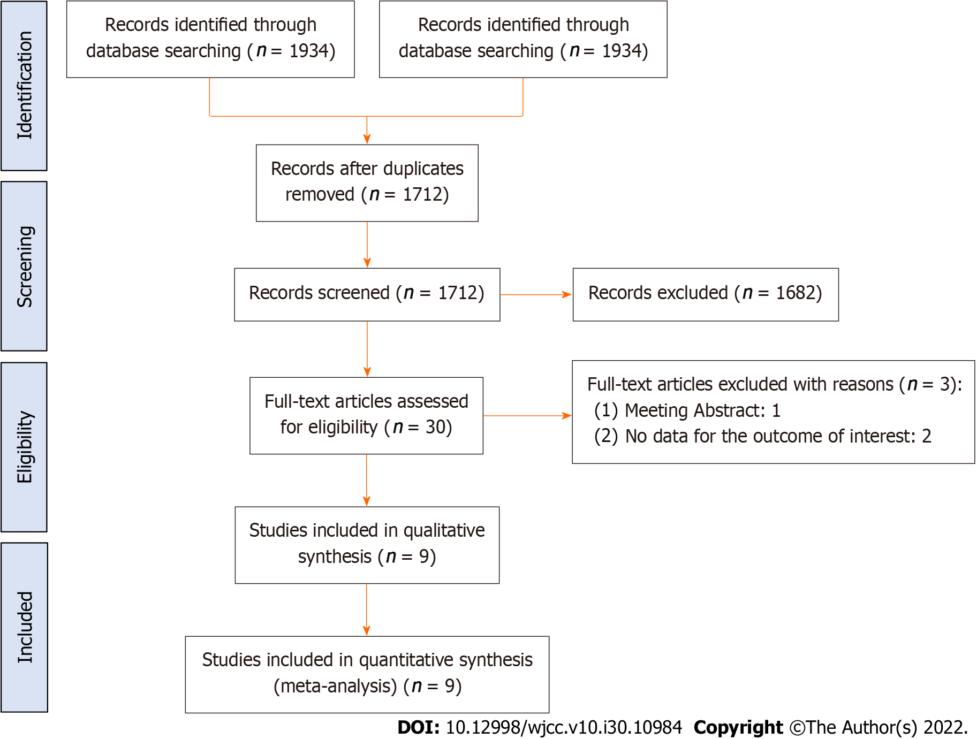
Figure 1 Flow chart of the literature search and study selection. N: Number.

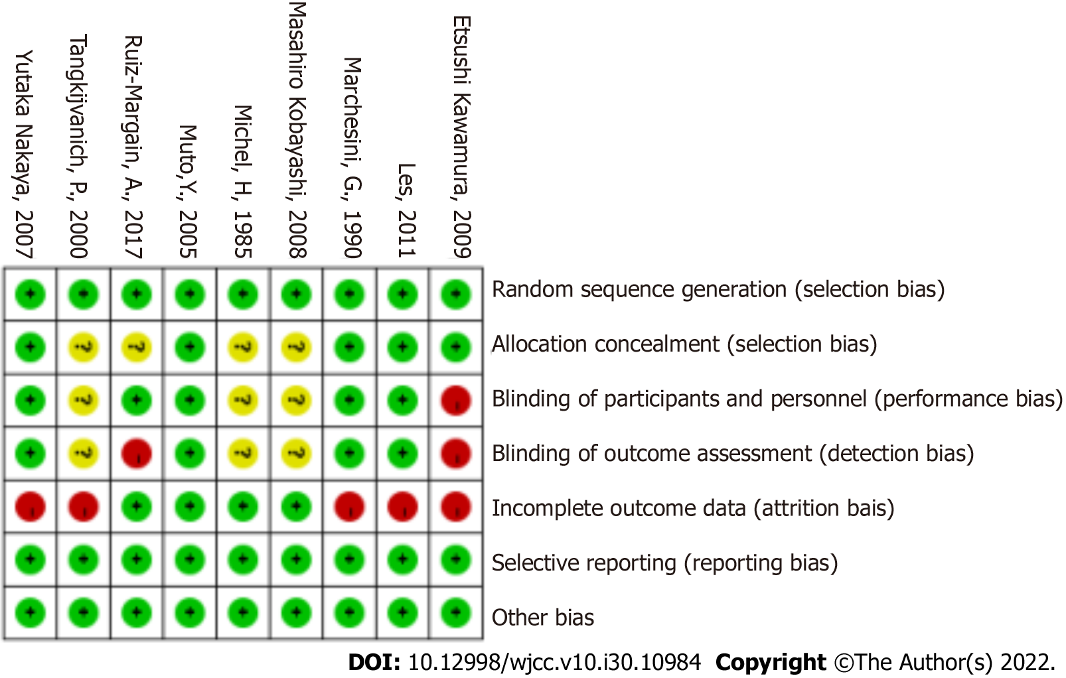
Figure 2 Risk of bias summary of all studies.

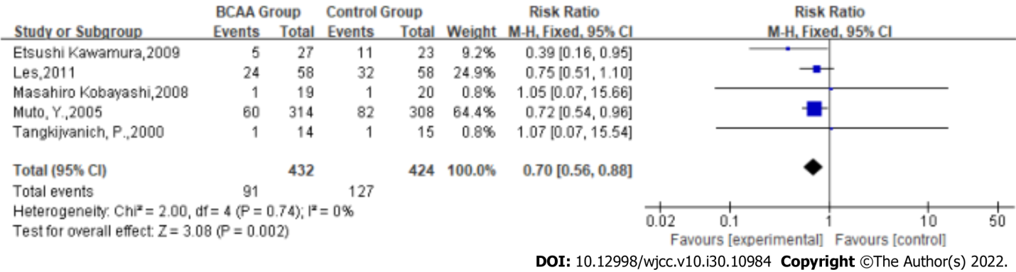
Figure 3 Forest plots of the meta-analysis of the complication rate. BCAA: Branched-chain amino acids; N: Number; CI: Confidence interval; I²: I-square.

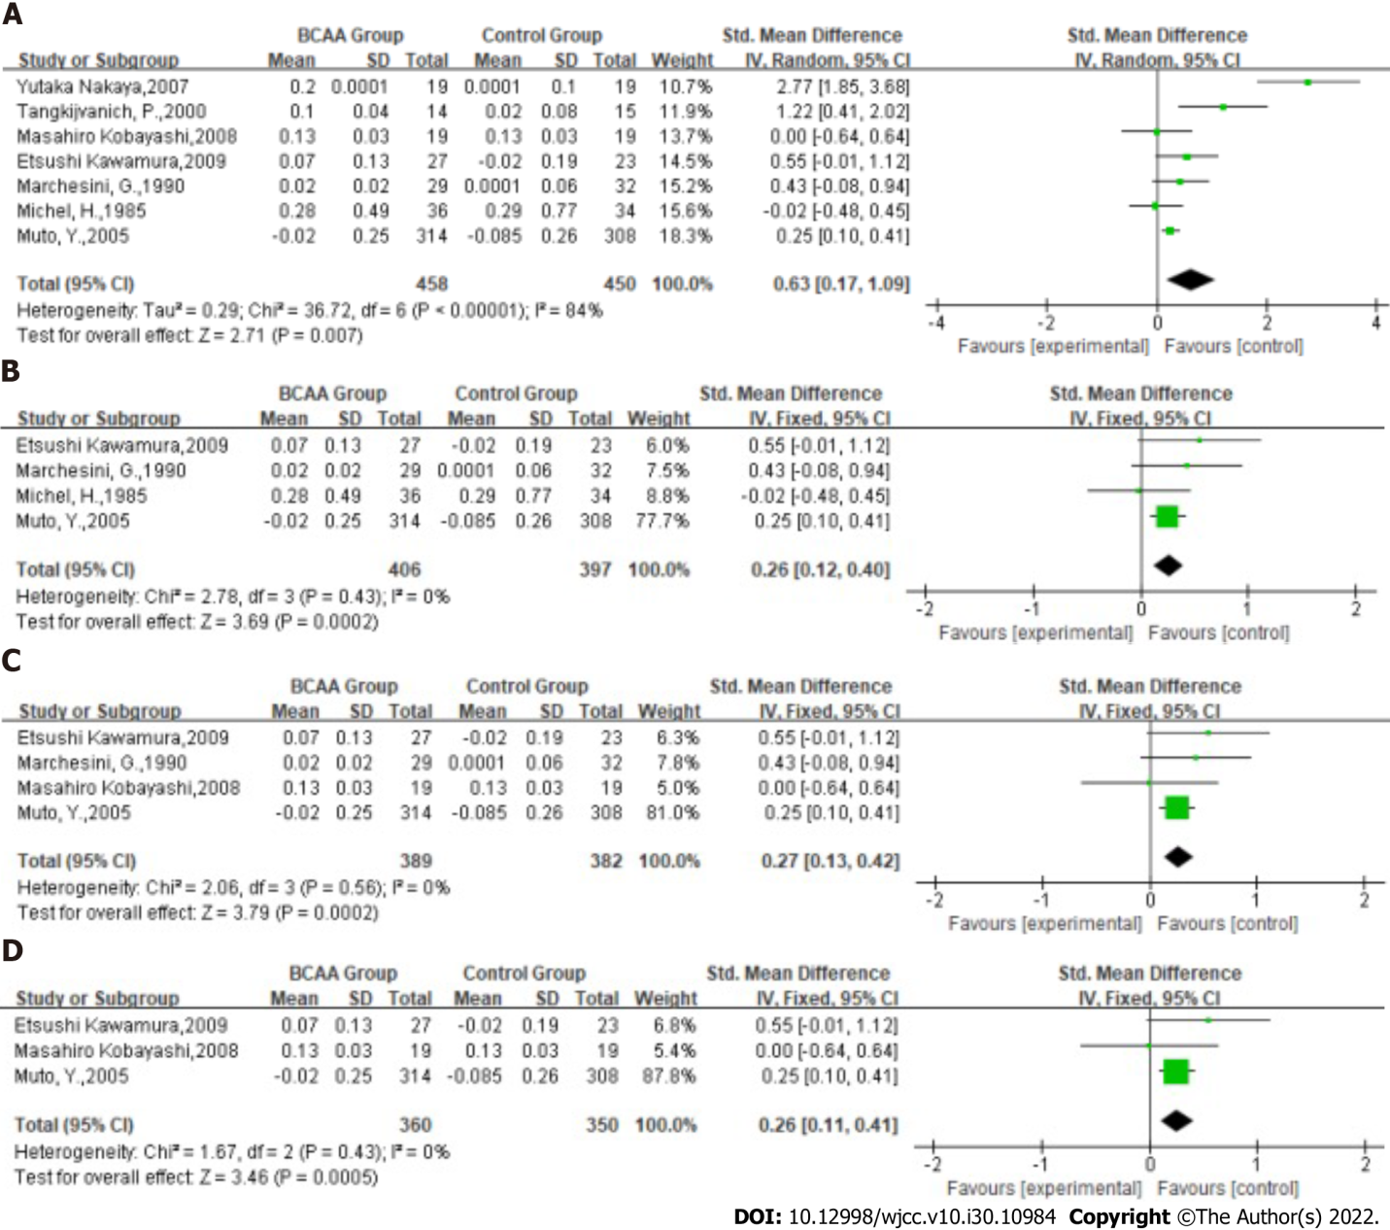
Figure 4 Forest plots. A: Forest plots of the meta-analysis of the albumin level; B: Forest plots of subgroup analysis of the albumin level (studies with a total number of patients less than 50 were excluded); C: Forest plots of subgroup analysis of the albumin level (studies with treatment duration greater than 3 mo were excluded); D: Forest plots of subgroup analysis of the albumin level (among the included studies, the majority of patients had Child grade A or B and treatment duration was greater than 3 mo). BCAA: Branched-chain amino acids; N: Number; CI: Confidence interval; SMD: Standard mean difference; I²: I-square.

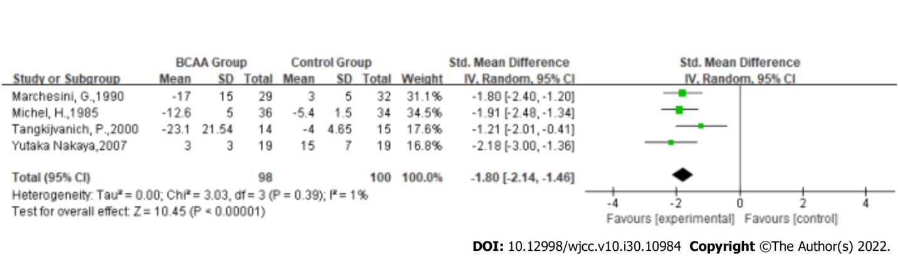
Figure 5 Forest plots of the meta-analysis of the aspartate aminotransferase level. BCAA: Branched-chain amino acids; N: Number; CI: Confidence interval; SMD: Standard mean difference; I²: I-square.

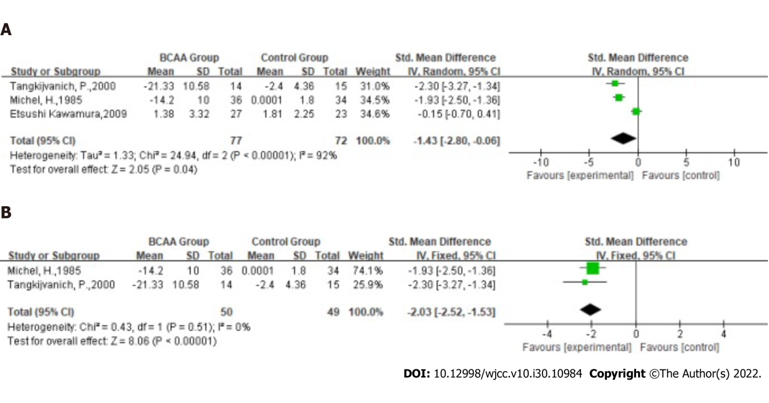
Figure 6 Forest plots. A: Forest plots of the meta-analysis of the alanine transaminase (ALT) level. B: Forest plots of subgroup analysis of the ALT level (Kawamura et al^{[19]}’s study was excluded). BCAA: Branched-chain amino acids; N: Number; CI: Confidence interval; SMD: Standard mean difference; I²: I-square.

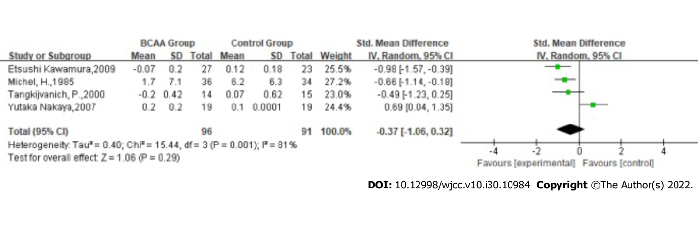
Figure 7 Forest plots of the meta-analysis of the bilirubin level. BCAA: Branched-chain amino acids; N: Number; CI: Confidence interval; SMD: Standard mean difference; I²: I-square.

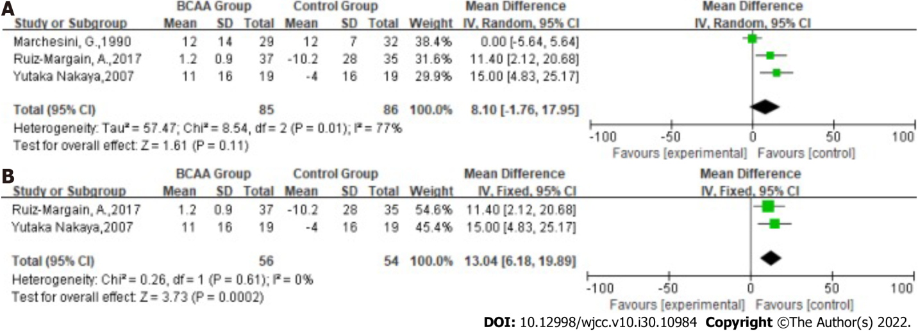
Figure 8 Forest plots. A: Forest plots of the meta-analysis of the glucose level; B: Forest plots of subgroup analysis of the glucose level (the Child grade of the patients in the included studies was A or B). BCAA: Branched-chain amino acids; N: Number; CI: Confidence interval; SMD: Standard mean difference; I²: I-square.

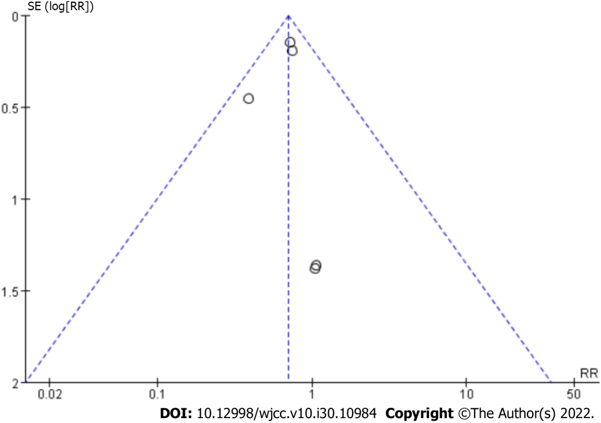
Figure 9 Publication bias.

Table 1 Characteristics of studies included in the meta-analysis, n = 1080
Trail | Country | Group | n | Treatment time | Child grade | Mean age | M/F | Study type
Etsushi Kawamura, 2009 | Japan | BCAA | 27 | 12 mo | A | 62.70 ± 10.08 | 13/14 | RCT
 |  | Control | 23 |  |  | 62.30 ± 7.30 | 12/11
Muto Y, 2005 | Japan | BCAA | 314 | > 5 mo | A/B/C | 62 ± 8 | 147/167 | RCT
 |  | Control | 308 |  |  | 61 ± 9 | 147/161
Yutaka Nakaya, 2007 | Japan | BCAA | 19 | 3 mo | A/B | 67 ± 9 | 13/6 | RCT
 |  | Control | 19 |  |  | 67 ± 8 | 7/12
Les, 2011 | Spain | BCAA | 58 | 56 wk | A/B | 64.1 ± 10.4 | 45/13 | RCT
 |  | Control | 58 |  |  | 62.5 ± 10.4 | 43/15
Tangkijvanich P, 2000 | Thailand | BCAA | 15 | 4 wk | - | 53.07 ± 10.58 | 10/5 | RCT
 |  | Control | 15 |  |  | 53.20 ± 12.74 | 12/3
Marchesini G, 1990 | Italy | BCAA | 29 | 12 mo | - | 60 | 24/6 | RCT
 |  | Control | 32 |  |  | 60 | 27/7
Michel H, 1985 | France | BCAA | 36 | 5 d | A/B/C | 60.5 ± 11.5 | 25/11 | RCT
 |  | Control | 34 |  |  | 59.3 ± 12.8 | 24/10
Ruiz-Margain, A, 2017 | Mexico | BCAA, | 37 | 6 mo | A/B | 54.9 ± 10.3 | 6/31 | RCT
 |  | Control | 35 |  |  | 47.8 ± 14.6 | 8/27
Masahiro Kobayashi, 2008 | Japan | BCAA | 19 | 168 wk | A/B | 62.9 ± 5.7 | 19/0 | RCT
 |  | Control | 20 |  |  | 59.5 ± 7.2 | 20/0
BCAA: Branched-chain amino acid; N: Number; M: Male; F: Female; RCT: Randomized controlled trial.

Table 2 Patient baseline characteristics of studies included in the meta-analysis, n = 1080
Trail | Group | Albumin in g/dL | Etiology as viral hepatitis/alcoholic/others | Ascites as absent/  presence | Hepatic encephalopathy as absent/presence | Esophagogastric varices as absence/presence
Etsushi Kawamura, 2009 | BCAA | 3.70 ± 0.38 | 25/2/0 | 27/0 | 27/0 | 27/0
 | Control | 3.81 ± 0.32 | 21/2/0 | 23/0 | 23/0 | 23/0
Muto, Y, 2005 | BCAA | 3.3 ± 0.3 | 266/20/28 | 240/74 | 287/27 | 144/170
 | Control | 3.3 ± 0.3 | 237/32/39 | 241/66 | 295/12 | 121/187
Yutaka Nakaya, 2007 | BCAA | 3.0 ± 0.4 | - | 16/3 | - | -
 | Control | 3.0 ± 0.3 | - | 15/4 | - | -
Les, 2011 | BCAA | 2.9 ± 0.6 | 24/17/17 | - | - | -
 | Control | 2.9 ± 0.5 | 18/25/15 | - | - | -
Tangkijvanich P, 2000 | BCAA | 3.81 ± 0.86 | 6/6/2 | - | - | -
 | Control | 3.66 ± 0.75 | 7/6/2
Marchesini, G, 1990 | BCAA | 3.41 ± 0.45 | 9/20/1 | - | - | -
 | Control | 3.39 ± 0.43 | 7/16/1 | - | - | -
Michel, H, 1985 | BCAA | 2.61 ± 0.10 | 4/28/4 | 10/26 | 0/36 | -
 | Control | 2.76 ± 0.08 | 4/29/1 | 11/23 | 0/34 | -
Ruiz-Margain, A, 2017 | BCAA | 3.2 ± 0.6 | - | - | - | -
 | Control | 3.2 ± 0.7 | - | - | - | -
Masahiro Kobayashi, 2008 | BCAA | 3.86 ± 0.26 | - | 19/0 | 19/0 | 9/10
 | Control | 3.90 ± 0.33 | - | 20/0 | 20/0 | 10/10
BCAA: Branched-chain amino acid.

Published by Baishideng Publishing Group Inc
7041 Koll Center Parkway, Suite 160, Pleasanton, CA 94566, USA
Telephone: +1-925-3991568
E-mail: bpgoffice@wjgnet.com
Help Desk: https://www.f6publishing.com/helpdesk
https://www.wjgnet.com

© 2022 Baishideng Publishing Group Inc. All rights reserved.

