Name of Journal: World Journal of Gastroenterology
ESPS Manuscript NO: 18554
Manuscript Type: ORIGINAL ARTICLE
Basic Study
Inhibition of SW620 human colon cancer cells by up-regulating microRNA-145

Li C et al. SW620 inhibition and microRNA-145

Chen Li, Na Xu, Yu-Qiang Li, Yu Wang, Zhi-Tu Zhu

Chen Li, Yu-Qiang Li, Yu Wang, Biobank, The First Affiliated Hospital of Liaoning Medical University, Jinzhou 121001, Liaoning Province, China

Na Xu, Department of Radiology, The First Affiliated Hospital of Liaoning Medical University, Jinzhou 121001, Liaoning Province, China

Zhi-Tu Zhu, Department of Oncology, The First Affiliated Hospital of Liaoning Medical University, Jinzhou 121001, Liaoning Province, China

Author contributions: Li C and Xu N contributed equally to this work; Li C, Xu N, Li YQ, Wang Y and Zhu ZT designed research; Li C, Wang Y, and Zhu ZT performed research; Zhu ZT and Wang Y contributed new reagents/analytic tools; Li C, Li YQ and Wang Y analyzed data; Li C, Xu N and Wang Y wrote the paper.

Supported by Liaoning Medical "Principal Fund" special fund clinical construction No. XZJJ20130214; and Liaoning Provincial Science and Technology Department of Science and Technology Program, No. 2013225305.

Institutional review board statement: This study is approved by the Ethics Committee of the First Affiliated Hospital of Liaoning Medical University.

Institutional animal care and use committee statement: All procedures in this study involving animals meet the requirements of the ethics of animal experimentation and are approved by Laboratory Animal Ethics Committee of the First Affiliated Hospital of Liaoning Medical University.

Conflict-of-interest statement: The authors have no conflict of interests to declare.

Open-Access: This article is an open-access article which was selected by an in-house editor and fully peer-reviewed by external reviewers. It is distributed in accordance with the Creative Commons Attribution Non Commercial (CC BY-NC 4.0) license, which permits others to distribute, remix, adapt, build upon this work non-commercially, and license their derivative works on different terms, provided the original work is properly cited and the use is non-commercial. See: http://creativecommons.org/licenses/by-nc/4.0/

Corresponding to: Zhi-Tu Zhu, MD, Department of Oncology, The First Affiliated Hospital of Liaoning Medical University, No. 2, Wuduan, Renmin Street, Jinzhou 121001, Liaoning Province, China. zhuzhitu2014jz@hotmail.com
Telephone: +86-416-4605040
Fax: +86-416-4605067

Received: April 23, 2015
Peer-review started: April 24, 2015
First decision: July 10, 2015
Revised: August 31, 2015
Accepted: November 30, 2015
Article in press:
Published online:

Abstract
AIM: To investigate the targeted inhibition of proliferation and migration of SW620 human colon cancer cells by up-regulating microRNA-145 (miR-145).

METHODS: Forty five samples of colon cancer tissues and 45 normal control samples were obtained from the biological database of the First Affiliated Hospital of Liaoning Medical University. Quantitative of miR-145 and N-ras expression in tissues, reverse transcription polymerase chain reaction analysis of miR-145 expression in colon cancer cell SW620 and normal colonic epithelial cells, construction miR-145 lentiviral vector and determination of miR-145 expression in SW620 transduced with miR-145 vector; analysis of miR-145 overexpression on SW620 proliferation. Analysis of miR-145 overexpression on SW620 migration using wound healing test, analysis of miR-145 on N-ras expression using Western blot.

RESULTS: MiR-145 expression was significantly down-regulated in colon cancer tissues with its expression in normal colonic tissues being 4-5 fold higher (two sample t-test, P < 0.05), whereas N-ras expression showed the opposite trend; miR-145 expression in SW620 was down-regulated, which was significantly lower as compared to colonic epithelial cells (two sample t-test, P < 0.05). miR-145 vector and control were successfully packaged; expression of miR-145 in SW620 transduced with miR-145 was 8.2-fold of that in control (two sample t-test, P < 0.05), the proliferation of miR-145-transduced SW620 was significantly decreased as compared to control (two sample t-test, P < 0.05). At 48 h in wound healing experiment, the migration indexes and control were (97.27% ± 9.25%) and (70.22% ± 6.53%), respectively (two sample t-test, P < 0.05). N-ras expression in miR-145-tranduced SW620 was significantly lower than others (one-way ANOVA, P < 0.05).

CONCLUSION: MiR-145 plays a critical role in inhibiting colon cancer cell proliferation and migration. This finding lays a good foundation for development of potential future colon cancer therapy by targeting tumor suppressor miR-145.

Key words: MicroRNA-145; Colorectal cancer; N-ras; Targeted therapy; Lentiviral vector

© The Author(s) 2015. Published by Baishideng Publishing Group Inc. All rights reserved.

Core tip: MicroRNA-145 (miR-145) may play an important role in inhibiting colon cancer proliferation and invasive migration. This finding lays a good foundation for further investigation on targeting miR-145 as a tumor suppressor in colon cancer treatment, and provides novel evidence for the anti-cancer effects and therapeutic potential of miR-145.

Li C, Xu N, Li YQ, Wang Y, Zhu ZT. Inhibition of SW620 human colon cancer cells by up-regulating microRNA-145. World J Gastroenterol 2015; In press

INTRODUCTION
Colorectal cancer is currently one of the most common malignancies worldwide^{[1,2]}. Invasive migration at early stages is a critical factor affecting the prognosis and survival of colorectal cancer patients^{[3,4]}. Despite increasingly improving diagnosis and medical technologies, treatment effects and clinical prognosis are still not ideal. With the development of genetic therapy, targeted therapy has become the top level specific anti-cancer treatment. Blocking invasive migration by modifying the microenvironment on the molecular basis is the frontier of current research in colorectal cancer therapeutics^{[5-7]}.
Recently, the discovery of a class of small non-coding RNA known as microRNA (miRNA) that regulates gene expression at the level of transcription shed new light on cancer research^{[8,9]}. miRNAs are endogenous, revolutionarily conserved, single chain non-coding RNA consisting of19-22 nucleotides, which inhibit mRNA transcription or induce mRNA degradation by base-paring with the 3’UTR of target mRNA, and thus play an important role in cell proliferation, differentiation, apoptosis, gene regulation, and tumor formation by suppressing the expression of target genes^{[10,11]}. Although current understanding of the biological function of miRNAs is still limited, we know for certain that miRNAs play a critical role in many aspects including modulating development, growth, differentiation, apoptosis, and tumorigenesis. In some malignant tumors, miRNAs function like oncogenes or tumor suppressors by regulating different gene targets. The function of specific miRNA during tumor formation and development is becoming a hot area in cancer research. Some experts predicted that targeting miRNA in biological cancer therapeutics will be more effective than targeting coding genes^{[12]}.
Earlier studies reported that microRNA-145 (miR-145) expression is down-regulated in many cancers including breast cancer, melanoma, ovarian cancer, and liver cancer, suggesting that miR-145 may function as a tumor suppressor^{[13-16]}. However, so far there has been no systemic research on the role of miR-145 in colorectal cancer. Therefore, we investigated the expression of miR-145 and its target gene N-ras in colon cancer tissues and normal control tissues, and postulated that miR-145 may play a biological role in colon cancer development and metastasis. Next, we constructed recombinant lentiviral vector expressing miR-145 and examined the inhibitory function of miR-145 after its transduction into SW620 colon cancer cells as an experimental basis for continued research on targeting miR-145 in colon cancer treatment. Lastly, we analyzed the expression of miR-145 target N-ras to clarify the regulatory role of miR-145 in colon cancer.

MATERIALS AND METHODS
Materials and reagents
Forty five samples of colon cancer tissues and 45 normal control samples were from the biological database of the First Affiliated Hospital of Liaoning Medical University. These samples were obtained from colon cancer patients attending the hospital between January 2013 and December 2013. Patients had no treatments before surgery. All patients gave written informed consent to the study, which was reviewed and approved by the First Affiliated Hospital of Liaoning Medical University Institutional Review Board. pSilencerTM 4.1 lentiviral vector system and Trizol reagent were purchased from Invitrogen. HEK293T cell line, SW620 colon cancer cell line, and normal human colonic epithelial cell line were purchased from ATCC. DMEM, FBS, and trypsin were from Gibco. Ultra-pure plasmid extraction kit was from Promega. Restriction endonucleases, DNA polymerase, plasmid miniprep kit, one-step reverse transcription polymerase chain reaction (RT-PCR) kit, and gel extraction kit were from TaKaRa. Monoclonal rabbit anti-human primary antibodies, secondary antibodies, and internal controls were from Santa Cruz. miR-145 and internal control U6 primer were designed and synthesized by TaKaRa (Table 1). Other common reagents were provided by the Central Laboratory of the First Affiliated Hospital of Liaoning Medical University.

Determine miR-145 and N-ras expression levels in tissue samples
One milliliter of Trizol reagent was added to 100 mg or less of frozen samples. After grinding in liquid nitrogen, total RNA was extracted using phenol-chloroform protocol. Quality of RNA was analyzed on 1% agarose gels. Qualified RNA samples were sent to TaKaRa for sequencing and quantitative analysis of miR-145 and N-ras expression in colon cancer and control tissues.

Determine miR-145 expression levels in SW620 and normal colonic epithelial cells
SW620 and normal colonic epithelial cells were grown to 3rd passage of exponential growth phase, and total RNA was extracted using phenol-chloroform protocol. Semi-quantitative one-step RT-PCR analysis of miR-145 expression was carried out according to the instruction provided by the manufacturer. PCR products were analyzed on 1% agarose gels and OD values were read on a gel imaging system. Experiments were repeated three times to compare miR-145 expression levels in these two cell lines.

Construction and packaging of miR-145 lentiviral expression vector
The complete sequence of miR-145 was PCR-amplified using up-stream and down-stream primers and purified by gel extraction. pSilencerTM 4.1 vector was linearized and purified according to the instruction provided with the lentiviral vector kit, and then ligated with miR-145 sequence. DH5α competent cells were then transformed with the ligation reaction. Positive clone was selected, and the sequence was amplified and linearized. miR-145 lentiviral vector was then packaged in HEK 293T cells using Lipofectamine 2000, and viral titer was determined. The control vector containing a scrambled unrelated sequence was constructed and packaged in the same way.

Determine miR-145 expression levels in transduced SW620 cells
SW620 cells that were 90% confluent were passaged at 1:3 at 18-24 h before transduction so that cells were 70%-80% confluent and at exponential growth stage at the time of transduction. SW620 cells were then transduced with successfully packaged miR-145 lentiviral vector or control vector with 50% multiplicity of infection (MOI = 50) and cultured for 48-72 h. When cytopathic effect (CPE) occurred, total RNA was extracted from each of the two groups. PCR products were analyzed on 1% agarose gels and OD values were read on a gel imaging system. Experiments were repeated three times to compare miR-145 expression levels in two groups of cells in order to confirm the successful construction of the expression system.

Effect of miR-145 overexpression on SW620 cell proliferation
SW620 colon cancer cells were grown to 3rd passage of exponential growth phase, and seeded into 96 well plates. Cells were then transduced with either of the two lentiviral vectors mentioned above. 20 μL of 5 mg/mL MTT solution was added to each well. After incubation for 4 h at 37 ℃, media were removed and 150 μL of DMSO was added. The absorption was then read on a plate reader at 490 nm, and proliferation curves were generated.

Effect of miR-145 overexpression on SW620 cell migration
SW620 cells at 3rd passage were plated into two sets of dishes. When cells were confluent, a homogenous scratch wound was created on the monolayer cells using a 1000 μL pipette tip to form a band of open area. MiR-145 lentiviral solution was then added to the experimental group. Media containing no lentivirus was used for the blank control group. Cells were imaged at 0 or 48 h after incubation. The width of the open area was measured at 3 different positions (top, middle, and bottom) and the average width was calculated. The speed of cell migration was described using migration index (MI).

Effect of miR-145 overexpression on the expression of its target gene N-ras
Using bioinformatics, we observed that miR-145 may induce colon cancer cell apoptosis via N-ras. In other words, N-ras gene might be a target of miR-145. We therefore further tested this at protein level. Total proteins were extracted from miR-145-tranduced SW620 cells and quantified. After separation on 5% stacking gel and 8% separating gel at 60 V-30 min and 100 V-1.5 h, proteins were transferred to a membrane and ponceau stained. After distaining for 3 times, blots were incubated with primary antibody (1:1000, monoclonal rabbit-anti-human) at 4 ℃ overnight. After incubation for 1 h at room temperature with secondary antibody (1:1500, polyclonal goat-anti-rabbit) and BCIP/NBT staining in dark for 3 h, blots were analyzed on a gel imaging system for target bands and internal reference bands. Experiments were repeated 3 times and OD values were calculated.

Statistical analysis
SPSS19.0 for Windows was used for statistical analysis. Data were expressed as mean ± SD. Differences among groups were compared using one-way ANOVA. P < 0.05 was considered statistically significant.

RESULTS
Expression of miR-145 in colon cancer tissues and normal control tissues
RNA sequencing and quantitative analysis indicated that miR-145 expression level was markedly decreased in colon cancer tissues as compared to normal colonic tissues. miR-145 level in control tissues was 4-5-fold higher than that in colon cancer tissues (P < 0.05). In contrast, N-ras expression level was significantly higher in colon cancer tissues then in control tissues (Figure 1).

Expression of miR-145 in SW620 and normal human colonic epithelial cell line
RT-PCR analysis revealed that miR145 expression level in normal colonic epithelial cells was relatively high whereas its expression level in SW620 colon cancer cells was markedly down-regulated. There was an approximately 5-fold difference, which was statistically significant (P < 0.05) (Figure 2).

Results of construction and packaging of miR-145 recombinant lentiviral vector and control vector
Construction of lentiviral vector and negative control sequence was successful, and sequencing results indicated no mutations. Both sequences were consistent with the expectation, indicating that insertion of miR-145 sequence was successful, and could be used for further experiments. Sequencing was done by TaKaRa. At 72 h post transfection of HEK293T cells with lentiviral vector system, we observed green fluorescence under fluorescence microscope. 80%-90% of cells expressed green fluorescence. Meanwhile we observed CPE phenomenon: shrinking, swelling and rounding of cells; some cells were detached and floating (Figure 3A and B). Viral titers were 2.08 × 10⁹ TU/mL in experimental group and 1.92×10⁹TU/ml in control group. Both met the requirement of the study and could be used for further experiments.

MiR-145 expression in transduced SW620 cells
RT-PCR data showed that miR-145 expression in SW620 cells transduced with control lentiviral vector was relatively low, whereas its expression in miR-145-tranduced SW620 cells was 8.2-fold higher. The difference was statistically significant (P < 0.05) (Figure 4), indicating the success of generating miR-145 lentiviral transfection system for future experiments.

Effect of miR-145 overexpression on SW620 cell proliferation
Two groups of SW620 cells were cultured separately for 24, 48, 72, 96, or 120 h followed by MTT analysis. Plates were read on a plate reader and proliferation curves were generated based on OD values. Results indicated that SW620 cells of the control group proliferated rapidly, whereas cells of the experimental group had significantly slower growth (P < 0.05), suggesting that miR-145 lentiviral vector can markedly inhibit the proliferation of SW620 colon cancer cells (Figure 5).

Wound healing study for analysis of the effect of miR-145 on SW620 cell migration
Our data showed that at 48 h after scratching the monolayer of cells, the wound in the control group was basically healed. miR-145 group showed a small number of cells migrating to the open area, and the wound was still apparent. The MI in controls and experimental groups were 97.27% ± 9.25% and 70.22% ± 6.53%, respectively. The differences between the two groups were statistically significant (P < 0.05), suggesting that up-regulating the expression of miR-145 can markedly inhibit the migration of SW620 cells (Figure 6).

Western blot analysis of miR-145 regulation of N-ras expression
Western blot analysis revealed that N-ras expression level in miR-145-tranduced SW620 cells was significantly reduced as compared the empty vector control and blank control groups (P < 0.05), whereas empty vector control and blank control groups had similar N-ras expression levels (P < 0.05), suggesting that miR-145 down-regulates N-ras protein expression by effectively suppressing N-ras mRNA translation (Figure 7).

DISCUSSION
Currently, the genes and molecular mechanisms involved in colon cancer development and progression have become a hot research area^{[17]}. Studies have shown that many miRNAs are abnormally expressed in colon cancer tissues and cell lines. Among them, miR-143 is down-regulated whereas miR-21 and miR-223 are up-regulated in colon cancer. They each function by regulating different target genes and are tightly related to each other during colon cancer development and progression^{[18-20]}. It has been demonstrated that miRNAs down-regulated in cancers often function as tumor suppressors, while miRNAs up-regulated in cancers often function as oncogenes^{[21]}. Various miRNAs and their target genes play important roles in colon cancer, but their specific mechanisms remain to be investigated.
MiR-145, like miR-143, is down-regulated in various cancers, but the degree of down-regulation varies in different cancers^{[22]}. Research has shown that miR-145 is down-regulated by approximately 2.5-fold in breast cancer, 10-fold in nasal cancer and 20-fold in bladder cancer^{[23-26]}. We have observed that miR-145 expression in colon cancer is 4-5-fold lower than normal colonic tissues, and the degree of its down-regulation is positively correlated with colon cancer progression. In the present study, we not only demonstrated miR-145 down-regulation in SW620 colon cancer cells but also found that the expression level of miR-145 in normal human colonic epithelial cells can be 5 times higher than that in SW620 cells. The above evidences support that miR-145 may play an important role in the development and progression of various cancers.
Because miR-145 expression is decreased in SW620 cells, we chose to further examine its function by up-regulating its expression. In this study, we used lentiviral vector to express miR-145. Lentiviral vector is a novel vector type developed in recent years, which has high transfection efficiency and low cellular immune response and exerts its silencing effect via gene integration^{[27,28]}. After successful construction of lentiviral vectors, HEK293T cells were transfected for viral packaging. Both transfection efficiency and viral titers met experimental requirement, so the vectors could be used for further experiments.
In terms of inhibiting SW620 proliferation, we found that cells in blank control group proliferated exponentially at 24 h, 48 h, 72 h, 96 h, and 120 h, while the proliferation rate of cells in experimental group (miR-145-tranduced SW620 cells) was significantly lower compared to blank control group, indicating that miR-145 can markedly suppress SW620 cell proliferation. This suggests that miR-145 may play a critical role in inhibiting colon cancer growth.
Cancer cells with metastasis potential have migratory ability, and cells with high metastasis potential often have more active migratory ability^{[29,30]}. We used wound healing assay to examine colon cancer cell migration. Our data showed that overexpression of miR-145 using recombinant lentiviral vector can decrease the MI of SW620 cells by over 20% and markedly suppress wound healing ability, indicating that miR-145 has the ability to suppress colon cancer cell migration and distant invasion. This is an important finding regarding cancer cell migration, which agrees with our expectation.
Ras oncogene is involved in human cancer development and progression. Although Ras mutation in colon cancer mainly involves K-ras, and N-ras mutation accounts for only 5%, the role of N-ras in colon cancer cannot be replaced by K-ras. K-ras expression promotes colon cancer cell proliferation, but it also makes these cancer cells prone to apoptosis. In contrast, high expression of N-ras does not promote cancer cell proliferation, but markedly inhibits cancer cell apoptosis. This function of N-ras cannot be replaced by K-ras^{[31,32]}. By determining N-ras expression level in colon cancer tissues, we found that N-ras expression in cancer tissues is increased as compared to normal tissues, and this trend is the opposite from miR-145. This is consistent with our finding using bioinformatics that N-ras is a target gene of miR-145. miR-145 may induce apoptosis of SW620 colon cancer cells by regulating N-ras. We postulate that down-regulation of miR-145 caused by a certain reason during colon cancer development may lead to decreased suppression of N-ras and therefore increased N-ras expression in cancer cells. N-ras signaling then leads to resistance to pro-apoptotic signals and promotes colon cancer development.
In conclusion, miR-145 may play an important role in inhibiting colon cancer proliferation and invasive migration. This finding lays a good foundation for further investigation on targeting miR-145 as a tumor suppressor in colon cancer treatment, and provides novel evidence for the anti-cancer effects and therapeutic potential of miR-145.

comments
Background
Invasive migration at early stages is a critical factor affecting the prognosis and survival of colorectal cancer patients. With the development of genetic therapy, targeted therapy has become the top level specific anti-cancer treatment. Blocking invasive migration by modifying the microenvironment on the molecular basis is the frontier of current research in colorectal cancer therapeutics. Some experts predicted that targeting miRNA in biological cancer therapeutics will be more effective than targeting coding genes.

Research frontiers
MicroRNA-145 (miR-145) expression is down-regulated in many cancers including breast cancer, melanoma, ovarian cancer, and liver cancer, suggesting that miR-145 may function as a tumor suppressor. However, so far there has been no systemic research on the role of miR-145 in colorectal cancer.

Innovations and breakthroughs
MiR-145 may induce apoptosis of SW620 colon cancer cells by regulating N-ras. The authors postulate that down-regulation of miR-145 during colon cancer development may lead to decreased suppression of N-ras and therefore increased N-ras expression in cancer cells. N-ras signaling then leads to resistance to pro-apoptotic signals and promotes colon cancer development.

Applications
MiR-145 may play an important role in inhibiting colon cancer proliferation and invasive migration. This finding lays a good foundation for further investigation on targeting miR-145 as a tumor suppressor in colon cancer treatment, and provides novel evidence for the anti-cancer effects and therapeutic potential of miR-145.

Terminology
MicroRNA: microRNA (miRNA) are endogenous, revolutionarily conserved, single chain non-coding RNA consisting of19-22 nucleotides, which inhibit mRNA transcription or induce mRNA degradation by base-paring with the 3’UTR of target mRNA, and thus play an important role in cell proliferation, differentiation, apoptosis, gene regulation, and tumor formation by suppressing the expression of target genes.

Peer-review
Authors presented a study in which they evaluated the role of microRNA-145 on colon cancer. They showed evidences of the tumor suppressor activity of microRNA-145 in colon cancer using several approaches.
REFERENCES
1 Swiderska M, Choromańska B, Dąbrowska E, Konarzewska-Duchnowska E, Choromańska K, Szczurko G, Myśliwiec P, Dadan J, Ladny JR, Zwierz K. The diagnostics of colorectal cancer. Contemp Oncol (Pozn) 2014; 18: 1-6 [PMID: 24876814 DOI: 10.5114/wo.2013.39995]
2 Winkels RM, Heine-Bröring RC, van Zutphen M, van Harten-Gerritsen S, Kok DE, van Duijnhoven FJ, Kampman E. The COLON study: Colorectal cancer: Longitudinal, Observational study on Nutritional and lifestyle factors that may influence colorectal tumour recurrence, survival and quality of life. BMC Cancer 2014; 14: 374 [PMID: 24886284 DOI: 10.1186/1471-2407-14-374]
3 Janakiram NB, Rao CV. The role of inflammation in colon cancer. Adv Exp Med Biol 2014; 816: 25-52 [PMID: 24818718 DOI: 10.1007/978-3-0348-0837-8_2]
4 Tsikitis VL, Larson DW, Huebner M, Lohse CM, Thompson PA. Predictors of recurrence free survival for patients with stage II and III colon cancer. BMC Cancer 2014; 14: 336 [PMID: 24886281 DOI: 10.1186/1471-2407-14-336]
5 Bhatt VR. Targeted therapy in metastatic colon cancer. Future Oncol 2014; 10: 707-711 [PMID: 24799052 DOI: 10.2217/fon.14.7]
6 Mahon SM. Microsatellite testing in colon cancer. Oncol Nurs Forum 2014; 41: 331-333 [PMID: 24769599 DOI: 10.1188/14.ONF.331-333]
7 Mathonnet M, Perraud A, Christou N, Akil H, Melin C, Battu S, Jauberteau MO, Denizot Y. Hallmarks in colorectal cancer: angiogenesis and cancer stem-like cells. World J Gastroenterol 2014; 20: 4189-4196 [PMID: 24764657 DOI: 10.3748/wjg.v20.i15.4189]
8 Lewis BP, Burge CB, Bartel DP. Conserved seed pairing, often flanked by adenosines, indicates that thousands of human genes are microRNA targets. Cell 2005; 120: 15-20 [PMID: 15652477 DOI: 10.1016/j.cell.2004.12.035]
9 Gregory PA, Bert AG, Paterson EL, Barry SC, Tsykin A, Farshid G, Vadas MA, Khew-Goodall Y, Goodall GJ. The miR-200 family and miR-205 regulate epithelial to mesenchymal transition by targeting ZEB1 and SIP1. Nat Cell Biol 2008; 10: 593-601 [PMID: 18376396 DOI: 10.1038/ncb1722]
10 Lu J, Getz G, Miska EA, Alvarez-Saavedra E, Lamb J, Peck D, Sweet-Cordero A, Ebert BL, Mak RH, Ferrando AA, Downing JR, Jacks T, Horvitz HR, Golub TR. MicroRNA expression profiles classify human cancers. Nature 2005; 435: 834-838 [PMID: 15944708 DOI: 10.1038/nature03702]
11 Huang Q, Gumireddy K, Schrier M, le Sage C, Nagel R, Nair S, Egan DA, Li A, Huang G, Klein-Szanto AJ, Gimotty PA, Katsaros D, Coukos G, Zhang L, Puré E, Agami R. The microRNAs miR-373 and miR-520c promote tumour invasion and metastasis. Nat Cell Biol 2008; 10: 202-210 [PMID: 18193036 DOI: 10.1038/ncb1681]
12 Chivukula RR, Shi G, Acharya A, Mills EW, Zeitels LR, Anandam JL, Abdelnaby AA, Balch GC, Mansour JC, Yopp AC, Maitra A, Mendell JT. An essential mesenchymal function for miR-143/145 in intestinal epithelial regeneration. Cell 2014; 157: 1104-1116 [PMID: 24855947 DOI: 10.1016/j.cell.2014.03.055]
13 Iorio MV, Visone R, Di Leva G, Donati V, Petrocca F, Casalini P, Taccioli C, Volinia S, Liu CG, Alder H, Calin GA, Ménard S, Croce CM. MicroRNA signatures in human ovarian cancer. Cancer Res 2007; 67: 8699-8707 [PMID: 17875710 DOI: 10.1158/0008-5472.CAN-07-1936]
14 Kim SJ, Oh JS, Shin JY, Lee KD, Sung KW, Nam SJ, Chun KH. Development of microRNA-145 for therapeutic application in breast cancer. J Control Release 2011; 155: 427-434 [PMID: 21723890 DOI: 10.1016/j.jconrel.2011.06.026]
15 Duan X, Hu J, Wang Y, Gao J, Peng D, Xia L. MicroRNA-145: a promising biomarker for hepatocellular carcinoma (HCC). Gene 2014; 541: 67-68 [PMID: 24630966 DOI: 10.1016/j.gene.2014.03.018]
16 Li Y, Huang Q, Shi X, Jin X, Shen L, Xu X, Wei W. MicroRNA 145 may play an important role in uveal melanoma cell growth by potentially targeting insulin receptor substrate-1. Chin Med J (Engl) 2014; 127: 1410-1416 [PMID: 24762580]
17 Djaldetti M, Bessler H. Modulators affecting the immune dialogue between human immune and colon cancer cells. World J Gastrointest Oncol 2014; 6: 129-138 [PMID: 24834143 DOI: 10.4251/wjgo.v6.i5.129]
18 Gregersen LH, Jacobsen A, Frankel LB, Wen J, Krogh A, Lund AH. MicroRNA-143 down-regulates Hexokinase 2 in colon cancer cells. BMC Cancer 2012; 12: 232 [PMID: 22691140 DOI: 10.1186/1471-2407-12-232]
19 Li T, Leong MH, Harms B, Kennedy G, Chen L. MicroRNA-21 as a potential colon and rectal cancer biomarker. World J Gastroenterol 2013; 19: 5615-5621 [PMID: 24039353 DOI: 10.3748/wjg.v19.i34.5615]
20 Zhang J, Luo X, Li H, Yue X, Deng L, Cui Y, Lu Y. MicroRNA-223 functions as an oncogene in human colorectal cancer cells. Oncol Rep 2014; 32: 115-120 [PMID: 24819398 DOI: 10.3892/or.2014.3173]
21 Nicoloso MS, Spizzo R, Shimizu M, Rossi S, Calin GA. MicroRNAs--the micro steering wheel of tumour metastases. Nat Rev Cancer 2009; 9: 293-302 [PMID: 19262572 DOI: 10.1038/nrc2619]
22 Iio A, Takagi T, Miki K, Naoe T, Nakayama A, Akao Y. DDX6 post-transcriptionally down-regulates miR-143/145 expression through host gene NCR143/145 in cancer cells. Biochim Biophys Acta 2013; 1829: 1102-1110 [PMID: 23932921 DOI: 10.1016/j.bbagrm.2013.07.010]
23 Schepeler T, Reinert JT, Ostenfeld MS, Christensen LL, Silahtaroglu AN, Dyrskjøt L, Wiuf C, Sørensen FJ, Kruhøffer M, Laurberg S, Kauppinen S, Ørntoft TF, Andersen CL. Diagnostic and prognostic microRNAs in stage II colon cancer. Cancer Res 2008; 68: 6416-6424 [PMID: 18676867 DOI: 10.1158/0008-5472.CAN-07-6110]
24 Chen HC, Chen GH, Chen YH, Liao WL, Liu CY, Chang KP, Chang YS, Chen SJ. MicroRNA deregulation and pathway alterations in nasopharyngeal carcinoma. Br J Cancer 2009; 100: 1002-1011 [PMID: 19293812 DOI: 10.1038/sj.bjc.6604948]
25 Ichimi T, Enokida H, Okuno Y, Kunimoto R, Chiyomaru T, Kawamoto K, Kawahara K, Toki K, Kawakami K, Nishiyama K, Tsujimoto G, Nakagawa M, Seki N. Identification of novel microRNA targets based on microRNA signatures in bladder cancer. Int J Cancer 2009; 125: 345-352 [PMID: 19378336 DOI: 10.1002/ijc.24390]
26 Sachdeva M, Mo YY. MicroRNA-145 suppresses cell invasion and metastasis by directly targeting mucin 1. Cancer Res 2010; 70: 378-387 [PMID: 19996288 DOI: 10.1158/0008-5472.CAN-09-2021]
27 Liu L, Zhang N, Liu J, Min J, Ma N, Liu N, Liu Y, Zhang H. Lentivirus-mediated siRNA interference targeting SGO-1 inhibits human NSCLC cell growth. Tumour Biol 2012; 33: 515-521 [PMID: 22161216 DOI: 10.1007/s13277-011-0284-0]
28 Prados J, Melguizo C, Roldan H, Alvarez PJ, Ortiz R, Arias JL, Aranega A. RNA interference in the treatment of colon cancer. BioDrugs 2013; 27: 317-327 [PMID: 23553339 DOI: 10.1007/s40259-013-0019-4]
29 Bailey KM, Wojtkowiak JW, Cornnell HH, Ribeiro MC, Balagurunathan Y, Hashim AI, Gillies RJ. Mechanisms of buffer therapy resistance. Neoplasia 2014; 16: 354-64.e1-3 [PMID: 24862761 DOI: 10.1016/j.neo.2014.04.005]
30 Tang X, Kuhlenschmidt TB, Li Q, Ali S, Lezmi S, Chen H, Pires-Alves M, Laegreid WW, Saif TA, Kuhlenschmidt MS. A mechanically-induced colon cancer cell population shows increased metastatic potential. Mol Cancer 2014; 13: 131 [PMID: 24884630 DOI: 10.1186/1476-4598-13-131]
31 Yin Y, Yan ZP, Lu NN, Xu Q, He J, Qian X, Yu J, Guan X, Jiang BH, Liu LZ. Downregulation of miR-145 associated with cancer progression and VEGF transcriptional activation by targeting N-RAS and IRS1. Biochim Biophys Acta 2013; 1829: 239-247 [PMID: 23201159 DOI: 10.1016/j.bbagrm.2012.11.006]
32 Panza A, Votino C, Gentile A, Valvano MR, Colangelo T, Pancione M, Micale L, Merla G, Andriulli A, Sabatino L, Vinciguerra M, Prattichizzo C, Mazzoccoli G, Colantuoni V, Piepoli A. Peroxisome proliferator-activated receptor γ-mediated induction of microRNA-145 opposes tumor phenotype in colorectal cancer. Biochim Biophys Acta 2014; 1843: 1225-1236 [PMID: 24631504 DOI: 10.1016/j.bbamcr.2014.03.003]
P-Reviewer: Chiurillo MA S-Editor: Yu J L-Editor: E-Editor:

Figure 1 Expression of miR-145 and N-ras in colon cancer tissues and normal colonic tissues.

Figure 2 MiR-145 expression in SW620 colon cancer cells and normal colonic epithelial cells.

A
B
Figure 3 HEK239T cells under regular (A) and fluorescence microscope (B) (magnification × 40) at 72 h after transfection with lentiviral vector.

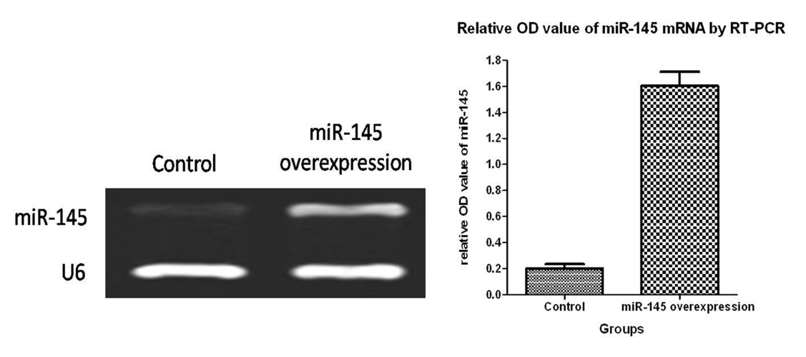
Figure 4 Reverse transcription-polymerase chain reaction analysis of mature miR-145 expression in two groups of cells.

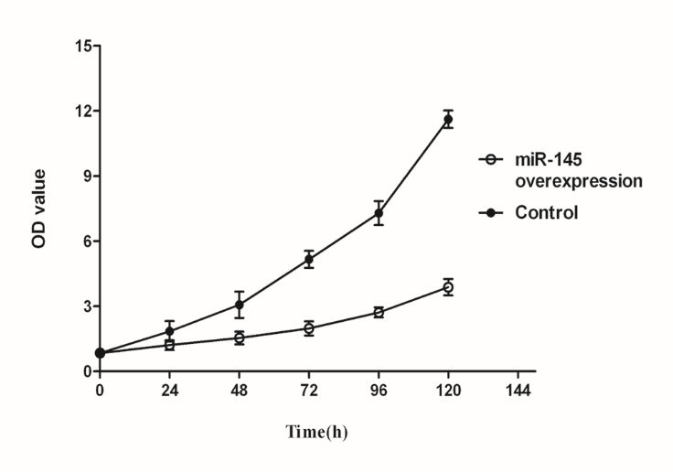
Figure 5 Growth curves of SW620 cells at indicated time points after transduction with lentiviral vectors.

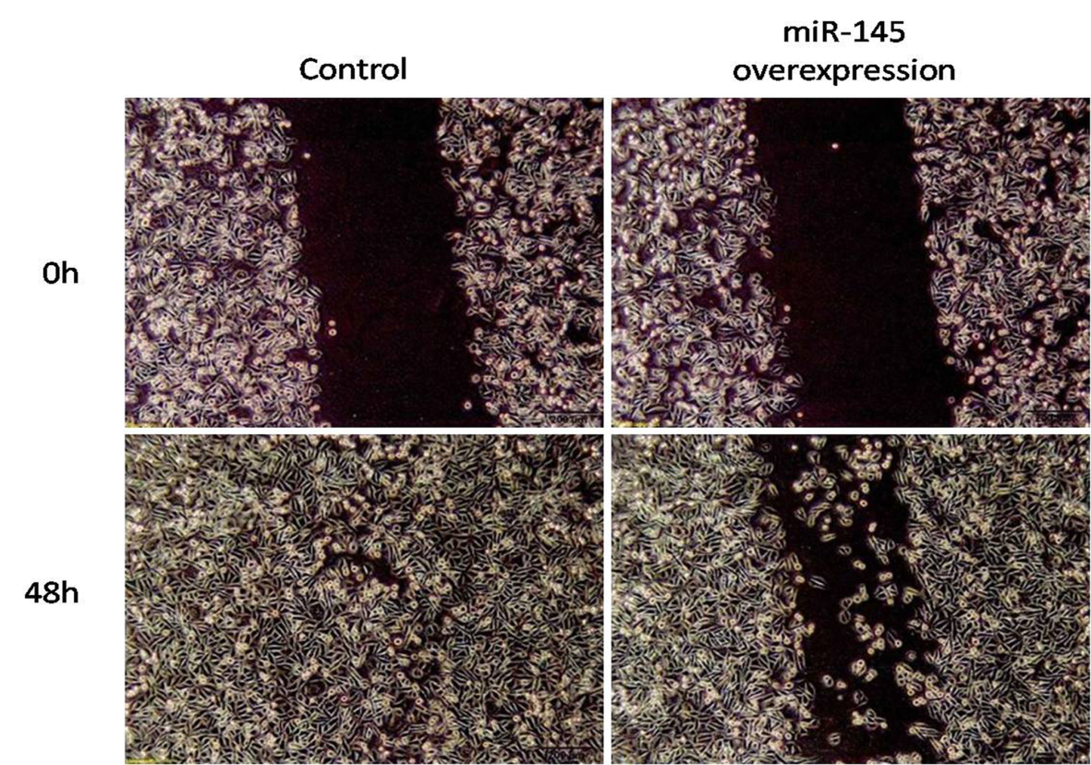
Figure 6 Effect of miR-145 on SW620 cell migration (magnification × 100). MI = 100% (g0-gt)/g0; g0 represents the width of the open area immediately after scratching the monolayer (0 h); gt represents the width of the open area at t h post scratching the monolayer.

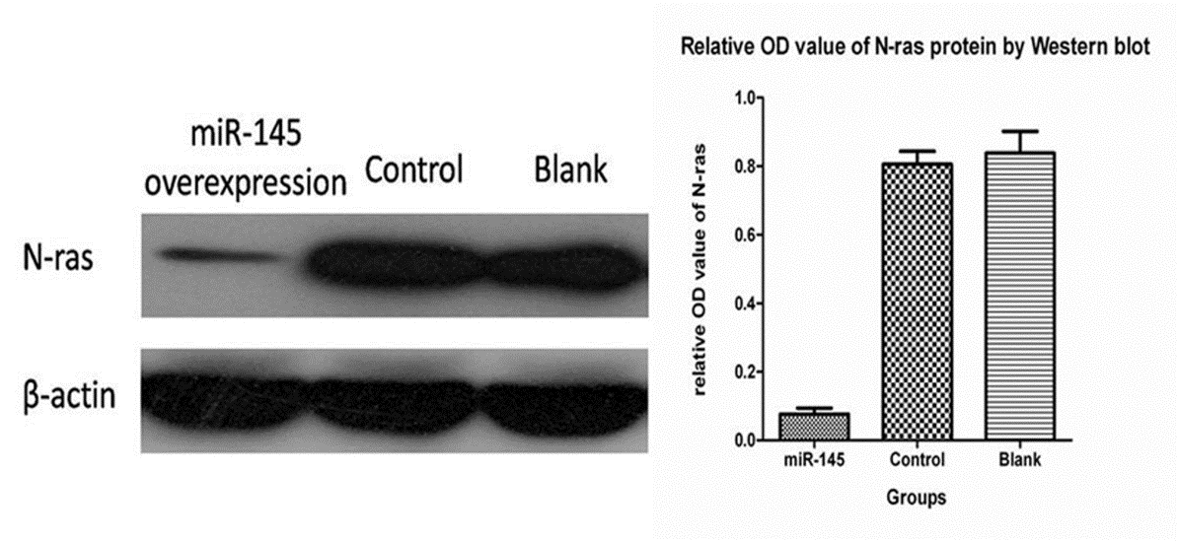
Figure 8 Effects of miR-145 on N-ras protein expression.

Table 1 Primer sequences
Primers | Sequences (5’-3’)
miR-145-F | ACACTCCAGCTGGGGTCCAGTTTTCCCAGGA
miR-145-R | CTCAACTGGTGTCGTGGAGTCGGCAATTCAGTTGAGAGGGATTC
U6-F | CTCGCTTCGGCAGCACA
U6-R  URP | AACGCTTCACGAATTTGCGT  TGGTGTCGTGGAGTCG
F: Forward; R: Reverse.

