Name of Journal: World Journal of Gastroenterology
Manuscript NO: 54734
Manuscript Type: MINIREVIEWS

Spontaneous porto-systemic shunts in liver cirrhosis: Clinical and therapeutical aspects

Nardelli S et al. SPSS in patients with cirrhosis

Silvia Nardelli, Oliviero Riggio, Stefania Gioia, Marta Puzzono, Giuseppe Pelle, Lorenzo Ridola

Silvia Nardelli, Oliviero Riggio, Stefania Gioia, Marta Puzzono, Lorenzo Ridola, Department of Translational and Precision Medicine, “Sapienza” University of Rome, Rome 00185, Italy

Giuseppe Pelle, Department of Interventional Radiology, Santa Maria Goretti Hospital, Latina 04100, Italy

Author contributions: Nardelli S and Ridola L drafted the article; Nardelli S, Riggio O and Ridola L contributed to critical revision of the article for important intellectual content; Nardelli S, Puzzono M and Gioia S contributed to conception and design; Pelle G contributed to shunts figures; Riggio O and Ridola L contributed to final approval of the article.

Corresponding author: Lorenzo Ridola, MD, PhD, Doctor, Department of Translational and Precision Medicine, “Sapienza” University of Rome, viale dell’Università 37, Rome 00185, Italy. lorenzo.ridola@uniroma1.it

Received: February 15, 2020
Revised: March 21, 2020
Accepted: March 27, 2020
Published online: April 21, 2020
Abstract
Spontaneous porto-systemic shunts (SPSS) are frequent in liver cirrhosis and their prevalence increases as liver function deteriorates, probably as a consequence of worsening portal hypertension, but without achieving an effective protection against cirrhosis' complications. Several types of SPSS have been described in the literature, each one associated with different clinical manifestations. In particular, recurrent or persistent hepatic encephalopathy is more frequent in patients with splenorenal shunt, while the presence of gastric varices and consequently the incidence of variceal bleeding is more common in gastrorenal shunt. In the advanced stage, the presence of large SPSS can lead to the so called “portosystemic shunt syndrome”, characterized by a progressive deterioration of hepatic function, hepatic encephalopathy and, sometimes, portal vein thrombosis. The detection of SPSS in patients with liver cirrhosis is recommended in order to prevent or treat recurrent hepatic encephalopathy or variceal bleeding.

Key words: Porto-systemic shunts; Liver cirrhosis; Variceal bleeding; Hepatic encephalopathy; Portal vein thrombosis; Porto-systemic shunt syndrome

Citation: Nardelli S, Riggio O, Gioia S, Puzzono M, Pelle G, Ridola L. Spontaneous porto-systemic shunts in liver cirrhosis: Clinical and therapeutical aspects. World J Gastroenterol 2020; 26(15): 1726-1732
URL: https://www.wjgnet.com/1007-9327/full/v26/i15/1726.htm
DOI: https://dx.doi.org/10.3748/wjg.v26.i15.1726

Core tip: Liver cirrhosis is characterized by a progressive increase in portal hypertension and the consequent formation of porto-systemic shunts, that act as “release valves” to reduce the portal pressure, but also act as bypasses to normal liver flow. As the shunt becomes large enough, the complications appear including hepatic encephalopathy, variceal bleeding, portal vein thrombosis and the deterioration of liver function.

INTRODUCTION
Portal hypertension is caused by an increase in resistance to portal outflow and by a growth in splanchnic blood flow^{[1,2]}. Regional alterations in vasoreactivity (vasodilation and vasoconstriction), sinusoidal remodeling and capillarization, angiogenesis, venous thrombosis and vascular distortion, all play a certain role in the pathophysiology of portal hypertension and expansion of the collateral circulation. Patients with liver cirrhosis frequently develop a vast variety of spontaneous portal-systemic shunts (SPSS) as a complication of long-standing portal hypertension^{[3]}. SPSS are communications between the portal vein and the systemic circulation than can open when portal pressure increases for the presence of liver cirrhosis^{[4]}. These SPSS act as “release valves” to reduce the portal pressure, but also act as bypasses to normal liver flow. Frequently, SPSS represent an insufficient compensatory mechanism, not allowing for an adequate reduction of portal pressure, but decreasing hepatic portal-venous perfusion^{[3-5]}. Numerous spontaneous portosystemic shunts have been described and named as shown in Table 1. SPSSs can be classified into left-sided and right-sided (central) shunts depending on their localization to the left or to the right of the spleno-porto-mesenteric confluence^{[5]}. The most frequent right-side shunt is paraumbilical shunt (Figure 1), while the most common left-sided shunts are gastrorenal shunt and splenorenal shunt. The gastrorenal shunt occurs in 80%-85% of cirrhotic patients with gastric varices and it is a communication between left gastric vein and left renal vein (Figure 2)^{[6]}. Less frequently, gastric varices could be sustained by a gastrorenal shunt. The splenorenal shunt consists in a direct communication between the splenic vein and the left renal vein (Figure 3) without passing through the submucosa of the gastrointestinal tract; in fact, it is not associated to gastric varices nor to bleeding risk. Gastric variceal bleeding is the most frequent complication of gastrorenal shunt^{[5-7]}, while hepatic encephalopathy and portal vein thrombosis, are frequently associated to splenorenal shunt. Moreover, SPSSs could be classified in large or small size according to its maximum diameter, with a cut-off of 8 mm; this value was chosen since it was the smallest size of a symptomatic shunt embolized reported in the literature^{[8,9]}. A recent multicenter retrospective study^{[8]} shown that the prevalence of SPSS in patients with liver cirrhosis increases as liver function deteriorates. The search for SPSSs allows to identify patients with a higher risk of worse outcomes, that would benefit from a more intensive care^{[8]}. Until now, computed tomography (CT) scan represents the gold standard to detect SPSSs because it allows to trace the origin, course and outlet of the shunt with a reconstruction in 3D. Also, nuclear magnetic resonance imaging (MRI) can also provide the same information when interpreted by expert radiologists. The ultrasound examination, on the other hand, is not very specific and sensitive for the detection of SPSSs. For this reason, all cirrhotic patients should undergo at least once a year to CT or MRI scan for a better identification of the shunts.

SPSS AND HEPATIC ENCEPHALOPATHY
Hepatic encephalopathy (HE) is a neuropsychiatric syndrome that frequently occurs in patients with cirrhosis and refers to potentially reversible neurological alterarations related to an accumulation of toxins due to hepatocellular dysfunction and portosystemic shunting^{[4,10-12]}. According to the recent guidelines^{[13]}, HE could be subdivided into: episodic, recurrent or persistent HE. While in some patients HE is related to a precipitating event, other patients have chronic HE, refractory to the conventional medical therapy, with a relatively mild hepatocellular disease that contrasts with the severity of the neurological impairment. In these patients the chronicity of HE may be sustained by presence of unrecognized spontaneous porto-systemic shunts (SPSS)^{[10-12]}, which are often large enough to divert a major proportion of the portal blood flow. The presence of the shunt increases the bioavailability of intestinal ammonia, increasing the risk of hepatic encephalopathy. Several clinical and pathophysiologic observations suggest the importance of portal-systemic shunts in the development of HE; in particular our group demonstrated the presence of SPSSs in 71% of cirrhotic patients with chronic HE, refractory to the standard medical treatment^{[12]}. In the retrospective cohort of Simón-Talero et al^{[8]} episodic HE was reported in 48% of patients with large SPSS, 34% of patients with small SPSS and 20% of patients without SPSS (P < 0.001). Recurrent or persistent HE was reported in 52% of patients with large SPSS, 44% of patients with small SPSS and 37% of patients without SPSS (P = 0.007). When patients were stratified by MELD score, SPSS were significantly associated to HE independently of liver function.
Another particular neurological alteration is the so called ‘‘cirrhosis-related Parkinsonism’’, characterized by extrapyramidal and cerebellar symptoms at precise neurological examination^{[14]}. Some patients develop a progressive hypokinetic-rigid syndrome with progressive ataxia, dystonia, choreoathetosis or spastic paraparesis with or without cognitive dysfunction. This chronic progressive form of HE is usually refractory to standard medical treatment and is frequently associated to the presence of SPSSs. Philips et al^{[15]} demonstrated that in five of seven patients with hepatic Parkinsonism, the embolization of the shunt significantly improved neurological symptoms. A large shunt may cause HE even in the absence of liver cirrhosis; this type of encephalopathy is classified as type B HE^{[10-13]}.

SPSS AND ESOPHAGO-GASTRIC VARICES
The clinical importance of the shunts remains of great interest, as there is a discrepancy regarding the protective effect of SPSS from oesophageal variceal bleeding and the development of hepatic encephalopathy in cirrhotic patients^{[16-18]}. Many cirrhotic patients continue to maintain an elevated portal pressure and suffer from EGV hemorrhage even in the presence of a SPSS. Compared to esophageal varices, gastric varices are more often found in patients with gastrorenal shunt, as already described^{[6,7]}. With regards to the relation between SPSS and esophagogastric varices, the case-control study performed by Riggio et al^{[12]} found that patients with chronic HE and large SPSS had less esophageal varices and portal-hypertensive gastropathy than patients without SPSS, suggesting that SPSS could have a protective role on gastrointestinal bleeding. Nevertheless, in former studies^{[5,16,17]}, presence of SPSS was not associated with lower risk of bleeding as compared to controls. Berzigotti et al^{[18]} evaluated the relationship between SPSS detected by ultrasound and the presence of esophageal varices, concluding that the development of new SPSS was associated with a higher rate of varices formation and growth. In the study conducted by Simón-Talero et al^{[8]}, SPSS were associated with more gastroesophageal varices and GI bleeding only in patients with SPSS but preserved liver function (MELD 6-9 or Child-Pugh A), who showed higher HVPG values and more clinical significant portal hypertension (CSPH). In addition, the presence of SPSS in patients with CSPH was associated to higher rate of complications compared to patients without SPSS with CSPH. Thus, the finding of SPSS in patients with good liver function probably identifies a subgroup of patients with more advanced portal hypertension, who are more likely to develop complications and might have a worse prognosis. The main limitation of the MELD score is the lack of information about portal hypertension’s complications, thus a new score taking into account MELD and the presence of SPSSs could have a better prognostic value compared to MELD alone.

SPSS AND PORTAL VEIN THROMBOSIS
With the progression of portal hypertension, SPSS grow and shunt more portal blood into the systemic circulation. Very ‘‘large’’ portosystemic shunts (with or without varices) can take over the splanchnic (splenic and mesenteric) outflow and compete with the liver (hepatic sinusoids) as the natural outflow of the portal vein; in other words, the liver disease, portal hypertension and portosystemic shunt become an enclosed vicious cycle^{[19].} Once the cycle is complete, the portal vein becomes diminutive and flow within it becomes hepatofugal; the portal vein may even thrombose in the end-stage, resulting in the portosystemic shunt becoming the only outflow of the splanchnic (splenic and mesenteric) circulation. Portal vein diminution with or without thrombosis occurs with left-sided portosystemic shunts and not recannulated paraumbilical veins (right-sided or intrahepatic shunt). In splenic shunts (such as splenorenal and gastrorenal shunts), there is dilation of the splenic vein and diminution of the portal vein. Hypersplenism is also a feature of this syndrome composed of splenomegaly, thrombocytopenia, and in severe cases pancytopenia. As the shunting progresses, the liver atrophies, the portal vein thromboses, and both hepatic synthetic function and encephalopathy become debilitating and intractable^{[20]}.

PORTOSYSTEMIC SHUNT SYNDROME
The term “portosystemic shunt syndrome” (PSS) was coined by Kumamoto et al^{[21]} to describe the gradual deterioration of hepatic function over five years in cirrhotic patients with SPSS. Subsequently, Saad et al^{[20]} elaborated on this term further by describing a complete syndrome with specific clinical manifestations. In the Saad classification, three stages were described. In the early stage (A), the patient is asymptomatic with well-preserved hepatic function and large SPSS. In the late stage (B), the patient is symptomatic with recurrent/persistent HE and fairly-preserved hepatic function. The terminal/end stage (C) is characterized by hepatic failure and HE, ascites and jaundice. Thrombocytopenia is also frequently observed in patients with PSS.

PORTOSYSTEMIC SHUNTS OCCLUSION
The treatment of portosystemic shunt syndrome has become important and several interventional radiology procedures have become leading treatments for portal hypertension because of the extensive range of indications^{[15]}. The main indications are: bleeding from gastric varices sustained by a gastrorenal shunt; recurrent HE due to the presence of a SPSS. With balloon-occluded retrograde transvenous obliteration (BRTO), a balloon catheter (with a diameter similar to the shunt’s size) is placed retrogradely in the gastrorenal shunt avoiding reflux into the inferior vena cava so that a sclerosant can be injected into the gastric varices for thrombus formation while the blood flow is cut off. Moreover, BRTO should be avoided when the contrast agent flows from the shunt into the portal vein under balloon-occluded retrograde venography, because there is a risk of portal thrombosis due to sclerosing agent migrated into the portal vein^{[15]}. BRTO has been shown to be very effective in treating gastric varices and refractory HE associated with SPSS with low rebleeding rates (0%–9%)^{[22,23]}.
Recently, new techniques such as plug assisted retrograde transvenous obliteration (PARTO) or coil assisted retrograde transvenous obliteration (CARTO) have been developed. In PARTO, a vascular plug is used as a substitute for the balloon and the procedure time is reduced^{[24]}. In CARTO, large-sized coils are used instead of the plug^{[25]}.
Different studies demonstrated that shunt-related hepatic encephalopathy due to the increased shunt blood flow can be dramatically improved by closing the shunts^{[15,26-29]}. In some patients, with isolated oesophageal varices or type 1 gastro-oesophageal varices (GOV1), Transjugular Intrahepatic Porto-Systemic Shunt (TIPS) should be used to decompress the portal venous system, and avoids variceal bleeding. However, in presence of type 2 gastro-oesophageal varices (GOV2) or Isolated gastric varices (IGV), TIPS could not be efficient to reduce the bleeding risk and in these patients additional embolization of the shunt should be considered. Regarding gastric variceal bleeding, Gimm et al^{[28]} demonstrated that BRTO provides better bleeding control, rebleeding-free survival and overall survival compared with transjugular intrahepatic porto-systemic shunt (TIPS).

SPSS AND LIVER TRANSPLANTATION
Spontaneous portosystemic shunts have been associated with worse clinical outcomes in the pre liver transplantation (LT) setting, but little is known about the potential impact of SPSSs in post LT patients^{[30]}. In a recent retrospective study^{[31]}, after comparing 326 patients without, small or large SPSSs, no statistical difference was found for overall patient survival and graft survival.

CONCLUSION
In summary, all cirrhotic patients should be studied with radiological imaging in order to detect the presence of porto-systemic shunt. In several cases, patients with large SPSS had a more impaired liver function and more frequent complications of portal hypertension^{[32]} so these patients would probably benefit from a closer surveillance and more intensive therapy. Moreover, the identification of SPSS became crucial in selected cases, in which the embolization of large SPSS may be associated with improved survival and liver function, as well as preventing the recurrence of HE or variceal bleeding.

REFERENCES
1 Blei AT. Portal hypertension and its complications. Curr Opin Gastroenterol 2007; 23: 275-282 [PMID: 17414843 DOI: 10.1097/MOG.0b013e3280b0841f]
2 Fernandez M, Mejias M, Garcia-Pras E, Mendez R, Garcia-Pagan JC, Bosch J. Reversal of portal hypertension and hyperdynamic splanchnic circulation by combined vascular endothelial growth factor and platelet-derived growth factor blockade in rats. Hepatology 2007; 46: 1208-1217 [PMID: 17654489 DOI: 10.1002/hep.21785]
3 de Franchis R; Baveno VI Faculty. Expanding consensus in portal hypertension: Report of the Baveno VI Consensus Workshop: Stratifying risk and individualizing care for portal hypertension. J Hepatol 2015; 63: 743-752 [PMID: 26047908 DOI: 10.1016/j.jhep.2015.05.022]
4 Ohnishi K, Sato S, Saito M, Terabayashi H, Nakayama T, Saito M, Chin N, Iida S, Nomura F, Okuda K. Clinical and portal hemodynamic features in cirrhotic patients having a large spontaneous splenorenal and/or gastrorenal shunt. Am J Gastroenterol 1986; 81: 450-455 [PMID: 3518409]
5 Saad WE. Vascular anatomy and the morphologic and hemodynamic classifications of gastric varices and spontaneous portosystemic shunts relevant to the BRTO procedure. Tech Vasc Interv Radiol 2013; 16: 60-100 [PMID: 23830670 DOI: 10.1053/j.tvir.2013.02.002]
6 Al-Osaimi AM, Caldwell SH. Medical and endoscopic management of gastric varices. Semin Intervent Radiol 2011; 28: 273-282 [PMID: 22942544 DOI: 10.1055/s-0031-1284453]
7 Maruyama H, Okugawa H, Yoshizumi H, Kobayashi S, Yokosuka O. Hemodynamic features of gastrorenal shunt: a Doppler study in cirrhotic patients with gastric fundal varices. Acad Radiol 2008; 15: 1148-1154 [PMID: 18692756 DOI: 10.1016/j.acra.2008.03.008]
8 Simón-Talero M, Roccarina D, Martínez J, Lampichler K, Baiges A, Low G, Llop E, Praktiknjo M, Maurer MH, Zipprich A, Triolo M, Vangrinsven G, Garcia-Martinez R, Dam A, Majumdar A, Picón C, Toth D, Darnell A, Abraldes JG, Lopez M, Kukuk G, Krag A, Bañares R, Laleman W, La Mura V, Ripoll C, Berzigotti A, Trebicka J, Calleja JL, Tandon P, Hernandez-Gea V, Reiberger T, Albillos A, Tsochatzis EA, Augustin S, Genescà J; Baveno VI-SPSS group from the Baveno Cooperation. Association Between Portosystemic Shunts and Increased Complications and Mortality in Patients With Cirrhosis. Gastroenterology 2018; 154: 1694-1705.e4 [PMID: 29360462 DOI: 10.1053/j.gastro.2018.01.028]
9 Sakurabayashi S, Sezai S, Yamamoto Y, Hirano M, Oka H. Embolization of portal-systemic shunts in cirrhotic patients with chronic recurrent hepatic encephalopathy. Cardiovasc Intervent Radiol 1997; 20: 120-124 [PMID: 9030502 DOI: 10.1007/s002709900118]
10 Nardelli S, Gioia S, Ridola L, Riggio O. Radiological Intervention for Shunt Related Encephalopathy. J Clin Exp Hepatol 2018; 8: 452-459 [PMID: 30564003 DOI: 10.1016/j.jceh.2018.04.008]
11 Shawcross DL, Olde Damink SW, Butterworth RF, Jalan R. Ammonia and hepatic encephalopathy: the more things change, the more they remain the same. Metab Brain Dis 2005; 20: 169-179 [PMID: 16167195 DOI: 10.1007/s11011-005-7205-0]
12 Riggio O, Efrati C, Catalano C, Pediconi F, Mecarelli O, Accornero N, Nicolao F, Angeloni S, Masini A, Ridola L, Attili AF, Merli M. High prevalence of spontaneous portal-systemic shunts in persistent hepatic encephalopathy: a case-control study. Hepatology 2005; 42: 1158-1165 [PMID: 16250033 DOI: 10.1002/hep.20905]
13 Vilstrup H, Amodio P, Bajaj J, Cordoba J, Ferenci P, Mullen KD, Weissenborn K, Wong P. Hepatic encephalopathy in chronic liver disease: 2014 Practice Guideline by the American Association for the Study of Liver Diseases and the European Association for the Study of the Liver. Hepatology 2014; 60: 715-735 [PMID: 25042402 DOI: 10.1002/hep.27210]
14 Tryc AB, Goldbecker A, Berding G, Rümke S, Afshar K, Shahrezaei GH, Pflugrad H, Barg-Hock H, Strassburg CP, Hecker H, Weissenborn K. Cirrhosis-related Parkinsonism: prevalence, mechanisms and response to treatments. J Hepatol 2013; 58: 698-705 [PMID: 23220368 DOI: 10.1016/j.jhep.2012.11.043]
15 Philips CA, Kumar L, Augustine P. Shunt occlusion for portosystemic shunt syndrome related refractory hepatic encephalopathy-A single-center experience in 21 patients from Kerala. Indian J Gastroenterol 2017; 36: 411-419 [PMID: 29124669 DOI: 10.1007/s12664-017-0787-8]
16 Lam KC, Juttner HU, Reynolds TB. Spontaneous portosystemic shunt: relationship to spontaneous encephalopathy and gastrointestinal hemorrhage. Dig Dis Sci 1981; 26: 346-352 [PMID: 6972295 DOI: 10.1007/bf01308377]
17 Aseni P, Beati C, Brambilla G, Bertini M, Belli L. Does large spontaneous portal systemic shunt in cirrhosis protect from the risk of gastroesophageal bleeding? J Clin Gastroenterol 1986; 8: 235-238 [PMID: 3488341 DOI: 10.1097/00004836-198606000-00006]
18 Berzigotti A, Merkel C, Magalotti D, Tiani C, Gaiani S, Sacerdoti D, Zoli M. New abdominal collaterals at ultrasound: a clue of progression of portal hypertension. Dig Liver Dis 2008; 40: 62-67 [PMID: 17913603 DOI: 10.1016/j.dld.2007.08.011]
19 Saad WE, Lippert A, Saad NE, Caldwell S. Ectopic varices: anatomical classification, hemodynamic classification, and hemodynamic-based management. Tech Vasc Interv Radiol 2013; 16: 158-175 [PMID: 23830673 DOI: 10.1053/j.tvir.2013.02.004]
20 Saad WE. Portosystemic shunt syndrome and endovascular management of hepatic encephalopathy. Semin Intervent Radiol 2014; 31: 262-265 [PMID: 25177088 DOI: 10.1055/s-0034-1382795]
21 Kumamoto M, Toyonaga A, Inoue H, Miyakoda K, Morita Y, Emori K, Sakamoto Y, Oho K, Sata M. Long-term results of balloon-occluded retrograde transvenous obliteration for gastric fundal varices: hepatic deterioration links to portosystemic shunt syndrome. J Gastroenterol Hepatol 2010; 25: 1129-1135 [PMID: 20594229 DOI: 10.1111/j.1440-1746.2010.06262.x]
22 Kanagawa H, Mima S, Kouyama H, Gotoh K, Uchida T, Okuda K. Treatment of gastric fundal varices by balloon-occluded retrograde transvenous obliteration. J Gastroenterol Hepatol 1996; 11: 51-58 [PMID: 8672742 DOI: 10.1111/j.1440-1746.1996.tb00010.x]
23 Hirota S, Matsumoto S, Tomita M, Sako M, Kono M. Retrograde transvenous obliteration of gastric varices. Radiology 1999; 211: 349-356 [PMID: 10228513 DOI: 10.1148/radiology.211.2.r99ma25349]
24 Gwon DI, Kim YH, Ko GY, Kim JW, Ko HK, Kim JH, Shin JH, Yoon HK, Sung KB. Vascular Plug-Assisted Retrograde Transvenous Obliteration for the Treatment of Gastric Varices and Hepatic Encephalopathy: A Prospective Multicenter Study. J Vasc Interv Radiol 2015; 26: 1589-1595 [PMID: 26316136 DOI: 10.1016/j.jvir.2015.07.011]
25 Lee EW, Saab S, Gomes AS, Busuttil R, McWilliams J, Durazo F, Han SH, Goldstein L, Tafti BA, Moriarty J, Loh CT, Kee ST. Coil-Assisted Retrograde Transvenous Obliteration (CARTO) for the Treatment of Portal Hypertensive Variceal Bleeding: Preliminary Results. Clin Transl Gastroenterol 2014; 5: e61 [PMID: 25273155 DOI: 10.1038/ctg.2014.12]
26 Laleman W, Simon-Talero M, Maleux G, Perez M, Ameloot K, Soriano G, Villalba J, Garcia-Pagan JC, Barrufet M, Jalan R, Brookes J, Thalassinos E, Burroughs AK, Cordoba J, Nevens F; EASL-CLIF-Consortium. Embolization of large spontaneous portosystemic shunts for refractory hepatic encephalopathy: a multicenter survey on safety and efficacy. Hepatology 2013; 57: 2448-2457 [PMID: 23401201 DOI: 10.1002/hep.26314]
27 Mukund A, Rajesh S, Arora A, Patidar Y, Jain D, Sarin SK. Efficacy of balloon-occluded retrograde transvenous obliteration of large spontaneous lienorenal shunt in patients with severe recurrent hepatic encephalopathy with foam sclerotherapy: initial experience. J Vasc Interv Radiol 2012; 23: 1200-1206 [PMID: 22832139 DOI: 10.1016/j.jvir.2012.05.046]
28 Gimm G, Chang Y, Kim HC, Shin A, Cho EJ, Lee JH, Yu SJ, Yoon JH, Kim YJ. Balloon-Occluded Retrograde Transvenous Obliteration versus Transjugular Intrahepatic Portosystemic Shunt for the Management of Gastric Variceal Bleeding. Gut Liver 2018; 12: 704-713 [PMID: 29938456 DOI: 10.5009/gnl17515]
29 An J, Kim KW, Han S, Lee J, Lim YS. Improvement in survival associated with embolisation of spontaneous portosystemic shunt in patients with recurrent hepatic encephalopathy. Aliment Pharmacol Ther 2014; 39: 1418-1426 [PMID: 24754260 DOI: 10.1111/apt.12771]
30 Saks K, Jensen KK, McLouth J, Hum J, Ahn J, Zaman A, Chang MF, Fung A, Schlansky B. Influence of spontaneous splenorenal shunts on clinical outcomes in decompensated cirrhosis and after liver transplantation. Hepatol Commun 2018; 2: 437-444 [PMID: 29619421 DOI: 10.1002/hep4.1157]
31 Rodriguez EA, Perez R, Zhang N, Lim ES, Miller C, Schwartz MA, McGirr AJ, Srinivasan A, Hewitt W, Silva AC, Rakela J, Vargas HE. Clinical Outcomes of Portosystemic Shunts on the Short-Term Outcome of Liver Transplantation. Liver Transpl 2019 [PMID: 31872966 DOI: 10.1002/lt.25710]
32 Praktiknjo M, Simón-Talero M, Römer J, Roccarina D, Martínez J, Lampichler K, Baiges A, Low G, Llop E, Maurer MH, Zipprich A, Triolo M, Maleux G, Fialla AD, Dam C, Vidal-González J, Majumdar A, Picón C, Toth D, Darnell A, Abraldes JG, López M, Jansen C, Chang J, Schierwagen R, Uschner F, Kukuk G, Meyer C, Thomas D, Wolter K, Strassburg CP, Laleman W, La Mura V, Ripoll C, Berzigotti A, Calleja JL, Tandon P, Hernandez-Gea V, Reiberger T, Albillos A, Tsochatzis EA, Krag A, Genescà J, Trebicka J; Baveno VI-SPSS group of the Baveno Cooperation. Total area of spontaneous portosystemic shunts independently predicts hepatic encephalopathy and mortality in liver cirrhosis. J Hepatol 2020 [PMID: 31954206 DOI: 10.1016/j.jhep.2019.12.021]
Footnotes
Conflict-of-interest statement: All authors have nothing to disclose and no conflict of interest.

Open-Access: This article is an open-access article that was selected by an in-house editor and fully peer-reviewed by external reviewers. It is distributed in accordance with the Creative Commons Attribution NonCommercial (CC BY-NC 4.0) license, which permits others to distribute, remix, adapt, build upon this work non-commercially, and license their derivative works on different terms, provided the original work is properly cited and the use is non-commercial. See: http://creativecommons.org/licenses/by-nc/4.0/

Manuscript source: Unsolicited manuscript

Peer-review started: February 15, 2020
First decision: March 15, 2020
Article in press: March 27, 2020

Specialty type: Gastroenterology and hepatology
Country/Territory of origin: Italy
Peer-review report’s scientific quality classification
Grade A (Excellent): 0
Grade B (Very good): B, B
Grade C (Good): 0
Grade D (Fair): 0
Grade E (Poor): 0

P-Reviewer: Balaban YH, Gatselis NK S-Editor: Wang YQ L-Editor: A E-Editor: Ma YJ
Figure Legends
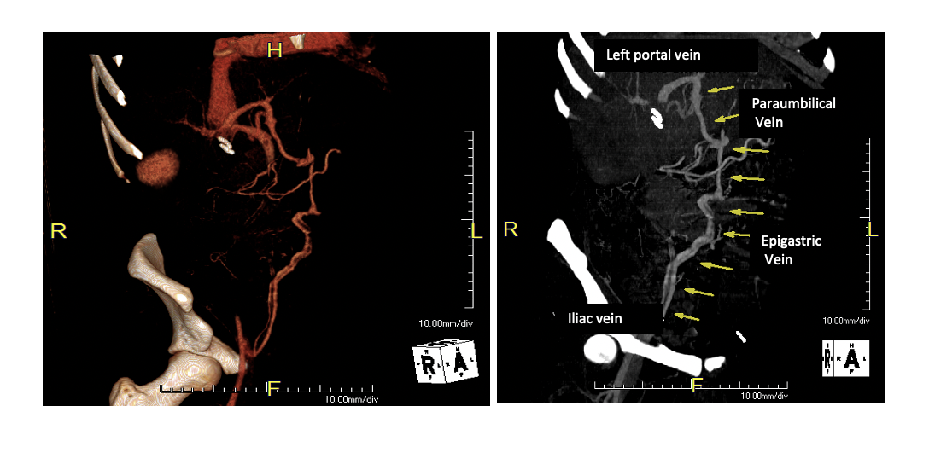
Figure 1 Paraumbilical shunt at computed tomography scan.

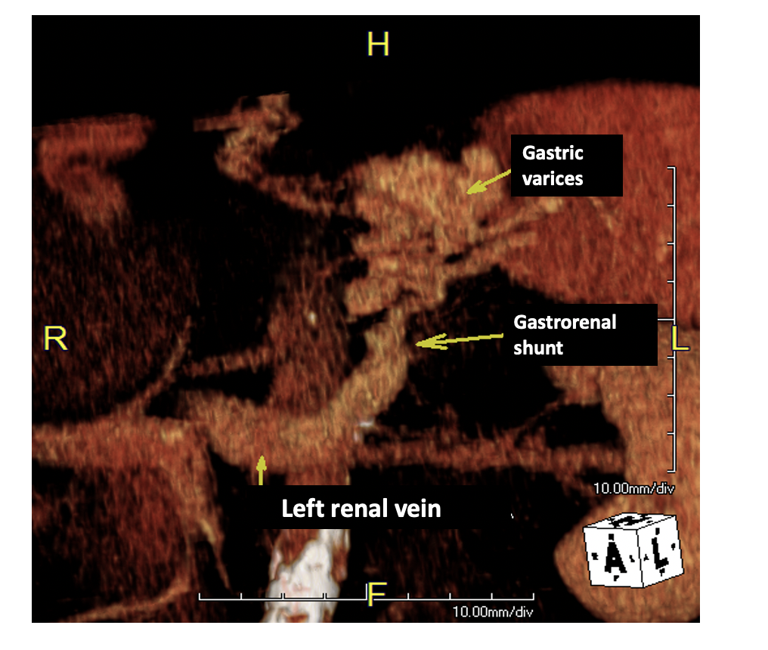
Figure 2 Gastrorenal shunt at computed tomography scan.

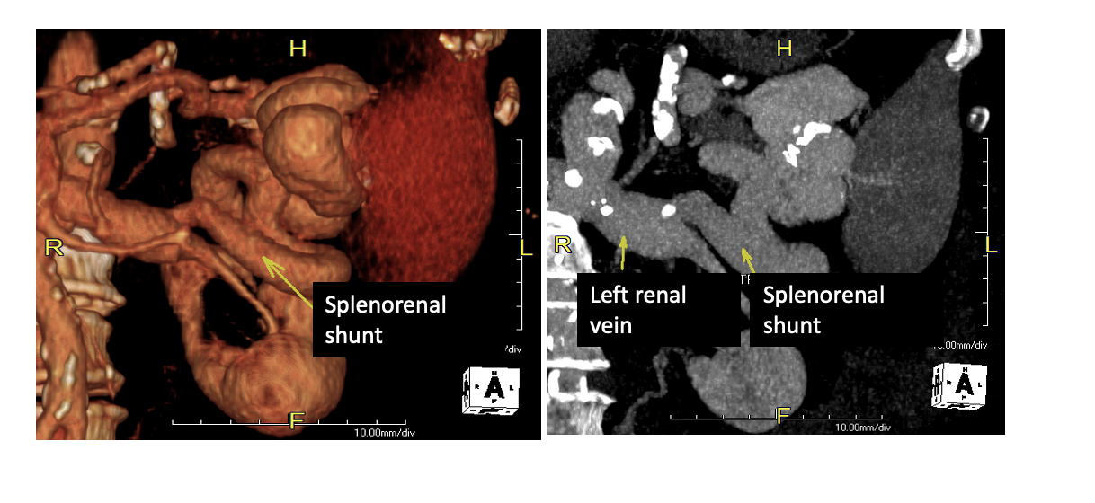
Figure 3 Splenorenal shunt at computed tomography scan.
Table 1 Clinical features of the main spontaneous porto-systemic shunts
SPSS type | Frequency | Clinical presentation (if any) | Laterality
Gastrorenal shunt | 80%-85% of patients with gastric varices | Gastric varices bleeding, less frequently hepatic encephalopathy or portal vein thrombosis if very large | Left
Gastrocaval shunt | Less frequent than gastrorenal shunt | Gastric varices bleeding | Left
Splenorenal shunt | 14%-21% of patients with cirrhosis | Hepatic encephalopathy; Portal vein thrombosis | Left
Mesorenal shunt | Uncommon | Hepatic encephalopathy | Central
Paraumbilical shunt | 6%-30% of patients with portal hypertension | Hepatic encephalopathy  Portal vein thrombosis | Right
Rectal varices | Rare | Lower gastro-intestinal bleeding | Right
Esophageal varices | 40%-80% of patients with cirrhosis | Hematemesis or melena | Right
SPSS: Spontaneous porto-systemic shunt.

