Name of Journal: World Journal of Clinical Cases
Manuscript NO: 59405
Manuscript Type: ORIGINAL ARTICLE

Observational Study
Healthy individuals vs patients with bipolar or unipolar depression in gray matter volume

Zhang YN et al. Gray matter in patients with unipolar vs bipolar depression

Yin-Nan Zhang, Hui Li, Zhi-Wei Shen, Chang Xu, Yue-Jun Huang, Ren-Hua Wu

Yin-Nan Zhang, Department of Rehabilitation Medicine, Mental Health Center of Shantou University, Shantou 515000, Guangdong Province, China

Hui Li, Chang Xu, Mental Health Center of Shantou University, Shantou 515000, Guangdong Province, China

Zhi-Wei Shen, Philips Healthcare China, Beijing 100000, China

Yuejun Huang, Department of Pediatrics, The Second Affiliated Hospital of Shantou University Medical College, Shantou 515000, Guangdong Province, China

Ren-Hua Wu, Department of Medical Imaging, The Second Affiliated Hospital of Shantou University Medical College, Shantou 515041, Guangdong Province, China

Ren-Hua Wu, Guangdong Key Laboratory of Molecular Imaging, Shantou 515000, Guangdong Province, China

Author contributions: Li H designed the study; Zhang YN diagnosed and treated the patients and participated in data collection; Xu C and Shen ZW performed imaging examination and analysis; Huang YJ followed the patients to assess their outcomes; Zhang YN and Wu RH conducted data analysis and prepared the manuscript; All authors approved the final version of the manuscript.

Supported by the Youth Fund of National Natural Science Foundation of China, No. 81701338; And the Shantou Medical Science and Technology Plan Project, No. 20150406.

Corresponding author: Ren-Hua Wu, MD, Professor, Department of Medical Imaging, The Second Affiliated Hospital of Shantou University Medical College, Dongxia North Road, Shantou 515041, Guangdong Province, China. rhwu@stu.edu.cn

Received: September 10, 2020
Revised: December 14, 2020
Accepted: December 23, 2020
Published online: February 26, 2021
Abstract
BACKGROUND
Previous studies using voxel-based morphometry (VBM) revealed changes in gray matter volume (GMV) of patients with depression, but the differences between patients with bipolar disorder (BD) and unipolar depression (UD) are less known.

AIM
To analyze the whole-brain GMV data of patients with untreated UD and BD compared with healthy controls.

METHODS
Fourteen patients with BD and 20 with UD were recruited from the Mental Health Center of Shantou University between August 2014 and July 2015, and 20 non-depressive controls were recruited. After routine three-plane positioning, axial T2WI scanning was performed. The connecting line between the anterior and posterior commissures was used as the scanning baseline. The scanning range extended from the cranial apex to the foramen magnum. Categorical data are presented as frequencies and were analyzed using the Fisher exact test.

RESULTS
There were no significant intergroup differences in gender, age, or years of education. Disease course, age at the first episode, and Hamilton depression rating scale scores were similar between patients with UD and those with BD. Compared with the non-depressive controls, patients with BD showed smaller GMVs in the right inferior temporal gyrus, left middle temporal gyrus, right middle occipital gyrus, and right superior parietal gyrus and larger GMVs in the midbrain, left superior frontal gyrus, and right cerebellum. In contrast, UD patients showed smaller GMVs than the controls in the right fusiform gyrus, left inferior occipital gyrus, left paracentral lobule, right superior and inferior temporal gyri, and the right posterior lobe of the cerebellum, and larger GMVs than the controls in the left posterior central gyrus and left middle frontal gyrus. There was no difference in GMV between patients with BD and UD.

CONCLUSION
Using VBM, the present study revealed that patients with UD and BD have different patterns of changes in GMV when compared with healthy controls.

Key Words: Bipolar disorder; Unipolar depression; Gray matter; Functional magnetic resonance imaging; Classification techniques; Voxel-based morphometry

©The Author(s) 2021. Published by Baishideng Publishing Group Inc. All rights reserved.

Citation: Zhang YN, Li H, Shen ZW, Xu C, Huang YJ, Wu RH. Healthy individuals vs patients with bipolar or unipolar depression in gray matter volume. World J Clin Cases 2021; 9(6): 1304-1317
URL: https://www.wjgnet.com/2307-8960/full/v9/i6/1304.htm
DOI: https://dx.doi.org/10.12998/wjcc.v9.i6.1304

Core Tip: Disease course, age at the first episode, and Hamilton depression rating scale scores were similar between patients with unipolar depression (UD) and those with bipolar disorder (BD). UD patients showed smaller gray matter volumes (GMVs) than the controls in the right fusiform gyrus, left inferior occipital gyrus, left paracentral lobule, right superior and inferior temporal gyri, and the right posterior lobe of the cerebellum, and larger GMVs than the controls in the left posterior central gyrus and left middle frontal gyrus. There was no difference in GMV between patients with BD and UD.

INTRODUCTION
Bipolar disorder (BD) is a severe mental illness featured by episodes of mania and depression in an alternating pattern, accompanied by changes in activity or energy and cognitive, physical, and behavioral symptoms^{[1,2]}. The overall incidence of BD worldwide is approximately 2%, with the disease's subthreshold forms affecting another 2% of the global population^{[3]}. The estimated lifetime prevalence of BD based on data from 11 countries is 0.4%-1.4%^{[4]}. According to data from the World Health Organization, the disability rate associated with BD ranks sixth in the youth population, causing a heavy financial burden on families and society^{[5]}.
In clinical practice, BD type I is characterized by at least one episode of mania. In comparison, BD type II is characterized by at least one episode of depression and at least one hypomanic episode, without mania episodes^{[1,2]}. However, since the disease episodes must be clinically monitored to determine the diagnosis, the two types are challenging to identify in the disease's early stages. As a result, diagnosis may be delayed by up to 10 years or even longer in one-third of patients with BD^{[6]}, and 60% of patients with BD who sought treatment for depressive symptoms were initially misdiagnosed as having unipolar depression (UD)^{[7]}. Thus, the similarities in the clinical symptoms of BD and UD cause difficulties in a timely and accurate diagnosis of the two conditions^{[8]}.
Several clinical studies have attempted to identify biological indicators that can distinguish UD from BD^{[9-11]}. Elevated plasma uric acid levels may be associated with emotional instability in patients with BD, while low uric acid levels may be related to UD patients’ depressive mood^{[10]}. Similarly, patients with BD show high plasma levels of nerve growth factor (NT)-3 and NT-4/5^{[11]}. Likewise, neuroelectrophysiological studies have suggested that the auditory steady-state response is a potential electrophysiological marker for distinguishing between BD and UD^{[9]}. While patients with BD and UD show some differences in electrophysiological and biochemical indicators, the evidence for using these indicators in differential diagnosis remains inadequate.
Voxel-based morphometry (VBM) is an automatic, comprehensive, and objective technique for the analysis of brain structural magnetic resonance (MR) images^{[12]}. In VBM, gray and white matter lesions in the brain are evaluated via quantitative analysis of the changes in brain gray and white matter volumes of each voxel of MR images. VBM is widely used in research to study a variety of neuropsychiatric diseases such as Alzheimer’s disease^{[13]}, depression^{[14,15]}, bipolar disorder^{[15,16]}, and schizophrenia^{[17]}, providing reliable imaging data regarding the changes in brain morphology in those diseases.
Previous VBM studies have reported gray matter structural abnormalities in patients with BD and depression. In patients with UD, smaller gray matter volume (GMV) are observed in the anterior cingulate gyrus^{[18]}, hippocampus^{[19]}, amygdala^{[18,19]}, caudate nucleus^{[14]}, frontal lobe^{[20]}, parietal lobe^{[20]}, temporal lobe^{[21]}, and cerebellum^{[21]}. In contrast, the brain regions reported to show smaller GMVs in patients with BD include the frontal lobe^{[22]} and the temporal lobe^{[23]}. Since very few studies have directly compared the VBM findings in the two diseases, the exact differences in GMV changes between patients with BD and UD remain unclear.
The results of the available VBM studies also lacked consistency because of methodological differences^{[24,25]}. For example, De Azevedo-Marques Perico et al^{[24]} showed that the GMV of the right lateral anterior cingulate cortex in BD patients was larger than that in normal controls. In comparison, the GMV of the bilateral dorsolateral prefrontal cortex in patients with UD was smaller than that in controls. Patients with UD and BD showed significant GMV differences at the level of the right dorsolateral prefrontal lobe. In contrast, Wise et al^{[25]} performed a meta-analysis of the VBM results in patients with BD and UD and showed that the GMVs of the bilateral insular lobe and the dorsomedial and ventromedial frontal cortices are smaller in both groups in comparison with normal controls, while the GMVs of the right frontal gyrus, left hippocampus and parahippocampal gyrus, right inferior temporal gyrus and fusiform gyrus, left inferior parietal lobule, and right cerebellar vermis are smaller in patients with UD than in those with BD^{[25]}. Redlich et al^{[26]} showed reduced GMV in the anterior cingulate gyrus in American and German patients with UD compared with BD and suggested a pattern classification (based on a multivariable analysis of GMV, white matter volume, and structural abnormalities) that had 79% accuracy. From Singapore, Cai et al^{[27]} showed that patients with BP1 and UD have lower GMV in the right frontal gyrus, but that lower GMV in the right middle cingulate gyrus might be specific to BP1.
Nevertheless, although differences in the GMV distributions in patients with UD and BD have been reported across multiple studies, only rare studies^{[26,27]} have attempted to determine whether these differences can be used to distinguish between BD and UD. Because of the possible cultural, language, ethnic, and technical [magnetic resonance imaging (MRI) sequences] differences in VBM results, this study aimed to use VBM to analyze the whole-brain GMV data of patients with untreated UD and BD compared with healthy controls.

MATERIALS AND METHODS
Study design and subjects
This study included 14 patients with BD and 20 patients with UD admitted to the outpatient department of the Mental Health Center of Shantou University between August 2014 and July 2015. The study protocol was approved by the ethics committee of Shantou University Medical College ([2017]0301). All patients voluntarily participated in the study and signed an informed consent form.
All patients were diagnosed according to the diagnostic criteria of the Diagnostic and Statistical Manual of Mental Disorders (DSM)-Ⅳ^{[28]}. Intelligence quotient (IQ) was tested using the Wechsler Adult Intelligence Scale-Revised in China^{[29,30]}. Depression was evaluated using the Hamilton depression rating scale (HDRS)^{[31]}, validated in Chinese^{[32]}.
For the UD group, the inclusion criteria were: (1) Meeting the diagnostic criteria for recurrent depression in DSM-IV (code 32.4); (2) 18-60 years of age; (3) HDRS score ≥ 17; (4) Right-handedness; (5) IQ > 70; and (6) No history of drug consumption for at least 2 wk. For the BD group, the inclusion criteria were as follows: (1) Meeting the diagnostic criteria for bipolar disorder depressive episodes in DSM-IV (codes 31.5 and 31.6); (2) 18-60 years of age; (3) HDRS score ≥ 17; (4) Right-handedness; (5) IQ > 70; and (6) No history of drug consumption for at least 2 wk. The exclusion criteria were: (1) Schizophrenia or schizoaffective psychosis; (2) Substance dependence; (3) Severe physical and neurological diseases; (4) Pregnancy or lactation; (5) Intrauterine contraceptive ring usage; (6) Presence of a cardiac pacemaker or other implantable metal devices; and (7) Left-handedness.
Twenty non-depressive individuals were recruited as controls, based on the following criteria: (1) No history of significant physical or mental illness; (2) 18-60 years of age; (3) Right-handedness; and (4) IQ > 70.

Head MRI
After routine three-plane positioning, axial T2WI scanning was performed. The connecting line between the anterior and posterior commissures was used as the scanning baseline. The scanning range extended from the cranial apex to the foramen magnum. The scanning parameters were as follows: Repetition time (TR), 7000 ms; Echo time (TE), 107.3 ms; Layer thickness, 5 mm; Layer spacing, 1 mm; Matrix, 384 × 384; Field of view (FOV), 240 × 240 mm²; Bandwidth, 62.5; And number of excitations (NEX), 2. T1 fluid-attenuated inversion recovery scanning was performed with the following parameters: TR, 1750 ms; TE, 24 ms; Matrix, 320 × 224; and FOV, 240 × 240 mm². Axial scanning was performed using the 3D-BRAVO sequence (T1WI) with the following parameters: TR, 6 ms; TE, 1.8 ms; Flip angle, 15°; Layer thickness, l mm; Continuous scanning with no intervals; FOV, 256 mm × 256 mm; Matrix, 256 × 256; NEX, l; Bandwidth, 41.67 Hz; number of scanning layers, 168; Voxel size, 1 mm × 1 mm × 1 mm; And scanning time, 2 m 59 s.

Data collection
Information about demographics (gender, age, income, employment status, and years of education) and clinical characteristics (age at the first episode, disease course, and HDRS scores) of the subjects were collected.

Image processing and data analysis
The VBM8 and DARTEL toolkits in the SPM8 software package (Statistical Parametric Mapping, http://www.fil.ion.ucl.ac.uk/spm) were used to process structural image data, as described previously^{[33]}. Post-processing was performed using the DARTEL algorithm. The specific processing steps were: (1) Format conversion: The original data in DICOM format was converted to the NIfTI format; (2) Segmentation: Images of the individual brain structures were segmented to obtain white matter, gray matter, and cerebrospinal fluid images; (3) Template establishment: Three groups of subjects (BD, UD, and controls) were used to generate the template, and the DARTEL algorithm was used to estimate the optimal registration template for each participant; (4) Volume modulation map generation: Space was normalized to the Montreal Neurological Institute (MNI) space^{[34]} to generate the volume modulation map; (5) Data smoothing: A Gaussian kernel with a full-width at half maximum of 8 mm was used for smoothing the data; and (6) Statistical analysis: Statistical analysis was performed on the data by using a two-sample t test in SPM8. The Alpha Sim application was used for correction for multiple comparisons. Age, sex, and total intracranial volume were used as covariates. After false discovery rate correction, P < 0.05 and a voxel threshold of > 100 were considered significant, at least statistically. The voxels with statistical significance were superimposed on 3D MNI standard templates to generate pseudo-color maps. The characteristics of GMV changes in the whole brains of the three groups were analyzed.
Categorical data are presented as frequencies and were analyzed using the Fisher exact test. Continuous data are presented as the mean ± SD and were analyzed using one-way analysis of variance (ANOVA) with the SNK post hoc test. SPSS 21.0 (IBM, Armonk, NY, United States) was used for statistical analysis. P values < 0.05 were considered statistically significant.

RESULTS
Characteristics of the subjects
MRI was performed in 14 patients with BD, 20 patients with UD, and 20 non-depressive volunteers. One patient with BD who showed a subarachnoid cyst was excluded. There were no significant intergroup differences in gender, age, or years of education (P > 0.05 for all three characteristics, ANOVA). Disease course, age at the first episode, and HDRS scores were similar between patients with UD and those with BD (Table 1).

GMV analyses in BD patients
The BD group showed significantly smaller GMVs in the right inferior temporal gyrus, left middle temporal gyrus, right middle occipital gyrus, and right superior parietal gyrus compared with healthy controls. The GMVs in the midbrain, left superior frontal gyrus, and right cerebellum in the BD group were larger than those in the controls (Table 2 and Figures 1 and 2).

GMV analyses in UD patients
The UD group showed smaller GMVs in the right fusiform gyrus, left inferior occipital gyrus, left paracentral lobule, right superior temporal gyrus, right inferior temporal gyrus, and right posterior cerebellar lobe compared with healthy controls. The GMVs in the left post central gyrus and left middle frontal gyrus in the UD group were larger than those in the controls (Table 3 and Figures 3 and 4).

GMV in BD vs UD
Between patients with UD and those with BD, the GMVs in the superior frontal gyrus (orbital part; 963 mm³ vs 958 mm³), middle frontal gyrus (3294 mm³ vs 3301 mm³), insula (1770 mm³ vs 1761 mm³), cuneus (1488 mm³ vs 1495 mm³), amygdala (114 mm³ vs 109 mm³), thalamus (1667 mm³ vs 1678 mm³), caudate (994 mm³ vs 989 mm³), and supramarginal gyrus (1973 mm³ vs 1981 mm³) were not significantly different (Table 4 and Figure 5; P > 0.05 for all).

DISCUSSION
BD is often misdiagnosed as UD^{[8]}, and none of the existing biochemical or neuroelectrophysiological markers have been validated for the differential diagnosis of these two diseases^{[9-11]}, and most functional imaging studies did not directly compare the two conditions or yielded inconsistent findings^{[24-27,35]}. Therefore, this study examined whether the GMV changes identified in VBM could distinguish UD from BD. The results show that both UD and BD patients showed significant changes in GMV when compared with healthy controls and that the patterns of changes were different. Still, the differences did not reach statistical significance between the UD and BD groups, probably because of study limitations. Although different patterns of change were observed, the present study does not suggest VBM as a supplementary technique for the differential diagnosis of UD and BD. Additional studies with a larger sample size is necessary to confirm this result.
The study by Redlich et al^{[26]} was conducted in parallel at two centers (one in the United States and one in Germany). They showed that UD and BD could be distinguished using a multivariable model that includes GMVs (anterior cingulate gyrus), and consistent results were obtained between the two centers. Of note, the two centers shared similar patients, i.e, Caucasians of European ancestry and languages sharing the same root. Cai et al^{[27]} showed significant differences in GMVs between BP1 and UD patients in the right middle cingulate gyrus, and that this region could be used to differentiate the two diseases. Chen et al^{[35]}, after adjusting for age, sex, body mass index, duration of illness, trivalent inactivated virus vaccine, lithium, and symptoms, showed that GMVs in the right orbitofrontal cortex and left lingual gyrus were significantly different between UD and BD patients. Besides, Li et al^{[36]} and Tan et al^{[37]} revealed differences in neuromatabolite levels between UD and BD, based on multi-voxel proton MR spectroscopy. Here, the results showed no significant differences between UD and BD for any part of the brain, which contradicts the studies above. Some factors could be responsible for those discrepancies. Chinese patients without drugs for at least 2 wk were recruited in the present study. Cultural and ethnic differences can be observed in the functional MRI data^{[38,39]} and could account for the discrepancies. Of course, drugs used in psychiatry affect brain functions^{[40]}. In addition, the MRI sequences are known to affect the brain function results^{[41,42]}. The present study used the 3D-BRAVO protocol, while Cai et al^{[27]} and Redlich et al^{[26]} used T1W images, and Chen et al^{[35]} used the BRAVO sequence. The discrepancies can also be attributed to the small number of participants. Another limitation was the lack of follow-up and re-imaging examinations after treatment, precluding comparisons of patients before and after treatment. Additional studies are still necessary to determine whether VBM can distinguish between UD and BD, especially in the context of inter-population variability. As suggested by Redlich et al^{[26]}, the answer may lie in multivariable models or, as suggested by Chen et al^{[35]}, in a combination of VBM and biochemical parameters.
The present study revealed two different patterns of changes in GMV between healthy controls and UD and BD. Still, no statistically significant difference was observed in GMV between UD and BD patients. The two groups showed the involvement of different brain regions compared to the normal control group, which possibly supports the differences in the pathophysiological mechanisms between the two groups. In addition, even though the patients did not receive treatment for at least 2 wk before undergoing functional imaging, they were not newly diagnosed patients. Some previously administered drugs may have had mid- and long-term effects on the brain's functional areas. Additional studies are essential to determine the exact mechanisms involved in the pathogenesis of BD and UD. Most studies reported that BD and UD patients had smaller cortical volumes in some brain regions; Some studies have also reported larger cortical volumes of local brain regions in depressive patients. For example, Qiu et al^{[43]} studied patients with first-episode depression without medication and found that the GMVs of the right orbitofrontal cortex, right middle frontal gyrus, and right superior margin gyrus were larger than those in the controls. Similarly, Papmeyer et al^{[44]} reported that patients with depression had larger left inferior frontal gyrus volume compared with the controls. Since compensatory changes in the GMV in different regions have been previously reported in patients with vestibular neuritis^{[45]}, the larger GMV in the left superior frontal gyrus in patients with BD and the left middle frontal gyrus in patients with UD might be compensatory responses to the reduction in other regions’ GMV. Still, this hypothesis has to be confirmed in future studies.
Compared with controls, the present study showed that patients with UD had a smaller GMV in the right cerebellum posterior lobe, while patients with BD had a larger GMV in the right cerebellum. The cerebellum is located behind the cerebral hemisphere and consists of the bilateral cerebellar hemispheres and the cerebellar vermis in the middle. Although the cerebellum was previously thought to mainly regulate the movement and balance functions of the human body, the cerebellum is also involved in higher brain function regulation, including cognition and emotions through multiple afferent and efferent neural pathways^{[46]}. The cerebellum is involved in the pathogenesis of BD and UD^{[47-49]}. Here, the results suggest that the pathogenesis of BD and UD involves the cerebellum, but the specific mechanisms need to be elucidated in future studies.
The temporal lobe is located below the frontal and parietal lobes, in front of the occipital lobe, and below the lateral fissure. It is divided into the superior temporal gyrus, middle temporal gyrus, inferior temporal gyrus, and superior temporal sulcus and inferior temporal sulcus^{[50,51]}. The temporal lobe is responsible for processing auditory information and is also related to memory and emotions. The temporal and parietal lobes are crucially involved in regulating emotion by the neural circuits connected with the nerve fiber bundle and frontal lobe^{[52,53]}. Here, patients with BD had smaller GMV of the right temporal lobe, as supported by Chen et al^{[54]}, who suggested that the temporal lobe was damaged and that the extensive damage to the temporal lobe structure might be involved in the pathogenesis of BD.
Based on the combination of anatomical nerve connections and functional regions, Koenigs et al^{[55]} proposed dividing the prefrontal cortex (PFC) into the dorsolateral PFC (dlPFC) and the ventromedial PFC. The dlPFC mainly includes the middle frontal gyrus and the superior frontal gyrus and mainly receives specific signals from the sensory cortex. It is closely associated with the premotor and oculomotor areas of the frontal lobe and the lateral parietal cortex. Therefore, it is mainly responsible for cognitive and executive functions, including operational working memory, purposeful behavior, abstract thinking, and attention control^{[56]}. Thus, the frontal lobe plays an important role in the pathogenesis of BD and UD^{[57]}.
The midbrain is located above the pons and is the midpoint of the whole brain. It is the reflection center for vision and hearing^{[58]}. Lauterbach et al^{[59]} reported that midbrain lesions could cause BD, while Wang et al^{[60]} found that reduced functional connections in the midbrain were associated with a polygenic genetic risk in patients with BD^{[60]}. Another study^{[61]} also reported abnormal connections between the striatum and midbrain in patients with BD and bipolar mania. These results support the involvement of the midbrain in the pathogenesis of BD. The present study showed a larger GMV in the midbrain of patients with BD compared to the controls, which might also be a compensatory midbrain response to the smaller GMV in the primary center. However, this hypothesis has to be validated in future studies as well.
This study has limitations. The small sample size is, of course, a significant limitation, especially when using a whole-brain approach (instead of a priori regions of interest to reduce risk of type II error) and performing a comparison (BD vs UD) where large effect sizes are not expected^{[62]}. This could have resulted in a lack of statistical power, especially when comparing UD vs BD. In addition, sex representation was unbalanced in the UD group.

CONCLUSION
In conclusion, UD patients showed smaller GMVs than the controls in the right fusiform gyrus, left inferior occipital gyrus, left paracentral lobule, right superior and inferior temporal gyri, and right posterior lobe of the cerebellum, and larger GMVs than the controls in the left posterior central gyrus and left middle frontal gyrus. There were no differences in GMV between patients with BD and those with UD. Although different patterns of change were observed, the present study does not suggest VBM as a supplementary technique for the differential diagnosis of UD and BD, and additional studies with a larger sample size are necessary. Classification techniques based on machine learning could be explored^{[26]}.

ARTICLE HIGHLIGHTS
Research background
Previous studies using voxel-based morphometry (VBM) revealed changes in gray matter volume (GMV) patients with depression.

Research motivation
The differences of GMV using VBM between bipolar disorder (BD) and unipolar depression (UD) are less known.

Research objectives
To analyze the whole-brain GMV data of patients with untreated UD and BD compared with healthy controls.

Research methods
Patients with BD, those with UD, and non-depressive controls were enrolled to further analyze the brain images.

Research results
There were differences in GMV between UD patients and controls, as well as between BD patients and controls. There were no differences in GMV between UD and BD patients.

Research conclusions
BM might have a low value for differentiating between UD and BD. However, patients with UD and BD had different patterns of changes in GMV when compared with healthy controls.

Research perspectives
Classification techniques based on machine learning could be explored.

REFERENCES
1 Anderson IM, Haddad PM, Scott J. Bipolar disorder. BMJ 2012; 345: e8508 [PMID: 23271744 DOI: 10.1136/bmj.e8508]
2 Price AL, Marzani-Nissen GR. Bipolar disorders: a review. Am Fam Physician 2012; 85: 483-493 [PMID: 22534227]
3 Geddes JR, Miklowitz DJ. Treatment of bipolar disorder. Lancet 2013; 381: 1672-1682 [PMID: 23663953 DOI: 10.1016/S0140-6736(13)60857-0]
4 Merikangas KR, Jin R, He JP, Kessler RC, Lee S, Sampson NA, Viana MC, Andrade LH, Hu C, Karam EG, Ladea M, Medina-Mora ME, Ono Y, Posada-Villa J, Sagar R, Wells JE, Zarkov Z. Prevalence and correlates of bipolar spectrum disorder in the world mental health survey initiative. Arch Gen Psychiatry 2011; 68: 241-251 [PMID: 21383262 DOI: 10.1001/archgenpsychiatry.2011.12]
5 Mathers CD, Fat DM, Boerma J. The global burden of disease: 2004 update. Geneva: World Health Organization, 2008
6 Baldessarini RJ, Tondo L, Baethge CJ, Lepri B, Bratti IM. Effects of treatment latency on response to maintenance treatment in manic-depressive disorders. Bipolar Disord 2007; 9: 386-393 [PMID: 17547585 DOI: 10.1111/j.1399-5618.2007.00385.x]
7 Hirschfeld RM, Lewis L, Vornik LA. Perceptions and impact of bipolar disorder: how far have we really come? Results of the national depressive and manic-depressive association 2000 survey of individuals with bipolar disorder. J Clin Psychiatry 2003; 64: 161-174 [PMID: 12633125]
8 Hirschfeld RM, Cass AR, Holt DC, Carlson CA. Screening for bipolar disorder in patients treated for depression in a family medicine clinic. J Am Board Fam Pract 2005; 18: 233-239 [PMID: 15994469 DOI: 10.3122/jabfm.18.4.233]
9 Isomura S, Onitsuka T, Tsuchimoto R, Nakamura I, Hirano S, Oda Y, Oribe N, Hirano Y, Ueno T, Kanba S. Differentiation between major depressive disorder and bipolar disorder by auditory steady-state responses. J Affect Disord 2016; 190: 800-806 [PMID: 26625092 DOI: 10.1016/j.jad.2015.11.034]
10 Kesebir S, Tatlıdil Yaylacı E, Süner O, Gültekin BK. Uric acid levels may be a biological marker for the differentiation of unipolar and bipolar disorder: the role of affective temperament. J Affect Disord 2014; 165: 131-134 [PMID: 24882190 DOI: 10.1016/j.jad.2014.04.053]
11 Loch AA, Zanetti MV, de Sousa RT, Chaim TM, Serpa MH, Gattaz WF, Teixeira AL, Machado-Vieira R. Elevated neurotrophin-3 and neurotrophin 4/5 levels in unmedicated bipolar depression and the effects of lithium. Prog Neuropsychopharmacol Biol Psychiatry 2015; 56: 243-246 [PMID: 25290636 DOI: 10.1016/j.pnpbp.2014.09.014]
12 Woermann FG, Free SL, Koepp MJ, Sisodiya SM, Duncan JS. Abnormal cerebral structure in juvenile myoclonic epilepsy demonstrated with voxel-based analysis of MRI. Brain 1999; 122: 2101-2108 [PMID: 10545395 DOI: 10.1093/brain/122.11.2101]
13 Chaim TM, Duran FL, Uchida RR, Périco CA, de Castro CC, Busatto GF. Volumetric reduction of the corpus callosum in Alzheimer's disease in vivo as assessed with voxel-based morphometry. Psychiatry Res 2007; 154: 59-68 [PMID: 17174533 DOI: 10.1016/j.pscychresns.2006.04.003]
14 Kim MJ, Hamilton JP, Gotlib IH. Reduced caudate gray matter volume in women with major depressive disorder. Psychiatry Res 2008; 164: 114-122 [PMID: 18930633 DOI: 10.1016/j.pscychresns.2007.12.020]
15 Chen L, Wang Y, Niu C, Zhong S, Hu H, Chen P, Zhang S, Chen G, Deng F, Lai S, Wang J, Huang L, Huang R. Common and distinct abnormal frontal-limbic system structural and functional patterns in patients with major depression and bipolar disorder. Neuroimage Clin 2018; 20: 42-50 [PMID: 30069426 DOI: 10.1016/j.nicl.2018.07.002]
16 Adler CM, Levine AD, DelBello MP, Strakowski SM. Changes in gray matter volume in patients with bipolar disorder. Biol Psychiatry 2005; 58: 151-157 [PMID: 15922309 DOI: 10.1016/j.biopsych.2005.03.022]
17 Kubicki M, Shenton ME, Salisbury DF, Hirayasu Y, Kasai K, Kikinis R, Jolesz FA, McCarley RW. Voxel-based morphometric analysis of gray matter in first episode schizophrenia. Neuroimage 2002; 17: 1711-1719 [PMID: 12498745 DOI: 10.1006/nimg.2002.1296]
18 Tang Y, Wang F, Xie G, Liu J, Li L, Su L, Liu Y, Hu X, He Z, Blumberg HP. Reduced ventral anterior cingulate and amygdala volumes in medication-naïve females with major depressive disorder: A voxel-based morphometric magnetic resonance imaging study. Psychiatry Res 2007; 156: 83-86 [PMID: 17825533 DOI: 10.1016/j.pscychresns.2007.03.005]
19 Chen VC, Shen CY, Liang SH, Li ZH, Tyan YS, Liao YT, Huang YC, Lee Y, McIntyre RS, Weng JC. Assessment of abnormal brain structures and networks in major depressive disorder using morphometric and connectome analyses. J Affect Disord 2016; 205: 103-111 [PMID: 27423425 DOI: 10.1016/j.jad.2016.06.066]
20 Salvadore G, Nugent AC, Lemaitre H, Luckenbaugh DA, Tinsley R, Cannon DM, Neumeister A, Zarate CA Jr, Drevets WC. Prefrontal cortical abnormalities in currently depressed versus currently remitted patients with major depressive disorder. Neuroimage 2011; 54: 2643-2651 [PMID: 21073959 DOI: 10.1016/j.neuroimage.2010.11.011]
21 Peng J, Liu J, Nie B, Li Y, Shan B, Wang G, Li K. Cerebral and cerebellar gray matter reduction in first-episode patients with major depressive disorder: a voxel-based morphometry study. Eur J Radiol 2011; 80: 395-399 [PMID: 20466498 DOI: 10.1016/j.ejrad.2010.04.006]
22 Almeida JR, Akkal D, Hassel S, Travis MJ, Banihashemi L, Kerr N, Kupfer DJ, Phillips ML. Reduced gray matter volume in ventral prefrontal cortex but not amygdala in bipolar disorder: significant effects of gender and trait anxiety. Psychiatry Res 2009; 171: 54-68 [PMID: 19101126 DOI: 10.1016/j.pscychresns.2008.02.001]
23 Lochhead RA, Parsey RV, Oquendo MA, Mann JJ. Regional brain gray matter volume differences in patients with bipolar disorder as assessed by optimized voxel-based morphometry. Biol Psychiatry 2004; 55: 1154-1162 [PMID: 15184034 DOI: 10.1016/j.biopsych.2004.02.026]
24 de Azevedo-Marques Périco C, Duran FL, Zanetti MV, Santos LC, Murray RM, Scazufca M, Menezes PR, Busatto GF, Schaufelberger MS. A population-based morphometric MRI study in patients with first-episode psychotic bipolar disorder: comparison with geographically matched healthy controls and major depressive disorder subjects. Bipolar Disord 2011; 13: 28-40 [PMID: 21320250 DOI: 10.1111/j.1399-5618.2011.00896.x]
25 Wise T, Radua J, Via E, Cardoner N, Abe O, Adams TM, Amico F, Cheng Y, Cole JH, de Azevedo Marques Périco C, Dickstein DP, Farrow TFD, Frodl T, Wagner G, Gotlib IH, Gruber O, Ham BJ, Job DE, Kempton MJ, Kim MJ, Koolschijn PCMP, Malhi GS, Mataix-Cols D, McIntosh AM, Nugent AC, O'Brien JT, Pezzoli S, Phillips ML, Sachdev PS, Salvadore G, Selvaraj S, Stanfield AC, Thomas AJ, van Tol MJ, van der Wee NJA, Veltman DJ, Young AH, Fu CH, Cleare AJ, Arnone D. Common and distinct patterns of grey-matter volume alteration in major depression and bipolar disorder: evidence from voxel-based meta-analysis. Mol Psychiatry 2017; 22: 1455-1463 [PMID: 27217146 DOI: 10.1038/mp.2016.72]
26 Redlich R, Almeida JJ, Grotegerd D, Opel N, Kugel H, Heindel W, Arolt V, Phillips ML, Dannlowski U. Brain morphometric biomarkers distinguishing unipolar and bipolar depression. A voxel-based morphometry-pattern classification approach. JAMA Psychiatry 2014; 71: 1222-1230 [PMID: 25188810 DOI: 10.1001/jamapsychiatry.2014.1100]
27 Cai Y, Liu J, Zhang L, Liao M, Zhang Y, Wang L, Peng H, He Z, Li Z, Li W, Lu S, Ding Y, Li L. Grey matter volume abnormalities in patients with bipolar I depressive disorder and unipolar depressive disorder: a voxel-based morphometry study. Neurosci Bull 2015; 31: 4-12 [PMID: 25502401 DOI: 10.1007/s12264-014-1485-5]
28 American Psychiatric Association. Diagnostic and Statistical Manual of Mental Disorders. 4th edition, text revision. Washington, D.C.: American Psychiatric Association, 2000
29 Dai XY, Gong YX. [A comparative study on the analysis of the Chinese revision of the Wechsler Adult Intelligence Scale and the original scale (WAIS and WAIS-R)]. Acta Psychol Sinica 1987; 19: 72-80
30 Dai XY, Ryan JJ, Paolo AM, Harrington RG. Factor analysis of the mainland Chinese version of the Wechsler Adult Intelligence Scale (WAIS-RC) in a brain-damaged sample. Int J Neurosci 1990; 55: 107-111 [PMID: 2084035 DOI: 10.3109/00207459008985956]
31 Hamilton M. A rating scale for depression. J Neurol Neurosurg Psychiatry 1960; 23: 56-62 [PMID: 14399272 DOI: 10.1136/jnnp.23.1.56]
32 Zheng YP, Zhao JP, Phillips M, Liu JB, Cai MF, Sun SQ, Huang MF. Validity and reliability of the Chinese Hamilton Depression Rating Scale. Br J Psychiatry 1988; 152: 660-664 [PMID: 3167442 DOI: 10.1192/bjp.152.5.660]
33 Zhang Z, Wang Y, Shen Z, Yang Z, Li L, Chen D, Yan G, Cheng X, Shen Y, Tang X, Hu W, Wu R. The Neurochemical and Microstructural Changes in the Brain of Systemic Lupus Erythematosus Patients: A Multimodal MRI Study. Sci Rep 2016; 6: 19026 [PMID: 26758023 DOI: 10.1038/srep19026]
34 Chau W, McIntosh AR. The Talairach coordinate of a point in the MNI space: how to interpret it. Neuroimage 2005; 25: 408-416 [PMID: 15784419 DOI: 10.1016/j.neuroimage.2004.12.007]
35 Chen MH, Chang WC, Hsu JW, Huang KL, Tu PC, Su TP, Li CT, Lin WC, Bai YM. Correlation of proinflammatory cytokines levels and reduced gray matter volumes between patients with bipolar disorder and unipolar depression. J Affect Disord 2019; 245: 8-15 [PMID: 30359810 DOI: 10.1016/j.jad.2018.10.106]
36 Li H, Xu H, Zhang Y, Guan J, Zhang J, Xu C, Shen Z, Xiao B, Liang C, Chen K, Zhang J, Wu R. Differential neurometabolite alterations in brains of medication-free individuals with bipolar disorder and those with unipolar depression: a two-dimensional proton magnetic resonance spectroscopy study. Bipolar Disord 2016; 18: 583-590 [PMID: 27870506 DOI: 10.1111/bdi.12445]
37 Tan HZ, Li H, Liu CF, Guan JT, Guo XB, Wen CH, Ou SM, Zhang YN, Zhang J, Xu CT, Shen ZW, Wu RH, Wang XQ. Main Effects of Diagnoses, Brain Regions, and their Interaction Effects for Cerebral Metabolites in Bipolar and Unipolar Depressive Disorders. Sci Rep 2016; 6: 37343 [PMID: 27869127 DOI: 10.1038/srep37343]
38 Paige LE, Ksander JC, Johndro HA, Gutchess AH. Cross-cultural differences in the neural correlates of specific and general recognition. Cortex 2017; 91: 250-261 [PMID: 28256199 DOI: 10.1016/j.cortex.2017.01.018]
39 McCutcheon R, Bloomfield MAP, Dahoun T, Quinlan M, Terbeck S, Mehta M, Howes O. Amygdala reactivity in ethnic minorities and its relationship to the social environment: an fMRI study. Psychol Med 2018; 48: 1985-1992 [PMID: 29328019 DOI: 10.1017/S0033291717003506]
40 Wandschneider B, Koepp MJ. Pharmaco fMRI: Determining the functional anatomy of the effects of medication. Neuroimage Clin 2016; 12: 691-697 [PMID: 27766202 DOI: 10.1016/j.nicl.2016.10.002]
41 Symms M, Jäger HR, Schmierer K, Yousry TA. A review of structural magnetic resonance neuroimaging. J Neurol Neurosurg Psychiatry 2004; 75: 1235-1244 [PMID: 15314108 DOI: 10.1136/jnnp.2003.032714]
42 Binder JR, Swanson SJ, Hammeke TA, Sabsevitz DS. A comparison of five fMRI protocols for mapping speech comprehension systems. Epilepsia 2008; 49: 1980-1997 [PMID: 18513352 DOI: 10.1111/j.1528-1167.2008.01683.x]
43 Qiu L, Lui S, Kuang W, Huang X, Li J, Li J, Zhang J, Chen H, Sweeney JA, Gong Q. Regional increases of cortical thickness in untreated, first-episode major depressive disorder. Transl Psychiatry 2014; 4: e378 [PMID: 24713859 DOI: 10.1038/tp.2014.18]
44 Papmeyer M, Giles S, Sussmann JE, Kielty S, Stewart T, Lawrie SM, Whalley HC, McIntosh AM. Cortical Thickness in Individuals at High Familial Risk of Mood Disorders as They Develop Major Depressive Disorder. Biol Psychiatry 2015; 78: 58-66 [PMID: 25534753 DOI: 10.1016/j.biopsych.2014.10.018]
45 Hong SK, Kim JH, Kim HJ, Lee HJ. Changes in the gray matter volume during compensation after vestibular neuritis: a longitudinal VBM study. Restor Neurol Neurosci 2014; 32: 663-673 [PMID: 25096973 DOI: 10.3233/RNN-140405]
46 Sullivan EV. Cognitive functions of the cerebellum. Neuropsychol Rev 2010; 20: 227-228 [PMID: 20811946 DOI: 10.1007/s11065-010-9144-8]
47 Depping MS, Nolte HM, Hirjak D, Palm E, Hofer S, Stieltjes B, Maier-Hein K, Sambataro F, Wolf RC, Thomann PA. Cerebellar volume change in response to electroconvulsive therapy in patients with major depression. Prog Neuropsychopharmacol Biol Psychiatry 2017; 73: 31-35 [PMID: 27665684 DOI: 10.1016/j.pnpbp.2016.09.007]
48 Mills NP, Delbello MP, Adler CM, Strakowski SM. MRI analysis of cerebellar vermal abnormalities in bipolar disorder. Am J Psychiatry 2005; 162: 1530-1532 [PMID: 16055777 DOI: 10.1176/appi.ajp.162.8.1530]
49 Zhang J, Zu CT, Wu RH. Progress in imaging studies of cerebellum in mental illness. J Int Psych 2011; 2011: 234-237
50 Carr VA, Rissman J, Wagner AD. Imaging the human medial temporal lobe with high-resolution fMRI. Neuron 2010; 65: 298-308 [PMID: 20159444 DOI: 10.1016/j.neuron.2009.12.022]
51 Khashper A, Chankowsky J, Del Carpio-O'Donovan R. Magnetic resonance imaging of the temporal lobe: normal anatomy and diseases. Can Assoc Radiol J 2014; 65: 148-157 [PMID: 24144924 DOI: 10.1016/j.carj.2013.05.001]
52 Koelsch S, Skouras S, Lohmann G. The auditory cortex hosts network nodes influential for emotion processing: An fMRI study on music-evoked fear and joy. PLoS One 2018; 13: e0190057 [PMID: 29385142 DOI: 10.1371/journal.pone.0190057]
53 Munoz-Lopez MM, Mohedano-Moriano A, Insausti R. Anatomical pathways for auditory memory in primates. Front Neuroanat 2010; 4: 129 [PMID: 20976037 DOI: 10.3389/fnana.2010.00129]
54 Chen X, Wen W, Malhi GS, Ivanovski B, Sachdev PS. Regional gray matter changes in bipolar disorder: a voxel-based morphometric study. Aust N Z J Psychiatry 2007; 41: 327-336 [PMID: 17464719 DOI: 10.1080/00048670701213229]
55 Koenigs M, Huey ED, Calamia M, Raymont V, Tranel D, Grafman J. Distinct regions of prefrontal cortex mediate resistance and vulnerability to depression. J Neurosci 2008; 28: 12341-12348 [PMID: 19020027 DOI: 10.1523/JNEUROSCI.2324-08.2008]
56 Forbes CE, Poore JC, Krueger F, Barbey AK, Solomon J, Grafman J. The role of executive function and the dorsolateral prefrontal cortex in the expression of neuroticism and conscientiousness. Soc Neurosci 2014; 9: 139-151 [PMID: 24405294 DOI: 10.1080/17470919.2013.871333]
57 Gałecki P, Talarowska M, Anderson G, Berk M, Maes M. Mechanisms underlying neurocognitive dysfunctions in recurrent major depression. Med Sci Monit 2015; 21: 1535-1547 [PMID: 26017336 DOI: 10.12659/MSM.893176]
58 Presacco A, Simon JZ, Anderson S. Evidence of degraded representation of speech in noise, in the aging midbrain and cortex. J Neurophysiol 2016; 116: 2346-2355 [PMID: 27535374 DOI: 10.1152/jn.00372.2016]
59 Lauterbach EC. Bipolar disorders, dystonia, and compulsion after dysfunction of the cerebellum, dentatorubrothalamic tract, and substantia nigra. Biol Psychiatry 1996; 40: 726-730 [PMID: 8894064 DOI: 10.1016/0006-3223(96)82516-9]
60 Wang T, Zhang X, Li A, Zhu M, Liu S, Qin W, Li J, Yu C, Jiang T, Liu B. Polygenic risk for five psychiatric disorders and cross-disorder and disorder-specific neural connectivity in two independent populations. Neuroimage Clin 2017; 14: 441-449 [PMID: 28275544 DOI: 10.1016/j.nicl.2017.02.011]
61 Altinay MI, Hulvershorn LA, Karne H, Beall EB, Anand A. Differential Resting-State Functional Connectivity of Striatal Subregions in Bipolar Depression and Hypomania. Brain Connect 2016; 6: 255-265 [PMID: 26824737 DOI: 10.1089/brain.2015.0396]
62 Carter CS, Bearden CE, Bullmore ET, Geschwind DH, Glahn DC, Gur RE, Meyer-Lindenberg A, Weinberger DR. Enhancing the Informativeness and Replicability of Imaging Genomics Studies. Biol Psychiatry 2017; 82: 157-164 [PMID: 27793332 DOI: 10.1016/j.biopsych.2016.08.019]
Footnotes
Institutional review board statement: The study protocol was approved by the ethics committee of Shantou University Medical College ([2017]0301).

Informed consent statement: All study participants, or their legal guardian, provided informed written consent prior to study enrollment.

Conflict-of-interest statement: All authors declare that they have no conflicts of interest to report.

Data sharing statement: Data are available upon reasonable request from corresponding author.

STROBE statement: The authors have read the STROBE Statement-checklist of items, and the manuscript was prepared and revised according to the STROBE Statement-checklist of items.

Open-Access: This article is an open-access article that was selected by an in-house editor and fully peer-reviewed by external reviewers. It is distributed in accordance with the Creative Commons Attribution NonCommercial (CC BY-NC 4.0) license, which permits others to distribute, remix, adapt, build upon this work non-commercially, and license their derivative works on different terms, provided the original work is properly cited and the use is non-commercial. See: http://creativecommons.org/Licenses/by-nc/4.0/

Manuscript source: Unsolicited manuscript

Peer-review started: September 10, 2020
First decision: November 30, 2020
Article in press: December 23, 2020

Specialty type: Psychiatry
Country/Territory of origin: China
Peer-review report’s scientific quality classification
Grade A (Excellent): 0
Grade B (Very good): 0
Grade C (Good): C
Grade D (Fair): 0
Grade E (Poor): 0

P-Reviewer: Ballini A S-Editor: Zhang H L-Editor: Wang TQ P-Editor: Wang LYT
Figure Legends
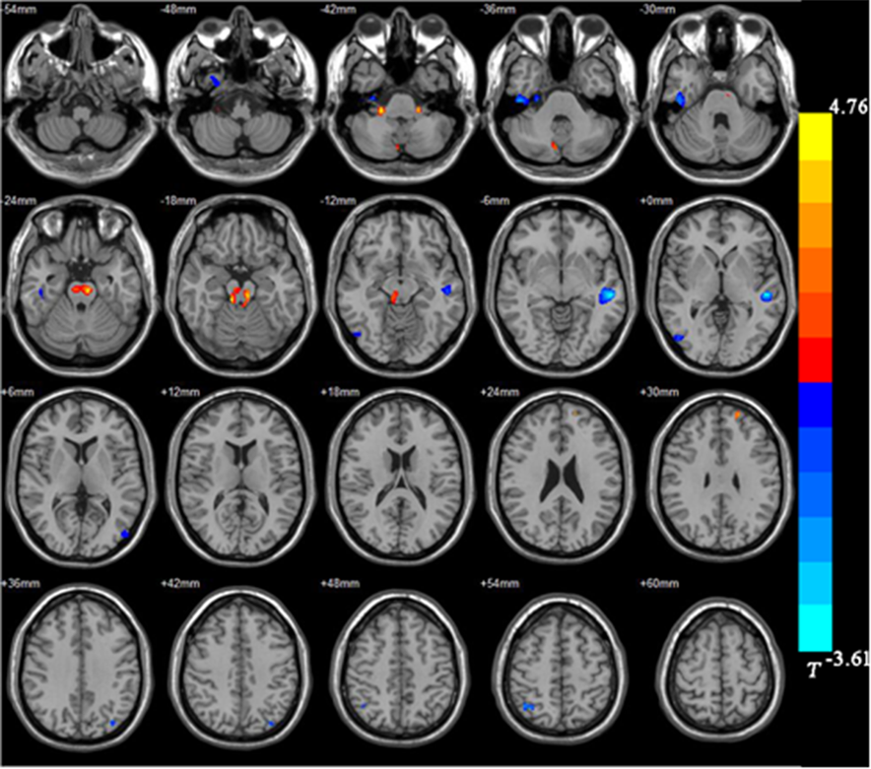
Figure 1 Distribution of brain regions with larger/smaller gray matter volume in the bipolar depression group compared with the control group. Red: Larger gray matter volume (GMV); Blue: Smaller GMV.
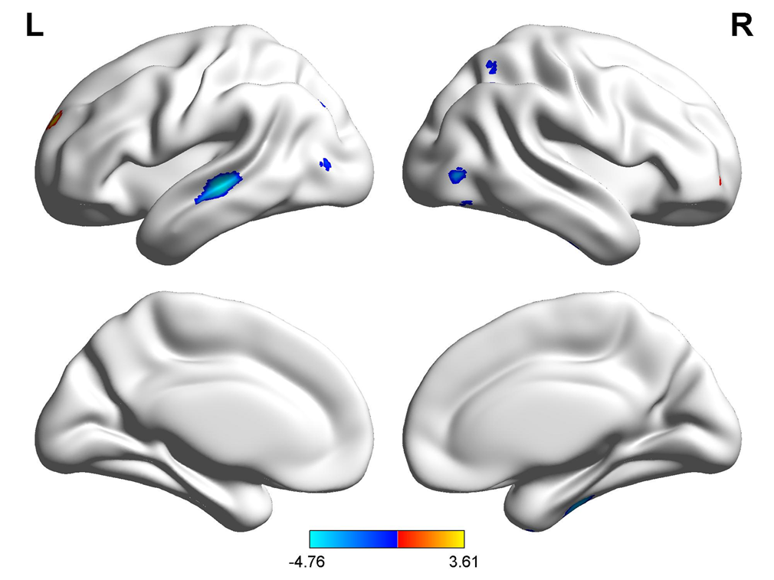
Figure 2 Comparison of voxel-based morphometry results between the bipolar depression group and the normal control group (Brainnet viewer). Red: Larger gray matter volume; Blue: Smaller gray matter volume.
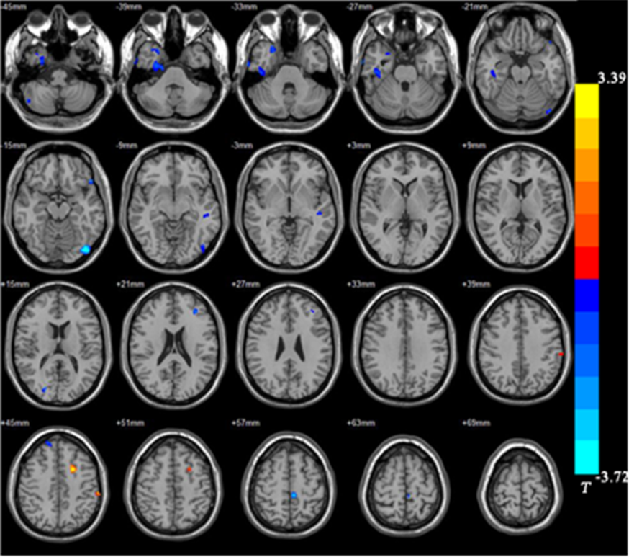
Figure 3 Distribution of brain regions with larger/smaller gray matter volume in the unipolar depression group compared with the control group. Red: Larger gray matter volume (GMV); Blue: Smaller GMV.
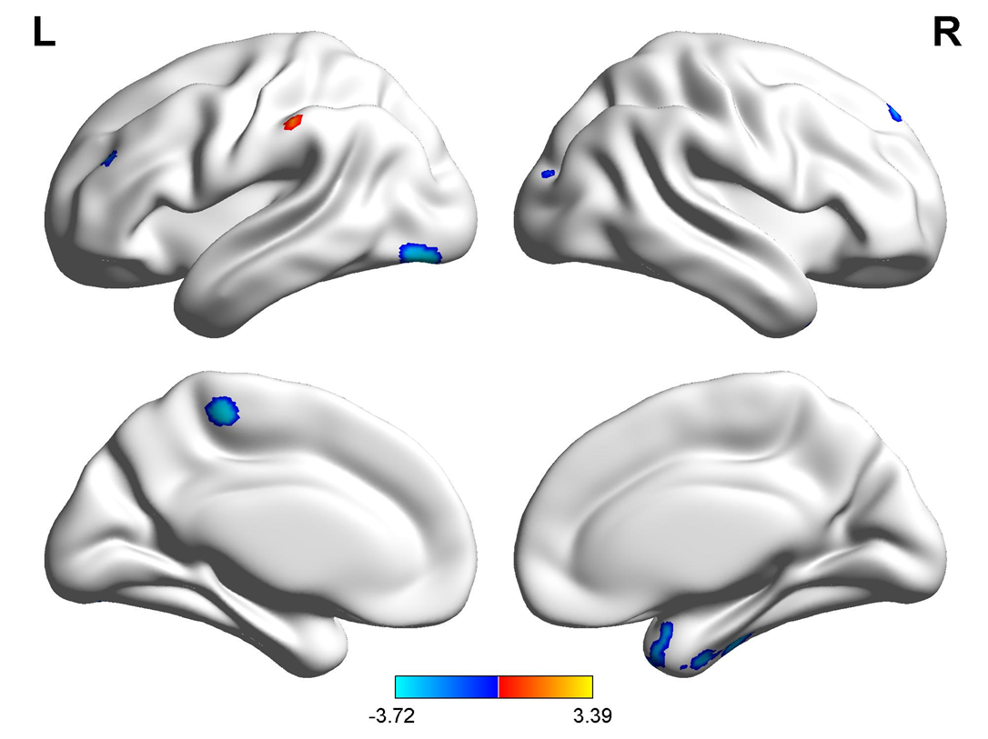
Figure 4 Comparison of voxel-based morphometry results between the unipolar depression group and the normal control group (Brainnet viewer). Red: Larger gray matter volume (GMV); Blue: Smaller GMV.
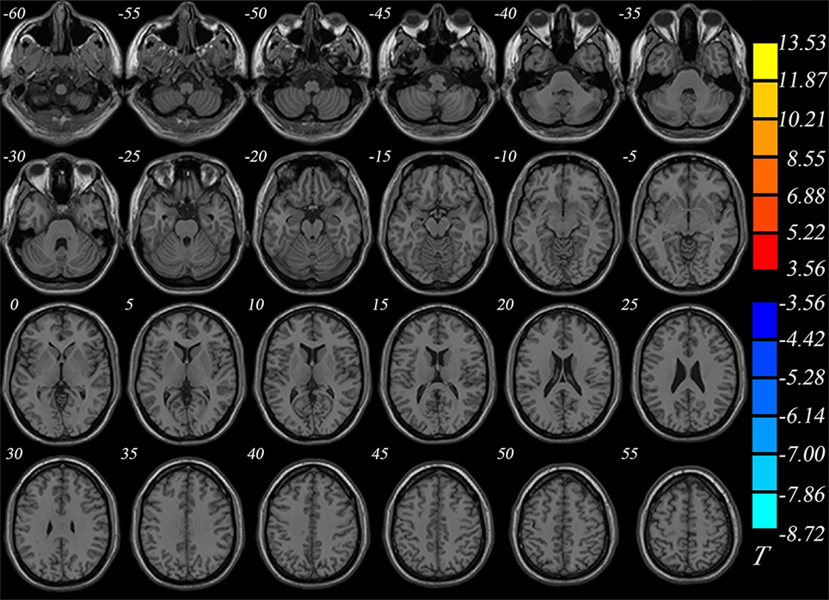
Figure 5 Comparison of gray matter volumes between the unipolar depression group and bipolar depression group (Brainnet viewer).
Table 1 Demographic and clinical data of the subjects
 | BD (n = 13) | UD (n = 20) | Controls (n = 20) | P value
Age (yr) | 31.0 ± 7.6 | 28.0 ± 9.1 | 31.7 ± 11.4 | 0.698
Gender (male/female) | 6/7 | 7/13 | 10/10 | 0.616
Education (yr) | 11.7 ± 4.0 | 10.6 ± 3.5 | 13.1 ± 3.9 | 0.083
First-episode age (yr) | 22.0 ± 8.0 | 23.3 ± 8.4 | -- | 0.442
Disease course (mo) | 108.0 ± 55.0 | 56.4 ± 29.4 | -- | 0.064
HDRS score | 24.8 ± 5.6 | 26.5 ± 7.1 | -- | 0.572
BD: Bipolar depression; UD: Unipolar depression; HDRS: Hamilton Depression scale.

Table 2 Distribution of brain regions with larger/smaller gray matter volume in the bipolar depression group in comparison with the control group
MNI coordinate
Brain region | Size | X | Y | Z | Tª
Right inferior temporal gyrus | 607 | 28.5 | -22.5 | -39 | -3.95
Right middle occipital gyrus | 110 | 51 | 70.5 | -13.5 | -2.94
Right superior parietal gyrus | 152 | 33 | -60 | 55.5 | -3.84
Left middle temporal gyrus | 795 | -49.5 | -24 | -1.5 | -4.76
Right cerebellum | 174 | 22.5 | -34.5 | -42 | 3.49
Left superior frontal gyrus | 101 | 33 | 49.5 | -3 | 2.99
Midbrain | 803 | -7.5 | -27 | -19.5 | 3.61
ªP < 0.05 and voxel threshold > 100 voxels after false discovery rate correction.
MNI: Montreal Neurological Institute.

Table 3 Distribution of brain regions with larger/smaller gray matter volume in the unipolar depression group in comparison with the control group
MNI coordinate
Brain region | Size | X | Y | Z | Tª
Right fusiform gyrus | 889 | 33 | 3 | -52.5 | -3.45
Right posterior cerebellar lobe | 138 | 49.5 | -66 | -46.5 | -2.87
Right inferior temporal gyrus | 449 | 45 | -21 | -30 | -2.74
Right superior temporal gyrus | 262 | 25.5 | 12 | -37.5 | -2.74
Left inferior occipital gyrus | 537 | -43.5 | -82.5 | -15 | -3.72
Left paracentral lobule | 126 | -6 | -31.5 | 58.5 | -3.45
Left medial frontal gyrus | 216 | -19.5 | 7.5 | 43.5 | 3.39
Left postcentral gyrus | 113 | -61.5 | -28.5 | 45 | 3.10
ªP < 0.05 after false discovery rate correction.
MNI: Montreal Neurological Institute.
Table 4 Gray matter volumes in brain regions of the unipolar depression group in comparison with the bipolar depression group
Brain region | UD (mm³) | BD (mm³) | P value
Superior frontal gyrus, orbital part | 963 8 | 958 8 | > 0.05
Middle frontal gyrus | 3294 8 | 3301 8 | > 0.05
Insula | 1770 8 | 1761 8 | > 0.05
Cuneus | 1488 8 | 1495 8 | > 0.05
Amygdala | 114 8 | 109 8 | > 0.05
Thalamus | 1667 8 | 1678 8 | > 0.05
Caudate | 994 8 | 989 8 | > 0.05
Supramarginal gyrus | 1973 8 | 1981 8 | > 0.05
BD: Bipolar depression; UD: Unipolar depression.

Published by Baishideng Publishing Group Inc
7041 Koll Center Parkway, Suite 160, Pleasanton, CA 94566, USA
Telephone: +1-925-3991568
E-mail: bpgoffice@wjgnet.com
Help Desk: https://www.f6publishing.com/helpdesk
https://www.wjgnet.com

© 2021 Baishideng Publishing Group Inc. All rights reserved.

