Name of Journal: World Journal of Gastrointestinal Endoscopy
Manuscript NO: 45360
Manuscript Type: CASE REPORT

Role of colonoscopy in diagnosis of capecitabine associated ileitis: Two case reports

Dao AE et al. Colonoscopy to diagnose capecitabine asociated ileitis

Alexander E Dao, Angela Hsu, Ahmad Nakshabandi, Rohan Mandaliya, Sandeep Nadella, Anita Sivaraman, Mark Mattar, Aline Charabaty

Alexander E Dao, Angela Hsu, Ahmad Nakshabandi, Rohan Mandaliya, Sandeep Nadella, Anita Sivaraman, Mark Mattar, Department of Gastroenterology, Medstar Georgetown University Hospital, Washington, DC 20007, United States

Aline Charabaty, Department of Gastroenterology, Johns Hopkins University at Sibley Memorial Hospital, Washington, DC 20016, United States

ORCID number: Alexander E Dao (0000-0002-7411-1841); Angela Hsu (0000-0002-9888-1429); Ahmad Nakshabandi (0000-0003-2207-9883); Rohan Mandaliya (0000-0002-0749-9022); Sandeep Nadella (0000-0002-3290-4018); Anita Sivaraman (0000-0002-0492-7896), Mark Mattar (0000-0002-9339-1607); Aline Charabaty (0000-0001-9810-3662).

Author contributions: Dao AE contributed to study design, data collection, manuscript writing and editing; Hsu A contributed to data collection, manuscript writing and editing; Nakshabandi A contributed to data collection and manuscript writing; Mandaliya R, Nadella S, Sivaraman A and Mattar M contributed to data collection and editing; Charabaty A contributed to study design, data collection and editing.

Informed consent statement: All procedures performed were in accordance with the ethical standards of the responsible committee on human experimentation (institutional and national) and the Helsinki Declaration of 1964 and later versions. Informed consent or a substitute of consent was obtained from all patients prior to inclusion in the study.

Conflict-of-interest statement: The authors have no conflicts of interest to declare.

CARE Checklist (2016) statement: The authors have read the CARE Checklist (2016), and the manuscript was prepared and revised according to the CARE Checklist (2016).

Open-Access: This article is an open-access article which was selected by an in-house editor and fully peer-reviewed by external reviewers. It is distributed in accordance with the Creative Commons Attribution Non Commercial (CC BY-NC 4.0) license, which permits others to distribute, remix, adapt, build upon this work non-commercially, and license their derivative works on different terms, provided the original work is properly cited and the use is non-commercial. See: http://creativecommons.org/licenses/by-nc/4.0/

Manuscript source: Unsolicited manuscript

Corresponding author: Aline Charabaty, MD, Attending Doctor, Department of Gastroenterology, Johns Hopkins University at Sibley Memorial Hospital, 5255 Loughboro Rd NW, Washington, DC 20016, United States. acharab1@jhmi.edu
Telephone: +1-202-6605555
Fax: +1-202-6606103

Received: January 29, 2019
Peer-review started: January 29, 2019
First decision: April 13, 2019
Revised: May 9, 2019
Accepted: May 13, 2019
Article in press:
Published online:

Abstract
BACKGROUND
Capecitabine is considered a first line agent in adjuvant therapy for breast and colorectal cancer. However, cases of severe diarrhea have been reported with increasing frequency in recent years. When diarrhea is severe and prolonged, capecitabine associated ileitis should be considered as a possible etiology.

CASE SUMMARY
Herein, we present two cases of capecitabine ileitis, specifically involving the terminal ileum and ascending colon. We will demonstrate the disease course and treatment modalities applied to alleviate this condition, as well as discuss the merits of using colonoscopy to aid in diagnosis.

CONCLUSION
Ultimately our cases demonstrate that symptomatic management with traditional anti-diarrheal medications is largely ineffective. Prompt recognition and discontinuation of capecitabine is an imperative step in proper management of this condition and colonoscopy with biopsy can be helpful when the diagnosis is unclear.

Key words: Capecitabine; Xeloda; 5-Fluorouracil; Ileitis; Ileocolitis; Colonoscopy; Case report

© The Author(s) 2019. Published by Baishideng Publishing Group Inc. All rights reserved.

Core tip: There have been nine published cases describing capecitabine associated ileitis, and only four of these cases document use of colonoscopy. We are presenting the fifth and sixth case reports of colonoscopy-assisted diagnosis of this condition. Combining analysis of these six colonoscopy reports, we determined patterns in the presentation of this condition. Given that the differential etiologies of diarrhea are so broad, we believe that our findings collectively can improve the diagnostic accuracy and optimize treatment. Additionally, we believe that colonoscopy with biopsy should be indicated as a standardized diagnostic measure in patients on capecitabine with refractory diarrhea.

Dao AE, Hsu A, Nakshabandi A, Mandaliya R, Nadella S, Sivaraman A, Mattar M, Charabaty A. Role of colonoscopy in diagnosis of capecitabine associated ileitis: Two case reports. World J Gastrointest Endosc 2019; In press

INTRODUCTION
Capecitabine (Xeloda) is an oral 5-fluorouracil (FU) prodrug used as adjuvant and/or palliative chemotherapy in the treatment of colorectal and breast cancer. According to monotherapy trials, up to 53% of patients develop diarrhea as an adverse effect. This diarrhea is usually self-limited, allowing patients to continue capecitabine with dose limitation^{[1]}; however, in rare cases capecitabine associated ileitis can occur, causing a severe persistent diarrhea characterized on endoscopy by mucosal inflammation in the ileum despite discontinuation of the drug. This complication has the potential to result in severe pain, electrolyte imbalances, nutritional deficiencies, and life-threatening hemodynamic instability. Our two cases characterize the disease course of capecitabine associated ileitis with a focus on imaging, colonoscopy findings, and treatment options for this uncommon condition.

CASE PRESENTATION
Chief complaints
(1) Case 1: A 72-year-old Caucasian female presented to the hospital with severe watery diarrhea; and (2) Case 2: A 42-year-old African American female presented to the hospital with severe voluminous bloody diarrhea.

History of present illness
(1) Case 1: She denied bloody stools, abdominal pain, fevers, or chills; and (2) Case 2: She was having six to ten bowel movements per day (some of which were bloody) with associated abdominal pain and fever.

History of past illness
(1) Case 1: The patient had a past medical history of with stage IIIC ascending colon adenocarcinoma and previously underwent laparoscopic right hemicolectomy and was started on adjuvant chemotherapy with capecitabine. She additionally had a history significant for diabetes, hypertension, ischemic cardiomyopathy with a biventricular pacemaker, as well as coronary artery disease status post stent placement; and (2) Case 2: The patient had a past medical history of stage IIIC recurrent right breast cancer as well as deep vein thrombosis with pulmonary embolus on lovenox.

Personal and family history
(1) Case 1: The patient was a nonsmoker and social drinker, with no relevant family history; and (2) Case 2: The patient was a nonsmoker and denied alcohol use. Family history was negative for cancer and otherwise noncontributory.

Physical examination
(1) Case 1: On admission, physical examination was notable for multiple oral ulcers, however she had a nontender abdominal exam and was otherwise unremarkable; and (2) Case 2: Physical exam was notable for mild tenderness to palpation of the epigastrium and right lower quadrant of the abdomen. Initial labs were notable for hypokalemia (K 2.9) and mild anemia (Hb 10.2), however there was no leukocytosis (WBC 4.4) or kidney injury (Cr 0.8).

Laboratory examination
(1) Case 1: Initial labs were concerning for severe malnutrition (albumin 1.7), leukopenia (WBC 1.5 K/mm³ with ANC 900) and acute kidney injury (Cr 1.32, baseline 1). Laboratory examination also included infectious workup with Clostridium difficile, stool cultures, ova and parasites, and rotavirus, all of which resulted as negative. Given her cardiac risk factors, there was concern for ischemic colitis, however lactate was normal and she denied any history of abdominal pain, melena, or hematochezia; and (2) Case 2: Laboratory examination included negative infectious workup with Clostridium difficile, Giardia, Ova and Parasites, stool culture, and rotavirus all resulting as negative.

Imaging examination
(1) Case 1: Initial computed tomography (CT) abdomen and pelvis showed mildly dilated fluid-filled loops of small bowel with adjacent engorgement of vasa recta and mesenteric edema consistent with enteritis (Figure 1); and (2) Case 2: Initial CT Abdomen and Pelvis with contrast revealed marked thickening of the small bowel with fluid filled bowel loops.

Colonoscopy and histology
(1) Case 1: This prompted subsequent colonoscopy and ileoscopy, which demonstrated granular erythematous mucosa with ulceration both above and below the ileocolonic anastomosis (Figure 2). Ileal biopsy showed mucosal erosion with acute inflammation and occasional atypical glands most likely representing reactive changes without evidence of Cytomegalovirus or herpes simplex viruses on immunohistochemical stains; and (2) Case 2: On colonoscopy, the terminal ileum was found to have diffuse pseudomembranes with severe inflammatory exudates and spontaneous bleeding (Figure 3). The right colon demonstrated erythema and mucosal thickening suggestive of mild colitis. Biopsy from the ileum and colon showed necrotic and inflammatory debris, but was negative for granulomas or viral inclusions.

FINAL DIAGNOSIS
(1) Case 1: The final diagnosis was refractory diarrhea due to capecitabine associated ileitis; and (2) Case 2: The final diagnosis was bloody diarrhea due to capecitabine associated ileitis.

TREATMENT
Case 1
On admission, the patient’s capecitabine was held. In addition to fluid and electrolyte resuscitation, diarrhea was addressed with loperamide, lomotil, and octreotide - however symptoms did not improve. Cholestyramine (4 mg daily) was trialed to counter any biliary diarrhea that may have contributed due to her prior right hemicolectomy. Additionally oral budesonide was trialed for three days in case of chemotherapy induced mucositis given the development of oral sores. She eventually required a three week course of total parenteral nutrition to address her severe protein deficiency.

Case 2
Capecitabine was held on admission due to concern that this was a potential etiology of the diarrhea. She underwent a short course of antibiotics that was then discontinued when infectious etiology was adequately ruled out. Despite stopping chemotherapy, diarrhea persisted and workup with a colonoscopy including ileoscopy was performed. As in the case above, the patient was initially fluid and electrolyte resuscitated and once infection was no longer a concern she was trialed on various anti-diarrheal medications that were ultimately unsuccessful including lomotil, loperamide, cholestyramine, and octreotide. Additionally, she was trialed on oral budesonide which improved abdominal pain however did not resolve the diarrhea. There was a discussion regarding initiation of parenteral nutrition however it was ultimately decided against as symptoms appeared to be improving by this time. Instead, she was trialed on a low lactose, low fat, high protein diet which seemed to contribute to the improvement of diarrheal symptoms by the end of her course.

OUTCOME AND FOLLOW-UP
(1) Case 1: Despite these interventions, the patient still had voluminous diarrhea for a total of four weeks after cessation of capecitabine. To date, she has not been restarted on capecitabine at any dose given the severity of her symptoms; and (2) Case 2: By four weeks after discontinuation of capecitabine, diarrhea had resolved and stools were improving in frequency and consistency. As in case 1, this patient was never restarted on capecitabine due to the severity of her diarrhea.

DISCUSSION
Capecitabine is an oral precursor of the antineoplastic agent FU. FU is a pyrimidine analog that inhibits the synthesis of the nucleoside thymidine, therefore interfering with normal DNA replication. Administration of FU is intravenous and nonspecific, resulting in harsh widespread toxicities including neutropenia, stomatitis, and diarrhea^{[2]}. Capecitabine was developed as a preferred agent to FU due to its oral route of administration and its multi-step metabolism conferring a more targeted distribution of active metabolite. It is considered a first line therapy for metastatic colorectal cancer when single agent fluoropyrimidines are indicated. The most clinically significant adverse effects of capecitabine include hand-foot syndrome and diarrhea, both of which can be so severe that treatment must be redirected.
Capecitabine induced ileitis is a rare yet severe adverse effect that has only been documented in few cases in the recent past. Roche Drug Safety identifies the incidence of suspected ileitis to be less than 0.01% of their patient population^{[3]}. It was first recognized as a complication of capecitabine in 2012 by Radwan et al^{[3]}, however its exact pathophysiology is still unknown. It has been proposed that decreased blood flow to intestinal mucosa and pro-inflammatory cytokines may contribute to mucosal injury^{[4]}. In a report by Lee et al^{[5]}, the authors describe two cases of capecitabine induced ileitis based on radiological evidence. Key management principles include early recognition of the adverse reaction, immediate cessation of capecitabine, and supportive therapy with total parenteral nutrition. In one of these cases, the diarrhea subsided 29 d post cessation of capecitabine^{[5]}. This was the same amount of time required to resolve the diarrhea after stopping the chemotherapy as reported in our two cases. These findings suggest that capecitabine induced ileitis can last multiple weeks and is not likely to respond to more conservative methods such as antimotility agents (i.e., lomotil, loperamide) or antisecretory agents (i.e., octreotide).
To date, there have been only nine published cases describing capecitabine associated ileitis, and only four of these cases document use of colonoscopy in diagnosis^{[6-9]}. We are presenting the fifth and sixth case reports of colonoscopy-assisted diagnosis of this condition. Combining our analysis of these six colonoscopy reports (Table 1), we have determined some patterns in the presentation of this condition. Firstly, capecitabine associated ileitis tends to localize in the terminal ileum. Secondly, a granular erythematous appearance of mucosa with ulcerations is commonly seen. Two of the six reports disclose a biopsy that is positive for eosinophilic infiltrates, and one report from our institution describes a pseudomembrane with inflammatory exudates. Given that the differential etiologies of diarrhea in a hospitalized patient is so broad (colitis, bacterial vs viral infection, inflammation, medication-induced) we believe that these findings collectively can improve the diagnostic accuracy of this condition and optimize treatment options. Additionally, we believe that colonoscopy with biopsy should be indicated as a standardized diagnostic measure in patients on capecitabine with diarrhea refractory to conservative methods.
In all published cases, approach to management posed a significant challenge. It appears that a combination or trial of cessation of capecitabine, fluid and nutritional resuscitation with TPN, and administration of steroids have shown some benefit^{[6,7,10]}.

CONCLUSION
Ultimately our cases demonstrate that symptomatic management with traditional anti-diarrheal medications is largely ineffective. There may be some role in symptomatic management of abdominal pain with the use of oral steroids, however this prospect requires further study. Overall, capecitabine induced ileitis is a serious adverse effect that is being recognized with increasing frequency in recent years. Supportive management with parenteral nutrition, hydration, and pain management are the cornerstone of treatment while inflamed intestinal mucosa heals. Prompt recognition and discontinuation of capecitabine is an imperative step in proper management of this condition and colonoscopy with biopsy can be helpful when the diagnosis is unclear.

REFERENCES
1 Saif MW, Katirtzoglou NA, Syrigos KN. Capecitabine: an overview of the side effects and their management. Anticancer Drugs 2008; 19: 447-464 [PMID: 18418212 DOI: 10.1097/CAD.0b013e3282f945aa]
2 Walko CM, Lindley C. Capecitabine: a review. Clin Ther 2005; 27: 23-44 [PMID: 15763604 DOI: 10.1016/j.clinthera.2005.01.005]
3 Radwan R, Namelo WC, Robinson M, Brewster AE, Williams GL. Ileitis secondary to oral capecitabine treatment? Case Rep Med 2012; 2012: 154981 [PMID: 23251164 DOI: 10.1155/2012/154981]
4 Soares PM, Mota JM, Souza EP, Justino PF, Franco AX, Cunha FQ, Ribeiro RA, Souza MH. Inflammatory intestinal damage induced by 5-fluorouracil requires IL-4. Cytokine 2013; 61: 46-49 [PMID: 23107827 DOI: 10.1016/j.cyto.2012.10.003]
5 Lee SF, Chiang CL, Lee AS, Wong FC, Tung SY. Severe ileitis associated with capecitabine: Two case reports and review of the literature. Mol Clin Oncol 2015; 3: 1398-1400 [PMID: 26807255 DOI: 10.3892/mco.2015.635]
6 Barton D. Ulcerative ileitis secondary to adjuvant capecitabine for colon cancer: a case report. UICC World Cancer Congress, Washington, DC, July 2006, 84-41
7 Al-Gahmi AM, Kerr IG, Zekri JM, Zagnoon AA. Capecitabine-induced terminal ileitis. Ann Saudi Med 2012; 32: 661-662 [PMID: 23396034 DOI: 10.5144/0256-4947.2012.661]
8 Mokrim M, Aftimos PG, Errihani H, Piccart-Gebhart M. Breast cancer, DPYD mutations and capecitabine-related ileitis: description of two cases and a review of the literature. BMJ Case Rep 2014; 2014: pii: bcr2014203647 [PMID: 24748142 DOI: 10.1136/bcr-2014-203647]
9 van Hellemond IEG, Thijs AM, Creemers GJ. Capecitabine-Associated Terminal Ileitis. Case Rep Oncol 2018; 11: 654-659 [PMID: 30483093 DOI: 10.1159/000492781]
10 Bouma G, Imholz AL. [Ileitis following capecitabine use]. Ned Tijdschr Geneeskd 2011; 155: A3064 [PMID: 21486509]

P-Reviewer: Guo JT, Lee CL, Smith RC, Wan QQ S-Editor: Ji FF L-Editor: E-Editor:

Specialty type: Gastroenterology and hepatology
Country of origin: United States
Peer-review report classification
Grade A (Excellent): A
Grade B (Very good): B, B
Grade C (Good): C
Grade D (Fair): 0
Grade E (Poor): 0

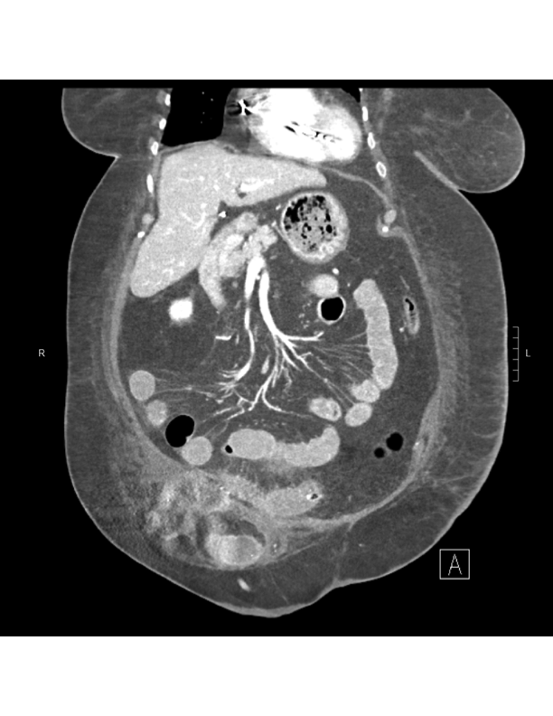

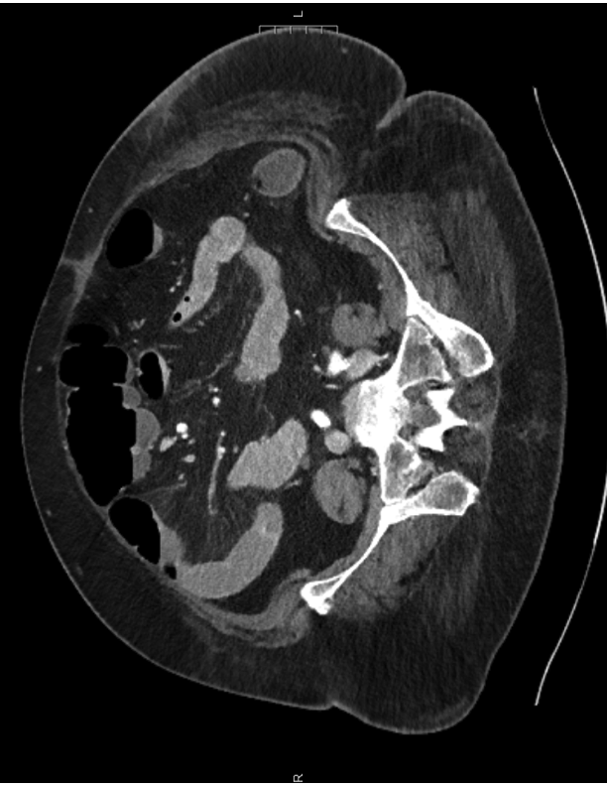
1A
1B

2A
2A

Figure 1 Abdominal computed tomography findings of enteritis. A: Axial computed tomography (CT) of the abdomen demonstration vasa recta engorgement and mesenteric edema (arrows); B: Coronal CT of the abdomen with “comb sign” demonstrating vasa recta engorgement and mesenteric edema (arrows).

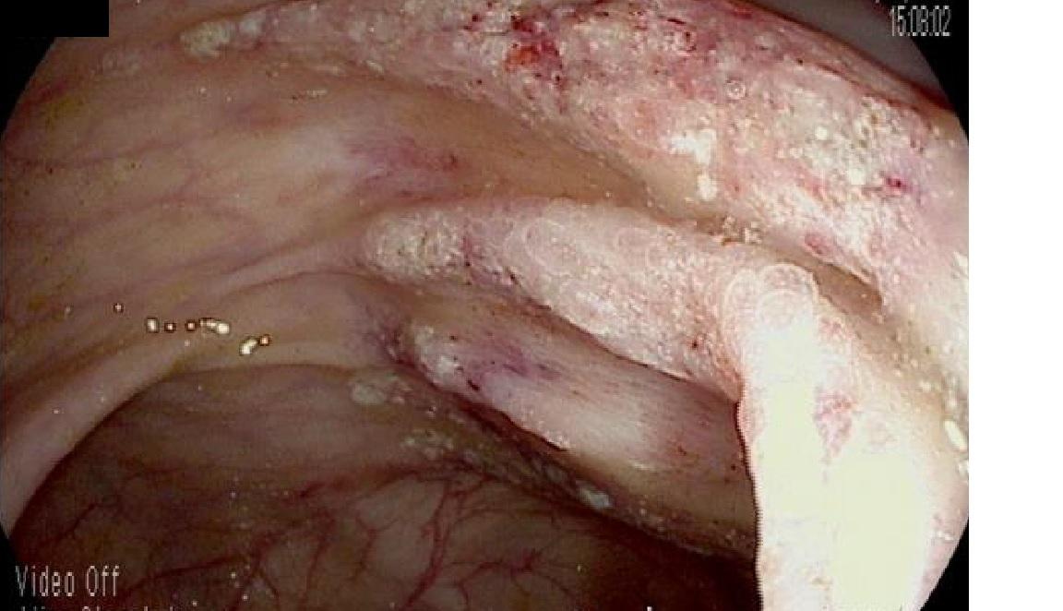
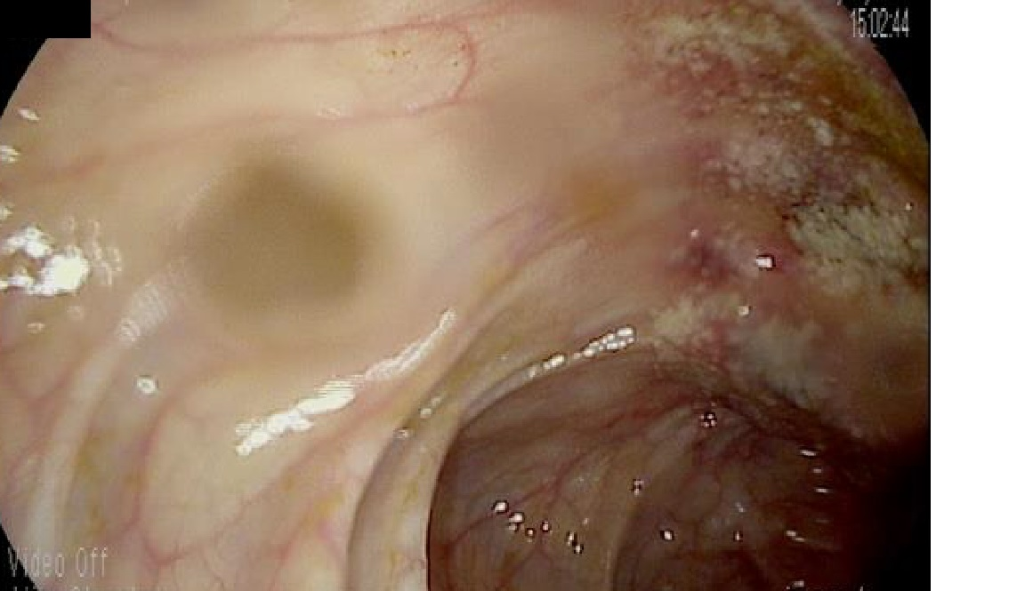
2B
2A
2B
2C
2D
2A

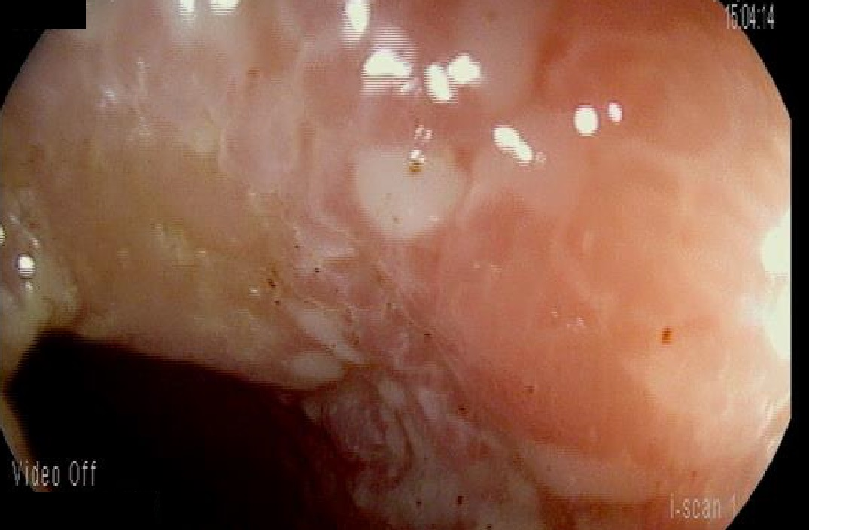
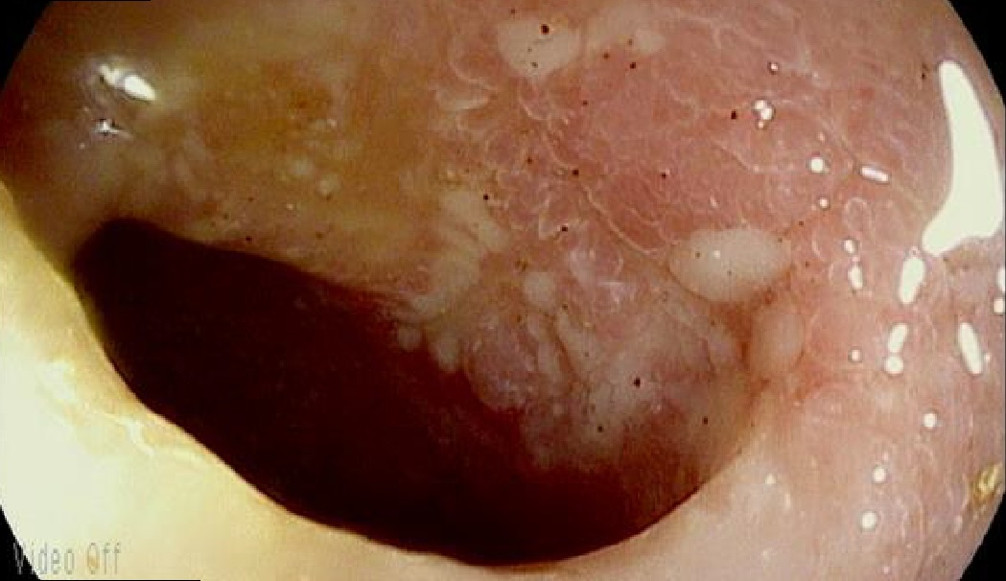
2D
2C

Figure 2 Colonoscopy and ileoscopy findings for case 1. A, B: For our first case, colonoscopy shows granular erythematous mucosa of the ascending colon (A and B) distal to the ileocolonic anastomosis; C, D: On ileoscopy, evidence of ulceration can be seen in the distal ileum (C and D)

Figure 3 Colonoscopy and ileoscopy findings case 2. For our second case, the ileum was noted to be severely granular and friable, with ulceration seen throughout

Table 1 Colonoscopy and histology reports from previous case reports of capecitabine associated ileitis

Case report | Findings seen on (1) colonoscopy and (2) histology
Barton^{[6]}, 2006 | (1) Ulcerative ileitis  (2) Eosinophilic infiltrates
Al-Gahmi et al^{[7]}, 2012 | (1) Isolated ulceration in the terminal ileum  (2) Inflammatory changes and eosinophilic infiltrate but no evidence of malignancy or granulomas
Mokrim et al^{[8]}, 2014 | (1) Inflammatory changes in the ileal mucosa  (2) Absence of intraepithelial lymphocytic infiltrates in favour of a non-atrophic ileitis
Van Hellemond et al^{[9]}, 2018 | - Terminal ileitis  - Extensive inflammation of the small intestine
Case 1 | (1) Evidence of granular erythematous mucosa with ulceration both above and below the ileocolonic anastomosis in the terminal ileum and ascending colon  (2) Mucosal erosion with acute and chronic inflammation and occasional atypical glands most likely representing reactive changes without evidence of Cytomegalovirus or herpes simplex viruses on immunohistochemical stains
Case 2 | (1) On colonoscopy, the terminal ileum was found to have diffuse pseudomembranes with severe inflammatory exudates and spontaneous bleeding.  (2) Necrotic and inflammatory debris, but was negative for granulomas or viral inclusions.

