Name of journal: World Journal of Gastroenterology
ESPS Manuscript NO: 17556
Manuscript Type: ORIGINAL ARTICLE

Basic Study

retinoic acid receptor α promotes autophagy to alleviate liver ischemia and reperfusion injury

Zhong C et al. RARα enhances autophagy by Foxo3/p-Akt/Foxo1 pathway

Chen Zhong, Li-Yong Pu, Ming-Ming Fang, Zhen Gu, Jian-Hua Rao, Xue-Hao Wang

Chen Zhong, Li-Yong Pu, Jian-Hua Rao, Xue-Hao Wang, Key Laboratory of Living Donor Liver Transplantation of Chinese Ministry of Health, Liver Transplantation Center, First Affiliated Hospital of Nanjing Medical University, Nanjing 210029, Jiangsu Province, China

Ming-Ming Fang, Department of Neurology, Jiangsu Province Hospital on Integration of Chinese and Western Medicine, Nanjing University of Chinese Medicine, Nanjing 210028, Jiangsu Province, China

Zhen Gu, State Key Laboratory of Reproductive Medicine, Research Center for Bone and Stem Cells, Department of Human Anatomy, Nanjing Medical University, Nanjing 210029, Jiangsu Province, China

Author contributions: Zhong C and Pu LY contributed equally to this study; Zhong C, Pu LY, Gu Z, Rao JH and Wang XH were responsible for the study’s design and conception; Zhong C and Fang MM participated in data analysis and collection and manuscript preparation; Zhong C, Pu LY, Gu Z, Rao JH and Wang XH took part in the revision of this article.

Supported by National Natural Science Foundation of China, No. 81273261.

Institutional review board statement: The study was reviewed and approved by the Institutional Review Board of Nanjing Medical University.

Institutional animal care and use committee statement: All procedures involving animals were reviewed and approved by the Institutional Animal Care and use Committee of Nanjing Medical University (NJMU, Protocol Number NJMU08-092).

Conflict-of-interest statement: All the authors indicated no potential conflicts of interest of this manuscript.

Data sharing statement: Technical appendix, statistical code, and dataset available from the corresponding author at wangxh@njmu.edu.cn.

Open-Access: This article is an open-access article which was selected by an in-house editor and fully peer-reviewed by external reviewers. It is distributed in accordance with the Creative Commons Attribution Non Commercial (CC BY-NC 4.0) license, which permits others to distribute, remix, adapt, build upon this work non-commercially, and license their derivative works on different terms, provided the original work is properly cited and the use is non-commercial. See: http://creativecommons.org/licenses/by-nc/4.0/

Correspondence to: Xue-Hao Wang, MD, PhD, Key Laboratory of Living Donor Liver Transplantation of Chinese Ministry of Health, Liver Transplantation of Chinese Ministry of Health, Liver Transplantation Center, First Affiliated Hospital of Nanjing Medical University, No. 300 Guangzhou Road, Nanjing 210029, Jiangsu Province, China. wangxh@njmu.edu.cn
Telephone: +86-25-83718836
Fax: +86-25-83672106

Received: March 12, 2015
Peer-review started: March 13, 2015
First decision: June 2, 2015
Revised: June 19, 2015
Accepted: August 25, 2015
Article in press:
Published online:

Abstract

AIM: To study the mechanism of retinoic acid receptor α (RARα) and autophagy in liver ischemia and reperfusion (IR) injury.

METHODS: All-trans retinoic acid (ATRA) was administered to mice for two weeks before operation. Reverse-transcriptase polymerase chain reaction and western blotting were used to detect the expression levels of related factors. To demonstrate the role of RARα, LE540, a RARα inhibitor, was used to treat hepatocytes injured by H₂O₂ in vitro.

RESULTS: ATRA pretreatment noticeably diminished levels of serum alanine aminotransferase and serum aspartate aminotransferase as well as the degree of histopathology. Apoptosis was also inhibited, whereas autophagy was promoted. In vitro, RARα was inhibited by LE540, resulting in decreased autophagy and increased apoptosis. Similarly, the expression of Foxo3a and p-Akt was downregulated, but Foxo1 expression was upregulated.

CONCLUSION: This research provides evidence that ATRA can protect liver from IR injury by promoting autophagy, which is dependent on Foxo3/p-Akt/Foxo1 signaling.

Key words: Ischemia/reperfusion; Retinoic acid receptor α; Foxo3a; Foxo1; Autophagy

© The Author(s) 2015. Published by Baishideng Publishing Group Inc. All rights reserved.

Core tip: To investigate the role of autophagy and the relationship between all-trans retinoic acid (ATRA) and autophagy in liver ischemia and reperfusion (IR) injury. We found that ATRA pretreatment alleviated liver IR injury by inducing autophagy and it may involves retinoic acid receptor α (RARα) activity. To clarify the mechanism of RARα, we used LE540 to inhibit RARα during reactive oxygen species-inducing cell damage in vitro. Our data showed that RARα activation enhanced Foxo3a and p-Akt expression except Foxo1. The Foxo3a/p-Akt/Foxo1 pathway has previously been proven to promote autophagy. Hence, we conclude that ATRA activates RARα to reduce liver IR injury by regulating the Foxo3a/p-Akt/Foxo1 pathway to promote autophagy.

Zhong C, Pu LY, Fang MM, Gu Z, Rao JH, Wang XH. retinoic acid receptor α promotes autophagy to alleviate liver ischemia and reperfusion injury. World J Gastroenterol 2015; In press

INTRODUCTION
Ischemia and reperfusion (IR) lead to damage in aerobically metabolizing tissues or organs^{[1]}. It is an important injury mechanism in many clinical settings, e.g., liver surgical resection and liver transplantation^{[2,3]}. Hepatocyte death due to IR insults releases reactive oxygen species (ROS) that initiate a sterile immune response. This activates Kupffer cells first and then recruits neutrophils to infiltrate^{[4]}; hence, liver IR injury has a biphasic pattern: the acute phase, which involves activation of Kupffer cells after 4-6 h of reperfusion, and the subacute phase, which results from neutrophil infiltration at 18-24 h^{[5-7]}.
Autophagy, including macroautophagy, microautophagy and chaperone-mediated autophagy, is a process that degrades macromolecules and organelles via lysosomes^{[8]}. It is very important for cell differentiation, survival during nutrient depletion and maintenance of homeostasis^{[9]}. When hepatocytes suffer from nutrient starvation and anoxia during IR insult, autophagy can ameliorate liver damage^{[8,10]}.
All-trans retinoic acid (ATRA) has been shown to protect liver from IR injury. The protective mechanism of ATRA is relied on inhibiting ROS generation and the nuclear factor-kappa B (NF-κB) pathway^{[11,12]}. In addition, ATRA has been shown to mediate autophagy in acute promyelocytic leukemia cells^{[13]}. Similarly, ATRA promotes autophagy by redistributing the cation-independent mannose-6-phosphate/IGFII receptor^{[14]}. ATRA increases the transcription of Forkhead box O (Foxo) 3a, which is a strong inducer of Foxo1^{[15,16]}. The Foxo3a/p-Akt/Foxo1 signaling pathway also augments autophagy^{[17]}. To date, there has been little research into how ATRA alleviates liver IR injury through autophagy. This report is the first to demonstrate the effects of the retinoic acid receptor α (RARα)/Foxo3a/p-Akt/Foxo1 pathway on liver IR injury.

MATERIALS AND METHODS
Animals
Male wild-type C57BL/6 mice (8-12-wk-old) were obtained from Vital River Experimental Animal Co., P.R. China. Mice were housed in special pathogen-free conditions with a 12-h light-dark cycle and free access to standard laboratory diet and water, and they received humane care in accordance with the guidelines of the Chinese Association of Laboratory Animal Care. The standards for animal use and care were approved by the Institutional Animal Care Committee of Nanjing Medical University (NJMU, Protocol Number NJMU08-092).

Operative procedure
Before the experiment, the mice received ATRA (Sigma-Aldrich, Shanghai, China) by gavageat 15 mg/kg per day for two weeks. We induced 70% hepatic ischemia by occluding the hepatic artery, portal vein and bile duct to the cephalad hepatic lobes for 90 min. During the ischemic process, mice were anesthetized using isoflurane, and the environmental temperature was maintained at 25 °C. After liver reperfusion for 6 h or 20 h, the mice were sacrificed, and then blood and liver tissue samples were harvested for analysis.

Hepatocellular function assay
Serum alanine aminotransferase (sALT) and serum aspartate aminotransferase (sAST) levels were measured to assess hepatocyte injury using an automated chemical analyzer (Olympus Automated Chemistry Analyzer AU5400, Tokyo, Japan).

Histopathological study
Liver samples were fixed with 10% neutral formaldehyde and embedded in paraffin. Paraffin sections at 5 μm were stained with hematoxylin and eosin and then blindly analyzed and scored from 0 to 4, as described by Suzuki et al^{[18]}.

Western blot analysis
Proteins were extracted from liver samples and cell lysates, and the concentration was detected using a BCA Protein Assay Kit (Thermo Fisher Scientific, Shanghai, China). The nuclei proteins were extracted to detect the level of Foxo1. The proteins were resolved by sodium dodecyl sulfate-polyacrylamide gel electrophoresis (SDS-PAGE) and transblotted onto polyvindylidene fluoride (PVDF) membranes (Millipore, United States). These membranes were blocked in non-fat dry milk (5% wt/vol) with Tris-buffered saline containing 0.1% Tween 20 (TBS-T) at 4 °C overnight and then incubated with primary antibodies against RARα (Santa Cruz Biotechnology, Santa Cruz, CA, United States), Bcl-2, Beclin-1, LC3B, β-actin (Cell Signaling Technology, Danvers, MA, United States), cleaved caspase3, p-Akt, Foxo1, Foxo3a, and p62 (Abcam, Shanghai, China). Following three washes with TBS-T, the membranes were incubated with peroxidase-conjugated secondary antibody (Cell Signaling Technology, Danvers, MA, United States) for 1 h at room temperature. Bands were quantified by densitometry using the Quantity One software for image analysis.

Quantitative real-time reverse transcriptase polymerase chain reaction
RNA was isolated using TRIzol reagent (Invitrogen, Shanghai, China). cDNA was synthesized according to the manufacturer’s instructions using the PrimeScriptTM RT Reagent Kit with gDNA Eraser (Takara, Japan). PCR was performed using SYBR Premix Ex TaqTM (Takara, Japan). The primer sets were as follows: β-actin, forward,
5’-CTACAATGAGCTGCG TGTGG-3’, reverse,5’-AAGGAAGGCTGGAAG AGTGC-3’; IL-6, forward, 5’-GACTTCCATCCAGTTGCCTTCT-3’, reverse, 5’-TTTCTCATTTCCACGATTTCCCA-3’; IL-1β, forward, 5’-GTGTTTTCCTCCTTGCCTCTGAT-3’, reverse, 5’-GCTGCCTAATGTCCCCTTGAAT-3’;and TNF-α, forward, 5’-CTCTGTGAAGGGAATGGGTGT-3’, reverse, 5’-TCTTGTGTTTCTGAGTAGTTGTTGA-3’.
Cell culture and treatment
FL83B was cultured in Ham’s F-12K medium containing 10% fetal bovine serum, 100 U/ml penicillin, and 100 μg/ml streptomycin. Before being co-cultured with 200 μmol/l H₂O₂ for 6h, cells were preincubated with ATRA(10 μmol/l) or LE540 (10 μmol/l, Wako Pure Chemical Industries Ltd., Osaka, Japan) for 24 h.

Annexin V and propidium iodide labeling
The cell samples were stained using an Annexin V (AV)-fluorescein isothiocyanate (FITC) Apoptosis Detection Kit (Sigma-Aldrich, St Louis, United States) following the manufacturer's instructions. For confocal microscopy, both probes were activated by a 488 nm diode laser, and the fluorescence emission was detected at 510 and 560 nm for AV and propidium iodide (PI), respectively. The fluorescence intensity was obtained for 20000 events, and the data were analyzedusing Cell-Quest™ (Becton–Dickinson, San Jose).The data are presented as the percentage of cells in four different population phenotypes—unstained, stained only with AV, stained only with PIor stained with both markers—relative to the total number of cells analyzed.

Statistical analysis
Data are presented as mean ± SD from at least three independent experiments. SPSS (Chicago, IL, United States) was used to calculate the statistical significance by performing one-way analysis of variance (ANOVA). All the P values were two-sided, and P < 0.05 was considered statistically significant.

RESULTS
ATRA pretreatment ameliorates liver injury after IR
We used an established model of hepatic damage in mice, inducing 90 min of ischemia and then sacrificing the mice at 6 h or 20 h after reperfusion. Before the operation, ATRA was administered by gavage once a day for two weeks. The levels of sALT and sAST, the area of necrosis on liver histopathology and the samples’ Suzuki scores were obviously decreased in the ATRA group compared with the IR control group (Figure 1).

ATRA pretreatment reduces apoptosis and inflammation in liver IR injury
When IR injury occurs, hepatocellular apoptosis is induced, and this condition results in liver injury^{[19]}. According to liver function and histological score, liver damage was more serious at reperfusion 6 h. So, we just chose the liver samples at reperfusion 6h to analyse by western blot. ATRA enhanced the expression of the anti-apoptotic protein Bcl-2 while inhibited the expression of the pro-apoptotic protein cleavedcaspase3 in liver IR injury (Figure 2A). This mechanism explains the downregulation of hepatocellular apoptosis. Besides, the role of IR injury on inflammation was weakened. Because the mRNA levels of tumor necrosis factor (TNF) α, interleukin (IL)-1β and IL-6 in the ATRA group were less than in the IR group (Figure 2B).

Autophagy is promoted by ATRA
RARα was activated by ATRA. Similarly, the Foxo3a/p-Akt/Foxo1 pathway was induced by RARα activation (Figure 3A). Foxo3a/p-Akt/Foxo1 has been shown to promote autophagy^{[17]}. The proteins Beclin1, LC3 II and p62 are involved in the process of autophagy. As a substrate, p62 is degraded by autolysosome and inversely with the autophagic activity^{[20-22]}. ATRA pretreatment enhanced the levels of Beclin1 and LC3 II but decreased the level of p62 (Figure 3B). These results suggest that ATRA promotes autophagy in liver IR injury.

RARα inhibits ROS-induced apoptosis in vitro
To further analyze the effect of RARα, LE540 was used to inhibit RARα activity. Following H₂O₂ stimulation, ATRA, the RARα agonist, upregulated the expression of Bcl-2, downregulated cleavedcaspase3 expression and ultimately decreased the number of apoptotic cells detected on Annexin V staining (Figure 4). However, LE540, an antagonist of RARα, aggravated the hepatocytes damage in comparison with the H₂O₂ group.

RARα mediates autophagy through the Foxo3a/p-Akt/Foxo1 pathway
As mentioned above, RARα activates the Foxo3a/p-Akt/Foxo1 pathway to mediate autophagy. Although Foxo3a and Foxo1 are both members of the Foxo family, they have opposing roles in autophagy. To enhance the level of autophagy, Foxo3a needs phosphorylated Akt to decrease Foxo1 accumulation in the nucleus^{[17]}. In our H₂O₂-induced damage model, RARα promoted the transcription of Foxo3a, which resulted in an autophagy-related chain reaction that including increased Beclin1 and LC3 II levels and decreased p62 levels (Figure 5B). This finding was confirmed in another manner by LE540. Because the level of Foxo3a expression was consistent with RARα activation, the levels of RARα, Foxo3a, p-Akt and Foxo1 were reversed in the LE540 group (Figure 5A). Ultimately, the degree of ROS-induced cell damage was strengthened by LE540’s inhibition of autophagy.

DISCUSSION
ATRA is the activated form of vitamin A, and its biosynthesis process is controlled by cytosolic alcohol dehydrogenases, retinol dehydrogenases and retinaldehydedehydrogenases^{[23-25]}. ATRA can also attenuate liver IR injury through suppressing NF-κBp65 expression, phosphorylating p38 mitogen-activated protein kinase and Akt to increase the expression of manganese superoxide dismutase(MnSOD)^{[11,12]}. Moreover, it can regulate the expression of many genes to mediate its biological effects by binding with RAR^{[26-28]}. In this study, ATRA increased the transcription of Foxo3a, which had a protective role in hepatic tissue after IR injury; in turn, this effect could be blocked by the RARα inhibitor LE540 in vivo.
Autophagy, which has an important role in cellular development, differentiation and survival, is necessary to maintain homeostasis and provide energy by degrading cytosolic components in vivo^{[8,29]}. During IR insults, autophagy can degrade abnormal or dysfunctional mitochondria to decrease ROS generation. In addition, the formation of autophagic vesicles and autophagic flux is decreased in IR injury^{[29]}. The process of autophagy is divided into three sections that the formation of autophagosome and autolysosome, and degration^{[30-32]}. Beclin1 and LC3II are involved with the initiation of autophagosome^{[33-35]}, but they cannot absolutely reflect the function of autophagy. Because autophagy is a degration system. Although the enhancement of Beclin1 and LC3II in the IR group, it did not mean that autophagy was increasing. In addition, p62, which is the substrate of autophagy and used to evaluate the degree of autophagy^{[36-38]}, was increasing in the IR group. Hence, the autophagy was inhibited and this was associated with the exacerbation of apoptotic cells and inflammation response in the IR group. We also found the similar results in H₂O₂ treatment group. However, these findings, were reversed by ATRA. Thus, ATRA can reduce apoptosis and inflammation by autophagy partially.
The Foxo family which includes Foxo1, Foxo3a, Foxo4 and Foxo6 in mammals, can control many cellular processes^{[39,40].} Except for Foxo6, the Foxo proteins are widely expressed in most tissues. Foxo1 and Foxo3a have been shown to be important for normal and abnormal liver function^{[41]}. Foxo3a is a strong inducer of the transcription factor Foxo1 because it positively regulates the promoter of Foxo1^{[15]}. Foxo1 plays a different role, depending on locating at cytoplasm or nucleus. This process is controlled by Akt kinase, which phosphorylates Foxo1 at Thr24, Ser256 and Ser319, and makes phosphorylated of Foxo1 translocate from nucleus to cytoplasm. Moreover, cytoplasmic Foxo1 promotes autophagy^{[42-44]}. We also found that the increased level of Akt phosphorylation diminished nuclear Foxo1 accumulation. Foxo3a is involved in mediating autophagy through Akt/Foxo1 pathway^{[17]}. This funding is consistent with our results.
In addition, ATRA can influence the expression of Foxo3a^{[16,45,46]}. In the ATRA group, the expression of Foxo3a was increased. This effect is related to RARα activity, which was completely inhibited by LE540 treatment. Additionally, ATRA can regulate phosphoinositide 3-kinase (PI3K) activity and the expression of PI3K catalytic subunit p110β^{[47]}. ATRA can also redistribute the cation-independent mannose-6-phosphate/IGFII receptor to mediate autophagy^{[14]}. Whether this effect is dependent on Foxo3a requires further investigation.
In conclusion, our study is the first to demonstrate that ATRA enhances autophagy to protect the liver from IR injury. This effect depends on RARα activation of the Foxo3a/p-Akt/Foxo1 pathway. This mechanism provides a new strategy for treating liver IR injury.

COMMENTS
Background
ischemia and reperfusion (IR) injury is an important clinical factor in the process of hepatic surgery. It can affect the prognosis of the patient. Liver IR injury, in nature, is a sterile immune response. All-trans retinoic acid (ATRA) can mitigate liver IR injury, but the underlying mechanism is not clear.

Research frontiers
ATRA can activate retinoic acid receptor (RAR) α to induce autophagy, and Foxo3a is the target of ATRA-induced apoptosis and granulocytic polarization in the treatment of acute promyelocytic leukemia (APL). In addition, the expression of Foxo3a is increased by ATRA treatment. Foxo3a also activates the Akt/Foxo1 pathway to regulate autophagy. However, this report is the first to discuss the relationship between ATRA andautophagy in liver IR injury.

Innovations and breakthroughs
ATRA pretreatment induces autophagy to decrease hepatocyte apoptosis in liver IR injury. This protective role depends on the Foxo3a/p-Akt/Foxo1 pathway through the activation of RARα.

Application
This study confirmed that ATRA pretreatment is an effective therapeutic treatment in liver IR injury. Moreover, ATRA has already been applied into treat APL in the clinic. Hence, ATRA is a potential drug for patients undergoing hepatic operations.

Peer-review
This study demonstrated the mechanism of ATRA-mediated autophagy in liver IR injury. The results are adequate to support the conclusions, and the design is reasonable.

REFERENCES
1 de Groot H, Rauen U. Ischemia-reperfusion injury: processes in pathogenetic networks: a review. Transplant Proc 2007; 39: 481-484 [PMID: 17362763 DOI: 10.1016/j.transproceed.2006.12.012]
2 Kim YI. Ischemia-reperfusion injury of the human liver during hepatic resection. J Hepatobiliary Pancreat Surg 2003; 10: 195-199 [PMID: 14605975 DOI: 10.1007/s00534-002-0730-x]
3 Kupiec-Weglinski JW, Busuttil RW. Ischemia and reperfusion injury in liver transplantation. Transplant Proc 2005; 37: 1653-1656 [PMID: 15919422 DOI: 10.1016/j.transproceed.2005.03.134]
4 Quesnelle KM, Bystrom PV, Toledo-Pereyra LH. Molecular responses to ischemia and reperfusion in the liver. Arch Toxicol 2015; 89: 651-657 [PMID: 25566829 DOI: 10.1007/s00204-014-1437-x]
5 Zhai Y, Shen XD, O'Connell R, Gao F, Lassman C, Busuttil RW, Cheng G, Kupiec-Weglinski JW. Cutting edge: TLR4 activation mediates liver ischemia/reperfusion inflammatory response via IFN regulatory factor 3-dependent MyD88-independent pathway. J Immunol 2004; 173: 7115-7119 [PMID: 15585830]
6 Zwacka RM, Zhang Y, Halldorson J, Schlossberg H, Dudus L, Engelhardt JF. CD4(+) T-lymphocytes mediate ischemia/reperfusion-induced inflammatory responses in mouse liver. J Clin Invest 1997; 100: 279-289 [PMID: 9218504 DOI: 10.1172/JCI119533]
7 Shen XD, Ke B, Zhai Y, Amersi F, Gao F, Anselmo DM, Busuttil RW, Kupiec-Weglinski JW. CD154-CD40 T-cell costimulation pathway is required in the mechanism of hepatic ischemia/reperfusion injury, and its blockade facilitates and depends on heme oxygenase-1 mediated cytoprotection. Transplantation 2002; 74: 315-319 [PMID: 12177608]
8 Rautou PE, Mansouri A, Lebrec D, Durand F, Valla D, Moreau R. Autophagy in liver diseases. J Hepatol 2010; 53: 1123-1134 [PMID: 20810185 DOI: 10.1016/j.jhep.2010.07.006]
9 Mizushima N, Levine B. Autophagy in mammalian development and differentiation. Nat Cell Biol 2010; 12: 823-830 [PMID: 20811354 DOI: 10.1038/ncb0910-823]
10 Wang D, Ma Y, Li Z, Kang K, Sun X, Pan S, Wang J, Pan H, Liu L, Liang D, Jiang H. The role of AKT1 and autophagy in the protective effect of hydrogen sulphide against hepatic ischemia/reperfusion injury in mice. Autophagy 2012; 8: 954-962 [PMID: 22694815 DOI: 10.4161/auto.19927]
11 Rao J, Qian X, Wang P, Pu L, Zhai Y, Wang X, Zhang F, Lu L. All-trans retinoic acid preconditioning protects against liver ischemia/reperfusion injury by inhibiting the nuclear factor kappa B signaling pathway. J Surg Res 2013; 180: e99-e106 [PMID: 22560855 DOI: 10.1016/j.jss.2012.04.008]
12 Rao J, Zhang C, Wang P, Lu L, Zhang F. All-trans retinoic acid alleviates hepatic ischemia/reperfusion injury by enhancing manganese superoxide dismutase in rats. Biol Pharm Bull 2010; 33: 869-875 [PMID: 20460768]
13 Trocoli A, Mathieu J, Priault M, Reiffers J, Souquère S, Pierron G, Besançon F, Djavaheri-Mergny M. ATRA-induced upregulation of Beclin 1 prolongs the life span of differentiated acute promyelocytic leukemia cells. Autophagy 2011; 7: 1108-1114 [PMID: 21691148 DOI: 10.4161/auto.7.10.16623]
14 Rajawat Y, Hilioti Z, Bossis I. Autophagy: a target for retinoic acids. Autophagy 2010; 6: 1224-1226 [PMID: 20953149]
15 Essaghir A, Dif N, Marbehant CY, Coffer PJ, Demoulin JB. The transcription of FOXO genes is stimulated by FOXO3 and repressed by growth factors. J Biol Chem 2009; 284: 10334-10342 [PMID: 19244250 DOI: 10.1074/jbc.M808848200]
16 Melnik BC. Isotretinoin and FoxO1: A scientific hypothesis. Dermatoendocrinol 2011; 3: 141-165 [PMID: 22110774 DOI: 10.4161/derm.3.3.15331]
17 Zhou J, Liao W, Yang J, Ma K, Li X, Wang Y, Wang D, Wang L, Zhang Y, Yin Y, Zhao Y, Zhu WG. FOXO3 induces FOXO1-dependent autophagy by activating the AKT1 signaling pathway. Autophagy 2012; 8: 1712-1723 [PMID: 22931788 DOI: 10.4161/auto.21830]
18 Suzuki S, Nakamura S, Koizumi T, Sakaguchi S, Baba S, Muro H, Fujise Y. The beneficial effect of a prostaglandin I2 analog on ischemic rat liver. Transplantation 1991; 52: 979-983 [PMID: 1750084]
19 Sun Y, Pu LY, Lu L, Wang XH, Zhang F, Rao JH. N-acetylcysteine attenuates reactive-oxygen-species-mediated endoplasmic reticulum stress during liver ischemia-reperfusion injury. World J Gastroenterol 2014; 20: 15289-15298 [PMID: 25386077 DOI: 10.3748/wjg.v20.i41.15289]
20 Lim J, Lachenmayer ML, Wu S, Liu W, Kundu M, Wang R, Komatsu M, Oh YJ, Zhao Y, Yue Z. Proteotoxic stress induces phosphorylation of p62/SQSTM1 by ULK1 to regulate selective autophagic clearance of protein aggregates. PLoS Genet 2015; 11: e1004987 [PMID: 25723488 DOI: 10.1371/journal.pgen.1004987]
21 Mizushima N, Yoshimori T, Levine B. Methods in mammalian autophagy research. Cell 2010; 140: 313-326 [PMID: 20144757 DOI: 10.1016/j.cell.2010.01.028]
22 Fang H, Liu A, Dahmen U, Dirsch O. Dual role of chloroquine in liver ischemia reperfusion injury: reduction of liver damage in early phase, but aggravation in late phase. Cell Death Dis 2013; 4: e694 [PMID: 23807223 DOI: 10.1038/cddis.2013.225]
23 Rhinn M, Dollé P. Retinoic acid signalling during development. Development 2012; 139: 843-858 [PMID: 22318625 DOI: 10.1242/dev.065938]
24 Al Tanoury Z, Piskunov A, Rochette-Egly C. Vitamin A and retinoid signaling: genomic and nongenomic effects. J Lipid Res 2013; 54: 1761-1775 [PMID: 23440512 DOI: 10.1194/jlr.R030833]
25 Parés X, Farrés J, Kedishvili N, Duester G. Medium- and short-chain dehydrogenase/reductase gene and protein families : Medium-chain and short-chain dehydrogenases/reductases in retinoid metabolism. Cell Mol Life Sci 2008; 65: 3936-3949 [PMID: 19011747 DOI: 10.1007/s00018-008-8591-3]
26 Altucci L, Gronemeyer H. The promise of retinoids to fight against cancer. Nat Rev Cancer 2001; 1: 181-193 [PMID: 11902573 DOI: 10.1038/35106036]
27 McKenna NJ. EMBO Retinoids 2011: Mechanisms, biology and pathology of signaling by retinoic acid and retinoic acid receptors. Nucl Recept Signal 2012; 10: e003 [PMID: 22438793 DOI: 10.1621/nrs.10003]
28 Mark M, Ghyselinck NB, Chambon P. Function of retinoic acid receptors during embryonic development. Nucl Recept Signal 2009; 7: e002 [PMID: 19381305 DOI: 10.1621/nrs.07002]
29 Czaja MJ, Ding WX, Donohue TM, Friedman SL, Kim JS, Komatsu M, Lemasters JJ, Lemoine A, Lin JD, Ou JH, Perlmutter DH, Randall G, Ray RB, Tsung A, Yin XM. Functions of autophagy in normal and diseased liver. Autophagy 2013; 9: 1131-1158 [PMID: 23774882 DOI: 10.4161/auto.25063]
30 Tanida I, Ueno T, Kominami E. LC3 conjugation system in mammalian autophagy. Int J Biochem Cell Biol 2004; 36: 2503-2518 [PMID: 15325588 DOI: 10.1016/j.biocel.2004.05.009]
31 Nakatogawa H, Suzuki K, Kamada Y, Ohsumi Y. Dynamics and diversity in autophagy mechanisms: lessons from yeast. Nat Rev Mol Cell Biol 2009; 10: 458-467 [PMID: 19491929 DOI: 10.1038/nrm2708]
32 Yang Z, Klionsky DJ. An overview of the molecular mechanism of autophagy. Curr Top Microbiol Immunol 2009; 335: 1-32 [PMID: 19802558 DOI: 10.1007/978-3-642-00302-8_1]
33 Mehrpour M, Esclatine A, Beau I, Codogno P. Autophagy in health and disease. 1. Regulation and significance of autophagy: an overview. Am J Physiol Cell Physiol 2010; 298: C776-C785 [PMID: 20089931 DOI: 10.1152/ajpcell.00507.2009]
34 Levine B, Kroemer G. Autophagy in the pathogenesis of disease. Cell 2008; 132: 27-42 [PMID: 18191218 DOI: 10.1016/j.cell.2007.12.018]
35 He C, Levine B. The Beclin 1 interactome. Curr Opin Cell Biol 2010; 22: 140-149 [PMID: 20097051 DOI: 10.1016/j.ceb.2010.01.001]
36 Ichimura Y, Kominami E, Tanaka K, Komatsu M. Selective turnover of p62/A170/SQSTM1 by autophagy. Autophagy 2008; 4: 1063-1066 [PMID: 18776737]
37 Komatsu M, Ichimura Y. Physiological significance of selective degradation of p62 by autophagy. FEBS Lett 2010; 584: 1374-1378 [PMID: 20153326 DOI: 10.1016/j.febslet.2010.02.017]
38 Shaid S, Brandts CH, Serve H, Dikic I. Ubiquitination and selective autophagy. Cell Death Differ 2013; 20: 21-30 [PMID: 22722335 DOI: 10.1038/Cdd.2012.72]
39 Birkenkamp KU, Coffer PJ. FOXO transcription factors as regulators of immune homeostasis: molecules to die for? J Immunol 2003; 171: 1623-1629 [PMID: 12902457]
40 van der Horst A, Burgering BM. Stressing the role of FoxO proteins in lifespan and disease. Nat Rev Mol Cell Biol 2007; 8: 440-450 [PMID: 17522590 DOI: 10.1038/nrm2190]
41 Tikhanovich I, Cox J, Weinman SA. Forkhead box class O transcription factors in liver function and disease. J Gastroenterol Hepatol 2013; 28 Suppl 1: 125-131 [PMID: 23855308 DOI: 10.1111/jgh.12021]
42 Nakae J, Park BC, Accili D. Insulin stimulates phosphorylation of the forkhead transcription factor FKHR on serine 253 through a Wortmannin-sensitive pathway. J Biol Chem 1999; 274: 15982-15985 [PMID: 10347145]
43 Daviet L, Lehtonen JY, Tamura K, Griese DP, Horiuchi M, Dzau VJ. Cloning and characterization of ATRAP, a novel protein that interacts with the angiotensin II type 1 receptor. J Biol Chem 1999; 274: 17058-17062 [PMID: 10358057]
44 Zhao Y, Yang J, Liao W, Liu X, Zhang H, Wang S, Wang D, Feng J, Yu L, Zhu WG. Cytosolic FoxO1 is essential for the induction of autophagy and tumour suppressor activity. Nat Cell Biol 2010; 12: 665-675 [PMID: 20543840 DOI: 10.1038/ncb2069]
45 Kim MJ, Ahn K, Park SH, Kang HJ, Jang BG, Oh SJ, Oh SM, Jeong YJ, Heo JI, Suh JG, Lim SS, Ko YJ, Huh SO, Kim SC, Park JB, Kim J, Kim JI, Jo SA, Lee JY. SIRT1 regulates tyrosine hydroxylase expression and differentiation of neuroblastoma cells via FOXO3a. FEBS Lett 2009; 583: 1183-1188 [PMID: 19285077 DOI: 10.1016/j.febslet.2009.03.007]
46 Sakoe Y, Sakoe K, Kirito K, Ozawa K, Komatsu N. FOXO3A as a key molecule for all-trans retinoic acid-induced granulocytic differentiation and apoptosis in acute promyelocytic leukemia. Blood 2010; 115: 3787-3795 [PMID: 20215638 DOI: 10.1182/blood-2009-05-222976]
47 Uruno A, Sugawara A, Kanatsuka H, Kagechika H, Saito A, Sato K, Kudo M, Takeuchi K, Ito S. Upregulation of nitric oxide production in vascular endothelial cells by all-trans retinoic acid through the phosphoinositide 3-kinase/Akt pathway. Circulation 2005; 112: 727-736 [PMID: 16043647 DOI: 10.1161/Circulationaha.104.500959]

P-Reviewer: Feo F, Ohkohchi N, Tarantino G S-Editor: Ma YJ L-Editor: E-Editor:

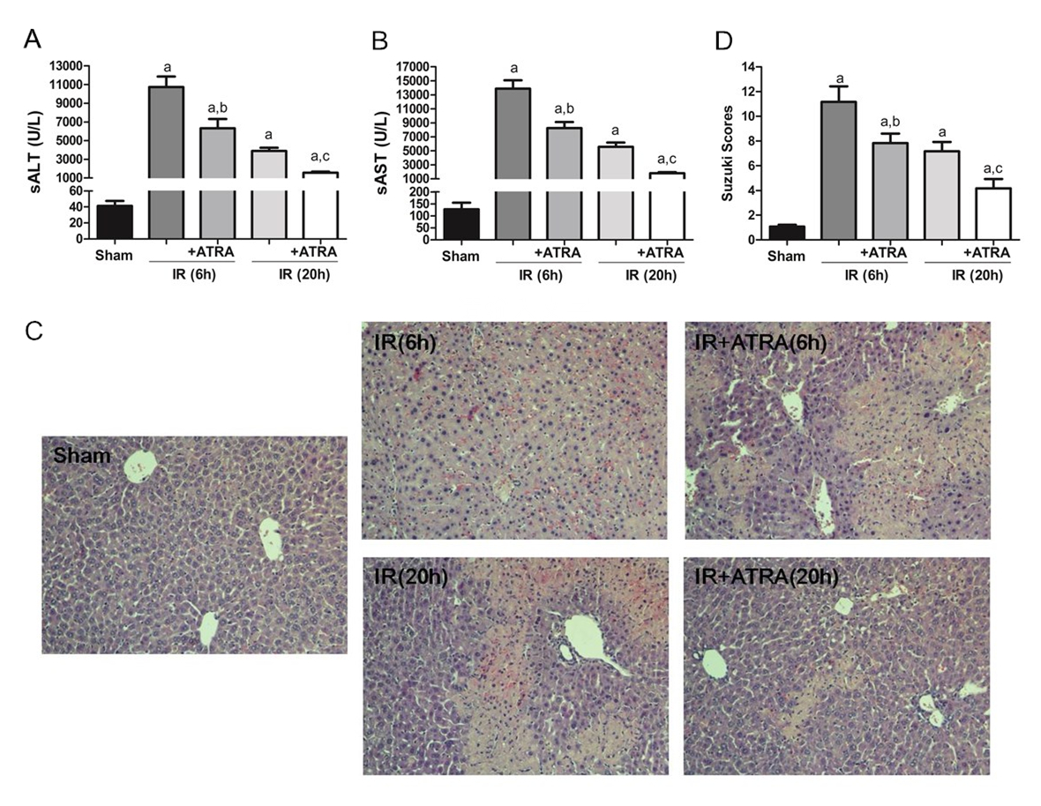
Figure 1 all-trans retinoic acid pretreatment ameliorates liver ischemia and reperfusion injury. Hepatic ischemia was induced in mice for 90 min, and then the mice were sacrificed at 6 h or 20 h after reperfusion. A and B: Hepatocellular function as assessed by sALT and sAST levels; C: Liver samples were stained with hematoxylin and eosin (× 200); D: Liver histological grade by the Suzuki criteria. Mean ± SD, n = 3-5/group, ªP < 0.05 vs the sham group; ^{b}P < 0.05 vs the IR 6 h group; ^{c}P < 0.05 vs the IR 20 h group. ATRA: All-trans retinoic acid; IR: Ischemia and reperfusion; sALT: Serum alanine aminotransferase; sAST: Serum aspartate aminotransferase.

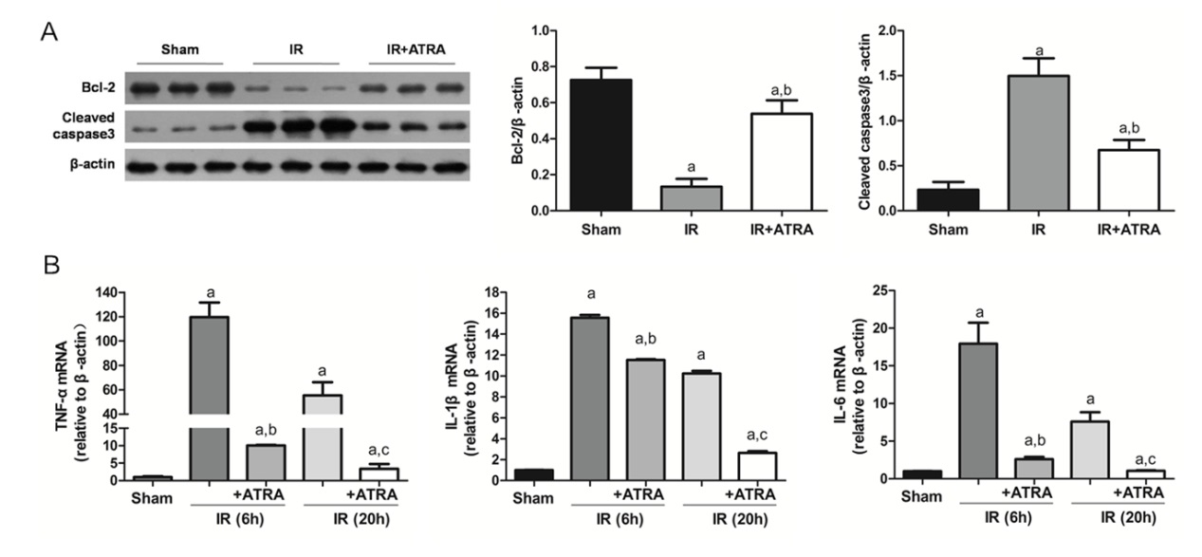
Figure 2 All-trans retinoic acid pretreatment reduces apoptosis and inflammation in liver ischemia and reperfusion injury. A: Apoptosis-related proteins Bcl-2 and cleaved caspase3 expressions were detected by western blot to demonstrate relative quantities in liver tissues; B: The levels of TNF-α, IL-1β and IL-6 mRNA were analyzed. Mean ± SD, n = 3-5/group, ªP < 0.05 vs the sham group; ^{b}P < 0.05 vs the IR 6h group; ^{c}P < 0.05 vs the IR 20h group. TNF: tumor necrosis factor; IL: interleukin; IR: Ischemia and reperfusion.

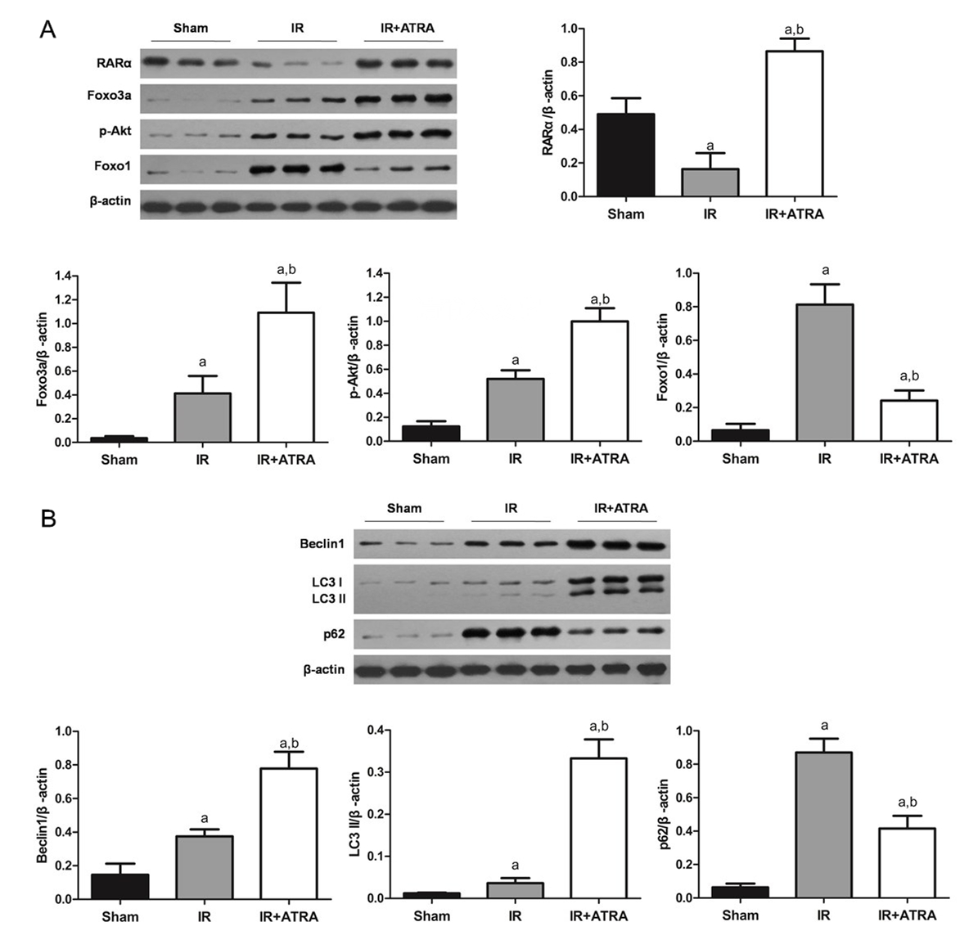
Figure 3 Autophagy is promoted by all-trans retinoic acid. A: Western blot assessment of RARα, Foxo3a, p-Akt, Foxo1, and β-actin expression levels; B: Western blot-assisted analysis of Beclin1, LC3I/II, p62 and β-actin expression levels. Mean ± SD, n = 3-5/group, ªP < 0.05 vs the sham group; ^{b}P < 0.05 vs the IR 6 h group. IR: Ischemia and reperfusion.

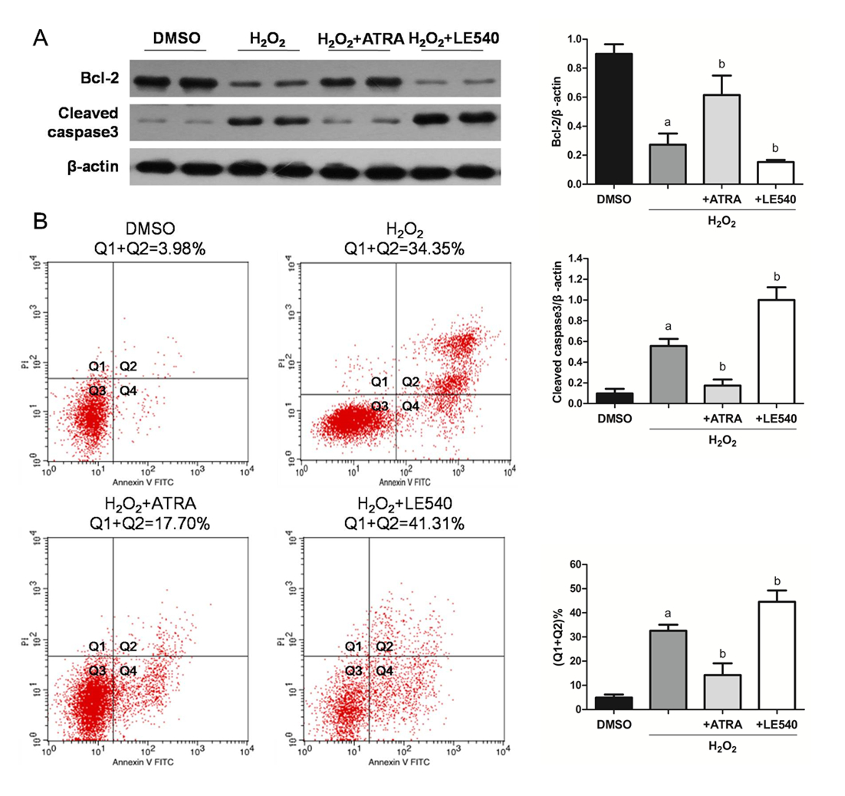
Figure 4 retinoic acid receptor α inhibits reactive oxygen species-induced apoptosis in vitro. LE540, an inhibitor of RARα, was cocultured with FL83B cells for 24 h, and then the cells were harvested 6 h after H₂O₂ treatment. A: Expression levels of Bcl-2, cleaved caspase3 and β-actin were measured by western blot; B: The number of apoptotic cells was assessed by AV and PI labeling. Mean ± SD, n = 3-5/group, ªP < 0.05 vs the DMSO group; ^{b}P < 0.05 vs the H₂O₂ group. RARα: retinoic acid receptor α; AV: Annexin V; PI: Propidium iodide.

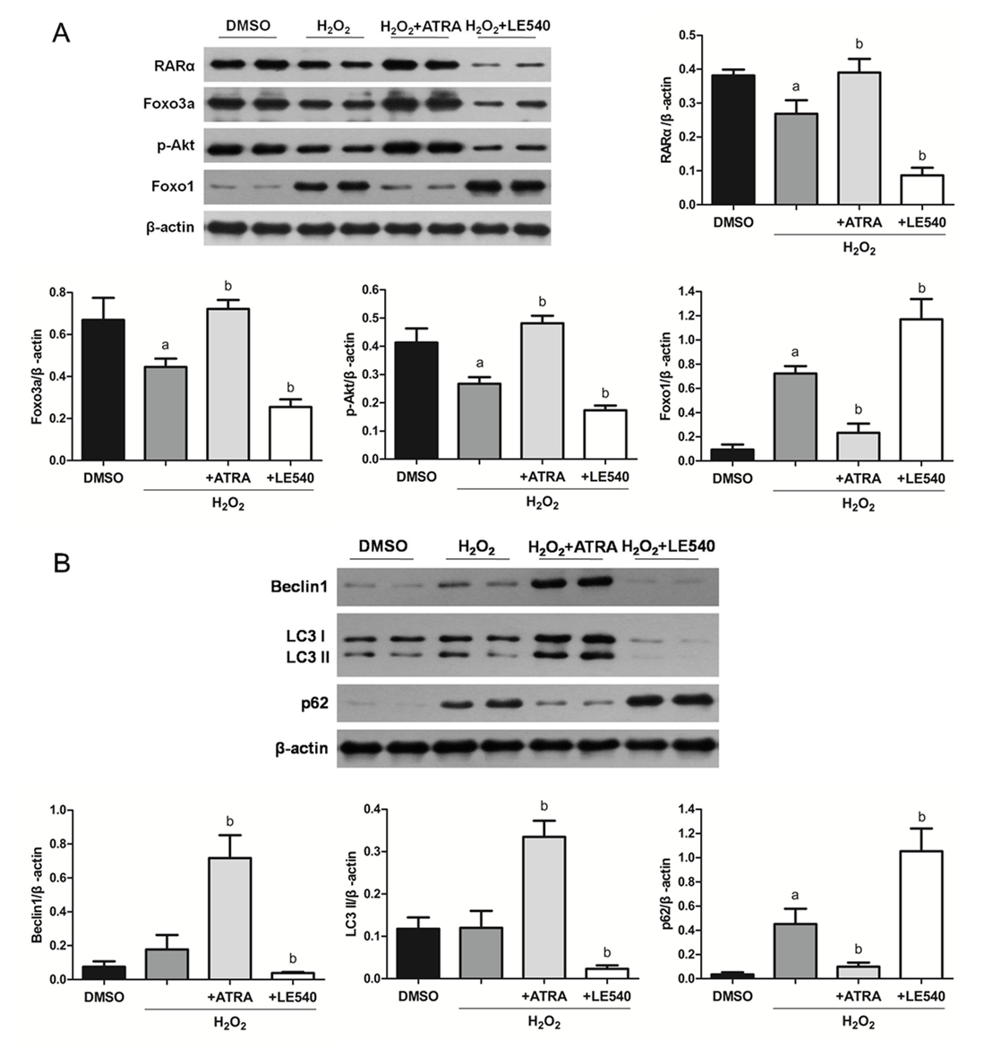
Figure 5 retinoic acid receptor α mediates autophagy through the Foxo3a/p-Akt/Foxo1 pathway. A: Western blot assessment of RARα, Foxo3a, p-Akt, Foxo1, and β-actin expression levels. B: Western blot-assisted analysis of Beclin1, LC3I/II, p62 and β-actin expression levels. Mean ± SD, n = 3-5/group, ªP < 0.05 vs the DMSO group; ^{b}P < 0.05 vs the H₂O₂ group. RARα: retinoic acid receptor α.

