Name of Journal: World Journal of Psychiatry
Manuscript NO: 90305
Manuscript Type: META-ANALYSIS

Alterations of sleep deprivation on brain function: A coordinate-based resting-state functional magnetic resonance imaging meta-analysis

Zhang Q et al. Sleep deprivation: Neural impact meta-analysis

Qin Zhang, Yong-Zhe Hou, Hui Ding, Yan-Ping Shu, Jing Li, Xi-Zhao Chen, Jia-Lin Li, Qin Lou, Dai-Xing Wang

Qin Zhang, Hui Ding, Jing Li, Xi-Zhao Chen, Qin Lou, Dai-Xing Wang, Department of Radiology, The Second People’s Hospital of Guizhou Province, Guiyang 550000, Guizhou Province, China

Qin Zhang, Department of Radiology, Guizhou Provincial People’s Hospital, Guiyang 550000, Guizhou Province, China

Yong-Zhe Hou, Yan-Ping Shu, Department of Psychiatry of Women and Children, The Second People’s Hospital of Guizhou Province, Guiyang 550000, Guizhou Province, China

Jia-Lin Li, Medical Humanities College, Guizhou Medical University, Guiyang 550000, Guizhou Province, China

Co-first authors: Qin Zhang and Yong-Zhe Hou.

Co-corresponding authors: Hui Ding and Yan-Ping Shu.

Author contributions: Zhang Q, Hou YZ, Chen XZ, Li J, Wang DX, and Lou Q designed the experiment and wrote the manuscript; Zhang Q, Hou YZ, and Li JL analyzed the data; Ding H and Shu YP contributed to the critical revision and editing of the article; Zhang Q and Hou YZ contributed equally to this manuscript and are therefore listed as co-first authors; Ding H and Shu YP contributed equally to this manuscript and are therefore listed as co-corresponding authors; this designation as co-corresponding authors underscores our shared responsibilities in handling correspondence, communicating with peers, and providing essential guidance throughout the research process. Our equal commitment and involvement affirm our joint leadership and contribution to this significant scientific endeavor.

Supported by the Guizhou Province Traditional Chinese Medicine and Ethnic Medicine Science and Technology Research Special Project, No. QZYY-2020-069; Health Commission of Guizhou Province, No. gzwjkj2019-1-203; 2024 Guizhou Provincial Health Commission Science and Technology Fund Project; Guizhou Province Science and Technology Plan Project, No. ZK-2023-195; 2021 Health Commission of Guizhou Province Project, No. gzwkj2021-150; and 2020 National Clinical Key Specialized Projects, No. 2020-128.

Corresponding author: Hui Ding, Doctor, Professor, Department of Radiology, The Second People’s Hospital of Guizhou Province, No. 206 South Section of Xintian Avenue, Yunyan District, Guiyang 550000, Guizhou Province, China. 857747438@qq.com

Received: November 29, 2023
Revised: December 21, 2023
Accepted: January 3, 2024
Published online: February 19, 2024

Abstract
BACKGROUND
Sleep deprivation is a prevalent issue that impacts cognitive function. Although numerous neuroimaging studies have explored the neural correlates of sleep loss, inconsistencies persist in the reported results, necessitating an investigation into the consistent brain functional changes resulting from sleep loss.

AIM
To establish the consistency of brain functional alterations associated with sleep deprivation through systematic searches of neuroimaging databases. Two meta-analytic methods, signed differential mapping (SDM) and activation likelihood estimation (ALE), were employed to analyze functional magnetic resonance imaging (fMRI) data.

METHODS
A systematic search performed according to PRISMA guidelines was conducted across multiple databases through July 29, 2023. Studies that met specific inclusion criteria, focused on healthy subjects with acute sleep deprivation and reported whole-brain functional data in English were considered. A total of 21 studies were selected for SDM and ALE meta-analyses.

RESULTS
Twenty-one studies, including 23 experiments and 498 subjects, were included. Compared to pre-sleep deprivation, post-sleep deprivation brain function was associated with increased gray matter in the right corpus callosum and decreased activity in the left medial frontal gyrus and left inferior parietal lobule. SDM revealed increased brain functional activity in the left striatum and right central posterior gyrus and decreased activity in the right cerebellar gyrus, left middle frontal gyrus, corpus callosum, and right cuneus.

CONCLUSION
This meta-analysis consistently identified brain regions affected by sleep deprivation, notably the left medial frontal gyrus and corpus callosum, shedding light on the neuropathology of sleep deprivation and offering insights into its neurological impact.

Key Words: Sleep deprivation; Resting-state-functional magnetic resonance imaging; Activation likelihood estimation-meta; Signed differential mapping-meta

©The Author(s) 2024. Published by Baishideng Publishing Group Inc. All rights reserved.

Citation: Zhang Q, Hou YZ, Ding H, Shu YP, Li J, Chen XZ, Li JL, Lou Q, Wang DX. Alterations of sleep deprivation on brain function: A coordinate-based resting-state functional magnetic resonance imaging meta-analysis. World J Psychiatry 2024; 14(2): 315-329
URL: https://www.wjgnet.com/2220-3206/full/v14/i2/315.htm
DOI: https://dx.doi.org/10.5498/wjp.v14.i2.315

Core Tip: This meta-analysis revealed consistent brain functional changes resulting from sleep deprivation, revealing notable alterations in the left medial frontal gyrus and corpus callosum. These findings offer crucial insights into the neurological impact of sleep loss and highlight specific brain regions affected by sleep deprivation, which may aid in understanding its neuropathological implications.

INTRODUCTION
Sleep deprivation refers to insufficient or severe lack of sleep caused by various factors. With the acceleration of the pace of societal life and the escalation of individual pressures, sleep deprivation has evolved into a widespread public health concern^{[1]}. The significance of high-quality sleep for maintaining one’s well-being cannot be overlooked. Reports indicate that approximately one-third or more of adults in the Americas, Europe, and Asia consistently fall short of the 7 h of nightly sleep recommended by public health authorities^{[2-5]}. Furthermore, the ceaseless 24-h nature of modern society readily disrupts the human body’s circadian rhythms. Both insufficient sleep and disturbances in the sleep-wake cycle exert substantial stress on physical health, including an increased risk of obesity^{[6,7]}. Research has revealed that the risk of obesity increases by 38% when comparing individuals with a short sleep duration (typically defined as less than 5 h or 6 h per day) to those with a normal sleep pattern^{[8]}. Additionally, adverse metabolic health outcomes, such as type 2 diabetes, cardiovascular disease, hypertension, and lipid abnormalities, are frequently associated with sleep deprivation and/or circadian rhythm disruptions^{[9,10]}. Prolonged sleep deprivation has been unequivocally linked to diminished cognitive abilities, altered emotional states, and the onset of inflammation and hormonal imbalances^{[11,12]}. However, our current understanding of how sleep deprivation precipitates changes in brain function is incomplete.
Neuroimaging analysis methods offer potent tools for investigating the neurobiological mechanisms of neuropsychiatric disorders. However, despite the promising prospects of neuroimaging, recent research reports have cast doubts upon the reliability of studies in this domain, raising concerns regarding issues such as small sample sizes, clinical heterogeneity, and the correction of multiple comparisons. These collective concerns have contributed to an increase in false-positive rates^{[13]}. Notwithstanding these limitations, neuroimaging techniques continue to provide valuable insights into the effects of sleep deprivation on the brain. It is essential to employ neuroimaging to detect and elucidate neurobiological alterations in specific regions associated with sleep deprivation. Meta-analytic approaches surmount the challenges of methodological diversity and outcome heterogeneity, aiding in the identification of trustworthy, practically significant research findings. In pursuit of comprehensive and persuasive outcomes, this study simultaneously employed both signed differential mapping (SDM) and activation likelihood estimation (ALE) meta-analytic methods.
While ALE-meta analysis has been conducted previously to investigate sleep deprivation, this study not only incorporated resting-state data but also task-related and positron emission tomography (PET) data^{[14]}. The question of whether the integration of results varies due to the inclusion of different data types, such as functional connectivity (FC), independent component analysis (ICA), and cerebral perfusion data, as well as whether different analytical methods impact the distribution of neurobiological biomarkers in sleep-deprived patients warrants further exploration. For example, some scholars argue that FC and ICA methods primarily involve examining functional correlations between seed points and the surrounding brain regions; however, these correlations may not align with the spontaneous neural brain function activity reflected by regional homogeneity (ReHo), amplitude of low-frequency fluctuation (ALFF), fraction ALFF (fALFF), or dynamic ALFF (dALFF) unless the emphasis is placed on studies of analogous networks^{[15]}. Furthermore, cerebral perfusion delineates the metabolic status and neural activity of corresponding brain regions by measuring local cerebral blood flow but may not comprehensively encapsulate the spontaneous functional activity of neurons in the brain^{[16]}. Despite notable success in transdiagnostic meta-analyses, the absence of crucial single-diagnosis findings underscores the ongoing importance of disease-specific methods as a critical research area.
Through functional neuroimaging SDM and ALE meta-analyses, we endeavored to elucidate the primary cerebral regions underlying alterations in brain function within the context of sleep deprivation. Our fundamental hypothesis posits that post-sleep deprivation imaging will reveal distinct cerebral functional patterns compared to pre-sleep deprivation imaging, potentially revealing the neurotraumatic mechanisms associated with sleep deprivation. This investigation exclusively encompasses studies concerning the reactivity of localized brain functional activities to comprehensively explore the localized activity patterns within sleep-deprived brain regions. With this approach, we aspire to delve deeper into the repercussions of sleep deprivation on the brain, furnishing novel insights into the neurobiological changes intertwined with its effects.

MATERIALS AND METHODS
Literature search
Study selection was conducted in accordance with the PRISMA guidelines^{[17]}. This review was registered with PROSPERO (ID: CRD42023451942). A systematic search was conducted for relevant studies in the PubMed, Web of Science, Google Scholar, Embase, and CNKI databases up to July 29, 2023. The following keywords were used to identify candidate resting-state functional magnetic resonance imaging (rs-fMRI) studies: (“sleep deprivation” OR “sleep loss” OR “sleep restriction”) AND (“amplitude of low-frequency fluctuation” OR “ALFF” OR “fALFF” OR “regional homogeneity” OR “ReHo”) AND (“magnetic resonance” OR “MRI” OR “functional MRI” OR “fMRI” OR “neuroimaging”). Manual searches in the bibliographies of the retrieved studies and suitable reviews were also conducted.
Studies were considered eligible if they met the following criteria: (1) Original studies investigating the neural correlates of sleep deprivation in healthy subjects without any psychiatric or medical conditions; (2) studies that used a before-after sleep deprivation protocol or compared two groups of subjects with and without sleep deprivation; (3) studies focused on acute sleep deprivation (between 22 h and 48 h at once); (4) studies that reported whole-brain results in the stereotactic space [Montreal Neurological Institute (MNI)] or Talairach coordinates for ALFF, fALFF, dALFF, PerAF, and ReHo; and (5) studies published in English with peer review. Our exclusion criteria were as follows: (1) Editorial letters, case reports, systematic reviews, meta-analyses, or methodological studies; (2) intervention studies; (3) studies with fewer than seven subjects; and (4) studies that did not perform whole-brain analysis. For a study containing multiple independent patient samples, group coordinates were treated as separate datasets. The corresponding authors were asked via email for any additional data not included in the original publications. Two researchers (Zhang Q and Hou YZ) independently evaluated the studies, and the inclusion and exclusion criteria were evaluated by consensus (Table 1).
The included studies were primarily assessed for greater activation in sleep deprivation conditions than in non-sleep deprivation conditions (SD > NS) or for lower activation in sleep deprivation conditions than in non-sleep-deprivation conditions (SD < NS). We identified several studies with the same or overlapping samples. ALE meta-analysis was utilized to integrate reported coordinates from different experiments. If publications used the same or an overlapping group of subjects and reported several experiments, those data were combined. Accordingly, we merged experiments from various publications.

Quality assessment
The quality of the included studies was assessed using the Newcastle-Ottawa Scale (NOS), a well-established tool for retrospective studies. The NOS comprises three levels with a total of eight items: (1) Four items for subject selection; (2) one item for comparability between groups; and (3) three items for outcome measurement. The total possible score is 9 points. Studies with a score ≥ 5 were eligible for data analysis. Each study was reviewed and rated by two authors (Zhang Q and Hou YZ) independently. If rating disagreements arose, the papers were discussed by the authors’ group to determine a consensus score.

ALE
ALE is a quantitative voxel-based meta-analysis method used in neuroimaging studies to estimate consistent changes in gray matter or functional images across multiple studies reporting peak activation coordinates of statistical significance. ALE models each alteration focus as the center of a spherical Gaussian probability distribution. This approach is employed to create spatial probability maps that highlight consistent brain region involvement in specific tasks or conditions. We set the parameters as cluster-level FWE P < 0.05, threshold permutations 1000, and P < 0.001, resulting in the generation of the ALE-image threshold map. Finally, the ALE analysis results were visualized using Mango software (http://rii.uthscsa.edu/mango/). Furthermore, to assess the stability (sensitivity) of the ALE meta-analysis results, this study employed the jackknife sensitivity analysis method. Specifically, the ALE meta-analysis was repeated 21 times, with each iteration excluding one of the 21 selected articles (in a nonrepetitive manner) before conducting the meta-analysis.

SDM
In this study, an SDM meta-analysis was conducted using AES-SDM v5.141 software (http://www.sdmproject.com) to identify significantly positive and negative activation peak coordinates at the whole-brain level related to sleep deprivation. Default parameters were utilized, including a full width at half maximum (FWHM) of 20 mm, an uncorrected voxel threshold of P < 0.005, a peak height SDM-Z > 1, and a minimum cluster extent of ≥ 10 voxels. The resulting images were visualized on the standardized anatomical template in MNI space. Furthermore, to assess the stability (sensitivity) of the SDM meta-analysis results, this study employed the jackknife sensitivity analysis method, also known as “leave one out” analysis^{[18]}. This method is commonly used for hypothesis testing, confidence interval calculations, and assessment of the stability of results in SDM meta-analyses. Specifically, AES-SDM was used to repeat the meta-analysis 21 times, with each iteration excluding one of the 21 selected articles (in a nonrepetitive manner) before conducting the meta-analysis.

RESULTS
General information of the included studies
The search strategy generated 171 related articles, and a total of 21 articles^{[19-40]} were included in this meta-analysis (Figure 1). One of the studies (Pan)^{[29]} used more than one analytical method to study sleep deprivation, and the different methods were considered three separate studies and were compared based on their individual quantities. Consequently, the effective number of “actual” experiments included in the study increased to a total of 23. Of the 171 retrieved papers in this meta-analysis, 21 studies, including 23 experiments and 498 subjects, were eligible for inclusion (Figure 1 and Table 1). These 21 studies included 8 ReHo, 8 ALFF, 3 fALFF, 2 perAF, 1 zReHo, 1 dALFF, and 1 zALFF.

Changes in brain function during sleep deprivation
The ALE results indicated that there was an increase in gray matter in the right corpus callosum and a decrease in the left medial frontal gyrus and the left inferior parietal lobule in the sleep-deprived state compared to the pre-sleep deprivation state (Figure 2 and Table 2). The SDM results indicated heightened brain functional activity in the left striatum and right posterior cingulate cortex, along with decreased activity in the right cerebellar hemisphere, left medial frontal gyrus, corpus callosum, and right cuneus, compared to those in the pre-sleep deprivation condition (Figure 3 and Table 3). Both neuroimaging meta-analytical methods revealed an overlapping increase in brain functional activity in the left medial frontal gyrus following sleep deprivation. However, the right corpus callosum and right cuneus exhibited elevated activity in the ALE results but reduced activity in the SDM results.

Subgroup analysis
Conducting a subgroup analysis utilizing the ALE method on data analysis approaches such as ALFF and ReHo revealed the following: in the ALFF analysis, when compared to the pre-sleep deprivation state, post-sleep deprivation brain functional activity increased in the right cuneus and decreased in the left inferior parietal lobule, left superior frontal gyrus, left medial frontal gyrus, and right pallidum (Figure 2 and Table 2). In the ReHo analysis, in contrast to the pre-sleep deprivation condition, sleep deprivation led to a decrease in brain functional activity in the left cingulate gyrus and right cuneus, with no regions exhibiting increased activity.
When employing the SDM method for subgroup analysis of the ALFF and ReHo data analysis approaches, no regions demonstrating either increased or decreased activity were discerned. This outcome may be attributed to the inclusion of too few studies when conducting meta-analyses of individual analytical techniques. Consequently, the central coordinates (location information of active brain regions) extracted from the included literature might be overly dispersed or insufficient in quantity to meet the threshold criteria, thus remaining undetectable.

Sensitivity analysis results
The sensitivity analysis results for the ALE study showed that the left middle frontal gyrus was consistently identified in 17 out of 21 analyses. The left inferior parietal lobule and right subcallosal gyrus were consistently identified in 18 out of 21 analyses (Table 4).
The sensitivity analysis results for the SDM study showed that the right cerebellum crus Ⅰ was consistently identified in 16 out of 21 analyses. The right cuneus cortex and right postcentral gyrus were consistently identified in 17 out of 21 analyses. The left middle frontal gyrus, left striatum, and corpus callosum were consistently identified in 19 out of 21 analyses. The corpus callosum itself was identified in 18 out of 21 analyses (Table 5).

DISCUSSION
This groundbreaking neuroimaging meta-analysis combined two different meta-analysis methods to explore changes in brain function during sleep deprivation. By integrating these two approaches, we revealed that sleep deprivation induces widespread changes in brain functionality across multiple regions, including the frontal lobe, parietal lobe, sensorimotor areas, temporal lobe, occipital lobe, corpus callosum, striatum, and screenlike nucleus, with the majority of these regions exhibiting downregulation associated with cognitive functions, sensations, motor functions, and pain perception. These findings underscore the critical importance of holistic brain analysis for obtaining a more profound understanding of the neuroactivity alterations underpinning sleep deprivation, with the potential to comprehensively elucidate its impact on brain function. Moreover, both the AES-SDM and ALE methods identified overlapping brain regions, specifically the left middle frontal gyrus and corpus callosum. This provides further evidence that the left medial frontal gyrus and corpus callosum may serve as the neuropathological basis for the brain damage induced by sleep deprivation. The neuropsychiatric damage associated with sleep deprivation may be related to widespread abnormal resting-state brain activity involving the cerebral cortex and subcortical structures. These research findings significantly contribute to broadening our understanding of the neuropathological mechanisms associated with sleep deprivation, helping to elucidate how to treat and prevent related disorders.
The role of the medial frontal gyrus and corpus callosum in sleep deprivation. Adequate sleep forms the bedrock of memory formation, with quality slumber preparing the brain for the establishment of new memories^{[41]}. Despite ongoing debates surrounding the physiological functions of sleep, it is widely acknowledged that sleep is beneficial for neuronal plasticity, which in turn supports brain function and cognition. Correspondingly, research has suggested that sleep deprivation can lead to impaired learning and memory^{[42]}, manifesting as memory decline, memory loss, and memory misconstruction, among other issues. As people continue to curtail their sleep duration, the impact of memory deterioration on daily life becomes increasingly pronounced. In a clinical study involving 96 participants, Santisteban et al^{[43]} reported that prolonged exposure to mild sleep deprivation negatively affects working memory. In a clinical experiment with 36 subjects, Hennecke et al^{[44]} confirmed that sleep deficits impair spatial working memory. Animal research conducted by Scullin et al^{[45]} and colleagues affirmed that rapid eye movement sleep deprivation and continuous sleep deprivation for 72 h both detrimentally affect memory capabilities.
The frontal lobe is intricately linked to various aspects of brain function, including cognition, sleep, working memory, short-term memory, sustained attention, planning, and behavioral control^{[46-50]}. Previous research has employed neuroimaging studies to assess the corresponding brain responses and their relationship with behavioral changes in various environments^{[51]}. Sleep deprivation can impair brain function and FC in various regions. Studies have indicated that after sleep deprivation, ReHo is greater in the left medial frontal gyrus, right precentral gyrus, right temporal gyrus, and bilateral posterior central gyrus^{[20]}. One study revealed that sleep deprivation leads to reduced FC between the right prefrontal cortex and the right medial frontal gyrus^{[52]}. Another study revealed that after 36 h of complete sleep deprivation, with increasing working memory load, there was a decrease in FC between the left hippocampus and the left frontal pole, right superior frontal gyrus, and bilateral anterior cingulate cortex^{[53]}. These findings suggest that sleep deprivation negatively affects brain function and FC in the medial frontal gyrus, leading to impairments in cognitive functions such as attention and working memory. In addition to the frontal lobe, studies using rs-fMRI have shown reduced ALFF in the precuneus^{[28]}. Li et al^{[52]} demonstrated that participants experiencing sleep deprivation exhibited decreased alertness and attention, and further investigation revealed reduced FC between the right precuneus and the right medial frontal gyrus after sleep deprivation. However, this finding contrasts with that of a study by Li et al^{[54]}, which revealed enhanced effective connectivity from the left medial frontal gyrus to the left superior parietal lobule after sleep deprivation. Furthermore, this functional neuroimaging evidence is further supported by a study involving structural imaging and brain metabolism. Sun et al^{[55]} used FreeSurfer software to calculate gray matter volume (GMV) and cortical thickness (CT) using volume and surface measurements and found that 24 h after acute sleep deprivation, there was a significant increase in gray matter density in the right frontal pole, right middle frontal gyrus, and right superior frontal gyrus, while the GMV and CT of the right temporal pole significantly decreased. A PET study also revealed a significant decrease in glucose metabolism in particular regions, including the frontal cortex, parietal cortex, and thalamus, following sleep deprivation, which correlated significantly with cognitive performance^{[56]}. In summary, considering the impaired cognitive functions such as attention and working memory in the frontal lobe following sleep deprivation, the reduced activity in the middle frontal gyrus after sleep deprivation observed in this study may reflect a compensatory response to reduced attention during sleep deprivation^{[36]}.
The corpus callosum, comprising a collection of neural fibers within the brain, serves as a pivotal conduit facilitating information transmission and coordination between the left and right cerebral hemispheres, with alterations in its functionality potentially giving rise to impairments in interhemispheric information exchange and coordination^{[57]}. One study indicated a link between sleep deprivation and functional impairments in the brain cortex, which could be associated with abnormalities in the development of the corpus callosum and visual radiation^{[58]}. Zhu et al^{[59]} reported that impaired interhemispheric connections may be a reason for sustained attention deficits following sleep deprivation, offering comprehensive insights into how sleep deprivation modulates interhemispheric connectivity and providing new evidence for the increased relevance of neuroimaging in sleepiness after sleep deprivation. Vargas et al^{[60]} reported that young people with symptoms of insomnia are particularly susceptible to sleep deprivation, which can reduce their natural tendency to focus on positive information in the environment due to acute sleep deprivation. In addition to impairing interhemispheric information exchange and coordination, sleep deprivation may also lead to emotional instability and other issues. For instance, Taraku et al^{[61]} discovered that individuals with depression exhibit decreased fractional anisotropy (FA) values in multiple white matter tracts, including the corpus callosum and corona radiata, after complete sleep deprivation. Furthermore, changes in FA values within the right superior corona radiata were significantly associated with improvements in rumination after complete sleep deprivation^{[61]}. Li et al^{[62]} also found weaker FC between the left corpus callosum/posterior cingulate gyrus and anterior cingulate cortex in patients with comorbid primary insomnia and depression. Additionally, Bellesi et al^{[63]} evaluated the ultrastructure of myelin sheaths in two brain regions (the corpus callosum and olfactory lateral bundle) in mice exposed to different durations of sleep deprivation, ranging from several hours to approximately 5 d of chronic sleep restriction. Chronic sleep deprivation led to an increase in the ratio of the axon diameter to the myelinated fiber outer diameter, which was mediated by a reduction in myelin sheath thickness in the corpus callosum and olfactory lateral bundle^{[63]}. Therefore, sleep deprivation can have a significant impact on the structure and function of the corpus callosum, resulting in decreased motor coordination and increased emotional fluctuations, among other issues. Notably, individual responses to sleep deprivation may vary, and many studies on this topic have been conducted using animal models or small sample populations. These studies may not fully represent the diversity of human responses to sleep deprivation.
Further research is needed to determine the precise link between sleep deprivation and brain function and structure. This approach will provide a more comprehensive understanding of the neurobiological mechanisms underlying sleep deprivation and pave the way for the development of more effective strategies to mitigate its adverse consequences.

Reasons for discrepancies with previous meta-analyses
By combining two methods (ALE and SDM) and refining the inclusion criteria (only including literature reflecting changes in spontaneous brain activity), this meta-analysis identified the left medial frontal gyrus, right cuneus, and corpus callosum as brain regions affected by sleep deprivation. However, in an ALE meta-analysis, Javaheripour et al^{[14]} reported reduced activity in the right superior frontal gyrus and superior parietal lobule. Our study did not yield the same results, which could be due to several reasons. First, their study included not only ReHo, ALFF, FC, and ICA but also t-fMRI, VBM, and PET-related data. The differences in experimental design, data preprocessing, and statistical methods used for t-fMRI, PET, and VBM compared to those used for rs-fMRI (ReHo, ALFF, FC, and ICA) might have led to the absence of brain regions showing abnormal activity. Second, different meta-analysis software may have been used. Third, our study included differences in sex, age, educational level, disease severity, and disease duration, which might have contributed to the differences in the results. Finally, the central coordinates (location information of active brain regions) extracted in our study were dispersed or insufficient in quantity to meet the threshold, potentially resulting in a lack of significant findings. This meta-analysis shares similarities with the research of Javaheripour et al^{[14]} but also presents differences, enriching our understanding of the mechanisms underlying impaired brain function before and after sleep deprivation.

Limitations
Several limitations should be noted in this meta-analysis. First, the number of included studies was relatively small. Second, while ALE and SDM effectively control false-positive results, avoiding false negatives is a challenge^{[18]}. Finally, it was not possible to completely eliminate heterogeneity among the included studies, such as variations in the demographic characteristics of patients and different imaging modalities representing aspects of resting-state abnormalities. For example, ALFF and ReHo are related to the strength and temporal synchronization of spontaneous neuronal activity, respectively, in various regions of the whole brain^{[64,65]}. Despite these differences, multiple analytical methods can complement each other and provide more comprehensive information. Different analysis modalities can also detect similar patterns of resting-state abnormalities. For instance, in most of the included studies, regardless of the imaging approach, reduced activity in the occipital lobe during the resting state was consistently observed.

CONCLUSION
In summary, this meta-analysis discerned notable and consistent alterations in brain function consequent to sleep deprivation, notably within the left middle frontal gyrus and corpus callosum. These discoveries hold the potential to provide fresh perspectives regarding the neuropathological underpinnings of sleep deprivation. Future investigations must further explore the potential applications of these brain regions, characterized by modified functionality, in the diagnosis and ongoing assessment of sleep deprivation.

ARTICLE HIGHLIGHTS
Research background
Sleep deprivation, a widespread public health concern, is characterized by inadequate or severely reduced sleep. With societal acceleration and increased individual pressures, the prevalence of sleep deprivation has risen, impacting cognitive function and overall well-being. Despite extensive research on its health implications, a comprehensive understanding of how sleep deprivation affects brain function remains incomplete.

Research motivation
Quality sleep is essential for well-being, yet a significant proportion of the global population consistently falls short of recommended sleep durations. Sleep deprivation is associated with various health risks, including obesity, metabolic disorders, and cognitive decline. Understanding the consistent neurobiological alterations resulting from sleep loss is crucial for devising effective preventive and therapeutic strategies.

Research objectives
To address the inconsistencies in existing neuroimaging studies on sleep deprivation by identifying and elucidating the brain functional changes associated with acute sleep loss. Through the integration of signed differential mapping (SDM) and activation likelihood estimation (ALE) meta-analytic methods, the study aims to provide a comprehensive understanding of the neuropathological impact of sleep deprivation.

Research methods
A systematic search following PRISMA guidelines was conducted across multiple databases to identify 21 eligible studies focusing on acute sleep deprivation in healthy subjects. The studies, written in English, reported whole-brain functional data and met specific inclusion criteria. SDM and ALE meta-analyses were employed on functional magnetic resonance imaging (fMRI) data to analyze brain functional changes consistently associated with sleep deprivation.

Research results
The meta-analysis, encompassing 21 studies with 23 experiments and 498 subjects, identified consistent brain functional alterations post-sleep deprivation. Notable changes included increased gray matter in the right corpus callosum and decreased activity in the left medial frontal gyrus and left inferior parietal lobule. SDM revealed additional alterations in brain functional activity, providing a comprehensive view of the impact of sleep deprivation on neural processes.

Research conclusions
This study consistently identified brain regions affected by sleep deprivation, emphasizing the left medial frontal gyrus and corpus callosum as key areas influenced by acute sleep loss. The findings contribute valuable insights into the neuropathology of sleep deprivation, offering a foundation for further research and potential interventions aimed at mitigating its adverse effects on brain function.

Research perspectives
Future research should explore the clinical implications of the identified brain regions and their functional changes in the context of sleep deprivation. Additionally, investigations into individual variability in response to sleep loss and the potential longitudinal effects on brain function will further enhance our understanding of the complex interplay between sleep, cognition, and neurological health.

REFERENCES
1 Griggs S, Harper A, Hickman RL Jr. A systematic review of sleep deprivation and neurobehavioral function in young adults. Appl Nurs Res 2022; 63: 151552 [PMID: 35034695 DOI: 10.1016/j.apnr.2021.151552]
2 Denney JT, Zamora-Kapoor A, Hansen DA, Whitney P. Race/ethnicity, sleep duration, and mortality risk in the United States. SSM Popul Health 2023; 21: 101350 [PMID: 36785549 DOI: 10.1016/j.ssmph.2023.101350]
3 Gilmour H, Lu D, Polsky JY. Sleep duration, sleep quality and obesity in the Canadian Armed Forces. Health Rep 2023; 34: 3-14 [PMID: 37219888 DOI: 10.25318/82-003-x202300500001-eng]
4 Svensson T, Saito E, Svensson AK, Melander O, Orho-Melander M, Mimura M, Rahman S, Sawada N, Koh WP, Shu XO, Tsuji I, Kanemura S, Park SK, Nagata C, Tsugane S, Cai H, Yuan JM, Matsuyama S, Sugawara Y, Wada K, Yoo KY, Chia KS, Boffetta P, Ahsan H, Zheng W, Kang D, Potter JD, Inoue M. Association of Sleep Duration With All- and Major-Cause Mortality Among Adults in Japan, China, Singapore, and Korea. JAMA Netw Open 2021; 4: e2122837 [PMID: 34477853 DOI: 10.1001/jamanetworkopen.2021.22837]
5 Chan CMH, Siau CS, Wong JE, Wee LH, Jamil NA, Hoe VCW. Prevalence of Insufficient Sleep and Its Associated Factors Among Working Adults in Malaysia. Nat Sci Sleep 2021; 13: 1109-1116 [PMID: 34285616 DOI: 10.2147/NSS.S295537]
6 Chaput JP, McHill AW, Cox RC, Broussard JL, Dutil C, da Costa BGG, Sampasa-Kanyinga H, Wright KP Jr. The role of insufficient sleep and circadian misalignment in obesity. Nat Rev Endocrinol 2023; 19: 82-97 [PMID: 36280789 DOI: 10.1038/s41574-022-00747-7]
7 Boege HL, Bhatti MZ, St-Onge MP. Circadian rhythms and meal timing: impact on energy balance and body weight. Curr Opin Biotechnol 2021; 70: 1-6 [PMID: 32998085 DOI: 10.1016/j.copbio.2020.08.009]
8 Chaput JP, Dutil C, Featherstone R, Ross R, Giangregorio L, Saunders TJ, Janssen I, Poitras VJ, Kho ME, Ross-White A, Carrier J. Sleep duration and health in adults: an overview of systematic reviews. Appl Physiol Nutr Metab 2020; 45: S218-S231 [PMID: 33054337 DOI: 10.1139/apnm-2020-0034]
9 Evbayekha EO, Aiwuyo HO, Dilibe A, Nriagu BN, Idowu AB, Eletta RY, Ohikhuai EE. Sleep Deprivation Is Associated With Increased Risk for Hypertensive Heart Disease: A Nationwide Population-Based Cohort Study. Cureus 2022; 14: e33005 [PMID: 36712752 DOI: 10.7759/cureus.33005]
10 Button KS, Ioannidis JP, Mokrysz C, Nosek BA, Flint J, Robinson ES, Munafò MR. Power failure: why small sample size undermines the reliability of neuroscience. Nat Rev Neurosci 2013; 14: 365-376 [PMID: 23571845 DOI: 10.1038/nrn3475]
11 Thompson KI, Chau M, Lorenzetti MS, Hill LD, Fins AI, Tartar JL. Acute sleep deprivation disrupts emotion, cognition, inflammation, and cortisol in young healthy adults. Front Behav Neurosci 2022; 16: 945661 [PMID: 36212194 DOI: 10.3389/fnbeh.2022.945661]
12 Garbarino S, Lanteri P, Bragazzi NL, Magnavita N, Scoditti E. Role of sleep deprivation in immune-related disease risk and outcomes. Commun Biol 2021; 4: 1304 [PMID: 34795404 DOI: 10.1038/s42003-021-02825-4]
13 Ye H, Ji M, Wang C, Wang C, Li Y, Chen Y, Cheng L, Li Y, Yang JJ. Integrated Functional Neuroimaging, Monoamine Neurotransmitters, and Behavioral Score on Depressive Tendency in Intensive Care Unit Medical Staffs Induced by Sleep Deprivation After Night Shift Work. Front Psychiatry 2022; 13: 848709 [PMID: 35392383 DOI: 10.3389/fpsyt.2022.848709]
14 Javaheripour N, Shahdipour N, Noori K, Zarei M, Camilleri JA, Laird AR, Fox PT, Eickhoff SB, Eickhoff CR, Rosenzweig I, Khazaie H, Tahmasian M. Functional brain alterations in acute sleep deprivation: An activation likelihood estimation meta-analysis. Sleep Med Rev 2019; 46: 64-73 [PMID: 31063939 DOI: 10.1016/j.smrv.2019.03.008]
15 Zang YF, Zuo XN, Milham M, Hallett M. Toward a Meta-Analytic Synthesis of the Resting-State fMRI Literature for Clinical Populations. Biomed Res Int 2015; 2015: 435265 [PMID: 26171391 DOI: 10.1155/2015/435265]
16 Zhang DS, Gao J, Zhe X. Meta-analysis of activation likelihood estimation in resting state function MRI abnormal activity brain region in type 2 diabetes mellitus patients. Chin J Radiol 2018; 52: 241-246 [DOI: 10.3760/cma.j.issn.1005-1201.2018.04.001]
17 Moher D, Liberati A, Tetzlaff J, Altman DG; PRISMA Group. Preferred reporting items for systematic reviews and meta-analyses: the PRISMA statement. PLoS Med 2009; 6: e1000097 [PMID: 19621072 DOI: 10.1371/journal.pmed.1000097]
18 Radua J, Mataix-Cols D, Phillips ML, El-Hage W, Kronhaus DM, Cardoner N, Surguladze S. A new meta-analytic method for neuroimaging studies that combines reported peak coordinates and statistical parametric maps. Eur Psychiatry 2012; 27: 605-611 [PMID: 21658917 DOI: 10.1016/j.eurpsy.2011.04.001]
19 Dai XJ, Gong HH, Wang YX, Zhou FQ, Min YJ, Zhao F, Wang SY, Liu BX, Xiao XZ. Gender differences in brain regional homogeneity of healthy subjects after normal sleep and after sleep deprivation: a resting-state fMRI study. Sleep Med 2012; 13: 720-727 [PMID: 22503940 DOI: 10.1016/j.sleep.2011.09.019]
20 Dai XJ, Gong HH, Min YJ, Wang SY, Liu BX. Resting-state fMRI observation on difference of regional homogeneity in healthy subjects after normal sleep and sleep deprivation. Zhongguo Yixue Yingxiang Jishu 2012; 28: 243-246 [DOI: 10.13929/j.1003-3289.2012.02.002]
21 Gao L, Bai L, Zhang Y, Dai XJ, Netra R, Min Y, Zhou F, Niu C, Dun W, Gong H, Zhang M. Frequency-dependent changes of local resting oscillations in sleep-deprived brain. PLoS One 2015; 10: e0120323 [PMID: 25798918 DOI: 10.1371/journal.pone.0120323]
22 Dai XJ, Liu CL, Zhou RL, Gong HH, Wu B, Gao L, Wang YX. Long-term total sleep deprivation decreases the default spontaneous activity and connectivity pattern in healthy male subjects: a resting-state fMRI study. Neuropsychiatr Dis Treat 2015; 11: 761-772 [PMID: 25834451 DOI: 10.2147/NDT.S78335]
23 Wang L, Chen Y, Yao Y, Pan Y, Sun Y. Sleep deprivation disturbed regional brain activity in healthy subjects: evidence from a functional magnetic resonance-imaging study. Neuropsychiatr Dis Treat 2016; 12: 801-807 [PMID: 27110113 DOI: 10.2147/NDT.S99644]
24 Li JY, Song YL, Qi JL, Wu Y, Peng ZB. Observation of local consistency changes in adult brain after long-term sleep deprivation at different times using resting state fMRI. Cigongzhen Chengxiang 2017; 8: 95-99
25 Li JY, Cai XP, Zhou L, Shao YC. The fMRI findings of the effect of transcranial electrical stimulation on local brain consistency after sleep deprivation. Zhongguo Yixue Yingxiangxue Zazhi 2017; 25: 335-339, 343
26 Zhou GL, Zhou YY, Liu Y, Peng L, Pan SY, Sun YY, Huang CJ, Chen XL, Zhu XH, Hu WM. Functional magnetic resonance imaging study on low-frequency amplitude changes during sleep deprivation in healthy adolescents. Zhongguo Xinlijiankang Zazhi 2017; 31: 170-176
27 Robinson JL, Erath SA, Kana RK, El-Sheikh M. Neurophysiological differences in the adolescent brain following a single night of restricted sleep - A 7T fMRI study. Dev Cogn Neurosci 2018; 31: 1-10 [PMID: 29680789 DOI: 10.1016/j.dcn.2018.03.012]
28 Chen L, Qi X, Zheng J. Altered Regional Cortical Brain Activity in Healthy Subjects After Sleep Deprivation: A Functional Magnetic Resonance Imaging Study. Front Neurol 2018; 9: 588 [PMID: 30116216 DOI: 10.3389/fneur.2018.00588]
29 Feng P, Becker B, Feng T, Zheng Y. Alter spontaneous activity in amygdala and vmPFC during fear consolidation following 24 h sleep deprivation. Neuroimage 2018; 172: 461-469 [PMID: 29378319 DOI: 10.1016/j.neuroimage.2018.01.057]
30 Feng P, Jin YL, Zheng Y, Feng TY. Neural mechanisms underlying fear memory consolidation influenced by sleep deprivation using the fraction amplitude of low- frequency fluctuations as marker. Zhongguo Kexue: Shengming Kexue 2018; 48: 1115-1125
31 Guo Z, Jiang Z, Jiang B, McClure MA, Mu Q. High-Frequency Repetitive Transcranial Magnetic Stimulation Could Improve Impaired Working Memory Induced by Sleep Deprivation. Neural Plast 2019; 2019: 7030286 [PMID: 31915432 DOI: 10.1155/2019/7030286]
32 Nechifor RE, Ciobanu D, Vonica CL, Popita C, Roman G, Bala C, Mocan A, Inceu G, Craciun A, Rusu A. Social jetlag and sleep deprivation are associated with altered activity in the reward-related brain areas: an exploratory resting-state fMRI study. Sleep Med 2020; 72: 12-19 [PMID: 32540632 DOI: 10.1016/j.sleep.2020.03.018]
33 Qiu GB, Liao WX, Liu YH, Chen JC. Study on resting brain function in chronic partial sleep deprivation Imaging. Yanjiu Yu Yixueyingyong 2021; 5: 61-62
34 Xu YQ, Wang XR, Hu WZ, Yin H, Zhu YQ. The cognitive neural mechanism of short-term sleep deprivation affecting sustained attention: based on resting state functional MRI low-frequency amplitude fraction analysis. Fangshexue Shijian 2021; 36: 158-163 [DOI: 10.13609/j.cnki.1000-0313.2021.02.003]
35 Zeng B, Zhou J, Li Z, Zhang H, Li Z, Yu P. Altered Percent Amplitude of Fluctuation in Healthy Subjects After 36 h Sleep Deprivation. Front Neurol 2020; 11: 565025 [PMID: 33519662 DOI: 10.3389/fneur.2020.565025]
36 Cai Y, Mai Z, Li M, Zhou X, Ma N. Altered frontal connectivity after sleep deprivation predicts sustained attentional impairment: A resting-state functional magnetic resonance imaging study. J Sleep Res 2021; 30: e13329 [PMID: 33686744 DOI: 10.1111/jsr.13329]
37 Nechifor RE, Popita C, Bala C, Vonica C, Ciobanu D, Roman G, Mocan A, Sima D, Inceu G, Craciun A, Pop RM, Craciun C, Rusu A. Regional homogeneity and degree of centrality in social jetlag and sleep deprivation and their correlations with appetite: a resting-state fMRI study. Bio Rhythm Res 2022; 53: 966-986 [DOI: 10.1080/09291016.2020.1854991]
38 Xin KK, Wang L, Sun ZH, Kang F, Quan ZY, Zhu YQ, Mu Y, Wang J. The percentage change of low-frequency oscillation amplitude in the resting state frontoparietal network after sleep deprivation. Shenjing Jiepouxue Zazhi 2022; 38: 549-554 [DOI: 10.16557/j.cnki.1000-7547.2022.05.010]
39 Yan FX, Lin JL, Lin JH, Chen HJ, Lin YJ. Altered dynamic brain activity and its association with memory decline after night shift-related sleep deprivation in nurses. J Clin Nurs 2023; 32: 3852-3862 [PMID: 36081313 DOI: 10.1111/jocn.16515]
40 Chen J, Gong X, Wang L, Xu M, Zhong X, Peng Z, Song T, Xu L, Lian J, Shao Y, Weng X. Altered Postcentral Connectivity after Sleep Deprivation Correlates to Impaired Risk Perception: A Resting-State Functional Magnetic Resonance Imaging Study. Brain Sci 2023; 13 [PMID: 36979324 DOI: 10.3390/brainsci13030514]
41 Cirelli C, Tononi G. The why and how of sleep-dependent synaptic down-selection. Semin Cell Dev Biol 2022; 125: 91-100 [PMID: 33712366 DOI: 10.1016/j.semcdb.2021.02.007]
42 Nissen C, Piosczyk H, Holz J, Maier JG, Frase L, Sterr A, Riemann D, Feige B. Sleep is more than rest for plasticity in the human cortex. Sleep 2021; 44 [PMID: 33401305 DOI: 10.1093/sleep/zsaa216]
43 Santisteban JA, Brown TG, Ouimet MC, Gruber R. Cumulative mild partial sleep deprivation negatively impacts working memory capacity but not sustained attention, response inhibition, or decision making: a randomized controlled trial. Sleep Health 2019; 5: 101-108 [PMID: 30670158 DOI: 10.1016/j.sleh.2018.09.007]
44 Hennecke E, Lange D, Steenbergen F, Fronczek-Poncelet J, Elmenhorst D, Bauer A, Aeschbach D, Elmenhorst EM. Adverse interaction effects of chronic and acute sleep deficits on spatial working memory but not on verbal working memory or declarative memory. J Sleep Res 2021; 30: e13225 [PMID: 33169493 DOI: 10.1111/jsr.13225]
45 Scullin MK, Gao C. Dynamic Contributions of Slow Wave Sleep and REM Sleep to Cognitive Longevity. Curr Sleep Med Rep 2018; 4: 284-293 [PMID: 31737466 DOI: 10.1007/s40675-018-0131-6]
46 Pizzagalli DA, Roberts AC. Prefrontal cortex and depression. Neuropsychopharmacology 2022; 47: 225-246 [PMID: 34341498 DOI: 10.1038/s41386-021-01101-7]
47 Lee MH, Lee KH, Oh SM, Seo MC, Lee H, Jeon JE, Lee YJ. The moderating effect of prefrontal response to sleep-related stimuli on the association between depression and sleep disturbance in insomnia disorder. Sci Rep 2022; 12: 17739 [PMID: 36272992 DOI: 10.1038/s41598-022-22652-9]
48 Yeung MK, Lee TL, Cheung WK, Chan AS. Frontal Underactivation During Working Memory Processing in Adults With Acute Partial Sleep Deprivation: A Near-Infrared Spectroscopy Study. Front Psychol 2018; 9: 742 [DOI: 10.3389/fpsyg.2018.00742]
49 Roussy M, Corrigan B, Luna R, Gulli RA, Sachs AJ, Palaniyappan L, Martinez-Trujillo JC. Stable Working Memory and Perceptual Representations in Macaque Lateral Prefrontal Cortex during Naturalistic Vision. J Neurosci 2022; 42: 8328-8342 [PMID: 36195438 DOI: 10.1523/JNEUROSCI.0597-22.2022]
50 Friedman NP, Robbins TW. The role of prefrontal cortex in cognitive control and executive function. Neuropsychopharmacology 2022; 47: 72-89 [PMID: 34408280 DOI: 10.1038/s41386-021-01132-0]
51 Sander TH, Zhou B. Linking neuroimaging signals to behavioral responses in single cases: Challenges and opportunities. Psych J 2016; 5: 161-169 [PMID: 27678481 DOI: 10.1002/pchj.143]
52 Li B, Zhang L, Zhang Y, Chen Y, Peng J, Shao Y, Zhang X. Decreased Functional Connectivity Between the Right Precuneus and Middle Frontal Gyrus Is Related to Attentional Decline Following Acute Sleep Deprivation. Front Neurosci 2020; 14: 530257 [PMID: 33408600 DOI: 10.3389/fnins.2020.530257]
53 Wang L, Wu H, Dai C, Peng Z, Song T, Xu L, Xu M, Shao Y, Li S, Fu W. Dynamic hippocampal functional connectivity responses to varying working memory loads following total sleep deprivation. J Sleep Res 2023; 32: e13797 [PMID: 36528854 DOI: 10.1111/jsr.13797]
54 Li Y, Ma M, Shao Y, Wang W. Enhanced effective connectivity from the middle frontal gyrus to the parietal lobe is associated with impaired mental rotation after total sleep deprivation: An electroencephalogram study. Front Neurosci 2022; 16: 910618 [PMID: 36248651 DOI: 10.3389/fnins.2022.910618]
55 Sun J, Zhao R, Yang X, Deng H, Zhu Y, Chen Y, Yuan K, Xi Y, Yin H, Qin W. Alteration of Brain Gray Matter Density After 24 h of Sleep Deprivation in Healthy Adults. Front Neurosci 2020; 14: 754 [PMID: 32903801 DOI: 10.3389/fnins.2020.00754]
56 Chen WH, Chen J, Lin X, Li P, Shi L, Liu JJ, Sun HQ, Lu L, Shi J. Dissociable effects of sleep deprivation on functional connectivity in the dorsal and ventral default mode networks. Sleep Med 2018; 50: 137-144 [PMID: 30055480 DOI: 10.1016/j.sleep.2018.05.040]
57 Szczupak D, Iack PM, Rayêe D, Liu C, Lent R, Tovar-Moll F, Silva AC. The relevance of heterotopic callosal fibers to interhemispheric connectivity of the mammalian brain. Cereb Cortex 2023; 33: 4752-4760 [PMID: 36178137 DOI: 10.1093/cercor/bhac377]
58 Bruce HA, Kochunov P, Kvarta MD, Goldwaser EL, Chiappelli J, Schwartz A, Lightner S, Endres J, Yuen A, Ma Y, Van der Vaart A, Hatch KS, Gao S, Ye Z, Wu Q, Chen S, Mitchell BD, Hong LE. Frontal white matter association with sleep quality and the role of stress. J Sleep Res 2023; 32: e13669 [PMID: 35698853 DOI: 10.1111/jsr.13669]
59 Zhu Y, Ren F, Zhu Y, Zhang X, Liu W, Tang X, Qiao Y, Cai Y, Zheng M. Gradually Increased Interhemispheric Functional Connectivity During One Night of Sleep Deprivation. Nat Sci Sleep 2020; 12: 1067-1074 [PMID: 33262670 DOI: 10.2147/NSS.S270009]
60 Vargas I, Drake CL, Lopez-Duran NL. Insomnia Symptom Severity Modulates The Impact of Sleep Deprivation on Attentional Biases to Emotional Information. Cogn Ther Res 2017; 41: 842–852 [DOI: 10.1007/s10608-017-9859-4]
61 Taraku B, Zavaliangos-Petropulu A, Loureiro JR, Al-Sharif NB, Kubicki A, Joshi SH, Woods RP, Espinoza R, Narr KL, Sahib AK. White matter microstructural perturbations after total sleep deprivation in depression. Front Psychiatry 2023; 14: 1195763 [PMID: 37457774 DOI: 10.3389/fpsyt.2023.1195763]
62 Li G, Zhang X, Zhang J, Wang E, Zhang H, Li Y. Magnetic resonance study on the brain structure and resting-state brain functional connectivity in primary insomnia patients. Medicine (Baltimore) 2018; 97: e11944 [PMID: 30142814 DOI: 10.1097/MD.0000000000011944]
63 Bellesi M, Haswell JD, de Vivo L, Marshall W, Roseboom PH, Tononi G, Cirelli C. Myelin modifications after chronic sleep loss in adolescent mice. Sleep 2018; 41 [PMID: 29741724 DOI: 10.1093/sleep/zsy034]
64 Biswal B, Yetkin FZ, Haughton VM, Hyde JS. Functional connectivity in the motor cortex of resting human brain using echo-planar MRI. Magn Reson Med 1995; 34: 537-541 [PMID: 8524021 DOI: 10.1002/mrm.1910340409]
65 Zang Y, Jiang T, Lu Y, He Y, Tian L. Regional homogeneity approach to fMRI data analysis. Neuroimage 2004; 22: 394-400 [PMID: 15110032 DOI: 10.1016/j.neuroimage.2003.12.030]

Footnotes
Conflict-of-interest statement: The authors declared that they have no conflicts of interest to this work.

PRISMA 2009 Checklist statement: The authors have read the PRISMA 2009 Checklist, and the manuscript was prepared and revised according to the PRISMA 2009 Checklist.

Open-Access: This article is an open-access article that was selected by an in-house editor and fully peer-reviewed by external reviewers. It is distributed in accordance with the Creative Commons Attribution NonCommercial (CC BY-NC 4.0) license, which permits others to distribute, remix, adapt, build upon this work non-commercially, and license their derivative works on different terms, provided the original work is properly cited and the use is non-commercial. See: https://creativecommons.org/Licenses/by-nc/4.0/

Provenance and peer review: Unsolicited article; Externally peer reviewed.
Peer-review model: Single blind

Peer-review started: November 30, 2023
First decision: December 11, 2023
Article in press: January 3, 2024

Specialty type: Neuroimaging
Country/Territory of origin: China
Peer-review report’s scientific quality classification
Grade A (Excellent): 0
Grade B (Very good): B
Grade C (Good): 0
Grade D (Fair): 0
Grade E (Poor): 0

P-Reviewer: Sawadogo W, United States S-Editor: Chen YL L-Editor: A P-Editor: Chen YX
Figure Legends
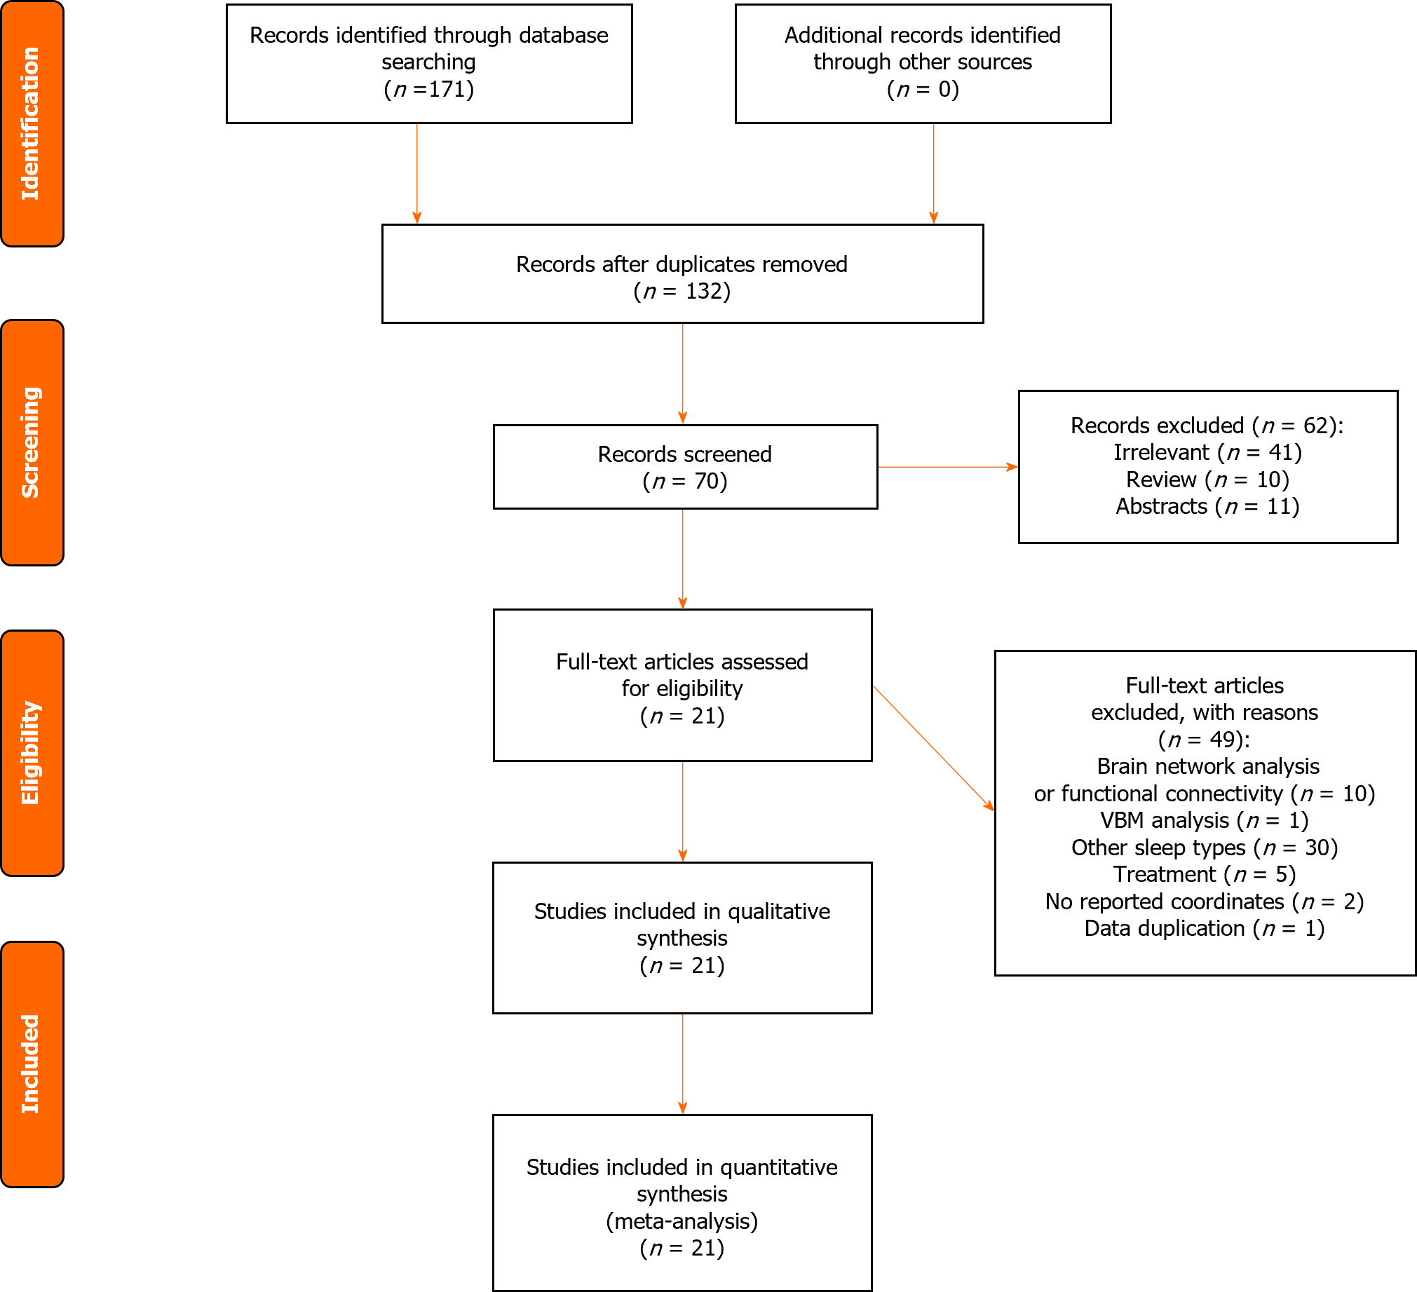
Figure 1 Flow chart of the study selection strategy. VBM: Voxel-based morphometry.
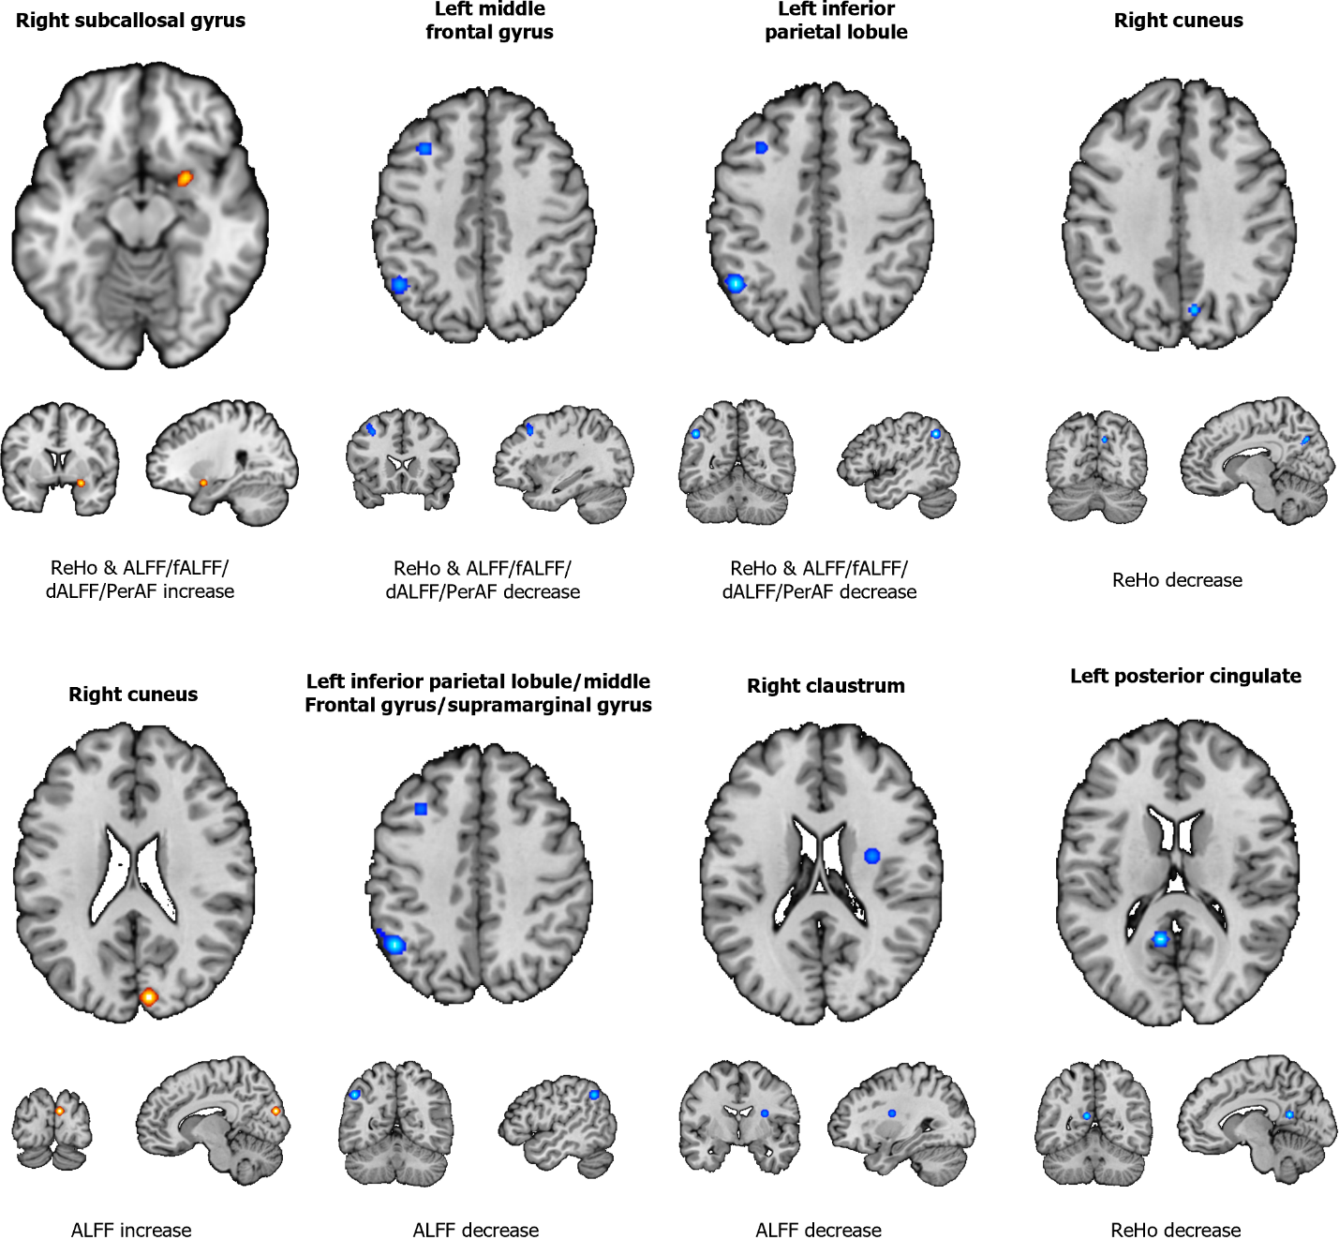
Figure 2 Abnormal regions identified in an activation likelihood estimation meta-analysis of neuroimaging studies in individuals with sleep deprivation. ReHo: Regional homogeneity; ALFF: Amplitude of low-frequency fluctuation; fALFF: Fraction amplitude of low-frequency fluctuation; dALFF: Dynamic amplitude of low-frequency fluctuation.
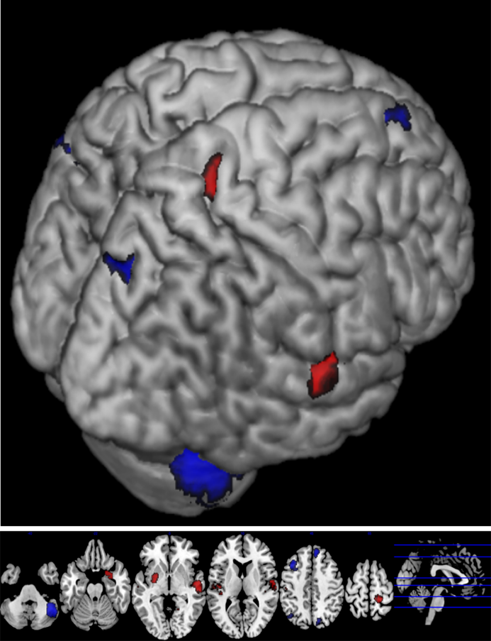
Figure 3 Abnormal regions identified in a signed differential mapping meta-analysis of neuroimaging studies of individuals with sleep deprivation.

Table 1 Characteristics of the included studies
Ref. | Sample size | Age (mean ± SD) | rs-fMRI scan | Field strength | Method | Differential brain region | Coordinate | Sample size | Quality
 |  |  | Before | After
Dai et al^{[19]}, 2012 | 16 | 21.00 | SW | SD 14 h | 3.0 T | ReHo | 7 | MNI | 4/1/1
Dai et al^{[20]}, 2012 | 15 | 22.00 ± 1.40 | SW | SD 24 h | 3.0 T | ReHo | 8 | MNI | 4/1/1
Gao et al^{[21]}, 2015 | 16 | 22.10 ± 0.80 | SW | SD | 3.0 T | ALFF | 9 | MNI | 4/1/1
Dai et al^{[22]}, 2015 | 12 | 24.83 ± 2.88 | SW | SD 72 h | 3.0 T | ALFF | 1 | MNI | 4/1/1
Wang et al^{[23]}, 2016 | 16 | 24.51 ± 2.75 | SW | SD | 3.0 T | ALFF | 5 | MNI | 4/1/1
Li et al^{[24]}, 2017 | 16 | 20.94 ± 1.73 | SW | SD 24 h | 3.0 T | ReHo | 15 | MNI | 4/1/1
Li et al^{[25]}, 2017 | 28 | 23.94 ± 1.73 | SW | SD 24 h | 3.0 T | ReHo | 13 | MNI | 4/1/1
Zhou et al^{[26]}, 2017 | 16 | 16.10 ± 0.90 | SW | SD 24 h | 3.0 T | ALFF | 5 | MNI | 4/1/1
Robinson et al^{[27]}, 2018 | 18 | 14.40 ± 1.94 | SW | SD | 7.0 T | ReHo | 10 | MNI | 4/1/1
Chen et al^{[28]}, 2018 | 22 | 26.901 ± 6.05 | SW | SD | 3.0 T | ALFF | 7 | MNI | 4/1/1
Feng et al^{[29,30]}, 2018 | 35 | 21.89 ± 1.97 | SW | SD 24 h | 3.0 T | zALFF & zReHo & fALFF¹ | 2 & 2 & 3 | MNI | 4/1/1
Guo et al^{[31]}, 2019 | 17 | 23.00 ± 1.37 | SW | SD | - | ALFF | 19 | MNI | 4/1/1
Nechifor et al^{[32]}, 2020 | 7 | 31.4 0 ± 5.70 | SW | SD 36 h | 3.0 T | fALFF | 4 | MNI | 4/1/1
Qiu et al^{[33]}, 2021 | 13 | 28.32 ± 3.71 | Control | SD | 3.0 T | ReHo | 8 | MNI | 4/1/1
Xu et al^{[34]}, 2021 | 54 | 22.46 ± 1.81 | Control | SD | 3.0 T | fALFF | 13 | MNI | 4/1/1
Zeng et al^{[35]}, 2020 | 20 | 22.25 ± 1.12 | SW | SD | 3.0 T | perAF | 5 | MNI | 4/1/1
Cai et al^{[36]}, 2021 | 42 | 21.57 ± 2.25 | SW | SD 24 h | 3.0 T | ALFF | 7 | MNI | 4/1/1
Nechifor et al^{[37]}, 2022 | 7 | 34.40 ± 5.70 | SW | SD 36 h | 3.0 T | ReHo | 1 | MNI | 4/1/1
Xin et al^{[38]}, 2022 | 54 | 22.46 ± 1.81 | SW | SD | 3.0 T | PerAF | 5 | MNI | 4/1/1
Yan et al^{[39]}, 2023 | 20 | 20.00 ± 0.80 | SW | SD | 3.0 T | dALFF | 30 | MNI | 4/1/1
Chen et al^{[40]}, 2023 | 19 | 21.79 ± 2.37 | SW | SD | 3.0 T | ReHo | 1 | MNI | 4/1/1
¹The study of Feng et al^{[29,30]} explored the same dataset using distinct methodologies.
ReHo: Regional homogeneity; ALFF: Amplitude of low-frequency fluctuation; fALFF: Fractional amplitude of low-frequency fluctuation; MNI: Montreal Neurological Institute; SW: Sleep-wake; SD: Sleep deprivation.
Table 2 Applying the activation likelihood estimation method to study changes in brain function activity after sleep deprivation
Research methods | Anatomical label BA | Peak MNI coordinate |  |  | ALE value | Volume (mm³)
 |  | X | Y | Z
ReHo and ALFF/fALFF decrease
 | Left middle frontal gyrus BA 6 | -34 | 20 | 42 | 0.01572180 | 1208
 | Left inferior parietal lobule BA 40 | -48 | -58 | 40 | 0.02166488 | 992
ReHo and ALFF/fALFF increase
 | Subcallosal gyrus BA 34 | 26 | 4 | -16 | 0.015194423 | 680
ALFF decrease
 | Left inferior parietal lobule BA 40 | -48 | -58 | 40 | 0.021612160 | 438
 | Left supramarginal gyrus BA 40 | -56 | -50 | 40 | 0.008252133 | 263
 | Left middle frontal gyrus BA 6 | -34 | 20 | 42 | 0.015355002 | 744
ALFF increase
 | Right cuneus BA 18 | 8 | -88 | 20 | 0.014324005 | 704
ReHo decrease
 | Left posterior cingulate BA 30 | -9 | -54 | 15 | 0.015816410 | 640
 | Right cuneus BA 7 | 9 | -72 | 36 | 0.009564294 | 448
BA: Brodmann area; MNI: Montreal Neurological Institute; ALE: Activation likelihood estimation.
Table 3 Changes in brain function activity after sleep deprivation using the signed differential mapping method
SDM | Anatomical label BA | Peak MNI coordinate |  |  | SDM-Z | P value | Voxels
 |  | X | Y | Z
Increase
 | Corpus callosum | 58 | -20 | 2 | 2.573 | 0.005037844 | 227
 | Left striatum | -28 | -4 | -2 | 2.087 | 0.018434286 | 19
 | Right postcentral gyrus BA 3 | 22 | -38 | 64 | 2.118 | 0.017078340 | 11
Decrease
 | Right cerebellum, crus 1 | 44 | -58 | -38 | -2.878 | 0.002000034 | 548
 | Left middle frontal gyrus, BA 9 | -38 | 18 | 48 | -2.508 | 0.006063104 | 75
 | Right cuneus cortex, BA 19 | 16 | -76 | 40 | -2.141 | 0.016148150 | 17
BA: Brodmann area; MNI: Montreal Neurological Institute; ALE: Activation likelihood estimation.

Table 4 Activation likelihood estimation sensitivity analysis results
Discarded article | Decreased |  | Increased
 | Left middle frontal gyrus | Left inferior parietal lobule | Right subcallosal gyrus
Yan et al^{[39]}, 2023 | N | Y | N
Chen et al^{[40]}, 2023 | Y | Y | Y
Nechifor et al^{[37]}, 2022 | Y | Y | Y
Zeng et al^{[35]}, 2020 | Y | Y | Y
Li et al^{[25]}, 2017 | Y | Y | Y
Nechifor et al^{[32]}, 2020 | Y | Y | Y
Guo et al^{[31]}, 2019 | N | N | Y
Robinson et al^{[27]}, 2018 | N | N | N
Chen et al^{[28]}, 2018 | N | N | N
Wang et al^{[23]}, 2016 | Y | Y | Y
Gao et al^{[21]}, 2015 | Y | Y | Y
Dai et al^{[22]}, 2015 | Y | Y | Y
Dai et al^{[19]}, 2012 | Y | Y | Y
Dai et al^{[20]}, 2012 | Y | Y | Y
Xin et al^{[38]}, 2022 | Y | Y | Y
Zhou et al^{[26]}, 2017 | Y | Y | Y
Qiu et al^{[33]} 2021 | Y | Y | Y
Xu et al^{[34]} 2021 | Y | Y | Y
Li et al^{[24]}, 2017 | Y | Y | Y
Li et al^{[25]}, 2017 | Y | Y | Y
Feng et al^{[29,30]}, 2018 | Y | Y | Y
Y: Yes; N: No.
Table 5 Signed differential mapping sensitivity analysis results
Discarded article | Decreased |  |  |  | Increased
 | Right cerebellum, crus | Left middle frontal gyrus | Corpus callosum | Right cuneus cortex | Right postcentral gyrus | Left striatum | Corpus callosum
Yan et al^{[39]}, 2023 | Y | Y | Y | Y | N | Y | Y
Chen et al^{[40]}, 2023 | N | Y | Y | Y | Y | Y | Y
Nechifor et al^{[37]}, 2022 | Y | Y | Y | Y | Y | Y | N
Zeng et al^{[35]}, 2020 | Y | Y | Y | Y | Y | Y | Y
Li et al^{[25]}, 2017 | Y | Y | Y | N | Y | Y | Y
Nechifor et al^{[32]}, 2020 | N | Y | Y | Y | N | N | Y
Guo et al^{[31]}, 2019 | Y | Y | Y | Y | Y | Y | N
Robinson et al^{[27]}, 2018 | Y | Y | Y | Y | Y | Y | Y
Chen et al^{[28]}, 2018 | Y | N | Y | Y | Y | Y | Y
Wang et al^{[23]}, 2016 | Y | Y | Y | Y | Y | Y | Y
Gao et al^{[21]}, 2015 | Y | Y | N | Y | Y | N | Y
Dai et al^{[22]}, 2015 | N | N | Y | Y | N | Y | Y
Dai et al^{[19]}, 2012 | Y | Y | Y | Y | Y | Y | Y
Dai et al^{[20]}, 2012 | Y | Y | Y | Y | Y | Y | Y
Xin et al^{[38]}, 2022 | Y | Y | Y | Y | Y | Y | Y
Zhou et al^{[26]}, 2017 | N | Y | N | Y | Y | Y | Y
Qiu et al^{[33]} 2021 | Y | Y | Y | Y | Y | Y | Y
Xu et al^{[34]} 2021 | Y | Y | Y | N | Y | Y | Y
Li et al^{[24]}, 2017 | N | Y | Y | N | Y | Y | N
Li et al^{[25]}, 2017 | Y | Y | N | Y | N | Y | Y
Feng et al^{[29,30]}, 2018 | Y | Y | Y | N | Y | Y | Y
Y: Yes; N: No.

Published by Baishideng Publishing Group Inc
7041 Koll Center Parkway, Suite 160, Pleasanton, CA 94566, USA
Telephone: +1-925-3991568
E-mail: office@baishideng.com
Help Desk: https://www.f6publishing.com/helpdesk
https://www.wjgnet.com

© 2024 Baishideng Publishing Group Inc. All rights reserved.

