Name of journal: World Journal of Gastrointestinal Surgery
ESPS Manuscript NO: 19313
Columns: Original Article

Prospective Study
Laying open (deroofing) and curettage under local anesthesia for pilonidal disease: An outpatient procedure

Garg P et al. LOCULA procedure for pilonidal sinus

Pankaj Garg, Mahak Garg, Vikas Gupta, Sudkirkumar Mehta, Paryush Lakhtaria

Pankaj Garg, Mahak Garg, Sudkir kumar Mehta, Department of Colorectal Surgery, Garg Fistula Research Institute, Panchkula, Haryana 134113, India

Pankaj Garg, Mahak Garg, Department of Colorectal Surgery, Indus Super Specialty Hospital, Mohali 160055, Punjab, India

Vikas Gupta, Department of General Surgery, Post Graduate Institute of Medical Education and Research, Chandigarh 160012, India

Paryush Lakhtaria, Department of Colorectal Surgery, New York Hospital Medical Centre of Queens, Colorectal Surgery, New York, NY 10461, United States

Author contributions: Garg P thought of the concept, Garg P, Garg M, Gupta V, Mehta SK and Lakhtaria P designed the study, acquired the data, analyzed it, drafted, revised and finally approved the draft, Garg P submitted the manuscript.

Institutional review board statement: The study was reviewed and approved by the Indus Hospital Ethical Committee.

Informed consent statement: All study participants, or their legal guardian, provided informed written consent prior to study enrollment.

Conflict-of-interest statement: None of the authors have received fees for serving as a speaker or as a position [such as consultant and/or an advisory board member] which could have a conflict of interest with this study. None of the authors have received research funding from any organization or individual. None of the authors is an employee of an organization, or owns stocks and/or shares in name of an organization which has potential conflict of interest with the study.

Data sharing statement: Technical appendix, statistical code, and dataset available from the corresponding author at drgargpankaj@yahoo.com. No consent was not obtained but the presented data are anonymized and risk of identification is low.

Open-Access: This article is an open-access article which was selected by an in-house editor and fully peer-reviewed by external reviewers. It is distributed in accordance with the Creative Commons Attribution Non Commercial (CC BY-NC 4.0) license, which permits others to distribute, remix, adapt, build upon this work non-commercially, and license their derivative works on different terms, provided the original work is properly cited and the use is non-commercial. See: http://creativecommons.org/licenses/by-nc/4.0/

Correspondence to: Dr. Pankaj Garg, Department of Colorectal Surgery, Garg Fistula Research Institute, Sector-15, Panchkula, Haryana 134113, India. drgargpankaj@yahoo.com
Telephone: +91-950-1011000
Fax: +91-172-2594556

Received: May 4, 2015
Peer-review started: May 5, 2015
First decision: June 3, 2015
Revised: June 10, 2015
Accepted: July 21, 2015
Article in press:
Published online:

Abstract
AIM: To test the efficacy of lay open (deroofing, not excision) with curettage under local anesthesia (LOCULA) for pilonidal sinus as an outpatient procedure

METHODS: LOCULA procedure was done for all types of pilonidal disease. The primary outcome measure was cure rate. The secondary outcome measures were hospital stay, operating time, return to work, healing time and complication rate.

RESULTS: Thirty-three (M/F–30/3, mean age-23.4 ± 5.8 years) consecutive patients were operated and followed for 24 months (6-46 months). Eleven were pilonidal abscess and 22 were chronic pilonidal disease. Six had recurrent disease. Operating time and the hospital stay was 22.3 ± 5.6 min and 63.8 ± 22.3 min respectively. The patients could resume normal work in 4.3 ± 3.2 d and the healing time was 42.9 ± 8.1 d. Thirty (93.8%) patients had complete resolution of the disease and two (6.2%) had a recurrence. Both the recurrences happened in patients who had complete healing but ignored the prescribed recommendations. One out of these got cured after operated again with the same procedure. Thus the overall success rate of this procedure was 96.9%.

CONCLUSION: Lay open (deroofing) with curettage procedure under local anesthesia is an effective procedure to treat both simple and complicated pilonidal sinus & abscess. It is a simple procedure, has a high cure rate (up to 97%), doesn’t require admission and is associated with minimal morbidity and scarring. Considering the distinct advantages, this procedure has the potential to become the first line procedure for treating pilonidal disease.

Key words: Pilonidal; Lay open; Deroofing; Curettage; Sinus

© The Author(s) 2015. Published by Baishideng Publishing Group Inc. All rights reserved.

Core tip: This study demonstrates that lay open with curettage under local anesthesia is a simple procedure to treat simple and complicated pilonidal disease. It is quite effective with high cure rate and can be done as an outpatient procedure. Apart from this, this procedure has distinct advantages- can be learnt easily, less time to operate, almost pain free, back to work faster, minimum incision, simple dressings after operation, small scar, minimal change in body shape, economically better and easy to repeat after a recurrence. This procedure can potentially become the frontline operation for all types of pilonidal disease.

Garg P, Garg M, Gupta V, Mehta S, Lakhtaria P. Laying open (deroofing) and curettage under local anesthesia for pilonidal disease: An outpatient procedure. World J Gastrointest Surg 2015; In press

INTRODUCTION
“Pilonidal sinus” as a term was first used in the year 1880^{[1]}. Though Mayo described this disease in detail in 1833, its optimal treatment is debated even today^{[2]}. Several procedures have been described for pilonidal disease. Acute abscess had been treated by incision and drainage^{[3]}. Chronic disease is usually treated by wide excision. After excising, the wound may be left open so that it heals with granulation tissue^{[4]}, or the wound may be closed on the operating table. The latter may be a midline closure^{[5]} or usage of a flap - Z-palsty^{[6]}, Karydakis flap^{[7]}, Bascom flap^{[8]} and Limberg flap^{[9]}. The principle behind these extensive procedures had been to remove all the diseased portion and to close the wound away from the midline^{[10,11]}. However, these excisional procedures lead to extensive incisions and removal of skin, large wounds and thereby increase morbidity. In spite of increased morbidity, the recurrence rate also didn’t necessarily come down after these extensive procedures^{[12-14]}.
Laying open of pilonidal sinus and curettage of tract under local anesthesia (LOCULA) procedure is a simple procedure to mange pilonidal sinus^{[15,16]}. Though this procedure has been described in the past yet no study has determined the feasibility and efficacy of this procedure done under local anesthesia as an office procedure.
We performed a prospective study between 2011 and 2014 to analyze the benefits and drawbacks of this procedure in all types of pilonidal disease - acute (abscess), chronic simple and complicated (recurrent, multiple tracts, etc.).

MATERIALS AND METHODS
Study population
In the period between January 2011 and July 2014, all the consecutive patients of pilonidal sinus (simple as well as complicated) were included in the study prospectively. The inclusion criteria were: Patients with chronic simple pilonidal sinus, patients having recurring disease and pilonidal disease having an associated abscess. All patients gave consent in writing in the language they understood. The hospital ethics committee approved the study protocol. All the operations were performed by a single surgeon (first author).

Surgical procedure
No preoperative preparation was done. All the procedures were done on an outpatient basis under local anesthesia and no hospital admission was done. No patient required general or spinal anesthesia. During operation, the patient was placed in a prone position. An adhesive tape was used to separate the buttocks so that proper exposure of the diseased area could be obtained. The solution of Povidine iodine was used to disinfect the operative area.
The sinus opening was probed gently to gauze the direction and length of the tract (Figure 1). The local anesthetic agent (2% Lignocaine with Adrenaline 0.005%) was infiltrated around the opening and along the tract/tracts (Figure 1). The anesthetic agent was kept ready in case the tracts were found to be longer than expected or any side tract was encountered. The tracts were identified with the help of mosquito (small artery) forceps and were laid open (Figure 1). If there were more than one tracts, then all the tracts were opened at the same time. All the hairs and debris were removed from the tracts (Figure 1) and all the granulation tissue was removed by rubbing with a dry gauze or with a curette. The skin edges were trimmed. The wound was checked thoroughly for any extensions or side/downward branches. The lateral wall and the base of the sinus were left intact and no marsupialization was done. The bleeding points were electrocauterized and haemostasis achieved. The wound was packed tightly with a povidone iodine soaked gauze.
The patient walked off to the recovery room and waited there for an hour. After this, the dressing was checked for any active bleeding and the patient was sent back home with instructions to resume daily routine. However, he/she was instructed to avoid strenuous work. Oral antibiotic (Cefixime 200 mg twice a day) and analgesic (Aciclofenac 500 mg) were prescribed twice a day for five days.

Follow-up
All the patients were examined on the next day of operation. The dressing was taken off, the wound gently rubbed with a dry gauze and then lightly packed with a povidine iodine soaked gauze. The process was explained to the relative and the latter was made to do the same under our supervision. After this, the patient’s relative was instructed to clean the operated area as required (once or twice a day) and the patient was encouraged to resume his normal work as soon as possible. The patient was followed up on weekly basis till the wound healed completely.
After the wound healed completely, the patient was instructed to keep three centimeters area all around the wound free of hair till he/she reached the age of thirty years. He/she was also advised to put powder in the intergluteal cleft for the same period. (India is a hot and humid country and increased sweating and moistness in the intergluteal region was reported by all our patients. We suspected this to be one of the contributing reason). The patient was told to report back in case of any swelling, pain or pus discharge from the operated area.

RESULTS
The various characteristics of the patients are summarized in Table 1. Thirty three (33) consecutive patients were prospectively recruited over a three and a half years period. The patients were followed for 21 mo (median, range: 3-43 mo). One patient was lost to follow up. The age of the patients ranged from 16 to 39 years (mean-23.4 ± 5.8) and the sex ratio-M/F - 30/3. Eleven were pilonidal abscess and 22 were chronic pilonidal disease. Six had recurrent disease. The operating time was 22.3 ± 5.6 min and the hospital stay after the operation was 63.8 ± 22.3 min. The patients were able to resume their normal work in 4.3 ± 3.2 d and the healing time was 42.9 ± 8.1 d. Thirty (93.8%) patients had complete resolution of the disease and two (6.2%) had a recurrence (Table 2). Both the recurrences happened in the patients who didn’t adhere to the prescribed recommendations after the complete healing. One patient with a recurrence was operated again with the same procedure and he got cured. The second patient was lost to follow up. Thus the overall cure rate was 96.9%. One patient had a bleeding six days after the operation. She was managed conservatively in the outpatient clinic and the wound got healed subsequently.

DISCUSSION
In this study, the laying open (deroofing) with curettage of the cavity under local anesthesia (LOCULA) was done on an outpatient basis in 33 patients with 96.9% success rate. All types of pilonidal sinus patients, simple and complicated (recurrent, abscess & multiple tracts) were included in the study. This is perhaps the first study in the literature which demonstrated that this simple procedure was highly effective (low recurrence rate) and could be done on outpatient basis without the need for hospital admission. This was possible because LOCULA could be done under local anesthesia. None of the patient required general or regional anesthesia. This makes it quite cost effective as well. The morbidity was minimal as the procedure was done under local anesthesia on an outpatient basis (all the patients left the hospital within one and a half hour after the procedure) and could resume their normal routine within a week (mean-4.3 d). The recurrence happened in only two (6.2%) patients and one of them underwent the same procedure and got cured. The recurrence also happened in those patients who didn’t follow the post-operative instructions (to regularly clean the area of hair).The only drawback seen in this procedure was slightly longer healing time (6 wk). But this delayed healing time did not interfere with the normal routine and resumption of work, hence didn’t much bother the patient.
During the operation, no attempt was made to excise the sinus. Only laying open (deroofing) was done and some trimming of the lateral walls was done to prevent adhesions and ensure healing by secondary intention. This made the procedure simple, took less time, led to minimal bleeding and resulted in a small wound. The postoperative pain was very less and the wound care was least demanding.
Though lay open with curettage procedure had shown to be effective in the past^{[15,16]}, yet it could not become the preferred procedure for treating pilonidal disease. One of the reasons could be that this procedure is perhaps confused with another procedure- drainage of acute abscess in pilonidal disease after simply incising it (without curetting the tracts and the cavity). The latter procedure was associated with a recurrence rate of up to 24%^{[3,17-19]}. However, when the cavity was curetted along with the drainage, the recurrence rate reduced significantly. In a large study (150 patients) with long follow-up (65 mo), Vahedian et al^{[19]} compared the success rate of only drainage procedure vs laying open with curettage and found that the cure rate in these procedures differed significantly (simple drainage - 46%, curettage - 90%). This is not difficult to understand because when the wound is thoroughly curetted, all the debris, hairs and granulation tissue are removed and any side braches/extensions are easily identified. The latter can then be laid opened and curetted.
To conclude, LOCULA (lay open with curettage under local anesthesia) is a simple procedure to treat simple and complicated pilonidal disease. It is quite effective with high cure rate and can be done as an outpatient procedure. Apart from this, this procedure has distinct advantages- can be learnt easily, less time to operate, almost pain free, back to work faster, minimum incision, simple dressings after operation, small scar, minimal change in body shape, economically better and easy to repeat after a recurrence. This procedure can potentially become the gold standard operation for all types of pilonidal disease. The only slight drawback is slightly longer healing time but this aspect doesn’t much bother patients as they can carry out their normal chores during the dressing period.

COMMENTS
Background
Pilonidal sinus is a notorious disease in which a tract (sinus) is formed in the lower back inside which there is a collection of hairs. This usually happens in sedentary, sweaty, slightly obese, hairy young males. This disease is characterized by regular pus formation and is notorious for recurrence after the operation.

Research frontiers
As of today, chronic disease is usually treated by wide excision. After excising, the wound may be left open so that it heals with granulation tissue^{[4]}, or the wound may be closed on the operating table. The latter may be a midline closure or usage of a flap - Z-palsty, Karydakis flap, Bascom flap and Limberg flap. However these extensive big operative procedures require administration of spinal or general anesthesia, hospital admission for 2-3 d and bed rest for 5-10 d. The resumption of normal work can take up to 4-6 wk. In spite of all this, the recurrence rate also is also 4%-10% after these extensive procedures.

Innovations and breakthroughs
This is the first study which demonstrates that a simple procedure (lay open with curettage) can treat simple and complicated pilonidal disease in an effective manner. This procedure can be done as an outpatient procedure without needing any hospital admission. Therefore, no hospital admission is required. Apart from this, this procedure has distinct advantages- can be learnt easily, less time to operate, almost pain free, back to work faster, minimum incision, simple dressings after operation, small scar, minimal change in body shape, economically better and easy to repeat after a recurrence.

Applications
As this simple procedure has so many distinct advantages over all other preferred procedures, this procedure can potentially become the frontline operation for all types of pilonidal disease.

Terminology
Pilonidal sinus- a tract or a sinus in the lower back in which a cluster of hairs go in leading to recurrent infection and pus formation. Excisional procedures- operations in which the sinus is removed by operation taking a big margin all around which results in a large wound.

Peer-review
1This study presented a novel procedure to treat simple & complicated pilonidal disease. The data was full and accurate. And the authors present a study on a modified approach to the operative treatment of pilonidal sinus disease. It’s an interesting and simple surgical procedure with good short-term results.

REFERENCES
1 Hodges RM. Pilonidal sinus. Boston Med Surg J 1880; 103: 485-486 [DOI: 10.1056/NEJM188011181032101]
2 Mayo O. Observations on injuries and diseases of the rectum. London: Burgess and Hill, 1833
3 Jensen SL, Harling H. Prognosis after simple incision and drainage for a first-episode acute pilonidal abscess. Br J Surg 1988; 75: 60-61 [PMID: 3337954 DOI: 10.1002/bjs.1800750122]
4 Testini M, Piccinni G, Miniello S, Di Venere B, Lissidini G, Nicolardi V, Bonomo GM. Treatment of chronic pilonidal sinus with local anaesthesia: a randomized trial of closed compared with open technique. Colorectal Dis 2001; 3: 427-430 [PMID: 12790943 DOI: 10.1046/j.1463-1318.2001.00278.x]
5 Bissett IP, Isbister WH. The management of patients with pilonidal disease--a comparative study. Aust N Z J Surg 1987; 57: 939-942 [PMID: 3439938 DOI: 10.1111/j.1445-2197.1987.tb01298.x]
6 Monro RS, Mcdermott FT. The elimination of causal factors in pilonidal sinus treated by Z-Plasty. Br J Surg 1965; 52: 177-181 [PMID: 14261120 DOI: 10.1002/bjs.1800520306]
7 Karydakis GE. New approach to the problem of pilonidal sinus. Lancet 1973; 2: 1414-1415 [PMID: 4128725 DOI: 10.1016/S0140-6736(73)92803-1]
8 Bascom J, Bascom T. Utility of the cleft lift procedure in refractory pilonidal disease. Am J Surg 2007; 193: 606-609; discussion 609 [PMID: 17434365 DOI: 10.1016/j.amjsurg.2007.01.008]
9 Bozkurt MK, Tezel E. Management of pilonidal sinus with the Limberg flap. Dis Colon Rectum 1998; 41: 775-777 [PMID: 9645748 DOI: 10.1007/BF02236268]
10 McCallum I, King PM, Bruce J. Healing by primary versus secondary intention after surgical treatment for pilonidal sinus. Cochrane Database Syst Rev 2007; (4): CD006213 [PMID: 17943897 DOI: 10.1002/14651858.cd006213.pub2]
11 McCallum IJ, King PM, Bruce J. Healing by primary closure versus open healing after surgery for pilonidal sinus: systematic review and meta-analysis. BMJ 2008; 336: 868-871 [PMID: 18390914 DOI: 10.1136/bmj.39517.808160.BE]
12 Gencosmanoglu R, Inceoglu R. Modified lay-open (incision, curettage, partial lateral wall excision and marsupialization) versus total excision with primary closure in the treatment of chronic sacrococcygeal pilonidal sinus: a prospective, randomized clinical trial with a complete two-year follow-up. Int J Colorectal Dis 2005; 20: 415-422 [PMID: 15714292 DOI: 10.1007/s00384-004-0710-5]
13 Karakayali F, Karagulle E, Karabulut Z, Oksuz E, Moray G, Haberal M. Unroofing and marsupialization vs. rhomboid excision and Limberg flap in pilonidal disease: a prospective, randomized, clinical trial. Dis Colon Rectum 2009; 52: 496-502 [PMID: 19333052 DOI: 10.1007/DCR.0b013e31819a3ec0]
14 Lorant T, Ribbe I, Mahteme H, Gustafsson UM, Graf W. Sinus excision and primary closure versus laying open in pilonidal disease: a prospective randomized trial. Dis Colon Rectum 2011; 54: 300-305 [PMID: 21304300 DOI: 10.1007/DCR.0b013e31820246bf]
15 Kepenekci I, Demirkan A, Celasin H, Gecim IE. Unroofing and curettage for the treatment of acute and chronic pilonidal disease. World J Surg 2010; 34: 153-157 [PMID: 19820992 DOI: 10.1007/s00268-009-0245-6]
16 Al-Homoud SJ, Habib ZS, Abdul Jabbar AS, Isbister WH. Management of sacrococcygeal pilonidal disease. Saudi Med J 2001; 22: 762-764 [PMID: 11590447]
17 Matter I, Kunin J, Schein M, Eldar S. Total excision versus non-resectional methods in the treatment of acute and chronic pilonidal disease. Br J Surg 1995; 82: 752-753 [PMID: 7627503 DOI: 10.1002/bjs.1800820612]
18 Allen-Mersh TG. Pilonidal sinus: finding the right track for treatment. Br J Surg 1990; 77: 123-132 [PMID: 2180534 DOI: 10.1002/bjs.1800770203]
19 Vahedian J, Nabavizadeh F, Nakhaee N, Vahedian M, Sadeghpour A. Comparison between drainage and curettage in the treatment of acute pilonidal abscess. Saudi Med J 2005; 26: 553-555 [PMID: 15900358]

P-Reviewer: Scheidbach H, Wang JS S-Editor: Tian YL
L-Editor: E-Editor:

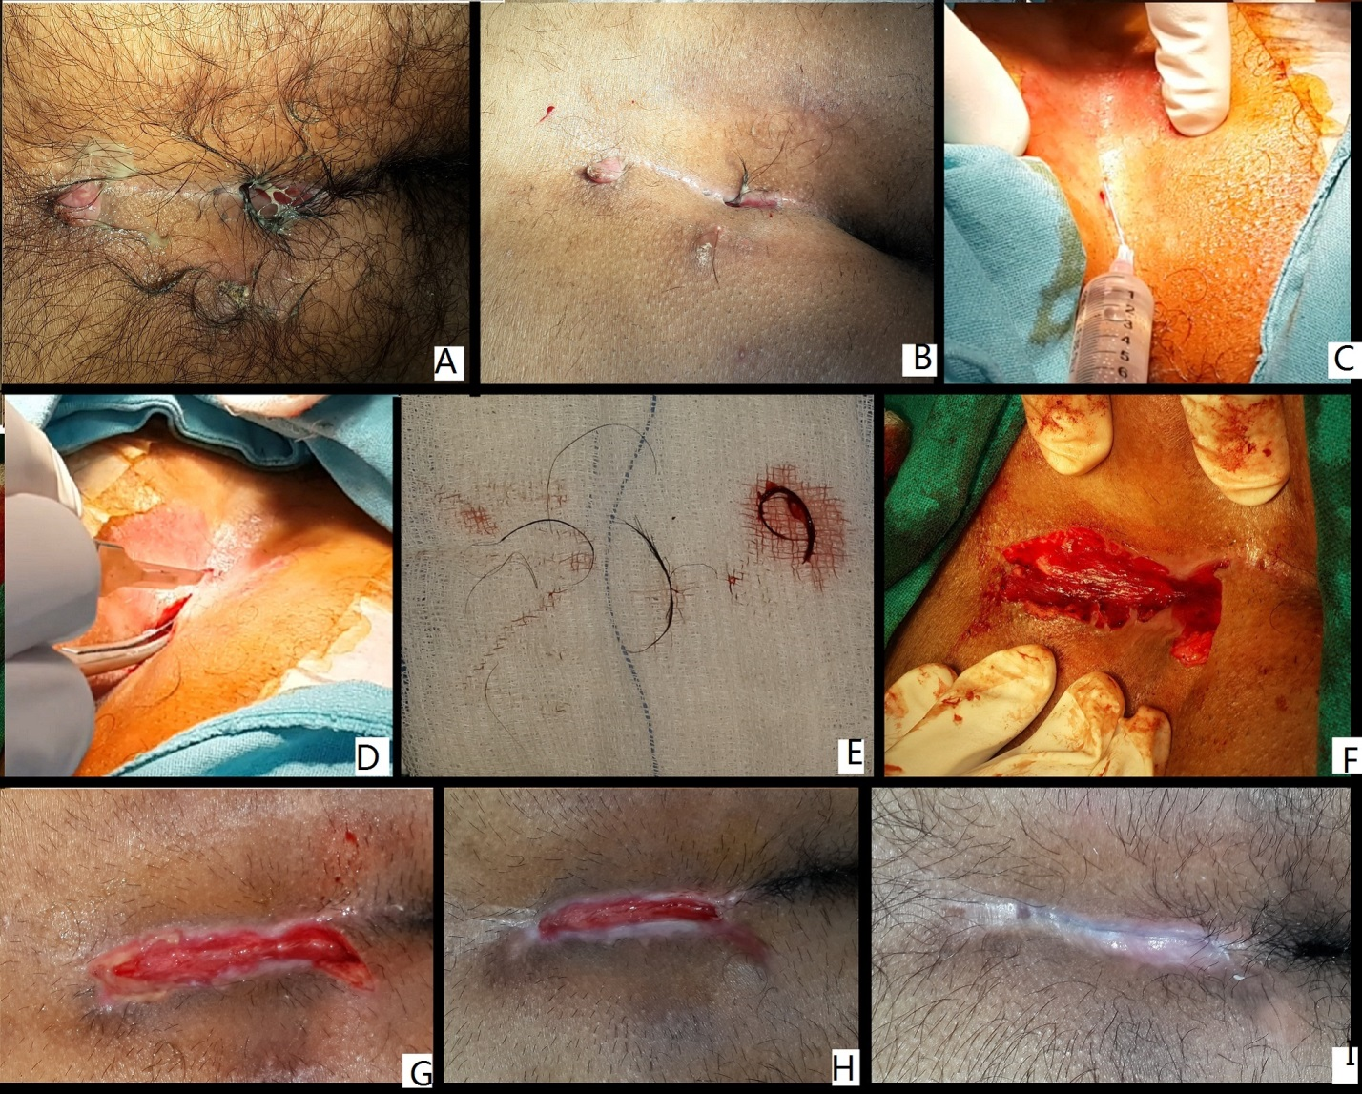
Figure 1 Lay open plus curettage under local anesthesia procedure for pilonidal disease. A: Preoperative photo without preparation; B: Preoperative photo after preparation; C: Infiltration of local anesthesia; D: Laying open after inserting an artery forceps in the sinus; E: Hairs and debris removed from the sinus; F: Immediate post-operative; G: One week postoperative; H: 3 wk post-operative; I: Completely healed wound - 6 wk postoperative.

Table 1 Demographic data and characteristics of the patients
Parameter | n = 33
Age | 23.4 ± 5.8 yr
Sex(M/F) | 30/3
Anesthesia | Local anesthesia
Inclusion criteria | Chronic, recurrent, abscess
Exclusion criteria | Refused consent
Recurrent | 6 (18.2%)
Abscess | 11 (33%)

Table 2 Results about the recurrences of the patients
Parameter | n = 33
Operating time | 22.3 ± 5.6 min
Hospital stay | 63.8 ± 22.3 min
Resume normal work | 4.3 ± 3.2 d
Healing time | 42.9 ± 8.1 d
Recurrence | 6.2%
Complications | 3.1%

