Name of Journal: World Journal of Virology
ESPS Manuscript NO: 22039
Manuscript Type: ORIGINAL ARTICLE

Observational Study
Neuropathology of JC virus infection in progressive multifocal leukoencephalopathy in remission

Santa Cruz KS et al. Neuropathology of PML remission

Karen S Santa Cruz, Gulmohor Roy, James Spigel, Elaine L Bearer

Karen S Santa Cruz, Elaine L Bearer, Department of Pathology, University of New Mexico, University of New Mexico Health Sciences Center, Albuquerque, NM 87131, United States

Gulmohor Roy, Department of Neurology, University of California, Irvine, CA 92697, United States

James Spigel, Department of Pathology, Presbyterian Hospital, Albuquerque, NM 87110, United States

Author contributions: Santa Cruz KS is a neuropathologist who reviewed all histopathology and determined the diagnosis, captured the histological images and helped to write the MS; Roy G was a resident in training who reviewed the medical chart and drafted and edited the MS; Spigel J performed the autopsy, contributed and edited clinical data and reviewed the MS; Bearer EL is an experimental neuropathologist who reviewed the pathology, wrote the MS, added the references, selected the images, prepared the figures and replied to reviewers’ comments.

Supported by The Harvey Family Endowment; and by NIH RO1 MH087660 (ELB).
Institutional review board statement: The Institutional review board of University of New Mexico finds IRB approval not applicable for post-mortem case reports.

Informed consent statement: Consent for post-mortem examination was obtained from the family.

Conflict-of-interest statement: The authors have no conflict of interest to report.

Data sharing statement: All blocks and slides from this report are available upon request to the corresponding author according to the policies of the pathology department at UNM.

Open-Access: This article is an open-access article which was selected by an in-house editor and fully peer-reviewed by external reviewers. It is distributed in accordance with the Creative Commons Attribution Non Commercial (CC BY-NC 4.0) license, which permits others to distribute, remix, adapt, build upon this work non-commercially, and license their derivative works on different terms, provided the original work is properly cited and the use is non-commercial. See: http://creativecommons.org/licenses/by-nc/4.0/

Correspondence to: Elaine L Bearer, Associate Professor, Department of Pathology, University of New Mexico, University of New Mexico Health Sciences Center, UNM Hospital (MSC08 4640), Albuquerque, NM 87131, United States. ebearer@salud.unm.edu
Telephone: +1-505-2722404
Fax: +1-505-2728084

Received: August 7, 2015
Peer-review started: August 11, 2015
First decision: September 22, 2015
Revised: October 14, 2015
Accepted: December 13, 2015
Article in press:
Published online:

Abstract
AIM: To investigate the neuropathology of the brain in a rare case of remission following diagnosis of progressive multifocal leukoencephalopathy (PML).

METHODS: Consent from the family for an autopsy was obtained, clinical records and radiograms were retrieved. A complete autopsy was performed, with brain examination after fixation and coronal sectioning at 1 cm intervals. Fourteen regions were collected for paraffin embedding and staining for microscopic analysis. Histologic sections were stained with Luxol blue, hematoxylin/eosin, and immunostained for myelin basic protein, neurofilament, SV40 T antigen and p53. The biopsy material was also retrieved and sections were stained with hematoxylin/eosin and immunostained for SV40 and p53. Sections were examined by American Board of Pathology certified pathologists and images captured digitally.

RESULTS: Review of the clinical records was notable for a history of ulcerative colitis resulting in total colectomy in 1977 and a liver transplant in 1998 followed by immune-suppressive therapy. Neurological symptoms presented immediately, therefore a biopsy was obtained which was diagnosed as PML. Immunotherapy was adjusted and clinical improvement was noted. No subsequent progression was reported. Review of the biopsy demonstrated atypical astrocytes and enlarged hyperchromatic oligodendroglial cells consistent with JC virus infection. Strong SV40 and p53 staining was found in glial cells and regions of dense macrophage infiltration were present. On gross examination of the post-mortem brain, a lesion in the same site as the original biopsy in the cerebellum was identified but no other lesions in the brain were found. Microscopic analysis of this cerebellar lesion revealed a loss of myelin and axons, and evidence of axonal damage. This single burned-out lesion was equivocally positive for SV40 antigen with little p53 staining. Examination of thirteen other brain regions found no other occult sites.
CONCLUSION: Our study reveals residual damage, rare macrophages or other inflammation and minimal evidence of persistent virus. This case demonstrates the possibility of complete remission of PML.

Key words: Progressive multifocal leukoencephalopathy; JC virus; Remission; Demyelinating

© The Author(s) 2015. Published by Baishideng Publishing Group Inc. All rights reserved.

Core tip: Progressive multifocal leukoencephalopathy after organ transplant is rapidly fatal in most cases, with an average time to death of 6.4 mo. We report a case with no clinical progression over 13 years despite on-going immunosuppressive therapy. At initial diagnosis the biopsy demonstrated classic histopathological features of JC virus. At autopsy, microscopic analysis of the cerebellar lesion revealed a residual loss of myelin and evidence of axonal damage without evidence of viral activity. These results suggest that JC virus can be kept in check even in a setting of immunesuppression, and argue for more investigation into the microbiome of the brain.

Santa Cruz KS, Roy G, Spigel J, Bearer EL. Neuropathology of JC virus infection in progressive multifocal leukoencephalopathy in remission. World J Virol 2015; In press

INTRODUCTION
Progressive multifocal leukoencephalopathy (PML) is a demyelinating disease of the central nervous system caused by reactivation of latent JC virus in immuno-compromised individuals. Oligodendroglial cells are preferentially infected with consequent loss of myelin and coalescing demyelination plaques, sometimes leading to mild-to-moderate axonal loss associated with axonal spheroids. Long-term survival in patients with PML is increasingly common in HIV-infected people treated with highly active anti-retroviral therapy (HAART)^{[1-8]}. In contrast, prolonged survival in patients with immuno-suppression following solid organ transplant is unusual^{[9,10]}. Here we present an unusual case in which there was a 13-year clinical remission after biopsy-proven PML, despite continued immuno-suppression after liver transplant.
PML had been universally fatal, usually within 6 mo, until the late 1990’s. Although no specific treatment has proven particularly effective, enhancing natural immunity by reducing the effects of HIV virus or by altering immunosuppressant therapy has been shown to improve survival^{[11]}. One explanation for prolonged survival is improved cellular immune responses against JC virus (JCV) in long term survivors versus those with poor outcomes^{[12]}. Detectable cytotoxic T lymphocytes (CTL) specific for JCV -T or VP-1 have been shown to be a prognostic indicator of long-term survival in HIV patients^{[12]}. Although long-term survival in immuno-suppressed transplant patients has been described^{[13,14]} these cases are unusual^{[9]} and detailed neuropathologic descriptions of residual demyelinating plaques in patients in complete remission are few, possibly because they are very rare or not frequently examined post-mortem^{[15]}. This study therefore fills an important gap in our knowledge of pathological processes that appear in long-term survival.

MATERIALS AND METHODS
Consent for the autopsy from the family was obtained as approved by Presbyterian Hospital. According to Internal Review Board of University of New Mexico Health Sciences Center neither post-mortem material nor case reports require IRB approvals. Clinical records were retrieved, and the clinical history together with results of all brain imaging studies that had been performed at UNM (12/2006 and 4/2008) reviewed. The original imaging studies were not available, and, in the absence of neurological symptomatology, imaging and CSF sampling were not performed during the final hospitalization, nor was post-mortem brain imaging done.
A complete autopsy was performed with subsequent examination of the brain after fixation. Gross examination of the brain included coronal sectioning of the neocortex at 1 cm intervals, and sectioning of the cerebellum and brainstem at 0.5 cm intervals. The surface of each slice was examined. Thirteen brain regions were selected, slabs 1.5 cm × 1.5 cm × 0.1 cm dissected and these were submitted for paraffin embedding. Histologic sections were stained with Luxol blue, hematoxylin/eosin, and for myelin basic protein (Dako, polyclonal rabbit anti-human), neurofilament (Dako, Clone 2F11), SV40 T antigen (Calbiochem, Ab-2, PAb 416) or p53 (Dako, Clone DO7) by immunohistochemistry at TriCore Reference Laboratories, Albuquerque, NM. The SV40 T-antigen (Ab-2) antibody is a mouse monoclonal antibody with specific determinants unique to the SV40 large T antigen and non-reactive with the small T antigen. The antigenic epitope is between Ile83 and Lys128 of the SV40 large T antigen, a region highly homologous to the JC virus large T antigen. For each immunostain, positive and negative controls were run in parallel. The paraffin block containing the biopsy was retrieved together with its slides from archives, new sections were made and also stained for SV40 and p53. Sections were examined on an Olympus BX40 microscope using 4×, 10×, 20× and 40× objectives, and digital images captured on an Olympus DP26 camera using cellSens Standard software. Images were prepared for figures using Adobe Photoshop to resize, create multi-image panels, adjust levels and add lettering.

RESULTS
Case history
A 76-year-old woman with a history of ulcerative colitis had a total colectomy in 1977 and subsequently developed sclerosing cholangitis. She received an orthotopic liver transplant in 1998. In 1999 neurological symptoms occurred, primarily consisting of ataxia in a setting of immunosuppressive therapy for the liver transplant. She was found to have a white matter lesion involving cerebellar white matter with no other sites of involvement. Brain biopsy performed in March 1999 showed classic changes of PML. The dosage of immunosuppressive therapy with Tacrolimus and Sirolimus was subsequently adjusted to minimize progression of further neurological disease and her mild cerebellar symptoms stabilized.
Her medical history was also significant for right hip fracture in 2003, status post hip replacement complicated by infection and requiring long term antibiotic therapy, chronic renal insufficiency, due to congenital hypoplastic kidney, end stage renal disease on dialysis since 2008, cardiovascular disease with episodes of atrial fibrillation and rapid ventricular response, hypothyroidism, gout and recurrent infections.
She had multiple hospital admissions from February 2012 to March 2013 due to gastroenteritis with subsequent workup for stool pathogens that was negative. She developed pancreatic insufficiency with findings on ultrasound examination that showed an atrophic right kidney, small liver and pancreatic cysts. Due to recurrence of the gastrointestinal illness, and to ultrasound findings, there was concern for an intraductal papillary mucinous neoplasm of the pancreas with associated pancreatic insufficiency. Computed tomography scan of the abdomen showed diffuse dilatation of the pancreatic duct, as well as a liver abscess. She died six days following abdominal imaging studies on March 25, 2013.
Mortality was due to complications related to remote liver transplantation for primary sclerosing cholangitis. An intraductal papillary mucinous neoplasm of the pancreatic duct was identified at autopsy with associated chronic atrophic pancreatitis. Post mortem examination determined the immediate cause of death to be due to infection from the liver abscess, cardiac arrhythmia and cardiomegaly.
Neurologic and Radiographic studies: The patient was seen by a neurologist at UNM on 3/2003, 2/2005, 12/2006, 6/2007, 4/2008, 7/2009, 4/2010 and 9/2011. During this period symptoms were stable on the reduced immunosuppressant protocol.
Imaging from 4/4/2008 was read as unchanged compared to the CT done 12/12/2006 (Figure 1). Both images show diffuse cerebral as well as cerebellar atrophy. A region of greater volume loss and accompanying low attenuation appeared in the right cerebellar hemisphere and middle cerebellar peduncle. Small foci of calcification were noted. These were not significantly changed between the 2006 and 2008 images. No new areas of abnormal attenuation were identified within the brain. Vertebral and internal carotid artery calcifications were also noted.

Pathological examination
Histopathologic review of the H&E stained slides from the cerebellar stereotactic biopsy specimen of 1999 showed the classic features of PML, including demyelination with abundant macrophages, no lymphocytes or granulocytes and relative preservation of axons. Occasional enlarged oligodendroglial cells with dense chromatin and atypical astrocytes were also present (Figure 2). To detect virus, SV40 T antigen immunostaining was used. JC virus is a papovavirus in the polyoma family. SV40 monoclonal antibody was raised against a short peptide from the large T antigen of Simian Virus 40, another member of this virus family. This antibody also recognizes the large T antigen from both JC and BK viruses. It does not recognize small T antigens. SV40 immunostaining highlighted nuclei of infected oligodendroglial cells and occasional bland-appearing astrocytes, but did not highlight atypical astrocytes in the biopsy. Staining for p53 was performed to detect secondary viral effects on glia as support for the diagnosis^{[16]}. The p53 antibody stained the nuclei of atypical glial cells. Thus these atypical astrocytes were likely reactive rather than infected. This review of the biopsy confirmed the previous diagnosis of PML.
At autopsy, gross examination of the brain surface and of coronal sections at 1 cm intervals revealed no ventricular enlargement, and no periventricular, or other white matter abnormalities. The brain was thoroughly examined by coronal sectioning from forebrain to brain stem and no areas of softening or discoloration were found. PML frequently extends initially to periventricular regions, yet no cerebral lesions were found in this case. Sagittal sectioning of the cerebellum revealed a 1.0 cm × 0.8 cm × 0.5 cm focus of tissue softening just lateral to the vermis on the left, in the region of the original biopsy. This is the area of the lesion identified in the 2006 and 2008 CT brain scans. This area of softening included cerebellar white matter and the dentate nucleus.
On histologic examination of the post-mortem brain sections from the original lesion in the cerebellar white matter were remarkable for white matter rarefaction, as evidenced by loss of myelin that was nearly proportional to axonal loss (Figure 3). Thus repair of the damage had not occurred. However, continuing damage was not detected. The heavy macrophage infiltration observed in the 1999 biopsy was absent, and macrophages were not apparent. Classical features of PML, such as enlarged oligodendroglial cells, were also mainly absent, atypical astrocytes were rare and only weak nuclear SV40 or p53 immunostaining was noted (Figure 3). We considered weak staining of the cytoplasm of glial cells to be non-specific since this low level of background staining was present in normal tissue within the section and also present in the negative control where no virus was present. A few rare cells displayed slightly more intense staining, which are shown in insets (Figure 3). Due to these rare cells, we cannot rule out residual viral antigens or continued low level of expression from latent virus in this burnt-out lesion.
There was minimal involvement of overlying cerebellar folia and minimal depletion of cerebellar granular cells, as determined by lack of detectable pathologic processes (Figure 3). Thirteen additional histologic sections from throughout the brain were dissected and processed according to the standard neuropathological brain examination procedure. Random sections of periventricular white matter, adjacent to the lateral ventricles and the aqueduct, where infection is most likely to spread, revealed no diagnostically significant abnormality. Sections from the pons were also stained for SV40 and p53 and no staining was detected.
Remarkably, fourteen years after diagnosis the lesion appeared confined to a single focus in the cerebellum, as in the original presentation. No additional foci throughout the brain, which are normally common in this multifocal disease, were found.

DISCUSSION
Progressive multifocal leukoencephalopathy (PML) is a demyelinating disease of the brain caused by the polyomavirus, JC (JCV) in immunosuppressed individuals. Although long-term survival has been reported in PML, the histological appearance of a demyelinating plaque in complete remission has not been well described. Here we show that demyelination in the original lesion was not repaired despite 14 years of remission, while evidence of continuing acute infection was absent.
The lack of defined viral particles, absence of progressive lesions, and inflammatory processes suggests that the virus had either been cleared or was latent. Since polyomaviruses persist in cells in a latent form, either episomally or when integrated into cellular DNA^{[17,18]}, surviving glia in the lesion could harbor latent virus and continue to express viral antigens at low levels without producing sufficient infective particles to spread the virus.
The risk of PML is present throughout the post transplantation period with a higher case fatality and incidence than reported in HIV patients on HAART or multiple sclerosis patients treated with natalizum^{[9]}. There is no cure for PML, but prolonged survival rates are becoming increasingly common; although in one series, patients with cerebellar lesions tended to have a worse clinical outcome^{[6]}. MRI brain findings typically show leukomalacia with ventricular enlargement secondary to destruction of the white matter at the site of previous PML lesions, and focal areas of subcortical atrophy with preservation of the cortical ribbon^{[6,8]}.
Although this case illustrates the classic histological features of PML at initial presentation together with neurological symptoms, imaging findings in the cerebellum and JC virus confirmed biopsy, the patient's neurological symptoms were non-progressive despite continued immunosuppression. At autopsy, only residual damage in the location of the original lesion was observed, and histopathologic features of active infection in this region were absent, presumably indicating an effective cellular immune response against the virus. Serological workup of HIV cases has suggested a role for CD8+ cytotoxic T-lymphocytes against JCV^{[12]}, although in this current case no significant lymphocytic presence was detected in either the cerebellar biopsy or the post-mortem brain. Recent reports suggest findings of mutated JC virus in CSF may correlate with slower or halted disease progression in HIV but no correlation was found in transplant recipients despite similarly mutated virus^{[2,19,20]}.
One of the earliest histopathological descriptions of patients with long term survival with PML revealed classical findings of progressive multifocal leukoencephalopathy, but with numerous eosinophils^{[21]}. Viral particles were found in oligodendrocyte nuclei and cytoplasm with electron microscopy. Other cases of long term survival in non-HIV-infected patients are so rare as to be reportable, and include immunosuppressed patients for leukemia-lymphoma treatment^{[6,7,22]} as well as solid organ transplant such as kidney^{[14]} and liver^{[13]}. The current case is unusual in that the neurological status was stable and at autopsy, gross evidence of multifocal pathology was absent, and histologic evidence of active viral infection was absent. Despite detection of low levels of viral antigen in the cerebellar region by immunostaining at autopsy, this patient was clinically stable for fourteen years. No progression was detected symptomatically, neurologically, or radiographically. No evidence of progressive demyelination or spread of pathology beyond the original lesion was found in post-mortem evaluation of the brain.
A multicenter, retrospective cohort study of cases of PML was performed among transplant recipients at Mayo Clinic, Johns Hopkins University, Washington University, and Amsterdam Academic Medical Center^{[9].} The incidence of PML was calculated at 1.24 per 1000 post transplantation person-years. In this study of 69 cases of PML associated with solid organ and bone marrow transplantation, median survival following symptom onset was 6.4 mo for solid organ vs 19.5 mo for bone marrow recipients; with survival beyond one year of only 55.7%^{[9]}. Anti-retroviral treatment for HIV improves the immune system and is beneficial for those with progressive multifocal leukoencephalopathy^{[1]}; however the only effective treatment for iatrogenically immunosuppressed patients appears withdrawal or re-configuration of life-saving immuno-suppressive therapy and consequent enhancement of their natural immunity.
The mechanisms for reactivation of latent JC virus in brain are poorly understood but thought to be related to immune competence. Viral and/or host genotypes may also play a role, since variation in human leukocyte antigens correlates with antibody response^{[23]}. Other viruses latent in brain include herpes simplex virus (HSV). While HSV DNA is found in a large percentage of normal brains, little evidence exists as to whether HSV reactivates in brain^{[24]}. Attempts to correlate HSV reactivation in the brain with the risk of neurodegenerative diseases such as Alzheimer’s are on-going^{[25,26]}. How either HSV or JCV are kept in check in the immune-competent infected person remains a mystery.
Our study reveals residual damage, rare macrophages, a few reactive astrocytes and minimal evidence of persistent viral antigen expression with no evidence of viral replication and infective particle production. This case demonstrates the possibility of complete remission of PML with long-term survival in a patient after solid organ transplant who was maintained on immunosuppressive therapy.

ACKNOWLEDGEMENTS
The authors would like to acknowledge the additional neuropathological guidance and editorial contributions of neuropathologist, Bette Kleinschmidt-DeMasters M.D., technical assistance of Kevin Reagan at UNM, histotech Karen Buehler at TriCore Reference Labs, and digital image editing of the first draft by Mike Grady.

COMMENTS
Background
JC Virus causes progressive multifocal leukoencephalopathy (PML), especially in immune-compromised patients. After solid organ transplant is typically rapidly progressive and fatal.

Research frontiers
Here we present a case of PML in a patient who received a solid organ transplant that did not progress for over 13 years despite on-going immune-suppression. The diagnosis was validated by pathological analysis of brain biopsy.

Innovations and breakthroughs
Rare insight into the histopathology of quiescent JC virus infection and residual damage, not repaired after 13 years, are presented. This is the first reported histopathology of a JC virus-induced lesion in remission.

Applications
This report demonstrates that PML progression may be halted but the original lesion does not repair.

Terminology
JC virus is a polyoma genetically similar to SV40. “JC” stands for John Cunningham, the first patient in which the virus was discovered. It is very common in the general population but only causes overt disease in immune compromised hosts. PML thought to be caused by JC virus, is a rare and usually fatal disease of the white matter in the brain.

Peer-Review
JCV is a human polyomavirus that infects greater than 60% of the human population during childhood, and establishes a latent infection in healthy individuals. Replication of the neurotropic strain of JCV in glial cells causes the fatal demyelinating disease of the central nervous system, progressive multifocal leukoencephalopathy (PML), which is seen in patients with underlying immunocompromised conditions. PML has also been described in patients with autoimmune diseases treated with immunomodulatory therapies. PML is a mortal disease and there is no specific therapy. Long-term survivors have been reported with no sign of viral reactivation and replication. There is little known about neuropathologic description of long-term survivals. In this manuscript, authors provided an interesting case report of a long-term PML survivor with immunohistological evaluation. These observations are interesting for the readers of the Journal.
REFERENCES
1 Engsig FN, Hansen AB, Omland LH, Kronborg G, Gerstoft J, Laursen AL, Pedersen C, Mogensen CB, Nielsen L, Obel N. Incidence, clinical presentation, and outcome of progressive multifocal leukoencephalopathy in HIV-infected patients during the highly active antiretroviral therapy era: a nationwide cohort study. J Infect Dis 2009; 199: 77-83 [PMID: 19007313 DOI: 10.1086/595299]
2 Ferenczy MW, Marshall LJ, Nelson CD, Atwood WJ, Nath A, Khalili K, Major EO. Molecular biology, epidemiology, and pathogenesis of progressive multifocal leukoencephalopathy, the JC virus-induced demyelinating disease of the human brain. Clin Microbiol Rev 2012; 25: 471-506 [PMID: 22763635 DOI: 10.1128/CMR.05031-11]
3 Focosi D. Does contrast enhancement predict survival in progressive multifocal leukoencephalopathy? J Infect Dis 2009; 199: 1410-141; author reply 1410-141; [PMID: 19358677 DOI: 10.1086/597622]
4 Gasnault J, Costagliola D, Hendel-Chavez H, Dulioust A, Pakianather S, Mazet AA, de Goer de Herve MG, Lancar R, Lascaux AS, Porte L, Delfraissy JF, Taoufik Y. Improved survival of HIV-1-infected patients with progressive multifocal leukoencephalopathy receiving early 5-drug combination antiretroviral therapy. PLoS One 2011; 6: e20967 [PMID: 21738597 DOI: 10.1371/journal.pone.0020967]
5 Gheuens S, Pierone G, Peeters P, Koralnik IJ. Progressive multifocal leukoencephalopathy in individuals with minimal or occult immunosuppression. J Neurol Neurosurg Psychiatry 2010; 81: 247-254 [PMID: 19828476 DOI: 10.1136/jnnp.2009.187666]
6 Lima MA, Bernal-Cano F, Clifford DB, Gandhi RT, Koralnik IJ. Clinical outcome of long-term survivors of progressive multifocal leukoencephalopathy. J Neurol Neurosurg Psychiatry 2010; 81: 1288-1291 [PMID: 20710013 DOI: 10.1136/jnnp.2009.179002]
7 Stam FC. Multifocal leuko-encephalopathy with slow progression and very long survival. Psychiatr Neurol Neurochir 1966; 69: 453-459 [PMID: 5971458]
8 Tavazzi E, White MK, Khalili K. Progressive multifocal leukoencephalopathy: clinical and molecular aspects. Rev Med Virol 2012; 22: 18-32 [PMID: 21936015 DOI: 10.1002/rmv.710]
9 Mateen FJ, Muralidharan R, Carone M, van de Beek D, Harrison DM, Aksamit AJ, Gould MS, Clifford DB, Nath A. Progressive multifocal leukoencephalopathy in transplant recipients. Ann Neurol 2011; 70: 305-322 [PMID: 21823157 DOI: 10.1002/ana.22408]
10 Shitrit D, Lev N, Bar-Gil-Shitrit A, Kramer MR. Progressive multifocal leukoencephalopathy in transplant recipients. Transpl Int 2005; 17: 658-665 [PMID: 15616809 DOI: 10.1007/s00147-004-0779-3]
11 Antinori A, Cingolani A, Lorenzini P, Giancola ML, Uccella I, Bossolasco S, Grisetti S, Moretti F, Vigo B, Bongiovanni M, Del Grosso B, Arcidiacono MI, Fibbia GC, Mena M, Finazzi MG, Guaraldi G, Ammassari A, d'Arminio Monforte A, Cinque P, De Luca A. Clinical epidemiology and survival of progressive multifocal leukoencephalopathy in the era of highly active antiretroviral therapy: data from the Italian Registry Investigative Neuro AIDS (IRINA). J Neurovirol 2003; 9 Suppl 1: 47-53 [PMID: 12709872 DOI: 10.1080/13550280390195388]
12 Du Pasquier RA. JCV-specific cellular immune response correlates with a favorable clinical outcome in HIV-infected individuals with progressive multifocal leukoencephalopathy. J Neurovirol 2001; 7: 318-322
13 Boulton-Jones JR, Fraser-Moodie C, Ryder SD. Long term survival from progressive multifocal leucoencephalopathy after liver transplantation. J Hepatol 2001; 35: 828-829 [PMID: 11738115 DOI: 10.1016/S0168-8278(01)00202-1]
14 Crowder CD, Gyure KA, Drachenberg CB, Werner J, Morales RE, Hirsch HH, Ramos E. Successful outcome of progressive multifocal leukoencephalopathy in a renal transplant patient. Am J Transplant 2005; 5: 1151-1158 [PMID: 15816900 DOI: 10.1111/j.1600-6143.2005.00800.x]
15 Gheuens S, Wüthrich C, Koralnik IJ. Progressive multifocal leukoencephalopathy: why gray and white matter. Annu Rev Pathol 2013; 8: 189-215 [PMID: 23092189 DOI: 10.1146/annurev-pathol-020712-164018]
16 Yang B, Prayson RA. Expression of Bax, Bcl-2, and P53 in progressive multifocal leukoencephalopathy. Mod Pathol 2000; 13: 1115-1120 [PMID: 11048806 DOI: 10.1038/modpathol.3880206]
17 Coelho TR, Almeida L, Lazo PA. JC virus in the pathogenesis of colorectal cancer, an etiological agent or another component in a multistep process? Virol J 2010; 7: 42 [PMID: 20167111 DOI: 10.1186/1743-422X-7-42]
18 Wold WS, Green M, Mackey JK, Martin JD, Padgett BL, Walker DL. Integration pattern of human JC virus sequences in two clones of a cell line established from a JC virus-induced hamster brain tumor. J Virol 1980; 33: 1225-1228 [PMID: 6245274]
19 Jensen PN, Major EO. A classification scheme for human polyomavirus JCV variants based on the nucleotide sequence of the noncoding regulatory region. J Neurovirol 2001; 7: 280-287 [PMID: 11517403 DOI: 10.1080/13550280152537102]
20 Delbue S, Elia F, Carloni C, Tavazzi E, Marchioni E, Carluccio S, Signorini L, Novati S, Maserati R, Ferrante P. JC virus load in cerebrospinal fluid and transcriptional control region rearrangements may predict the clinical course of progressive multifocal leukoencephalopathy. J Cell Physiol 2012; 227: 3511-3517 [PMID: 22253012 DOI: 10.1002/jcp.24051]
21 Kepes JJ, Chou SM, Price LW. Progressive multifocal leukoencephalopathy with 10-year survival in a patient with nontropical sprue. Report of a case with unusual light and electron microscopic features. Neurology 1975; 25: 1006-1012 [PMID: 1237816 DOI: 10.1212/WNL.25.11.1007]
22 Demir E, Liebert UG, Söylemezoglu F, Yalaz K, Köse G, Anlar B. Childhood case of progressive multifocal leukoencephalopathy with improved clinical outcome. J Child Neurol 2005; 20: 241-244 [PMID: 15832618 DOI: 10.1177/08830738050200031301]
23 Sundqvist E, Buck D, Warnke C, Albrecht E, Gieger C, Khademi M, Lima Bomfim I, Fogdell-Hahn A, Link J, Alfredsson L, Søndergaard HB, Hillert J, Oturai AB, Hemmer B, Kockum I, Olsson T. JC polyomavirus infection is strongly controlled by human leucocyte antigen class II variants. PLoS Pathog 2014; 10: e1004084 [PMID: 24763718 DOI: 10.1371/journal.ppat.1004084]
24 Roizman B, Whitley RJ. An inquiry into the molecular basis of HSV latency and reactivation. Annu Rev Microbiol 2013; 67: 355-374 [PMID: 24024635 DOI: 10.1146/annurev-micro-092412-155654]
25 Bearer EL. HSV, axonal transport and Alzheimer's disease: in vitro and in vivo evidence for causal relationships. Future Virol 2012; 7: 885-899 [PMID: 23335944 DOI: 10.2217/fvl.12.81]
26 Itzhaki RF. Herpes simplex virus type 1 and Alzheimer's disease: increasing evidence for a major role of the virus. Front Aging Neurosci 2014; 6: 202 [PMID: 25157230 DOI: 10.3389/fnagi.2014.00202]

P-Reviewer: Sariyer IK, Williamson EM S-Editor: Qiu S L-Editor: E-Editor:

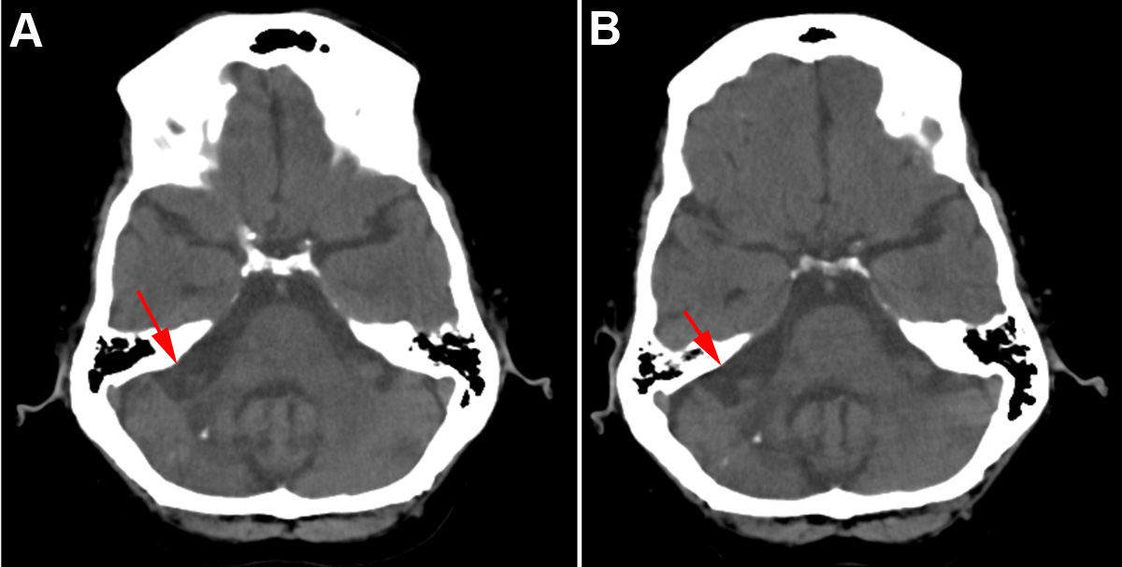
Figure 1 Computed tomography scans show no progression. A: Axial slice from the CT scan of 2006 showing the cerebellar lesion (red arrow), a small calcification, and atherosclerosis of cerebral vasculature; B: Axial slice of the same coordinates as in (A) from the CT scan of 2008 showing the cerebellar lesion (red arrow), as well as the calcification. Note the radiolucency of the cerebellar peduncle and the loss of tissue density in the cerebellum. This location corresponds to that of the 1999 biopsy and the histologic sections examined at autopsy.

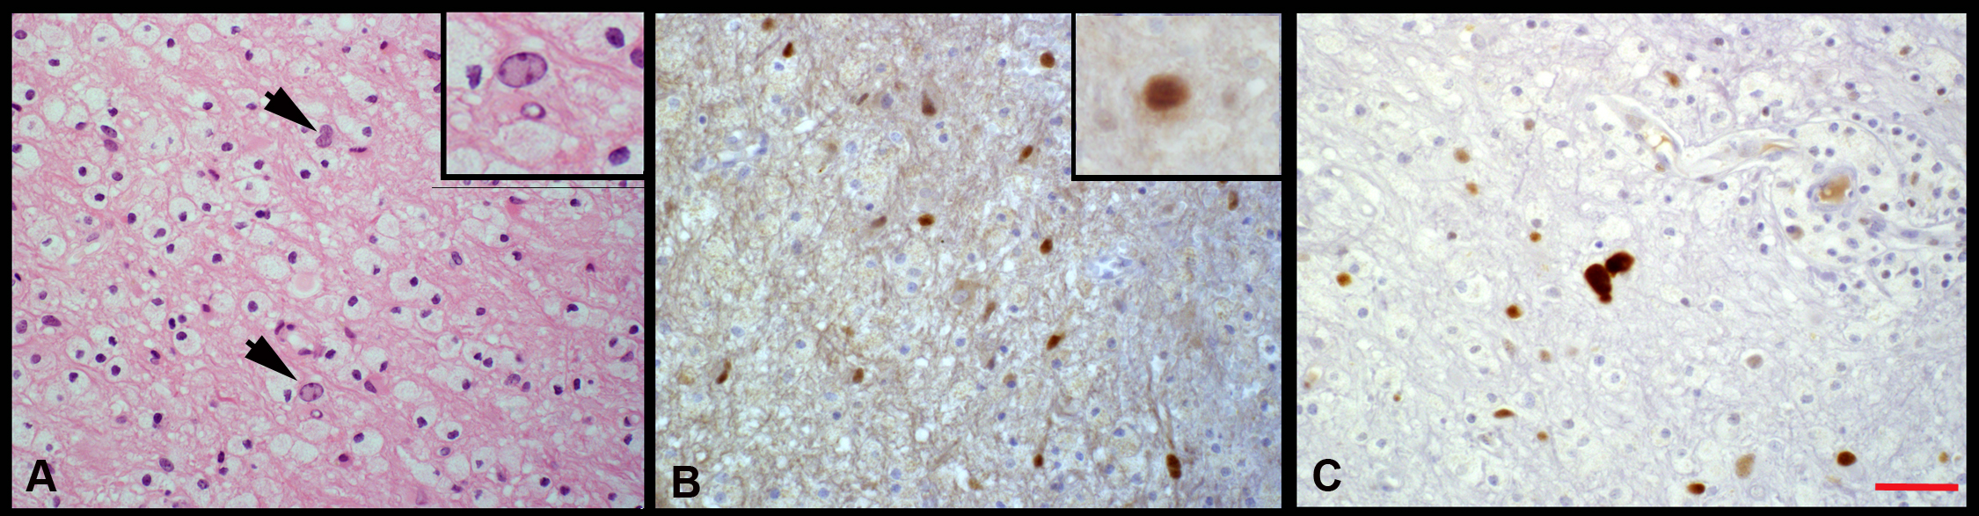
Figure 2 Histopathology of the original diagnostic biopsy. A: Histopathology of the cerebellar biopsy specimen from 1999 stained with hematoxilin and eosin (H and E). Atypical glia is indicated by arrows. Inset shows higher magnification of one example. Numerous macrophages surround the atypical cells and fill the parenchyma; B: Immunohistochemical staining for SV40 T antigen of another section from the biopsy shows numerous scattered strongly positive brown stain in nuclei of atypical glial cells, consistent with oligodendroglial infection by JC virus. Inset shows a higher magnification of another example of a positive glial cell; C: Immunohistochemistry for p53 detected strongly positive atypical glia and scattered weaker staining of macrophages consistent with inflammatory reaction to viral infection (A-C Bar = 300 µm).

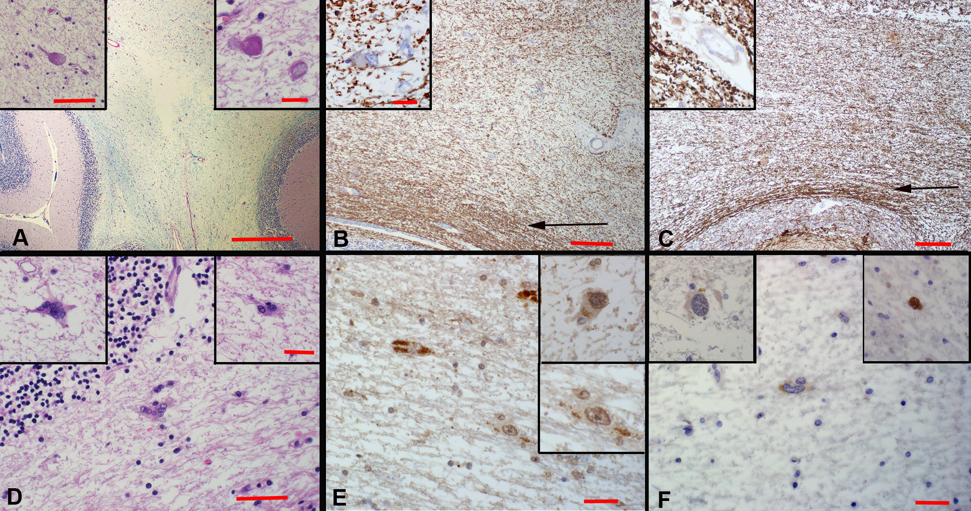
Figure 3 Post-mortem histologic analysis. A: The cerebellar lesion examined by histology shows a severe loss of myelinated fibers in the white matter, as stained by Luxol blue/Periodic Acid-Schiff. Note central pale area in the image. Also note that the surface folia, stained pink at the lower corners of the image, displays no involvement. Bar = 500 µm. Inset (left) shows a higher magnification of an axonal spheroid from the region of the lesion, indicative of residual axonal damage, stained by hematoxilin and eosin (H&E).. Bar = 150 µm. Inset (right) shows another axonal spheroid from the same region at higher magnification also stained by H and E. Bar = 100 µm. Note that the pale lesion lacks evidence of active viral infection, with no macrophage infiltration or other inflammatory processes; B: Myelin basic protein immuno-staining reveals a severe loss of myelinated fibers stained brown in the cerebellar lesion. Note relative sparing of subcortical U-fibers (arrow). Bar = 250 µm. Inset (left) Higher magnification of a cell in the lesion stained for myelin basic protein that shows ragged myelin distribution. Bar = 100 µm. This demyelination appears to be quiescent; C: Section of the lesion in the cerebellum stained for neurofilament protein shows a loss of axons nearly proportional to the loss of myelin Note relative sparing of subcortical U-fibers (arrow). Bar = 250 µm. Inset (left) shows higher magnification of neurofilament staining in the area of the lesion. Axons apparently lost in the acute phase in 1999 have not regenerated. Bar = 100 µm; D: Examples of rare atypical astrocytes found at the periphery of the lesion in H&E stained sections. Bar = 150 µm. Insets at higher magnification, Bar = 100 µm; E: SV40 immunostaining for T antigen shows some non-specific granular pattern within the cytoplasm of a few glial cells in the region of the lesion, some faint nuclear staining and scattered acellular granular deposits. This staining suggests latent infection with low levels of residual antigen. Insets show examples at higher magnification. Bar = 100 µm; F: The p53 immunostain shows that atypical astrocytes are mostly negative. Inset (left) another example of an atypical astrocyte that does not stain at the same magnification, and inset (right) a rare example of a p53 positive atypical glial cell. Macrophages were very rare and p53 staining was not observed. Bar = 100 µm.

